A critical evaluation and the identification of next teaching and learning steps focussing on a case study of an individual learner or a group of learners, based on an observed critical incident.
Before delving deeper into the topic of a critical incident, the initial thought was that a critical incident is usually a negative and impactful moment. Joshi (2018) shares that it can be seen as a negative event that has happened and been identified by the researcher, which was similar to the view that was previously held. However, having looked deeper into the topic, a critical incident can be any normal event which only becomes critical due to this particular event being analysed (Shapira, 2011; Tripp, 2012). Therefore, from this further research into what a critical incident is, the following assignment will look at a particular event that has been observed, and this event will then be critically analysed to discover the positives of the particular event, and also the challenges in order to identify possible next steps to improve teaching and learning. However, throughout doing this, careful consideration will be placed on the fact that the main method used is observations, as one of the greatest challenges this method of research faces is the Hawthorne effect and researcher bias, which can have an impact on what is being discussed and the points that will be made (Crowther and Lancaster, 2012).
The observations took place in a community school in the local authority of Rhondda Cynon Taff, it is a large school with 424 pupils and the school itself consists of 13 single- age classes and one mixed age class (Estyn, 2018).This particular school will be labelled as School X as all participants must remain anonymous during this research (BERA, 2018). There are two of each year group within the school and they are split based on their age. Therefore, one class will have the younger pupils of an age group and the second class will have the older pupils in the same age group. 10% of the pupils within this school are eligible for free school meals, 11% have been identified as having additional learning needs, and there are very few pupils that speak English as an additional language. The percentages are all relatively lower than the Wales and National Averages (Estyn, 2018). The school itself has been identified as a yellow support category which means that they receive up to ten days of challenge adviser time (Welsh Government, 2018). Also, the critical incident that has been discussed took place in a Reception class with twenty nine pupils, one class teacher and two learning support assistants.
In order to identify the critical incident, it was decided that a case study approach will be taken. A case study can be described as a study that can be small- scale in order to investigate a topic closely in one particular setting (Jarvis et al. 2013). Due to having a small time scale to complete the research, and having to provide a detailed investigation into an event that was not yet known, the case study approach was seen to be the best methodology for this particular research (Cohen, Manion and Morrison, 2018). Although, a possible drawback to the case study method can be identified during the reflection and analysing process, as this is where your personal thoughts and feelings can come into play (Cohen, Manion and Morrison, 2018). In order to try and prevent this, an objective viewpoint should always be used when analysing any data, and a number of different perspectives will be looked at to remain critical throughout (Ayres, 2013). However, when reflecting on the critical incident observed, ARC model sheets were completed (see appendix 2, 4, 6 and 8). These ARC model sheets were important as they allowed the researcher to discuss their particular feelings on the event, however, by doing this you cannot provide an objective viewpoint as they are your own personal feelings, and by considering your own feelings, you may subconsciously then bring these into your writing as you have had to think about and discuss them beforehand (Ayres, 2013; Cohen, Manion and Morrison, 2018).
In order to gain the detailed description, a non- participant observation was used to conduct the research. Observation research consists of gathering data by watching and listening to a real life event that is taking place (Kumar, 2014), and during this research, four observations were conducted on two different dates, although, only one observation was evaluated (see appendix 1, 3, 5 and 7). This was decided to be the best form of capturing the data as you do not need to rely on second- hand accounts, as everything has been seen by the researcher themselves (Cohen, Manion and Morrison, 2018). In order to do this, the researcher took a non- participant approach as it was felt that it was best not to become involved in any activities in order to focus all of the attention into what is being seen to prevent missing key moments (Crowther and Lancaster, 2012). It was felt that if a participant stance was taken, there was the possibility that there could have been a greater chance of research bias, as the events that the researcher took part in may have been interpreted differently due to them personally being involved in the event that is being written about (Kawulich, 2005). Despite taking the non- participant approach to try and eliminate any unreliability of the research, the observer is likely to change the environment they are in, no matter what approach you take (Jarvis et al. 2013). This is called the Hawthorne effect, and this is where the awareness of being observed causes the people within the environment to change their behaviours in order to fit an expectation that they feel the observer will have for them (Mccambridge, Witton and Elbourne, 2013). Under the ethical guidelines for educational research, participants in the research must be made aware that they are being observed, and due to this, it is unethical to lower the chance of the Hawthorne effect by not informing the participants of the observations (BERA, 2018). Therefore, it was decided that the best way to try and minimise the Hawthorne effect was to remain uninvolved so that the observer minimally disrupted the natural environment that the participants are used to, whilst also recognising that it will be difficult to completely minimise the Hawthorne effect (Jarvis et al. 2013).
Donaldson (2015) has devised four purposes for the new curriculum, they are articulated by discussing what children and young people should become throughout their education. The four purposes explain that children and young people will be Ambitious capable learners, Enterprising creative contributors, Ethical informed citizens, and Healthy confident individuals (Welsh Government, 2019a). It is felt that the critical incident linked particularly closely with the one out of the four purposes. One child had to stand at the front of the class, with the rest of the class sat on the carpet, discussing each object that they had brought within their paper bag (see Appendix 7). It is felt that this area of the critical incident linked particularly well with the Healthy Confident individuals, as each child had to participate in this activity and so they had to have great confidence within themselves to talk aloud in front of the whole of their class (Donaldson, 2015). Each child that was observed seemed confident to complete this activity, which was surprising as it could be seen as quite a daunting activity for children that are quite young (see Appendix 8). However, for children who may demonstrate less confidence in class, this activity may have discouraged them to be Healthy Confident Individuals as an activity as such could be quite frightening for a child, and could then project negative feelings onto them regarding these kind of activities, which may have an influence on their future feelings when participating in a similar activity (Eggum- Wilkens et al. 2015). Also, part of the critical incident was that all of the interactions were done by the class teacher (see Appendix 8). This could also be linked with the Healthy Confident Individuals, but for the children who were not participating in the interactions. By having the children to sit and listen, rather than participate, it was allowing them to develop empathy by learning how to behave when someone else is talking in front of the class (Donaldson, 2015). It also encourages children to become Healthy Confident Individuals by becoming more socially responsible, as they grow in self- awareness by considering how their particular actions may impact on others when they are completing particular activities that may be quite challenging for them (Welsh Government, 2019b). However, again, the children may have been discouraged to be Healthy Confident Individuals as the level of disruption did grow during the incident (see Appendix 8), and so, this may have impacted on the children who were talking’s emotional well being as the noise level may have impacted on their confidence (Donaldson, 2015).
Using language within the early years of education is extremely important in regards to children’s development (Test, Cunningham and Lee, 2010). Not only does language allow children to talk about new experiences and share thoughts that they have (Mercer, 2000), but it also allows teachers to engage children within the classroom by stimulating and extending their learning, by asking in depth questions, for example (Alexander, 2008). Therefore, it is important to look at the different ways in which teachers use language in the classroom to develop children’s learning.
The role of the adult is undeniably important within the classroom, especially during language encounters as teachers tend to hold the role of the more powerful speaker who mediates the structure and content of conversations between them and the children (Mercer, 2000). However, children are just as vital when developing their language, and being given the opportunity to ask questions and lead in conversations allows them to become, not only active inquisitors, but also to begin to understand how to act during different encounters (Wragg and Brown, 2001). Therefore, there must be a balance between adults controlling the language within classrooms, with children also being provided these opportunities to take lead, in order to develop these different areas of their spoken language (Test, Cunningham and Lee, 2010). Piaget agreed with this idea that children should be able to experience these elements of control during language encounters, as he described children as active participants in their own learning, and therefore, they should be provided with environments where they are able to exercise these levels of control in order to construct their own learning and understanding without adult intervention (Lindon, 2012). This was not the case during the critical incident, the teacher was actively involved during the children’s language activity and influenced the learning greatly by asking questions to the children when they were discussing their objects. However, in conflict with Piaget’s view, Vygotsky believed that through spoken language with adults, and other children, children’s development benefitted as learning is a social process as well as being a biological one (Alexander, 2008). He felt that adults should actively intervene in children’s learning in order to move them on to learn new knowledge or build on previous skills that they had acquired (Lindon, 2012). Therefore, it could be said that teachers should be present during these language encounters in order to help children progress in areas that they may find more difficult (Myhill, Jones and Hopper, 2006). For example, if a child is finding it more difficult to answer a question or elaborate on a topic that they are discussing, having a teacher present can allow the teacher to ask more questions that other children may not think of, and also provide them with prompts to encourage them to expand on what they are discussing, and without a teacher or a more capable adult being present, then this would not be able to happen and the child’s learning in that particular moment may have been hindered (Mercer, 2000). This idea of an adult being present in order to aid children’s learning is called scaffolding, this term was created from ideas by theorists such as Bruner (Alexander, 2008). Bruner disagreed with Piaget’s ideas that children’s development should not be intervened by adults, as he felt that children’s development could be developed greatly by adults taking more of an active role in children’s learning as they are able to help children directly when they are having difficulties within a certain situation (Lindon 2012). It is clear by looking briefly at these three theorists, that in fact, the adults presence during the critical incident was very important as it could have been scaffolding the children’s learning by allowing them to adapt on their reasoning and think more deeply about what they were discussing (Mercer, 2000; Lindon, 2012). However, more recently, Gross (2013) discussed a classroom approach called Philosophy for Children, where the children lead discussions by listening, exploring, questioning and reflecting through dialogue. Opportunities as such are important as some children learn best by being more active with their leaning (Wragg and Brown, 2001). This opportunity was not given to the children during the activity, and it may have given the children the chance to be more engaged with the activity, and therefore, more active with the learning (Wragg and Brown, 2001). Although, it is felt that when looking at language in the classroom, it is important that there is a balance of the different approaches. Teachers should be present during these kind of language interactions in order to scaffold children’s learning and support them during difficulties (Mercer, 2000; Lindon, 2012). However, children should also be given the opportunity to take part in the discussions and be provided with opportunities to ask questions, so that they can actively participate in their learning and become active inquisitors, which in turn will not only develop their language, but also many different developmental aspects (Wragg and Brown, 2001).
As well as children’s language being important to look at within the classroom, it is also important to look at children’s wellbeing during these language opportunities that are provided within the classroom, and how they may be possibly affected during them.
Health and wellbeing is crucially important as it encompasses all aspects of life, such as the physical, psychological, emotional and social (Welsh Government, 2019b). Mag (2015) suggests that in order to be successful in society today, it is largely based on how our health and wellbeing is. This is also recognised within the education system, as it is widely recognised that a key enabler for successful learning is for children to have good health and wellbeing, which is why it is so important to help children to develop and maintain their health and wellbeing throughout their education (Welsh Government, 2019b).
An important aspect of children developing their wellbeing is to become more self- regulated and socially responsible (Welsh Government, 2019b). By developing and maintaining children’s health and wellbeing, children can learn how to regulate their emotions and behaviours by becoming more independent and competent, and in turn, they can then become more socially responsible by recognising how their actions and behaviours can impact on others (Welsh Government, 2019b). Therefore, by encouraging the children to sit quietly and listen during the critical incident, it may be developing their wellbeing as they can then understand and learn how to behave in the correct manner when someone is talking in front of an audience (Welsh Government, 2019b). Also, it is important to encourage the children to listen rather than participate in the activity not just for their wellbeing but also for their learning, as it also allows the class teacher to demonstrate how to communicate with the child that is talking by asking them questions and responding to what they say (Nurpahmi, 2017). Therefore, it is important that children experience activities such as the one in the critical incident, as it can, not only encourage them to learn certain behaviours and regulate them in order to show respect to the person who is talking, but it can also allow them to learn from the teacher regarding how to act within further communicative activities in the future (Nurpahmi, 2017; Welsh Government, 2019b). However, the children participating within the critical incident were still very young (see appendix 7). Piaget described young children as egocentric, this is where they can only see things from their own perspective and may not acknowledge that other people see things in a different way (Lindon, 2012). However, the Theory Of Mind challenges Piaget’s thinking on children being egocentric as they found that children as young as two, are able to have a basic understanding of the differences between their feelings and other peoples (Halpenny, 2014). Although, it could be seen in the critical incident that the children who were not involved in the activity, wanted to share their own feelings by shouting out if they liked them or not (see Appendix 7). This could support Piaget’s idea of egocentrism as the children wanted to give their input, as they may have felt that theirs was important too (Lindon, 2012). This level of disruption that was created may have then affected the children’s wellbeing as some children may already be more quiet in class, and therefore, may already want to avoid activities as such as they may not know how to handle the pressures that they are faced with when talking in front of the class (Eggum- Wilkens et al. 2015). However, if we hide children away from activities as such in order to help their wellbeing at that particular time, then we may actually hinder their wellbeing for the future as children are able to build their resilience and confidence when taking part in challenging and demanding activities, as they can then learn how to cope with the emotional demands that they are faced with, and then learn how to control these (Collins and Foley, 2008). Eggum- Wilkens et al. (2015) supports this within their own research, as they found that children who are more quiet within the class tend to engage less with voluntary participation and so they cannot learn how to cope with the emotional demands of speaking in front of other people. Therefore, it is important to have activities in the class that encourage all children to speak, such as the activity within the critical incident, so that the children can then experience those feelings that they would not voluntarily put themselves in the position to do so by themselves (Eggum- Wilkens et al. 2015).
After considering both the negatives and positives within the critical incident, it could be said that how the teacher led the activity was actually very important for so many different reasons, one being that it allowed the children’s learning to be facilitated, as the children were able to observe how they can actively participate in further communication activities, from the class teachers interactions with the child that was talking (Nurpahmi, 2017). Also, despite there being some initial doubts on how the activity may have negatively impacted on the children’s wellbeing, from further research I can now see that it is important to provide activities where children have to take themselves out of their comfort zone as they may not always do this in the classroom, and without these opportunities, they cannot learn how to control the emotional demands that consequently come with doing this (Eggum- Wilkens et al. 2015).
Reflective practice is vital when working with children, as it allows us as practitioners to consider ways in which we can further benefit and develop children’s learning by enhancing our own professional development (Paige-Smith and Craft, 2008). In order to do this, practitioners must reflect on their own teaching methods, and consider how they can improve them to invent new strategies that may work better during future lessons (Ting, 2013). Hattie emphasises how important practitioners reflections are regarding children’s learning, “…the biggest effects on student learning occur when teachers become learners of their own teaching” (Hattie, 2009, p.22). Thus, in order for me to improve children’s learning, I must enhance my own professional development by consistently developing my knowledge and teaching practices in order to benefit those that I am teaching (Gutierez, 2015). If I am never reflecting on my practices as a practitioner, then I will never be able to improve as a professional and the learning of the children may then be affected (Paige-Smith and Craft, 2008).
Therefore, keeping this in mind, despite feeling that the activity was beneficial in helping children develop confidence, resilience and self- regulation (Welsh Government, 2019b; Collins and Foley, 2008). Most things are not completely perfect, and so, some next steps have been identified which I feel could possibly benefit the children’s learning even more. If I was to conduct an activity like the one where the critical incident was identified, I would think about conducting it similar to Circle Time where children may have more confidence as the groups would then be a lot smaller (Collins and Foley, 2008). Although, I felt that the role of the teacher was more hands on during this activity which worked well in order to help develop the children’s language (Mercer, 2000). I would think about taking more of a facilitated approach during the circle time, whilst still keeping control of what was happening by sitting within the circle with the children (Taylor, 2003). I would do this so that I am still able to help the children if they are finding it difficult (Lindon, 2012), and, I would also be able to ensure that the activity stays on task by being present within the circle (Taylor, 2003). Also, instead of not allowing the children to participate, I would encourage the children to sit and listen whilst the child is speaking so that they are still developing their self- regulation and self- awareness (Welsh Government, 2019b). However, I would allow the children to engage with what the child has said once they have finished talking, as research shows that given children the opportunity to talk to each other by asking and engaging with their conversation develops their language, and also their social skills as they become more aware of how to act whilst having conversations (Gross, 2013).
To conclude, the main method that was used was non- participant observations so that I was able to watch and listen to the life events that took place within the classrooms (Kumar, 2014). Whilst also acknowledging, that the Hawthorne affect may have had a possible impact on what was observed, due to the participants being aware of the observations (Mccambridge, Witton and Elbourne, 2013). From the four different observations that were conducted, one critical incident was identified. This then allowed me to consider the role of the teacher within the classroom, and also to consider how children’s wellbeing may be impacted during activities that the critical incident was identified in. I was then able to use the research that I had completed to reflect on the practices. This part of the research was extremely important as the Professional Standards for Teaching and Leadership has highlighted, throughout their five professional standards, the importance of reflection in order to develop pedagogy,
“The teacher consistently extends knowledge, skills and understanding and can show how reflection and openness to challenge and support informs professional learning to progressively develop pedagogy.” (Welsh Government, 2019c, p.16).
By completing this reflection, I was able to identify some next steps relating to children’s wellbeing, by using a circle time system the groups of children would be smaller and this possibly encourage the children to have more confidence (Collins and Foley, 2008). The role of the practitioners in the classroom as facilitators to ensure the activity stays on topic, and there is still a level of control (Taylor, 2003), and finally, to encourage children’s engagement by giving them the opportunity to engage with what each child has said, which could then also develop their social skills (Gross, 2013).

Appendices

Appendix 1

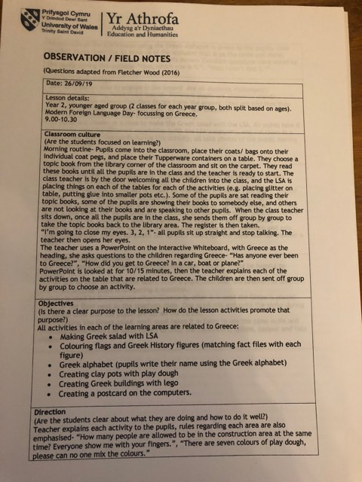
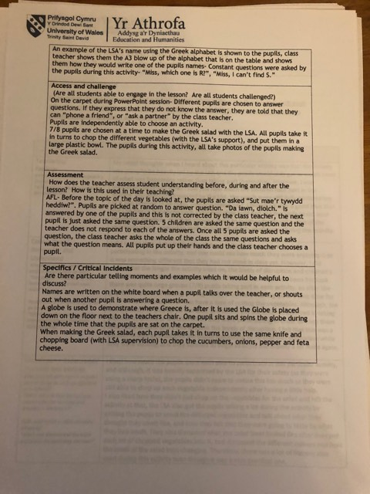

Appendix 2

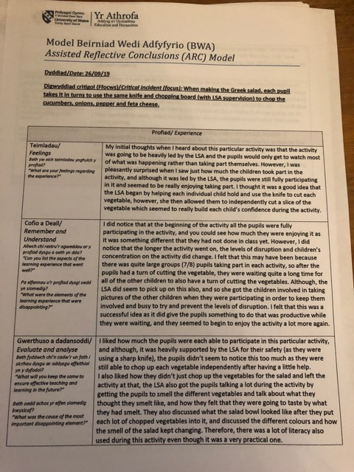

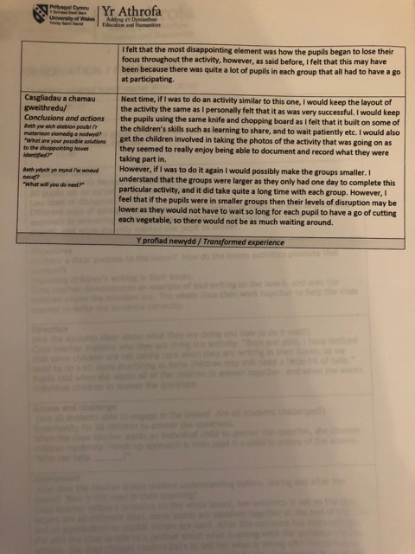

Appendix 3

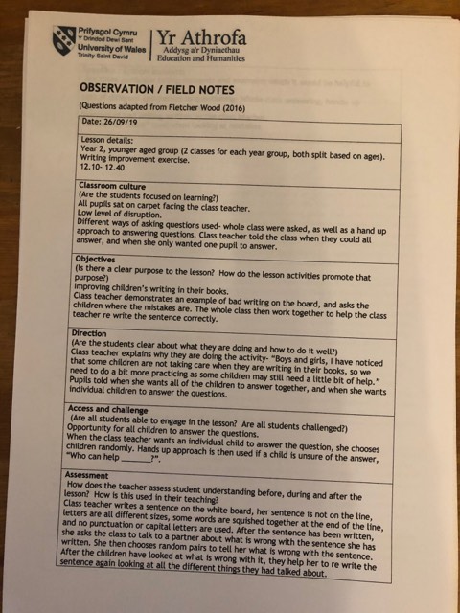

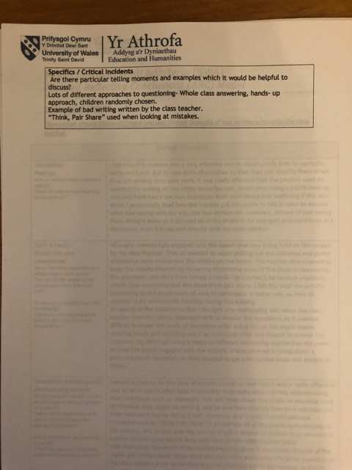

Appendix 4

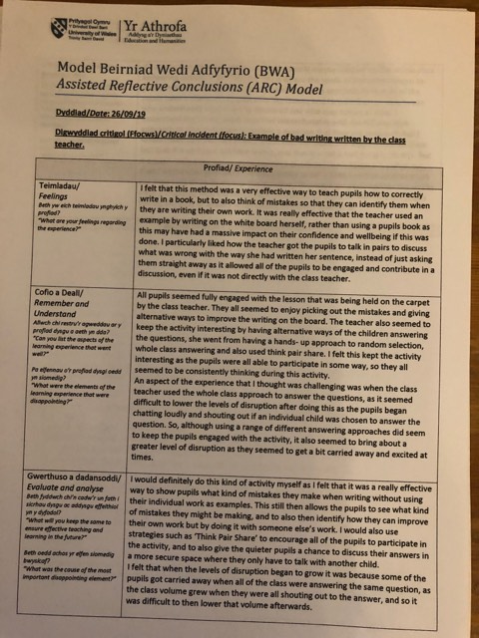

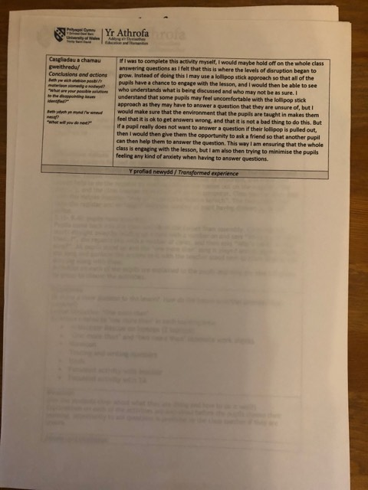

Appendix 5

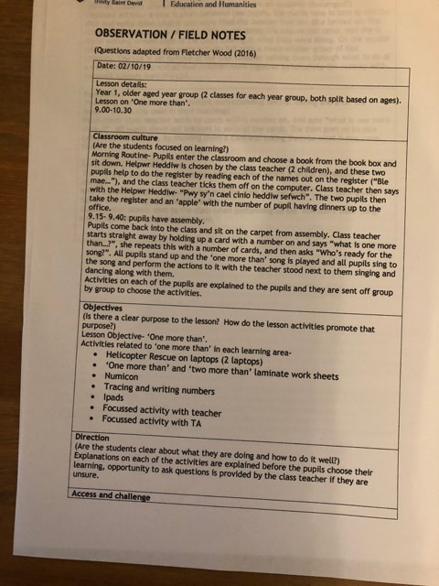
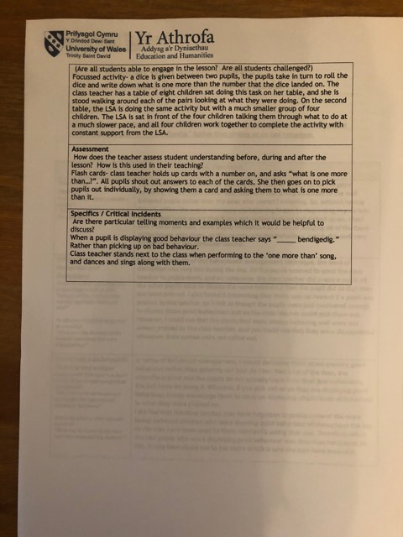

Appendix 6

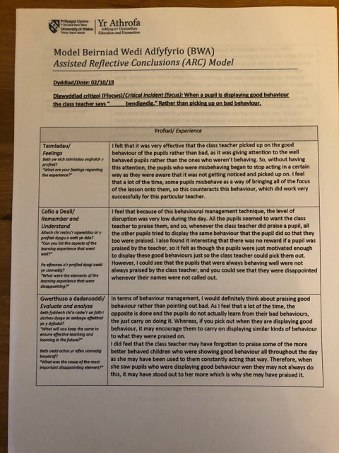
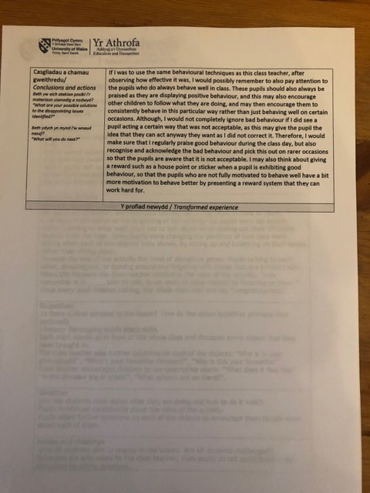

Appendix 7

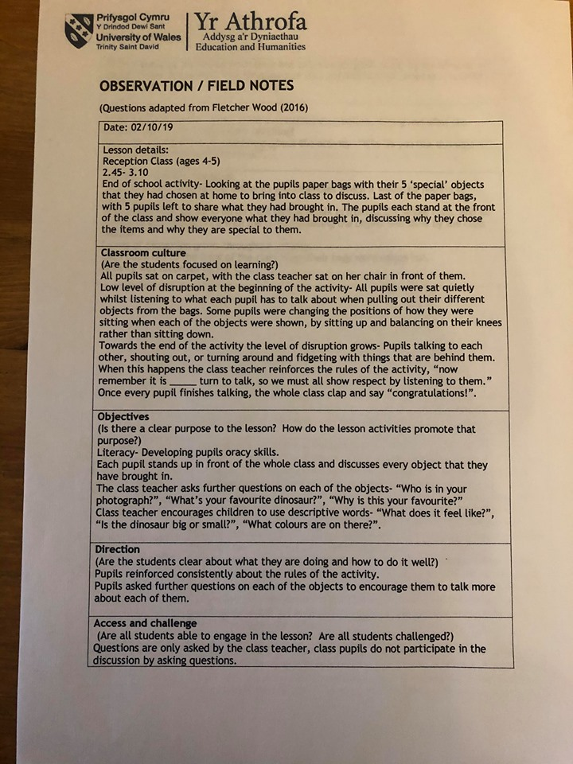
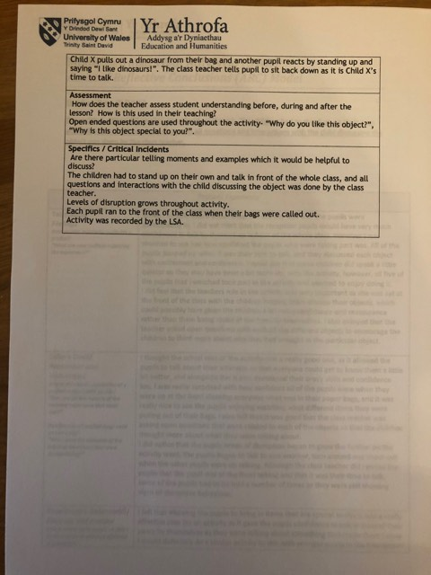

Appendix 8

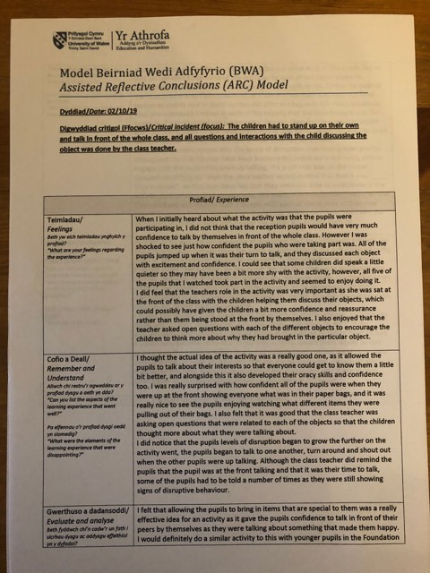
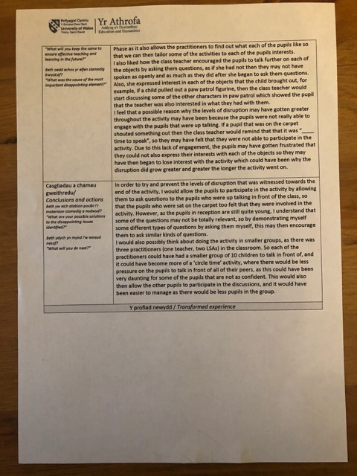

References
Alexander, R. (2008) Towards Dialogic Teaching: Rethinking classroom talk. (4th ed.) Thirsk, Yorkshire: Dialogos.
Ayres, D. (2013) Critical Incidents. Available at: http://danieljayres.blogspot.com/2013/12/critical-incidents.html (Accessed: 11th October 2019)
BERA (2018) Ethical Guidelines for Educational Research. (4th ed.) London. Available at: https://www.bera.ac.uk/publication/ethical-guidelines-for-educational-research-2018 (Accessed: 5th October 2019)
Cohen, L., Manion, L. and Morrison, K. (2018) Research Methods in Education. London: Routledge.
Collins, J. and Foley, P. (2008) Promoting children’s wellbeing: Policy and practice. Bristol: Policy Press.
Crowther, D. and Lancaster, G. (2012) Research Methods. (2nd ed.) Hoboken: Taylor and Francis.
Donaldson, G. (2015) Successful Futures- Independent Review of Curriculum and Assessment Arrangements in Wales. Cardiff.
Eggum- Wilkens, N.D., et al. (2014) Children’s shyness, popularity, school liking, cooperative participation and internalising problems in the early school years. Early Childhood Research Quartely, 29(1), pp. 85-95. URL: http://dxdoi.org/10.1016/j.ecresq.2013.10.002
ESTYN (2018) Estyn Report. Available at: https://www.estyn.gov.wales/provider/SchoolX (Accessed: 4th October 2019)
Gross, J. (2013) Time to Talk: Implimenting outstanding practice in speech, language and communication. London; New York: Routledge.
Gutierez, S.B. (2015). Teachers’ Reflective Practice in Lesson Study: A Tool for Improving Instructional Practice. Alberta Journal of Educational Research, 61(3), pp. 314-328. URL: https://web-b-ebscohost-com.ezproxy.uwtsd.ac.uk/ehost/pdfviewer/pdfviewer?vid=1&sid=012933e2-7462-4819-9a99-e1acd40c0115%40pdc-v-sessmgr04
Halpenny, A.M. (2014) Introducing Piaget: A guide for practitioners and students in early years education. London: Routledge.
Hattie, J. (2009) Visible learning: a synthesis of over 800 meta- analyses relating to achievement. London; New York: Routledge.
Jarvis, P. et al. (2013) Research in the Early Years: A step by step guide. Oxfordshire, England; New York: Routledge.
Joshi, K.R. (2018) Critical Incidents for Teachers’ Professional Development. Journal of NELTA Surkhet, 5(1), pp. 82-88. URL: file:///C:/Users/MILES%20FAMILY/AppData/Local/Packages/Microsoft.MicrosoftEdge_8wekyb3d8bbwe/TempState/Downloads/Critical%20Incidents_Khem%20Raj%20Joshi%20(1).pdf
Kawulich, B. (2005) Participant Observation as a Data Collection Method. Forum: Qualitative Social Research, 6(2), pp. 1-28. URL:
Kumar, R. (2014) Research Methodology. (4th ed). London: Sage.
Mag. A.G. (2015) Promoting children’s wellbeing. Policies, practices and current trends. Procedia- Social and Behavioral Sciences, 180(1), pp. 1391-1397. DOI: 10.1016/j.sbspro.2015.02.283
McCambridge, J., Witton, J. and Elbourne, D.R. (2013) Systematic review of the Hawthorne effect: New concepts are needed to study research participation effects. Journal of Clinical Epidemiology, 67(1), pp. 267-277. DOI: 10.1016/j.jclinepi.2013.08.015
Mercer, N. (2000) Words and Minds: How we use language to think together. London; New York: Routledge.
Myhill, D., Jones, S. and Hopper, R. (2006) Talking, Listening, Learning: Effective Talk in the Primary Classroom. Maidenhead: Open University Press.
Nurpahmi, S. (2017) Teacher Talk in Classroom Interaction. Eternal, 3(1), pp. 34-43. DOI: 10.24252/Eternal.V31.2017.A4
Paige- Smith, A. and Craft, A. (2008) Developing Reflective Practice In The Early Years. Maidenhead: Open University Press.
qualitative-research.net/index.php/fqs/article/view/466/977
Shapira, O.S. (2011) Teachers’ Critical Incidents: Ethical Dilemmas in Teaching Practice. Teacher and Teacher Education, 27(1), pp. 648-656. DOI: 10.1016/j.tate.2010.11.003
Taylor, M.J. (2003) Going round in circles: Implementing and learning from Circle Time. Cambridge: Taylor and Francis Ltd.
Test, J.E., Cunningham, D. and Lee, A.C. (2010) Talking with young children: How Teachers Encourage Learning. Dimensions of Early Childhood, 38(3), pp. 3-14. URL: https://web-a-ebscohost-com.ezproxy.uwtsd.ac.uk/ehost/pdfviewer/pdfviewer?vid=1&sid=9f8db49d-5ac7-4fdf-9cbc-a1f4896d5e98%40sdc-v-sessmgr03
Ting, K.Y. (2013) Student Teachers’ Reflective Practice on a Tutorial Teaching Approach. International Education Studies, 6(7), pp. 150-156. DOI: 10.5539/ies.v6n7p150
Tripp, D. (2012) Critical Incidents in Teaching: Developing Professional Judgement. London: Routledge.
Welsh Government (2018) My Local School. Available at: http://mylocalschool.wales.gov.uk/SchoolX?lang=en (Accessed: 4th October 2019)
Welsh Government (2019a) Draft Curriculum for Wales 2022: Draft Statutory Guidance: A guide to Curriculum for Wales 2022. Cardiff: Welsh Government.
Welsh Government (2019b) Draft Curriculum for Wales 2022: Draft Statutory Guidance: Area of Learning and Experience- Health and Well Being. Cardiff: Welsh Government.
Welsh Government (2019c) Professional standards for teaching and leadership. Cardiff: Welsh Government.
Wragg, E.C. and Brown, G. (2001) Questioning in the Primary School. London: Routledge/ Falmer.

