REFERENCE PROPERLY
AND AVOID PLAGIARISM
Part One
Citations

ACTIVITY BOOKLET

- Do these activities after watching the PowerPoint presentation.
- If you need to refresh your memory while doing the activities go back to the slides indicated at the beginning of each activity.
- Use the answer key or get help from your teacher to check your answers.

ACTIVITY 1 [Slides 3-9 and slide 19]
Choose one option to complete the following sentences:
- Plagiarism means that
you have used somebody else’s work without their permission
a
you have used somebody else’s work without acknowledging that it was their work

- Plagiarism is
a serious offence in academic and professional contexts
a serious offence only in professional contexts

- You can avoid plagiarism by
indicating that you have used information that is not your own and providing details about the source
mentioning at the beginning of your work that you have used several sources to find information about the topic

- The reader must be provided with
enough information to being able to find the original source
only the author and title of the source

- Citations are references included
at the end of your work
within your work

- Citations are presented
in brackets
in between commas

- The three basic elements of a citation are
the name of the author, year of publication, page number
the surname of the author, year of publication, page number

- Citations do not include page number if
your source is an article instead of a book
the information used in your work comes from the source as a whole and not from a specific page
ACTIVITY 2 [Slides 9-12]
You are researching the topic of your assignment and have selected a few ideas (see images) from a book titled How to Manage, written by Jo Owen and published in 2006.

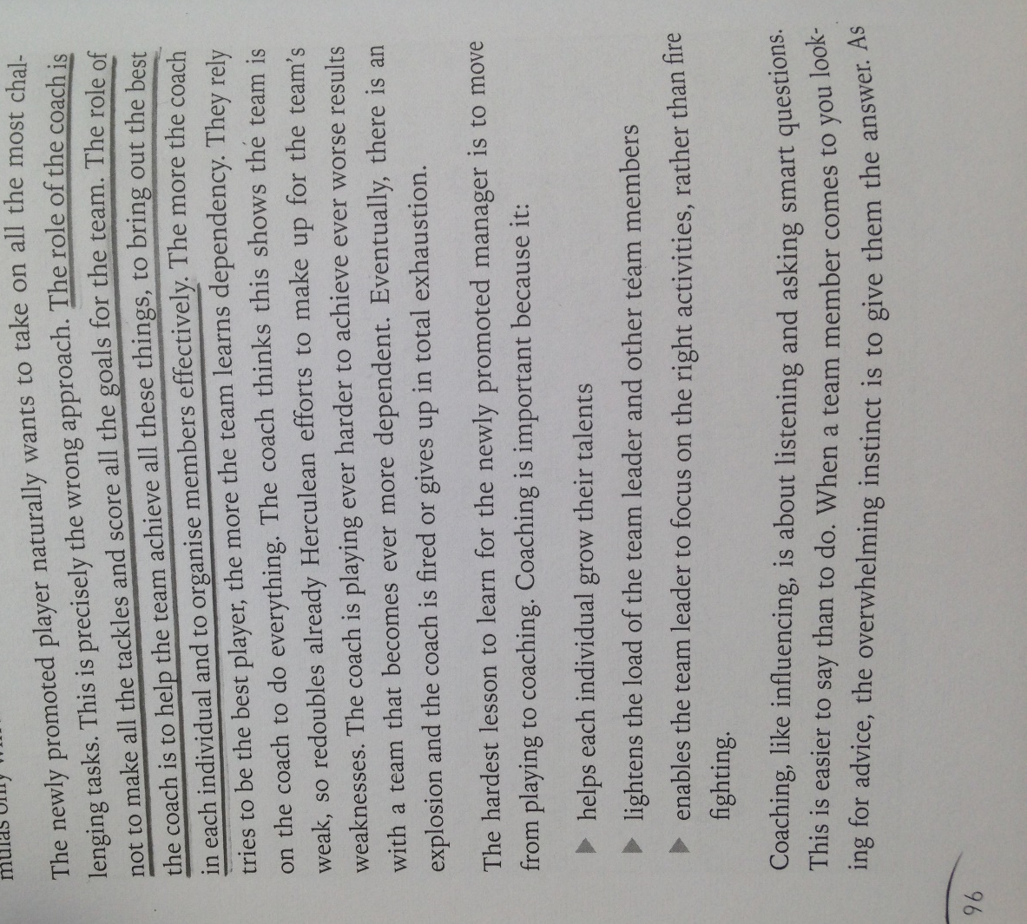

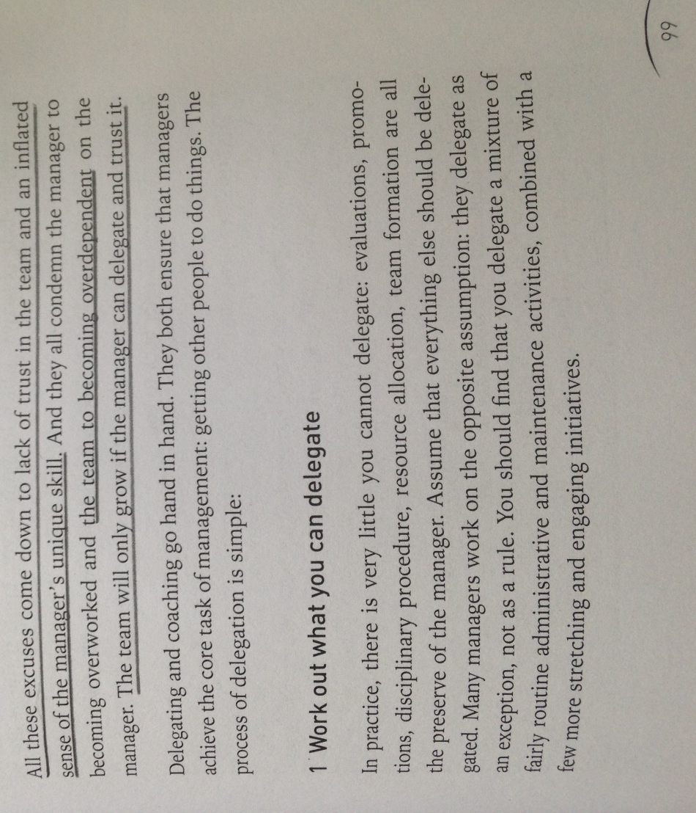

Complete the following citations and then answer the questions:
Owen explains that the role of the coach is not “to make all the tackles and score all the goals for the team” (2006, p96).

It has been pointed out that it is not the role of the coach to make everything for the team members (Owen, 2006, p96).

According to Owen, the excuses many managers use to explain why they do not delegate show that they do not trust their team (2006, p99).

All the excuses given by managers to explain why they do not delegate in their team members “come down to lack of trust in the team and an inflated sense of the manager’s unique skill” (Owen, 2006, p99).

- Why is the author’s surname not included in two of the citations above?
Because it has been mentioned in the main body of the text .

- Two of the citations above come after quotations, does this mean that we can remove the citations from the text?
No, it helps with the flow for the reader and you need to citate the quotation to show the reader where it has been accessed. Regardless of it being a paraphrasing , direct quotation or an idea.
Activity 3 [Slide 14]
In your assignment you have included information from Essential Study Skills. The Complete Guide to Success at University (2012) written by Tom Burns and Sandra Sinfield.

- Two of the following citations are not correct. Which ones are they and why are they not correct?
The first and second one’s are incorrect. The first as it’s contains the initials of the authors which isn’t needed within the text citation. The second one as it has only referenced one of the authors .

Working in groups helps participants to develop important skills such as flexibility, diplomacy and the ability to listen and compromise (Burns, T. and Sinfield, S., 2012, p121).

Some people are reluctant to work in a group, among other things because they do not want to depend on members who in their opinion do not pull their weight (Burns, 2012, p121).

Burns and Sinfield (2012, p121) point out that in the case of students an advantage of team work is that it can offer social support and “break down the isolation often associated with being a student”.

Activity 4 [Slide 14]
- What does et al. indicate in the citation below?
Et al. means and others and demonstrating that there are more than 3 authors. ……………………………………………………………………………………………………………………………………………………………………………………..
The study shows that people with low self-esteem “do things to avoid feeling guilty or anxious or to satisfy others” (Kernis et al., 2000, p1303).

Activity 5 [Slides 15-16]
You have used in your assignment this article published online in the newspaper The Economist. Complete the citation and answer the question below:

Falling bank shares

European banks are in the eye of a new financial storm

Feb 13th 2016
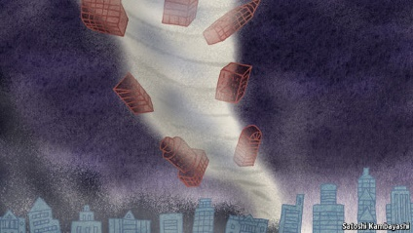

IF THE start of the year has been desperate for the world’s stockmarkets, it has been downright disastrous for shares in banks. Financial stocks are down by 19% in America. The declines have been even steeper elsewhere. Japanese banks’ shares have plunged by 36% since January 1st; Italian banks’ by 31% and Greek banks’ by a horrifying 60% (see chart). The fall in the overall European banking index of 24% has brought it close to the lows it plumbed in the summer of 2012, when the euro zone seemed on the verge of disintegration until Mario Draghi, the president of the European Central Bank (ECB), promised to do “whatever it takes” to save it.

In fact, the bank shares have plunged so dramatically that the overall European bank index has come “close to the lows it plumbed in the summer of 2012” (The Economist, 2016, online).

- Why do we use “online” instead of page numbers in the citation above?
As there is no page numbers to direct the reader to the original source , its demonstrating the source was accessed online and there available.
Activity 6 [Slide 15]
- Which of these two citations is correct? Explain why.
The first one as the second one has inserted the URL into the citation which is unnecessary unless within the reference list .
After sharp falls after the Brexit results, the financial markets seem to be recovering (The Wall Street Journal, 2016, online).

After sharp falls after the Brexit results, the financial markets seem to be recovering (http://www.wsj.com/europe, 2016, online).

Activity 7 [Slide 16]
You are using this article published online in the newspaper The Guardian. Complete the citation.

Rolls-Royce cuts dividend for first time in almost 25 years
The engineering group has slashed in half its final payment to shareholders in the first dividend cut since 1992
Julia Kollewe Friday 12 February 2016


Rolls-Royce has cut its dividend payment to shareholders for the first time in almost 25 years and warned of further job cuts to come. The final dividend payment to investors has been slashed by 50%, to 7.1p a share. Analysts had expected a 30% reduction.
But relief that the engineering group had not issued another profits warning saw its shares jump 13%, to 602p, although the share price has still halved in value over the past two years.
Sandy Morris, analyst at the company’s house broker Jefferies, said: “The unchanged 2016 guidance should help stop the rot in sentiment. The 50% cut in the final dividend is a painful step, but Rolls makes a fairly clear commitment to a progressive dividend policy.”

Rolls-Royce shareholders have not received good news this week, after the company “cut its dividend payment for the first time in almost 25 years” (The Guradian, 2016, online).

Activity 8 [Slides 15-16]
You have used information from the Maersk website in your assignment (http://www.maersk.com/en/markets). Complete the citation.

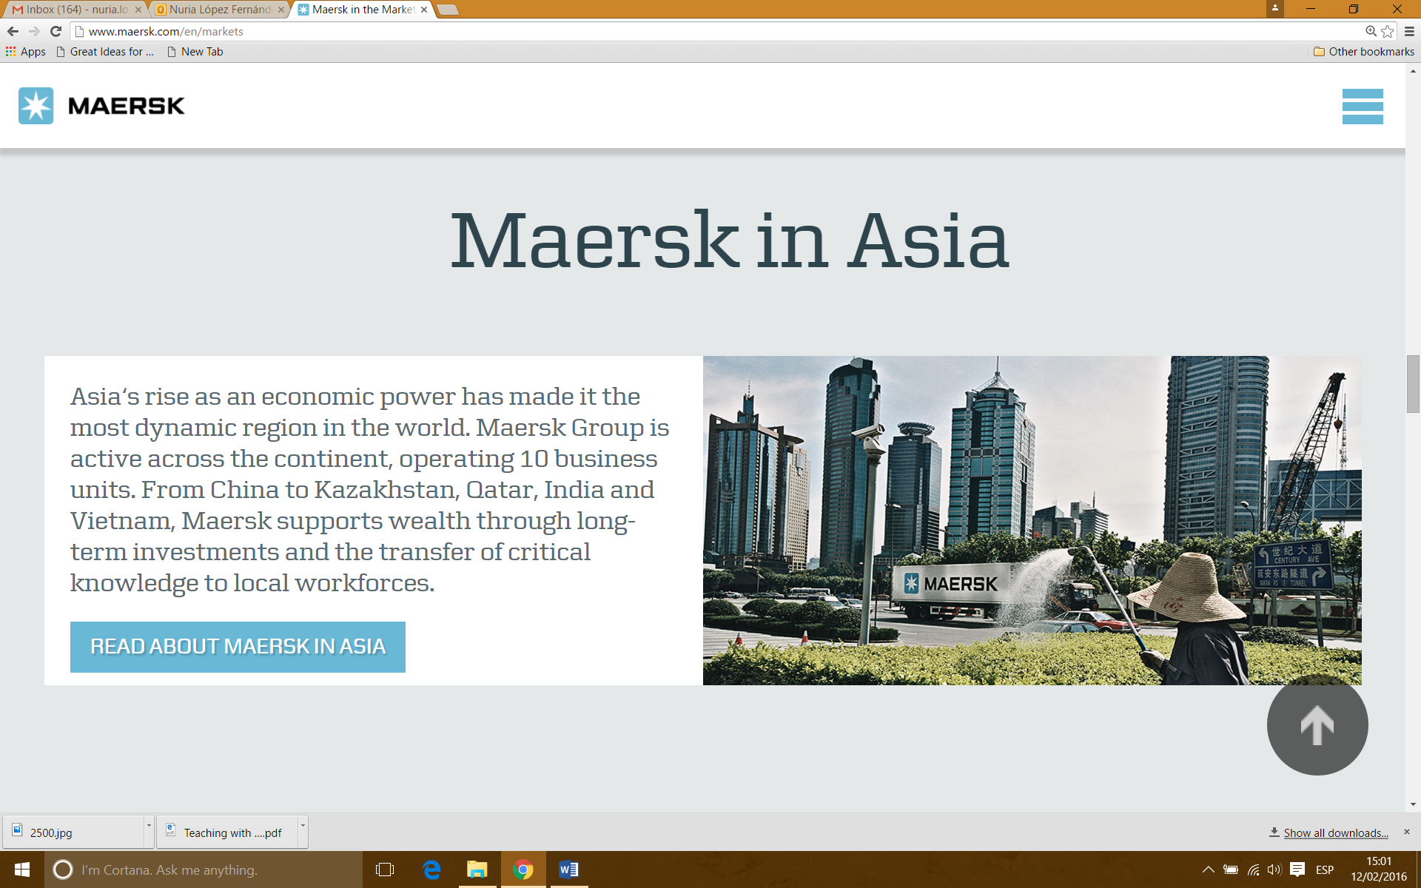
Maersk is very present in the Asian continent supporting wealth “through long-term investments and the transfer of critical knowledge to local workforces (Maersk, nd., online).

Activity 9 [Slides 9 and 15-16]
You have used information from the Lego website in your assignment (http://www.lego.com/en-us/aboutus/lego-group/the_lego_history). Complete the citation.

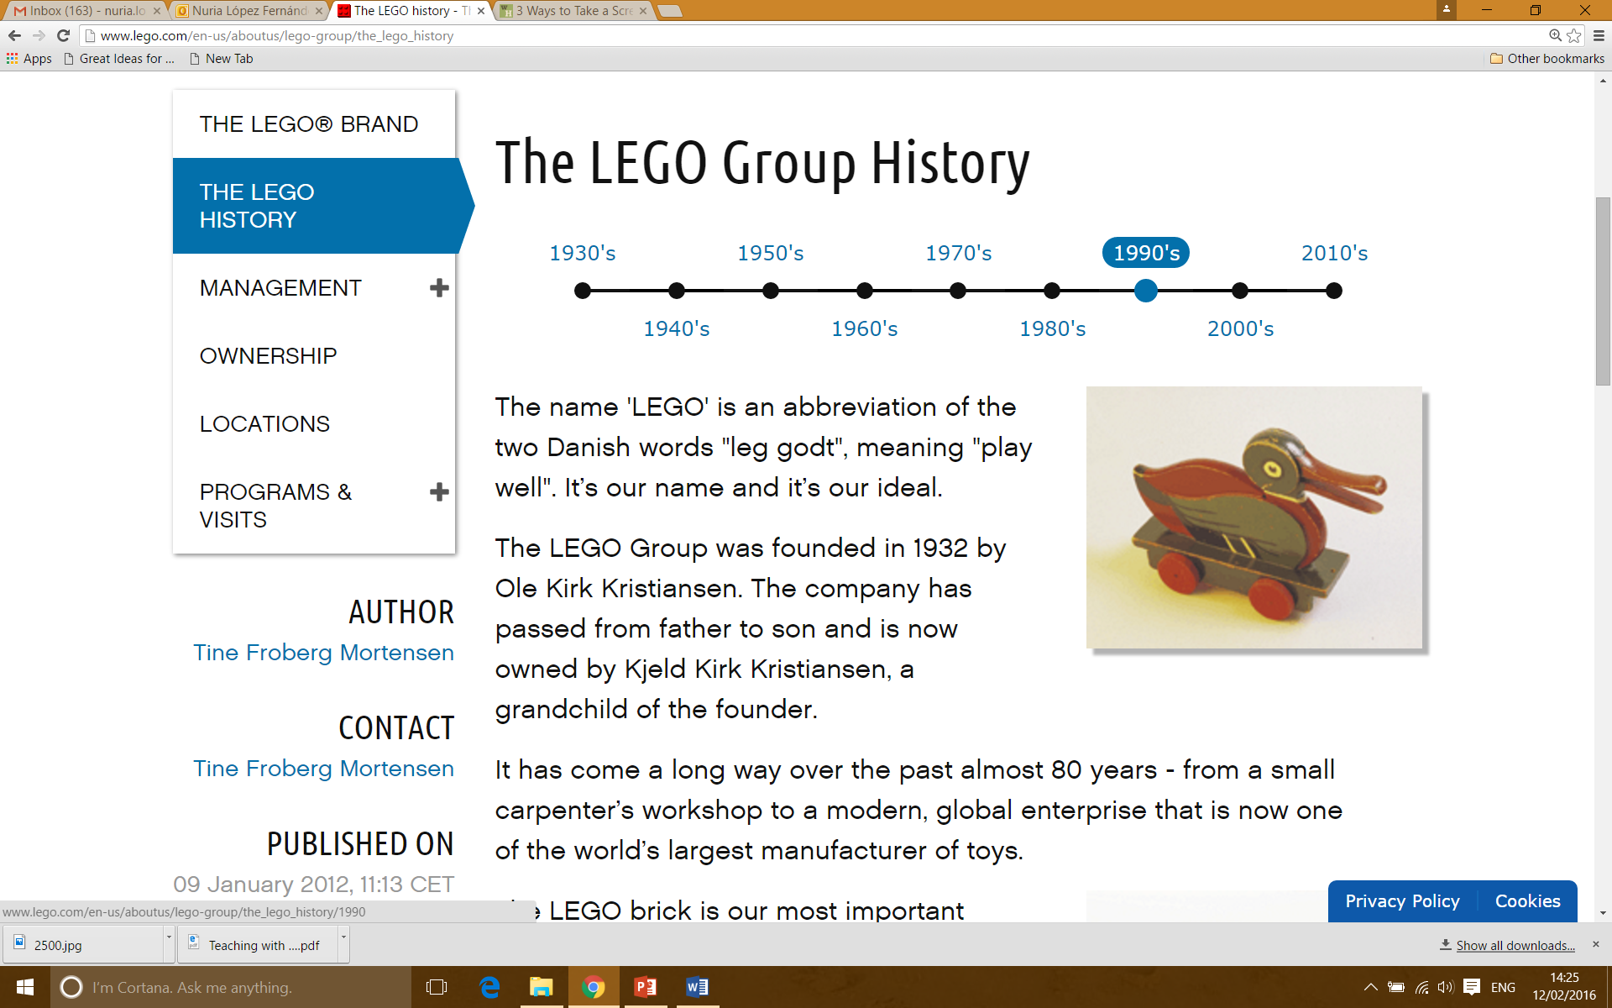
LEGO is still in the hands of the family which founded the company in 1932. Nowadays LEGO is owned by Kjeld Kirk Kristiansen, a grandchild of its founder, Ole Kirk Kristiansen (Lego, 2012, online).

Activity 10 [Slide 17]
You have used information from one chapter of a book titled Applied Linguistics and Material Development (2013), edited by Brian Tomlinson. The authors of the chapter you have used are Michael Byram and Hitomi Masuhara. Complete the citation:
Cross-cultural training can be defined as the “broad field of interest in international trading and, in more recent times, the global economy and globalization” (Byram and Masuhara, 2013, p144).

Activity 11 [Slide 18]
In Essential Study Skills. The Complete Guide to Success at University (2012) the authors, Tom Burns and Sandra Sinfield, make reference to Tony Buzan’s work.
- Explain why the following citation is incorrect.
Surnames only should be included in the citation.

Tony Buzan points out the importance of active revision if we do not want to forget 98% of what we have learned (Burns and Sinfield, 2012, p385).

Now complete this citation:
Tony Buzan points out the importance of active revision if we do not want to forget 98% of what we have learned (Buzan, 1989 cited in Burns and Sinfield, 2012, p385).

ANSWER KEY
ACTIVITY 1
Plagiarism means that you have used somebody else’s work without acknowledging that it was their work.
Plagiarism is a serious offence in academic and professional contexts.
You can avoid plagiarism by indicating that you have used information that is not your own and providing details about the source.
The reader must be provided with enough information to being able to find the original source.
Citations are references included within your work.
Citations are presented in brackets.
The three basic elements of a citation are the surname of the author, year of publication, page number.
Citations do not include page number if the information used in your work comes from the source as a whole and not from a specific page.

ACTIVITY 2
Owen explains that the role of the coach is not “to make all the tackles and score all the goals for the team” (2006, p96).

It has been pointed out that it is not the role of the coach to make everything for the team members (Owen, 2006, p96).

According to Owen, the excuses many managers use to explain why they do not delegate show that they do not trust their team (2006, p99).

All the excuses given by managers to explain why they do not delegate in their team members “come down to lack of trust in the team and an inflated sense of the manager’s unique skill” (Owen, 2006, p99).

*Please note that bold is only used in the answer key to highlight the citations, but you should not use bold font for the citations in your text.

- Why is the author’s surname not included in two of the citations above?
Because the surname, Owen, is already mentioned in the sentence.
- Two of citations above come after quotations, could we then remove the citations from the text? No, regardless of whether we are quoting, paraphrasing or summarising, we need to include a citation.

ACTIVITY 3
- Two of the following citations are not correct. Which ones are they and why are they not correct?
The first and second citations are incorrect: the first one because it includes the authors’ initials (not necessary) and the second because it includes only the first author’s surname (surnames of the two authors are necessary).

ACTIVITY 4
- What does et al. indicate in the citation below?
It indicates that apart from Kernis there are at least three other authors for this source. We use et al. when there are more than three authors.

ACTIVITY 5

In fact, the bank shares have plunged so dramatically that the overall European bank index has come “close to the lows it plumbed in the summer of 2012” (The Economist, 2016, online).

- Why do we use “online” instead of page numbers in the citation above?
Because page numbers were not available in the source (online newspaper).

ACTIVITY 6
- Which of these two citations is correct? Explain why.
The first citation is the correct one because it includes the site’s name. Remember that you should not include website addresses in citations.

ACTIVITY 7
Rolls-Royce shareholders have not received good news this week, after the company “cut its dividend payment for the first time in almost 25 years” (Kollewe, 2016, online).

*Remember that if the author’s name is available, that takes priority over the website’s name. That is why in this case we include Kollewe in the citation and not The Guardian.

ACTIVITY 8
Maersk is very present in the Asian continent supporting wealth “through long-term investments and the transfer of critical knowledge to local workforces (Maersk, nd., online).

ACTIVITY 9
LEGO is still in the hands of the family which founded the company in 1932. Nowadays LEGO is owned by Kjeld Kirk Kristiansen, a grandchild of its founder, Ole Kirk Kristiansen (Froberg, 2012, online).

ACTIVITY 10
Cross-cultural training can be defined as the “broad field of interest in international trading and, in more recent times, the global economy and globalization” (Byram and Masuhara, 2013, p144).

*Remember that in the case of using one chapter from an edited book, you need to include the surname(s) of the chapter’s author(s) in the citation, not the surname of the editor of the book.

ACTIVITY 11
- Explain why the following citation is incorrect.
It is incorrect because the information comes from Tony Buzan and therefore it is his surname that should be included in the citation.
Tony Buzan points out the importance of active revision if we do not want to forget 98% of what we have learned (Buzan, 1989 cited in Burns and Sinfield, 2012, p385).

*To find out the date of Buzan’s work you would need to consult the Bibliography at the end of Burns and Sinfield’s book.

