DS 1 Template
Stefon Wallace 2611934

My Screenshots/Photos

Screenshot/Photo 1
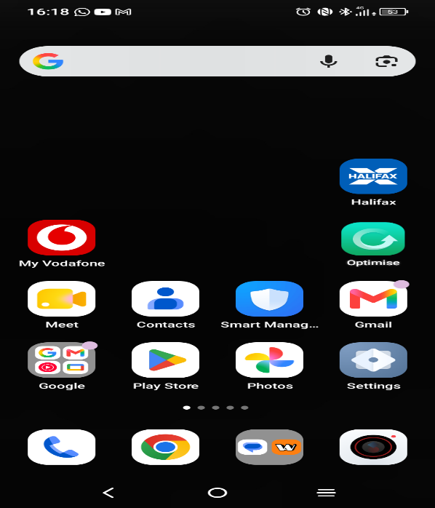

This displays the apps I use on my phone daily for example Chrome and Gmail

Screenshot/Photo 2
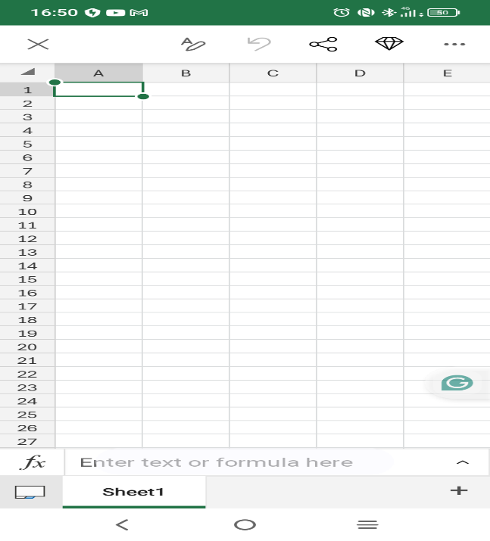
This demonstrates that I can create a simple table and user the SUM formula in Excel

Screenshot/Photo 3
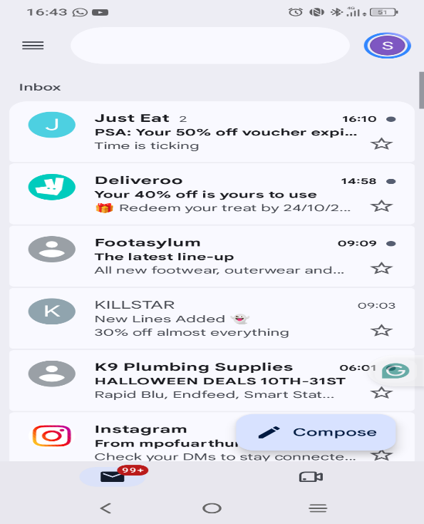
This Shows that I use outlook to read university emails and sort my messages

Screenshot/Photo 4
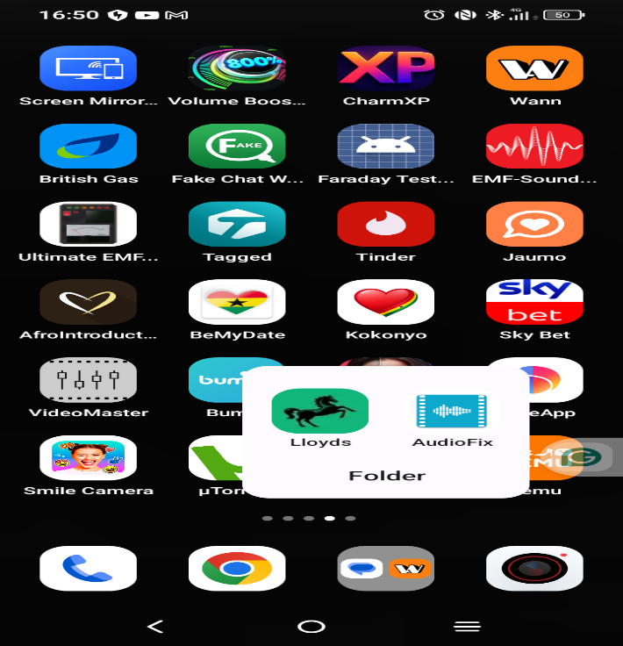
This display uses digital banking to check my balance and pay bills

My Short Reflection
- Write 5–8 simple sentences about your digital life.
- You can use the sentence starters below if helpful.
I feel confident when I am using Microsoft Excel to create a monthly expense tracker that tracks the list of items also categories and cost.
Hopefully this module will help me advance my digital skills, for instance, calculations and analysis in Microsoft Excel.
I am certain I can use digital tools daily in my life. For example, using WhatsApp to communicate with family and friends and outlook to read emails from university.
Digital skills are important for me because they require utilising online banking to check my balance; however, I setup standing orders to arrange monthly payments for utilities.
I am convinced this module will benefit me by helping me use digital tools to govern myself for my studies and future tasks.

