Programme: BA (Hons) Leadership and Management Skills for the Workplace

Module: Understanding and Engaging in the Customer Experience BMSW 5103

Assignment: Organisation’s quality systems and customer relationship management

Lecturer’s Name:Mohammad Rahman
Student Name:Gabriela-Madalina Ciobanu
Student Number:2111891

Table of Content
Introduction 3
Task 1 4
Overview of ASOS Plc 4
“How have internal and external factors affected or influenced ASOS Plc’s quality systems and controls for customers to deliver a 24-hour customer service?” 4
Introduction to the key marketing theories and models to be underpinned in the study 4
Critical analysis of the external and internal factors influencing ASOS Plc’s controls and quality systems for customers 8
Task 2 13
“How can ASOS Plc deal with the new customer demand and achieve its business objectives by developing and maintaining good customer relationships 24/7/365?” 13
“Identification of the systems supporting ASOS Plc’s quality processes” 14
“Critical understanding of how the quality systems can help ASOS meet customer demands and maintain good customer relations 24/7/365” 15
Conclusion 17
References 18

Introduction
Quality management of an organisation refers to its culture that defines and supports the company to continuously succeed in providing effective customer satisfaction (Anshari et al., 2019). In this context, customer relationship management (CRM) is a practice that was developed in early 1995 that brings together a range of quality management systems. CRM can be defined as one of the most essential combinations of strategies, technologies, and practices that allow organisations to analyse and manage the best possible relationships with their customers (Goodman, 2019). The interactions and relationships with existing as well as potential customers are maintained effectively with the help of appropriate CRM practices and technologies (Kumar and Reinartz, 2018). The following report aims to provide an in-depth understanding of the external and internal factors influencing the quality controls and systems for the customers of ASOS Plc in delivering 24/7 customer service. It will briefly introduce different types of theories and models that will be underpinned in the report to analyse the factors that have influenced the company’s quality controls and systems for its customers. Then, it will apply some of the key theories of CRM and marketing to ASOS Plc and critically determine the factors that have influenced the company’s practices and strategies. It will then proceed to provide a better understanding of the accurate practices and procedures adopted by ASOS Plc to effectively deal with emerging customer demands and requirements. This section will also consider identifying how those management systems and practices have helped the company achieve its objectives through the development and maintenance of proper customer relationships 24/7/365.

Task 1

Overview of ASOS Plc
ASOS Plc, the company chosen as the subject for this study, is a British online cosmetic and fashion retailer that was founded around 2000 in London and has been growing rapidly over the years (ASOS Plc, 2022). This company primarily aims at young adults across global markets by operating using wholly owned subsidiaries. It offers a wide range of lifestyle products with own label and branded products which include men’s and women’s wear, footwear, beauty products, and jewellery and accessories. As per statistics, 25% of the UK’s online shoppers shop from ASOS which means the company is known by 87% of the population and 29% of them use it (Kunst, 2022). The company achieved a revenue growth of 7% in 2022 with £1,762.8m but the online penetration was found to be declining year-on-year. Nevertheless, the company has been growing its online market by 10.1% which is 140 bps as of FY2022 (Kunst, 2022).

“How have internal and external factors affected or influenced ASOS Plc’s quality systems and controls for customers to deliver a 24-hour customer service?”
Factors affecting an organisation and its performance in terms of customer relationship and quality management can be understood using some of the most effective theories that have been developed and refined throughout the years (Bolton et al., 2018). Hence, some of the most essential and effective theories are being discussed below so that the best possible analysis of ASOS Plc’s marketing and customer relationship management can be understood.

Introduction to the key marketing theories and models to be underpinned in the study
Marketing mix
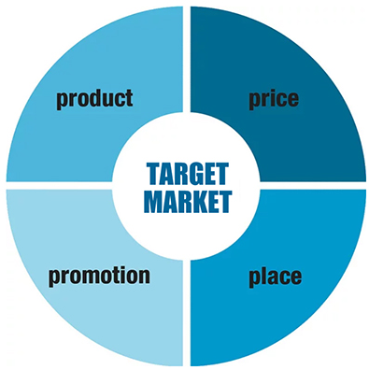
Figure 1: 4Ps of Marketing Mix
Source: (Thabit and Raewf, 2018)
The theory marketing mix suggests some essential actions and tactics that organisations can utilise and apply to the promotion of its brands or products within target markets (Sukma et al., 2019). The 4Ps of marketing mix is a typical form of marketing mix applied by product-oriented businesses which suggests that four key elements must be considered when devising appropriate strategies to achieve better marketing outcomes (Thabit and Raewf, 2018). These elements are Product, Promotion, Price, and Place which helps businesses form comprehensive marketing plans to promote, position, and advertise their offerings and their benefits.
Ansoff Matrix
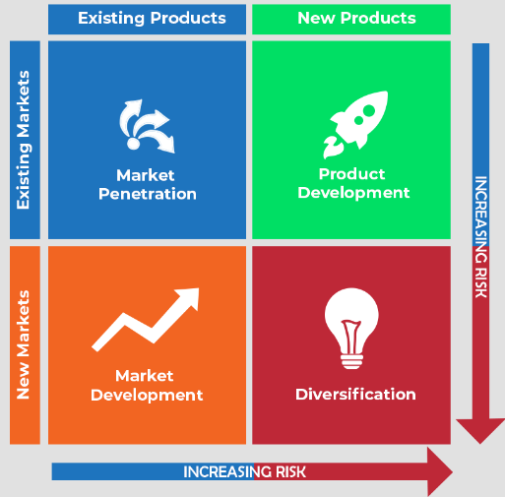
Figure 2: Ansoff Matrix
Source: (Sukma et al., 2019)
Ansoff Matrix can also be known as the product or market expansion grid which is an essential tool adopted and applied by businesses for analysing and planning their growth strategies. The growth strategies that Ansoff Matrix provides to businesses are also known and intensive growth strategies wherein a firm utilises different approaches to achieve growth and success (Sukma et al., 2019). The four differences in this matrix are market penetration which comes with least risks moving upward to market development, product development, and diversification which is the riskiest grid of the matrix. Market penetration is where the company introduces new processes and devises new approaches to meet the needs of its customers in the existing market for its existing products. Market development is where businesses tend to enter new markets with existing products (Clarissia, 2019). Product development is used by businesses to develop and introduce new products or variants of existing products in existing markets. The last strategy is diversification which poses the highest risk to businesses as they will have to introduce new products or services within completely new markets to diversify its business reach and customer base.
Communication mix
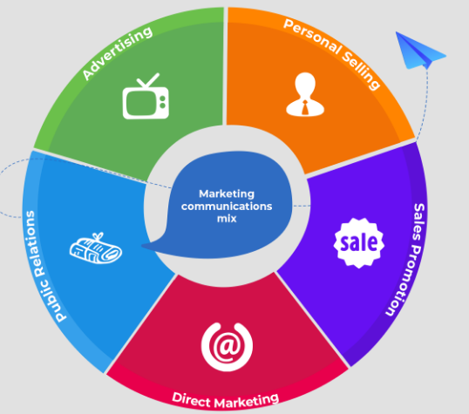
Figure 3: Communication Mix
Source: (Gopalakrishna et al., 2022)
Communication mix is recognised as one of the most important tools used by businesses for communicating within their existing and potential customers. A communication mix utilises specific methods and procedures that are combined to promote an organisation or its products to the global target market and consumers (Gopalakrishna et al., 2022). It involves a range of tools and elements that are used by organisations to establish and maintain better communication with their customers. These can be advertising, personal selling, sales promotion, campaigns, public relations, social media marketing, mobile marketing, and experiences and events.
Stakeholder map
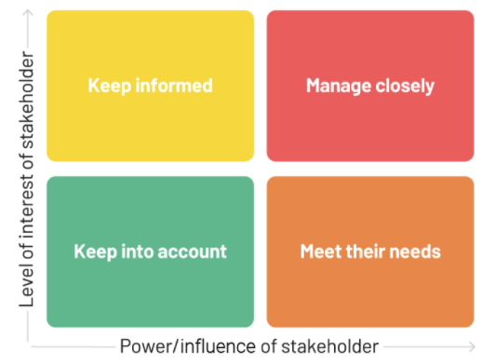
Figure 4: Mendelow’s stakeholder Power-Interest Matrix
Source: (Micheaux and Bosio, 2019)
Stakeholder mapping can be defined as one of the most well-known tools which uses a visual process for identifying and determining the essential stakeholders of an organisation and its products (Micheaux and Bosio, 2019). This process represents the key individuals or groups who can influence the company and its products and how they manage effective relations and quality based on the needs and expectations of the stakeholders. It also helps identify which of the stakeholders hold higher power and influence over the company and its management activities. Mendelow’s Matrix is an essential tool that helps businesses perform effective stakeholder mapping which divides stakeholders based on their power and interests within an organisation (Almutairi et al., 2019).
Porter’s 5 forces
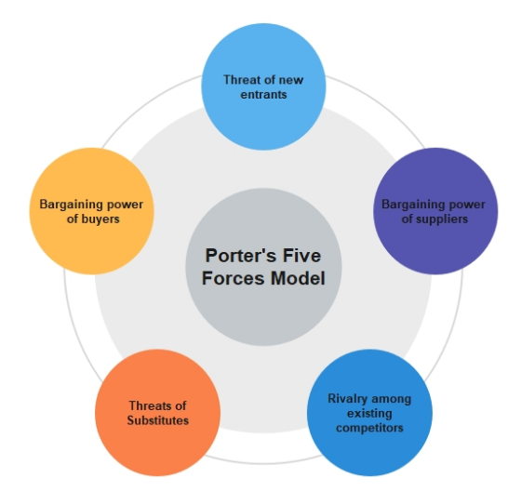
Figure 5: Porter’s five forces model
Source: (Gopalakrishna et al., 2022)
Porter’s Five Forces analysis has been widely utilised by marketers to identify the amount of competition and threats faced by an organisation within its target market (Bruijl and Gerard, 2018). This theory suggests that there are five key forces that drive an organisation's competitiveness and also determines its position within the market based on its ranking and positioning. These forces are competitive rivalry, new entrant threats, substitution threats, power of suppliers, and power of buyers (Blut et al., 2018).

Critical analysis of the external and internal factors influencing ASOS Plc’s controls and quality systems for customers
Porter’s Five Forces Analysis of ASOS Plc
Competitive Rivalry: ASOS Plc is facing high competition after the advent of e-commerce and increasing online shopping trends among the customers leading to increased competition in the global and national fashion markets. As a retailer, ASOS has been growing its business effectively throughout the years and is even recognised as a leading brand in the UK (Saker-Clark, 2022). However, it has to continuously maintain its competitiveness from various strong competitors like Unilever, Tesco, Burberry, Amazon, and many more. Such levels of competition encourages the company to consistently observe and identify the changing consumer demands through consumer surveys, market research, and reviews (Dutta and Das, 2020). Doing so allows it to find approaches through which it can stay above its competition.
Buyer’s bargaining power: The bargaining powers of buyers is considered moderate for ASOS as despite the customers having control over its decisions on marketing and production, it has a loyal customer base (Butler, 2022). Nevertheless, the market consists of several affordable or cheap as well as more environment friendly businesses that can attract the customers to switch to those sellers. The quality system of the company continuously enhances effective control over the quality and prices of its products so that the products are attractive to its target customers (Fisk et al., 2018). The process control approach also allows the company to ensure that its customers are receiving faster and better services with the help of closely monitored and carefully tailored customer service management.
Supplier’s bargaining power: The bargaining power of suppliers is considered to be high as ASOS Plc is more involved in providing quality products to its customers and its entire business is supported by its commitment and dedication to deliver quality (Saker-Clark, 2022). This makes the company deal with the best suppliers while managing string rapport and long-lasting relationships with them. Consideration of the process control approaches of ASOS is further helpful for the company to ensure that it is developing as well as maintaining strong relationships with its suppliers.
Threats of substitution: In terms of the threats posed by substitution of products to processes, the company has been continuously encouraged to highlight the advantages and differentiation of its products to avoid substitution in the market (Zanjirani Farahani et al., 2022). It is one of the most influential forces for ASOS Plc as the company is required to meet the needs and of the customers while marketing itself and its products to be more beneficial that its competitors’.
New entrant threats: The threats posed by new entrants in the online retailing market is moderate as the barrier to this sector is not significantly high and new businesses can enter and establish themselves easily (Knutsen, 2021) However, the new entrants will not be able to compete with a leading company like ASOS as they will have to face high competition in different levels of the market.
It can be said that the company’s operations and marketing decisions are shaped by factors like competition, substitution, and changing consumer demands.
4Ps of marketing mix of ASOS Plc
Product: As leading fashion e-retailer of the UK, ASOS sells varieties of products while targeting the young adults through products like shoes, beauty accessories, clothing, and other similar products sold directly through online platforms (Camargo et al., 2020). The company sells products by manufacturing it on the brand’s name or collaborating with several other brands producing products for both women and men. The company has also launched a new brand for children known as Little ASOS which has successfully attracted customers across the world to purchase its products online. ASOS has been able to reach a wide range of customer base by diversifying its product portfolio that concentrates on quality. Large and leading brands like Adida, Nike, Calvin Clein, and many more are used for apparels and it has Bourjois brand for its beauty products (Eley, 2022). These help demonstrate that ASOS operates a large mix of products in its portal that demonstrates how it caters to the demands of its customers worldwide.
Price: ASOS is highly considerate of the convenience and satisfaction of its customers which is why it utilises an affordable pricing strategy for its products based on the products being offered (Clarissia, 2019). It ensures that its customers are receiving better quality products within the best possible affordable costs which means the company utilises an affordable competitive pricing to stay competitive and meet consumer demands.
Promotion: The key promotion strategy adopted by ASOS to reach wider consumer networks are mobile apps and websites so that its services can be accessed and used by businesses more effectively. They consistently mail customers about offers and discounts while updating newly registered emails of customers (Eley, 2022). In doing so, the company also ensures to utilise traditional marketing effectively with the help of flyers, booklets, and so on delivered through post. It also has an effective social networking strategy that can help the company’s customers interact and contact the customer care services 24/7/365 about any queries or complaints (Petter, 2020). ASOS has one of the most engaging online campaigns and social media contents that attracts and retains its target audience.
Place: This element refers to the distribution strategy that the company follows to help its customers access its products easily. ASOS started out as a completely internet based retailing platform (Butler, 2022). It targeted the first few online shoppers for footwear and apparels and with the growth of its business and market occupancy, it has increased its presence using smartphone applications for iPhones and Androids. It allows the customers to purchase products online that are directly delivered to their registered addresses which can be both postpaid or prepaid. The company has set warehouses near its subsidiaries and large customer bases so that the stored products can be delivered to the customers faster. Doing so also helps the company ensure that the best possible quality of the purchased products are maintained with safe storage and fast delivery (Saker-Clark, 2022). Setting up of warehouses across its operational areas has allowed the company to provide its customers with satisfaction on good packaging, fast delivery, and instant response to customers’ orders/purchases.
Stakeholder Mapping of ASOS Plc using

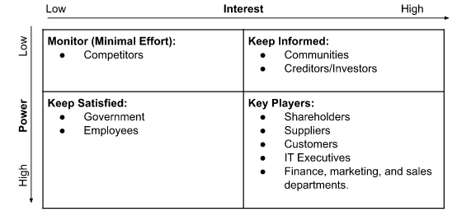
Figure 6: Stakeholder influence mapping of ASOS Plc
Source: (Self-created)
As per the stakeholder mapping proposed by Mendelow, it can be understood that ASOS Plc has many stakeholders who have high influence over its performance and success as an online retailer (Butler, 2022). The first grid of this matrix describes the stakeholders of ASOS who have low power and gain low interest from the company’s operations. It helps understand that ASOS has to continuously monitor its competitors to achieve successful growth and success in the market. In doing so, the company’s management ensures that the offerings, quality, and benefits of the offering presented by its competitors are analysed and monitored thoroughly. Although it requires the least effort from the company, competitors still play an essential role of external stakeholders as they encourage a company like ASOS to develop and achieve greater goals (Saker-Clark, 2022). The keep-informed grid of the matrix holds stakeholders of ASOS who gain high interest from the activities of the company but have low influence on how it operates. The initiatives taken by ASOS can be significantly helpful to the communities as they can gain improvement in their education, environment, or other aspects of their lifestyles. Similarly, the investors gain financial benefits with the success of the company which is why the company is required to keep these stakeholders informed using monthly reports on their performance, sustainability, financial gains and losses, and so on (ASOS Plc, 2021).
The keep satisfied grid illustrates that the company has to keep its employees and the government satisfied which is why its management ensures that the company is continuously compliant with the rules and regulations imposed by the governments. In this consideration, the company is highly influenced to comply with consumer safety and data privacy policies, restrictions, laws, and regulations (Gopalakrishna et al., 2022). ASOS is also influenced to meet the sustainable standards and expectations that the communities and government keeps from such organisations in terms of the promotion of environmental safety and sustainable and ethical business practices.
ASOS is further influenced by the employees who hold high power in the company, although their interest might be low. It is influenced by these stakeholders to keep them satisfied and engaged continuously so that they can perform better for the achievement of the objectives of the company with increased productivity, innovation, and better performance (ASOS Plc, 2022). The shareholders are the owners of the business which is why they have higher power to influence ASOS to fulfil their demands in the possible ways. Similarly, the suppliers and customers are also held as the key players by ASOS which makes them highly powerful. The company is influenced by the requirements of its suppliers and changing demands of its customers making the company more considerate about its practices. In this context, the quality systems of the company ensures that the company has ethical and strong relationships with its suppliers. ASOS is also highly influenced to understand how its customers are viewing its services and whether their needs and expectations are being met successfully (Petter, 2020). In doing so, ASOS has to conduct customer reviews while continuously addressing their queries through AI generated chat systems, customer service representatives, and so on. These are some of the simplest approaches that the company has adopted to ensure that its customers’ queries and complaints are being responded to as quickly as possible.
The IT executives and marketing, finance, and sales departments are also the key stakeholders of ASOS because they influence the company to access and provide the best possible technological equipment and platforms. The company has been training and developing its executives in these departments to continuously tackle the challenges of cybersecurity while operating more effectively (ASOS Plc, 2021). In terms of effective relationships and quality management within the organisation, ASOS has been quite successful in delivering effective experiences to its stakeholders by using advanced technology for connectivity and diversified portfolio for better sales. The company also utilises differentiated channels to promote itself which provides its sales and marketing departments with increased effectiveness.

Task 2

“How can ASOS Plc deal with the new customer demand and achieve its business objectives by developing and maintaining good customer relationships 24/7/365?”
“Customer relationship management” (CRM) plays a very important role because it helps the organisation to maintain proper employee engagement of the potential customer of the organisation (Talón-Ballestero et al., 2018). CRM is the combination of technologies, strategies and practices that an organisation can implement and maintain good relationships with the customer. There are different types of CRM such as collaborative, analytical and operational. In a “collaborative CRM”, the main focus of the organisation is to bridge the whole gap between the departments and team to share required information and then develop a seamless “Customer experience”. ASOS can use this type because it will help in bridging the gaps between different components in an organisation (Rodriguez and Boyer, 2020). This will help the organisation to use the required information about the customer. When the organisation will get the information it will be taking necessary steps to fullfill the requirements of the consumer. This will help the organisation to use a holistic approach to managing customer relationships. Collaborative CRM mainly focuses on sales, marketing and customer services (Vila and González, 2020.). Collaborative CRM has two different components channel and interaction management. “Interaction management” help in tracking touch points between the business and their customer with the help of different communication channels. When ASOS will track everything this will help in identifying whether the customer is not overpopulated. Channel management can be used by ASOS because it will help in gathering information from the interaction and identify the best mode of communication with the customer. The type of CRM helps in improving the information regarding the information shared between the marketing, sales and customer support departments.
“Analytical CRM” is another type, this enables the organisation in understanding properly the data which has been gathered from the interaction between the customer and business. This is one of the most effective types because it helps in converting a larger amount of information into actionable insights (Iranmanesh et al., 2019). The main purpose of this CRM is to leverage consumer information into the growing trends and takes necessary action as per the requirements. ASOS can use this type of CRM and it will be productive because it will help in gathering information about the customer and formulating strategies and ideas to maintain the proper relationships with the customer. This CRM also mainly focuses on customer retention, when there is proper retention in an organisation they will remain loyal to ASOS organisation. Customer retention is very much important in attracting and keeping potential customers in the organisation. As ASOS is one of the growing e-commerce businesses they can use the analytical CRM because it is suitable for larger and medium size businesses. They gather a larger amount of information that helps the organisation to develop an idea that will be productive for the insights and trends (Saha et al., 2021.). Their are some analytical tools such as “Online Analytical Processing” (OLAP), data warehouse and data mining. A data warehouse is a data bases that are implemented for the collection, integration and prepare all customer data. A data mining is another important tool for analytical CRM, this help in analysing the information and the correlation.
“Operational CRM” in another form, in this CRM the organisation bend all the business process, such as sales, marketing and customer service. The main goal of this CRM is that helps in streamlining the operations of the business and centralise customer sales and interaction and the process of marketing (Ullah et al., 2020). ASOS can use this CRM because it helps in capturing consumer information and provide better service to the customer lifecycle that which includes service automation, sales and marketing. This help in increasing brand awareness, when there is good brand awareness the consumers get information about the organisation and increase their level of confidence. Sale automation will help the ASOS to organise the information and help business to meet the needs of the customer and increase the rate of sale in a very effective and efficient manner (Winatha, 2019). It also includes different CRM modules such as sale forecasting, contact management and lead management. Service automation refers to connection points between the teams or service reps and consumers. It covers many things, including the setting of the boxes that aggregate the customer emails. Setting up the chatbots and coordinating the live chats. This will also help ASOS to delegate all the service tasks to reps with the help of the ticketing system and also include the base of knowledge and FAQ pages.
These are some of the CRM types that can be used by the ASOS organisation to meet the objectives and also improve customer engagement.

“Identification of the systems supporting ASOS Plc’s quality processes”
The “Quality Management System”, refers to the documentation of the business function, process and the policies of necessary for continuous improvement of the quality aimed, so that it will fullfill the requirement of the consumer (Giampieri et al., 2019). The CMMI is a quality system that which is supporting the quality process of ASOS Plc. CMMI helps the organisation to effectuate the process improvement and also develop the behaviours that decrease the risk in software development, product and service. This also helps the organisation in developing quality products or service, improving consumer satisfaction, increasing the value of stockholders, and growth in the market share. “ISO 9001” is another system that helps in recognising the QMS that will benefit the organisation. This helps the organisation reduce the cost of the organisation (Manville et al., 2021). ASOS use materials that are recycled and use them in developing product and service for the organisation. This also helps the organisation to win business and compete in the tenders. The organisation also becomes more resilient and develops sustainability in the business. These also help the organisation to work in a very effective manner with the stakeholders and the respective shareholders.

“Critical understanding of how the quality systems can help ASOS meet customer demands and maintain good customer relations 24/7/365”

The quality system is very much important because it helps in developing the quality of product and service provided by the organisation and also maintain proper customer relation. CMMI helps in streamlining the process when the process is very much flexible every department will be performing their respective duties in a very effective manner that automatically improves the quality of the product and services. When the product and service are of the best quality then the customer gets attracted to the best quality product and service (Aliyu et al., 2020). This system focuses more on customer satisfaction, so when the organisation is focused on customer satisfaction they try every possible way to fullfill the requirement of the consumers. This directly improves the customer relationship with the organisation because customer feedback will be given priority. Getting regular feedback helps the organisation to understand weather the formulated plan is productive or not. Feedback also helps the consumer to resolve their respective queries, when the consumer queries are solve they get motivated.
The other system is the “ISO9001”, they give priority to maintain suatianability. For example ASOS, they develop god quality product by using waste materials. This kind of activity motivates or encourages the consumer to do business with the organisation. These days people are very much conscious of the environment, so providing or maintaining sustainability is very much importance (Siitari and Holopainen, 2022.). This also helps the organisation to fullfill the requirement of the stakeholders, so when the stakholders are satisfied the customer of the organisation get easily satisfied. The organisation will give priority and formulate ideas or strategies to meet the needs of stakeholders. Their are four different components such as quality planning, quality assurance, quality improvement and quality control. When ASOS will dvelop quality planning this will help the organisation to direct them to their targeted goal or objectives. The quality control refers to the controling of the plan that which will be executed by the organisation. It is a process of the physical testing and ispecting all the stages whether they are functioning in a proper manner. Quality assurance help in inspecting the actual services and products in field. This will help the ASOS to review their delivery process of the service. Qualit imporvement is anotther important factor, after completing the quality process ASOS can thoroughly review their findings and develop ideas to improve the quality and service of the oraganisation.

Conclusion
The completion of this study helped identify a range of theories and models that businesses can utilise for devising better strategies for quality and relationships management. It not only studied the general concepts but also applied them to an organisation named ASOS Plc which helped identify that the organisation can be influenced by a range of factors around it to make better quality management decisions. In terms of providing effective customer service and satisfaction 24/7/365, the report helped understand that continuous research and utilisation of technological advancements can be helpful in the future for businesses like ASOS. This report provided proper understanding of the external and internal factors influencing the quality controls and systems for the customers of ASOS Plc in delivering 24/7 customer service. It also described the theories and models that were used to analyse the factors influencing the company’s quality controls and systems for its customers. It also implemented some of the key theories of CRM and marketing to ASOS Plc and critically determined the factors that have influenced the company’s practices and strategies. The report also identified and discussed the key strategies adopted by ASOS Plc to understand and meet emerging consumer demands and business objectives through the development and maintenance of better customer relationships.

References
sAliyu, A., Maglaras, L., He, Y., Yevseyeva, I., Boiten, E., Cook, A. and Janicke, H., 2020. A holistic cybersecurity maturity assessment framework for higher education institutions in the United Kingdom. Applied Sciences, 10(10), p.3660.
Almutairi, A., Collier, Z.A., Hendrickson, D., Palma-Oliveira, J.M., Polmateer, T.L. and Lambert, J.H., 2019. Stakeholder mapping and disruption scenarios with application to resilience of a container port. Reliability Engineering & System Safety, 182, pp.219-232.
Anshari, M., Almunawar, M.N., Lim, S.A. and Al-Mudimigh, A., 2019. Customer relationship management and big data enabled: Personalization & customization of services. Applied Computing and Informatics, 15(2), pp.94-101.
ASOS Plc, 2021. Stakeholder engagement - Annual Report and Accounts 2021. Available at: https://asos-12954-s3.s3.eu-west-2.amazonaws.com/files/8816/3827/4062/Stakeholder_engagement.pdf (Accessed: December 26, 2022).
ASOS Plc, 2022. Results centre, ASOS plc. Available at: https://www.asosplc.com/investor-relations/results-centre/ (Accessed: December 26, 2022).
Blut, M., Teller, C. and Floh, A., 2018. Testing retail marketing-mix effects on patronage: A meta-analysis. Journal of retailing, 94(2), pp.113-135.
Bolton, R.N., McColl-Kennedy, J.R., Cheung, L., Gallan, A., Orsingher, C., Witell, L. and Zaki, M., 2018. Customer experience challenges: bringing together digital, physical and social realms. Journal of Service Management, 29(5), pp.776-808.
Bruijl, D. and Gerard, H.T., 2018. The relevance of Porter's five forces in today's innovative and changing business environment. Available at SSRN 3192207.
Butler, S., 2022. UK retailers launch discounting blitz after month of falling sales, The Guardian. Guardian News and Media. Available at: https://www.theguardian.com/business/2022/nov/28/uk-retailers-discounting-blitz-month-falling-sales (Accessed: December 26, 2022).
Camargo, L.R., Pereira, S.C.F. and Scarpin, M.R.S., 2020. Fast and ultra-fast fashion supply chain management: an exploratory research. International Journal of Retail & Distribution Management, 48(6), pp.537-553.
Clarissia, M.S., 2019. A study on Ansoff Matrix Technique: As a growth strategy and an adaptive learning technique adopted in the leading brand of products. Journal of Composition Theory, 12(9), pp.1494-1506.
Dutta, A. and Das, S., 2020. Adoption of grid-connected solar rooftop systems in the state of Jammu and Kashmir: A stakeholder analysis. Energy Policy, 140, p.111382.
Eley, J., 2022. Asos Loosens Performance Targets for annual executive bonus, Subscribe to read | Financial Times. Financial Times. Available at: https://www.ft.com/content/272be16f-5c5b-4862-80ee-de63fcbb4fff (Accessed: December 26, 2022).
Fisk, R.P., Dean, A.M., Alkire, L., Joubert, A., Previte, J., Robertson, N. and Rosenbaum, M.S., 2018. Design for service inclusion: creating inclusive service systems by 2050. Journal of Service Management.
Giampieri, A., Ling-Chin, J., Taylor, W., Smallbone, A. and Roskilly, A.P., 2019. Moving towards low-carbon manufacturing in the UK automotive industry. Energy Procedia, 158, pp.3381-3386.
Goodman, J., 2019. Strategic customer service: Managing the customer experience to increase positive word of mouth, build loyalty, and maximize profits. Amacom.
Gopalakrishna, S., Lilien, G.L. and Donsbach, A., 2022. Trade shows in the business marketing communications mix. In Handbook of business-to-business marketing (pp. 247-265). Edward Elgar Publishing.
Iranmanesh, S.H., Hamid, M., Bastan, M., Hamed Shakouri, G. and Nasiri, M.M., 2019, July. Customer churn prediction using artificial neural network: An analytical CRM application. In Proceedings of the International Conference on Industrial Engineering and Operations Management, Pilsen, Czech Republic (pp. 23-26).
Knutsen, I.F., 2021. Innovation: the driving force of sustainability within the fashion industry (Master's thesis, uis).
Kumar, V. and Reinartz, W., 2018. Customer relationship management. Springer-Verlag GmbH Germany, part of Springer Nature 2006, 2012, 2018.
Kunst, A., 2022. Asos Brand Profile UK 2022, Statista. Available at: https://www.statista.com/forecasts/1252277/asos-fashion-online-shops-brand-profile-in-the-uk (Accessed: December 26, 2022).
Manville, G., Papadopoulos, T. and Garengo, P., 2021. Twenty-first century supply chain management: a multiple case study analysis within the UK aerospace industry. Total Quality Management & Business Excellence, 32(7-8), pp.869-885.
Micheaux, A. and Bosio, B., 2019. Customer journey mapping as a new way to teach data-driven marketing as a service. Journal of Marketing Education, 41(2), pp.127-140.
Petter, O., 2020. Asos promises to pay back furlough cash as sales spike in lockdown, The Independent. Independent Digital News and Media. Available at: https://www.independent.co.uk/life-style/fashion/asos-furlough-lockdown-cash-pay-back-workers-a9619831.html (Accessed: December 26, 2022).
Rodriguez, M. and Boyer, S., 2020. The impact of mobile customer relationship management (mCRM) on sales collaboration and sales performance. Journal of Marketing Analytics, 8(3), pp.137-148.
Saha, L., Tripathy, H.K., Nayak, S.R., Bhoi, A.K. and Barsocchi, P., 2021. Amalgamation of customer relationship management and data analytics in different business sectors—A systematic literature review. Sustainability, 13(9), p.5279.
Saker-Clark, H., 2022. Asos to reveal sales impact from tightened household budgets, Evening Standard. Evening Standard. Available at: https://www.standard.co.uk/business/business-news/asos-to-reveal-sales-impact-from-tightened-household-budgets-b1032835.html (Accessed: December 26, 2022).
Siitari, M. and Holopainen, W., 2022. On the road to total quality: a multi-purpose quality handbook for the sourcing unit in anticipation of ISO9001 certification.
Sukma, D., Lubis, P.H. and Utami, S., 2019. Analysis of Marketing Strategy of Minyeuk Pret Using STP, Ansoff Matrix, and Marketing Mix.
Talón-Ballestero, P., González-Serrano, L., Soguero-Ruiz, C., Muñoz-Romero, S. and Rojo-Álvarez, J.L., 2018. Using big data from customer relationship management information systems to determine the client profile in the hotel sector. Tourism Management, 68, pp.187-197.
Thabit, T. and Raewf, M., 2018. The evaluation of marketing mix elements: A case study. International Journal of Social Sciences & Educational Studies, 4(4).
Ullah, A., Iqbal, S. and Shams, S.R., 2020. Impact of CRM adoption on organizational performance: Moderating role of technological turbulence. Competitiveness Review: An International Business Journal.
Vila, T.D. and González, E.A., 2020. CRM as a key element in online commercialization: Analysis of tourism search and metasearch engines. In Advances in Tourism, Technology and Smart Systems (pp. 173-188). Springer, Singapore.
Winatha, K.R., 2019. The Implementation of Customer Relationship Management (CRM) Supported by SMS Gateway Technology. Jurnal Pendidikan Teknologi dan Kejuruan, 16(1), pp.45-54.
Zanjirani Farahani, R., Asgari, N. and Van Wassenhove, L.N., 2022. Fast Fashion, Charities, and the Circular Economy: Challenges for Operations Management. Production and Operations Management, 31(3), pp.1089-1114.

