

Student Name: JIGARKUMAR PRAJAPATI
Student ID:2430810
Module Name: HUMAN CAPITAL MANAGEMENT
Module Code: LCMB7023

Lecturer’s Name: DR. GLADIUS KULOTHUNGAN

Work Count: 2594

Term 1
Table of Contents
Introduction 3
Technological Advancements and Their Implications for HRM and IHRM 3
Technological Transformation of Labour Markets 3
Strategic and Theoretical Framing 3
Critical Insight 5
Demographic and Geopolitical Influences on Employment Markets 6
Demographic Dynamics 6
Geopolitical and Economic Forces 6
HRM and IHRM Responses 8
Addressing Skills Gaps and Talent Shortages through Strategic HRM 9
Problem Definition 9
Strategic Frameworks 10
Tools and Interventions - National and International Strategies 10
Reflective Report on Employability in an International Context 10
Technological Competence 10
Communication 11
Teamwork and Collaboration 11
Leadership 12
Self-Directed Learning 12
Conclusion 13
References 14
Bibliography 17

Introduction
This assignment is a critical investigation into how the technological, demographic and geopolitical forces are transforming Human Resource Management (HRM) and International HRM (IHRM). It examines AI based innovations, skills shortage and global labour dynamics using strategic frameworks like Ulrich's and Guest's model linking them to individual employability, leadership and lifelong learning development.

Technological Advancements and Their Implications for HRM and IHRM

Technological Transformation of Labour Markets
Xavier et al. (2025) argue that the organisation of work and people is changing because of Artificial Intelligence (AI), automation, and digital platforms. AI-powered tools currently conduct applicant sourcing, employee appraisal, education, and labour budgeting. According to Busari (2025), predictive analytics and scenario modeling allow HR to know in advance when they will need more staff and when they will have skills gaps, allowing the company to have the right talent at the right time. An example of such a change can be found in FinServe Bank, where AI is used in recruitment and upskilling, and the behavior of recruiters can be better described as coaching than screening. Likewise, NHS Digital plans to use AI for scheduling and remote settings, and Google has its own AI-based app, the so-called People Analytics, which helps employees have a better life. Global analytics at IBM indicates the pattern of hiring and skills lacks, and 59 percent of AI-enabled businesses intend to increase investment (IBM, 2024). In all industries, HR is becoming less administrative and more strategic in terms of talent optimisation with the digitalisation process.

Strategic and Theoretical Framing
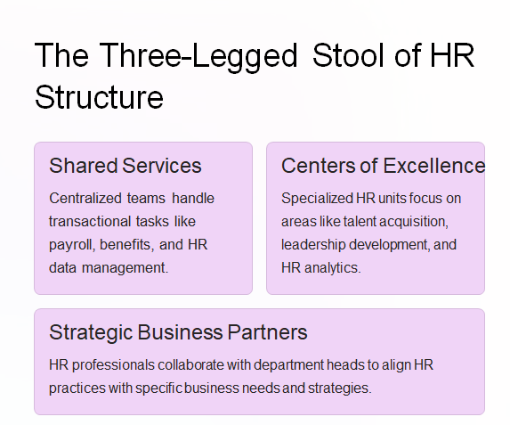
Figure 1: Human Resource Management Functions and the Ulrich Model
(Collected from lecture notes)
These changes demonstrate the model of HR Business Partner in which HR is a strategic business partner and change agent in digital transformation (Ulrich et al., 2008). In the three-legged stool by Ulrich, the HR business partners work with managers to implement technology-based initiatives with Centres of Excellence, analytics, and shared service platforms, to ensure transactional efficiency (CIPD, 2024).
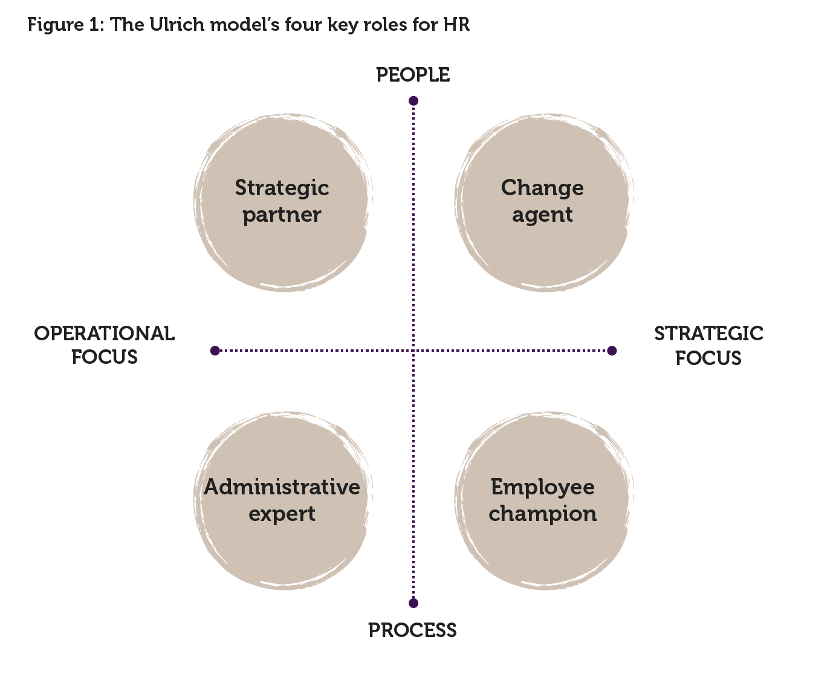
Figure 2: Four key roles of HR according to Ulrich’s “three-legged stool”
(CIPD, 2024)
This development is consistent with the debate of the hard vs. soft HRM. Hard HRM is about the use of data, efficiency, and algorithms of employee work, and soft HRM is based around engagement, trust, and growth. Alternative HRM is a balance between the two, as AI can be used to make the recruitment process more efficient (hard), but it will need open communication and emotional intelligence (soft). This balance is supported by the HRM model introduced by Guest (1987), as the investments of analytics (hard) are to be consistent with the development of employees and values-oriented leadership (soft) in order to have sustainable commitment and performance.

Critical Insight
HR can apply predictive analytics and concentrate on strategic initiatives using AI and automation, yet if not careful, this can make work depersonalized (Xavier et al., 2025; Solanki et al., 2025). Scholars suggest considering augmented intelligence, which is a hybrid of machine effectiveness and human belief. This involves AI governance, ethical, and empathic training. Prejudice and unfairness can be avoided through frequent reviews of humans in the loop to ensure fairness. Finally, the task of HR is to responsibly drive the change in AI that will improve the performance and the human race by creating systems aimed at improving the performance and humanity. A harmonious approach that incorporates the strategic use of technology and ethical protection is the key factor in the sustainable future of HRM and IHRM.

Demographic and Geopolitical Influences on Employment Markets

Demographic Dynamics
The global workforce is being redefined by demographic change. Discussion. Based on OECD (2024) data, it is predicted that the proportion of retirees (65+) to working-age adults (20-64) in OECD countries will be twice the ratio by 2060, which will reduce labour pools and burden working-age adults with more care and healthcare needed. However, participation patterns between the youth and females are changing - Gen Z and women are seeking more purpose-driven and flexible working environments. Unlike in the US, where the migrant population constitutes 24.3% of the labor force (Migration Observatory, 2025), the UK workforce has a proportion of 19% migrants, which is alarming enough to focus on Diversity, Equity, and Inclusion (DEI) policies. The model of Harvard stakeholders supports the necessity to have inclusive policies that benefit employees, the community, and unions. In reality, it is through flexible work options for older workers, unconscious bias sessions, and targeted hiring of marginalized groups to make sure that there is generational engagement and retention.

Geopolitical and Economic Forces
In employment patterns, there is still an impact of globalisation and geopolitics. The normative offshoring economies like the IT sector in India are under shifting dynamics of unsynchronisations, where remote work and new visa programmes (Thomas, 2025) are decentralising labour. According to Gallup (2025), 60 percent of eligible distant workers want hybrid arrangements, which require organisational flexibility. Such incidents as Brexit, the COVID-19 pandemic and regional conflicts have led to an interference with migration and the mobility of the workforce. Higher UK immigration restrictions with a post-Brexit environment, such as labour shortages in health, hospitality, and construction, will increase shortages. According to the OECD findings (2025), it is also necessary to remain a factor of filling labour gaps, but emphasizes the integration by qualification and language support recognition.
Atlas Fashion, among the companies, is another example that embraced the three-legged HR model proposed by Ulrich et al. (2010), as the HR Business Partners, Centres of Excellence, and shared services to deal with the cross-border diversity. Social missions benefit values-driven companies such as Patagonia and Ben and Jerry as they are integrated throughout global operations and include areas like fairness and responsibility towards the climate. The cultural dimensions described by Hofstede indicate the degree of power distance and individualism of each country, and this necessitates that IHRM should be able to develop cultural intelligence. Cross-cultural awareness in leadership training equips managers with the ability to manage diversity.
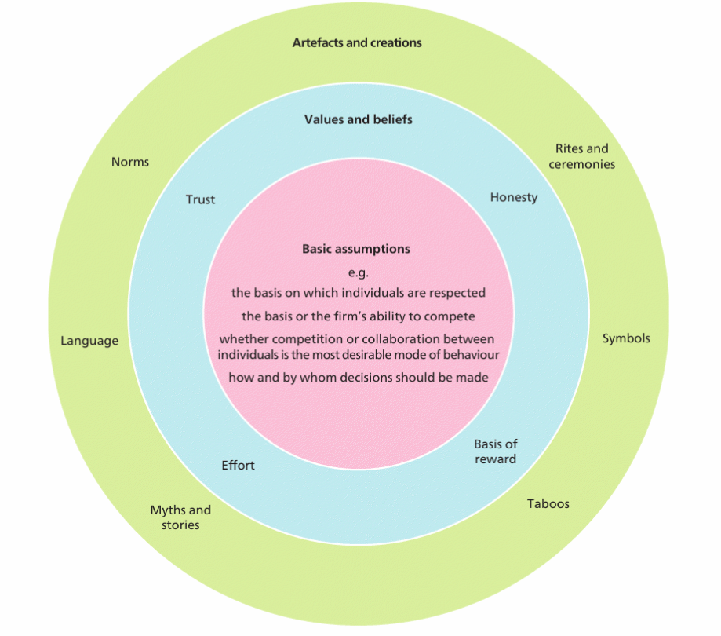
Figure 3: Levels of culture and factors that are highlighted most by Mullins and McLean (2019)
(Collected from lecture notes)

HRM and IHRM Responses
HRM and IHRM need to be strategic in dealing with demographic and geopolitical changes. Migration policies, such as the EU blue card, H1B, and UK points-based system, should be consistent with workforce planning. The next way through which skills gaps can be addressed is through upskilling programs and global mobility programmes, as observed in the NHS and HSBC. With the help of the model proposed by Ulrich, Centres of Excellence are able to design frameworks of D&I and have them implemented locally by the HR Business Partners. Due to demographic ageing, migration pressure, and uncertainty in geopolitical situations, ethical, flexible systems may help organisations remain resilient by incorporating compliance, inclusivity, and adaptability.

Addressing Skills Gaps and Talent Shortages through Strategic HRM

Problem Definition
The shortage of skills is escalating in the world. According to the World Economic Forum (2025), as jobs are outsourced to machines, more than 170 million new jobs will be created by 2030; however, 63 percent of employers refer to skills deficits as their chief obstacle to change. The technology, healthcare, and sustainability industries have extremely high demands with minimal supply. WHO (2025) estimates that there will be an 11 million gap between health workers by the year 2030, aggravated by population ageing and burnout. The data on OECD (2024) indicates that in 2020, there were 30 persons, 65 years old or over, for each 100 working-age adults, and the trends are supposed to go as high as 59 in 2060. According to CIPD (2024), 69 percent of employers in the UK find that they are increasingly struggling with competition to hire the most skilled and talented, and 56 percent say they have challenges with retention.
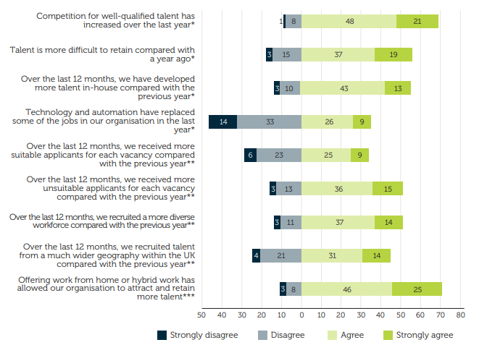
Figure 4: Views on the employment market and resourcing
(CIPD, 2024)
The problem is reflected in case studies. In Stellar Tech Ltd., the software team turnover increased as the recruitment diversity was low and the training investment was poor. GreenHarvest is an agritech company that had an ageing R&D workforce. In both instances, inefficient recruitment does not work without a well-thought-out HR structure.

Strategic Frameworks
Traditional models of HRM direct reactions. This model by Guest (1987) associates HRM with performance in terms of trust, quality, and commitment of the employee. Companies need to use a combination of recruitment, development, and retention to enhance the levels of engagement and productivity. The Harvard model introduces an element of stakeholder orientation - reaching a compromise between business requirements and the aspirations of employees and the targeted society. As an illustration, the development of nurses helps in enhancing health in the population and the stability of the workforce. Flexible learning plans and unions or government partnerships can be co-designed and maintained.

Tools and Interventions - National and International Strategies
It is possible to predict the future skills needs with the help of AI-based forecasting, as 59 out of 100 jobs will have new skills needed in the future (We Forum, 2025). Having learning initiatives that are measured through the Kirkpatrick Model develops measurable capability. The next generation leaders programs, such as that of StellarTech, are focused on the emerging leaders, and companies like Patagonia and Unilever rely on purpose-oriented employer branding to recruit skilled talent.
The UK NHS Long Term Workforce Plan (2023) is nationally expected to increase training capacity by 27% with the help of apprenticeships and visa reforms (NHS, 2024). MNCs such as HSBC and Accenture use the global talent market and virtual leadership platforms internationally. Shared Services, Centres of Excellence, and HR Business Partners make Ulrich HR three three-legged structure consistent.

Reflective Report on Employability in an International Context

Technological Competence
The increasing HR digitisation, as stated in the case of FinServe Bank and the discussion of the workforce systems based on AI provided by Ekuma (2024), provided direct insights on the strategic application of technology in HRM today. I also worked on the group activities of predictive analytics and labour forecasting, which helped me to better understand the role that digital devices play in making HR a strategic rather than an administrative task, as proposed in the Ulrich model. I interpret data and critically analyze it; I am able to use digital knowledge for workforce planning and performance management. Nevertheless, this experience also showed that there is a knowledge gap on AI ethics and data governance. The case of Amazon recruitment bias (Dastin, 2018) and the EU AI act proposals (Solanki et al., 2025) indicated to me that unchecked automation can be detrimental, and I need to be more literate in algorithmic fairness and GDPR compliance. To deal with this, I will finish a CIPD micro-course on Responsible AI in HR and design a rudimentary ethical system to assess data-based HR systems. These measures will guide me to make sure that my future career application of AI is balanced in terms of innovation and integrity.

Communication
One of the learning points and personal strengths I gained during the module was communication. Writing and presenting case studies, on behalf of StellarTech and Atlas Fashion, enabled me to simplify complicated HRM models, including the performance model proposed by Guest and the three-legged structure introduced by Ulrich, to simple, practitioner-friendly language. My written and verbal communication skills have become clear and sharp, which was a result of the Harvard model focusing on stakeholder alignment and transparency. However, I realised that there was a common weakness in intercultural group discussions, as I tended not to confront ideas in order to keep the conversation on track, which did not allow me to have an in-depth discussion. In HR settings in the modern global world that embrace assertiveness and negotiation as important abilities, this shyness would limit my influence. My intercultural communication competence development strategy will include the following points, like enrolling in a workshop on cross-cultural management and training in assertive yet respectful methods of debate. Through the lessons in finding a balance between empathy and confidence, I will strive to be more effective when interacting with various professionals.

Teamwork and Collaboration
Nowadays, HRM is based on cross-boundary collaboration, which is also present in the case studies of Atlas Fashion and Patagonia. I have enhanced my skills in organizing various views, combining the work of specialists, and ensuring the inclusion of everyone by working in project teams. My style is consistent with a soft HRM approach and the employee champion role of Ulrich, where cooperation and trust form the basis of performance. Peer responses revealed that I was a good organiser who sees through the group deliverables as they fall due. Yet, my over-management of coordination work may unintentionally diminish collective ownership, which is also the dilemma of empowerment and control in leadership. Furthermore, since the area of global HR is becoming more reliant on distant cooperation, I should train in the ability to work in a virtual team. To cope with that, I will become part of an international online consultancy project, during which I will manage cross-time-zone communication with the help of such platforms as Microsoft Teams or Trello. It will assist me in the practice of distributed teamwork and reinforce the digital collaboration habits that are needed with post-pandemic HRM.

Leadership
One of the main learning aspects in the activities in the modules has been leadership competence. In the project with the Stellar Tech transformation project, I was the head of certain parts of the HR redesign proposal, where I used the Ulrich model to incorporate learning, analytics, and business partnering. The experience encouraged my tendency toward transformational and participative leadership, in which collaboration and decision-making are encouraged. My inspirations are Patagonia and Ben & Jerry, whose leadership concepts (purpose-driven and social activism, respectively) are excellent examples of how ethical leadership strengthens an organisation's culture all over the world. I am strong in empathy and inclusiveness, which creates psychological safety in teams. Nevertheless, I realised that I had a weakness in being decisive in stressful situations. I also procrastinated on action to reach a consensus, which, according to OECD (2024), is not always a good idea in unstable labour conditions when there is no time to lose. In order to reinforce this further, I will volunteer as a team lead in an HR student initiative to train on agile decision-making and the loop of feedback. I will also use end-of-short reflexive reviews at the end of every leadership experience to review the outcomes and improve my approach.

Self-Directed Learning
An important part of my professional development is self-directed learning. Engaging with the WEF (2025) Future of Jobs report and CIPD (2024) surveys improved my understanding of trends in the labour market with a strong sense of motivation and commitment to lifelong learning. My main strength is linking theory to contemporary HR issues using the data from the OECD and case materials. However, my experience is somewhat of an academic nature with limited exposure to international HR practise. To address this, I am going to seek an internship or volunteer position in a multi-national or NGO HR environment, which can be supplemented by a structured CPD log which I will use constantly along with the resources available to me in CIPD for growth.

Conclusion
Overall, the study illustrates that future success of HRM and IHRM is connecting technology with ethics, inclusivity, and adaptability. By combining analytical insight, intercultural competence and continuous self-directed learning, HR professionals can ensure that innovation is valued in alignment with human values from a long-term perspective, ensuring sustainable talent management and strategic leadership in a rapidly changing employment future.

References
Busari, M. (2025). Predictive Analytics for Identifying Skill Gaps and Future Workforce Requirements. https://www.researchgate.net/profile/Muhammed-Busari/publication/389859719_Predictive_Analytics_for_Identifying_Skill_Gaps_and_Future_Workforce_Requirements/links/67d51d287d56ad0a0f02e5d4/Predictive-Analytics-for-Identifying-Skill-Gaps-and-Future-Workforce-Requirements.pdf
CIPD (2024). Do current HR operating models serve future needs? Available at: https://www.cipd.org/en/views-and-insights/thought-leadership/insight/future-models/ [Accessed on 7th November 2025]
CIPD (2024). Resourcing and talent planning report 2024. Available at: https://www.cipd.org/globalassets/media/knowledge/knowledge-hub/reports/2024-pdfs/8662-resource-and-talent-planning-2024-report-web.pdf#:~:text=Competition%20for%20talent%20persists%20Acute,issue%20for%20the%20public%20sector [Accessed on 8th November 2025]
Dastin, J. (2018). Insight - Amazon scraps secret AI recruiting tool that showed bias against women. Available at: https://www.reuters.com/article/world/insight-amazon-scraps-secret-ai-recruiting-tool-that-showed-bias-against-women-idUSKCN1MK0AG/#:~:text=SAN%20FRANCISCO%20%28Reuters%29%20,engine%20did%20not%20like%20women' [Accessed on 7th November 2025]
Ekuma, K., (2024). Artificial intelligence and automation in human resource development: A systematic review. Human Resource Development Review, 23(2), pp.199-229. https://journals.sagepub.com/doi/pdf/10.1177/15344843231224009
Gallup (2025). Where Are People Working Now and Into the Future? Available at: https://www.gallup.com/401384/indicator-hybrid-work.aspx#:~:text=Gallup%27s%20latest%20insights%20show%20that,site [Accessed on 8th November 2025]
Guest, D.E. (1987). Human resource management and industrial relations [1]. Journal of Management Studies, 24(5), pp.503-521. http://dx.doi.org/10.1111/j.1467-6486.1987.tb00460.x
IBM (2024). Data Suggests Growth in Enterprise Adoption of AI is Due to Widespread Deployment by Early Adopters, But Barriers Keep 40% in the Exploration and Experimentation Phases. Available at: https://newsroom.ibm.com/2024-01-10-Data-Suggests-Growth-in-Enterprise-Adoption-of-AI-is-Due-to-Widespread-Deployment-by-Early-Adopters [Accessed on 7th November 2025]
Migration Observatory (2025). Migrants in the UK labour market: an overview. Available at: https://migrationobservatory.ox.ac.uk/resources/briefings/migrants-in-the-uk-labour-market-an-overview/#:~:text=%2A%20In%20December%202024%2C%2019,receipt%20of%20a%20Universal%20Credit [Accessed on 8th November 2025]
Mullins, L. J. and McLean, J.E. (2019). Organisational behaviour in the workplace. 12th edn. Harlow: Pearson Education Limited.
NHS (2024). NHS Long Term Workforce Plan. Available at: https://www.england.nhs.uk/long-read/nhs-long-term-workforce-plan-2/ [Accessed on 8th November 2025]
OECD (2024). Society at a Glance 2024: OECD Social Indicators. Available at: https://www.oecd.org/en/publications/society-at-a-glance-2024_918d8db3-en/full-report/demographic-trends_06973ace.html#figure-d1e9832-8cd0a55a48 [Accessed on 7th November 2025]
OECD (2025). Migration to OECD countries declined in 2024, but remained high by historical standards. Available at: https://www.oecd.org/en/about/news/press-releases/2025/11/migration-to-oecd-countries-declined-in-2024-but-remained-high-by-historical-standards.html#:~:text=%E2%80%9CMigration%20flows%20to%20OECD%20countries,acquisition%2C%20job%20search%2C%20and%20skills [Accessed on 8th November 2025]
Solanki, A.S., Mahanta, N., and Singh, A. (2025). Artificial Intelligence in Indian Workplaces: Diversity Law Issues from Hiring to Exits. Available at: https://www.ibanet.org/artificial-intelligence-in-Indian-workplaces#:~:text=accountable%20for%20algorithmic%20bias%20or,48 [Accessed on 8th November 2025]
Thomas, P.A. (2025). India Tech Pay Plunges 40%, Signaling a Shift in Offshoring Dynamics. Available at: https://www.cio.com/article/4083886/india-tech-pay-plunges-40-signaling-a-shift-in-offshoring-dynamics.html#:~:text=The%20shift%20reflects%20how%20remote,reliance%20on%20any%20single%20geography [Accessed on 8th November 2025]
Ulrich, D., Brockbank, W., Johnson, D., Sandholtz, K., and Younger, J. (2010). HR competencies: mastery at the intersection of people and business. https://journals.sagepub.com/doi/abs/10.1177/0974173920100422
We Forum (2025). Future of Jobs Report 2025: 78 Million New Job Opportunities by 2030, but Urgent Upskilling Needed to Prepare Workforces. Available at: https://www.weforum.org/press/2025/01/future-of-jobs-report-2025-78-million-new-job-opportunities-by-2030-but-urgent-upskilling-needed-to-prepare-workforces/#:~:text=Frontline%20roles%2C%20including%20farmworkers%2C%20delivery,rapidly%20reshapes%20the%20labour%20market [Accessed on 8th November 2025]
WHO (2025). Health workforce. Available at: https://www.who.int/health-topics/health-workforce#tab=tab_1 [Accessed on 8th November 2025]
Xavier, N., Mishra, B.S., Dokku, S.R., Kumar, T.C.A., Singh, S.K., and Vyas, B. (2025). The Future of Work: How AI and Automation Are Transforming HR Practices. Advances in Consumer Research, Issue 2, pp. 813–821. https://acr-journal.com/article/download/pdf/986/#:~:text=employees%2C%20potential%20turnover%2C%20and%20ways,for%20the%20flexibility%20and%20adaptability

Bibliography
Armstrong, M. and Taylor, S. (2020). Armstrong's Handbook of Human Resource Management Practice. 15th ed. London: Kogan Page.
CIPD. (2023). Managing employee relations. [online] Available at: https://www.cipd.org/uk/knowledge/factsheets/employee-relations-factsheet/ [Accessed 27 October 2025]
Ulrich, D., Brockbank, W., Johnson, D., Sandholtz, K. and Younger, J., 2008. HR Competencies: Mastery at the Intersection of People and Business. Alexandria: Society for Human Resource Management

