Title 5HR01 Employment Relationship Management
Ffion Evans
Content List: 1.1,1.3,1.5,1.4,1.2,4.1,4.2,4.3,2.1,2.2,2.3,2.4,3.3,3.2,3.4,3.1
METHODOLOGY: In this report I have used credible websites, published literature and fact sheets#
Task1
(AC 1.1,1.3,1.5) Explain the role of employee voice in relation to engagement and wellbeing, the range of employee voice tools and approaches and how the concept can contribute to the design of better working lives.

1.1
Employee relations is about creating and maintaining a positive working relationship between and organisation and its people (CIPD, Professional Map). Our organisations culture plays a key part in supporting the employee relations. We as people professionals have and important role in helping to set that culture. We can help enforce a good working culture (CIPD, ‘professional map) through the development of policies and processes which apply the law in a practical, fair and transparent way.’
There are two main types of employee engagement:
- Regulatory focused, is regulation based, needing to establish rules, regulations and agreements between the employee and employer. Putting policies and procedures in place that will help and support employers and employees.

- Relationship-based CIPD Factsheet (2018) ‘Today, employee relations is seen as focusing on both individual and collective relationships in the workplace, with an increasing emphasis on direct forms of representation and helping line managers establish trust-based relationships with employees.’

(Human Resource management ,2016 pg. 81) ‘Employee engagement is at ‘the heart of the workplace relationship between employers and employees’ and that it is key for unlocking productivity.’ If an organisation is successful in creating a positive employee relationship environment and a high employee engagement rate the organisation will potentially have better business outcomes as well as employees having better health and wellbeing. (CIPD,2021a) Employee voice is recognised in two forms:
- Individual, this is when an individual will voice their opinion and give any suggestions on a decision that affects and has an impact on the employees own work.
- (CIPD,2021a). Organisational Voice Refers to the positive benefits that voice can bring to an organisation, for example, higher innovation. Some voice mechanisms, such as suggestion schemes, allow the organisation to benefit from employees’ ideas.

The three main purpose for employee voice are:
(CIPD,2021a)
- To address the fundamental right of every employee to have good work, including a voice to shape their working life
- To improve the ways organisations function and perform
- To highlight issues with damaging consequences, potentially and actually.
The way the employee can voice their opinions is becoming more complex. (CIPD,2019 c) Key trends such as remote working, increasing workforce diversity and alternative working arrangements are creating new challenges of individuals to have a say over their work conditions and decisions.
1.3
Employee voice was traditionally associated with trade unions. There is more recent growth in non-trade-union forms of employee voice by where employees have direct communication with managers and voice their opinion.
It is important for organisations to have policies and practices in place that encourages and enables employees to voice their opinion and feel comfortable in raising any concerns they may have (CIPD,2021a). Whistleblowing has become a great tool and effective way for employees to communicate and voice important information to their employer. Whistleblowing usually occurs when an employee feels they need to raise a concern or danger in the workplace, the person raising the whistleblowing is usually not directly affected by the danger or illegality. Any personal complaints or allegations such as harassment or discrimination need to be handled according to the organisations grievance policy and not through whistleblowing.
Employee Relations are using employee voice insights through using working groups, staff forums, questionnaires, collective bargaining, suggestion schemes and many more. Having robust employee voice tools will help increase a more positive working environment and better the organisations working culture (CIPD,2021a).
Organisations are having to move with the times and use technology in a new way, (CIPD,2022 b) with the emergence of new voice channels through technology and social media, and the rise of the gig economy. Due to the increase of remote working and hybrid working, is here to stay for many employees. Over the period of COVID 19 organisations have invested in technology and mobile devices. Employee apps, digital meetings such as Microsoft teams and Zoom has become and effective way to reach out to employees and gather employee insights. Other employee voice tools such as surveys, team meetings, employee forums are also used to collate employee voice.

1.5
Promoting employee wellbeing is good for employees and the organisation. If an organisation encourages and promotes wellbeing and a good work life balance it can help reduce stress and create a more positive working environment, this tends to help productivity and individually and the organisation can flourish. CIPD, (2022 d) Good health and wellbeing can be a core enabler of employee engagement and organisational performance.
Encouraging and supporting employee wellbeing is where we can begin to champion better working and working lives. Many workplaces have a much better understanding of holistic health and wellbeing approaches and the benefits they can have to help people flourish and reach their full potentials and goals (CIPD,2021). An organisation will also benefit from CIPD (2022 d) ‘investing in employee wellbeing as it can lead to increase resilience, better employee engagement, reduced sickness absence and a higher performance and productivity.’
The CIPD have created a job quality index, and this is made up of 7 dimensions. These 7 dimensions cover what a job/role needs to have to be of quality job for working lives.

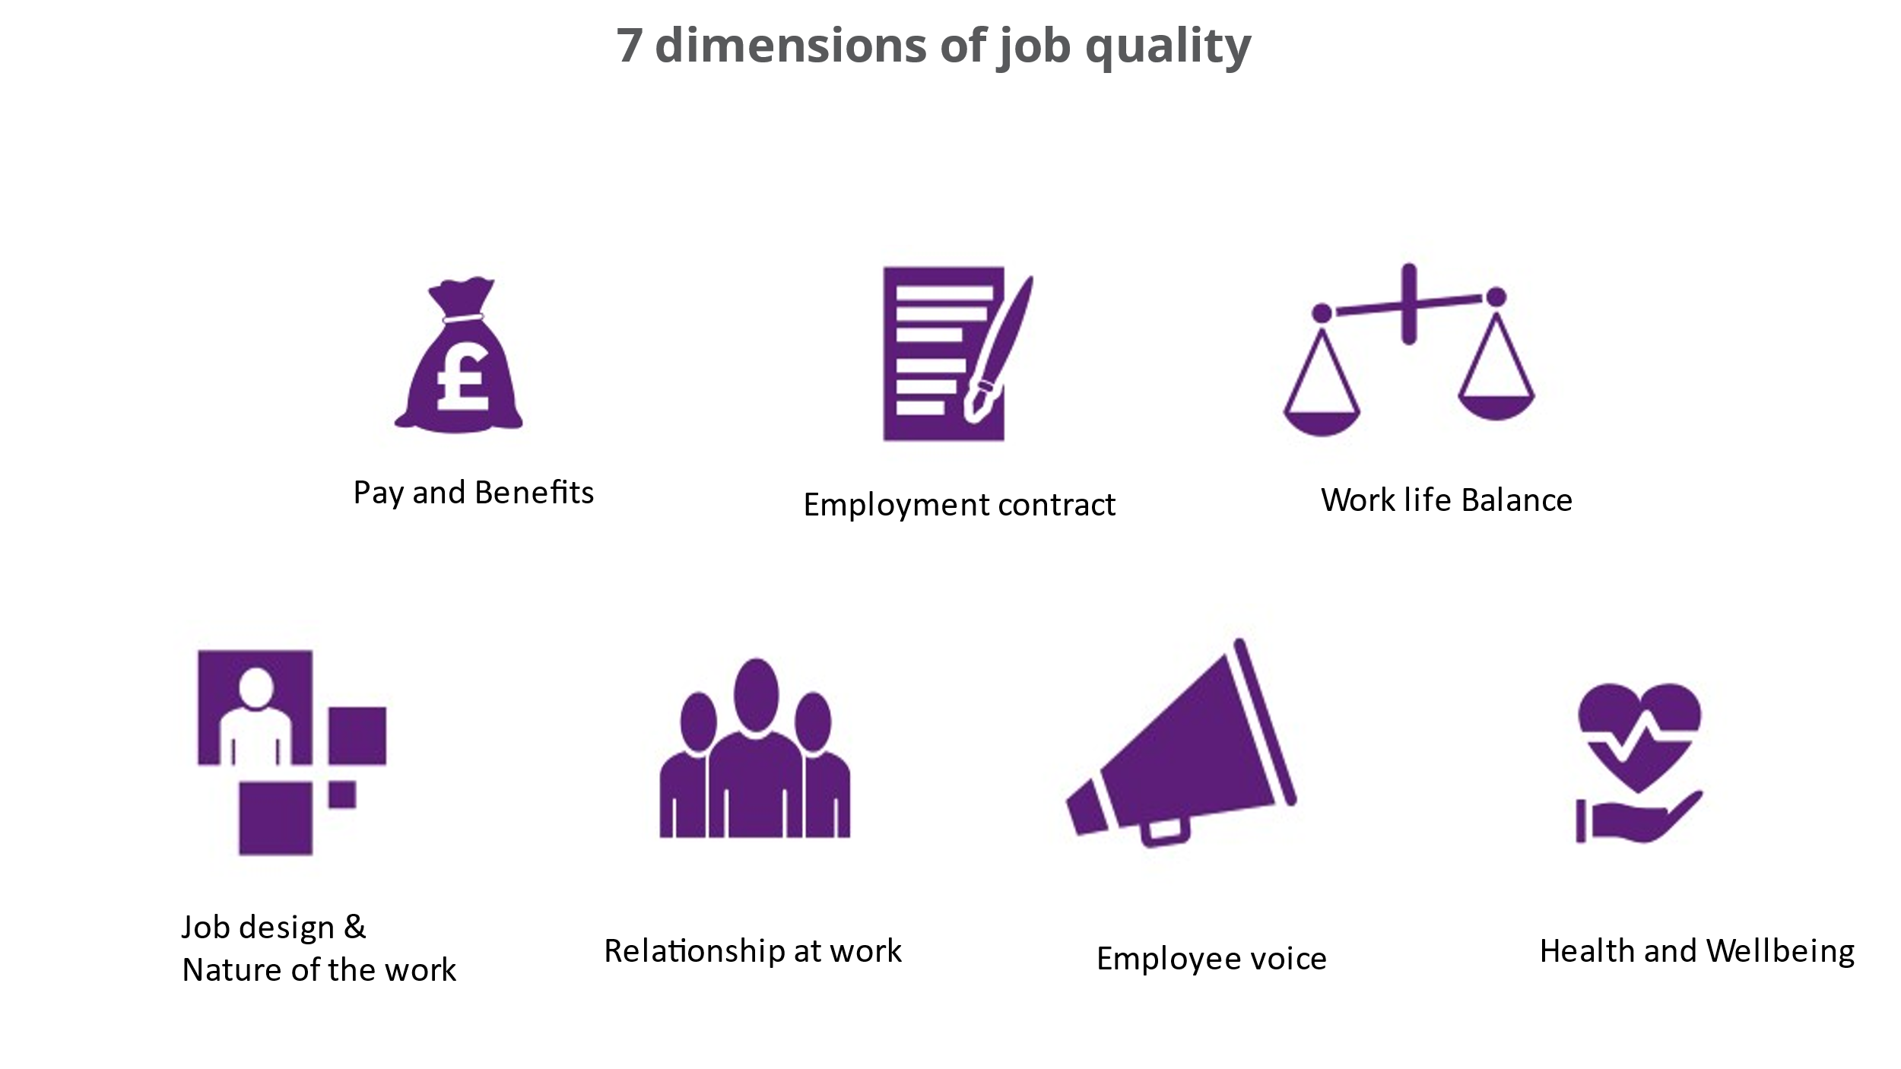

It is important for an organisation to measure GDP and employment rates and it is key to understand whether the jobs that the organisation have are of good or poor quality and how they can improve. The 7 dimensions will give guidance and structure to job quality. If an organisation gets this right, it will benefit the employees and society as much as it benefits the organisation and economy. (CIPD,2021 e)

Task 2
(AC 1.4) Critically evaluate the inter-relationship between employee voice and the organisational performance
(Human resources management pg115) The use of employee voice practices was optional for an organisation until 2005 when Information and Consultation of Employees (ICE) Regulation were implemented in the UK. ICE provided employees with the legal right to be informed about various employee matters and changes.
It is important for an organisation to create opportunities for employees to be able to voice their ideas and opinions at work (CIPD,2021). However, some organisations will have a collaborative meeting or use an open plan office space to hold informal meetings, there is a downside to this as some individuals work better in a quiet office space as they are more introvert and prefer to have one to one conversation rather in a large group and this can have a negative effect.
Employee voice practices means that employees can communicate their views, opinion, concerns, and suggestions to their managers and influence matters that affect them directly in work. It is very important that these discussions are two way and that managers listen to their employee’s voice. When employees feel that they are listened too, this will lead to feeling valued and this can help build trust and relationships between the employee and employer and this will lead to organisation productivity and improvement (CIPD2021). CIPD, (2021 f) Employee voice is important in creating inclusive and safe working environments too.
If an employee feels valued, they are more likely to stay within an organisation and contribute and develop their skills. The organisation will benefit from retaining staff and having a positive reputation. This will potentially make it easier for an organisation to recruit good employees.
Task 3 (a)
1.2
Employee involvement and participations is very important to and organisation to maintain a happy work force and the organisations success.
Employee’s involvement is when and organisation involve their employees and try and get their contribution through different activities. A range of techniques can be used to get information from employees about their ideas and how and organisation can improve their service and working practice (CIPD)2017
Some of these techniques include (CIPD,2017):
- Digital media
- Two-way communications
- Suggestion schemes
- Attitude surveys
- Working groups
The above techniques are formal, there are also several informal ways that can be used that are very affective such as social media or ESNs. This is where employees can talk with other co-workers and at the same time voicing their opinions to their manager.

Employee participation is when employees are given an opportunity to participate in decision making processes and power their voice through trade unions. Representatives such as trade unions would meet with managers regularly and communicate issues. This would mean that employees would not directly discuss with managers, but it would be mediated with the desired representative. CIPD, (2019)

Approaches can include:
- Partnership schemes
- Joint consultation
- Employee forums
- European Works Councils (CIPD, 2017)

There are several different angles you could look at employment relationship from, these include Unitarist, pluralist, economic view, and psychological contract.

Unitarist/ Unitarism is when employees share the same interests and will pull together to reach the same goal. This is done in harmony and with cooperation and would mean less conflict within an organisation. This is how managers would like things completed.
Pluralist/ Pluralism is when employees have both similar and different interest in the employee relationship. Employer will focus more on companies and bargaining to recognise differences. This can cause conflict and tensions that will need to be managed through a formal procedure such as disciplinary procedures.

Task 3 (b)
(AC 4.1,4.2,4.3) Explain the roles and typical approaches taken by the key parties in employment relations: trade unions, management, government and its employment relations agencies and the reasons why collective bargaining is used

4.1

Previously employee relations were known as industrial relations. Its impact is to make sure that the relationship between an organisation and employer is managed with relevant law and transparency. Within an organisation, it is important to make sure that we educate our managers with the correct skills to manage relationships collectively and on an individual basis. In the UK we have several legal provisions that apply to employee relations. (CIPD,2021) And a key point of implementing the law is to champion fairness at work.

Individual
- Contract law
- Terms and conditions
- Employee handbook
- Staff Manual

These applied with ACAS Codes of Practice and grievance and disciplinary procedures they are key policies and acts that are supported by employer relations employee act 1996 and Equality Act 2010. Employee rights will include holiday entitlement, sickness, Maternity and paternity leave and other forms of parental leave, whistleblowing, communications, and an opportunity. It is important for employers to follow the ACAS code of Practice because if an employee takes their employer to an Employment Tribunal, for example for a claim against unfair dismissal. The tribunal will look at whether the employer has followed the ACAS code of conduct. (acas.org.uk)
(CIPD,2021 g) ‘The collective dimensions include collective bargaining, information and consultation, arbitration and industrial action.’
Employers could have an agreement with employee’s representation such as trade unions that gives them the right to negotiate terms and conditions, working hours and pay for example. This is called collective agreements

(GOV.UK) ‘Collective agreements ‘The terms of the agreement could include, how negotiations will be organised, who will represent employees, which employees are covered by the agreement and which terms and conditions the agreement will covers’.

4.2
There are a variety of ways in which employees can be represented in the workplace, by union or non-trade union representation.
If an employee is going to be represented by a union representative it is important for union representatives to build and effective way of communicating, consulting, and negotiating between managers and representatives. Acas can help work with employers and unions build these relationships.
There are 9 areas where union representatives have statutory rights.
Type of Representative
Union Representative
Union learning representative
Health and Safety
Information and consultation
European consultative bodies
Pension
TUPE
Collective redundancy
Workforce agreements

As part of their representative right, they have legal rights for example for paid time off to carry out their duties, paid time off for training and protected against dismissal and detriment.

(linkedin.com) In a Union workplace: The Union bargains with the employer for a contract, and then makes sure that the contract is carried out. Your Collective Agreement is a contract. Contracts are legal documents between you and your employer that spell out wages, benefits, and rules of employment.

In a non-union workplace: The employer makes all the rules, sets all the wage rates, and makes all the decisions on things like discipline, promotions, and hours of work. The worker has no voice.
Pros of belonging to a Union:
- More access to benefits
- Job security
- Strength in numbers.

Draw backs
- Initiation fees
- Loss of autonomy
When a non-union representative is use you cand see barging happen in the form of joint negotiation committees, employee forums, staff councils, works councils, differences in power of employee bodies.

4.3

Collective bargaining is a process of negotiation between an employers and employees. This is when trade unions will get involved to discus and bargain changes to an employee’s terms and conditions and physical conditions of work for their members for example or matters of discipline. It is usually up to the unions to agree which terms and conditions are covered. These are usually things like pay, holidays and working hours. (GOV.UK)
Trade unions and the employers will need to agree on how the process of bargaining will work.
For example (GOV.UK)
- who’ll represent the workers peer group of workers
- How aften meetings will take place
- who’s included in a bargaining unit
- what will be discussed
- what to do if the union and employer cannot come to an agreement

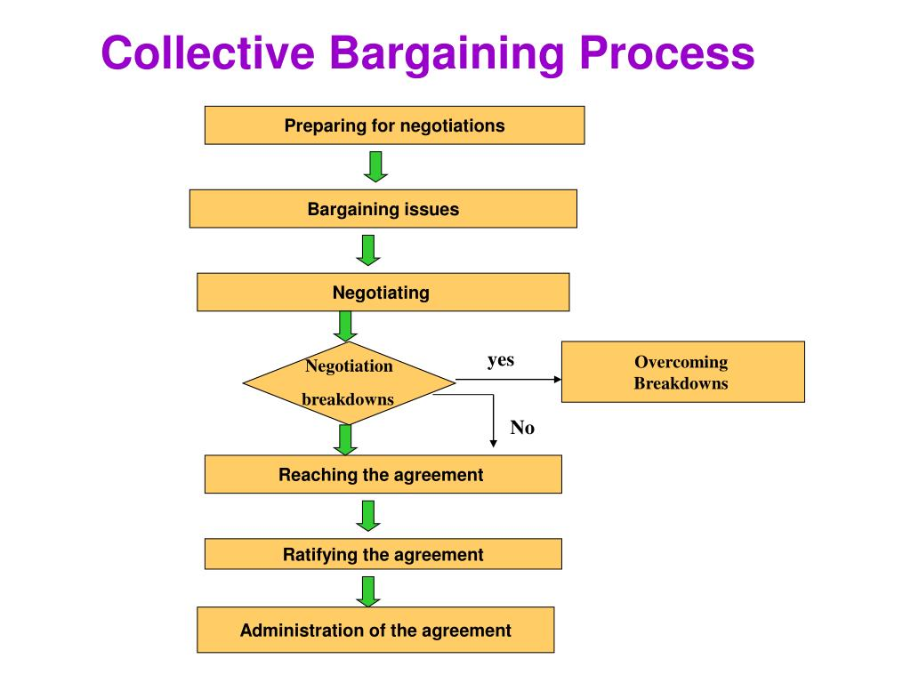
(acas.org.uk) Any form of bargaining the union representative needs to be fully trained and able to communicate with the trade unions. They also need to have access to all relevant information and have time to prepare for meetings. (acas.org.uk)
If trade unions and employers are having difficulties resolving an issue Acas can be of help by (gov.uk) ‘Collective conciliation can move parties towards a resolution of a dispute through the expertise of an impartial and independent third party - for example through the use of Acas services.’
When an agreemnt is agreed through collective bargaining for examplet for pay increases, this is called ‘collective agreement’. The collective agreement will cover both union and non-trade union staff employed in specific group.(acas.org.uk)

Task 4c
Explain different types of individual and collective conflict behaviour and some of the evolving approaches that can be used to manage these. Your response should include and distinguish between: (AC 2.1,2.2,2.3,2.4)

2.1
Misbehaviour in an organisation is when an employee purposely misbehaves to harm or damage and organisations’ reputation or an individual in any way. This could be through aggression, violence, deviance, damage to organisation property or reputation and fraud.
Conflict differs from misbehaviour in that it is a natural occurrence in all workplaces, Conflict within an organisation is when a misunderstanding or disagreement happens within a group of people or difference in individuals who have a different in opinion or prospective on things and how they should be done. When conflict arises, there can be a low level of harassment, for example a difference of opinion to serious incidents of bullying (CIPD,2020). Conflict needs to be managed positively and proactively. (CIPD,2022) ‘Some workplace conflict can be positive, such as a healthy amount of competition between team members to reach goals. But negative workplace conflict, like bullying or personality clashes, can harm individuals and undermined team members.’
Conflict at work can be very costly for and organisation. According to Ethan Peters 2021 the cost of conflict at work to UK organisations was £28.5 billion, nearly 10 million staff members experienced conflict at work in 2021 and over half went off sick with stress and anxiety and half a million resigned. (acas.org.uk)
There are several ways to try and resolve conflict:
- Conciliation
- Arbitration
- Mediation

ACAS can help with any conflict within an organisation. They are impartial and can help the employer and employee resolve conflict and make sense of complex issues.
It is important that managers are trained in handling difficult conversations with employees. Acas can provide help and advice or even training for managers when needed.
lumenlearning.com 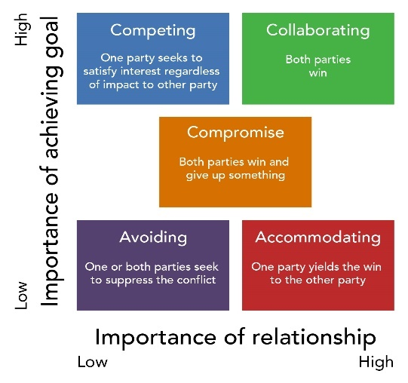

2.2
Official employee industrial action is when employees are a member of the Trade union and the industrial action such as a Strike or refusing to do over time is authorised by the Trade union because the dispute with their employers cannot be solved through negotiations. (CIPD,2021) Any form of industrial action, including a strike, which is not authorised or endorsed by a trade union, will generally be ‘unofficial.’ This will include where a non-member of a union purports to join in with strike action. If employees decide to take part in an unofficial industrial action, they will have no statutory protection against unfair dismissal as the trade unions had not been involved and authorised the industrial action.
Trade unions can only call for industrial action if the majority of its members agree with this decision - this is called a ‘ballot’. On occasions it has been known that the employer may stop workers from returning to work during a dispute. This is called a ‘lock-out’(gov.uk).

2.3
These days trade Unions have a friendly and sincere relationship but not overly close with management unlike old times. Also, the employment relations have changed from focusing on sales driven target and pay/bonuses to developing employees and working together (linkedin.com) More recent years it has become key for any good employee relations that there is trust between them and the employer and trade unions.
We are seeing industrial sanctions when significant change to contract and working conditions are trying to be applied. Zero hours contract, pay, working conditions and issues around minimum wage have been at the forefront of disputes in recent years. (gov.uk)
Conflict is more likely to occur when there is a clash of personalities in the workplace and also when there is a lack of clarity around targets, general guidelines and rules. Conflict can result in industrial action. If disputes and issues are not resolved amicably to the satisfaction of either party, workers or employee, an industrial action may be the result of this. Industrial action is when workers will go on strike or take other action like refusing to work overtime (gov.uk) When a strike takes place, working days are lost and can be costly for the organisation because if staff members are a member of trade union, they may have pay protection.

2.4
Employees can get support and help form a third party to try and solve disputes between the employee and employer. A third party is someone that is not involved in the situation or dispute but can act as a neutral person.
The three main ways to do this are:
- Medication is voluntary, this is when an impartial third party discusses the problem with your and the employee or between you and another employee to try and find a solution to the differences.

2. Conciliation is like medication and again voluntary but is used when and employee believes they are entitled to make a claim to the employee tribunal or already have done so. ACAS can help resolve and steal potential claims free of charge.

3.Arbitration is when a third party make a solid decision on a case after investigation and considering all issues. The employee and employer must agree to this decision, and it will be legally binding. If both parties do not agree this case can then be taken to the employment tribunal (gov.uk)

If an employee has not been able to resolve the issue with the employee, then you many need to go to an employment tribunal. At the tribunal you and your employer will present your case/argument and the tribunal will come to decision on the basses of the presentation and facts.

Bibliography
Discussion on Dispute Resolution | Podcasts | CIPD
Emerging trends in Industrial and Employment Relations (linkedin.com)
Solve a workplace dispute: Mediation, conciliation and arbitration - GOV.UK (www.gov.uk)
Trade Union Recognition & Industrial Action Q&As | CIPD
Trade Union Representation in the Workplace (acas.org.uk)
Conflict Management Styles | Organizational Behavior and Human Relations (lumenlearning.com)
Employee Voice | Factsheets | CIPD (a)
The future of employee voice | CIPD (B)
talking-about-voice_employees-experiences_tcm18-54482.pdf (cipd.co.uk) ©
Wellbeing at Work | Factsheets | CIPD (d)
Good Work Index | Survey reports | CIPD (e)
Empowering employee voice | CIPD (f)
Employee Relations | Factsheets | CIPD (g)
Discussion on Dispute Resolution | Podcasts | CIPD

The Difference Between a Union and a non-Union Workplace (linkedin.com)

Emerging trends in Industrial and Employment Relations (linkedin.com)

The UK Sanctions List - GOV.UK (www.gov.uk)

Task 2- Case Study
A manager at ABC limited has brought to the attention of a HR officer that they would like to take disciplinary action against an employee who was allegedly been bullying a fellow colleague. It is important for ABC to follow their organisations policy’s and procedure in dealing with the actions.
Before taking formal disciplinary action, it is important that the manager gathers all relevant information. The manager must not be bias or discriminate within the process and all documents should be kept through the process (CIPD,2021 a)

3.3
First, it is important to establish all the facts. Meeting with the employee allegedly been bullying and meeting the fellow colleague that is being accused of bullying. This will help gather the full picture from both sides. The manager may feel it is appropriate for both colleagues to have a meeting together and for the staff member feeling that they are being treated inappropriately to explain why their actions is causing them distress and ask them to stop. This may need someone to act as a mediator or speak directly with this person as sometimes people don’t realise that their behaviour offends or impacts others. (CIPD,2021 b)
Sometimes and informal route is not appropriate, and a formal grievance process will need to be followed. Firstly, the employee that has raised the grievance must attend a grievance investigation meeting. A formal letter will be sent to the employee explaining that this is just a fact-finding meeting. This letter should include the information about where, when, who will attend, their right to be accompanied and so forth. (gov.uk)
As the manager has not witnessed the act himself the investigation will also need to include talking with witnesses and taking statements and establish if the act was witnessed as ‘banter’ or actual bullying, and has it been seen on a regular basis, also has this behaviour offended other staff members. The manager would also benefit from checking CCTV footage if available.
Depending on the seriousness of the allegation suspension or paid leave may be considered for one of the members involved pending full investigation.
3.2
Grievance is found in a form of a complaint raised by an employee against another within the workplace. This can be found on a day-to-day basis. There are many reasons why a grievance could be raised in the workplace. For example, lack of flexibility, unfair rules, and treatment, working conditions, harassment, and bullying. Also, individual characters, culture, religion and beliefs may also be a reason for bullying and disagreement within the workplace.
In this instance within ABC limited the grievance raised is bullying. (CIPD,2022 c) Bullying is not specifically defined in UK law but Acas says bullying 'may be characterised as: Offensive, intimidating, malicious or insulting behaviour, an abuse or misuse of power through means that undermine, humiliate, denigrate or injure the recipient’.
Bullying may be covered by The Equality act 2010 or The Employment Rights Act 1996 (gov.uk)
Employees should have robust policies and guidance in place that clearly promote and encourage dignity and respect as a part of their working culture, employees and employers should imbed this culture in everything that they do. It is also important for employees and managers are aware of how technology is becoming a big part of our organisations and growing day to day. It is important to remember that bulling can happen virtually, this is known as ‘cyber bulling’ through text, email, mobile or images posted on external websites.
Organisations must make sure that managers are trained in how to manage and handle these situations in our ever change environment.

3.4
A grievance in the first instance should try and be resolved informally. If it is a more serious allegation the employer must move towards a formal procedure and evoke the grievance procedure. If ABC Limited feels they do not have the capacity to deal with this grievance internally then they will need to look for external providers to help. This may include HR consultants or lawyers. If ABC limited do not have their own policies and procedures in place, they will need to follow the ACAS Code of Practice. ACAS Code of Practice is recognised by tribunals and can also be used alongside Acas guide ‘Disciplinary and Grievance at work’ (acas.org.uk) & (CIPD,2022)
(acas.org.uk) You must follow a full and fair procedure in line with the Acas Code for any discipline or grievance case. The procedure you’ve followed will be taken into account if the case reaches an employment tribunal.
ABC Limited has 150 employees at one site. Acas stated regardless of the size of the organisation employers should follow a full and fair grievance procedure and have set this guidance follows.
- make clear they’ll deal with grievances fairly and consistently
- investigate to get as much information as possible
- allow the employee to bring a relevant person to a grievance meeting
- give everyone a chance to have their say before making a decision
- take actions and make decisions as soon as they can
- allow the employee to appeal against the grievance outcome (acas.org.uk)

Following Acas Code of Practice and guidance will avoid legal claims and make sure that ABC are compliant by law.
Below I have outlined 8 key steps that ABC can follow to managing a fair and transparent process. Acas also gave a Grievance process checklist that ABC limited would need to use and have access to this on acas.org.uk.

- If the solution is informal, notify the employee and close the case | - Establish the facts by investigating
- Meet with the employee who has brought the grievance for a grievance investigation meeting | - Adjourn the meeting
- Decide on appropriate action | - Further investigation
- Write outlining the findings | - The appeal

3.1
Unfair dismissal is governed by the UK law under the employment act 1996. Unfair dismissal law is based on that employee have the right to be treated fairly. (gov.uk)
The CIPD outlines the law requires to avoid unfair dismissal. The ‘employers have a fair reason to dismiss and the decision to dismiss is fair in the circumstances has followed a fair process.’ The employee must show that they have followed their own process and the Acas Code of Practice on the disciplinary and grievance procedure.
For a claim to bought forward for unfair dismissal the employee must have been:
- Dismissed
- Be employed and not a worker
- Commence the claim within 3 calendar months of dismissal unless an extension applies
- Be employed for the required qualifying period
- And not with in an excluded categories such as armed forces.

An employee must be able to prove and justify why they feel that they have been unfairly dismiss to the employee Tribunal.
(gov.uk) An employer can dismiss an employee if:
- they’re incapable of doing their job to the required standard
- they’re capable, but unwilling to do their job properly
- they’ve committed some form of misconduct

Capability is possibly one of the main fair reasons of dismissal. The reason for this would be because the employee was incapable. As part of the capability process employers must make sure to include performance reviews, look if additional assistance is needed and put training and support in place to help the employee improve and perform to the required standers.
(CIPD, 2020), The employees’ capability is assessed by reference to his or her skill, aptitude, health or any other physical or mental quality.’
Generally, lack of capability dismissal falls in these three categories:
- Qualifications
- Incompetence or poor performance
- Illness

NNED TO END EMAIL

Handling grievances | CIPD People Skills Hub
Step 1: Understanding the options: Formal grievance procedure: step by step - Acas
Unfair dismissal: Dismissals - Acas
Unfair Dismissal Q&As | CIPD

factsheet_20220414T103528.pdf (a)
Discipline & Grievance at Work | Factsheets | CIPD
Discipline & Grievance at Work | Factsheets | CIPD (b)
Bullying & Harassment at Work | Factsheets | CIPD ©
Workplace bullying and harassment - GOV.UK (www.gov.uk)

