

LEVEL 4 ASSESSMENT SPECIFICATION

Student name: | Adam David Moore | Student ID number: | 1004334
Programme: | BSc/HND Computing (All Streams)
Module: | Internet Technology and Security
Module code: | ACCA4018 | Contribution to Overall Module Assessment (%): | 50%
Lecturer: | Jaymie Phillips | Internal Verifier: | -
Assignment Title: | HTML & CSS Web Development | Word count (or equivalent): | 1,996
Submission deadline: | 3rd May 2019 | Return date of provisional marks & written feedback: | -

Table of Contents
Introduction 3
Requirements 4
Implementation 5
Validation 12
Evaluation 15
Bibliography 19

Introduction

The website, titled ‘The Old School Pinball’ was created to showcase a private collection of pinball machines produced in the 1990s. Pinball has a relatively small cult following, while small those involved in the community are fanatical.

It must be noted that the website produced in conjunction with this report was based on an artificial scenario. A close relative of mine owns a private pinball collection and in order to produce this website and report, I approached this relative and requested permission to produce content with their property and indeed publish much of it online (YouTube), the owner is also aware this material will be used in this report and gave full consent for me to do so.

While the scenario is artificial, the ‘consultation’ and criteria upon which the website was designed and created was genuine. The key differing fact is simply that during the consultation I was asking my relative what they would want and why, as opposed to what they do want and why.

This report demonstrates the outcome of the consultation process, or ‘requirements’ of the website build. This step was critical to determine what was important in this niche field and why.

Validating the HTML and CSS code provides assurances of the quality of a websites underlying code for a plethora of reasons, such as future proofing and debugging[1].

Also explored are alternate avenues that could have been explored, additional features that can be added in future and justification for the actual state of the website and decisions that were taken.

Requirements

The owner of the private arcade made it clear that the nature of this hobby is the frequent buying, selling or trading of machines. While this website’s primary purpose should not be to advertise the collection for sale, it should facilitate this in a gentle way. The main reason this is important, is that pages will need to be continuously overhauled in the ‘Pinball Machines’ section. To this end, the pages should be uniform in their layout, making it as easy as possible for the owner to maintain, change, remove or add pages.

Other requests included:

- A picture of the premises, as people often travel from afar to view or purchase machines. This will help them recognise the property when they arrive.
- A ranking page. The owner of the arcade wished to keep this updated so the community could see what was currently in and out of favour easily. He explained that, if a machine was out of favour – he would be more open to selling it, and prospective buyers/traders would be more likely to come forth.
- Means for machines that are currently being sought or indeed the owner is looking to sell can be gently advertised to encourage buyers to come forth.
- Simplistic, intuitive design. The owner stipulated that this was his preference, his logic was that most visitors to the website would be upwards of 40 and that therefore this type of design would be more appreciated by the perceived visitors.
- As the online community is mainly online-forum based, the owner explained he did not currently have any plans to operate with any social media presence. Links therefore would be unnecessary.

Implementation

Below is a screenshot of every page in this website. Please note, these screenshots were taken post validation.

Please also note, all content (videos and images) are my own and were produced specifically for the purposes of building this website.

Home Page:

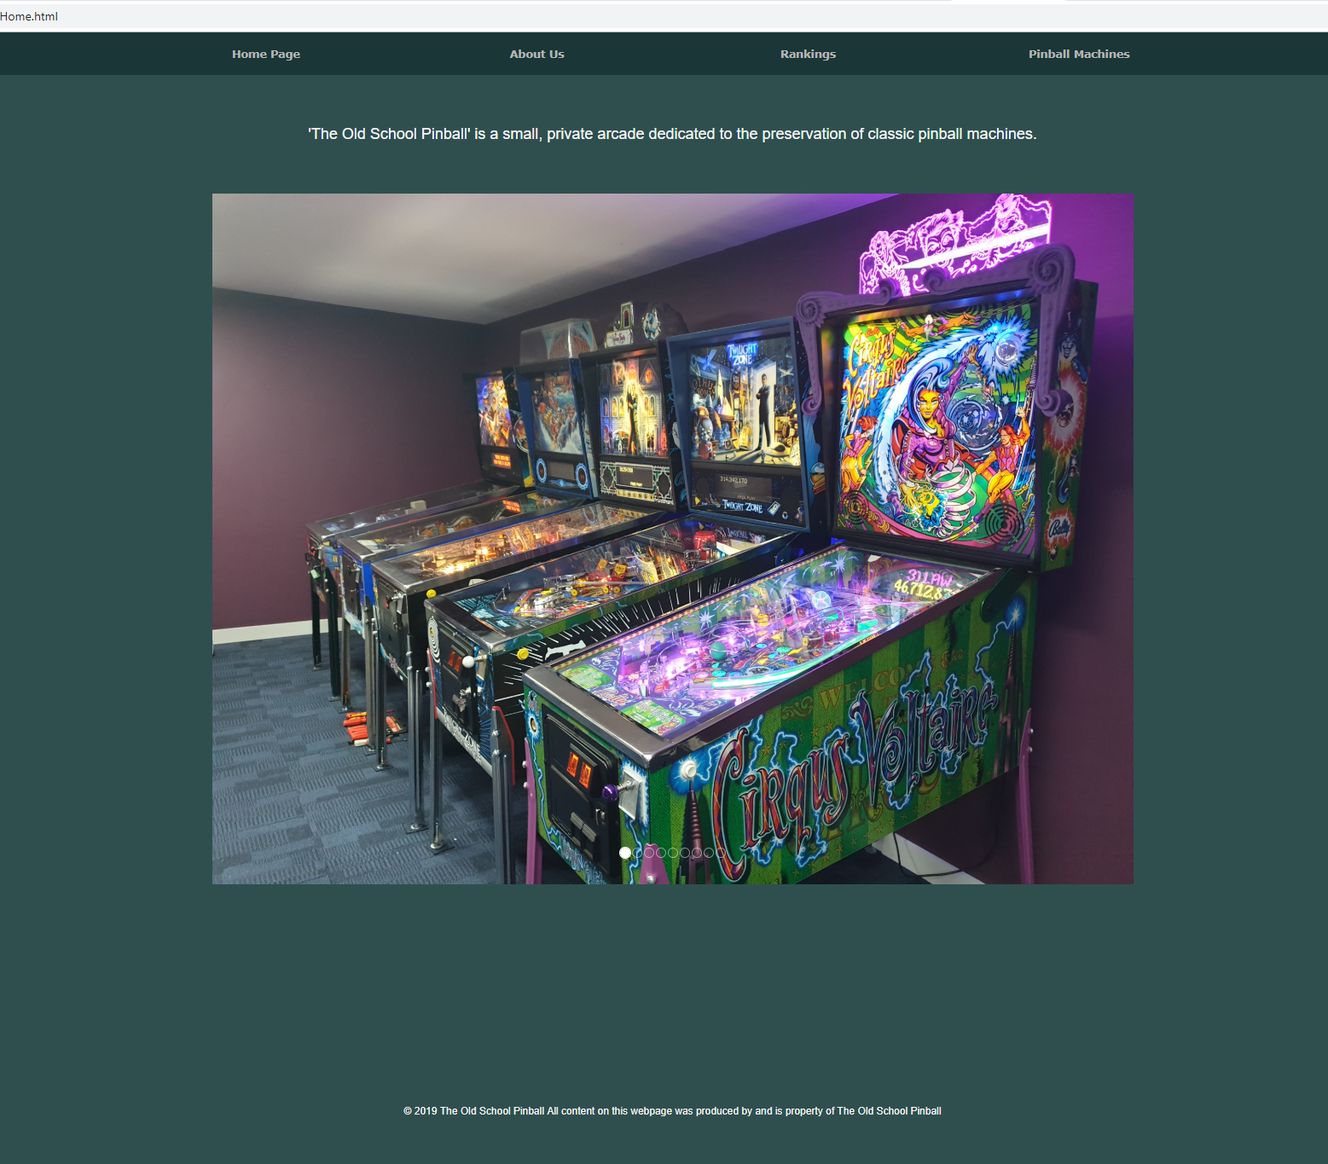

‘About us’ page:

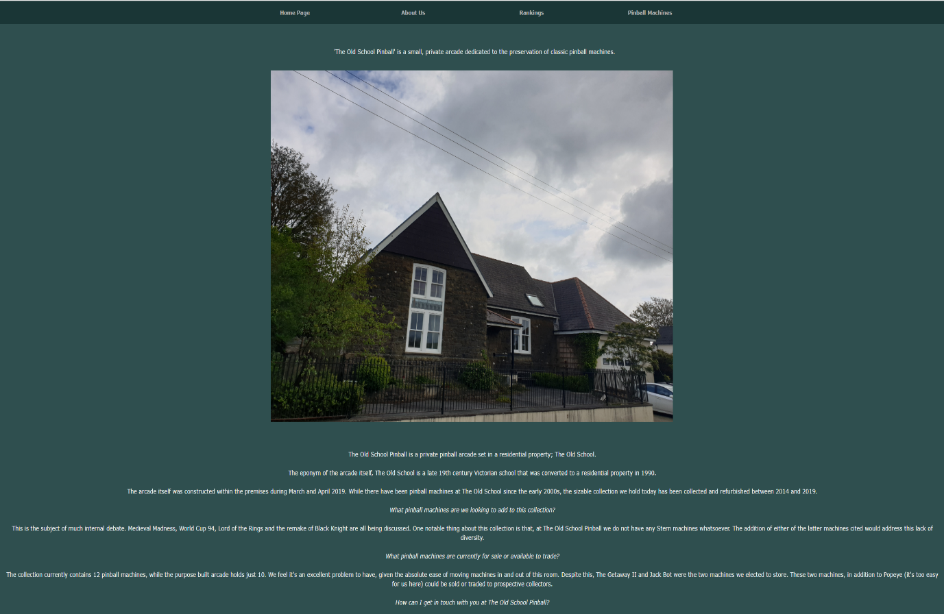

‘Rankings’ page:

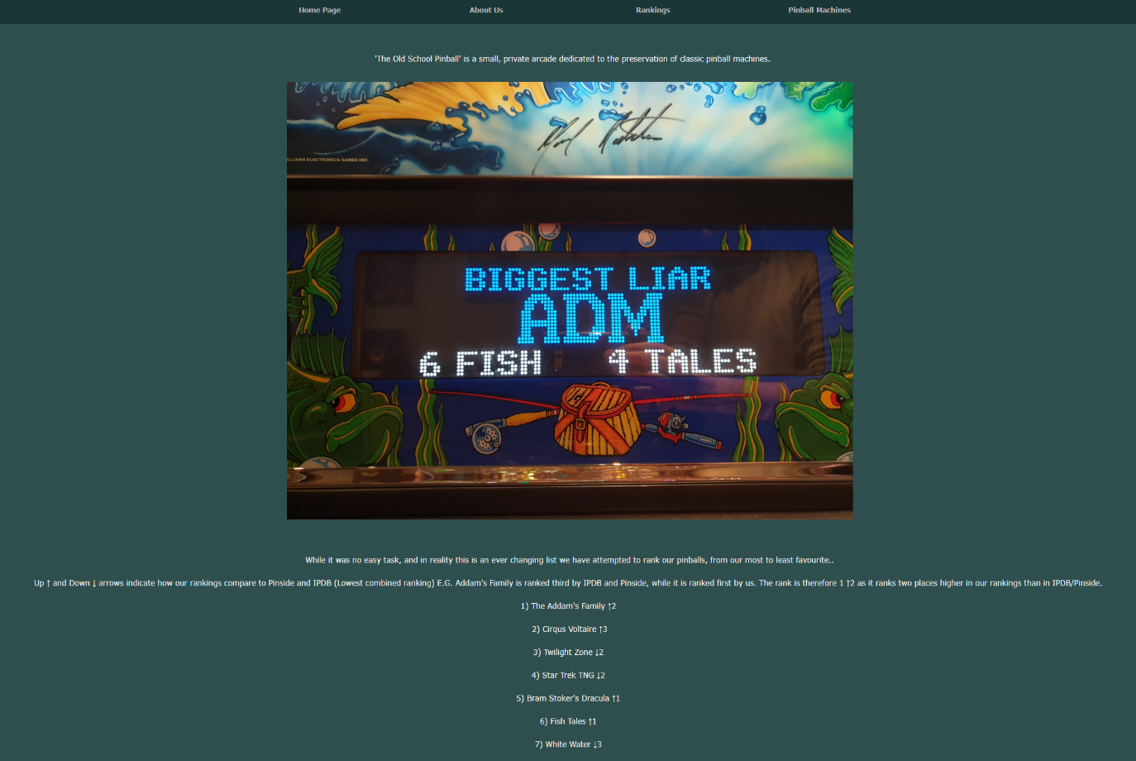

Addam’s Family page:

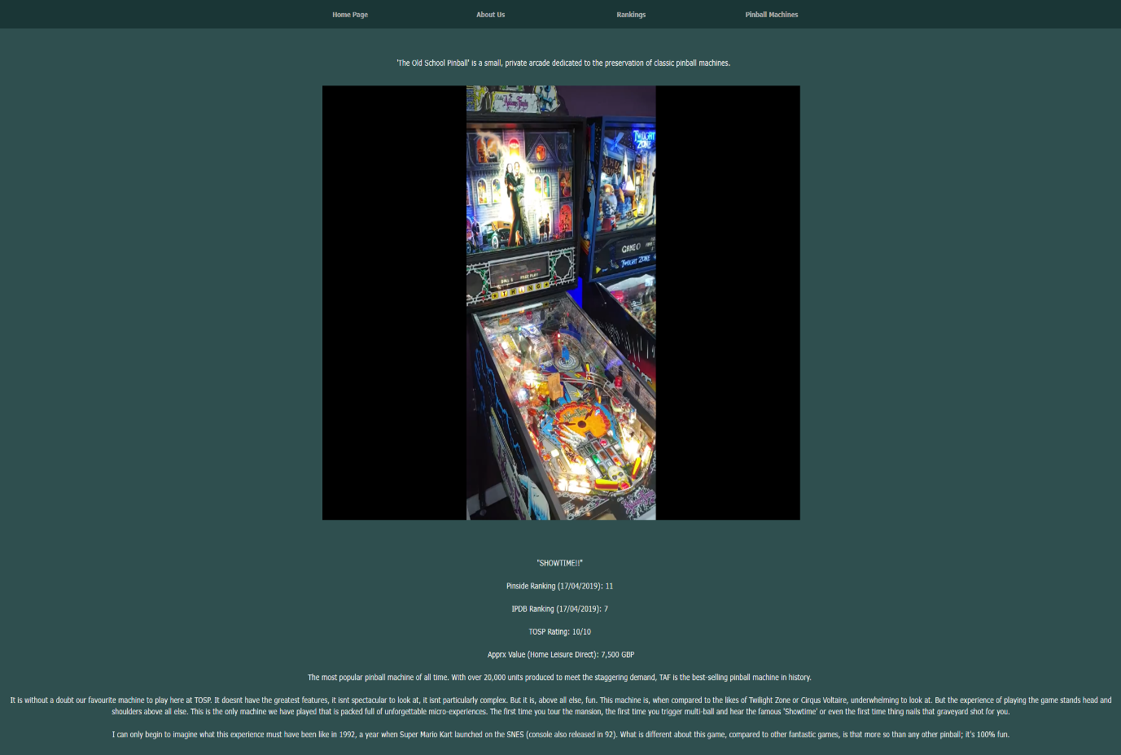

Twilight Zone page:

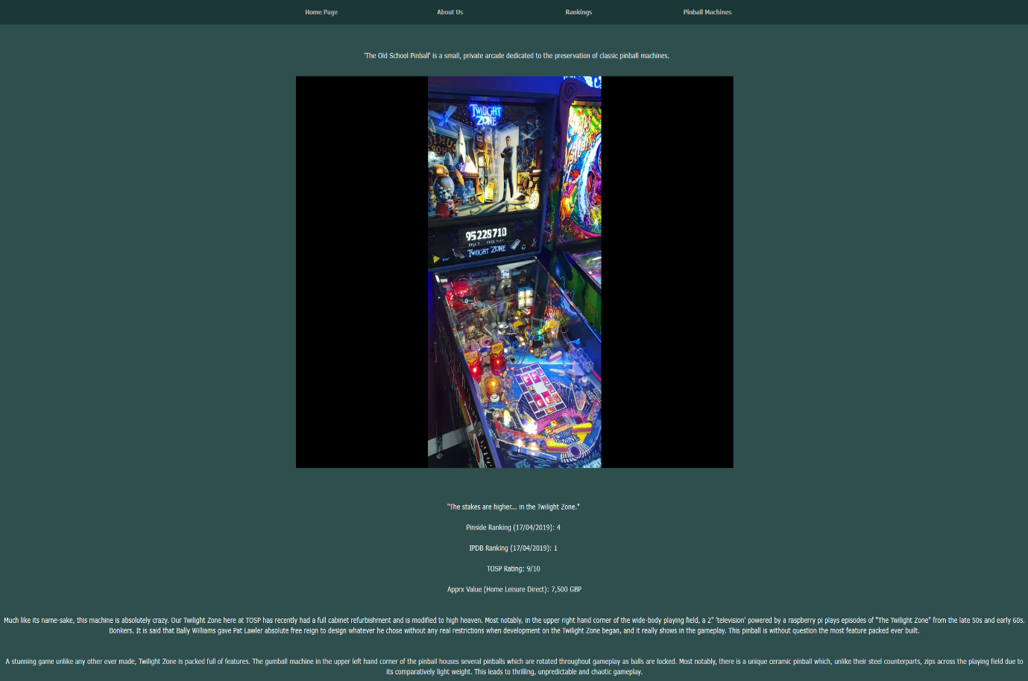

Cirqus Voltaire page:

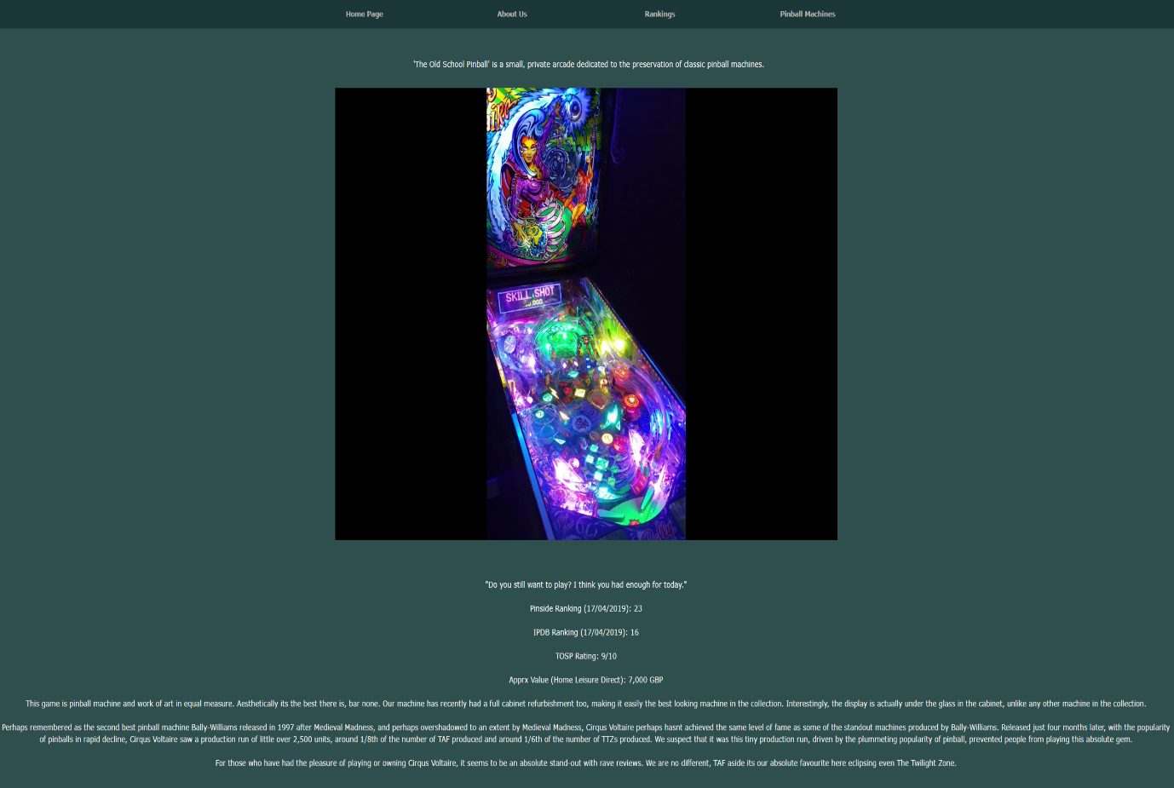

White Water page:

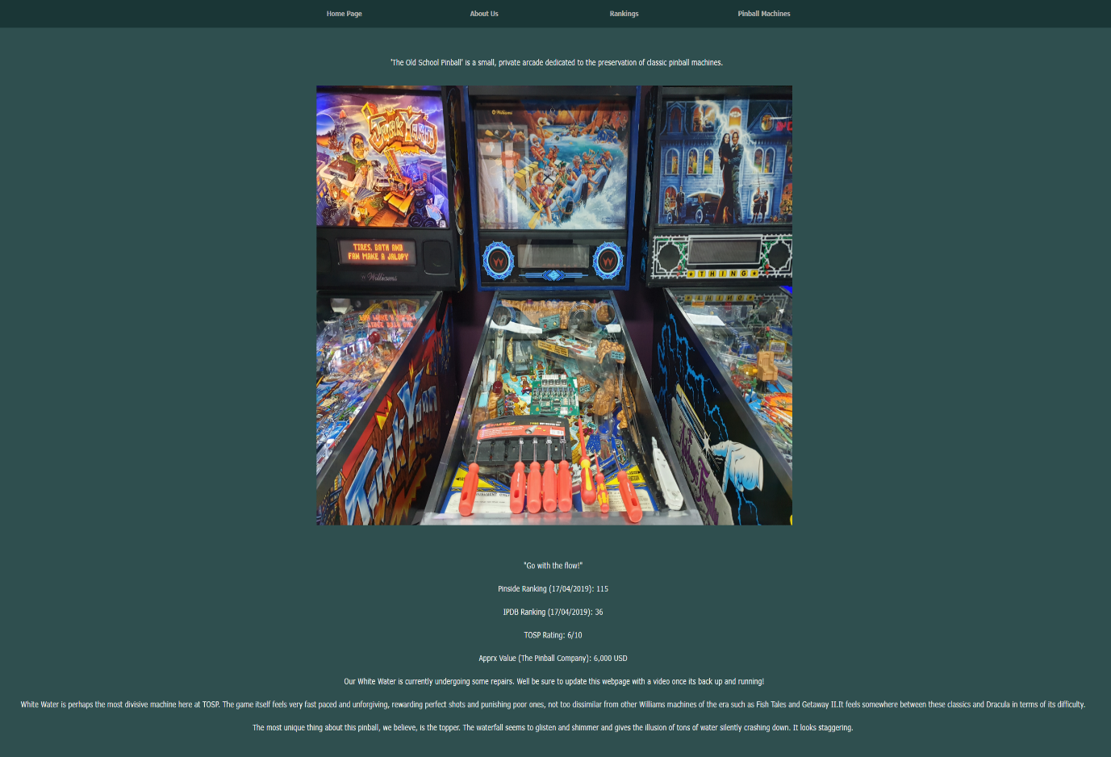

Star Trek TNG page:

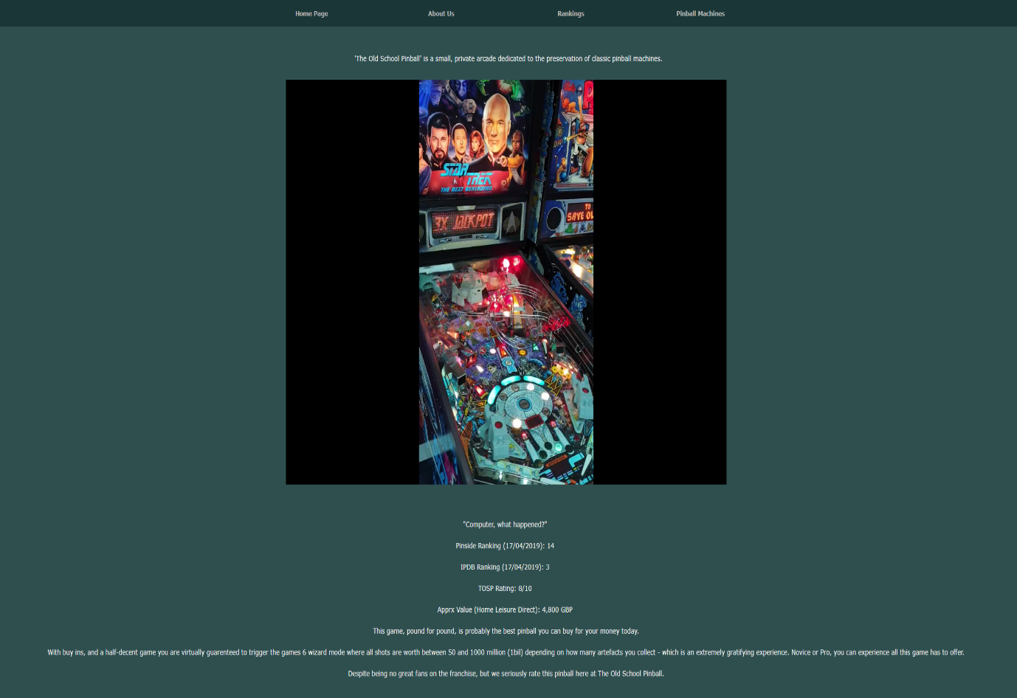

Fish Tales page:

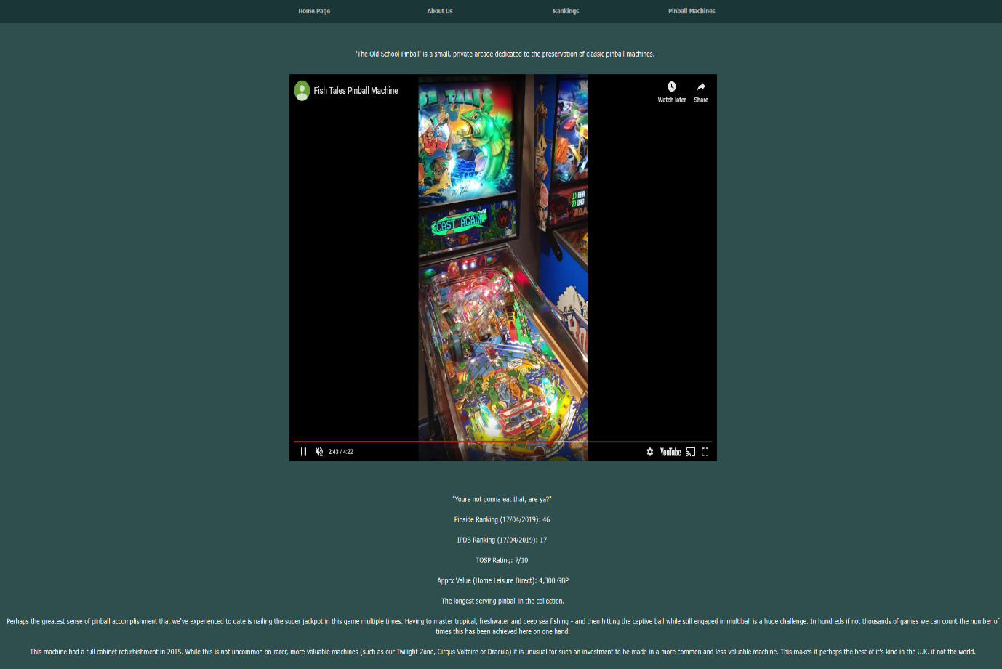

Bram Stoker’s Dracula page:

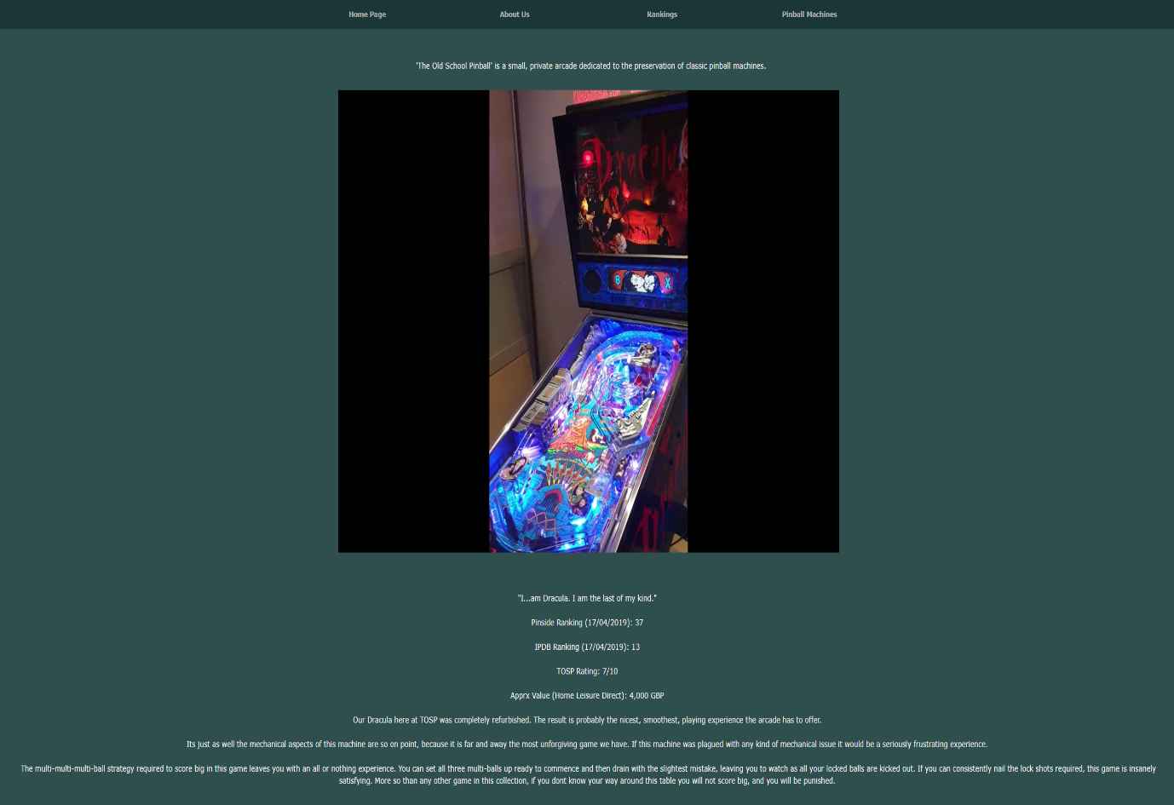

Road Show page:

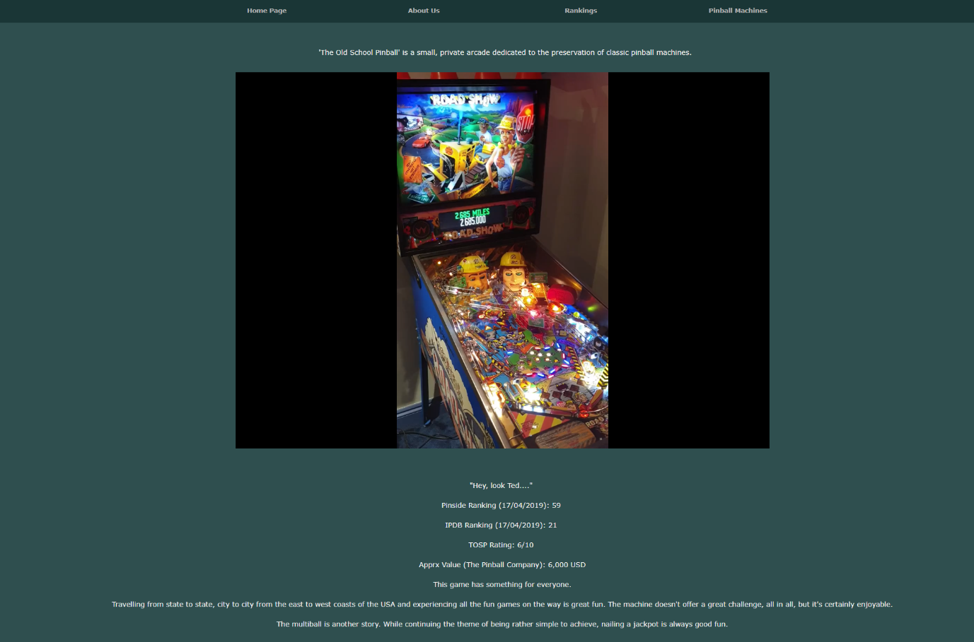

Popeye Saves the Earth page:

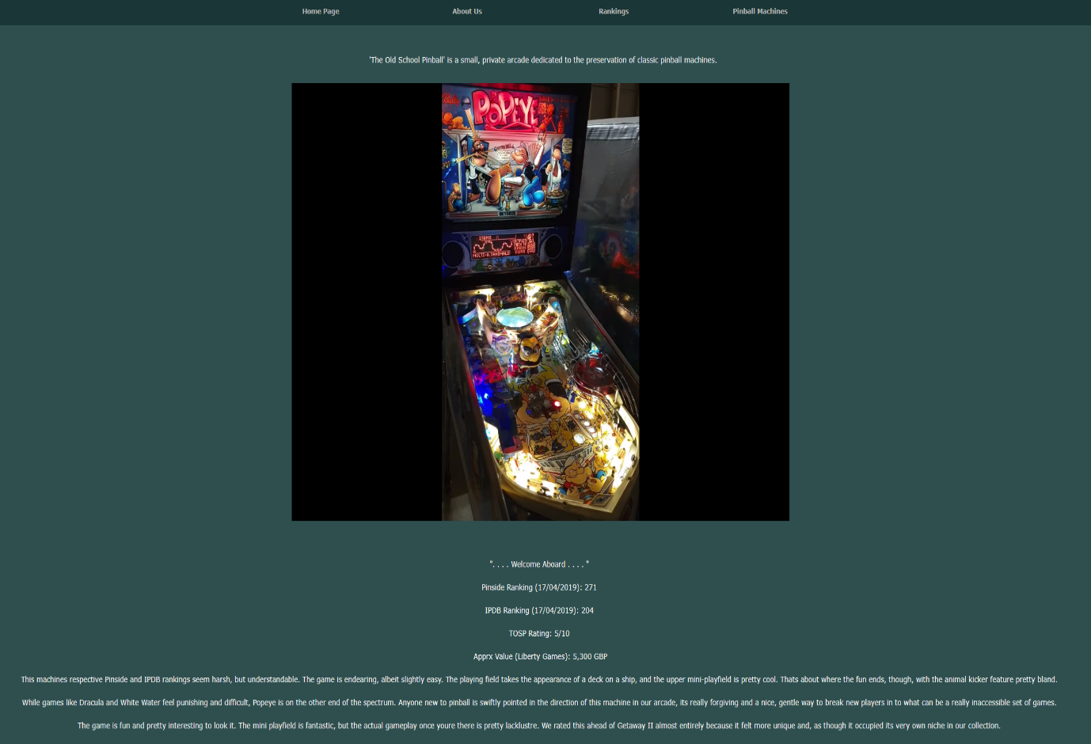

Junk Yard page:

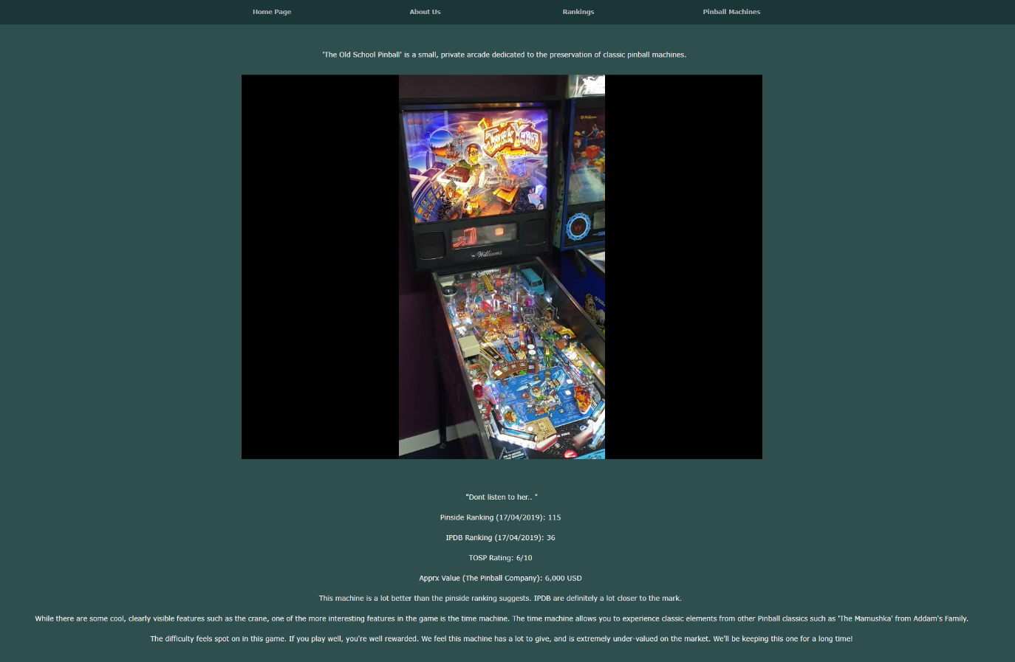

Validation

HTML Validation

Errors 1 and 2 related to a line of code at the very start of my home page html code. In the head, I specified some meta data that contained attributes (Name and Content) that are ‘not allowed’ on this (meta) type of element ‘at this point’. These two attributes were however listed below as ‘attributes for element meta’. While slightly confusing, my instinct was that the ‘at this point’ may have been very important.

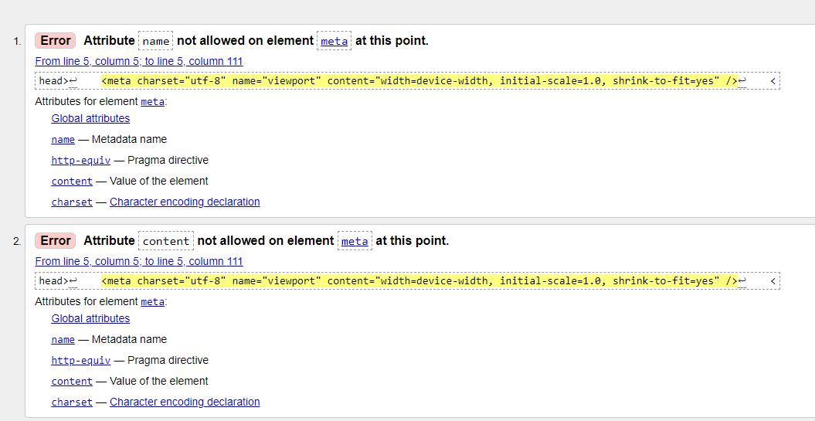

By switching the order of this information (moving charset to the last point of the element) and re-running the validation, the following was received:

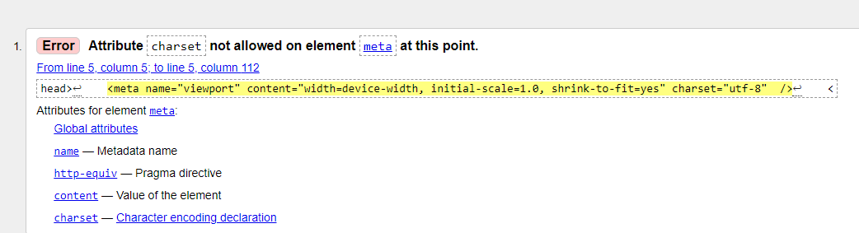

While the previous two issues regarding name and content seem to have been resolved, a new issue has occurred. While it was not actually clear how to resolve this issue, or indeed exactly why this was an issue – the next decision taken was to remove the charset attribute and attribute this attribute to the meta element on a separate entry (two separate meta elements, the second having the charset attribute only). This resolved the validation issue.

The third error related to the use of a para element within the body element.

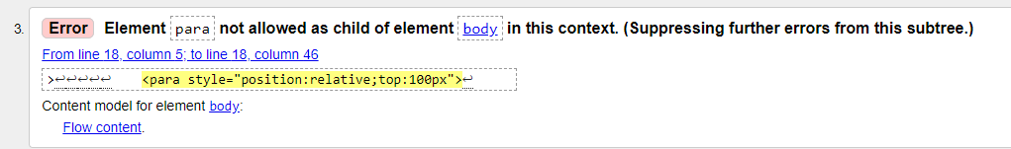

Simply changing this element from ‘para’ to ‘h4’ resolved the issue. There was no detriment to the quality of the webpage, the desired format was still retained.

The fourth error immediately made sense and was admittedly rather a poor error to commit. The name of one of the jpeg files utilised was saved with a space (as opposed to a dash or underscore) in the file name. The perceived solution was simply to add an underscore into the name of the file itself, and adjust the html file to recognise this.

As anticipated, this quick and simple fix resolved the issue.

The fifth error, much like the third, referenced an attempt to incorrectly nest a ‘para’ element with the ‘body’ element. Rather than adjust this to a ‘h’ element the decision was taken to take the para out of the body element and insert it outside of this element.

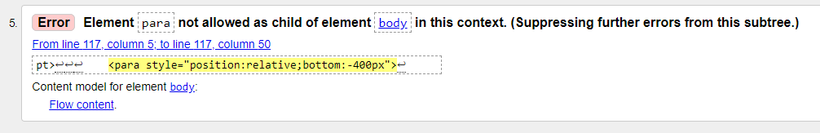

This process was akin to going one step forwards and two back.

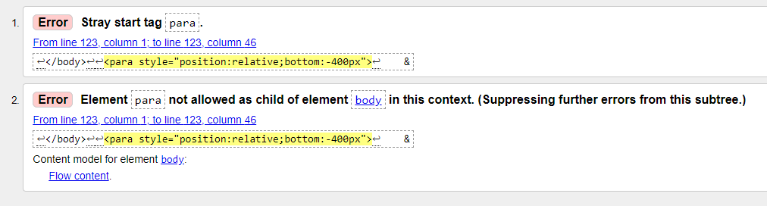

Having failed to resolve the issue, the previous solution of simply changing a paragraph element to a heading element was selected. The code was moved back to its original position and ‘para’ was amended to ‘h6’. This resolved the issue and, in fact, was aesthetically better than the original character size.

Errors 6 and 7 were with regards to a redundant ‘foot’ tag. As it was no longer required, the solution seemed to be to simply to remove the tag, fixing the errors.

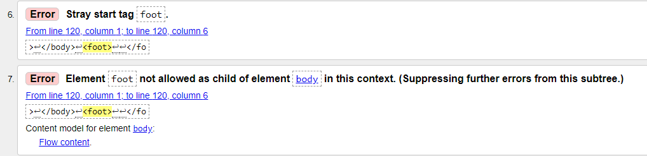

After doing so, the errors were indeed not longer present when validating the code.

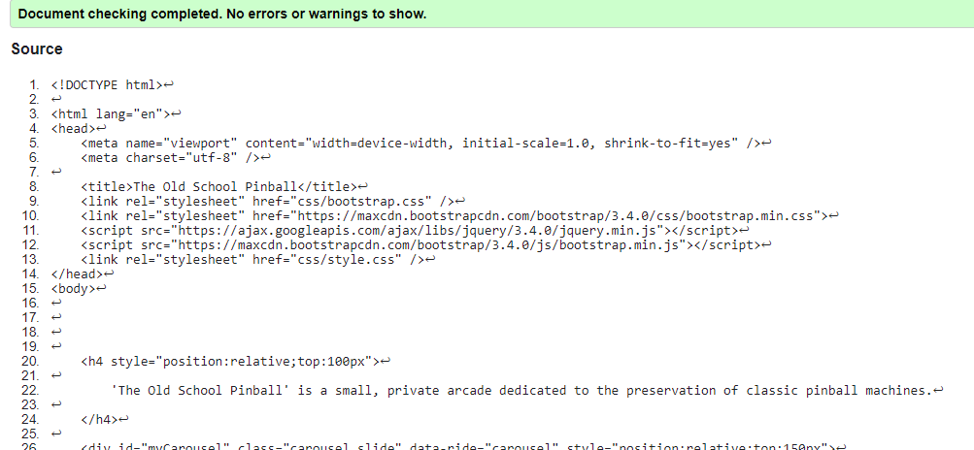

CSS Validation

No CSS validation issues were detected.

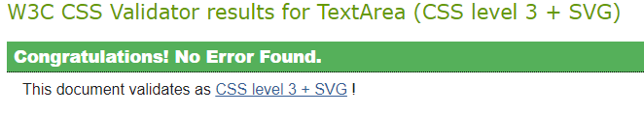

Evaluation

An online luminosity contrast ratio tool indicated that my websites theme had a contrast ration of 12.92:1, giving a result of ‘very good’ and far in excess of the minimum recommended 3.

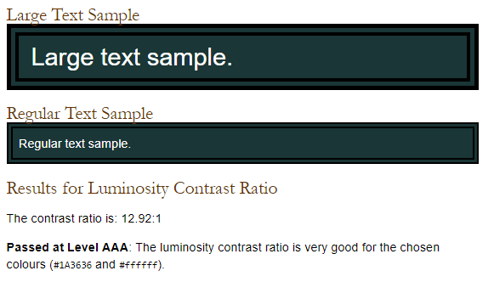

Another tool indicated that the background and foreground combination was excellent, while also confirming that the luminosity contrast with regards to the first image on the home page ticked all the boxes in terms of contrast, with a colour difference score of 631.

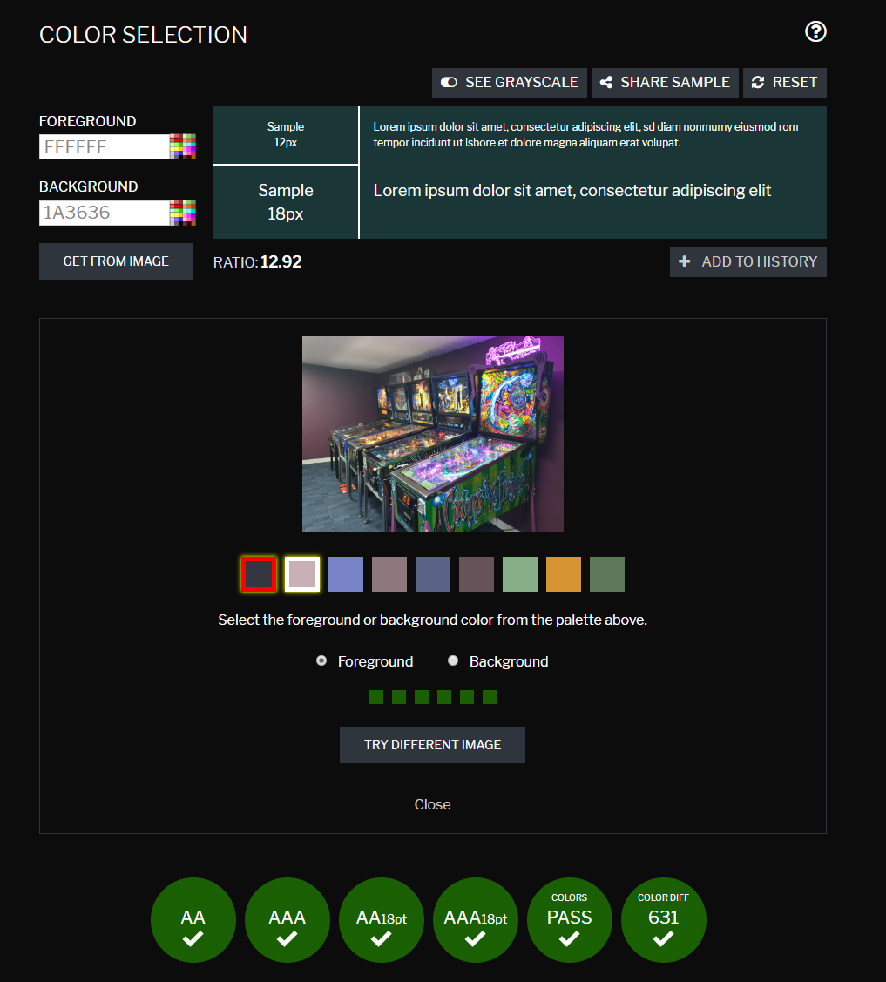
The aXe accessibility tool indicated there were some breaches of best practice, such as the order of headings in the code not being semantically correct.

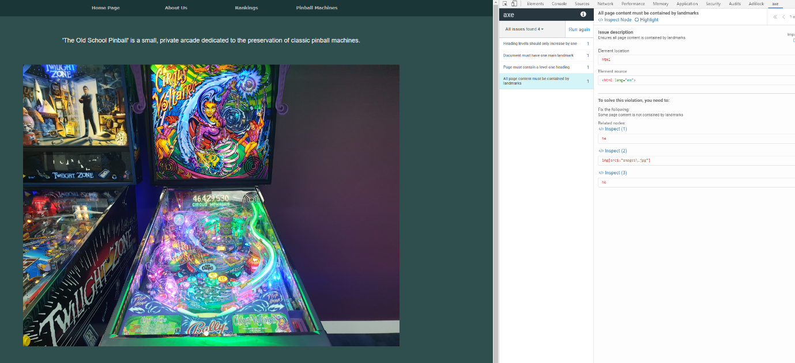

When attempting to make use of the Wave evaluation tool, reports would not be generated on my webpages. The tool worked on other pages, but not these webpages as it ‘could not read’ the sites data. Unfortunately, therefore, the wave tool could not be used to further evaluate any accessibility issues or recommendations.

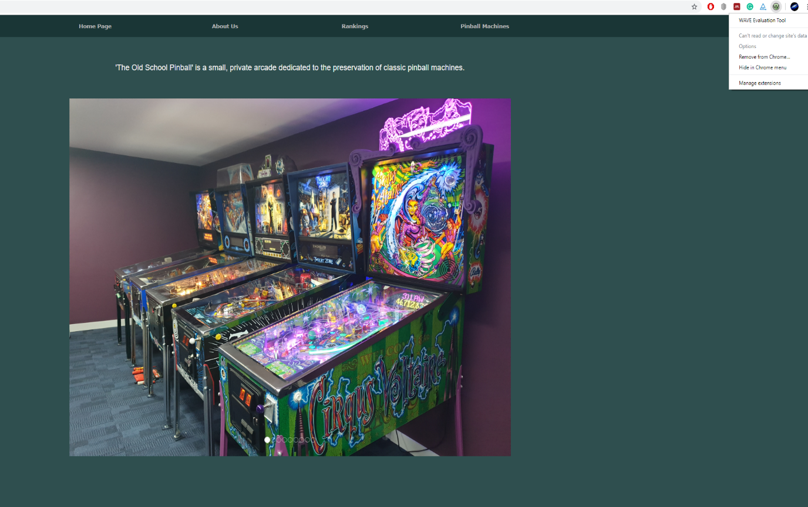

As outlined in the web content accessibility guidelines or WCAG (2.1) websites must achieve the four key principles of accessibility to be deemed accessible to users. These principles are[2]:

- Perceivable
- Operable
- Understandable
- Robust

Inadequate application of the WCAG can effectively erect barriers that cannot be overcome by groups of individuals[3]. Failing to adhere to these guidelines, then, can only serve to reduce your potential audience or target market.

The design of the website could be described as refined, sleek and minimalistic. It could also be described as bland, boring and lacklustre. Whether websites are an appropriate canvas for artistic expression will likely remain a subject of debate, however, if a website adheres to WCAG then at the very least, personal taste or ‘better alternatives’ will be the only reason individuals may elect not to use your website. When considering the general theme of the website and indeed the intended target audience, I believe the design will genuinely resonate and the simplicity will be appreciated; in fact, the feedback received from a small sample of this targeted audience has been fantastic.. Features such as hovering over the carousel on the home page causing the timer to reset and pause, the clear and straightforward navigation bar and the embedded content.

The usability is spot on, with one exception, leading to stress free navigation. The one exception is the ‘Pinball Machines’ tab. This links the user back to the home page if clicked, as the drop-down menu is how users will navigate to a specific pinball machine. In retrospect, a pinball machine ‘hub’ could have been created to further drive the website forward, with a small grid of images (the pinball machines) each one a hyperlink to the relevant webpage; an additional means to navigate based on personal preference.

Although edited and uploaded in the space of a few hours, the footage took many weeks to obtain. Recording began on April 8th and each machine took many hours – unfortunately the reality of this hobby is that most games are over very quickly and not a lot happens. This doesn’t make for good content. Persistence was key in obtaining footage of reasonable quality. Due to the ongoing construction of the arcade room throughout March and April (it is still not fully complete) better images could certainly have been taken. The arcade itself only has 7 of the actual 10 machines present on site and one of these is currently out of order and requires repair, leading to just 9 of the 10 machines demonstrated having video content. These are all areas in which the content could be better on this website.

Other additional features that could be added in future include a genuine, graphical high score board, detailing the best scores achieved on each machine. This would be superior, particularly if graphical elements are done well, to the simple rankings page that is currently on the website. Some element of interactivity and engagement with the user beyond YouTube (comments etc) would also be beneficial, perhaps a poll asking which manufacturers are best, which pinballs are best or even what pinball machines The Old School Pinball should look at adding to the collection next.

In a field as niche as pinball, it is likely that good outcomes in terms of the proportion of individuals searching for websites relating to this content. The issue, in terms of actual traffic, would most likely be due to the niche nature of the content and the fact that it’s likely very few individuals are searching for this type of content. Search Engine Optimisation (SEO), however, is good overall.

The only negative factor that could be applicable to this website is that content could be described as ‘thin, shallow, or lacking substance’[4]. All other negative attributes for a website that may negative impact SEO are seemingly not applicable, with many centred around ads, piracy or deception.

Keywords are strewn throughout, with words such as jackpot, pinball and the various names of each pinball machine cited several times. I do not anticipate this would illicit ‘stuffing’, a negative factor in SEO[4], but would reap some reward in terms of ‘research’. The embedded videos (trusted site) and images would also be positive in terms of SEO optimisation, as well as the speed. As the website is quite sleek in its design, there is not a huge amount to load; especially considering embedded videos are loaded on demand rather than automatically.

While no applied effort has been made to maximise SEO, it appears that generally through simply not being a malicious or ad-laden website, the outcome was good overall.

Bibliography

[1] “Why Validate?” [Online]. Available: https://validator.w3.org/docs/why.html. [Accessed: 03-May-2019].
[2] “Introduction to Understanding WCAG 2.1.” [Online]. Available: https://www.w3.org/WAI/WCAG21/Understanding/intro#understanding-the-four-principles-of-accessibility. [Accessed: 03-May-2019].
[3] P. Acosta-Vargas, T. Acosta, and S. Lujan-Mora, “Framework for Accessibility Evaluation of Hospital Websites,” in 2018 International Conference on eDemocracy & eGovernment (ICEDEG), 2018, pp. 9–15.
[4] “The Periodic Table of SEO Success Factors - Search Engine Land.” [Online]. Available: https://searchengineland.com/seotable. [Accessed: 03-May-2019].

