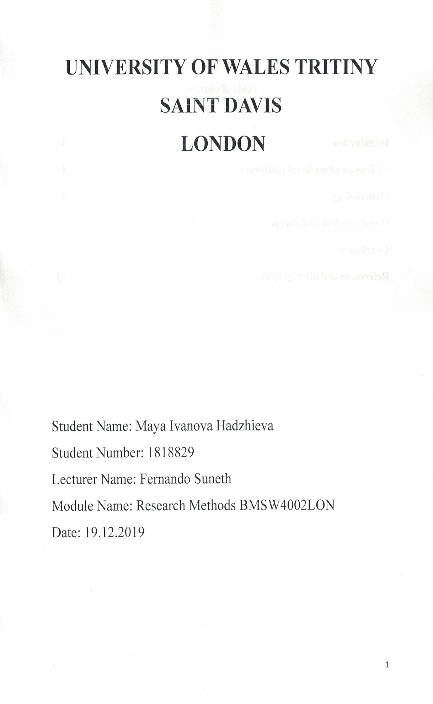
Table of content:

Introduction 3
VLE as an educational platform 4
Methodology 5
Questionnaires and charts 6
Conclusion 12
References and bibliography 13

EXECUTIVE SUMMARY
This report for research methods and their importance for in depth theory’s building research. One of the theory’s four main criteria is research methods. This is significant for providing a groundwork for analyses and for discussions in the actual practice.

Introduction
The research method is methodical strategy for research conduction. There are differentially of research methods like observations, surveys research and experiment research. The research method is important considerations of studies about specific concerns consuming scientific methods.
A Virtual Learning Environment is an educational on-line operated podium for numerical aspect of education course inside the institution of education (Weller, 2007). There are actions, interactivities inside the course structure for variety processes of the assessment. People are working on this platform and is required as an integrational part of the institutional system. Virtual Learning Environment is a widely platform for content management, communication, collaboration, curriculum mapping and planning, real time communication, and additional resources.
The process to enhance the learn experience to virtual resource room based on student centred environment to encourage students to have responsibilities for self-learning. They can learn and discuss lectures, exams, laboratory reports, with on-line feedbacks. This leads to increase academic performances to meet graduate standards (Weller, 2007). The process gives new opportunities to the student by providing diverse learning needs to all of them by digital curriculum. There is a strong on-line presentation and has economised costs and teaching staff time. This process provides real time headway and performances.

VLE is an internet orientated stage for numerical features for studying at the institutions for education mainly at the universities. This includes and level of integration inside a development organisation and there are various scenes of the valuation. VLE platform allows administrative information for the course, updated information for the ongoing course, distance learning and course bases, self-assessment, formal assessment, outside courses connections, documentations, statistics and other authoring tools (Dougiamas, 2004).
Virtual learning environment is well-established in educational institutions for delivering the learning actions and content. It has very strong strengths to manage the online assessments and for student tracking. These integrated product tools may be one product for example Moodle or added functions like e-portfolio (Dougiamas, 2004). The advantages of this system are: technical support, presentation of consistent experience for the staff and students and the abilities for delivering courses to many students. Positives are student dialogue, online and email courses, board discussions and support collaboration. Other benefits of the VLE is staff trainings innovative design and flexible methods of engagement (Dougiamas, 2004).
Virtual learning environment is a new stage of the educational process where the artificial world is replaced with real life. It exchanged the classroom with the virtual environment. It added value with the extension of the physical learning environment. VLE provides more opportunities to stretch the imaginations of students and the teachers. The ideal place to learn from the virtual learning environment is everywhere with the laptop (Bri, 2009). This offers brilliant designed space for learning and teaching, it offers easiness with all process with the learning with lesson plans, homework and software organisation. VLE enhanced the classroom social space and more hubs are offered like resources for worksheet, power point, for the documents, articles from journals and newspapers, to embed YouTube videos and to delivers platforms for scholar shaped podcasts (Weller, 2007). VLE is valuable because offers numerous entryways to boundless paths linking, content and knowledge from the teachers, students and for the advantages of all.
The VLE is defined as a type of learning founded on communication technology and information. It is making the learning process easy, independently and with new education strategy. Vital part of the procedure is the synchronous communication between teachers and students for example, forum, blog, emails and etc. There is a design software system that supports learning by integrated online environment (Bri, 2009).
Virtual learning environment delivers new responsibilities, new knowledge, new roles. The computer now is verbal-linguistic, maths-logical, bodily-kinaesthetic intelligence (Yan Xu, 2011).
Virtual learning environment is concern with issues with training, learning, entertainment and future development with e-learning.

The objectives of the VLE are provided that a knowledge atmosphere for scholars are providing an education situation for scholars to teach different courses with the traditional teaching environment, to permit students with special needs to take participation in the courses with this learning environment, to provide geographically widespread admission to this learning environment, to advance learning environment anywhere students can learn the material and to provide a course source for many different universities with the contract from VLE (Weller, 2007).
Methodology – there are new learning methodologies and resources for advanced development like critical thinking. The new methodologies explore technical, pedagogical, methodological, tutorial, legal aspects of e-learning with e-learning innovation for professional and academical fields (Dougiamas, 2004).
Primary Data Analysis – the methods of the primary data collection are direct observation, telephone surveys, experiments, written questionnaires and personal interview.

Survey
Virtual Learning Environment
Moodle
I have formed these questionnaires which are associated to the usage of the University of Wales’s moodle website. I’ll present it to my tutors and the university administration, so they understand how supportive are these units to scholars and the ways that can progress them. There are no correct or incorrect responses. The responses should be your own opinion. This survey is unconditionally anonymous.

What is your gender? Male: 1 Transgender: 0 Female: 9
What is your age? 18-24: 0 25-39: 9 40-above: 1

According to this survey there are ten students from which one man and nine women with different age group from nine people (25-39) and one person with group (40 and above).

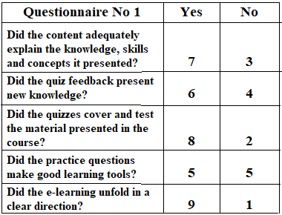
Table 1: Questionnaire No 1
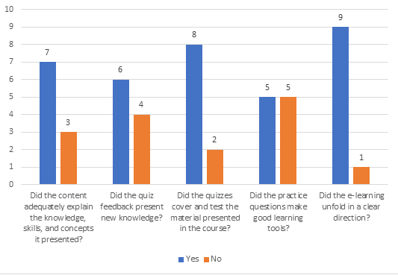
Figure 1: Chart of the first five questions
There are five questions given to ten students to give simple answers with yes or no (Ofsted, 2019) . The most of them are agreed with the question and given positive answers. On the first question the students need to answer on whether the content adequately explains the knowledge, skills, and concepts presented. Two thirds reply yes, while a third gave negative answer. Second question is about whether the quiz feedback presents new knowledge, there are 60% agree. The third question is about the cover of the material in the course where 80% are agree. There is equality on the fourth question is connection of the practice with the learning tools, where are 50% on both answers. And the last question which is about the clear direction of e-learning where 90% are agree.
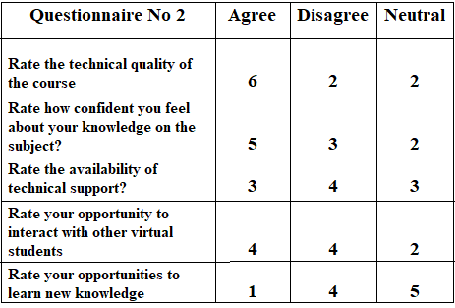
Table 2: Questionnaire with three possible options
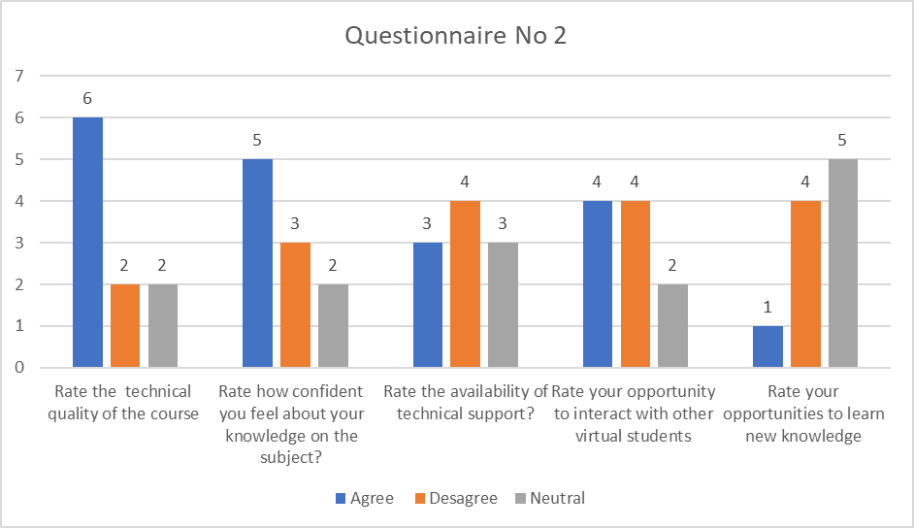
Figure 2: Chart with the three possible options
In the second questionnaire there are five questions given to ten students. Every question has three options – agree, disagree and neutral (Ofsted, 2019). The first question is to put rating of technical quality of the course material, where 60% of the student are agree. 20% each are disagreed and neutral. The second question is to put rating of the confidence in the knowledge in the subject, where half of the student are agreed, 30% are disagree and 20% are neutral. The third question is to put rating in the availability in the technical support, where 40% are disagreed, 30% agreed and 30% are neural. On the fourth question is to put rating on the opportunities to interact with other students, there are 40% agreed, 40% disagreed and 20% neutral. The last question is to put rating on the opportunities with new knowledge, where 50% are agreed, 10% are agreed and 40% are neutral.
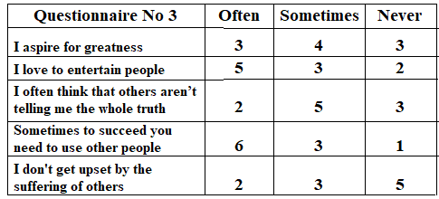

Table 3: Questionnaire No 3 with three possible options
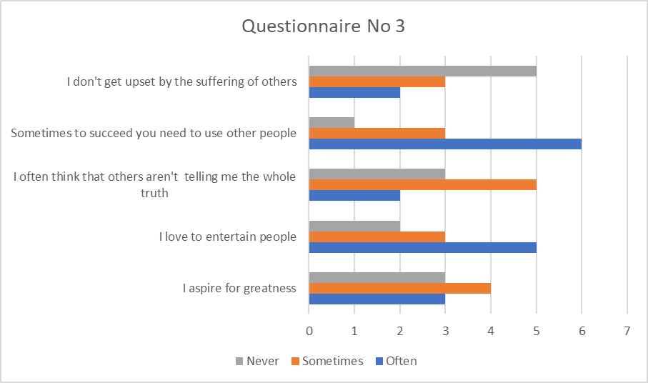
Figure 3: Chart with three possible options
The last questionnaire has five questions given to ten students do they do something with three possible answers – often, sometimes and never. There are variety of answers and are shown in the chart (Ofsted, 2019). On the first option is for aspiration of the greatness, there are three options – sometimes with four answers, and never and often with three answers each. The second option is to entertain people, 50% give answer often, 20% never and 30% sometimes. The next option is about the whole truth from people, 50% are with sometimes, 20% often and 30% never. The fourth option is about the success that depends from other people, where 60% give answer often, 30% sometimes and 10% never. The last option is the suffering from others, where 50% give option never, 30% sometimes and 20% often.

After the whole survey there are different opinions with overall results with positive answers are the most. The student like the unit and the learning options for their education, learning and development. This is important for their future career and activities.
I have created this questionnaire which is related to the University website. I’ll present it to my tutors and they can give me feedback. The purpose of this survey is to help the University to understand how helpful is this unit to students and how to be improved.
Advantages of using the primary sources are the control of the design and the information in the questions. Disadvantages of the primary sources are time consuming is expensive and the principal data is weak use of resources (McKhann, 2000).
Rewards of the secondary sources are improved usage of the capitals and well-designed and independently surveys. Weaknesses of the secondary bases are that is problematic to find the suitable information, and the payments are likely to be required.

Virtual Learning Environment is university specific for providing special requirements for user-based answers and methods for the specified responsibilities. Main research is for VLE products and advice on general progress (Yan Xu, 2011). There are analyses on different patterns developments and then secondary research if its obligatory. VLE is online platform and is used by scholars to sustenance their topics. The students can use puzzles, numerous schemes, automated files to complete the responsibilities (Strang, 2012). Many universities around the sphere are invested to implement various VLE for teaching and learning procedure. The purposes are many advantages and objectives to be achievable. The implementation with the new technologies is vital (Dalgamo, 2002). The well-organized method is to be flexible and in order to user’s desires.
Advantages of a Virtual Learning Environment
Simple to track and valuation: with the virtual learning environment software, it’s easy to find which workforces have accomplished the actions. Built-in valuations like puzzles can assistance to safeguard for absorbing the resources (Yan Xu, 2011).
Seamless Distribution: Each member of staff has admission to the similar material, no matter when he or she gets hired. The message is consistent through the years; when you make a change in organisation strategy, that can be efficient in your learning system, and all workers have admission to it (Dougiamas, 2004).
To save time: easy way to fill the gas of the workforce and the new employees have direct access to the all trainings and courses needed (Preston, 2004).
To save financial resources: The investments in virtual learning platforms is developing prospectus with multiple usage to education and development. Relations to the expenditures that companies made for new employees and to make payments for trainings, venues, transport costs, reduction of the productivity and profitability. This is costs efficient virtual learning environment (Dougiamas, 2004).
Communication and Linking: statement as one of the advantages of a virtual learning environment with forums and communication boards, seasoned workforces can answer questions and offer mentoring and advice for new workforces. This saves time for those in organisation roles and builds a sense of connection and community among your team (Davies, 2013).
Flexibility: The workers can have trainings at anytime and from everywhere with the flexibility of the resources (Dougiamas, 2004).

Conclusion
The changes in the society and the new reality in the institutions gives new benefits for the learning process. Virtual learning environment provides new resources for the enrichment of the intellect. This offers practical activities and with the software delivers platform for learning, development and for future progress. Reflections are that many students do their work from home rather than school, because the knowledge is significant important. Virtual learning environment delivers new learning, new knowledge, offers solutions and options.

REFERENCES AND BIBLIOGRAFY

Bri, D., García, M., Coll, H. and Lloret, J., (2009). A study of virtual learning environments. WSEAS Transactions on Advances in Engineering Education, Vol. 6, No. 1, pp.33-43.
Dalgamo, B., (2002). The potential of 3D virtual learning environments: A constructivist analysis. Electronic Journal of Instructional Science and Technology, Vol. 5, Issue 2, pp. 3-6.
Davies, G., and Verdejo M., (2013). The virtual campus: trends for higher education and training. Springer: s.n.
Dougiamas, M., (2004). Moodle: A virtual learning environment for the rest of us. TESL-EJ, Vol. 8, No. 2, pp. 1-8.
McKhann, H., and Goldberg, G., (2000). Student test scores are improved in a virtual learning environment. Advances in physiology education, Vol. 23, Issue 1, pp. 59-66.
Ofsted, (2019). Virtual learning environments. [Online]
Available at: https://assets.publishing.service.gov.uk/government/uploads/system/uploads/attachment_data/file/383958/VLE_e-portfolio_-_case_studies_booklet.pdf
[Accessed 16 November 2019].
Preston, D., (2004). Virtual learning and higher education. Rodopi: s.n.
Strang, D., (2012). Constructivism in synchronous and asynchronous virtual learning environments for a research methods course. Virtual Learning Environments: Concepts, Methodologies, Tools and Applications, pp. 1466-1480.
Weller, M., (2007). Virtual Learning Environments. London and New York: Routledge.
Yan Xu, Park. H. and Baek. Y., (2011). A new approach toward digital storytelling: An activity focused on writing self-efficacy in a virtual learning environment,. Journal of educational technology & society, Vol.1, Issue 14, pp. 181-191.

