

How has mental health changed in policing?
Lewys Thomas
2131845
BSc (Hons)Professional Policing
March 2025

Word Count: 7847 Words

Acknowledgements
I would like to thank all my friends and family in helping me complete my dissertation. Without their patience, time and understanding I would not have been able to do it. As well as acknowledging the helpfulness of my friends and family I also see it fit to thank my work colleagues and my supervisor for supporting me through the completion of my university work and final year dissertation.
The role of a police officer is a very challenging one, however an extremely rewarding role, the ability to do this job and complete my dissertation, would have been a lot more difficult had it not been for the guidance and assistance of my team and supervisor, helping me achieve my goal.
All in all, I must thank my parents, friends, colleagues and supervisor for the immense support and help during this project. Without their help, completing this project would have been a lot more difficult than it already has been.

Declaration
- Declaration- This work has not previously been accepted in substance for any degree and is not being submitted in candidature for any degree. Signed: Lewysthomas Date: 21/11/2024

- Statement 1- This dissertation is being submitted in partial fulfilment of the requirements for the degree of BSc. Signed: Lewysthomas Date: 21/11/2024

- Statement 2- This dissertation is the result of my own independent work/investigation, except where otherwise stated. Other sources are acknowledged by footnotes giving explicit references. A bibliography is appended. Signed: Lewysthomas Date: 21/11/2024

- Statement 3- I hereby give consent for my dissertation, if accepted, to be available for photocopying and for interlibrary loan, and the title and summary to be made available to outside organisations. Signed: Lewysthomas Date: 21/11/2024

- Statement 4- I hereby give consent for my dissertation, if accepted, to be available on the university’s IT system to those who have consent to use the system. Signed: Lewysthomas Date: 21/11/2024

Abstract
This Research is due to police attending a wide range of mental health calls. A large quantity of incidents that the police deal with today are solely based on people’s mental health and wellbeing and in this dissertation, I will discuss how the level of these calls has increased over the years in policing, along with how the mental health of the police officers dealing with these incidents has also been affected and why the calls and demand of the job have had this effect.
Over the years, especially since Covid 19 and lockdown, the world has become more aware of mental health and the effects it has on people. There are so many different factors that can attribute to how high or low you are feeling, whether it be for example the things police officers see on a day-to-day basis or dealing with personal issues such as financial troubles. I will discuss and examine how officers seek support when they require it, if they know where to find it and if they would know how to assist a colleague if that colleague reached out to them in need of assistance with their mental health and or personal struggles.

Table of contents
Chapter 1- Introduction 7
Chapter 2- Literature review 9
2.1 Introduction 9
2.2 The different methods that are in place to assist with mental health in policing. 10
2.3 How the demand on policing has increased in regards to assisting and attending mental health calls. 11
2.4 The general increase in mental health issues since Covid 19 and lockdown. 12
2.5 How more experienced officers are affected by calls compared to new officers experiencing situations for the first time. 13
2.6 Conclusion 14
Chapter 3- Methodology 15
3.1 Introduction 15
3.2 Research strategy 15
3.3 Data collection 16
3.4 Limitations and problems 17
3.5 Analysis of results 17
3.5.1 Question 1 18
3.5.2 Question 2 19
3.5.3 Question 3 20
3.5.4 Question 4 21
3.5.5 Question 5 22
3.5.6 Question 6 23
3.5.7 Question 7 24
3.5.8 Question 8 26
3.5.9 Question 9 27
3.5.10 Question 10 28
3.6 The comparison of 9 and 10 28
Chapter 4- Conclusion and recommendations 30
4.1 Summary 30
4.2 Evaluation of aims and objectives 30
4.3 Future needs 31
Bibliography 32

Chapter 1- Introduction
Since joining the police in 2022, I have been to a wide range of mental health calls. A large quantity of incidents that the police deal with today are solely based on people’s mental health and wellbeing and in this dissertation, I am going to discuss how the level of these calls has increased over the years in policing, along with how the mental health of the police officers dealing with these incidents has also been affected and why the calls and demand of the job have had this effect. I will gather information first hand, from serving police officers. By doing this I will discover their honest and accurate opinions on the matter at hand, therefore allowing me to analyse my accurate data that will be collected.
Over the years especially since Covid 19 and lockdown, the world has become more aware of mental health and the effects it has on people. I believe this topic is worthy of being considered for an undergraduate dissertation due to the fact that there are so many different factors that can attribute to how high or low you are feeling whether it be for example the trauma related incidents that police officers attend every day in their front line role, or their personal struggles, since Covid 19 especially there has been a clear increase in financial problems therefore resulting in an overall increase in mental health issues, I will further look to back this up, by carrying out my primary research.
In many cases the police are often the first point of contact for a person experiencing a mental health crisis. In background research I have conducted prior to the commencement of my dissertation, I discovered that last year police detained more than 2000 people across Wales under the mental health act and that approximately 10 percent of all incidents that police deal with have some sort of mental health aspect. Again, since Covid these statistics have only increased, one of the topics I will look to focus on in the questionnaire that I provide to a variety of officers, will concentrate on their views and experiences on the topic of mental health.
I intend to study this further in my dissertation, breaking down all the different aspects and changes that have occurred over the years, and in turn, have attributed to the increase in the public and police officers’ mental health. I will also look at the services offered to the police when they require assistance with their mental health, and if they know where to seek the help from.
I have set out several objectives that I wish to complete and focus on during my dissertation, these are as follows
- To discuss the different methods that are in place to assist with mental health in policing now, compared to the past.
- To discover how the demand on policing has increased regarding assisting and attending mental health calls
- The general increase in mental health issues since Covid 19 and lockdown.
- How more experienced officers are affected compared to new officers experiencing situations for the first time.
Throughout my gatherings and findings, I will need to respect the privacy of individuals who may wish to remain anonymous and or may not want to take part. I am looking to gather a wide range of findings, and I am aware that I may face some obstacles when doing this, some of these obstacles may include, struggling to reach my desired quantity of participants, within the time limit I have provided myself with.
This in turn could result in me not gathering the quality of research that I initially desired.

Chapter 2- Literature Review
2.1 Introduction
I will be starting my literature review by recapping my objectives. In my study I intend to review the literature relating to ‘How has mental health changed in policing?’. To answer and discuss this question, I will look to focus on several objectives to help me with my studies. These objectives are as follows.
- Discuss the different methods that are in place to assist with mental health in policing now, compared to in the past.
- How the demand on policing has increased regarding assisting and attending mental health calls.
- The general increase in mental health issues since Covid 19 and lockdown
- How more experienced officers are affected by calls compared to new officers experiencing situations for the first time.
Thoroughly discussing and studying these objectives in depth will allow me to answer my main statement to this best it can be answered.
Mental health has increased drastically over recent years. Being a frontline police officer, I witness the effects of mental health daily. It is a massive issue currently and I believe that since Covid 19 there has been an even bigger spike in the amount of mental health issues, part of this review will be how and why this has happened as well as using my objectives to answer my main question, which is stated above. In a study carried out by quality watch it was found that 1 in 6 adults experienced a mental health disorder during Covid 19, this being either depression or anxiety. It was also found that 1 in 6 children between 6 and 16 also experienced this. During 2020 intentional harm was the main cause of death for people between 5 and 34 years of age (Flinders, 2022).
This information alone is enough to suggest that during Covid mental health was a huge impact factor. From researching this online it is clear to see that there is a large amount of research and statistics out there, backing up this fact, the research is rather up to date also considering that Covid 19 was not long ago, therefore increasing the accuracy and validity of the information that I have gathered in relation to my study.

2.2 The different methods that are in place to assist with mental health in policing
In this sub section of the literature review I will focus on how the methods that can help with officers’ mental health have improved, compared to what they used to be like. Now that people and public services are more aware of the struggles that individuals face in relation to their mental health and wellbeing, it would be believed that it is now easier to gain assistance for these matters, this question will look to focus on if this is actually the case.
More and more police officers are using the services provided to them, in the Metropolitan police service occupational health provide counselling to officers, figures show that the number of officers utilising this procedure has gradually increased over a 5-year period. In 2018, 1027 officers used this method to seek help regarding their mental health, in 2022 the number had risen to 2224 (Metropolitan Police, No date). I believe this source to be incredibly accurate and correct since this data has been published on the official Metropolitan police services website and is available for all to see, however it cannot be edited by anyone other than the publisher, therefore increasing its accuracy. This information shows that more and more people are recognising that they suffer with some sort of mental illness, I believe this to be because there are more and more support systems on offer, compared to recent years, individuals are realising that they can be helped and require what the service has to offer.
Mental health has vastly improved since 1959 when the mental health act was introduced. This is when the UK leaders and the UK residents started to improve how people suffering with mental health issues were seen and treated by the NHS and the public in general. More often than not prior to this Act being introduced the individuals that identified themselves as sufferers of some sort of mental health were treated behind closed doors and admitted to an asylum (National institute for health care and excellence, 2018). Being more aware of these issues has an overall increase on how the sufferers are treated and cared for.
Again in 1983, the mental health act was revised, and the issue of consent was introduced. Although people could still be detained under the Mental health, most people being treated for mental health issues at the time were ones that had sought after the help voluntarily. (National institute for health care and excellence, 2018). The information provided is a clear Indication that the acts and legislation relating to mental health are improved and monitored regularly, this has occurred since as far back as 60 years ago.
The literature provided backs up my objective shown above, it clearly indicates that since back in 1959 when the mental health act was originally introduced, there has been a gradual but positive increase in the access to mental health services. Aswell as this it also shows that the stigma around mental health issues has drastically decreased and that more people are open to getting the help that they require and need more than they know.

2.3 How the demand on policing has increased in regards to assisting and attending mental health calls
In this section of the literature review I will discuss the change in the demand on the police force in terms of attending and assisting with mental health calls. I will also discuss how often that the police are required to assist ambulance with mental health calls and the literature and information available relating to this. I will thoroughly evaluate the literature also, considering different facts and opinions.
There are a large amount of statistics available in relation to the number of policing incidents that relate to mental health issues, the information that stands out above the rest however is what has come from the mayor of London directly. Sadiq Khan has stated that over the last year Met police received an average of 6000 calls per month. Of these 6000 calls 20 percent of them were mental health related. This is a very large quantity of mental health issues and this is in London alone ( Khan, 2017). This information is relevant to my objective as it shows that the police are clearly faced with a wide range of mental health calls on a daily basis. This information I also believe to be accurate and up to date as it is from the mayor of London, therefore there would be no reason why the information would be exaggerated or be anything other than accurate, and he would have this information gathered and readily available to him, specifically to provide to the public. The statistics provided in the above literature are from 2017 so I can only assume that since then there has continued to be an increase in the number of mental health issues faced by police services across the UK, due to obvious factors such as Covid 19. However I will further confirm this in my research, which is discussed at a later part of my dissertation.
There is endless amounts of information online regarding how police forces have in recent years come together in order to minimise the amount of mental health calls they attend. From viewing some of the research available to me it is clear that there are a lot of incidents where police are called to mental health related matters prior to other services attending, however the issue is that in some instances these other services may be better suited, as an example of this paramedics may be better suited to a situation where there is no risk of harm to themselves and they are also better trained in this specific field to deal with the matter. With right care right person being introduced this utilises the service best needed to face the task at hand, which as a result maximises efficiency. The national police chiefs council lead for mental health, Deputy Chief Constable Rachel Bacon discussed right care right person in depth upon its initial introduction. Some of the key stand out elements from conducting my research states that the introduction of this is not about stepping away from mental health incidents, it is about ensuring that the people who are at risk of harm and suffering with mental health issues receive the correct care which on some occasions police are not the best ones to provide it. Evidence suggest that in some instances a police presence at a mental health call has a negative impact as it may make the person feel that they are doing something wrong and criminalising themselves when all that they really require is assistance (Bacon, 2023). Linking this evidence back to my objective, I believe that it has clearly been recognised that the demand on police assistance in regard to attending mental health calls has obviously increased in recent years. Due to this police forces from across the UK have worked together to effectively deploy themselves to incidents they are suited to specifically, therefore deploying themselves less to ones that may be better suited to paramedics. Although this may be the case, up on the other services attendance, if they make a risk assessment and feel as though yes in fact police are required, then there will be no hesitation, and we will be there to provide assistance immediately.

2.4 The general increase in mental health issues since Covid 19 and Lockdown
Due to the pandemic, there has been a clear spike in mental health issues across the UK and the rest of the world since the start of it. There are several factors that have affected this, for example a large majority had their lives put on hold, resulting in no reason to get up in the morning as there was no work, and not allowed to socialise with others including closest family members. For most, these factors are detrimental when it comes to individuals’ health and mental wellbeing as it can be the thing keeping them from suffering.
People of all age groups were affected because of the pandemic however there was one certain category that studies show suffered more than others. A study was led by Professor Willem Kuyken at Oxford University, and it allowed him and his co assessors to compare the mental health difficulties and wellbeing of a multitude of UK secondary school pupils that experienced all three lockdowns. Professor Kuyken compared his findings with a group of students who participated in the same study before the coronavirus also. The studies found that cases of high social, emotional and behavioural difficulties increased 7.9% in the pandemic cohort vs only 3.5% in the pre pandemic cohort. Cases of possible mental health difficulties increased 12.8% in the pandemic group versus 4.5% in the pre pandemic group (University of Oxford, 2023).
This literature is very credible, firstly since the professor who carried out the study is well known around the world as he has published a number of books. Aswell as this he has carried out a variety of different studies dedicating all his research to that relating to mental health which in the above findings is the focus also. This again supports the fact that he is an accurate source, as he clearly has a good understanding of mental health due to his many books and studies.
Aswell as this the author has gathered a variety of different school pupils from across the UK, having this variety allows the statistics to be as accurate as possible finding any anomalies that may arise when carrying out the research. The wider the variety of participants in the data the more accurate and clearer the results.
Finally, all research carried out and the literature available relating to this specific objective is new and up to date, this is due to the fact that Covid only occurred within the last 4 years, as a result all information and studies carried out, provide fresh evidence relating again to the objective that the literature is helping me discover, this objective being in regards to the general increase in mental health issues since Covid 19 and lockdown.

2.5 How more experienced officers are affected by calls compared to new officers experiencing situations for the first time
Having reviewed the literature in relation to the above objective I can conclude that there is not much to offer on this specific topic. There is no data and or statistics to show how the officers with different lengths of service react and tackle the day-to-day challenges of being a police officer. I believe the reason behind this is that there has been a lack of studies in this specific field with no one publishing their findings if they have discovered anything that is.
A statistic that I did find however when researching and reviewing the literature relating to the above objective is as follows. Government figures show that the number of voluntary resignations from the police in the UK has increased drastically by 72% from 2021 to 2022. Also in just 10 years voluntary resignations have increased by 196% in total (Charman, 2022). Having read the study more in depth I have determined that one of the main reasons for this overall increase is because the officers that have resigned felt as though they had little to none support from their superiors when it came to facing the difficulties faced each day when in the role of a police officer. In order to prevent this happening with the new officers joining, more and more methods need to be put into place in order to assist with officers’ mental health and wellbeing, and from the literature provided in relation to my first objective, forces are slowly but surely improving these methods.

2.6 Conclusion
Having researched and reviewed each objective, I feel that there is a wide variety of information readily available to me in order to successfully complete my study. With that said there is a clear gap in the field in relation to how the calls that the officers face affect those with different lengths of service. As this gap has been identified early on in my study, I feel that when I conduct my own research, I will be able to clearly focus on the gap and gather a wide range of opinions ranging from officers with a number of different years of service, therefore filling the gap. Having reviewed the literature thoroughly I feel as though there are a great deal of studies that back up what it is I am looking to achieve in this dissertation. There are also a wide range of opinions that I can use and utilise, in order to help support what it is that I am trying to accomplish and find.

Chapter 3- Methodology
3.1 Introduction
As stated previously, I will be researching aspects in relation to my title and achieving my objectives. I am undertaking this research to discuss the vast increase in mental health related calls over the years. I will be studying the increase in mental health, and more specifically how it has changed since Covid 19 and lockdown, speaking about how it has both affected police officers and the public.
Before looking more in depth at my research methodology, I would like to reiterate the objectives of this study and therefore the focus of the overall dissertation and research.
The first objective of this dissertation is to discuss the different methods that are in place to assist with mental health in policing now, compared to in the past. I will seek to achieve this by including several officers in my research, with a wide range of different lengths of service.
I will also research how the demand on policing has increased regarding assisting and attending mental health calls.
The final two objectives of the dissertation, and the focus of my study is the general increase in mental health issues since Covid 19 and lockdown as well as how more experienced officers are affected by calls compared to new officers experiencing situations for the first time.
Having completed and thus reflected on my literature review, there is a clear gap in the research and results I am trying to achieve and evaluate, due to this I will look to focus on this gap now that it has been identified, when I complete my survey. The gap identified in my research relates specifically to one of my objectives, this being in relation to how officers with different lengths of service are affected by the wide variety of calls attended when conducting our duty as police officers. Therefore, when considering what the questions in my questionnaire will focus on, a wide variety of the focus, will be on gathering information to fill the gap which has been identified.
3.2 Research Strategy
The research method I have decided to use is to create a questionnaire, this survey will be available to serving police officers and I will look to gather the results from a range of different officers with different lengths of service, I will do this to specifically focus on the gap that has previously been identified.
The reason I have chosen this method is because I believe it to be the one that will most likely be able to address the gap identified, as I will be able to focus on specific questions and topics, related to the gap that I am trying to fill. As I have created the questionnaire myself, I have included certain questions in it, that I believe when answered will assist in filling the gap with the information that is missing from my research and essentially is required in order to have a better understanding of the topic of my dissertation.
I intend reaching my target audience by asking my close colleagues and supervisors to complete the questionnaire. Within this sample of participants, there is a wide variety of experience and opinions, which will again, assist with the completion of the gap that has been clearly identified in my literature review. As well as having a range of experience and opinions, within my questionnaire and answers, I will have more accurate results, due to gathering information from several different ages groups. Therefore, also allowing me to see the difference in opinions, the longer the length of service, again reiterating the fact that it will aide with my study.

3.3 Data Collection
I will look to analyse my findings by placing them into several bar charts. I believe that by collecting the data and producing it in this format, it will allow for the readers to see the results clearly, and also allow for a simple but effect analysation of the collected data. Any anomalies will also be easily identified and clearly set out, then they can as a result be reviewed as to why and how they are there.
I have completed my questionnaire, and it is a qualitive method of collecting data. Several of my questions are either yes or no answers. I believe that upon doing this it sets out the participants opinions, and allows any third party reviewing the data, to easily see people’s choices. This provides an efficient way to analyse the data and it gives a transparent answer from the participant that is easy to understand.

3.4 Limitations and problems
In this section of my dissertation, I will look to discuss the limitations and the problems in relation to the research element of my work, reviewing how I could have improve, when having to complete research again, and specifically where I may have excelled when gathering and creating the data, that I have analysed.
I have not encountered a large number of limitations and problems however there has been some, it is important that I am aware of these issues, as they allow me to see what could have been done, in order to gather better results, a wider variety of results, and or overall improve the accuracy of my findings.
The first one I would like to discuss is the fact that I have limited the number of participants in my questionnaire to 20, I believe that allowing 10 to 15 more participants to give their views and opinions on the matter would have allowed a much broader range of values. My focus with these participants would have been their different lengths of service, asking more with very little and more with a large amount of service, would have enabled me to see more transparently, how officers’ opinions change, due to their length of service within the police force, overall increasing the accuracy of my results and providing me with more data to collect and review.
Furthermore, adding a few extra questions to my questionnaire would have again assisted in the accuracy and versatility of my results. Allowing for me to get a better understanding of my participants and their views and opinions. It would have also allowed me to have more questions suited to my objectives.
3.5 Analysis of results
My questionnaire involved 10 questions and 20 participants completed it. The main aspect of my questionnaire was of course the topic of my dissertation. The focus of the questions are my objectives, that I have already stated clearly throughout and implemented into my questionnaire in order to achieve the desired results.

3.5.1 Question 1
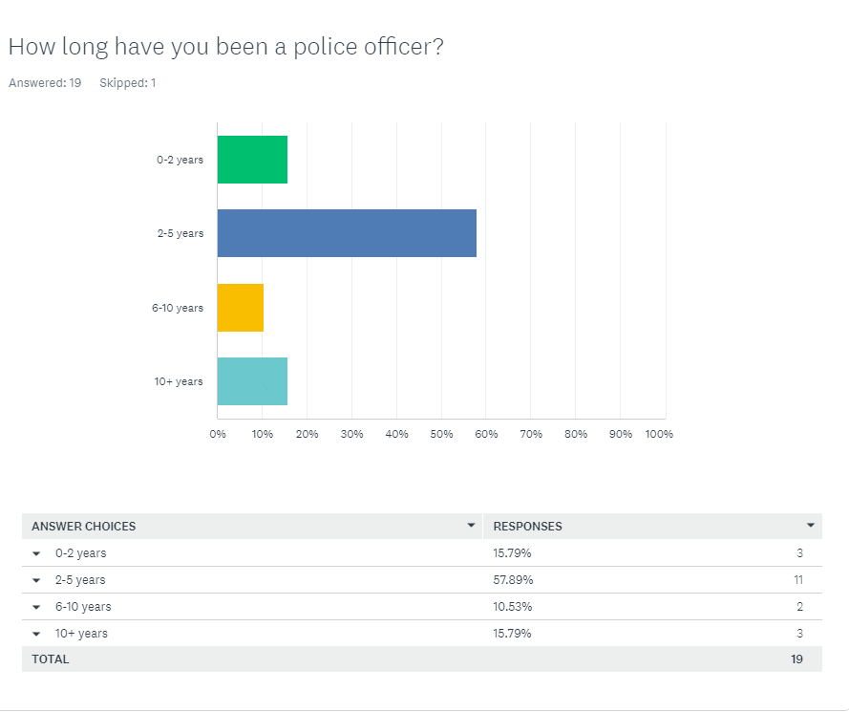

This question I believe is a very important first question, even though it is a simple one it helps me to understand my participants. Having this question at the start allows me to clearly see the experience level of the officers completing my questionnaire and assisting me with my study. I believe a wide range of officers have been asked, however relating back to the problems and limitations part of my work, I still feel as though having asked more officers would have helped me get more with 10 plus years’ experience, and 0-2 years’ experience. Allowing for participants in these categories to be understood further, in regards to their opinions on the matter.

3.5.2 Question 2
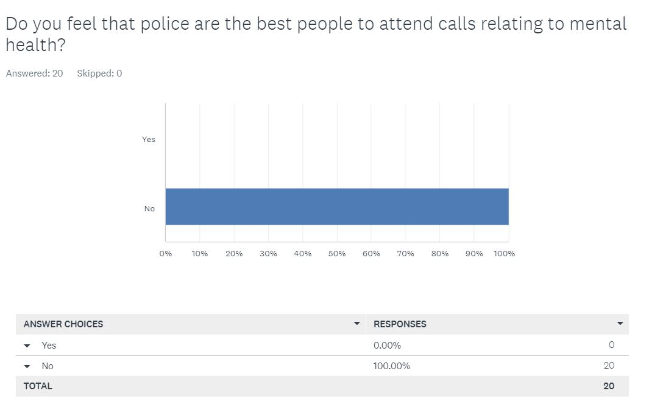
As previously mentioned, only police officers were asked this question. I feel as though the fact that 100% of the participants have given the same answer, shows clearly that police officers feel strongly, and obviously all have the same opinion about attending and dealing with mental health calls when policing. Having asked officers with a range of service, shows that no matter their level of experience or expertise, they think the same on the matter as someone who hasn’t been in the job very long. I think that the officers feel this way due to paramedics being better suited to this type of situation, in terms of the mental health element and a hospital and or mental health unit is a better place for the person suffering. When risk is involved though, ambulance control room will assess the situation, and the paramedics will not go without police presence if there is mention of a risk to them. To resolve this, and allow less involvement from police, more conflict management and resolution training could be given to the other parties, to lessen that involvement from the police when their services are not required.
In addition to this, my participants work in all different areas of South Wales Police, it is easy to see that regardless of where they work within the area, their opinion on the matter has not changed. This emphasises the idea that police attend more mental health related calls than they are actually needed for.
3.5.3 Question 3
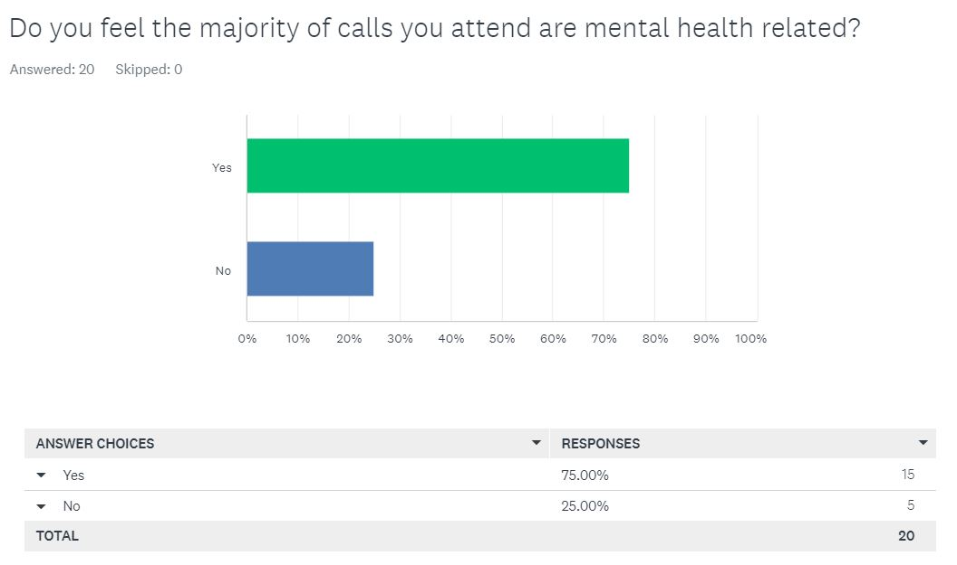
Upon reviewing this question, this a 50% difference between yes and no. In relation to the previous question this also gives me the impression that when attending these calls, the officers do not feel as though they should be the ones present. This can have an overall effect on the officer’s own welfare as they could be better use using their skills at another call that may not be resourced. From analysing the data provided so far it clearly shows that they attend a wide range of mental health calls, even though there are other partner agencies, better equipped and better trained to deal with these types of calls.

3.5.4 Question 4
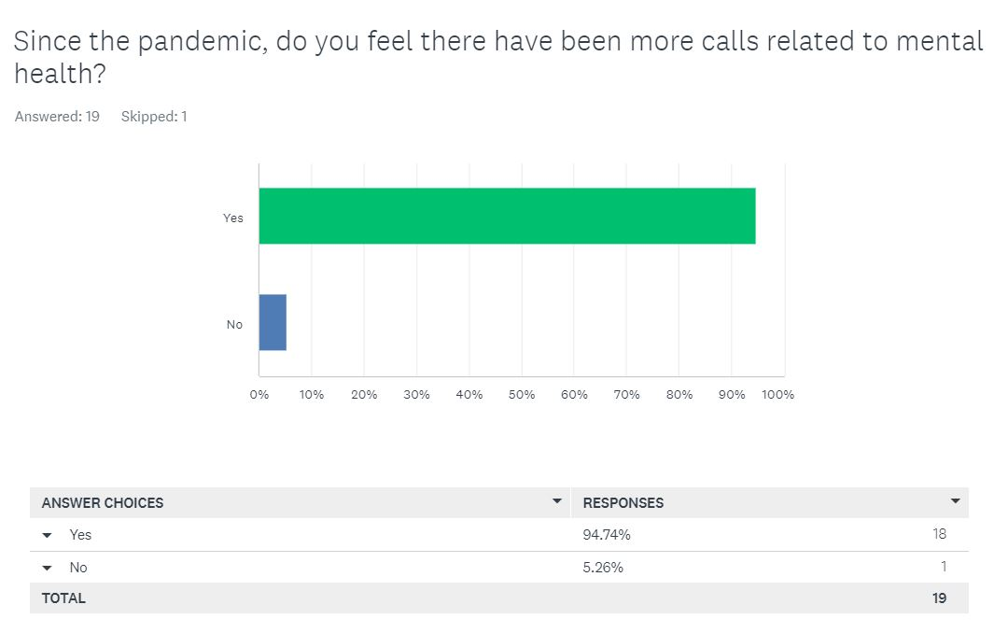
Firstly, one of the participants skipped this question, I can only assume the reason for them doing so is as they were not a police officer at the time and would not be able to accurately express their opinion on the matter. However, it could have still been answered considering their own views of mental health during and after the Covid period. From analysing the above results, it’s clear to see that the participants feel as though Covid had and continues to have a lasting effect on individuals mental health. I believe this is because of people not being able to do their daily routine, that some people rely on, not being able to see loved ones and family and friends, as well as struggling financially due to many jobs not paying their employees. All these factors along within the lack of human contact, I believe have had a lasting effect on people, which overall has caused an increase in mental health calls and scenarios, post lockdown and coronavirus. This is clearly evidenced by the statistics shown in the bar chart above.

3.5.5 Question 5
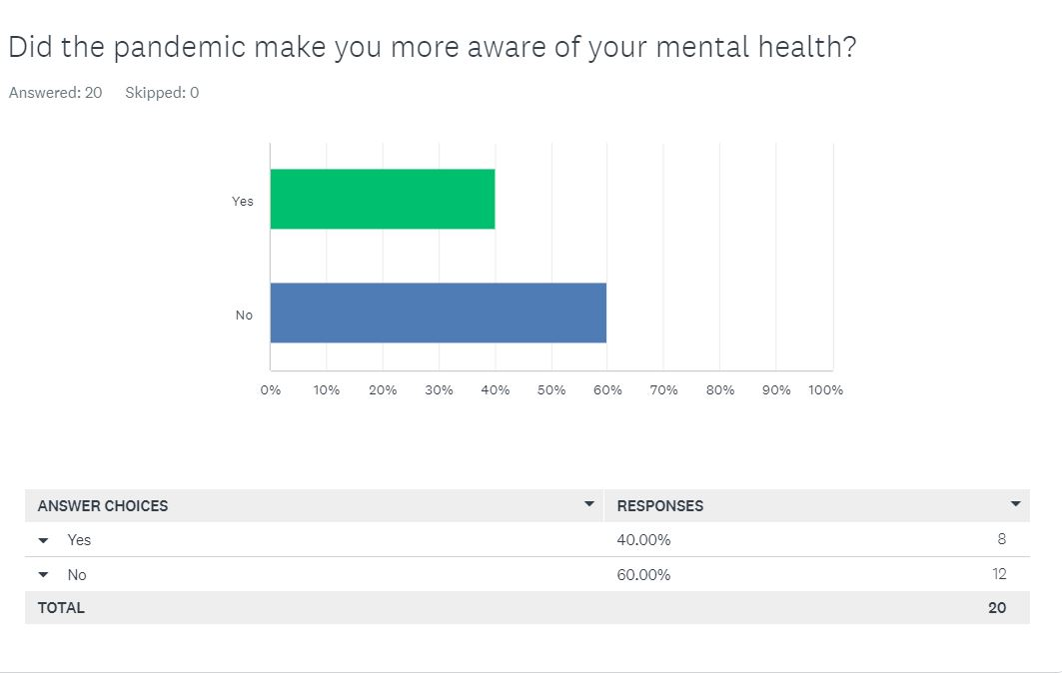
Upon analysing this question, it is clear to see that there is a close split with a percentage of 40 saying yes, the pandemic made them more aware of their mental health, and a percentage of 60 saying no, the pandemic did not make them more aware of their mental health. This can may be due to them already being aware that they suffer with some form of mental health issues, if this is the case, I will look to discover this later in my questionnaire. Reviewing these results shows that out of my 20 police officer participants, more than half of them, suffered and or became aware of their mental health during and after the pandemic. Realising this and accepting assistance when it is required, especially in a job that can be very stressful on times is very important. The police offer many internal methods of assistance to aid in the healing process, when officers acknowledge and or suffer with their mental health, it is important to seek the help that is on offer or find ways to manage it appropriately.

3.5.6 Question 6
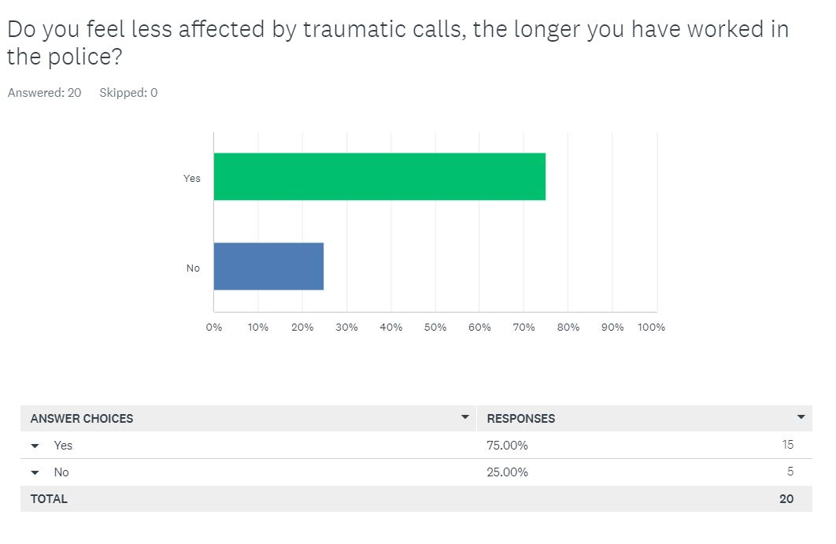
Next, I will be linking this question into number 1, where it shows that just over 25 percent of my participants have served 6 years or more in the police, by this time these officers would have experienced and attended an unimaginable range of traumatising and high intensity incidents. Upon reviewing question 6 it can be shown that 75 percent of my participants feel less affected by traumatic experiences the longer they have been a police officer, I feel strongly that from the 25 percent in question 1, all of them, or most of them are in the 75 percent of question 6. This is due to them becoming more accustomed to the demands of the job, and the things they see daily. Things that some people who are not police officers or emergency service workers, may never see in their lives, let alone each day when they go to work.

3.5.7 Question 7
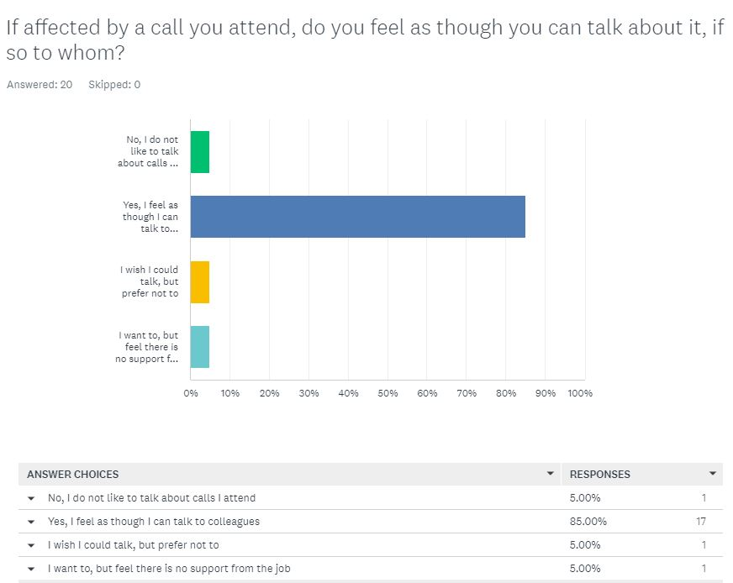
In this question there are four options, and all four options have been chosen by the participants which shows there are several different opinions on the matter at hand, this is good as it shows there are a range of mixed beliefs when the officers focus on this question. This question identifies if an officer is affected by a call, and the different ways they deal with it, or on the other hand if they decide to keep it to themselves. 5 percent of the participants stated that they do not like to talk about the calls that they attend. Upon doing this and keeping it to yourself, it can have an overall negative affect on one’s mental health, and as discovered, keeping it to yourself is not the best way to deal with the issue as it will only continue to worsen and eat away at you. Therefore, I believe it is important to seek help provided.
The second option is the one where 85 percent of the participants stated that they feel as though they can talk to their colleagues. I believe this to be the most popular opinion as the officers more often than not attend the traumatic incidents together, this allows them to relate and talk honestly about the way the traumatic incident made them feel, they can all then reflect on the incident together allowing for a place where they can feel heard and understood, as the people they are speaking to have gone through the same thing and or something similar, multiple times before.
Thirdly, 5 percent of the participants stated that they wish they could talk but prefer not to. This could be down to feeling as though they have no support professionally, or it could also link into option 2. On this occasion, they may not get along with their colleagues, so feel as though they cannot voice their opinions and mental health issues, due to lack of support from colleagues. If this is the case, they could seek help from the professional services provided internally by the police.
Finally, the last option of this question relates to people that would like to speak, however feel that the job offers no support. 5 percent of the participants voiced that this is the way they feel. This could be due to not knowing where to find the support. After a traumatic incident is identified, supervisors can put in something called a TRIM referral for colleagues, TRIM, then assist with officers affected mentally by calls they attend will reach out and assist, however if the officers does not raise their concerns, and a referral is not sent out, the officer may not know how to seek the help they need, on their own.

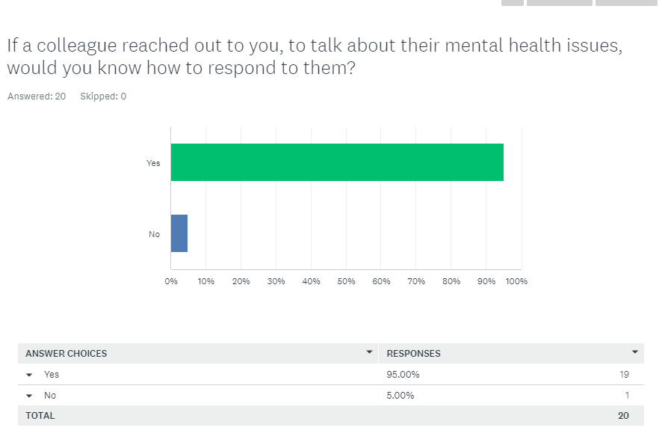
3.5.8 Question 8
In the last question, 85 percent of participants said that they feel as though they can talk to colleagues when struggling with their mental health, or after a traumatic call. This question is similar as 95 percent of participants stated that they would know how to help if a colleague that was struggling with their mental health, reached out to them. I believe these findings to be a positive result as it shows people are more than willing to help others and consider themselves approachable. I believe this because it shows that most of the participants feel that if they are struggling with issues involving the role of a police officer or their everyday life, they know they have someone to speak to. It as well shows that if somebody who had the same issue, came to them for assistance, they would know how to help and how to talk to them.

3.5.9 Question 9
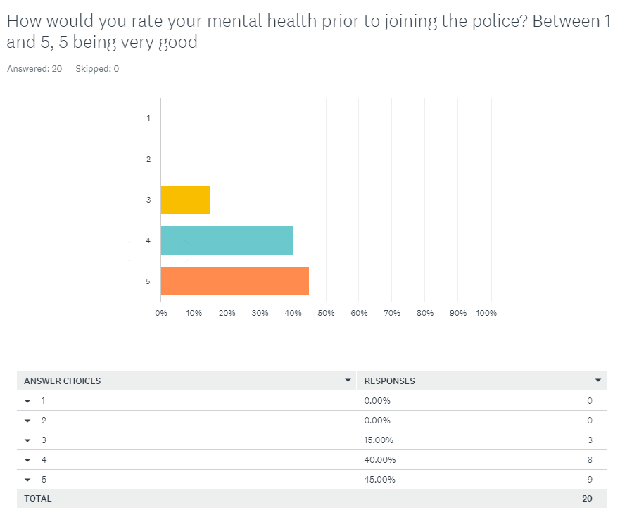
For question 9, the participants were asked to rate their mental health on a scale of 1 to 5 prior to joining the police, 5 being very good. In these findings, 15 percent gave the answer of 3, 40 percent gave a 4 and 45 percent gave a response of 5. Overall, most of the participants showed in this question that their mental health levels were good, there were no 1s or 2s. In this next part of the analysation segment of my dissertation, I will look to compare the findings from question 9, with the findings of question 10. Question 10 being like 9, however this is now asking the participants to rate their mental health out of 5, since becoming a police officer. The two questions will then be compared.

3.5.10 Question 10
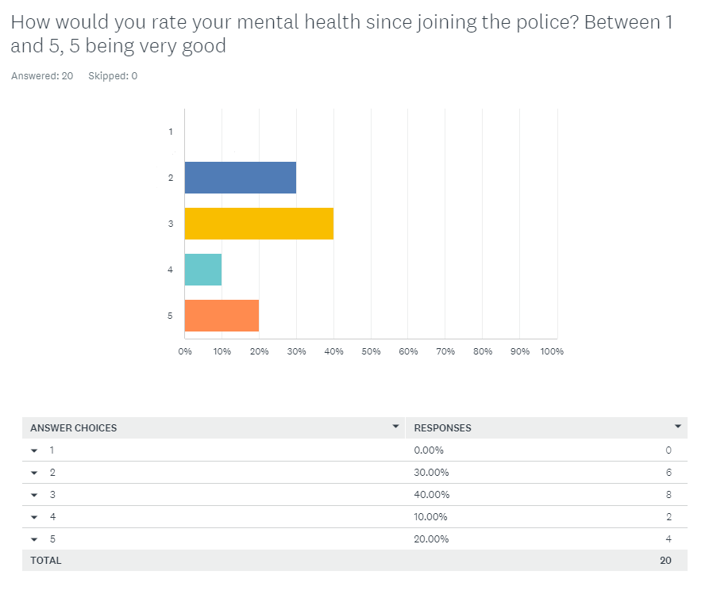
As you can see, there have been several shifts and changes in the two charts provided in question 9 and 10, meaning that the participants mental health, has seen a change, after becoming a police officer and experiencing traumatic incidents. The following is a comparison of the 2.

3.6 The comparison of 9 and 10
In both question 9 and 10, no participants stated that their mental health was a 1. This means that none of my 20 police officer participants had a particularly low level of mental health prior to joining the police, nor during and after they have become a police officer. However, we have seen a change in the results which will be analysed thoroughly throughout this part of the dissertation.
In question 9, none of the 20 participants stated that their mental health was at a 2, however I can see upon examining their responses in question 10, 30 percent of the participants, showed that their mental health had decreased to a 2. This is a clear indication that at least 6 of the 20 participants, can say honestly, that they have seen a decrease in their wellbeing from becoming a police officer, and upon their completion of this questionnaire, that is how they currently feel.
Also, in question 9 where 15 percent of my participants gave their answer as a 3, another drastic change can be seen in the answers shown in question 10. There was an increase to 40 percent. In question 10 this answer had the greatest number of votes, whereas in question 9, people were happier prior to joining as the majority voted answer 4 and answer 5. These statistics alone show officers mental health decreasing since joining the police which could be down to a number of factors.
As stated above, a clear decrease can be seen in the participants happiness since they joined the police. The votes on question 9 for the answers 4 and 5 were most of the participants. The answers for 4 being 40 percent, and the answer for number 5 being at a high ofc 45 percent, almost half of the participants.
In question 10, the answer for number 4 decreases by a massive 30 percent, and the answer for number 5 on question 10 decreases by a quarter of the participants. This again is a clear indication that the participants happiness and or mental health has decreased since they have become police officers.

Chapter 4- Conclusion and Recommendations
4.1 Summary
In this chapter I will conclude my dissertation by tying in what has been stated earlier and reflecting on future needs.
An initial review of current research on mental health in policing, highlighted that there is currently a gap to be filled in terms of the research relating specifically to how officers are affected by traumatic incidents in different ways, depending on how long they have served within the police. Having identified this gap I focused my research on discovering my own findings on the matter.
Data was collected via the questionnaire that I created, when creating it I focused specifically on aspects that I felt needed to be focused on, as well as the gap that I had previously identified and mentioned. The officers that participated in my questionnaire had a range of different amount of service, allowing my results to be accurate and for any anomalies to be easily identified and highlighted.
My sample group of 20 participants who are currently also serving police officers, identified that the larger amount of service that you have within the police, the less effected by feel by the traumatic incidents that you attend as part of your role. As well as this my participants helped me identify that they felt as though, becoming a police officer overall has had a negative effect on their mental health, although not the case for all participants, it was the case for many, which is again highlighted in my study.
My study was limited by the fact that I only had 20 participants, had I had considered allowing another 10 to 15 participants, it would have allowed a wider variety of data to be collected, reviewed and analysed.
4.2 Evaluation of aims
Upon reviewing my objectives, I have learnt that there are a multitude of different methods that are in place, to help serving police officers with their mental health. I have discovered that people are becoming more aware of their mental health, especially since Covid, to assist with this the methods of assistance are becoming more advanced. My research has helped me to discover also if when struggling with their mental health, they know how to reach out, most participants stated that they do.
From my research I have also learnt that police officers feel as though they are attending more and more mental health calls. Sometimes even when they are not required or not the best suited form of public service. Furthermore, my research has taught me that the longer police officers serve, the more accustomed they are to traumatic incidents.
Given the opportunity to repeat my study, I would include more participants. I would also consider asking officers from other forces their opinions on the matter. This would allow an insight into how the different forces assist their colleagues when they are suffering with mental health, the overall wellbeing of their officers and also how the officers choose to deal with the trauma.
4.3 Future needs
The outcome of my research provided insight into South Wales Police officers views and opinions relating to the topic of mental health, but it also highlighted the need for future research which went beyond the scope of my study.

Bibliography
London Assembly. (2017). Increased demand on MPS related to mental health. Available from: Increased demand on MPS related to mental health | London City Hall (Accessed 24 July 2024).
Metropolitan Police service. (No Date). Information on police officers mental health issues in London. Available from: Information on Police Officers' mental health issues in London | Metropolitan Police (Accessed 24 July 2024).
National Institute for health and care excellence. (2018). Mental health and the NHS what’s changed and what’s to come?. Available from: Mental health and the NHS (nice.org.uk) (Accessed 24 July 2024).
NPCC. (2023). 1M officer hours saved with new approach to mental health. Available from: 1M officer hours saved with new approach to mental health (npcc.police.uk) (Accessed 27th July 2024).
Nuffieldtrust. (2022). Mental health. Available from: https://www.nuffieldtrust.org.uk/news-item/mental-health-indicator-update?gad_source=1&gclid=EAIaIQobChMIteLvrIqvhwMVspJQBh18-AxtEAAYASAAEgIOXvD_BwE (Accessed 17/07/2024).
University of Oxford (2023) Young peoples mental health deteriorated at greater rate during the pandemic. Available from: Young people’s mental health deteriorated at greater rate during the pandemic | University of Oxford (Accessed: 27th July 2024).
University of Portsmouth (2022) Police officer resignations have risen by 72% in the last year – we asked former officers why. Available from: Police officer resignations have risen by 72% in the last year – we asked former officers why | University of Portsmouth (Accessed: 28th July 2024).

