Kim Richards
Contemporary Developments in Employment Relations
Unit No/s – 5DER
March 2018

Contents

Introduction 3
Question 1 – Context of ER 4
External factors affecting the employment relationship 4
Other factors identified to the breakdown in relationships 4
Indeterminacy of the employment relationship 5
Pluralist and unitarist approaches of employment relationships 6
Question 2 – Employment Law 7
Describe and critique the essential features of different contracts of employment that can be used 7
Main sources of UK and EU employment relations in law-making 8
Changes in employment law 9
Trade Union Act 2016 9
Working Time Regulations 1998 10
The role of trade union and the scope of statutory trade union recognition 10
Question 3 – Employee Voice 12
The difference between employee involvement, participation and partnership 12
Employee Involvement 12
Employee Participation 13
Employee Partnership 13
Union and non-union forms of employee representation 13
Union employee representation 13
Non-union employee representation 14
Employee voice and organisation performance 14
Question 4 – Conflict 15
How should the conflict be resolved…. 15
Distinguish between conflict and misbehavior and between official and unofficial industrial action 15
Trends in types of conflict and industrial sanctions 16
Individual disputes 16
Employment Tribunals 17
Recommendations 18
Skills needed to advise, coach and guide managers for effective grievance/dispute handling 18
Dispute resolution approaches 19
Individual disputes 19
Collective disputes 20
Collective arbitration 20
Collective mediation 21

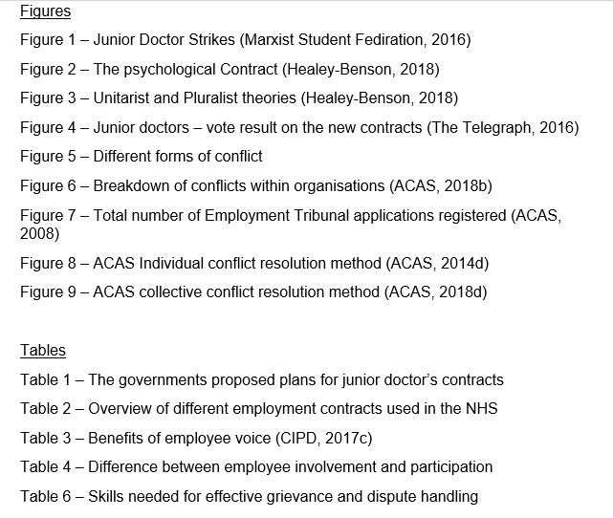

Introduction

This essay will outline the NHS Junior Doctors dispute of 2016. It was announced that The Department of Health was to re-write the contracts for junior doctors (doctors below consultant level). The new proposals would affect how much junior doctors get paid, working hours and decisions around which specialties they choose to train in. The government is changing the contracts based on recommendations by an independent body called the Review Body on Doctors’ and Dentists’ Remuneration (DDRB).
Collective negotiations between the British Medical Association (BMA), the NHS and the government over new junior doctors’ contracts initially began in 2013. In the autumn of 2015 members of the BMA voted to strike over their continuing disagreement with the government (Full Fact, 2016).

Figure 1 – Junior Doctor Strikes (Marxist Student Fediration, 2016)


Question 1 – Context of ER

External factors affecting the employment relationship

The external factors that are affecting the employment relationship are difficult economic conditions created by government measures to reduce public expenditure. The NHS is subject to acute economic austerity and fighting the imposition of the proposed contracts is the same fight against austerity generally. The world economic market has been in crisis since the downfall in 2008 and the growth on a world scale is the longest ever seen. Austerity has resulted in the slowdown of the global market and the government will then aim to reduce spending by maintaining the essential services. In previous years there has been opposition to the cuts however to date has not prevented the attack of austerity mainly due to a lack of political expression until the election of Jeremy Corbyn as Labour Leader in September 2015 (Marxist Student Fediration, 2016).
Having already made cut backs to the welfare system the economy was still struggling, and it was only a matter of time before Junior Doctors came under scrutiny. The aim of austerity is to reduce public spending on junior doctors and potentially starve the NHS of funds.
Other external factors include increasing choice and competition in health and care markets. Expansion of non-NHS healthcare, growing opportunities on international healthcare markets and the EU moving in to direct healthcare policy (Evennett, 2018).

Other factors identified to the breakdown in relationships

The government has described the current contracts as outdated and unfair, pointing out they were introduced in the ‘90s. Ministers drew up plans to change the contract in 2012, but talks broke down in 2014 and restarted again in 2015. The government intends on improving the service in becoming a seven-day week operation. However, with junior doctors already working weekends under the new proposals it is intended on making Saturdays part of normal working hours (BBC News, 2016). In addition to this an extension of standard working time from 60 hours to 90 hours per week (Marxist Student Fediration, 2016). The government’s proposed plan for junior doctors is as follows: -
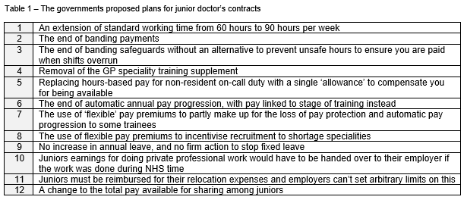

Indeterminacy of the employment relationship

According to (CIPD, 2017a) employee relations has replaced industrial relations as the term for defining the relationship between employers and employees. The characteristic of employment relationship consists of indeterminacy. Employment contract assumes that both parties are in equal way and without any liability involve. However, workers are in a much weaker position than the expected employer due to the UK’s tight labour market. A ‘tight’ labour market is one in which employers are obliged to compete fiercly to secure the services of the people they require. This occurs when there are fewer people looking for jobs than there are available. In other words demand for people outstrips supply resulting in employees having increased bargaining power. In some cases labour markets are always tight as the skills needed are limited (Taylor, 2014). Conditions in the UK labour market vary depending on the position of the economy, the number of people with the skills that organisations are seeking and levels of unemployment (Woodhams, 2016).
By contrast, when people are in plentiful supply, labour markets are ‘loose’. In the opinion of Taylor (2014) these are easier to manage from a resourcing perspective. Vacancies are easy and cheap to fill quickly and it is less vital to ensure that people are content in their employment. In a loose market unemployment rates are high with demand for jobs outstripping supply, skills are more readily available and the employer has increased baragining power (Taylor, 2014).
The labour market trends may impact on the psychological contract. The term ‘psychological contract’ refers to subject expectations, beliefs and obligations, as perceived by the employer and the worker (CIPD, 2018a). The psychological contract refers to the unwritten set of expectations of the employment relationship as distinct from the formal, codified employment contract. Taken together, the psychological contract and the employment contract define the employer-employee relationship (HR Zone, 2018) as outlined below: -

Figure 2 – The psychological Contract (Healey-Benson, 2018)
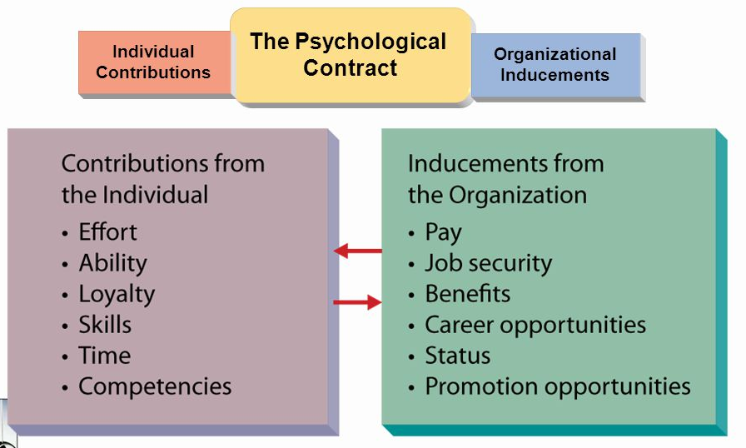

Breaches of the psychological contract can have a detrimental effect on the relationship between employer and employee, leading to disengagement, reduced productivity and in some cases workplace conflict and defiance. Fairness is an important part of the psychological contract, bound up in equity theory – employees need to perceive that they’re being treated fairly to sustain a healthy psychological contract (HR Zone, 2018).

Pluralist and unitarist approaches of employment relationships

There are two basic theories of employee relation. The first one is the unitary while the other is pluralistic approach. The main differences are outlined in figure 3 below:
Figure 3 – Unitarist and Pluralist theories (Healey-Benson, 2018)

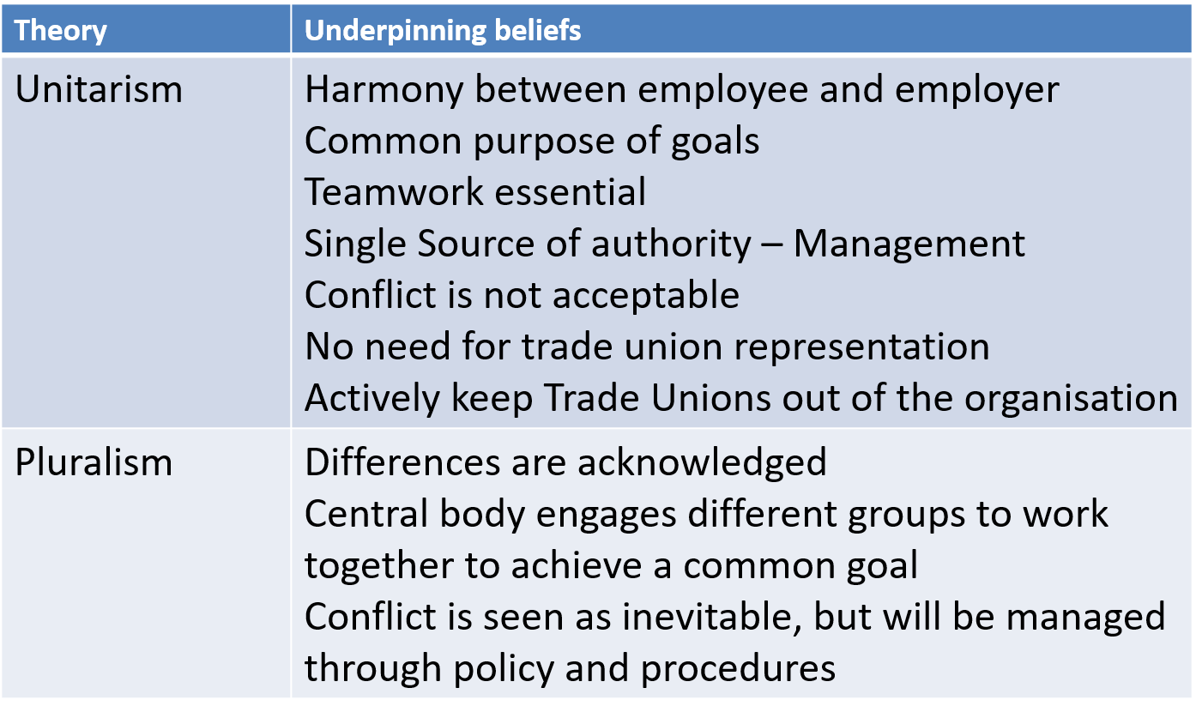

The assessment of these two theories would assist in analysing their impact on management on the employee relation by resolving conflict. Unitary approach considers every organisation to be an integrated unit which is devoted towards accomplishing the common interest. the pluralists are of the view that conflict is essential in organisations and can be managed through different arrangements. Pluralist accepts the existence of multiple source of power and considers different opinion from the management and trade unions. Trade unions are vital in promoting the interest of the employees and employee relation can be achieved through negotiation and agreement between management and trade unions.
With it’s strong union presence the NHS has a strong pluralistic approach of employee relation. Conflict is resolved with the participation of the stakeholders (Public, government, Managers, employees, trade unions) in the decision-making process. It is believed that conflict is used to understand the basic shortcomings within the organisation and developing effective strategies will help to avoid circumstances even in future. This type of approach is ground in the organisation which has large number of employees. Pluralist approach is more effective in resolving in large organisation as compared to that unitarist perspective.

Question 2 – Employment Law

Describe and critique the essential features of different contracts of employment that can be used

Contracts of employment are legally binding agreements between an employee and employer. They consist of express terms that are written in the employment contract (job title, rate of pay, hours of work etc.) and implied terms which are not expressly stated (mutual trust, safe systems of work, equality etc.). Although employment contracts are governed by contract law, there are statutory rules which affect employment contracts too (CIPD, 2017b). Organisations having clear contracts enabling both employer and employee to understand the basis that the employment has been agreed is good practice in addition to following the law (CIPD, 2017b).
There may come a time when either party that are bound by a contract may want to change it. This could be because the employer may need to change working hours due restructuring the organisation due to economic changes or an employee might decide to alter their hours for domestic reasons or seek an increase in salary. Changes can be made individually or collectively and are usually varied with the agreement of both parties (ACAS, 2018a).
The NHS utilise a range of different employment contracts to provide the level of cover and service required across all areas. The below table demonstrates the value and benefits of each contract type: -

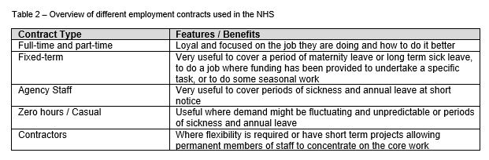

Main sources of UK and EU employment relations in law-making

Employment law exists to regulate the relationship between businesses and their employees. By complying with relevant legislation, both employers and their staff members can ensure that their hiring processes, dismissal processes, and their workplace, are fair for every individual. Employment law also helps us combat discrimination, and effectively promote equality at work (Reed, 2018).
UK employment law originates in three places: in Parliament through the legislative process, in the courts through judicial decisions and in European Union institutions (CIPD, 2016). Acts of Parliament are sources of primary legislation in which the key principles of the law are set out. Important acts relating to employment law include: -
- Employment Rights Act 1996
- Employment Act 2002
- Equality Act 2010
- Enterprise and Regulatory Reform Act 2013
- Trade Union Act 2016
While the Acts are in draft format and under consideration by Members of Parliament they are called Bills (CIPD, 2016). Before a bill can officially become an Act, it must have Royal assent and the Queen must give it her formal approval.
Statutory instruments are a form of delegated legislation or secondary legislation. These are issued by ministers under Acts of parliament. They are sets of regulations and orders containing a lot more detailed legislation than is found in their ‘Parent Acts’. EU law is implemented in the UK through delegated legislation of this type because the European Communities Act 1972 allows ministers to give effect to European directives using delegated legislation without a vote needed in parliament (CIPD, 2016). Examples of statutory instruments from employment law are: -
- Working Time Regulations 1998
- Transfer of Undertakings (Protection of Employment) Regulations 2006
- Parental Leave (EU Directive) Regulations 2013
European law is derived from three principle sources: EU directives, treaties and regulations. European law became a further source after 1973 when the UK joined the European Economic Community, which subsequently evolved into the European Union. The impact of the UK’s membership of the EU in employment regulation grew considerably after 1997 when the Social Chapter of the Maastricht Treaty started to apply (CIPD, 2018b). The treaty enforced the principle of equal pay between men and women although was already being introduced in the UK at the time. EY employment law has expanded and now covers the following: -
- Health and Safety
- Transfers of undertakings (TUPE)
- Discrimination on grounds of sex, race, ethnicity, national origin, disability, age, sexual orientation and religion/belief
- Working Time
- Data Protection
- Information and consultation
- Part-time and fixed-term employees and agency workers
- Family-friendly rights
Sometimes EU labour law requires Parliament to amend existing laws and bring in to line with the EU. Also, it has been a requirement for the UK to create entire new employment rights which would not exist if the UK was not an EU member (CIPD, 2018b).

Changes in employment law

The following changes in employment law has affected the conflict in the NHS with junior doctors: -

Trade Union Act 2016

In May 2016 the Trade Union Act set out to protect people from undemocratic industrial action following a series of modernised reforms announced by the Government in 2015. In summary, the Act was introduced to ensure strikes can only go ahead because of a clear democratic mandate from union members, with a view to uphold the option to strike whilst reducing disruption to millions of affected people.
Initially there was confusion over which parts of the health service would be regarded as ‘important public services’ and would therefore be subject to the 40% support threshold. This has now been clarified and the following sectors will be regarded as ‘important public services: -
- Services provided in an emergency by an ambulance or associated transport service, including dealing with calls for help and organising their response
- Accident and emergency services in a hospital
- Services which are provided in high-dependency units and intensive care in a hospital
- Psychiatric services provided by a hospital for conditions which require immediate attention to prevent serious injury, serious illness or loss of life; and
- Obstetric and midwifery services provided by a hospital for conditions which require immediate attention to prevent serious injury, serious illness or loss of life (Hempsons, 2017).

Working Time Regulations 1998

These Regulations govern the time that people may work. The Regulations apply to all workers and specify minimum rest breaks, daily rest, weekly rest and the maximum average working week. First, it sets a default rule that workers may work no more than 48 hours per week (although you can opt out). Secondly, it granted a mandatory right to paid annual leave of at least 4 weeks (including bank holidays and public holidays). Thirdly, it creates the right to a minimum period of rest of 20 minutes in any shift lasting over 6 hours (HSE, 2018). With the government intending on improving the service of the NHS in becoming a seven-day week operation then junior doctors will have to consider ensure they understand the following impacts on WTR: -
- That they are supported, informed and understand their position regarding the working time regulations
- They understand the situation regarding indemnities
- They appreciate it is in their interests to check they accurately record the hours they work
- They understand that opting out is an individual right and wholly voluntary
- They understand that any opt-out is an agreement between them and their employer in writing (RCPCH, 2009).

The role of trade union and the scope of statutory trade union recognition

Trade unions have been around for decades to resist through equal bargaining power the domination of employers over employees and to represent workers’ interests in the employment relationship. It is through union efforts that workers benefit from better pay and working conditions, and that they are treated with dignity and respect at work (Williams, 2018). Unions achieve their aims through: -
- Negotiation of agreements
- Collective agreements
- Grievance
- Industrial Action
- Use of third party intervention
- Joint consultation
- Campaigns
- Delegations
- Lobbying
- Pressure groups
- Sitting on UK/EU Government advisory committees
- *At international level (Global union federations)

All 58 unions within the UK are affiliated to The Trades Union Congress (The TUC) which is an umbrella group for trades unions within the UK. The TUC unions to draw up common policies, lobby government, campaign and represent British workers on international bodies in the EU and the International Labour Organisation. The TUC's decision-making body is the annual congress, the unions' equivalent of a political party conference. For four days in September delegates from each affiliated union meet to discuss motions, which then form the basis of the TUC's work for the next year (BBC News, 2008).

The British Medical Association (BMA) is the professional association and registered trade union for doctors in the United Kingdom. They have had a big impact in the collective negotiations on the junior doctor contracts. During 2016 new contracts proposed by the government for junior doctors was rejected by the BMA after 58% of medics opposed it. This followed six strikes including the first full walk out and the first in the history of the NHS. The Industrial action was backed by 98% of junior doctors in a ballot only months prior (The Telegraph, 2016).

Figure 4 – Junior doctors – vote result on the new contracts (The Telegraph, 2016)
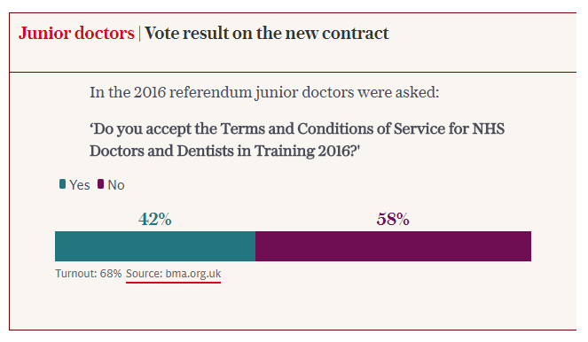

The government made a series of concessions resulting in a deal backed by BMA causing head of the union’s junior doctors committee to resign following a vote against the new contract. In a message to medics, Dr Yannis Gourtsoyannis, a member of the BMA’s junior doctors committee (JDC) detailed plans for repeated and crippling strikes, increasing pressure on NHS services as the winter approached. The BMA stated it would be the trade union dispute of the century.
This caused concerns with the chief executive of the NHS saying ‘industrial action achieves little or nothing’ but placed extra pressure on already stretched services and causes worry and disruption for patients (The Telegraph, 2016).
The BMA were key during the collective negotiations on the junior doctor contracts. An agreement was reached on the introduction of a 'guardian of safe working hours' in organisations that employ or host NHS trainee doctors to oversee the process of ensuring safe working hours for junior doctors.

Question 3 – Employee Voice

The difference between employee involvement, participation and partnership

Employee voice is how employees communicate their views to their employer and express their opinions and have meaningful input into work related decision making. It’s the way employees can influence matters that affect them at work. For employers, effective voice contributes toward innovation, productivity and business improvement. For employees, it often results in increased job satisfaction, greater influence and better opportunities for development (CIPD, 2017c). Giving employees a voice allows them to be legitimate stakeholders in the employment relationship and in turn allows them to feel valued and builds a trustful relationship. There are benefits to employee voice for employees, employer as outlined in table 3: -
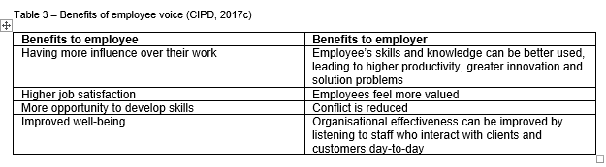

Employee Involvement

Employee involvement is a one-on-one method between the employee and employer. It is a direct approach of managing a work project as the individual is involved in all aspects of the decision making. This allows the individual to take ownership od the outcome of the project. The employee makes decisions with the managers encouraging the employee to be more involved and share their ideas for improvement (Morreaux, 2018). Managers may engage with employees to gain their ideas via email, briefings and newsletters.

Employee Participation

Employee participation involves an employee participating in a work activity and shares the activity with others thus forming a team with the employee. The team provides the forum where the employee can make suggestions to make the activity more effective and decisions about his portion of the team’s activity. All team members are encouraged to participate no matter how small or large their involvement (Morreaux, 2018). Employees may participate through forums, committees and joint consultations.

Employee Partnership

There is no commonly agreed definition to employee partnership. Employers, Tus, unions, academics & other interested parties have different ideas of what partnership is or should be. Employers often argue that 'direct' employee involvement e.g. teamwork and problem-solving groups in non-union enterprises can constitute partnership while unions would argue that partnership in any sense must provide independent collective representation for workers as a counterbalance to employer power.
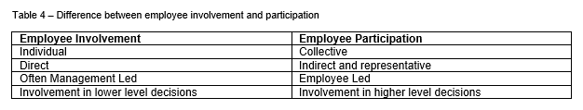

Union and non-union forms of employee representation

Union employee representation

A union employee representative is an employee of an organisation elected or appointed in accordance with the union rules to represent union members in a company, or group of companies, where they also are an employee (ACAS, 2014b). It is the role of the union representative to: -
- Discuss any concerns you have about your employer
- Go with (‘accompany’) employees to disciplinary or grievance hearings with management
- Represent employees in negotiations (‘collective bargaining’) over pay and terms and conditions of employment
- Meet with the employer to find solutions to workplace issues
- Develop the best possible health and safety procedures with the employer

Union representatives are entitled to reasonable paid time off to carry out their duties providing the union is independent and officially recognized by the organisation. Reps aren’t allowed paid time off to attend union meetings or go to meetings with union officials. Instead, employers should allow unpaid time off for these activities. Reps aren’t allowed any time off for industrial action (gov.uk, 2018).

Non-union employee representation

Non-union representatives of employee safety are appointed in workplaces where no union is recognised, or where groups of workers are outside the scope of union recognition. It is estimated that around half of employee representatives in the UK are non-union. Their role tends to be much more restricted than that of their union counterparts, being limited in the main to consultation (ACAS, 2014a). In some cases, for example in dealing with collective redundancies and the transfer of undertakings in firms which do not recognise trade unions, non-union representatives have statutory rights to facilities, time off for training and facility time.

The roles of union and non-union representatives have a lot of similarities however union representatives have the backing and support of the wider union and also have legal protection.

Employee voice and organisation performance

Employee voice is a key component in the productivity puzzle, according to Sir Brendan Barber, Acas Chair (ACAS, 2016). Employee voice covers a broad spectrum, from representation and negotiation to open communication between colleagues on the shop floor. He noted how voice had been linked in research to:
- Higher levels of employee engagement
- Lower staff turnover
- Better business outcomes
Having a lack of communication in any organisation will lead to conflict and employee voice will help facilitate in making a good relationship between employees and employers. Employee involvement and participation is essential for organisation performance and success which leads to enhancing job satisfaction hence leading to organisational performance and productivity. According to CIPD,(2017c) success factors that make for effective employee voice are: -

- Leadership
- Training
- Trust and openness
Companies such as Google and Virgin are prime examples of companies who successfully utilise employee engagement to get the best out of their employees and excel in their performance. Google have been intentional about creating the culture they want. An aspect of that culture is their attention on transparency. The idea is to break down barriers, encourage creativity and collaboration. Employees as a result feel empowered. Culture comes down to behavioural habits and by creating a culture of transparency and freedom, creates habits of creativity. Formalising that people spend 20% of their time doing something outside their normal work function, facilitates a creative culture. Ultimately culture is about ‘how things get done’ and should not be left to chance, it’s too powerful not to take control over and Google has done this well.
Organisations that focus on transparency engaging employees more than those that don’t. Employees want to be a part of something where there are no hidden agendas and they are experiencing an honest perspective whether that is good news or not. Informed employees feel valued and engagement typically follows (Chartered Management Institute, 2015).

Question 4 – Conflict

How should the conflict be resolved…?

Distinguish between conflict and misbehavior and between official and unofficial industrial action

Conflict can be defined as disagreement between two or more parties e.g. individuals, groups, departments, organisations, countries - who perceive that they have incompatible concerns. There are several reasons why conflicts can occur, and this includes poor communication, poor management, difference in personalities, different values, bullying and harassment and competition (Johnson, 2018). Not all conflicts will be visible such as a heated argument as some people might hide their feelings as a way of coping with the issue while cutting themselves off from the organisation. The quicker a problem is identified and dealt with the less chance of it escalating and a better chance of identifying the underlying causes, reaching a sustainable agreement and resolving the conflict quickly (ACAS, 2014c). There are different forms of conflict. Organised – where strikes can occur on a collective basis, unorganised – which tends to be unlawful and short-term and misbehaviour such as sabotage on an individual or collective basis.

Figure 5 – Different forms of conflict

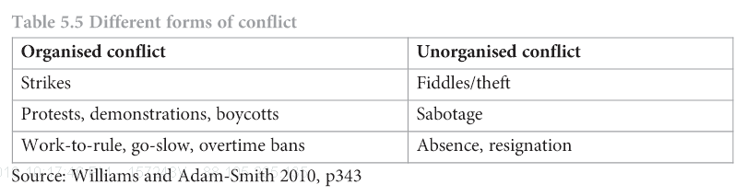

Industrial action is a sign of poor employment relations. Generally, industrial action can be divided into two groups: OVERT and COVERT. These two groups are outlined below: -
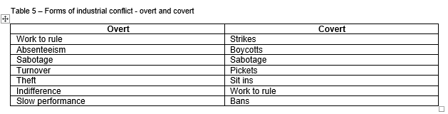
Industrial action is 'official' if it is formally backed by a trade union and members of that union are taking part in it. If you're involved in industrial action against your employer, you'll probably be in breach of your employment contract and you are therefore unlikely to be paid when taking industrial action. However, you will be protected against being dismissed for taking industrial action provided your union follows the right procedure when organising it (nidirect, 2018). This relates to the junior doctor strikes which was an official and organised industrial action
Unofficial industrial action is industrial action that is not organised by and is not the responsibility of any trade union. You normally have no right to claim unfair dismissal if you are dismissed while taking part in this kind of action. Taking part in industrial action when you are not a member of a union is also classed as ‘unofficial’ and could result in dismissal via the disciplinary process.

Trends in types of conflict and industrial sanctions

Individual disputes

Individual conflict may be expressed formally as disciplinary action or employee grievances but also by disagreements and clashes between colleagues and between managers and their staff (ACAS, 2018b). Managers with responsibility for workplace relations stated that overall organisation conflict is rare however, conflict remains a feature for many with many saying they had experienced conflict in the past 12 months: -

Figure 6 – Breakdown of conflicts within organisations (ACAS, 2018b)
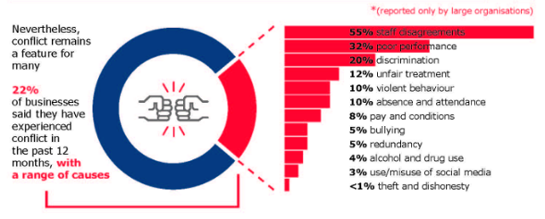

Employment Tribunals

Employment Tribunals (ET) are an independent judicial body established to resolve disputes between employers and employees over employment rights. The tribunal will hear claims about employment matters such as unfair dismissal, discrimination, wages and redundancy payments (ACAS, 2018c). ACAS must be notified before submitting an ET with an attempt to resolve through early conciliation. An ACAS conciliator will attempt to resolve the conflict/dispute between the two parties which is quicker, less stressful and cheaper.
There is no longer a requirement to pay a fee to make a claim to the Employment Tribunal or the Employment Appeals Tribunal. This was confirmed on July 26th, 2017 by the Supreme Court which declared unlawful the Employment Tribunals and Employment Appeal Tribunal Fees Order 2013 (ACAS, 2018c).
Since the early 90’s the total volume of applications to ET’s increased four-fold (figure 7) These were located largely under unfair dismissal and redundancy pay jurisdictions, though claims relating to equal pay, and to sex and race discrimination were also within the scope of the Tribunals (ACAS, 2008).

Figure 7 – Total number of Employment Tribunal applications registered (ACAS, 2008)
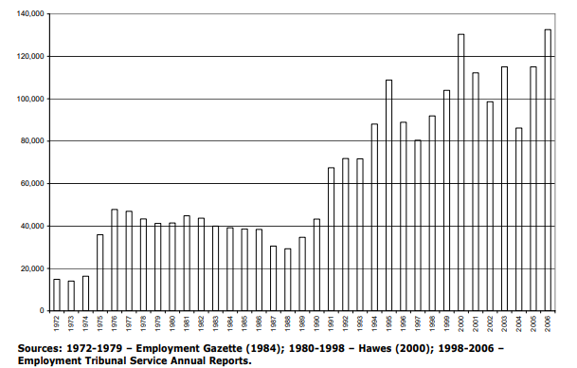

Claims brought against the NHS at ET cover unfair dismissal for breach of patient confidentiality and refusal to take an emergency call; a reasonable adjustment for a diabetic employee; letters about a doctor's fitness to attend court; and relocation resulting in a transferred employee's redundancy (Xperthr, 2018).

Recommendations

Skills needed to advise, coach and guide managers for effective grievance/dispute handling

Managing conflict at work is becoming increasingly challenging for managers. The number of employment tribunal claims are increasing which could be down to the publics increased awareness of their employment rights and the introduction of new employment legislation. It is advised that managers intervene quickly in cases of conflict and deal with it head on (CIPD, 2018c). CIPD have worked in conjunction with HSE to produce a competency framework for managers to effectively handle conflict and disputed in the work place. They cover the following areas giving positive and negative examples of manager behaviour (CIPD, 2018c):-
- Dealing with issues
- Use of official processes
- Participative approach
- Mentoring team relationships
- Acting as a role model
- Integrity

The skills needed to advise, coach and guide line managers in the skills needed to effective grievance and dispute handling procedures are outlined in the below table: -

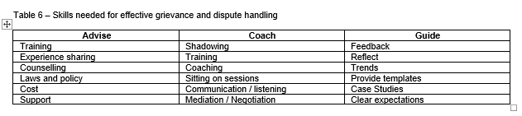

Dispute resolution approaches

Disagreements in the work environment can easily escalate into bigger issues if not dealt with correctly leading employment tribunal claims; others may turn into industrial disputes between groups of employees and the employer. Disputes can be time-consuming and expensive to handle. ACAS can provide organisations with independent, impartial and confidential ways of assisting both parties to resolve disputes and build effective productive working relationships. They can assist individuals and groups of workers and their employers to talk and can help companies to diagnose and work through issues that might lead to disputes (ACAS, 2018d). ACAS (the neutral third party) can assist with the following: -
- Collective Conciliation
- Collective Arbitration
- Collective Mediation

Individual disputes

The resolution of individual conflict has become an increasingly important place in policy debates over contemporary work and employment due to the decline in collective industrial action and the rise in the volume of employment tribunal applications. It reflects a growing concern over the implications of individual employment disputes for those involved but has perhaps been driven by concerns over the cost of litigation and the perceived burden that this places on employers. ACAS provides the following approach as a method to resolve individual workplace disputes: -

Figure 8 – ACAS Individual conflict resolution method (ACAS, 2014d)
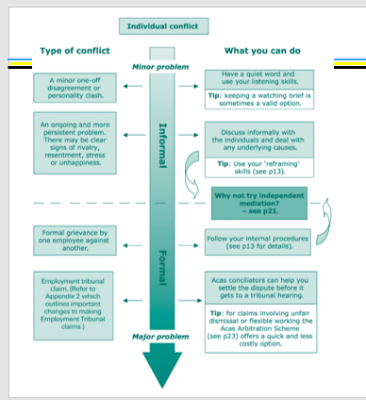

Collective disputes

Collective conciliation is used when an employer and its employees that are usually represented by a trade union are in dispute over an issue and cannot reach a solution. Many benefit from an impartial third party listening to the facts, suggesting where there are strengths and weaknesses in each argument, and helping them find common ground to reach an agreement. Either party can contact ACAS independently to discuss the issue confidentially without any obligation to take it further (ACAS, 2018d).

Collective arbitration

Collective arbitration takes place when parties (an employer and its employees, usually represented by a trade union) have exhausted their negotiating procedures on a dispute and are unable to agree a settlement. ACAS will help the employee and employer agree terms of reference for the arbitration and what they require the decision on. They must both agree to accept the arbitrator’s decision who is impartial. This form of resolution is useful when the dispute is not clear cut (ACAS, 2018d).

Collective mediation

Collective mediation is utilised to support an organisation and its employees (usually represented by a trade union) to resolve a dispute where they are unable to agree a settlement between them. ACAS can provide an impartial and independent third party to help parties to find a solution usually through drawing up terms of reference and agreeing to seriously considering their recommendations. Mediation is voluntary and confidential (ACAS, 2018d)

ACAS provides the following approach as a method to resolve collective workplace disputes: -

Figure 9 – ACAS collective conflict resolution method (ACAS, 2018d)

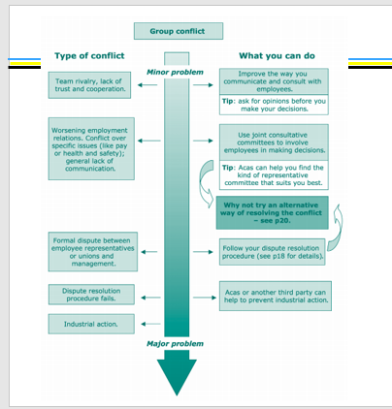

References
ACAS, 2008. Conflict at work: The pattern of disputes in Britain Since 1980. [Online]
Available at: http://www.acas.org.uk/media/pdf/f/j/Acas_Research_Conflict_at_work_03_08-accessible-version-July-2011.pdf
[Accessed 26 March 2018].
ACAS, 2014a. Non-Union Representation. [Online]
Available at: http://m.acas.org.uk/media/pdf/9/o/Non-union-representation-in-the-workplace-advisory-booklet.pdf
[Accessed 24 March 2018].
ACAS, 2014b. Trade Union Representation. [Online]
Available at: http://m.acas.org.uk/media/pdf/k/k/Trade-Union-Representation-in-the-Workplace.pdf
[Accessed 24 March 2018].
ACAS, 2014c. Managing conflict at work. [Online]
Available at: http://www.acas.org.uk/media/pdf/j/o/Managing-conflict-at-work-advisory-booklet.pdf
[Accessed 25 March 2018].
ACAS, 2014d. Reframing Resolution - Managing Conflict and Resolving Individual Employment Disputes in the Contemporary Workplace. [Online]
Available at: https://moodle.uwtsd.ac.uk/pluginfile.php/151783/mod_resource/content/1/reframing_policy_paper_FINAL.pdf
[Accessed 26 March 2018].
ACAS, 2016. Employee voice is the key to better productivity. [Online]
Available at: http://www.acas.org.uk/index.aspx?articleid=5640
[Accessed 24 March 2018].
ACAS, 2018a. Changing or varying a contract. [Online]
Available at: http://www.acas.org.uk/index.aspx?articleid=3971
[Accessed 17 March 2018].
ACAS, 2018b. Individual workplace conflict - Acas research and policy. [Online]
Available at: http://www.acas.org.uk/index.aspx?articleid=5989
[Accessed 25 March 2018].
ACAS, 2018c. Employment tribunals. [Online]
Available at: http://www.acas.org.uk/index.aspx?articleid=1889
[Accessed 26 March 2018].
ACAS, 2018d. Acas Dispute Resolution. [Online]
Available at: http://www.acas.org.uk/index.aspx?articleid=1697
[Accessed 26 March 2018].
BBC News, 2008. What is the Trades Union Congress?. [Online]
Available at: http://news.bbc.co.uk/1/hi/uk_politics/5321254.stm
[Accessed 18 March 2018].
BBC News, 2016. Junior doctors' row: The dispute explained. [Online]
Available at: http://www.bbc.co.uk/news/health-34775980
[Accessed 17 March 2018].
Chartered Management Institute, 2015. 6 COMPANIES THAT GET EMPLOYEE ENGAGEMENT – AND WHAT THEY DO RIGHT. [Online]
Available at: http://www.managers.org.uk/insights/news/2015/december/six-companies-that-get-employee-engagement-and-what-they-do-right
[Accessed 24 March 2018].
CIPD, 2016. How UK employment law is made. [Online]
Available at: https://www.cipd.co.uk/knowledge/fundamentals/emp-law/about/uk-emp-law-made
[Accessed 17 March 2018].
CIPD, 2017a. Employee relations: an introduction. [Online]
Available at: https://www.cipd.co.uk/knowledge/fundamentals/relations/employees/factsheet
[Accessed March 17 2018].
CIPD, 2017b. Contracts of employment. [Online]
Available at: https://www.cipd.co.uk/knowledge/fundamentals/emp-law/terms-conditions/contracts-factsheet
[Accessed 17 March 2018].
CIPD, 2017c. Employee voice. [Online]
Available at: https://www.cipd.co.uk/knowledge/fundamentals/relations/communication/voice-factsheet
[Accessed 24 March 2018].
CIPD, 2018a. The psychological contract. [Online]
Available at: https://www.cipd.co.uk/knowledge/fundamentals/relations/employees/psychological-factsheet
[Accessed 17 March 2018].
CIPD, 2018b. Employment law: EU and Brexit. [Online]
Available at: https://www.cipd.co.uk/knowledge/fundamentals/emp-law/about/eu-impact
[Accessed 17 March 2018].
CIPD, 2018c. Managing conflict at work - A guide for managers. [Online]
Available at: http://georgejamesltd.com/wp-content/uploads/2017/03/Managing-Conflict-CIPD.pdf
[Accessed 26 March 2018].
Evennett, C., 2018. Summary of the key strategic issues that will shape healthcare over the next 20 years, London: PIRU.
Full Fact, 2016. Junior doctors' contracts: an introduction to the dispute. [Online]
Available at: https://fullfact.org/health/junior-doctors-pay-short-introduction-dispute/
[Accessed 01 March 2018].
gov.uk, 2018. The rights of trade union reps. [Online]
Available at: https://www.gov.uk/rights-of-trade-union-reps
[Accessed 24 March 2018].
Healey-Benson, F., 2018. Employment relations theories. Swansea: Felicity Healey-Benson.
Healey-Benson, F., 2018. The Psychological Contract. Swansea: Felicity Healey-Benson.
Hempsons, 2017. Trade Union Act 2016 – how will the legislation impact on the healthcare sector?. [Online]
Available at: http://www.hempsons.co.uk/news-articles/employment-blog-trade-union-act-2016/
[Accessed 17 March 2018].
HR Zone, 2018. What is a Psychological Contract?. [Online]
Available at: https://www.hrzone.com/hr-glossary/what-is-a-psychological-contract
[Accessed 17 March 2018].
HSE, 2018. The Working Time Regulations. [Online]
Available at: http://www.hse.gov.uk/contact/faqs/workingtimedirective.htm
[Accessed 17 March 2018].
Johnson, R., 2018. What Causes Employee Conflict in the Workplace?. [Online]
Available at: http://smallbusiness.chron.com/causes-employee-conflict-workplace-21264.html
[Accessed 25 March 2018].
Marxist Student Fediration, 2016. The facts and the future of the junior doctors’ fight. [Online]
Available at: http://marxiststudent.com/the-facts-and-the-future-of-the-junior-doctors-fight/
[Accessed 16 March 2018].
Morreaux, A. d. l., 2018. The Difference Between Employee Participation & Employee Involvement. [Online]
Available at: http://smallbusiness.chron.com/difference-between-employee-participation-employee-involvement-13013.html
[Accessed 24 March 2018].
nidirect, 2018. Industrial action. [Online]
Available at: https://www.nidirect.gov.uk/articles/industrial-action
[Accessed 25 March 2018].
RCPCH, 2009. A guide to the implications of the European Working Time Directive for doctors in training. [Online]
Available at: https://www.rcpch.ac.uk/sites/default/files/user31401/Implications%20of%20the%20EWTD.pdf
[Accessed 17 March 2018].
Reed, 2018. Why does employment law exist?. [Online]
Available at: https://www.reed.co.uk/career-advice/why-does-employment-law-exist/
[Accessed 17 March 2018].
Taylor, S., 2014. Resourcing and Talent Management. Sixth ed. London: Chartered Institute of Personnel and Development.
The Telegraph, 2016. Junior doctors threaten 'trade union dispute of the century' with rolling strikes from September. [Online]
Available at: https://www.telegraph.co.uk/news/2016/08/12/junior-doctors-threaten-trade-union-dispute-of-the-century-with/
[Accessed 18 March 2018].
Williams, J., 2018. The Role of Trade Unions in Industrial Relations. [Online]
Available at: http://smallbusiness.chron.com/role-trade-unions-industrial-relations-65197.html
[Accessed 18 March 2018].
Woodhams, T. a., 2016. Studying Human Resource Management. 2nd ed. London: CIPD.
Xperthr, 2018. Claims against the NHS: employment tribunal decisions. [Online]
Available at: https://www.xperthr.co.uk/editors-choice/claims-against-the-nhs-employment-tribunal-decisions/112881/
[Accessed 26 March 2018].

