

An Early Years Practitioners Handbook:
A guide to Transitions

(Source: pngtree.com, 2017)

Contents
Introduction Page 3

Role of the Adult Page 4-6

The Needs of the Child Page 7-8

Environment Page 9-10

Partnership Working Page 11-12

Interventions Page 13-15

Proposed Outcomes Page 16

Introduction

Aims
This aim of this handbook is to support early years practitioners through children’s transitions. The handbook will look at what is meant by the term transition, the role of the adult, the needs of the child, the learning environment, the importance of partnership working, some of the practical interventions that we as practitioners can employ to facilitate smooth transitions and preferred outcomes for children. It will also look at some of the theories that are associated with transitions in the early years setting.

What is a Transition?
“Transitions are milestone events for children and have a definite effect on their development”, Early Years Matters (2018). A notable, changeable event or movement in a child’s life. The purpose of this handbook is to be a guide to practitioners to support children experiencing transitions into the nursery setting. Transition is a process, not a ‘one off’ event, it should involve everyone, child, parents and practitioners.
In familiar surroundings like the home, most children will feel safe and secure and demonstrate confidence and competence as a result. However, any change to their routine can be potentially emotionally challenging. Older children may be able to explain their fears and concerns, but within the early years this is often not the case. Therefore, it is vital that early years practitioners understand their role in facilitating and supporting transitions so that they cause minimal disruption to a child’s development.
Dowling (2014) believes that children and adults feel safe with people they know but also when they are in familiar surroundings. Dowling also believes that the values we place on ourselves are affected by how safe and secure we feel.
For a child starting in an early year’s setting, they will be faced with new experiences, new faces and new environments. Even children who appear to be confident can be intimidated by starting in a group setting. A child’s early experiences of transitions will shape their future ability to deal with new experiences, Dowling (2010).
As a child moves through transitions they will experience a variety of emotions.

Role of the Adult

During a child’s very early life, they will form strong bonds with their primary care giver, usually their mother, this is known as attachment
When the child begins attending nursery, they will have to form new bonds with unfamiliar people. In recent times it has become widely accepted that young children need access to a familiar adult during transitions, Dowling (2014). When we talk about the role of the adult, we are not talking exclusively about the key worker.
Bronfenbrenner’s model (1976) was based on the child being at the centre of an ecological system, Henry (1996). The model consists of four parts.
The microsystem- this is the immediate environment which the child spends most of their time, they are normally active and confident in this environment. The long-term relationships within this microsystem are have a stable and long-lasting effect on a child’s development.
The Mesosystem- this is the extended environments for example, extended family, school, nursery, community etc.
The Exosystem- these are usually settings that do not directly involve children but can influence a child’s development. This can include media, politics, neighbours, industry
The Macrosystem- this is the much wider reaching ideology, laws, regulations and cultural influences.
Bronfenbrenner believed that a more holistic approach to a child’s development would be more beneficial.
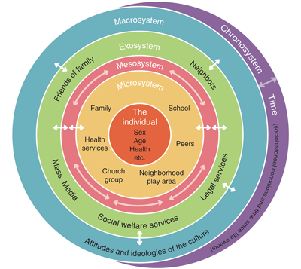

www.isotis.org (2017)
Parents
The main role of the parents is, in partnership with the setting, to maintain excellent communication. Being open and honest with the setting from the beginning will ensure that the setting know everything they need to know about the individual, resulting in a transition that is tailored to that individual’s needs. Henry (1996) states that parents know their children better than anyone else and can be a valuable resource to practitioners.

Keyworker
It is our responsibility as childcare practitioners to put everything in place to make the transition to nursery as trouble free as possible. Article 12 of the United Nations Convention on the Rights of the child states that children should be involved in decision making and should always be listened to, Welsh Government (2015). Children will be at the forefront of any decisions being made on their behalf. For a child to learn and develop, they need to feel safe and secure, they need to be valued, this will only occur if communication is maintained. The keyworker will establish a good, trusting relationship with parents starting at the home visit.
Bowlby’s attachment theory (1969) discusses the attachment that babies and young children form with their primary caregiver. Keenan, Evans and Crowley (2016) state that this theory focuses on the bonding of parents and children and the impact of this relationship on a child’s phycological development. Boyd and Bee (2004) discuss Bowlby’s theory as being a survival mechanism, because it ensures that babies and children receive sustenance. There is an interlocking pattern of behaviour, for example, when the child cries, it gets picked up, or if a child smiles, adults respond in a high-pitched voice. Bowlby believed that children can initiate proximity to their caregiver by using a communicative system, crying, smiling or cooing.


Kidsattuned.com (2011)
It is a result of Bowlby’s theory that the Key worker system has become more widely accepted and used in early years.
Erikson had strong beliefs that an infant must develop a sense of trust and comfort in their caregiver. Failure to do this may shape their ability to form trusting relationships in the future. Erikson also believed that as a child develops they will gain a sense of autonomy and independence. Henry (2016) states that Erikson believed children can have their needs met by individuals other than parents, and that building secure attachments with non-parental caregivers may actually strengthen pre-existing attachments. He believed that if a child is forced to undertake activities that they do not like, it could result in feelings of shame and doubt, Keenan, Evans and Crowley (2016).
The key worker is an experienced individual who will use a variety of methods to allow a smooth transition into the nursery. They will spend time observing the child to discover what the child’s interests, likes and dislikes are. Dowling (2014) states that for a child to feel comfortable, the child needs to know that their behaviour is understood. The key worker will be asking questions like is the child a schema? If so, what is they like to do? How do they communicate? Do they like to play with their peers or individually? Do they take comfort from being near their key worker? Key workers can use a variety of methods of communication. Often, a child who is finding transition difficult may not be able to communicate their needs. Key workers will be able to read cues, body language, interpret mark making and recognise a variety of emotions, including frustration, anger, anxiety or fear. Consistency is important for a child going through transition. A child needs to feel familiar with its surroundings in order to learn and develop.

Setting Manager
It is the responsibility of the setting manager to establish excellent practice with clear policies and procedures in place. They will ensure that no child is disadvantaged, providing a service that is inclusive and diverse. The manager will oversee the relationship between the key worker and the parents, ensuring that it is one that will provide the most positive outcomes for the child during the transition period. It is also the responsibility of the manager to make certain that the child has access to a fun, safe, stimulating and rich learning environment.

Role modelling
Being a good role model is something that all adults involved a with children’s care can achieve. Bandura believed that children, even from an early age, can acquire many new skills just by watching and listening to others around them, Keenan, Evans and Crowley (2016). Adults can demonstrate good role modelling by making good lifestyle choices, always showing respect, showing curiosity, using appropriate language and showing kindness and compassion to others.

The Needs of the Child

The key to meeting a child’s needs is understanding that every child is an individual, and as such, so are their needs. To enable us as practitioners to care for a child, the emphasis must be on getting to know the child, their likes and dislikes, how they think and what their interests are, Dowling (2014).
Maslow’s Hierarchy of Needs (1943) is a model depicting the human needs of an individual. The needs at the bottom of the triangle must be fulfilled before the needs higher up can be achieved. This is important in transitions because, if a child doesn’t feel safe and secure, they may refuse the most basic of needs, food and water, and as a result they are unlikely to form relationships, build self-esteem or develop as independent learners.

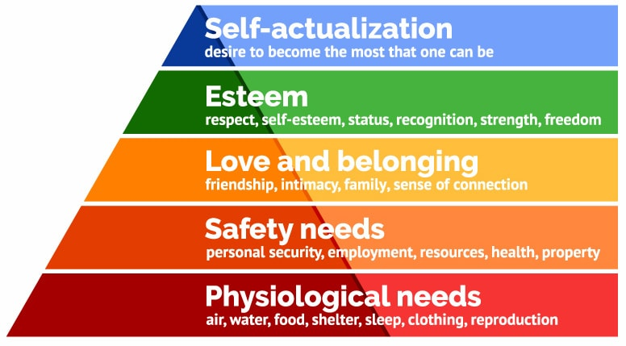

Simply Psychology, 2018

Communication is key to building a successful relationship with any individual, this can be harder when dealing with a child. Communication may be difficult for a variety of reasons. Children find it difficult to communicate when they are anxious, scared or overwhelmed. Some children maybe non-verbal and their body language may not be easy to read if they are uncomfortable. Recognising when a child is anxious or concerned is something all practitioners are trained to do and will have a wealth of experience in recognising signals and techniques to alleviate concern.
A schema is a pattern of behaviour that children demonstrate on everything around them, Arnold (2001). If a child is recognised by their key worker as demonstrating schema behaviour, this can be incorporated into planning for that individual. For example, if a child is observed to be filling containers and transporting, more resources can be provided to support this behaviour, resulting in the child feeling more comfortable.
Observations will be undertaken on a regular bases to allow the key worker to best plan for the needs of the child. These may be formal or informal observations, but they will provide evidence of what the individual will benefit from having access to. Monitoring and evaluating of the activities is an ongoing process, again, this ensures that the activities on offer are benefiting the children.
It is important to bet the balance of stimulation right to promote brain development. Keenan, Evans and Crowley (2016) believe that whilst children benefit from an enriched and stimulating environment, overstimulation can have a negative effect. Harvard University, (2018) believe that children benefit from a ‘serve and return’ like interaction, stating that it promotes brain development. The interaction between a caregiver and a child, responding to a child’s cry or talking in a high-pitched voice in response to a smile, can be compared to a game of table tennis. “When caregivers are sensitive and responsive to a young child’s signals and needs, they provide an environment rich in serve and return experiences” (Harvard University, 2018).

Environment

During transitions, the learning environment plays a vital role in supporting a child’s needs.
Vygotsky believed that children are active in exploring their social environments and that this enables them to be active in their own development. Vygotsky’s theory (1962) largely surrounded his thinking that children are born with a set of abilities, but those abilities could not be fully developed without social interaction. It is only through this social interaction with other more skilled and intelligent individuals that children can develop their skills, Keenan, Evans and Crowley (2016). Vygotsky believed that language played a significant part of cognitive development.
Vygotsky was responsible for the birth of the Zone of Proximal Development (ZPD). This is the theory that demonstrates the interaction between experienced or more able individuals and less experienced individuals. This technique is often referred to as scaffolding in early years.

What is not known
Zone of Proximal Development
Skills that can be learnt with guidance from other, more knowledgeable individuals.
What is already known

Piaget, like Vygotsky, also believed that children learn from actively exploring the environment around them, and furthermore, their actions upon it. Keenan, Evans and Crowley (2016) state that Piagets’s theory of cognitive development is thought to be one of the most influential theories in human development. However, in contrast to Vygotsky, Piaget believed that this was more of an independent process, believing that development was a result of our tendencies to organise and adopt to new situations. The Foundation Phase is Wales largely incorporates the theories of Piaget.

A well-planned curriculum gives children opportunities to be creatively involved in their own learning which must build on what they already know and can do, their interests and what they understand. Active learning enhances and extends children’s development (Welsh Government, 2015)

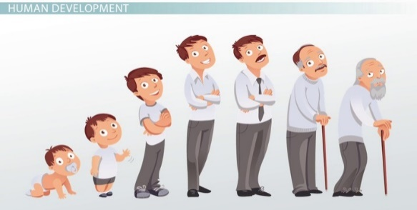

(Source: study.com, 2018)
Other philosophy’s that have influenced the creation of the Foundation Phase Curriculum are the Monterssori, Steiner, Reggio Emilia and Te Whāriki approaches to education and learning. Maria Montessori’s method of education was to teach each child as an individual, focus on child led activities, matching a child’s learning environment to their level of development and the role of physical education when learning new concepts and practical skills, Doherty and Hughes (2009). The Steiner approach is comparable to the Montessori approach. According to Drummond and Jenkinson (2009) allowing children space and time to interact with peers, both older and younger, providing opportunities to ‘take in’ the world around them using consistent routines and planning (2009, cited by Rod Parker- Rees 2010, p .74). Reggio Emilia allow children to develop by offering them opportunities to explore ideas and develop existing skills, and as a result, a sense of identity, Jones et al. (2008). The Te Whāriki approach is to allow children to make a valued contribution to society by allowing children to develop their mind, body and spirit, giving them a sense of belonging, allowing them to become excellent communicators, (Education.govt.nz, 2018).
Play is used to help children learn and develop. Play is also a fundamental part of transitions. Dowling (2014) states that children will ‘play out’ their own life experiences, this enables us to see and understand things from their perspective.
Play should be purposeful, initiated and led by children, sustained and led by children for the purpose of children (Moyles, 2010, p20).
Children will be allowed space within their environment to fully express themselves, Bilton (2010) believes that movement is crucial for young children to learn and develop.

Partnership Working

Partnership working is a fundamental part of committing to a child’s development. Working together for the interests of the child is vital to ensure a clear plan is in place for that child’s transition. Working in partnerships with a variety of other agencies, as well as parents, will allow for meaningful interventions that can make a difference to a child’s transition.
Strong links need to be established between all parties involved to support positive transitions.

Child- Central to everything
Keyworker
Multi Agency Team
Family
Setting Manager

The diagram above illustrates how important it is that the child is central to all communications. It also illustrates how important the role of the key person is in liaising and communicating with everyone involved in a child’s care.
As a result of ongoing, formal and informal observations and evaluations of the child within the setting, any additional support that may be deemed necessary can be acquired. The aim of a multi-agency approach is to build on the abilities of parents, schools, a variety of other professionals to support children in an effective and practical way, Jones et al. (2008).



(Source: Joomla, 2016)

Interventions

To support children through transitions many interventions have been implemented. These are all aimed at building and maintaining close links with families and children and begin even before a child starts in nursery.
Home visits
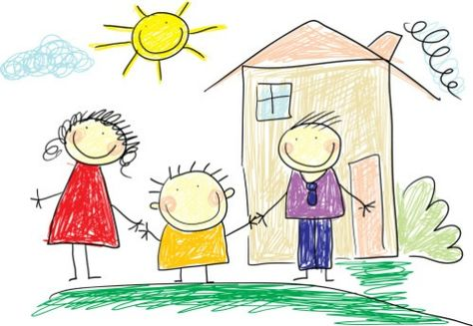

(Source: Pintrest, 2018)
Before a child starts in the nursery, a nursery teacher and the child’s keyworker will visit the child in their own home. Bronfenbrenner believed that there had been too much emphasis placed on observing children’s behaviour in strange places for short periods of time. His approach was to observe children in their actual environments, Keenan, Evans and Crowley (2016). Home visits allow the child to see that mum/dad/carer trust us enough to allow us into their home, this is the beginning of building close relationships with the family as a whole. This is an opportunity to see the child in an environment they feel happy, comfortable, confident and safe in, a ‘true picture’ of the child’s personality. It is also an opportunity to chat with families to discover the child’s interests, likes, dislikes, fears etc.

Welcome Pack
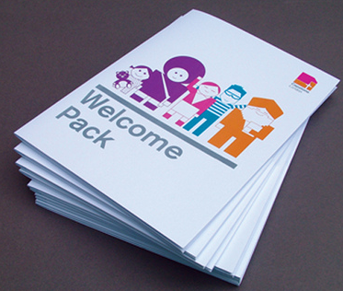

(Source: Flickr, 2009)
Each family will be given a welcome pack at the home visit. This consists of all the necessary forms to be completed, including a ‘child record’ form. This is an opportunity for the family to provide us with a written record of all relevant information regarding the child. There is also a t-shirt, teddy bear key ring (wearing the same t shirt), pen and notebook with the setting logo on for the child, so that they feel a sense of belonging before they even start.

Settling in Sessions
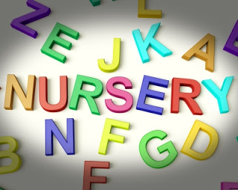

(Source: My-little-l.blogspot.com, 2016)
Before a child starts in the nursery, he or she will be invited a series of settling in sessions. The first of which, parents and carer are encouraged to stay with their child to provide reassurance. Thereafter, the child will stay without a parent for an hour. The amount of settling in sessions will vary from child to child. Settling in sessions are a time for information sharing about the child and the most important people in that child’s life (Collins, 2010, p.233).

Handovers



(Source: Shutterstock.com, 2018)
At the end of each session the child’s key worker will do an informal handover with the parents, this is an opportunity to discuss any issues or concerns. Information gathered at these handovers can help practitioners plan activities to support children (Collins, 2010, p. 234).

Stay and Play


(Source: Applegarth Academy, 2018)
Throughout the year, once all the children have settled, there will be an opportunity for parents, carers and guardians to come into the nursery for informal stay and play sessions.

Proposed Outcomes

A child’s transition has been successful once the child demonstrates that they are settled. This will be evident if the child begins to play independently, less dependent on their key person for reassurance. They will begin to develop relationships, not only with peers but possibly with other practitioners within the setting. The child will begin to show an understanding of their environment once they become more comfortable within it. They will start to demonstrate a sense of self, understanding where they fit into their surroundings. A child who is settled will demonstrate that they are responsive, consistent, sensitive, emotionally mature, happy, secure and are able to explore their surroundings independently.
According to Laevers (1994) children learning and development can be assed using two tools. The first being emotional well-being, which can be categorised by how open a child is, how receptive they are, how flexible and assertive they are, how relaxed they are and how confident they are. The second being involvement, this involves looking at a child’s concentration, energy, persistence, expressions and satisfaction.

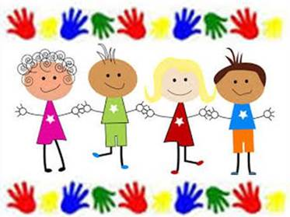

(Source: All Saints Academy, 2016)

References
All Saints Academy (2016) Available at: http://allsaints.stmarysacademytrust.co.uk/2016/05/18/stay-and-play-session-in-fs/ (Accessed on 27th November 2018).
Applegarth Academy (2018) Available at: https://www.applegarth-academy.croydon.sch.uk/stay-and-play-at-the-family-hub/ (Accessed on 27th November 2018).
Arnold, C. (2001) Child Development and Learning 2-5 years- Georgia’s Story. London: Paul Chapman Publishing Ltd.
Bilton, H. (2010) Outdoor Learning in the Early Years. 3rd Ed. Abingdon: Routledge.
Boyd, D. and Bee, L. (2014) The Developing Child. 13th Ed. Essex: Pearson Education Limited.
Collins, S (2010) ‘Thinking through the uses of observation and documentation’ in Moyles, J. (ed) Thinking about play. Berkshire: Open University Press.
Doherty, J. and Hughes, M. (2009) Child Development. Essex: Pearson Education Limited.
Dowling, M. (2010) Young Children’s Personal, Social and Emotional Development. 3rd Ed. London: Sage.
Dowling, M. (2013) Young Children’s Thinking. London: Sage.
Dowling, M. (2014) Young Children’s Personal, Social and Emotional Development. 4th Ed. London: Sage.
Education.govt.nz (2018) Te Whāriki. Available at: https://www.education.govt.nz/early-childhood/teaching-and-learning/te-whariki/ (Accessed: 25th November 2018).
Every Child Matters (2018) Transitions. Available at: http://www.earlyyearsmatters.co.uk/eyfs/positive-relationships/transitions/ (Accessed: 30th November 2018).
Flickr (2009) Available at: https://www.flickr.com/photos/hotsonstudio/3951002348 (Accessed: 25th November 2018).
Harvard University (2018) Available at: https://developingchild.harvard.edu/science/key-concepts/serve-and-return/ (Accessed on 30th November 2018).
Henry, M. (1996) Young Children, Parents and Professionals. London: Routledge.
Isotis (2017) Inclusive education and social support to tackle inequalities in society. Available at: http://www.isotis.org/about-isotis/work-packages/mod (Accessed: 22nd November 2018).
Joomla! Community Magazine (2016) Joomla working together! Available at: https://magazine.joomla.org/issues/issue-june-2016/item/3063-joomla-working-together (Accessed on 25th November 2018).
Keenan, T. and Evans, S. and Crowley, K. (2016) An introduction to Child Development. 3rd Ed. London: Sage.
Kelman, K. and Lauchlan, L. (2010) ‘Thinking through transition, pedagogy and play from early childhood education to primary’ in Moyels, J. (ed.) Thinking about play. Maidenhead: Open University Press.
Kids Attuned (2015) Communication in Context: First year of life 0-12 months. Available at: http://kidsattuned.com/page/2/ (Accessed: 22nd November 2018).
Laevers, F. (1994) Defining and assessing quality in early childhood education. Leuven: Leuven University Press.
Lumen Learning (2013) Psychodynamic perspectives on personalities. Available at: https://courses.lumenlearning.com/boundless-psychology/chapter/psychodynamic-perspectives-on-personality/ (Accessed on 21st November 2018).
Moyles, J. (2010) ‘Practitioner reflection on play and playful pedagogies’ in Moyles, J. (ed) Thinking about play. Berkshire: Open University Press.
My Little (2016) Available at: http://my-little-l.blogspot.com/2016/09/settling-in-session-at-nursery-and.html (Accessed on 27th November 2018).
Pinterest (2018) Available at: https://www.pinterest.co.uk/pin/513058582530846212 (Accessed on 22nd November 2018).
Pngtree (2017) Available at: https://ru.pngtree.com/freepng/childrens-hands-childrens-day-61_304242.html (Accessed on 22nd November 2018).
Rodger, R. (2016) Planning an Appropriate Curriculum in the Early Years. 4th Ed. Abingdon: Routledge.
Shutterstock (2018) Available at: https://www.shutterstock.com/search/parent+teaching+meeting?image_type=vector (Accessed 30th November 2018).
Simoly Psychiology (2018) Maslow’s Hierarchy of Needs. Available at: https://www.simplypsychology.org/maslow.html (Accessed: 15th November 2018).
Study.com (2018) Human development stages from infancy to late adulthood. Available at: https://study.com/academy/lesson/human-development-stages-from-infancy-to-late-adulthood.html (Accessed: 22nd November 2018).
Welsh Government (2015) Curriculum for Wales: The Foundation Phase Framework. Cardiff: Welsh Government.

