Keri Lawrence
Creative Research
11 November 2017

Topic
Within a given time period, select examples of what could be considered high and low cultural artefacts. Discuss these, taking into consideration the surrounding social, political and historical commemoration.

Introduction
The cultural connections which Pop Artist’s reference allows their audiences to relate personally to their art. Pop Art communicates to a wide variety of people by being relative to diverse aspects of society and economy. According to Livingston,
Its use of these media ⎯ exclusively associated with a capitalist economy ⎯ has led to its being perceived as the reflection of a materialist society saturated with images of itself and particularly of its hedonism and affluence in the post-war years (1990).
Relating to the general public through iconic people, symbols, and subjects. Pop Art broke the boundaries of fine art by creating the ideas of mass production and commercializing Fine Art. By playing with the boundaries of Fine Art and commercial art, the question of whether or not pop art is seen as high or low culture arises.

History: Black Mountain College
Evolving during a post war period, Pop Art originated from a curious place called Black Mountain College.
Set in rural North Carolina, Black Mountain was not an art school. Its wide-ranging curriculum put the arts at the center of living, in an environment intended to encourage learning through doing, where the imagination could be trained to equip people to deal humanely with a complex and uncertain world (Harris et al., 2005).
From the college, many unique concepts and ideas flourished. For Example, Robert Rauschenberg and his “reconsiderations of collage were vital in preparing the way for the audacious dedication to found material and ready-made images that came to characterize much Pop in the early 1960s” (Livingston, 1990). The many new ideas from Black Mountain College that effected ways in which Fine Art was viewed. For example, First Landing Jump created by Rauschenberg was a collage of found objects in which:
…the components of art became like those of the new “music” and the new “dance”; individual elements, none to the exclusion of others were distributed in a non-hierarchal field that re-emerged the viewer into the world rather than shunted him or her away from it and into a sacred and separate precinct labeled art (Leslie,1997).
The mixture of found items put on a canvas raised questions to whether or not this is high or low culture work. The concept of mixing art and life seemed to be the main theme for Rauschenberg, but, how much could a canvas of found objects be attributed? As an argument for the high culture of his work, Rauschenberg is reacting to the economy and a transformation to an era of mass production leading to larger amounts of waste. However, his use of these objects could also be viewed as low culture because they are essentially unwanted items on a canvas. Yet, some would say it is considered high culture art because he relates to the era by “accepting them as a general range of artifacts of human culture” (Leslie,1997).
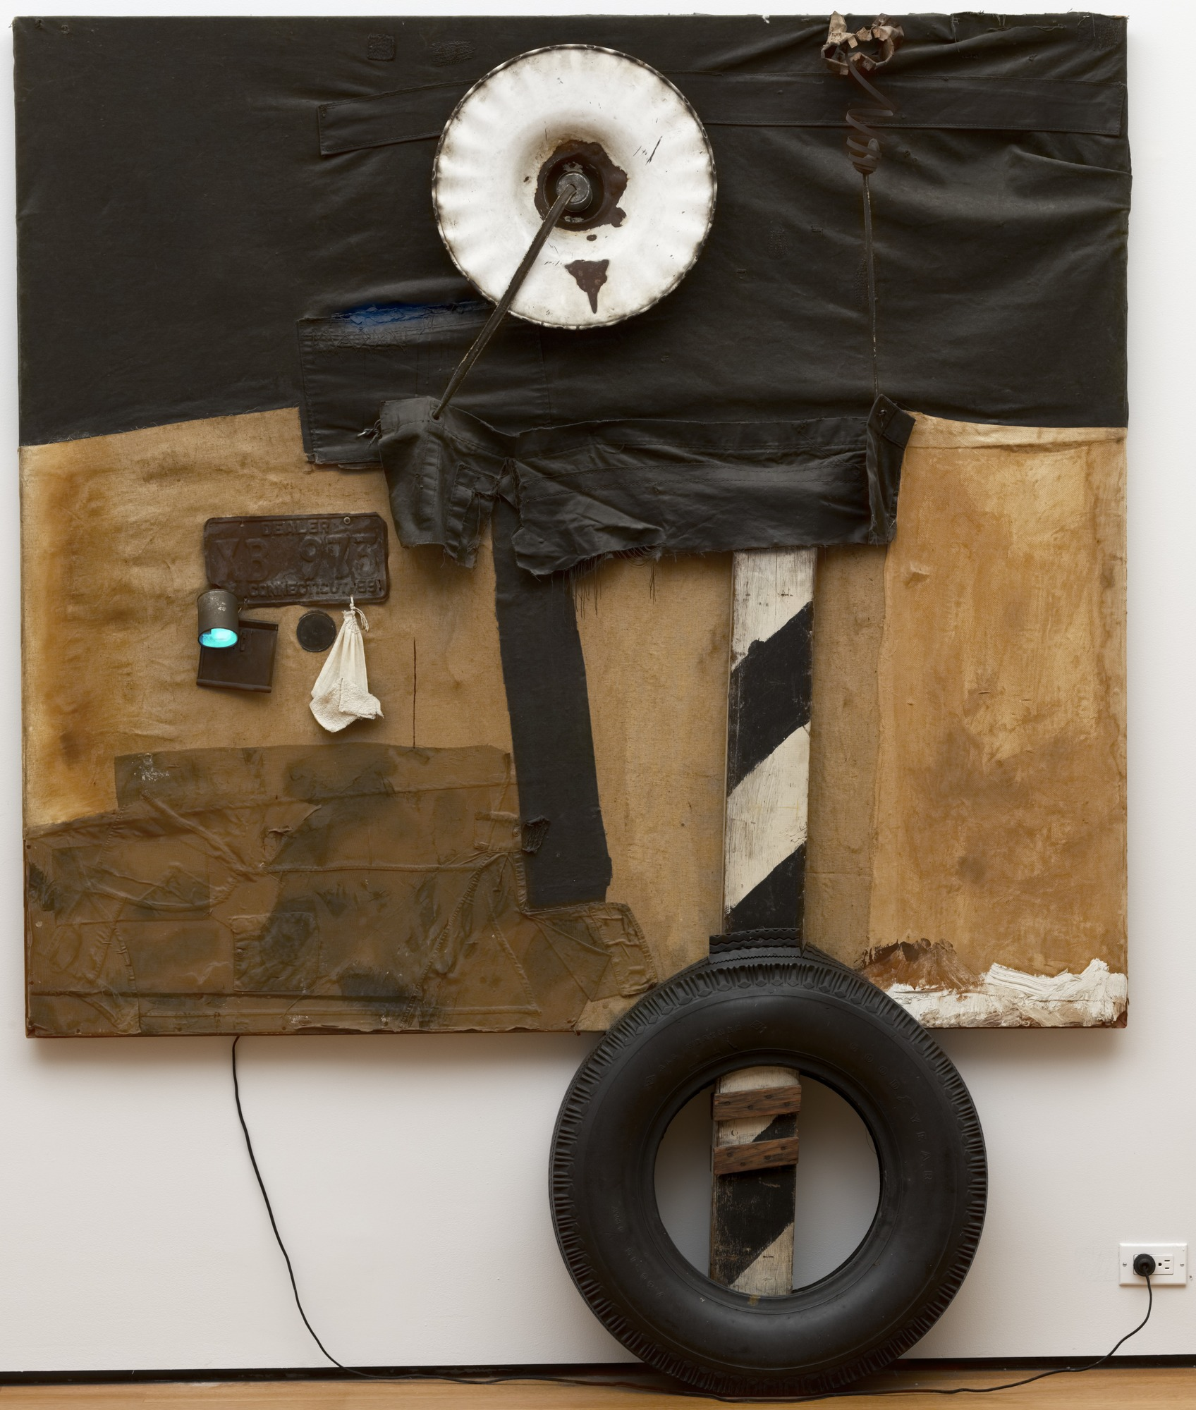
-Roy Lichtenstein, First Landing Jump 1961

Impacts: Lichtenstein, Johns, Warhol, and Ruscha
Thus, from the Black Mountain College era Pop Art begins to surface. Cultural values of art begin to change creating a shift in Fine Art traditions.
Unlike the avant-garde, who “used art to dig the trench between art and life, pop did things the other way around… it made a fetish of the new and ushered in a fascination with consumer goods as art and the gleeful appropriation of any image” (Jencks 1987).(Taylor and Ballengee- Morris, 2003).
The media impacts culture, directly evoking the population with ideas of money, fame, fitness, fashion, etc. From this, it is easy to understand why Pop Art grew, because it focuses on the characteristics of the current society. For example, Roy Lichtenstein referencing war time comics such as Whaam! Is where Pop Art, mass production, and copyright all take place within the movement. Critics such as Harrold Rosenberg summoned up the distinction succinctly when he suggested that, “the difference between a comic strip of Mickey Mouse and a Lichtenstein painting of the same was art history, the fact that Lichtenstein paints with the idea of the museum in mind.” (Rosenberg,1969).” (Beaty,2017). Using images from mass media, such as comics,is what the critics were evaluating so strictly. The replication of comic strips was negatively viewed by many critiques during this era. Aside from the critiques, society was relating to these comics because of the satirical post war aspects which interested the public and also many gallery owners. High culture can be viewed in Lichtenstein’s art as a “celebration of art and its modernist rules in the same way that it criticized and celebrated the very culture that had generated the changes” (Leslie, 1997). Gallery owners and art collectors found high culture within the works showcasing them to the public. Pop Art influenced by mass media complicates high and low culture. Being a climax for the Pop Art world for over twenty years, Lichtenstein, still struggled with the daze of high and low culture within the Pop Art world.
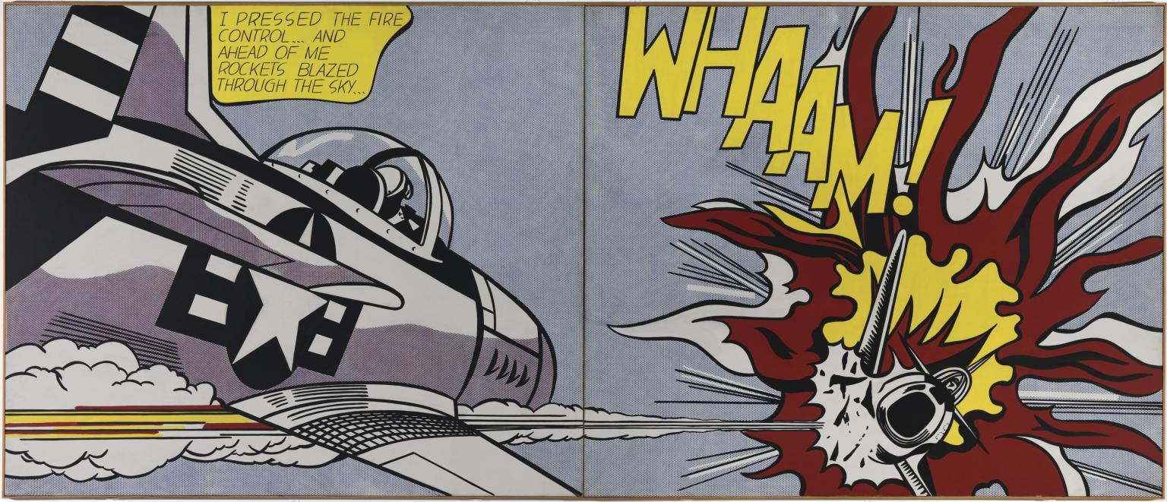
-Roy Lichtenstein, Whamm 1963
Jasper Johns also left a great impact on the culture of Pop Art. Johns, also influenced from Black Mountain college, had a way of working which had not been seen before in the art world. His new techniques of painting were most surprising to the critics during this era. His interesting and unique painting style is what made his art stand out. Johns, as other Pop Artists, dealt with iconic images. For example, Flag, one of his most famous works, is a great representation for his position as a Pop Artist. By creating a piece of work from an already existing symbol, Johns questions what art really is. Johns worked from ideas that came to him through dreaming and the unconscious mind. “One night I dreamed that I painted a large American flag, and the next morning I got up and went out and bought the materials to begin it.” (MOMA, 2011). Working with the idea of turning iconic images into paintings, Johns created works of art that arose controversy about his pieces being “just a flag” or “just a painting”. His paintings could be viewed as low culture because he mostly worked from ideas that were already in the mind. Like the American flags, Johns painted images that he already knew. Some could say that he wasn’t exactly coming up with his own ideas by painting this flag, he was just reproducing an already iconic image. His painting could have also been viewed as high culture because the flag “complicates the representation and invites close inspection” (MOMA, 2011). Gallery owners and art critiques found his flag paintings compelling and something “new” in the world of art. Johns made his impact on the Pop Art world from his use of murky, dream like ideas that overtook his paintings in the 20th century.
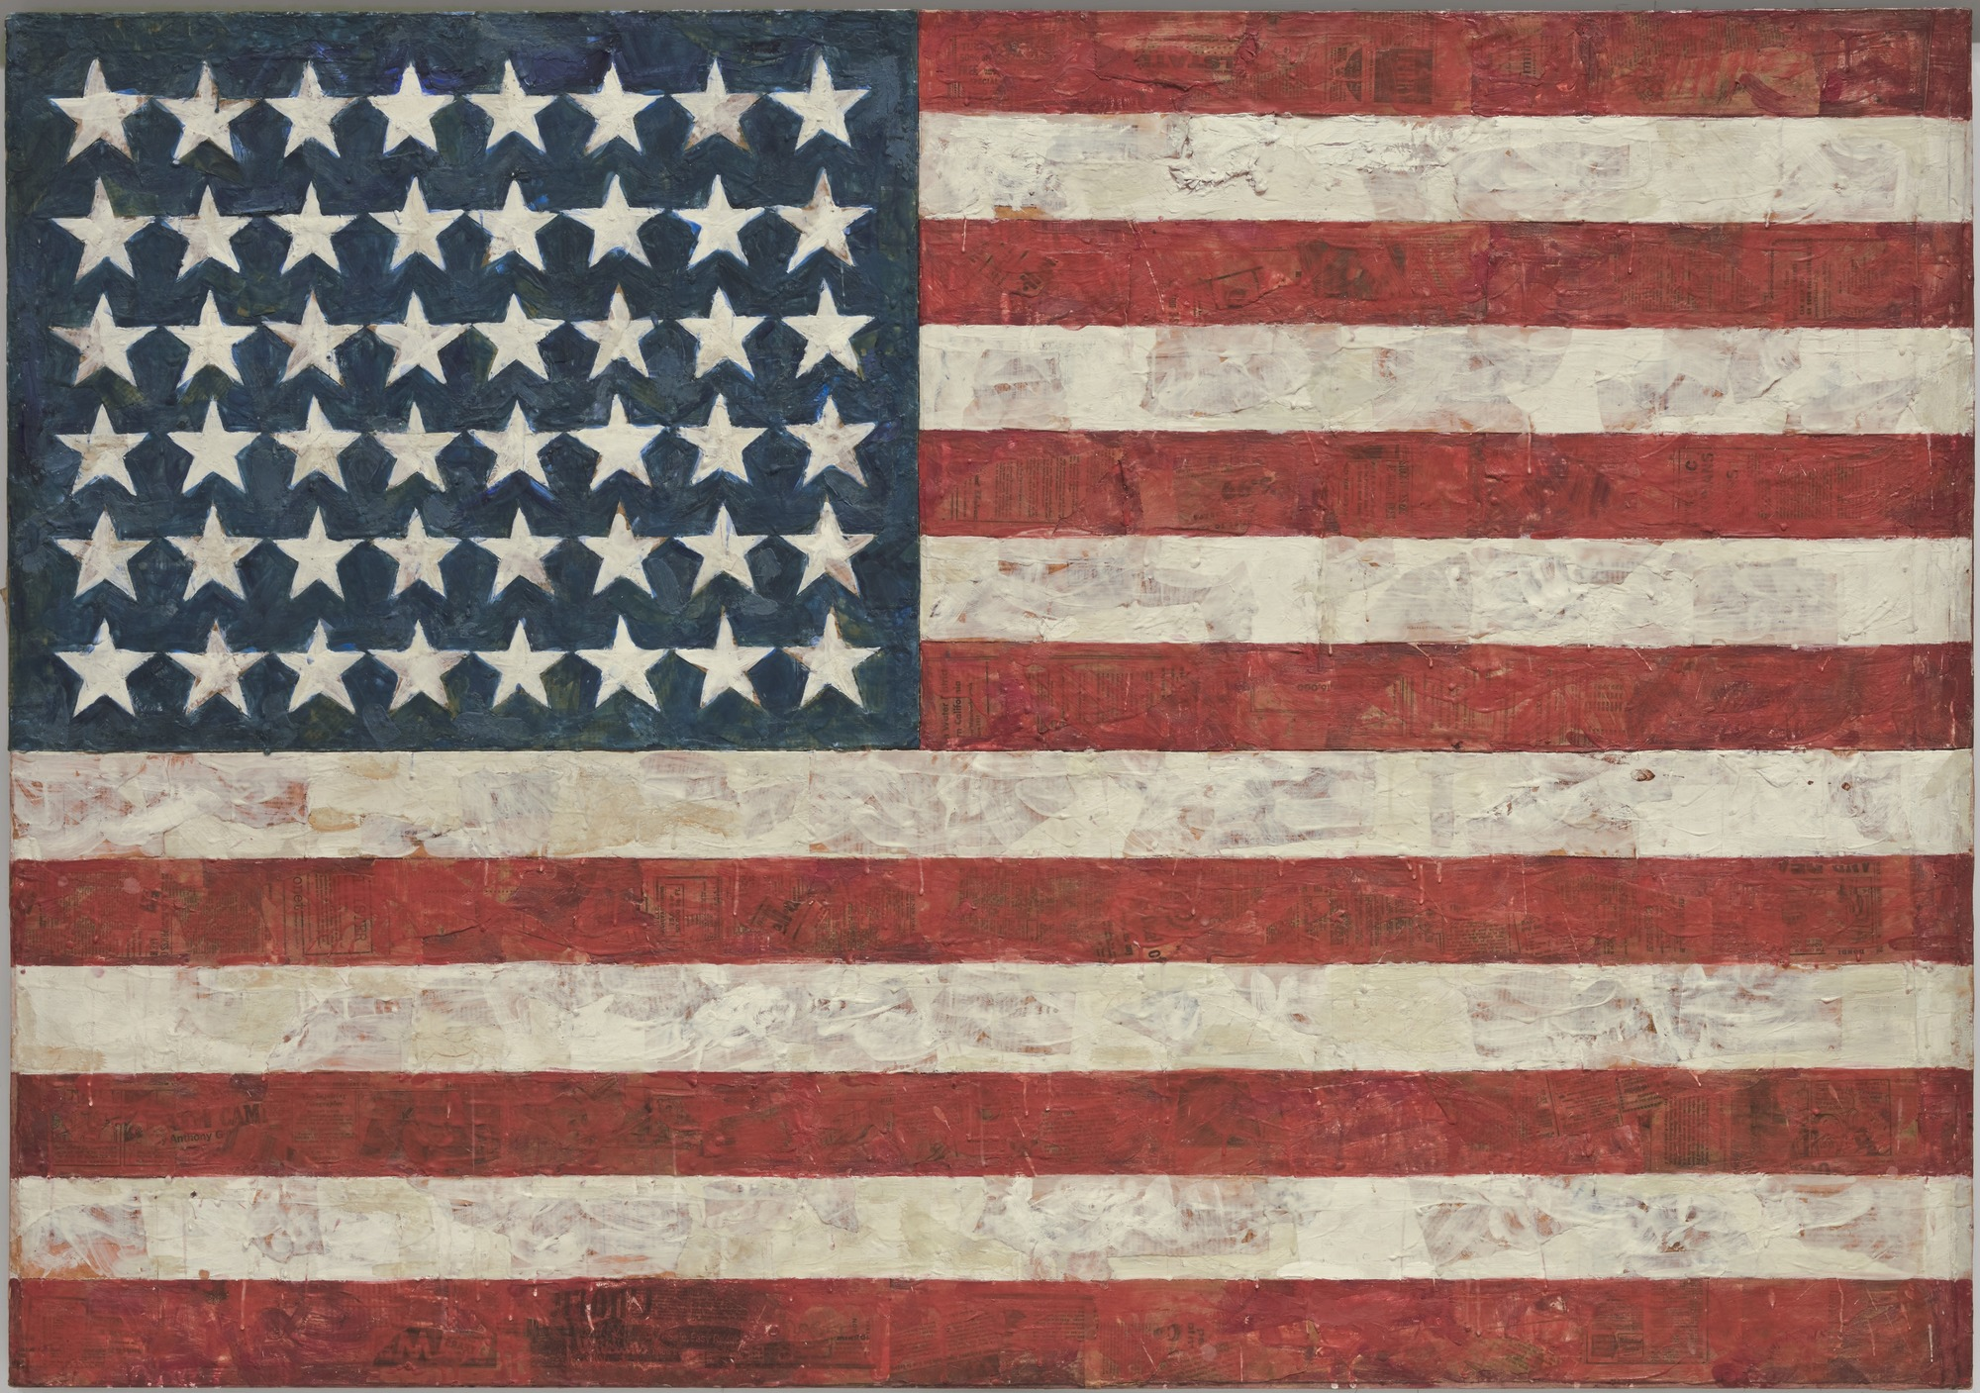
-Jasper Johns, Flag 1954
Another face that is so widely known in the Pop Art culture, is Andy Warhol. Like Lichtenstein, Warhol played with images seen as low culture and turned them into art by mass producing them. Producing images that were inspired by popular culture, advertising, newspapers, and mass media, Andy Warhol flourished in the Pop Art movement.
Images within a system of advertising; soup cans and people within this system were equal as commodities, and in service of the same goals; fame sought and achieved through exposure and sales. No one bought an original; everyone could own and use a reproduction or a mass commodity. (Leslie,1997)
By creating these commercial images, Warhol related to the public through the idea that art can be made by anyone. The reproduction and repetition techniques Warhol used to represent the media and the “now” of the era are what make him and his art so powerful in this art movement. Warhol’s Marilyn Monroe pieces are, often times, questioned on whether or not they are high or low culture. According to Andreas Huyssen,
Warhol has chosen one photo and reproduced it with the silk screen technique, adding slight modifications to the original. Art thus becomes the reproduction of a reproduction. It is not reality itself that provides the content of the work of art, but rather a secondary reality ⎯ the portrait of the mass idol as the cliché image that appears millions of times in the mass media and that sinks into the consciousness of a mass audience (1975).
By creating the clique popular culture images, Warhol’s Marilyn’s are often perceived as low culture. This is because taking an image of a famous icon and repeating it over and over again seems to fall in a low category of culture. Warhol makes Marilyn seem as if she is easily replicable and easily reproduced. Audiences can see the intent he is trying to make with the fading away of her image just like all pop stars tend to do. Aside from it being seen as a low culture piece, it is still put in museums, galleries, magazines, and books. The repeated Marilyn’s is widely known and a popular piece. In some ways, it has to be viewed as a high culture work as well. “Warhol selected the most powerful visual images the media had to offer, from the most familiar to the most terrifying and removed them from familiar contexts and turned them into mysterious, sometimes frightening symbols of our times” (Taylor and Ballengee- Morris, 2003). Due to his unique ability to combine the rich and famous with the rest of society, Warhol is the idol of Pop Art. 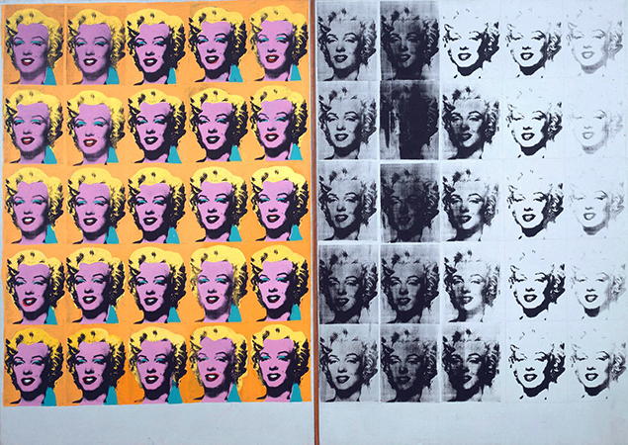

-Andy Warhol, Marilyn Diptych 1962
Another artist who stood out during the Pop Art movement was Ed Ruscha, characterized by his use of big letters and bright colors. Known for his American road-way scenes, Ruscha captures the views of a typical road trip across Route 66. “Ruscha’s paintings of Standard gas stations signaled the conspicuous American road culture and the emergence of a corporate standardization that would constitute the new universal cultural literacy” (Leslie, 1997). For example, Standard Station, Amarillo, Texas 1963, Ruscha’s use of the colors red, black, and yellow relate to the typical advertisement colors. Also, he insinuates the point of view of the print from inside of a moving vehicle. The perspective he used to make this piece seems as if it is flying by, just as it would from the inside of a vehicle. According to Marco Livingstone, “we approach the gasoline sign, then glimpse it from the side, then face a blank stretch of road before seeing another identical sign ahead, giving us the impression through repetition and sameness that we are back where we started” (1990). Ruscha’s work could also fall between the lines of low and high culture. His images give a feeling of placelessness because they are representing buildings placed alongside a highway, that are seen multiple times over and over and out of place. The feeling the prints give viewers make these paintings more similar to low culture art. But, like Warhol, Ruscha is capturing the culture during the era. A time of media, mass production, advertisement, and fame. “Culture is the heritage of the future that provides a dynamic blueprint of how we live our lives. It contains multiple aspects that define us” (Taylor and Ballengee- Morris, 2003). The images stand for a symbol of this era. The art is representing the culture and is illustrating the movement during the Pop age.
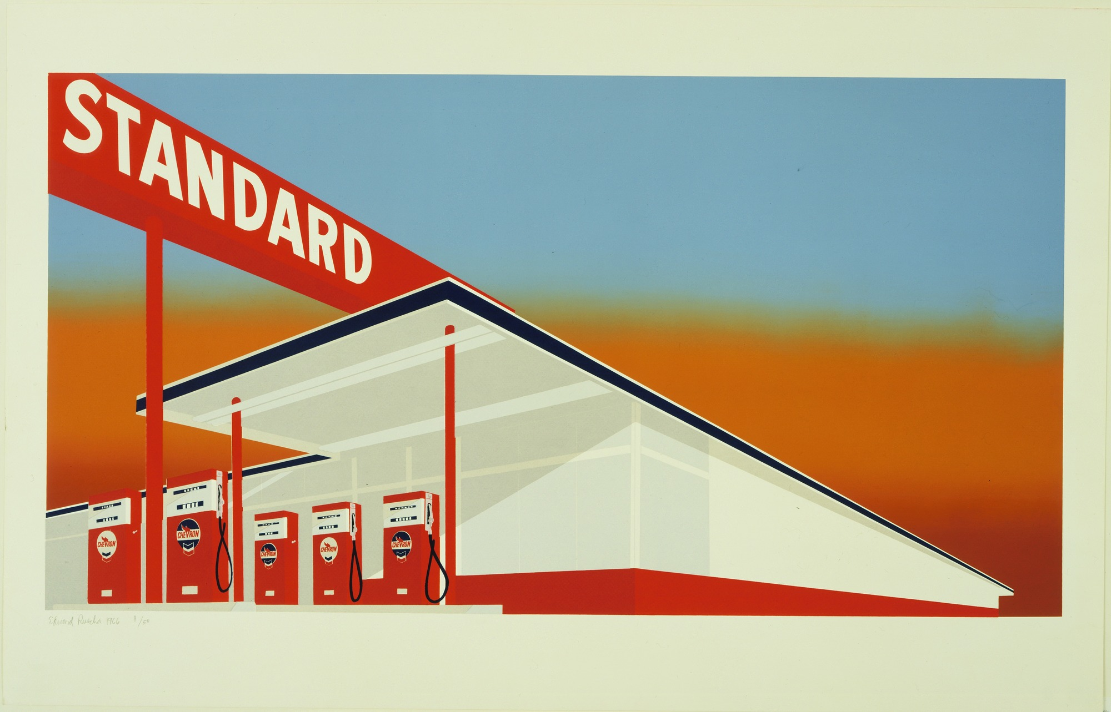
-Ed Ruscha Standard Station, Amarillo Texas 1966

Conclusion: High or Low Culture?
In Conclusion, Pop Art is representing the life during the 1960s. Rauschenberg, Lichtenstein, Johns, Warhol, and Ruscha all flourished as artists in the Pop Art era. By relating directly to society through the uses of advertisement, mass media, television, iconic images and figures, Pop Art communicates the 1960s lifestyle. “Pop Artists explored U.S. culture’s effect on both personal and societal levels. Their art gave people opportunities to continue that exploration within larger settings as they explored consumerism and its effect on society known today as global culture” (Taylor and Ballengee- Morris, 2003). The debates of whether Pop Art is placed in high culture or low culture will be ongoing, because this era was a shift from what was formally viewed as fine art. The mass production and consumerization aspect of Pop Art may be viewed as low culture. But, the images and how they relate to the generation are viewed as high culture. “We better understand today that pop in popular culture represented the appearance of a new media culture that characterized the second half of the twentieth century” (Leslie 1997). Pop Art is the living visualization of everyday life during the 1960s. In summary, Pop Art changed how art is viewed by evolving during a time of cultural and artistic revolution, opening a door for new ways of thinking and working. One must ask themselves, if everything revolving around artist’s lives and how they viewed the world changed drastically, can their work be categorized in the same manner as their predecessors or should a new era of art be defined?

Bibliography
Beaty, B. 2004. Roy Lichtenstein’s Tears: Art vs. Pop in American Culture. Canadian Review of American Studies 34: 249-268. http://web.a.ebscohost.com/ehost/. Accessed November 5, 2017.
Harris, E.H., Benfey, C., Diaz, E., Waal, E.D., Perl, D. 2005. Starting at zero: Black Mountain College 1933-57. Arnolfini and Kettle’s Yard, Cambridge.
Huyssen, A. 1975. The Cultural Politics of Pop: Reception and Critique of US Pop Art in the Federal Republic of Germany. New German Critique 4: 77-97. http://www.gko.uni-leipzig.de/fileadmin/user_upload/kunstgeschichte/pdf/Lehrbeauftragte/Abdullah/Huyssen-Cultural_Politics_of_Pop_Reception-US_Pop_Art_in_FGR-1975.pdf. Accessed November 5, 2017.
Johns, Jasper. 1954. Flag. Digital Image. MOMA. Accessed January 7, 2017. https://www.moma.org/collection/works/78805.
Jencks, C. 1987. Post-Modernism: The New Classicism in Art and Architecture. Academy Editions, New York.
Lichtenstein, Roy. 1963. Whamm!. Digital Image. TATE. Accessed January 7, 2017. < http://www.tate.org.uk/art/artworks/lichtenstein-whaam-t00897>.
Lislie, R. 1997. Pop Art: A New Generation of Style. Todtri Productions Limited, New York.
Livingston, M. 1990. Pop Art: A Continuing History. Thames and Hudson, London.
Moma, 2011. Jasper Johns. https://www.moma.org/collection/works/78805. Accessed January 7, 2017.
Rosenberg, Harold. 1969. Art and Its Double. Artworks and Packages. New York.
Ruscha, Edward. 1966. Standard Station, Amarillo Texas. Digital Image. MOMA. Accessed January 7, 2017. < https://www.moma.org/collection/works/76637>.
Taylor, P., Ballengee- Morris, C. 2003. Using Visual Culture to Put a Contemporary “Fizz” on the Study of Pop Art. Art Education 56: 20-24. http://web.a.ebscohost.com/ehost/. Accessed November 5, 2017.
Warhol, Andy. 1962. Marilyn Diptych. Digital Image. Khan Academy. Accessed January 7, 2017. < https://www.khanacademy.org/humanities/ap-art-history/later-europe-and-americas/modernity-ap/a/warhol-marilyn-diptych>.
Rauschenberg, Robert. 1961. First Landing Jump. Digital Image. MOMA. Accessed January 7,2017. < https://www.moma.org/collection/works/81468>.
Johns, Jasper. 1954. Flag. Digital Image. MOMA. Accessed January 7, 2017. https://www.moma.org/collection/works/78805.

