Module: Professional Career Development
Module code: BMSW4005
Donatas Keliauskas:2120434
Lecturer:Saqib Shamim

Assignment Title: Professional career development report and role-play (Task-2)

Table of Content
Introduction 2
A personal reflection on role-playing 2
Personal development plan 4
Self-evaluation Plan 6
SWOT Analysis 6
Action steps 9
Conclusion 9
Reference 10

Introduction
This report compiles all of the necessary data and provides insights into a scenario of a job interview. Here the report is extremely well presented through some role-playing for a certain work description. It also evaluates the questions that are connected to a certain job description. The most attractive is the theatrical appearance which helps to establish the mood of the interview to may get rid of the dread of the one’s interview. Overall, this study gives extremely useful insights into the interview procedures. Gibb's reflecting cycle is also extremely useful in comprehending the circumstance.

A personal reflection on role-playing
One of the most significant advantages of role-playing is the ability to demonstrate the abilities rather than simply discussing them in a verbal interview. Here, Gibb's reflective cycle is used to better grasp the situation and the work position of the Sunday restaurant manager. In higher education, developing reflection capabilities are necessary because it may assist students in making conscious modifications to their lives and thoughts (Ahmed, 2020).
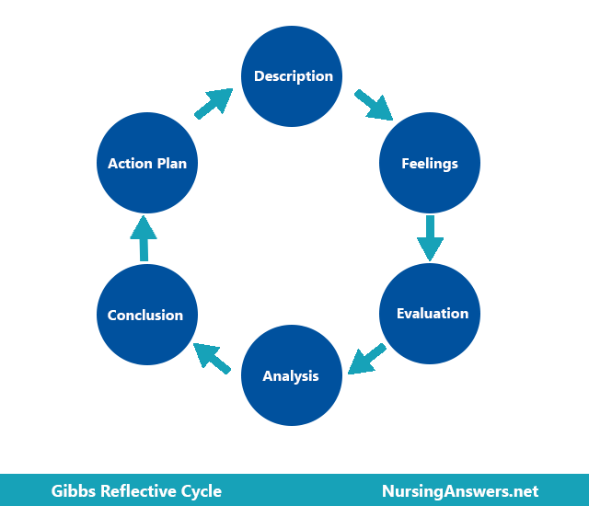
Figure: Gibbs Model of Reflection
(Source: NA, 2022)
Description
The overall atmosphere of the room during the interview was fairly nice and I gained a significant amount of knowledge in the work function of a restaurant manager, as well as a general concept of the kind of questions that would be posed during the interview. A Restaurant Manager has to make sure the restaurant works smoothly. They employ and train workers following business policies. Furthermore, Restaurant Managers interact with clients about any issues or difficulties, as well as create work plans (Principato, Pratesi and Secondi, 2018). The main responsibility of a restaurant manager is to maintain the quality, revenue and mainly profit of the restaurant.
Feelings
I felt confident in my ability during the interview process, although I was a little uncomfortable before the interview commenced. Nervousness is not a new thing to me. It plays a vital role in my big tasks. However, following a decent conversation well with the interviewer at the outset, I overcame my worries and expressed myself really effectively.
Evaluation
During the overall process, it appears to me that the major elements that affect me most are uneasiness and confidence. I am aware that I have certain characteristics of a restaurant manager, yet my uneasiness acts as a hindrance. When I conquer this, I present myself quite nicely. The interviewer's pleasant nature helps me the most in getting rid of this.
Analysis
This must have been crucial for me. As a result, It assists me to recognize my strengths and identify areas where I need to develop. Overall, it benefits to make me slightly confident. And the most important thing is that if I will not work on those, it will definitely make a mess in the real interview.
Conclusion
This procedure has been really beneficial in identifying my shortcomings. I believe it is a really useful tool for individuals to discover their talents and shortcomings. But don't be upset if they perform poorly throughout the whole process. Everyone should always try to learn from their mistakes.
Action Plan
This simulated stage allows me to identify my areas for improvement. I need to figure out how to improve my poor talents while also trying to sharpen my existing ones in order to avoid failing in a genuine interview.

Personal development plan
To achieve my personal growth, I must establish SMART objectives that are short, medium and long-term in nature (Latham, 2020). I spent enough time brainstorming and discussing the goals. Also, I tried to choose one or two objectives that will assist me to attain my other goals.
Short-term Goal
Specific | Attempt to strengthen my communication and interpersonal abilities.
Measurable | Trying to maintain an eye on this technique allows me to trace my growth along with some capabilities and enhance my communication skills.
Agreed | Collaboration is an effective method of enhancing communication skills that are also feasible and keeps me motivated.
Realistic | Work-related targets are more meaningful which is essential to be enhanced. Every opportunity to develop communication skills should be utilised.
Time-bound | 4 to 5 months

Mid-term Goal
Specific | I need to concentrate on developing new abilities such as diverse knowledge and money-making schemes.
Measurable | I might easily manage my workplace if I acquired these new skills. Somehow it assists to strengthen my managerial abilities.
Agreed | The objective of obtaining new skills constantly drives me to accomplish it without setting unrealistic expectations. It also assists me in expanding my knowledge.
Realistic | Mid-term objective pushes me further to achieve my long-term target which is simply my future vision. Learning new things motivates me to be more focused on my work while also increasing my knowledge.
Time-bound | 2 to 3 Years

Long-term Goal
Specific | Try to convince my coworkers to look to me as a mentor with outstanding interpersonal skills and a wealth of knowledge and to recognize me as a polite person at work.
Measurable | I should adhere to constructive actions that advance my knowledge and abilities. It will undoubtedly aid me in achieving my long-term objective.
Agreed | The objectives should always be attainable and realistic in order to keep us inspired and from becoming distracted from the job.
Realistic | I need to put in a lot of effort and excel at work if I want to reach my objective. It will enable me to advance professionally and take on more responsibility in my place of employment.
Time-bound | 2 to 5 Years

Self-evaluation Plan
Distinctive leadership style: My leadership style of authoritarianism helps me in my professional endeavours. It's a type of leadership where the leaders are extremely knowledgeable about their missions and enthusiastic about their work (Al Khajeh, 2018). As team members focused on their measurable goals, it could also provide them with more power. They must be capable of building a project team, successful outcomes and teamwork in order to accomplish the team members' intended objectives. It helps me motivate coworkers, encourage and facilitate them and organise meeting schedules. Being the group leader, I focus on my goal and how it could help other colleagues become more motivated to do their jobs well (Vasilescu, 2019). My leadership style helps by guiding teammates toward their goals so they may accomplish them.
Motivating Power: Motivation is nothing more than the desire to act in the interests of others. It is one of the forces that influence how people behave. A team leader must possess the ability to inspire and lead the group, which has a profound effect on employee engagement and boosts productivity and ownership, as well as personal growth (Kovach, 2020). For me, the desire to lead a team always comes from the inside. Some of the good qualities of a great team leader that serve to inspire team members include acting with integrity, exhibiting devotion, effective listening, appreciation, recognising talent, and having a clear vision of work.
Explanation of prior experiences: As a group leader, I have prior experience. I have a lot of responsibilities as a leader that help to inspire my team members. One of my skills may help my teammates feel long-term loyalty, morale, devotion, dependability, and trust, which inspires and builds their confidence (MIRALAM, ALI and JEET, 2020).

SWOT Analysis
The methodology is simple and sufficient that one could be motivated to ignore it entirely, focusing instead on their intuition to account for these factors. It assists everyone in developing their strengths, identifying their weaknesses, minimising their risks, and maximising their opportunities for stratospheric achievement. This may also be utilised to learn more about their rivals, which will help them come up with a unique approach that will set them apart from the competition and take them to the top of a particular market (Teoli, Sanvictores and An, 2019).
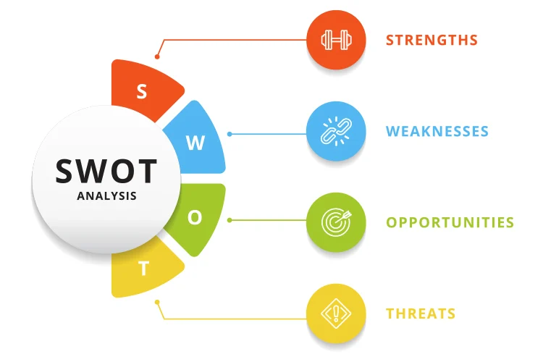
Figure: SWOT Analysis Template
(Source: BH, 2022)

Strength: As a restaurant manager, I am capable of effectively and clearly communicating the roles and other organisational expectations, as well as coworkers' goals. In this scenario, spoken and written communication ensures that current employees understand how to meet the goals (Segal, 2018). Inspiring others, making commitments, acting with dignity, presenting a clear vision, appreciation, acknowledgement and many more qualities assist me as a restaurant manager in a variety of ways. I could encourage my coworker to collaborate on initiatives or duties.
Weakness: As a restaurant manager, I felt incompetent every time when I used to have to make a choice. While working as a manager, I encountered numerous flaws such as unclear hypotheses, low adaptability, inability to encourage the entire team, poor decision-making skills, inability to outsource, hard work, thoughts of scarcity, not appropriately paying attention to coworkers, poor communication skills, and many others. In addition, when focused on their measurable goals, my coworkers discovered various issues such as collective decision-making taking much time, groups being much more likely to make errors in decision-making and hence taking longer to create an understanding of tasks and roles, and so on.
Opportunities: As a restaurant manager, I have a lot of choices. Hiring smart people, practising with patience, reaching goals on time, communicating effectively, listening carefully to everyone, integrity, sincerity and many other things are some of the opportunities for everyday growth that I pursue. Other opportunities for restaurant managers include learning something new, developing new skills, having the freedom to work effectively and many more.
Techniques: A skilled restaurant manager will be able to change their communication skills for store management. They may also be struggling to meet their goals owing to the use of specific techniques. Transformational leadership, transactional leadership, delegating leadership, participatory leadership, authoritarian leadership and many more management styles have all contributed to my success as a restaurant manager. Management skills also help with effective and pleasant communication, decision-making, problem-solving, openness, food waste management capacity, communication skills and several other areas (Filimonau, Zhang and Wang, 2020).
Johari Window: This paradigm explains the manner in which people communicate and face criticism (Mathew, and Sebastian, 2020). It is the kind of technology which is supposed to help people better understand their own as well as others' relationships. This is a framework that supports the understanding and self-realization of others, as well as the knowledge of conscious and unconscious prejudices. The goal of the Johari window is to increase the open area size without concealing personal information and decrease the unknown area size. As a restaurant manager, the Johari window helps me comprehend the connections among my coworkers. It is among the most successful methods for boosting personal self-awareness and development in any environment.

Action steps
To get rid of my weakness I make some action steps and also a time limit.
Weaknesses | How to deal with the defect | Time Limit
Poor communication abilities | I may improve my communication skills by exchanging ideas, knowledge, opinions, points of view, and facts. | 3 - 4 days
Lack of self-assurance | I suffered from low confidence as a result of my lack of self-motivation. As a result, I wish to motivate my coworkers in order to help them conquer their lack of self-assurance. It gives them more confidence in their profession. | 3 - 5 days
Insufficient decision-making ability | Making a good plan, being assertive, establishing a deadline, thoroughly studying the assignment, and a variety of other things can help me reduce the problem of poor decision-making. | 4 - 7 days

Conclusion
Most conventional interviews do not involve instant notifications from the recruiter on the performance. However, role-play interviews nearly always include an evaluation and feedback component once the scenario is completed. In most situations, the scenario of the role play is just one will experience on the job which can help them to prepare efficiently for the task. According to the outcomes of the article, team managers are the most significant and direct impact on team members' experiences. In the past, I've discovered that my acts, instead of my words, might lead others astray. As a result of my working technique, colleagues are deeply stirred, and they may offer their all to reach their measurable targets. Confidence and trust, valuing others, resolving problems, appreciating others, and hearing other teammates are all instances of leading by example.

Reference
Ahmed, A.M., 2020. From reluctance to addiction: The impact of reflective journals on Qatari undergraduate students’ learning. Reflective Practice, 21(2), pp.251-270.
Al Khajeh, E.H., 2018. Impact of leadership styles on organizational performance. Journal of Human Resources Management Research, 2018, pp.1-10.
BH, 2022, “How to Do a SWOT Analysis [With Template & Examples]” Available at https://blog.hubspot.com/marketing/swot-analysis [Accessed on 18th December]
Filimonau, V., Zhang, H. and Wang, L.E., 2020. Food waste management in Shanghai full-service restaurants: A senior managers’ perspective. Journal of Cleaner Production, 258, p.120975.
Kovach, M., 2020. The impact of# MeToo: A review of leaders with supervisor power on employee motivation. The Journal of Values-Based Leadership, 13(1), p.13.
Latham, G., 2020. Goal setting: A five-step approach to behavior change. In Organizational Collaboration (pp. 10-20). Routledge.
Mathew, J. and Sebastian, T., 2020. Johari window model a self disclosure process to promote the teamwork. TNNMC Journal of Mental Health Nursing, 8(1), pp.25-29.
MIRALAM, M.S., ALI, N. and JEET, V., 2020. Impact of Big Five Model on leadership initiation in critical business environment among marketing executives. The Journal of Asian Finance, Economics and Business, 7(11), pp.507-517.
NA, 2022, “ Gibbs' Reflective Cycle - NursingAnswers.net” Available at https://nursinganswers.net/reflective-guides/gibbs-reflective-cycle.php [Accessed on 18th December]
Principato, L., Pratesi, C.A. and Secondi, L., 2018. Towards zero waste: An exploratory study on restaurant managers. International Journal of Hospitality Management, 74, pp.130-137.
Segal, L.D., 2018. Designing team workstations: The choreography of teamwork. In Local applications of the ecological approach to human-machine systems (pp. 392-415). CRC Press.
Teoli, D., Sanvictores, T. and An, J., 2019. SWOT analysis.
Vasilescu, M., 2019. Leadership styles and theories in an effective management activity. Annals-Economy Series, 4, pp.47-52.

Appendix 1
Job application form
Application for [job title] - Restaurant Manager
Your details
Name:
Education and training
Please give details:

Qualifications
Please give details:

Employment history
Your current or most recent employer
Name of employer:
Job title:
Length of time with employer:
Reason for leaving:
Duties:

Previous employers
Please tell us about other jobs you have done and about the skills you used or learned in those jobs.

I have learned different skills in my previous job and most importantly, I have learned communication skills in my previous job.

Supporting statement
Please tell us why you applied for this job and why you think you are the best person for the job.

I left my previous job as I want to pursue new career option in my life and most importantly, I want stable growth in my future.

Right to work in the UK
Do you need a work permit to work in the UK? Yes / No
References
Please give the names and contact details of 2 people who we can ask to give you a reference. We may ask them before an employment offer is made. We will not ask your current employer until we get your permission.
Declaration
I confirm that to the best of my knowledge the information I have provided on this form is correct and I accept that providing deliberately false information could result in my dismissal.

Name:
Signature:
Date:

Appendix 2
1.So tell me why you want to work here?
2.Please tell me about yourself?
3.What are your strengths?
4.Why do you think you are a good suit for this company?
5.What are your goals for the future?
6.Mention 5 things that describe you?

