Assignment Title: Building Survey
Module: Digital Surveying and Highways Design
Module Code: ACBA4017
Lecturer: Hannah Williams
Submission Deadline: 23/07/2026
Word Count: 2061
Student Number: 2512680

Contents
Introduction 3
The Purpose and Scope of the Survey 3
Survey Area Assessment and Planning 4
Health and Safety 4
The Practical Survey 5
Measurements and Analysis 5
Conclusion 6
References 7

Introduction
The surveying of existing buildings is a fundamental part of the construction industry and provides the information required for refurbishment projects, maintenance works, and the production of accurate drawings. The growing use of Building Information Modelling has increased the demand for reliable digital information, particularly when working with texisting structeres where original drawings may be incomplete or outdated (Volk, Stengl and Schultman, 2014). Traditionally, surveyors have relied on manual methods such as tape measures and hand held lasers to obtain dimensions. More recently however, digital technologies have become more common in capturing data. Research by Russhakim et al. (2019) demonstrate that terrestrial laser scanning can achieve a high degree of accuracy whilst significantly reducing uncertainty associated with conventional measurement techniques. Unlike more conventional methods, laser scanners are capable of recording millions of measurements simultaneously which creates a three-dimensional point cloud that can later be used to produce plans and digital models. As part of this project, measurements were undertaken on the first floor of the IQ Building at the University of Wales Trinity Saint David (UWTSD). The area surveyed consisted primarily of an open communal space, connected by corridors and included lecture room and toilet doors. Although the practical exercise involved the use of tape measures and handheld laser measuring devices, the aim of the project was to compare these traditional techniques with professional laser-scanning systems, and particular attention was paid to the accuracy of the measurements obtained, the time required to complete the survey and the challenges that arose when working in an occupied building. Through this comparison, it became possible to evaluate which methods are most appropriate for different surveying tasks and whether a combination of approaches offers the greatest benefits.

The Purpose and Scope of the Survey
Before any measurements could be collected, it was necessary to establish the objectives of the survey and define the extent of the work. The purpose of the exercise was to record the dimensions and layout of the first-floor communal spaces, corridors and doorways within the IQ Building whilst examining the differences between manual measurement methods and digital surveying technologies. Building surveys of this nature are frequently undertaken to support refurbishment projects, facilities management strategies and the creation of Building Information Models (BIM). In many existing buildings, original drawings may no longer reflect the current layout due to alterations that have taken place over time, consequently, obtaining accurate information is essential to ensure that any future work is based on reliable data. The survey area included the open-plan communal sections of the floor together with the connecting corridors. Defining these boundaries at an early stage was important because it influenced the amount of time required on each area, and determined which methods would be most suitable for collecting measurements. Smaller features, such as door reveals and openings, required a different approach to larger spaces such as corridors and communal areas. Establishing the scope of the survey also reduced the risk of important dimensions being overlooked.
Unlike professional laser-scanning systems, surveying methods require surveyors to decide in advance which measurements are necessary. This places greater responsibility on the individuals carrying out the survey and increases the importance of effective planning. Decisions had to be made regarding which dimensions would be collected using tape measures and which would be measured using handheld laser equipment. Understanding the strengths and limitations of each technique was a key element of the planning process.

Survey Area Assessment and Planning
An initial assessment of the survey area was undertaken before measurements began. This allowed the survey team to familiarise themselves with the layout of the first floor and identify any factors that could affect the survey. The survey area contained a large communal area and long corridors with multiple doorways which created different challenges depending on the equipment being used. Open spaces generally provided clear lines of sight for handheld laser devices, whereas smaller architectural details such as door reveals often required the use of tape measures. Access arrangements formed an important part of the planning stage due to the building remaining in use throughout the survey. Students and staff continued to move through the communal spaces and corridors, meaning that we had to consider how measurements could be obtained safely without disrupting normal activities. Emergency exits and access routes needed to remain unobstructed at all times, and the survey had to be organised in a way that minimised inconvenience to building users.
The practical exercise did not involve the use of a professional tripod-mounted laser scanner; however, understanding how such systems operate was an important part of the project. Professional laser scanners work by emitting laser pulses and recording the reflected signals to create a detailed point cloud of the surrounding environment. According to Leica Geosystems (2023), these systems allow surveyors to collect substantial quantities of information within a relatively short period of time while reducing the risk of missing important dimensions. In contrast, manual methods require individual measurements to be recorded one at a time, making them more labour intensive and increasing the potential for human error.

Health and Safety
Health and safety formed an important component of the planning process, and although the equipment used during the survey was relatively simple, there were still several hazards that needed to be considered. One of the most significant risks was the movement of students and staff through the survey area. As measurements were being collected within communal spaces and corridors, the team had to remain aware of their surroundings and ensure that access routes were not obstructed. The survey team needed to consider operational risks, such as battery failure, inaccurate measurements and the possibility of data being recorded incorrectly, along with the practical limitations of the equipment itself. Handheld laser devices are dependent upon suitable target surfaces, while tape measures rely heavily on the accuracy and judgement of the surveyor. To minimise errors, measurements were checked throughout the exercise and notes were recorded carefully. Thorough preparation ensured that the survey could be completed as efficiently as possible, whilst maintaining an appropriate standard of accuracy.

The Practical Survey
The practical stage of the project involved collecting measurements within the communal spaces and corridors on the first floor of the IQ Building. Before work commenced, the team reviewed the layout of the area and identified the dimensions that needed to be recorded. Measurements were then taken using both tape measures and handheld laser measuring devices, allowing the advantages and disadvantages of each method to be assessed under real conditions. The tape measure proved particularly effective when measuring smaller features and detailed elements within the building. Door reveals, internal openings and shorter distances could be measured quickly and with a high degree of confidence because both ends of the tape could be positioned accurately. The simplicity of the equipment also meant that measurements could be checked immediately if there was any uncertainty regarding the recorded dimensions. For these smaller measurements, the tape measure offered a practical and reliable solution. However, in contrast, larger areas such as the communal spaces and corridors highlighted some of the limitations associated with manual techniques. Measuring long distances with a tape often required several people to hold the equipment in position and maintain tension, increasing the likelihood of inconsistencies. The handheld laser measure provided a faster alternative for these larger spaces and reduced the need for physical access between measurement points, therefore distances that would usually require considerable effort could now be obtained in a matter of seconds.
Despite its advantages, the handheld laser device was not without problems. During the survey, some of the longer walls extended into open areas without providing a suitable endpoint for the laser beam. In these locations, the equipment struggled to obtain reliable readings, demonstrating that handheld devices remain dependent upon environmental conditions and clear target surfaces. The survey also took place in an occupied university building, and foot traffic through the communal areas frequently interrupted the work. Students and staff moving through the space occasionally required the team to stop measuring and wait for the area to clear before continuing. This practical exercise highlighted that no single method was suitable for every aspect of the survey. Each technique performed differently depending on the type of measurement being collected, and the experience reinforced the importance of selecting the most appropriate equipment for each task. It also demonstrated that successful surveying depends not only on the technology available but also on the ability of surveyors to adapt to the conditions encountered on site.

Measurements and Analysis
The dimensions collected during the survey allowed the layout of the first floor to be analysed and provided an opportunity to compare traditional methods with professional laser-scanning technology. Whilst the tape measure and handheld laser device both proved capable of producing useful information, the exercise revealed that each technique is better suited to particular types of measurement. The tape measure was most effective when used to measure smaller features, particularly door reveals and short internal distances. Its straightforward design, ease of use and low cost make it a valuable tool for collecting detailed measurements where precision is required over relatively short distances. However, the accuracy of the results remains dependent on the individual using the equipment. Human error in reading or recording measurements can still occur, particularly when large numbers of dimensions are being collected.
Handheld laser devices offered clear advantages when measuring longer distances within the corridors and communal spaces. The equipment reduced the amount of time required on site and removed the need for multiple people to hold a tape measure across large areas. However, the exercise clearly demonstrated that handheld laser measures are not always reliable in every situation. The difficulty experienced when measuring long uninterrupted walls showed that the technology relies on suitable target surfaces and may struggle in certain environments.
Professional laser scanners differ significantly from both of these approaches. Rather than recording individual dimensions, they capture millions of points simultaneously to create a digital point cloud of the building. This allows surveyors to extract measurements after leaving the site and reduces the risk of information being missed. The technology also minimises human error because the majority of the measurement process is automated. According to the Royal Institution of Chartered Surveyors (RICS, 2024), laser scanning has become increasingly important in the production of accurate building surveys and digital models. Despite these advantages, laser scanning is not always the most practical solution as it requires specialist software, trained operators and a significant financial investment. For smaller measurements, such as door reveals and internal openings, the use of a tape measure may be quicker and more cost effective than relying solely on a scanner. Equally, handheld laser devices remain useful for measuring larger spaces where traditional tapes become difficult to manage.
The findings of this project suggest that the most effective surveying strategy is not to rely exclusively on either manual methods or laser scanning. Instead, the best results are achieved by combining the strengths of each approach. Tape measures provide accuracy and control when collecting smaller measurements, handheld laser devices improve efficiency across larger areas and professional laser scanners offer a comprehensive digital record of the building. By integrating these techniques, surveyors can achieve a balance between accuracy, practicality and efficiency.

Conclusion
The survey undertaken within the IQ Building provided a valuable insight into the advantages and limitations of both traditional measurement techniques and modern laser-scanning technology. The planning stage demonstrated the importance of defining the survey area, considering site conditions and selecting the most appropriate equipment for the task. During the practical exercise, issues such as foot traffic and the limitations of handheld laser devices highlighted the challenges associated with surveying occupied buildings. The comparison between the different methods showed that each equipment has a specific role within the construction industry. Tape measures proved to be particularly effective for smaller dimensions such as door reveals, while handheld laser devices offered greater efficiency when measuring corridors and larger communal spaces. Professional laser scanners, meanwhile, provide a detailed digital record that can support more complex projects and reducing the influence of human error.
Rather than identifying a single method as the better option, the project demonstrated that the most effective approach combines the advantages of manual measurement and laser-scanning technology. Using different tools for different tasks allows surveyors to maximise accuracy, improve efficiency and produce more reliable information about existing buildings.

References
Leica Geosystems (2023) Laser Scanning Solutions.
Available at: https://leica-geosystems.com/products/laser-scanners (Accessed: 20 July 2026).

Royal Institution of Chartered Surveyors (2024) Measured Surveys of Land, Buildings and Utilities.
Available at: https://www.rics.org/profession-standards/rics-standards-and-guidance (Accessed: 20 July 2026).

Russhakim, N.A.S., Ariff, M.F.M., Majid, Z., Idris, K.M., Darwin, N., Abbas, M.A., Zainuddin, K. and Yusoff, A.R. (2019) ‘The suitability of terrestrial laser scanning for building survey and mapping applications’, International Archives of the Photogrammetry, Remote Sensing and Spatial Information Sciences, XLII-2/W9, pp. 663–670.
Available at: https://doi.org/10.5194/isprs-archives-XLII-2-W9-663-2019 (Accessed: 22 July 2026).

Volk, R., Stengel, J. and Schultmann, F. (2014) ‘Building Information Modelling for existing buildings: A review and future needs’, Automation in Construction, 38, pp. 109–127.
Available at: https://doi.org/10.1016/j.autcon.2013.10.023 (Accessed 22nd July 2026).

Laser Scanner
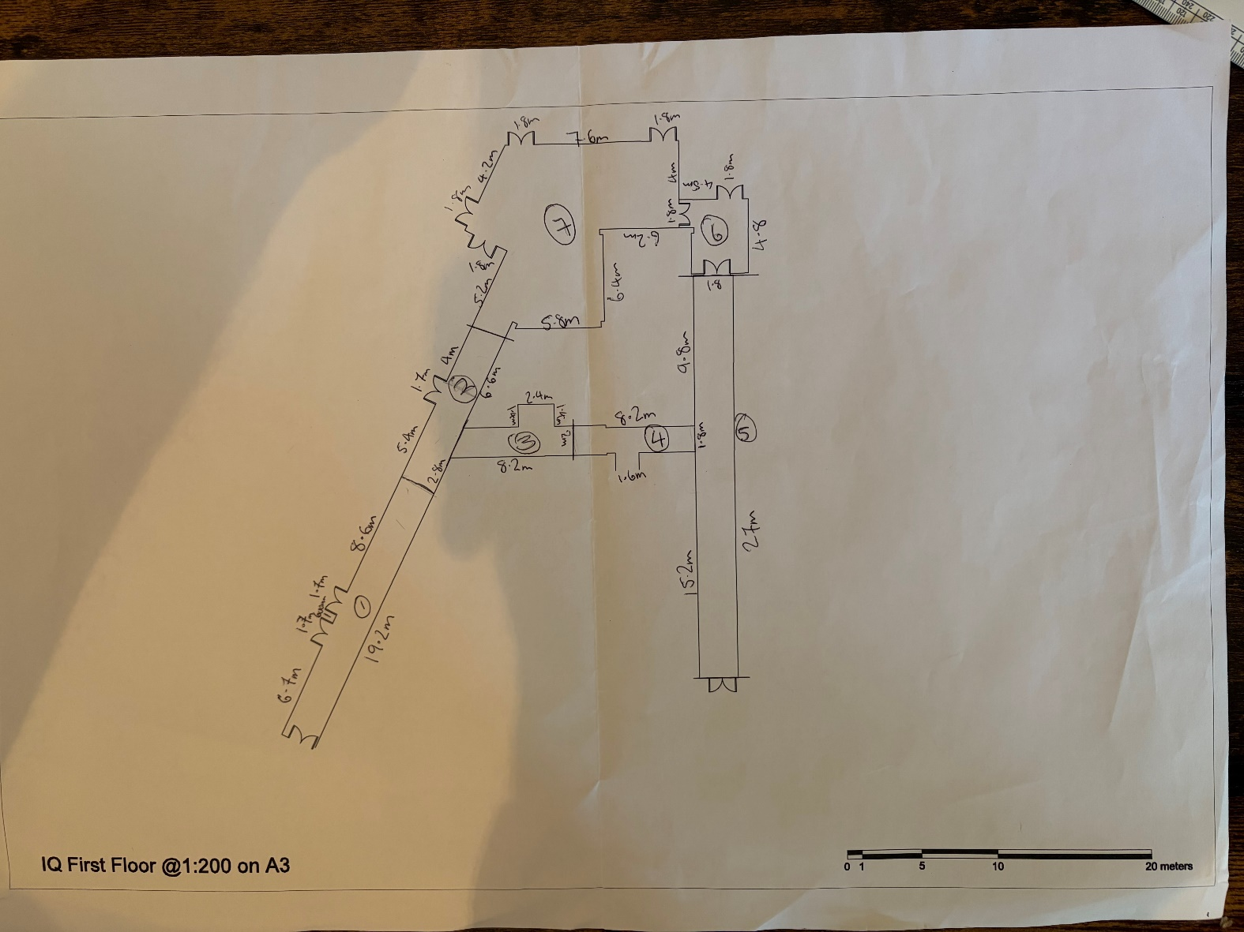

Manual Measurements


