Effective Team Working and Communication
Managing Conflict

Student Name-Claudia Buica
Student ID-2133742

Table of Content
Introduction 1
Conflict Management and its importance on the business 1
Theories of Conflict Management 2
Blake and Mouton Conflict Model 2
Thomas Kilmann Conflict Model 3
Rahim’s meta Model 5
Ways of Conflict Management at workPlace 6
Recommendation 6
Conclusion 7
Reference 8

Introduction
Conflict seems to be the method by which individuals or organizations think that others have performed an action that is destructive to their interests. Conflict is an unavoidable aspect of team life. So it is very much needed to manage the conflict in the workplace so that the office environment remains healthy to work. If there is no conflict management needed on a team, this might indicate a problem. Conflict can occur for a variety of reasons, including confusion about people's motives, differences of personality, hidden schedules, insufficient norms, aggressive reward structures and incorrectly run meetings. The main purpose of conflict management is to diminish these problems in a suitable manner. This report contains the importance of conflict management by demonstrating several theories and ways to handle conflict management in organizations.

Conflict Management and its importance on the business
In the framework of an organization's everyday operations, conflict is inevitable. One of the key competencies that significantly affects the everyday duties that employees must complete is conflict resolution (Paresashvili et al., 2021). A team may have bad outcomes from conflict. Thoroughly examining difficulties make team performance low. It can also result in emotional concerns that impede communication. Sometimes conflict is viewed as a negative thing which is also unavoidable and an indication of a healthy team. It is also found that circumstances, conflicts, and relative growth rates in family businesses impact performances (Caputo, Marzi, Pellegrini and Rialti, 2018). Conflict management improves the team by encouraging it to try new tactics, motivating members to better grasp difficulties, and encouraging new ideas.
Determining the conflict's nature and the team's task, conflict management help to work for the team in a positive way. Whenever a conflict grows passionate, it can be harmful to the team. Conflict can hinder a team's capacity to establish consensus, harm social relationships within the team, and limit acceptance of its judgments. By utilising conflict management productively, teams must establish an atmosphere that is open and accepting of different points of view, where teammates feel free to voice their thoughts. It must establish constructive working relationships so that disputes are not misunderstood as personal assaults. Teams that have a high level of trust and psychological empowerment might be benefited from conflict. Team conflict has come to be recognised over the past few years as a significant risk factor for software project failure (Nunkoo and Sungkur, 2021). For the benefit of all parties involved in the project, conflict management must be handled effectively.

Theories of Conflict Management

Blake and Mouton Conflict Model
The Managerial Grid of Blake Mouton is a theoretical framework and visual aid that attempts to classify a leader's style of leadership (Todăriţă, 2021). It is often referred to as the Leadership Grid or the Managerial Grid. Five conflict management strategies were outlined by Blake and Mouton. Smoothing, forcing, retreat, compromise, and problem-solving were the labels given to these (Mindapa, 2022). Smoothing engaged the looser of the win-lose positioning and indicated strong relation with the demands of others. The model is constructed on two behavioural dimensions:
People’s Concern: This shows the endure to which a leader can identify teammates' needs, interests and growing opportunities.
Result-oriented Concern: This describes a leader's motos on specific targets, the effectiveness of the organization and high productivity by extending the barriers of the targets which can easily be done.
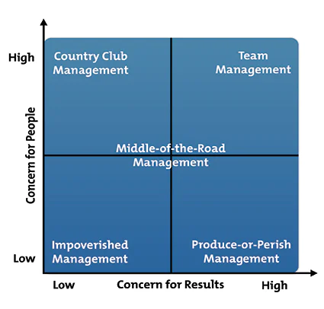
Figure: The Blake Mouton Grid
(Source: Mindapa, 2022)
As illustrated in the illustration, the model depicts a matrix with production responsibility on the X-axis and care for people on the Y-axis, with each axis varing from 1 (Low) to 9 (High). The five types of leadership are explained more below.
Leadership style of the country club (1, 9): The leader is concerned about the employees' needs and sentiments. Concern for people is strong in this scenario (9) while concern for output is low (1).
Perish Leadership (9, 1): The only goal of leadership style is productivity. Low motivation and morale of the team will eventually affect the work performance of the employees and this type of leader will face difficulty to maintain great performers (Mindapa, 2022). On the other hand, some individuals assume that their teammates are only a means to an aim. This boss is authoritarian and imposes tight work rules, norms, and procedures.
Impoverished Leadership (1, 1): This group of leaders is largely unproductive because they are unconcerned with establishing a system and culture conducive to output and employee pleasure. As a result, it will become a site of discord, discontent, and inadequacy.
Team Management (9, 9): This technique develops emotions among employees that the firm is like a member of their personal family, which leads to a better perception of the organization's target and productivity. Team leaders constantly strive to establish a positive work atmosphere that takes into account the sentiments and emotions of their subordinates (Mindapa, 2022).
Middle-of-the-Road (5, 5): This method is not as successful as it appears. They break down to inspire great performance and to completely satisfy the demands of the people because they constantly compromise.

Thomas Kilmann Conflict Model
The model of Thomas-Kilmann is intended to evaluate a people's behaviour under stress. This model defines 'conflict' as a circumstance in which people's concerns cannot be differentiated from those of others. Conflict occurs when more than two persons or organisations are concerned about matters that are diametrically opposed to each other. This model covers the two key aspects while choosing a method of behaviour in a scenario of conflict: 'intensity' and 'cooperativeness' (Savchenko et al., 2022). The level to which one strive to settle and overcome for the chosen results is referred to as intensity and consider this the Y-Axis variable of a graph. Cooperativeness is the degree to which they attempt to address the difficulties of the other party. This is the component on the X-Axis of the graph.
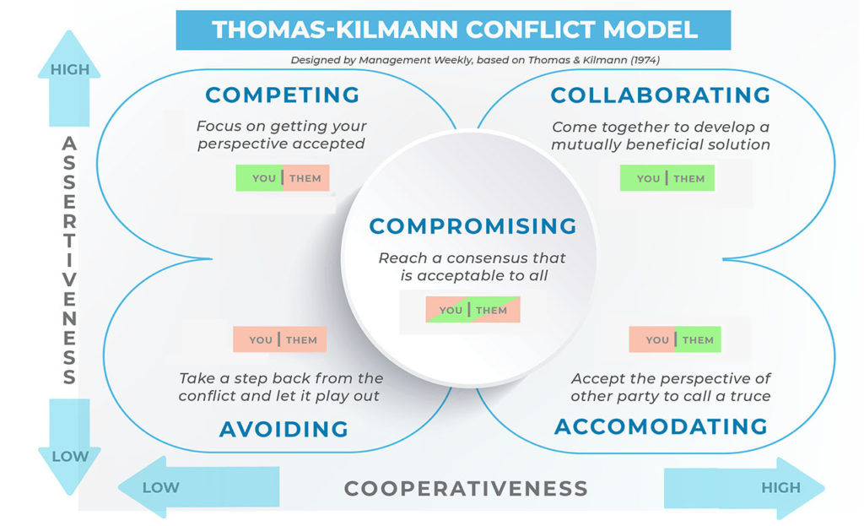
Figure: Thomas Kilmann Conflict Model
(Source: MW, 2022)
Thomas-Kilmann provided the following five strategies for dealing with the conflicts represented based on the relationship between these two and the size of implementation:
Competing: This refers to indistinct only on one's self-interests at the outlays of the worries of the others. The capability of the individual to argue, their standing in the organization, or their economical might is the one of important factors (Sinskey, 2019).
Accommodating: This approach emphasises the notion of self-sacrifice. Typically, accommodating entails unselfish understanding, compassion, or charity. While adapting, the individual ignores their own concerns or views in order to handle the difficulties of the other party.
Avoiding: This is both uncommunicative and disobedient in the Thomas-Kilmann paradigm. An individual does not wish to confront either their self or others' concerns.
Collaborating: Collaborating demands making a deliberate effort to combine with the opposite party to discover a solution that completely identifies the common problem. Collaborating entails digging deep into a problem to find out the key demands of the involved person or parties.
Compromising: This situates between competitive and acceptable. It confronts a problem more effectively than ignoring it but comes up short of researching it. In the other case, it may demand seeking a middle of the ground, to make compromises, or make the search for a rapid answer that gives a running down of the deadlock.

Rahim’s meta Model
Rahim's systematic approach to conflict resolution incorporates five conflict resolution philosophies: integrating, complying, dominating, avoiding, and compromising (Alshammri, 2021).
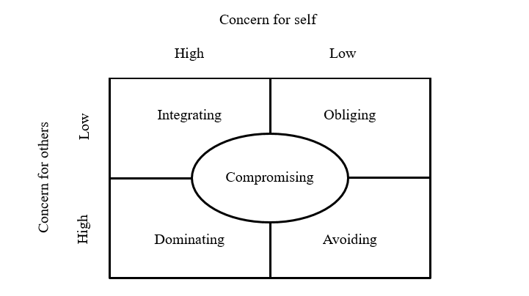
Figure: Rahim’s meta Model
(Source: RG, 2022)
Integrity: In this technique, interested parties address the matter and work together to find out the problem, produce and assess possible solutions, and choose one. Integrating is suited for difficult topics that are fraught with misconception. It is, however, ineffective for resolving disputes entrenched in competing value systems. Its key strength is that it has a longer-lasting impact since it addresses the fundamental problem rather than just the symptoms.
Obliging: Obliging might be an exact conflict-handling method when it is merely possible to get something in return. But this is not appropriate for complex problems. Its fundamental strength is that it encourages cooperation.
Dominating: When an unknown remedy must be imcorporated, the issue is minimal, a deadline is approaching, or a catastrophe approaches, dominating is suitable. It can be uncomfortable in a participatory and open environment. Its major strength is its speed.
Avoiding: This technique might consist of either passive disengagement from the situation or aggressive suppression of the problem. Whenever the costs of engagement surpass the advantages of resolving the disagreement, avoidance is appropriate.
Compromising: This implies a give-and-take attitude that involves new concern for oneself and others. When parties have opposing aims or equal power, compromise is appropriate.

Ways of Conflict Management at workPlace
Using Blake and Mouton Conflict Model, managers use the management or leadership grid to enhance performance and increase productivity. It is used by managers to assess their strong leadership styles using a technological method known as grid training. Grid training processes in a similar way that managers are required to answer questions on a predetermined questionnaire. It assists them in determining their place in terms of people and duties (Alonzo, 2018). Using Thomas Kilmann Conflict Model, managers get several interpretation materials available to assist users in identifying acceptable usage of the styles and in becoming more confident with styles with which they are less familiar. It also offers a practical method to dispute resolution. (Patro et al., 2020). Rahim’s meta Model might be utilised during an intervention, which is a strategy that allows managers to decrease emotional conflict while achieving and sustaining a reasonable degree of substantial conflict at the personal, group, and inter-group levels. By analyzing all the conflict management models, it is clear that if one can follow the steps, conflict can be easily suppressed. Such as, Talking to the other person, concentrating on behaviour and events rather than people, paying close attention, determining areas of agreement and conflict, emphasising the areas of contention, creating a strategy for resolving each issue, carrying out the strategy and building on the accomplishment.

Recommendation
The Blake Mouton Grid concept focuses on helping managers in developing a leadership style but the model ignores the importance of both internal and external limitations on the working methods. Aside from that, it doesn’t pay attention to the issues and circumstances that may develop when many points of view and ideas are offered (Islam, Hassan Jalil Shah and Ansari, 2022). So it is needed to pay attention also. Though the Thomas Kilmann model aids at the beginning of a safe and constructive discourse regarding conflict resolution yet is a numerous inquiry that many users find annoying. And the biggest disadvantage of Rahim’s meta method is that it is time-consuming and fails to confront the underlying problem. So it can be said that no model is appropriate for all kinds of conflict.
One can easily overcome the conflict through some steps. Firstly, the problem must be acknowledged, Secondly, all necessary information should be gathered. Thirdly, by setting guidelines, be decisive while keeping emotion out of the discussion.

Conclusion
Conflict Management provides a huge advantage to a team. Conflict harms the team by eliciting strong negative emotions, eroding group cohesion, and interfering with the team's capacity to function. Conflict Management helps the team's performance by encouraging discussion and stimulating creativity. There isn't any single most effective style; each has advantages and disadvantages and is affected by contextual factors. Conflict resolution strategies differ based on how forceful people are about getting what they want and how collaborative they wish to be. Although team members utilise various conflict resolution strategies depending on the scenario, teamwork is usually the most successful. Collaboration is to find an alternate solution that is acceptable to both sides.

Reference
Alonzo, M.L.M., 2018. The Relationship Between Managerial Grid Model Position and Job Satisfaction of Regular Employees of Bank X. The Reflective Practitioner, 3, pp.9-18.
Alshammri, S.N., 2021. Do informal groups threaten organizations? Comparing group conflict management styles with supervisors. Independent Journal of Management & Production, 12(4), pp.997-1018.
Caputo, A., Marzi, G., Pellegrini, M.M. and Rialti, R., 2018. Conflict management in family businesses: A bibliometric analysis and systematic literature review. International Journal of Conflict Management, 29(4), pp.519-542.
Islam, R., Hassan Jalil Shah, D. and Ansari, S.H., 2022. THE MANAGERIAL GRID–THE MAKING OF A CLEVER DEVICE FOR DEPICTING MANAGERIAL STYLES. Pakistan Journal of International Affairs, 5(3).
Mindapa, A.K., 2022. Critical Evaluation of Blake And Mouton’s Managerial Grid and Its Application To Baze University Library.
MW, 2022, “ Thomas Kilmann Conflict Model - Management Weekly” Available at https://managementweekly.org/thomas-kilmann-conflict-resolution-model/ [ Accessed on 15th December]
Nunkoo, D.K. and Sungkur, R.K., 2021. Team conflict dynamics & conflict management: derivation of a model for software organisations to enhance team performance and software quality. Global Transitions Proceedings, 2(2), pp.545-552.
Paresashvili, N., Maisuradze, T., Gechbaia, B., Weis, L. and Koval, V., 2021. Conflict management impact on the employee productivity. In SHS Web of Conferences (Vol. 111, p. 01010). EDP Sciences.
Patro, S.G.K., Mishra, B.K., Panda, S.K., Kumar, R. and Apoorva, A., 2020, March. Hybrid Social Recommender Systems for Electronic Commerce: A Review. In 2020 International Conference on Computer Science, Engineering and Applications (ICCSEA) (pp. 1-6). IEEE.
RG, 2022, “ Rahim's five interpersonal conflict styles (Rahim, 1983, p.369)” https://www.researchgate.net/figure/Rahims-five-interpersonal-conflict-styles-Rahim-1983-p369_fig1_346954600#:~:text=Rahim's%20five%20types%20of%20conflict [Accessed on 15th December]
RHP, 2022, “Thomas Kilmann Conflict Mode Instrument - Riverhouse ePress” Available at https://www.riverhouseepress.com/en/blog/thomas-kilmann-conflict-mode-instrument/ [Accessed on 15th December]
Savchenko, O., Kovalkova, T., Lovka, O., Boychuk, O. and Kostikova, O., 2022. Choice of conflict resolution strategies in negative emotional states. In SHS Web of Conferences (Vol. 150, p. 01003). EDP Sciences.
Sinskey, J.L., Chang, J.M., Shibata, G.S., Infosino, A.J. and Rouine-Rapp, K., 2019. Applying conflict management strategies to the pediatric operating room. Anesthesia & Analgesia, 129(4), pp.1109-1117.
Todăriţă, E.T., 2021, June. Leadership Style Determination according to Robert Blake and Jane Mouton’s Managerial Grid. In International conference KNOWLEDGE-BASED ORGANIZATION (Vol. 27, No. 1, pp. 241-246).

