Discuss how the evolution of HRM facilitates the strategic development

of an international hotel brand through workforce planning, recruitment, and selection.
(A case study of Marriott)

Introduction
This essay includes a discussion of different HRM aspects related to the international hotel brand. The hotel brand selected in this essay is Marriott Hotel which works to manage the HRM process differently. It has been analysed that the Marriott is one of the largest hotel chains in the entire world and it almost has 31 brands with approx. 8000 properties. Human Resource Management (HRM) refers to planning, recruiting, selecting, training and doing away with individuals in a ware house for the purpose of coping organizational goals. It includes performance appraisal, remuneration and also vary depending on the employee relations.
The evolution of HRM is too essential in managing several functions as well as responsibilities of the employees of the hotel. The evolution of HRM plays an essential role in the strategic development of hotel brands. This essay will discuss the changing roles of HRM that mainly support the strategic development of Marriott with the use of workforce planning, recruitment, and selection processes. The essay will also provide examples of Marriott to analyse how HR practices mainly involve business unit development. Some of the key terms that will be used in this essay are strategic development, HR functions, recruitment process, and hotel brand.
Evolution of HRM
There has been a progressive transition of the HRM from a function that was largely administrative and compliance-driven to one that is strategic and, critical toward organizational success. In the past, HRM was mainly focused on jobs such as payroll handling, recruitment process, and meeting employment law requirements (Belarmino, et al. 2022).However, as the organizations became aware of their human capital value for accomplishing strategic goals, HRM experienced a dramatic change.
In the modern business environment, HRM becomes a strategic aspect that dictates culture, employee involvement, and ultimately how well companies perform (Alreahi, et al. 2022). This includes a more positive impact on talent management, workforce preparation, and connecting HR systems with larger business objectives. The strategic development of HRM includes the shift from a supportive to a leadership function, which helps in influencing decision-making processes and nurturing an agile workforce.
Strategic planning today would not have been complete without the inputs of HR professionals, whose roles ensure that human capital is well organized to be a driver for competitive advantage and development (Ari, 2023). The growth of HRM is based upon the realization that employees are not only a source but also an essential element and there should be a strategic approach to use them to draw maximum benefit from their potential at the workplace.
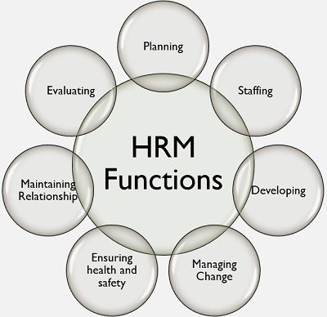
Figure 1: HRM functions
Source: Business Jargon, 2023

Strategic role of HR functions
In the context of Marriott International, HR functions play a strategic role in that they seem to transcend beyond traditional personnel management into diverse aspects. At Marriott, HR is considered a strategic partner that works to ensure the achievement of business goals for its overarching objectives. The HR activities that are evident at Marriott are talent management, workforce planning, and building a corporate culture that is aligned with the brand’s values (Khaled and Alena, 2021).
Marriott’s HR professionals work in the background and help to shape, grow, nurture as well as retain top talent. They work closely with other business units to ensure that the HR strategies adopted complement Marriott’s plans for expansion while ensuring that employees are adequately prepared for challenges posed by a global hospitality market. The strategic approach is reflected in Marriott’s commitment to diversity and inclusiveness as HR works actively towards building a workforce that mirrors the different backgrounds, orientations, or personalities of its guests (Hassanein and Ozgit, 2022).

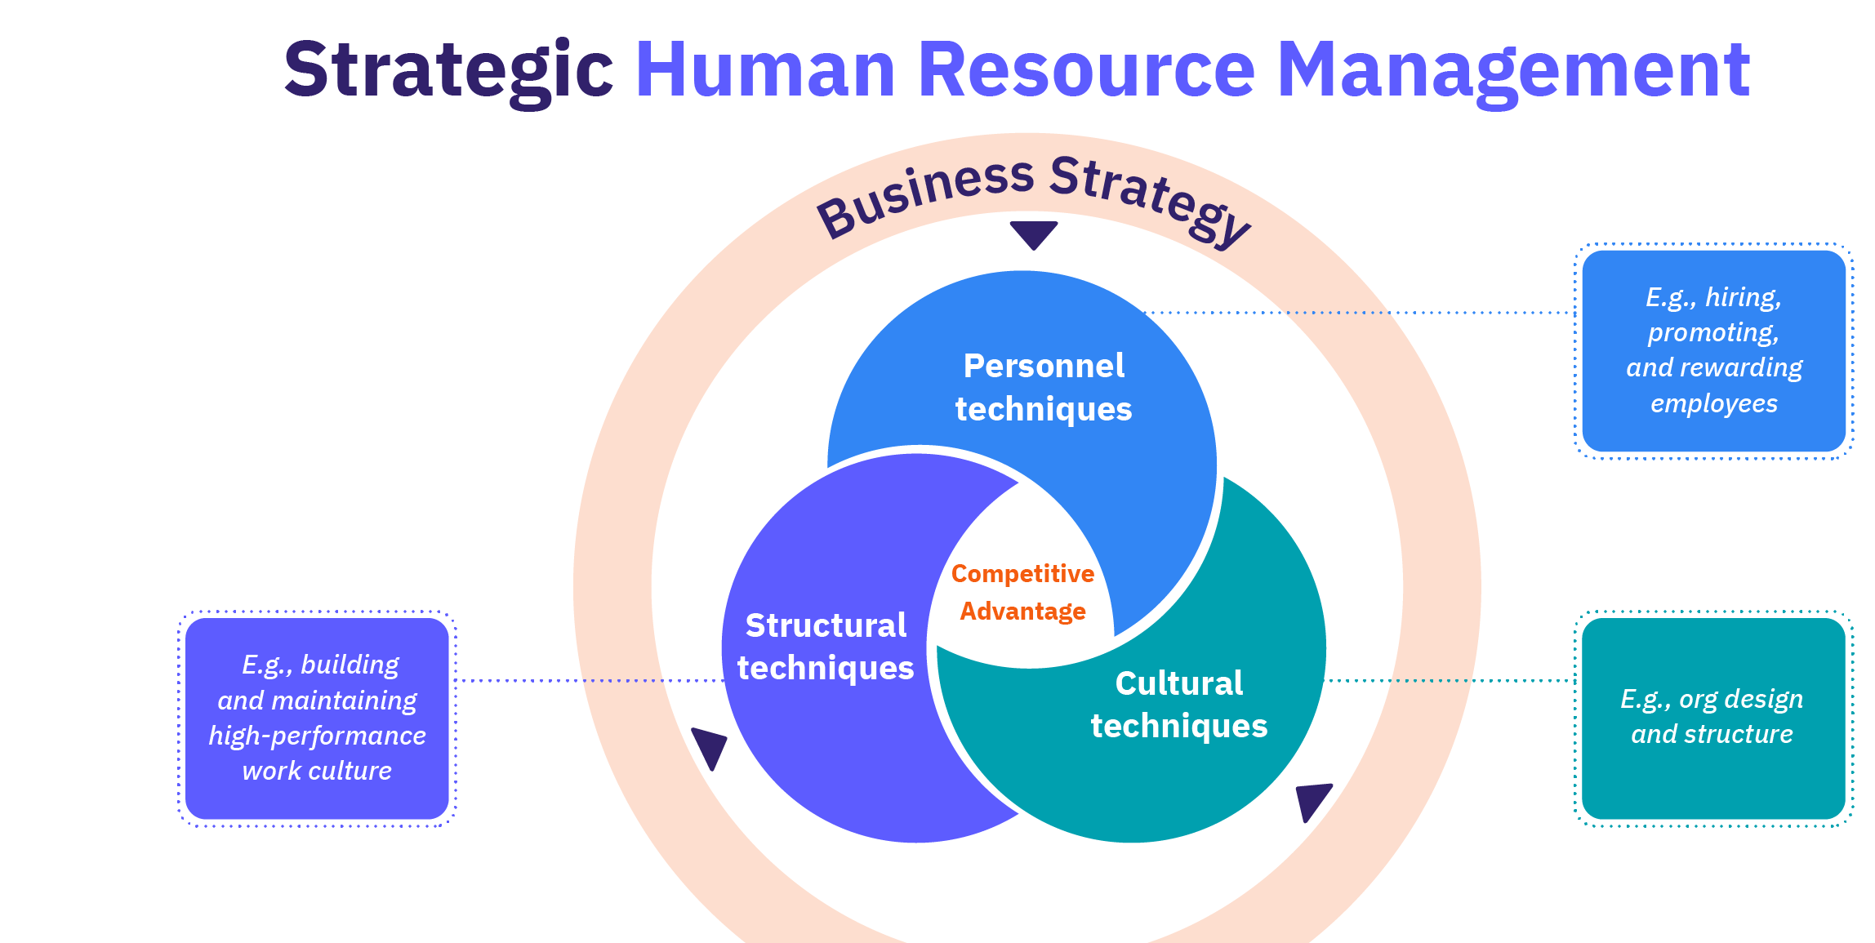

Figure 2: Strategic HRM
Source: AIHR, 2023
Additionally, the HR functions of Marriott help in creating an organizational culture through employee engagement and well-being. This focus helps to increase employee satisfaction, which in turn means improved guest experiences and ultimately good business results (Eschenbrenner, et al., 2023). Essentially, the strategic role of HR at Marriott goes far beyond administrative tasks since human capital supports the brand’s competitive advantage and becomes a key factor in promoting its long-term development amid challenging trends within hospitality.
Strategic HR planning process
As a classic example of the strategic Human Resources (HR) planning process that transcends traditional methods, Marriott International affects its workforce management to fit into broader companies’ objectives. The strategic HR planning process in Marriott is characterized by a range of essential components, which demonstrates the company’s progressive and proactive stance toward managing its human resources.
1. Forecasting Labour Demand and Supply:
Marriott’s strategic planning in HR starts with a thorough analysis of labor demand and supply. By using historical data, trends in the industry and inputs from different channels, HR managers at Marriott can make sound forecasts about future labor needs. For example, in the high travel seasons or special occasions like large conferences and cultural events, Marriott expects increased demand (Garavan, et al. 2021). On the other hand, in times of low travel such as economic downturns or international crises like pandemics and disease outbreaks, it does reduce its labor supply.
This forecasting process is critical to Marriott’s worldwide operations as each hotel and business unit must have the appropriate numbers of knowledgeable, diverse talent who meet guest requirements while achieving operational superiority. Marriott achieves cost efficiency and customer delight by matching labor forecasting with business cycles (Machova, et al. 2022).
2. Goal Setting and Strategic Planning:
After the labor demand is predicted, Marriott HR undertakes goal setting and strategic planning. This means that HR goals should be brought in line with a wider company strategy (Nash, et al. 2021). For instance, when Marriott seeks to establish a regional presence in emerging markets, HR defines more specific goals such as talent acquisition and training or cultural competency development (Szende, et al. 2021). These objectives are part and partial of the general goals in facilitating growth strategy ensuring that workers have relevant skills and knowledge.
Strategic planning in Marriott involves coordination between HR and other departments. The coordination of HR goals with the objectives of business ensures that there is a unified and integrated approach to realizing organizational vision. This strategic alignment supports Marriott’s adaptation to the trends and technological developments of the industry as well as people who may be its clients (Yoo and Yang, 2021).
3. Program Implementation and Evaluation:
The execution stage of strategic HR planning for Marriott includes carrying out programs and initiatives that are consistent with the planned goals. One of these programs includes recruitment drives, worker training, leadership development, and diversity inclusion (Baum, et al. 2023). Marriott’s involvement in programs that promote exemplary workplace culture and employee welfare is particularly evident in its commitment to environmental sustainability and social responsibility.
The process of strategic HR planning by Marriott is based on continuous evaluation (Bello-Gomez and Avellaneda, 2023). HR practitioners are constantly evaluating the performance of introduced programs through KPIs, employee feedback mechanisms, and likewise criteria. This iterative evaluation enables Marriott to adjust the developed strategies based on current figures, enabling HR initiatives not only to fulfil business objectives but also to improve employee engagement and organizational success.
Recruitment stages and selection process
As one of the world’s leading hospitality brands, Marriott International uses a model recruitment and selection strategy that is reflective of its culture for building an inclusive workforce (Tirkolaee, et al. 2021).The stages of recruitment and selection that are used in Marriott play a vital role by contributing to the development of business units all over its large portfolio.
1. Talent Acquisition Strategies: Marriott uses ground-breaking talent acquisition tactics to ensure that it engages the most appropriate candidates. The brand uses technology to make the hiring process more efficient. For instance, Marriott can keep track of candidate data as well as applications and identify matches with available jobs using applicant tracking systems (ATS). Such a technology-driven process facilitates faster and more accurate initial screening stages (Retnandari, 2022). In addition, Marriott understands the role of social media in Employer Branding for managing talent acquisition. For this reason, the company uses sites like LinkedIn, Instagram, and Twitter to demonstrate its corporate culture values and employee success stories.
Marriott not only cultivates a positive image by actively involving potential candidates through social media but also attracts people who can easily associate the company with its mission and values. Working together with academic centres is an important element of Marriott’s talent recruitment program (Hou, et al. 2023). Marriott forms pipelines by partnering with hospitality schools and universities. Such a proactive approach provides for the uninterrupted flow of individuals who are skilled and driven to operate units in areas where Marriott is increasing its presence.
2. Comprehensive Selection Processes: In the selection process of Marriott, they are developed to examine candidates in a much broader sense than just technical skills by evaluating cultural fit and brand values. This method is essential in ensuring that the selected individuals not only match current job demands but also impact positively on the future success of any business unit.
a. Multiple Interview Rounds: When interviewing, Marriott is likely to hold more than one round of interviews that each serve a particular function. First interviews could measure technical features, and then other rounds are dedicated to soft competencies, cultural compatibility, and coordination with Marriott’s service idea (Khanthavudh, et al. 2023). This comprehensive approach enables Marriott to obtain a complete picture of each candidate.
b. Assessments and Simulations: To measure practical skills and problem-solving attributes, Marriott employs tests and simulations as part of the selection process. For instance, those looking to become managers may be given live scenarios that will test their decisiveness and leadership potential (Sharma and Kaur, 2021). These assessments ensure that those selected by the business unit have the necessary skills to help achieve both operational and strategic goals of operations.
c. Cultural Fit Evaluation: Marriott’s selection process includes cultural fit as one of the most important factors. The brand is very committed to creating a diverse and inclusive work environment that embodies the values of its international clientele (Walford-Wright and Scott-Jackson, 2018). The selection process helps Human Resource professionals determine if a candidate fits well with Marriot’s core values, including critical qualities of customer-centricity, teamwork, and superior service delivery.
Examples from Marriott: Marriott’s involvement with HR planning, recruitment, and selection processes is evident in its initiatives targeting the development of business units.
1. Apprenticeship Programs: An example of how the brand generates future talent through investment is Marriott’s “Take Care” program. This apprenticeship scheme provides individuals with hands-on knowledge in several job positions within the hospitality industry (Bugg, 2015). Through talent nurture, Marriott would not only support workforce planning but also maintain the pipeline of workers ready to cater to business units.
2. Marriott's Voyage Program: This project aims at identifying and nurturing potential future leaders from within the organization. This program targets high-potential associates and gives them a process to plan their development, which includes mentoring, leadership training as well exposure to different aspects of the business. Through initiatives such as Voyage, Marriott can identify and develop talent in a deliberate fashion that ensures some future leaders can propel business unit success.
3. Global Career Development: Marriott highlights global career growth benefits for its staff members. Promoting from within and giving employees opportunities to progress in the company also helps the organization retain talent while making them loyal to it (Jose, 2019). This strategic approach contributes not only to the support of HR planning by creating a constant stream of fresh talent but also helps develop business units as workers progress within the company.
Conclusion
From the above information, it has been concluded that the evolution of Marriott’s HRM exemplifies a shift from tradition to strategic partnership whereby human capital is integrated with brand-led needs. So, the strategic HR planning process with forecasting, goal setting, and program implementation will allow Marriott to have a workforce that is suitable for its growth. As the recruitment stages and selection processes focus on not only technical skills but also cultural fit, it creates an organization’s workforce pushing the development of business units. Marriott’s strategic HRM functions serve as a significant pillar of business growth in the highly contested hotel industry that depends on both an effective and skilled workforce.
The company uses technology to align its workers with their roles and engages student institutions to attract fresh minds while ensuring cultural fitment is valued more than just skill set qualifications. Programs such as apprenticeship programs, leadership development initiatives, and global careers show the presence of HR planning that is directly focused on developing business units. Through these practices, Marriott builds a workforce that continues to contribute towards the brand’s success and survival in an increasingly competitive world hospitality industry.

References
Alreahi, M., Bujdosó, Z., Kabil, M., Akaak, A., Benkó, K. F., Setioningtyas, W. P., and Dávid, L. D. (2022). Green human resources management in the hotel industry: A systematic review. Sustainability, 15(1), 99.
Ari, E. (2023). Human resource risk challenges in the hotel industry. Journal of Hospitality and Tourism Insights, 6(5), 2073-2092.
Baum, T., Rubio, J. C., Congreve, E., Alberti, G., Clifton, N., Guthrie, J., ... and Simpson, B. (2023). ReWAGE Evidence Paper: Work, wages and employment in the UK’s hospitality sector.
Belarmino, A., Koh, Y., and Shin, H. H. (2022). Blurred lines: comparing room rates, star-ratings, and user-generated contents for full-service and select-service hotels. Service Business, 16(3), 721-742.
Bello‐Gomez, R. A., and Avellaneda, C. N. (2023). Goal Achievement in Municipal Strategic Planning: The Role of Executives’ Background and Political Context. Public Administration Review.
Bugg, K. (2015). Best practices for talent acquisition in 21st-century academic libraries. Library Leadership and Management, 29(4).
Eschenbrenner, B., Zlatic, A., Bechtel, M., Collins, B., Straley, C., and Gubbels, G. (2023). Marriott International: A Managerial Strategic Audit.
Garavan, T., Matthews-Smith, G., Gill, A. M., and O’Brien, F. (2021). Strategic talent management in the hospitality industry. In Talent management innovations in the international hospitality industry (pp. 9-30). Emerald Publishing Limited.
Hassanein, F., and Özgit, H. (2022). Sustaining human resources through talent management strategies and employee engagement in the Middle East hotel industry. Sustainability, 14(22), 15365.
Hou, Y. N., Chimonas, S., Gubili, J., Deng, G., and Mao, J. J. (2023). Integrating herbal medicine into oncology care delivery: development, implementation, and evaluation of a novel program. Supportive Care in Cancer, 31(2), 128.
Jose, S. (2019). Innovation in recruitment and talent acquisition: A study on technologies and strategies adopted for talent management in IT sector. International journal of marketing and human resource management, 10(2), 1-8.
Khaled, G., and Alena, F. (2021). Industry 4.0 and human resource management in the hotel business. Human progress, 7(2), 1.
Khanthavudh, C., Grealish, A., Tzouvara, V., Huang, J., and Leamy, M. (2023). Implementation and evaluation of recovery-oriented practice interventions for people with mental illness in Asia: An integrative review. International Journal of Nursing Studies, 104591.
Machová, V., Šanderová, V., Šuleř, P., and Hodinová, A. (2022). Prediction of supply and demand for jobs in the Czech Republic. In SHS Web of Conferences (Vol. 132, p. 01006). EDP Sciences.
Nash, R. C., Schooner, S. L., O'Brien-DeBakey, K. R., and Edwards, V. J. (2021). The government contracts reference book: A comprehensive guide to the language of procurement.
Retnandari, N. D. (2022). Implementation of strategic planning in regional/municipal governments, obstacles and challenges. Policy and Governance Review, 6(2), 155-175.
Sharma, M., and Kaur, P. (2021). A comprehensive analysis of nature-inspired meta-heuristic techniques for feature selection problem. Archives of Computational Methods in Engineering, 28, 1103-1127.
Szende, P., Dalton, A. N., and Yoo, M. (Eds.). (2021). Operations management in the hospitality industry. Emerald Publishing Limited.
Tirkolaee, E. B., Sadeghi, S., Mooseloo, F. M., Vandchali, H. R., and Aeini, S. (2021). Application of machine learning in supply chain management: a comprehensive overview of the main areas. Mathematical problems in engineering, 2021, 1-14.
Walford-Wright, G., and Scott-Jackson, W. (2018). Talent Rising; people analytics and technology driving talent acquisition strategy. Strategic HR Review, 17(5), 226-233.
Yoo, M. M., and Yang, S. (2021). Forecasting Demand. In Operations Management in the Hospitality Industry (pp. 71-94). Emerald Publishing Limited.

