Programe : BA (Hons) Leadership and Management Skills for the Workplace

Module : Understanding and Engaging in the Customer Experience

Module code : BMSW 5103

Module Leader : Zainab Atta

Assigment Tilte : Organization’s quality systems and customer relationship management Task1 and Task2

Student Name : Iosif Tcaciu

Student Id : 2022775

Contents
Executive Summary 3
Introduction 5
Company Context 5
Marketing Mix 6
Porters 5 forces model 7
Stakeholder Mapping 8
Covid-19’s effect on Unilever 9
Reviewing Models 11
SERVQUAL Gap 11
Marketing Mix 7P 13
Appropriate model for Unilever 14
Discerning Unilevers challenges with application of model 15
Recommended pathways to handle Unilevers challenges 17
Conclusion 18

Executive Summary
Throughout this report, we have tried to show the quality management and customer service relationship management-related problems of Unilever. We brought in many marketing theories and Models which helped us further see through the problems that the company might be facing and after factually seeing and analysing many theories and models we concluded that Servqual would be the best to evaluate and find out Unilever's problems in all 5 dimensions.
We tried to show the effect of covid -19 in the retail business of Unilever and how things changed with time and how people's taste in purchasing goods also changed due the trying times. As more consumers buy online, they will feel much more compelled to do so online. As a result, customers must be more engaged with online content and influencers who can help make Unilever products more appealing to them.
On the other hand, as people become more health, social, and environmentally conscious, they must be provided with more sustainable and eco-friendly products that also cater to their micro-level needs. Servqual's study assisted us in identifying holes in Unilever's business that, ideally, Unilever would close over time.

Introduction
Customer Relationship Management (CRM) is a business technique that has been around for a long time and isn't new. Despite the fact that CRM is all about the customer, it isn't enough to make it a success. People, procedures, and technology should all be considered while implementing CRM in a business. As a consequence, we were able to improve our ability to manage our time and our ability to wow customers. It is possible to attain "maximum customer satisfaction at the lowest total cost to the company" by implementing a quality management system (also known as a "quality system" or "QMS"). The QMS helps a company accomplish its quality-related objectives by integrating philosophies, standards, techniques, and technologies. Real-time consumer surveys across all channels are captured by Unilever's CRM system and tailored campaigns are launched to acquire customer data. Segmenting clients based on their particular demands is critical when dealing with a wide selection of items. Unilever is a huge company that understands the importance of having consumer data in one place and responding to it. Unilever has identified a solution via Alchemetrics, a marketing technology business (Windhia, 2020). Alchemetry completed a project to integrate client data into Thrust. Unilever uses this platform to run multi-channel campaigns that target customers. Unilever's Dove is a good example.

Company Context
Unilever is a fast-moving consumer products company and provider. The company's product line includes food, drinks, household items, and health and wellness products. From North America to South America, Europe to Asia-Pacific and Africa to the Middle East are all areas in which the corporation has economic interests. Unilever is a company that has a 116.84 bn dollar market cap in the consumer goods market and has been holding the 3rd position in the market of 1.005 Tn dollars (companiesmarketcap.com, 2022). Unilever's headquarters are located in London, England (Windhia, 2020). Over the course of the last 5 years, Unilever's revenue has been fairly stable within the range of 50000-53000 million euros while its gross profit margin is around 41-43% (statista.com, 2022). While the company's market position, R&D, and operational network are strong, revenue decrease and liquidity remain concerns. Covid-19 has both hit Unilever positively and negatively. Worldwide its retail outlets have been closed off which has led to layoffs. But on the other hand, online sales of its healthcare goods rose drastically leading to profit. The internal factors that are affecting Unilever are: -
- Shareholders and owners: Shareholders' and owners' profits depend on the company's efficiency and customer acquisition, as a result, the combined effect many major decisions of the company.
- Employees: Employees are the fundamental part of a company and act as the heart of it if they revolt or don’t do things as they were supposed to it will affect the customer acquisition.
- Intellectual Property: Intellectual property such as patents and copyright acts are the main revenue-generating items which also help attract customers. So degradation or increase in intellectual property can greatly influence the firms' profitability.
- Culture: A culture means the value and behaviour and ethics with which the employees and whole organization have grown by this affects how the business process should be and how the whole organization will run so it affects the customer segment.
Also, there are some other factors which affect them on different scales.
- Finances
- Policies
- Internal Process
- Directors
- Equipment
- Brand Value
However, some external factors affect Unilever in many ways.
- Strict rules: External strict rules and regulations in Europe have often affected the business process of companies there it has been the same for Unilever
- Fierce rivalry: The consumer goods market has faced fierce competition as Nestle is at the top of the industry Unilever is trying its best to become number 1 but it is quite tough.
- Policies: There are trade policies which impose high tariffs thus affecting the business of Unilever.
- Conflict with distributors over Brexit-induced currency rises.
- Volatility in the currency market.
- Expansion of the burgeoning market for luxury skincare.
- Implementing Ultralogistik's integrated supply chain.
- Using 'People Data Centres’ to study consumer habits.
- Awaiting regulatory permission slows corporate expansion.
- Climate changes impact the supply chain.
- Tax regulation variability.

Marketing Mix
The marketing mix of Unilever consists of 7p’s which are: -
Product: Product lines are organized into five major categories, with each serving as a subcategory. Lux, Lifebuoy, Surf surf, Rin, Wheel, Glow & Lovely, Pond's, Vaseline, Lakmé, Dove, Clinic Plus, Sunsilk, Pepsodent, Closeup, Axe, Brooke Bond, Bru, Knorr, Kissan, Kwality Wall's, Horlicks, and Pureit are among the company's major household brands.
Pricing: The present pricing plan is a competitive pricing approach. Because of the industry's vast number of rivals, data about competitors is widely accessible (Peelen, 2016). Competes by charging more for its items than its rivals. This is because it has more features, and the expensive price compensates for them.
Place: It has two marketing channels. First, it sells directly to customers through its website. Second, it sells to wholesalers who then sell to other stores around the nation (Schierholz, 2014). Customers buy these.
Promotion: Promotes its goods via various mediums. It employs conventional media, such as TV and radio commercials. This is advantageous because of its wide reach and capacity to draw huge crowds. It employs online and social media advertising, which is cheaper and more effective as internet use grows.
People: Its sales force has personnel who are crucial to its marketing initiatives. These professionals are trained in persuasion but also respect the company's clients' choices.
Process: So those shops are notified when their inventory levels are low, the company has established systems. orders additional items to fill its stock (Oakland, 2014). This assures clients may get things whenever they need them.
Physical Evidence: Its items are packaged in bright colours that stand out on store shelves. These are put on company-supplied shelves that are likewise unique in colour and style. This helps buyers find such shelves in crowded supermarkets.

Porters 5 forces model
This model is used mainly to see 5 factors that affect the profitability and growth of the company.
Bargaining Power of Buyer (Low): The buyers are decentralized internationally which causes them to have low bargaining power as they can’t combine and go against the pricing of Unilever market competition is irrelevant in the case of customer decentralization. Due to bargaining power being low while covid many products in some countries had seen the price rise but still the consumers bought it.
Bargaining Power of Supplier (Low): Unilever usually has agreements with its suppliers to deliver items for a certain length of time at a set fee. This strategy prevents suppliers from leaving and accusing exorbitant charges (Kotler, Armstrong and Amador Araujo, 2017). Within covid suppliers faced a major production crunch but still, they couldn’t increase costs majorly due to having low bargaining power.
The threat of New Entry (Low): Unilever has a huge brand value and customer loyalty and also as it has huge capital and technological investment it creates a barrier to entry for new firms. Though demographically some places others might have the edge. In covid times in some smaller countries, people started buying from boutique shops but still, they were unable to majorly affect the market share of Unilever.
Competitive Rivalry (High): Unilever is a multinational firm that is well-known globally. So the rivalry is quite fierce and severe. Not just little merchants, but also market giants like P&G, Kraft, and Nestle.
The threat of Substitutes (Moderate): This study shows that consumers desire to try new and alternative items at least once in their lives. They will use other similar items to sway shoppers away from Unilever (Murphy & Murphy, 2018). These techniques may attract customers, but those who are familiar with Unilever's goods will first consider the brand's name and reputation in the market. Within covid people went towards more organic products as people felt more environmentally conscious.

Stakeholder Mapping
It is used to identify stakeholders and classify them in terms of their impact and interest in the project by using a four-quadrant matrix.
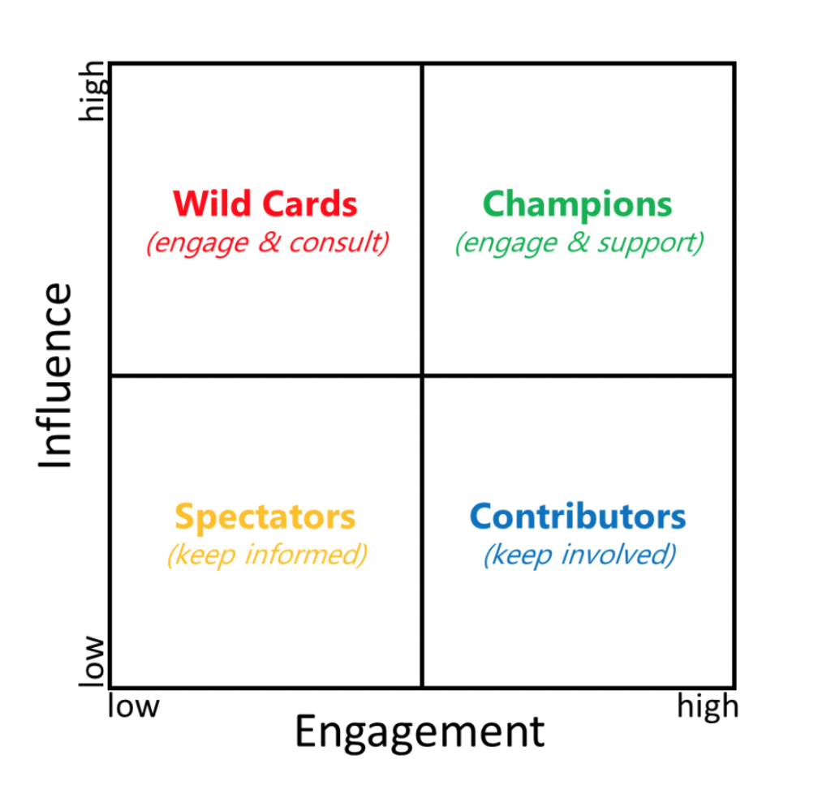
Figure 1: Stakeholder Map (idenhaus.com, 2022)
The stakeholders in Unilever may be classified into four quadrants. In the first quadrant, we have the wild cards, who are the consumers and government, who are critical and should be kept happy since their dissatisfaction might have implications in terms of revenue and tax, respectively. On the right, we have the champions, who are the business partners, investors, and suppliers. These individuals need a high degree of involvement and also have a significant influence on the operation and financing of the firm as essential actors (BOONE, 2020). And in the bottom left quadrants are the onlookers, such as those who do not purchase Unilever products or who lack authority; they just need to be educated. And in the right quadrants, we have the company's personnel. Even if they lack considerable influence, they must be kept engaged in the business and driven to perform successfully. Within covid, we have seen that suppliers have become an important part of the business if the investors and suppliers aren’t on your side it may cause your production serious damage so they are the most important of the stockholders. And the contributors are the ones running the company they are the 2nd most important as they will help in creating value for customers and also create good brand loyalty and fondness within the customers.

Covid-19’s effect on Unilever
Covid-19 has created a lot of positive and negative scopes for businesses around the world it is the same for Unilever. We were able to find various insights on consumer behaviour concerning the epidemic, including the following:
- Pre-lockdown frantic shopping and stocking up caused drastic demand fluctuations. Demand fluctuations created massive supply chain inefficiency a lot of shelves in the marts were empty without any products people faced difficulty getting the goods they wanted as there wasn’t enough stock which hampered the quality of service the customers should have gotten.
- During the quarantine period, Categories/Types exhibit different patterns, which are tied to consumption events.
- There is a strong increase in all hygienic items and in-home consumption compared to the more heavily hit categories of personal care and outside-of-home use (Spiridonova and Mrochko, 2021).
- People favour small stores, e-commerce, and O2O shopping channels.
- Premiumisation is a momentarily reversing course.
- Consumption of digital media has risen causing an increase in snack consumption.
Statistically, it has affected the whole industry as Unilever has a big market share in Britain’s consumer goods market, we will use the industry statistics as a proxy of Unilever's information. We have seen that over the pandemic the food-related products grew by 15.4% (statista.com, 2022). Whereas beauty products have seen a 4.2% decline in growth as people stayed more at home and wanted to spend less on non-essential items as they had less income (statista.com, 2022). Sales through the internet have risen by 33.9% which is peak sales online (ons.gov.uk, 2022).
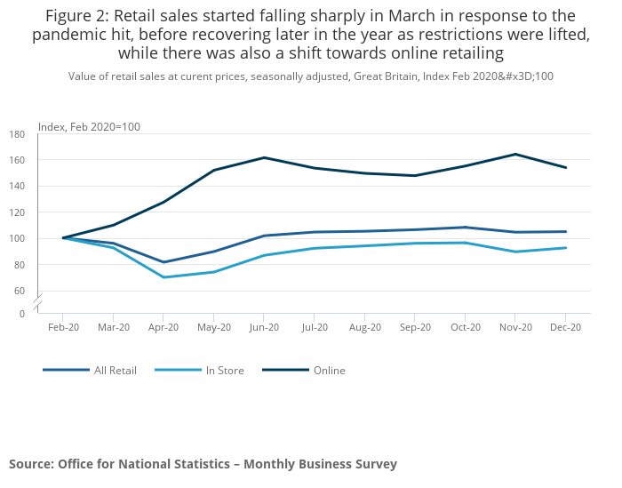
Figure 2: Retail Sales Growth (ons.gov.uk, 2022)

As we can see in the graph at the start of the pandemic in March the retail sales saw a huge drop due to people's interest decreasing in non-essential items and increases spending on stocking essential items. Though the dip started to recover slowly due to mass digital marketing and promotions which increased the digital sales of goods which is true for most companies.

Reviewing Models
In this part, we are going to talk about some of the relevant CRM and marketing models that can be used to enhance Unilever's service quality and any other challenges they might be facing.

SERVQUAL Gap
The SERVQUAL model, an acronym for Service Quality Model, is a research technique for capturing and analysing customer expectations and views about a service (Armstrong, Kotler and Opresnik, 2019). Gap analysis is part of Servqual, a common service quality management technique. Servqual proposes a gap analysis to determine why consumers get poor service.
- The gap between Management Perception and Customer Expectation: This gap occurs when management or service providers misunderstand the customer's desires. Communication issues between contact personnel and management can cause it. The market is not segmented. Insufficient market research causes this Gap. Covid-19 has increased the gap between customer expectation and management as management expected customers to be more rational and customers expected better supply chain and product stock but as shops around the world faced stock out situations this gap increased
- The gap between Service Quality Specification and Management Perception: This gap occurs when management or service providers accurately understand consumer needs but fail to establish performance standards. An unsystematic new service development process or bad service design might cause it. The overall service quality specification and management perception gap have been fairly stable for Unilever as they were able to provide the same level of product quality.
- The gap between Service Quality Specification and Service Delivery: This gap may occur in service personnel circumstances. Inadequate training, inability or reluctance to satisfy service standards might cause it. Inappropriate evaluative and compensatory systems. The major culprit is ineffective recruitment. There has become a gap in the market for developing countries during covid as there was a huge increase in home delivery but in some places, they were unable to meet this requirement as good as developed countries.
- The gap between External Communication and Service Delivery: Advertisements and corporate executives' words heavily affect consumer expectations. This void occurs when certain presumptions are not met at the moment of service delivery. There has been a communication GAP in recent times Unilever faced lawsuits from its customers of fair and lovely users in India this only shows they were unable to communicate what was the actual value they wanted to give and the customers felt betrayed.
- The gap between Experienced Service and Expected Service: When a consumer perceives a service quality attribute as undesirable, it might cause a gap between Expectations and Perceptions (EVALUATION OF CUSTOMER SATISFACTION-SERQUAL SCALE, 2021). It is currently used to assess total consumer discontent, which is the sum of all other gaps. The total consumer discontent has been increasing rapidly among the brown customers of the South Asian region as they felt they were toyed with by giving them dreams which never could be fulfilled using the fair and lovely product.

The gaps we have discussed until now are a culmination of the 5 dimensions we are talking about below. Mainly these dimensions are the ones that help either to increase or decrease the Servqual gaps due to their positive increase or negative downgrade.
Tangibility: The look of physical facilities, equipment, staff, and communication materials are referred to as their "tangibility". Cleaning and maintaining a professional appearance are important to customers, as are well-dressed staff members and well-written and produced items like menus, websites, and signage (Desai, 2018). Pandemic has changed this part of the model quite a bit as people are ordering more from their homes need for tangible shops has decreased. But still, the expense has increased due to keeping the stored more virus-free.
Reliability: Reliability is the capacity to deliver on promises consistently. To please your consumers, you must do what you say you will do when you say you will. They expect your company to produce a functional product or service, to aid them when they need it, and to do it quickly. This dimension is all about customers trusting the firms they purchase from. During pandemics, people are giving more importance to businesses that are reliable with their promises as it is important for health and safety.
Responsiveness: In today's fast-paced environment, responding immediately to client issues and concerns is essential. Even if your consumers take a long time to react to you, you still need to be responsive. To at least let clients know you're working on their request, respond quickly.
Assurance: Personnel can transmit trust and confidence through their expertise and civility (Desai, 2018). In today's competitive marketplace, customers expect firms to be experts in their field. Whether you do this through presenting qualifications and industry certifications or client testimonials, buyers will feel more comfortable doing business with you if you communicate your knowledge to them.
Empathy: Empathy is the firm's caring, personalized approach to consumers. Customers want to feel like they're part of something bigger than a transaction. Even the finest product or service might fall short of their expectations. Empathy for consumers implies showing concern for them. Inspiring staff to give outstanding, compassionate service with frequent smiles and discussions will help you surpass expectations. In this time of the pandemic, people are going through a lot so empathy has become more important customers like to engage with more empathetic businesses rather than corporate money-making machines.

Marketing Mix 7P
Another important marketing theory or model that has been an integral part of the business is the marketing mix where we use the 7p’s to see the different segments of Unilever and how the pandemic has affected the marketing mix.
Product: During the pandemic, Unilever focused more on the food & hygiene segment of its product line as more people needed sanitisers and other healthcare products, so they created new products in this line. They have highly differentiated their products
Price: During the pandemic due to demand and supply fluctuation and supply chain management is in chaos it has made Unilever affect its pricing in some spectrum of its goods (Srivastava, 2018). Due to the increase in digital sales, they have given discounts on many goods to attract online sales of customers.
Place: Usually Unilever has used retail as the main selling place for its goods but throughout the pandemic, they have shifted towards their online sales. For this, they have increased investment and marketing for Ushop an online-based marketplace for Unilever where they sold their goods at a high discount and also delivered them for free.
Promotions: As people stayed more at home customers were more into consuming content online such as Unilever decided to do more online marketing and digital mass marketing using influencers. As influencers are becoming the new buzz among people. There exists almost every kind of content for every target group, so companies have selected specific content makers and influencers and marketed specific products that appeal to that consumer.
People: Unilever faced problems during the pandemic as they had to cut off retail outlets, they are being less profitable and also, they had to face a serious crisis regarding what they should do with the employees of those outlets. Some were able to integrate into other segments of their company but a lot of them had to be let go.
Process: The process of an organization goes from the production of goods to their being delivered to the outlets. But this process saw increased change as more people ordered online, they could make inventory more just in time instead of keeping more finished goods they could keep more world raw and work in process and produce goods according to public demand which would lower their working capital.
Physical Evidence: During the pandemic physical evidence for keeping track of inventory and sales hasn’t changed that much but increased sales online have created a vast amount of data that could be kept track of online with a database that is good for customer tracking.

The appropriate model for Unilever
There are several major tools for assessing service quality in contemporary service literature. Researchers and practitioners alike respect and utilize the SERVQUAL model to assess and improve service quality in a variety of contexts and across cultural divides. The SERVQUAL model may be used to gauge a company's level of customer satisfaction for several reasons, some of which are listed below.
- On an ongoing basis, customers' views of a company's service quality may be tracked against those of its rivals. If you have studied and presented the data, you can easily determine your strengths and flaws when compared to your competitors. Unilever can use it to track their consumer goods against Nestles. For example, Ben and Jerry’s of Unilever competes against Hagen-Zazs of Nestle here one can track the product quality of both.
- Companies may evaluate their service quality on an individual level as well as across all aspects using this tool. It can be used to measure the quality of a single product such as Ben and jerry's or for the whole line of ice cream products to see how they stack up against others.
- It gives the company the ability to divide its clients into several groups depending on their SERVQUAL ratings (Parasuraman, 2014). Unilever is able to divide its customers into several segments for example if we think about the ice cream line up their consumers can be divided into a bunch of different groups people in Asia who normally go for Magnum normally like a premium quality whereas those who go for Kwality Walls.
- When applied in a variety of service settings, the SERVQUAL model may be customized to meet the unique characteristics of every firm. It may be used in a wide range of factual contexts and numerous nations and cultural backgrounds, making it universally relevant. Unilever is able to use it to widely discern its customers based on their values, and culture, for example how its Asian customers are responding to its fair products.
- The SERVQUAL gap analysis technique seems to be a rational and clear idea, and the questionnaire is also pre-described and may be altered as needed.
- This instrument has been tested and shown to be useful for benchmarking purposes. Due to considerable field testing and refining, it is a statistically valid instrument (Al Bassam & Al Shawi, 2015).

If we try to align Unilever's problems during the pandemic and what factors might be affecting them, we will get a better idea of why the service quality gap is an important model for this company. First of all, let’s talk about the strict rules which are imposed by multiple regulatory bodies this will help keep Unilever in line with maintaining the quality of the goods which will help the increased reliability of the products thus decreasing the quality gap. The fierce rivalry will keep them in the run by keeping the product cheap and making it more diverse and adhering it to customers taste this will have an increasing effect on both reliability and tangibility of the product as it needs to be more attractive. Implementing an integrated supply chain will increase the delivery time and product quality thus it will increase the responsiveness of the company so they can respond fast to the orders. Using data centres to read consumer habits will also help them become more empathetic as they will be able to cater to the personal preference of their customers. Dramatic fluctuation in the exchange rate market and also raw material market will decrease the reliability of the company's products (Haming et al., 2019). Consumption of goods through digital media also gives importance to rapid responsiveness as if they aren’t responsive the customer will shift to another place. The use of digital influencers will increase the assurance of customers on the company thus bridging the Servqual gap more.

Discerning challenges of Unilever with the application of the model
There are a couple of steps to applying a Servqual model. First of all, a survey has to be done on the customer on each of 5 dimensions and get a cumulative average then we will take the expected number and minus the actual surveyed number and with that, we will get the gap number. For example, the customer will be asked on each level what is their expectation from such service they can rate it from 1 to 7 and after that, they will again rate what they think they got from this feature or product this will act as the perception number. The difference between the expected number and perceived number will be the Servqual gap (Prentkovskis et al., 2018). If we look at the first dimension or tangible part of Unilever we will be asking if Unilever has the state of the art manufacturing equipment compared to what customers expect they should have in the business. Unilever has been doing it by keeping its product manufacturing safety its main concern by doing so it is able to give customers the promise that it is using the best manufacturing equipment to make the goods safe for both employees and customers. It also tracks the incidents that occur due to product defects and try to solve them worldwide using its thorough investigation after going to the roots it sends a lesson learned document to that branch to better understand how this problem can be mitigated thus reducing 70% of the incidents. After seeing reviews of customers, we can see that they have met their expectations so we can see no gap lies there. Second, we try to see if the retail stores are visually appealing to the customers this has been varied across the online surveys the gap is quite low in areas in Europe, Australia, America, Japan and such developed nations but the gap is quite high in an underdeveloped and developed nation. Are the employees working in the Unilever retail stores neatly and clean? This gap has been quite low around all offices and shops that are directly handled by Unilever. Are pamphlets and advertisements and other promotional ways visually attractive to the customers? Most of the customers have shown positive reviews in this regard so we can say that the Tangibility gap is quite low for Unilever.
In the case of reliability, Unilever must face some questions such as Does Unilever keep the promises it made? And most customers said as they are becoming a more sustainable brand, they are keeping their promise to win the power of good quite a bit. But many also say that they aren’t doing enough for the sustainable development of the environment around it so there are gaps. Is Unilever able to give good products and services on the first try? The reviews are quite low in this sector, so a significant gap exists. Does Unilever insist that they have an error-free record? In this case, Unilever doesn’t have an error-free record often they have made products that didn’t meet the customer needs and they failed severely with CSR.
Responsiveness survey we tried to see if Unilever responded to their customers with swiftness or not. At the first question, we tried to see if they delivered the product at the time, they said they would all around Europe, America, Asia this had positive reviews but in countries in Africa and Bangladesh it was quite negative meaning that the gap is quite high depending on development. Does customer care respond quickly online or not, and do they solve the customer’s problem or not? In this question, there were mostly positive reviews so we can say that the Gap is quite low (Unilever layoffs, 2020). Do they always help customers with post-purchase dissonance and product replacement? It also had a positive review, so it has a low gap. After a consumer makes a successful purchase from Unilever, it educates them about the goods to prevent post-buy dissonance. Aside from that, it makes certain that its website provides a fair pricing (lower than its competition) and a reliable product review in Ushop.
With the assurance part, we try to see if the customer can believe in Unilever by providing them with safe and sustainable products. Do the products and their developers give confidence to the customers the reviews showed that most believed in India had negative effects as they tried to sell Fair & Lovely with an assurance which wasn’t logical so there exists a big gap in this sector (Customer engagement, 2015). Are the employees constantly able to answer all important questions regarding the usage of its products? We see the same scenario as before in developed nations the employees are more aware and know more there remains a gap in the developing nations.
Does Unilever give its customers special attention to their needs in most cases? Unilever is a mass brand they are unable to show separate attention so there exists a gap in this place. Do they make their operation as such which adheres to the problems of the customer and make it easier for the customer to avail of their products? In this case, Unilever has done well and very few people are concerned so the gap is low (Customer engagement, 2015). And at the third question, we want to know if Unilever makes a product with customers’ best interest at heart here most people say Unilever has the goods that help them, but many baby products aren’t exactly fully kid's skin-friendly so there exists a moderate gap. So, all over in the case of Empathy Unilever is empathetic on a broader level in the case of CSR but it isn’t enough to cater to their customer needs at the micro-level.

Recommended pathways to handle Unilever challenges
Unilever wants to bring all its customers within a single customer view across all channels. Meaning they want to add email, chat, web, feedback under one single Database this can be achieved using CRM software and also this will enable them to keep everyone on track and give them individual attention which will help them in increasing the empathy dimension thus help in reducing the gap (Al Wugayan, 2021). Unilever had major problems with its empathy part as they couldn’t cater to them on a micro-level. Mainly they were impacted due to not having enough people on the ground level in the developing countries who would listen to the wants of those customers. There are some products which are essential to the low-income communities of these places but Unilever hasn’t listened to their needs on a broader level that’s why locally made low-quality products are often bought by them. To help with this they are increasing data centres which will help with increasing customer data and suggest products that could cater to their individual needs. They have also reliability problems in the developing countries as most products are low priced they are unable to give top quality material in those products (Al Wugayan, 2021). I think by also marketing their premium eco-friendly products they will become further reliable to another target market. As many people in the developed country have to acquire these products with quite a difficulty. Their assurance also saw a severe drop with their fair and lovely product in India as this showed a fake promise and instilled bias towards fair skin within a whole generation, they are trying to fix it by renaming this product but this product needs to be completely gotten rid of to earn the trust of their educated customers. More consumption of digital media and ordering online has reduced people's interest in retail buying during the pandemic. The people who were laid off or are thought to be laid off should be instead restated in a place where Unilever can help enhance their customer responsiveness by using them so that they people can get instant service which will reduce the quality gap (Unilever layoffs, 2020).

Conclusion
Throughout this report, we tried to show by analysis of the business of Unilever how their customer is being engaged and how they are maintaining the relationship related challenges in the Covid-19 period. As more and more people buy online, they will feel much more inclined to buy online so the customer must be engrossed more with online content and influencers who can make the Unilever products more appealing to them while in the other spectrum we can see people are becoming more health and socially and environmentally concerned so they need to be given more sustainable and eco-friendlier product which also will cater to micro-level needs of the people. Servqual analysis has helped us find out the gaps in Unilever's business which hopefully Unilever themselves will reduce with time.

Reference
Al Bassam, T. and Al Shawi, S., 2015, April. Analysing the use of the SERVQUAL model to measure service quality in specific-industry contexts. In Proceedings of 14th International Business Research Conference.

Al Wugayan, A., 2021. Do customer equity drivers affect customer relationship quality and customer relational outcomes in banking. International Journal of Electronic Customer Relationship Management, 13(1), p.1.
Armstrong, G., Kotler, P. and Opresnik, M., 2019. Marketing. Harlow, United Kingdom: Pearson Education, Limited, pp.311-360.
BOONE, L., 2020. CONTEMPORARY MARKETING. [Place of publication not identified]: CENGAGE LEARNING, pp.67-83.
Buttle, F., 2015. Customer Relationship Management. Taylor and Francis, pp.111-140.
Desai, S., 2018. Service Quality Servqual. Journal of Advances and Scholarly Researches in Allied Education, 15(6), pp.169-173.
Focus on Surfactants, 2020. Unilever layoffs. 2007(1), p.7.
Haming, M., Murdifin, I., Syaiful, A.Z. and Putra, A.H.P.K., 2019. The application of SERVQUAL distribution in measuring customer satisfaction of retails company. Journal of Distribution Science, 17(2), pp.25-34.
International Journal of Biology, Pharmacy and Allied Sciences, 2021. EVALUATION OF CUSTOMER SATISFACTION-SERQUAL SCALE. 10(9).
Kotler, P., Armstrong, G. and Amador Araujo, L., 2017. Marketing. México, D.F.: Pearson Educación, pp.150-200.
Murphy, P.E. and Murphy, C.E., 2018. Sustainable living: Unilever. In Progressive Business Models (pp. 263-286). Palgrave Macmillan, Cham.
Oakland, J., 2014. Total quality management. London, pp.205-224.
Ons.gov.uk. 2022. Home - Office for National Statistics. [online] Available at: <https://www.ons.gov.uk/> [Accessed 9 March 2022].
Parasuraman, A., 2014. Service quality and productivity: A synergistic perspective. Managing Service Quality, 12(1), pp.6-9.
Peelen, E., 2016. Customer relationship management. Amsterdam: Pearson Education.
Prentkovskis, O., Erceg, Ž., Stević, Ž., Tanackov, I., Vasiljević, M. and Gavranović, M., 2018. A new methodology for improving service quality measurement: Delphi-FUCOM-SERVQUAL model. Symmetry, 10(12), p.757.
Schierholz, R., 2014. Mobile customer relationship management. [Bradford, England]: Emerald, pp.41-92.
Spiridonova, G. and Mrochko, L., 2021. Anti-crisis FMCG market trends during the pandemic: e-grocery, marketplace and digital technology. Ekonomicheskie i sotsial’no-gumanitarnye issledovaniya, (1(29), pp.26-33.
Srivastava, R., 2018. Shift of Marketing Mix to E-Marketing Mix: The Birth to New Era. SSRN Electronic Journal,.
Statista. 2022. Statista - The Statistics Portal. [online] Available at: <https://www.statista.com/> [Accessed 9 March 2022].
Windhia, E., 2020. Implementasi Corporation Social Responsibility PT Unilever Indonesia Tbk Melalui Agenda Unilever Sustainable Living Plan (USLP). GLOBAL INSIGHT JOURNAL, 5(2).
2015. Customer engagement. Sage, pp.298-310.

