LCLM4005_BIRM – RESIT Component 2

Task 1 – Compare Jobs Ads.

Job 1 - Customer Experience Manager – Berkley Care Group
What we are looking for:
An individual who is kind, compassionate and treats others with respect
Outstanding people skills with the ability to engage with a variety of people, eg residents, their families, the home team and the local community
Strong leadership skills with the experience to motivate, develop and delegate to others
Strong commercial, business development and sales experience
Creativity, innovation with experience of event marketing and social media
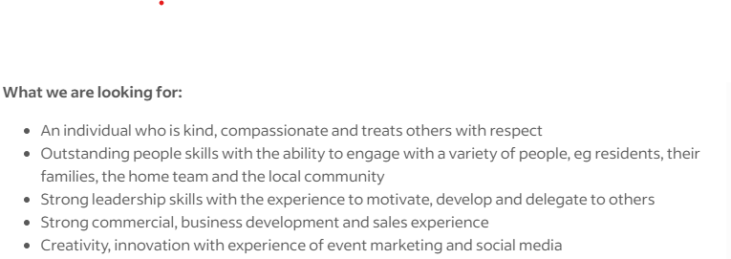

Job 2 - Customer Experience Manager – Colliers International
Job Description
Basics done better – Ensure the fundamentals of customer services are followed and delivery to the highest standards
Deliver a warm hospitality-style welcome and a fond farewell to clients, customers, and guests, ensuring they receive a unique experience throughout their time at the property
Actively assist with marketing initiatives and viewing activity.
Co-ordinate with all key stakeholders including the hotel to maximise value for the community.
Create, plan and execute community, occupier & social value engagement initiatives working closely with the Beyond leadership team
Launch & maintain property social media handles, as well as maintain a social media content planner
Schedule and manage content for the external media façade as well as internal digital screen working closely with the site team, marketing partners and community stakeholders.
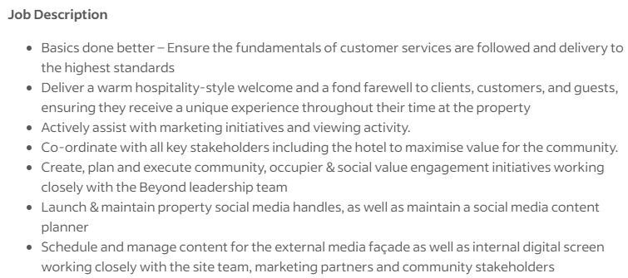

Job 3 - Customer Service Advisor – EcoTalk
What you will do…

Provide first class customer service in all interactions, focused mainly on inbound and outbound phone calls, delivering first contact resolution.
Ensure our customer accounts are correct and all requests are completed accurately.
To take responsibility and ownership for customer queries ensuring the customer is responded too promptly & updated frequently.
Mobile port ins for customers who want to keep their mobile phone number.
Managing customer queries via email and social media.
Adapt to the business needs when required.
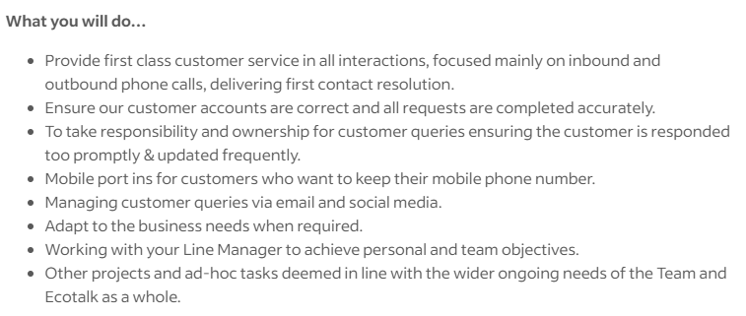

Job 4 - Customer Service Assistant - Royal Life Saving Society UK
KEY TASKS AND RESPONSIBILITIES
Customer Service

To respond to incoming telephone enquiries regarding RLSS UK qualifications, awards, membership, services and personal enquiries regarding information stored on the main database
Support customers enquiring via RLSS UK general email account, by responding to e-mails accurately
Ensure all communication with customers is professional and in a timely manner, this includes over phone, email and in person
Provide technical support to internal and external customers with the use of RLSS UK online Course Management System (tahdah)
Support customers with use of their RLSS UK Account, including access, certification, online learning, resources etc
Assist customers with updating records where required
To liaise with the Customer Service Manager regarding all issues affecting the efficiency of customer service
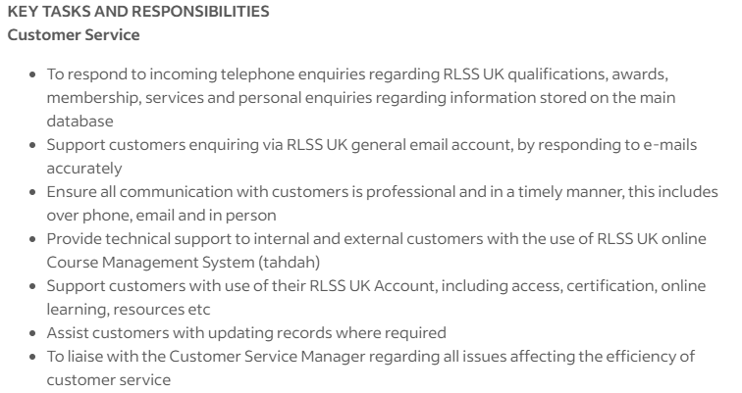

Common Skills Identified
When comparing the four job adverts, I noticed that strong leadership and people management were mentioned in all of them. Employers were looking for team leaders who can supervise customer service teams, carry out performance reviews, coach staff, and motivate team members to meet service targets. This showed me that the role goes beyond managing tasks and focuses heavily on supporting and developing people.
Time management and organisation were also common requirements. The adverts often referred to managing workloads, planning rotas, and maintaining service levels, which highlighted the importance of being organised in a busy customer service environment. Several adverts also mentioned continuous improvement, with an expectation that team leaders analyse performance data and suggest ways to improve processes and efficiency.
Most of the adverts also required a good understanding of company policies, compliance, and data protection. This made it clear that team leaders are trusted with responsibility and must ensure customer information is handled correctly. Overall, reviewing these adverts helped me understand what employers expect from a customer service team leader and the skills I need to continue developing for this role.
Task 2
AWOT analysis
Strenghts  Great team player  Well organised  Enthusiastic & friendly  Problem-solving mindset | Weaknesses  Taking criticism  Perfectionism under pressure
Opportunities  Process improvement initiatives  Leadership progression | Threats  Role stagnation  Burnout risk

The SWOT analysis shows that my key strengths are disciplined, customer-focused professional with strong leadership potential, it also shows that I can burn out from taking too many responsibilities affecting performance. The SWOT analysis suggests that I influence through example and consistency, not authority.

Evidence of Readiness
My SWOT analysis shows that my communication and team working skills are strong, I have developed these skills by:
From an academic perspective, I am currently studying Business and Management, which has strengthened my understanding of organisational behaviour, leadership, operations, and strategic decision-making.
In terms of work experience, my role as a Customer Service Advisor has allowed me to build strong communication, problem-solving, and customer relationship management skills.
I also demonstrate readiness for advancement through leadership behaviours within my current role. I frequently assist new starters, share best practices with colleagues, and contribute ideas to improve service quality and efficiency.
Beyond work and study, my extracurricular commitments—including structured gym training, competitive football, and preparing for an ultramarathon—provide strong evidence of resilience, goal-setting, and perseverance.

Task 3
Employment Goals: My short-term goal is to develop formal leadership capability within my current workplace. This includes seeking opportunities to support team supervision, such as coaching new starters, assisting with performance monitoring, and leading small tasks or improvement initiatives. I also aim to improve my ability to delegate and escalate effectively, rather than attempting to manage all responsibilities independently.
These goals are important because they address my current development gaps and will help me transition from individual contributor to emerging leader.
My long-term goal is to progress into a Customer Care Team Leader or supervisory role, where I can contribute at a team and operational level. In this role, I aim to take responsibility for people development, performance improvement, and service quality. Ultimately, I aspire to progress into operations or service management, combining my customer service experience with my Business and Management education.

These goals align closely with my career aspirations, as they allow me to leverage my strengths in communication, reliability, and problem-solving while addressing identified weaknesses.

Personal Development Plan

Development Area | Action Plan | Timeline | Resources Required | Measurement of Progress
Limited formal leadership experience | Volunteer to support team supervision | 0–6 months | Line manager support, internal training, shadowing opportunities | Feedback from line manager, evidence of tasks led
Delegation and escalation confidence | Practise delegating tasks during peak workloads and escalate issues earlier using agreed procedures | 0–3 months | Team processes, mentoring from a Team Leader | Reduced workload bottlenecks, positive feedback from peers
Perfectionism under pressure | Adopt a “good decision, right time” approach by setting time limits on decisions and focusing on outcomes | 0–6 months | Reflection tools, supervisor feedback | Faster decision-making, reduced stress levels
Confidence in leadership visibility | Proactively contribute ideas in meetings and lead at least one service improvement initiative | 6–12 months | Team meetings, performance data, manager sponsorship | Implementation of improvement ideas, recognition or outcomes

- Armstrong, M. (2020) Armstrong’s Handbook of Human Resource Management Practice. 15th edn. London: Kogan Page.
- Torrington, D., Hall, L., Taylor, S. and Atkinson, C. (2020) Human Resource Management. 11th edn. Harlow: Pearson Education.
- Mullins, L.J. and Christy, G. (2016) Management and Organisational Behaviour. 11th edn. Harlow: Pearson Education.

