Cloud computing
Architecture
Module Code: ACCA5025
ASSESSMENT 2
STUDENT:
MD ALIF ALAM
LECTURER:
SUNETH FERNANDO

Table of content
Abstract……………………………………………………………………………………………………………………………………….3
1.0 Virtual machine………………………………………………………………………………………………………………………3
1.1 Resources Associated with a Virtual Machine…………………………………………………………………………3
1.2 Example of Creating a Virtual Machine in the Azure Portal with screenshots…………………………4
1.3 Virtual Images…………………………………………………………………………………………………………………………10
1.4 Create an Image………………………………………………………………………………………………………………………10
2.0 Virtual Network……………………………………………………………………………………………………………………….11
2.1 Creating a Virtual Network on Azure………………………………………………………………………………………..11
3.0 Network Security Groups…………………………………………………………………………………………………………14
4.0 Case Scenario…………………………………………………………………………………………………………………………..15
4.1 Creating a Virtual Network Implementing Network security group…………………………………………..16
Conclusion……………………………………………………………………………………………………………………………………….22
List of Reference………………………………………………………………………………………………………………………………23

Abstract
As a means of supporting a large number of disparate applications running concurrently on server platforms, data centres are increasingly employing virtualization and consolidation. However, server architectures are still designed and evaluated based on the performance modelling of a single highly parallel application or a collection of homogeneous workloads operating concurrently. The benchmarks had complex behaviours, required multiple client/server systems, and were difficult to implement on full-system simulators, posing a significant challenge to the development of performance analysis capabilities for such commercial server operations.
1.0 Virtual Machine
A virtual machine (VM) is a software implementation of an operating system that operates on a physical host machine. It behaves as if it were a distinct physical machine with its own virtual CPU, memory, storage, and network interfaces. Virtualization software running on the host machine manages the resources associated with a virtual machine, such as virtual hard drives [1].
To create and manage a VM, one needs a virtualization platform, such as Hyper-V, VMware, or VirtualBox. In this answer, we will use Microsoft Azure as an example.
1.1 Resources Associated with a Virtual Machine
There are different resources we need to consider while we setup a virtual machine [2]:
- CPU- A VM is allocated a portion of the physical CPU resources of the host machine, which it uses to operate its own operating system and applications. The CPU resources are shared among the virtual machines operating on the host machine, according to the virtualization software's configuration.
- Memory - A VM is allocated a portion of the physical memory of the host machine, which it can use to operate its own operating system and applications. The memory resources are shared among the virtual machines operating on the host machine, according to the virtualization software's configuration.
- Storage - A virtual machine has its own virtual hard drives, which are stored in files on the physical storage of the host machine. The virtual hard drives mimic physical hard drives and can be managed and configured in the same manner as physical hard drives. The virtual hard drives may be dynamically allocated or fixed in capacity, and they may be attached or detached from the virtual machine as required.
- A virtual machine's virtual network interface device (NIC) emulates a physical NIC. The virtual NIC is connected to a virtual switch, which connects the virtual machine to other virtual machines and the external network. The virtual switch can be configured to prioritise network traffic and provide network isolation and security.
A virtual machine is, in summation, a software-based emulation of a physical computer system with its own virtual hardware resources, such as CPU, memory, storage, and network interfaces. The host machine's virtualization software allocates the resources, which can be configured and managed similarly to physical resources.

1.2 Example of Creating a Virtual Machine in the Azure Portal with screenshots.
To complete the following task we are going to use Microsoft Azure with a subscription provide by the university called Azure for Students:
- First of all login we need to logon on the Azure portal – https://portal.azure.com
- On the screenshot below shows the interface where is the service to create a virtual machine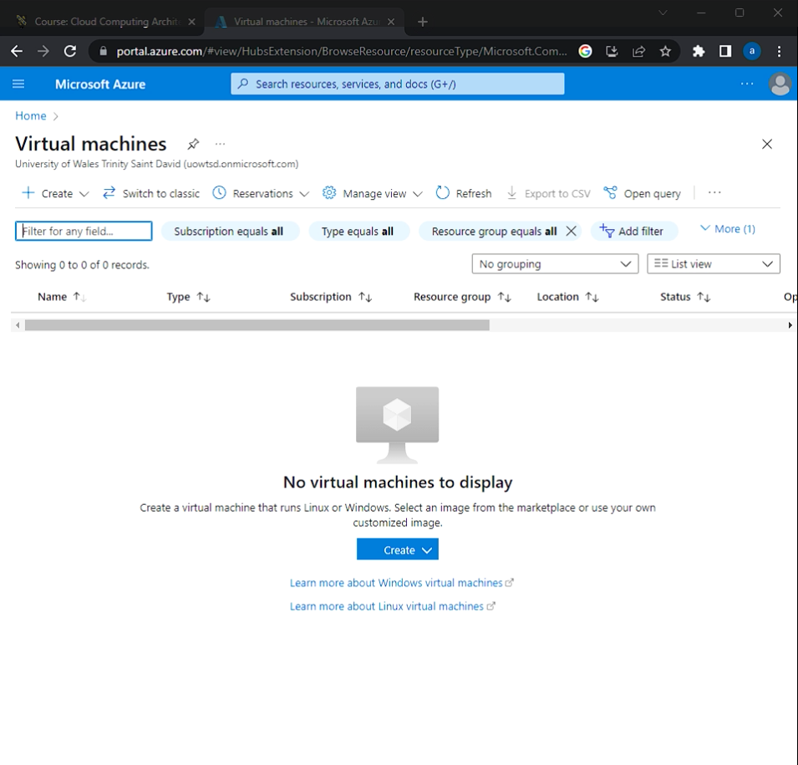
- After pressing the button create it will show the setup interface which we can insert different values depending on how we want the setup to run.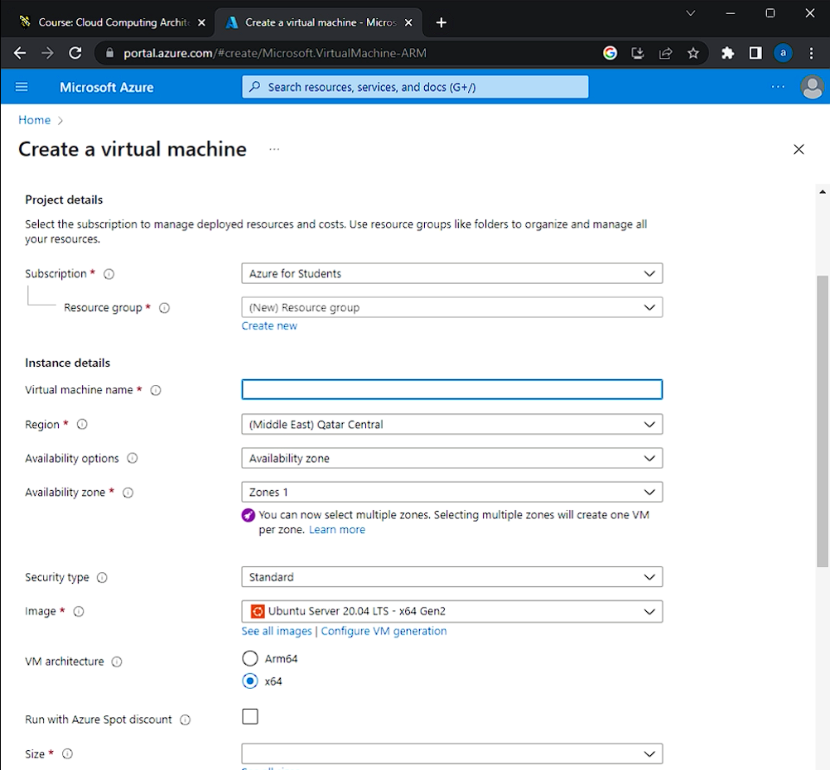
- In our case the settings that we are going to change are the resource group, virtual machine name, location, administrator username/password and lastly inbound ports:
- Resource group - A resource group is a container that contains associated Azure solution resources.
- Virtual machine name – Any type of name as long as it gives you an hint of the function of the VM
- Location – In this case (US) East US
- Image – For this case scenario Windows server 2019 will be the best option
- Administrator username/password – Very important step since the moment trying to establish a connection to the VM without the right credentials it will not gives us access to the VM
- Inbound ports – inbound ports Protect the network from incoming traffic from the Internet or other network segments, including unauthorised connections, malware, and denial-of-service (DoS) attacks [3]. In this case port HTTP (80) and RDP (3389) are selected.
- After filling the configuration details switch the Management tab to monitoring section, here disable Boot diagnostics. Boot diagnostic is a diagnostic feature for virtual machines (VM) in Azure that enables the diagnosis of launch failures. 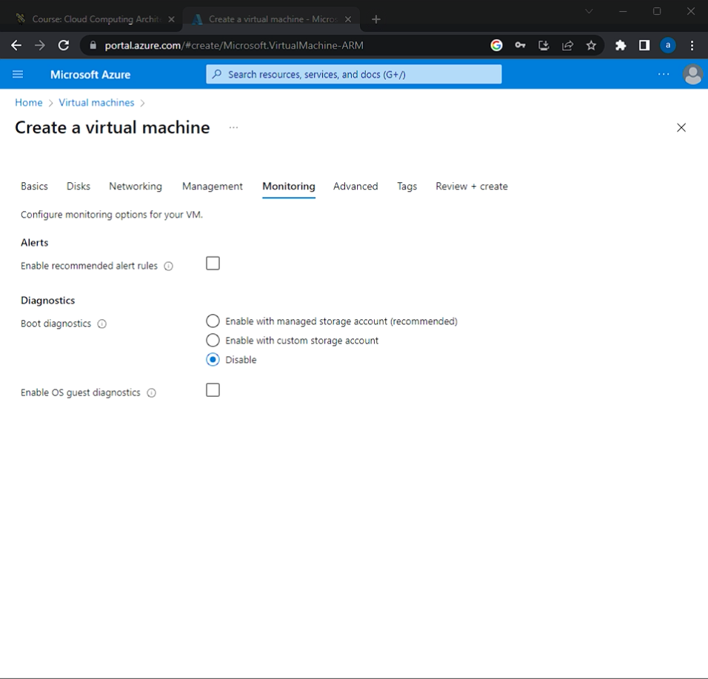
- After setting up and received the validation confirmation we need to verify that the virtual machine has been setup properly. Therefore, we will use RDP (Remote Desktop) to connect the Virtual machine.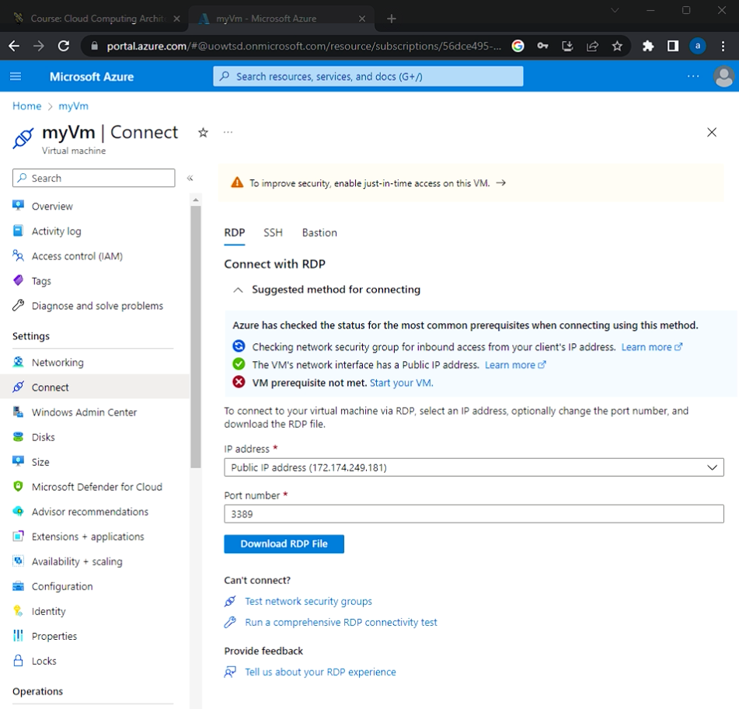
- After downloading the RDP file, a massage will come up on the screen saying to enter the credentials we created before to establish a remote connection to the Virtual machine. After successfully entering the credentials, we should be able to have access to the Virtual machine.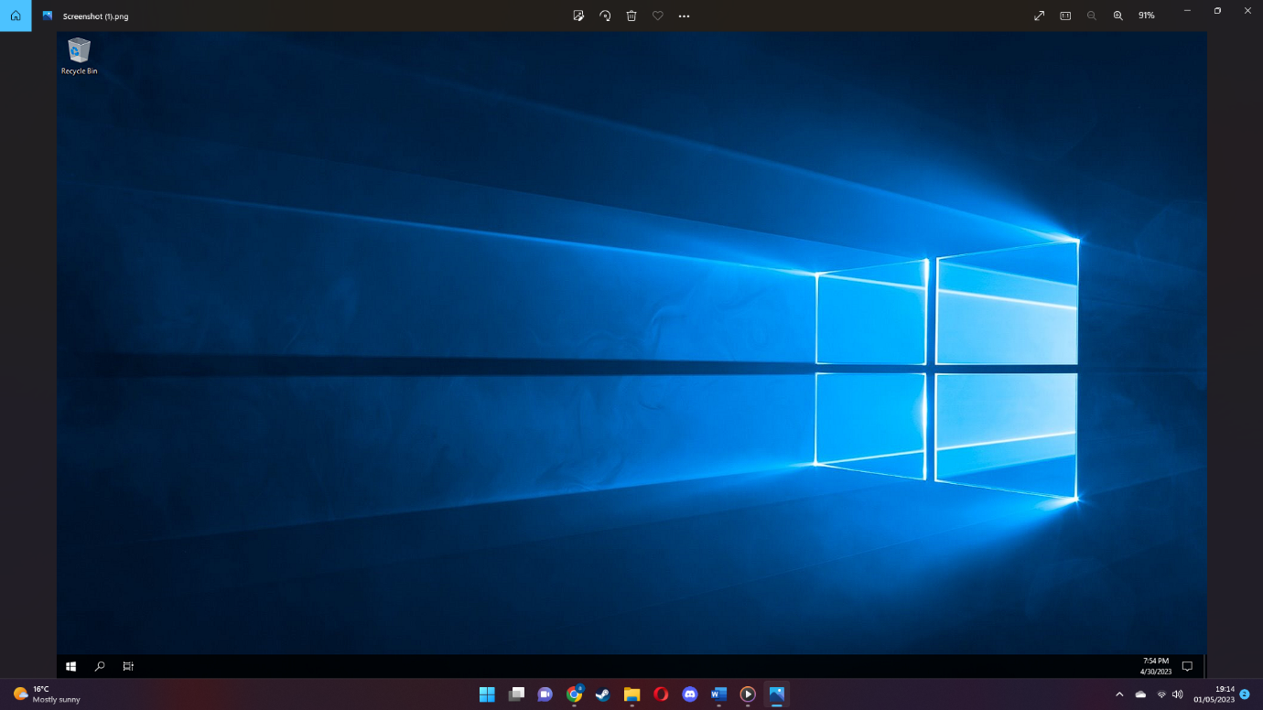
- After checking that the Virtual machine is running properly, we need to install Web server Role for our Windows server to test that the server has been setup correctly. Open Windows Power shell and type the following code- Install-WindowsFeature -name Web-Server -IncludeManagementTools (command that install web server role and its features).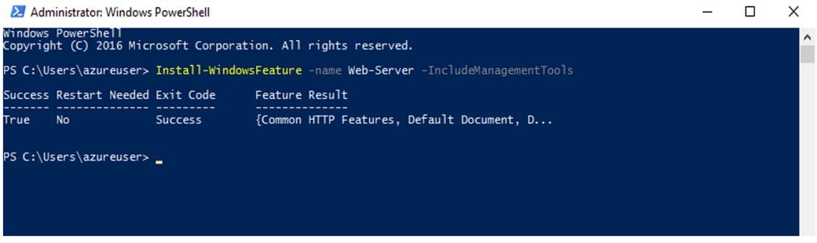
- After configurating the Windows Server to simply verify that everything went according to our plan is to go back to the Azure Portal, check the public Ip address in this case is 172.174.249.181 copy it and paste it on any search engine, to show the test I have used Google Chrome. 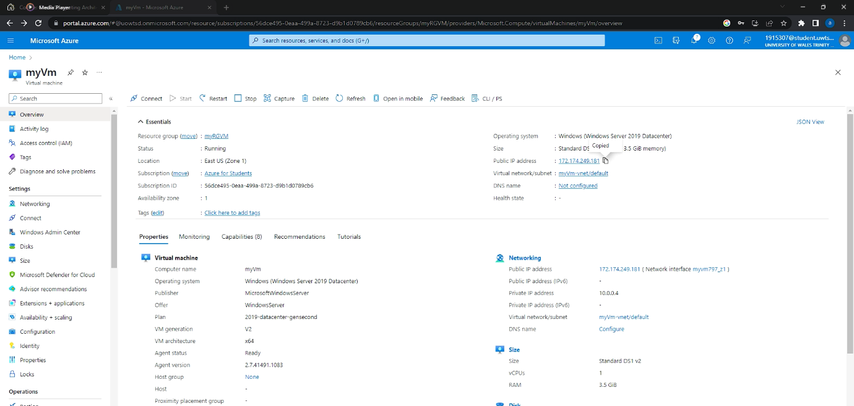
- As it shown below the configuration has been installed successfully and to access it we just need to type its public address which I added above.
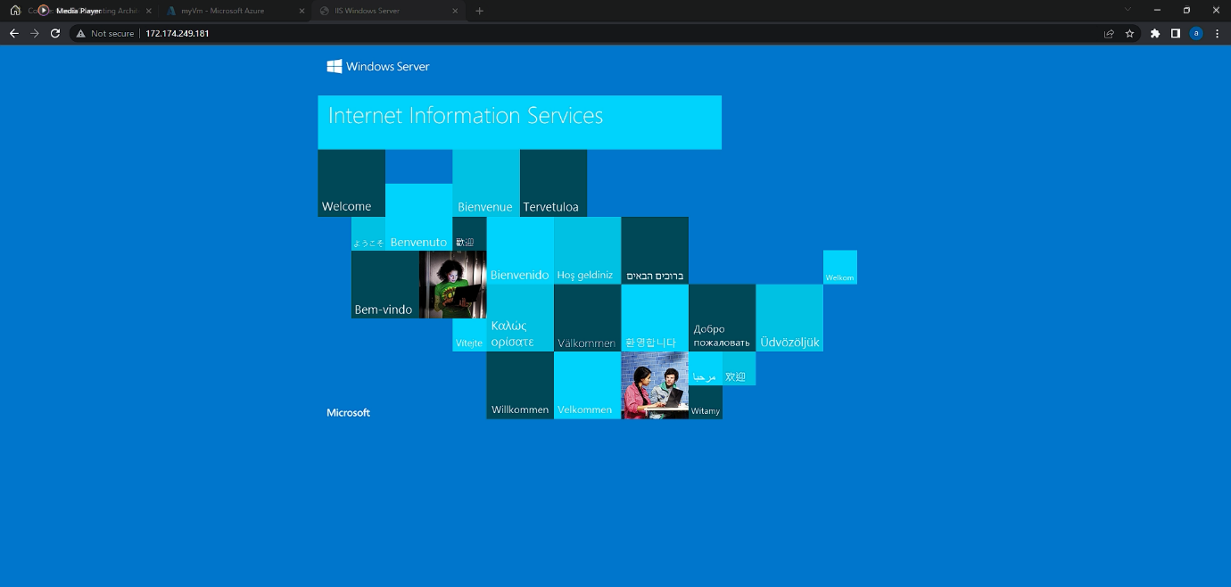

1.3 Virtual Images
As per idea of Olzak “A Virtual Machine Image is a completely configured virtual machine that is used to generate a MED-V image for enterprise deployment” [4]. Virtual Images are an integral part of many Azure services and offer a convenient method to deploy and administer applications and infrastructure. Whether you're utilising virtual machines, containers, or web applications, Azure makes it simple to use pre-configured images or create your own.
1.4 Create an image
An Azure Compute Gallery (previously known as Shared Image Gallery) facilitates the exchange of custom images across an organisation. Custom images are similar to images from a marketplace, but you create them yourself. A VM, VHD, snapshot, managed image, or another version of an image can be used to produce an image [5].
Resource | Description
Image source | This resource may create gallery images. A generalist or specialised Azure VM, managed image, capture, or image version from another gallery might be an image source.
Gallery | Like the Azure Marketplace, a gallery manages and shares photos and VM apps, but you regulate access.
Image definition | Gallery image definitions provide picture metadata and internal use restrictions. Release notes, minimum and maximum memory requirements, and Windows or Linux status are included. Image type description.
Image version | Creating a virtual machine (VM) from a gallery picture. As many images as your surroundings needs. Like a managed image, an image version creates new discs for a VM. Use many images.

2.0 Virtual Network
As depicted in Fig. 1, we view virtualization as a resource abstraction that permits dividing a resource into multiple segments [6]. Typically, this abstraction is implemented as a software layer that provides "virtual sliced interfaces" that closely resemble the actual resource interface.
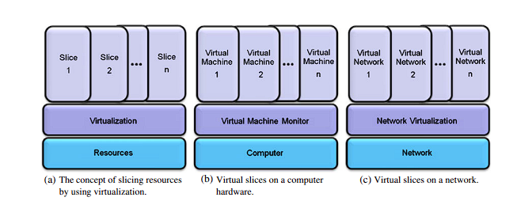
Figure (1)
Multiple virtual segments can coexist over the same resource because the virtualization layer dissolves the coupling between the actual resource and the layer above it. Figure 1 depicts two examples of virtualization, including computer and network virtualization.
2.1 Creating a Virtual Network on Azure
A virtual network, or vNet, is a logical representation of a network that connects virtual machines (VMs) to each other and to the external network.
- First of all login we need to logon on the Azure portal – https://portal.azure.com
- On the Create Virtual machine interface we need to change the settings according to our scheme.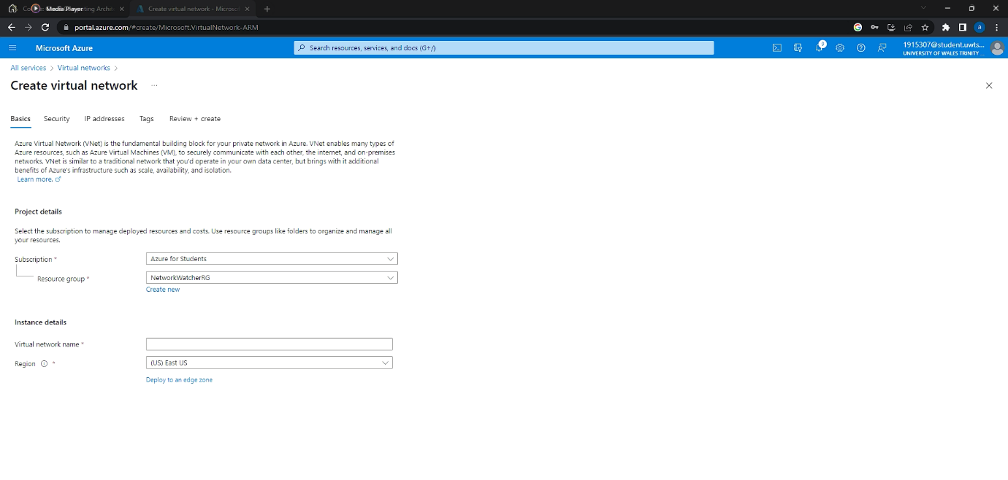
- In our case the settings that we are going to change are name, Address space, Location, Subnet address range and resource group.
- Virtual machine Name - Any type of name as long as it gives you an hint of the function of the VM.
- Address space - When constructing a VNet, a custom private IP address space must be specified using both public and private (RFC 1918) addresses. In our case 10.1.0.0/16
- Location – (US) East US
- Subnet address range - A subnet or subnetwork is a portion of a larger network that is segmented. In our case 10.1.0.0/24.
- Resource group - A resource group is a container that contains associated Azure solution resources.
- After completing the creation of the Virtual Network, we need to verify the network by using two virtual machines.
- Instructions have been given above to how to create virtual machines (Creating a Virtual Machine in the Azure Portal).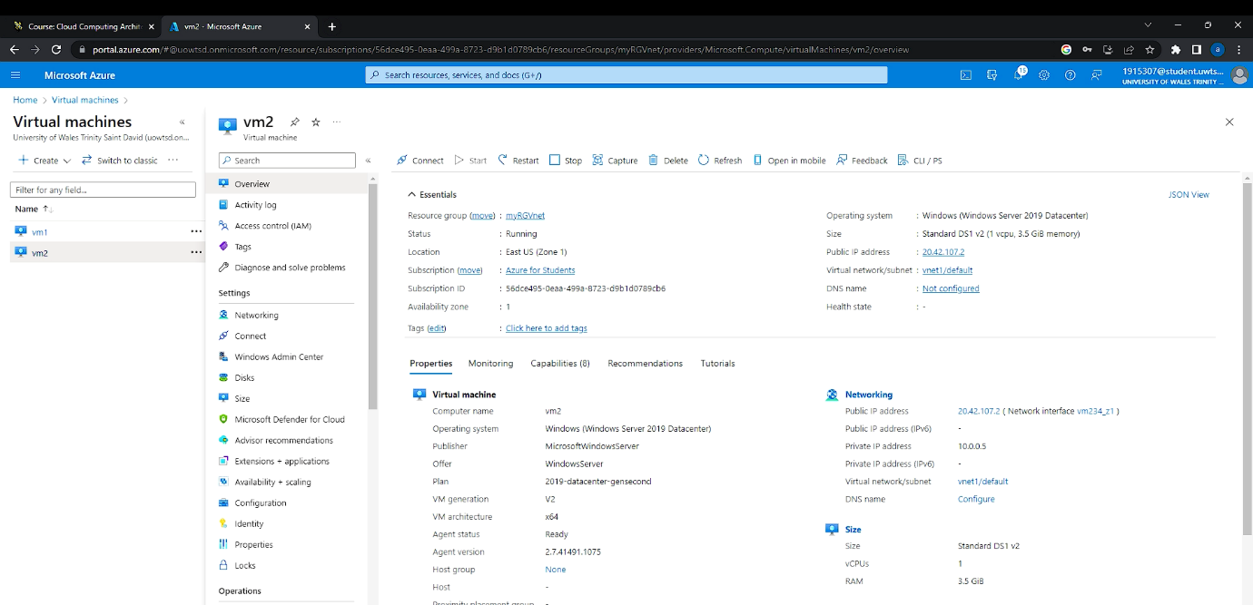
- After succeeding of creating our lab we need to test the connection between our two devices. To conduct our test we simply need to open up command shell and use the ping command to verify the connectivity between the two devices. 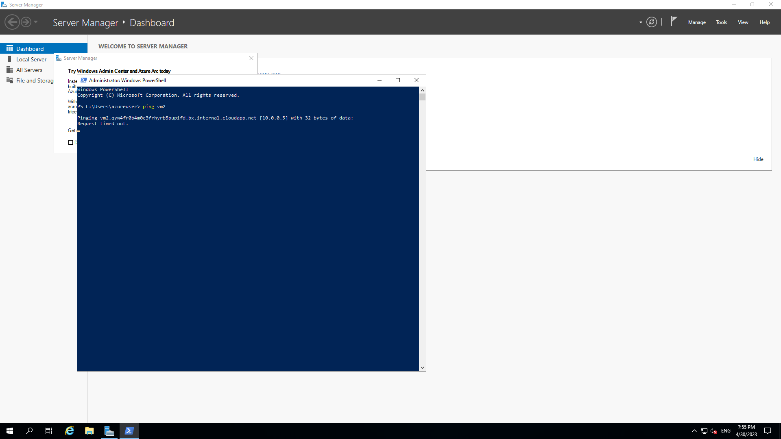
- As it shown above in the screenshot we can see that the device are not connecting the reason behind is that the ping method use a ICMP (Internet Control Message Protocol), through windows firewall it deny this type of connection. So to debug the error we need to disable the windows firewall by typing the following command New-NetFirewallRule -DisplayName “Allow ICMPv4-In” -Protocol ICMPv4.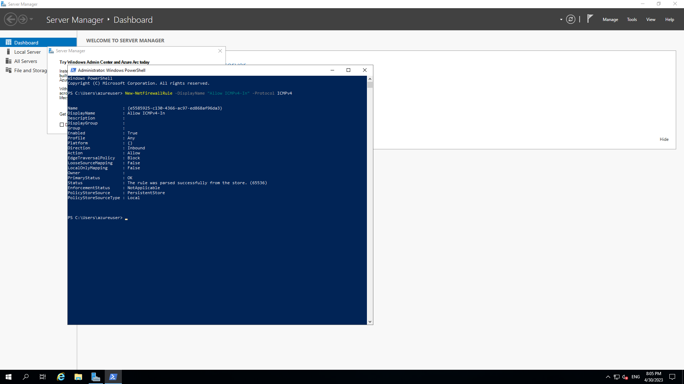
- After successfully disabling the Windows Firewall the two devices should be able to communicate with each other.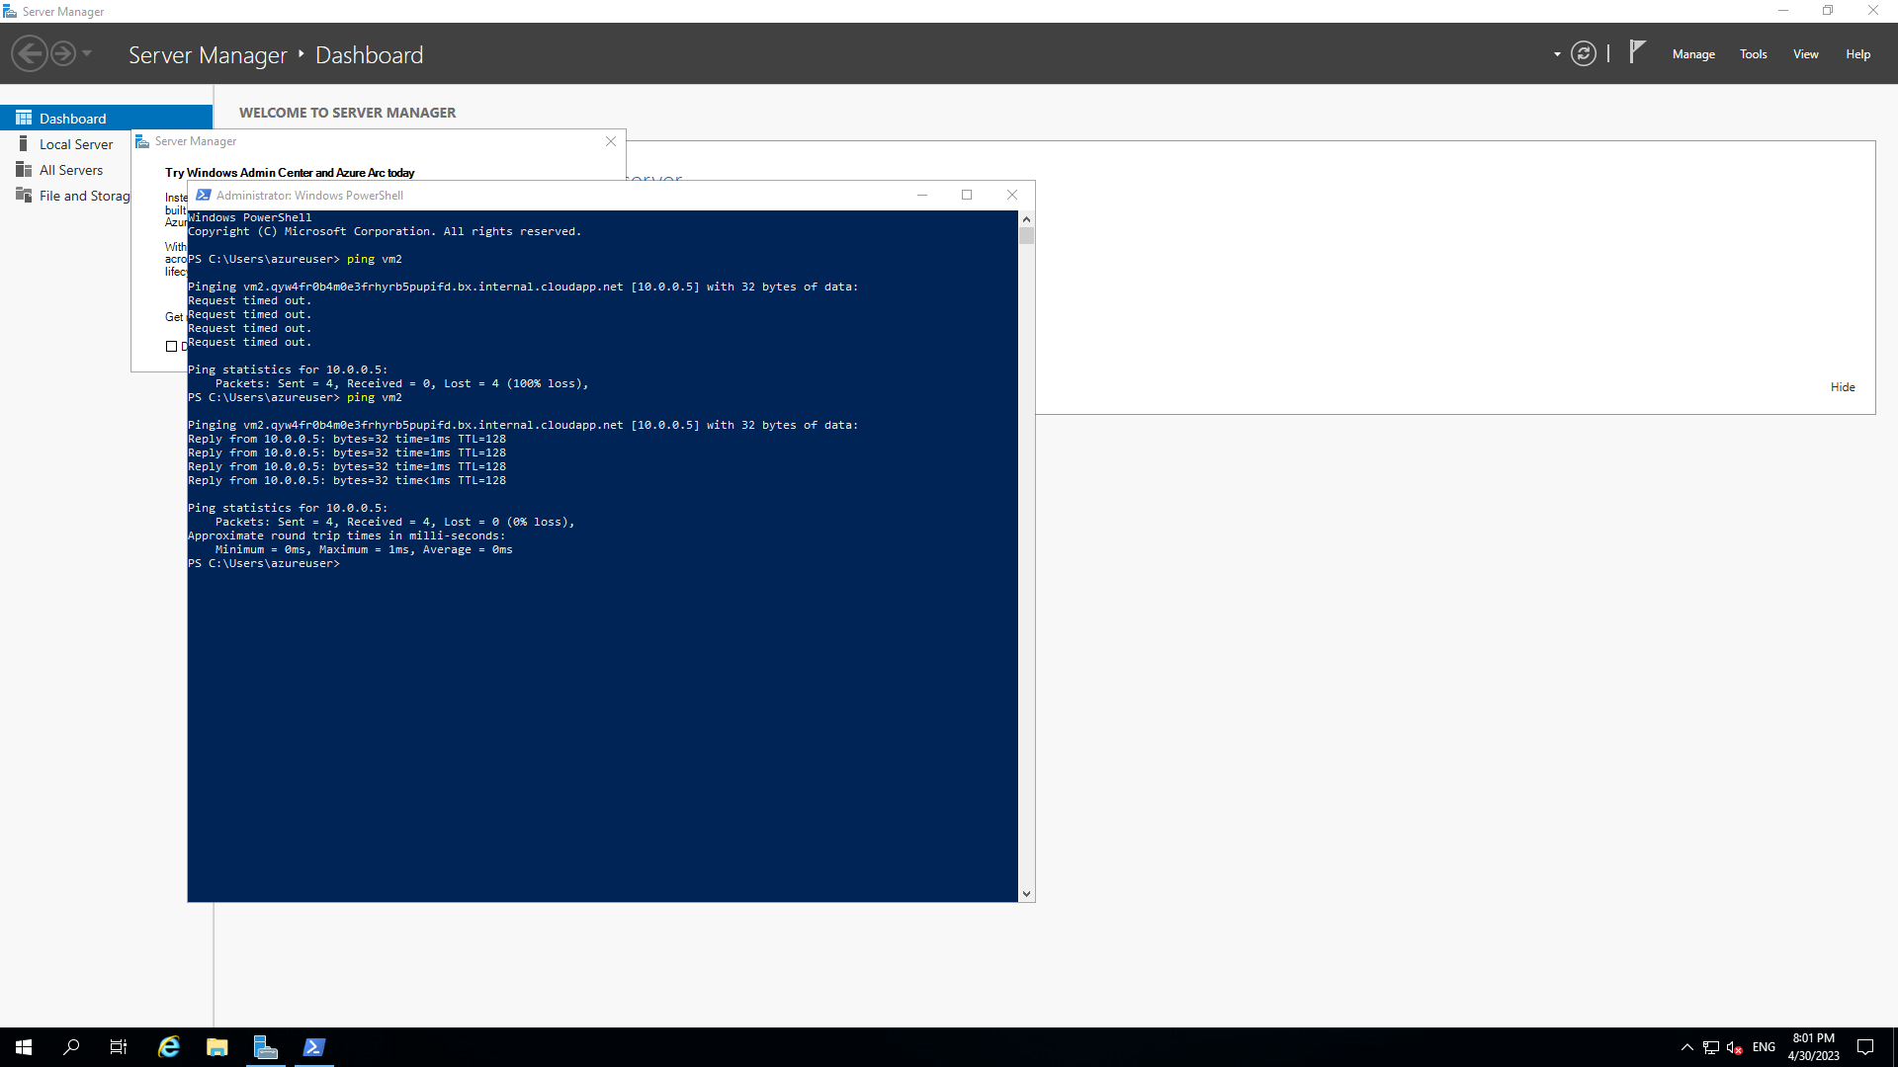
3.0 Network Security Groups
Network Security is the process of protecting a network from a variety of internal and external hazards. To develop a comprehensive comprehension of network security, it is necessary to comprehend the hazards against which network security seeks to defend a network. The objective of instituting security on a network is attained by following a series of stages, each of which clarifies the relationship between threats and protective measures [7]:
- Understand what you are trying to protect.
- Find out what are the threats.
- Study how the threats work.
- Implement measures that helps or prevent from threats.
- Keep yourself updated for new threats or new bugs.
For our case scenario as shown above in the chapter of creating a virtual network we used a security measure which was Windows firewall.
As it shown above Windows firewall prevent a ICMP connection between the two devices.
4.0 Case scenario
The assessment task required to develop a Network security group that deny the access of the database server without permission. The service used in this Case scenario to complete the task is Microsoft Azure which allows to deploy two Vm machine, create services within the client such as PostgreSQL-client and add security groups which is the main task requested to complete the exercise.
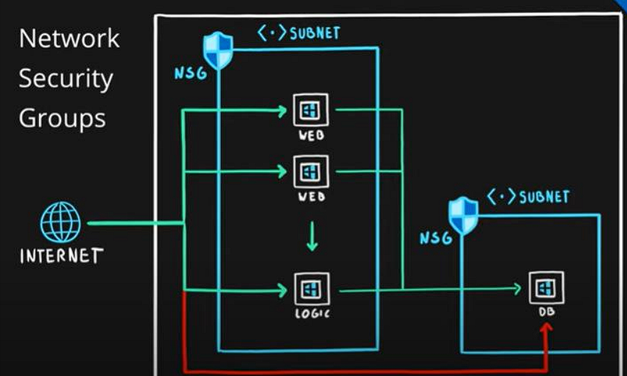
As it shown on the diagram above the purpose of this exercise is to demonstrate that the two devices can communicate with each other however it is mandatory to develop a security group to one of the two Vm and show that without permission you are not allowed to communicate.
4.1 Creating a Virtual Network implementing Network security group
To complete the following assessment, we used the different services provided by Microsoft Azure, no coding was required while developing the lab.
- First step is to logon on the Azure portal-– https://portal.azure.com
- In the various services choose create Virtual Network.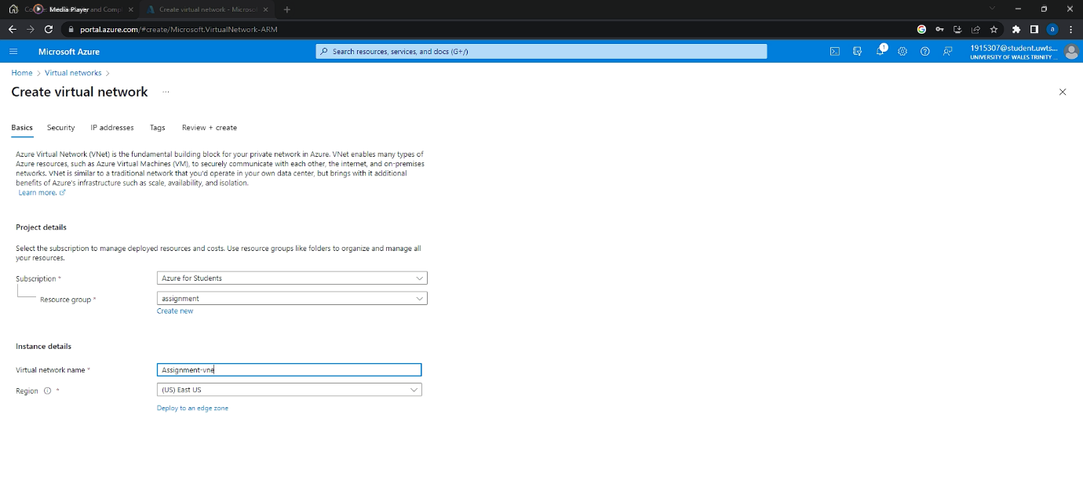
- In the switch management tab we will move to Ip addresses where we are going to add a subnet mask which the value that is going to be insert is 10.0.1.0/24, therefore the Ip address space goes from 10.0.1.0 – 10.0.1.255 so in total we will have 256 address.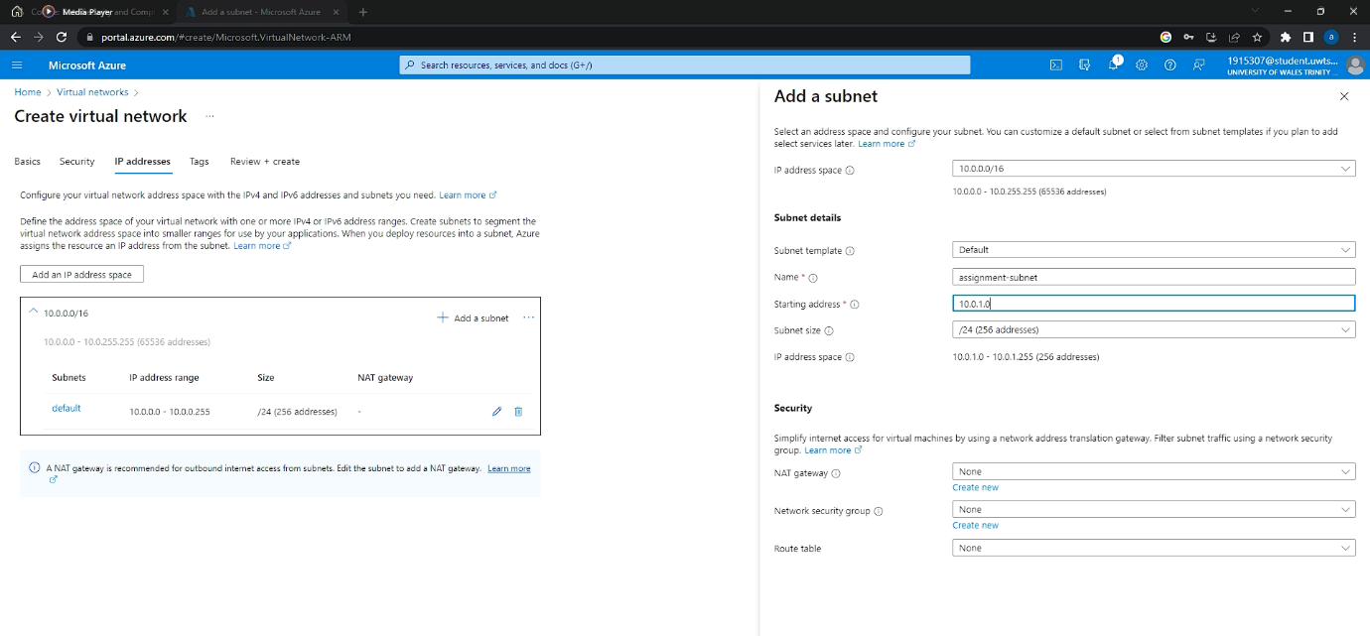
- On the security tab Azure Bastion has been enabled to provide a secure RDP/SSH connectivity to the virtual machine without the mandatory use of a public IP address.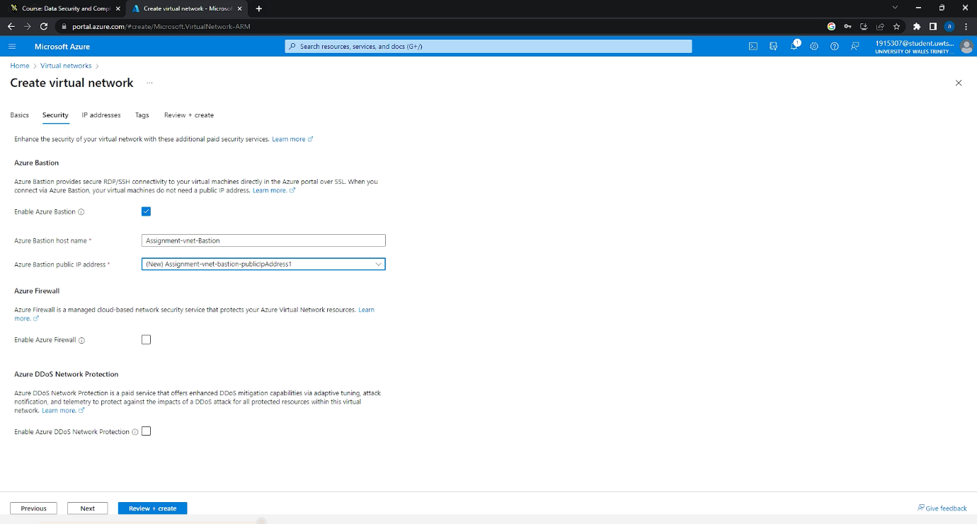
- After creating the virtual network, we need to create two Virtual machine to carry on our lab, in this case the image used is ubuntu and not Windows Data server 2019.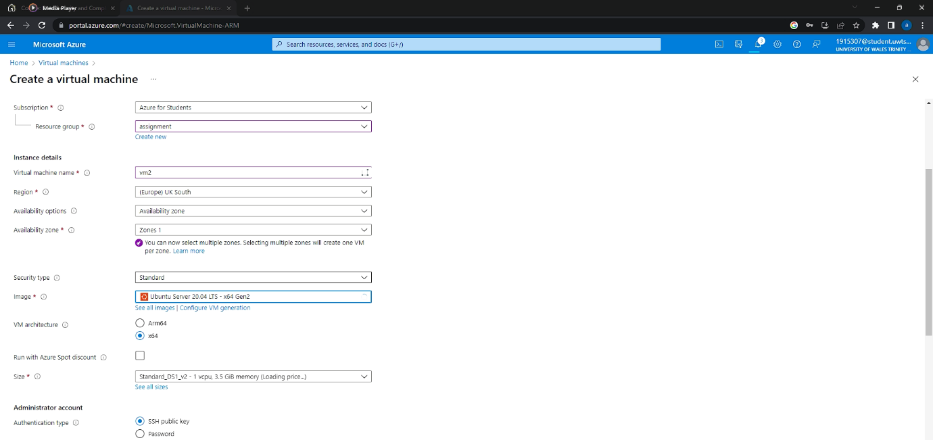
- Succeeding on creating the two virtual machine we try to connect through bastion on the Vm1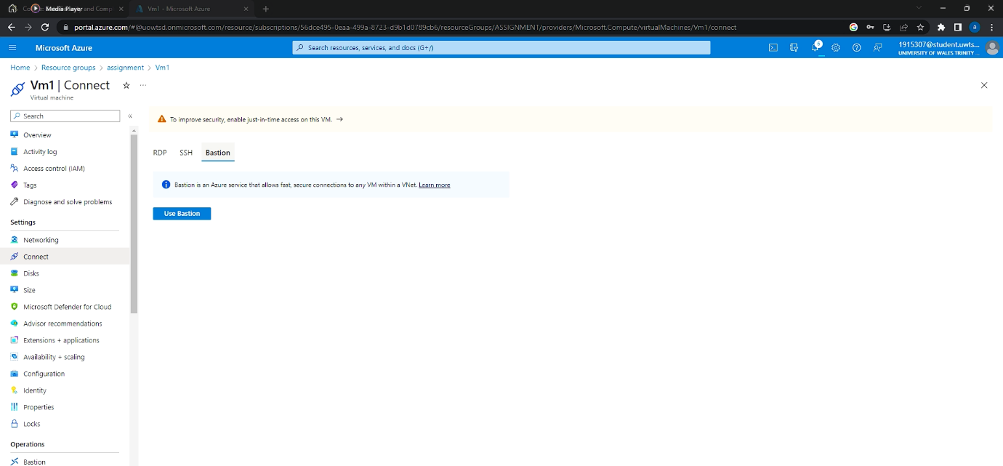
- Established the connection the interface that opens up on our Operating System is the terminal where we are going to use the command Sudo which give the administrator access and apt update allows the user to update the Operative System. Linux command – Sudo apt-update.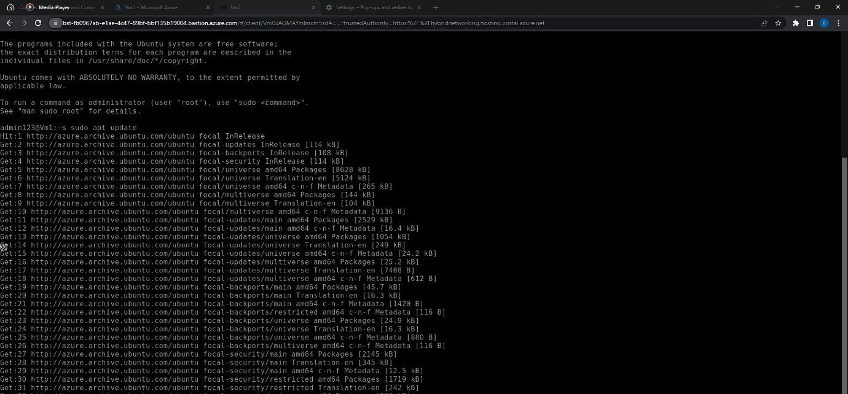
- After updating the Operative System, we are going to install Nginx server which is a web server typically employed as a reverse proxy. It can operate effectively as both a web server and a reverse proxy [8].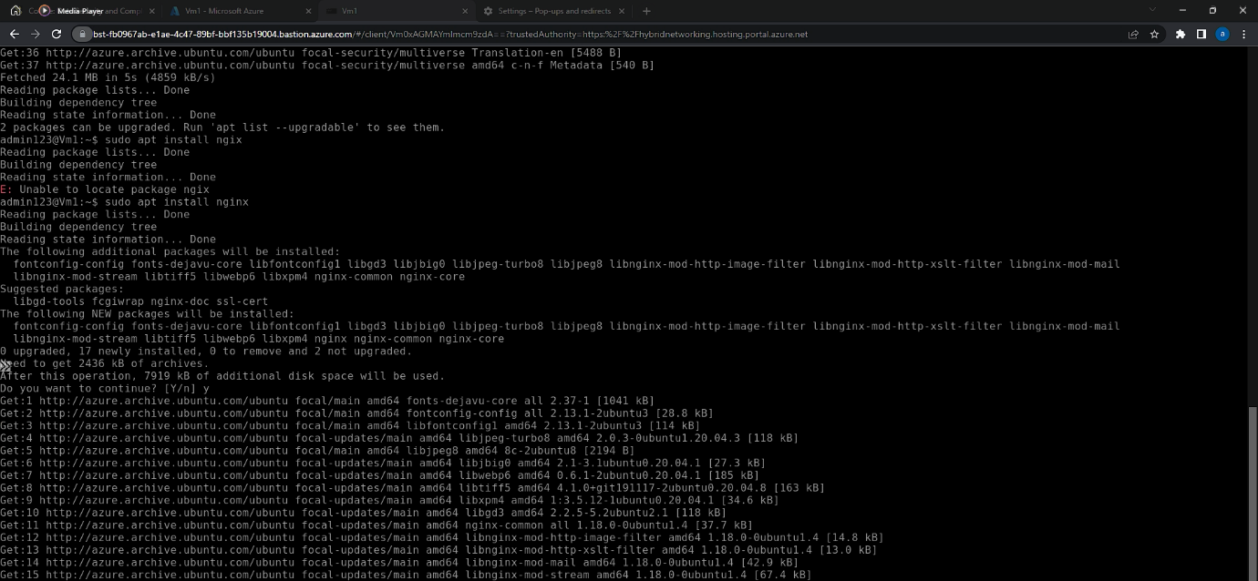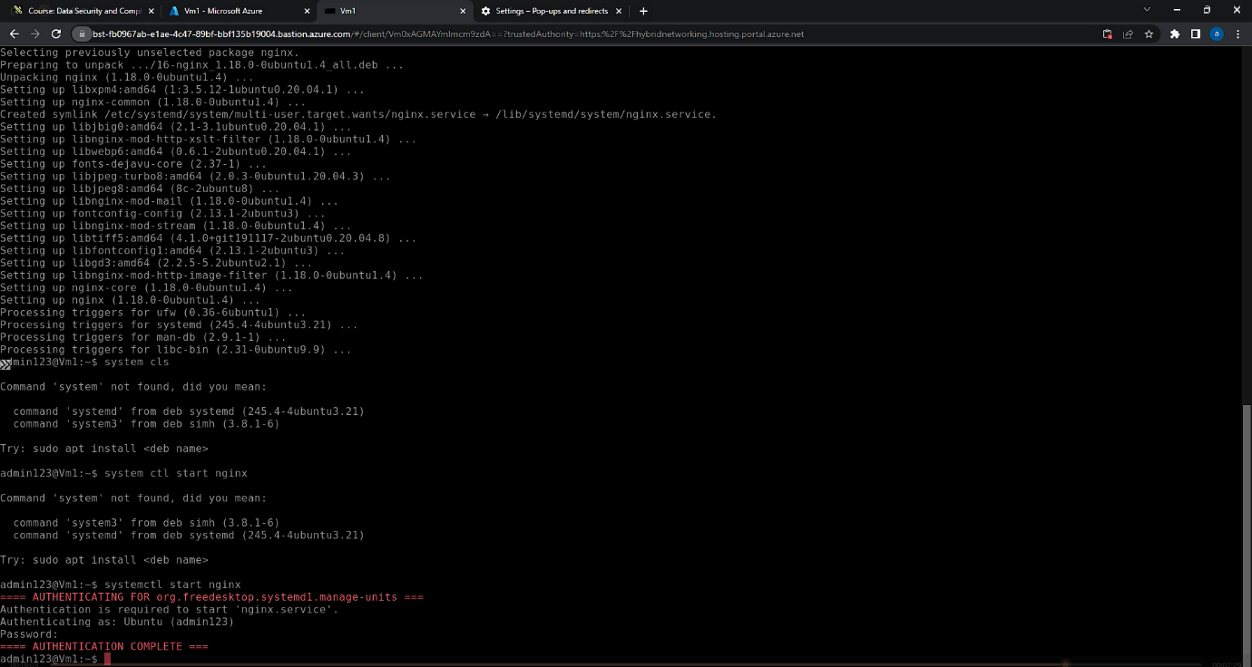
- To verify that the Nginx Web server has been installed correctly we need to retrieve the Ip address of our machine, to find the ip address we have many options in our case we copied from azure interface.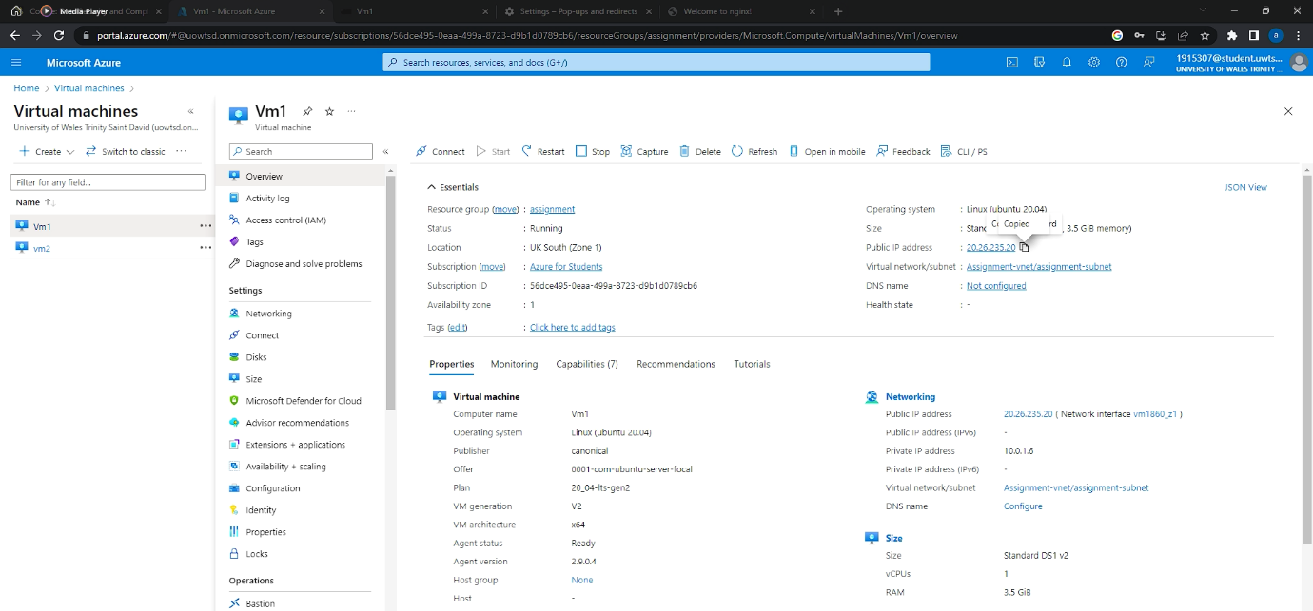
- After copying the Ip address paste it onto any web search engine such as chrome, Firefox and Microsoft edge.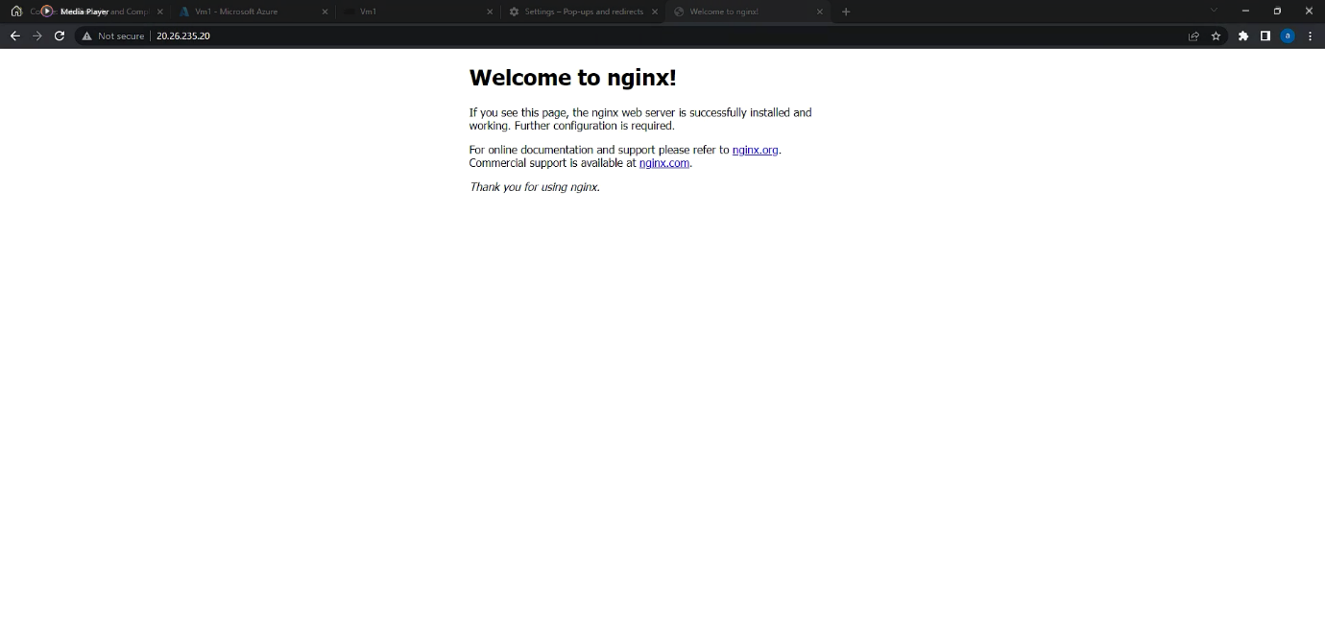
As we can see on the image illustrated above the web server has been configurated correctly.
- Last step of our lab is to test that the two devices can communicate with each other through the ping method on the public address. To accomplish the following task we simply open up the terminal on the Vm1 and write the following command- ping vm2.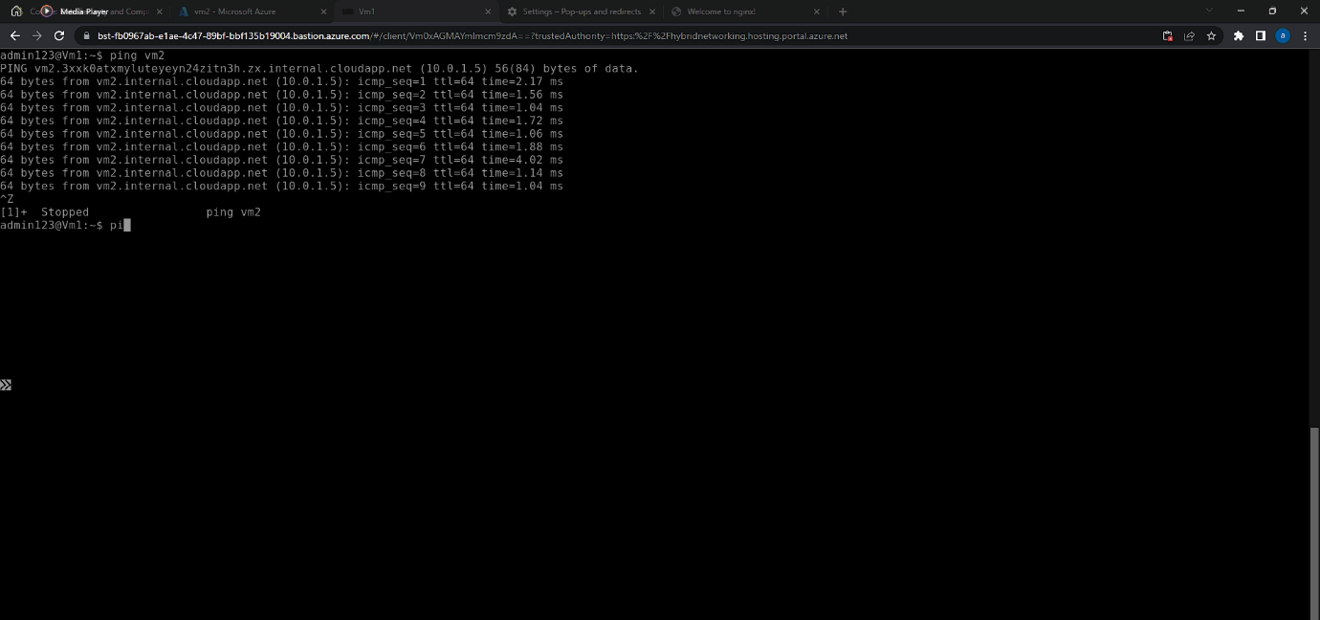
- After certifying that the two devices communicate with each other, one last verification needs to be done in our case is that the Vms are not allowed to communicate through the private IP address.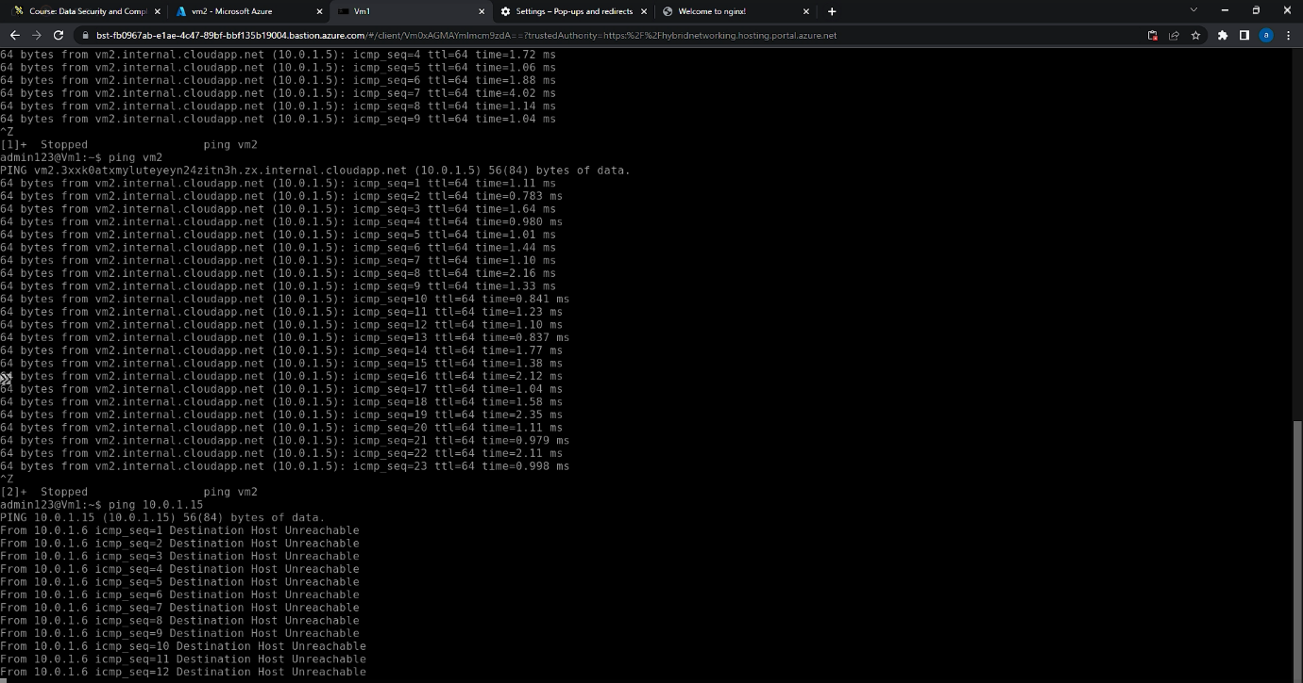As it shown above if we try to ping onto the private net which is 10.0.1.15 that we created before in the virtual network, the connection does not go through, so it can be stated that the experiment has been successful and the network security group has been configurated properly.

Conclusion
In conclusion the assessment requested by the University gave me different insights of how a cloud services works more importantly all the features such Virtual machines, Virtual network deploying Virtual images with services built in. There were many obstacles and challenge throughout the fulfilment of the task but thanks for different methods and strategies of research I was able to identify the problem and achieve the outcome requested. Lastly since I had previous knowledge of how remote system work for example the use of ansible from a previous assessment helped me clarify and understand many steps and passages I done through the completion of the assessment.

List of reference
[1] O. Tickoo, R. Iyer, R. Illikkal, and D. Newell, “Modeling virtual machine performance,” ACM SIGMETRICS Performance Evaluation Review, vol. 37, no. 3, pp. 55–60, 2010.
[2] R. Fitzhugh, Vsphere Virtual Machine Management. Packt Publishing, 2014.
[3] K. Beaver, “Inbound vs. outbound firewall rules: What are the differences?: TechTarget,” Security, 10-Dec-2020. [Online]. Available: https://www.techtarget.com/searchsecurity/answer/Comparing-firewalls-Differences-between-an-inbound-outbound-firewall. [Accessed: 27-Apr-2023].
[4] T. Olzak, J. Boomer, R. M. Keefer, and J. Sabovik, “Desktop virtualization,” Microsoft Virtualization, pp. 377–441, 2010.
[5] S. praichura, “Create an image definition and image version - azure virtual machines,” Create an image definition and image version - Azure Virtual Machines | Microsoft Learn, 17-Feb-2023. [Online]. Available: https://learn.microsoft.com/en-us/azure/virtual-machines/image-version?tabs=portal%2Ccli2. [Accessed: 01-May-2023].
[6] N. C. Fernandes, M. D. Moreira, I. M. Moraes, L. H. Ferraz, R. S. Couto, H. E. Carvalho, M. E. Campista, L. H. Costa, and O. C. Duarte, “Virtual networks: Isolation, performance, and Trends,” annals of telecommunications - annales des télécommunications, vol. 66, no. 5-6, pp. 339–355, 2010.
[7] S. Malik, Network Security Principles and Practices. Indianapolis, USA: Cisco Press, 2003.
[8] D. O. Curry, “What is Nginx? understanding the basics of Nginx in 2021&nbsp;!,” Medium, 22-Jan-2021. [Online]. Available: https://medium.com/devopscurry/what-is-nginx-understanding-the-basics-of-nginx-in-2021-f8ee0f3d3d54. [Accessed: 01-May-2023].

APPENDIX
https://youtu.be/6tDJNQgWTSE : Video demonstration of additional Exercise.

