
CERTIFICATE OF HIGHER EDUCATION BUSINESS SKILLS FOR THE WORKPLACE

LCLM4002: DIGITAL SKILLS
MODULE LEAD: KOUSHIK MODAK

TASK 3: WRITTEN REPORT

STUDENT NAME: RAUL MARGEL
STUDENT ID: 2334867

Executive Summary
This report examines how social and digital media has revolutionised the way through which a company is able to access more customers; it also discusses the advantages of these platforms; for instance, visibility, affordability, and niche marketing. Some of the tactics mentioned in the report include content, influencer collaboration, and SEO, where the study stresses the need to align the organisation’s social and digital media engagements. Recommendations include the creation of a holistic plan, the use of analysis, and the focus on genuine interaction; it further notes that it is imperative to optimise on the use of these tools critical in the growth of businesses in a competitive environment.

Table of Contents
1.0 Introduction 2
2.0 Main Body 3
2.1 Understanding Social and Digital Media Platforms 3
2.2 Benefits of Using Social and Digital Media for Customer Reach 4
2.3 Strategies for Expanding Customer Base through Social Media 6
2.4 Digital Media Tactics for Wider Reach 7
2.5 Integration of Social and Digital Media Efforts 9
3.0 Recommendation 10
4.0 Conclusion 11
5.0 Reference List 12

1.0 Introduction
The digital era has greatly impacted the ways in which organisations interact with clients via social and digital platforms. These platforms are paramount to modern marketing, as they provide unmatched interaction possibilities. Statista (2024) reports that in the UK, there were 56.20 million social media users as of January 2024, which represents 82.8 percent of the total population. Additionally, 88.86 million cellular mobile connections were active as of early 2024, which represents 131.0 percent of the population and highlights the platform's enormous potential for reaching a wide audience. This study aims to discuss the role of these platforms in expanding customer base in the current dynamic market.
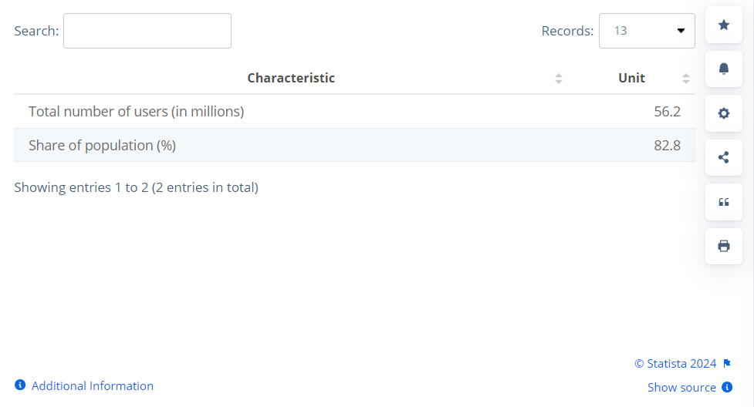
Figure 1: Active social media users
(Source: Statista, 2024)

2.0 Main Body

2.1 Understanding Social and Digital Media Platforms
Social media is a set of computer-based applications that allow users to create, share and exchange information, ideas and knowledge through social networks, micro blogging and visual content sharing sites (Shahbaznezhad, Dolan and Rashidirad, 2021). These are Facebook, Instagram, Twitter, and LinkedIn, each of which caters to a specific audience. Digital media in the broadest sense encompasses web-based platforms such as websites, blogs, and email marketing, which enables direct communication with the target market; by monthly active users, Facebook (3,065M), YouTube (2,504M), Instagram (2,000M), WhatsApp (2,000M), and TikTok (1,582M) are the most popular social networks, according to Statista (2024).
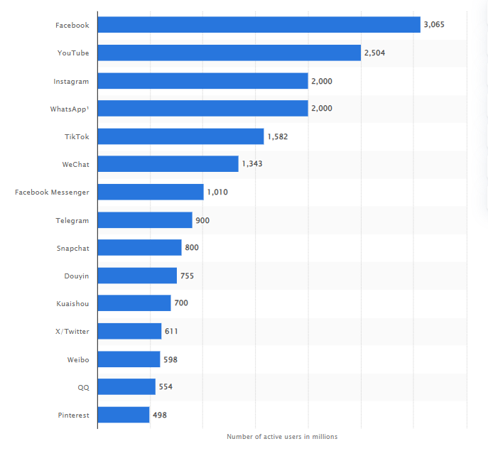
Figure 2: Monthly active users of the top social networks
(Source: Statista, 2024)

2.2 Benefits of Using Social and Digital Media for Customer Reach
The use of social and digital media for reaching out to customers has the following benefits to business organisations. Firstly, they ensure that an organisation’s visibility and brand awareness are greatly increased since the platforms are usually popular among many people; social media has millions of active users meaning that through social media companies can market their products or services to customers who may not be reached through conventional marketing (Appel et al., 2021). Secondly, social and digital media marketing is cheaper as compared to the traditional ones; such sites are usually free of charge, and paid promotion is usually significantly cheaper and more effective. Another benefit is that targeting specific audiences is possible, because social media collect vast amounts of information about their users, allowing firms to reach audiences within a certain demographic (Ahmadi et al., 2024). According to Statista (2024) 43% of the marketing leaders used X (formerly Twitter) for content marketing while 42% used Facebook; this reaffirms the importance of selecting the right platforms that would enable businesses to reach out to their target market and improve their content marketing strategies.
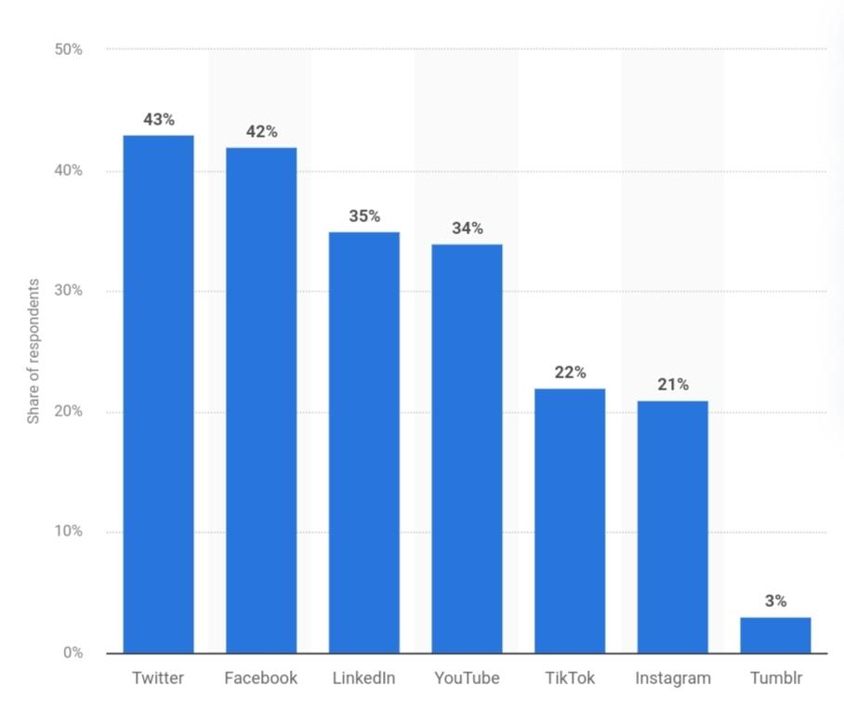
Figure 3: Global marketers' top social media content platforms
(Source: Statista, 2024)

2.3 Strategies for Expanding Customer Base through Social Media
There are several strategies that can be used by businesses in order to achieve this goal of using social media to increase the number of customers. Sharing content that is informative, entertaining, and promotional is essential to reach out to audiences as stated by Luttrell (2021). Using UGC is also efficient because it increases reach and credibility (Sykora et al., 2022). DeGruttola (2019) also explained that Stackla survey showed that 79% of consumers are driven by UGC when making their purchase. Working with influencers increases reach as the UK ad spend on influencers increases from 2019 to 2023 to 791 million pounds (Statista Research Department, 2024). Other ways are social media contests and paid advertisements which enhance engagement and reach the potential buyers (Macarthy, 2021).
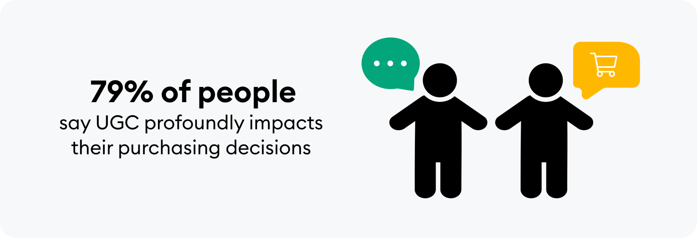
Figure 4: Impact of UGC on Purchasing Decisions
(Source: DeGruttola, 2019)

2.4 Digital Media Tactics for Wider Reach
There are a number of other digital media strategies that businesses can employ to increase their customer base beyond social media. SEO plays a crucial role in enhancing the website’s presence on the internet and leads to increased organic traffic from the search engine (Jusuf, 2023). Blogs and articles in content marketing help in creating authority within the industry and also helps in the improvement of search engine results. Email marketing is also an effective way and targeted content assists companies in reaching out to potential clients (Chaffey and Smith, 2022). Dencheva (2023) projects that the worldwide email marketing industry will reach $17.9 billion by 2027, growing at a compound annual growth rate (CAGR) of 13.3% from its anticipated $7.5 billion in 2020. With a return on investment of $36 for every $1 invested, email marketing is a particularly effective tool for gaining and keeping clients (HubSpot Blog Research, 2024). According to Oberlo (2024), 91.8% of internet users watch videos, with 48.2% of viewers seeing music videos, 35.0% seeing funny or viral content, and 27.7% viewing live streaming; this trend offers businesses a chance to interact with potential customers. Also, the increased popularity of podcasts and audio materials helps businesses to target specific audiences and become industry leaders.
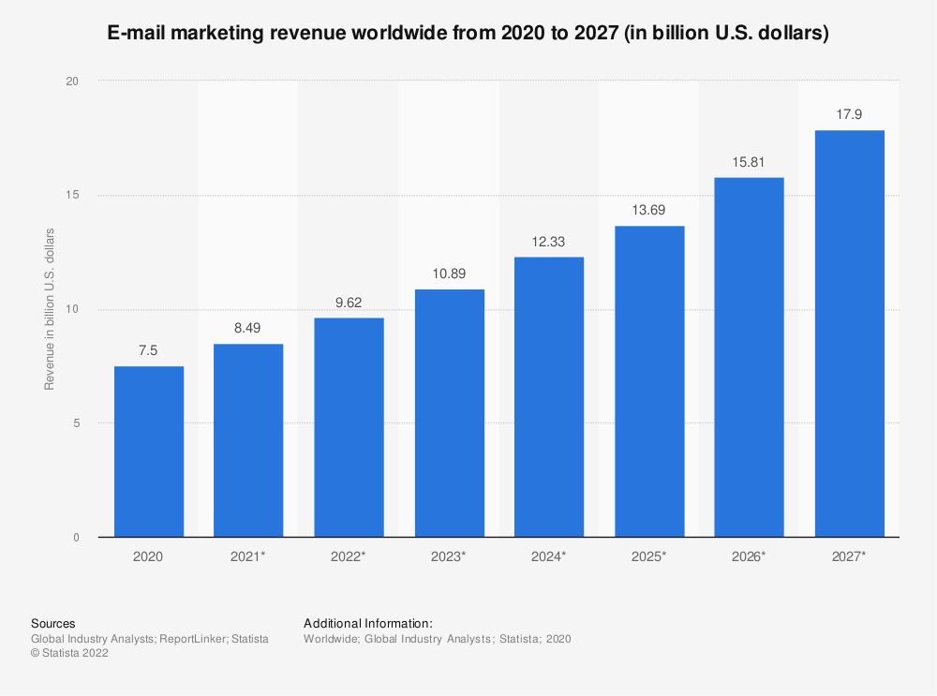
Figure 5: Revenue of Global Email Marketing
(Source: Dencheva, 2023)
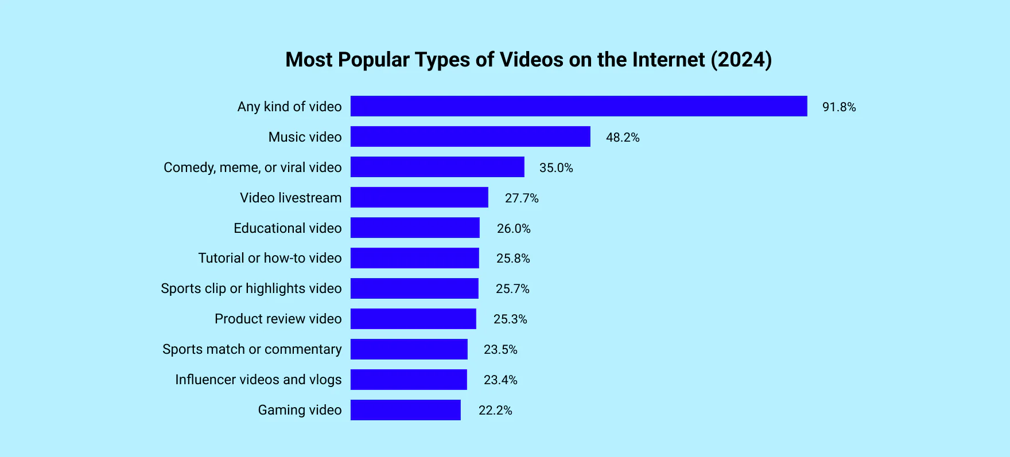
Figure 6: Popular Internet Video Types
(Source: Oberlo, 2023)

2.5 Integration of Social and Digital Media Efforts
The coordination of social and digital media activities is crucial for achieving the optimal impact and ensuring a consistent brand image as Chaffey and Smith, (2022) asserts; integrated communication strategies guarantee that the messages being sent to the public are harmonised to keep on promoting the brand image while at the same time improving the customers’ experience.
Integration Strategy | Description | Benefits
Cross-platform promotion | Share content across multiple social and digital channels | Increases visibility and reinforces messaging (Krijestorac, Garg and Mahajan, 2020)
Consistent branding | Maintain uniform visual identity and tone across all platforms | Strengthens brand recognition and trust
Unified messaging | Align key messages and campaigns across social and digital media | Enhances clarity and impact of marketing efforts
Integrated customer data | Combine data from various platforms for a holistic view of customer behaviour | Enables more personalised and effective marketing strategies (Chou et al., 2021)
Omnichannel customer service | Provide seamless support across all digital touchpoints | Improves customer satisfaction and loyalty
Table 1: Social and Digital Media Integration Strategies
(Source: Self-Created)

3.0 Recommendation
In order to enhance customer reach through social and digital media, businesses should:
Recommendation | Details
Develop a comprehensive, integrated strategy | Leverage both social and digital media platforms to create a unified approach (Yu et al., 2022).
Focus on creating high-quality, engaging content | Tailor content to each platform's strengths and audience preferences for maximum impact.
Utilise data analytics | Continuously refine targeting and content strategies based on data insights.
Invest in a mix of organic and paid promotion | Expand reach beyond existing followers through a balanced approach.
Prioritise authentic engagement and community building | Foster long-term customer relationships by engaging authentically with the audience (Okonkwo and Namkoisse, 2023).

Table 2: Recommendations
(Source: Self-Created)

4.0 Conclusion
Therefore, social and digital media are critical tools for any organisation that wants to increase its customer base. Taking advantage of the special features of different sites and combining the actions in different platforms will help the companies to increase the exposure, attract more users and gain long-term development. These strategies include the use of quality content, proper advertisement, and proper analysis of data; as digital landscapes evolve, businesses that excel in these areas will thrive.

5.0 Reference List
Ahmadi, I., Abou Nabout, N., Skiera, B., Maleki, E. and Fladenhofer, J., (2024). Overwhelming targeting options: Selecting audience segments for online advertising. International Journal of Research in Marketing, 41(1), pp.24-40.
Appel, G., Grewal, L., Hadi, R. and Stephen, A.T., (2020). The future of social media in marketing. Journal of the Academy of Marketing science, 48(1), pp.79-95.
‌Chaffey, D. and Smith, P.R., (2022). Digital marketing excellence: planning, optimizing and integrating online marketing. Routledge.
Chou, S.F., Horng, J.S., Liu, C.H.S. and Lin, J.Y., (2020). Identifying the critical factors of customer behavior: An integration perspective of marketing strategy and components of attitudes. Journal of retailing and consumer services, 55, p.102113.
DeGruttola, M. (2019). Stackla Survey Reveals Disconnect Between the Content Consumers Want & What Marketers Deliver. [online] www.businesswire.com. Available at: https://www.businesswire.com/news/home/20190220005302/en/Stackla-Survey-Reveals-Disconnect-Between-the-Content-Consumers-Want-What-Marketers-Deliver. [Accessed 25 Aug. 2024].
Dencheva, V. (2023). Email marketing market value 2027. [online] Statista. Available at: https://www.statista.com/statistics/812060/email-marketing-revenue-worldwide/. [Accessed 25 Aug. 2024].
HubSpot Blog Research (2024). The 2024 State of Marketing & Trends Report: Data from 1400+ Global Marketers. [online] Available at: https://blog.hubspot.com/marketing/hubspot-blog-marketing-industry-trends-report?hubs_content=blog.hubspot.com%2Fmarketing%2Femail-marketing-stats&hubs_content-cta=HubSpot%20Blog%20Research. [Accessed 25 Aug. 2024].
Jusuf, D.I., (2023). Optimizing SEO (Search Engine Optimizing) Strategy to Increase Visibility and Achievement of Marketing Goals. Lead Journal of Economy and Administration, 2(2), pp.98-103.
Krijestorac, H., Garg, R. and Mahajan, V., (2020). Cross-platform spillover effects in consumption of viral content: A quasi-experimental analysis using synthetic controls. Information Systems Research, 31(2), pp.449-472.
‌Luttrell, R., (2021). Social media: How to engage, share, and connect. Rowman & Littlefield.
Macarthy, A., (2021). 500 social media marketing tips: essential advice, hints and strategy for business: facebook, twitter, pinterest, Google+, YouTube, instagram, LinkedIn, and mor.
Oberlo (2024). Online Video Consumption Statistics [Updated Aug 2022]. [online] www.oberlo.com. Available at: https://www.oberlo.com/statistics/online-video-consumption-statistics. [Accessed 25 Aug. 2024].
Okonkwo, I. and Namkoisse, E., (2023). The Role of Influencer Marketing in Building Authentic Brand Relationships Online. Journal of Digital Marketing and Communication, 3(2), pp.81-90.
Shahbaznezhad, H., Dolan, R. and Rashidirad, M., (2021). The role of social media content format and platform in users’ engagement behavior. Journal of Interactive Marketing, 53(1), pp.47-65.
Statista (2024). Active social media audience in the United Kingdom (UK) in January 2023. [online] Statista. Available at: https://www.statista.com/statistics/507405/uk-active-social-media-and-mobile-social-media-users/. [Accessed 25 Aug. 2024]
Statista (2024). Most popular social networks worldwide as of January 2024, ranked by number of monthly active users. [online] Statista. Available at: https://www.statista.com/statistics/272014/global-social-networks-ranked-by-number-of-users/. [Accessed 25 Aug. 2024]
‌Statista Research Department (2024). Topic: Influencer marketing in the United Kingdom (UK). [online] Statista. Available at: https://www.statista.com/topics/7119/influencer-marketing-in-the-uk/#topicOverview. [Accessed 25 Aug. 2024].
Statista. (2024). Top socials for content marketing 2024 | Statista. [online] Available at: https://www.statista.com/statistics/245131/social-media-used-by-b2b-marketers-in-north-america/#:~:text=Social%20media%20platforms%20most%20used%20for%20content%20by%20marketers%20worldwide%202024&text=During%20a%202024%20global%20survey [Accessed 25 Aug. 2024].
Sykora, M., Elayan, S., Hodgkinson, I.R., Jackson, T.W. and West, A., (2022). The power of emotions: Leveraging user generated content for customer experience management. Journal of Business Research, 144, pp.997-1006.
Yu, J., Pauleen, D.J., Taskin, N. and Jafarzadeh, H., (2022). Building social media-based knowledge ecosystems for enhancing business resilience through mass collaboration. International Journal of Organizational Analysis, 30(5), pp.1063-1084.

