Stator Design
James Bunyan
James Bunyan (1708795)
2019

Abstract

In this assignment, we have been given the task to improve the flux leakage factor of the motor. This can be achieved numerous different ways, but by conducting a series of experiments, I have proven which adjustment to the motor has worked best.
This assignment has taught me the basics on the losses that occur within the motor and how they can be improved.

Table of Contents
Abstract 1
Table of Figures 3
Introduction 4
Flux Leakage Factor and How to improve it? 4
Hysteresis Loss 5
Eddy Current Losses 6
The Method 7
The Results 11
Discussion 20
Conclusion 21
Bibliography 22

Table of Figures

Figure 1 - DC Losses 4
Figure 2 - Hysteresis Loss 5
Figure 3 - Eddy Current Losses 6
Figure 4 - Stator Circuit 7
Figure 5 - Boundary 8
Figure 6 - Mesh 8
Figure 7 - Magnetic Flux 9
Figure 8 - Experiment 1 11
Figure 9 - Experiment 2 12
Figure 10 - Experiment 3 13
Figure 11 - Experiment 4 14
Figure 12 - Experiment 5 15
Figure 13 - Experiment 6 16
Figure 14 - Experiment 7 17
Figure 15 - Experiment 8 18
Figure 16 - Experiment 9 19

Introduction

The aim of this assignment is to determine the flux leakage factor of the current design, and then improve the DC motor so that there is less leakage. This will be done, by adjusting different parts of the motor, and testing the total flux and max total flux to work out the leakage factor.

Flux Leakage Factor and How to improve it?

The efficiency of the motor changes as the dimensions of the motor change. Efficiency is a measure of how much work or energy is conserved in a process. In most processes the energy is lost, this could be through heat or even vibration of the machine etc. The perfect process would have and efficiency of 100%. [1] The equation for efficiency is;

$$Efficiency =\frac{Energy Out}{Energy In} x 100\%$$

Motor efficiency is the ratio between mechanical power and electrical power. The mechanical power is based on torque and RPM, while the electrical power is based on the current and voltage supplied to the motor. Mechanical power output is always lower than electrical as the energy is lost during conversion such as heat and friction. [2]

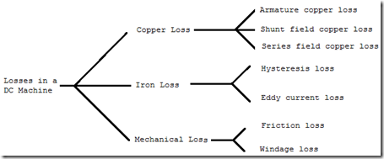
Figure 1 - DC Losses

With this assignment in mind, the losses that concern us are called ‘iron losses’ and these consist of eddy current loss and hysteresis loss which occur in the armature iron core. The armature core is made of iron, which rotates in a magnetic field, a small current gets induced in the core itself. [3]

Hysteresis Loss

“Hysteresis loss is caused by the magnetization and demagnetization of the core as current flows in the forward and reverse directions. As the magnetizing force (current) increases, the magnetic flux increases. But when the magnetizing force (current) is decreased, the magnetic flux doesn’t decrease at the same rate, but less gradually. Therefore, when the magnetizing force reaches zero, the flux density still has a positive value. In order for the flux density to reach zero, the magnetizing force must be applied in the negative direction.” [4]
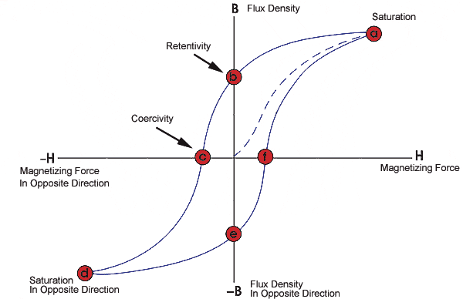
Figure 2 - Hysteresis Loss

In Figure 2 above, it shows the relationship between the magnetizing force (H) and the flux density (B) and is shown on a hysteresis curve.

Eddy Current Losses

“Eddy current losses are the result of Farady’s law, which states that, “Any change in the environment of a coil of wire will cause a voltage to be induced in the coil, regardless of how the magnetic change is produced.” Thus, when a motor core is rotated in a magnetic field, a voltage, or EMF, is induced in the coils. This induced EMF causes circulating currents to flow, referred to as eddy currents. The power loss caused by these currents is known as eddy current loss.” [4]
The armature of a motor use thin pieces of iron, instead of using a single piece as the resistance is higher with more than one thicker piece of iron. The result of higher resistance is smaller eddy currents. The pieces of iron and insulated from each other to avoid eddy currents jumping from one sheet to another. [4]
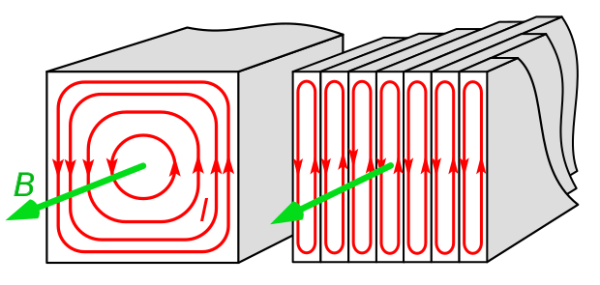
Figure 3 - Eddy Current Losses

Figure 3 shows the bigger single piece of iron on the left, compared to the thinner numerous sheets of iron on the right.

The Method

Using FEMM 4.2 the stator specified in the brief is created. Placing various nodes on the system to eventually create the motor. The nodes are then joined together using a series of lines or curves to give the shape.
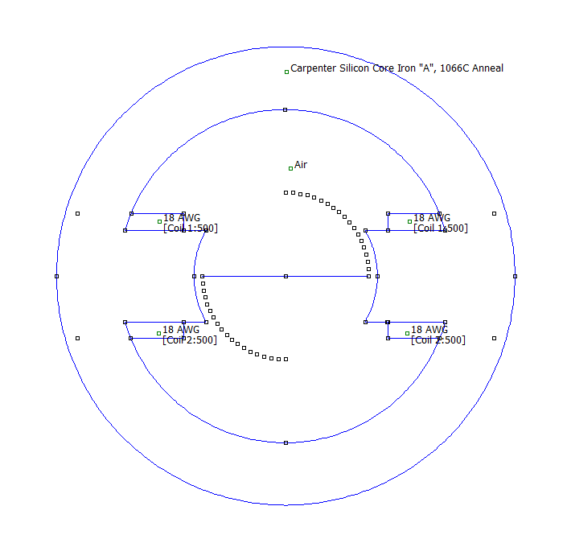
Figure 4 - Stator Circuit

Block labels are added to the design as seen above, to determine which materials and other problems that part of the motor is. The block regions used are air, Carpenter Silicon Core and 18 AWG. 18 AWG being the copper wire. Circuit properties are added to the coil region of the design.
A Boundary is also added to the design that accurately emulates the impedance of an unbounded domain.
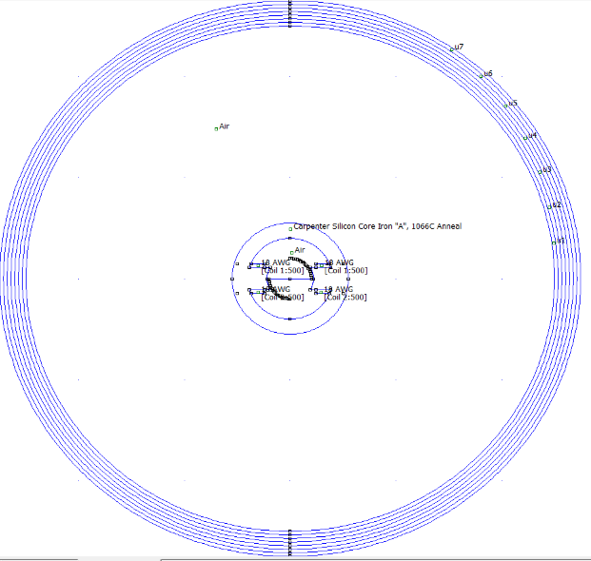
Figure 5 - Boundary

Once the design is completed, we mesh the design, that generates a triangular mesh for the problem. If the software manages to mesh the problem, we then ‘turn the crank’ that analyses the model before we can be able to see the results.
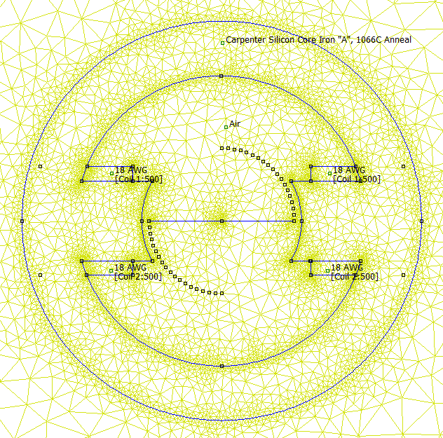
Figure 6 - Mesh

Once the mesh has been created, we can then see the results of the magnetic flux of the stator circuit. We can see the magnetic flux of the stator below, shown by the lines going across. This is the magnetic flux in the stator.
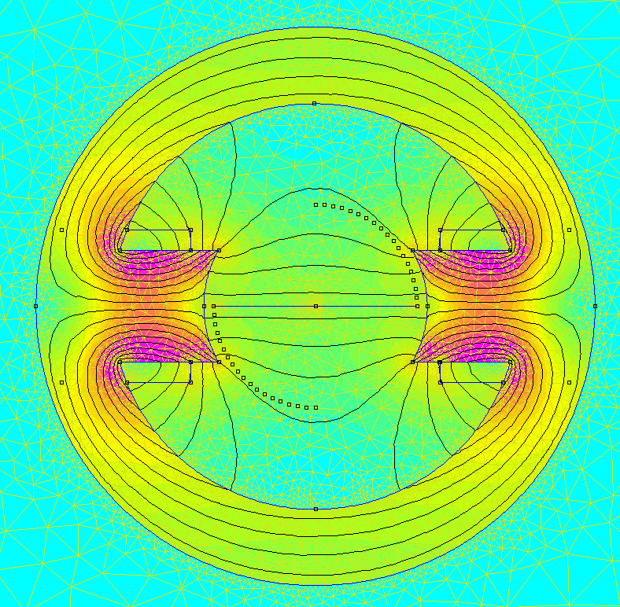
Figure 7 - Magnetic Flux

After calculating the Total flux and Max useful flux in the stator circuit, then adjustments can be made to the stator to try and improve the max leakage factor (efficiency) of the motor.
The adjustments that can be made are;
- Stator Inner Radius
- Armature Dimensions
- Winding Position
- Armature Face
The adjustments that were made are as follows.
 | Stator Radius | Armature Width | Fishtail
1 | 40mm | 20mm | None
2 | 45mm | 10mm | Big
3 | 48mm | 15mm | Small
4 |  | 30mm
5 |  | 35mm

Above are the different adjustments that were made to the stator, and what the dimensions were.

Experiment
1 | 1 | 1 | 1
2 | 2 | 1 | 1
3 | 3 | 1 | 1
4 | 1 | 2 | 1
5 | 1 | 2 | 3
6 | 1 | 2 | 2
7 | 1 | 5 | 1
8 | 3 | 3 | 1
9 | 3 | 4 | 1

Above is the experiments conducted and which adjustments were made.

The Results

Experiment 1
(1 , 1 , 1)
Figure 8 - Experiment 1

Angle | X | Y |  | Total Flux | Max Useful Flux
40 | 15.32088886 | 12.85575219 |  |  | 2.21E-05
50 | 12.85575219 | 15.32088886 |  |  | 2.28E-05
60 | 10 | 17.32050808 |  |  | 2.27E-05
 |  |  |  | 6.45751E-05
 |  |  |  | Leakage | 64.69%

Experiment 2
(2 , 1 , 1)
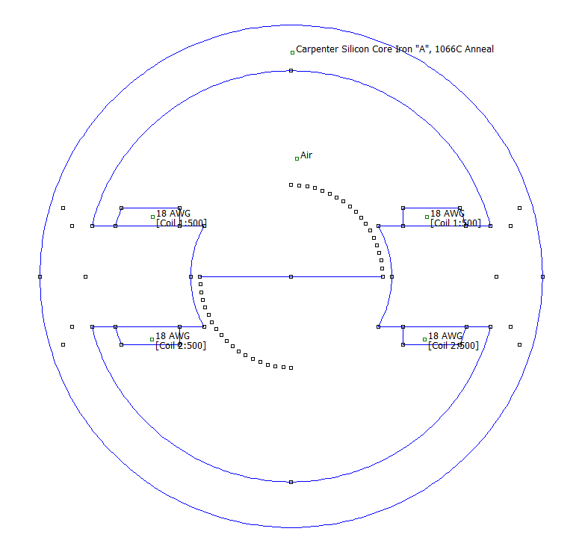
Figure 9 - Experiment 2

Angle | X | Y |  | Total Flux | Max Useful Flux
40 | 15.32088886 | 12.85575219 |  |  | 2.18E-05
50 | 12.85575219 | 15.32088886 |  |  | 2.27E-05
60 | 10 | 17.32050808 |  |  | 2.28E-05
 |  |  |  | 5.47E-05
 |  |  |  | Leakage | 58.36%

Experiment 3
(3 , 1 , 1)

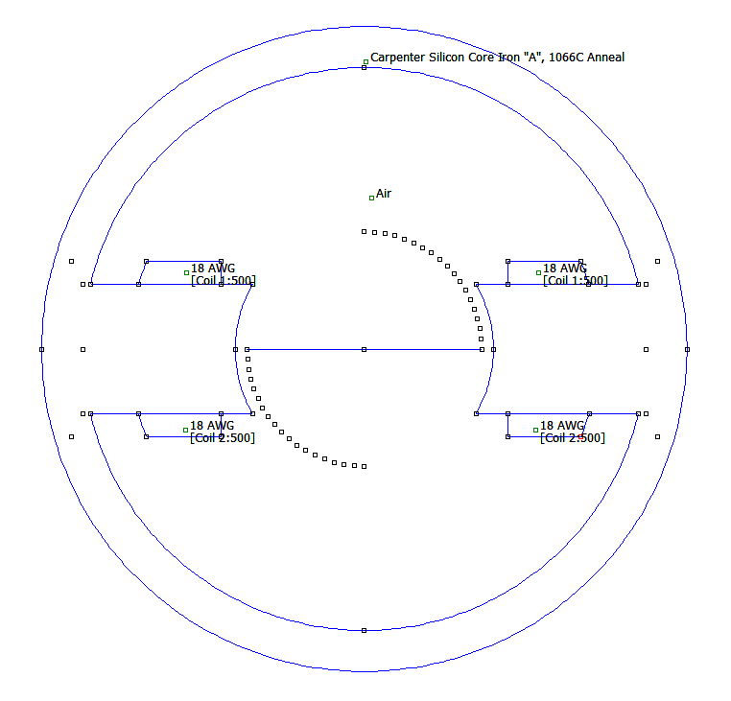

Figure 10 - Experiment 3

Angle | X | Y |  | Total Flux | Max Useful Flux
40 | 15.32088886 | 12.85575219 |  |  | 2.17E-05
50 | 12.85575219 | 15.32088886 |  |  | 2.27E-05
60 | 10 | 17.32050808 |  |  | 2.28E-05
 |  |  |  | 5.15E-05
 |  |  |  | Leakage | 55.68%

Experiment 4
(1, 2, 1)
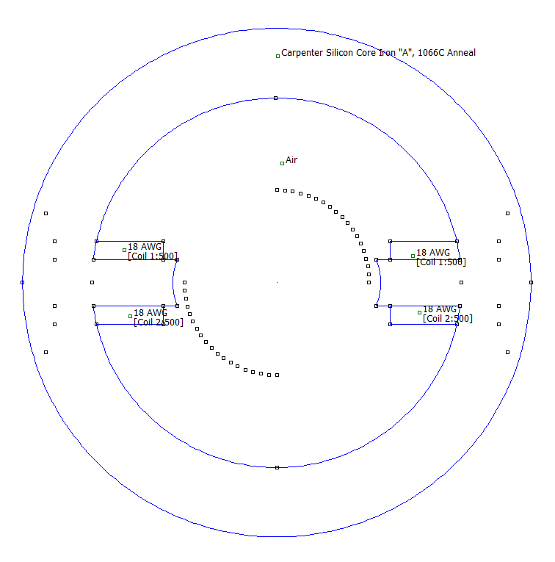

Figure 11 - Experiment 4

Angle | X | Y |  | Total Flux | Max Useful Flux
30 | 17.32050808 | 10 |  |  | -1.56E-05
40 | 15.32088886 | 12.85575219 |  |  | 1.59E-05
50 | 12.85575219 | 15.32088886 |  |  | -1.56E-05
 |  |  |  | 4.83E-05
 |  |  |  | Leakage | 67.12%

Experiment 5
(1, 2, 3)
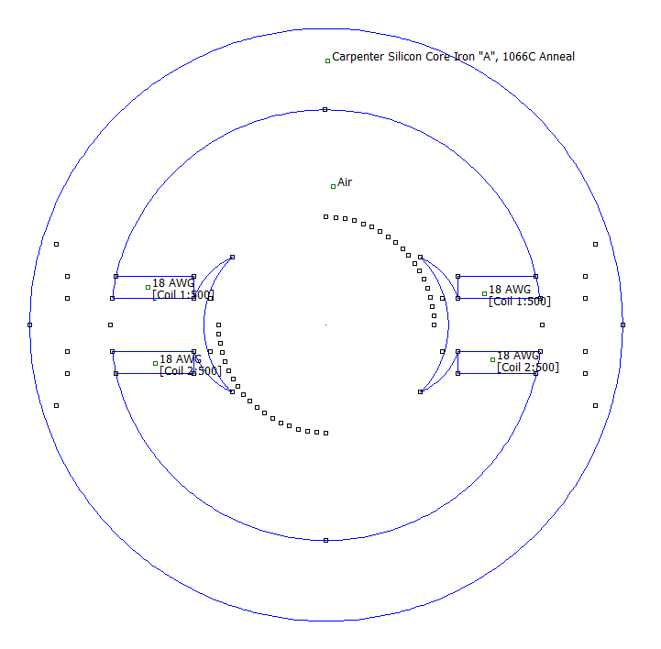
Figure 12 - Experiment 5

Angle | X | Y |  | Total Flux | Max Useful Flux
40 | 15.32088886 | 12.85575219 |  |  | 2.32E-05
50 | 12.85575219 | 15.32088886 |  |  | 2.43E-05
60 | 10 | 17.32050808 |  |  | 2.40E-05
 |  |  |  | 7.23E-05
 |  |  |  | Leakage | 66.46%

Experiment 6
(1, 2, 2)
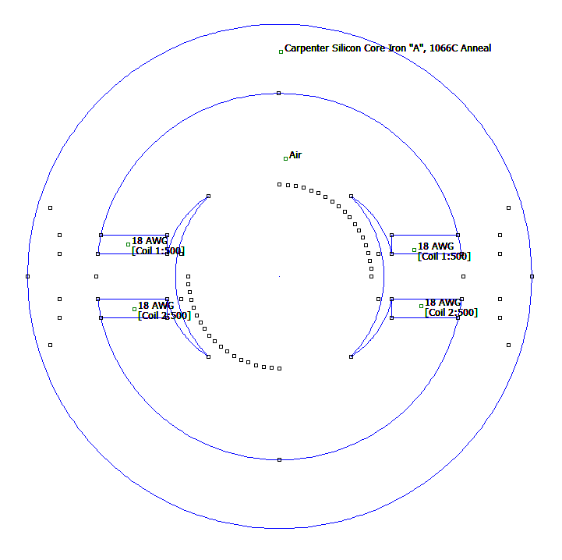
Figure 13 - Experiment 6

Angle | X | Y |  | Total Flux | Max Useful Flux
40 | 15.32088886 | 12.85575219 |  |  | 1.93E-05
50 | 12.85575219 | 15.32088886 |  |  | 2.50E-05
60 | 10 | 17.32050808 |  |  | 2.76E-05
70 | 6.840402867 | 18.79385242 |  |  | 2.80E-05
 |  |  |  | 9.22E-05
 |  |  |  | Leakage | 69.63%

Experiment 7
(1, 5, 1)
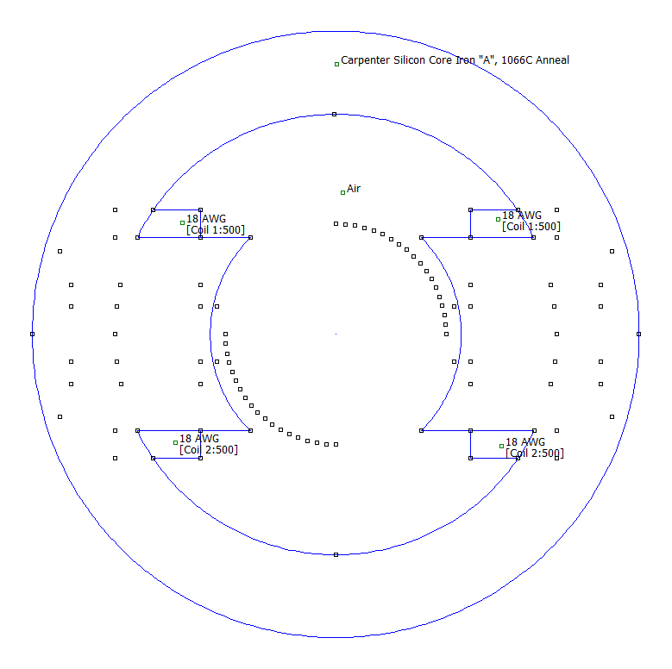
Figure 14 - Experiment 7

Angle | X | Y |  | Total Flux | Max Useful Flux
40 | 15.32088886 | 12.85575219 |  |  | 1.91E-05
50 | 12.85575219 | 15.32088886 |  |  | 2.51E-05
60 | 10 | 17.32050808 |  |  | 2.81E-05
70 | 6.840402867 | 18.79385242 |  |  | 2.89E-05
 |  |  |  | 8.55E-05
 |  |  |  | Leakage | 66.24%

Experiment 8
(3, 3, 1)
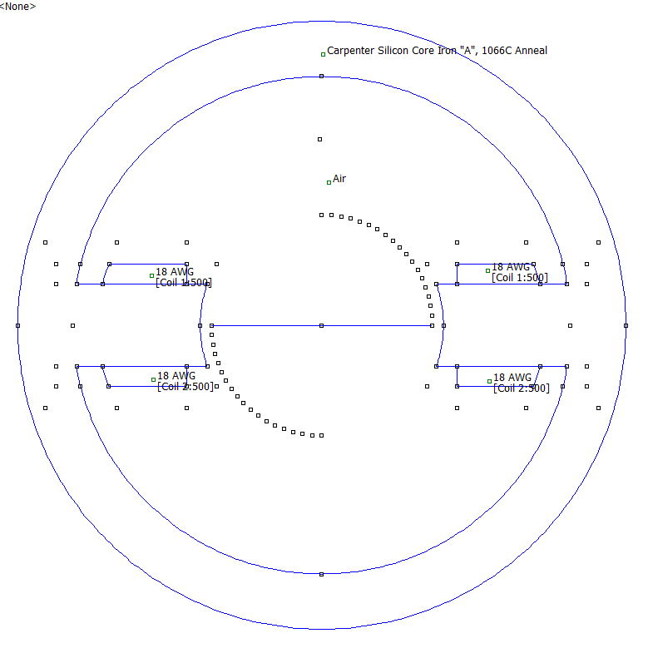
Figure 15 - Experiment 8

Angle | X | Y |  | Total Flux | Max Useful Flux
40 | 15.32088886 | 12.85575219 |  |  | 1.88E-05
50 | 12.85575219 | 15.32088886 |  |  | 1.89E-05
60 | 10 | 17.32050808 |  |  | 1.87E-05
 |  |  |  | 4.66E-05
 |  |  |  | Leakage | 59.56%

Experiment 9
(3, 4, 1)

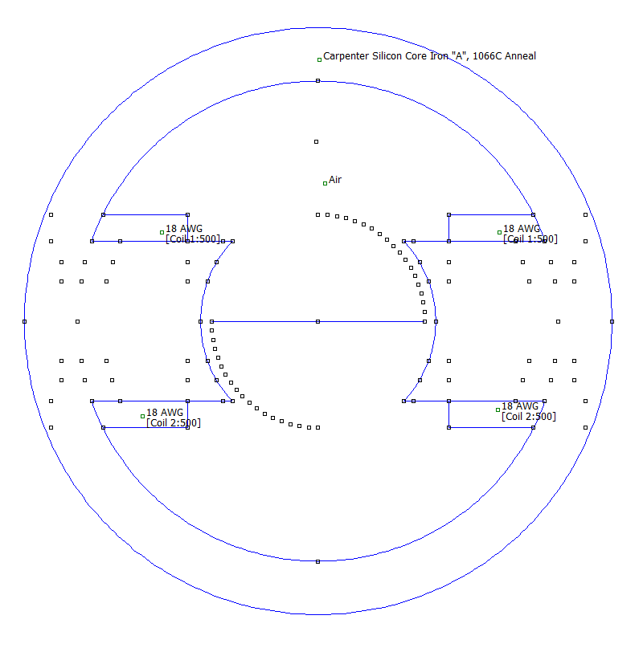
Figure 16 - Experiment 9

Angle | X | Y |  | Total Flux | Max Useful Flux
40 | 15.32088886 | 12.85575219 |  |  | 2.10E-05
50 | 12.85575219 | 15.32088886 |  |  | 2.64E-05
60 | 10 | 17.32050808 |  |  | 2.79E-05
70 | 6.840402867 | 18.79385242 |  |  | 2.82E-05
 |  |  |  | 7.70E-05
 |  |  |  | Leakage | 63.41%

Discussion

After conducting 9 different experiments to try and improve the flux leakage factor of the stator, experiment 3 was the best. The flux leakage factor was 55.68%, which is down almost 10% from the original 64.69%.
The only adjustment made in experiment 3 was the stator radius that was changed from 40mm to 48mm. Experiment 2 also only adjusted the stator radius but it was changed to 45mm with a FLF of 58.36%, this was still better than the initial 64.69% but not as good as experiment 3.
Experiment 4 only changed the armature width from 20mm to 10mm which gave a FLF of 67.12%, this made the FLF worse than the initial 64.69%, which proved that just making the armature smaller on its own wouldn’t give us better efficiency, so in experiment 5 I also added a small fishtail. The small fishtail and 10mm armature did have a better FLF than experiment 4, but was still 66.46% which is still higher. Experiment 6 then changed the fishtail to a big fishtail, which made the FLF worse again going to 69.63%. This made it clear that neither of the fishtails would enhance the efficiency of the motor.
In Experiment 7, only the armature width was changed, as in previous experiments making the armature smaller made the FLF worse, I wanted to see what effect making the armature bigger would do. By increasing the armature width to 35mm, the FLF changed to 66.24% which was worse than the initial FLF again, but not as bad as making the armature smaller.
In experiment 8, the stator radius is changed back to 48mm which had the best FLF, but also decreasing the armature width to 15mm, which gave a FLF of 59.56%. This was less than the initial FLF, but wasn’t better than just changing the stator radius on its own.
Just to confirm that changing the stator radius on its own was the best option, in experiment 9 I kept the stator radius at 48mm but increased the armature width to 30mm, which had a FLF of 63.41%.
By looking through all 9 experiments, we can clearly see that experiment 3 was the most successful.

Conclusion

This assignment has given me a better knowledge and understanding on how to improve the efficiency of a motor. By conducting various different experiments, and adjusting it slightly it has shown what type of effects each one has on the motor. And after analysing all of the results coming out with a more efficient motor and proving it has enhanced my knowledge.
I have also familiarised myself more with flux leakage factor, and also the different losses that occur in a motor. Hysteresis losses and eddy current losses are the core losses that I have learnt more about by doing research for this assignment.
This assignment has been beneficial to myself in learning the basics of what losses occur inside a motor and different ways they can be rectified or improved.

Bibliography

[1] | “Efficiency Formula,” Softschools.com, [Online]. Available: http://www.softschools.com/formulas/physics/efficiency_formula/29/. [Accessed 21 3 2019].
[2] | “Motor Efficiency,” Portescap, [Online]. Available: https://www.portescap.com/motor-solutions/motor-efficiency. [Accessed 21 3 2019].
[3] | K. Daware, “Losses In A DC Generator And DC Motor,” Electrical Easy, [Online]. Available: https://www.electricaleasy.com/2014/01/losses-in-dc-machine.html. [Accessed 21 3 19].
[4] | D. Collins, “Hysteresis loss and eddy current loss: What’s the difference?,” Motion ControlTips, 30 3 18. [Online]. Available: https://www.motioncontroltips.com/hysteresis-loss/. [Accessed 21 3 19].

