Results Chapter

Introduction
In the previous chapter, it explained the research methods and methodology. This chapter will now examine the and establish what the extent of domestic abuse within the Cardiff locality and views of operational police officers to establish if they believe the CPS are taking a strong enough approach to deal with it.
As highlighted in the previous chapter, the research that will has been conducted consists of mainly a mixed method approach. Research has been carried out primarily by a survey. The survey as stated in the previous chapter consists of the blending of qualitive and quantitative research questions. All questions in the survey start as a multiple-choice question, some questions then give the participants the choice to expand on their answer and make a comment regarding their answer.
The way the questionnaire is designed makes it an easy process for operational police officers who have little time in their roles to answer the questionnaire. If the participants feel as if they don’t want, or don’t have the time to make a personalised comment to answer the questions put to them, they can simply not make a comment and skip to the next question.
The methodological approach that was taken with this survey also allows the main research aim of the paper to be met whilst also allowing a more complex answer which can’t be obtained from a simple multiple choice questions.

Data Analysis
Data analysis is described as the process of using data to extract relevant information, organise data, and to find patterns in data that can be used to guide informed decisions (Coursera, 2022). The data analysis in the following paragraphs will seek to address the questions that have been raised in the previous chapters. The data was collected through the website Smart Survey and will be analysed and organised into pie charts for easy and simple viewing.

Advantages of Smart Survey
Smart Survey is described as an easy-to-use platform which provides instant results from participants who complete the survey, it is also a secure platform which protects the identity of those participants to keep in line with the ethical standards set in this project (Smart Survey, n.d.). Smart Survey facilitated for mixed method approach of the question styles, is easy to complete and data is simply presented.

Disadvantages of Smart Survey
Disadvantages include that further questions cannot be raised regarding the answers that participants provide on the survey. Data errors may also be present as participants are not required to answer all questions prior to completion of the survey.

Questionnaire Findings

Extent of Domestic Abuse within the Cardiff Locality.
A total of 38 responses were made to the survey that had been sent out. The survey was submitted to approximately 110 police officers across the Cardiff locality that work in a number of different departments, these departments included, Response, CID (Criminal Investigation Department), RIT (Rape Investigation Team), HUB (Department which progresses volume crime investigations) and RPU (Roads Policing Unit). All participants worked are currently working in operational policing roles and are a mix of Police Constables, Detective Constables and Sergeants. As stated in the previous chapter, a higher response rate was hoped for, around the margin of 40 – 100 responses, however, the lower completion rate could be down to high workload officers are carrying and not having the time to complete the survey, annual leave, retractions from shift.

Participants Length of Service.
One of the first questions raised in the questionnaire was the participants length of service in the force. This was to establish the correlation between the length of service and how the participants believe domestic abuse reporting has changed over time. As shown below approximately a third of the participants have over 5 years’ service which is considered a large amount of time of service and will usually mean well informed views on the questions put to them. A majority of the participants approximately two thirds have less than five years’ experience, which can be considered not much, however, a majority of UK police forces have a majority of the workforce with small amounts of service. However, the 14 officers with two to five years’ experience can also be considered to have a good deal of experience.
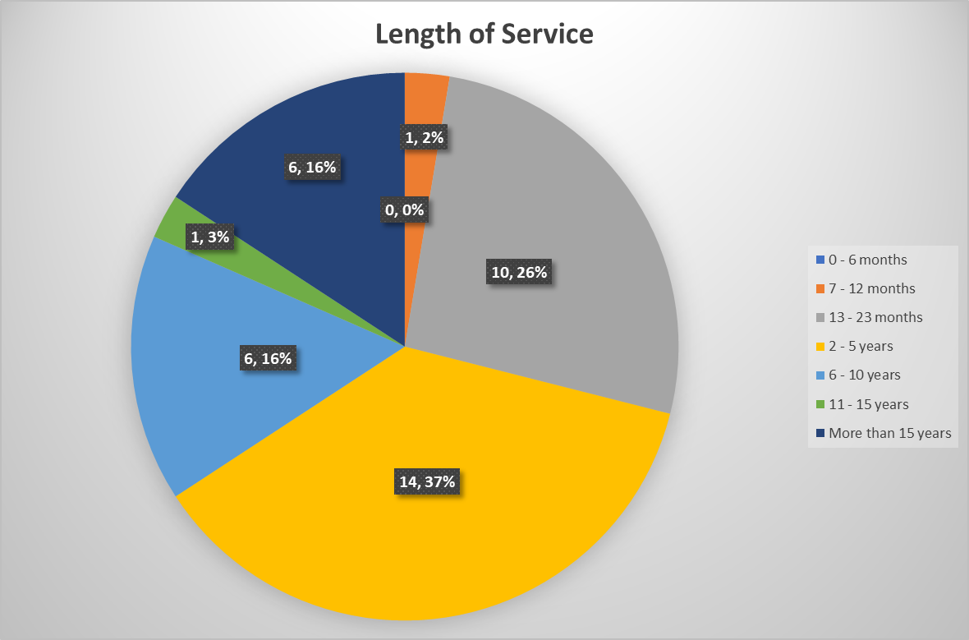

Particpants who play active roles in domestic abuse incidents.
One of the questions raised is ‘In your role, do you have any dealing in domestic abuse incidents’. It was established by this question that only two particpants don’t have any dealings in domestic abuse incidents. This is good, as a majority of the participants have up to date knowledge on domestic abuse incidents and are able to provide a sound knowledge to the questions raised. However, the two particpants that don’t have dealings with domestic abuse in their roles, it would be safe to presume at an earlier point in their career they had and still have valuable knowledge to share on their experiances.
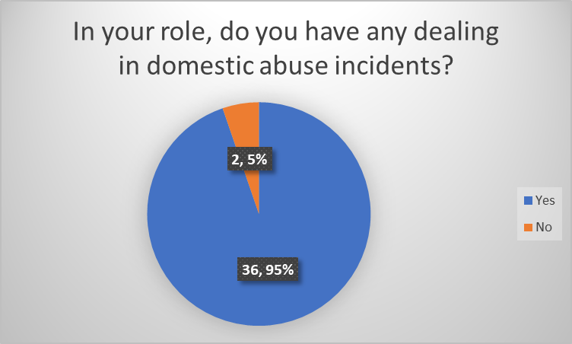

How often do the participants deal with Domestic Abuse Incidents?
One of the questions raised is ‘How often do you deal with domestic abuse incidents in your role?’. From looking at the chart below, 63% of participants state they deal with domestic abuse every day in their role, whilst 21% suggest they deal with domestic abuse a few times a week. This would suggest that there is a large proportion of domestic abuse incidents taking place within the Cardiff Area. This data also suggests that the officers that have taken part in this questionnaire seem to have a wealth of experience in domestic abuse incidents and should have a sound knowledge to share in this project.
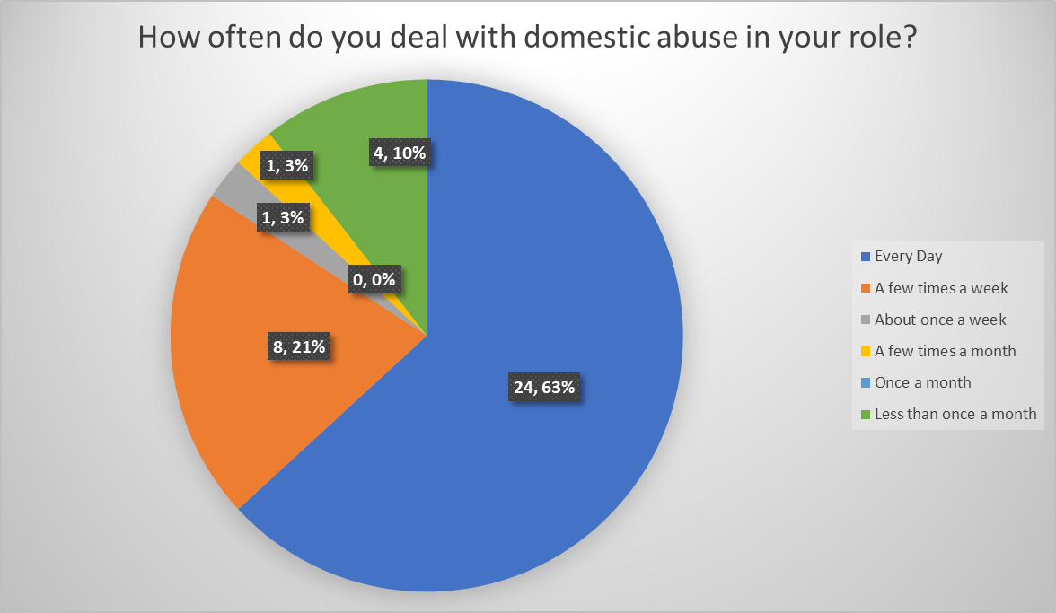

Is there a change in the amount of domestic abuse incidents throughout time?
One of the questions raised is ‘What are your thoughts about levels of domestic abuse over the time of your service?’. From the below table, out of 38 responses, no participants in the survey believed that domestic abuse cases were decreasing in any way. Only 29% of participants believed that levels remained neutral, and 71% believed that domestic abuse incidents were increasing. However, as highlighted in previous chapters, the reasoning behind this may be down to increased reporting of incidents over later years or also increased crime recording by UK police forces. This question gained 17 responses.
One response identifies that over recent years, there are new forms of domestic abuse being identified and being brought into legislation which may be adding to an increase of offences.
‘Increasing in such, newer forms of abuse are being identified such as Coercive control, financial abuse, emotional abuse etc and are being reported. There is more awareness amongst staff and the community of what is an abusive relationship.’
Another response identifies that there seemed to be a drop n reporting during the Covid-19 pandemic, however, since the pandemic ended, reports have returned to pre-pandemic levels.
‘There was a decrease during the pandemic and lockdowns, but since the number has returned to pre pandemic levels.’
One respondent believes that domestic abuse incidents aren’t necessarily increasing, however, the number of reports is increasing, which could be down to victims more willing to report incidents.
‘I believe the amount of domestic related incidents is increasing, however this does not necessarily mean that domestic related incidents are increasing. I believe that people are more willing to report it now than before.’
One participant believes that incidents are increasing, however, the threat levels aren’t, implying that more verbal domestics are being reported and increased reporting by third parties.
‘DV incidents are increasing BUT the treat levels are not. They are staying between common and ABH BUT are being reported more due to verbal arguments or third party.’
One participant believes that domestic violence incidents appear to be increasing and believes it could be down to the police service becoming more accessible with the addition of social media reporting and online reporting methods as well as partner agencies reporting.
‘DV incidents appear to be increasing over the years which could be contributed to police services becoming more accessible to our communities using a variety of engagement methods (phone, email, social media, partner agencies).’
Another participant believes that police have an increased confidence by the public which is resulting in increased reports.
‘More reports possibly due to confidence in reporting to police and agencies.’

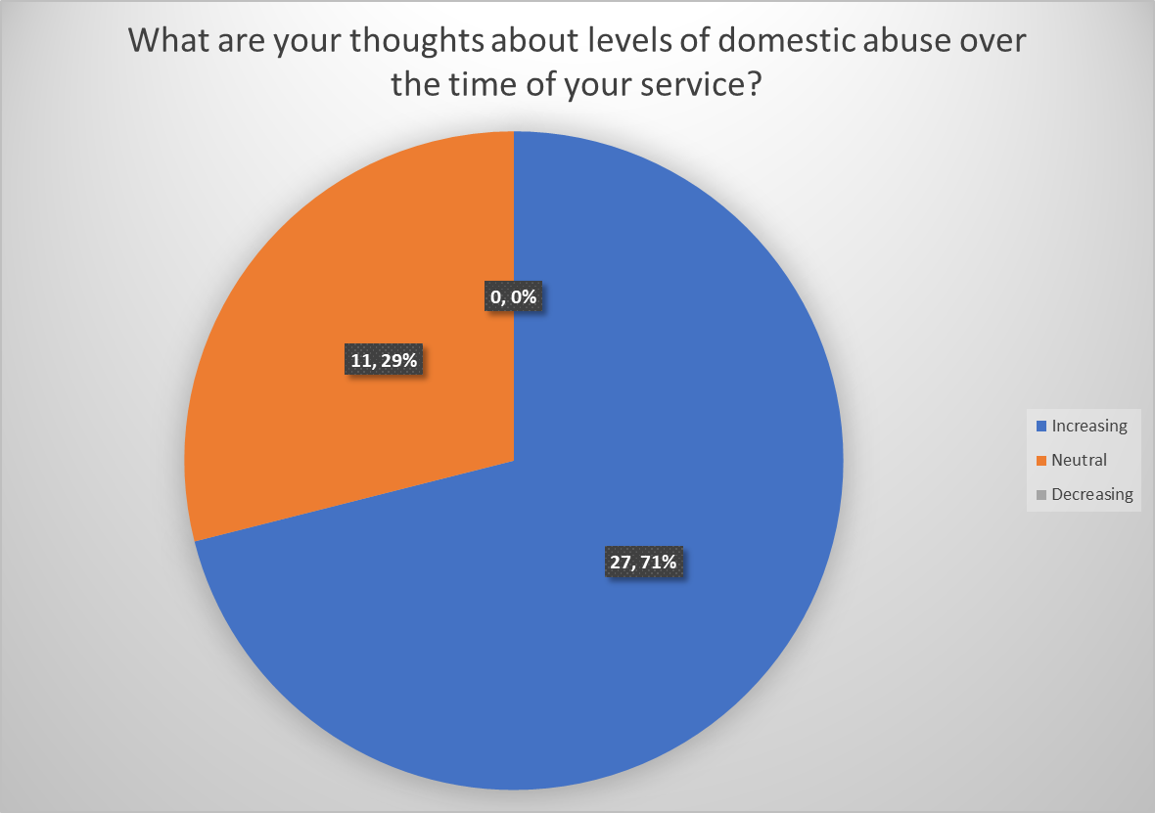

Is domestic abuse more common in poorer communities?
As mentioned in previous chapters, the Cardiff locality contains some of the most deprived communities in Wales. The question ‘Do you believe domestic abuse levels are higher within poorer communities?’ has been raised to try and establish what officers’ views are of this. As can be seen in the below graph, the largest proportion of participants at 79% believe the poorer communities experience increased domestic abuse incidents. This question gained 15 comments.
One participant believes that domestic abuse is not higher in poorer communities, however, believes it may be more reported within those communities instead of more wealthy communities. If this is the case, this could potentially be down to public perception, victims not wanting involvement with police and victims in wealthy communities may not want persons around them knowing the abuse.
‘I think that da is reported more within poorer communities, but not that it is higher necessarily.’
A further comment below has the same outlook as above.
’ I think that levels of DV are common in more prosperous communities however they are less likely to report it due to reputation and other persons perceptions about them and their family.’
The comment below raises a good argument for why domestic abuse may be more prevalent in those poorer communities. The below brings into factors such as ACE’s (Adverse Childhood Experiences) which may also be more prevalent in poorer communities.
‘I feel in general, persons from poorer communities are on the backfoot from the beginning. They are likely to have more ACEs than those from more affluent areas, which creates challenges all through their lives. I think those from poorer communities have less opportunities to learn and less likely to be supported by parents financially and in education. There are higher rates of crime in poorer areas and environments of this nature encourage continuous behaviour traits from generation to generation. A combination of all these things can result in higher levels of Domestic abuse.’
A further comment below makes note that Cardiff contains both a mix of affluent and impoverished areas. This participant believes that domestic abuse calls are higher in the poorer communities, however, when domestic abuse takes place in affluent areas, it can tend to be worse.
‘We cover a financially diverse patch with some of the richest and poorest communities in Cardiff and there are domestic incidents among both communities, with the number of calls being higher/more frequent among poorer communities but when incidents are reported by richer families the abuse tends to be more severe’

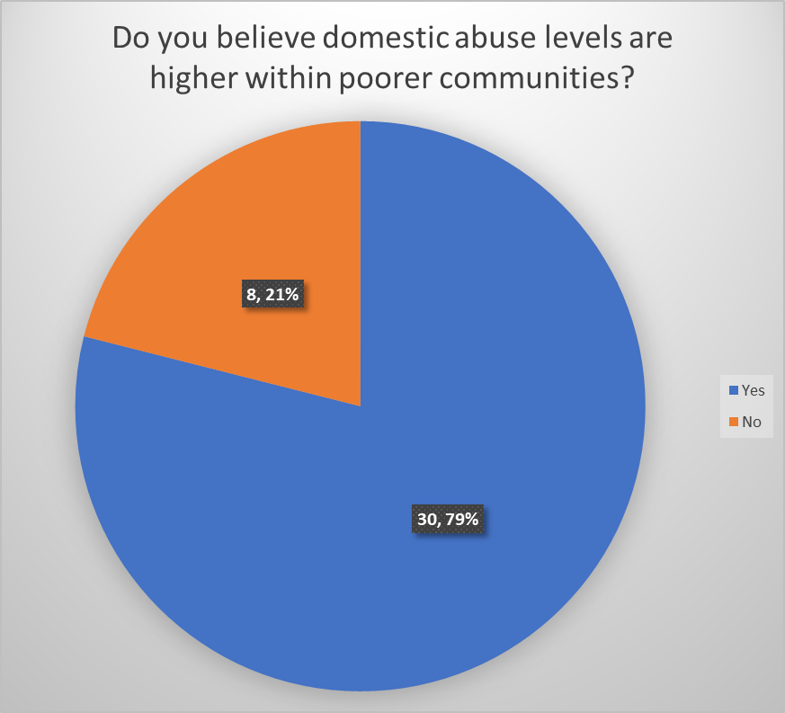

Bibliography:
Coursera (2022) What Is Data Analysis? (With Examples), Available at: https://www.coursera.org/articles/what-is-data-analysis-with-examples (Accessed: 30th January 2023).
Smart Survey (n.d.) Powerful Survey Software to make Smarter Decisions, Available at: https://www.smartsurvey.com/ (Accessed: 30th January 2023).

