s


Introduction to Health and Social Care
LCHS4003
Sajid abbas
word count 600

2415148
LCHS4003
Portfolio 1and 2 task
Dr Helen parsons

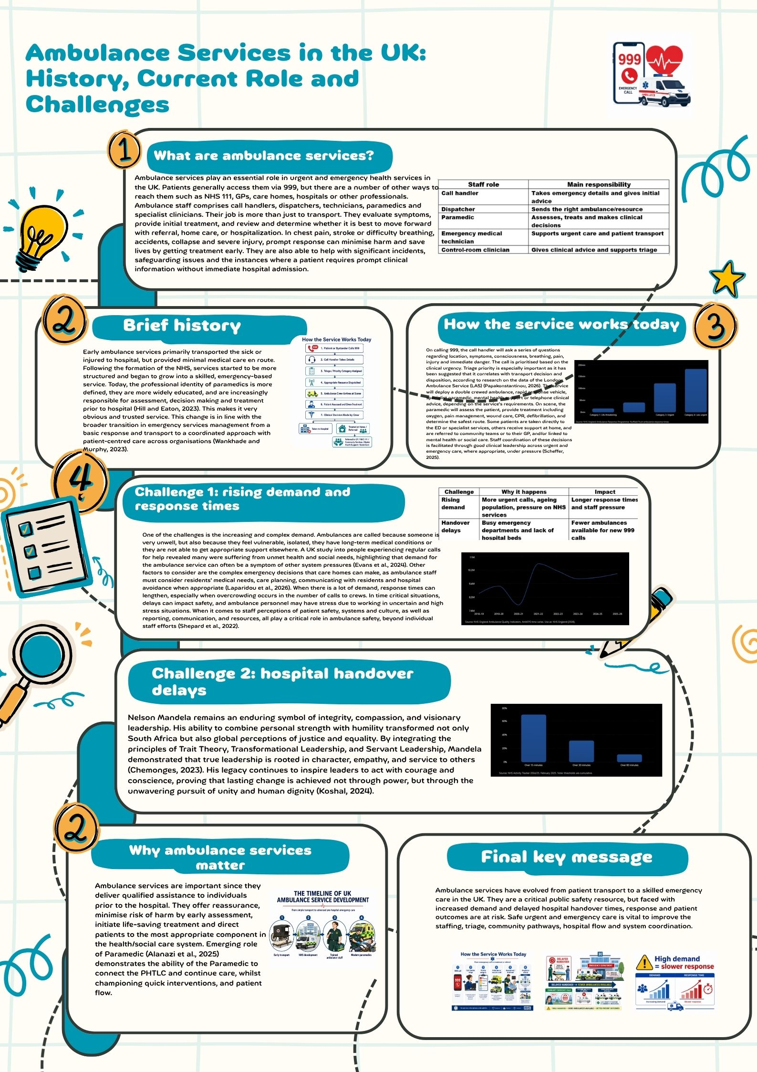

Part 2
Domiciliary Care Services within the Community.
Introduction
Domiciliary care is organised assistance that is given in a person's own home to enable them to live as safely as they can, to live as independently as they can, and to do these things every day. This can involve washing, dressing, eating, walking, reminding to take medicine, and provision of companionship. In community services, not only is it used to get things done, but to enable people to stay in their homes, with dignity, control, and connection.

Outline the origins and historical context of Domiciliary Care.
The roots of domiciliary care are connected with the general trend from institutional to community based care. Deinstitutionalisation was a strategy to de-institutionalise, though this focus was accompanied by a need for robust local services to make community living viable and secure (Golinowska, 2022). The development of modern health and social care has been shaped by the evolving nature of relationships between the state, families, markets and voluntary organisations (Glasby, 2026). This is why societies felt that older people and the disabled should be supported, rather than filling hospitals or residential homes, and that's why domiciliary care grew.

How Domiciliary Care Services Function Today
Domiciliary care is now typically delivered by a local authority, private domiciliary care service, a voluntary organisation or a package provided by the family. Care needs are identified and a care plan is developed which details visit times, risks, preferences and support required. Home-care providers can play a role in commissioning as they have a knowledge of the needs of older people, and the realities of service delivery (Davies et al., 2022). A key consideration for safe older people's care is the need for good governance and coordination between nursing services, home support and wider community services (McDonald, Frazer and Warters, 2022). The reality of working with care is that care workers enter people's homes, assist with the daily living activities, make observations and report issues.

Critical evaluation of current domiciliary care services.
One of its main advantages is its ability to keep individuals in their own homes while providing them with the care they need, and preventing them from entering residential care when they don't need to. But staffing shortages, time constraints and limited funding cause stress to the service. Short appointment models might generate conflict between being efficient and providing full care, because the worker will not have enough time to address emotional and physical needs (Alamodi et al., 2024). Information regarding the benefits, costs and cost-effectiveness of services will be relevant since decisions about services must take into account outcomes, value and sustainability (Vadean et al., 2026). Another limitation is that loneliness or social isolation are a problem for some users, which must therefore be taken into account in caring, along with practical matters (Pollak et al., 2025).

Significance of Domiciliary Care in Enhancing Quality of Life
Care at home can enhance the quality of life for people by helping them with safety, feeding, personal cleanliness, medication, and movement and confidence. When care is respectful, it can also support older people's sense of self when they feel that there is a loss of control (Hughes, 2023). Person-centred care is linked to older adult's psychological wellbeing (Lorber et al., 2025). Feeling recognised, supported and socially connected helps to build dignity and wellbeing for older people (Roos et al., 2023).

Conclusion
The importance of domiciliary care is the ability to help individuals to stay in their own community and home. It is worth because it is independent, dignifying and preventive, but requires sufficient time, competent staff, co-ordinated practice and person-centred practice to be effective. Home support is both practical and relationship-based: successful domiciliary care will seek to strike a balance between efficiency and compassion.

Bibliography
Alamodi, L.A., Daafi, A.A., Hindi, W.S., Sherah, K.M.I., Mubaraki, T.D.A., Omaysh, K.A., Alsalem, W.S., Otayf, S.Y., Majrabi, F.A., Shubayli, A.A. and Shannaq, G.Y.A., 2024. Beyond the Clock: Reconciling Efficiency with Comprehensive Care in the 15-Minute Visit. Saudi Journal of Medicine and Public Health, 1(2), pp.2313-2319.
Davies, K., Dalgarno, E., Angel, C., Davies, S., Hughes, J., Chester, H., Jasper, R., Roberts, A. and Challis, D., 2022. Home‐care providers as collaborators in commissioning arrangements for older people. Health&Social CARE in the community, 30(2), pp.644-655.
Glasby, J., 2026. Understanding health and social care. In Understanding Health and Social Care. Policy Press.
Golinowska, S., 2022. On the concept of deinstitutionalisation of care and the measures undertaken. Possibilities and limits. Problemy Polityki Społecznej. Social Policy Issues, 58(3), pp.215-237.
Hughes, S., 2023. Domiciliary care, self and older age (Doctoral dissertation, Anglia Ruskin Research Online (ARRO)).
Lorber, M., Mlinar Reljić, N., McCormack, B. and Kmetec, S., 2025, June. Person-Centred Care in Association with Psychological Well-Being of Older Adults. In Healthcare (Vol. 13, No. 12, p. 1379). MDPI.
McDonald, A., Frazer, K. and Warters, A., 2022. Irish Public Health Nursing Services and Home Support Services: Governance of older persons’ home care. Public Health Nursing, 39(1), pp.96-102.
Pollak, C., Pham, Y., Ehrlich, A., Verghese, J. and Blumen, H.M., 2025. Loneliness and social isolation risk factors in community-dwelling older adults receiving home health services. BMC geriatrics, 25(1), p.290.
Roos, C., Swall, A., Marmstål Hammar, L., Boström, A.M. and Skytt, B., 2023. Promoting the person-centred aspects of dignity and well-being: learning from older persons’ experiences of living in residential care facilities. Working with Older People, 27(3), pp.219-229.
Vadean, F., Mamolis, G., Rand, S., Gousia, K., Teo, H., Birch, S., Alvarez Nishio, A., Towers, A.M., Allan, S., Darton, R. and Gregory, F., 2026. The benefits and costs of domiciliary care: a study protocol for evaluating the cost-effectiveness of domiciliary care in England. BMJ open, 16(6), p.e117555.

