University of Wales Trinity Saint David
Voice Study Centre

Final MA Assignment: BMPF7010

Project Tittle:
‘Creating a BA (Hons) in Musical Theatre in Portugal’

Sara Teixeira
Student Number: 2029082

1ST of March 2024

Contents Pages

Project Proposal 3 - 8
Introduction 9 - 12
Literature review 12 - 20
Methodology 21 - 26
Ethical Considerations 27
Findings 27 - 38
Analysis and Discussion 38 - 45
Reflections and Conclusions 46 - 49
Limitations, Recommendations, and Impact 49 - 50
Final Conclusions 50 - 51
References 52 - 61
Appendices:
Appendix 1: Approved ethics form 62 - 77
Appendix 2: Educators’ signed consent forms 78 - 89
Appendix 3: Students’ signed consent forms 90 - 101
Appendix 4: UK Pedagogues’ survey In Vivo Coding 102 - 106
Appendix 5: Students’ focus group transcription and In Vivo Coding 107 - 111
Appendix 6: Educators’ focus group transcription and In Vivo Coding 112 - 115

Sara Teixeira: Student number: 2029082
BMPF7010 Project Proposal

Project tittle: Creating a BA (Hons) in Musical Theatre in Portugal

Background and justification
This project aims to understand the viability of creating a BA (Honorous) in Musical Theatre in Portugal focusing on a singing pathway and understand its’ advantages for Portuguese students in a pre-professional stage.

As a singing teacher within vocational training in musical theatre, I have encountered an increasing number of students wanting to pursue a higher education and, consequently a career in Musical Theatre. Nonetheless, it does not exist a BA (Hons) in Musical Theatre in Portugal. This causes students willing to follow this career path to go study abroad consequently leaving behind their families and friends while supporting all the expenses of living away from home. There are four main vocational schools of Musical Theatre in Lisbon, such as Academia Vilar do Paraíso (AMVP), Primeiro Acto, Stagedoor and EDSAE – Escola de Dança e Teatro Musical (Carrilho, 2016). All of them have a specialized three-year course and every year the receive between 18 to 23 students and, according to last year´s data, approximately 85% of them intend to undertake a higher education degree in Musical Theatre (EDSAE, 2023; AMVP, 2023; Primeiro Acto, 2023; Stagedoor, 2023).

In addition to this, throughout the last two years there’s been an increasing number of international musicals taking place in Portugal such as Chicago, The Sound of Music, Ordinary Days (Teatro da Trindade, 2021; Armando Calado Produções, 2022, Stagedoor Produções, 2022) as well as original shows such as Sonho de Uma Noite de Verão, Laura, A Madrugada Que Eu Esperava (Teatro da Trindade, 2023; Teatro Politeama, 2023; Força de Prdução, 2023).

Taking these aspects into consideration, it is relevant to think about the impact that a Musical Theatre degree could have on the Portuguese industry.
Project Aims
The aims for this research project will be:

- To recognize the Musical Theatre industry’s demands in Portugal comparing to the industry’s demands abroad.

- To understand the possibility of creating a BA (Hons) in Portugal that would meet the Musical Theatre industry’s demands, comparable to leading training establishments abroad.

- To analyze the possibility of arranging funding for a potential BA (Hons) in Musical Theatre allowing lower costs to students.

- Ascertain advantages for students of studying in their own country instead of studying abroad.

Research Methodology
Asking individuals about their experiences, to understand how students feel about having to move to another country to follow their passion and all the challenges it intakes is extremely important. Considering that different people have different views of the world, this project lies within a constructivist domain in which reality is socially constructed and it is given meaning by people (Easterby - Smith, Thorpe and Jackson, 2011). This project implied analyzing and understanding the individuals’ views of the world (Cohen et al., 2018).

This will be an action research project and it is defined as a ‘form of collective reflective enquiry undertaken by participants in social situations in order to improve the rationality and justice of their own social or educational practices, as well as their understanding of these practices and the situations in which these practices are carried out’ (Kemmis & McTaggart, 1998, p. 6). Therefore, it seeks to resolve the issues investigated and has a political agenda, it’s democratic and collaborative as the participants are actively involved in the research. Action research can be useful within the education setting to expand educational processes, enable positive organizational change, better curriculums, enhance access to education and social justice and to improve pedagogy and classroom-based knowledge (Winter, 2021).

To increase consistency of findings, for this project there will be a triangular approach considering three viewpoints regarding the importance and advantages of a higher education degree in Portugal and use this data to design a curriculum.
The three viewpoints will be of 4 Portuguese students in a pre-professional stage of their training in Musical Theatre that intend to take their studies further, 4 Portuguese musical theatre performers/educators and 4 musical theatre pedagogues that have created musical theatre course models in the UK.

Methods
For this research, the different participants will be subject to different ways of collecting data. Initially, there will be a literature review within the fields of Musical Theatre, singing, dance and higher education to collect data and from that develop research questions and a program of studies. Regarding the students in a pre-professional stage and the musical theatre performers/educators the method of data collection will be in the form of a focus group that will be recorded and transcribed. Focus groups have been shown to provide valuable insight by ‘… generating information on collective views, and the meanings that lie behind those views’ (Gill et al, 2008). According to Kitzinger, focus group methods are also popular with ‘… those concerned to "empower" research participants because the participants can become an active part of the process of analysis’ (Kitzinger, 1995), making them highly appropriate for action research. A purposive sample (Teddlie and Yu, 2007) of students in a pre-professional stage and of musical theatre performers/educators will be chosen by the researcher to form two focus groups. The researcher will act as group moderator during the sessions.

Concerning the musical theatre pedagogues, there will be arrangements to have an online interview with each of them the creation of their degree program in the UK.
In addition to these, there might also be a need to use surveys to gather supporting data from the participants for statistical analysis. Using an interactive cycle, the researcher will ask for feedback from both groups regarding the possibility of creating a course model for a BA (Hons) in Musical Theatre in Portugal.

This research will happen online in the UK while sending the questionnaires to the musical theatre pedagogues as well as in Portugal, over Zoom with the students’ and teachers’ focus groups during the months of September 2023 – March 2024 inclusive. Please see GANTT chart below for a proposed timeline.

Task | Aug/Sept  2023 | Out/Nov  2023 | Dez/Jan  2024 | Feb/Mar  2024
Preparation
Agree on research topic with tutor
Determine aims and objectives
Invite focus group participants
Write project proposal
Research
Literature Review
Determine common themes and code initial data
Find primary source material according to theme
Interview
Draft Curriculum
Focus Group
Report
Write introduction and methodology sections
Analyse and code data from focus group sessions
Write results and report findings
Draft report deadline

Ethical Considerations
Considering ESRC and WIWBL ethical guidelines there is no significant risks to participants are anticipated during this time. Even though, it is recognized that, whilst there are considerable advantages to being an insider researcher such as improving and creating knowledge within the practice (Breen, 2007; Costley, 2010) which can be very motivating for the researcher (Costley, 2006), there are also potential downsides, such as ‘myopia’ (Mercer, 2007) from internal perspectives and over-familiarity with the subject matter or the participants themselves. The researcher hopes to avoid these potential issues by ensuring that since some of the participants will have a professional relationship with the researcher and it could influence their answers, the received questionnaire will be anonymous, they will be free to express their true opinions and ideas and the researcher will only be the moderator of the conversation. In addition to this, all the volunteers will receive a consent form prior to their participations detailing the aims of the project, with contact information through where they could ask any questions they had and guaranteeing that the information they provide would not be disclosed to anyone. Since the focus groups will be recorded, there is a higher risk of some personal data disclosure. However, the risk will be mitigated by ensuring the use of a code for all the participants and having all data stored on a personal password secured computer of which only the researcher has access to.

All responses will be anonymous anonymized in the questionnaires and confidentiality remained in the transcription of the focus group discussion so participants, students, and educators, cannot be identified (Bell, 2005). All participants will also be made aware they can withdraw from the project at any time without recrimination.

Personal Learning Outcomes

- To analyze the viability of creating a degree course that will enable Portuguese students in a pre-professional stage to have training that accords with both the global and Portuguese musical theatre industry’s demands.

- To develop the researcher’s capacity of organizing and structuring a data that could back up a possible course model that could contribute significantly to the musical theatre industry in Portugal.

- To listen, learn and appreciate the perspectives and views of a group of experienced educational and industry professionals.

- To create connections with UK educational institutions and pedagogues.

Sara Teixeira: Student Number: 2029082
MA Assignment: BMPF7010

Project Tittle: Creating a BA (Hons) in Musical Theatre in Portugal

Introduction
This study represents the culmination of extensive hours of research over the past two years during which I executed a broad critical analysis within the musical theatre pedagogy and industry globally but al specifically in Portugal. It is my belief that having a structured higher degree course with an emphasis on a singing pathway is now needed in Portugal considering the constant growing of the industry in the country and the number of students interested in taking a higher degree in this subject (EDSAE, 2024; Agenda Cultura de Lisboa, 2024). Currently there is no accredited higher education route for musical theatre even though there are several BA (Hons) all across Europe in countries such as the UK, France, Italy and Spain (Bachelor Studies, 2024). As both a professional musical theatre performer and singing teacher I wanted to address this shortfall by understanding the viability and possible interest and benefits of having a BA (Honorous) in Musical Theatre in Portugal.

With the previous studies, my intention was to highlight themes and key points within the literature, critically analyze and compare the content of those themes and draw conclusions that would enable me to better understand the Musical Theatre industry’s demands not only in Portugal but also abroad. My plan with this assignment is to connect my findings, expand upon them and understand how viable a higher education degree in musical theatre could be in Portugal.

For the past 4 years I have been a Musical Theatre singing teacher and I have also been working as a Musical Theatre performer for the past 5 years. Although I am very familiarized with the requirements needed to work within the Musical Theatre industry and have been able to guide my students on their journey, specific higher education training is nonexistent in Portugal, which leads students to go abroad to take their degrees. However, this does not match with the extensive amount of musicals that have been premiering in Portugal for the past 6 years:
Production Company | Show
AM LIVE | The Wizard of Oz on Ice
AM LIVE | Peter Pan on Ice
AM LIVE | The New Cinderella on Ice
AM LIVE | Alladin on Ice
Armando Calado Produções | The Phantom of the Opera
Armando Calado Produções | The Sound of Music
Caixa de Cena Produções | The Hunchback of Notre-Dame
Caixa de Cena Produções | Snow White and the Magic Mirror of the World
Contracanto Produções | Into the Woods
Contracanto Produções | Anastasia
Filipe La Féria Produções | The Little Mermaid
Filipe La Féria Produções | Rapunzel
Filipe La Féria Produções | Cinderella
Filipe La Féria Produções | Sleeping Beauty
Filipe La Féria Produções | LAURA
Força de Produção | Avenue Q
Força de Produção | Chicago
Força de Produção | The Dawn that I was Waiting For
Força de Produção | Dear Evan Hansen
GrowUp Produções | Hansel&Gretel – The Chocolate House
GrowUp Produções | It’s Christmas Again
GrowUp Produções | The Puss in Boots
GrowUp Produções | The Caterpillar
Lisbon Film Orchestra | The Last Five Years
Stagedoor Produções | Ordinary Days
Teatro da Trindade - Inatel | A Midsummer’s Night Dream
Teatro Independente de Oeiras | The Kingdom of Hapiness
Teatro Independente de Oeiras | The Meows
Teatro Infantil de Lisboa | The Wizard of Oz
Teatro Infantil de Lisboa | Jack´s Magic World

(AM LIVE, 2023; AC Produções, 2023; Caixa de Cena Produções, 2023; ContraCanto AC, 2023; Filipe La Féria Produções, 2023; Força de Produção, 2023; GrowUp Produções, 2023; Stagedoor Produções, 2023; Teatro da Trindade-Inatel, 2023: T.I.O, 2023; TIL, 2023)

Table 1: Musicals premiering in Portugal over the past 6 years.

Creating a BA (Honours) in Musical Theatre in Portugal could present some unique challenges. Despite the increasing interest in this area of study and a very evident increase in the number of musical theatre productions, both original or imported, arriving to Portugal, I have observed through my students that there are still lots of doubts when it comes to this subject as a degree or a viable career. This happens because there is a cultural perception that Musical Theatre is a lesser form of art in Portugal and this view is shared mostly by some actors and pedagogues who only work in straight plays. On the other hand, my research has revealed that there has been an increasing curiosity in the field of Musical Theatre and students are more willing to up their training to meet the industry’s demands and they are very interested in specific topics like vocal health and hygiene, for example. This data will inform the viability and interest in a prospective program for higher education training of musical theatre performers. My aim is to invite several educators and performers to discuss this possibility and advantages for the Portuguese Musical Theatre industry.

To condense, my aims and objectives for this project are:

Aims:
- To recognize the Musical Theatre industry’s demands in Portugal comparing to the industry’s demands abroad.
- To understand the possibility of creating a BA (Hons) in Portugal that would meet the Musical Theatre industry’s demands, comparable to leading training establishments abroad.
- To analyze the possibility of arranging funding for a potential BA (Hons) in Musical Theatre allowing lower costs to students.
- Ascertain advantages for students of studying in their own country instead of studying abroad.

Objectives:
- To draw upon the knowledge from a focus group of musical theatre performers/educators, musical theatre students and from a questionnaire given to UK’s musical theatre pedagogues.
- Analyze the participants’ opinions into the viability of creating a BA (Hons) in Musical Theatre in Portugal.
- Identify important subjects to take into consideration for the creation for eventual program model of a BA (Hons) in Musical Theatre in Portugal.

Literature Review
For this study, there will be a comprehensive summary of these studies I have undertaken over the past two year even though that is beyond the scope of the literature review parameters for this study, but a summary of my rationale and principal findings is given below.

At the beginning of my studies, two years ago, I set out to understand the different aspects that were important so the performers could be more prepared for the musical theatre industry, by using a comprehensive literature review process. This included, researching through an already available published literature written on musical theatre performers and the industry by using the library data base as well as books and published voice journals. On the other hand, I have also used other ‘grey literature’ (Berkeljon & Baldwin, 2009, cited in Rhoades, 2011) including online blogs, theses, unpublished papers and other web content since there are a lot of pedagogues and performers who have insightful information on this topic available online.

The findings were as much as possible corroborated with empirical evidence. From my past studies, I have made a list of the addressed topics which were coded into categories:
- Vocal Health and Hygiene (Thompson, 2014; Burnett, 2017; Chandler, 2014; Scearce, 2016; LeBorgne, 2014; Henny, 2019; Fisher and Kayes, 2016; Hughes, 2014; Titze, 2013)

- Acting as a tool for singing (Adler, 2000; Ahmed, 2021; Burgess, 2005; Cole, 1955; Freeman, 2015; Harvard, 2013).

- The importance of repertoire (Edwin, 2003; Flom, 2016; Flom, 2013; Freeman, 2015; Amadeo, 2021; Lindsay, 2021).

- Schedule organization for the musical theatre performer (Donahue, et al, 2014; Waltar, et al, 2012; Timmermans, 2005; Chan et al, 2003; Sataloff et al, 2002; Smith et al, 2004; Samlan et al, 2004)

The vocal demands of the musical theatre performer were also a recurring theme that emerged from the data since it was always related to how the performers should have the appropriate tools to navigate the different vocal styles needed within the industry and how teachers and higher education institutions should be able to provide them with those tools. Considering my investigation theme for this project, this is one of the topics that I will be exploring now.

Updated Literature Findings

Current vocal demands of the Musical Theatre industry in the UK and NY
Musical theatre is an everchanging industry that is constantly developing and evolving as “Broadway’s musical and vocal styles are in a constant state of flux” (Freeman et al., 2015, p.491). There are constantly new shows emerging that have a more classical vocal approach alternan with others that have a more contemporary very similar to pop/rock songs approach (Flom, 2016; Freeman, 2015).

When looking at audition notices in casting platforms such as Backstage or Spotlight, the musical theatre repertoire is generally divided into four categories (Freeman et al., 2015; Meyer, 2014, Jones, n.d):

- Legit – shorthand for ‘‘legitimate’’ and generally signifies a round resonant tone with consistent vibrato throughout.” While there are still some stylistic differences, legit musical theatre is closely tied to the classical voice tradition” (Skdev, 2023) and the songs in the style of opera/operetta with a distinctly classical timbre.
- Traditional Musical Theatre - songs in the style of Golden Age Broadway with emphasis on the lyrics rather than the melody which results in a more speech-like quality when compared with classical production. Belting, the chest-dominant production associated with Contemporary Commercial Music singing, first appears in this genre. “Traditional musical theatre belt songs, unlike more contemporary ones, tended to be lower, and brassy enough that they could fill a theater without the use of amplification.” (Skdev, 2023).
- Contemporary Musical Theatre - pop influenced songs written for the theatre which may require a higher using ‘‘mix’’ (neither pure chest nor head-dominant) production, straight tone (no vibrato) and it “tends to be very speech-driven as it uses a more speech-level mixed belt” (Skdev, 2023). It may also draw upon the vocal ornamentations and embellishments found in rock and pop music.
- Pop/Rock - songs from top 40 or nontheatrical popular artists, covering a large range of vocal styles and timbres like pop, rock, country, hip-hop, R&B, and others. “These musicals still have a more Broadway-tinged sound to them” (Skdev, 2023) even though it is an empathetic, reactive, and emotion-based genre of singing that embraces intentional vocal distortions, such as growls, shrieks, and screams, which may obscure the meaning of the lyric in the interest of stylistic authenticity.

By analyzing the different audition briefs on these platforms, it is possible to understand that it is mostly requested that the performer brings a contemporary or pop/rock song to their audition (Spotlight UK, 2022; Backstage, 2022) like demonstrated in the following:
“Vocal versatility is a must for this role, styles include Pop, Jazz, Swing, Rock & Musical Theatre.” (Spotlight UK, 2022)

“Seeking powerhouse vocalists with great stamina. Styles to include pop/rock, R&B, contemporary musical theater.” (Spotlight UK, 2022)

“Powerhouse vocalists, who can sing in the styles of contemporary pop/rock and musical theater.” (Spotlight UK, 2022)

“LEADING SOLOIST SINGERS FOR PRODUCTION SHOWS - All singers need to vocally encompass a wide variety of genres of pop/rock/modern musical theatre, with a talent for harmonies”. (Spotlight UK, 2022)

“Must have great contemporary pop voices” (Spotlight UK, 2022)

Table 2: Casting Briefs in UK Casting Platforms

In the last 30 years, musical theatre has become a showcase for almost every popular music style on the market, as audiences for commercial theatre are drawn to the styles most familiar to their ear, this is proven by the successful runs of shows such as Dear Evan Hansen, Six, Next to Normal, (Freeman et al., 2015; Meyer et al., 2014; Jones, n.d). However, there were also some shows within this style that did not do so well, and an example is the musical Viva Forever! which opened in London in 2012. Judy Craymer, the producer of the hit show Mamma Mia! tried to repeat her success with this musical based on the music of the Spice Girls, which followed a fictional girl group’s quest for stardom. It got terrible reviews and lost more than 5 million pounds for investors (Lengel, 2016).

On the other hand, the current influence of pop and rock music implies that musical theatre performers face the possibility of vocal demands well beyond the parameters of classical or even traditional musical theatre training increasingly approaching more Contemporary Commercial Music (CCM) styles (Freeman et al., 2015; Meyer et al., 2014). As shown in the examples above, it is not only about pop/rock songs anymore but all their varieties such as R&B, Jazz, Swing, Country, Soul have been influencing the musical theatre industry for the past few decades which has resulted in shows such as Waitress, Dreamgirls, Hamilton, Bonnie&Clyde, Bandstand amongst others (Jones, n.d).

Many productions in this genre were based on material lifted directly from the commercial music industry, originating Jukebox Musicals (Larson, 2014). Examples of these shows include Jersey Boys (the music of The Four Seasons), Mamma Mia! (ABBA), and We Will Rock You (Queen), On Your Feet! (Gloria Estefan), Rock of Ages (80’s songs) amongst others. (Meyer at al., 2014; Jones, n.,d).

In some cases, there are even audition notices that have specific requests to imitate commercial artists such as asking for a ‘‘strong falsetto, think Boy George,’’ an ‘‘Elvis rock sound to G,’’ or a ‘‘young David Lee Roth to Freddy Mercury sound” (Backstage, 2013; Spotlight UK, 2020).

All these aspects have urged performers to explore this kind of material and develop their skills within these genres so they could easily respond to the demands of the industry. To excel at it, performers must be guides by voice teachers that have knowledge and understanding of CCM styles and voice function to dominate the styles that have been emerging in the musical theatre industry (Flom, 2016).

The Portuguese Musical Theatre Industry
When turning to Portugal and analyzing the Musical Theatre Industry in the country, it is important to understand that contrary to what happened on Broadway or the West End, the first musical to be produced in Portugal was Godspell in 1976. The show was brought to Portugal by Vasco Morgado in Teatro Villaret, in Lisbon. This musical was the turning point to produce this performing genre which was completely new for the Portuguese audiences. Later, in 1983 Sérgio Azevedo produced Annie and in 1990, A Severa, an original Portuguese musical (Carrilho, 2011). So, Portugal has been importing foreign well-known musicals, adapting them to Portuguese and some of these examples include Chicago, Cabaret, My Fair Lady and The Sound of Music (Carrilho, 2011; Araújo, 2016). However, there are some pieces of music theatre that are original work, resulting in original text and lyrics in Portuguese, but these end up by being more of a cycle of songs or a sequence of musical scenes, instead of a musical itself (Araújo, 2016).

The fact that there is not a higher degree in Musical Theatre can explain this situation, since composer will not have enough training regarding specific musical theatre composing techniques unlike what happens with English or American composers.

Currently, the children-youth musical has been assuming an important role as a source of culture for the youngest layers of the Portuguese society (Araújo, 2016; Carrilho, 2011). This type of shows has been growing over the last years especially due to the interest demonstrated by schools to this type of productions (Carrilho 2011; Araújo, 2016) The number of professional productions has revealed a prioritizing of this type of shows. These shows mostly adapt fairytales known by the public, with original text and songs in Portuguese (Carrilho, 2011). This concept has worked as a mean of culture, diffused through several schools that attend these events.

Nowadays, there are several companies in the country that dedicated their work exclusively to these audiences, creating original shows and cultural events (Araújo, 2016). This type of strategy is used to stimulate children to be interested in the performing arts, which will continue when they become adults (Araújo, 2016).
The Vocal Demands of the Portuguese Musical Theatre Industry
In terms of vocal demands, Portugal being a country with very recent and very little musical theatre culture, the pedagogues teaching in higher education settings, do not have specific training to teach this genre, and this is proved by actors and singers who must learn the core subjects of Music, Dance and Theatre separately (Araújo, 2016).

In addition to this, in higher education institutions in Portugal, the predominant genre of singing that is taught is classical singing having its foundation in Bel Canto and with the aim of training Opera Singers (Aguiar, 2007). Even though there were some attempts of introducing the style Sprechgesang, a vocal genre in which the musical speech is within singing and speaking and the singer must produce each sound very carefully and using the rest of the duration of the note to modulate the sound, instead of singing the notes exactly as they are written (Aguiar, 2007). This attempt has brought contradictory opinions in which some scholars would say that those types of songs do not have enough vocal character (Bosseur & Bosseur, 1990). This has limited the students into exploring this type of sound that is more contemporary and not so classical in their higher education training (Alcobia, 2014). Contemporary technique and repertoire are still viewed as “wrong” or “damaging” singing by the classical pedagogues (Alcobia, 2014).

The lack of knowledge of the Musical Theatre genre and style in Portugal, leads to performers, contrary to what happens in the UK or in the USA, feeling very lost and without the tools to choose the appropriate repertoire for their auditions. Audition notices in Portugal tend to not be very specific in the style required, the duration of the song is often not mentioned, the character or type of show is not always referred as the following table shows:
“Singer/Actors; 18-25; must send one song of their choice” (FProdução, 2023)

“Singer/Actors; 18-35; must send one song and one monologue” (FProdução, 2023)

“Candidates must be ready to sing two musical theatre songs acapella, one in English and one in Portuguese, and must also prepare a monologue of their choice” (AM LIVE, 2016)

“Singers/Actors/dancers, must send a 2-minute video showcasing singing and dancing ability” (FProdução, 2019)
“Singer/Actors, legit and contemporary singers, bring a song of your choice” (La Féria, 2019)

Table 2: Audition Briefs in Portugal by different producing companies

These audition notices can be very vague for performers and unless they have already studied musical theatre abroad and can make connections to the appropriate material they should take to these auditions, it can be very hard to navigate the industry and understand what exactly is being asked of them. This corroborates with the importance and need to have a higher education degree in Portugal and make the students industry ready.

It is also important to refer that in 2016, Universidade de Aveiro, a college in the north of Portugal made a study, regarding the need for and importance of having a BA (Hons) in Musical Theatre in Portugal. The results of this study revealed that all participants considered that possibility to be very important since the musical theatre industry was growing in Portugal and it would be fundamental to have trained performers as well as having trained creatives like composers, chorographers, directors, sound, and light technicians so that Portuguese musical theatre productions could have a raise in their quality and become highly successful. Participants also mentioned that having qualified professionals in Portugal would allow producers of shows the opportunity to hire educated and specialized staff contrary to what happens nowadays. In addition to this, students also mentioned that the costs of taking a degree in Musical Theatre in Portugal would be reduced, comparing to studying abroad, as they would only have to pay for the course fees and needed material and not for their housing and food as they could still live with their families.

These aspects demonstrate a very clear interest in the creation of a BA (Hons) in Musical Theatre in Portugal, as it would enable students with the needed tools to level up their knowledge and consequently their career within the industry. It is also important to mention that this kind of degree would also expand the number of original Musical Theatre productions since the creatives would also have specific training for the genre.

Methodology

Ontology and epistemology
Researchers must establish their philosophical positioning from the outset of study (Lincoln and Guba, 1994), or risk jeopardizing the viability and applicability of their research (Merriam, 1995, p.53). The basis of this philosophy is founded on the twin concepts of ontology - that is, our ideas about the social world (Barbour, 2014, p. 29) and what constitutes reality and truth (Schwandt, 1997) – and epistemology, the nature and theory of knowledge: ‘What is known… and how it comes to be known’ (Whitehead and McNiff, 2006, p. 23). For my study, I believe that it is necessary to place greater value on experimental, qualitative research data: that is information about individual’s own thoughts, feelings and experiences (Kawulich, 2012).

Paradigm
The amalgamation of a researcher’s ontology and epistemology determines the ‘paradigm’ of their research focus: ‘… the basic belief system or worldview that guides the investigator’ (Lincoln and Guba, 1994, p.105). My chosen paradigm was shaped by my experiences of conducting other research in this area during the last two and a half years, when I became increasingly aware of the different views that my students have around the musical theatre industry and training. I believe that it is important to take their opinions and preferences into consideration and having open discussions about what they feels is extremely valuable so I would say that I am more drawn to a constructivist approach.

This paradigm offers considers reality to be socially constructed and it is given meaning by people (Easterby -Smith, Thorpe, and Jackson, 2008). It engages in social observation and searches for meaning through critical reflection. It acknowledges the existence of multiple realities, and it considers the moral and personal engagement of the researcher (Charmaz, 2006; Denzin, 2000).
Within a constructivist approach, researchers work with individuals analyzing and understanding their views of the world, meaning that this paradigm focus on action (Cohen et al., 2011). So, considering this, it is of extreme importance to acknowledge the role of the researcher as theories are not ‘discovered’ but ‘co-constructed’ thanks to the researcher and the research subjects. (Charmaz, 2006). This approach is mostly fond of qualitative research but will also use quantitative, meaning that it is not opposed to mixed method research (Mackenzie & Knipe, 2006). Considering that for the creation of the program of studies for a potential BA (Hons) in musical theatre I intend to take into consideration the opinions and needs students as well as the views of the industry of other Portuguese and English educators so, I believe that a constructive paradigm will be very useful to my research.

Action Research is defined as a ‘form of collective reflective enquiry undertaken by participants in social situations in order to improve the rationality and justice of their own social or educational practices, as well as their understanding of these practices and the situations in which these practices are carried out’ (Kemmis & McTaggart, 1998, p. 6). Therefore, it seeks to resolve the issues investigated and has a political agenda, it’s democratic and collaborative as the participants are actively involved in the research.

The process of action research is cyclical as it includes a repeated cycle of reflection, observation and planning and it can be very time consuming (Calhoun 1994; Hine, 2013). Researchers need to suppress their previous assumptions when engaging with action research to allow alternative interpretations to emerge (Eden and Huxman, 1995 cited in Easterby et al, 2008). Action research can be useful within the education setting to expand educational processes, enable positive organizational change, better curriculums, enhance access to education and social justice and to improve pedagogy and classroom-based knowledge (Winter, 2021).

For my study, action research is very useful as one of the most important things for me while understanding the viability of the creation of a BA (Hons) in Musical Theatre is to have my students’ feedback as well as discussing this possibility with my fellow colleagues.

There are advantages for the practice-based teacher pursuing an action research approach: Firstly, it is collaborative and participatory by its very nature, with learning from other individuals’ experiences embedded in its philosophy (Barbour, 2013; Kemmis and McTaggart, 1988; Reason and Bradbury, 2001; Pieters et al, 2019). Action researchers combine continuous ‘cyclical’ personal reflection (Hine, 2013) with a process of dialogical exploration to obtain meaning from data and induce positive social change (Hine, 2013; Whitehead and McNiff, 2006, p.8). Teachers are often more isolated in their working environments than their professional counterparts in other industries, with collaborative opportunities thinner on the ground (Sagor, 1992, cited in West, 2011). Singing teachers engaged in their own private practices may also be prone to this isolation. So, the dialogue with other teachers as ‘co-researchers’ (Reason and Bradbury, 2001) is vital if we want to produce shared experience and meaningful research to inform our future actions as a wider community (Laprise, 2017).

Secondly, action research has been described as ‘… bridging the gap between theory and practice’ (Barbour, 2013, p. 230). Laprise notes that most music educators believe that ‘… research published in scholarly journals is not relevant to… “real world” teaching’ (ibid, 2017). The emphasis placed on shared information between other teaching professionals is considered a gateway to more practicable knowledge and information, narrowing the ‘rigour/relevance gap’ (Keiser and Leiner, 2009) and making research more applicable to practice (Reason and Bradbury, 2001; Laprise, 2017; Barbour, 2013; Pieters et al, 2019; Hine, 2013; Cain, 2008; West, 2011).

These aspects align with my view for this project in which I intend to take into consideration the viewpoints of my students, as well as other educators/performers to understand the viability of creating a BA (Hons) a program. By adhering to the action research/reflection cycle pictured below, I intend to help maintain perspective throughout the process and by inviting different individuals to participate from a variety of institutions, practices, backgrounds, and locations.
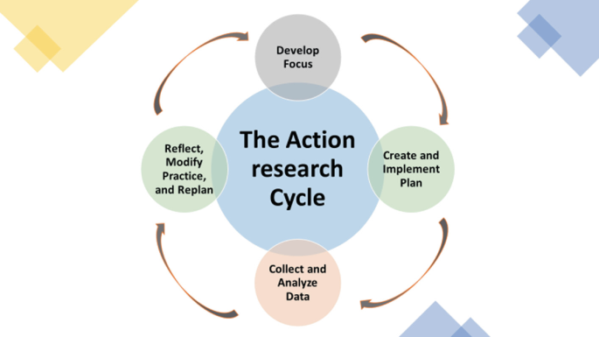

Figure 1: The Action Research Cycle (Laprise, 2017)

Methods
This project attempts to understand the viability of creating a BA (Hons) in Musical Theatre in Portugal. To achieve this, a strategy of inquiry needs to be fit for purpose (Cohen et al., 2011; Denscombe, 2003, p. 3) and for this project, it implied analyzing and understanding the individuals’ views of the world (Cohen et al., 2011). Taking this into consideration, it was essential to ask individuals about their thoughts and experiences (Cohen et al., 2011) to understand how students would feel to have the opportunity to take a higher education degree in Musical Theatre in Portugal and how performers/educators taught that could have an effect in the Portuguese industry. Considering that different people have different views of the world, this project lies within a constructivist domain in which reality is socially constructed and it is given meaning by people (Easterby - Smith, Thorpe and Jackson, 2008).

This was an action research approach which is a qualitative method that includes an interactive inquiry process that balances problem-solving actions implemented in a collaborative context with data-driven collaborative analysis or research to understand underlying causes enabling future predictions about personal and organizational change (Bradbury et al., 2001; Aarons et al., 2015; Riel et al. 2017).

To increase consistency of findings, triangulation was achieved through a literature review, use of an online questionnaire and two online focus group discussions (Gray, 2009).

Interpreting Data
When interpreting data, reflexivity and objectivity are very important, however, the insider researcher, as someone with a previously established, and consequentially greater, intimacy relationship with the group (Breen, 2007; Costley, 2010) does not need to apologize for such (Breen, 2007). It is because of that interest that the collected data can be treated with more care and consideration since the results will have a direct impact upon the group being studied and the researcher.

For this research initially I intended to interview four pedagogues that had been involved in the development of Musical Theatre Courses abroad. However, due to scheduling conflicts, I had to make some changes and do a survey instead (Appendix 4). Considering this, there was one questionnaire provided for the UK Musical Theatre pedagogues which was made available online using surveymonkey.com. I have chosen SurveyMonkey as it is a leading survey and feedback management solution platform around the globe and it enables millions of users across more than 300,000 organizations around the world to collect feedback, interpret the results, and identify actionable insights to drive growth and innovation (G2 Crowd, 2024). It is also the most popular survey software by Capterra customers (SurveyMonkey, 2024; Capterra, 2024).

The survey consisted of open questions that required extended response and investigated how the pedagogues organized and considered the musical theatre courses they developed.

For this project, I led two focus-groups discussion. A focus-group is a form of group interview that assents on communication between research participants to generate data (Denscombe, 2003; Kitzinger, 1995). This kind of group work generates diverse data collection for the researcher and can be very dynamic and useful when subjects are only available for a limited period (Berg, 2001; Kitzinger, 1995; Morgan, 1996). I was the mediator of the focus groups interfering as little as possible and allowing the participants to think and reflected about what they wanted to share and encouraging a spontaneous conversation, allowing every individual voice to be heard. (Gill et al., 2008; Kitzinger, 1995).

The discussions happened in an online format, using the Zoom platform for thirty minutes each. The use of this platform was a great option for me since all my participants lived far away from each other and this platform allows geographic independency, and it is highly efficient since the participants can all be in their own homes (Provoke Insights, 2020). There are also some disadvantages like the fact that participants can be distracted by other people around them however, I have also found from my experience in other online focus groups that participants at their own homes are more comfortable and it is possible to draw deeper insights for them. It also lowers costs as I did not have to rent a room to have the discussion in person. Regarding internet stability and technical difficulties, I am aware that it can be a disadvantage of this tool (Provoke Insights, 2020) however, this is something I did not experience in my focus-groups.

For the first focus group, the four students were selected by me and for the second focus group the four performers/educators also selected by me (Fern, 1982; Berg, 2001). My selection of participants was based on the fact that they were diverse, articulate, and engaged (Patankar et al. 2023). So, regarding the students, they were all between the ages of 19 and 25 years old with different backgrounds, the fact that they have already taken pre-professional training in Portugal, their different professional ambitions, and their intent to go to different countries to take a BA (Hons) in Musical Theatre. The performers/educators were between the ages of 24 and 30 and were chosen considering their different backgrounds, the fact that they currently teaching Musical Theatre at a pre-professional level and that they all took a BA (Hons) in Musical Theatre in different countries all over Europe. They will later be referred as Educator 1, Educator 2, Educator 3 and Educator 4. The transcriptions of the discussions were kept anonymous maintaining confidentiality.
Ethical Considerations
When taking this research, several ethical considerations were taken into place as described in the Ethics Form (Appendix 1). All the volunteers received a consent form prior to participating in the focus groups (Educators/ performers Appendix 2; Students – Appendix 3) and prior to answering the questionnaires (UK Pedagogues – Appendix 4). These documents detailed the aims of the project, with contact information through where they could ask any questions they had and guaranteeing that the information they provide would not be disclosed to anyone. All responses were anonymized in the questionnaires and confidentiality remained in the transcription of the focus groups discussion so participants cannot be identified (Bell, 2005).

Insider research has helped me to improve and create knowledge within my practice (Breen, 2007; Costley, 2010) which was very motivating for me. As a colleague of my fellow peers and a teacher of the students involved, I was aware that my position could influence their answers into saying what they believed I wanted to hear. The anonymous of the focus group transcripts helped combat this problem of the insider researcher. The focus groups were time limited and moderated by me.

Findings
For this project I did a survey and hosted two focus groups.

Survey
The survey was sent to four pedagogues who have developed Musical Theatre Courses in different countries. However, I could only obtain one answer. This result means that there will only be the opinions and views of one UK pedagogue on this topic which cannot reflect the views and opinions of this group of people but instead of a single individual.

Focus Group Composition
The first of focus group was composed by four students who are intending to go abroad to take a BA (Hons) in Musical Theatre. The participants were identified as Student 1, Student 2, Student 3 and Student 4. The second focus group was composed by four performers/educators who have taken a BA (Hons) in Musical Theatre abroad. The participants were identified as Educator 1, Educator 2, Educator 3 and Educator 4.

The focus groups were held in a Zoom meeting setting and full transcripts of the meeting are contained in the appendices.

Coding
With the focus groups I aimed to understand what kind of musical theatre degree could make the students want to study in Portugal and not abroad as well as understanding the impact that said degree could have in the Portuguese industry. The information was coded using In Vivo coding - using the direct language of the participants as the primary data source (Saldaña, 2016) – which can be found in appendices 5 and 6.

Quotations
Through the focus groups, the participants have mentioned very interesting points and some of those will be quoted on this discussion to bring content to life (White et al., 2014) and to prevent the (mis)use of catchy phrases (Eldth et al, 2020). In my choosing of quotes, it was vital that they are applied in a way that shows respect to participants and that they are presented in a reliable manner, including that they maintain participants’ confidentiality (Polit & Beck, 2016).

In my research quotes will be used to provide explanations, to elucidate processes and they will also be used to illustrate a need to describe how something has affected an informant in his or her own words (Corden and Sainsbury, 2006; Eldth et al, 2020). The quotes will provide explanations, and elucidate processes and informants’ perspectives as well as deepen the understanding by means of enrolling the informant’s voice (Eldth et al., 2020) The aim of introducing quotes is to aid communication, enhance readability and providing vividness to the text and serve as evidence since original data helps to serve the reader’s assessment of the accuracy of the analysis, thereby strengthening the findings (Corden and Sainsbury, 2006; Eldth, 2020).

Students’ Focus Group
Through the coding of the transcripts of the focus group discussion which can be found in appendix 5, three themes were revealed such as: Advantages and Disadvantages of having a BA (Hons) in Portugal, Type of Program, Teachers and Outcomes from the Course.

Advantages and Disadvantages of having a BA (Hons) in Portugal
Through the focus group the students identified both advantages and disadvantages of having a higher education degree in Musical Theatre in the country. The main advantage would be in terms of costs as the participants acknowledge that in “terms of money it could be very helpful” (S2).

Apart from this, they also considered that it could be an interesting option since “we have lots of musical theatre performers in Portugal and I think we could have lots of experiences from professionals that maybe a few years ago we couldn’t” (S1); “would be very good since we would not need to leave our country to study what we love” (S2); “having a Musical Theatre college here would be very valuable. When I was younger it took me a while to understand that I could make a living out of Musical Theatre. Especially because the industry here was not as developed as it is now.” (S3); “that kind of course here will promote the development of the industry and will improve what the actors and artists can offer the audiences.” (S3)

However, they also appointed some disadvantages that this kind of degree could bring “just because I don’t know if there would be enough people.” (S1) because there could not be “many people who would be interested. Because the industry is getting more developed in Portugal but at the same time, not that much and I think there would be many people that would think that abroad they would have a better experience than here.” (S4).
Another disadvantage was the fact that they would not “go abroad to have that experience” (S2) of studying in an international environment.

Type of Program
The type of program was also an important aspect for the students. They mentioned the importance of having a “balance between theory and practice”. (S1). Furthermore, mentioning the theoretical subjects such as “I think Musical Theatre History is very important” (S3) as they considered that “it is important to educate for musical theatre and for different repertoire. So that would be very important to explore and dive deeper into the musical theatre world.“ (S2) and practical subjects such as “subjects related to voice work and how we can use it effectively.” (S3) and “Acting Through Song, different dance styles, one-to-one singing lessons.” (S1).

Adding to the above mentioned, students recalled the importance of having workshops on “subjects like repertoire, technique, anatomy, vocal health” (S3) as well as workshops with “professionals that can teach us how to start our careers would be great” (S4).

Another important topic and the most mentioned aspect by the students was the importance of vocal health for the musical theatre performer and how they find it to be “super important, not only vocal technique and anatomy but how to really take care of our voice in a singing context but also in our daily lives.” (S1) as they believe in a “technical approach but also a health approach” (S1) that can “balance between vocal health and knowing our voice. We need to have solid technique and solid vocal health knowledge.” (S4).

Students also mentioned a very clear need and interest in exploring the different vocal styles within the musical theatre industry, as they considered they need to “understand how to approach the different styles and songs. It would be helpful to understand the different styles, differences, to see our difficulties and how to improve the voice in terms of styles matching the song we are working on.” (S3)
Acting Through Song was also a topic of interest as the students considered it to be “the heart of musical theatre.” (S2) as performers need “the acting side to be clear at all times since they should be able to always sustain their character.” (S3).

These were the most important aspects regarding a higher degree program in Musical Theatre in Portugal.

Teachers
In parallel, students also referred the importance of having appropriate teachers in a BA (Hons) in Musical Theatre in Portugal. To them, this means “to have people actively working in the industry teach in a BA (Hons).” (S1) and “who would be working not only here but also abroad so students could understand how the industry works here and that it is possible to make a living from musical theatre here in Portugal.” (S2).

Having teachers from abroad was a very significant aspect for students as they believed “having people form Broadway or West end, for example to give us guidance would be very beneficial for us and for the country itself.” (S4). They also considered Spain a country with a developing musical theatre industry so they mentioned that “Spain has lots of musicals and productions so it became a great option for me and that would be interesting to understand how it works. Having Spanish actors working with us would be very interesting.” (S2).

On the other end, students also expressed their concern regarding the fact that “there are so many actors that do not have a higher education degree so it would be weird to teach at a higher education level. There would have to be specific criteria to choose the teachers.” (S1). So, this is something to consider within a possible creation of a BA (Hons) in Musical Theatre in Portugal.

Outcomes from the Course
The students also referred the importance of having good tools when finishing a degree in musical theatre in Portugal.
The most important thing for them was to guarantee that they knew themselves and their skill set since that could make them understand the “correct auditions and castings. And that is hard to do but in classes we really need to try and find ourselves and what would show us better according to what we can do, and we are good at so that we are always ready for the auditions we go into.” (S1). They considered that knowing their place within the industry was “essential” (S4) as well as knowing the industry and being ready for rejection and “understand the reality of the industry that it is not perfect and that you won’t get the most amazing jobs after auditioning twice.” (S4).

Knowing how to have their material ready like “a good CV, good headshot, how to make our own showreel” (S2) was also an essential outcome to take from the course. As well as being able to “connect the three elements of musical theatre. A character does not change because they are singing or dancing and that seems simple, but it is super important.” (S3).

S1 also mentioned that developing their critical sense towards their own work and their peers’ work was a skill they found useful, and they believed that “it should be great to develop this in a higher degree level” (S1).

Educators’ Focus Group
Through the coding of the transcripts of the focus group discussion which can be found in appendix 6, seven themes were revealed such as: Studying in Portugal, Costs, Effects on the Portuguese Musical Theatre Industry, Organization of Program, Different Types of Programs, Investment in Portugal and Teachers.

Studying in Portugal
All the educators have a BA (Hons) in Musical Theatre and took their degree abroad. They mentioned how they would feel if there was an option to take the degree in Portugal and they all agreed that it would depend on how the course would be structured and what it had to offer, especially in terms of connections with the international musical theatre industry.
Educators also weighted the fact that it would depend on the individual goals as E2 mentioned “Personally, I have always known that I wanted to work in Portugal so, if I had the option I would have studied here because I would already be networking within the industry I wanted to get into.” and E3 added that they also “see myself working in Portugal so if there was a degree here, I would probably stay.”

On the other hand, E4 mentioned that they would for sure go abroad and study in London since even if there was an option in Portugal, “18-year-old me would not think that it would be as good as a London School. For me I really wanted to go and audition for London schools, work there, and get into that industry. As a kid I don’t think I really connected to the Portuguese culture, I wanted to find something different, and I was always felt more connected to the London culture.”
Taking each individual professional goals would be, according to the educators, the most important factor when choosing to study either in Portugal or abroad.

Costs
Regarding the costs of the course, educators mentioned the advantages that studying in Portugal could have for the students since they would not have to pay for housing or food supplies as most of them would still be able to live with their families and would only have to cover the costs of the degree itself.

Educators also mentioned that this type of degree would need governmental funding to make it accessible for the Portuguese students, especially “because there was already a trial for a higher degree in Musical Theatre here, but it was so expensive that no one could afford it.” (E2) do there “must be an investment by the government.” (E3).

Having funding by the government was considered an essential factor when creating a BA (Hons) in Musical Theatre in Portugal.

Effects on the Portuguese Musical Theatre Industry
Creating a BA (Hons) in Musical Theatre in Portugal would have an impact on the Musical Theatre of the country as the educators mentioned. It would be beneficial since they considered that there would be an increase of shows produced “that you could guarantee that there would be enough jobs for the people graduating.” (E2) and in addition to this they also considered that “there would also have to a raise in the quality of the shows and a bigger variety of shows to guarantee that more and new people would get into the industry.” (E2). They agreed that a degree with a performance focus could develop the Portuguese musical theatre industry further, as well as bringing “great recognition to Portugal” (E1).

Organization of the Program
Regarding the organization of the program, the educators agreed on similar subjects such as:

Figure 2: Possible disciplines of a BA (Hons) in Musical Theatre in Portugal

In addition to these, the also expressed the need of having vocal health incorporated into a higher degree since some of them did not have that when they were studying, and they feel that it is “super important” (E1) to take into consideration for their careers.

Different Types of Programs
Educators also considered that there could be different types of programs, depending on the aim of the course and on “what the students want.” (E1), namely:

Figure 3: Possible types of programs of a BA (Hons) in Musical Theatre in Portugal

According to them, degrees within the performing arts fields are very creative/devising focus, which can be a good thing an “give the students the tools to create their own shows and expand the industry.” (E4).

However, they also consider that it is important to have a clear focus on the performing aspect of Musical Theatre to make a shift on the way this form of art is perceived and performed because “since Portugal does not have a very clear idea of what is musical theatre and has developed their own genre within the genre.” (E2), the Portuguese industry is not on the same level of development of other countries across the world. So, unless the degree is only focused on the Portuguese Musical Theatre Industry, it also needs to “educate for the international industry.” (E3) to give prospectives students the chance to aim and have tools to navigate around it.

Investment in Portugal
Investment in Portugal was a theme that all educators brought up and they It was agreed that having a higher degree level in Musical Theatre could bring great investment to the country itself as it could bring international students that would “live and get to know Portugal and the country could benefit for it.” (E1).

The degree could eventually be internationalized and having more international students could lead to them watching shows in Portugal and consequently, the audiences would grow as well, which would bring more investment in the country and specifically in the Portuguese culture.

Teachers
When considering possible teachers for the degree, the educators mentioned the importance for students to contact with international staff and get work with different teachers through their journey, which would mean for example “having international choreographers and directors to work with the students” (E1).

It was also pointed the importance of allowing students to work with different teachers through their training and this would include switching one-to-one singing teachers which E3 considered to be “super useful and beneficial so that students can gather different tools through their training.”

UK Musical Theatre Pedagogues - Surveys
In addition to the focus groups, I have also developed a survey that was sent to four UK Musical Theatre Pedagogues and can be seen in appendix 4. The survey included seven questions regarding the organization and important aspects to consider when developing a course in Musical Theatre. From these surveys, I could only gather the answers from one of the pedagogues since the others have not completed the questionnaire during the time of this study. In this survey, it was seen that, according to the UK Pedagogue, the key aspects to take into consideration when developing a Musical Theatre course included the contact hours the students would get, the market into which the students would eventually enter, introducing the students to the industry, guaranteeing that the course can have Spotlight accreditation (this is a casting platform in which the students can hots their CVs and materials) and guaranteeing one-to-one sessions with the students and their singing teachers.

Regarding subjects, it was mentioned the importance of the following skill set training:

Figure 4: Indispensable subjects in a BA (Hons) in Musical Theatre

These matters are very similar to the ones I studied when I was taking my BA (Hons) in Musical Theatre and are also common to several leading drama schools across Europe (IAB, 2024; Artsed, 2024; GSA, 2024). These also go in concordance to what the educators and students mentioned.

The UK Pedagogue also mentioned the importance of leading the training according to what would be achievable in the timeframe of the course:
“I think you need to know what your training does and connect this to what level the student needs to be at to begin. Or the reverse, if you know your market is small, how far can you get that group in the time. What is achievable.”

Taking into consideration the level that the students are accepted into a degree and the aim for them to be industry-ready is very important when considering the creation of a BA(Hons) in Musical Theatre. In addition to this, there is also bureaucratic steps that need to be taken care of which, according to the UK Pedagogue, include consultation with industry partners, testing concepts, writing and rewriting of curriculum, external scrutiny and cost analysis. This last aspect was very important since the pedagogue did not have direct funding for their program, the only existing income comes from the students’ fees and of the ticket sales from the shows presented at their college. It was also mentioned that sometimes there are scholarships and bursaries that are directly offered to the students, and these come from institutions like the Andrew Lloyd Webber Foundation.

For unbiased recruitment, this pedagogue chose the staff for their course using a platforms of Conservatoire systems with widest reach, which does not exist an equivalent in Portugal, so this type of process would be very difficult to achieve.
Regarding the advantages for performers to have a higher education within the musical theatre industry, the UK Pedagogue mentioned that it would allow them to have industry introduction as well as “rigorous, vocational full-time training”, something that does not exist in Portugal but could be implemented with the creation of a BA (Hons in Musical Theatre.

Analysis and discussion
Before starting my analysis, I have to mention that I acknowledge that qualitative analysis is iterative and subjective to some extent (Srivastava et al., 2009) and I understand the importance of maintaining transparency and be reflective about my own biases and assumptions through this analysis.

Considering this, it is important to mention that prior to this research, through my years as a musical theatre singing teacher and performer, I had already understood that theatre was a big need and want for the creation of a BA (Hons) in Musical Theatre. This is something I had observed with my peers and my students.

Overall, the feedback I received from my focus groups is in concordance with the survey by the UK pedagogues as well as most aspects of my literature review and with my previous assumption regarding the need and want for a BA (Hons) in Musical Theatre in Portugal.

Firstly, it is undeniable the importance that a Musical Theatre degree could have to the Portuguese industry and performers S2 mentioned the fact that it “would be very good since we would not need to leave our country to study what we love” and this kind of degree could help legitimate Musical Theatre as a career and make students want to pursue it more because, as S3 mentioned “When I was younger it took me a while to understand that I could make a living out of Musical Theatre. Especially because the industry here was not as developed as it is now.” This aspect is very important as mentioned in the literature review, there is a lack of knowledge about this genre in Portugal, which contributes to the discreditation of this art form and a degree in the area could help legitimate that (Alcobia, 2014; Araújo, 2016).

Considering the Portuguese industry, the educators considered that a musical theatre degree could have a great impact on it, since, according to E2 “you would have to have lots more shows so that you could guarantee that there would be enough jobs for the people graduating. There would also have to a raise in the quality of the shows and a bigger variety of shows to guarantee that more and new people would get into the industry” however, E4 disagreed and mentioned “I don’t necessarily think that the BA would create more investment in the Portuguese culture, and I am not sure of how that could equal to more projects”. But then, E2 made a point that “since Portugal does not have a very clear idea of what is musical theatre and has developed their own genre within the genre and our degrees here are about the creative side of the art not about the performance aspect of it. The mentioned above data goes in concordance with my literature review, since, Portuguese creators have developed their own way of producing musicals which is not all similar to what is done in other countries (Araújo, 2016) and this comes from a place of not knowing what is expected of them in this genre and what they are in fact supposed to do (Araújo, 2016; Carrilho, 2011).

Taking the above mentioned into consideration, having a degree with performance focus would have to automatically make that shift” and this is really according to my literature review since it mentions that in Portugal the original shows are either aimed at children or the there are some pieces of music theatre that are original work, resulting in original text and lyrics in Portuguese, but these end up by being more of a cycle of songs or a sequence of musical scenes, instead of a musical itself (Araújo, 2016; Carrilho, 2011). In fact, literature also mentions that the fact that there is not a higher degree in Musical Theatre can explain this, especially when it comes to music composition, since composers will not have specific musical theatre composing training available like English or American composers do (Araújo, 2016). The creation of a BA (Hons) in Musical Theatre could support them in gaining the necessary skill set to produce work at the level of what is done in other countries.

Considering costs, it is important to mention that the cost of studying musical theatre in Europe can currently range from 10.000 euros – 28.000 euros per year and this only includes the training itself, the rest of the material as well as housing and food costs are extra (IAB, 2024; Bird College, 2024, Artsed, 2024, GSA, 2024). So this was a very important factor and advantage for students as they considered that studying in Portugal and not abroad “in terms of money it could be very helpful” (S2) “and going abroad is a bigger logistic than if we had a course here” (S4). This is something that the educators also mentioned “In terms of costs, it would be more beneficial for us, because we would only have to pay for the course and not the rest of the costs of living abroad.” (E1) E2 mentioned “For me it’s similar because the costs would be reduced but international elements like international teachers and that could increase the cost of the course.” These perspectives corroborate with literature since participants of a study in Universidade de Aveiro in 2016, have also mentioned that reduced costs was also a great advantage about having a degree in Portugal instead of having to go abroad to study.

All the educators considered a very important aspect regarding funding, the Portuguese government had to make an investment and pay for a part of a BA (Hons) in Musical Theatre, so students could afford it because, according to E2, “there would have to be a big support from the government to have this kind of degree here. Because there was already a trial for a higher degree in Musical Theatre here, but it was so expensive that no one could afford it”. This is also something that the UK Pedagogue mentioned that for their college there are “scholarships and bursaries for students from places like Andrew Lloyd Webber foundation but these go direct to student.” So, this is not a government sponsorship, just a financial aid for the students themselves, since the college’s “only income is student fees and tiny ticket sales (that doesn't cover cost of show so loss).”

However, some students also mentioned some disadvantages regarding studying in Portugal, being the main one the fact that they would not “go abroad to have that experience” of studying in an international environment (S2). Some of the educators also agreed with this, according to E4 “for me, even if there was an option here, 18-year-old me would not think that it would be as good as a London School. For me I really wanted to go and audition for London schools, work there, and get into that industry” and E1 said “the experience of living abroad with people from all over the world is something I would not trade at all”. Getting to study abroad is a very enriching experience, since it allows students not only to study what they love but also see the world, contact with other cultures, get new language skills, find new career opportunities, find new interests, make new friends, grow personally, and get more life experience (International Student, n.d). For some people this is a very important aspect to take into consideration when choosing where to study.

On the other hand, other educators mentioned that depending on the course offer and its connections to the industry, they would “have stayed in Portugal and maybe later try and go abroad for a MA, I believe I would have probably done a BA in Portugal and then go abroad.” (E1) and E3 added “I also see myself working in Portugal so if there was a degree here, I would probably stay. It would really depend on the course and the way it was organized.” E2 also mentioned their career aims “personally, I have always known that I wanted to work in Portugal so, if I had the option I would have studied here because I would already be networking within the industry I wanted to get into” Another important aspect that students mentioned was that they did not know “if there would be enough people.” (S1) “Because the industry is getting more developed in Portugal but at the same time, not that much and I think there would be many people that would think that abroad they would have a better experience than here.” (S4).
However, a 2016 study conducted in Universiade de Aveiro revealed that all of the participants considered the creation of a BA(Hons) in Musical Theatre to be essential to the development of the genre in Portugal and it also revealed that there were lots of interested students in taking this course (Araújo, 2016). Apart from this, from my own experience as a musical theatre singing teacher, I can say that every year, in a school with about 100 students, there’s an average of 40 students who audition for drama schools all over the Europe (EDSAE, 2024), so there would be enough people interested in this type of degree to make it sustainable every year.

Regarding organization and type of program, the students mentioned the importance of having a “balance between theory and practice” (S1) and they especially mentioned the importance of having Musical Theatre History classes (S3), and “solid theoretical foundation because there is still a lot of missed information here. It is important to educate for musical theatre and for different repertoire. So that would be very important to explore and dive deeper into the musical theatre world” (S2). This goes in concordance with the UK pedagogue that considers contextual studies to a be an essential subject for a higher education degree. They also added the importance of having different styles of dance and the “importance of having subjects related to voice work and how to use it effectively” (S3). This was corroborated by educators who mentioned the importance of “getting to know our voice and our vocal health” (E4); “Yes, vocal health is super important. We had that on my degree, and it was super useful to have a good foundation of voice work.” (E1).
In addition to this, as mentioned in the findings, both students and educators mentioned the same subjects as the ones they felt were essential for a BA (Hons) in musical theatre, which included:
- Acting Through Song
- Repertoire
- Vocal Technique and anatomy
- Vocal Styles
- Acting
- Voice and Dialects
- One-to-one singing lessons
- Different Dance Styles (Tap, Ballet, Jazz)

This goes in concordance to what is practiced in other leading drama schools all over Europe (IAB, 2024; GSA, 2024; Bird College, 2024; Artsed, 2024) and it is corroborated by the UK Musical Theatre pedagogue that also mentions the necessity of having dance disciplines, Voice (spoken and sung), One to one singing and Rep. It was also added the importance of having industry preparation subjects that included artistic development, audition technique, business management and making work (ensemble devising/writing). These aspects were also mentioned by the students that considered they had to “know ourselves and know what we can do. So, we can turn to the correct auditions and castings that fit us” (S1); “We also need to know what the industry is. And be ready to get the No’s and understand the reality of the industry” (S4). These aspects are related to audition technique classes and artistic development classes, which are of extreme importance to students entering the musical theatre industry (Flom, 2016).

Also “being ready for auditions with our personal materials, like a repertoire, a good CV, good headshot, how to make our own showreel.” (S2) is related to the artistic development and audition technique subjects mentioned by the UK pedagogue and literature also mentions the importance of having appropriate repertoire material to get into each audition (Freeman et al., 2015; Flom, 2016).
S1 also mentioned the importance of developing “critical sense. I can now observe my peers and observe myself and see what went well and what didn’t and that is very important to me. It should be great to develop this in a higher degree level.” and this is also a part of the artistic development subject.

As the UK pedagogue mentioned, making work with devising and writing is of a biger importance and this aspect was also sustained by the Portuguese educators that mentioned “if we have a degree with a focus on the musical theatre creative it could give the students the tools to create their own shows and expand the industry.” (E4); “I also think that having a good creative side to the degree is important.” (E3). In the previously referred study led by Universidade de Aveiro participants also mention the importance of capacitating performers to create their own work within a musical theatre context (Araújo, 2016).

Regarding teachers, the students mentioned the importance of having teachers that are actively working in the musical theatre industry both in Portugal, but also abroad in places like New York City, London or Spain. S1 mentioned “that it is super important to have people actively working in the industry teach in a BA (Hons).” And S2 added “it would be very important to bring people of the industry and who would be working not only here but also abroad so students could understand how the industry works here and that it is possible to make a living from musical theatre here in Portugal.”; “having people from Broadway or West end, for example to give us guidance would be very beneficial for us” (S4); “Having Spanish actors working with us would be very interesting.” (S2). The educators also acknowledged the importance of “having international choreographers and directors to work with the students” (E1). They also took into consideration the importance of working with different teachers through their training journey, “getting work with different teachers is super useful and beneficial so that students can gather different tools through their training.” (E3)
In terms of potential Portuguese teachers, S1 had a very interesting point “in terms of teachers, I am not sure…there are so many actors that do not have a higher education degree so it would be weird to teach at a higher education level. There would have to be specific criteria to choose the teachers. But I think there could be moments with professionals of the industry when the students could have that kind of contact.” This connects with literature review that says that Portugal being a country with very recent and very little musical theatre culture, the pedagogues teaching in higher education settings, do not have specific training to teach this genre, and this is proved by actors and singers who must learn the core subjects of Music, Dance and Theatre separately (Araújo, 2016). According to the UK pedagogue’s survey, the process of teachers’ recruitment happened via Conservatoire systems, for unbiased recruitment with widest reach however, in Portugal we do not have this type of system, so recruitment in Portugal would have to be based on the teachers’ skills and eventual higher degree education within Musical Theatre (DGAE, 2024).

Regarding the key aspects to take into consideration, when developing a course in musical theatre, the UK pedagogue mentioned the following:
- Market
- Contact hours
- Level of 1-1s
- Spotlight accreditation
- Industry introduction
- Depends on the type of graduate trained.

These were combined with the organization of the course to guarantee the students would be industry ready by the time they finished, included one year of development, consultation with industry partners, testing concepts, writing and rewriting of curricular, external scrutiny and cost analysis. This analytical and developing process must be taken into consideration, regarding the creation of a Musical Theatre degree in Portugal as there would have to be constant adjustments made to it.

Reflections and Conclusions
By using Gibbs’ reflective cycle, I have taken into consideration my participants opinions and after careful analysis, I have concluded that the most appropriate action plan regarding the creation of a BA (Hons) in Musical Theatre in Portugal is to consider the following four topics (Gibbs, 1988):
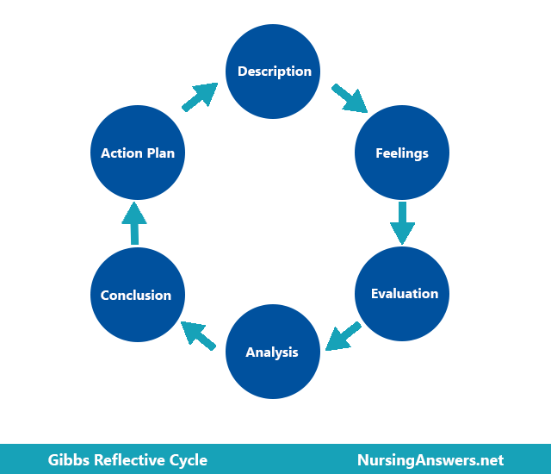

Figure 5: Gibbs’ reflective cycle (1988)

- Advantages of creating a BA (Hons) in Musical Theatre in Portugal
- Subjects to include in the degree
- Teachers
- Costs

Advantages
All the participants in both focus groups mentioned that they found that a musical theatre degree in Portugal would be very helpful to the development of this genre in the country. The students all mentioned that the biggest advantage for them would be the fact that they could stay in their country, close to their friends and family while studying what they loved. For them, having this degree located in Portugal was important, especially because some of them intended to work in in the country and this would allow them to have a direct contact with the Portuguese Musical Theatre industry. It also mentioned by all the participants this type of degree would help legitimate Musical Theatre as a possible career for future generations. The educators also mentioned that having this degree, would have a great impact on the Portuguese industry as there would have to be more shows so that there could be a guarantee of jobs for the graduating students and validate the importance of the degree. E2 also mentioned a very important advantage which includes the fact that having a Musical Theatre degree with a performance focus would shift the way Musical Theatre is perceived and understood in Portugal. Personally, I had not thought about this last point and the impact that a higher education course could potentially have in the conception of shows and their development and creation. It was also mentioned that having higher degree level training is of extreme importance for performers, as the UK pedagogue referred, so they can have a “Rigorous, vocational, full-time training and industry introduction.”

Subjects
Regarding subjects, all the participants agreed with that on the same topics to be necessary to create a structured BA (Hons) in Musical Theatre:
- Acting Through Song
- Repertoire
- Vocal Technique and anatomy
- Vocal Styles
- Acting
- Voice and Dialects
- One-to-one singing lessons
- Different Dance Styles (Tap, Ballet, Jazz)
- Artistic Development
- Audition Technique
- Contextual Studies
- Business Management
- Making Work (ensemble devising/writing)

These subjects are very similar to the ones existing in other programs at leading drama schools all over Europe (IAB, 2024; Artsed, 2024; GSA, 2024; Bird College, 2024) and they were all considered by me beforehand. However, I was not expecting that in the students’ focus group discussion all of them mentioned how important they found to have a very solid theoretical foundation, especially mentioning Vocal anatomy, vocal health and mostly Musical Theatre History (that falls into the subject of contextual studies). From my experience, this is not very common as students within performing settings tend to prioritize all the practical subjects over the theoretical ones so, this was a pleasant aspect to observe as for me, a good theoretical knowledge is essential for a performer.

Teachers
In terms of teachers, it was common for students to refer the importance of having teacher who were actively working within the Musical Theatre industry, whether that was in Portugal or abroad like London, New York, or Spain. They considered this aspect to be important so that it could motivate aspiring performers to understand that “it is possible to make a living from musical theatre here in Portugal.” (S2). Regarding language barriers, in Portugal all students have English as a mandatory subject since first grade so they can also speak and understand the language at a good level (DGE, 2024). In addition to this, Portugal is one of the few countries in Europe in which series and movies are not dubbed but subtitled so, people tend to have a great amount of contact with the language not only when they are studying but also in their daily lives (Martins, 2018).

Having international staff to work with the students was also mentioned by the educators as well as the importance of working with different teachers through the degree. Personally, I was surprised by the fact that the students mentioned that it could be interesting to have Spanish teachers working with them. Even though there are several productions, Spain is not always a place taken into consideration when thinking about musical theatre, but the students mentioned that since it is very close to Portugal, it is an industry that was very appealing to them.
It was also referred the importance of a meticulous recruitment process when it comes to choosing Portuguese teachers, especially because there are not many people with higher education degrees in Musical Theatre so, there would have to be a thorough analysis to choose the most appropriate staff.

Costs
Studying Musical Theatre is very expensive as it not only includes the fees of a higher degree course but also the material needed for the different subjects and the performers’ materials such as headshots and printed CVs. Taking this into consideration, all the students mentioned that studying in Portugal would consider a reduction on the costs as students would only have to pay for the fees and materials but not housing expenses, which are also very high when studying abroad.

Apart from this, all the educators had a very important point that I had not thought about during this study. They all mentioned that for this type of degree to be a possibility for Portuguese students to afford, there would have to be governmental financial support. E2 also mentioned that there was already, a few years ago, an attempt to create a BA (Hons) in Musical Theatre in a private institution, but the costs were so high that it never happened. In the UK, there are scholarships offered directly to students, so, this could also be a possibility, to have specific programs that could offer loans to the students to help with financial questions. Regarding international students, in Portuguese universities, there is always an increasing in fees for non-Portuguese students (ISCTE, 2024; ESMAE, 2024; ESTC, 2024) so, this would probably be the case with a BA program in Musical Theatre. The fact that I have also established connections with UK pedagogues during the project that I hope to keep in touch with, could mean possible partnerships in the future to mitigate this situation.

Limitations, Recommendations, and Impact
For my research, the focus groups were delivered on Zoom, which had its advantages already mentioned above but it also meant that opportunities for free-flowing group dialogue were reduced. However, as the mediator, I was aware of this and would read body language to tell if someone had something to say, steering the discussion to ensure everyone’s voice was heard. Furthermore, the participants are used to use the platform to take online lessons so, being in a virtual environment was not as impactful as it would have been if this was not the case. In addition to this, having only four participants in each focus group and only one UK pedagogue answering the survey can be considered a limitation as well, therefore future research could include more participants since more group data with similar outcomes would increase the research validity.

I believe that this study has showed an increase of interest in the field of Musical Theatre in Portugal as well as the advantages of having a BA (Hons) in Musical Theatre in Portugal, for students, for educators and for performers. So, a further study could lead to the creation of a BA program, eventually make connections with international institutions, and develop the Portuguese Musical Theatre market even more.

Final Conclusions
From the beginning of my project, I knew that I was setting myself for a challenge: Understanding the viability of creating a BA (hons) in Musical Theatre in Portugal, taking into consideration the lack of evidence regarding this topic. This felt like a frustrating experience at times. I also experienced nerves and periods of self-doubt, considering that I was going to discuss this project with my students, my peers and international pedagogues.

Nonetheless, my passion for this subject encouraged me to keep going. Through the discussions with my peers and students, I felt very confident and reassured with my project and I feel that my conversations with all my participants have been a fertile source of rich data, but it has made it difficult to decide where to draw the line on my analysis. The advice given to me has given me the determination and courage to continue with my study and keep developing it in the future.

Looking back at the aims and objectives I outlined at the start of this project, I feel I have achieved what I set out to do:
- I have a clearer understanding of the Musical Theatre industry’s demands in Portugal and abroad.
- I comprehend the importance of having financial aid to help the students support the costs of the course.
- I have ascertained advantages for students of studying in their own country versus abroad.
- I have listened to the perspectives and views of a group of experienced educators and industry professionals as well as students, and I have learned a lot from them.
- I have established connections with UK pedagogues.

With the support and encouragement of my students and my peers, I feel confident to keep developing this project and eventually create a BA (Hons) in Musical Theatre in my home country.

REFERENCES
10 benefits to studying abroad: Study Abroad Guide (no date) International Student. Available at: https://www.internationalstudent.com/study-abroad/guide/ten-benefits-to-studying-abroad/ (Accessed: 01 February 2024).
Aarons, G.A., Ehrhart, M.G., Farahnak, L.R. et al. Leadership and organizational change for implementation (LOCI): a randomized mixed method pilot study of a leadership and organization development intervention for evidence-based practice implementation. Implementation Sci 10, 11 (2015).
AC Produções (2023) AC Produções. Available at: https://en.acprod.pt/ (Accessed: 30 July 2023).
Anon, How to know your casting type. Spotlight. Available at: https://www.spotlight.com/news-and-advice/tips-and-advice/know-your-casting-type/ (Accessed 15 February 2024).
Amadeo, D., 2021, How to pick audition songs for Musical Theater - Backstage. Available at: https://www.backstage.com/magazine/article/pick-song-material-musical-theater-auditions-4203/ (Accessed 13 December 2023).
Anon, Actor types: A complete guide | backstage. Available at: https://www.backstage.com/magazine/article/find-type-actor-3730/ (Accessed 13 December 2023).
Agenda: Teatro da Trindade Inatel (2023) Teatro da Trindade. Available at: https://teatrotrindade.inatel.pt/programacao/ (Accessed: 10 February 2024).
Aguiar, M.C.P. (2007) O Ensino de Canto em Portugal: uma perspetiva analítico-reflexiva a partir de meados do Século XX. Available at: https://ria.ua.pt/bitstream/10773/1138/1/2008001232.pdf (Accessed: 20 December 2023).
Alcobia, I.. (2014). Obras para voz e piano de Frederico de Freitas – A Vocalidade entre fado e canção. Tese de Doutoramento. Aveiro: Universidade de Aveiro.
AM live (2023) AM Experience Group. Available at: https://amexperiencegroup.com/ecossistema/am-live (Accessed: 28 February 2024).
Araújo, D.S. (2016) O (TEATRO) MUSICAL EM PORTUGAL: PROCESSO DE CRIAÇÃO DE UM ESPETÁCULO, Repositório Universidade de Aveiro. Available at:https://ria.ua.pt/bitstream/10773/21179/1/Relat%c3%b3rio%20de%20Projeto.pdf (Accessed: 20 December 2023).
BA (Hons) in Professional Dance and Musical Theatre (2024) Bird College. Available at: https://birdcollege.co.uk/he-fe/full-time-courses/ba-hons-in-professional-dance-and-musical-theatre/ (Accessed: 01 February 2024).
BA (hons) musical theatre (2024) ArtsEd. Available at: https://artsed.co.uk/course/undergraduate/undergraduate-musical-theatre/ (Accessed: 01 February 2024).
Barbour, R., 2014. Introducing qualitative research: a student's guide. Sage.
Bell, J. (2005) Doing Your Research Project: A Guide for First-Time Researchers in Education and Social Science. Milton Keynes, Gran Bretaña: Open University Press.
Best bachelor degrees & programs 2024- over bachelors degrees globally (no date) https://www.bachelorstudies.com. Available at: https://www.bachelorstudies.com/ (Accessed: 10 February 2024).
Best survey software in 2022: Compare reviews on 380+ (no date) | G2. Available at: https://www.g2.com/categories/survey (Accessed: 08 January 2024).
Best survey software 2024 (2024) Capterra. Available at: https://www.capterra.com/survey-software/#infographic (Accessed: 28 January 2024).
Bosseur, D.; Bosseur, J., (1990), Revoluções Musicais - A Música Contemporânea depois de 1945, Lisboa, Editorial Caminho, AS.
Bradbury, H. and Reason, P. (2001) The sage handbook of action research: Participative inquiry and practice. Los Angeles: Sage.
Breen, L. (2007). The Researcher in the Middle: Negotiating the insider/outsider Dichotomy. ECU Publications. 19.
Cain, T. (2008) The characteristics of action research in music education, British Journal of Music Education, Vol. 25 No. 3, pp.283-313, Cambridge University Press.
CAIXA DE CENA (2023) Facebook. Available at: https://www.facebook.com/caixadecenaproducoes/ (Accessed: 28 February 2024).
Calhoun, E. F. (1994). How to use action research in the self-renewing school.
Alexandria, VA: ASCD.

Carrilho, P.. (2011). O musical em Lisboa (2000/2010). Dissertação de Mestrado. Évora: Universidade de Évora.

Carol C. and Paul G. (2006) Researching Others: Care as an Ethic for Practitioner Researchers, Studies in Higher Education, 31:1, 89-98.
Carrilho, P. (2014) Teatro Musical: Uma Breve Exposição. Lisboa: Chiado.
Carrilho, P. (2016) Teatro Musical: Uma Breve Exposição – Volume 2. Lisboa: Chiado.
Charmaz K. (2006). Constructing grounded theory: A practical guide through qualitative analysis. Thousand Oaks, CA: Sage.
Cohen, L; Manion, L. and Morrison, K. (2011). Research Methods in Education. London.
Cohen, L., Manion, L. and Morrison, K. (2018) Research Methods in Education. Abingdon: Routledge.
Contracanto Associação cultural: Lapa do lobo (2023) Facebook. Available at: https://www.facebook.com/contracantoAC/ (Accessed: 10 February 2024).

Corden, A., & Sainsbury, R. (2006). Exploring “quality”: Research participants’ perspectives on verbatim quotations. International Journal of Social Research Methodology,9(2),97–110.
Costley, C, Elliott, G and Gibbs, P (2010) Doing Work Based Research: Approaches to Enquiry for Insider-Researchers, Sage Publishing.
Curso de Teatro Musical (2018) AMVP. Available at: https://www.amvp.pt/curso-de-teatro-musical/ (Accessed: 30 July 2023).
Denzin N. K., Lincoln Y. S. (2000). Introduction: The discipline and practice of qualitative research. In Denzin N., Lincoln Y. (Eds.), The SAGE handbook of qualitative research. Thousand Oaks, CA: Sage.
Denscombe, M (2003) The Good Research Guide for small scale social research projects Open University Press, Berkshire.
DGAE – Recrutamento (2024). Available at: https://www.dgae.medu.pt/recrutamento (Accessed: 01 February 2024).
Easterby-Smith, M., Jackson, P.R. and Thorpe, R. (2011) Management Research. Los Angeles: Sage.
Easterby, S.M., Thorpe, R., Jackson, P., & Lowe, A. (2008) Management Research 3rd Edn London: Sage.
EDSAE (2024) Edsae. Available at: https://www.edsae-escola.com/ (Accessed: 10 February 2024).
Eldh, Ann & Arestedt, Liselott & Berterö, Carina. (2020). Quotations in Qualitative Studies: Reflections on Constituents, Custom, and Purpose. The International Journal of Qualitative Methods. 19.
Escola de Teatro Musical (2024) STAGEDOOR. Available at: https://www.stagedoor.pt/ (Accessed: 09 February 2024).
Espetáculos em Cena (2023) Filipe La Féria. Available at: https://filipelaferia.pt/ (Accessed: 09 February 2024).
EVENTOS (2024) Agenda Cultural de Lisboa. Available at: https://www.agendalx.pt/?archive=agenda&s=&type=event (Accessed: 28 February 2024).
Fern, E.F. (1982) The use of focus groups for idea generation: The effects of groups size, acquaintanceship, and moderator on response quantity and quality, Journal of Marketing Research, Vol. 19 No. 1, Sage Journals.
Flom, J., 2013. Act like it's your business branding and marketing strategies for actors, Lanham, MD: Scarecrow Press.
Flom, J., 2016. Get the Callback: The Art of Auditioning for Musical Theatre. 1st ed. London: Rowan & Littlefield.
Força de Produção (2023). Available at: https://www.fproducao.pt/ (Accessed: 30 July 2023).
Freeman, W., Green, K. and Sargent, P. (2015) 'Deciphering vocal demands for today's broadway leading ladies', Journal of Singing, 71(4), 491+, available: https://link.gale.com/apps/doc/A405989977/AONE?u=anon~d6b08433&sid=googleScholar&xid=9a9fdff2 (accessed 08 Feb 2024].
Gill, P et al., 2008. Methods of data collection in qualitative research: interviews and focus groups. British Dental Journal, 204(6), pp.291–295.
Gorgal, A. (2024) Propinas, Taxas E Emolumentos, Escola Superior de Música e Artes do Espetáculo. Available at: https://www.esmae.ipp.pt/comunidade/intranet/propinas-taxas (Accessed: 02 February 2024).
Guba, E.G. and Lincoln, Y.S. (1994) Competing Paradigms in Qualitative Research (in N.K. Denzin and Y.S. Lincoln Handbook of Qualitative Research, Thousand Oaks, Sage).
Gray, D. (2009). Doing Research in the Real World.
GROWUP PRODUÇÕES (2023) Facebook. Available at: https://www.facebook.com/growupproducoes.pt/ (Accessed: 09 February 2024).
Inglês (2024) Início. Available at: https://www.dge.mec.pt/ingles (Accessed: 02 February 2024).
Hine, G.S., 2013. The importance of action research in teacher education programs, Issues in Educational Research, Vol. 23 No. 2, Special Issue: Teaching and learning in higher education: Western Australia's TL Forum.
ISCTE (2024) Estatuto do estudante internacional - iscte – instituto ... Available at: https://www.iscte-iul.pt/conteudos/internacional/estudante-internacional/guia-para-licenciaturas/976/estatuto-estudante-internacional (Accessed: 02 February 2024).
Jones, K.M., 2017. Finding new repertoire. Musical Theatre Resources. Available at: https://musicaltheatreresources.com/2015/12/05/finding-new-repertoire-tip1-know-your-broadway-doppelgangers/ (Accessed 17 February 2024).
Jones, K.M, n.d. The Four Main Types of Singing On Broadway Today. (online)Musical Theatre Resources. Available at: https://musicaltheatreresources.com/2015/11/28/the-four-main-types-of-singing-on-broadway-today/ (Accessed 10 February 2024].
Kawulich, B. (2012) Selecting a research approach: Paradigm, methodology and methods, Doing social research: A global context, Vol. 5 No. 1, pp.51-61.
Kemmis, S., McTaggart, R. (1988) The action research planner: Doing critical participatory action research, Springer Science & Business Media.
Kieser, A. and Leiner, L. (2009). ‘Why the rigour–relevance gap in management research is unbridgeable’. Journal of Management Studies, 46, 516–33.
Kitzinger, J. (1995) Introducing Focus Groups, BMJ: British Medical Journal, Vol. 311(7000), pp.299– 302.
Laprise, R. (2017) Empowering the Music Educator through Action Research, Music Educators Journal, Vol. 104 No. 1, pp.28-33, Sage Journals.
Larson, S. (2014). "LET'S ROCK: IN DEFENSE OF JUKEBOX MUSICALS". The New Yorker.
Lengel, K. (2016) The 5 best jukebox musicals (and 5 that flopped), The Arizona Republic. Available at: https://eu.azcentral.com/story/entertainment/arts/2016/12/02/jukebox-musicals-best-flops/94755610/ (Accessed: 28 February 2024).
Mackenzie, N. & Knipe, S. (2006). Research dilemmas: paradigms, methods and methodology. Issues In Educational Research, 16, 1-15.
Martins, J.B. (2018) ‘Porque é que em Portugal temos o hábito de legendar (e não dobrar) os filmes e as séries?’, Cineblog, 24 January. Available at: https://cineblog.blogs.sapo.pt/porque-e-que-em-portugal-temos-o-habito-1010131 (Accessed: 02 February 2024).
Mercer, Justine (2007) The Challenges of Insider Research in Educational Institutions: Wielding a Double-edged Sword and Resolving Delicate Dilemmas, Oxford Review of Education; February 2007, Vol. 33 Issue 1, Taylor and Francis Ltd.
Merriam, Sharan. B (1995) What Can You Tell From An N of 1?: Issues of Validity and Reliability in Qualitative Research (PAACE Journal).
Morgan, D.L., 1996. Focus Groups. Annual review of sociology, 22(1), pp.129–152. Morris, R. and Hutchison, L. (2017) If in Doubt, Breathe Out!: Breathing and Support for Singing Based on the Accent Method, Compton Publishing.
Morgan, D.L. (2007) ‘Paradigms lost and Pragmatism regained’, Journal of Mixed Methods Research, 1(1), pp. 48–76.
MUSICAL THEATRE (no date) GSA. Available at: https://gsauk.org/ (Accessed: 01 February 2024).
Patankar, J.J. et al. (2023) How can you select the best Focus Group participants?, How to Select the Best Focus Group Participants. Available at: https://www.linkedin.com/advice/0/how-can-you-select-best-focus-group-participants (Accessed: 10 February 2024).
Pieters, J., Voogt, J. & Pareja Roblin, N., 2019. Collaborative Curriculum Design for Sustainable Innovation and Teacher Learning 1st ed. 2019.
Polit, D., & Beck, C. (2016). Nursing research: Generating and asses-sing evidence for nursing practice (10th ed.). Wolters Kluwer.
Propinas e Emulomentos (2024) Início. Available at: https://www.estc.ipl.pt/propinas-emolumentos (Accessed: 03 February 2024).
Performing arts degrees & programmes (2024) Institute of the Arts Barcelona. Available at: https://www.iabarcelona.com/ (Accessed: 01 February 2024).
Reason, P. and Bradbury, H. eds., 2001. Handbook of action research: Participative inquiry and practice. Sage.
Rhoades, Ellen A. (2011) Literature Reviews, The Volta Review, Vol. 111, pp. 61 – 71.
Riel, Margaret & Rowell, Lonnie. (2017). Action Research and the Development of Expertise: Rethinking Teacher Education. 10.1057/978-1-137-40523-4_40.
Robinson KA, Saldanha IJ, Mckoy NA (2011). ‘Frameworks for Determining Research Gaps during Systematic Reviews’. Methods Future Research Needs Report No. 2. Available at: www.effectivehealthcare.ahrq.gov/reports/final.cfm.
Saldaña, Johnny (2016) The Coding Manual for Qualitative Researchers, Sage Publishing Inc.
Schwandt, T. (1997) Qualitative Inquiry: A Dictionary of Terms, Thousand Oaks, London: Sage.
Service, D. (2020) Online Focus Group Research Software vs. web conferencing tool, Provoke Insights. Available at: https://provokeinsights.com/online-focus-group-research-software-vs-web-conferencing-tool/ (Accessed: 11 February 2024).
Skdev (2023) What are the different types of musical theatre singing, The Inside Voice. Available at: https://www.ensembleschools.com/the-inside-voice/what-are-the-different-types-of-musical-theatre-singing/ (Accessed: 01 February 2024).
Srivastava, P., & Hopwood, N. (2009). A Practical Iterative Framework for Qualitative Data Analysis. International Journal of Qualitative Methods, 8(1), 76-84.
Teatro da Trindade INATEL (2023) Teatro da Trindade. Available at: https://teatrotrindade.inatel.pt/ (Accessed: 30 July 2023).
Teatro Independente de Oeiras (2023). Available at: https://www.teatrodeoeiras.com/ (Accessed: 08 February 2024).
Teatro Infantil de Lisboa (2023) TIL. Available at: https://til-tl.com/ (Accessed: 09 February 2024).
Teddlie, Charles and Yu, Fen (2007) Mixed Methods Sampling: A Typology with Examples, Journal of Mixed Methods Research 2007; 1; 77, Sage Publishing.
West, Chad, 2011. Action Research as a Professional Development Activity. Arts Education Policy Review, 112(2), pp.89–95.
White, C., Woodfield, K., Ritchie, J., & Ormston, R. (2014). Writing up qualitative research. In J. Ritchie, J. Lewis, C. Nicholls McNaughton, &R. Ormston (Eds.), Qualitative research practice (pp. 368–400). Sage.
Whitehead, Jack and McNiff, Jean (2006) Action Research Living Theory, Sage Publications Ltd, London.
Why choose surveymonkey (2024) SurveyMonkey. Available at: https://www.surveymonkey.com/mp/why-choose-surveymonkey/ (Accessed: 28 January 2024).
Winter, Deborah (2021) Voicing a Practitioner Research Methodology: Further Framing the Conversation, Voice and Speech Review, Vol. 15 No. 1, pp. 76-88, Routledge.

APPENDIX 1

ETHICS FORM

APPLICATION FOR ETHICAL APPROVAL

In order for research to result in benefit and minimise risk of harm, it must be conducted ethically. A researcher may not be covered by the University’s insurance if ethical approval has not been obtained prior to commencement.

The University follows the OECD Frascati manual definition of research activity: “creative work undertaken on a systematic basis in order to increase the stock of knowledge, including knowledge of man, culture and society, and the use of this stock of knowledge to devise new applications”. As such this covers activities undertaken by members of staff, postgraduate research students, and both taught postgraduate and undergraduate students working on dissertations/projects.

The individual undertaking the research activity is known as the “principal researcher”.

Ethical approval is not required for routine audits, performance reviews, quality assurance studies, testing within normal educational requirements, and literary or artistic criticism.

Please read the notes for guidance before completing ALL sections of the form.

This form must be completed and approved prior to undertaking any research activity. Please see Checklist for details of process for different categories of application.

Delete the Guidance Notes at the end of the form BEFORE submitting your application

SECTION A: About You (Principal Researcher)
1 | Full Name: |  | Sara Alexandra Augusto Teixeira
2 | Tick all boxes which app | ly: | Member of staff: | ☐ | Honorary research fellow: | ☐
3 | Undergraduate Student | ☐ | Taught Postgraduate Student | ☒ | Postgraduate  Research Student | ☐

4 | Institute/Academic Discipline/Centre: | WAPPAR
5 | Campus: | Carmarthen
6 | E-mail address: | sarateixeira97@gmail.com
7 | Contact Telephone Number: | 00351968698196
 | For students:
8 | Student Number: | 2029082
9 | Programme of Study: | MA in Professional Practice (Voice Pedagogy)
10 | Director of Studies/Supervisor: | Julie Crossman/ Debbie Winter

SECTION B: Approval for Research Activity
1 | Has the research activity received approval in principle? (please check the Guidance Notes as to the appropriate approval process for different levels of research by different categories of individual) |  | YES | ☒ | NO | ☐
 |  |  |  |  | Date
2 | If Yes, please indicate source of approval (and date where known): Approval in principle must be obtained from the relevant source prior to seeking ethical approval | Research Degrees Committee |  | ☐
3 |  | Institute Research Committee |  | ☐
4 |  | Other (write in)  WAPPAR Ethics Board  Representative |  | ☒

SECTION C: Internal and External Ethical Guidance Materials
 | Please list the core ethical guidance documents that have been referred to during the completion of this form (including any discipline-specific codes of research ethics, and also any specific ethical guidance relating to the proposed methodology). Please tick to confirm that your research proposal adheres to these codes and guidelines.
1 | UWTSD Research Ethics & Integrity Code of Practice | ☒
2 | UWTSD Research Data Management Policy | ☒
3 |  | ☐

SECTION D: External Collaborative Research Activity
1 | Does the research activity involve collaborators outside of the University? |  | YES | ☐ | NO | ☒
2 | If Yes, please provide the name of the external organisation and name and contact details for the main contact person and confirmation this person has consented to their personal data being shared.as part of this collaboration.
3 | Institution
4 | Contact person name
5 | Contact person e-mail address
6 | Has this individual consented to sharing their details on this form? |  | YES | ☐ | NO |  | ☐
7 | Are you in receipt of a KESS scholarship? |  | YES | ☐ | NO |  | ☐
8 | Is your research externally funded |  | YES | ☐ | NO |  | ☐
9 | Are you specifically employed to undertake this research in either a paid or voluntary capacity? | Voluntary | YES | ☐ | NO |  | ☐
10 |  | Employed | YES | ☐ | NO |  | ☐
11 | Is the research being undertaken within an existing UWTSD Athrofa Professional Learning Partnership  (APLP) | If YES then the permission question below does not need to be answered. | YES | ☐ | NO |  | ☐
12 | Permission to undertake the research has been provided by the partner organisation | (If YES attach copy) If NO the application cannot continue | YES | ☐ | NO |  | ☐

Where research activity is carried out in collaboration with an external organisation
13 | Does this organisation have its own ethics approval system? | YES | ☐ | NO | ☐
14 | If Yes, please attach a copy of any final approval (or interim approval) from the organisation

SECTION E: Details of Research Activity
1 | Indicative title: | Creating a BA (Hons) in Musical Theatre in Portugal
2 | Proposed start date: | 10th July 2023 | Proposed end date: | 1st March 2024
3 | Introduction to the Research (maximum 300 words)  Ensure that you write for a Non-Specialist Audience when outlining your response to the three points below:  - Purpose of Research Activity  - Proposed Research Question  - Aims of Research Activity  - Objectives of Research Activity  Demonstrate, briefly, how Existing Research has informed the proposed activity and explain  - What the research activity will add to the body of knowledge  - How it addresses an area of importance.
4 | Purpose of Research Activity  The purpose of this project is to create a BA (Hons) in Musical Theatre in Portugal that meets the needs and expectations of students in pre-professional stages who intend to take a higher education degree. In Portugal, if students intend to take a BA (Hons) they must move abroad and spend a lot of money to do so. Last year, 8 out of 13 students in my graduating class moved abroad to pursue a degree in Musical Theatre. With this research, I intend to create an opportunity for students to take their degree in their own country.  (this box should expand as you type)
5 | Research Question  What would be needed to create a BA (Hons) in Musical Theatre in Portugal that will serve students in a preprofessional stage who intend to take a higher education degree?  (this box should expand as you type)
6 | Aims of Research Activity  - Create a program of studies that would run in concordance with the Musical Theatre industry’s demands, comparing it to other foreign drama schools’ curriculum.  - Understand which institutions could be sponsors for this course allowing lower costs to students.  - Understand the viability of linking a BA (Hons) in Musical Theatre to a Portuguese University. - Ascertain advantages for students of studying in their own country versus abroad.  (this box should expand as you type)
7 | Objectives of Research Activity  Develop and create a degree course that will enable Portuguese students in a pre-professional stage to have training that accords with both the global and Portuguese musical theatre industry’s demands.  Develop my own capacity of organizing and structuring a course model that contributes significantly to the musical theatre industry in Portugal.  (this box should expand as you type)
8 | Proposed methods (maximum 600 words)  Provide a brief summary of all the methods that may be used in the research activity, making it clear what specific techniques may be used. If methods other than those listed in this section are deemed appropriate later, additional ethical approval for those methods will be needed.
9 | Triangulation  For this project I will use a mixed methods methodology and I will be coding the collected data. I will consider three viewpoints regarding the importance and advantages of a higher education degree in Portugal and use this data to design a curriculum. The three viewpoints will be a group of students in a pre-professional stage of their training in Musical Theatre that intend to take their studies further, a  group of Portuguese musical theatre performers/educators and a group of musical theatre pedagogues that have created musical theatre course models in the UK. I will also conduct a literature review to collect data.  Methods  - Focus Group  The method of data collection for the students in a pre-professional stage group and the musical theatre performers/educators will be in the form of a focus group that will be recorded and transcribed.  - Questionnaires  The Portuguese performers’/educators’ data will be in the form of questionnaires which will be emailed to the participants.  - Interviews  I will interview musical theatre pedagogues regarding the creation of their degree programmes.  4. Surveys  I might need to use surveys to gather supporting quantitative data from the participants for statistical analysis.  5. Literature review  I will use a literature review to collect data and from that develop a programme of studies. I will be working with literature review in the fields of Musical Theatre, singing, dance and higher education.  Using an interactive cycle, I will ask for feedback from both groups on the course models and make adjustments.  (this box should expand as you type)

10 | Location of research activity  Identify all locations where research activity will take place.
11 | The research will be conducted online over zoom or via email.  (this box should expand as you type)
12 | Research activity outside of the UK  If research activity will take place overseas, you are responsible for ensuring that local ethical considerations are complied with and that the relevant permissions are sought. Specify any local guidelines (e.g. from local professional associations/learned societies/universities) that exist and whether these involve any ethical stipulations beyond those usual in the UK (provide details of any licenses or permissions required). Also specify whether there are any specific ethical issues raised by the local context in which the research activity is taking place, for example, particular cultural and/or legal sensitivities or vulnerabilities of participants.
13 | This research will happen online in the UK while interviewing the musical theatre pedagogues as well as in Portugal, over Zoom with some of my regular students. After investigation, I understand that there are no other ethical considerations or requirements needed to do this project in Portugal.  (this box should expand as you type)

14 | Use of documentation not in the public domain: Are any documents NOT publicly available? | NO | ☒
14 |  | YES | ☐
15 | If Yes, please provide details here of how you will gain access to specific documentation that is not in the public domain and that this is in accordance with prevailing data protection law of the country in question and England and Wales.  (this box should expand as you type)

SECTION F: Scope of Research Activity
1 | Will the research activity include: | YES | NO
2 | Use of a questionnaire or similar research instrument? | ☒ | ☐
3 | Use of interviews? | ☒ | ☐
4 | Use of diaries? | ☐ | ☒
5 | Participant observation with their knowledge? | ☐ | ☒
6 | Participant observation without their knowledge? | ☐ | ☒
7 | Use of video or audio recording? | ☒ | ☐
8 | Access to personal or confidential information without the participants’ specific consent? | ☐ | ☒
9 | Administration of any questions, test stimuli, presentation that may be experienced as physically, mentally or emotionally harmful / offensive? | ☐ | ☒
10 | Performance of any acts which may cause embarrassment or affect self-esteem? | ☐ | ☒
11 | Investigation of participants involved in illegal activities? | ☐ | ☒
12 | Use of procedures that involve deception? | ☐ | ☒
13 | Administration of any substance, agent or placebo? | ☐ | ☒
14 | Working with live vertebrate animals? | ☐ | ☒
15 | Other primary data collection methods, please explain in this box  For example, ‘focus groups’. Please indicate the type of data collection method(s) in this box and tick the accompany box. | ☒ | ☐
16 | Details of any other primary data collection method:  Focus group and surveys  (this box should expand as you type) | ☒ | ☐
If NO to every question, then the research activity is (ethically) low risk and may be exempt from some of the following sections (please refer to Guidance Notes).

If YES to any question, then no research activity should be undertaken until full ethical approval has been obtained.

SECTION G: Intended Participants
1 | Who are the intended participants: | YES | NO
2 | Students or staff at the University? | ☐ | ☒
3 | Adults (over the age of 18 and competent to give consent)? | ☒ | ☐
4 | Vulnerable adults? | ☐ | ☒
5 | Children and Young People under the age of 18? (Consent from Parent, Carer or Guardian will be required) | ☐ | ☒
6 | Prisoners? | ☐ | ☒
7 | Young offenders? | ☐ | ☒
8 | Those who could be considered to have a particularly dependent relationship with the investigator or a gatekeeper? | ☐ | ☒
9 | People engaged in illegal activities? | ☐ | ☒
10 | Others (please identify specifically any group who may be unable to give consent) please indicate here and tick the appropriate box. | ☐ | ☒
11 | Other – please indicate here:  (this box should expand as you type) | ☐ | ☒

12 | Participant numbers and source  Provide an estimate of the expected number of participants. How will you identify participants and how will they be recruited?
13 | How many participants are expected? | 12  (this box should expand as you type)
14 | Who will the participants be? | 4 Portuguese students in a pre-professional stage.  4 Portuguese musical theatre teachers.  4 Musical Theatre Educators from the UK.  All of them adults over the age of 18  (this box should expand as you type)
15 | How will you identify the participants? | Students: S1, S2, S3, S4  Performers: P1, P2, P3, P4  Educators: E1, E2, E3, E4  I will be recruiting from my own musical theatre students, my peers who are also performers with whom I have worked, as well as my teaching colleagues that work with me.  (this box should expand as you type)

16 | Information for participants: | YES | NO | N/A
17 | Will you describe the main research procedures to participants in advance, so that they are informed about what to expect? | ☒ | ☐ | ☐
18 | Will you tell participants that their participation is voluntary? | ☒ | ☐ | ☐
19 | Will you obtain written consent for participation? | ☒ | ☐ | ☐
20 | Will you explain to participants that refusal to participate in the research will not affect their treatment or education (if relevant)? | ☒ | ☐ | ☐
21 | If the research is observational, will you ask participants for their consent to being observed? | ☒ | ☐ | ☐
22 | Will you tell participants that they may withdraw from the research at any time and for any reason? | ☒ | ☐ | ☐
23 | With questionnaires, will you give participants the option of omitting questions they do not want to answer? | ☒ | ☐ | ☐
24 | Will you tell participants that their data will be treated with full confidentiality and that, if published, it will not be identifiable as theirs? | ☒ | ☐ | ☐
25 | Will you debrief participants at the end of their participation, in a way appropriate to the type of research undertaken? | ☒ | ☐ | ☐
26 | If NO to any of above questions, please give an explanation
27 | (this box should expand as you type)

28 | Information for participants: | YES | NO | N/A
29 | Will participants be paid? | ☐ | ☒ | ☐
30 | Is specialist electrical or other equipment to be used with participants? | ☒ | ☐ | ☐
31 | Are there any financial or other interests to the investigator or University arising from this study? | ☐ | ☒ | ☐
32 | Will the research activity involve deliberately misleading participants in any way, or the partial or full concealment of the specific study aims? | ☐ | ☒ | ☐
33 | If YES to any question, please provide full details
34 | Line 30: I will only be using voice recording equipment in the focus group.  (this box should expand as you type)

SECTION H: Anticipated Risks

1 | Outline any anticipated risks that may adversely affect any of the participants, the researchers and/or the University, and the steps that will be taken to address them.  If you have completed a full risk assessment (for example as required by a laboratory, or external research collaborator) you may append that to this form.
2 | Full risk assessment completed and appended? |  | Yes | ☐
2 |  |  | No | ☒
3 | Risks to participants  For example: emotional distress, financial disclosure, physical harm, transfer of personal data, sensitive organisational information
4 | Risk to Participant:  Considering that I will be recording the focus group, there will be the risk of some personal data disclosure.  (this box should expand as you type) | How will you mitigate the Risk to Participant  I will mitigate this risk by ensuring I use a code for all the participants and having all data stored on my password secured computer of which only I have access. All participants will also be made aware they can withdraw from the project at any time without recrimination.  (this box should expand as you type)
5 | If research activity may include sensitive, embarrassing or upsetting topics (e.g. sexual activity, drug use) or issues likely to disclose information requiring further action (e.g. criminal activity), give details of the procedures to deal with these issues, including any support/advice (e.g. helpline numbers) to be offered to participants. Note that where applicable, consent procedures should make it clear that if something potentially or actually illegal is discovered in the course of a project, it may need to be disclosed to the proper authorities
N/A
(this box should expand as you type)
6 | Risks to investigator  For example: personal safety, physical harm, emotional distress, risk of accusation of harm/impropriety, conflict of interest
 | Risk to Investigator:  There may be a risk of emotional distress recalling the time when I was trying to understand what the best degree would be to apply to when I wanted to move abroad to study Musical Theatre.  There may be a conflict of interest if the students have completely different views of the industry and of the kind of training that they would need that have nothing to do with mine.  (this box should expand as you type) | How will you mitigate the Risk to Investigator:  I am aware of the possible emotional stress and will seek professional help if necessary.  The students have been training in similar institutions so their education path has been comparable and that minimizes the risk of conflict. However, multiple views are valuable and vital for a full perspective. Triangulation and data analysis methods will support me to mitigate against any bias.  (this box should expand as you type)
7 | University/institutional risks  For example: adverse publicity, financial loss, data protection
 | Risk to University:  The risk to the University will be of data protection  (this box should expand as you type) | How will you mitigate the Risk to University:  This will be mitigated by all data being coded to ensure anonymity and securely stored in my computer which has a password and is only accessed by myself. All data will be destroyed at the end of the project.
 |  | (this box should expand as you type)

8 | Disclosure and Barring Service
9 | If the research activity involves children or vulnerable adults, a Disclosure and Barring Service (DBS) certificate must be obtained before any contact with such participants. | YES | NO | N/A
10 | Does your research require you to hold a current DBS Certificate? | ☐ | ☒ | ☐

SECTION I: Feedback, Consent and Confidentiality
1 | Feedback  What de-briefing and feedback will be provided to participants, how will this be done and when?
I will provide an e-mail address to the participants so they will be able to contact me for further details and results.

(this box should expand as you type)
2 | Informed consent  Describe the arrangements to inform potential participants, before providing consent, of what is involved in participating. Describe the arrangements for participants to provide full consent before data collection begins. If gaining consent in this way is inappropriate, explain how consent will be obtained and recorded in accordance with prevailing data protection legislation.
I will be meeting with my participants prior to gaining formal consent and give details of their time
involvement and what information I am seeking and its purpose. Then, with my online questionnaire, I will have a screen before the questions start that will act as a consent form, informing participants that by clicking on the NEXT button they are providing consent for participating in the research. Without clicking this participants will not have given consent and will not be able to proceed with the research project.

(this box should expand as you type)
3 | Confidentiality / Anonymity  Set out how anonymity of participants and confidentiality will be ensured in any outputs. If anonymity is not being offered, explain why this is the case.
I will use a code for each participant the key to which will be stored in a password secured file on my computer. I will not name participants or the organisations to which they are affiliated.

(this box should expand as you type)

SECTION J: Data Protection and Storage
In completing this section refer to the University’s Research Data Management Policy and the extensive resources on the University’s Research Data Management web pages
(http://uwtsd.ac.uk/library/research-data-management/).
1 | Does the research activity involve personal data (as defined by the General Data Protection Regulation 2016 “GDPR” and the Data Protection Act 2018 “DPA”)? | YES | NO
 | “Personal data” means any information relating to an identified or identifiable natural person (‘data subject’). An identifiable natural person is one who can be identified, directly or indirectly, in particular by reference to an identifier such as a name, an identification number, location data, an online identifier or to one or more factors specific to the physical, physiological, genetic, mental, economic, cultural or social identity of that natural person. | X | ☐
2 | If YES, provide a description of the data and explain why this data needs to be collected:
Personal data that will be collected includes the email addresses, phone numbers, names of participants, the online consent forms and the audio recordings made and the respective transcriptions.

(this box should expand as you type)
3 | Does it involve special category data (as defined by the GDPR)? | YES | NO
 | “Special category data” means sensitive personal data consisting of information as to the data subjects’ – (a) racial or ethnic origin,  (b) political opinions,  (c ) religious beliefs or other beliefs of a similar nature,  - membership of a trade union (within the meaning of the Trade  Union and Labour Relations (Consolidation) Act 1992),  - physical or mental health or condition,  - sexual life,  - genetics,  - biometric data (as used for ID purposes), | ☐ | X
4 | If YES, provide a description of the special category data and explain why this data needs to be collected:
 | (this box should expand as you type)

5 | Will the research activity involve storing personal data and/or special category data on one of the following: | YES | NO
6 | Manual files (i.e. in paper form)? | ☐ | ☒
7 | University computers? | ☐ | ☒
8 | Private company computers? | ☐ | ☒
9 | Home or other personal computers? | ☒ | ☐
10 | Laptop computers/ CDs/ Portable disk-drives/ memory sticks? | ☒ | ☐
11 | “Cloud” storage or websites? | ☐ | ☒
12 | Other – specify: | ☐ | ☒
13 | For all stored data, explain the measures in place to ensure the security of the data collected, data confidentiality, including details of password protection, encryption, anonymisation and pseudonymisation:
All data will be kept in password protected cloud storage on the company’s Office 365 system which will not be shared. Audio/visual data will be transcribed and would be shown to participants to check accuracy of reporting. Any USB sticks used to store or transfer data will be password protected. All participants will be given a unique identifier to ensure confidentiality and this list will be kept securely in the password protected folder.

(this box should expand as you type)
14 | All Data Storage
15 | Will the research activity involve any of the following activities: | YES | NO
16 | Electronic transfer of data in any form? | ☒ | ☐

17 | Sharing of data with others at the University? | ☐ | ☒
18 | Sharing of data with other organisations? | ☐ | ☒
19 | Export of data outside the European Union or importing of data from outside the UK? | ☒ | ☐
20 | Use of personal addresses, postcodes, faxes, emails or telephone numbers? | ☒ | ☐
21 | Publication of data that might allow identification of individuals? | ☐ | ☒
22 | Use of data management system? | ☐ | ☒
23 | Data archiving? | ☐ | ☒
24 | If YES to any question, please provide full details, explaining how this will be conducted in accordance with the GDPR and DPA (and/or any international equivalent):
All data will be encrypted and kept in password protected cloud storage on the Company’s Office 365 system which will not be shared. Any USB sticks used to store or transfer data will be password protected. All data transfers will be encrypted and password protected. All participants will be given a unique identifier to ensure confidentiality and this list will be kept securely in the password protected folder. The data will be stored until the completion of the project and then deleted. In accordance with the DPA2018, participants will have the right to ask to see what data is held relating to them, and this data will be deleted immediately if the participant requests this, in which case the data will not be used in the project.

(this box should expand as you type)
25 | List all who will have access to the data generated by the research activity:
Only myself, the principal researcher

(this box should expand as you type)
26 | List who will have control of, and act as custodian(s) for, data generated by the research activity:
Only myself, the principal researcher

(this box should expand as you type)
27 | Give details of data storage arrangements, including security measures in place to protect the data, where data will be stored, how long for, and in what form. Will data be archived – if so how and if not why not.
All data will be encrypted and kept in password protected cloud storage on the Company’s Office 365 system which will not be shared. Any USB sticks used to store or transfer data will be password protected and will be reformatted at the end of the project in order to destroy the data. The data will be stored until the completion of the project and then deleted.

(this box should expand as you type)
28 | Please indicate if your data will be stored in the UWTSD Research Data Repository (see https://researchdata.uwtsd.ac.uk/ ). If so please explain. (Most relevant to academic staff)
N/A

(this box should expand as you type)
29 | Confirm that you have read the UWTSD guidance on data management (see https://www.uwtsd.ac.uk/library/research-data-management/) | YES | ☒
29 |  | NO | ☐
30 | Confirm that you are aware that you need to keep all data until after your research has completed or the end of your funding | YES | ☒
30 |  | NO | ☐

SECTION K: Declaration
31 | The information which I have provided is correct and complete to the best of my knowledge. I have attempted to identify any risks and issues related to the research activity and acknowledge my obligations and the rights of the participants.  In submitting this application I hereby confirm that I undertake to ensure that the above named research activity will meet the University’s Research Ethics and Integrity Code of Practice which is published on the website: https://www.uwtsd.ac.uk/research/research-ethics/
 | Signature of applicant: | Sara Teixeira | Date:  08/06/2023

For STUDENT Submissions:
32 | Director of  Studies/Supervisor: | Laura James | Date:  3.7.23
33 | Signature: | Laura James | Date:  3.7.23
For STAFF Submissions:
34 | Academic Director/ Assistant Dean: |  | Date:
35 | Signature: |  | Date:

Checklist: Please complete the checklist below to ensure that you have completed the form according to the guidelines and attached any required documentation:
☒ | I have read the guidance notes supplied before completing the form.
☒ | I have completed ALL RELEVANT sections of the form in full.
☒ | I confirm that the research activity has received approval in principle
☐ | I have attached a copy of final/interim approval from external organisation (where appropriate)
☐ | I have attached a full risk assessment (and have NOT completed Section H of this form) (where appropriate) ONLY TICK IF YOU HAVE ATTACHED A FULL RISK ASSESSMENT
☒ | I understand that it is my responsibility to ensure that the above named research activity will meet the University’s Research Ethics and Integrity Code of Practice.
☒ | I understand that before commencing data collection all documents aimed at respondents (including information sheets, consent forms, questionnaires, interview schedules etc.) must be confirmed by the DoS/Supervisor, module tutor or Academic Director.
☒ | I have deleted the guidance notes before submitting the PG2 for consideration

RESEARCH STUDENTS AND STAFF ONLY
All communications relating to this application during its processing must be in writing and emailed to pgresearch@uwtsd.ac.uk , with the title ‘Ethical Approval’ followed by your name.
You will be informed of the outcome of your claim by email; therefore it is important that you check your University and personal email accounts regularly.
STUDENTS ON UNDERGRADUATE OR TAUGHT MASTERS PROGRAMMES should submit this form
(and receive the outcome) via systems explained to you by the supervisor/module leader.

This form is available electronically from the Academic Office web pages:
https://www.uwtsd.ac.uk/academic-office/appendices-and-forms/

Application Process

All staff research projects and all research students must submit the Ethical Approval Form to the University Research Ethics Committee via the Academic Office (pgresearch@uwtsd.ac.uk). Staff research directly in relation to personal study for taught undergraduate or Masters programmes should be submitted via the Institute procedures explained below.

Taught masters and taught undergraduate research Ethical Approval Forms are considered within
Institutes. Institutes will provide details of the specific processes for this. Where the Ethical issues within any single ethical application are of particular concern the Institute will refer these to the University Research Ethics Committee. Any student activity that involves the collection of primary data needs to undergo Ethical approval, this includes assignment work as well as dissertations.

APPENDIX 2
CONSENT FORMS - EDUCATORS

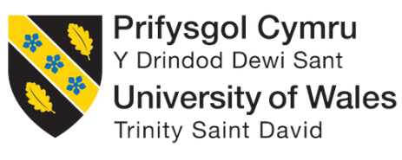


Focus Group Consent Form

Research project title: Creating a BA (Hons) in Musical Theatre in Portugal
Research investigator: Sara Teixeira

- I agree to participate in the Educators’ Focus Group carried out by Sara Teixeira of the Voice Study Centre and University of Wales Trinity Saint David, to aid with the research of Creating a BA (Hons) in Musical Theatre in Portugal.
- I have read the information sheet related to the project ‘Creating a BA (Hons) in Musical Theatre in Portugal and understand the aims of the project.
- I am aware of the topics to be discussed in the focus group.
- I am fully aware that I will remain anonymous throughout data reported
- I am fully aware that I have the right to leave the focus group at any point.
- I am fully aware that data collected will be stored securely, safely until the research project is completed and in accordance with General Data Protection Regulation (Regulation (EU) 2016/679).
- I agree to have the focus group video recorded, so it can be transcribed after the focus group is held. I am aware that I have the right to edit the transcript of the Focus Group once it has been completed.
- I am aware that I can make any reasonable changes to this consent form I understand that signed consent forms and original audio recordings will be retained in the researcher’s computer which has a password and is only accessed by the researcher until the 26th of April.
- I am fully aware that I am not obliged to answer any question, but that I do so at my own free will.
- I am aware that I can withdraw from the project at any point
- I understand that a transcript of my interview in which all identifying information has been removed will be retained for two years from the date of the exam board.
- I understand that under freedom of information legalisation I am entitled to access the information I have provided at any time while it is in storage as specified above.
- I understand that I am free to contact any of the people involved in the research to seek further clarification and information.
Names, degrees, affiliations and contact details of researchers (and academic supervisors when relevant).
Signature of research participant
----------------------------------------- ----------------
Signature of participant Date

Signature of researcher
I believe the participant is giving informed consent to participate in this study

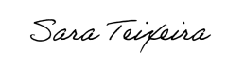
Signature of researcher Date 10/12/2023
Contact Information

This research has been reviewed and approved by the Voice Study Centre and the University of Wales Trinity Saint David Research Ethics Board.
If you have any further questions or concerns about this study, please contact:
Sara Teixeira
Full address: Rua Helena Vaz da Silva, 13, 2820-425, Palhais, Charneca de Caparica, Portugal
Tel: 00351968698196
E-mail: sarateixeira97@gmail.com

You can also contact Sara Teixeira’s supervisor:
Pippa Anderson
Full address: Voice Study Centre
The Old Stables
Hadleigh Road
East Bergholt
Suffolk
CO7 6QT
Tel. 01206 298172
E-mail: pippa@voicestudycentre.com

What if I have concerns about this research?
If you are worried about this research, or if you are concerned about how it is being conducted, you can contact the Director of Studies at:
Voice Study Centre
The Old Stables
Hadleigh Road
East Bergholt
Suffolk
CO7 6QT
(or email at info@voicestudycentre.com).

Focus Group Consent Form

Research project title: Creating a BA (Hons) in Musical Theatre in Portugal
Research investigator: Sara Teixeira

- I agree to participate in the Educators’ Focus Group carried out by Sara Teixeira of the Voice Study Centre and University of Wales Trinity Saint David, to aid with the research of Creating a BA (Hons) in Musical Theatre in Portugal.
- I have read the information sheet related to the project ‘Creating a BA (Hons) in Musical Theatre in Portugal and understand the aims of the project.
- I am aware of the topics to be discussed in the focus group.
- I am fully aware that I will remain anonymous throughout data reported
- I am fully aware that I have the right to leave the focus group at any point.
- I am fully aware that data collected will be stored securely, safely until the research project is completed and in accordance with General Data Protection Regulation (Regulation (EU) 2016/679).
- I agree to have the focus group video recorded, so it can be transcribed after the focus group is held. I am aware that I have the right to edit the transcript of the Focus Group once it has been completed.
- I am aware that I can make any reasonable changes to this consent form I understand that signed consent forms and original audio recordings will be retained in the researcher’s computer which has a password and is only accessed by the researcher until the 26th of April.
- I am fully aware that I am not obliged to answer any question, but that I do so at my own free will.
- I am aware that I can withdraw from the project at any point
- I understand that a transcript of my interview in which all identifying information has been removed will be retained for two years from the date of the exam board.
- I understand that under freedom of information legalisation I am entitled to access the information I have provided at any time while it is in storage as specified above.
- I understand that I am free to contact any of the people involved in the research to seek further clarification and information.
Names, degrees, affiliations and contact details of researchers (and academic supervisors when relevant).
Signature of research participant
----------------------------------------- ----------------
Signature of participant Date 10.12.2023

Signature of researcher
I believe the participant is giving informed consent to participate in this study
Signature of researcher Date 10/12/2023

Contact Information

This research has been reviewed and approved by the Voice Study Centre and the University of Wales Trinity Saint David Research Ethics Board.
If you have any further questions or concerns about this study, please contact:
Sara Teixeira
Full address: Rua Helena Vaz da Silva, 13, 2820-425, Palhais, Charneca de Caparica, Portugal
Tel: 00351968698196
E-mail: sarateixeira97@gmail.com

You can also contact Sara Teixeira’s supervisor:
Pippa Anderson
Full address: Voice Study Centre
The Old Stables
Hadleigh Road
East Bergholt
Suffolk
CO7 6QT
Tel. 01206 298172
E-mail: pippa@voicestudycentre.com

What if I have concerns about this research?
If you are worried about this research, or if you are concerned about how it is being conducted, you can contact the Director of Studies at:
Voice Study Centre
The Old Stables
Hadleigh Road
East Bergholt
Suffolk
CO7 6QT
(or email at info@voicestudycentre.com).

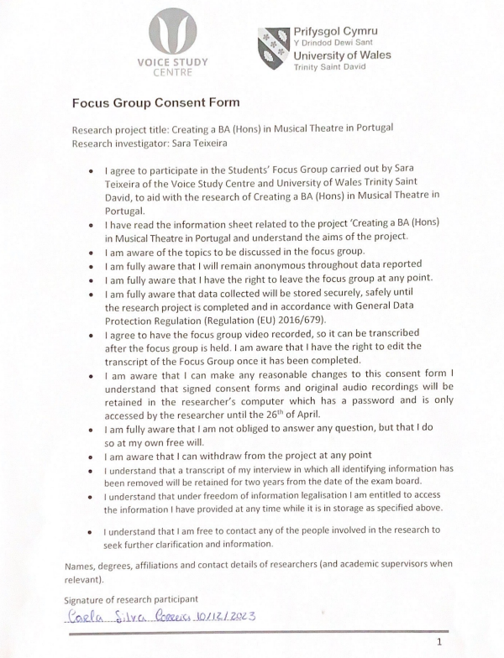

Signature of researcher
I believe the participant is giving informed consent to participate in this study
Signature of researcher Date 10/12/2023

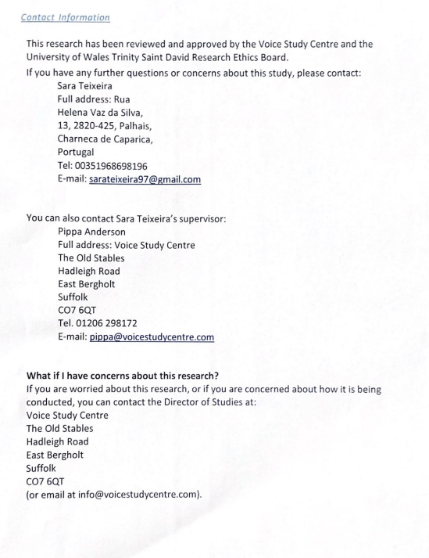

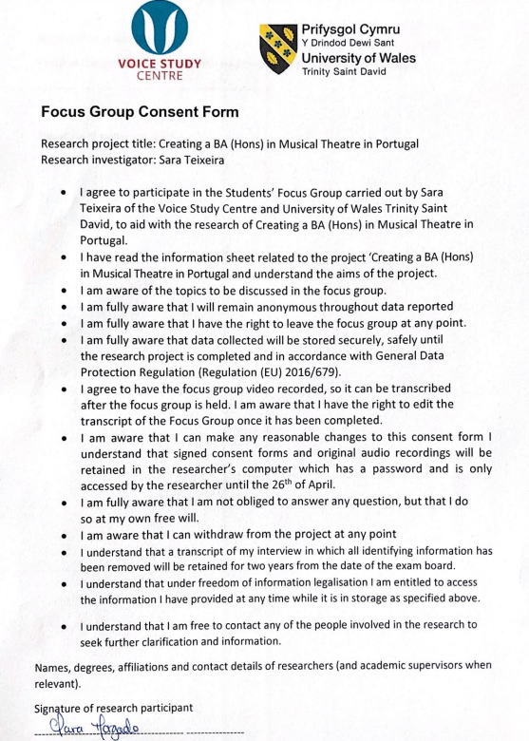

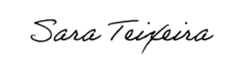
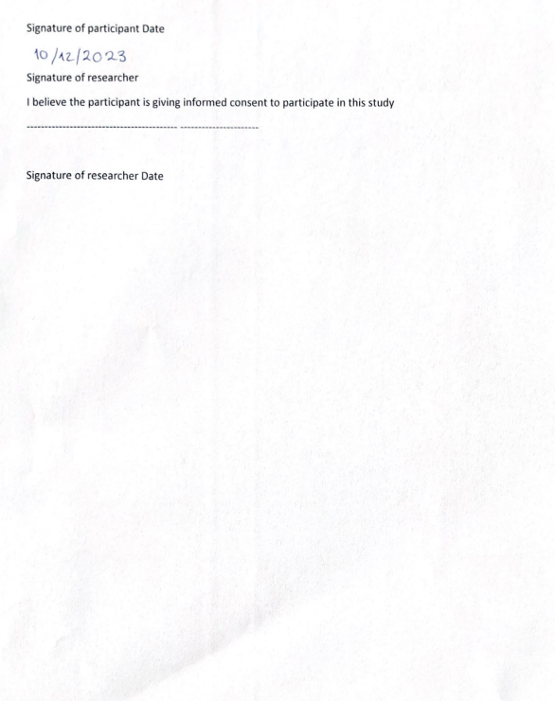
10/12/2023

APPENDIX 3
CONSENT FORMS - STUDENTS

Focus Group Consent Form

Research project title: Creating a BA (Hons) in Musical Theatre in Portugal
Research investigator: Sara Teixeira

- I agree to participate in the Students’ Focus Group carried out by Sara Teixeira of the Voice Study Centre and University of Wales Trinity Saint David, to aid with the research of Creating a BA (Hons) in Musical Theatre in Portugal.
- I have read the information sheet related to the project ‘Creating a BA (Hons) in Musical Theatre in Portugal and understand the aims of the project.
- I am aware of the topics to be discussed in the focus group.
- I am fully aware that I will remain anonymous throughout data reported
- I am fully aware that I have the right to leave the focus group at any point.
- I am fully aware that data collected will be stored securely, safely until the research project is completed and in accordance with General Data Protection Regulation (Regulation (EU) 2016/679).
- I agree to have the focus group video recorded, so it can be transcribed after the focus group is held. I am aware that I have the right to edit the transcript of the Focus Group once it has been completed.
- I am aware that I can make any reasonable changes to this consent form I understand that signed consent forms and original audio recordings will be retained in the researcher’s computer which has a password and is only accessed by the researcher until the 26th of April.
- I am fully aware that I am not obliged to answer any question, but that I do so at my own free will.
- I am aware that I can withdraw from the project at any point
- I understand that a transcript of my interview in which all identifying information has been removed will be retained for two years from the date of the exam board.
- I understand that under freedom of information legalisation I am entitled to access the information I have provided at any time while it is in storage as specified above.
- I understand that I am free to contact any of the people involved in the research to seek further clarification and information.
Names, degrees, affiliations and contact details of researchers (and academic supervisors when relevant).
Signature of research participant

Signature of participant Date
01/12/2023
Signature of researcher
I believe the participant is giving informed consent to participate in this study

Signature of researcher Date 01/12/2023
Contact Information

This research has been reviewed and approved by the Voice Study Centre and the University of Wales Trinity Saint David Research Ethics Board.
If you have any further questions or concerns about this study, please contact:
Sara Teixeira
Full address: Rua Helena Vaz da Silva, 13, 2820-425, Palhais, Charneca de Caparica, Portugal
Tel: 00351968698196
E-mail: sarateixeira97@gmail.com

You can also contact Sara Teixeira’s supervisor:
Pippa Anderson
Full address: Voice Study Centre
The Old Stables
Hadleigh Road
East Bergholt
Suffolk
CO7 6QT
Tel. 01206 298172
E-mail: pippa@voicestudycentre.com

What if I have concerns about this research?
If you are worried about this research, or if you are concerned about how it is being conducted, you can contact the Director of Studies at:
Voice Study Centre
The Old Stables
Hadleigh Road
East Bergholt
Suffolk
CO7 6QT
(or email at info@voicestudycentre.com).

Focus Group Consent Form

Research project title: Creating a BA (Hons) in Musical Theatre in Portugal
Research investigator: Sara Teixeira

- I agree to participate in the Students’ Focus Group carried out by Sara Teixeira of the Voice Study Centre and University of Wales Trinity Saint David, to aid with the research of Creating a BA (Hons) in Musical Theatre in Portugal.
- I have read the information sheet related to the project ‘Creating a BA (Hons) in Musical Theatre in Portugal and understand the aims of the project.
- I am aware of the topics to be discussed in the focus group.
- I am fully aware that I will remain anonymous throughout data reported
- I am fully aware that I have the right to leave the focus group at any point.
- I am fully aware that data collected will be stored securely, safely until the research project is completed and in accordance with General Data Protection Regulation (Regulation (EU) 2016/679).
- I agree to have the focus group video recorded, so it can be transcribed after the focus group is held. I am aware that I have the right to edit the transcript of the Focus Group once it has been completed.
- I am aware that I can make any reasonable changes to this consent form I understand that signed consent forms and original audio recordings will be retained in the researcher’s computer which has a password and is only accessed by the researcher until the 26th of April.
- I am fully aware that I am not obliged to answer any question, but that I do so at my own free will.
- I am aware that I can withdraw from the project at any point
- I understand that a transcript of my interview in which all identifying information has been removed will be retained for two years from the date of the exam board.
- I understand that under freedom of information legalisation I am entitled to access the information I have provided at any time while it is in storage as specified above.
- I understand that I am free to contact any of the people involved in the research to seek further clarification and information.
Names, degrees, affiliations and contact details of researchers (and academic supervisors when relevant).

Signature of research participant


Signature of participant Date

Signature of researcher
I believe the participant is giving informed consent to participate in this study

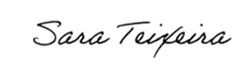

Signature of researcher Date 01/12/2023
Contact Information

This research has been reviewed and approved by the Voice Study Centre and the University of Wales Trinity Saint David Research Ethics Board.
If you have any further questions or concerns about this study, please contact:
Sara Teixeira
Full address: Rua Helena Vaz da Silva, 13, 2820-425, Palhais, Charneca de Caparica, Portugal
Tel: 00351968698196
E-mail: sarateixeira97@gmail.com

You can also contact Sara Teixeira’s supervisor:
Pippa Anderson
Full address: Voice Study Centre
The Old Stables
Hadleigh Road
East Bergholt
Suffolk
CO7 6QT
Tel. 01206 298172
E-mail: pippa@voicestudycentre.com

What if I have concerns about this research?
If you are worried about this research, or if you are concerned about how it is being conducted, you can contact the Director of Studies at:
Voice Study Centre
The Old Stables
Hadleigh Road
East Bergholt
Suffolk
CO7 6QT
(or email at info@voicestudycentre.com).

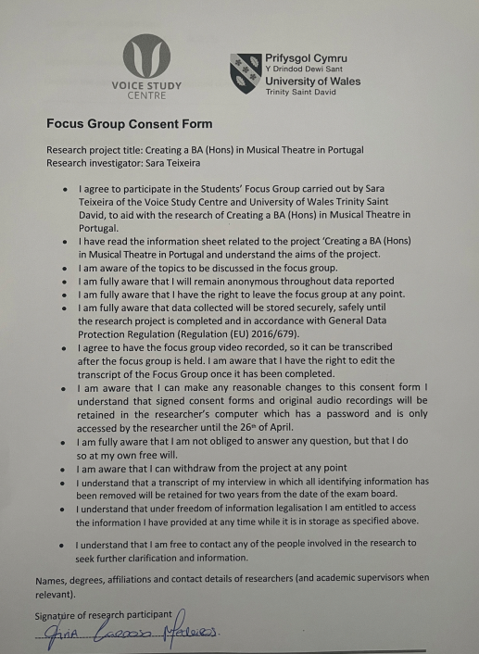

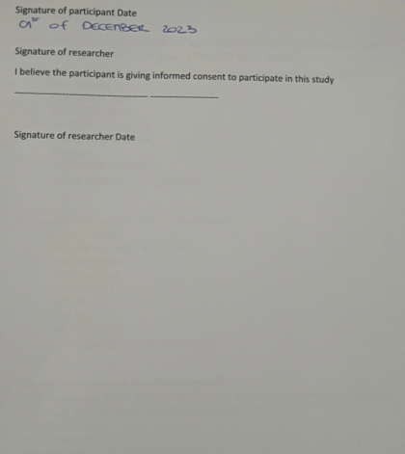

01/12/2023

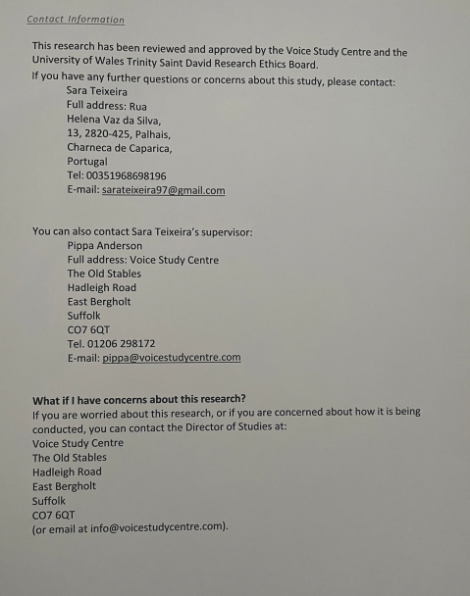

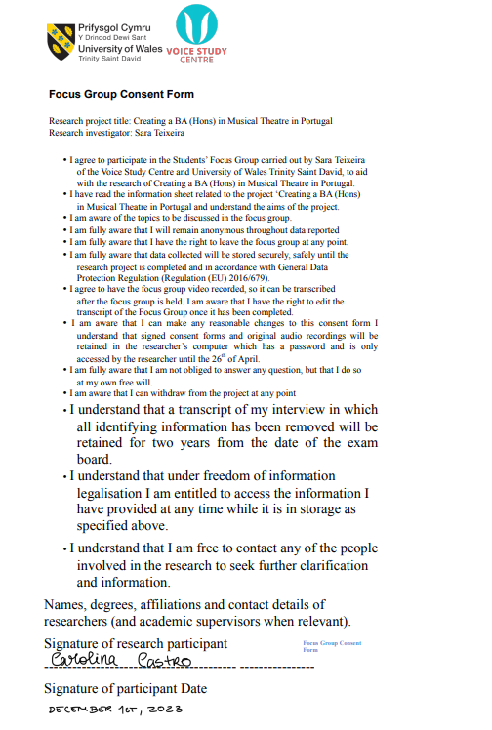


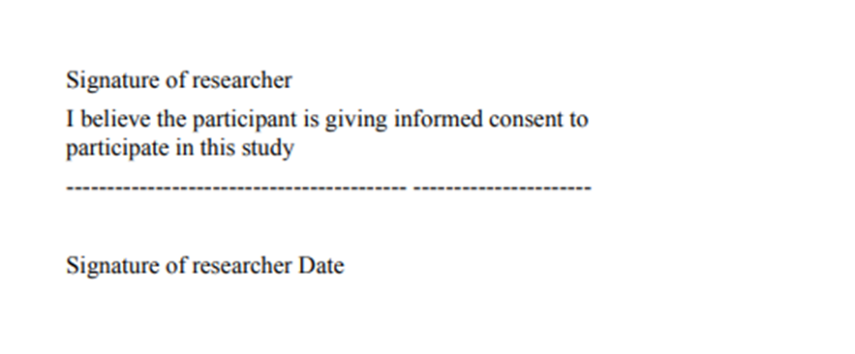

Contact Information

This research has been reviewed and approved by the Voice Study Centre and the University of Wales Trinity Saint David Research Ethics Board.
If you have any further questions or concerns about this study, please contact:
Sara Teixeira
Full address: Rua Helena Vaz da Silva, 13, 2820-425, Palhais, Charneca de Caparica, Portugal
Tel: 00351968698196
E-mail: sarateixeira97@gmail.com

You can also contact Sara Teixeira’s supervisor:
Pippa Anderson
Full address: Voice Study Centre
The Old Stables
Hadleigh Road
East Bergholt
Suffolk
CO7 6QT
Tel. 01206 298172
E-mail: pippa@voicestudycentre.com

What if I have concerns about this research?
If you are worried about this research, or if you are concerned about how it is being conducted, you can contact the Director of Studies at:
Voice Study Centre
The Old Stables
Hadleigh Road
East Bergholt
Suffolk
CO7 6QT
(or email at info@voicestudycentre.com).

APPENDIX 4
SURVEY – UK PEDAGOGUES
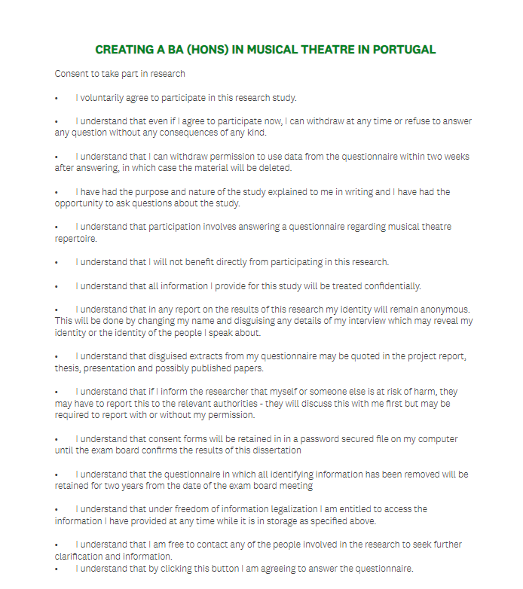

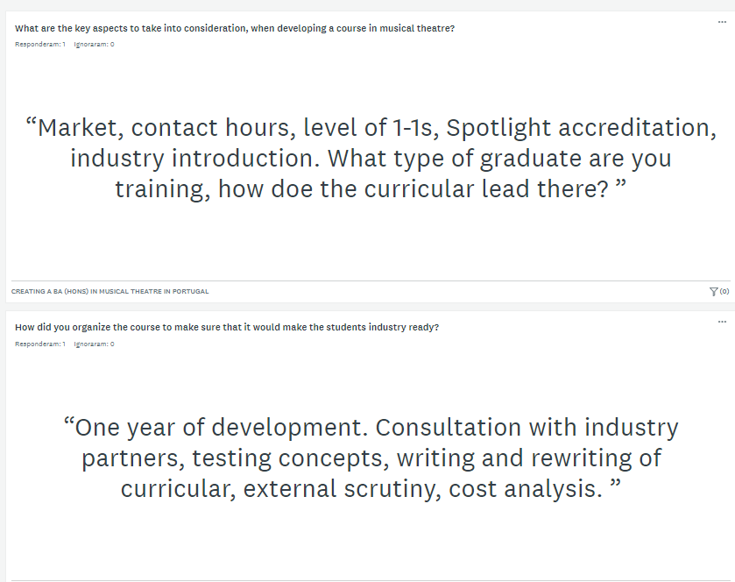

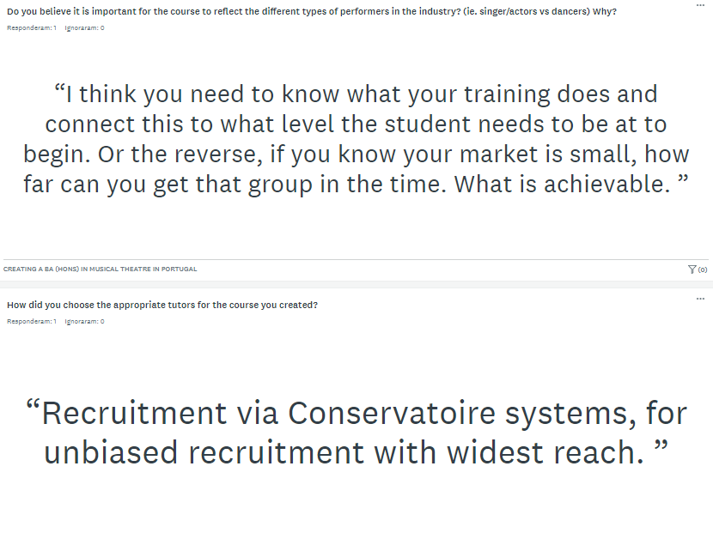

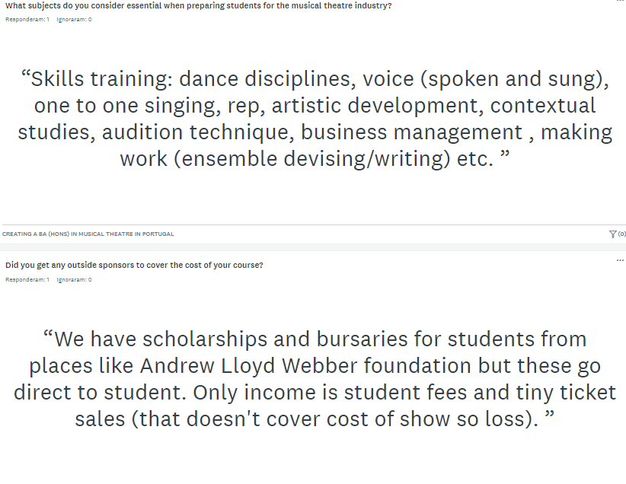

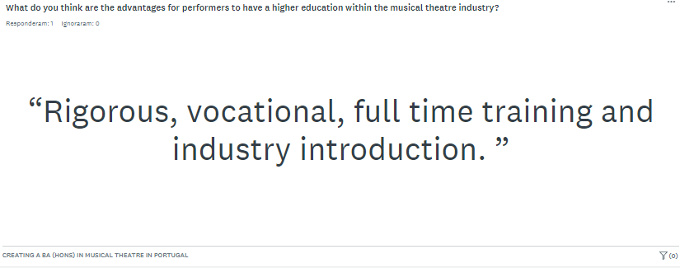

APPENDIX 5
FOCUS GROUP - TRANSCRIPTION – STUDENTS
IN VIVO CODING

DISADVANTAGES OF A DEGREE IN PORTUGAL
VANTAGES
TYPE OF PROGRAM
TEACHERS
TAKE FROM THE COURSE

Mediator: So, from what I know, you all study musical theatre at EDSAE and your objective is to go abroad to take your degree since in Portugal there aren’t higher education degrees in Portugal. So, if there was one, what do you think would be the advantages, disadvantages. Would you be interested in it?
Student 1: The only disadvantage I see is not for me personally, it’s just because I don’t know if there would be enough people. But I think it would be very interesting because we have lots of musical theatre performers in Portugal and I think we could have lots of experiences from professionals that maybe a few years ago we couldn’t.
Mediator: And advantages for you?
Student 2: I think it would be very good since we would not need to leave our country to study what we love. Especially in terms of money it could be very helpful. However, I don’t know if I would stay. If I could I would go abroad to have that experience and it would depend on the course itself and the amount of industry contact we could get through the college.
Student 3: I agree with the last part Student 2 said. The industry is growing more and more and having a Musical Theatre college here would be very valuable. When I was younger it took me a while to understand that I could make a living out of Musical Theatre. Especially because the industry here was not as developed as it is now.
Mediator: Of course.
Student 3: And I think that kind of course here will promote the development of the industry and will improve what the actors and artists can offer the audiences.
Student 4: I agree with what was said. I think a very good point would be in terms of costs and going abroad is a bigger logistic than if we had a course here, but I agree with Student 1. I don’t know how many people would be interested. Because the industry is getting more developed in Portugal but at the same time, not that much and I think there would be many people that would think that abroad they would have a better experience than here.
Mediator: Okay, good points. And if there was a course here in Portugal, what kind of program do you think there would be? What disciplines? What kind of teachers? How could the course be structure to give students the tools for the industry?
Student 1: In terms of structure, I think there would have to be a balance between theory and practice. In terms of subjects I don’t think I would change from what it already exists and the disciplines we already have at EDSAE like Acting Through Song, different dance styles, one-to-one singing lessons. I don’t think I would change from what I already know because I think it works. In terms of teachers, I am not sure…
Mediator: You don’t have to say specific names
Student 1: Yes, I know. It’s just because there are so many actors that do not have a higher education degree so it would be weird to teach at a higher education level. There would have to be specific criteria to choose the teachers. But I think there could be moments with professionals of the industry when the students could have that kind of contact.
Mediator: So, even if it wasn’t full time, students should be able to contact with industry professionals currently working like in workshops or lectures setting, for example.
Student 1: Yes, that is what I mean, I think that is super important to have people actively working in the industry teach in a BA (Hons).
Student 3: In terms of theory I think Musical Theatre History is very important. It is so important to have people in the industry that know what they are talking about. This kind of theoretical subjects is super important. Also, subjects related to voice work and how we can use it effectively .
Mediator: So you mean something like repertoire, technique and anatomy, vocal health, like, very specific subjects.
Student 3: Or maybe workshops on those subjects.
Mediator: Okay, okay. Do you want to add anything else?
Student 3: I was wondering about possible teachers, but I think Student 1 explained what I think very well.
Student 2: In terms of subjects, I agree and really think that it is important to have a solid theoretical foundation because there is still a lot of missed information here. It is important to educate for musical theatre and for different repertoire. So that would be very important to explore and dive deeper into the musical theatre world. But I agree and would not change the subjects we already have at EDSAE and IAB for example. In terms of teachers, Student 1 made a great point and it would be very important to bring people of the industry and who would be working not only here but also abroad so students could understand how the industry works here and that it is possible to make a living from musical theatre here in Portugal.
Mediator: Great! Student 4?
Student 4: I think they already said what I was going to say. In terms of subjects, we really need more specific subjects not broad fields like dance, theatre and singing. And workshops with professionals that can teach us how to start our careers would be great because personally, now, I have no idea where to start.
Mediator: And regarding the people from abroad teaching, do you think it would be beneficial to have people from Broadway, West End, Madrid amongst others to teach students how to try and navigate those industries even if you are not from those countries?
Student 4: I think it would be great! Portugal is not the most famous musical theatre place and taking people to work abroad could contribute to the growth of the country’s reputation in the area. And having people form Broadway or West end, for example to give us guidance would be very beneficial for us and for the country itself.
Mediator: Perfect. And maybe within the Spanish industry we could try to make connections?
Student 2: Yes, and Spain has lots of musicals and productions so it became a great option for me and that would be interesting to understand how it works. Having Spanish actors working with us would be very interesting.
Mediator: And regarding the subjects just to conclude, in terms of voice work what do you specifically think should be included?
Student 1: I think it is important to have a vocal health module, even if it is not a regular discipline. I have lots of issues with my voice and talking to my teachers about vocal health has been super helpful. So having that kind of module would be super important, not only vocal technique and anatomy but how to really take care of our voice in a singing context but also in our daily lives.
Mediator: So, you mean not only a technical approach but also a health approach.
Student 1: Yes!
Mediator: Great!
Student 3: Also, vocal styles are super important. We need to understand how to approach the different styles and songs because we cannot sing Phantom of the Opera the same way we would sing &Juliet! It would be weird. It would be helpful to understand the different styles, differences, to see our difficulties and how to improve the voice in terms of styles matching the song we are working on.
Student 4: I think we must have balance between vocal health and knowing our voice. We need to have solid technique and solid vocal health knowledge. That is super important.
Mediator: And if we talk about Acting Through Song, Accent work, would that be important?
Student 2: Yes, It would be super important. These things are part of a foundation for our futures as artists. Acting Through Song is essential for the course as it is the heart of musical theatre.
Mediator: Good and now, what would you say you need to take from a BA (Hons) in Musical Theatre, to feel super prepared for the industry you want to get into?
Student 1: One thing that I believe is super important is to know ourselves and know what we can do. Have a solid rep, good monologues, dance solos. Knowing who we are as performers. Working in the industry is very challenging as we audition a lot and do not get many jobs most of time. So, if we know who we are and what we are good or less good at, we can turn to the correct auditions and castings that fit us. And that is hard to do but in classes we really need to try and find ourselves and what would show us better according to what we can do, and we are good at so that we are always ready for the auditions we go into. We need to have these super clear before entering the industry.
Student 3: I Think Student 1’s answer was good. But I think we need to be able to connect the three elements of musical theatre. A character does not change because they are singing or dancing and that seems simple, but it is super important. So, we need the acting side to be clear al all times. Since Musical Theatre has evolved and the acting is not stopping anymore to have a singing or dancing moment, then the performers should be able to always sustain their character.
Moderator: Okay, so maybe in these aspects Acting Through Song becomes very important for performers.
Student 3: Yes, completely!
Student 4: For me, adding to Student 1, knowing where we fit is essential. We also need to know what the industry is. And be ready to get the No’s and understand the reality of the industry that it is not perfect and that you won’t get the most amazing jobs after auditioning twice. Like, that is not a realistic view it does not happen like that.
Student 2: Actually, more specifically, being ready for auditions with the material, but also with our personal materials, like a good CV, good headshot, how to make our own showreel. Having it all ready when we finish our degree or at least have the tools to do it correctly. This is very important. As well as everything they said. But knowing how to create these elements is essential because no one ever tells us how to and it would really be beneficial.
Mediator: Yes, that is very good! Great point! Does anyone have anything to add?
Student 1: Actually, I want to add that one thing I believe I am working a lot on Acting Through Song classes is my critical sense. I can now observe my peers and observe myself and see what went well and what didn’t and that is very important to me. It should be great to develop this in a higher degree level.
Mediator: That is great! Developing our critical sense towards us and our colleagues! Does anyone have anything to add?
Student 4: No, I’m good.
Student 3: Me too.
Student 1: Yeah
Craolina: Same
Mediator: Well, then thank you for your help and for participating! Bye everyone!

APPENDIX 6
FOCUS GROUP – TRANSCRIPTION - EDUCATORS
IN VIVO CODING
STUDY IN PORTUGAL
COSTS
EFFECTS ON THE INDUSTRY
ORGANIZATION OF THE PROGRAM
DIFFERENT TYPES OF PROGRAMS
INVESTMENT IN PORTUGAL
TEACHERS

Mediator: So, all of you, including myself have studied Musical Theatre to a higher degree level abroad. My question to you is what do you think would have happened if you had studied in Portugal? Advantages, Disadvantages, do you think you would still want to go abroad?
Educator 1: For me, it would depend on the course offer and the connections it had with the industry. If it was like what exists abroad, then I would have stayed in Portugal and maybe later try and go abroad for a MA, for example. In terms of costs, it would be more beneficial for us, because we would only have to pay for the course and not the rest of the costs of living abroad. However, the experience of living abroad with people from all over the world is something I would not trade at all. So, it would really depend on the factors, but I believe I would have probably done a BA in Portugal and then go abroad.
EDUCATOR 2: For me it’s similar because the costs would be reduced. However, if we think of the Portuguese culture, to have a degree similar to other European schools, you would have to have some international elements like teachers and that could increase the cost of the course. But I would consider my goals to choose either to study in Portugal or abroad. Personally, I have always known that I wanted to work in Portugal so, if I had the option I would have studied here because I would already be networking within the industry I wanted to get into. I believe that the college I studied in Spain is like the Portuguese culture and it was easier to branch out to other places as it feels like neutral territory.
Mediator: So, you think that it depends on what the students want? The cultures they want to contact with and the industry they want to get into.
Educator 1: Yes!
Educator 2: And let’s imagine that if there is a Musical Theatre college here in Portugal and it is successful, what happens is that more international students will want to go to it. So that would be useful to get the school and the country recognized.
Mediator: Educator 3, what do you think?
Educator 3: I agree! I also see myself working in Portugal so if there was a degree here, I would probably stay. However, I think that it is very important for a course in Portugal to have good international elements since the Musical Theatre culture in Portugal is not the same as Spain or London. So, I would want to go to Portugal to do something different, so going abroad to study can give us good tools to then bring to the Portuguese industry. It would really depend on the course and the way it was organized.
Mediator: Great! Educator 4?
Educator 4: My experience is very black and white because ever since I was a kid, I always went to London over summer to see musicals and take some musical theatre courses, so I always had that idea of studying and working in London. So, for me, even if there was an option here, 18-year-old me would not think that it would be as good as a London School. For me I really wanted to go and audition for London schools, work there, and get into that industry. As a kid I don’t think I really connected to the Portuguese culture, I wanted to find something different, and I was always felt more connected to the London culture.
Mediator: Oh, okay! That’s great! So, let’s imagine that there is a BA (Hons) in Musical Theatre here in Portugal. What kind of advantages do you feel it could have to the Portuguese industry?
Educator 2: It would have a great impact. First you would have to have lots more shows so that you could guarantee that there would be enough jobs for the people graduating. There would also have to a raise in the quality of the shows, since Portugal does not have a very clear idea of what is musical theatre and has developed their own genre within the genre. So, there would have to be a bigger variety of shows to guarantee that more and new people would get into the industry. Consequently, there would have to be more money invested in the Portuguese culture and shows.
Mediator: Yes! Great! Educator 4?
Educator 4: I don’t think I fully agree. Unless the BA (Hons) had a great amount of support by the Portuguese government, I don’t necessarily think that the BA would create more investment in the Portuguese culture.
Educator 2: But the thing is that there would have to be a big support from the government to have this kind of degree here. Because there was already a trial for a higher degree in Musical Theatre here but it was so expensive that no one could afford it.
Educator 4: I’m just not sure of how that could equal to more projects, do you understand?
Educator 2: Yes, but the thing is that our degrees here are about the creative side of the art not about the performance aspect of it. So having a degree with performance focus would have to automatically make that shift.
Educator 4: Oh, I see what you mean. But also, if we have a degree with a focus on the musical theatre creative it could give the students the tools to create their own shows and expand the industry.
Educator 3: Can I add ideas?
Mediator: Yes, of course?
Educator 3: So, for me, there are two options for the course. Either you have a course that educates for the Portuguese industry, or the course can educate for the international industry. Depending on that, there would be different outcomes. I also think that having a good creative side to the degree is important, but there must be an investment by the government.
Mediator: Of course, yes. The course would have to have support by the government so that Portuguese students could afford it.
Educator 1: I totally agree. This could bring a great recognition to Portugal. Because a course could bring international students and consequently, they would live and get to know Portugal and the country could benefit for it. Also, having international choreographers and directors to work with the students would be great for the country. This is related to the government but also to the audiences that would consume more musical theatre in Portugal.
Mediator: So, this connects with my last question, which is what kind of subjects or organization of the degree do you think are essential?
Educator 4: For me it starts with one-to-one singing lessons. And when I was studying, I had a teacher with whom I could not connect with, and I felt that my voice was not the focus of the lessons and that really affected my vocal health. My teacher had their own technique and did not adapt it to me as a student.
Mediator: Ok, I know what you mean. And maybe there could be a bigger focus on vocal health?
Educator 4: Yes, completely. Not only when singing but in our daily routine, especially if we are working on a show. Getting to know our voice and our vocal health.
Educator 1: Yes, vocal health is super important. We had that on my degree, and it was super useful to have a good foundation of voice work. Now, regarding the singing teachers, I think each teacher will always have their own approach, but they need to adapt to their students. For example, I had a singing teacher that I couldn’t identify with, however, I had a singing technique class in which I could explore other things. That was a group class and we had time with the teacher to work on very specific things. That was very helpful for me.
Educator 3: I agree with Educator 1. For me in terms of subjects, I think we need to have one-to-one singing lessons, singing technique, vocal health modules, repertoire, acting through song twice a week so that more students could sing within the class. Acting classes are also super important to explore the connection to the characters we are portraying. And for me it is very important to get through all the vocal styles within musical theatre and getting to work with different teachers is super useful and beneficial so that students can gather different tools through their training. Also, voice and dialects could also be important.
Mediator: Perfect! Educator 2, do you want to add anything?
Educator 2: No, I totally agree with what was said.
Mediator: Well, then thank you so much for participating!

