LCBB4003
Introducing the Modern Workplace
Assessment 1
Student Name: Mariana Zaharia
Student ID : 1917341
Lecturer: Gregory Cowan

Contents
Introduction 3
Organisational Review: Micro Focus 3
Analysis of the Relationship Between Structure, Culture, People and Organisational Performance 4
The Role of Leadership 9
Variables that Determine Effective Management and Leadership 10
The Behavioural Approach to Management, Through Understanding the Factors that Affect Differences in Individual Behaviour 11
Conclusion 12
References 13

Introduction
Operating a business organisation can be a difficult ordeal because of the various intricate factors one must deal with (Alblas and Wijsman, 2019). The structure and culture of a business organisation are two such notable factors that have a tremendous impact on the operations and sustainability of a business organisation. This essay explores the impact of these factors on the business of Micro Focus.

Organisational Review: Micro Focus
Micro Focus is a public limited company operating in the United Kingdom. The company began its operations in 1976, almost 44 years ago. It is currently headquartered in Newbury, England. Greg Lock is the current Chairman, while Stephen Murdoch is in the role of the CEO (Micro Focus, 2020).


Micro Focus has about 12,000 employees as of 2020. It also has two subsidiaries, NetIQ and Serena Software. The company primarily offers IT consulting.

Analysis of the Relationship Between Structure, Culture, People and Organisational Performance

Organisational Structure
The organisational structure is defined as the system by which an organisation divides the task between its employees. Through an organisational structure, the organisation defines the hierarchy of tasks so every employee can clearly understand his roles and responsibilities (Ananthan, Appannaiah and Reddy, 2010). As an organisation needs to accomplish thousands of tasks and therefore, it requires numerous employees, a specific organisational structure is very necessary for any organisation. Without a specific organisational structure, an organisation cannot organise all of the tasks and it cannot even direct employees to accomplish the task as well.
Some organisational structures are more commonly seen in business organisations than others. Three such organisational structures are explored here:
- Functional: The functional organisational structure deals with dividing tasks according to business function. A business comprises of different functions such as operation, marketing, finance, logistics etc. The functional organisational structure assigns and distributes tasks based on this function (Aquinas, 2008). For example, the marketing department and finance department are separate if this structure is integrated into an organisation.
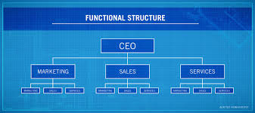
Figure: Functional Organisational Structure (Aquinas, 2008).
- Division: This structure does not consider business function as the element of dividing tasks, rather it deals with dividing tasks according to the geographical area or products/services (Ananthan, Appannaiah and Reddy, 2010). That means, this structure does not assemble all sort of similar skills within a department, rather it decentralises skills and distributes where the skill is required most. Therefore, each division comprises of skills to run every business function.
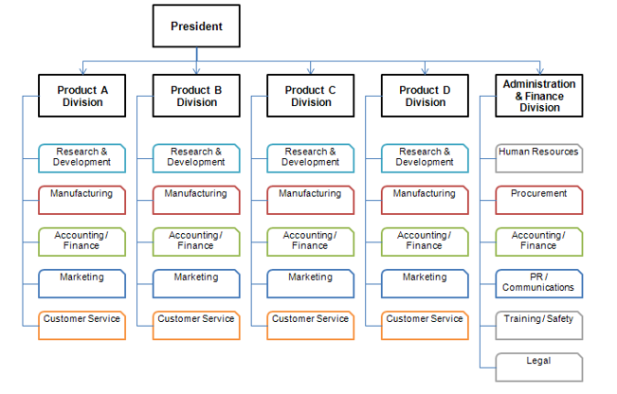
Figure: Divisional Organisational Structure (Ananthan, Appannaiah and Reddy, 2010).

- Matrix: Matrix organisational structure is a project-based structure and it does not follow the rule of functional and divisional structure although matrix structure is an amalgam of these two structures (Bartol and Martin, 2014). In this structure, a team has consisted of several employees for a specific project. After completing the project, employees perform their regular tasks.
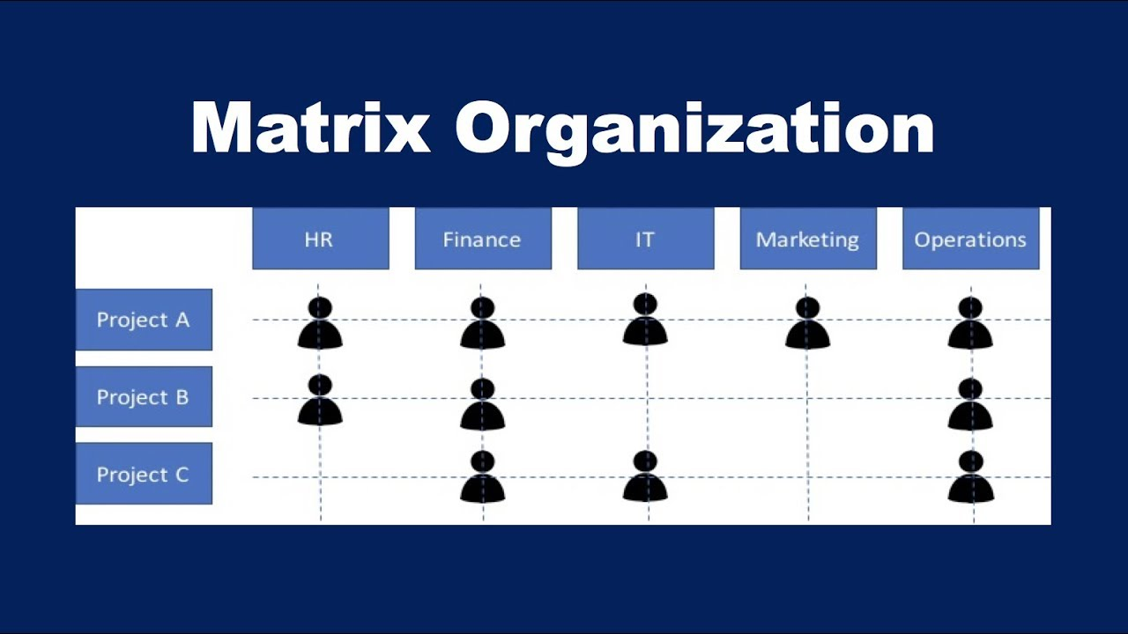
Figure: Matrix Organisational Structure (Bartol and Martin, 2014).

Organisational Culture
Organisational culture is defined as collective values and norms that all employees and employers share and follow. Organisational culture is very important for any business organisation since value and norms impact on how employees treat organisational goals and how they communicate (Daft and Lane, 2015). Also, organisational culture dictates how employees of an organisation thrive to accomplish tasks. There are many organisational cultures a business organisation can integrate, and those cultures are discussed below:
- Hierarchy: Hierarchy culture focuses on authority and control. The practice of authorisation and controlling is usually maintained by a well-defined order (Gregoire, 2009). A subordinate, for instance, cannot initiate a plan without the order or confirmation from the superordinate. Generally, the functional organisational structure fits in hierarchy culture.
- Market: This culture is an organisational culture which promotes competition between employees. Market culture focuses on specific skills and output from employees. As a result, employees are asked to produce targeted output so that the organisation can add up those contribution to achieve organisational goals (Daft and Lane, 2015). Additionally, there is no specific order of management in this culture. Hence, market culture is possible in any organisational structure.

- Adhocracy: This organisational culture is quite different from other cultures. There is not a specific practice that the organisation holds firmly. Rather, it encourages creativity and thinking outside the box (Gregoire, 2009). There is no specific role that employees have to perform. What employees need to do is co-opt with changing environment. And therefore, they are highly encouraged to rely on creativity and dynamism.

Relationship Between Organisational Structure, Culture, People and Performance
People or employees are the most important for Micro Focus or any other organisations as employees organise, supervise and accomplish tasks which are required to meet organisational goals (Miner, 2015). For instance, Micro Focus aims at facilitating business enterprises in security solutions, COBOL development, IT operation management etc so that enterprises can easily manage business operations. For providing such quality services Micro Focuses requires a bunch of people who can afford to support the organisation through their highly qualified skills and high organisational performance (Kummerow and Kirby, 2013). Subsequently, it is also a fact that a team of people without high performance cannot contribute to organisational goals.

Image: Chief Organisational Team of Micro Focus (Micro Focus, 2020).
Another fact is that organisational structure and organisational culture are interrelated and this interrelationship affects people and organisational performance. For instance, functional organisational structure dictates stable and well-defined managerial order according to each function. In this organisational structure, every function is separate and tasks regarding each function are divided based on tall hierarchy. Therefore, hierarchy culture is practised within the functional structure. As a result, the scope of communication becomes narrowed which results in poor performance. On the other hand, matrix organisational structure is project-based structure and it mostly fits in adhocracy culture. In other words, adhocracy culture best fits in a matrix structure (Bartol and Martin, 2014). Within the combination of matrix structure and adhocracy culture, creativity is highly encouraged and besides, communication between employees become effective. As a result, employees can take part in decision making and that specific team becomes resources with various ideas which ultimately leads to the most productive way to accomplish the project. Also, employees can learn effective teamwork which according to the modern workplace practice is very important for high productivity. For instance, Micro Focus does not follow the hierarchy, rather it focuses on team-working. The supreme team of this organisation comprises of the chief of the various function which indicates that this organisation has integrated divisional organisational structure. Besides, it follows the matrix structure for project management (Daft and Lane, 2015). However, the fact is that Micro Focus highly concentrates on creativity and dynamism which enhances the skills and competencies of employees. As a consequence of it, it can ensure high organisational performance. Also, the team-based organisational structure of this organisation shows that clan culture has been also integrated within this organisation. One of the benefits of clan culture is how it can support co-operation in the workplace, thereby presenting better opportunities for improvement and growth of the employees. Because of that, Micro Focus has ensured high organisational performance.
Identification of the essential nature of managerial work
Managerial work, in terms of functions and processes, is managed by a manager. Furthermore, basic functions of management are organising, planning, staffing, directing, controlling, coordinating etc. (Bartol and Martin, 2014). Managerial work, thus, refers to the activities that a manager needs to oversee, and the responsibilities s/he is given in an organisation.
- A manager must organise all sort of tasks that are to be accomplished.
- A manager needs to plan the process of accomplishing tasks.
- A manager needs to organise and plan of staffs based on skills and competencies of employees (Aquinas, 2008).
- He needs to supervise to confirm whether tasks are accomplished on time or not.
- A manager needs to set a standard of tasks and thereby controls the standard of tasks.

The Role of Leadership
Leadership has a core role to play in the management of a business organisation. A leader may occasionally perform the duties of a manager as well, but the role they play in the organisation is very specific (Alblas and Wijsman, 2019). There are four notable aspects to this role. These are:
- Inspiring Trust: A leader needs to inspire trust in others and fill them with confidence. If the leader is not ready to take risks and face challenges, then no one else will have the courage either.
- Creating Vision: A leader needs to keep the team on track and towards specific goals and objectives. This creates a synergy in the team that the leader takes control of.
- Executing Strategy: A leader must consistently achieve results by incorporating the right people in any given task. Choosing the best individuals for any given task is important leadership ability (Gregoire, 2009).
- Coaching Potential: A leader must also identify individuals brimming with talent and potential. Guiding the next generation of employees in the right direction is for the betterment of the company as well.
Micro Focus must prioritise leadership in its business to ensure that the employees have people to look up to and follow. The unique role of a leader can help the employees of Micro Focus understand their roles better, thereby also becoming more capable in those roles.

Variables that Determine Effective Management and Leadership
Effective leadership and management are desired in any business organisation, but some variables determine the effectiveness of these two roles. These variables are explored here:
- Time: Time comes in two forms for a business organisation. The first is the available working hours for employees in each week, and the second is the available working days until the deadline of a specific task (Miner, 2015). The performance of managers and leaders can be affected by this variable.
- Money: Money is the major influencer in the business world, and it resides at the core of the business organisation itself. Hence, it is only fair that money would be a determiner for effective management and leadership. Talented employees must be hired for a complimentary salary.
- Resources: In the view of the executives, resources refer to the employees in the company (Kummerow and Kirby, 2013). The most important resource for managers and leaders to manage are themselves, only after which comes the employees they are in charge of.
Because these variables exist, simply putting the pressure on leaders and managers will not yield results for Micro Focus. Instead, Micro Focus needs to keep track of the variables and ensure that the condition for the leaders and managers are not negative, allowing these individuals to properly fulfil their roles in the organisation.

The Behavioural Approach to Management, Through Understanding the Factors that Affect Differences in Individual Behaviour
The behavioural approach to management is an advancement from the classical approach. It is primarily divided into two branches (Daft and Lane, 2015). The Human Relations Approach and the Behavioural Science Approach. Both approaches have their advantages over the other.
The Human Relations Approach explores how managers should connect with their subordinates. As human individuals do not operate according to strict patterns, it is necessary to recognise the behavioural aspects of the employees including their need for recognition and social acceptance. The Behavioural Science Approach extends the previous approach a step further. It assigns a value to the attitudes, behaviour and performance of individuals in the company (Ananthan, Appannaiah and Reddy, 2010). This approach considers humans to be more complex than previously understood. Hence, it focuses on the nature of work, as well as how they need for recognition is fulfilled. Both of the branches showcase how the employees should be better treated in a business organisation.
The Behavioural Approach to Management has made some notable contributions as well. First, it has improved the way teams are utilised in achieving organisational goals. Second, it has placed greater emphasis on the training and development of staff. Third, it has made innovative use of rewards and incentive to boost performance (Gregoire, 2009). Finally, it has modernised the management theory to better understand human resources.
For Micro Focus, these two approaches present an untapped opportunity in how the organisation manages its employees. By implementing these approaches, Micro Focus can improve the development, training of the employees while also motivating them to strive further ahead more effectively.

Conclusion
In these ways, the structure and culture of Micro Focus have an impact on its operations and performance in the market. If the company can utilise these factors to its advantage, it can control how it operates in the market and how its employees perform. As such, it would also be possible to direct the business on the right path to success more easily.

References
Alblas, G. and Wijsman, E., 2019. Organisational Behaviour. 3rd ed. Groningen: Noordhoff Uitgevers.
Ananthan, B., Appannaiah, H. and Reddy, P., 2010. Business Management. 7th ed. Mumbai [India]: Himalaya Pub. House.
Aquinas, P., 2008. Organization Structure and Design: Applications & Challenges. 6th ed. Excel Books.
Bartol, K. and Martin, D., 2014. Management. 4th ed. Boston: McGraw-Hill Co.
Daft, R. and Lane, P., 2015. Leadership. 6th ed. Stamford: Cengage Learning.
Gregoire, R., 2009. Business Management. 7th ed. [Paris]: UNESCO.
Kummerow, E. and Kirby, N., 2013. Organisational Culture. 4th ed. Singapore: World Scientific Publishing Company.
Microfocus.com. 2020. Micro Focus. [online] Available at: <https://www.microfocus.com/en-us/home> [Accessed 16 August 2020].
Miner, J., 2015. Management Theory. 4th ed. New York: Macmillan.

