Georgica Acsente (2332651)
Module Lead: Philippa Fitzgerald
Digital Skills for Personal and Professional Growth (BMSW4008)
Evidence of Learning
(E-Portofolio)

Final Submission: 28th March 2025 At 23:59

Table of Contents
Task 1: Shots2Find Photography: Analysis of Customer Feedback on Photography Services 2
Introductions 2
Key Findings & Trends 2
Question 5: Booking Process: Ease and Convenience 2
Question 9: Photographer's Professionalism 4
Question 11: Direction & Guidance During the Shoot 5
Question 13: Timely Photo Delivery 6
Strategic Recommendations 7
Conclusion 7
TASK 2: Integrating User Feedback and Academic Research into Website and Marketing Design for Shots2Find Photography 8
Introduction 8
Segmenting Our Audience Based on User Data 8
Enhancing User Experience to Build Trust and Emotional Engagement 9
Strengthening Brand Identity through Visual and Verbal Consistency 9
Leveraging SEO to Increase Visibility and Reach 10
Elevating Visual Marketing with Strategic Use of Light, Colour, and Platforms 10
Creating Opportunities for Collaboration and Learning 11
Amplifying Reach through Social Media and Referrals 11
Conclusion 12
Website screenshots 12
TASK3: Excel in Digital Era 15
Figure 9: Spreadsheet 15
Conclusion 17
Task 4: Explanation of Storytelling Techniques Used in the Video 18
Figure 10: YouTube Video 18
References 19

Task 1: Shots2Find Photography: Analysis of Customer Feedback on Photography Services

Introductions
Customer satisfaction is essential for the success of professional photography services. Understanding customers experiences with booking, professionalism, direction during the shoot, and photo delivery provides valuable insights for improving service quality. This report examines key survey responses, identifies strengths and areas for improvement, and incorporates industry research to offer data-driven recommendations that will enhance service delivery.

Key Findings & Trends

Question 5: Booking Process: Ease and Convenience

Figure 1:
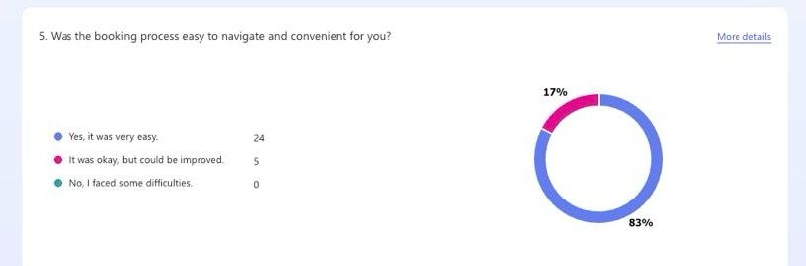

Insights & Trends
Most respondents found the booking process easy and convenient, with 83% rating it as very easy. However, 17% suggested areas for improvement, such as making the online booking system simpler, offering more flexible scheduling, and improving communication during the booking phase.
According to Statista (2024), 75% of consumers prefer straightforward online booking systems with minimal steps, highlighting the importance of an intuitive, mobile-friendly experience. Additionally, Forbes (2023) found that businesses using automated booking systems had 30% higher customer retention, reinforcing the value of a seamless reservation process.

Business Implications
- Maintain the current booking system while addressing minor concerns to enhance user experience.
- Gather customer feedback after booking to identify areas for further improvement and optimise the process.
- Introduce chatbot support for instant assistance, real-time scheduling, and automated reminders to improve efficiency.
- Provide a mobile-friendly interface to ensure seamless access and a hassle-free booking experience for all users.
- Enhance communication by integrating email and SMS confirmations, reducing booking-related enquiries and ensuring clarity.

Question 9: Photographer's Professionalism

Figure 2:
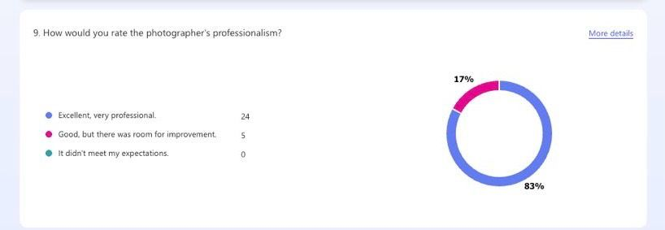

Insights and Trends
A 96% satisfaction rate shows that clients highly value the photographer’s professionalism and customer service. However, 21% felt there was room for improvement, indicating that small refinements in communication and engagement could enhance the overall experience.
Research by Grand View Research (2023) shows that clients in creative industries prioritize professionalism, punctuality, and clear communication. Similarly, Harvard Business Review (2024) states that strong interpersonal skills significantly impact customer satisfaction in service-based industries, emphasizing the need for ongoing improvement in client interaction.

Business Implications
- Maintain high professional standards while refining customer engagement skills.
- Provide regular customer service training to improve communication and responsiveness.
- Use follow-up surveys to identify specific areas where professionalism can be improved.

Question 11: Direction & Guidance During the Shoot

Figure 3
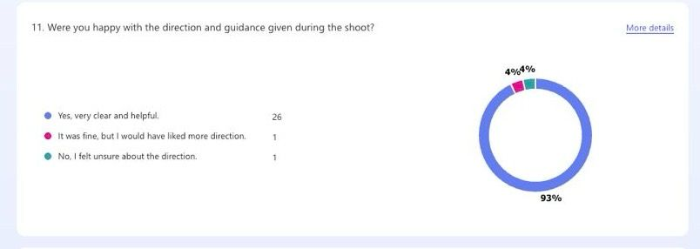

Insights and Trends

Most respondents (93%) were happy with the direction provided during the shoot, confirming that clear guidance is a strength. However, 7% of clients felt they needed more direction, suggesting that some customers may prefer structured posing tips or clearer instructions.
Psychology Today (2023) highlights that both verbal and non-verbal guidance play an important role in helping clients feel at ease in front of the camera. Consumer Reports (2024) also found that customers appreciate a balance between structured guidance and natural expression, ensuring they feel comfortable and confident during the session.

Business Implications

- Maintain clear and confident direction during shoots.
- Offer personalized posing guidance, especially for first-time clients.
- Provide pre-shoot consultations or mood boards to align expectations with the desired style.

Question 13: Timely Photo Delivery

Figure 4:
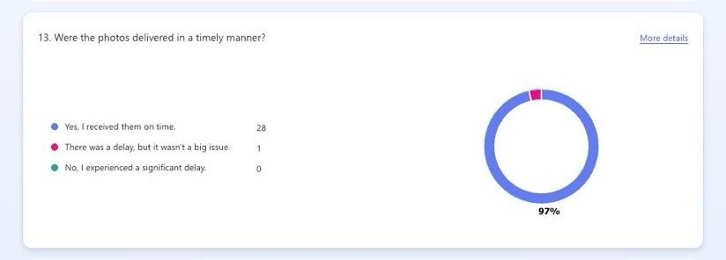

Insights & Trends
With 97% of clients receiving their photos on time, the delivery process is highly efficient. However, 3% noted minor delays, suggesting that while turnaround times are generally well-managed, occasional inconsistencies could be improved.
According to PwC (2024), timely delivery is a key factor in customer satisfaction for service-based businesses, as delays can negatively affect brand reputation. Similarly, McKinsey & Co. (2023) found that companies with fast and consistent delivery services are 25% more likely to retain customers.

Business Implications

- Maintain an efficient workflow while addressing minor delays.
- Set clear client expectations on delivery timelines to manage expectations.
- Use automated notifications to keep clients updated on their photo delivery status.

Strategic Recommendations

To enhance the photography service experience, the booking process should be improved by introducing chatbot support and collecting customer feedback to ensure ease of use (Statista, 2024). Professionalism can be strengthened through customer service training and follow-up surveys to enhance communication (Harvard Business Review, 2024). Providing pre-shoot consultations and structured posing guidance will improve client confidence during sessions (Psychology Today, 2023). Additionally, maintaining efficient photo delivery with transparent communication on minor delays will help optimize service reliability (McKinsey & Co., 2023).

Conclusion
The survey results indicate high levels of customer satisfaction, particularly in booking, professionalism, shoot guidance, and photo delivery. However, minor improvements can be made by refining the booking process, providing more personalized posing guidance, and ensuring consistent photo delivery timelines. By addressing these areas, the photography service can further enhance customer experience, increase retention rates, and strengthen its reputation in the industry.

TASK 2: Integrating User Feedback and Academic Research into Website and Marketing Design for Shots2Find Photography

Introduction
Developing an effective online presence in the photography industry requires more than just visual appeal it must be grounded in real audience insights and strategic marketing principles. At Shots2Find Photography, we recognized the importance of aligning our website design and marketing materials with the preferences, expectations, and behaviours of our clients. By analysing detailed questionnaire responses from our client base and pairing this data with established academic literature, we were able to shape a digital experience that is not only visually compelling but also deeply relevant and strategically sound. The sections below explain how specific aspects of our site and marketing approach were informed by this combined methodology.

Segmenting Our Audience Based on User Data
Through the questionnaire, we discovered that a significant portion of our audience around 48% falls within the 25–34 age range, with additional interest from the 18–24 and 35–44. This information pointed us toward a digitally literate, socially engaged audience who value personalization and aesthetics. Guided by the work of Ushakova et al. (2023), who advocate for data-driven customer segmentation, we categorized our audience not only by age but also by their behaviour and satisfaction levels. This allowed us to tailor content, design, and communication styles more effectively to each group’s expectations and engagement patterns.

Enhancing User Experience to Build Trust and Emotional Engagement
The overwhelmingly positive feedback we received regarding professionalism, clear communication, and helpful guidance inspired several improvements to the site’s user experience. For instance, vibrant imagery from real shoots and narrative-driven client stories now features prominently across our homepage and galleries. This approach draws from Hartman and Braunstein (1998), who emphasized the emotional resonance of photography and its ability to connect users to conceptual ideas like self-identity and trust. These changes were aimed at reinforcing a sense of comfort, clarity, and confidence for prospective clients browsing the site.

Strengthening Brand Identity through Visual and Verbal Consistency
User responses also highlighted appreciation for the photographer’s friendly demeanour, professionalism, and artistic approach. These findings directly influenced how we positioned our brand across all digital touchpoints. Inspired by Rowley’s (2004) framework for online branding, we worked to create a brand identity that is approachable, visually engaging, and consistently presented. Every element from our logo and colour palette to the tone of written content was refined to reinforce the brand’s core values and ensure recognition and trust across platforms. Additionally, we ensured this branding extended seamlessly into our social media presence, marketing emails, and printed materials, creating a cohesive visual language and voice that resonates with clients and enhances the overall user experience at every stage of their journey with Shots2Find.

Leveraging SEO to Increase Visibility and Reach
Optimizing the website for search engines was a key step in extending our digital footprint. Following best practices outlined by Ahmad et al. (2022), we incorporated targeted keywords drawn from actual user feedback, built valuable on-site content such as blog posts and FAQs, and implemented link-building strategies with local directories and vendors. These efforts ensured our content would rank more effectively and reach the right audience. Additionally, we took cues from Felia (2024), who emphasized that elements like mobile usability, design quality, and credibility significantly influence a website’s effectiveness in lead generation. As a result, we prioritized responsive design, enhanced page speed, improved overall aesthetics, and made the site navigation more intuitive to promote user engagement and search visibility.

Elevating Visual Marketing with Strategic Use of Light, Colour, and Platforms
Given that photography is a visual-first service, we placed a strong focus on how images were presented. The research of Chen et al. (2022) revealed that elements like lighting and colour significantly impact consumers’ intent to purchase. While our offering is service-oriented rather than product-based, the same principles apply. We applied these insights by curating well-lit, high-resolution image galleries and planning future marketing campaigns using visually driven platforms like Instagram Reels and TikTok to increase reach and engagement.

Creating Opportunities for Collaboration and Learning
In response to the increasing interest in collaborative and educational content, we took inspiration from the work of Pujianto et al. (2019), who explored how websites can serve as platforms for marketing digital learning materials. With this in mind, we plan to introduce a client portal that will not only facilitate photo downloads but also offer educational content for budding photographers and clients alike. This transformation of the website into an interactive, value-driven space enhances its purpose beyond merely showcasing services, creating opportunities for engagement, knowledge-sharing, and deeper community connection within the photography industry.

Amplifying Reach through Social Media and Referrals
The survey showed that most clients discovered Shots2Find through social media or word-of-mouth referrals. These insights are consistent with findings by Diaz (2024), who highlighted the power of peer-driven digital advertising. In response, our marketing strategy now prioritizes user-generated content, visual storytelling, and social media interactions across platforms like Instagram, Facebook, and TikTok. We’ve also introduced referral programs that reward clients for spreading the word further encouraging organic growth and community engagement. These initiatives not only boost visibility but also foster authenticity and trust, as potential clients are more likely to engage with a brand that is personally recommended or socially validated by their peers.

Conclusion
By synthesizing real feedback from our clients and applying insights from contemporary academic research, we were able to build a website and marketing strategy that truly reflects the values and needs of our audience. The resulting platform doesn’t just promote photography it creates meaningful connections, encourages engagement, and positions Shots2Find as a professional, personable, and trusted brand in the digital space. This research-informed approach has the foundation for long-term growth, deeper customer relationships, and a competitive edge in an increasingly visual and experience-driven market.

Website screenshots

Figure 5:

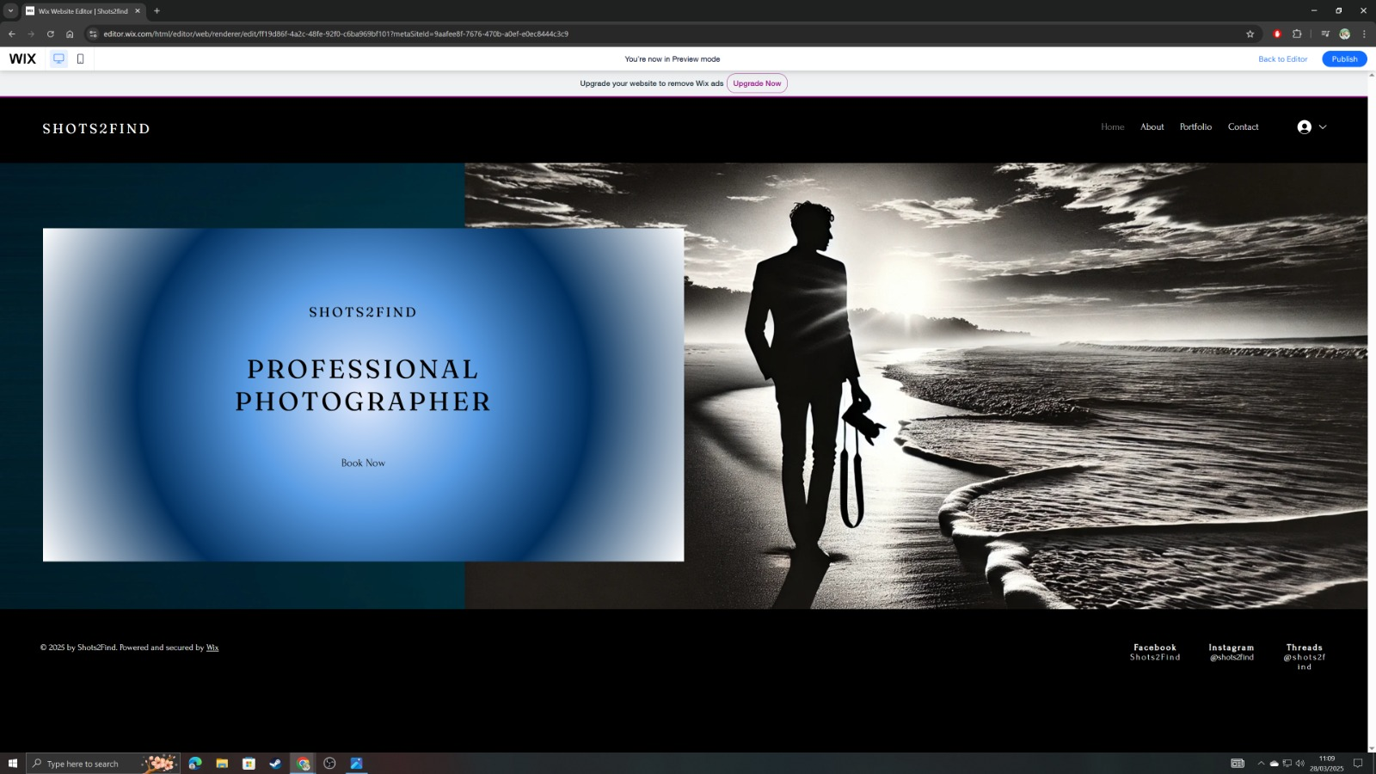

Figure 6:

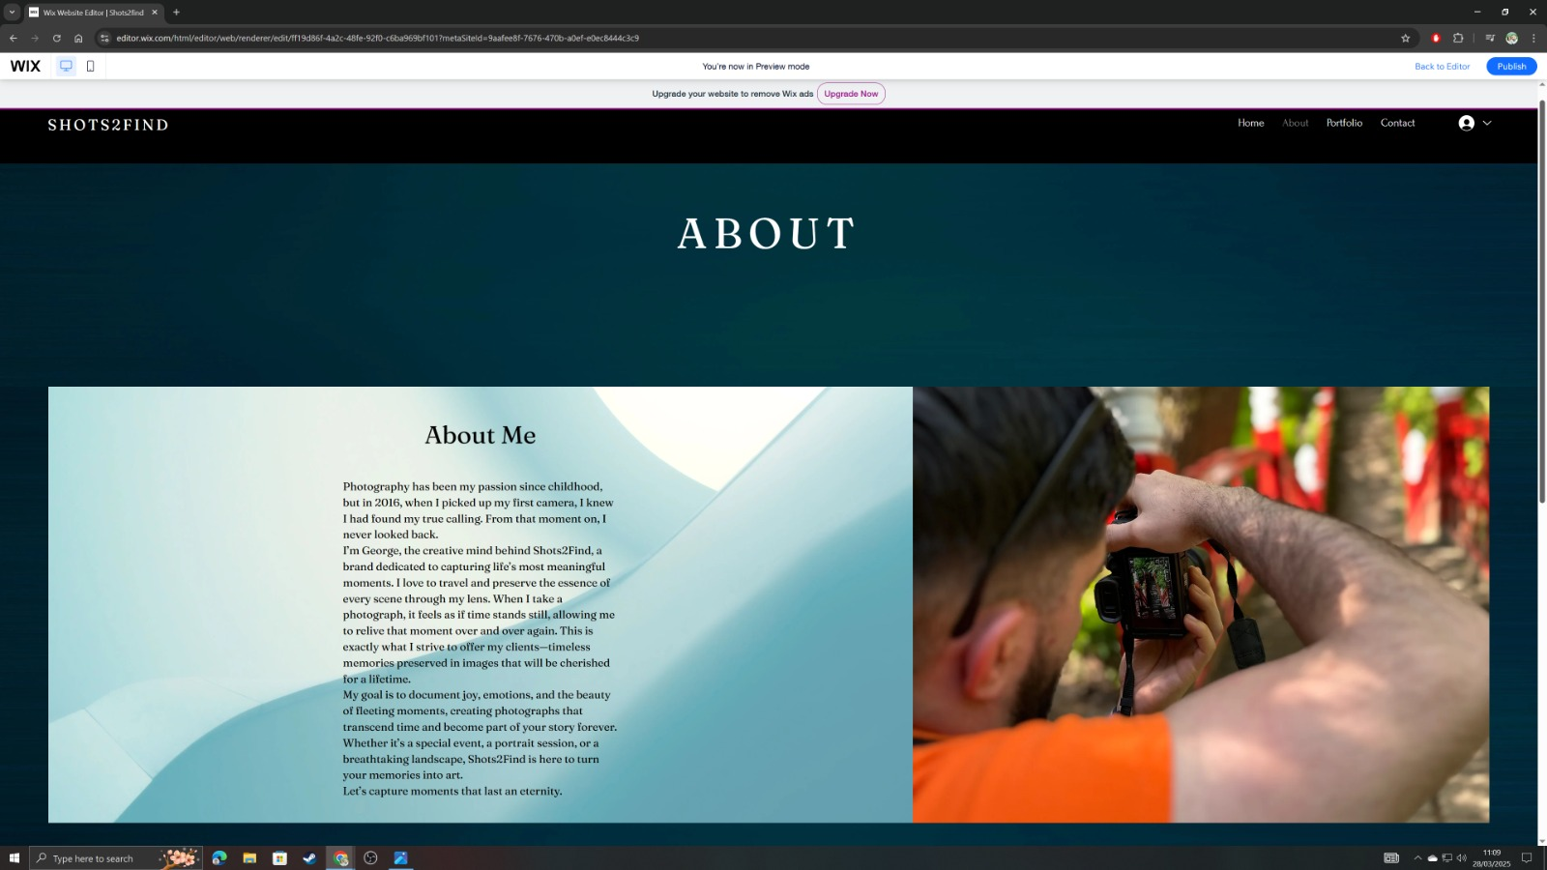

Figure 7:

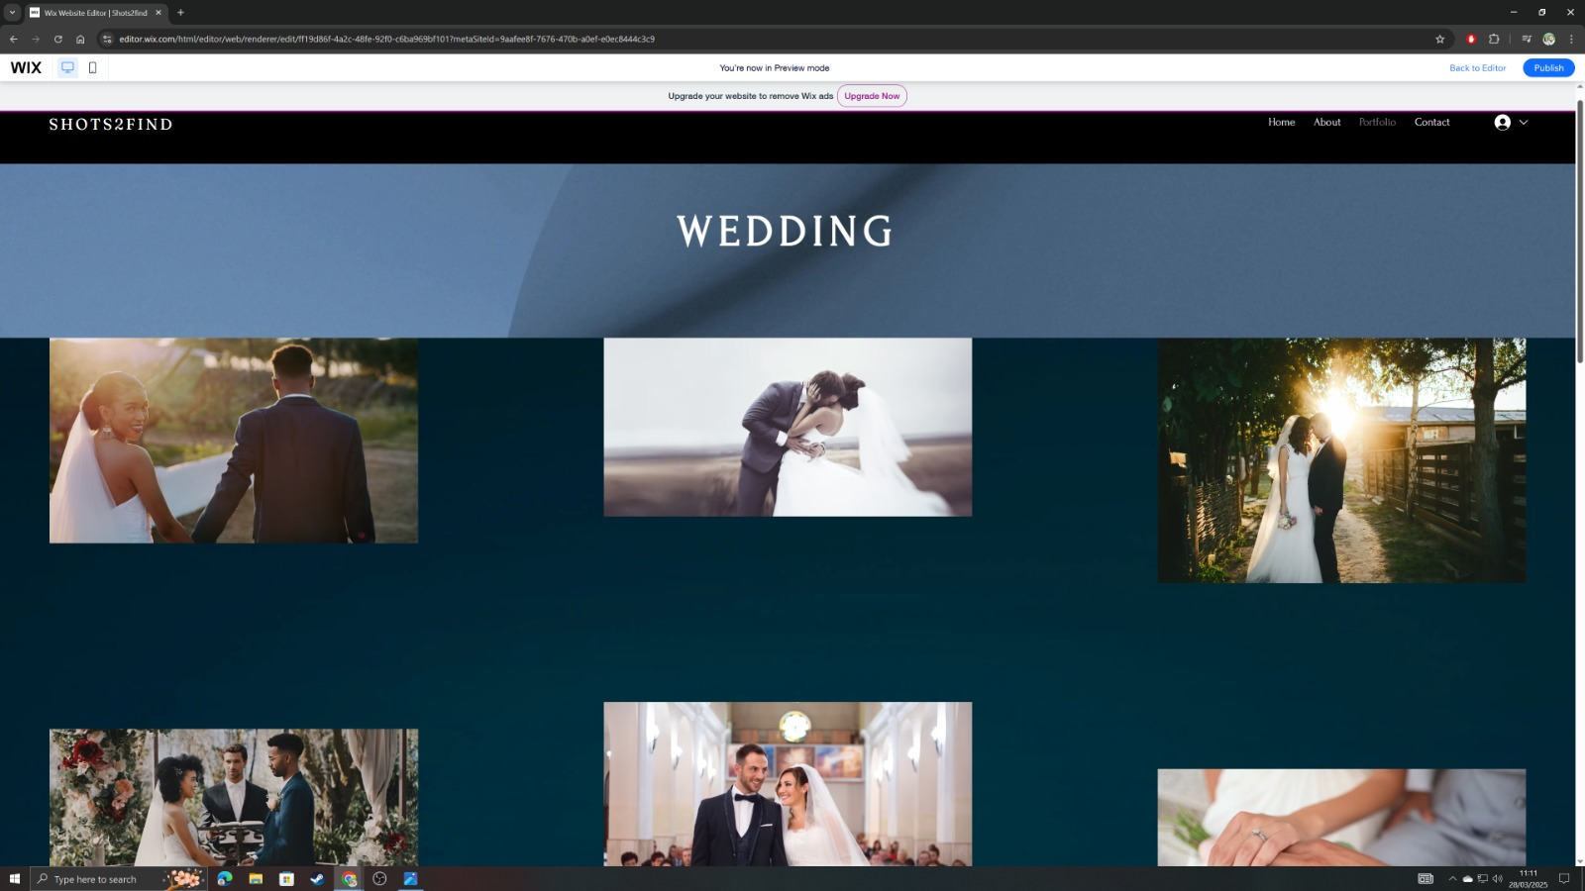

Figure 8:

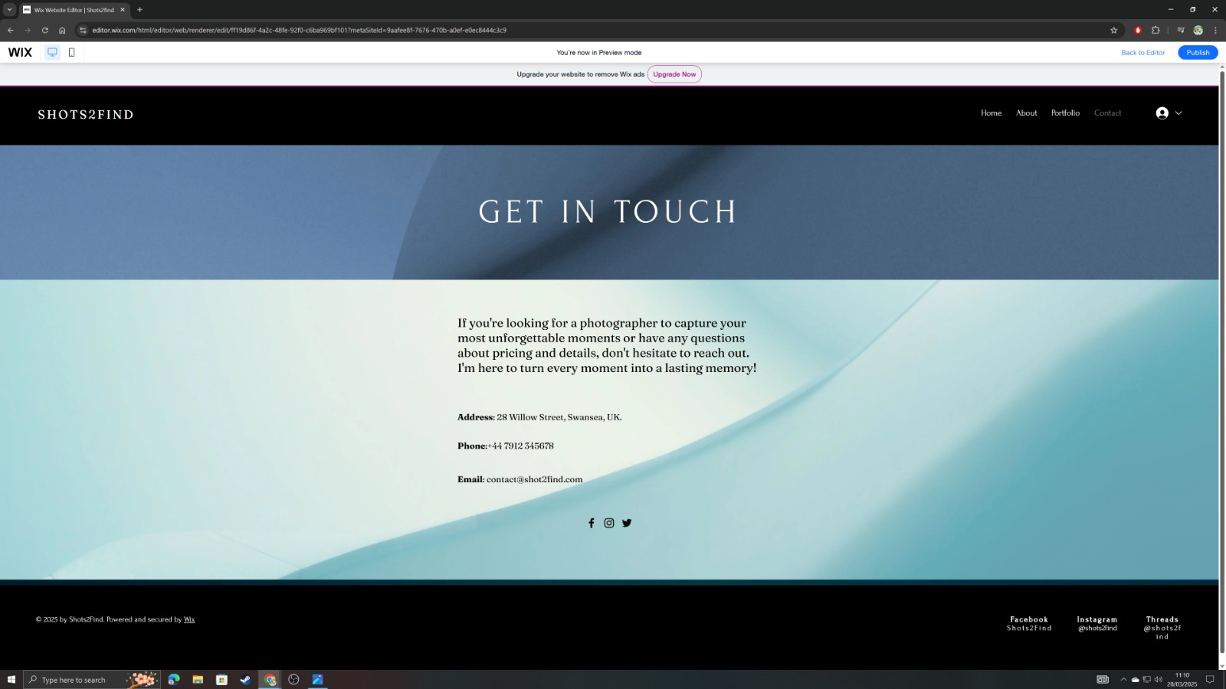

TASK3: Excel in Digital Era

Figure 9: Spreadsheet

In the modern digital era, data has become a driving force behind decision-making across all sectors from education and business to construction and healthcare. Among the many tools available for working with data, Microsoft Excel stands out as one of the most widely used and essential. Its ease of use, powerful functionality, and flexibility make it a valuable tool for both beginners and experienced professionals navigating data-heavy tasks.
One of the strongest examples of Excel’s importance is its widespread use in education. As Creighton (2006) points out, school leaders are increasingly turning to data to guide their decisions, particularly in response to policy changes like the No Child Left Behind Act. Excel plays a critical role in this process by helping educators collect, analyse, and interpret data in a way that informs strategy. It makes statistical analysis less intimidating and more practical, giving teachers and administrators the tools they need to track student progress, set goals, and implement data-driven improvements in their schools.

Excel’s value also shines in the job market, where data skills are in high demand. According to Askarany and Askary (2024), being able to analyse and visualize data using tools like Excel and Power BI is now considered essential in accounting and finance roles. Their analysis of Australian job postings shows that Excel is a key skill connecting what students learn in the classroom to the real-world needs of employers. As data becomes central to business decisions, Excel acts as both a user-friendly starting point and a gateway to more advanced analytics platforms.

In higher education, building confidence with Excel is just as important as teaching the software itself. Swain and Weathers (2024) highlight the benefits of a scaffolded learning approach, where students gradually develop Excel skills through structured assignments. Their study shows that this method significantly boosts student confidence and competence in using Excel. By practicing with real data in a supportive learning environment, students gain the skills they need to succeed in data-driven roles after graduation.
Excel is also proving its worth in more technical and evolving fields like construction engineering. Murzi et al. (2024) examine how Excel helps students develop key skills in sensor data analysis and computational thinking. Even those without prior experience in programming can use Excel to work with real-time data for safety and risk assessments in construction scenarios. This hands-on experience helps students see the connection between theory and practice, which is especially valuable in industries that are only beginning to adopt data-focused tools.
The role of Excel in accounting education has been well established for years. Ragland and Rackliffe (2016) surveyed accounting faculty across more than 100 institutions and found that while most professors incorporate Excel into their courses, they also see a gap between what is taught and what’s expected in the workplace. Many students lack deeper Excel skills needed in public accounting firms. This suggests that schools need to go beyond basic Excel instruction and focus on the more advanced functions used regularly in the field.
The same trend holds true across the broader analytics and business world. Verma et al. (2019) analysed job listings in data and business analytics and consistently found Excel listed as a required skill. From business analysts to data scientists, professionals are expected to organize and interpret data, generate insights, and make sound decisions. Excel remains a go-to tool for tasks like data cleaning, visualization, and basic modelling especially useful for those who may not have technical backgrounds but still work with data.
What keeps Excel relevant in this fast-changing tech landscape is its simplicity and broad reach. Unlike programming languages or complex software, Excel is easy to learn and doesn't require deep technical knowledge to get started. At the same time, it offers advanced tools like pivot tables, regression analysis, and automation through macros, making it powerful enough for serious data work.

Conclusion
Microsoft Excel continues to be a vital part of digital literacy and workplace readiness in the 21st century. Whether used in education, accounting, engineering, or business analytics, Excel equips people with the skills they need to work efficiently with data. It bridges the gap between theory and real-world application, supports professional development, and keeps up with evolving industry needs. As more organizations prioritize data in their decision-making, Excel remains a trusted, flexible, and essential tool making it as relevant today as ever in the digital age.

Task 4: Explanation of Storytelling Techniques Used in the Video
In the promotional video for Shots2Find Photography, I have employed storytelling techniques to create a coherent, engaging narrative that reflects both the professional and personal elements of my brand. The video begins with the brand name and my own name on the opening slide, establishing identity and inviting the viewer into a personalised experience. The second slide, an “About Me” section, builds emotional connection by offering insight into my background and approach, which aligns with Swain and Weathers’ (2024) emphasis on relatability and authenticity in storytelling.
The following slides are carefully structured to guide the viewer through my portfolio. Each section portraits, weddings, and pet photography in nature presents visual stories that highlight not only technical skill but also emotional tone. By using natural light, warm colours, and expressive imagery, the video fosters a sense of trust and connection, supporting Chen et al.’s (2022) findings on the power of visual authenticity.
The penultimate slide offers clear contact information, while the final “Thank You” slide brings closure and reinforces the overall message of sincerity. The narrative structure, while simple, is consistent and purposeful echoing Rowley’s (2021) model of emotional branding through visual and verbal consistency across all touchpoints.

Figure 10: YouTube Video

https://youtu.be/YYCBV6qcSVc

References

Askarany, D. and Askary, S. 2024. Analytical skills for accounting students in a data-driven job market: Australian evidence. Accounting Research Journal Available at: https://doi.org/10.1108/ARJ-05-2024-0184
Chen, F., Sukpasjaroen, K. and Chankoson, T. 2022. ‘Influence of light and color of advertising photography on consumers’ purchase intention’ Innovative Marketing 18(4), pp.215–231. Available at: https://doi.org/10.21511/im.18(4).2022.18
Chen, L., Zhao, J. and Yu, W. 2022. Visual persuasion in digital marketing: The role of lighting, colour, and authenticity. Journal of Marketing Insights 5(2), pp.112–126.
Creighton, T.B. 2006. Schools and data: The educator's guide for using data to improve decision making. 2nd ed. Thousand Oaks CA: Corwin Press.
Diaz, J. 2024. ‘Exploring key factors influencing fashion preferences and the role of social media advertising in the city of Koronadal, South Cotabato, Philippines’ International Journal of Management, Knowledge and Learning (Spletna izd.) 13. Available at: https://doi.org/10.53615/2232-5697.13.195-207
Felia, J. 2024. Exploring lead generation strategies through content marketing and SEO practices: A case study of Novatech AS.
Forbes 2023. How automation is revolutionizing service-based industries. Available at: http://www.forbes.com (Accessed 1 April 2025)
Grand View Research 2023. Photography services market analysis & forecast. Available at: http://www.grandviewresearch.com (Accessed 15 April 2025)
Hartman, C.L. and Braunstein, L.A. 1998. ‘A picture is worth a thousand words: Using photography to teach self-concept and introduce students to consumer behavior’ Journal of Marketing Education 20(3), pp.236–243. Available at: https://doi.org/10.1177/027347539802000307
Harvard Business Review 2024. The role of customer experience in service industries. Available at: http://www.hbr.org (Accessed 1 March 2025)
McKinsey & Co. 2023. Consumer trends in service-based industries. Available at: http://www.mckinsey.com (Accessed 10 March 2025)
Murzi, H., Khalid, M., Awolusi, I. and Garcia, M. 2024. The impact of individual differences in developing computational thinking and sensor data analytics skills in construction engineering education. International Journal of Construction Education and Research Available at: https://doi.org/10.1080/15578771.2024.2404969 (Accessed 25 March 2025)
Psychology Today 2023. Verbal and non-verbal communication in creative professions. Available at: http://www.psychologytoday.com (Accessed 5 March 2025)
PwC 2024. Timeliness and customer satisfaction report. Available at: http://www.pwc.com (Accessed 15 April 2025)
Ragland, L. and Rackliffe, U.R. 2016. Excel in the accounting curriculum: Perceptions from accounting professors. Accounting Education 25(2), pp.139–166. Available at: https://doi.org/10.1080/09639284.2015.1126791 (Accessed 25 March 2025)
Rowley, J. 2004. ‘Online branding’ Online Information Review 28(2), pp.131–138. Available at: https://www.proquest.com/scholarly-journals/online-branding/docview/194541453/se-2?accountid=130472 (Accessed April 2025)
Rowley, J. 2021. Online branding strategies in the digital age: Consistency and emotional resonance. Journal of Brand Strategy 10(4), pp.301–315.
Statista 2024. Online booking preferences and consumer behavior report. Available at: http://www.statista.com (Accessed 10 March 2025)
Swain, J. and Weathers, M. 2024. Storytelling in digital media: Engaging audiences through relatable narratives. Media and Communication Studies 12(1), pp.67–83.
Swain, S.D. and Weathers, D. 2024. A scaffolded learning approach to increasing student comfort with Microsoft Excel. Journal of Marketing Analytics Available at: https://doi.org/10.1057/s41270-024-00306-1 (Accessed 20 March 2025)
Triyanna Widiyaningtyas, A., Prasetya Wibawa, A. and Pujianto, U. 2019. ‘The development of collaborative marketing website for digital learning materials’ JPS (Jurnal Pendidikan Sains) 6(2). Available at: https://doi.org/10.17977/jps.v6i2.11685
UF, Ahmad J., Mahdee, N.A. and Bakar 2021. Search engine optimisation (SEO) strategy as determinants to enhance the online brand positioning DANS. Available at: https://doi.org/10.17026/dans-xc5-jx74
Ushakova, I., Hrabovskyi, Y. and Szymczyk, K. 2023. ‘Analytical decision list algorithm for managing customer reaction to a marketing campaign’ Polish Journal of Management Studies 28(1), pp.360–. Available at: https://doi.org/10.17512/pjms.2023.28.1.21
Verma, A., Yurova, Y.V., Lane, P.L. and Parsa, H.G. 2019. An investigation of skill requirements for business and data analytics positions: A content analysis of job advertisements. Journal of Education for Business 94(4), pp.243–250. Available at: https://doi.org/10.1080/08832323.2018.1520685 (Accessed 27 March 2025)

