University Of Wales Trinity Saint David

Future Developments in the Field of Marketing

Student name: Silvia Stancu ( 1906421)
Lecturer: Chris Wilkin

Executive Summary
This report assesses Marriott UK's marketing plan by looking at the definition and significance of marketing, the macro and micromarketing environment, the target market, and the media choices. The analysis draws the conclusion that Marriott UK's marketing strategy has a number of flaws based on the data, such as a lack of attention to the local market, a sparse use of social media, and insufficient investment in digital marketing. The report offers a number of suggestions to address these problems, including working with local communities, utilising social media, investing in digital marketing, and improving the customer experience.

Table of Contents
Executive Summary 2
Introduction 4
Task 1: Critical evaluation of Marriott UK marketing activities 4
The Concept and Importance of Marketing 4
Marketing Environment (Macro and Micro) 5
Target Market 7
Media Selection 8
Measuring Success 8
Task: 2 Conclusion: Shortcomings of Marriott's Marketing Strategy 9
Shortcomings: 9
Task: 3 Recommendations to strengthen the marketing plan of Marriott UK 10
Conclusion 13
Recommendations 14
References 15
Appendix 17

Introduction
One of the top hotel operators in the world, Marriott International manages more than 7,600 hotels in 133 countries and territories. With a wide range of brands in its portfolio, Marriott has been able to satisfy the requirements and taste of a wide spectrum of visitors. However, because of how fiercely competitive the hospitality sector is, Marriott has a difficult time luring and keeping consumers. The effectiveness of Marriott's marketing plan is one of the main determinants of success. With an emphasis on the concept and significance of marketing, the macro and micro marketing environment, target market(s), media selection, and success measuring, this research seeks to critically assess Marriott's marketing strategy. The analysis' findings will be utilised to create recommendations for marketing plan for Marriott.

Task 1: Critical evaluation of Marriott UK marketing activities

The Concept and Importance of Marketing
Marketing is the process of producing, conveying, delivering, and exchanging value-added offerings for customers, clients, partners, and society as a whole. It is a crucial function that enables organisations to comprehend customer requirements, develop products and services to match those requirements, and convey the value of those offers to target customers. Marriott International invests heavily in marketing to increase brand awareness and generate bookings across its 30 hotel brands. According to the company's annual report, sales and advertising expenses in 2020 will total $1.5 billion. This is a reduction from the previous year, owing to the COVID-19 pandemic's influence on the hospitality industry (Correia, 2022).
Marriott UK reaches out to its target customers through a variety of marketing activities such as marketing, public relations, promotions, and sponsorships. Traditional and digital media, such as television, print, and online advertising, are used in the company's advertising campaigns. In 2020, Marriott UK, for example, released a television advertising campaign advertising its Marriott Bonvoy reward programme, which featured a family on a road trip staying at several Marriott hotels. To build its brand reputation, it will use public relations, with a focus on environment and involvement in the community. For example, the corporation has implemented various environmental initiatives, such as decreasing single-use plastics and obtaining sustainable seafood for its restaurants (Quesenberry, 2020).
Promotions and sponsors are also used by the company to boost bookings and raise brand recognition. Marriott UK, for example, offers seasonal promos and packages, such as its winter holiday package, which includes benefits like breakfast and a spa treatment. The corporation also sponsors events like the London Marathon, which exposes it to a large number of potential clients.
Overall, Marriott UK's marketing investment is large, indicating the importance of marketing in creating and preserving the company's brand name (Claudy et al., 2019).

Marketing Environment (Macro and Micro)
Numerous elements in the macro and micro marketing environments have an impact on Marriott UK's advertising approach. These elements influence the company's marketing strategy and enable it to adapt to market developments.
Macro Environment:
Economic Environment: The economic environment, particularly consumer spending and economic growth, has an impact on Marriott UK's marketing strategy. For instance, the business changed its marketing approach during the COVID-19 epidemic to concentrate on local travel and staycations in order to draw clients who were unable to travel abroad. This was reflected in the business' "Discover Local" marketing strategy, which urged clients to discover their local areas and book stays at Marriott hotels throughout the UK (Nozdreva and Churakova, 2021).
Technological Environment: The marketing plan for Marriott UK has been impacted by the technological environment. Customers can reserve accommodations, get credits, and use hotel amenities using the Marriott Bonvoy app, for instance. The company's marketing initiatives, which frequently emphasise the convenience and simplicity of booking through digital channels, are consistent with this technology-driven approach.
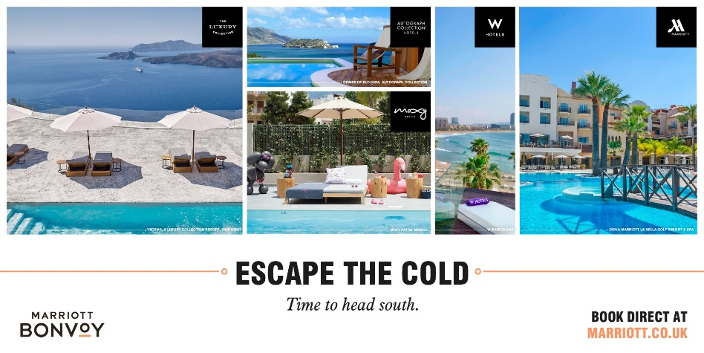
Figure 1(Mobile Marketing Magazine, 2023).

Micro environment:
Competitors: Hilton, Accor, and IHG are just a few of the hospitality companies that fiercely compete with Marriott UK. The company's marketing strategy has been impacted by the competition because it must differentiate its services and provide distinctive value propositions in order to draw in and keep clients. For instance, to encourage repeat business, Marriott UK's "Marriott Bonvoy" loyalty programme provides members with exclusive prizes and advantages including free hotel upgrades and complimentary breakfasts (Nozdreva and Churakova, 2021).
Suppliers: Vendors of food and beverages are just one example of the suppliers that affect Marriott UK marketing approach. To assist the neighbourhood and promote its environmental initiatives, the company frequently collaborates with regional vendors. For instance, Marriott UK's "Rooted in Nature" marketing initiative emphasised the company's dedication to obtaining organic and regionally farmed food for its hotels and restaurants.
Intermediaries: The use of intermediaries, such as tour guides and online travel agencies (OTAs), is also a part of Marriott UK's marketing plan. To reach a larger audience, the business must balance its direct booking channels, such as its website and mobile app, with alliances with OTAs. As an illustration, Marriott UK frequently partners with OTAs like Expedia and Booking.com to offer special deals and promotions to entice price-conscious clients (Іerko and Rudyk, 2020).

Target Market
The primary target market for Marriott UK is made up of business and vacation travellers seeking first-rate lodging, amenities, and services. The company offers a wide selection of hotel brands that serve various market sectors, from upscale accommodations to more affordable choices. To effectively reach its target customers, Marriott UK combines market segmentation, targeting, differentiation, and positioning techniques.
Market Segmentation: Marriott UK employs market segmentation to break the market up into more manageable categories according to the demands, tastes, and habits of each group. By providing convenient locations, conference spaces, and business centres, Marriott UK, for instance, caters to business travellers. By including amenities like restaurants, spas, and swimming pools, it also caters to leisure guests (Maltseva et al., 2021).
Targeting: Marriott UK employs differentiated targeting in their various market segments with tailored offers that satisfy their demands. For instance, the company's premium brands, like The Ritz-Carlton, cater to high-end visitors who appreciate exclusivity and luxury, while its value-oriented brands, like Courtyard by Marriott, cater to travellers who are cost-conscious and value-driven (Niemelä, 2019).
Differentiation: Marriott UK distinguishes its hotel brands by providing distinctive features, facilities, and services that address certain market niches. For instance, its W Hotels brand features hip design, a vibrant nightlife, and services that are fashion-focused, while its Marriott Hotels brand offers a "Meetings Imagined" programme that offers customizable meeting spaces.
Positioning: Marriott UK presents its hotel brands as suppliers of first-rate services, amenities, and guest experiences. The business touts its innovative capabilities in the hospitality sector, with an emphasis on technology, sustainability, and wellness.
Marriott UK use a variety of marketing mix components to successfully connect with its target audience. For instance, the business communicates with clients via social media and email marketing, and it provides booking incentives like loyalty programmes, deals, and packages. To make sure that its team gives great service to clients, the business also makes investments in the training and development of its employees (Visser, 2021).
Overall, Marriott UK's targeting tactics are successful in attracting a variety of customers by providing unique goods and services that suit their tastes and demands. The company's focus on sustainability, technology, and wellness is in line with current consumer trends and contributes to its positioning as a pioneer in the hotel sector (Conrady, 2020).

Media Selection
Marriott UK communicates with its customers using a variety of platforms, including social media, email marketing, search engine optimisation, and traditional advertising. The company has a strong social media presence, having accounts on the following networks: Facebook, Instagram, Twitter, and LinkedIn. In order to promote repeat reservations, Marriott UK's email marketing efforts feature personalised incentives and promos. Search engine optimisation is also used by the company to increase its exposure in online searches. Overall, Marriott UK's media selection is acceptable and effective, with the company reaching out to its target customers through a variety of channels (Buhalis et al., 2019).

Measuring Success
The success of Marriott UK's marketing campaigns is measured using website traffic, bookings, social media participation, and customer feedback are all examples of metrics. Data analytics are used by the organisation to track client behaviour and preferences, allowing it to fine-tune its marketing strategy and services. Marriott UK's marketing approach is typically effective, as evidenced by the company's consistent top rankings in brand reputation surveys and good revenue growth. However, the corporation is still dealing with the COVID-19 pandemic, which has had a huge impact on the hospitality industry (Khalimova, 2020).
The company has a sharp emphasis on its target market and use a number of marketing channels to reach them, according to the research of Marriott International's marketing strategy. The marketing plan does have a few flaws, though, that might be fixed to increase the impact of the ads.

Task: 2 Conclusion: Shortcomings of Marriott's Marketing Strategy

Shortcomings:
Rely on digital marketing too much
The fact that Marriott mainly relies on digital marketing channels, such social media platforms and email marketing, to reach its target audience, is one of the company's weaknesses in terms of marketing strategy. Even though digital marketing is a crucial component of every marketing plan, leaning too much on it can restrict the audience for the brand's message. Older clients, for instance, who might not be as active. These techniques might not be effective for digital channels (Mathews, Pattnaik and Panda, 2018).
Inconsistent Brand Messaging
Marriott's marketing plan also has an issue with inconsistent brand messaging. With over 30 hotel brands under its management, each has a distinctive value proposition and messaging. Although this strategy enables Marriott to serve a wide spectrum of clients, it can also result in inconsistent brand messaging. Customers may become confused as a result and creating a distinct brand identity may become challenging.
Limited Attention Paid to Sustainability
Customers are paying more attention to sustainability as a concern, and many want hotels to take the lead in this area. While Marriott has made some sustainability-related initiatives, including with its Green Hotels Global project, there isn't enough focus on sustainability in the marketing plan of the business. For its marketing initiatives, Marriott might gain by emphasising sustainability as a major message to draw in clients that value ecologically sound behaviour (Buhalis and Cheng, 2020).
Business travellers are only partially targeted
While a wide spectrum of clients, including families, business travellers, and leisure travellers, are targeted by Marriott's marketing approach, business travellers are not given as much attention. Business travellers are a valuable market for hotels since they frequently travel over longer distances and have greater spending habits. To draw business travellers, Marriott could profit from using more focused marketing strategies.
Even though Marriott has a solid marketing plan, there are several issues that might be fixed to increase the efficiency of its advertising campaigns. Among them is decreasing the excessive reliance on Increasing the targeting of business travellers, using digital marketing, creating a more unified brand message, and emphasising sustainability. By resolving these issues, Marriott might improve the success of its marketing initiatives and forge a more solid brand identity (Alnawafleh et al., 2019).

Task: 3 Recommendations to strengthen the marketing plan of Marriott UK
One of the biggest hotel chains in the world, Marriott International has a significant footprint in the global hospitality sector. However, as noted in Task 2, there are several issues with Marriott's marketing plan that might be fixed to increase the success of its efforts. The following suggestions are made to improve Marriott's marketing approach based on the findings from Task 2.
To lessen its over-reliance on digital marketing platforms, Marriott should diversify its marketing mix. Even if it is crucial in the current economic climate, only one marketing channel should be used. To reach its target audience, Marriott should think about utilising conventional marketing strategies like print commercials, radio ads, and billboards. Marriott, for instance, to offer packaged packages that could be promoted through conventional media means, team up with airlines, tour operators, or car rental firms. With this strategy, Marriott may connect with clients who might not be frequent users of digital media platforms and raise brand awareness (Francis et al., 2020).
Consistent Brand Messaging: With more than 30 hotel brands under the Marriott umbrella, it is crucial to create a unified brand identity and messaging. Marriott could take a more centralised approach to messaging in which all of its hotels abide by a single messaging structure. By using this strategy, the confusion brought on by the Marriott brand's various hotels using various messaging strategies will be removed. Marriott, for example, might strengthen its basic values by using its "Bonvoy" reward programme using language like "Stay for the experience, not just the stay.”
Promote Sustainability: Customers are growing more and more concerned about sustainability, so Marriott's marketing approach might be improved by promoting its sustainability initiatives. To draw clients that value ecologically friendly behaviours, Marriott might make sustainability a central theme of its marketing campaigns. For instance, Marriott might promote the use of environmentally beneficial practises like recycling, energy-efficient lighting, and water conservation in its hotels by utilising its Green Hotels Global project (Ergashev and Berdiev, 2020).
Target Business Travellers: Marriott should expand its focus on this market segment, which consists primarily of business travellers, by implementing more targeted marketing strategies. For business travellers, Marriott might provide specialised services such meeting rooms, and high-speed internet, and use specialised advertising to reach them. To draw business travellers, Marriott may potentially work with airlines to provide packaged deals that include both hotel and flight reservations. Business travellers may also receive loyalty rewards from Marriott, such as free hotel upgrades and savings on subsequent bookings, in addition to other benefits.
Utilise Influencer Marketing: Marriott may make use of the growing popularity of this marketing tactic to reach more people. Marriott may collaborate with social media influencers who are well-liked by its target market. Influencers could produce material for social media channels emphasising their visits to Marriott hotels. By using this strategy, Marriott could enhance brand awareness among potential new customers as well as the brand's reputation among younger age groups (Domínguez-Navarro and González-Rodríguez, 2020).
Engage in data analytics to learn more about the preferences and behaviour: With this strategy, Marriott would be able to create marketing efforts that are specifically suited to the wants and preferences of its target audience. Additionally, data analytics would assist Marriott in recognising new industry trends and modifying its marketing plan accordingly. Marriott, for instance, may utilise data analytics to determine which social media sites are where the majority of its target demographic is active, and then modify its social media approach accordingly.
Cooperate with Local Communities: In order to establish its brand in regional markets, Marriott should cooperate with local communities. With this strategy, Marriott would be able to forge a solid bond with the neighbourhood and raise the likelihood of returning customers. Marriott may support neighbourhood organisations, donate to neighbourhood causes, and assist local students through scholarships. Marriott would be able to build a favourable perception of its brand and establish itself as a responsible and reliable business by interacting with the neighbourhood. Additionally, by taking this method, Marriott would be better able to comprehend local customs and tastes, which might be helpful in modifying its marketing plans to better suit regional clients' requirements (Kolobkova et al., 2021).
Utilise Social Media: Marriott may use social media to reach more people and have more interactive interactions with customers. Marriott may raise its visibility and draw in more clients by producing and disseminating interesting content on websites like Facebook, Instagram, and Twitter. Social media could also be used to target clients with discounts and recommendations based on their interests and past bookings. This might aid Marriott in increasing customer loyalty and retention. Additionally, social media might be a forum for clients to share their stories and offer feedback, which could be helpful in identifying problem areas and resolving client issues (Çınar and Weiss, 2020).
Invest more in digital marketing: Marriott might spend more money on this strategy in order to more effectively target its customers and strengthen its online presence. This can entail utilising search engine optimisation (SEO) methods to raise the ranking of its website in search engine results and spending money on pay-per-click (PPC) advertising to reach clients looking for lodging online. Additionally, Marriott may use email marketing to connect with its clients and make tailored offers and suggestions to them. Marriott might increase its reservations and revenue by spending more on digital marketing to increase its online exposure and get more visitors to its website (Ofosu-Boateng and Acquaye, 2020).

Conclusion
The marketing plan of Marriott UK has a number of advantages, including a strong brand reputation and a large selection of goods and services. There are, however, a number of areas that can be improved, such as the lack of attention paid to the local market, the sparse use of social media, and insufficient investment in digital marketing. The report advises Marriott UK to work with regional communities, take advantage of social media, engage in digital marketing, and improve the customer experience to overcome these problems. These suggestions would assist Marriott UK in reaching a larger audience, building a positive brand image, and enhancing client loyalty and retention.

Recommendations
The following suggestions are given to Marriott UK based on the findings of the report:
- Work together with regional organisations to build the brand in the area's markets and raise the likelihood that customers will come back.
- Utilise social media to connect with customers in a more engaged way and reach a bigger audience.
- Spend more money on digital marketing to improve your online presence and better target your customers.
- By giving clients more individualised services and experiences, you may improve the customer experience.

References
Alnawafleh, H., Alghizzawi, M. and Habes, M., (2019). The impact of introducing international brands on the development of Jordanian tourism. International Journal of Information Technology, 3(2), pp.30-40.
Buhalis, D. and Cheng, E.S.Y., (2020). Exploring the use of chatbots in hotels: technology providers’ perspective. In Information and Communication Technologies in Tourism 2020: Proceedings of the International Conference in Surrey, United Kingdom, January 08–10, 2020 (pp. 231-242). Springer International Publishing.
Buhalis, D., Harwood, T., Bogicevic, V., Viglia, G., Beldona, S. and Hofacker, C., (2019). Technological disruptions in services: lessons from tourism and hospitality. Journal of Service Management.
Çınar, K. and Weiss, D., (2020). Digital marketing and virtual tourism to enhance destination accessibility. In Sustainable destination branding and marketing: strategies for tourism development (pp. 198-204). Wallingford UK: CABI.
Claudy, M., Doyle, G., Marriott, L., Campbell, N. and O’Malley, G., (2021). Are sugar-sweetened beverage taxes effective? Reviewing the evidence through a marketing systems lens. Journal of Public Policy & Marketing, 40(3), pp.403-418.
Conrady, R., (2020). Development of the Macro-environment of the (Luxury) Tourism Market. Luxury Tourism: Market Trends, Changing Paradigms, and Best Practices, pp.7-31.
Correia, H.F.P.R.N., (2022). Marriott international inc. equity research-consolidating a leading position amid recovery (Doctoral dissertation).
Domínguez-Navarro, S. and González-Rodríguez, M.R., (2020). Social Media managerial implications for budget accommodation venues: use of Social Media platforms more effectively and efficiently. Quality & Quantity, 54(5-6), pp.1671-1689.
Ergashev, T.K. and Berdiev, J.Q., (2020). THEORETICAL AND PRACTICAL ASPECTS OF USING MODERN MANAGEMENT METHODS IN THE HOTEL INDUSTRY. Theoretical & Applied Science, (4), pp.849-859.
Francis, K., Wamathai, A., Wandaka, J.K. and Jilo, N., (2020). Analysis of the skills gap in tourism and hospitality industry in Kenya. Journal of Tourism Management Research, 7(1), pp.42-51.
Khalimova, N.J., (2020). Analysis of foreign experience in hotel career enhancement programs. Central Asian Problems of Modern Science and Education, 2020(2), pp.3-14.
Kolobkova, V.A., Romanov, A.A. and Frolova, E.A., (2021). Digital technologies in the hotel industry: new prospects for sustainable development. Socio-economic Systems: Paradigms for the Future, pp.387-394.
Maltseva, M.V., Tsunaeva, Y.O., Arakelian, A.M. and Galazova, S.S., (2021). Information and Networking Technologies in the System of Promotion of Hotel Services. In " Smart Technologies" for Society, State and Economy 13 (pp. 1440-1450). Springer International Publishing.
Mathews, N.E., Pattnaik, M. and Panda, S., (2018). Six Sigma Analysis in Indian Hospitality Industry: Marriott Hotel.
Niemelä, M., (2019). Brand management strategies of hotel chain sub-brands Sheraton Marriott and DoubleTree by Hilton.
Nozdreva, R. and Churakova, A., (2021). Digital tools in empirical marketing strategies of global hotel companies. Digital strategies in a global market: Navigating the Fourth Industrial Revolution, pp.213-227.
Ofosu-Boateng, I. and Acquaye, P., (2020). Effects of service quality and customer satisfaction on customers’ loyalty in the hospitality industry of Ghana. European Journal of Business and Management Research, 5(5).
Quesenberry, K. A. (2020). Social Media Strategy: Marketing, Advertising, and Public Relations in the Consumer Revolution. Rowman & Littlefield.
Visser, M., (2021). Digital Marketing. In Digital Marketing Fundamentals (pp. 12-28). Routledge.
Іerko, I. and Rudyk, A., (2020). Ecological marketing as a tool of strategy of hotel business and tourism development. Economic journal of Lesya Ukrainka Volyn National University, 3(23), pp.77-83.

Appendix

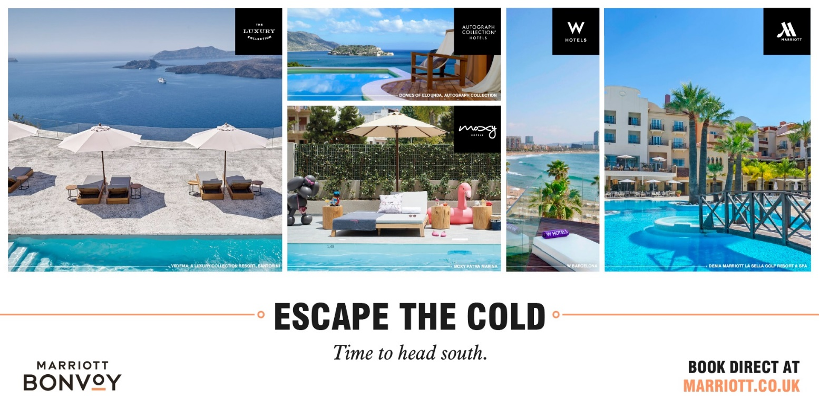
Figure 1(Mobile Marketing Magazine, 2023).

