Suspect Interview Criminal Damage Task Sheet
Scenario 9 Criminal Damage to a car – Suspect brief

Criminal damage to a car - Suspect brief

Criminal Damage- Suspect
Suspect details: Your details
Suspect address: Your details

Caution reply;
“YOU CAN FUCK OFF, I HAVENT DAMAGED FUCK ALL”.

Instructions-
You were arrested this morning on suspicion of Criminal Damage. This was at your previous place of work as an assistant grounds person at Vantage Point Cwmbran.

You will admit to the officers that you used to work at Vantage Point as an assistant to the current grounds person (details supplied by trainer), but was fired illegally by your boss because you were so much better than them.

You returned to the site to collect your tools which you purchased prior to starting work at the site and wanted them back after leaving quickly when fired due to an argument.

You will confirm an argument took place with the grounds person when you were collecting your tools and left with your property. You will say that the grounds person

Shouted at you but you cannot recall what was said and that you shouted back but cannot remember, but you know that it was heated.

It was alleged that day that you made threats to cause Criminal Damage and you were arrested for that. The decision by the custody unit for the previous incident was No Further Action.

Being annoyed at what has happened you return to Vantage Point and you locate the grounds person’s car and write “TOSSER” on the bonnet in a permanent felt pen. You have the pen in your possession when you are searched by the police officer.
!! Watch the video !!

The police arrive and you are consequently arrested on suspicion of CRIMINAL DAMAGE.

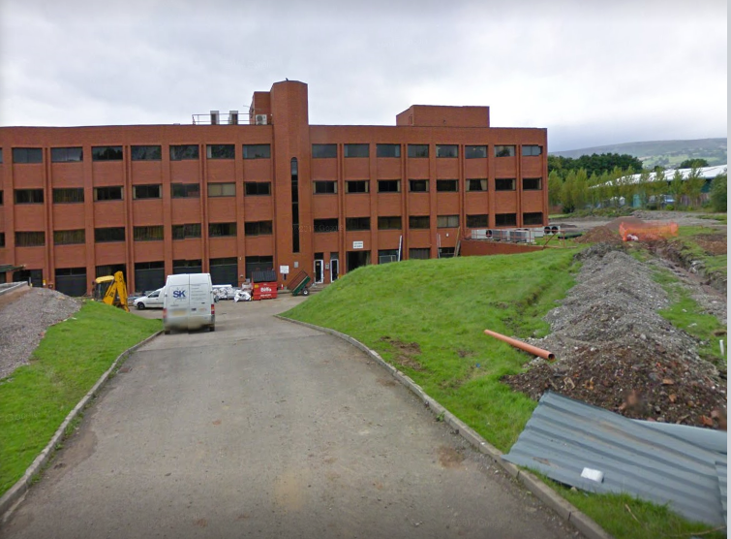

INTERVIEW

Initially you reply;
“NO COMMENT”.

Then revert to your account but deny writing on the window of the car.
When the police locate a pen on you, you tell them that it must be one of your children’s felt tip pens.
Tell them that the writing was already on the window.

Aims of the Scenario

- The aim of investigative interviewing is to obtain accurate and reliable accounts from victims, witnesses or suspects about matters under police investigation.
- Investigators must act fairly when questioning victims, witnesses or suspects. Vulnerable people must be treated with particular consideration at all times.
- Investigative interviewing should be approached with an investigative mind-set. Accounts obtained from the person who is being interviewed should always be tested against what the interviewer already knows or what can reasonably be established.
- When conducting an interview, investigators are free to ask a wide range of questions in order to obtain material which may assist an investigation.
- Investigators should recognise the positive impact of an early admission in the context of the criminal justice system.
- Investigators are not bound to accept the first answer given. Questioning is not unfair merely because it is persistent.
- Even when the right of silence is exercised by a suspect, investigators have a responsibility to put questions to them.

Outcome of the Scenario

- Aim: To Provide interviewers with the competence to prepare and plan interviews with suspects.
- Objectives
- Assess information gathered about suspect(s)
- Assess the type and current condition of the suspect to inform the approach to the interview in accordance with legal requirements.
- Establish the correct interview approach utilising the engage and explain phase aide memoir
- Identify the nature of the allegation and identify investigative important information
- Produce a written interview plan that takes account of the suspect assessment , the needs of the investigation and legal requirements
- Select and set up the necessary interview location, resources and personnel.

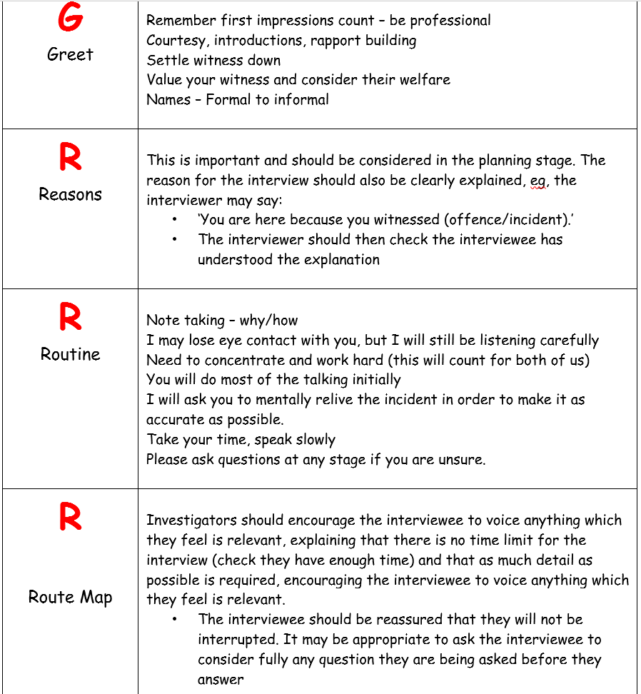

Criminal Damage Act 1971 - destroying or damaging property

Section 1 of the Criminal Damage Act 1971
1(1) A person who without lawful excuse, destroys or damages any property, belonging to another, intending to destroy or damage any such property or being reckless as to whether any such property would be destroyed or damaged shall be guilty of an offence.
1(2) A person who without lawful excuse, destroys or damages any property, whether belonging to himself or another -
(a) intending to destroy or damage any property or being reckless as to whether any property would be destroyed or damaged; and
(b) intending by the destruction or damage to endanger the life of another or being reckless as to whether the life of another would be thereby endangered;
Shall be guilty of an offence
1(3) An offence committed under this section by destroying or damaging property by fire shall be charged as arson. (see note (vii) below)
Notes
(i) It is bad for duplicity to charge for both 'destroying' and 'damaging' property so, wherever possible, a choice should be made;
Destroyed - Property which has been destroyed must be incapable of being repaired and must be replaced. In practice, if something has been destroyed, the value specified in the charge should reflect the full replacement cost.
Damaged - Property which has been damaged is that which has suffered some physical harm, impairment or deterioration. The value of the damage should reflect the cost of the repair.
(ii) If an offence under this section is racially or religiously aggravated, you should consider the more serious version of this offence under section 30 of the Crime and Disorder Act 1998.
(iii) Low value offences - where the value of the damage is below five thousand pounds, the offence can only be tried at a Magistrates Court. However, for all other purposes, it is still has the status of an 'either way offence'. It is possible to charge 'attempted criminal damage' of whatever value. For more on these issues, please see section 22 of the Magistrates' Court Act 1980.
(iv) Officers should be aware that endanger life in relation to criminal damage, does not require attempt to kill, otherwise murder or manslaughter would be the more appropriate charge and there is no requirement for any actual injury. It is sufficient that life was endangered; for example, if a jealous husband cuts the brake pipe of his

rivals car, no harm may actually come to the intended victim, but the potential for harm exists.
However, either intent or recklessness must be proved and the potential for harm to someone other than the defendant must be proved. The actual damage caused must also be the cause of the danger, shooting at someone in a room through a window both endangers life and damages the window, but it is not the damage that endangers the life.
(v) The same incident may involve separate activities, some causing ordinary damage and some damage by fire (for example, protestors break into a laboratory building, smash laboratory equipment and set fire to some files). In such circumstances they are separate offences and best charged as such (R v Booth 1999).
(vi) There is a special offence of criminal damage to an ancient monument in section 28 of the Ancient Monuments and Archaeological Areas Act 1979. The advantage of using this offence is that the owner can be prosecuted for damaging a protected monument which he owns (the term 'belonging to another' having been omitted from the wording).
(vii) For an offence of arson to be complete, some of the damage must be by fire, this does not include smoke damage. Intent or recklessness as regards the use of fire must be proven. It is a common defence to arson that a burglar dropped a lighted match that he was using for illumination. Most arsons involve the use of 'accelerants' such as petrol or lighter fuel to start the fire. If it is suspected that accelerants might have been used, special procedures need to be implemented in order to obtain forensic samples.

