Project Planning, Monitoring and Control

M3X8761

Mark Studley – 1811227
Words - 3118

Contents
Introduction 3
Background 4
Case study 6
Solutions 7
Discussion 8
Conclusion 13
References 14
Appendixes 15

Introduction
The purpose of this report to is to undertake a cash flow forecast analysis for a construction project to build a commercial building. The investigation will utilise cost forecasting techniques to calculate monthly cost expenses for the project. Using information contained in a Gantt chart for the project, monthly invoices and payments will be calculated, taking into account both profit and retention. The investigation will identify the amount of locked up capital each month along with the total payments received. From this financing options and costs will be examined and the ultimate viability and profitability of the scheme will be determined.

Background.
An important element within any construction scheme is the cash flow forecast. It is key to programme planning and control and has a number of uses. Cash flow can be used for negotiating financing options such as overdrafts or loans, anticipating cash shortages and to support the financial control of contracts. Cash flow forecasting is key to ensuring companies avoid overtrading (Cooke and Williams, 2013).
Overtrading can result in the failure of a company or organisation due to liquidity problems. If a company is unable to raise the capital it requires for projects or is forced to rely on more expensive reactive financing options such as overdrafts it is likely to struggle long term (Ogilvie and Graham, 2008).
Cash forecasting depends on the ability to accurately predict a number of key variables. Variables that can influence the ability to accurately predict cash flow include, predicting the timeframes of work, obtaining accurate costs for the tasks to be undertaken and accurate prediction of when payments will be made or received (Fitzgerald, 2002).
As stated by Kalb, cash flow is not always certain and continually needs to be updated. He argues that forecasts should be updated on a daily basis as conditions, cash positions and underlying assumptions will change (Kalb, 1992)
Cash flow forecast will directly influence how a company operates. If the forecast indicates a deficit is likely the business can make arrangements to raise additional cash. If a surplus is expected then a company can plan how best to utilise this surplus (Coyke, 2000). Cash flow forecasts and balance sheets are changed by a number of different business activities. Cash flows out on construction projects for a number of aspects including materials, salaries and equipment (Lalli, 2012). Incoming cash can include payment for work costs, profit charged and retention being returned (Hendrickson and Au, 2008).
There are a number of different techniques utilised to estimate cash flow. S Curves can be one method of showing estimated expenditure over the course of a construction project. To produce an S Curve a sum of all the estimated costs by period needs to be completed. The costs baseline can then be displayed graphically. The cumulative expenditures are then shown on the y axis over time (Miloeseviac, 2003). This method is also known as the Thirds and quarters method. It is the most rudimentary and therefore least accurate method. The total net value of the project is divided by four. On the S Curve four points are then marked, the start and end point, and then at one third time a quarter of the estimated costs is plotted, at two thirds time the total cost minus a quarter of the costs is plotted, meaning that the remaining fifty percent of the costs occur during the middle third of the project (Buchan, Fleming and Grant, 2003).
Another method that can be utilised to prepare a forecast is producing a cumulative percentage value per month based on data analysed from similar types of projects. The purpose is again to produce a reasonable S curve approximation, usually at the feasibility or tender stage (Cooke and Williams, 2013). Figure 1 below is an example of what this would look like for this scheme.
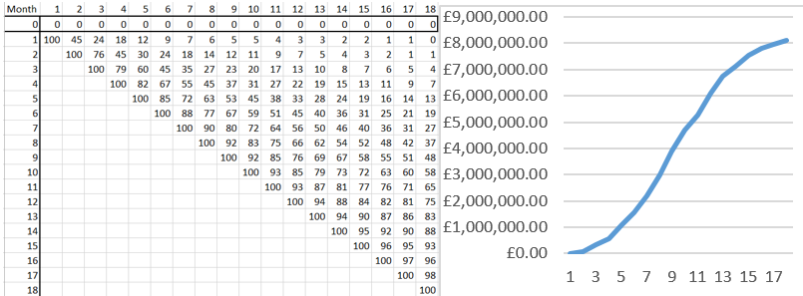
Figure 1 – example S Curve and cumulative percentage table (Author, 2019)
There are other forecasting tools available as well as S- Curves. Project management software can be utilised to produce cost estimations and cash flow estimations, however Datey argues that they still fall short of traditional cash flow estimation (Datey, 2015).
The final method that can be utilised is pricing the planning bar chart. Buchan et al state that this approach is both the most accurate and the most time consuming. Priced quantities, either via a proper bill of quantities or the estimator’s own quantities are formulated on the planning Gantt or bar chart. The total value for each item is recorded on the left hand side of the chart. It is then divided by the number of weeks shown for the bar item. From this weekly or monthly costs for the items can then be calculated. The total cost per week/month is then calculated by adding vertically. An accumulative value is entered in the row below the totals. This accumulative cost can then be recorded on a graph (Buchan, Fleming and Grant, 2003). From this balance sheets including cash flow can also be formulated.

.
Case study.
The project is to construct a commercial building consisting of four distinct blocks. Each block will contain 2 underground floors. The blocks will be varying heights with Block A consisting of 5 floors, Block B of 7 floors, Block C of 11 and Block D of 15. Each block has a surface area of approximately 500m². Figure 2 shows the footprint of the building and its location to surrounding structures. The inclusion of the basement levels provide additional construction challenges due to the depth of the excavations required to accommodate them. The building is unique in design for the area so it is not possible to compare similar projects. No budget has been provided by the client for the project and the end user is undetermined so the internal fittings will not be installed as part of this project.
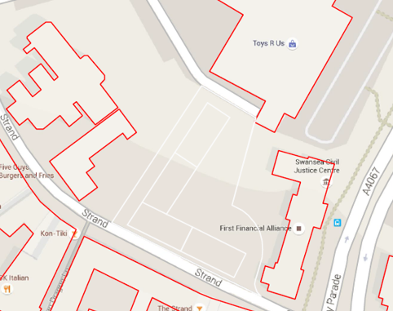
Figure 2 – Proposed site footprint (Author, 2019).

Solutions.
The solution implemented for this report was a cash flow analysis based on a bar chart. A total cost was estimated for each task utilising a combination of both SPONs (AECOM, 2016) and previous construction experience. This total was put next to each task as a total cost within the bar chart. Based on the Gantt chart that had been produced for the project the percentage of each task being completed in any given month was calculated. The total costs of each task were then multiplied by the percentage of task being completed to give a monthly cost which was added to the corresponding column within the chart shown below.
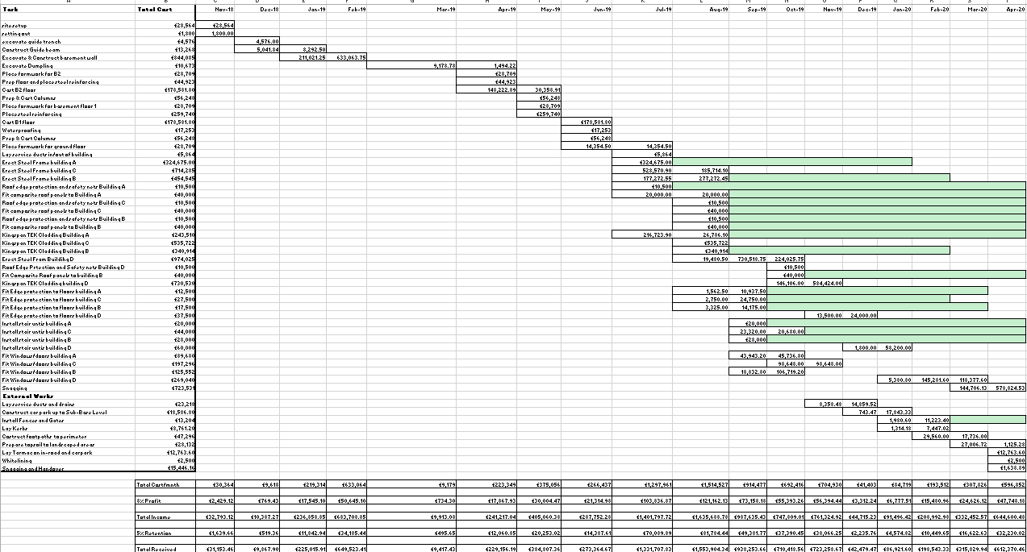
Figure 3: Bar chart showing estimated task construction costs per month (Author, 2019)
Once the monthly costs for each task had been calculated it was then possible to provide further analysis. The total cost per month was calculated by adding all of the totals for each month and recorded beneath each column. It was then possible to calculate the amount of profit charged for each month by calculating 8% of this total. The total income from the tasks each month was then calculated by adding the profit to the Total costs per month. As 5% of this would be held in retention 5% of the total income was calculated and recorded for each month. The total cash in amount each month was determined by taking the retention value away from the Total income that would ultimately be received for the task. Figure 4 below is an extract showing the values for part of the project.
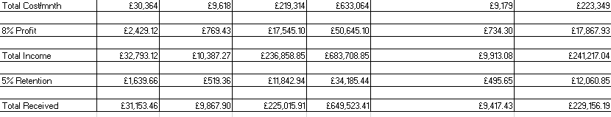
Figure 4 – Cost, Profit, Income, Retention and Cash in Calculations (Author, 2019).
From this information it was then possible to undertake a cash flow analysis to determine the expected cash flow for the scheme. Figure 5 below shows the completed cash flow analysis from this data.
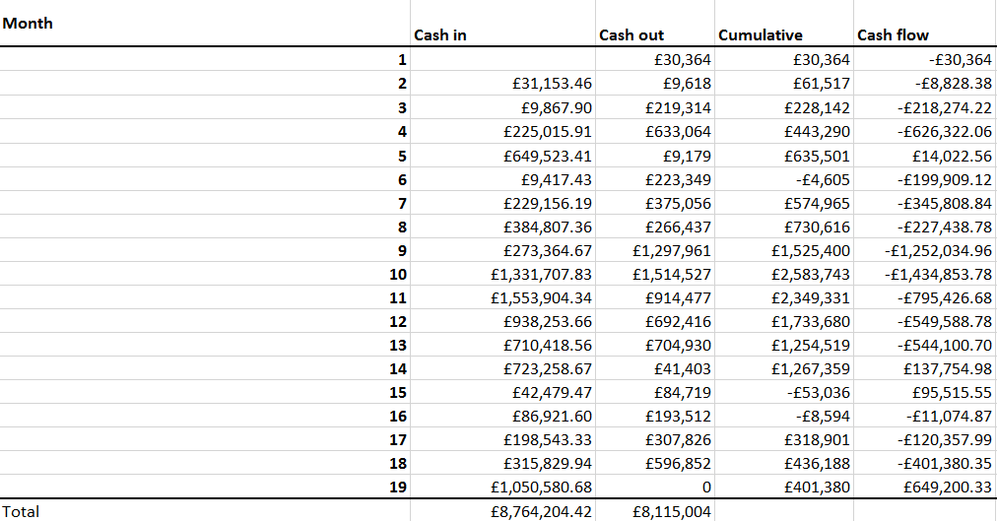
Figure 5 – Cash flow analysis for the scheme (Author, 2019)
Once it had been determined that the project would ultimately be profitable funding options were explored. An analysis of the locked up capital using an average compound interest formula determined that the additional cost in interest at 15% was approximately £92,388.39. The final estimate for the profitability of the scheme was then calculated at an estimate of £556,811.94.
Discussion.
Based on the analysis undertaken the best option would be to self-fund the project without the need for any loans. If that approach was taken then the total profit for the project would be £649,200.33 based on a maximum investment of £1,434,853.78 needed as shown in Figure 6 below.
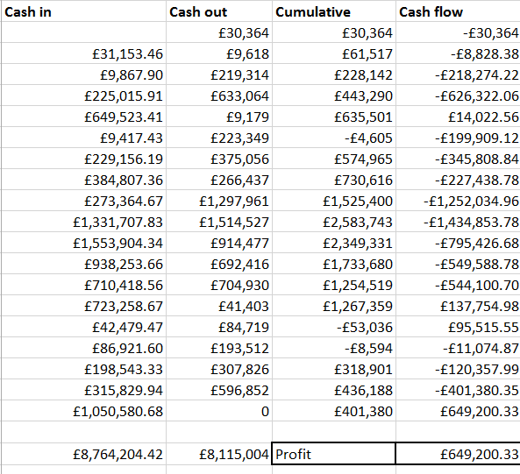
Figure 6: Cash flow forecast based on self-funding the project (Author, 2019).
While this would be the ideal solution it is unlikely that the majority of construction companies would have £1.4m free to invest in a single project. Due to this, financing options utilising bank loans were investigated as more realistic solutions.
The maximum shortfall predicted during the project based on the cash flow analysis was £1,434,853.78. Based on an interest rate of 15% the cost of taking out a loan for this amount over the duration of the project was estimated. Figure 7 below shows the calculations using both simple and compound interest to highlight the additional costs financing the project in this way would incur.
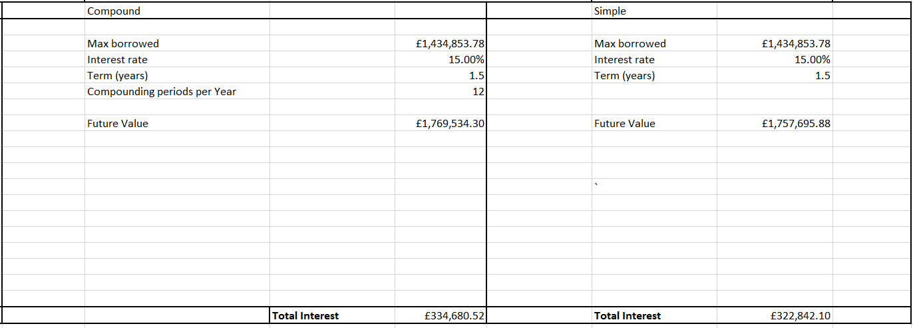
Figure 7: Compound and Simple interest for 18 month loan (Author, 2019).
Taking the additional costs from this away from the estimated profits for the scheme the total profit becomes £314,519.80 using the compound estimate or £326,358.23 using the simple estimate. Again this would make the scheme a profitable undertaking. This approach would likely to be the simplest as in theory provided there were no cost overruns/late payments. It would involve setting up a single loan and not needing to make further changes throughout the scheme. As shown in Figure 8 however, the requirement to have the full £1.4million available does not extend for the duration of the scheme.

Figure 8: Cash flow diagram excluding interest payments (Author, 2019)
It is therefore reasonable to argue that taking a loan of the maximum amount needed for the full duration of the profit is likely to unnecessarily increase the costs of the scheme due to additional interest. One solution to reduce the total interest payments would be to examine if resource smoothing could be utilised to reduce the value of the maximum loan needed. Alternatively with tight project management it may be possible to arrange smaller loans or overdrafts to cover just the amount required each month.
From analysis of the locked up capital, based on the cash flow forecast, it is possible to estimate the amount of interest that would be paid if only the value required each month were borrowed. Figure 9 shows the instances of locked up capital highlighted in red. Based on this analysis there are 15months within the projected where locked up capital exists.
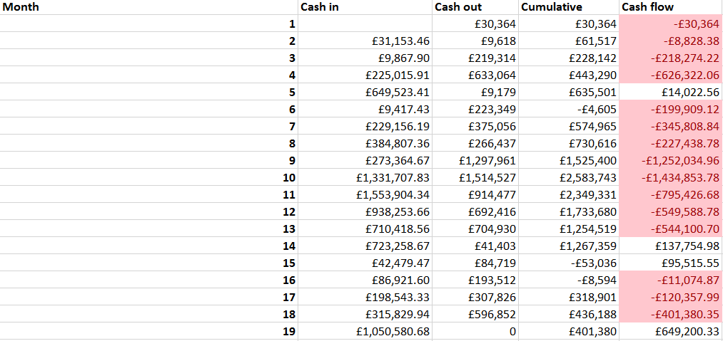
Figure 9 - Table highlighting months with locked up capital (Author, 2019).
From analysis of the locked up capital, the data can be used to estimate both simple and compound interest.
The formula to calculate the total simple interest that would be paid for this scheme using this method is as follows:

$Total Simple Interest= \sum_{I-0}^{I=n}{x_{i }}$ $×\frac{INT}{12}$
Where $x_{i}$is the locked up capital each month, i is the number of months with locked up capital and INT is the annual interest rate. From this equation the total simple interest that would be paid is estimated as £85,392.10. This would leave a profit of £563,808.23 making it a significantly better approach than borrowing the maximum amount needed for the full course of the project. However as shown above there are three clear periods where locked up capital exists. As such it is likely that a compound figure is going to be more accurate than a simple interest estimate. In order to estimate compound interest on the locked up capital the following formula is used:
$$Total Compound Interest= \frac{\sum_{I-0}^{I=n}{x_{i }}}{n}\left((1+\frac{INT}{12})^{n}-1\right)$$
From this equation total compound interest is calculated at £92,388.39. Again including this in the calculation to estimate the profit of the scheme the profit including this interest would be £556,811.94. Given that there is a significant margin for error remaining on this scheme based on this calculation it would be reasonable to use this figure as a basis and not undertake any further investigation.
If however the exact interest payment dates are needed then the cash flow forecast diagram can be updated to show the interest. Assuming the money borrowed to cover each month is paid back the following month then the simple interest calculation will be accurate. From this it would mean that the value of £85,392.10 will be paid in total, which is the lowest possible amount, therefore maximising profit. Figure 10 below shows the exact interest payable. The monthly interest has been calculated by multiplying the locked up capital by the annual interest rate divided by the number of months that value remains the same. Therefore in this instance each month’s cash flow is multiplied by (0.15/12). These values have then been added to calculate the total amount paid each month.
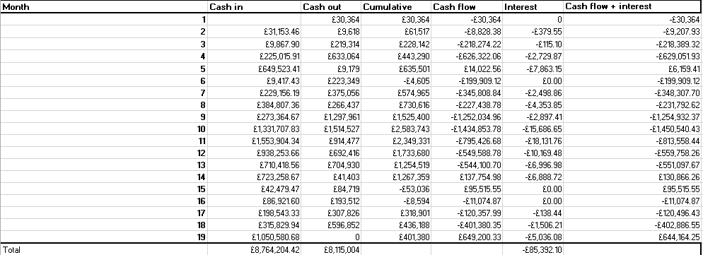
Figure 10 – Cash flow forecast diagram including interest (Author, 2019)
From this the most accurate estimate of cash flow can be seen. While this will need to be updated throughout the scheme this is the most detailed evaluation that can be undertaken.
Figure 11 below is the revised Cash flow diagram taking into account the interest payments.

Figure 11 – Cash flow diagram including interest payments (Author, 2019).
As mentioned earlier with all of these estimates it may be possible to utilise resource smoothing to reduce the total amount of interest that needs to be paid.
One significant flaw to the analysis undertaken was that the total costs of each task within the Gantt chart are only estimated costs. As such there is a risk that these costs could be significantly different leading to drastically different values. If the contract has been negotiated at a fixed price based on these costs then every instance where the estimate is below what the actual cost is will reduce the profit margin. The costs for this scheme have been estimated using a combination of SPONS (AECOM, 2016) and previous site experience. One way these estimates could be improved would have been to approach contractors for each of the tasks and to obtain cost estimates from them. While this may have provided more accurate data neither approach provides total certainty and in both scenarios the data will require continual monitoring and updating throughout the construction project.
The use of the bar chart method to estimate the monthly costs has a number of benefits. Not only does it give an analysis of the specific site, it also allows for analysis to be easily updated and changed as the scheme progresses. The bar chart method also shows where the scheme can be manipulated using the available float. However it is a significant undertaking to analyse every aspect of a construction project each time in this way. On schemes where certainty is not as critical or where a significant number of similar projects have been previously undertaken than it may be more time efficient to use some of the other methods of analysis such as S-curves based on analysis of similar project types. This S- Curve approach was not chosen in this instance due to the comparable data not being readily available.
Another risk to the analysis is that the estimated time each task takes may not be accurate. Overruns or inaccurate timescales for tasks may alter how much of each task is done every month. This will again directly impact the cash flow of the project and could ultimately change how much interest is paid or the amount required to finance the scheme.

Conclusion
The use of bar chart analysis and cash-flow forecasting has demonstrated that this project should be profitable to the construction company. While S Curve analysis and examination of previous similar projects were alternative methods that could have been used, in this instance bar chart analysis was the most suitable method due to its lack of dependence on supporting data.
The cash flow analysis demonstrated that there will be several sustained periods of locked up capital within this scheme. Being aware of this upfront will allow for more adequate planning and budgeting.
The cash flow investigation indicates that financing options would likely be needed. More detailed assessment of these options indicated that careful management of these would result in significantly less interest payments when compared to less stringent alternatives.
There are a number of limitations to the forecast with both costs and expected timescales being estimated. Ongoing monitoring of these would be required in order to ensure that the project remains appropriately financed and profitable. The accuracy of the information contained within the analysis could be improved further, one way this could be achieved is via obtaining quotations for each of the elements of work within the Gantt chart.
Further steps could be taken to try and increase the profitability of the schemes. These include undertaking resource smoothing to try and reduce the amount of locked up capital or compound interest payable. Additionally it is evident that interest payments will have a significant impact upon the profit margin. Undertaking a cash flow analysis for the scheme highlights the impact of interest payments, and subsequently the potential benefits negotiating a reduced interest rate could potentially have.

References

AECOM (2016). Spon's Architect's and Builders' Price Book 2016. 1st ed. Boca Raton: CRC Press.
Buchan, R., Fleming, F. and Grant, F. (2003). Estimating for builders and surveyors. Oxford: Elsevier Butterworth-Heinnemann.
Cooke, B. and Williams, P. (2013). Construction Planning, Programming and Control. 1st ed. Chicester: Wiley.
Coyle, B. (2000). Cash flow forecasting and liquidity. 1st ed. Chicago: Glenlake Pub.
Datey, Vivek C. (2015). Cash Flow Estimation for Engineering Projects using Project Management Software. Aweshkar Research Journal, 19(1), 95-109.
Fitzgerald, R., 2002. Part I: The purpose and content of financial statements Chapter 05: Cash forecasting. London: Kogan Page Ltd.
Hendrickson, C. and Au, T. (2008). Project management for construction. Pittsburgh, Penn.: Carnegie Mellon University.
Kalb, I. (1992). Structuring your business for success. Los Angeles: K & A Press.
Lalli, W. (2012). Handbook of budgeting. Hoboken, New Jersey: John Wiley & Sons.
Miloéseviâc, D. (2003). Project Management Toolbox - Tools and Techniques for the Practicing Project Manager. 1st ed. Hoboken: John Wiley & Sons.
Ogilvie, J. and Graham, T. (2008). CIMA strategic level. 1st ed. Oxford: Elsevier.

Appendixes.
Appendix A – Project Gantt chart
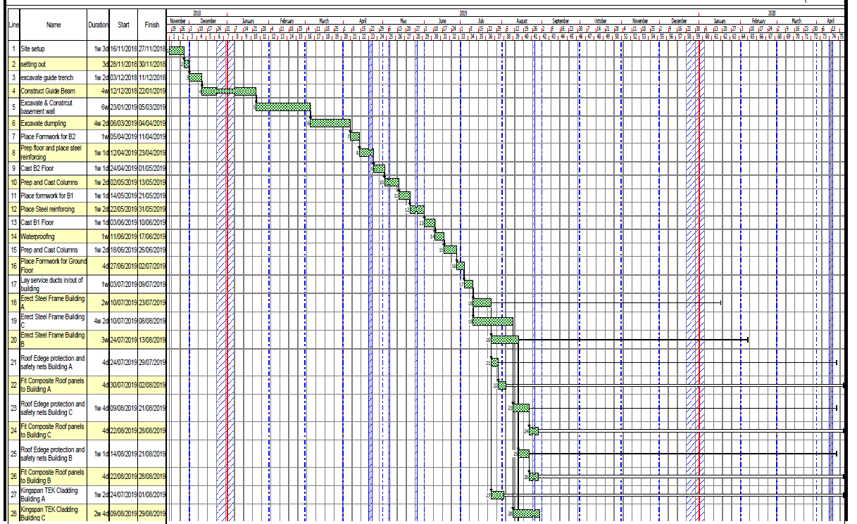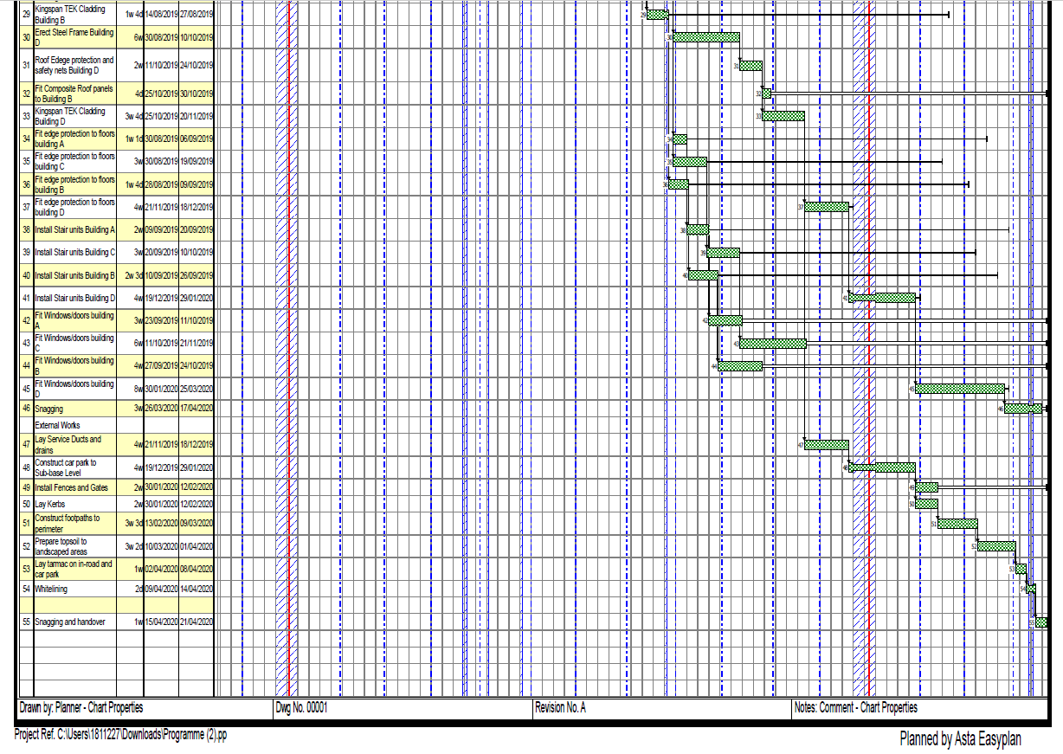
Appendix B – Gantt spreadsheet has been emailed seperately

