The Effectiveness of Social Media Marketing in Influencing Customer Intentions: The Case of Chinese Luxury Brands

1. Introduction

This quantitative research aims to test the effectiveness of social media marketing activities (SMMA) on the construct of relationship quality and to evaluate their impact on customer purchase intentions, loyalty intentions, and participation intentions. Additionally, the study set out to provide insights and recommendations for businesses on how to effectively use social media activities as marketing strategies, identifying the key SMMA elements to focus on to achieve business objectives and ensure sustainable growth. The research consists of five main sectors. The first section introduces the background of the proposed topic and outlines the research problems, objectives, questions, and contributions. The second section provides an in-depth literature review in the area, including key concepts, theories, and variables. The third section explains the rationale for adopting a quantitative research approach and illustrates the developed hypotheses. The fourth section presents the results of data analysis, and the final part of the research offers recommendations based on the statistical findings.

2. The significance of research

2.1 Research background and context
Today, as digital technologies grow rapidly and online platforms become more popular, brands are increasingly using social media to connect with their customers and target audiences (Saravanakumar et al, 2012). However, for businesses that prioritize exclusivity and heritage, the question arises: is it truly beneficial to be exposed to billions of viewers online? This concern has historically caused luxury brands to hesitate in establishing a social media presence (Kim & Ko, 2010). Over time, however, these brands recognized the need to overcome their initial reservations and establish an online presence to reach a broader, more tech-savvy audience (Bazi & al, 2020). Nonetheless, this delayed adoption of social media has positioned luxury brands in a challenging situation, as they lag behind other sectors in expertise. Furthermore, luxury brands must approach social media marketing with prudence, due to the vital need to preserve a meticulously crafted brand image (Kim & Ko, 2010).

Meanwhile, over the past decade, Mainland China has experienced significant growth in its luxury goods market and is poised to become the world's largest luxury consumer by 2025 (Luan et al., 2019). This rapid economic expansion in recent decades has facilitated the swift development of its luxury market. Based on the statistics in 2020, Chinese luxury consumption is predicted to hold the largest share in the global market by 2025 (Statista, 2020). At the same time, Chinese customers’ purchase behaviors are shifting. According to the research of Wang et al. (2021), Chinese customers are increasingly relying on the e-commerce and online shopping. Additionally, favorable government policies have become a stimulus for the luxury consumption. Government issued incentives such as Hainan Duty-Free Zoon provide customers more transparent pricing in luxury products (Lannes et al., 2020). Potential markets, online purchase intentions, and policy support collectively create substantial opportunities for luxury businesses expanding in China.

2.2 Research Problem Statement
In the 21st century, as businesses increasingly rely on the Internet to facilitate their operation, the research debate has shifted from whether to adopt digital marketing to how businesses can effectively manage their online marketing strategies (Porter, 2001). On one hand, the Internet offers great opportunities for luxury businesses to promote their products and enhance their brand image. It offers an additional communication channel with consumers, by enriching the brand experience and delivering more information (Ozuem et al., 2014). On the other hand, the over-exposure of the Internet has certain negative influence on luxury brands. As denoted by Quach & Thaichon (2017), there is a misalignment of characteristics between mass media and luxury brands. Mass media platforms are designed to reach a wide range of audiences effortlessly and serve as channels for the general public. However, luxury brands are exclusive to the public, in order to preserve their exclusivity and heritage (Quach & Thaichon, 2017). Therefore, luxury brands that aims to build personalized relationships often face challenges in using mass media platforms. Table 1 below illustrates the various characteristics that make luxury fashion brands hesitate to adopt digital marketing in the early stage. Meanwhile, Collier et al. (2018) propose that consumer delight is derived from an in-store luxury experience where the interaction between luxury brands and customers generates unexpected value that meets each customer’s specific needs. For luxury brands, physical stores serve as a crucial connection that can significantly enhance customers’ experiential satisfaction (Akaka et al., 2015) and offer opportunities to cultivate, strengthen, and celebrate customer-brand relationships (Dion & Arnould, 2011). This type of in-store experience is unique and cannot be replicated by online shopping platforms (Collier et al., 2018).

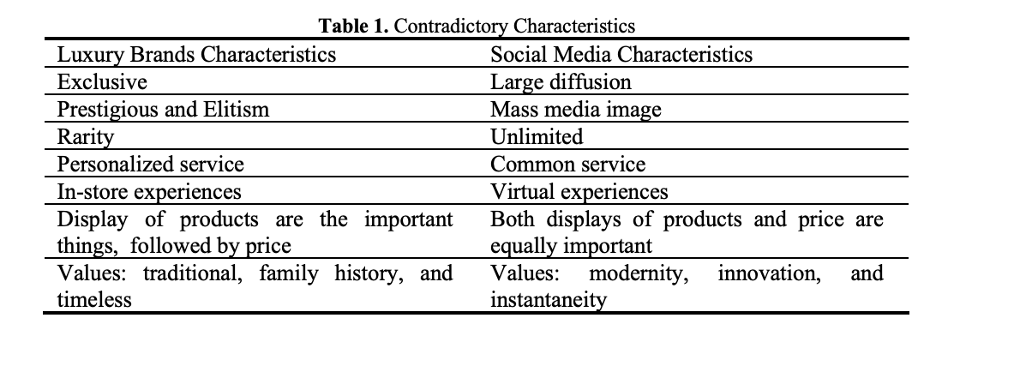
(Chernatony et al., 2001)

Another research problem concerning the phenomenon is that the consumption behaviour of Chinese consumers is constantly changing. According to McKinsey (2019), in the early 2000s, traditional luxury consumers were mainly individuals aged 50 to 69 (the Baby Boomer Generation), whereas the luxury industry's current demographics are increasingly shifting toward young generations consisting of Millennials and Gen Z. The rise in social media usage among Millennials and Generation Z has led these groups to rely heavily on social media as their primary communication platform. Their high demand for purchasing luxury brands online is driven by influences from peers and social media “influencers” (Demers et al., 2017). Consequently, Millennials and Generation Z are reshaping the digital luxury marketing landscape, prompting luxury brands to rethink traditional digital strategies. It is crucial for luxury companies to prioritize these young demographics, given their substantial influence in the market.

2.3 Research questions and objectives

Objectives
1. Examine how different social media marketing activities (including entertainment, interaction, trendiness, customization, and electronic word-of-mouth) affect customer relationship quality. Determine the most effective social media marketing strategies for enhancing relationship quality.
2. To analyze how relationship quality influenced by trust and satisfaction affects consumer purchase, participation, and loyalty intentions towards luxury brands.
3. Offer actionable recommendations for social media marketers and brand managers in the fashion luxury industry to enhance customer intentions.

Research Questions
1. How do different types of social media marketing strategies affect relationship quality? Which types of strategies (entertainment, interaction, trendiness, customization, and electronic word-of-mouth) generate the highest levels of relationship quality?
2. How does the relationship quality built through social media impact consumer intentions to purchase, participate, and remain loyal to luxury brands?
3. What practical recommendations can be derived for enhancing customer intentions on social media?

2.4 Research aims and contributions
This research aims to offer two key contributions in both theoretical and practical ways. First, it provides actionable insights for fashion luxury brands on social media marketing strategies within the Chinese digital economy. Many high-profile luxury labels, such as Louis Vuitton, Gucci, and Chanel, are investing heavily in digital marketing in China (Deloitte, 2019). To successfully navigate this market, luxury brands need to adopt strategic approaches that are both culturally sensitive and tailored to Chinese unique characteristics. As a result, this research employs sample data of the Chinese market and focuses on understanding their specific perceptions, behavioral intentions, and expectations, particularly Millennials and Gen Z. This analysis will assist brands in adapting their digital marketing and engagement strategies to align with specific cultural perspectives. Furthermore, the study examines social media trends and addresses the challenges of aligning luxury brands with mass-media platforms. It aims to help luxury brands leverage social media to strengthen their brand presence, connect with a wider audience, and maintain a carefully cultivated brand image.
Additionally, given these considerations, this research theoretically seeks to address the identified research gap by examining the effectiveness of social media marketing activities undertaken by luxury brands. Employing a quantitative approach, the study aims to analyze the correlation between social media marketing strategies and online customer intentions from both transactional and non-transactional perspectives. The overall goal is to enrich the academic literature with empirical insights and offer practical guidance to luxury brands navigating the specific Chinese context of social media marketing.
3. Literature Review

3.1 Theoretical background

3.1.1 Social Media Marketing
The growing interest in social media within the marketing field is attributed to its significant impact on consumer behavior. There are several tools that businesses can leverage to adapt their digital marketing strategies, and social media is one of the most effective and widely adopted tools that help businesses achieve their overall goals (Strauss & Frost, 2014). Organizations are drawn to social media for its multiple advantages, including cost reduction, profitability enhancement, knowledge sharing, and the formation of business partnerships (Neti, 2011). Additionally, a recent systematic review examined social media as internet-based platforms that allow users to engage with broad or targeted communities, providing value through user-generated content and fostering a sense of connection with others (Hayes et al., 2015). Based on prior research, Bilgin (2018) has developed a framework for social media marketing to underscore that utilizing social media as a marketing tool provides unique advantages distinct from traditional platforms. The advantages of social media in marketing include: first, customers are more engaged by the brand's free marketing content, which promotes increased social network activity (Arrigo, 2018; Kim & Ko, 2014). Second, social media allows customers to customize their information search through built-in search features on social networking sites (SNS), hashtags, or specific search services provided by the brand (Liu et al., 2021; Kim & Ko, 2014). Third, the real-time and immediate nature of social media enables customers to receive the most current information and trends on products or services (Cheung et al., 2021; Kim & Ko, 2014). Fourth, social media campaigns facilitate direct interactions among users, which can lead to, fifth, word-of-mouth effects, whereby customers are more inclined to share information encountered on the brand's social media with others (Mangold and Faulds, 2009).

Social media can successfully contribute to marketing only if businesses strategically identify and execute their marketing activities on platforms in an effective way. Kim and Ko (2012) have been pioneers in classifying social media marketing activities (SMMA), identifying categories specifically for luxury brands encompassing entertainment, interaction, trendiness, customization, and word-of-mouth communication. Building on this foundational framework, numerous scholars have leveraged the SMMA concept to investigate its impact on enhancing business performance across various sectors. Notable studies that have extended this work include those by, Kaplan and Haenlein (2012), Bruhn et al. (2012), Sashi (2012), Mangold and Faulds (2014), Risius and Beck (2015), and Lamberton and Stephen (2016), each expanding on how these strategies influence business outcomes. In this quantitative study, we adopt social media marketing activities (SMMA) that incorporate five key elements to examine their effectiveness in enhancing customer relationship quality and, subsequently, influencing customer intentions in the Chinese market.

3.1.2 Types of Intentions
When it comes to the context of social media marketing and business performances, it is inevitable to discuss the concept of customer engagement. As Kumar (2016) posits, greater engagement on online platforms can lead to both direct and indirect business benefits. However, measuring customer engagement quantitatively poses challenges, as it cannot be easily captured through statistical analysis. Consequently, several quantified customer intentions are designed to replace the concept of customer engagement. Despite the difficulty of directly incorporating customer engagement into quantitative analyses, the underlying dimensions and theories of customer engagement concept offer valuable insights. Scholars like Pentina et al. (2018) emphasize that understanding customer engagement involves recognizing the behaviors of customers who interact with brands, whether or not these interactions involve a financial transaction. Pentina’s theory serves as a direction guide for investigating different customer behavioral outcomes. Some studies have assessed online customer engagement from the non-transaction standpoint. For example, Van Doorn et al. (2010), developed a framework for assessing online customer engagement from non-transactional behaviors, including word-of-mouth, customer retention, and value co-creation. Similarly, Beckers (2016) emphasizes customers’ online activities like commenting, sharing, and recommending, highlighting the importance of value co-creation with firms. On the other hand, some scholars examine online customer engagement primarily from the direct transaction side. Hollebeek (2015) and Kumar (2016) focus solely on the customers’ transactional behaviors, categorizing the concept of purchasing into customer spending and cross-buying dimensions.

The multidimensions of customer engagement demonstrate the complexity of assessing customer behavioral outcomes. In this research, to fully capture the customer behavioral outcomes, it is essential to evaluate the concept from both transactional and non-transactional dimensions. As Wibowo (2020) illustrated in his quantitative research, different dimensions of customer behavioral outcomes collectively represent the overall business performance. From the perspective of direct transaction, purchase intention serves as a metric to evaluate the possibility of a customer purchasing the products (Shiffman, 2009). Such a metric directly contributes to the business’s overall profits (Shiffman, 2009). Similarly, Wu et al. (2011) suggest that when customers have a positive intention to buy, it boosts their commitment to the brand, making them more likely to actually make a purchase. Furthermore, from the perspective of non-transactional behaviors, participation intention, and loyalty intention are two frequently adopted metrics for assessing customer interactions in quantitative research. Participation intention refers to the desire of customers to interact with certain brands or activities (Wibowo et al., 2020). Additionally, loyalty intention reflects the commitment of customers to the brands in the long run (Yadav, 2018). Both intentions reflect customer behavior outcomes that don't involve direct transactions. Combining these two dimensions in the quantitative study is important for they encompass both immediate and long-run interaction. To conclude, in the quantitative study, measuring customer behavioral outcomes still needs to consider both transactional and non-transactional perspectives. This refined framework has proven effective in assessing overall business performance on digital platforms.

3.1.3 Intrinsic and Extrinsic Motives for Customers Participate in Social Media Marketing Activities
Previous literature lacks a comprehensive framework to explain the factors driving luxury consumers to increasingly use social media for interacting with brands. (Aldhamiri et al., 2024). Although previous empirical studies have explored the role of social capital in fostering online advocacy within social media communities of luxury brands (Wong, 2023), luxury brand managers still lack empirical and theoretical insights on how to effectively appeal to customers' motivations to encourage them to participate on social media. To address these research gap, recent literature has explored the impact of intrinsic and extrinsic motivations on luxury customers' attitudes and behaviors toward luxury brands and investigate how customer characteristics factors influence the relationship between customer motivations and their behaviors toward the brand (Aldhamiri et al., 2024). Managers are advised to incorporate these motivational insights into their social media marketing strategies to better tailor their approaches to the unique preferences and behaviors of luxury consumers.

Self-Determination Theory (SDT) is one of the most prevailing models that evaluate the factors driving customer engaging in certain behaviors (Deci & Ryan, 2000). SDT theory categorized customer motivations into intrinsic and extrinsic types. Intrinsic motivation includes personal interest, enthusiasm, and the inherent value of the activity itself. Extrinsic motivations often involve values and rewards that are not directly related to the activity. Previous studies have indicated that both intrinsic and extrinsic motivations are crucial in influencing customers’ perceptions, attitudes, and intentions (Hollebeek, 2011; Brodie, 2013; Lemon & Verhoef, 2016). Recent research has delved into the specific intrinsic and extrinsic factors that motivate customers to actively engage in social media marketing activities. For example, Yahia et al. (2018) found out that the extrinsic motivations like social support can greatly facilitate customer interaction on social media apps. Moreover, Varies et al. (2017) indicated that utilitarian rewards are able to enhance customer engagement within online social platforms. Based on these studies of extrinsic motivations, managers could strategically incorporate extrinsic motivations into their digital marketing strategies. Since social support is a key driver of enhancing customer interaction on digital platforms, luxury brands could provide more interactive functions within their digital apps (Aldhamiri et al., 2024). Additionally, based on the findings of Varies et al. (2017), luxury brands should issue incentives that offer active users a greater chance to earn valuable digital rewards, such as coupons (Grover et al., 2020). This will boost customer engagement and enhance customer satisfaction (Grover et al., 2020).

3.2 Conceptual Framework
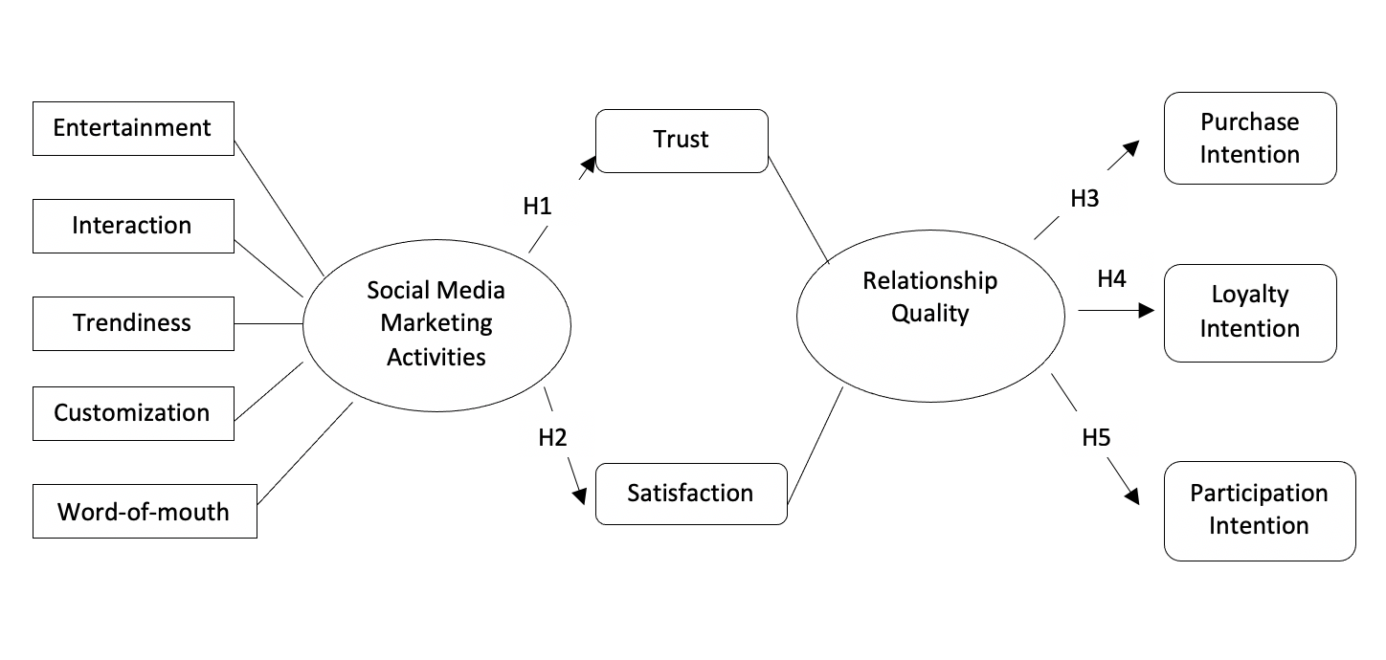
Figure 1. Conceptual Framework

Independent Variables (Social Media Marketing Activities)
Entertainment
Interaction
Trendiness
Customization
Word-of-mouth
Mediating Variables (Relationship Quality)
Trust
Satisfaction
Dependent Variables (Customer Intentions)
Purchase Intention
Participation Intention
Loyalty Intention

3.2.1 Social Media Marketing Activities
Kim & Ko (2012) identify five variables that comprise social media marketing activities (SMMA), which are entertainment, interaction, trendiness, customization, and word of mouth. It is revealed that SMMA greatly influences brand equity and purchase intentions. Chen and Lin (2019) also found that SMMA indirectly affects social identity and perceived value, contributing to overall customer satisfaction. Recent research has explored SMMA in various contexts, revealing its broad impacts and advantages. First, Liu et al. (2021) emphasize the importance of entertainment, which is the brand's ability to provide engaging content through social media platforms. Scholars believe that entertaining content tends to generate higher user interaction and is more likely to be shared widely (Liu et al., 2021). Second, interaction reflects how effectively social media content prompts users to share it with others. It can foster social engagement and discussions about updated products (Muntinga et al., 2011). Third, trendiness represents social media’s ability of real-time and fast speed in allowing customers to get the latest information (Arrigo, 2018). Brands need to inform their customers of the latest trends since this can influence their purchase decisions. Fourth, customization involves tailoring content for specific individuals or demographics, which can reduce information overload and enhance decision-making in e-commerce (Lui et al., 2021). Finally, word of mouth (WOM) refers to consumers spreading information about luxury brands to others, which can directly influence trust and purchasing behavior (Kim & Ko, 2010; Duan et al., 2008). This variable highly represents the level of customer engagement with the firm.

3.2.2 Relationship Quality
Relationship quality is defined as the overall evaluation of the strength of a particular relationship (Verma et al., 2016). Existing research often views relationship quality as a mediator between its antecedents and outcomes (Wibowo et al., 2020). Tajvidi et al. (2018) further clarify that the core focus of marketing relationships is to establish connections between service providers and customers. In general, this construct is considered multidimensional, typically encompassing trust, satisfaction, and commitment (Palmatier et al., 2006). Anastasiei et al. (2017) assert that trust, a key element of relationship quality, depends on the nature of the messages communicated by the brand. Furthermore, Masri et al. (2020) found that satisfaction positively affects the intention to continue engagement. However, some studies focus solely on trust and satisfaction, excluding commitment from their analysis. This exclusion is justified, as commitment is more accurately viewed as a result of the customer relationship, linked to customer loyalty (Liu et al., 2011). Therefore, commitment is not a core component of relationship quality (Jap et al., 1999; Holmlund, 2008). Overall, relationship quality is crucial for sustaining customer loyalty (Giovanis et al., 2015), influencing purchase intentions (Oliveira et al., 2017), and encouraging participation in social commerce (Wibowo, 2020).

3.2.3 Customer Behavioral Outcomes
From a marketing perspective, if companies wish to maintain their community and achieve success through community-driven marketing, they need to prioritize three main objectives (Chen and Qasim, 2021). This study emphasizes that purchase intention, loyalty intention, and participation intention are key customer behavioral outcomes, and these three variables demonstrate the effectiveness of social media platforms in marketing (Wibowo et al., 2020). Firstly, purchase intention reflects customers' desire to buy a product (Shareef et al., 2019). Schiffman and Kanuk (2009) argue that purchase intention indicates the likelihood of customers making a purchase: the higher the purchase intention, the greater the likelihood of completing the purchase. Secondly, customer loyalty refers to the willingness to make repeat purchases from a specific seller, which contributes to a company's long-term profitability and financial stability (Johnson et al., 2000). Various studies believe that loyal customers are essential for maintaining a strong and lasting relationship with the company (Hapsari, 2017). Finally, participation intention is crucial for effective community marketing (Anastasiei et al., 2005). This involves the willingness of members to engage in company activities, projects, or discussions, which can lead to word-of-mouth marketing, as customers may recommend products or services to others (Beig 2018).

3.3 Hypothesis Statement
Social media and its associated marketing activities have become an essential component of luxury brand marketing strategies. These related strategies provide new avenues for growth and competitive advantage. Generally speaking, research indicates that the five dimensions of social media marketing—entertainment, interactivity, fashion, customization, and word-of-mouth—can effectively engage consumers and reshape their perceptions of marketing strategies (Chen & Lin, 2019; Kim & Ko, 2010).

Trust plays an important role in economic and social transactions. In the context of social media platforms, Kim and Park (2013) investigate how trust mediates the relationship between social commerce attributes and behavioral intentions. Their study supports the idea that users are more likely to trust social commerce platforms with a positive online environment, which includes effective communication, transaction security, a large user base, high-quality information, and favorable word-of-mouth referrals. Additionally, Duarte et al. (2018) denote that a positive social media experience is a key factor in improving relationship quality. Both trust and satisfaction are dimensions of relationship quality. Regarding the discussion above, we proposed the following hypothesis:

H1: Social media marketing activities (SMMAs) have a positive impact on customer trust.

Customer satisfaction is essential for assessing overall business performance. The metrics can be evaluated throughout the entire business process, from pre-purchase expectations to post-purchase resolution of complaints (Duarte et al., 2018). It is believed that improved customer satisfaction contributes to a long-term customer commitment and increased business revenues (Oliver, 1999). Scholars have explored different factors in driving customer satisfaction on social media platforms. For example, Dingus et al. (2016) denote that customer satisfaction can be improved by a smooth transaction process. Moreover, intensive communication and community support can increase customer satisfaction, and result in a positive customer commitment in the long run (Sahibzada, 2020). In essence, an effective SMMA can facilitate strong customer relationships, as reflected in high levels of customer satisfaction (Henning-Thurau et al., 2002). Besides, numerous marketing studies have proved that satisfactory experience would influence the intention of future repurchases. Hence, we proposed the following hypothesis:

H2: Social media marketing activities (SMMAs) have a positive impact on customer satisfaction.

In the context of social media platforms, company profits are largely influenced by consumer behaviors such as purchase intention, customer loyalty, and participation intention. Trust, as a key aspect of relationship quality, positively affects purchase intention (Oliveira et al., 2017) and satisfaction also plays a significant role in influencing purchase intention (Hsu, 2015). Customer loyalty intention emerges as a crucial indicator of a strong relationship between a company and its customers (Hyun et al., 2017). Research indicates that customer participation intention on social media platforms is impacted by the quality of the relationship between the company and its customers (Hajli, 2014). Additionally, satisfaction, as a component of relationship quality, affects the intention to participate (Wibowo et al., 2020) and trust is essential for enhancing consumer participation intentions (Agag, 2016). Therefore, the research suggests that when customers connect with a brand’s culture on social media, it strengthens their relationship with the brand, which can boost their purchase intention. Furthermore, positive relationships between customers and the company can foster loyalty and increase participation in company-sponsored events or programs. Hence, the research proposes hypotheses H3–H4 to examine these relationships:

H3a: Customer trust has a positive impact on purchase intention.
H3b: Customer trust has a positive impact on loyalty intention.
H3c: Customer trust has a positive impact on participation intention.

H4a: Customer satisfaction has a positive impact on purchase intention.
H4b: Customer satisfaction has a positive impact on loyalty intention.
H4c: Customer satisfaction has a positive impact on participation intention.

4. Methodology Approach
4.1 Quantitative Research Design
Quantitative research tends to gather measurable data on variables and draw conclusions from sample pools. The quantitative methods emphasize the objectivity and generalizability of the result and focus on the prediction of the findings (Lincoln & Guba, 1985). To achieve this, researchers must involve reflexivity throughout the research process. It requires researchers to set their own beliefs and biases, in order to maintain objectivity in conducting the study and interpreting the findings (Bryman, 2004). Typical features of quantitative research include using tools like tests or surveys for data collection and applying probability theory to test statistical hypotheses, ensuring that the data are gathered in a systematic and unbiased manner (Creswell, 2003). These methods are considered deductive since the conclusions are derived from statistics data and the findings need to adapt to broader populations and contexts (Lincoln & Guba, 1985). Additionally, quantitative research often assumes that reality is objective and can be observed and measured, and knowledge can be gained through empirical observation and testing (Bhattacherjee, 2002).

The research ‘assessing the effectiveness of social media marketing for increasing customer engagement’ employs a quantitative approach for several advantages. Firstly, surveys as frequently used tools in quantitative research, are effective in capturing information and perceptions collectively from a large group of samples (Faria et al., 2017). Besides, the data collected from surveys represents a high scale of data size and is relatively cost-effective compared to other research methods (Queiros et al., 2017). Secondly, according to Creswell (2003), quantitative research often ensures the generalizability of the research. Considering the large potential luxury markets in China, involving a large data set is essential to guarantee the research’s objectivity and generalizability. The generalizability of the research can also enhance the applicability of findings to a broader context. Thirdly, quantitative research emphasizes the prediction and projection (Bryman, 2004). The statistics patterns and traits are capable of forecasting customer behaviors in the future. Such forecasts based on empirical data enable brands to make data-driven decisions for their marketing strategies. Additionally, quantitative methods could provide measurable benchmarks for evaluating the effectiveness of digital marketing strategies. The statistics benchmarks can be monitored and documented over a long period of time, to assess the overall business performance.

4.2 Research Instrument
The research ‘the effectiveness of social media marketing activities on customer intentions’ adopts the quantitative approach to measure the key antecedents and outcomes. Due to the time limitation, there is no data collection in this study, instead, a prior completed data set is used for analysis. The completed data set includes 286 respondents. The participants were social media users as well as the customers of luxury goods. The research questions were developed based on numerous literature reviews to ensure the quality and validity of the survey instrument. There are two sections of the survey, which are demographic information and hypotheses measurements. In the first section of the survey, basic information was asked to explore whether gender and sexuality could influence customer decisions in buying luxury goods. The second section of the survey encompasses 10 variables, including 5 independent variables, 2 mediators, and 3 dependent variables. To provide a detailed explanation, the independent variables related to the SMMA include 15 questions. Respondents were asked to answer the question by rating the level of agreement from one to five. The use of such five-point Likert scale is likely to enhance the precision of the responses (Wibowo, 2020). The mediator variables include 6 questions collectively. These questions were mainly designed to explore the level of trust and satisfaction in certain luxury brands. Finally, the dependent variables consisted of 9 questions, to analyze the final customer behavioral outcomes. To conclude, the structured survey aims to ensure the robustness of the findings as well as align with the best practices in quantitative research.

5. Data analysis

5.1 Data Coding and Preparation
The data set employed in my research is a second-hand source. In order to enhance the further analysis, data coding and cleaning are adopted before the direct analysis phase. The original data set contained 300 sources. However, as I checked the missing value in SPSS, it was reported that there were 14 missing values. Accordingly, I cleaned the dataset by removing these missing values, resulting in a final dataset with 286 respondents. Besides, in the first section of the survey, there were two demographic questions related to customers’ age and sexuality. Age and sexuality are crucial in understanding motivations and perceptions behind customer behaviors. However, responses in answering these two questions were blank from 187 to 286. Consequently, the analysis to identify which groups of people show the highest level of intentions in response to effective social media marketing activities can only be measured from the first to 186 data. This lack of data may result in inconsistency and biases in the findings. Since this dataset is derived from secondary sources, the implications of the missing values in demographics questions will be clarified and discussed in the further section.

Additionally, the original dataset contained blank labels for each variable, which can cause misunderstanding and inefficiency in analyzing data in SPSS. To address this, I assigned labels to each variable to clarify the meaning of each question. For example, in assessing the level of entertainment for customers using social media platforms, I labeled the three related questions as ‘ENT1’, ‘ENT2’, and ‘ENT3’ to distinguish them from other questions. The survey contains 10 variables in the dataset, including entertainment, interaction, trendiness, customization, word-of-mouth, trust, satisfaction, and three customer intentions. Each of these variables is assessed through three questions, resulting in a total of 30 questions shown in the SPSS. This complexity adds to the difficulty of data analysis. To deal with this issue, I calculated the average of the three variables related to the same question. This average variable represents the mean value of these three questions. For example, I combined the three questions ‘ENT1’, ‘ENT2’, and ‘ENT3’ and labeled their average as ‘CompositeENT’. As a result, the key variables were all calculated and represented by their mean values, which greatly reduced the analytical effort and provided a clearer representation of the data.

5.2 Validity and Reliability

Current literature review emphasizes that both reliability and validity are essential attributes of measuring instruments in quantitative research. Validity is concerned with whether the measuring instrument accurately measures the intended behavior or quality (Anastasi & Urbina, 1997). It also refers to how well the quantitative instrument performs in its function (Anastasi & Urbina, 1997). Reliability reflects the consistency of the measured values under identical conditions using the same instrument (Heale, 2015). It is important to consider both the validity and reliability of the quantitative tools when conducting the research.

There are three main types of validity, which are content validity, construct validity, and criterion validity (Cronbach & Meehl, 1955). Construct validity is commonly applied in research and relies on the logical connections between variables (Cronbach & Meehl, 1955). In this study, a construct validity is adopted to test the ability to make inferences about test scores in relation to the concept under investigation. In the rotated component matrix, loadings above 0.4 are typically considered to indicate a high level of validity. The result of the component matrix is shown in Figure 1. The components of 6 main variables are from 0.641 to 0.768, indicating a strong level of validity. Additionally, the high score shows that the variable strongly correlates with the factor.
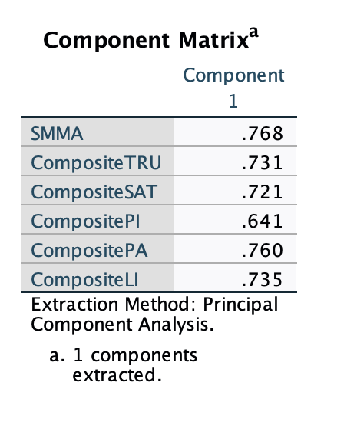
Figure 1

Reliability concerns with the consistency of the measure instruments (Heale, 2015). Although it is not likely to capture the exact calculation of the reliability, several approaches can help estimate the reliability of the research. Correlation is one of the attributes that indicate the level of reliability (Bollen, 1989). Strong correlations suggest high reliability, while weak correlations indicate that the instrument may lack reliability (Bollen, 1989). Cronbach’s α is the most frequently used method for assessing an instrument's internal consistency. The result of Cronbach’s value ranges from 0 to 1 (Streiner, 2003). A score of 0.7 or higher is considered as an acceptable reliability score (Streiner, 2003). In this study, I used 6 variables to calculate Cronbach’s value, including ‘SMMA’, ‘Composite Trust’, ‘Composite Satisfaction’, ‘Composite Purchase Intention’, ‘Composite Participation Intention’, and ‘Composite Loyalty Intention’. The result is shown in Figure 2. The Cronbach’s Alpha value is 0.738, which is greater than 0.7, indicating that the level of reliability of the instruments is acceptable in this research.
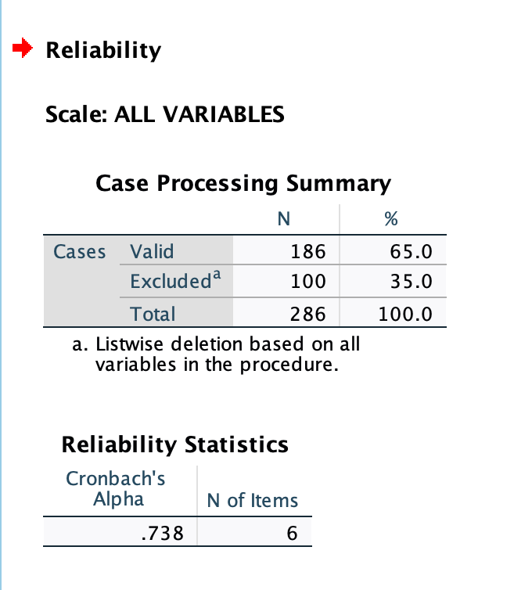
Figure 2

5.3 Regression Analysis
Simple regression refers to the hypothetical model of the relationship between two variables (Hedge, 1983). The aim of regression analysis is to determine whether one or more independent variables have an impact on a dependent variable. This study aims to adopt a linear regression method to test the effectiveness of SMMA on customer trust and satisfaction, and how these relationship quality influences the customer intention outcomes. Before conducting the linear regression analysis, there are several assumptions that the regression model must adhere to. Firstly, there must be a linear relationship between dependent variable and independent variables (Draper, 1966). A scatter plot can be used to test whether the relationship is linear or curvilinear. If the relationship is typical linear, a straight line would be drawn through the center of the points (Draper, 1966). In this research, I tested the linear relationship between different variables, which are shown in Figures 3 to 10. The graphs indicate that there is a general trend where the points cluster around a straight line, with a positive slope indicating a positive relationship between the variables. The scatterplots indicate that there is a linear relationship between SMMA and customer trust, SMMA and customer satisfaction, customer trust and three customer intentions, customer satisfaction and three customer intentions. Therefore, the analysis of these scatterplots supports the fulfillment of the first assumption.

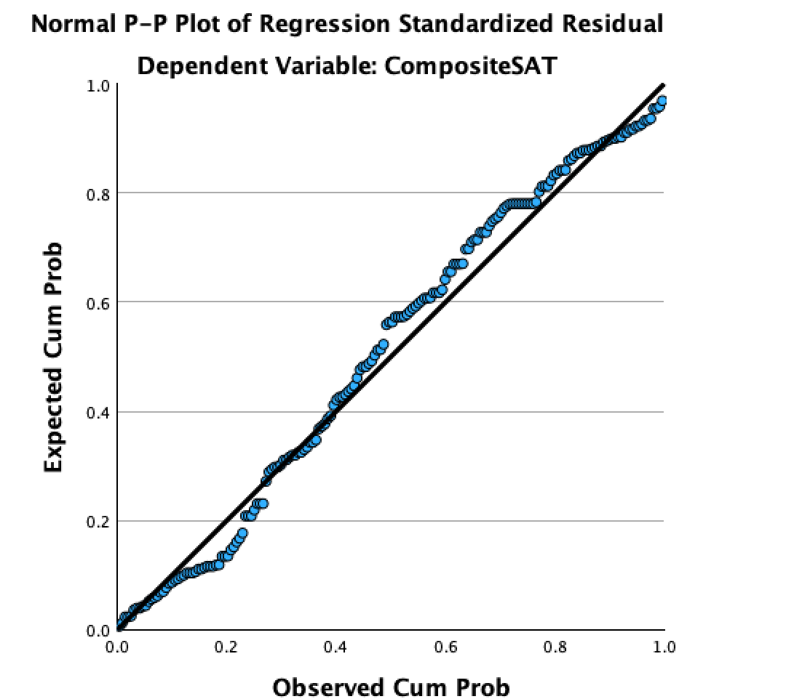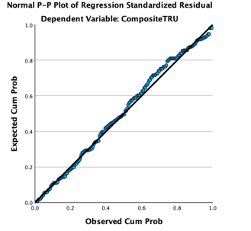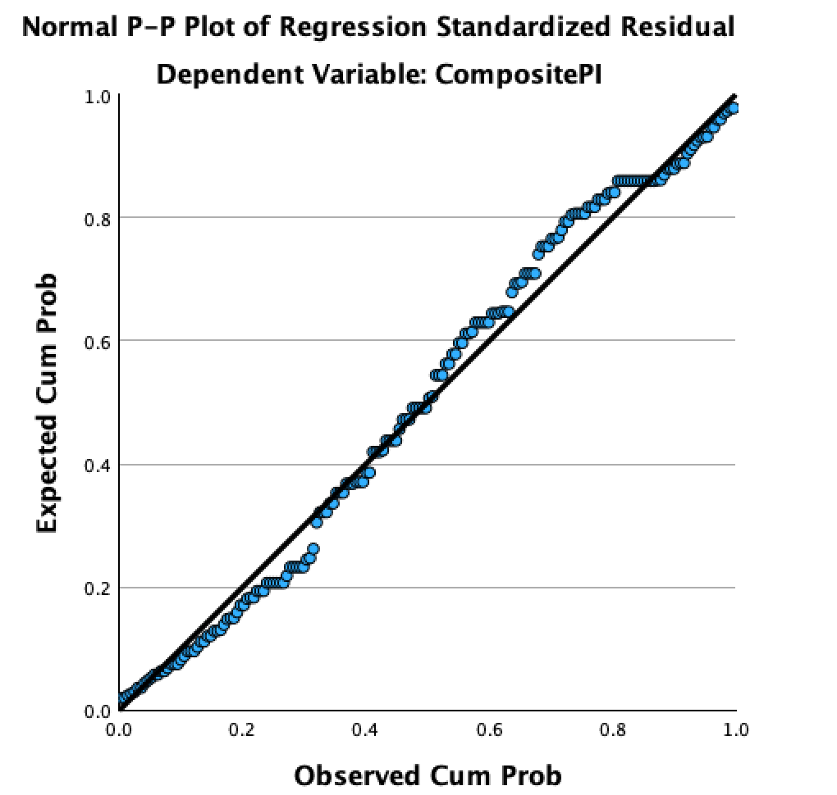
Figure 3 Figure 4 Figure 5
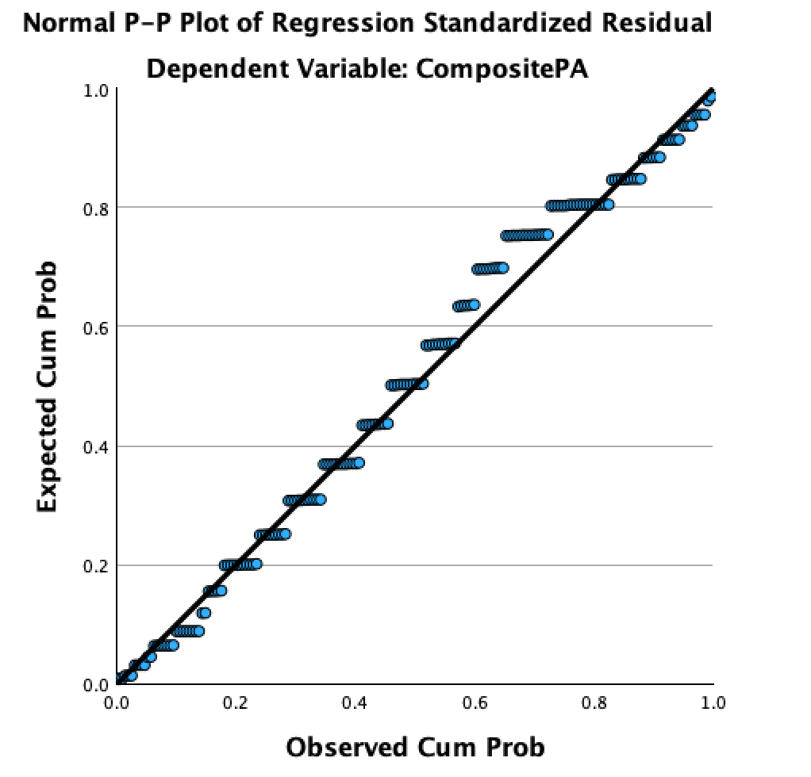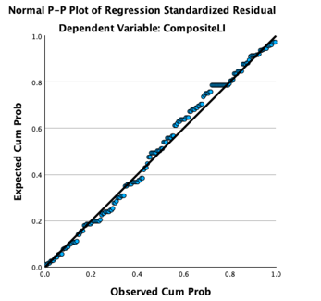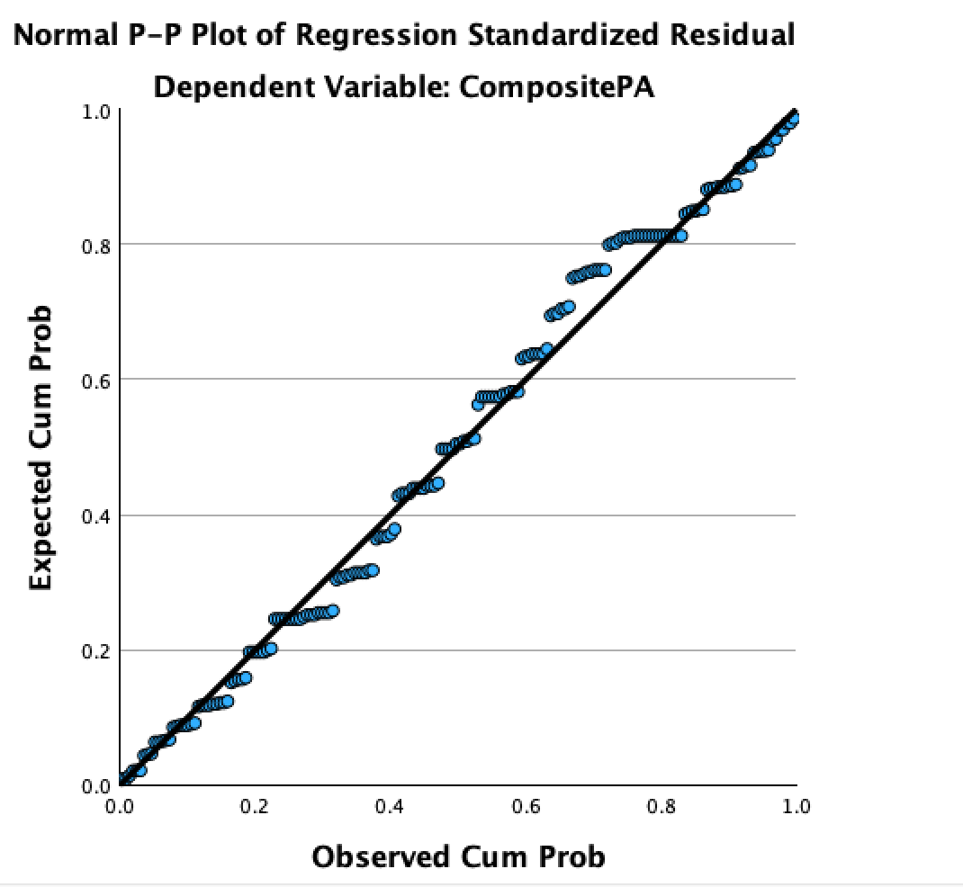
Figure 6 Figure 7 Figure 8
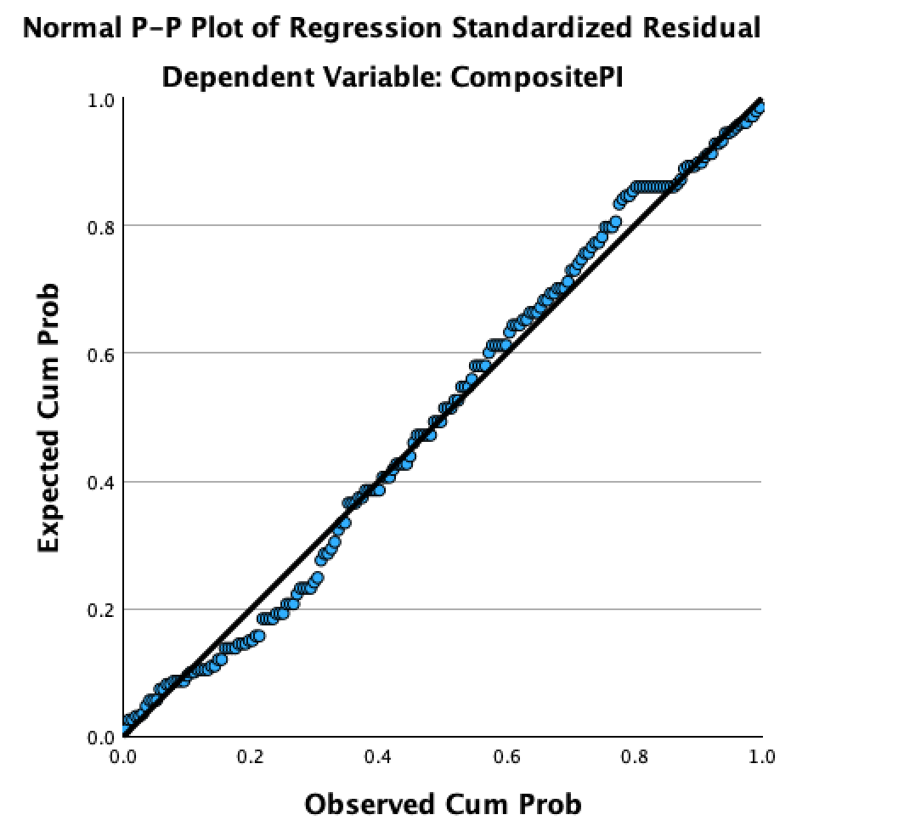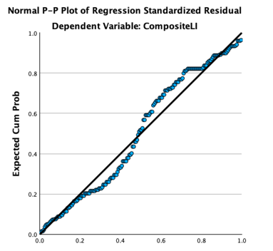
Figure 9 Figure 10

Second, multiple regression assumes that the residuals are normally distributed, which is often regarded as multivariate normality (Malkovich, 1973). Testing for multivariate normality often involves visual methods like Q-Q plots and statistical tests. In this study, the tests for skewness and kurtosis are adopted to assess multivariate normality. According to Malkovich (1973), if skewness and kurtosis values for the variables fall within the acceptable range, it supports the assumption of multivariate normality. A skewness value close to 0 means the symmetry (Shanthi, 2019). Generally, a skewness value between -1 and 1 is acceptable for normality (Shanthi, 2019). A kurtosis value close to 0 suggests the normal distribution (George, 2011). Normally, a range between -2 and 2 of the kurtosis value is often considered acceptable (George, 2011). The analysis outcomes of descriptive statistics in this research are displayed in Figure 11. The skewness values for each variable are between -1 and 1. Additionally, the kurtosis values for each variable are between -2 and 2. The results align with the second assumption, indicating that the residuals of variables are normally distributed.
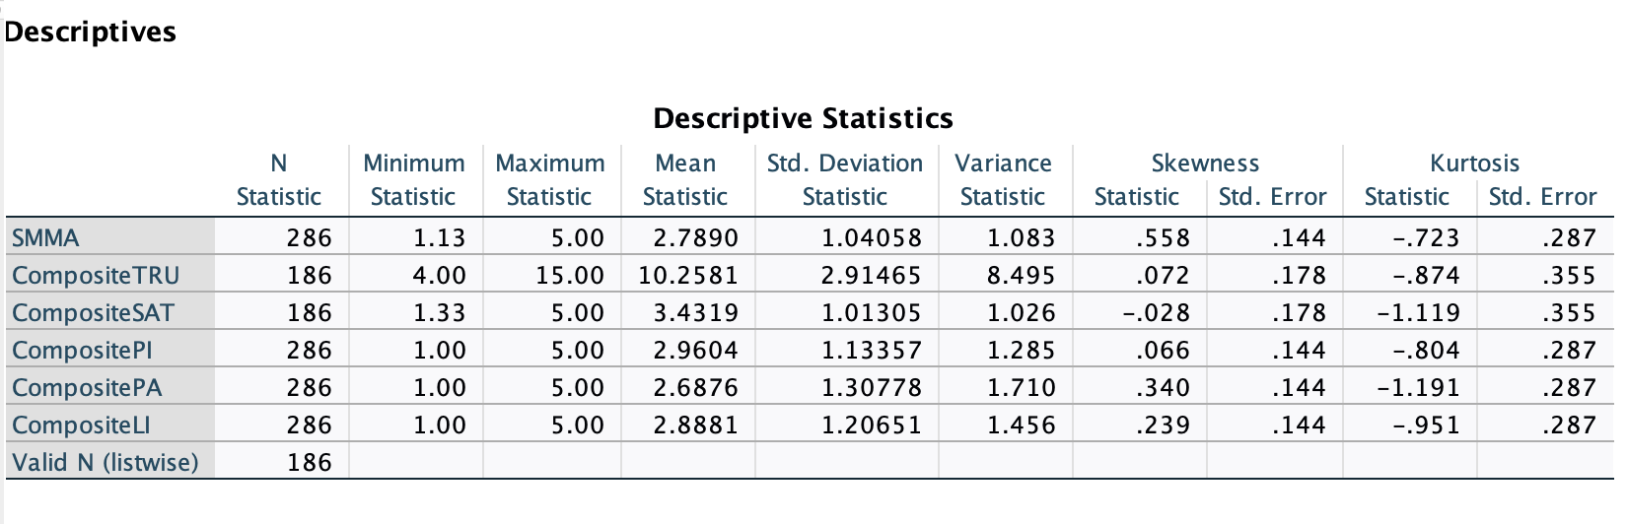
Figure 11

Third, regression models assume that independent variables are not highly correlated with each other (Daoud, 2019). This assumption is important since high multicollinearity can make it difficult to determine the individual effect of each variable on the dependent variable (Kumari, 2008). When predictors are correlated, the standard error of their coefficients will increase. A high coefficient can lead to inflated variance (Kumari, 2008). In this condition, The Variance Inflation Factor (VIF) is used to measure this inflation in variance. VIF value under 10 is considered as acceptable (Shrestha, 2020). In this study, I run a regression analysis and check the "Collinearity Statistics" table in the output. I conducted 8 linear regression analysis based on the hypotheses H1 to H4c. And the VIF values for each regression are close to 1, indicating that there is no multicollinearity between independent variables and the dependent variable (Figures 12 to 19).
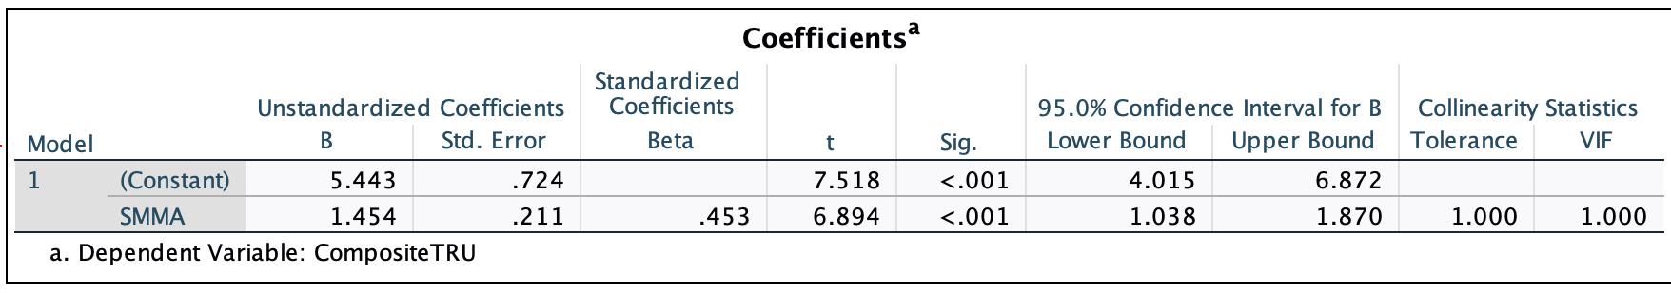
Figure 12
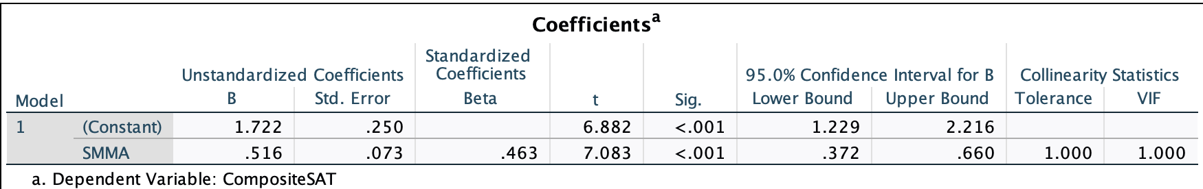
Figure 13

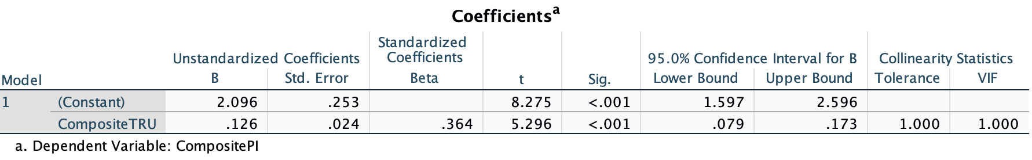
Figure 14

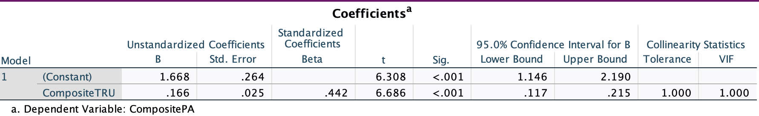

Figure 15
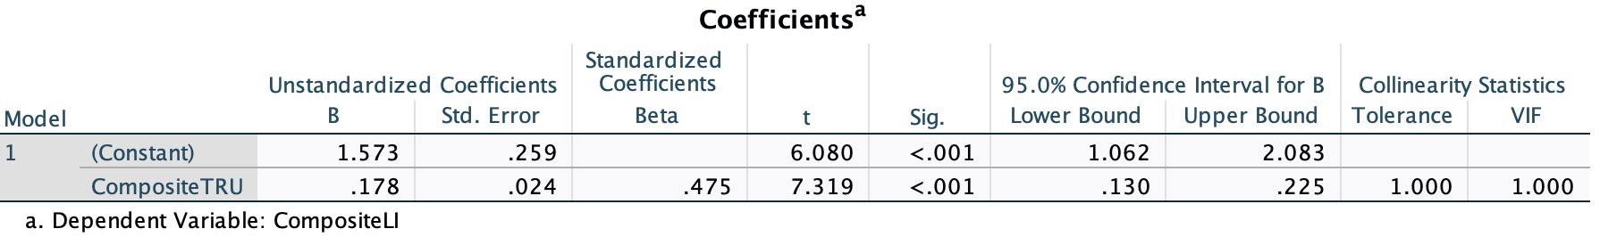
Figure 16
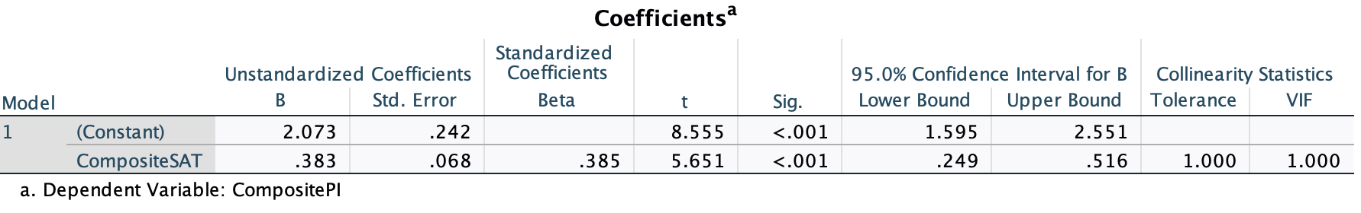
Figure 17
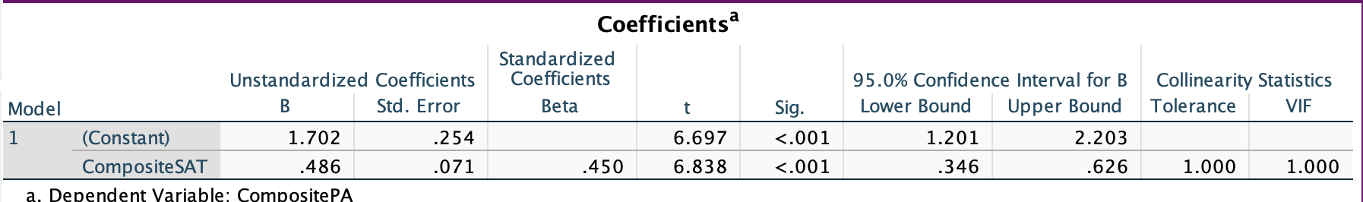
Figure 18
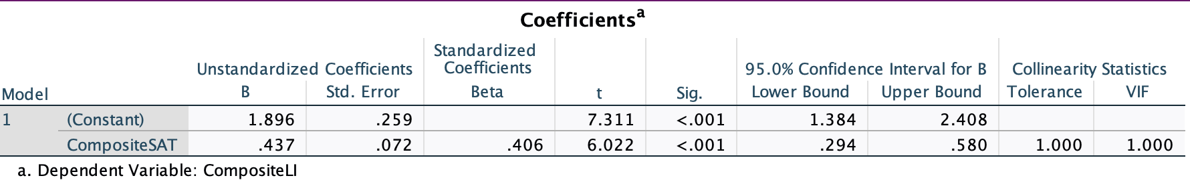
Figure 19

Finally, the fourth assumption indicates that the variance of residuals is similar across all levels of the independent variables (Alabi, 2020). This assumption is quite important since it ensures that the model’s predictions are reliable. In the linear regression table, I chose ‘Plots’ and entered the standardized residual plot (ZPRED on the x-axis and ZRESID on the y-axis) to assess homoscedasticity and the normality of the residuals. Based on Figures 20 to 28, there is a random scatter of points around the horizontal axis without any discernible pattern. The points are evenly distributed and form a cloud, which suggests a homoscedasticity in regression analysis.
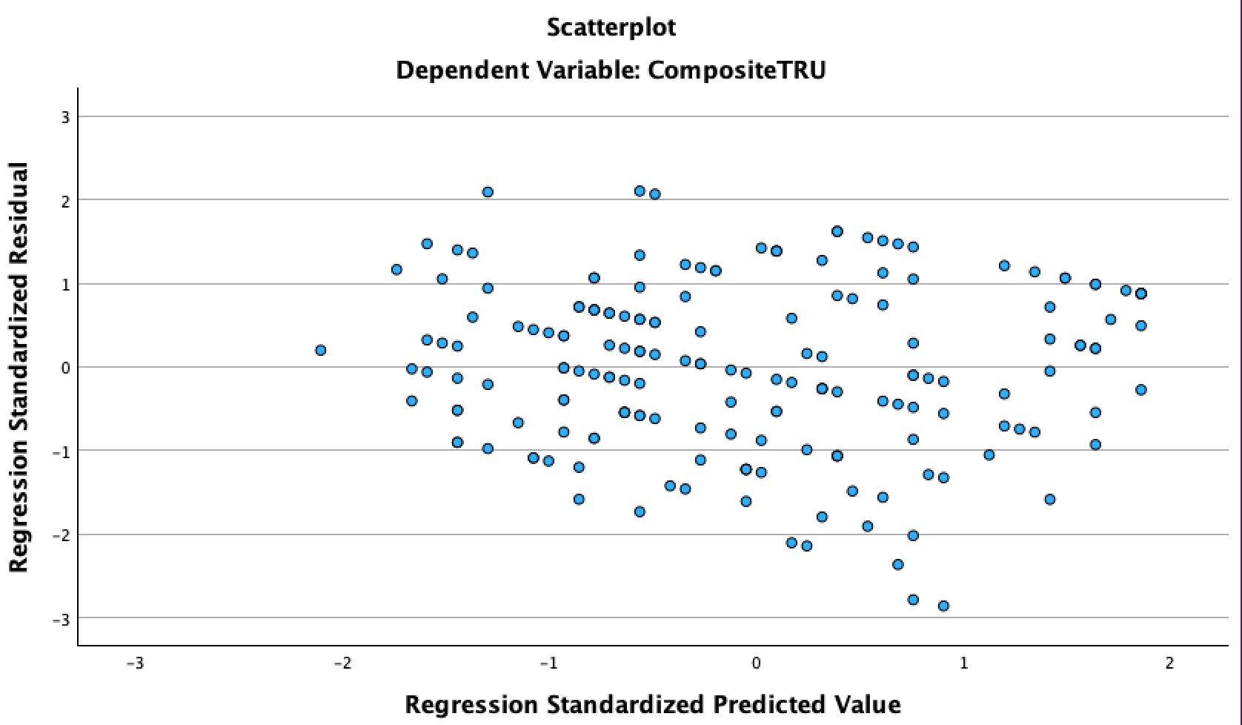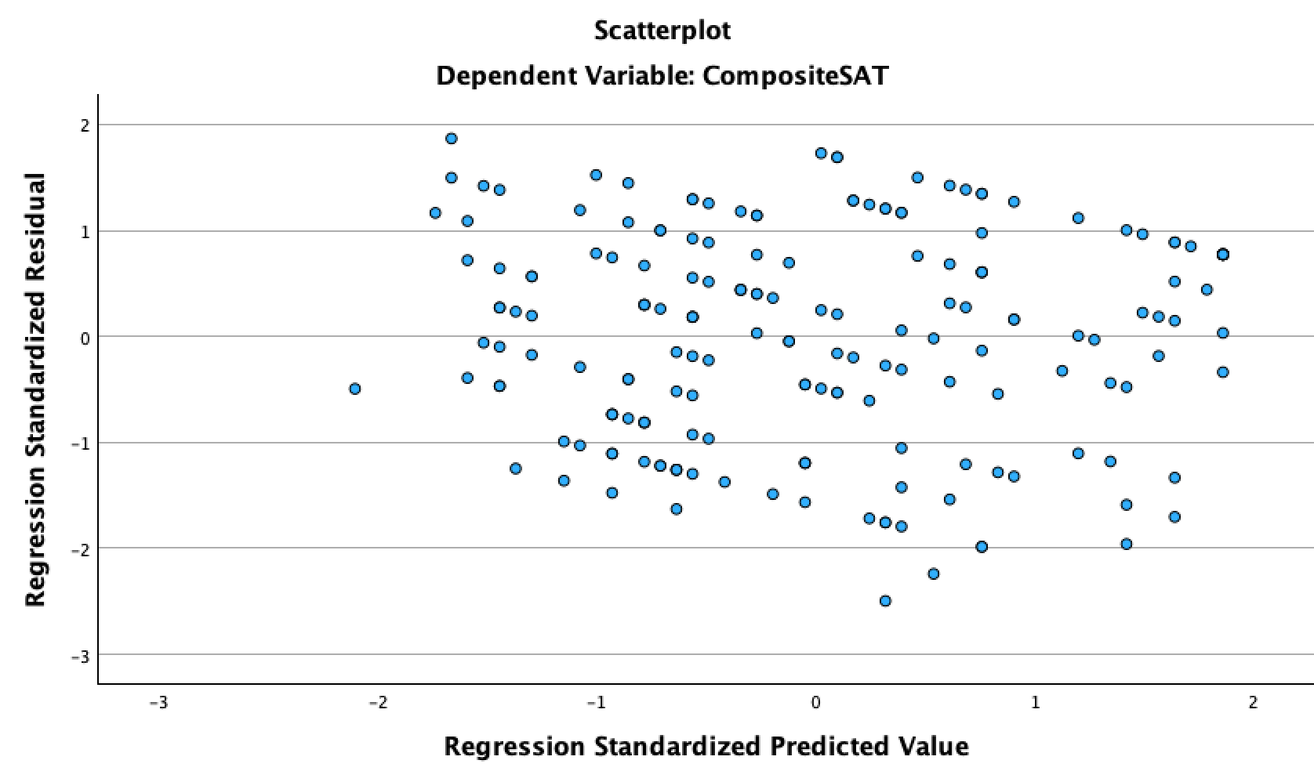
Figure 20 Figure 21
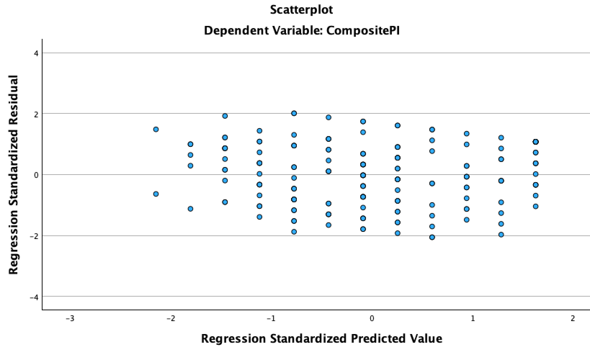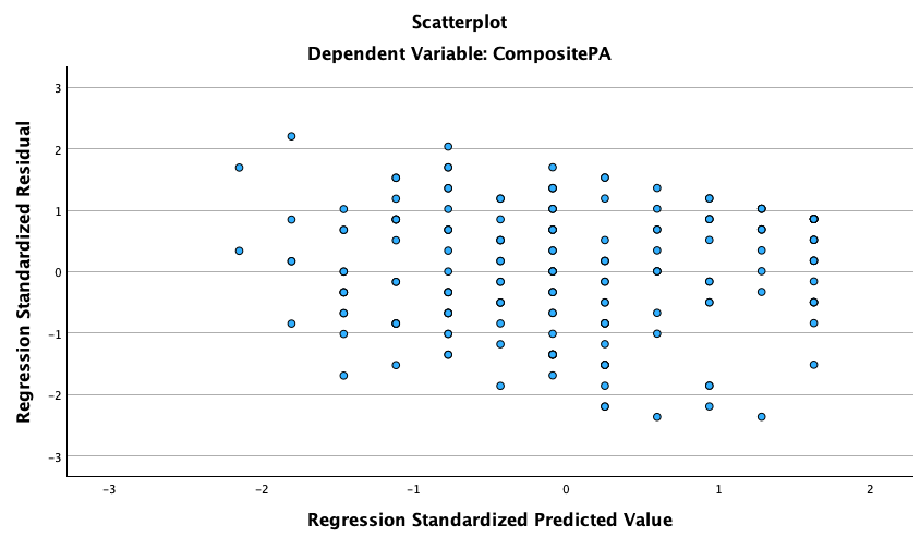
Figure22 Figure 23
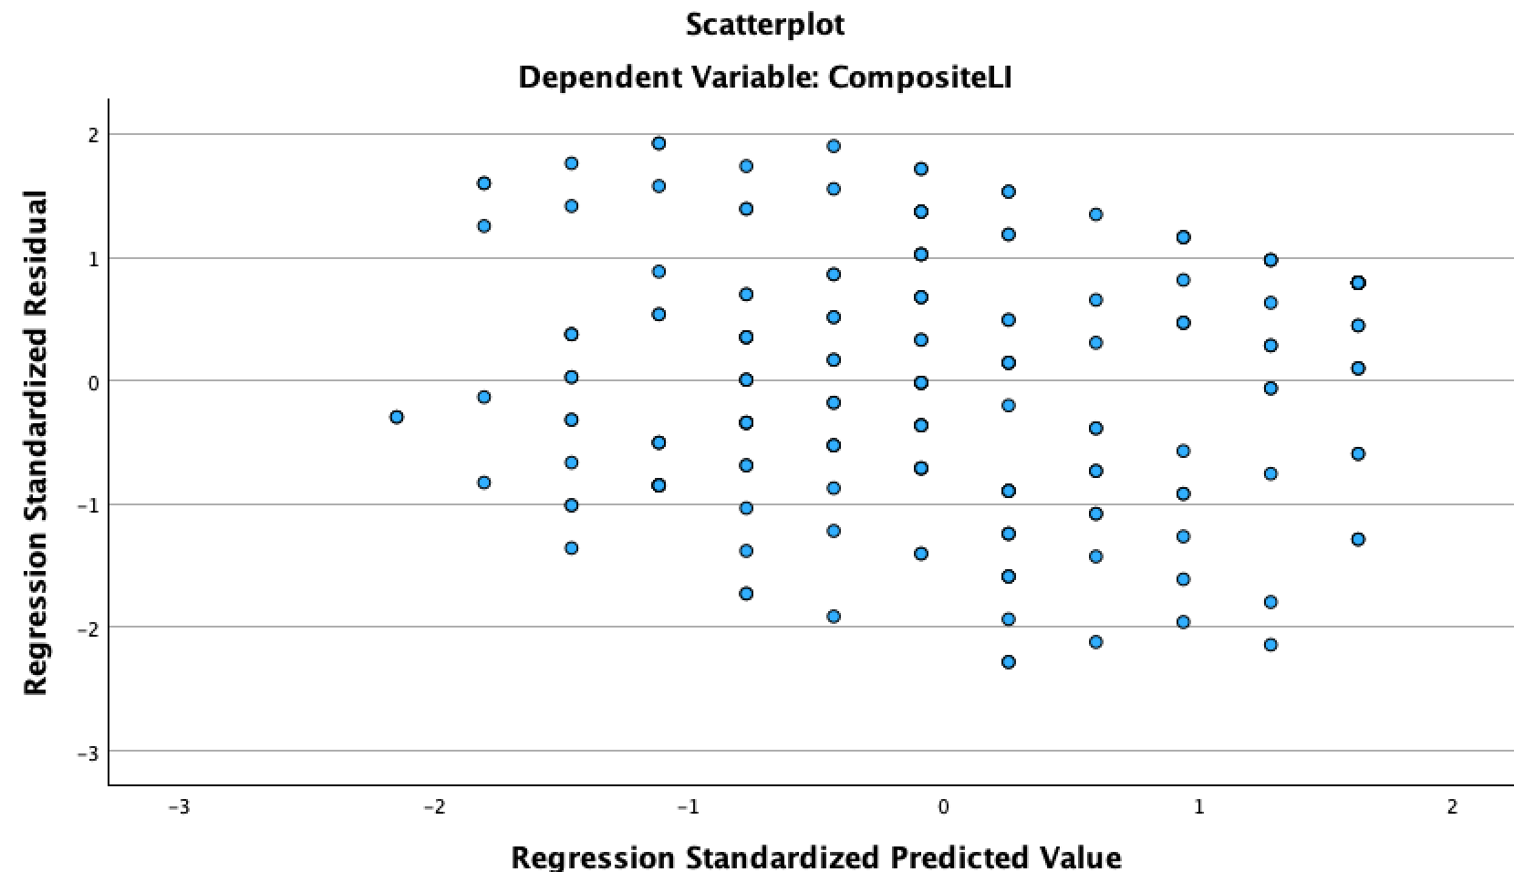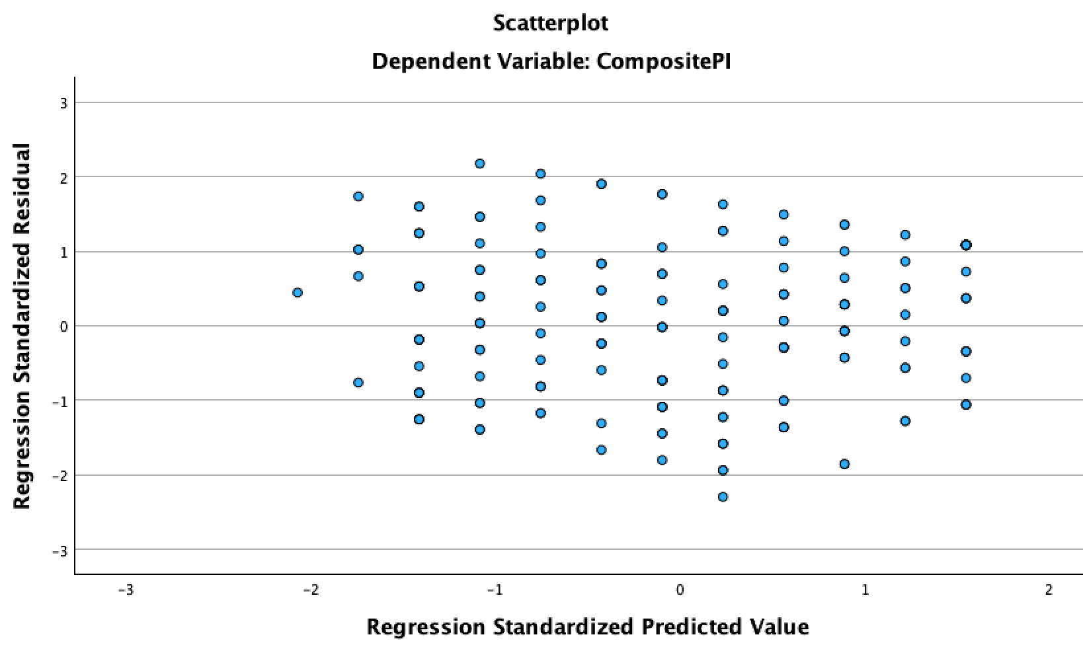
Figure 24 Figure 25
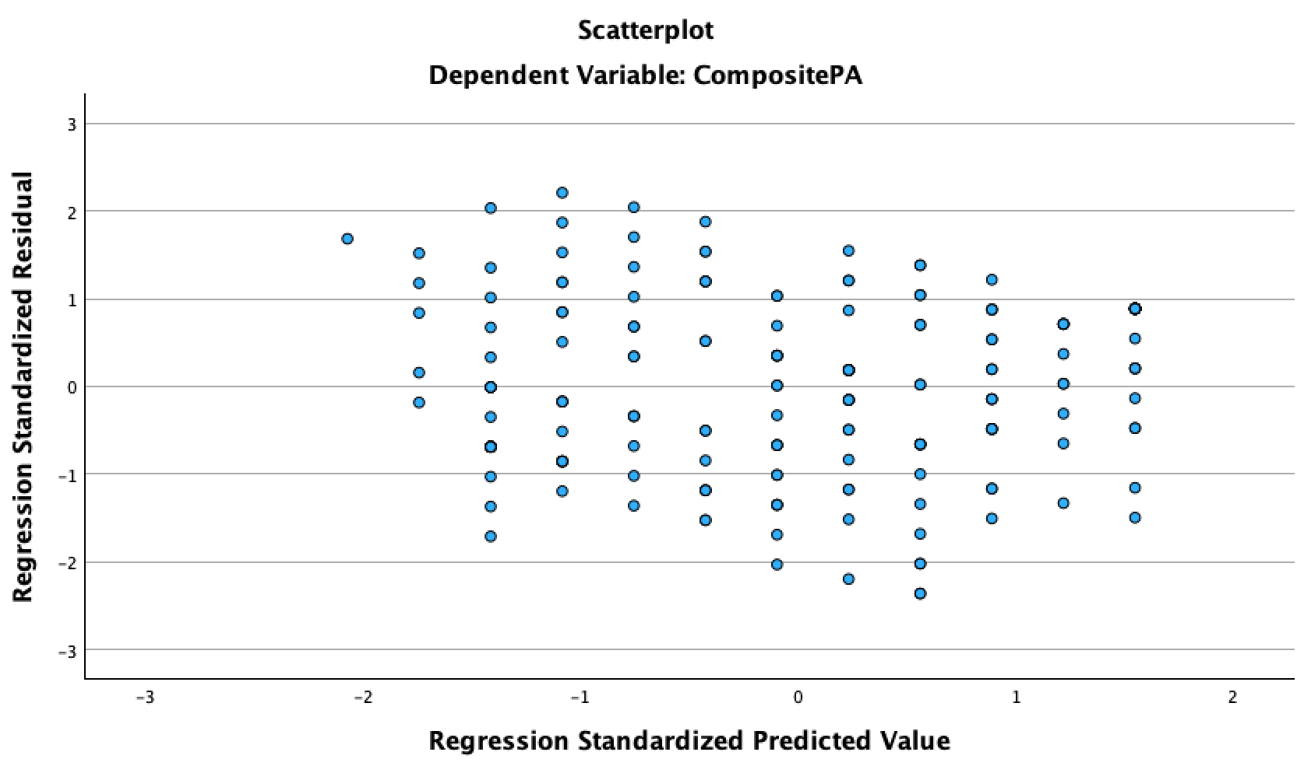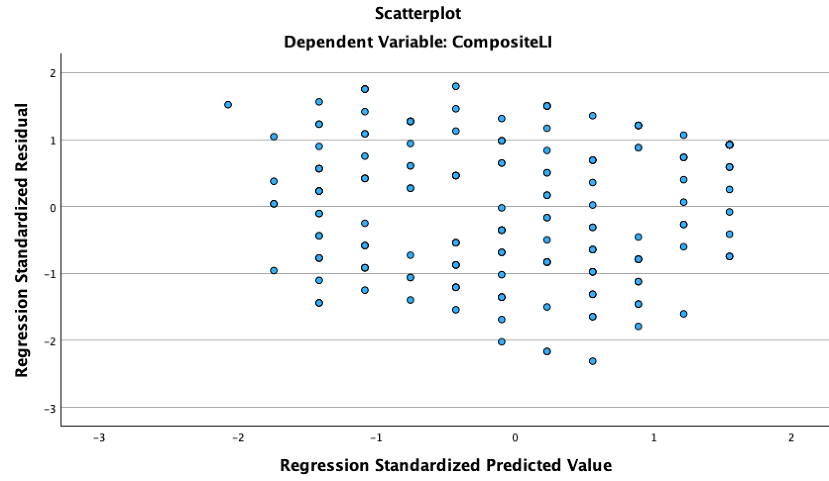
Figure 26 Figure 27

To conclude, four regression assumptions are fulfilled in this research, therefore regression analysis can be adopted to assess how different independent variables influence the dependent variable. Additionally, R² value is an essential tool to find out ‘the explanatory power of the model’. This value indicates the extent to which independent variables account for the variation in the dependent variables (Biecek, 2021). R² value ranges from 0 to 1 (Sarstedt, 2021). A higher value of R² represents a higher level of predictive accuracy (Biecek, 2021). According to Sarstedt (2021), if R² value is greater than 0.5 in the primary results, the model indicates a strong explanatory power. In this study, the construct R² values is close to 0.5, which possesses a moderate predictive accuracy. Several factors may contribute to this outcome, including a sample size that is not sufficiently large and the presence of missing values. Both conditions can impact the model prediction accuracy.

5.4 Hypotheses Analysis
This research evaluates the effectiveness of SMMA on customer trust and satisfaction, and how these relationship quality influences three customer intention outcomes. Based on the main research questions and objectives, 8 hypotheses were designed to find out explanatory statistics results. Additionally, a linear regression analysis was used to test the hypotheses. The results of simple linear regression indicate that all hypotheses are significant and have a positive value. Regarding to the first hypothesis, Figure 20 presented that SMMA has a significant and positive effect on customer trust. The constant is 5.443 and the unstandardized beta coefficient is 1.454, indicating that for each unit increase in SMMA, customer trust increases by 1.454 units. The standardized coefficients beta is 0.453, indicating a moderate positive relationship between SMMA and customer trust. The significance value is less than 0.001, and the t-value is 7.518 for constant and 6.894 for SMMA, representing great confidence in the coefficient as a predictor. In summary, the model shows that SMMA is a significant positive predictor of customer trust, and the model’s coefficients are statistically significant.
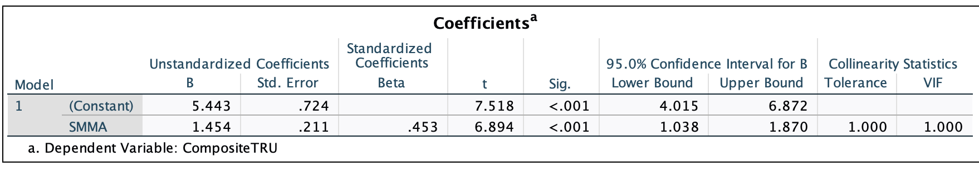
Figure 20

According to the second hypothesis, Figure 21 presented that SMMA has a significant and positive effect on customer satisfaction. The constant is 1.722 and the unstandardized beta coefficient is 0.516, indicating that for each unit increase in SMMA, customer satisfaction increases by 0.516 units. The standardized coefficients beta is 0.463, indicating a moderate positive relationship between SMMA and customer satisfaction. The significance value is less than 0.001, and the t-value is 6.882 for constant and 7.083 for SMMA, representing great confidence in the coefficient as a predictor. To conclude, the model suggests that SMMA has a statistically significant positive impact on customer satisfaction. 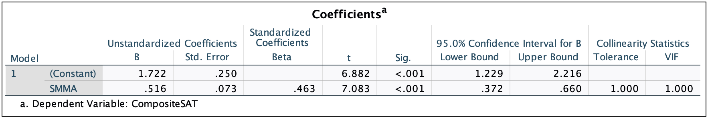
Figure 21

Regarding the third hypothesis, Figure 22 presented that customer trust has a significant and positive effect on customer purchase intention. The constant is 2.096 and the unstandardized beta coefficient is 0.126, indicating that for each unit increase in customer trust, customer purchase intention increases by 0.126 units. The standardized coefficients beta is 0.364, indicating a moderate positive relationship between customer trust and customer purchase intention. The significance value is less than 0.001, and the t-value is 8.275 for constant and 5.296 for customer trust, representing the great confidence in the coefficient as a predictor. To conclude, the model suggests that customer trust has a statistically positive effect on customer purchase intention. The t-values confirm that both the constant and customer trust significantly predict customer purchase intention.
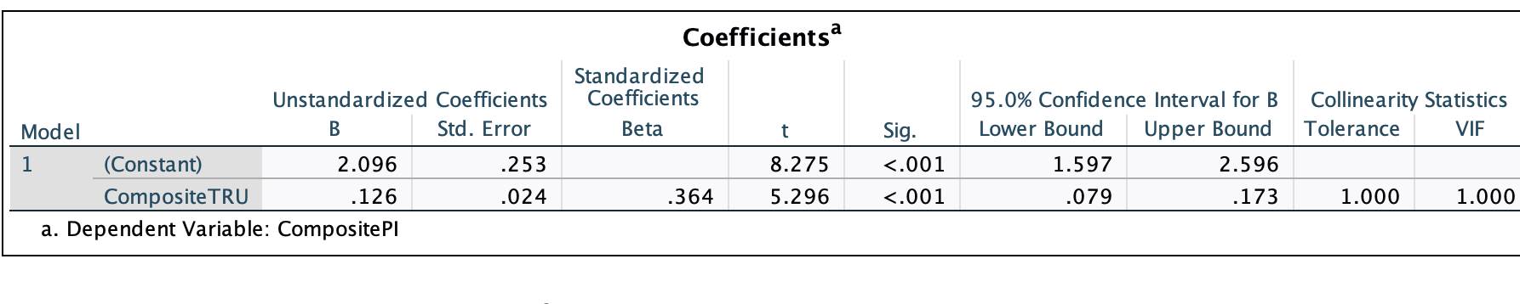
Figure 22

Regarding the fourth hypothesis, Figure 23 presented that customer trust has a significant and positive effect on customer participation intention. The constant is 1.668 and the unstandardized beta coefficient is 0.166, indicating that for each unit increase in customer trust, customer participation intention increases by 0.166 units. The standardized coefficients beta is 0.442, indicating a moderate positive relationship between customer trust and customer participation intention. The significance value is less than 0.001, and the t-value is 6.308 for constant and 6.686 for customer trust, representing the great confidence that the coefficient as a predictor. In summary, the model suggests that customer trust has a statistically positive effect on customer participation intention. The t-values confirm that both the constant and customer trust significantly predict customer participation intention.
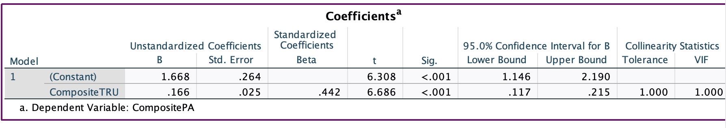Figure 23

Regarding the fifth hypothesis, Figure 24 presented that customer trust has a significant and positive effect on customer loyalty intention. The constant is 1.573 and the unstandardized beta coefficient is 0.178, indicating that for each unit increase in customer trust, customer loyalty intention increases by 0.178 units. The standardized coefficients beta is 0.475, indicating a moderate positive relationship between customer trust and customer loyalty intention. The significance value is less than 0.001, and the t-value is 6.080 for constant and 7.319 for customer trust, representing the great confidence that the coefficient as a predictor. In summary, the model shows that customer trust is a significant positive predictor of customer loyalty intention, and the model’s coefficients are statistically significant.
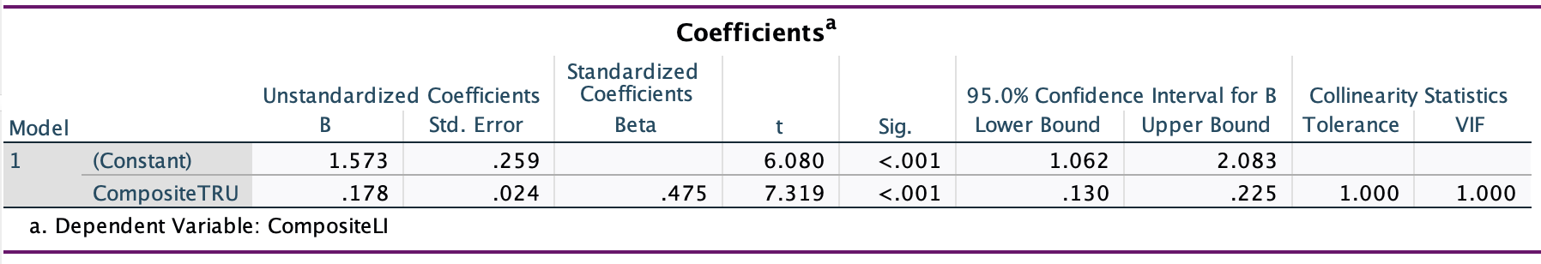
Figure 24

Regarding the sixth hypothesis, Figure 25 presented that customer satisfaction has a significant and positive effect on customer purchase intention. The constant is 2.073 and the unstandardized beta coefficient is 0.383, indicating that for each unit increase in customer satisfaction, customer purchase intention increases by 0.383 units. The standardized coefficients beta is 0.385, indicating a moderate positive relationship between customer satisfaction and customer purchase intention. The significance value is less than 0.001, and the t-value is 8.555 for constant and 5.651 for customer satisfaction, representing the great confidence that the coefficient as a predictor. To conclude, the model suggests that customer satisfaction has a statistically positive effect on customer purchase intention. The t-values confirm that both the constant and customer satisfaction significantly predict customer purchase intention.
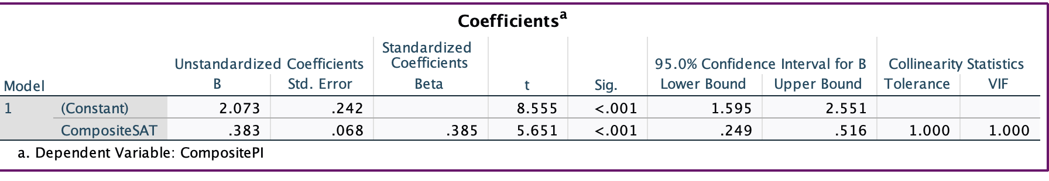
Figure 25

Regarding the seventh hypothesis, Figure 26 presented that customer satisfaction has a significant and positive effect on customer participation intention. The constant is 1.702 and the unstandardized beta coefficient is 0.486, indicating that for each unit increase in customer satisfaction, customer participation intention increases by 0.486 units. The standardized coefficients beta is 0.45, indicating a moderate positive relationship between customer satisfaction and customer participation intention. The significance value is less than 0.001, and the t-value is 6.697 for constant and 6.838 for customer satisfaction, representing the great confidence that the coefficient as a predictor. In summary, the model suggests that customer satisfaction has a statistically positive effect on customer participation intention. The t-values confirm that both the constant and customer satisfaction significantly predict customer participation intention.
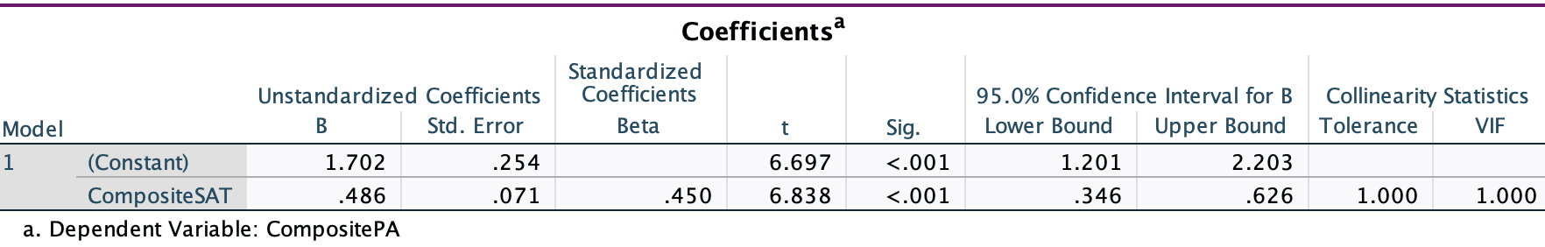Figure 26

According to the eighth hypothesis, Figure 27 presented that customer satisfaction has a significant and positive effect on customer loyalty intention. The constant is 1.896 and the unstandardized beta coefficient is 0.437, indicating that for each unit increase in customer satisfaction, customer loyalty intention increases by 0.437 units. The standardized coefficients beta is 0.406, indicating a moderate positive relationship between customer satisfaction and customer loyalty intention. The significance value is less than 0.001, and the t-value is 7.311 for constant and 6.022 for customer satisfaction, representing the great confidence that the coefficient as a predictor. In summary, the model suggests that customer satisfaction has a statistically positive effect on customer loyalty intention. The t-values confirm that both the constant and customer satisfaction significantly predict customer loyalty intention.
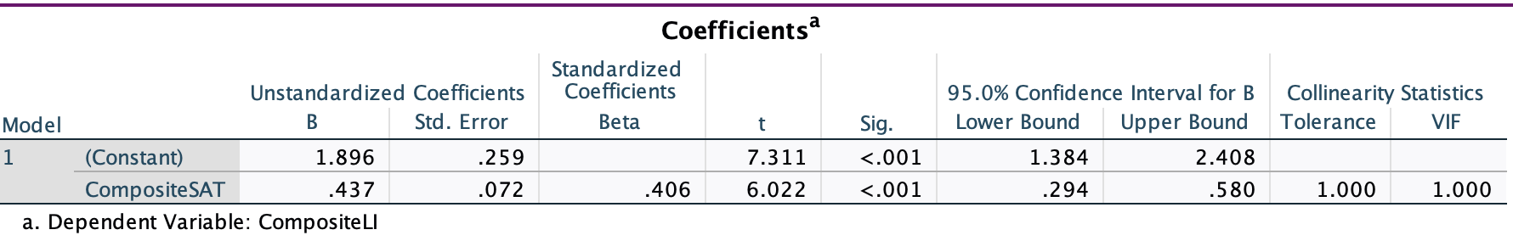
Figure 27

6. Findings and Implications
This study provides several contributions to the literature on social media marketing (SMMA), customer relationships, and customer intentions outcomes. First, it presents a solid model that outlines the antecedents of key customer intention outcomes, such as purchase intention, participation intention, and loyalty intention, in response to SMMA. Even though social media marketing activities have been widely discussed and researched in the marketing concepts, there has been a lack of comprehensive models in explaining customer intentions outcomes on these digital platforms. Second, this study investigates the role of customer relationship quality as a mediator in the relationships between SMMA and customer intention outcomes. Although existing studies have explored that SMMA and customer intentions can both affect customer relationship quality, there remains a lack of literature that uses customer relationship quality as a mediator and tests its impact on SMMA and customer intentions outcomes.

This study provides actionable and practical suggestions to luxury brand managers and social media operators who consider social media activities as their marketing strategies. Based on the results of multiple linear regression, WOM and entertainment have a greater impact on customer relationship quality among other social media marketing activities, with significant t-values. Therefore, luxury brands should treat carefully with their word-of-mouth, and implement strategies to increase positive word-of-mouth which is then expected to improve overall business performances. According to Krishna (2013), encouraging consumers to review products on social media and rewarding those who provide testimonials can greatly improve business online word-of-mouth. Additionally, enhancing positive word-of-mouth can be achieved by establishing an online community where companies and consumers can actively engage, address complaints, answer product-related questions, and share product information (Soelasih & Sumani, 2021). Furthermore, content created by luxury brands on social media platforms should prioritize the factor of entertainment. This may include combining the content with the story, layout design or other entertainment elements (Krishna, 2013).

Moreover, based on hypotheses 3 and 4, customer trust and satisfaction have significant positive impacts on customer intentions. We found that managing a good relationship quality can increase customer’s willingness to purchase, remain loyal, and engage actively with brands’ programs. This finding aligns with the study (Masri et al., 2020) that rational relationship quality is able to reduce costs and efforts by focusing on retaining existing customers. Therefore, it is important for luxury brands to understand how their marketing content, quality, and timing contribute to achieving customer trust and satisfaction and enhancing customer intentions outcomes. To achieve a high level of trust, marketing managers are able to help customers build inner online communities within social media apps. Online communities can improve communications between users and convey brand’s positive images (Broweus et al., 2018). Moreover, marketing objectives such as customer satisfaction can be achieved by creating customized and personalized content, in order to meet each individual’s characteristics and needs (Masri et al., 2020). Customers who receive personalized information or services are willing to express their actions that align with the brand’s goals (Hultén et al., 2009).

7. Conclusions and Reflections
In the digital era, marketers are increasingly aware of the need to focus not only on commercial aspects but also on socially-oriented elements. Adopting social media activities as a marketing tool is effective when the strategies align with the principles of SMMA and customer relationship quality. As a result, marketers must think critically and creatively to develop marketing strategies that align with the preferences of their target audiences. Such efforts can directly affect the quality of the relationship between the customer and the business and the customer intentions outcomes. This research adopts quantitative methods with linear regression models to analyze which SMMA tools luxury brands can adopt to achieve their marketing objectives. Based on the statistical findings and results, the research provides practical suggestions to enhance customer trust, satisfaction, and three customer intentions outcomes. There are certain limitations and biases concerning the subjectivity and positionality of the researcher and participants. For example, people usually have preferences for certain social media platforms based on their region or country. Further research will explore how cultural and social factors may influence customer interaction on social media platforms. Besides, the reliability and validity of second-hand datasets are not as strong as those of first-hand data sources. The future study will collect first-hand data source to guarantee the data trustworthiness and reliability.

Moreover, the module ‘Quantitative Research Methods’ enhanced my quantitative skills in using SPSS and data analysis. SPSS provides a wide range of statistical tests and techniques, from simple descriptive statistics to advanced multivariate analyses (e.g., regression, and factor analysis). Additionally, SPSS offers tools for creating graphs, charts, and tables, enhancing my ability to visualize data and interpret results. This also improved my understanding of trends and patterns within the dataset. Regarding the linear regression model that I adopted, SPSS allows to build predictive models, test hypotheses, and assess relationships between variables. Using these advanced features can improve skills in critical analysis and decision-making based on rich data insights. Overall, by regularly studying this module and working with SPSS, I have become more familiar with statistical techniques, and my quantitative analysis skills have greatly improved. This learning process will serve as valuable guidance and support for my future doctoral studies.

References:
1. Anastasiei, B.; Dospinescu, N. A model of the relationships between the Big Five personality traits and the motivations to deliverword-of-mouth online. Psihologija 2018,51, 215–227.
2. Agnihotri, R., Dingus, R., Hu, M. Y., & Krush, M. T. (2016). Social media: Influencing customer satisfaction in B2B sales. Industrial marketing management, 53, 172-180.
3. Agag, G., & El-Masry, A. A. (2016). Understanding consumer intention to participate in online travel community and effects on consumer intention to purchase travel online and WOM: An integration of innovation diffusion theory and TAM with trust. Computers in human behavior, 60, 97-111.
4. Aldhamiri, A., Carlson, J., Vilches-Montero, S., Rahman, S. M., & Gudergan, S. P. (2024). What drives higher active customer engagement in luxury brands’ social media? Measurement and contingencies. Journal of Retailing and Consumer Services, 79, 103804.
5.Alabi, O. O., Ayinde, K., Babalola, O. E., Bello, H. A., & Okon, E. C. (2020). Effects of 5. multicollinearity on type i error of some methods of detecting heteroscedasticity in linear regression model. Open Journal of Statistics, 10(4), 664-677.
6. Arrigo, E. (2018). Social media marketing in luxury brands: A systematic literature review and implications for management research. Management Research Review, 41(6), 657-679.
7. Akaka, M. A., Vargo, S. L., & Schau, H. J. (2015). The context of experience. Journal of service management, 26(2), 206-223.
8. Brodie, R. J., Ilic, A., Juric, B., & Hollebeek, L. (2013). Consumer engagement in a virtual brand community: An exploratory analysis. Journal of business research, 66(1), 105-114.
9. Bryman, A. (2004). Qualitative research on leadership: A critical but appreciative review. The leadership quarterly, 15(6), 729-769.
10. Bhattacherjee, A. (2002). Individual trust in online firms: Scale development and initial test. Journal of management information systems, 19(1), 211-241
11. Bollen, K. A. (1989). A new incremental fit index for general structural equation models. Sociological methods & research, 17(3), 303-316.
12. Biecek, P., & Burzykowski, T. (2021). Explanatory model analysis: explore, explain, and examine predictive models. Chapman and Hall/CRC.
13. Bilgin, Y. (2018). The effect of social media marketing activities on brand awareness, brand image and brand loyalty. Business & management studies: an international journal, 6(1), 128-148.
14.Bruhn, M., Schoenmüller, V., Schäfer, D., & Heinrich, D. (2012). Brand authenticity: Towards a deeper understanding of its conceptualization and measurement. Advances in consumer research, 40.
15. Bazi, Y., Al Rahhal, M. M., AlHichri, H., Ammour, N., Alajlan, N., & Zuair, M. (2020). Real-time mobile-based electrocardiogram system for remote monitoring of patients with cardiac arrhythmias. International Journal of Pattern Recognition and Artificial Intelligence, 34(10), 2058013.
15. Beckers, S. (2016) Economics Outcomes of Customer Engagement. Routledge.
16. Collier, J. E., Barnes, D. C., Abney, A. K., & Pelletier, M. J. (2018). Idiosyncratic service experiences: When customers desire the extraordinary in a service encounter. Journal of Business Research, 84, 150-161.
17. Creswell, J.W. (2003) Research design: Qualitative, quantitative, and mixed methods approaches. (2nd ed.) Thousand Oaks: Sage
18. Chen, S. C., & Lin, C. P. (2019). Understanding the effect of social media marketing activities: The mediation of social identification, perceived value, and satisfaction. Technological forecasting and social change, 140, 22-32.
19. Chen, X., & Qasim, H. (2021). Does E‐Brand experience matter in the consumer market? Explaining the impact of social media marketing activities on consumer‐based brand equity and love. Journal of Consumer Behaviour, 20(5), 1065-1077.
20. Dion, D., & Arnould, E. (2011). Retail luxury strategy: assembling charisma through art and magic. Journal of retailing, 87(4), 502-520.
21. Duarte, P.; Silva, S.C.E.; Ferreira, M.B. How convenient is it? Delivering online shopping convenience to enhance customersatisfaction and encourage e-WOM. J. Retail. Consum. Serv. 2018,44, 161–169.
22. Deloitte. (2019). Global Powers of Luxury Goods. https://www2.deloitte.com/content/dam/Deloitte/ar/Documents/Consumer_and_Industrial_Products/Global-Powers-of-Luxury-Goods-abril-2019.pdf (Accessed: 21 December 2023).
23. Flavián, C.; Guinalíu, M.; Gurrea, R. The role played by perceived usability, satisfaction and consumer trust on website loyalty.Inf. Manag. 2006,43, 1–14
24. Grover, P., & Kar, A. K. (2020). User engagement for mobile payment service providers–introducing the social media engagement model. Journal of Retailing and Consumer Services, 53, 101718.
25. Giovanis, A., Athanasopoulou, P., & Tsoukatos, E. (2015). The role of service fairness in the service quality–relationship quality–customer loyalty chain: An empirical study. Journal of Service Theory and Practice, 25(6), 744-776.
26. Gremler, D. D., Gwinner, K. P., & Henning-Thurau, T. (2002). Understanding relationship marketing outcomes. Journal of Service Research, 3.
27. Heale, R., & Twycross, A. (2015). Validity and reliability in quantitative studies. Evidence-based nursing, 18(3), 66-67.
28. Hapsari, R., Clemes, M. D., & Dean, D. (2017). The impact of service quality, customer engagement and selected marketing constructs on airline passenger loyalty. International Journal of Quality and Service Sciences, 9(1), 21-40.
29. Holmlund, M. (2008). A definition, model, and empirical analysis of business‐to‐business relationship quality. International journal of service industry management, 19(1), 32-62.
30. Hultén, B., Broweus, N., Van Dijk, M., Hultén, B., Broweus, N., & van Dijk, M. (2009). What is sensory marketing? (pp. 1-23). Palgrave Macmillan UK.
31. Hollebeek, L. (2015) Customer Engagement: Contemporary Issues and Challenges. Routledge.
32. Jap, S. D., Manolis, C., & Weitz, B. A. (1999). Relationship quality and buyer–seller interactions in channels of distribution. Journal of business research, 46(3), 303-313.
33. Kumari, S. S. (2008). Multicollinearity: Estimation and elimination. Journal of Contemporary research in Management, 3(1), 87-95.
34. Kumar, S. (2023) ‘How e-WOM influences consumers' purchase intention towards private label brands on e-commerce platforms: Investigation through IAM (Information Adoption Model) and ELM (Elaboration Likelihood Model) Models’, Technological Forecasting and Social Change, 187. Available at: https://www.sciencedirect.com/science/article/pii/S004016252200720X
35. Kaplan, A. M., & Haenlein, M. (2012). Social media: back to the roots and back to the future. Journal of systems and information technology, 14(2), 101-104.
36. Kim, A. J., & Ko, E. (2010). Impacts of luxury fashion brand’s social media marketing on customer relationship and purchase intention. Journal of Global fashion marketing, 1(3), 164-171.
37. Kim, S., & Park, H. (2013). Effects of various characteristics of social commerce (s-commerce) on consumers’ trust and trust performance. International journal of information management, 33(2), 318-332.
38. Lamberton, C., & Stephen, A. T. (2016). A thematic exploration of digital, social media, and mobile marketing: Research evolution from 2000 to 2015 and an agenda for future inquiry. Journal of marketing, 80(6), 146-172.
39. Liu, X. (2021) ‘Examining the impact of luxury brand's social media marketing on customer engagement: Using big data analytics and natural language processing’, Journal of Business Research, 125, pp.815-826. Available at: https://www.sciencedirect.com/science/article/pii/S0148296319302954
40. Luan, M., Sun, J., & Li, H. (2023). Do maximizing consumers engage more in conspicuous consumption?. Journal of Consumer Behaviour, 22(5), 1146-1157.

41. Mangold, W. G., & Faulds, D. J. (2009). Social media: The new hybrid element of the promotion mix. Business horizons, 52(4), 357-365.
42. McKinsey (2019) The Chinese Luxury Consumer. Available at: https://www.mckinsey.com/featured-insights/china/the-chinese-luxury-consumer (Accessed: 12 January 2024).
43. Muntinga, D. G., Moorman, M., & Smit, E. G. (2011). Introducing COBRAs: Exploring motivations for brand-related social media use. International Journal of advertising, 30(1), 13-46.
44. Masri, N. W., You, J. J., Ruangkanjanases, A., Chen, S. C., & Pan, C. I. (2020). Assessing the effects of information system quality and relationship quality on continuance intention in e-tourism. International journal of environmental research and public health, 17(1), 174.
45. Malkovich, J. F., & Afifi, A. A. (1973). On tests for multivariate normality. Journal of the american statistical association, 68(341), 176-179.
46. Oliver, R. L. (1999). Whence consumer loyalty. Journal of marketing, 63, 33-44.
47. Oliveira, T., Thomas, M., Baptista, G., & Campos, F. (2016). Mobile payment: Understanding the determinants of customer adoption and intention to recommend the technology. Computers in Human Behavior, 61, 404–414. https://doi.org/10.1016/j.chb.2016.03.030
48. Ozuem, W., Howell, K., & Lancaster, G. (2014). Corporate social responsibility: Towards a context-specific perspective in developing countries. Social Responsibility Journal, 10(3), 399-415.
49. Porter, M. E. (2001). Strategy and the Internet. Harvard Business Review.
50. Pentina, I., Guilloux, V., & Micu, A. C. (2018). Exploring social media engagement behaviors in the context of luxury brands. Journal of Advertising, 47(1), 55-69.
51. Palmatier, R. W., Dant, R. P., Grewal, D., & Evans, K. R. (2006). Factors influencing the effectiveness of relationship marketing: A meta-analysis. Journal of marketing, 70(4), 136-153.
52. Quach, S., & Thaichon, P. (2017). From connoisseur luxury to mass luxury: Value co-creation and co-destruction in the online environment. Journal of Business Research, 81, 163-172.
53. Queirós, A., Faria, D., & Almeida, F. (2017). Strengths and limitations of qualitative and quantitative research methods. European journal of education studies.
54. Ryan, R. M., & Deci, E. L. (2000). Intrinsic and extrinsic motivations: Classic definitions and new directions. Contemporary educational psychology, 25(1), 54-67.
55. Risius, M., & Beck, R. (2015). Effectiveness of corporate social media activities in increasing relational outcomes. Information & Management, 52(7), 824-839.
56. Saravanakumar, T. The impact of social media influencers on consumer purchase decisions. CHANGING LANDSCAPE OF NEWS MEDIA & ENTERTAINMENT, 91.
57. Statista (2023) Monthly active users of Douyin in China 2021-2022. Available at: https://www.statista.com/statistics/1361354/china-monthly-active-users-of-douyin-chinese-tiktok/ (Accessed: 20 December 2023).
58. Schiffman, L.G.; Kanuk, L.L. Consumer Behavior, 10th ed.; Prentice Hall: Upper Saddle River, NJ, USA, 2009.
59. Shareef, M. A., Mukerji, B., Dwivedi, Y. K., Rana, N. P., & Islam, R. (2019). Social media marketing: Comparative effect of advertisement sources. Journal of Retailing and Consumer Services, 46, 58-69.
60. Shrestha, N. (2020). Detecting multicollinearity in regression analysis. American Journal of Applied Mathematics and Statistics, 8(2), 39-42.
61. Tajvidi, M., Richard, M. O., Wang, Y., & Hajli, N. (2020). Brand co-creation through social commerce information sharing: The role of social media. Journal of Business Research, 121, 476-486.
62. Van Doorn, J., Lemon, K. N., Mittal, V., Nass, S., Pick, D., Pirner, P., & Verhoef, P. C. (2010). Customer engagement behavior: Theoretical foundations and research directions. Journal of service research, 13(3), 253-266.
63. Wibowo, A., Chen, S. C., Wiangin, U., Ma, Y., & Ruangkanjanases, A. (2020). Customer behavior as an outcome of social media marketing: The role of social media marketing activity and customer experience. Sustainability, 13(1), 189.
64. Verma, V., Sharma, D., & Sheth, J. (2016). Does relationship marketing matter in online retailing? A meta-analytic approach. Journal of the academy of marketing science, 44, 206-217.
65. Yadav, M.; Rahman, Z. The inﬂuence of social media marketing activities on customer loyalty: A study of e-commerce industry.Benchmarking 2018,25, 3882–3905
66. Yahia, I. B., Al-Neama, N., & Kerbache, L. (2018). Investigating the drivers for social commerce in social media platforms: Importance of trust, social support and the platform perceived usage. Journal of Retailing and Consumer Services, 41, 11-19.

