

UWTSD: School of Engineering

Predictive Maintenance Strategies

Author: Catrina Morgan
2405745

BSc Manufacturing Systems Engineering

Date: 28/09/26

Module Name: Control Technology
Code: ACMA6001

Contents Page

Contents
1 Contents Page 2
1.1 Contents 2
1.2 Index of Figures 7
1.3 Index of Tables 9
1.4 Index of Equations 9
2 Introduction 10
2.1 Industrial Context 10
2.1.1 Importance of Maintenance in Industrial Operations 10
2.1.2 Rotating Machinery in Refineries 10
2.1.3 Consequences of Failure 10
2.1.4 Economic and Operational Impacts 10
2.2 Case Study Overview 10
2.3 Research Aim and Objectives 10
2.3.1 Research Aim 10
2.3.2 Research Objectives 10
2.3.3 Purpose of the Report 10
3 Literature Review 11
3.1 Maintenance Strategies in Industrial Operations 11
3.2 Condition Monitoring and Fault Diagnosis 11
3.3 Artificial Intelligence in Predictive Maintenance 11
4 Methodology 12
4.1 Case Study System Description 12
4.2 Synthetic Dataset Generation and Preparation 13
4.3 Model Development Procedure 13
4.3.1 Support Vector Machine (SVM) 13
4.3.2 Neural Network 13
4.4 Experimental Design 14
4.4.1 Consistent testing procedure 14
4.4.2 Data Splitting 14
4.4.3 Data Normalisation 14
4.4.4 MATLAB Implementation 14
4.4.4.1 Building Network 1: Sensor Drift 14
4.4.4.2 Building Network 2: Shaft Wear 14
4.4.4.3 Building Network 3: Gear Tooth Fault 14
4.4.5 Cross-Validation Procedure 14
4.5 Performance Evaluation Metrics 15
4.5.1 Accuracy 15
4.5.2 Cross-Validated Accuracy 15
4.5.3 Confusion Matrix Analysis 15
5 Results 16
5.1 Sensor Drift 16
5.1.1 Results Table 16
5.1.2 Fine Tree 17
5.1.2.1 Scatter Plot 17
5.1.2.2 Validation Confusion Matrix 17
5.1.3 SVM 18
5.1.3.1 Scatter Plot 18
5.1.3.1.1 Linear SVM 18
5.1.3.1.2 Cubic SVM 18
5.1.3.1.3 Quadratic SVM 19
5.1.3.1.4 Fine Gaussian SVM 19
5.1.3.1.5 Medium Gaussian SVM 20
5.1.3.1.6 Coarse Gaussian SVM 20
5.1.3.2 Validation Confusion Matrix 21
5.1.3.2.1 Linear SVM 21
5.1.3.2.2 Cubic SVM 21
5.1.3.2.3 Quadratic SVM 22
5.1.3.2.4 Fine Gaussian SVM 22
5.1.3.2.5 Medium Gaussian SVM 23
5.1.3.2.6 Coarse Gaussian SVM 23
5.1.4 Neural Network 24
5.1.4.1 Scatter Plot 24
5.1.4.1.1 Narrow Neural Network 24
5.1.4.1.2 Medium Neural Network 24
5.1.4.1.3 Wide Neural Network 25
5.1.4.1.4 Bilayered Neural Network 25
5.1.4.1.5 Trilayered Neural Network 26
5.1.4.2 Validation Confusion Matrix 26
5.1.4.2.1 Narrow Neural Network 26
5.1.4.2.2 Medium Neural Network 27
5.1.4.2.3 Wide Neural Network 27
5.1.4.2.4 Bilayered Neural Network 28
5.1.4.2.5 Trilayered Neural Network 28
5.1.4.3 Training Process 29
5.1.4.3.1 Narrow Neural Network 29
5.1.4.3.2 Medium Neural Network 29
5.1.4.3.3 Wide Neural Network 30
5.1.4.3.4 Bilayered Neural Network 30
5.1.4.3.5 Trilayered Neural Network 31
5.1.5 Model Comparison 31
5.1.5.1 Accuracy 31
5.1.5.2 Coder Model Size 32
5.1.5.3 Error Rate 32
5.1.5.4 Prediction Speed 33
5.1.5.5 Total Cost 33
5.1.5.6 Training Time 34
5.2 Gear Tooth Fault 35
5.2.1 Results Table 35
5.2.2 Fine Tree 36
5.2.2.1 Scatter Plot 36
5.2.2.2 Validation Confusion Matrix 36
5.2.3 SVM 37
5.2.3.1 Scatter Plot 37
5.2.3.1.1 Linear SVM 37
5.2.3.1.2 Cubic SVM 37
5.2.3.1.3 Quadratic SVM 38
5.2.3.1.4 Fine Gaussian SVM 38
5.2.3.1.5 Medium Gaussian SVM 39
5.2.3.1.6 Coarse Gaussian SVM 39
5.2.3.2 Validation Confusion Matrix 40
5.2.3.2.1 Linear SVM 40
5.2.3.2.2 Cubic SVM 40
5.2.3.2.3 Quadratic SVM 41
5.2.3.2.4 Fine Gaussian SVM 41
5.2.3.2.5 Medium Gaussian SVM 42
5.2.3.2.6 Coarse Gaussian SVM 42
5.2.4 Neural Network 43
5.2.4.1 Scatter Plot 43
5.2.4.1.1 Narrow Neural Network 43
5.2.4.1.2 Medium Neural Network 43
5.2.4.1.3 Wide Neural Network 44
5.2.4.1.4 Bilayered Neural Network 44
5.2.4.1.5 Trilayered Neural Network 45
5.2.4.2 Validation Confusion Matrix 45
5.2.4.2.1 Narrow Neural Network 45
5.2.4.2.2 Medium Neural Network 46
5.2.4.2.3 Wide Neural Network 46
5.2.4.2.4 Bilayered Neural Network 47
5.2.4.2.5 Trilayered Neural Network 47
5.2.4.3 Training Process 48
5.2.4.3.1 Narrow Neural Network 48
5.2.4.3.2 Medium Neural Network 48
5.2.4.3.3 Wide Neural Network 49
5.2.4.3.4 Bilayered Neural Network 49
5.2.4.3.5 Trilayered Neural Network 50
5.2.5 Model Comparison 50
5.2.5.1 Accuracy 50
5.2.5.2 Coder Model Size 51
5.2.5.3 Error Rate 51
5.2.5.4 Prediction Speed 52
5.2.5.5 Total Cost 52
5.2.5.6 Training Time 53
5.3 Output Shaft Wear 54
5.3.1 Results Table 54
5.3.2 Fine Tree 55
5.3.2.1 Scatter Plot 55
5.3.2.2 Validation Confusion Matrix 55
5.3.3 SVM 56
5.3.3.1 Scatter Plot 56
5.3.3.1.1 Linear SVM 56
5.3.3.1.2 Cubic SVM 56
5.3.3.1.3 Quadratic SVM 57
5.3.3.1.4 Fine Gaussian SVM 57
5.3.3.1.5 Medium Gaussian SVM 58
5.3.3.1.6 Coarse Gaussian SVM 58
5.3.3.2 Validation Confusion Matrix 59
5.3.3.2.1 Linear SVM 59
5.3.3.2.2 Cubic SVM 59
5.3.3.2.3 Quadratic SVM 60
5.3.3.2.4 Fine Gaussian SVM 60
5.3.3.2.5 Medium Gaussian SVM 61
5.3.3.2.6 Coarse Gaussian SVM 61
5.3.4 Neural Network 62
5.3.4.1 Scatter Plot 62
5.3.4.1.1 Narrow Neural Network 62
5.3.4.1.2 Medium Neural Network 62
5.3.4.1.3 Wide Neural Network 63
5.3.4.1.4 Bilayered Neural Network 63
5.3.4.1.5 Trilayered Neural Network 64
5.3.4.2 Validation Confusion Matrix 64
5.3.4.2.1 Narrow Neural Network 64
5.3.4.2.2 Medium Neural Network 65
5.3.4.2.3 Wide Neural Network 65
5.3.4.2.4 Bilayered Neural Network 66
5.3.4.2.5 Trilayered Neural Network 66
5.3.4.3 Training Process 67
5.3.4.3.1 Narrow Neural Network 67
5.3.4.3.2 Medium Neural Network 67
5.3.4.3.3 Wide Neural Network 68
5.3.4.3.4 Bilayered Neural Network 68
5.3.4.3.5 Trilayered Neural Network 69
5.3.5 Model Comparison 69
5.3.5.1 Accuracy 69
5.3.5.2 Coder Model Size 70
5.3.5.3 Error Rate 70
5.3.5.4 Prediction Speed 71
5.3.5.5 Total Cost 71
5.3.5.6 Training Time 72
5.4 Overall Results Comparison 73
6 Results and Discussion 74
6.1 Comparative Performance Analysis 74
6.2 Fault Detectability Analysis 75
6.2.1 Gear Tooth Damage 75
6.2.2 Output Shaft Wear 75
6.2.3 Sensor Drift 75
6.2.4 Hardest Fault Class to Detect 75
6.3 Feature Effectiveness 75
6.4 Industrial Implications 76
7 Conclusions, Limitations and Recommendations 76
7.1 Conclusions 76
7.2 Study Limitations 76
7.3 Recommendations 76
7.3.1 Future work 76
8 References 77
9 Appendices 80
9.1 Results Tables 80
9.1.1 Sensor Drift 80
9.1.2 Gear Tooth Fault 83
9.1.3 Output Shaft Wear 85

Index of Figures
Figure 1 - Transmission System Model Diagram (Jenkins, 2026) 12
Figure 2– Sensor Drift - Scatter Plot - Fine Tree 17
Figure 3– Sensor Drift - Validation Confusion Matrix - Fine Tree 17
Figure 4– Sensor Drift - Scatter Plot - Linear SVM 18
Figure 5– Sensor Drift - Scatter Plot - Cubic SVM 18
Figure 6– Sensor Drift - Scatter Plot - Quadratic SVM 19
Figure 7– Sensor Drift - Scatter Plot - Fine Gaussian SVM 19
Figure 8– Sensor Drift - Scatter Plot - Medium Gaussian SVM 20
Figure 9– Sensor Drift - Scatter Plot - Coarse Gaussian SVM 20
Figure 10– Sensor Drift - Validation Confusion Matrix - Linear SVM 21
Figure 11– Sensor Drift - Validation Confusion Matrix - Cubic SVM 21
Figure 12– Sensor Drift - Validation Confusion Matrix - Quadratic SVM 22
Figure 13– Sensor Drift - Validation Confusion Matrix - Fine Gaussian SVM 22
Figure 14– Sensor Drift - Validation Confusion Matrix - Medium Gaussian SVM 23
Figure 15– Sensor Drift - Validation Confusion Matrix - Coarse Gaussian SVM 23
Figure 16 – Sensor Drift - Scatter Plot - Narrow Neural Network 24
Figure 17 – Sensor Drift - Scatter Plot - Medium Neural Network 24
Figure 18 – Sensor Drift - Scatter Plot - Wide Neural Network 25
Figure 19 – Sensor Drift - Scatter Plot - Bilayered Neural Network 25
Figure 20 – Sensor Drift - Scatter Plot - Trilayered Neural Network 26
Figure 21 – Sensor Drift - Validation Confusion Matrix - Narrow Neural Network 26
Figure 22 – Sensor Drift - Validation Confusion Matrix - Medium Neural Network 27
Figure 23 – Sensor Drift - Validation Confusion Matrix - Wide Neural Network 27
Figure 24 – Sensor Drift - Validation Confusion Matrix - Bilayered Neural Network 28
Figure 25 – Sensor Drift - Validation Confusion Matrix - Trilayered Neural Network 28
Figure 26 – Sensor Drift - Training Process - Narrow Neural Network 29
Figure 27 – Sensor Drift - Training Process - Medium Neural Network 29
Figure 28 – Sensor Drift - Training Process - Wide Neural Network 30
Figure 29 – Sensor Drift - Training Process - Bilayered Neural Network 30
Figure 30 – Sensor Drift - Training Process - Trilayered Neural Network 31
Figure 31 – Sensor Drift - Model Comparison - Accuracy 31
Figure 32 – Sensor Drift - Model Comparison - Coder Model Size 32
Figure 33 – Sensor Drift - Model Comparison - Error Rate 32
Figure 34 – Sensor Drift - Model Comparison - Prediction Speed 33
Figure 35 – Sensor Drift - Model Comparison - Total Cost 33
Figure 36 – Sensor Drift - Model Comparison - Training Time 34
Figure 37 – Gear Tooth Fault - Scatter Plot - Fine Tree 36
Figure 38 – Gear Tooth Fault - Validation Confusion Matrix - Fine Tree 36
Figure 39 – Gear Tooth Fault - Scatter Plot - Linear SVM 37
Figure 40 – Gear Tooth Fault - Scatter Plot - Cubic SVM 37
Figure 41 – Gear Tooth Fault - Scatter Plot - Quadratic SVM 38
Figure 42 – Gear Tooth Fault - Scatter Plot - Fine Gaussian SVM 38
Figure 43 – Gear Tooth Fault - Scatter Plot - Medium Gaussian SVM 39
Figure 44 – Gear Tooth Fault - Scatter Plot - Coarse Gaussian SVM 39
Figure 45 – Gear Tooth Fault - Validation Confusion Matrix - Linear SVM 40
Figure 46 – Gear Tooth Fault - Validation Confusion Matrix - Cubic SVM 40
Figure 47 – Gear Tooth Fault - Validation Confusion Matrix - Quadratic SVM 41
Figure 48 – Gear Tooth Fault - Validation Confusion Matrix - Fine Gaussian SVM 41
Figure 49 – Gear Tooth Fault - Validation Confusion Matrix - Medium Gaussian SVM 42
Figure 50 – Gear Tooth Fault - Validation Confusion Matrix - Coarse Gaussian SVM 42
Figure 51 – Gear Tooth Fault - Scatter Plot - Narrow Neural Network 43
Figure 52 – Gear Tooth Fault - Scatter Plot - Medium Neural Network 43
Figure 53 – Gear Tooth Fault - Scatter Plot - Wide Neural Network 44
Figure 54 – Gear Tooth Fault - Scatter Plot - Bilayered Neural Network 44
Figure 55 – Gear Tooth Fault - Scatter Plot - Trilayered Neural Network 45
Figure 56 – Gear Tooth Fault - Validation Confusion Matrix - Narrow Neural Network 45
Figure 57 – Gear Tooth Fault - Validation Confusion Matrix - Medium Neural Network 46
Figure 58 – Gear Tooth Fault - Validation Confusion Matrix - Wide Neural Network 46
Figure 59 – Gear Tooth Fault - Validation Confusion Matrix - Bilayered Neural Network 47
Figure 60 – Gear Tooth Fault - Validation Confusion Matrix - Trilayered Neural Network 47
Figure 61 – Gear Tooth Fault - Training Process - Narrow Neural Network 48
Figure 62 – Gear Tooth Fault - Training Process - Medium Neural Network 48
Figure 63 – Gear Tooth Fault - Training Process - Wide Neural Network 49
Figure 64 – Gear Tooth Fault - Training Process - Bilayered Neural Network 49
Figure 65 – Gear Tooth Fault - Training Process - Trilayered Neural Network 50
Figure 66 – Gear Tooth Fault - Model Comparison - Accuracy 50
Figure 67 – Gear Tooth Fault - Model Comparison - Coder Model Size 51
Figure 68 – Gear Tooth Fault - Model Comparison - Error Rate 51
Figure 69 – Gear Tooth Fault - Model Comparison - Prediction Speed 52
Figure 70 – Gear Tooth Fault - Model Comparison - Total Cost 52
Figure 71 – Gear Tooth Fault - Model Comparison - Training Time 53
Figure 72 – Output Shaft Wear - Scatter Plot - Fine Tree 55
Figure 73 – Output Shaft Wear - Validation Confusion Matrix - Fine Tree 55
Figure 74 – Output Shaft Wear - Scatter Plot - Linear SVM 56
Figure 75 – Output Shaft Wear - Scatter Plot - Cubic SVM 56
Figure 76 – Output Shaft Wear - Scatter Plot - Quadratic SVM 57
Figure 77 – Output Shaft Wear - Scatter Plot - Fine Gaussian SVM 57
Figure 78 – Output Shaft Wear - Scatter Plot - Medium Gaussian SVM 58
Figure 79 – Output Shaft Wear - Scatter Plot - Coarse Gaussian SVM 58
Figure 80 – Output Shaft Wear - Validation Confusion Matrix - Linear SVM 59
Figure 81 – Output Shaft Wear - Validation Confusion Matrix - Cubic SVM 59
Figure 82 – Output Shaft Wear - Validation Confusion Matrix - Quadratic SVM 60
Figure 83 – Output Shaft Wear - Validation Confusion Matrix - Fine Gaussian SVM 60
Figure 84 – Output Shaft Wear - Validation Confusion Matrix - Medium Gaussian SVM 61
Figure 85 – Output Shaft Wear - Validation Confusion Matrix - Coarse Gaussian SVM 61
Figure 86 – Output Shaft Wear - Scatter Plot - Narrow Neural Network 62
Figure 87 – Output Shaft Wear - Scatter Plot - Medium Neural Network 62
Figure 88 – Output Shaft Wear - Scatter Plot - Wide Neural Network 63
Figure 89 – Output Shaft Wear - Scatter Plot - Bilayered Neural Network 63
Figure 90 – Output Shaft Wear - Scatter Plot - Trilayered Neural Network 64
Figure 91 – Output Shaft Wear - Validation Confusion Matrix - Narrow Neural Network 64
Figure 92 – Output Shaft Wear - Validation Confusion Matrix - Medium Neural Network 65
Figure 93 – Output Shaft Wear - Validation Confusion Matrix - Wide Neural Network 65
Figure 94 – Output Shaft Wear - Validation Confusion Matrix - Bilayered Neural Network 66
Figure 95 – Output Shaft Wear - Validation Confusion Matrix - Trilayered Neural Network 66
Figure 96 – Output Shaft Wear - Training Process - Narrow Neural Network 67
Figure 97 – Output Shaft Wear - Training Process - Medium Neural Network 67
Figure 98 – Output Shaft Wear - Training Process - Wide Neural Network 68
Figure 99 – Output Shaft Wear - Training Process - Bilayered Neural Network 68
Figure 100 – Output Shaft Wear - Training Process - Trilayered Neural Network 69
Figure 101 – Output Shaft Wear - Model Comparison - Accuracy 69
Figure 102 – Output Shaft Wear - Model Comparison - Coder Model Size 70
Figure 103 – Output Shaft Wear - Model Comparison - Error Rate 70
Figure 104 – Output Shaft Wear - Model Comparison - Prediction Speed 71
Figure 105 – Output Shaft Wear - Model Comparison - Total Cost 71
Figure 106 – Output Shaft Wear - Model Comparison - Training Time 72

Index of Tables
Table 1 - Confusion Matrix Analysis - Overview 15
Table 2 – Sensor Drift – Results Table 16
Table 3 – Gear Tooth Fault – Results Table 35
Table 4 – Output Shaft Wear – Results Table 54
Table 5 - Results comparison - Top 3 models per 3 faults 73
Table 6 - Gear Tooth Fault - Results - Full 83
Table 7 - Output Shaft Wear - Results - Full 85

Index of Equations
Equation 1 - Accuracy 15
Equation 2 - Cross-Validation Accuracy 15

Introduction

Industrial Context

Importance of Maintenance in Industrial Operations
The smooth running of industrial operations relies on the effective maintenance of equipment such as motors, gearboxes, and pumps (ISO, 2018). Equipment failures can lead to unplanned downtime, safety hazards, environmental impacts, and a decline in product quality (Hector and Panjanathan, 2024). Refineries and other process industries increasingly rely on reliable maintenance practices to maximise equipment availability and minimise operational risks.

Rotating Machinery in Refineries
Rotating machinery, including pumps, compressors, turbines, motors, and gearboxes, forms the backbone of refinery operations. As continuous operation is essential for efficient production, plant performance is directly dependent on the reliability of these assets.

Consequences of Failure
Equipment failures can cause unplanned downtime, environmental impacts, and safety hazards. For example, the failure of critical systems such as cooling equipment may lead to overheating and increased operational risks. In addition to disrupting production, these failures can adversely affect product quality and, in severe cases, halt production entirely.

Economic and Operational Impacts
Equipment failures can significantly reduce production availability and result in substantial financial losses. Unexpected breakdowns often require urgent repairs and replacement components, which can increase maintenance costs due to fluctuating part prices and expedited procurement. While planned maintenance may temporarily disrupt production schedules, it plays a vital role in reducing the likelihood of unplanned failures and their associated operational, safety, and economic impacts.

Case Study Overview
The Simulink-based Pump P-2201A drivetrain model was used to simulate vibration responses from normal operation and three fault conditions: gear tooth damage, output shaft wear, and sensor drift. Synthetic labelled datasets were generated to train and evaluate Support Vector Machine (SVM) and Neural Network fault-classification models.

Research Aim and Objectives

Research Aim
To compare the effectiveness of SVM and Neural Network models for predictive maintenance of refinery rotating machinery.

Research Objectives
- Review predictive maintenance approaches.
- Evaluate SVM and Neural Network performance.
- Compare fault detection capabilities.
- Assess industrial suitability.

Purpose of the Report
To investigate AI-based fault classification for predictive maintenance and its potential to improve maintenance decision-making in refinery operations.

Literature Review

Maintenance Strategies in Industrial Operations
Maintenance strategies generally range from reactive maintenance, which addresses failures after they occur and can result in unplanned downtime and increased costs, to preventive maintenance, which seeks to minimise failure risk through scheduled interventions but may lead to unnecessary maintenance activities and associated expenditure (Yousof Gholipour, 2025). Predictive maintenance uses condition monitoring data to identify developing faults before failure occurs, enabling proactive maintenance planning and reducing the likelihood of unplanned downtime while improving equipment availability and operational safety (ISO, 2018; Taoufyq et al., 2025).

Gearbox degradation is a significant concern in refinery applications, as gear failures can lead to production quality degradation, equipment malfunction, and, in severe cases, catastrophic failure (Luo and Wang, 2025). Consequently, condition monitoring is widely used to assess gearbox health, support continuous plant operation, and reduce the safety risks associated with unexpected equipment failures (ISO, 2018).

Condition Monitoring and Fault Diagnosis
Condition monitoring is widely used to detect developing faults in rotating machinery before functional failure occurs (ISO, 2018). Traditional fault-diagnosis approaches include manual vibration analysis, threshold alarms, signal-processing techniques, and statistical methods, which rely heavily on expert interpretation of machine behaviour. While these methods are relatively simple and transparent, they can struggle to detect complex fault patterns. Recent advances in machine learning and deep learning have enabled more automated fault classification using data-driven techniques. Deep learning models can learn diagnostic features directly from vibration data and have shown significant potential for machinery fault prediction and health management (Wang et al., 2025). However, these approaches typically require larger datasets and greater computational resources than conventional methods (Mushtaq et al., 2021).

Artificial Intelligence in Predictive Maintenance
Advances in sensor technology, data analytics, artificial intelligence, and machine learning have accelerated the adoption of predictive maintenance across industrial operations (Hector and Panjanathan, 2024). Machine learning algorithms can automatically identify fault patterns within condition-monitoring data, while deep learning techniques can learn diagnostic features directly from raw datasets, improving the detection of complex machinery faults. These approaches offer advantages including automation, scalability, and enhanced pattern-recognition capabilities. However, their implementation often requires large, labelled datasets, substantial computational resources, and may present challenges in model explainability compared with traditional diagnostic methods (Mushtaq et al., 2021; Wang et al., 2025).

Methodology

Case Study System Description
The system comprises an induction motor, two-speed gearbox, accelerometer, tachometers and pump (P-2201A). A physics-based Simulink model of the pump drivetrain was developed to investigate three common industrial fault modes: gear tooth damage, output shaft wear and vibration sensor drift. Due to limited historical plant fault data, the model was used to generate labelled synthetic vibration datasets across a range of fault severities for classifier training. The case study compares a conventional machine learning approach with a neural network-based method for industrial maintenance decision-making.
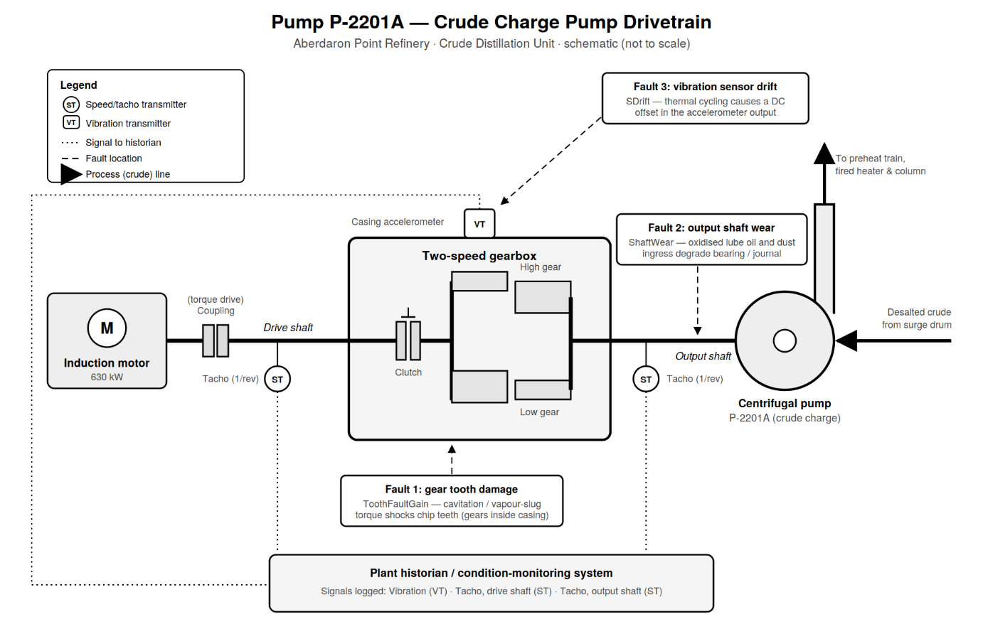
Figure 1 - Transmission System Model Diagram (Jenkins, 2026)

Synthetic Dataset Generation and Preparation
Synthetic data were generated due to the unavailability of plant data. As noted by Marwala, Fournier-Tombs and Stinckwich (2023), synthetic data can balance data utility and privacy protection. A physics-based Simulink model was used to simulate predefined fault conditions and generate vibration signals. Following transient removal, features were extracted, labelled according to fault condition, and compiled into the final dataset used for classifier training.

Model Development Procedure

Support Vector Machine (SVM)
An SVM is a machine learning algorithm that classifies data by identifying the maximum-margin boundary between classes using support vectors and, where required, kernels for non-linear data (Heaton, 2017). In this study, the SVM uses a feature-based approach, where vibration signals are represented by extracted statistical, non-linear and spectral features rather than raw data. Labelled feature vectors generated from the Simulink model are used to train the classifier, enabling new observations to be assigned to the most likely fault category.

Neural Network
Neural networks are machine learning models consisting of interconnected nodes arranged in layers. In this study, vibration spectrum data generated from the simulated pump drivetrain are used as inputs. During training, the network learns patterns within the data by adjusting its internal parameters, enabling fault classification when presented with new vibration signals (IBM, 2021; Heaton, 2017). The architecture comprises input, hidden and output layers, with the network performing fault diagnosis by identifying the fault present from the measured vibration signal (Heaton, 2017).

Experimental Design

Consistent testing procedure
To ensure consistency, vibration data underwent standardised preprocessing, including transient removal, resampling, FFT transformation and logarithmic scaling before being used as neural network inputs.

Data Splitting
The dataset was split into training (70%), validation (15%) and testing (15%) subsets. Training data were used to optimise the model, validation data to monitor performance and prevent overfitting, and test data for final evaluation. Stratified sampling ensured all fault combinations were represented across each subset.

Data Normalisation
Prior to training, the data were normalised using z-score standardisation to place all spectrum values on a comparable scale. Normalisation parameters were calculated using only the training dataset, preventing data leakage and ensuring an unbiased performance assessment.

MATLAB Implementation

Building Network 1: Sensor Drift
A shallow neural network was developed to identify sensor drift using normalised vibration spectra. The model used a single hidden layer with 20 neurons, class weighting and early stopping to reduce overfitting. Performance was evaluated using unseen test data, classification accuracy and confusion matrices.

Building Network 2: Shaft Wear
A second neural network was developed to detect output shaft wear using normalised spectral inputs. The model used a single hidden layer with 20 neurons, together with class weighting, validation monitoring and early stopping to improve generalisation. Performance was evaluated using unseen test data and confusion matrix analysis.

Building Network 3: Gear Tooth Fault
A third neural network was developed to identify gear tooth damage from processed vibration spectra. Using the same architecture as the previous models, it employed a single hidden layer with 20 neurons and weighted training to address class imbalance. Validation data were used during training, while performance was evaluated on unseen test data using accuracy and confusion matrices.

Cross-Validation Procedure
To improve the reliability of performance estimates, five-fold cross-validation was used. The dataset was split into five subsets, with each subset used for testing once. Normalisation was performed independently within each fold to prevent data leakage, while a smaller, more regularised network was used to improve generalisation.

Performance Evaluation Metrics
The performance of the SVM and neural network classifiers was evaluated using accuracy, cross-validated accuracy and confusion matrix analysis, as these metrics are well suited to fault classification.

Accuracy
Accuracy measures the proportion of correctly classified observations relative to the total number of observations (Heaton, 2017).
Equation 1 - Accuracy
$$Accuracy= \frac{TP+TN}{TP+TN+ FP+FN}$$

Where TP, TN, FP and FN represent true positives, true negatives, false positives and false negatives, respectively. In this study, accuracy is used to compare the overall classification performance of the SVM and neural network models. While a high accuracy indicates effective fault classification, it does not identify the specific errors made by the model.

Cross-Validated Accuracy
Cross-validated accuracy provides a more robust measure of model performance by evaluating the classifier across multiple training and testing iterations (James et al., 2014). In this study, five-fold cross-validation was employed, with four folds used for training and one for testing during each iteration. Where k represents the number of folds and Accuracyi the accuracy achieved for each fold. This approach reduces bias from a single train-test split and provides a more reliable estimate of performance on unseen data.
Equation 2 - Cross-Validation Accuracy
$$CV Accuracy= \frac{\sum_{i=1}^{k}{{Accuracy}_{i}}}{k}$$

Confusion Matrix Analysis
A confusion matrix provides a detailed breakdown of classification performance by comparing predicted fault states with actual fault states (Heaton, 2017).
Table 1 - Confusion Matrix Analysis - Overview
 | Predicted Fault | Predicted Healthy
Actual Fault | True Positive (TP) | False Negative (FN)
Actual Healthy | False Positive (FP) | True Negative (TN)

Unlike accuracy, confusion matrices identify specific classification errors. In fault diagnosis, false negatives are particularly important as undetected faults may lead to equipment damage, downtime and increased costs, whereas false positives can result in unnecessary maintenance. Consequently, confusion matrices provide a more informative assessment of classifier performance than accuracy alone and support maintenance decision-making.

Results

Sensor Drift

Results Table

An expanded data table can be found in the appendix.

Table 2 – Sensor Drift – Results Table
Model Number | Model Type | Preset | Accuracy % (Validation) | Total Cost (Validation) | Error Rate % (Validation) | Weighted Precision % (Validation) | Weighted Recall % (Validation) | Weighted F1 Score % (Validation) | Prediction Speed (obs/sec) | Training Time (sec) | Compact Model Size (bytes) | Coder Model Size (bytes)
1 | Tree | Fine Tree | 100 | 0 | 0 | 100 | 100 | 100 | 3275.709 | 5.364 | 5627 | 2816
2.1 | Neural Network | Narrow Neural Network | 95.673 | 9 | 4.327 | 95.869 | 95.673 | 95.741 | 3082.203 | 9.514 | 8688 | 5184
2.2 | Neural Network | Medium Neural Network | 95.673 | 9 | 4.327 | 95.869 | 95.673 | 95.741 | 3158.382 | 7.079 | 11208 | 7704
2.3 | Neural Network | Wide Neural Network | 97.115 | 6 | 2.885 | 97.205 | 97.115 | 97.146 | 13530.831 | 14.241 | 23808 | 20304
2.4 | Neural Network | Bilayered Neural Network | 95.192 | 10 | 4.808 | 95.495 | 95.192 | 95.291 | 20580.000 | 3.388 | 10412 | 6408
2.5 | Neural Network | Trilayered Neural Network | 97.596 | 5 | 2.404 | 97.585 | 97.596 | 97.554 | 27291.932 | 2.770 | 12136 | 7632
3.1 | SVM | Linear SVM | 92.308 | 16 | 7.692 | 92.005 | 92.308 | 92.024 | 16663.195 | 3.022 | 15169 | 12134
3.2 | SVM | Quadratic SVM | 91.827 | 17 | 8.173 | 91.603 | 91.827 | 91.685 | 12890.831 | 2.826 | 13433 | 10534
3.3 | SVM | Cubic SVM | 98.077 | 4 | 1.923 | 98.065 | 98.077 | 98.055 | 23261.015 | 5.036 | 12953 | 10054
3.4 | SVM | Fine Gaussian SVM | 79.808 | 42 | 20.192 | 71.954 | 79.808 | 74.811 | 23075.216 | 1.976 | 37429 | 34534
3.5 | SVM | Medium Gaussian SVM | 90.865 | 19 | 9.135 | 90.399 | 90.865 | 90.329 | 21384.657 | 4.114 | 19509 | 16614
3.6 | SVM | Coarse Gaussian SVM | 82.692 | 36 | 17.308 | NaN | 82.692 | 74.858 | 27552.953 | 0.989 | 18229 | 15334
4 | SVM | Quadratic SVM | 91.827 | 17 | 8.173 | 91.603 | 91.827 | 91.685 | 22107.904 | 3.404 | 13593 | 10694
5 | SVM | Linear SVM | 92.308 | 16 | 7.692 | 92.005 | 92.308 | 92.024 | 22920.110 | 1.846 | 15169 | 12134

Fine Tree

Scatter Plot
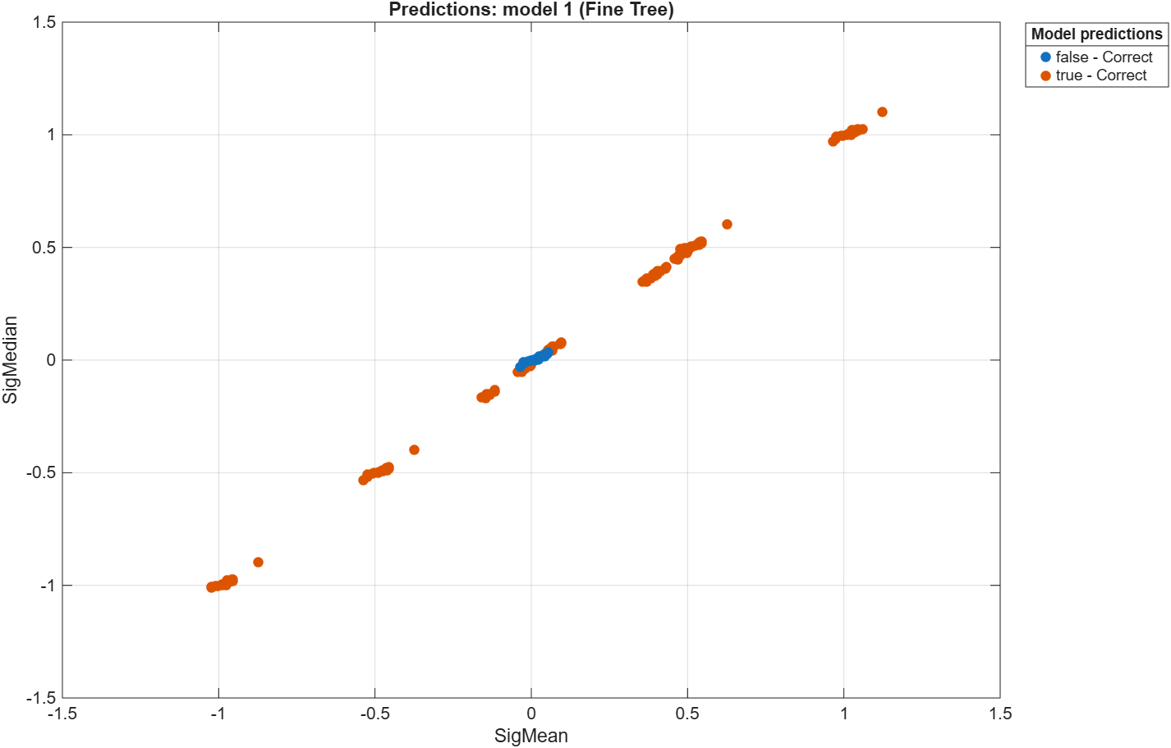
Figure 2– Sensor Drift - Scatter Plot - Fine Tree

Validation Confusion Matrix
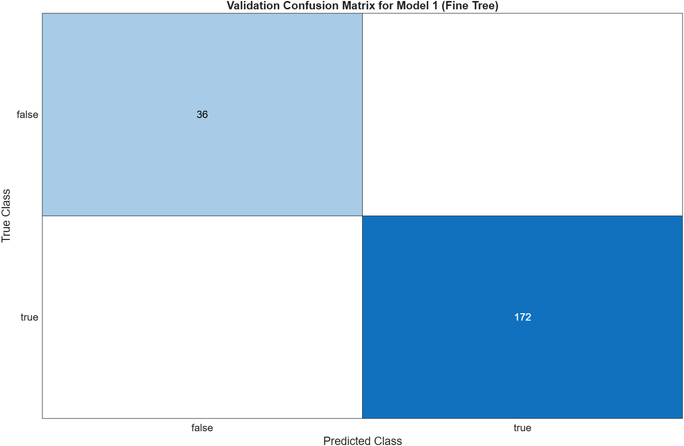
Figure 3– Sensor Drift - Validation Confusion Matrix - Fine Tree

SVM

Scatter Plot

Linear SVM
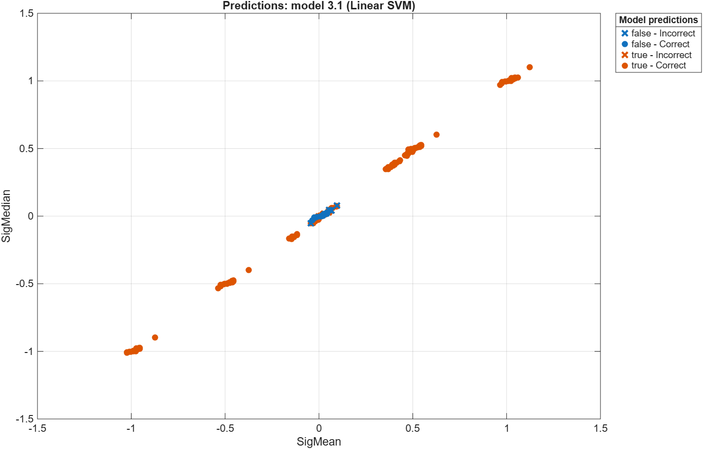
Figure 4– Sensor Drift - Scatter Plot - Linear SVM

Cubic SVM
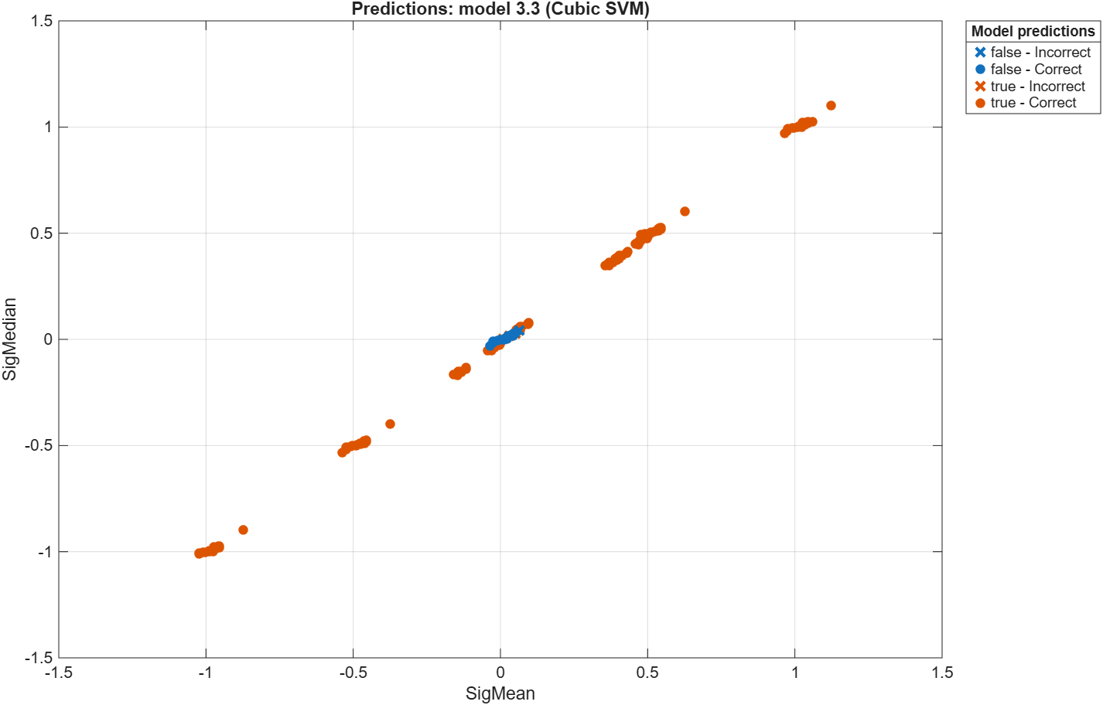
Figure 5– Sensor Drift - Scatter Plot - Cubic SVM

Quadratic SVM
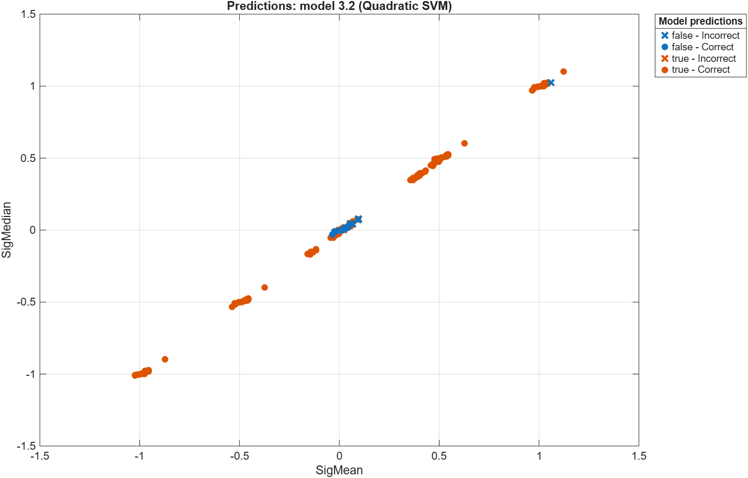
Figure 6– Sensor Drift - Scatter Plot - Quadratic SVM

Fine Gaussian SVM
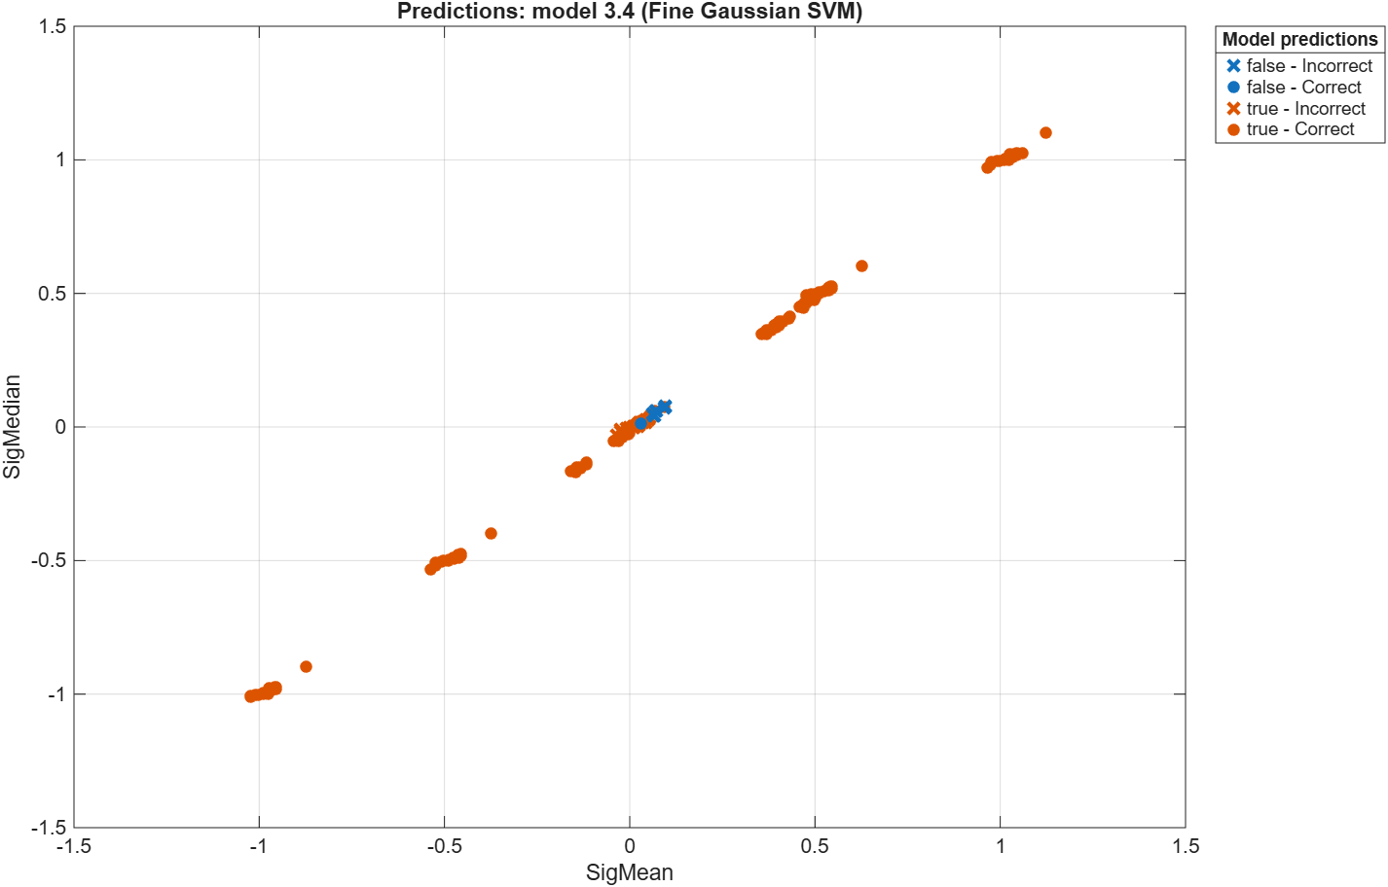
Figure 7– Sensor Drift - Scatter Plot - Fine Gaussian SVM

Medium Gaussian SVM
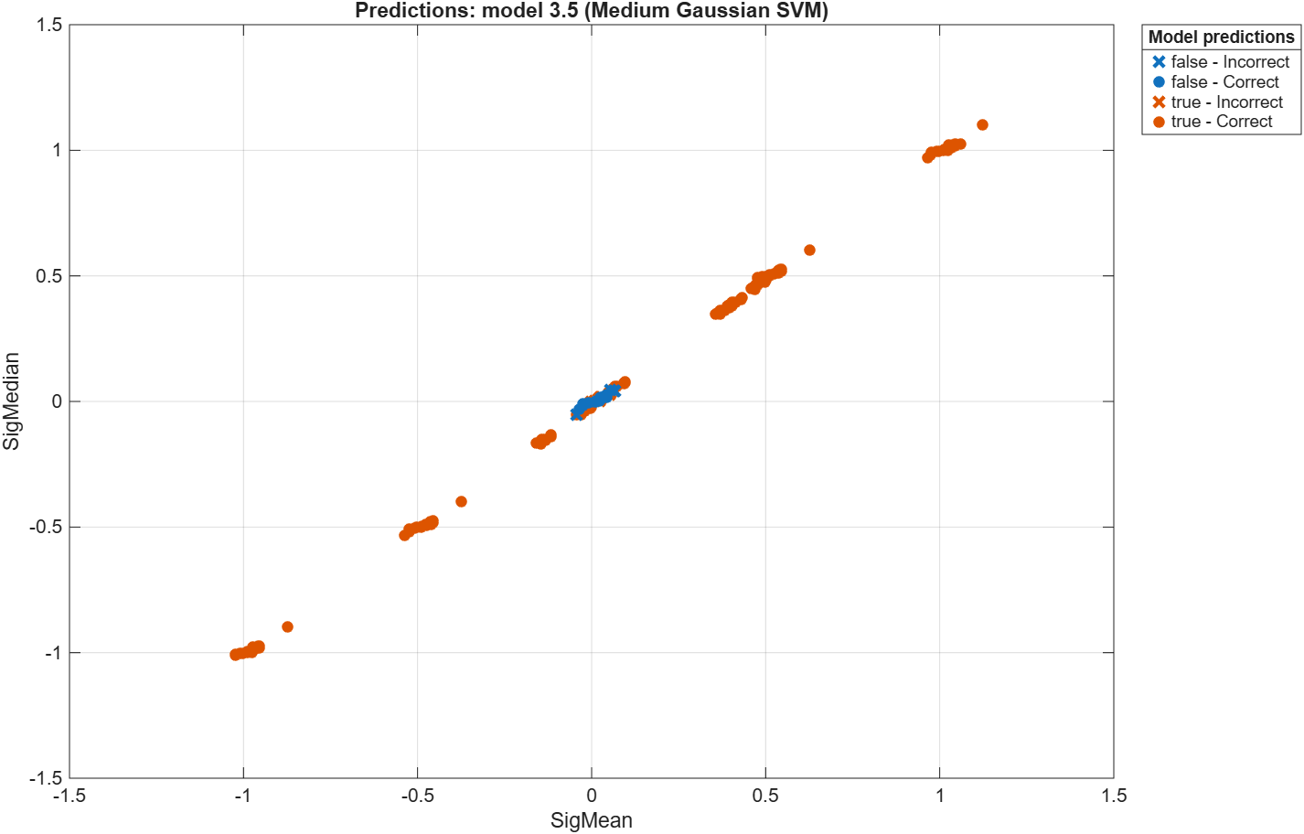
Figure 8– Sensor Drift - Scatter Plot - Medium Gaussian SVM

Coarse Gaussian SVM
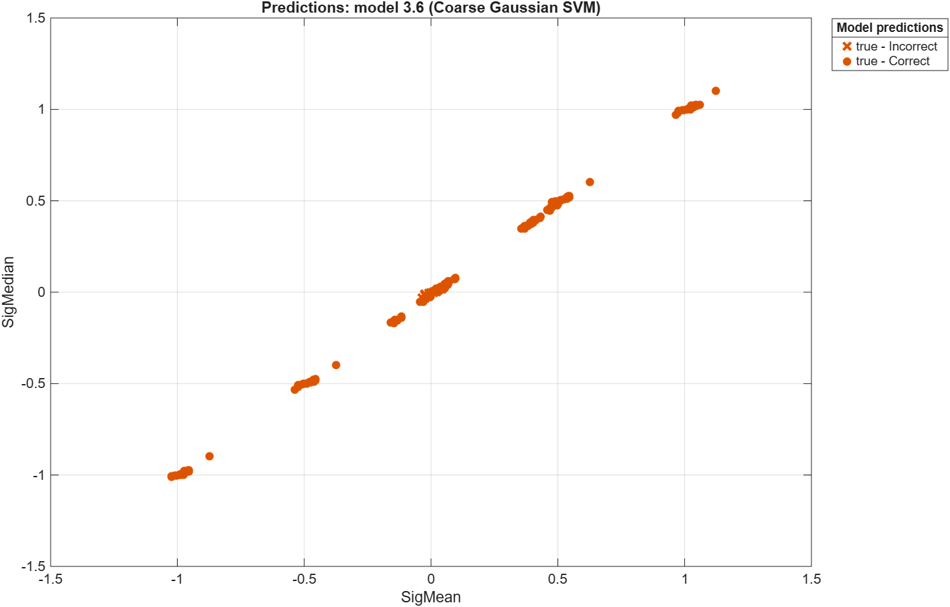
Figure 9– Sensor Drift - Scatter Plot - Coarse Gaussian SVM

Validation Confusion Matrix

Linear SVM
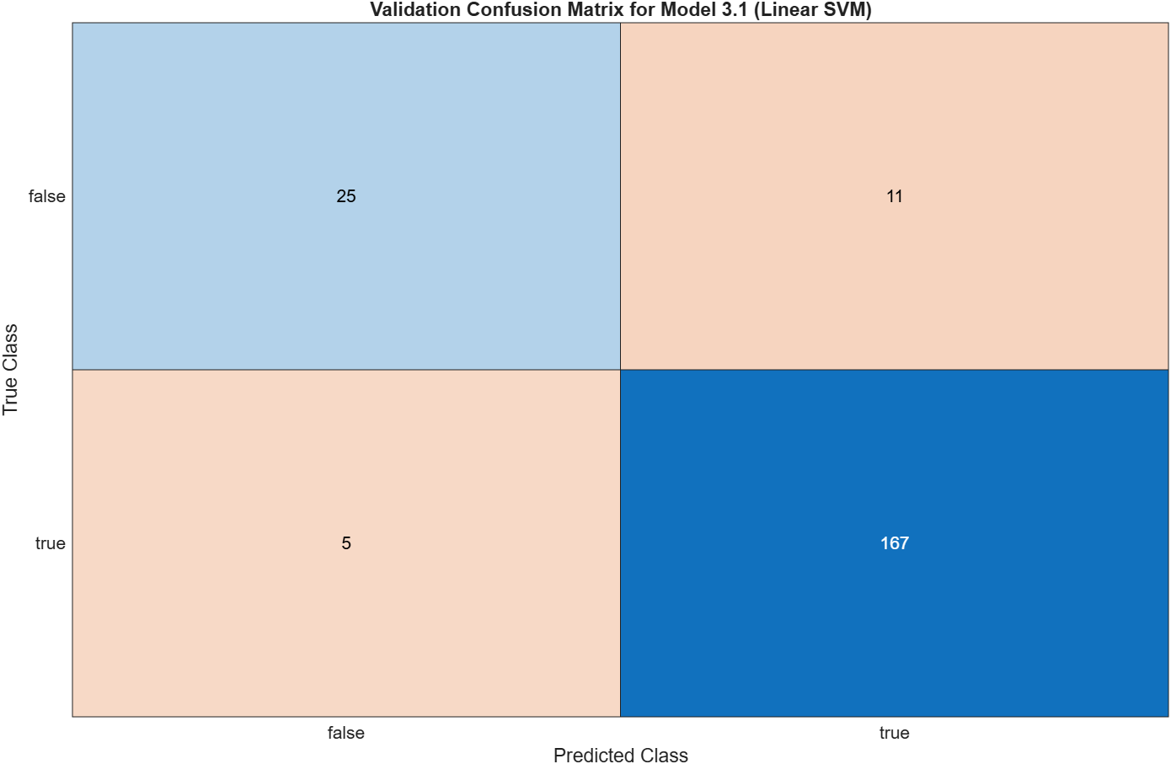
Figure 10– Sensor Drift - Validation Confusion Matrix - Linear SVM

Cubic SVM
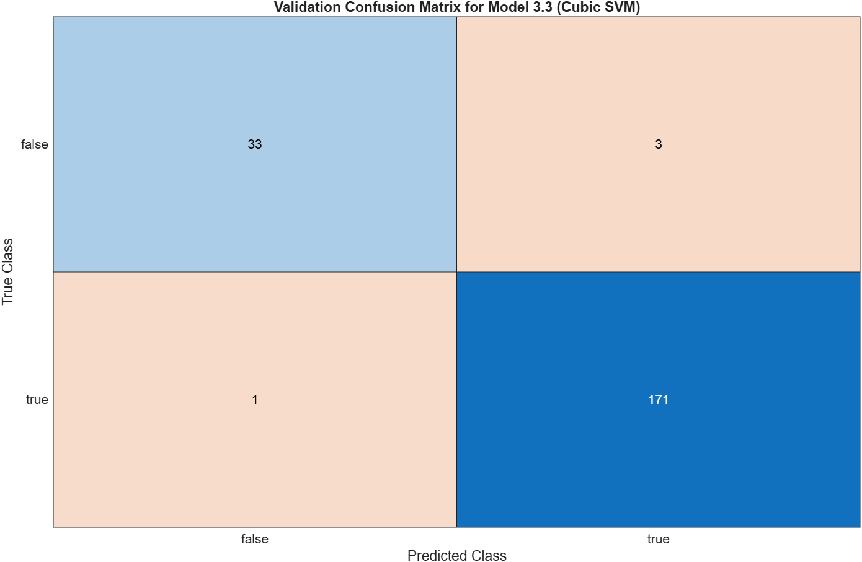
Figure 11– Sensor Drift - Validation Confusion Matrix - Cubic SVM

Quadratic SVM
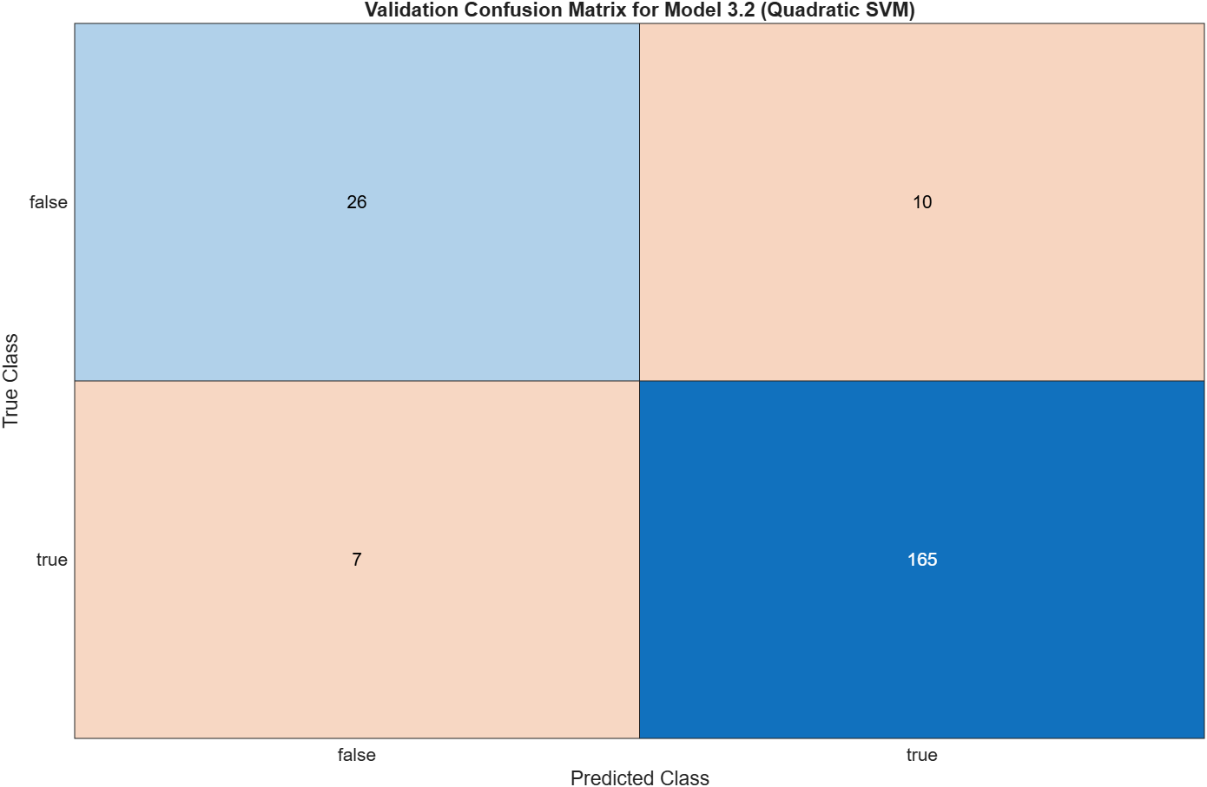
Figure 12– Sensor Drift - Validation Confusion Matrix - Quadratic SVM

Fine Gaussian SVM
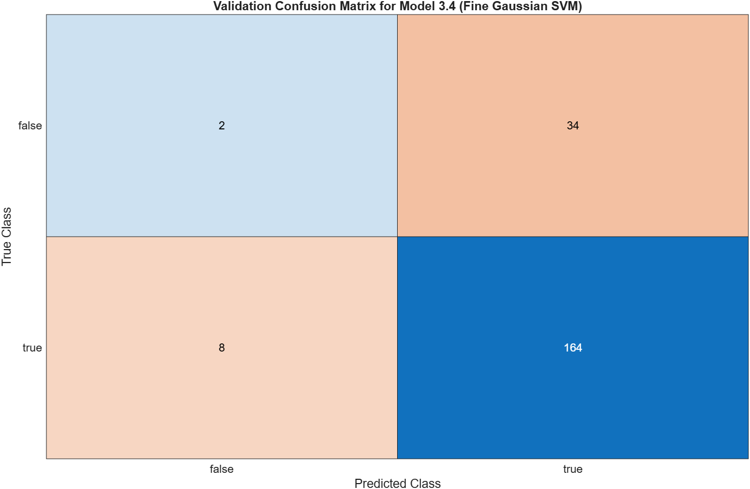
Figure 13– Sensor Drift - Validation Confusion Matrix - Fine Gaussian SVM

Medium Gaussian SVM
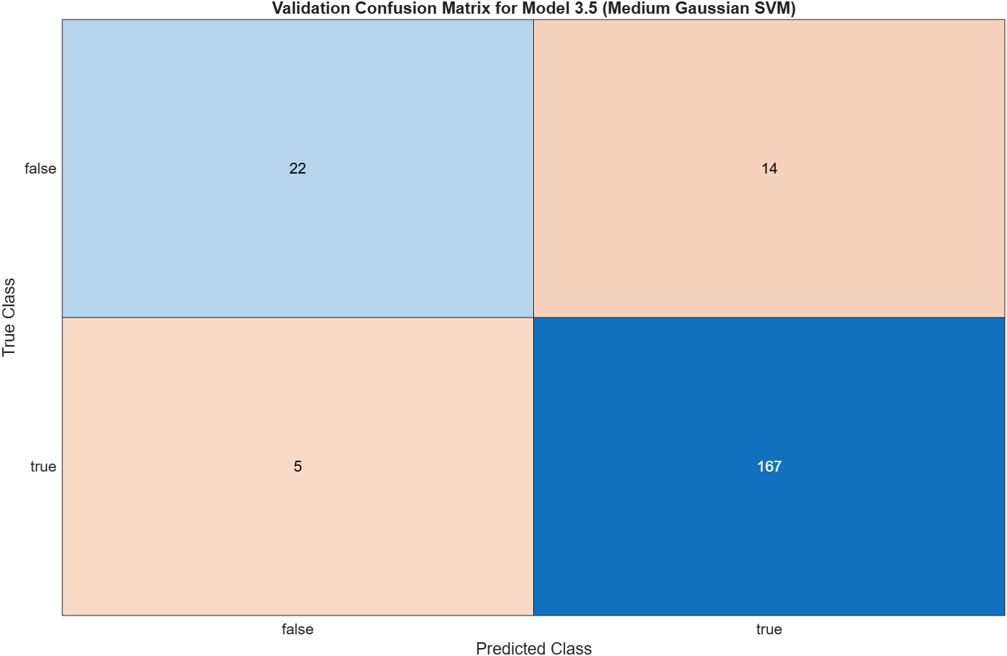
Figure 14– Sensor Drift - Validation Confusion Matrix - Medium Gaussian SVM

Coarse Gaussian SVM
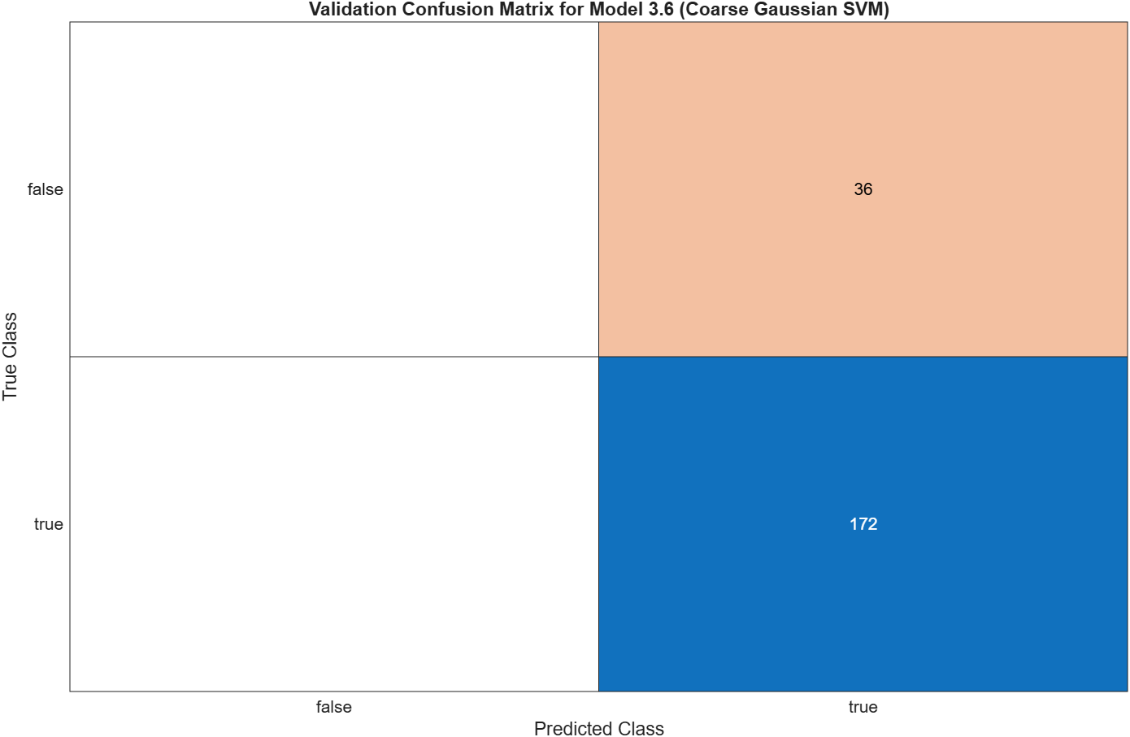
Figure 15– Sensor Drift - Validation Confusion Matrix - Coarse Gaussian SVM

Neural Network

Scatter Plot

Narrow Neural Network
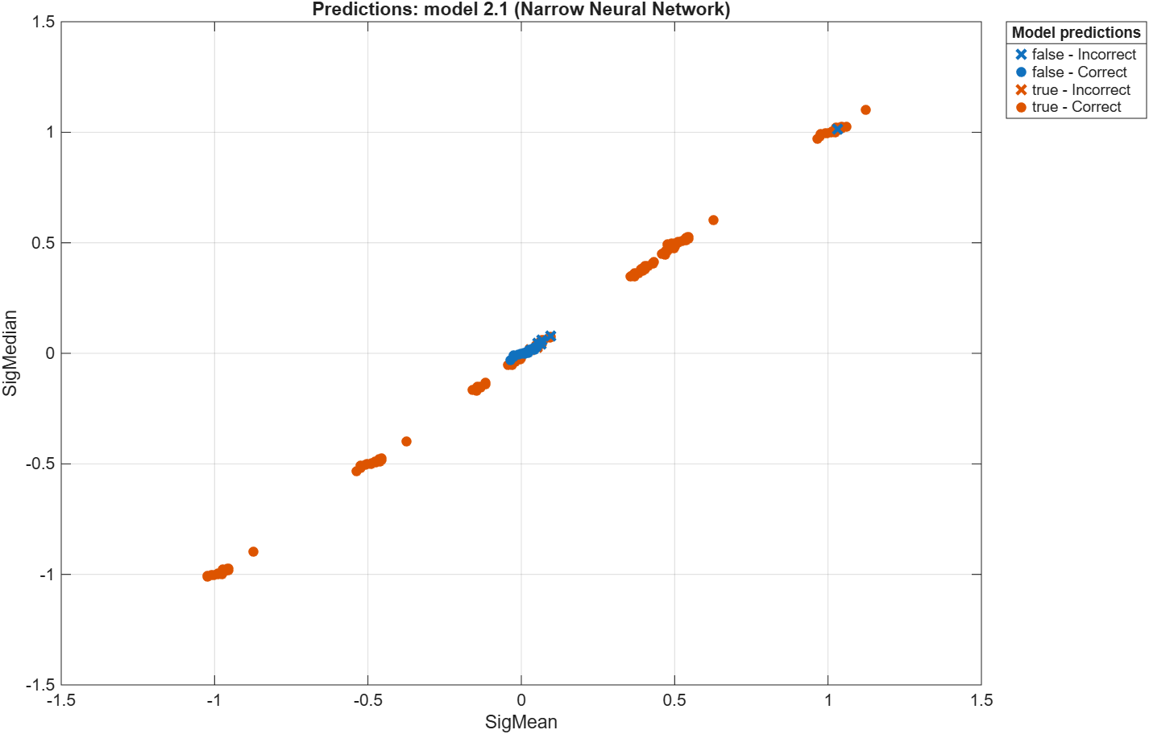
Figure 16 – Sensor Drift - Scatter Plot - Narrow Neural Network

Medium Neural Network
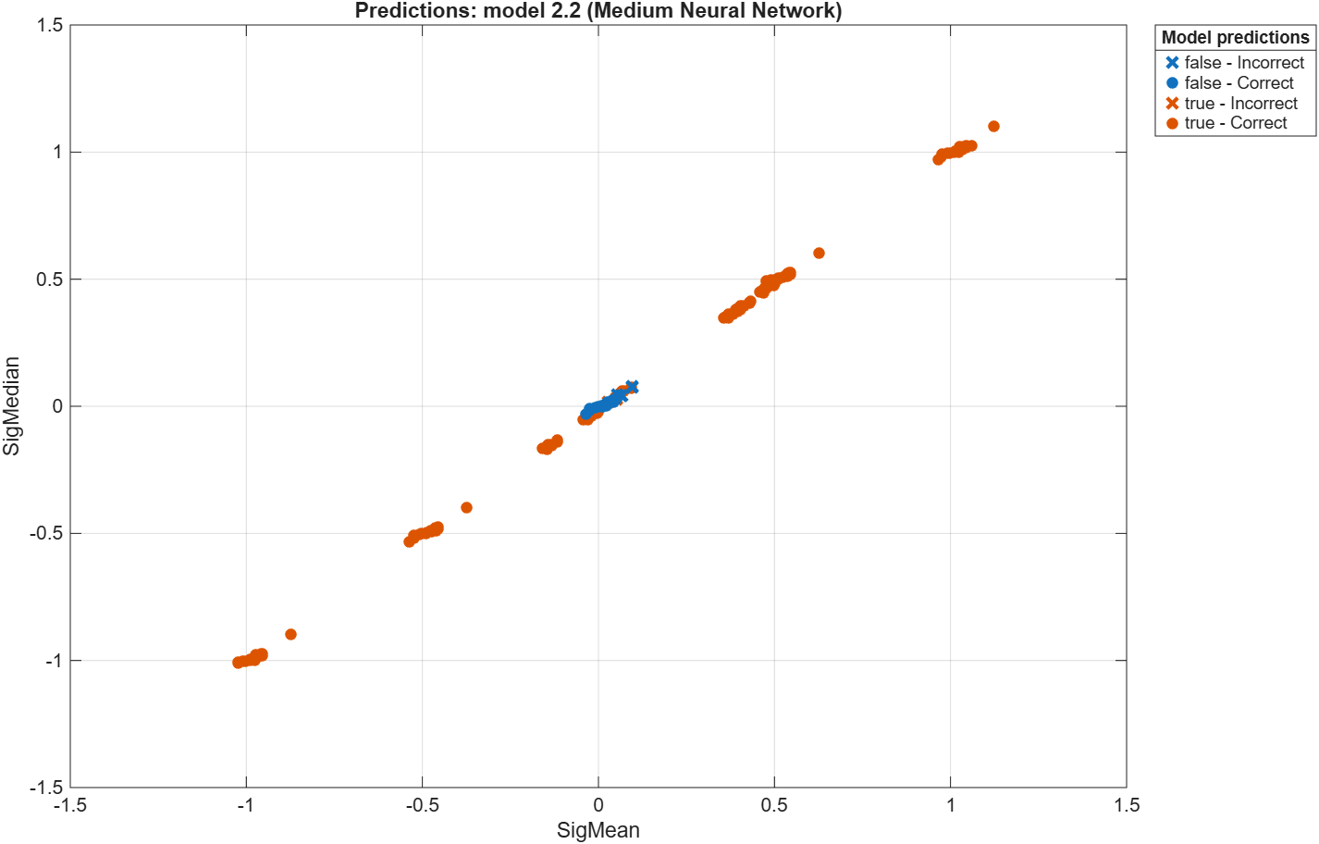
Figure 17 – Sensor Drift - Scatter Plot - Medium Neural Network

Wide Neural Network
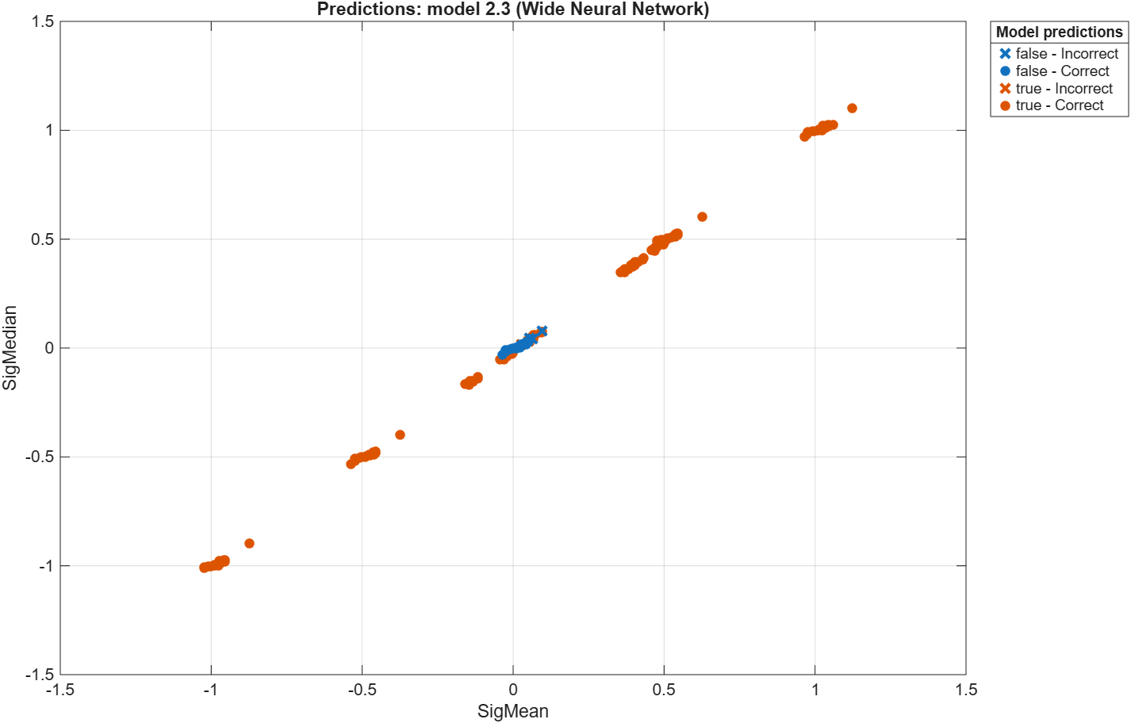
Figure 18 – Sensor Drift - Scatter Plot - Wide Neural Network

Bilayered Neural Network
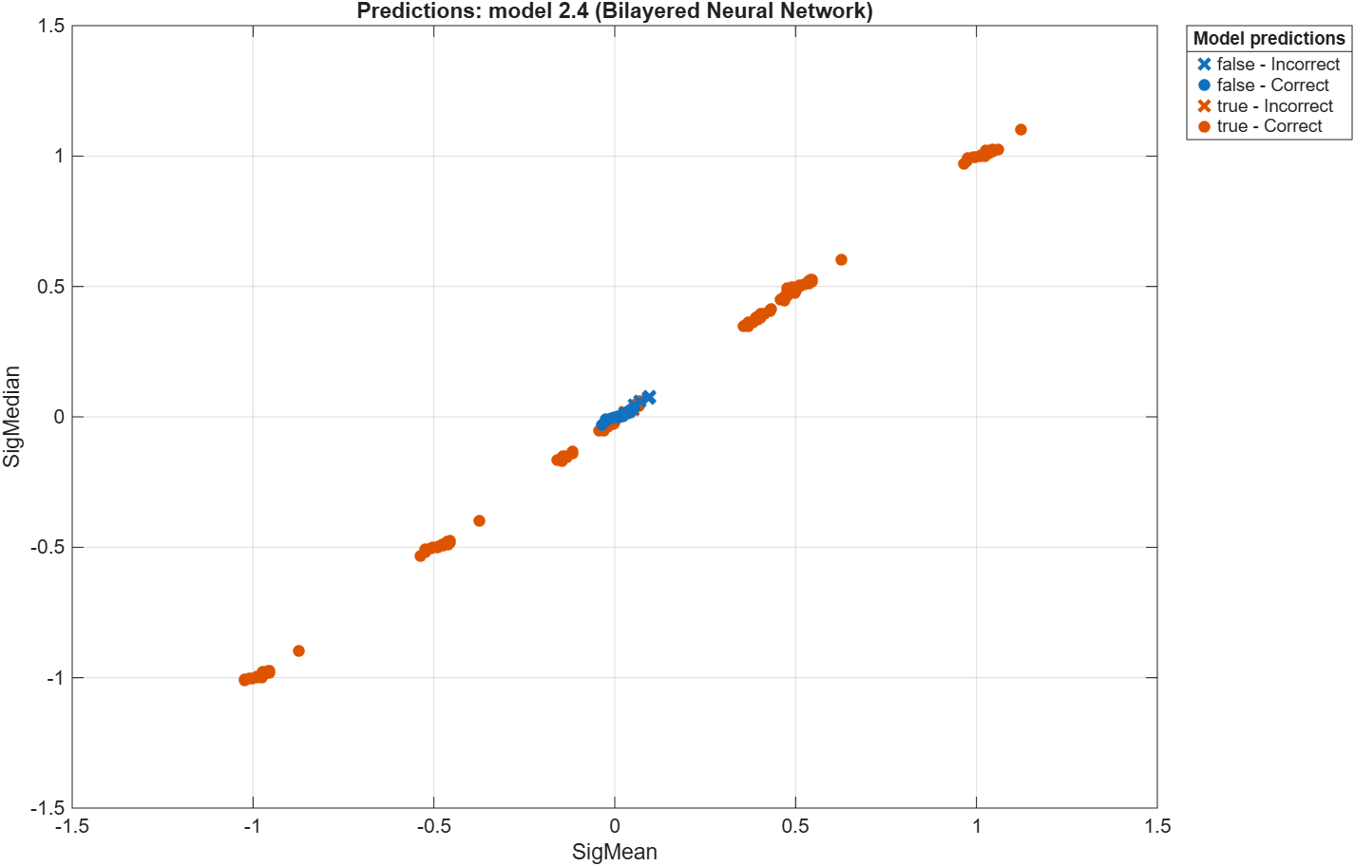
Figure 19 – Sensor Drift - Scatter Plot - Bilayered Neural Network

Trilayered Neural Network
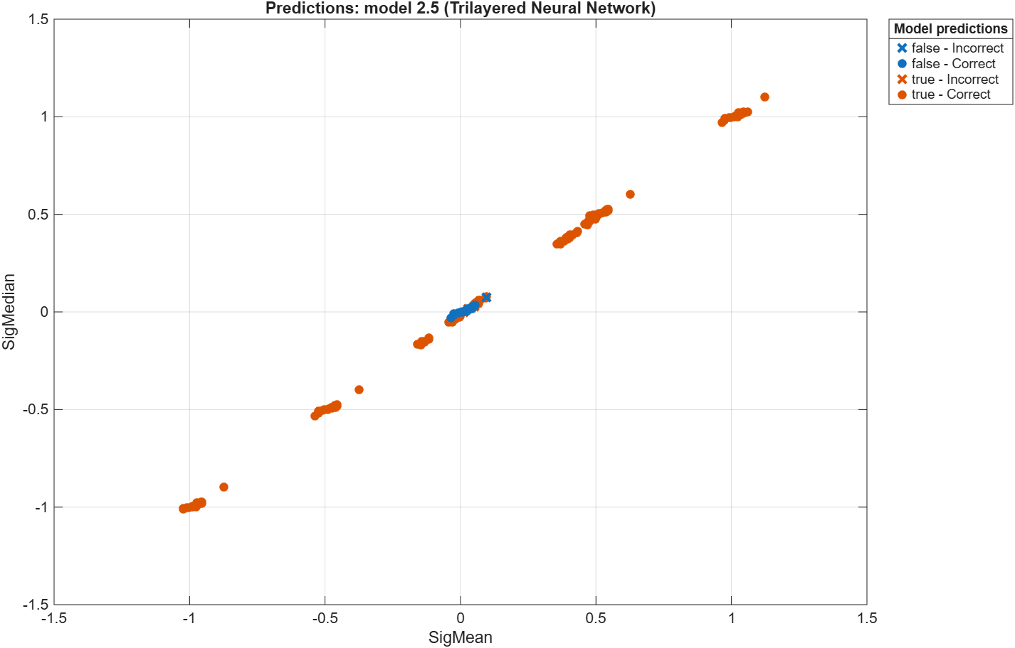
Figure 20 – Sensor Drift - Scatter Plot - Trilayered Neural Network

Validation Confusion Matrix

Narrow Neural Network
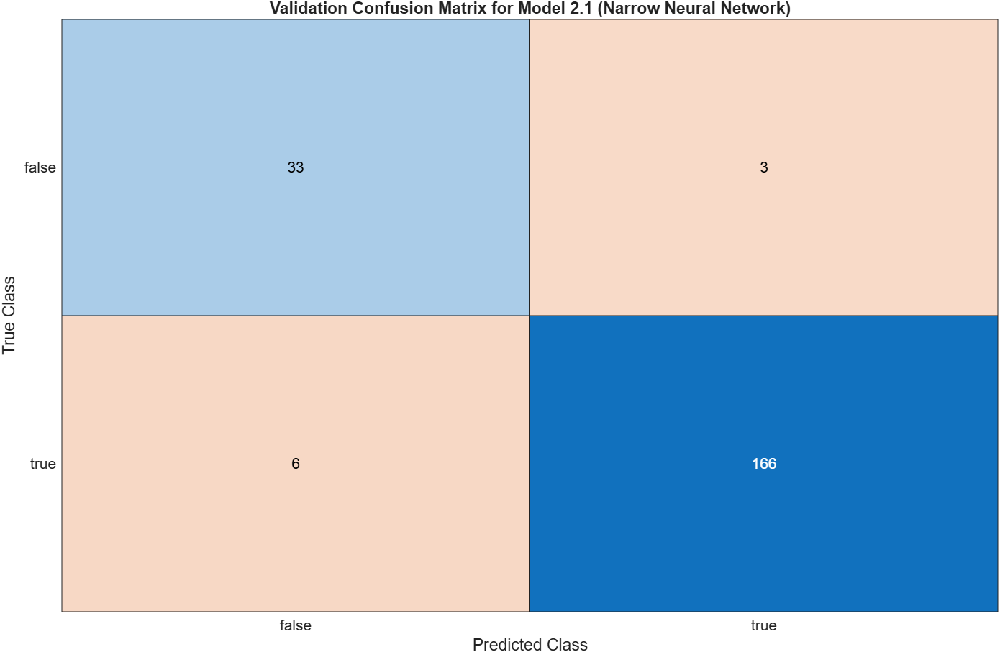
Figure 21 – Sensor Drift - Validation Confusion Matrix - Narrow Neural Network

Medium Neural Network
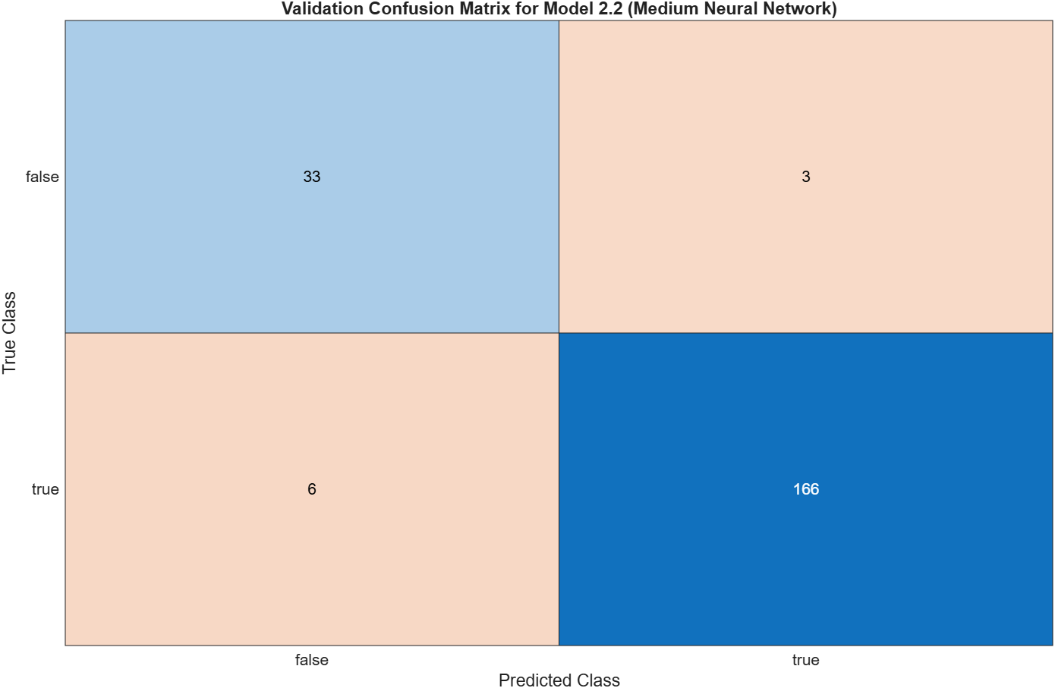
Figure 22 – Sensor Drift - Validation Confusion Matrix - Medium Neural Network

Wide Neural Network
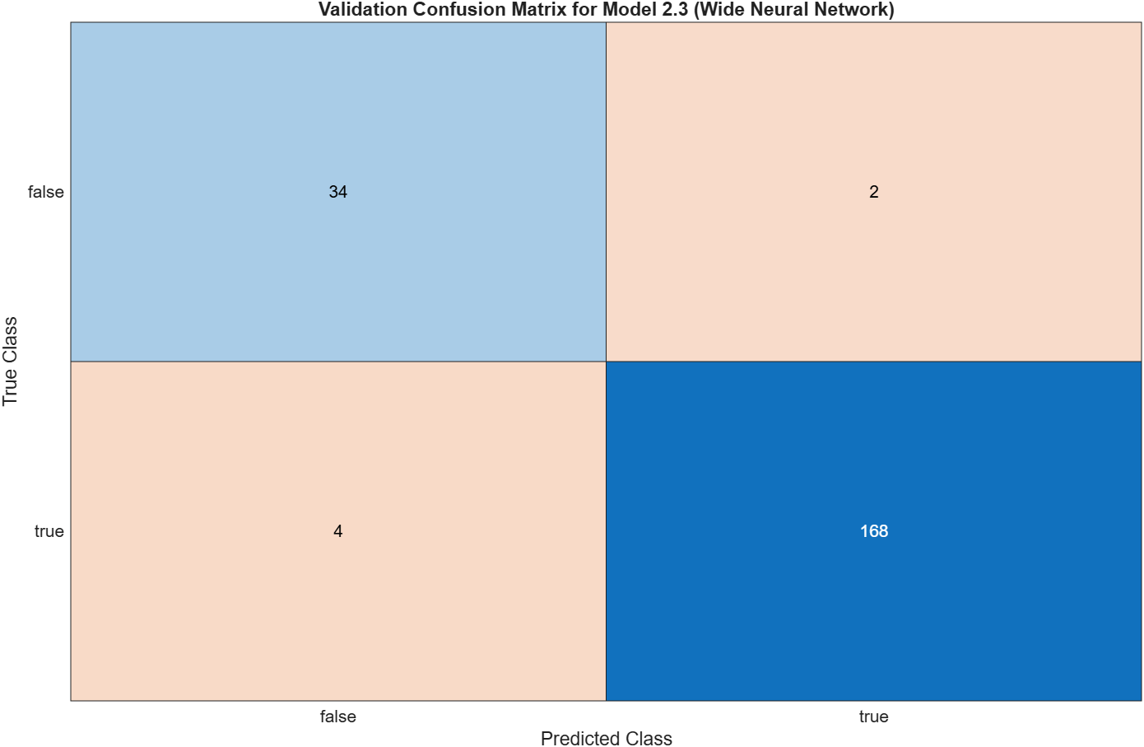
Figure 23 – Sensor Drift - Validation Confusion Matrix - Wide Neural Network

Bilayered Neural Network
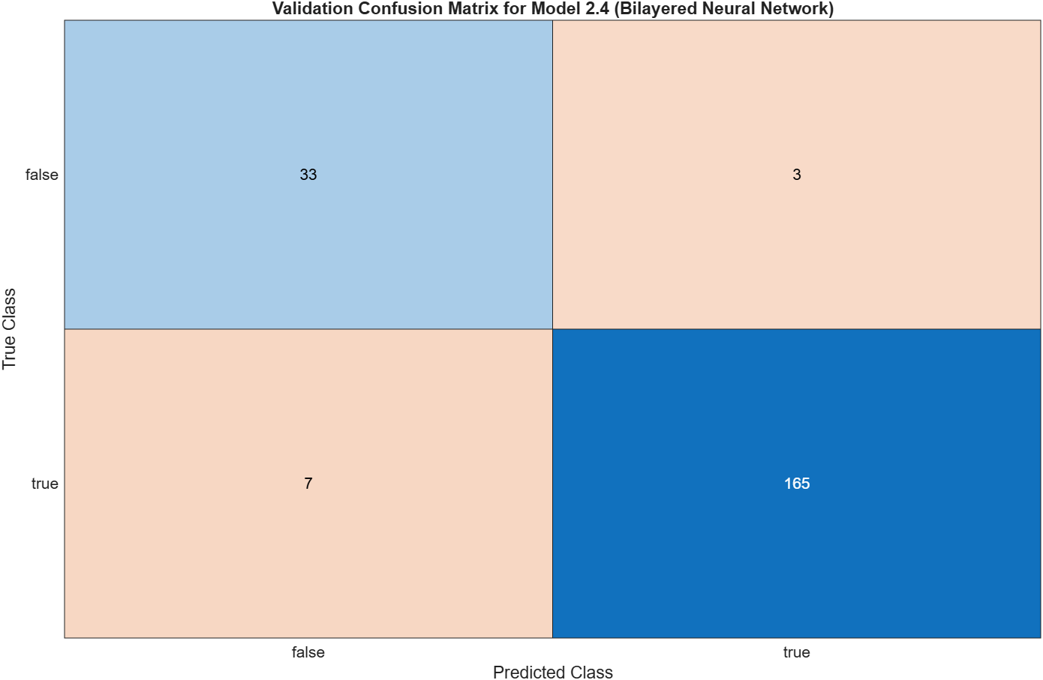
Figure 24 – Sensor Drift - Validation Confusion Matrix - Bilayered Neural Network

Trilayered Neural Network
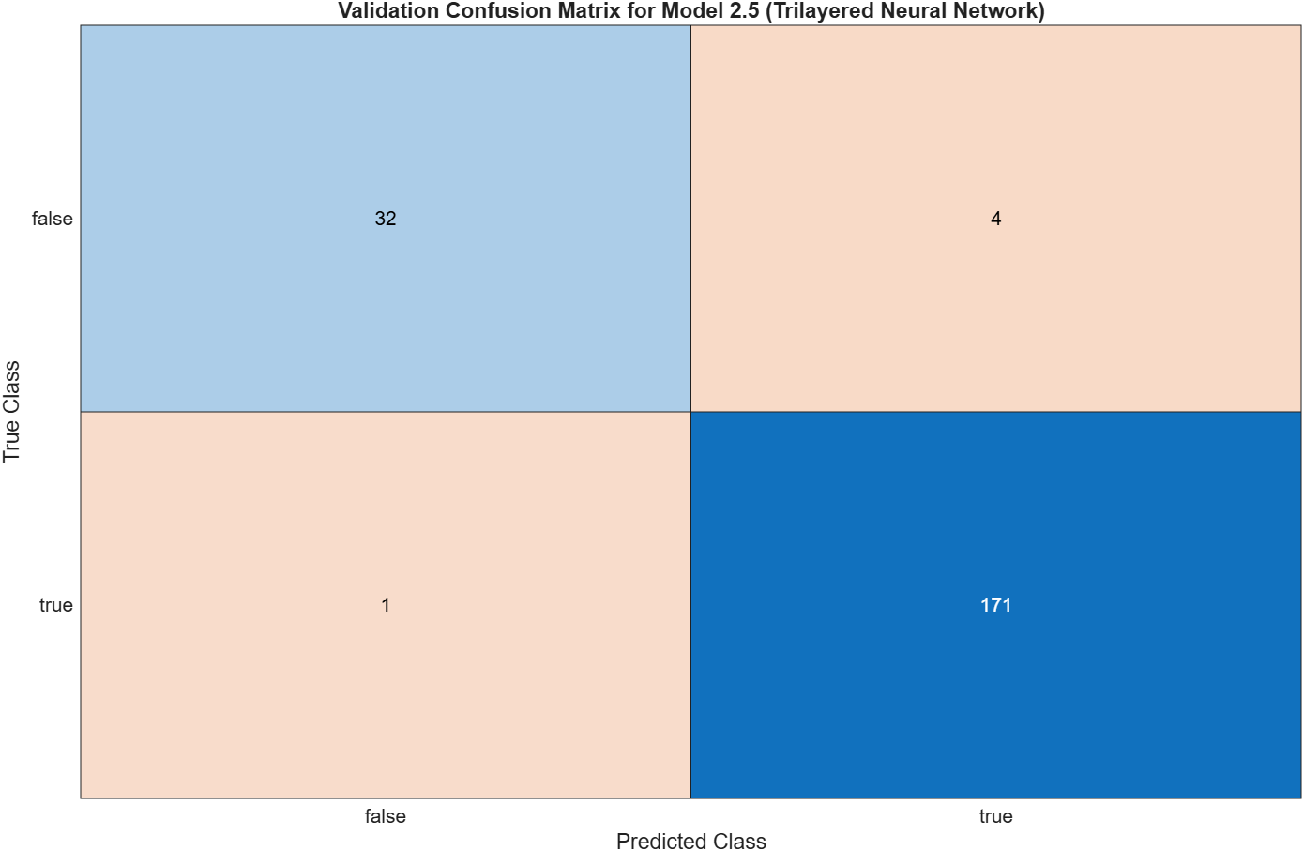
Figure 25 – Sensor Drift - Validation Confusion Matrix - Trilayered Neural Network

Training Process

Narrow Neural Network
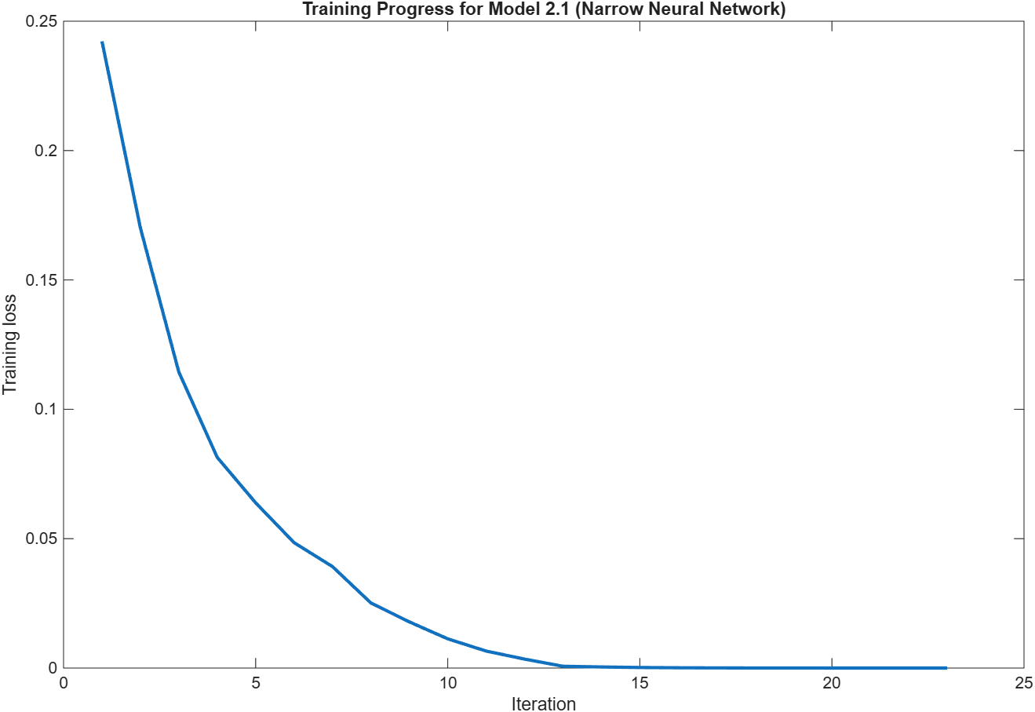
Figure 26 – Sensor Drift - Training Process - Narrow Neural Network

Medium Neural Network
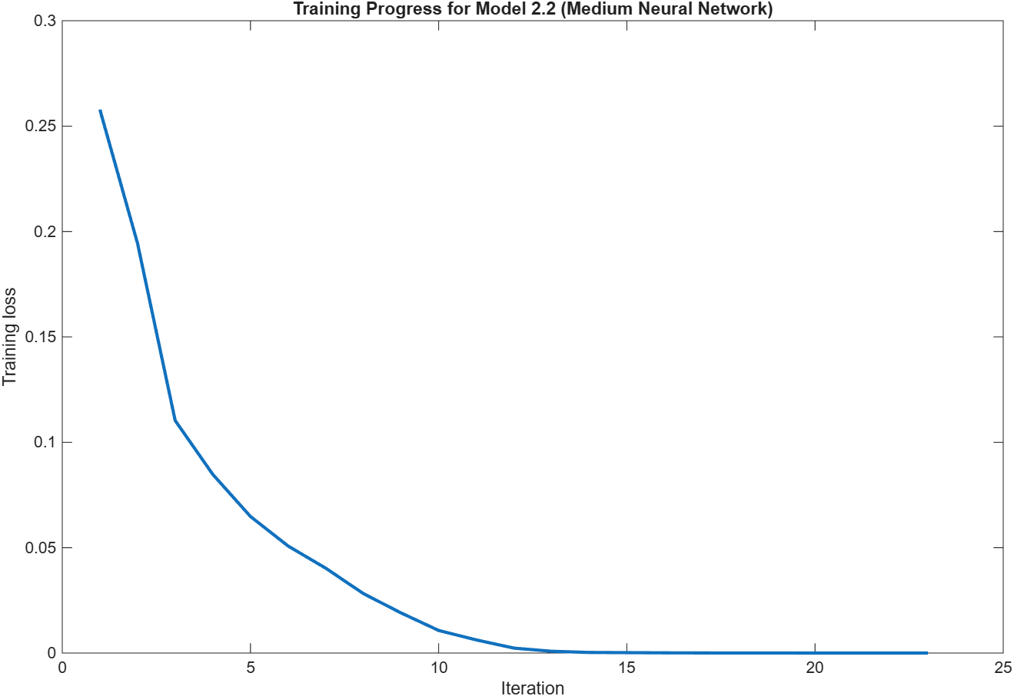
Figure 27 – Sensor Drift - Training Process - Medium Neural Network

Wide Neural Network
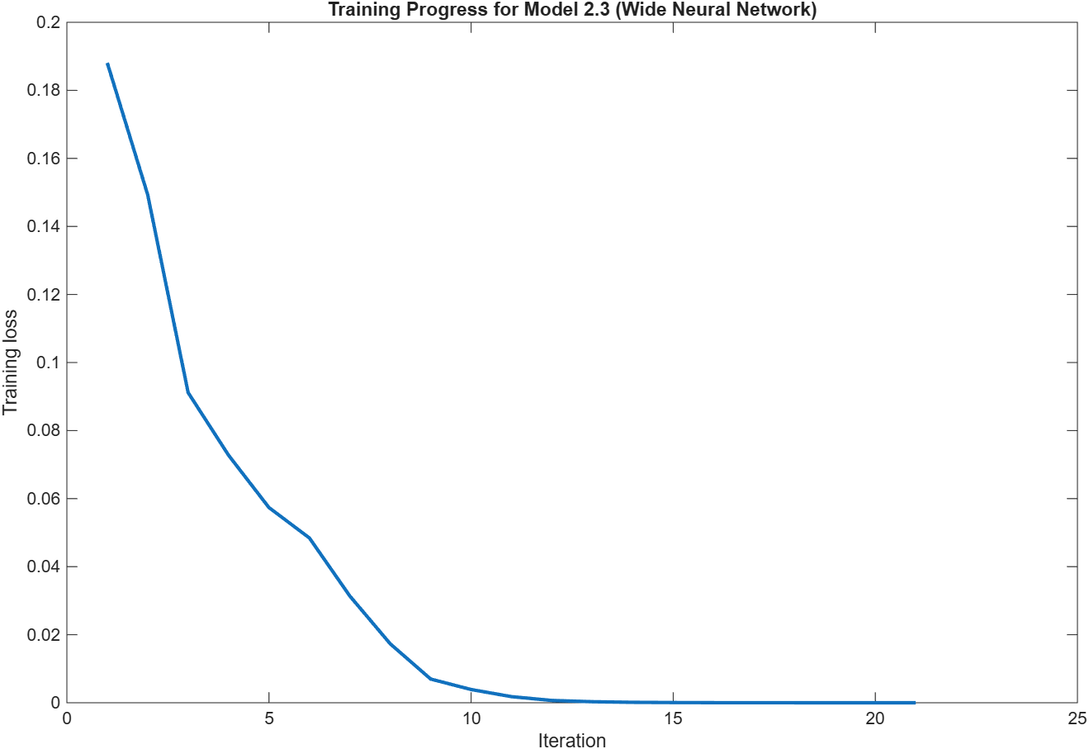
Figure 28 – Sensor Drift - Training Process - Wide Neural Network

Bilayered Neural Network
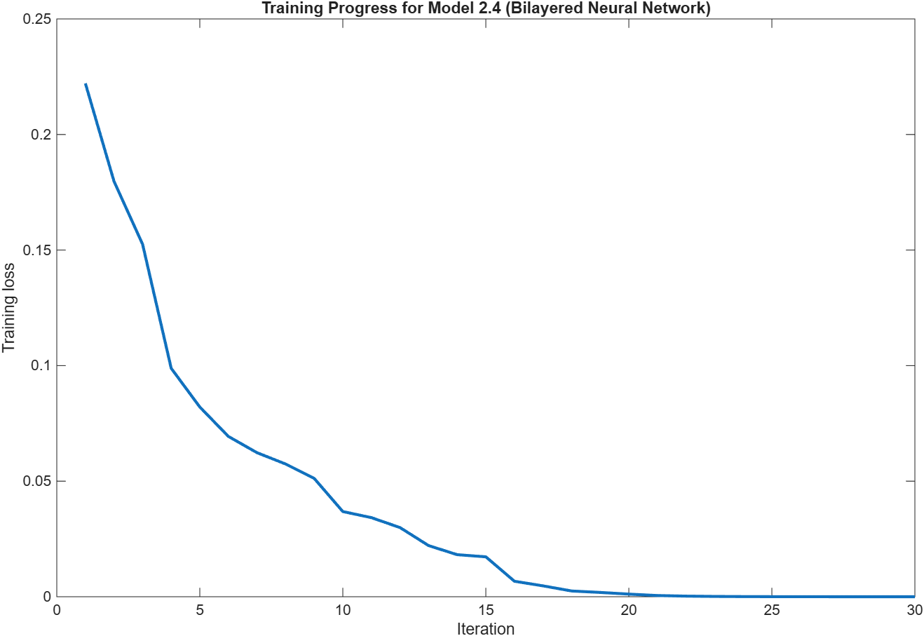
Figure 29 – Sensor Drift - Training Process - Bilayered Neural Network

Trilayered Neural Network
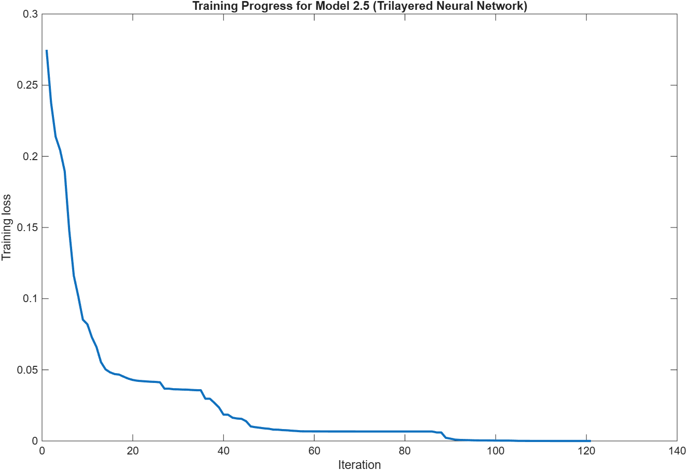
Figure 30 – Sensor Drift - Training Process - Trilayered Neural Network

Model Comparison

Accuracy
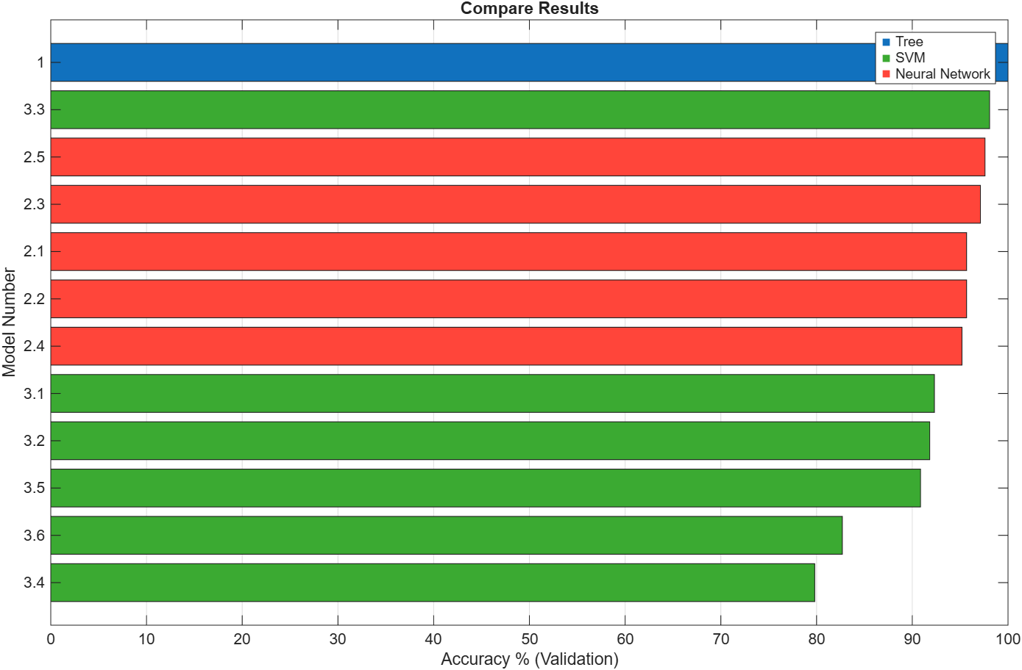
Figure 31 – Sensor Drift - Model Comparison - Accuracy

Coder Model Size
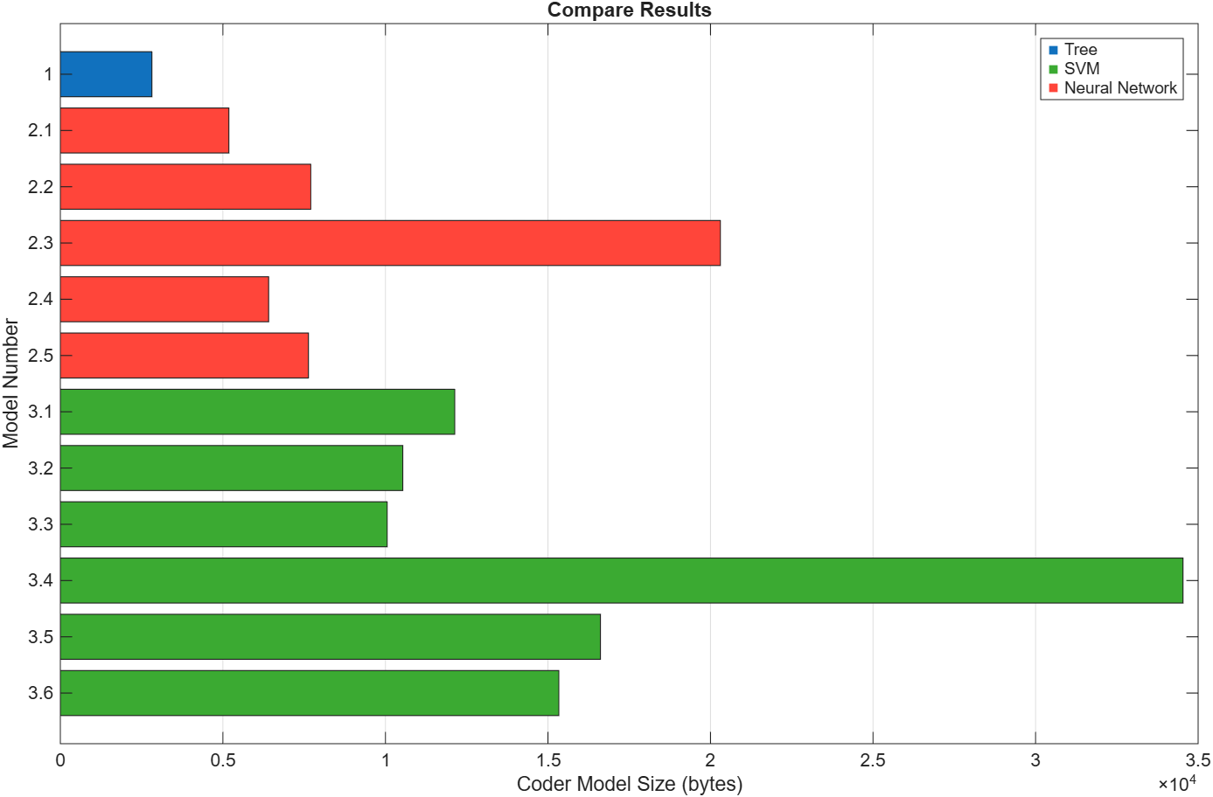
Figure 32 – Sensor Drift - Model Comparison - Coder Model Size

Error Rate
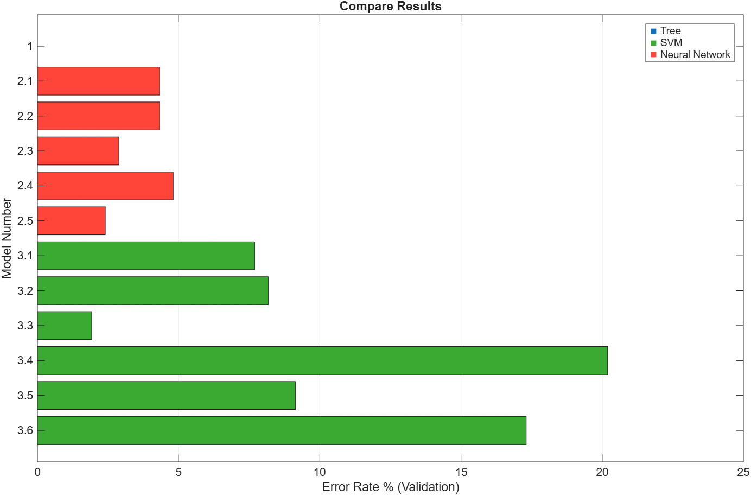
Figure 33 – Sensor Drift - Model Comparison - Error Rate

Prediction Speed
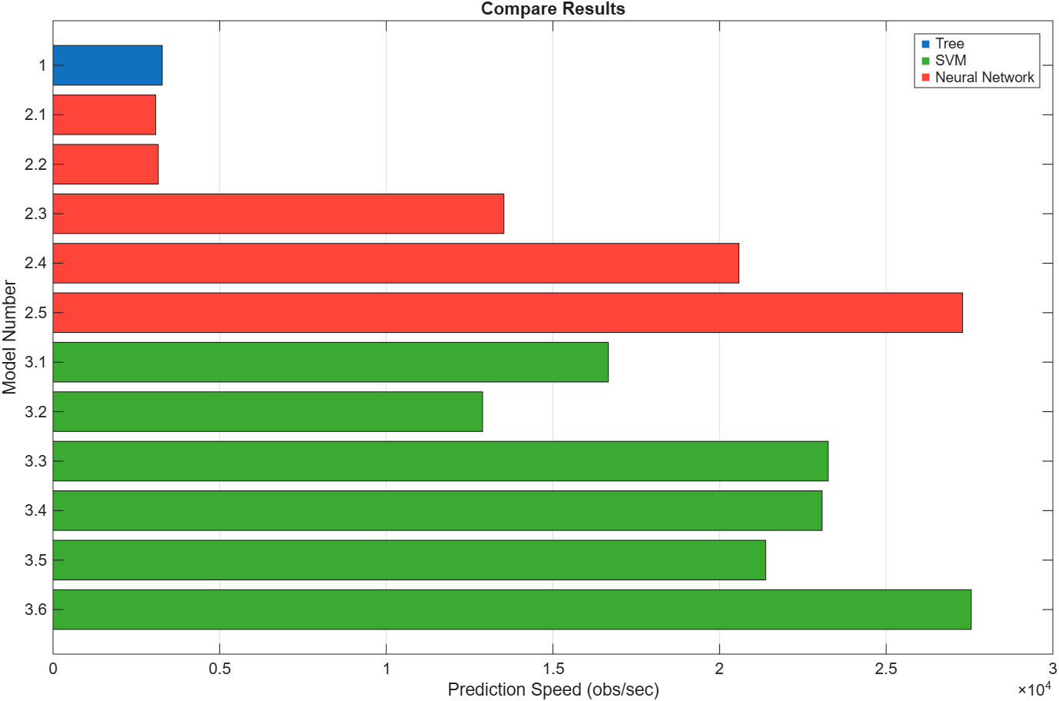
Figure 34 – Sensor Drift - Model Comparison - Prediction Speed

Total Cost
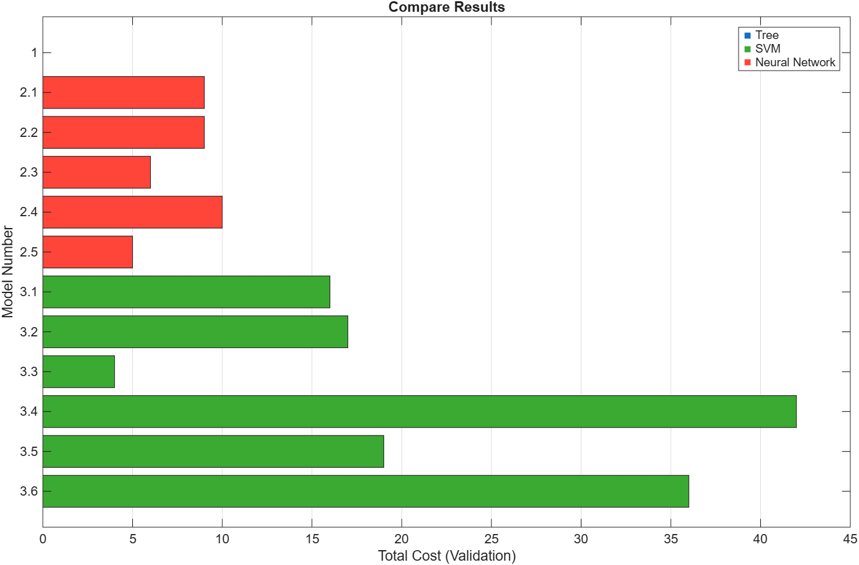
Figure 35 – Sensor Drift - Model Comparison - Total Cost

Training Time
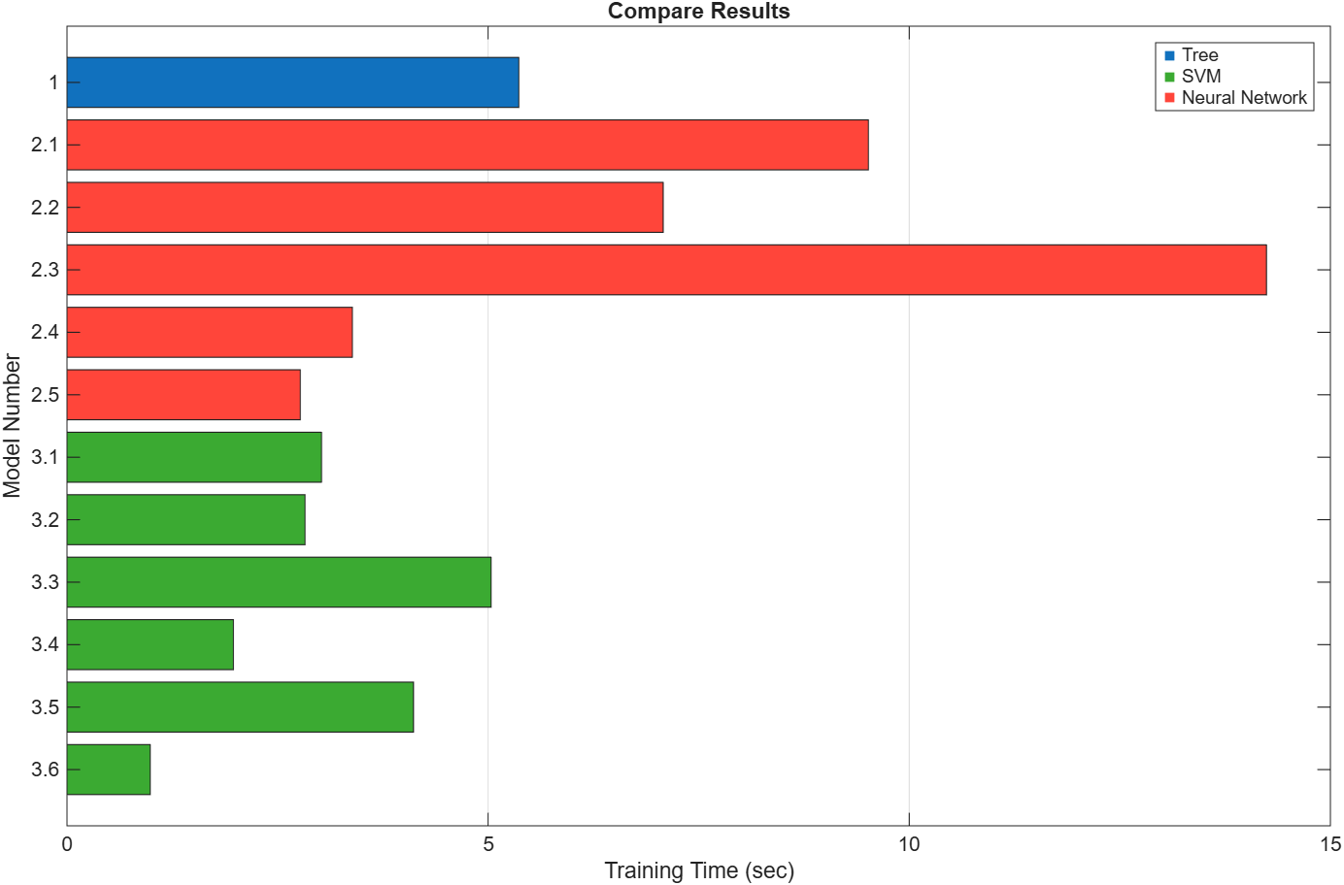
Figure 36 – Sensor Drift - Model Comparison - Training Time

Gear Tooth Fault

Results Table

An expanded data table can be found in the appendix.

Table 3 – Gear Tooth Fault – Results Table
Model Number | Model Type | Preset | Accuracy % (Validation) | Total Cost (Validation) | Error Rate % (Validation) | Weighted Precision % (Validation) | Weighted Recall % (Validation) | Weighted F1 Score % (Validation) | Prediction Speed (obs/sec) | Training Time (sec) | Compact Model Size (bytes) | Coder Model Size (bytes)
1 | Tree | Fine Tree | 100 | 0 | 0 | 100 | 100 | 100 | 26704.669 | 2.310 | 5343 | 2700
2.1 | Neural Network | Narrow Neural Network | 99.519 | 1 | 0.481 | 99.532 | 99.519 | 99.522 | 31283.841 | 2.445 | 8688 | 5184
2.2 | Neural Network | Medium Neural Network | 99.038 | 2 | 0.962 | 99.038 | 99.038 | 99.038 | 27434.480 | 5.203 | 11208 | 7704
2.3 | Neural Network | Wide Neural Network | 99.519 | 1 | 0.481 | 99.532 | 99.519 | 99.522 | 28360.671 | 1.653 | 23808 | 20304
2.4 | Neural Network | Bilayered Neural Network | 99.038 | 2 | 0.962 | 99.050 | 99.038 | 99.028 | 33091.511 | 3.179 | 10412 | 6408
2.5 | Neural Network | Trilayered Neural Network | 98.077 | 4 | 1.923 | 98.067 | 98.077 | 98.057 | 31029.030 | 0.774 | 12136 | 7632
3.1 | SVM | Linear SVM | 91.346 | 18 | 8.654 | 91.188 | 91.346 | 91.255 | 32487.310 | 2.907 | 14369 | 11334
3.2 | SVM | Quadratic SVM | 100 | 0 | 0 | 100 | 100 | 100 | 27494.680 | 0.949 | 11993 | 9094
3.3 | SVM | Cubic SVM | 100 | 0 | 0 | 100 | 100 | 100 | 31058.683 | 4.962 | 12633 | 9734
3.4 | SVM | Fine Gaussian SVM | 91.827 | 17 | 8.173 | 92.570 | 91.827 | 90.844 | 33653.146 | 4.290 | 37429 | 34534
3.5 | SVM | Medium Gaussian SVM | 95.192 | 10 | 4.808 | 95.100 | 95.192 | 95.087 | 29953.917 | 0.992 | 15989 | 13094
3.6 | SVM | Coarse Gaussian SVM | 81.731 | 38 | 18.269 | NaN | 81.731 | 73.514 | 34010.825 | 3.709 | 18869 | 15974

Fine Tree

Scatter Plot
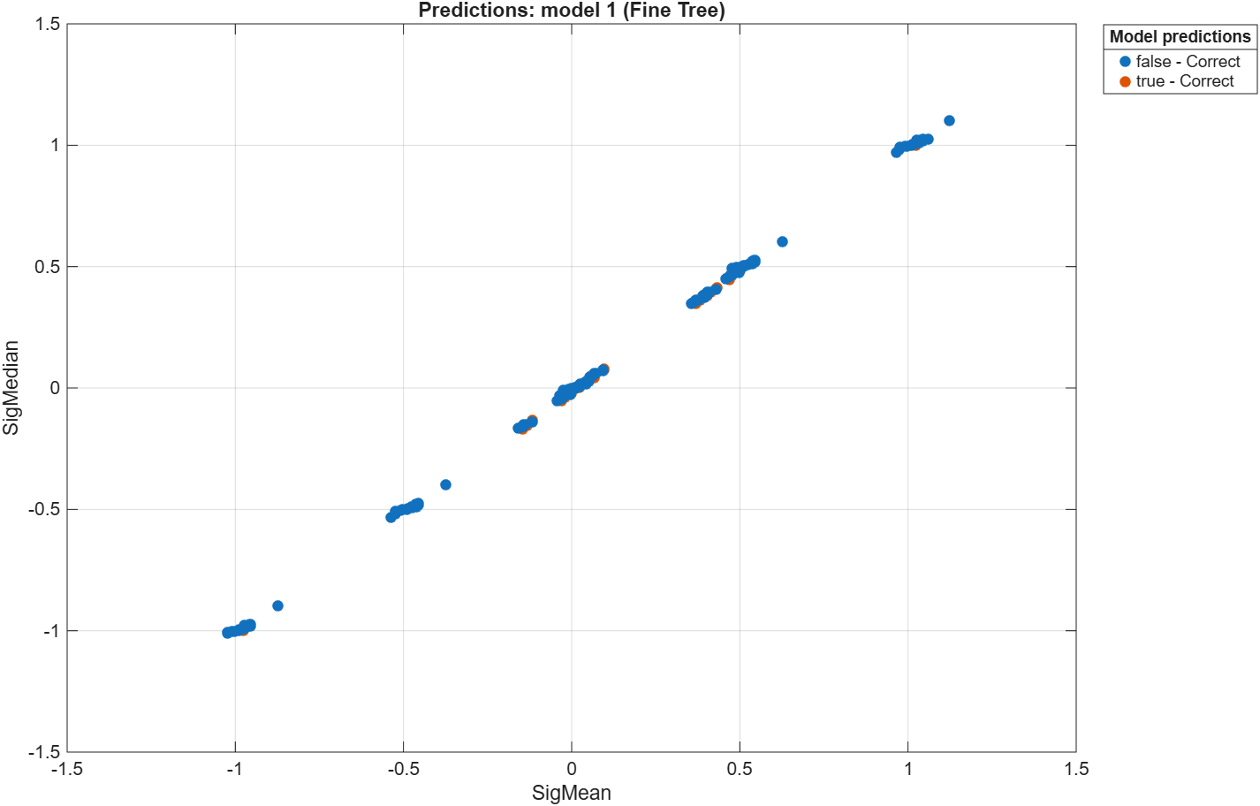
Figure 37 – Gear Tooth Fault - Scatter Plot - Fine Tree

Validation Confusion Matrix
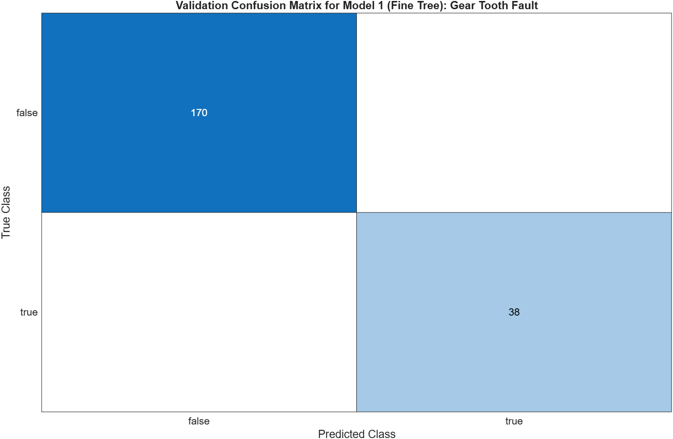
Figure 38 – Gear Tooth Fault - Validation Confusion Matrix - Fine Tree

SVM

Scatter Plot

Linear SVM
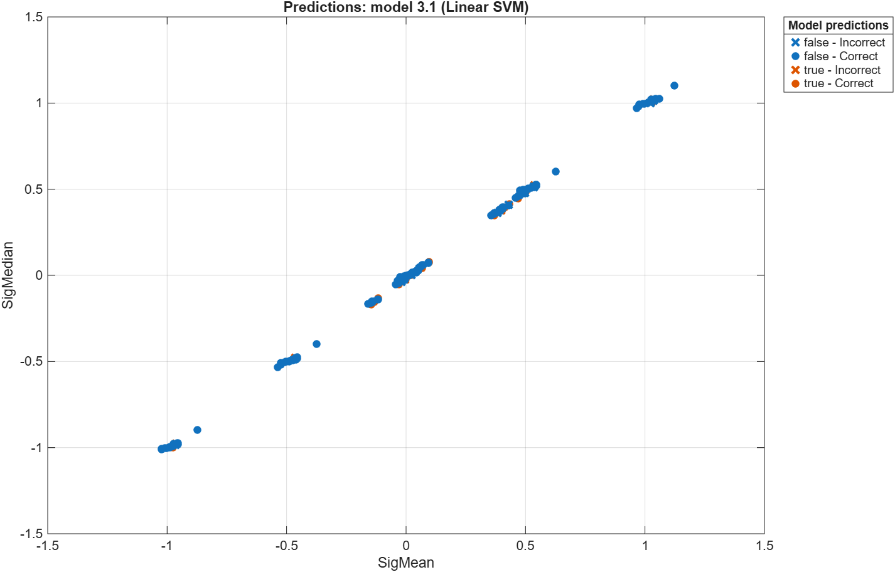
Figure 39 – Gear Tooth Fault - Scatter Plot - Linear SVM

Cubic SVM
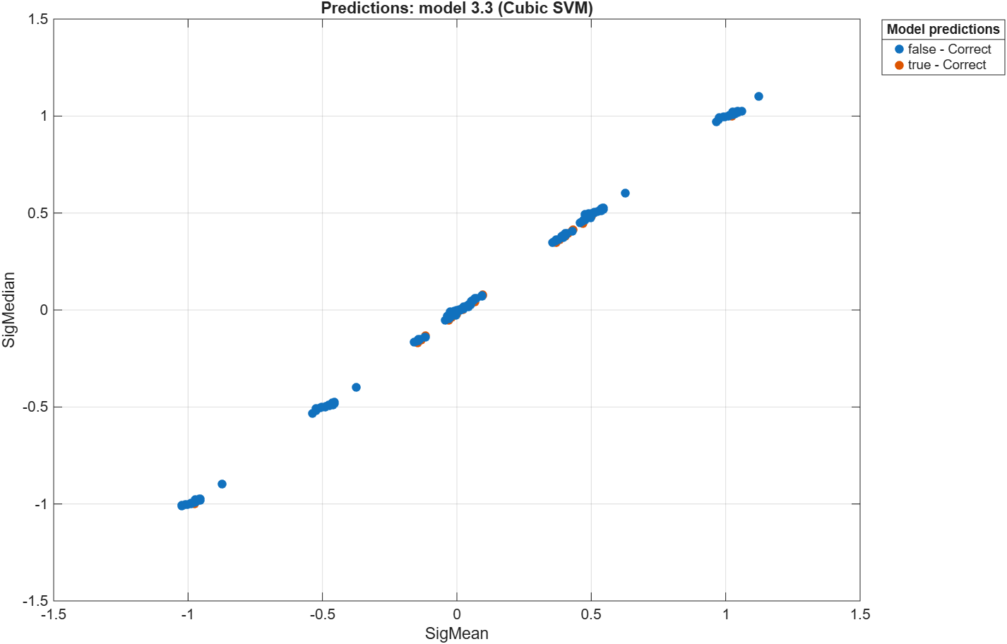
Figure 40 – Gear Tooth Fault - Scatter Plot - Cubic SVM

Quadratic SVM
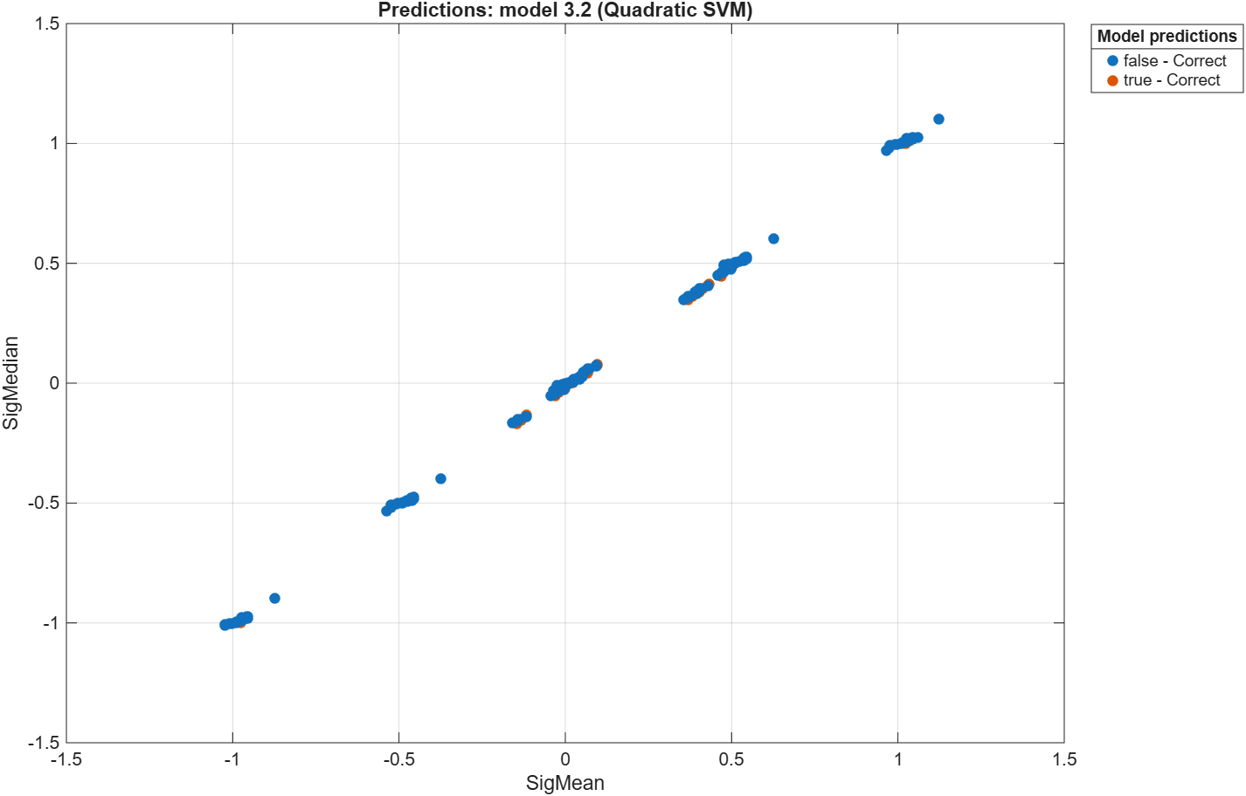
Figure 41 – Gear Tooth Fault - Scatter Plot - Quadratic SVM

Fine Gaussian SVM
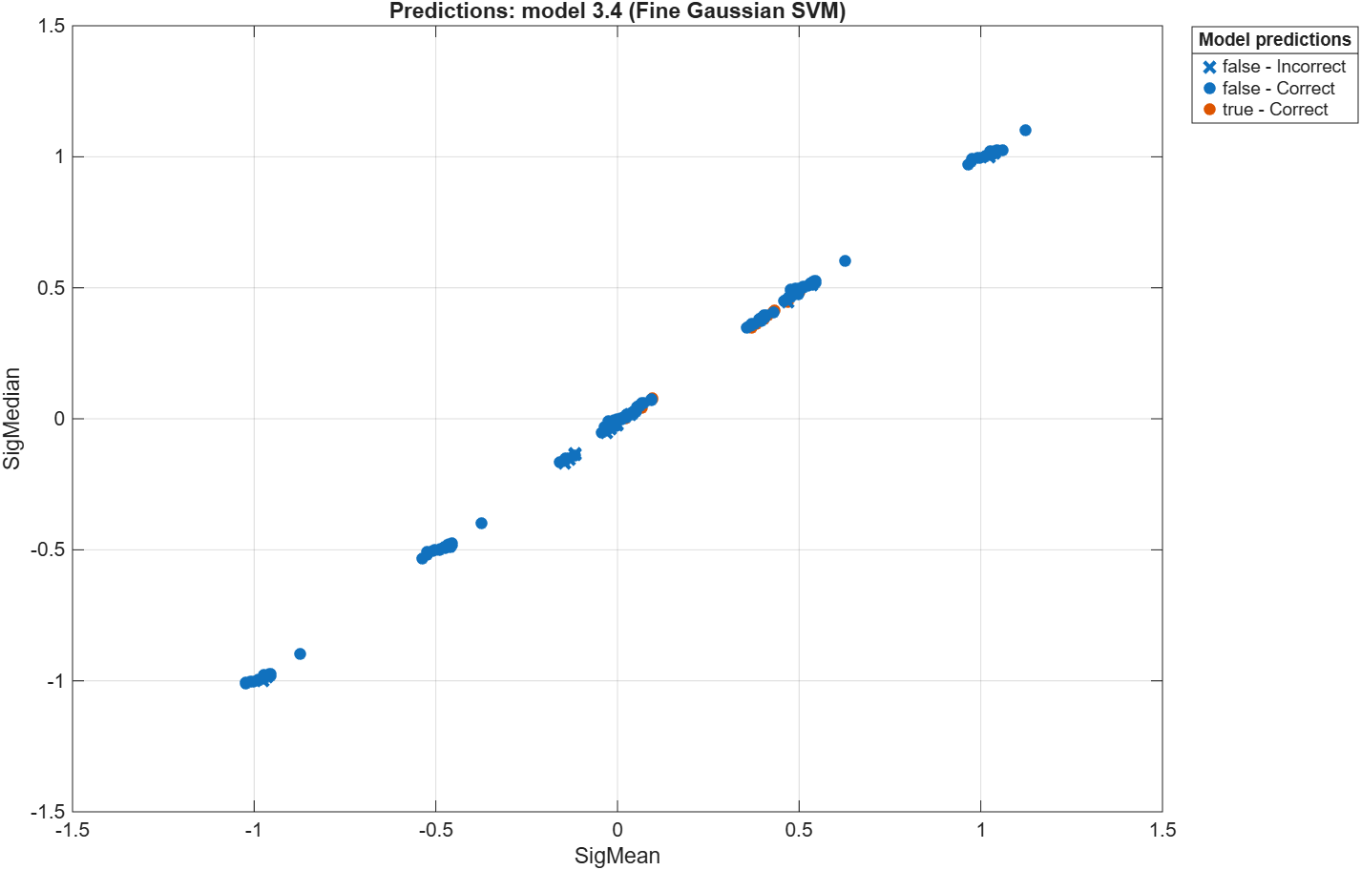
Figure 42 – Gear Tooth Fault - Scatter Plot - Fine Gaussian SVM

Medium Gaussian SVM
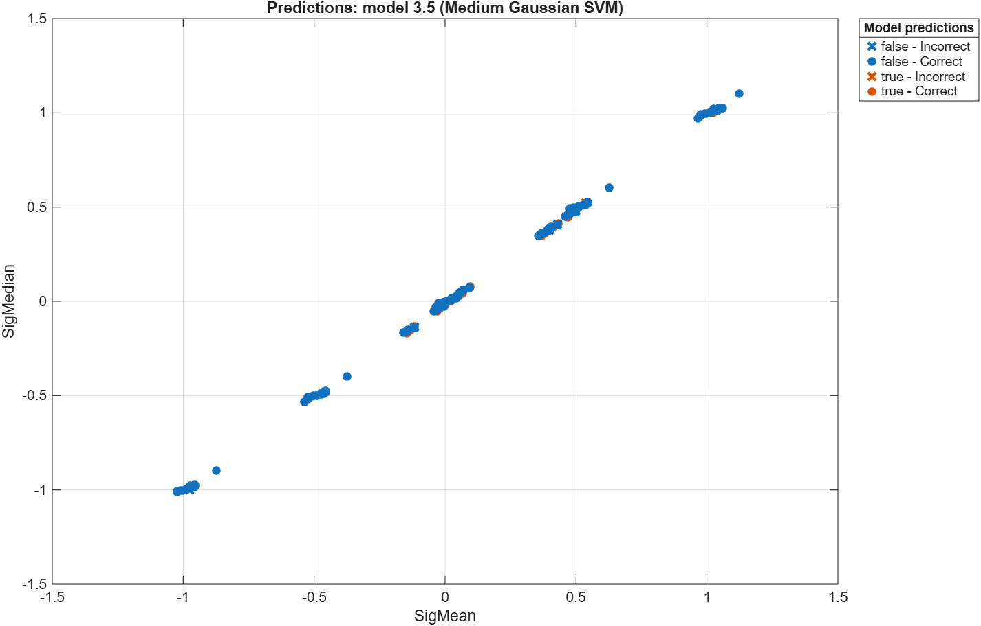
Figure 43 – Gear Tooth Fault - Scatter Plot - Medium Gaussian SVM

Coarse Gaussian SVM
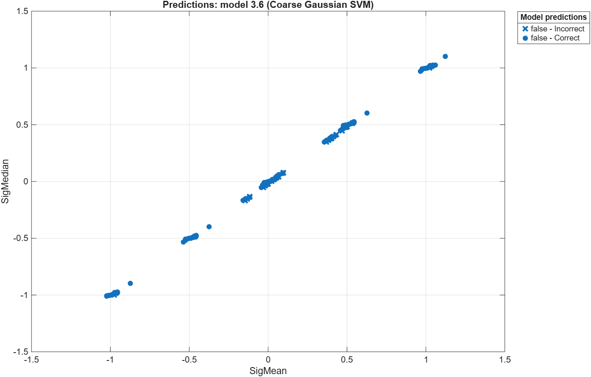
Figure 44 – Gear Tooth Fault - Scatter Plot - Coarse Gaussian SVM

Validation Confusion Matrix

Linear SVM
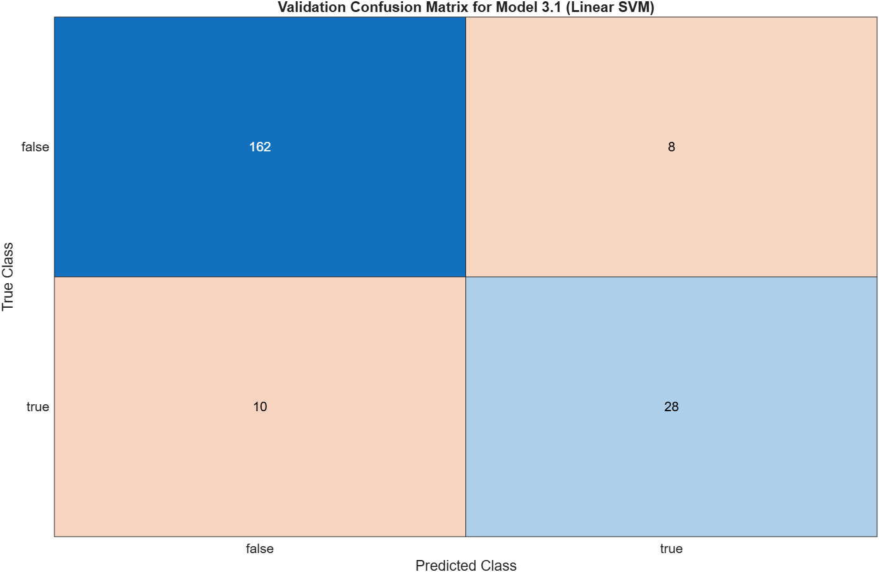
Figure 45 – Gear Tooth Fault - Validation Confusion Matrix - Linear SVM

Cubic SVM
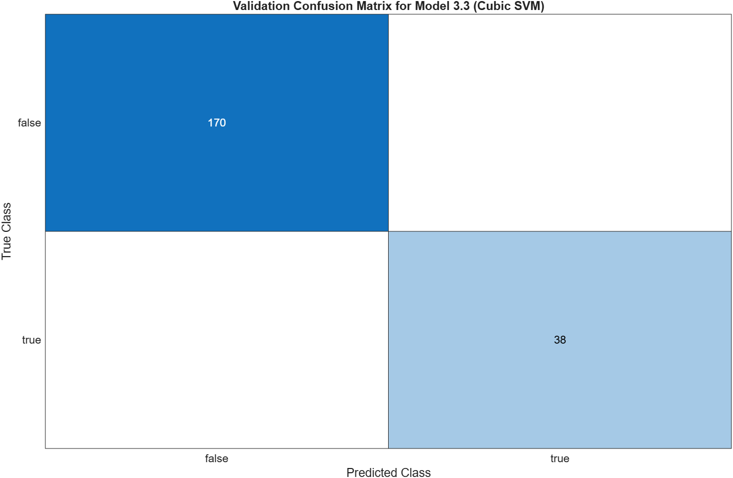
Figure 46 – Gear Tooth Fault - Validation Confusion Matrix - Cubic SVM

Quadratic SVM
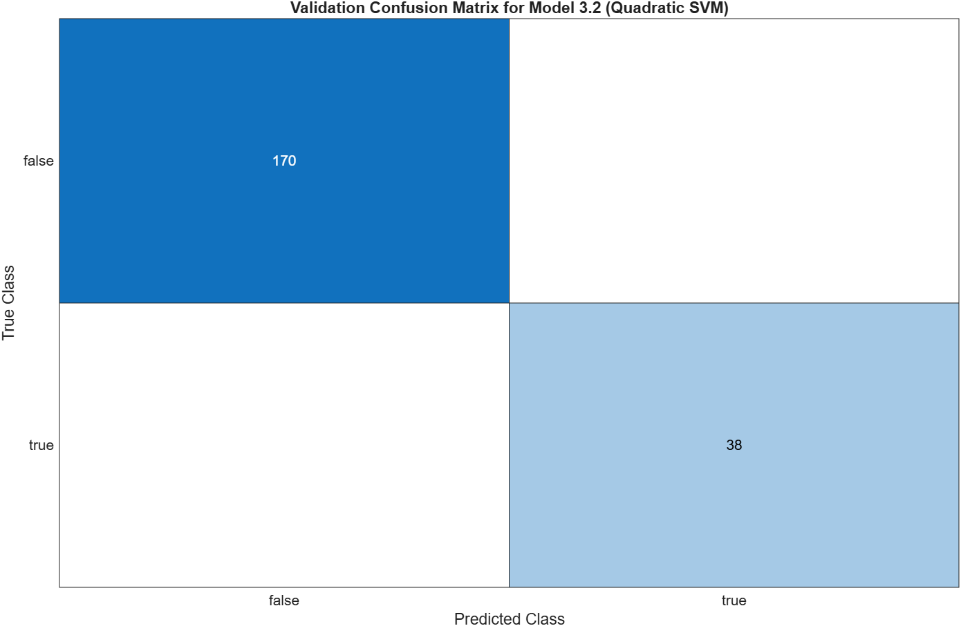
Figure 47 – Gear Tooth Fault - Validation Confusion Matrix - Quadratic SVM

Fine Gaussian SVM
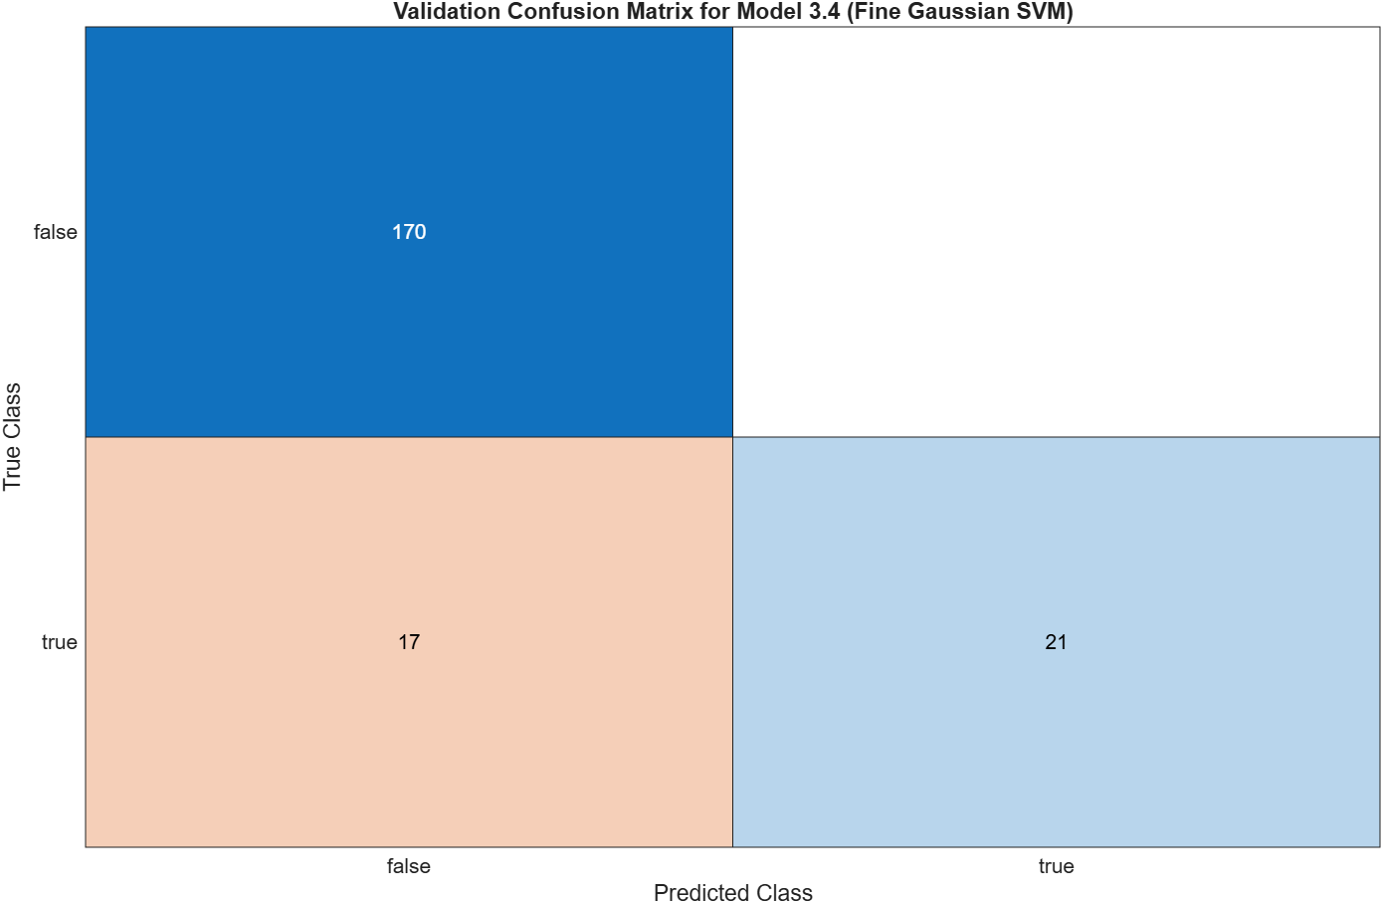
Figure 48 – Gear Tooth Fault - Validation Confusion Matrix - Fine Gaussian SVM

Medium Gaussian SVM
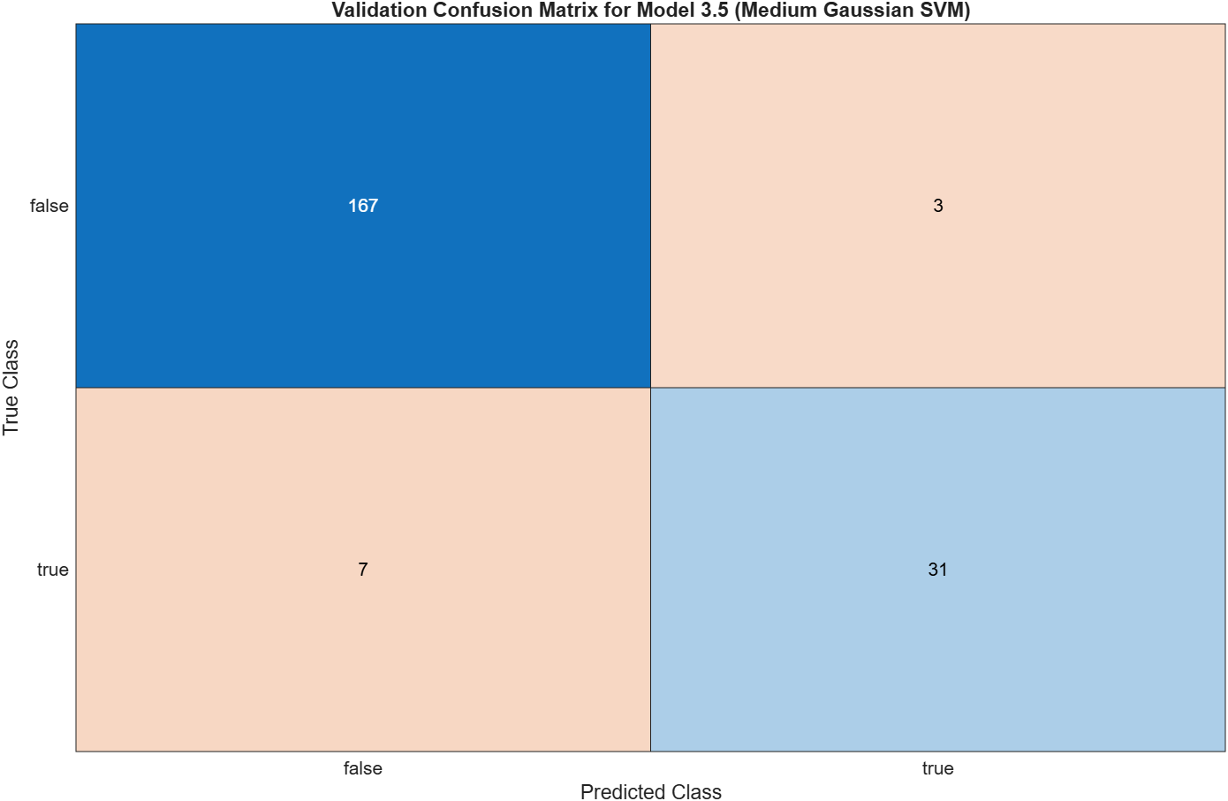
Figure 49 – Gear Tooth Fault - Validation Confusion Matrix - Medium Gaussian SVM

Coarse Gaussian SVM
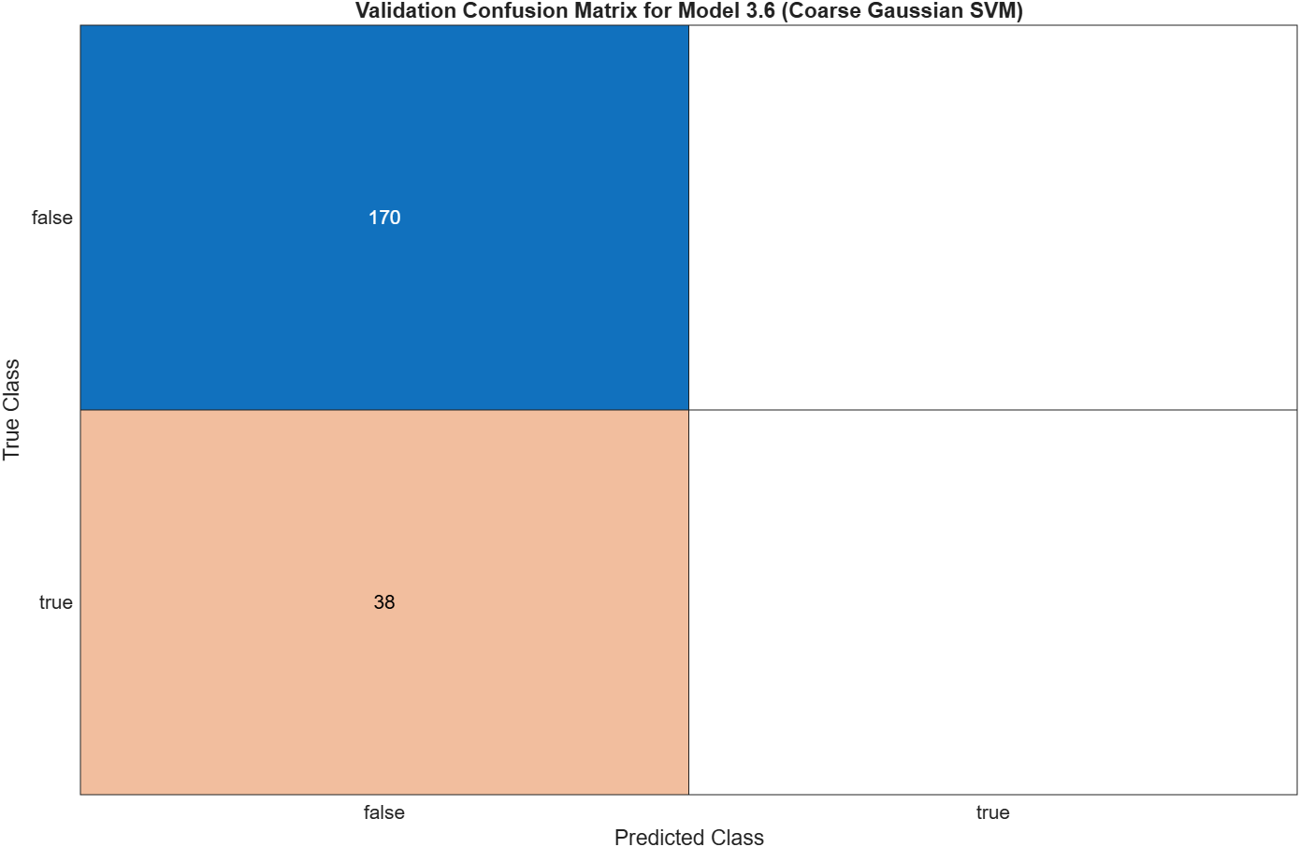
Figure 50 – Gear Tooth Fault - Validation Confusion Matrix - Coarse Gaussian SVM

Neural Network

Scatter Plot

Narrow Neural Network
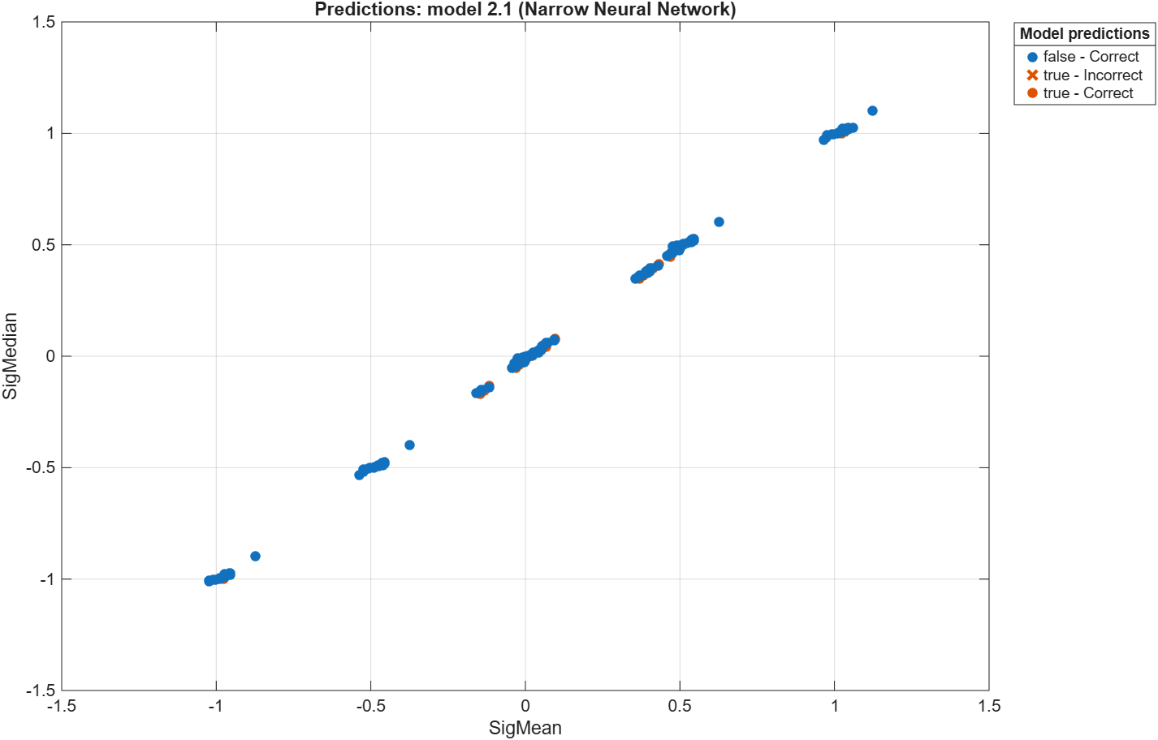
Figure 51 – Gear Tooth Fault - Scatter Plot - Narrow Neural Network

Medium Neural Network
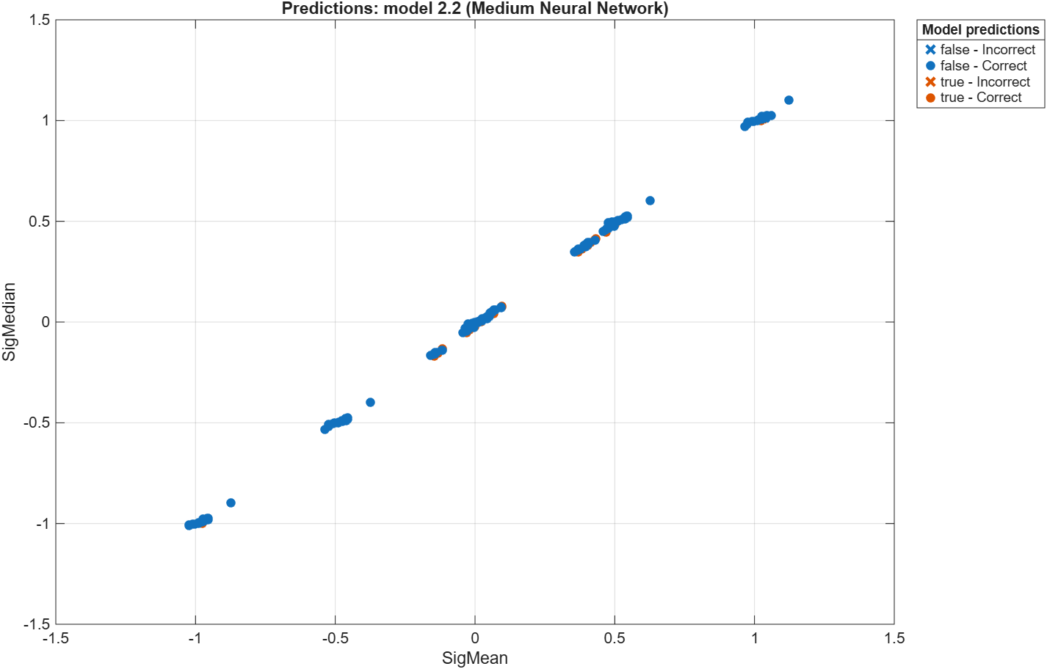
Figure 52 – Gear Tooth Fault - Scatter Plot - Medium Neural Network

Wide Neural Network
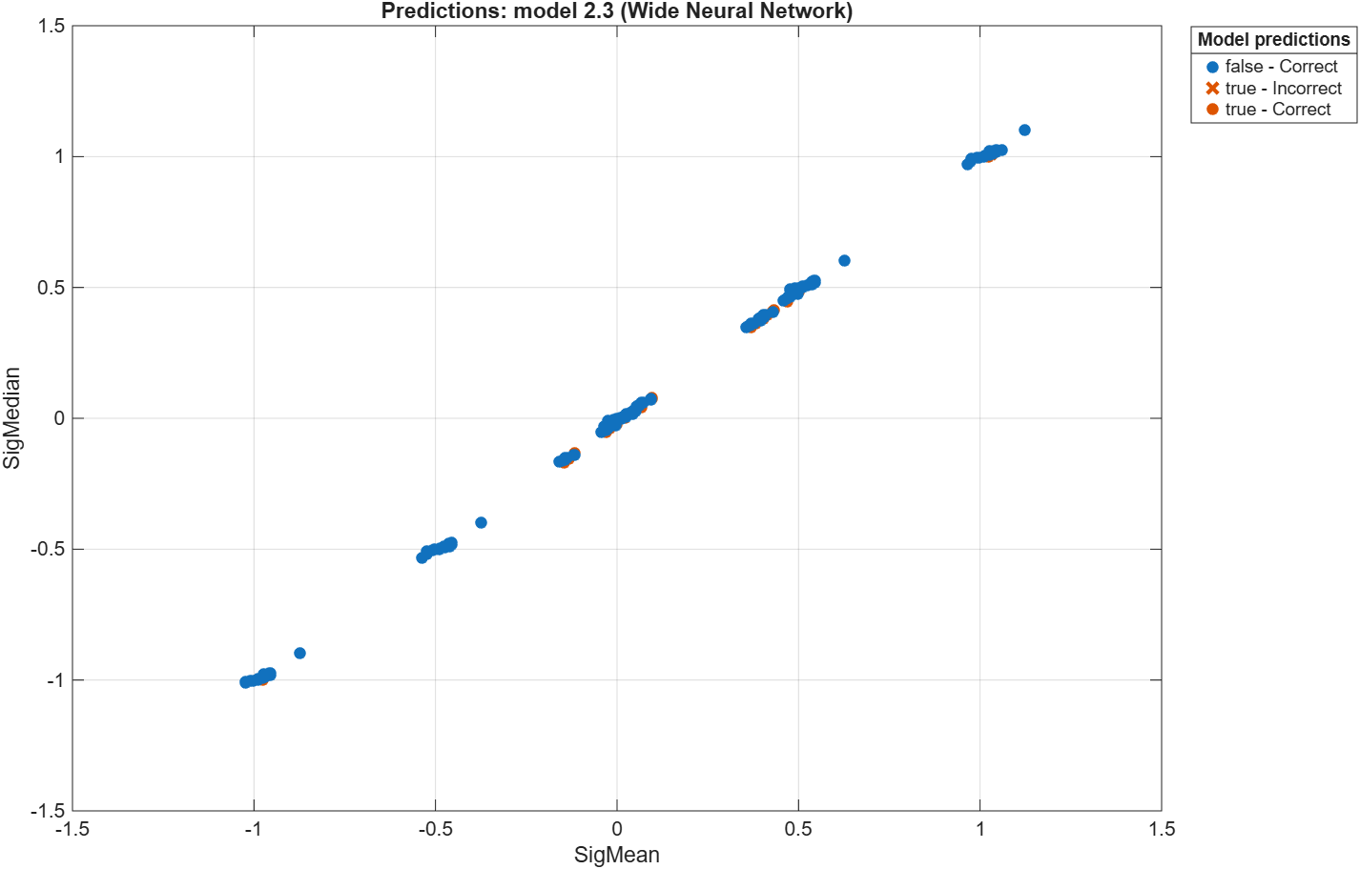
Figure 53 – Gear Tooth Fault - Scatter Plot - Wide Neural Network

Bilayered Neural Network
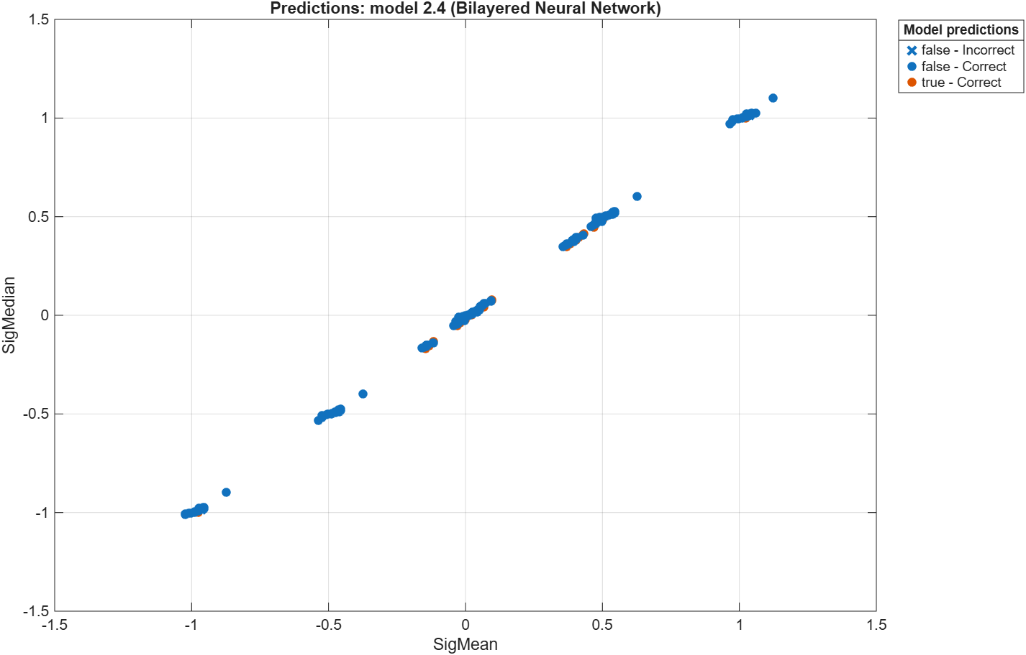
Figure 54 – Gear Tooth Fault - Scatter Plot - Bilayered Neural Network

Trilayered Neural Network
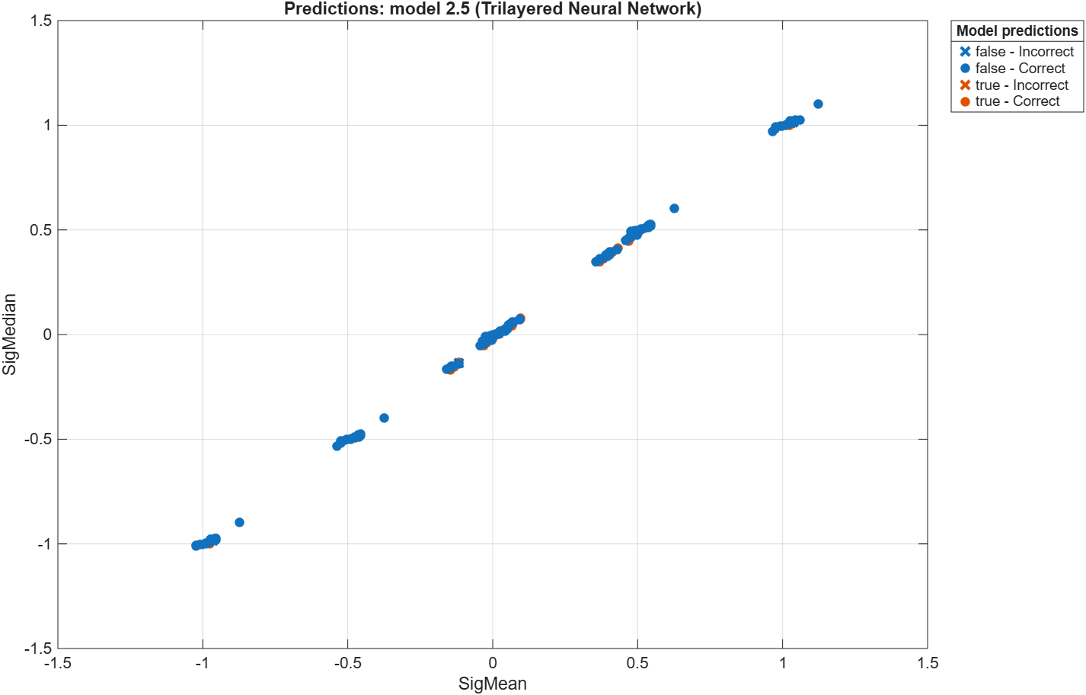
Figure 55 – Gear Tooth Fault - Scatter Plot - Trilayered Neural Network

Validation Confusion Matrix

Narrow Neural Network
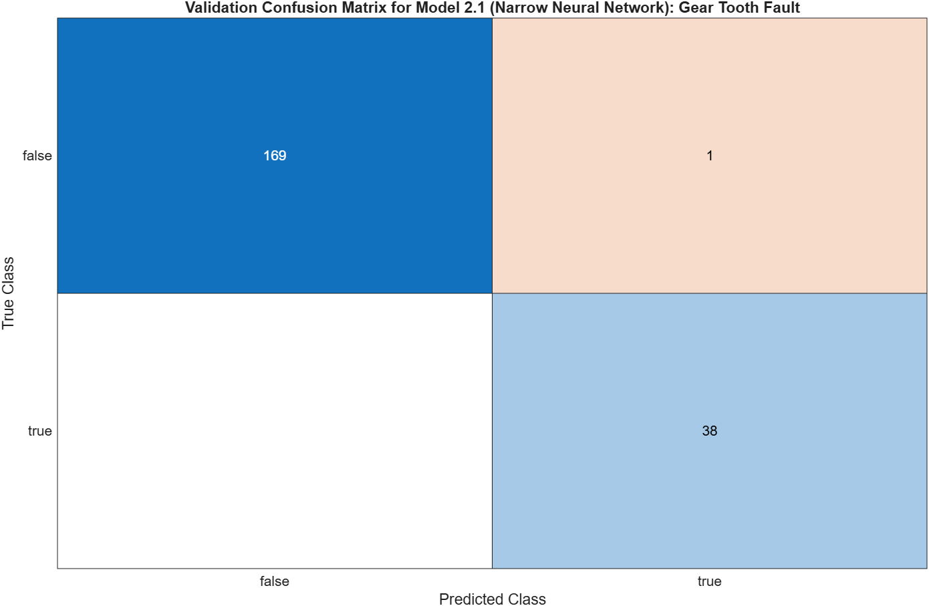
Figure 56 – Gear Tooth Fault - Validation Confusion Matrix - Narrow Neural Network

Medium Neural Network
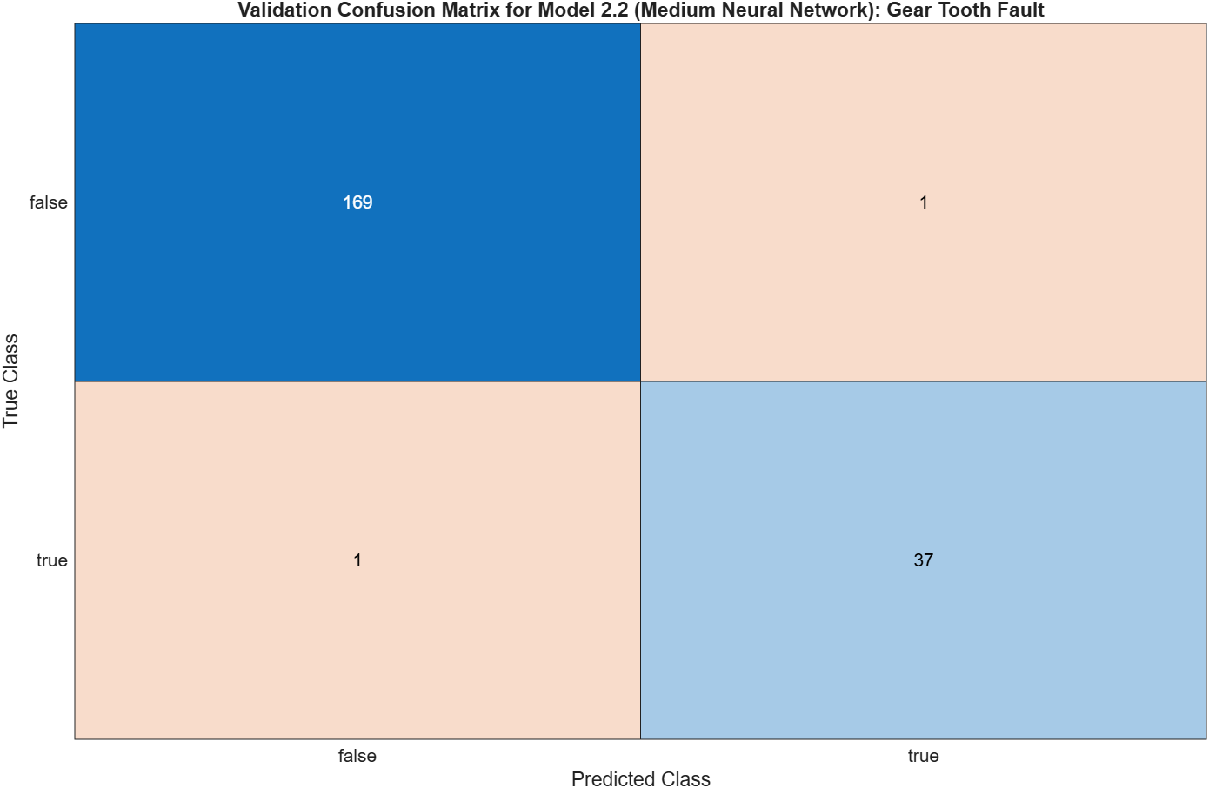
Figure 57 – Gear Tooth Fault - Validation Confusion Matrix - Medium Neural Network

Wide Neural Network
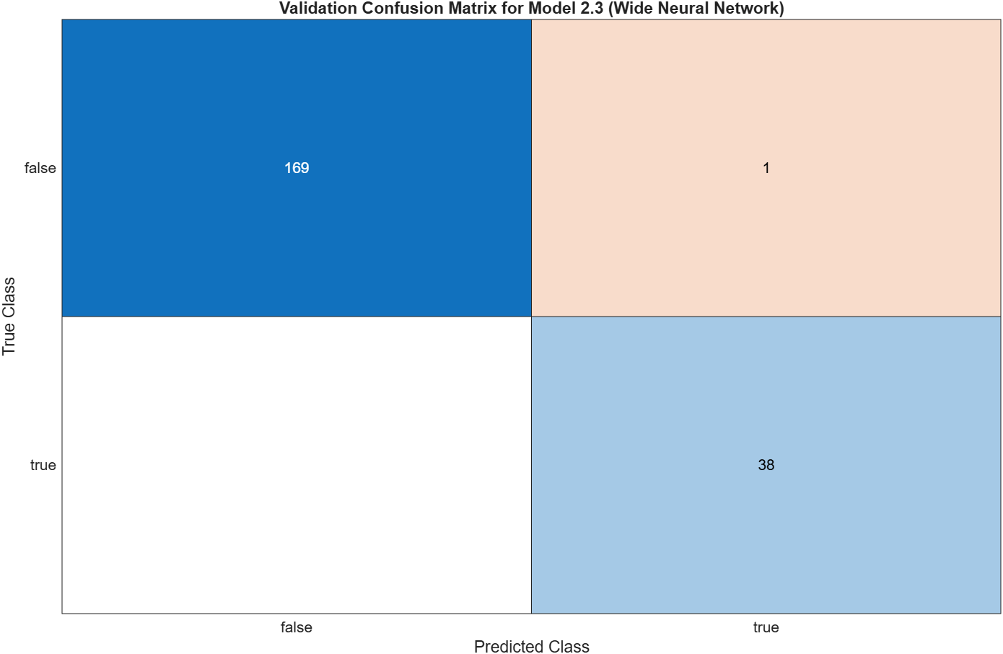
Figure 58 – Gear Tooth Fault - Validation Confusion Matrix - Wide Neural Network

Bilayered Neural Network
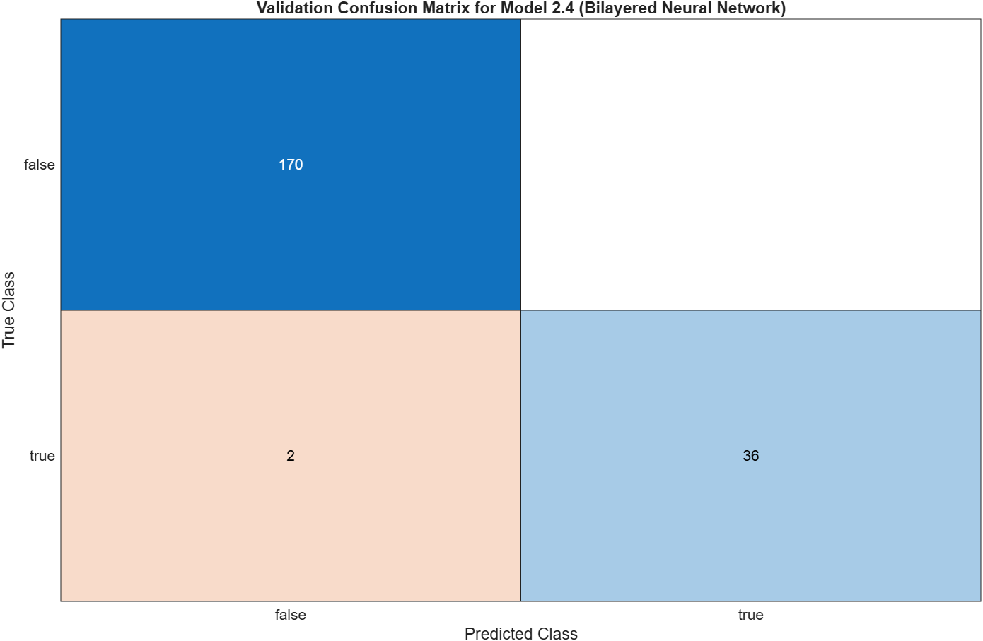
Figure 59 – Gear Tooth Fault - Validation Confusion Matrix - Bilayered Neural Network

Trilayered Neural Network
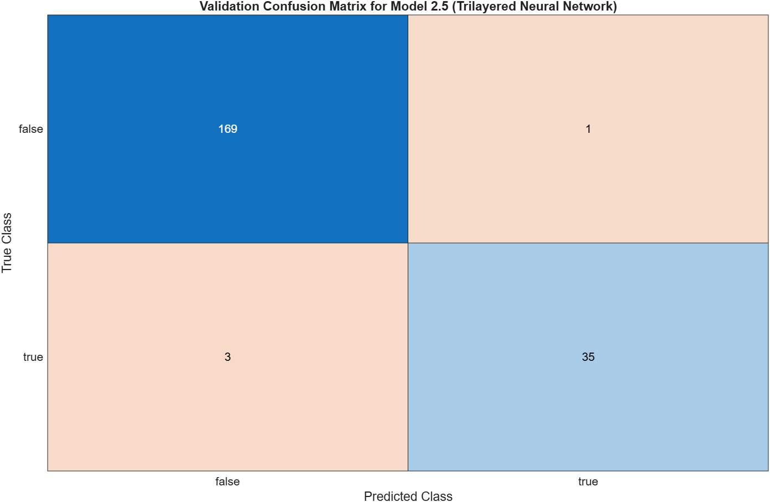
Figure 60 – Gear Tooth Fault - Validation Confusion Matrix - Trilayered Neural Network

Training Process

Narrow Neural Network
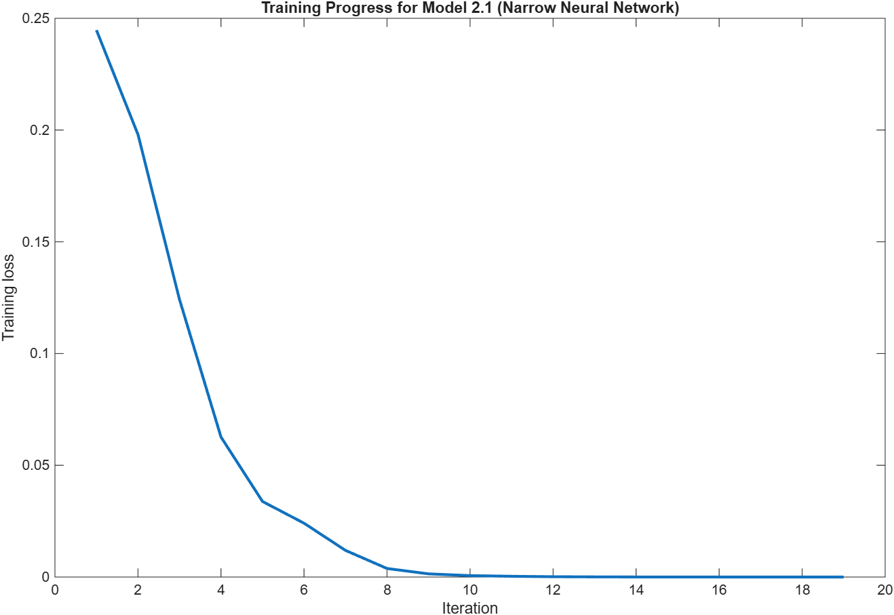
Figure 61 – Gear Tooth Fault - Training Process - Narrow Neural Network

Medium Neural Network
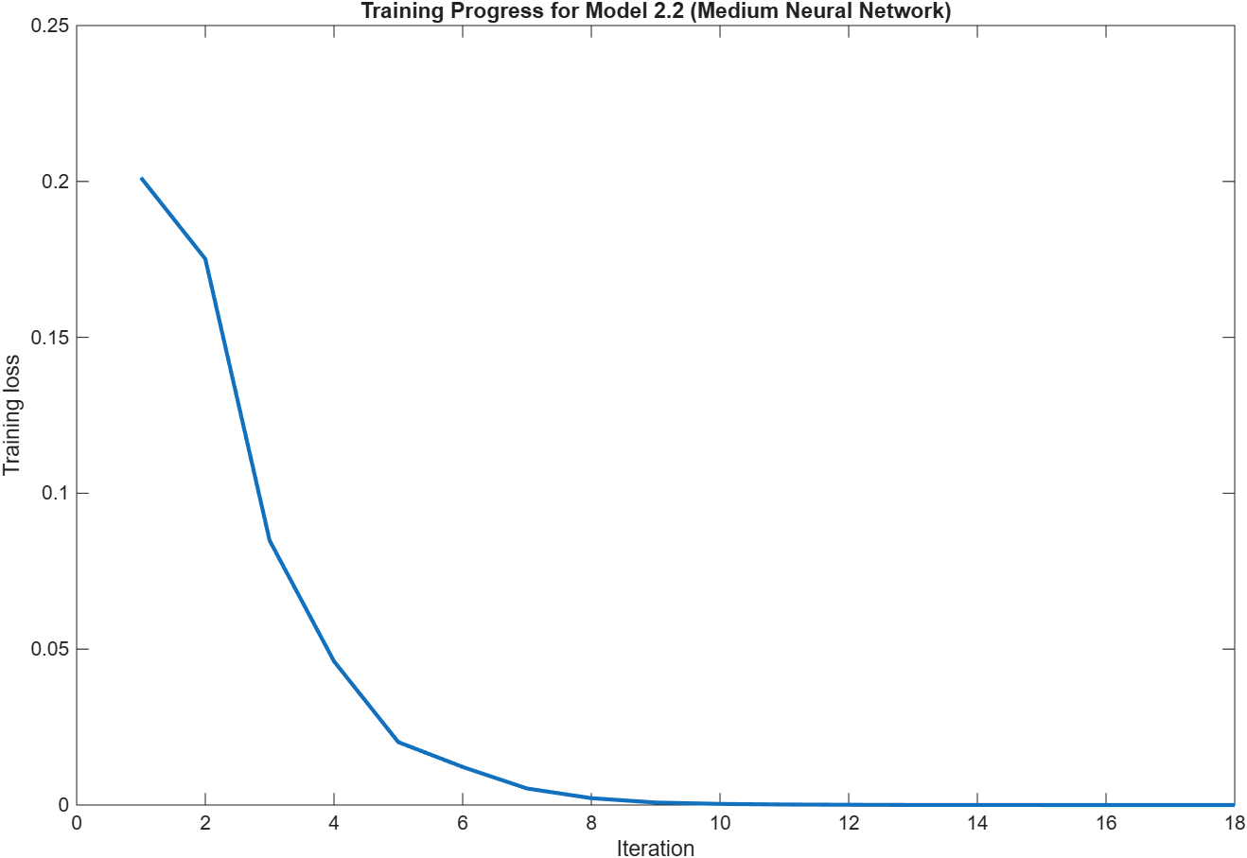
Figure 62 – Gear Tooth Fault - Training Process - Medium Neural Network

Wide Neural Network
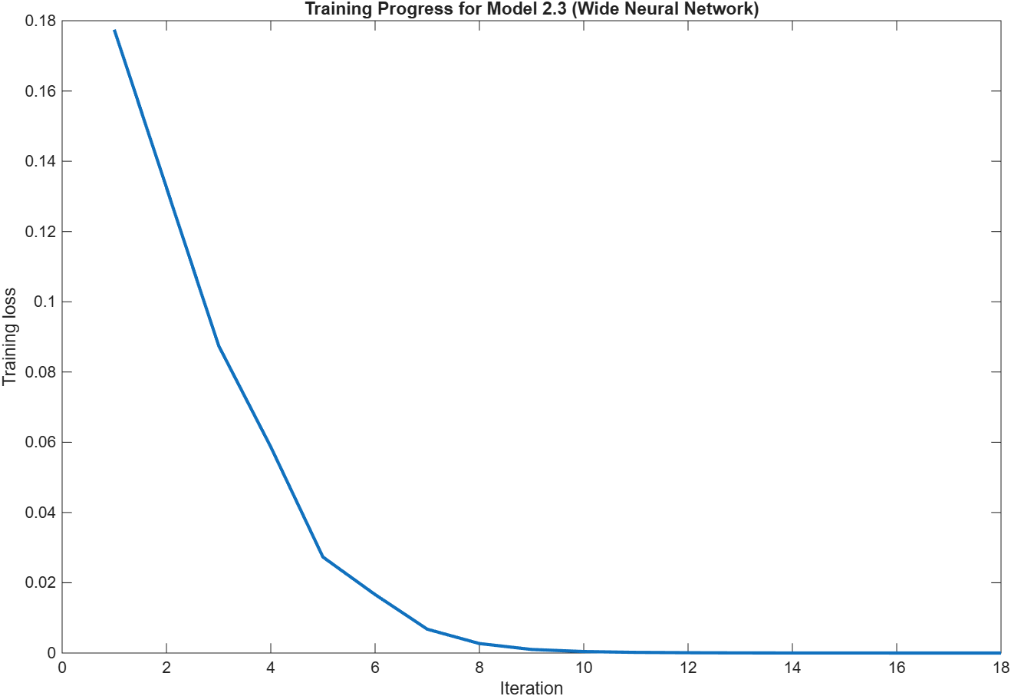
Figure 63 – Gear Tooth Fault - Training Process - Wide Neural Network

Bilayered Neural Network
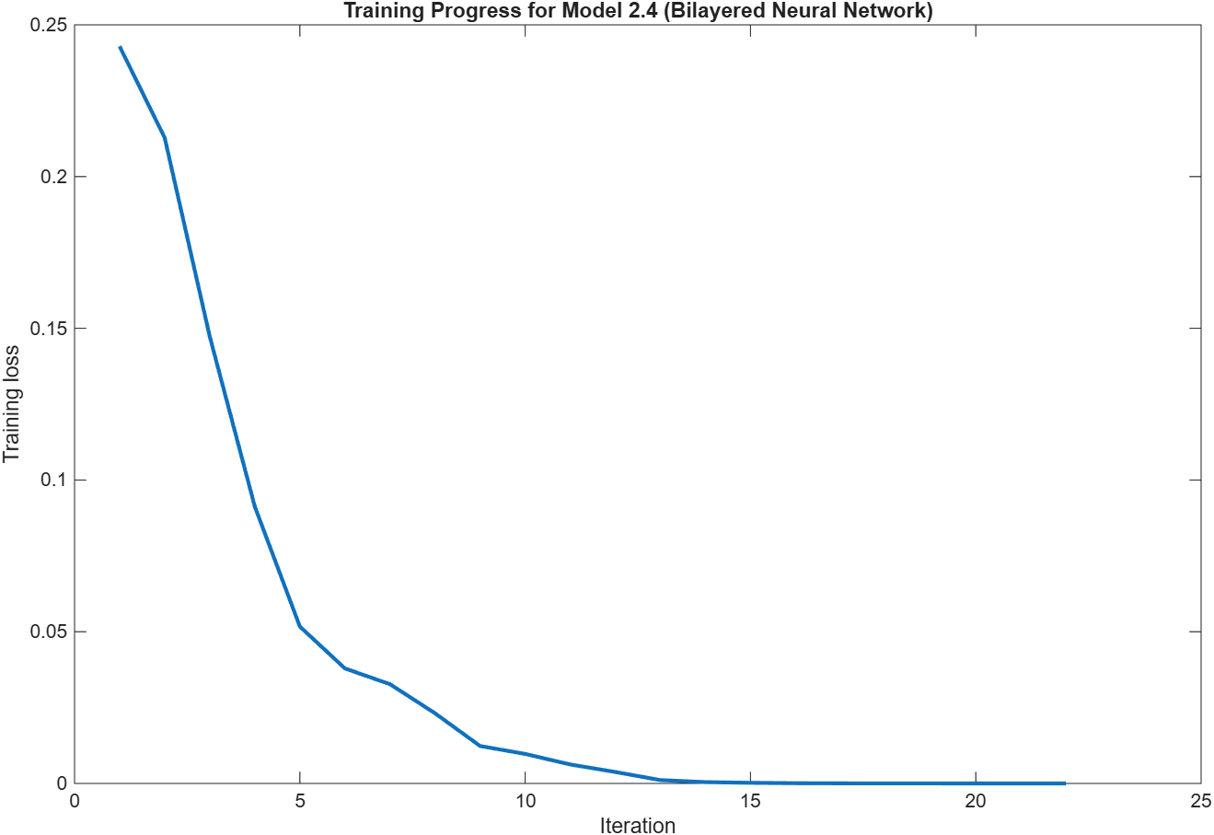
Figure 64 – Gear Tooth Fault - Training Process - Bilayered Neural Network

Trilayered Neural Network
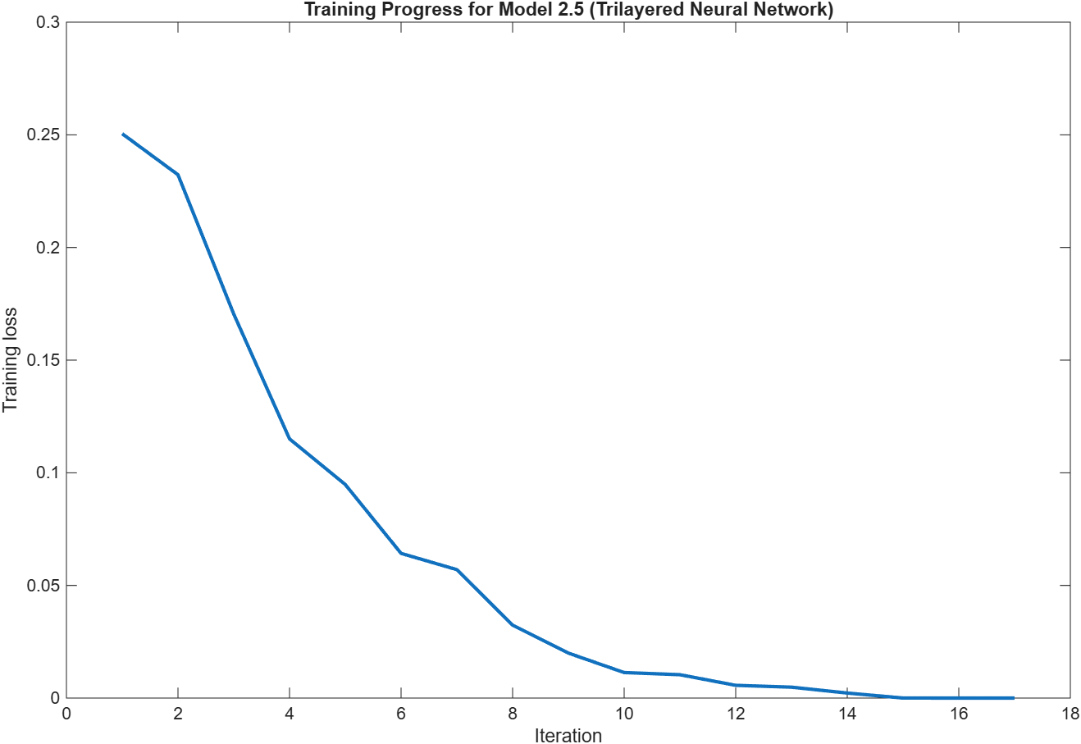
Figure 65 – Gear Tooth Fault - Training Process - Trilayered Neural Network

Model Comparison

Accuracy
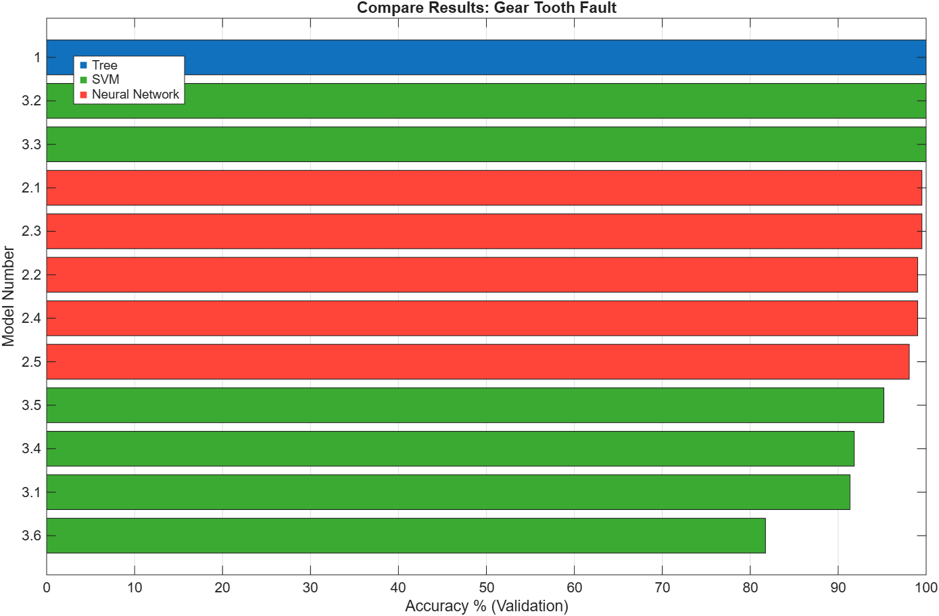
Figure 66 – Gear Tooth Fault - Model Comparison - Accuracy

Coder Model Size
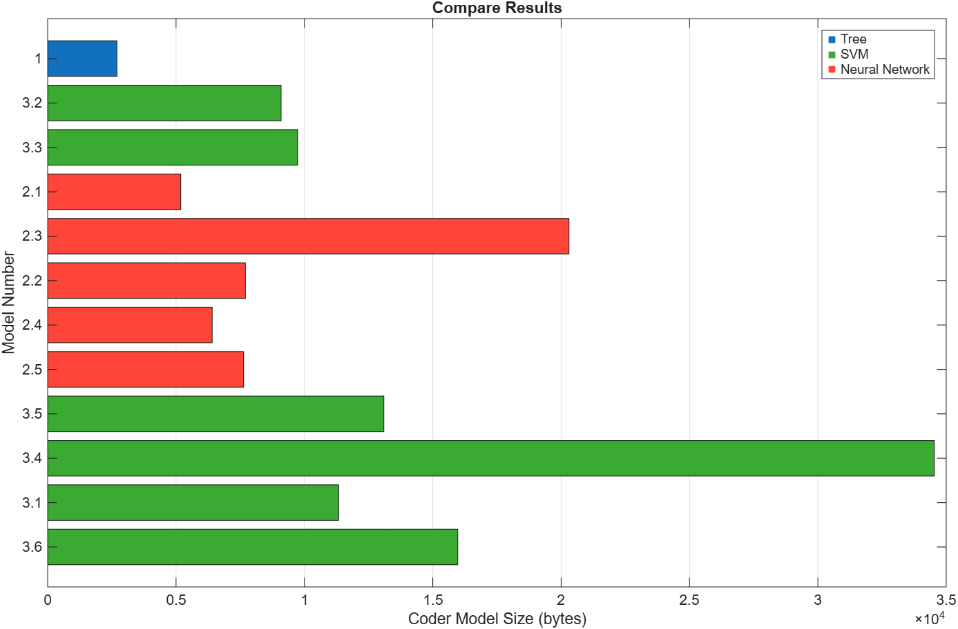
Figure 67 – Gear Tooth Fault - Model Comparison - Coder Model Size

Error Rate
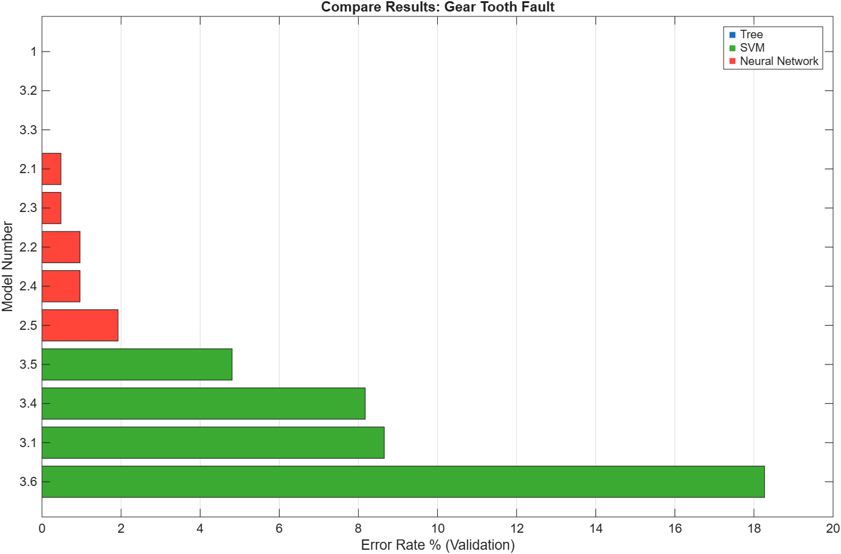
Figure 68 – Gear Tooth Fault - Model Comparison - Error Rate

Prediction Speed
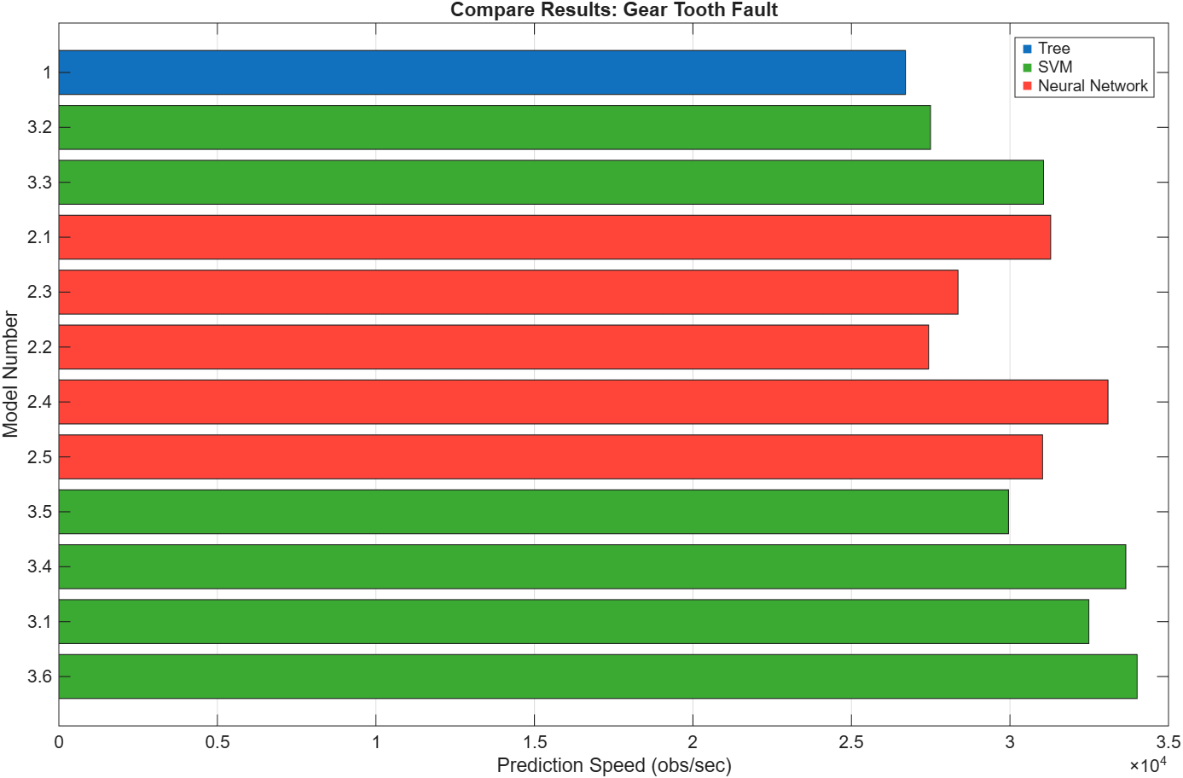
Figure 69 – Gear Tooth Fault - Model Comparison - Prediction Speed

Total Cost
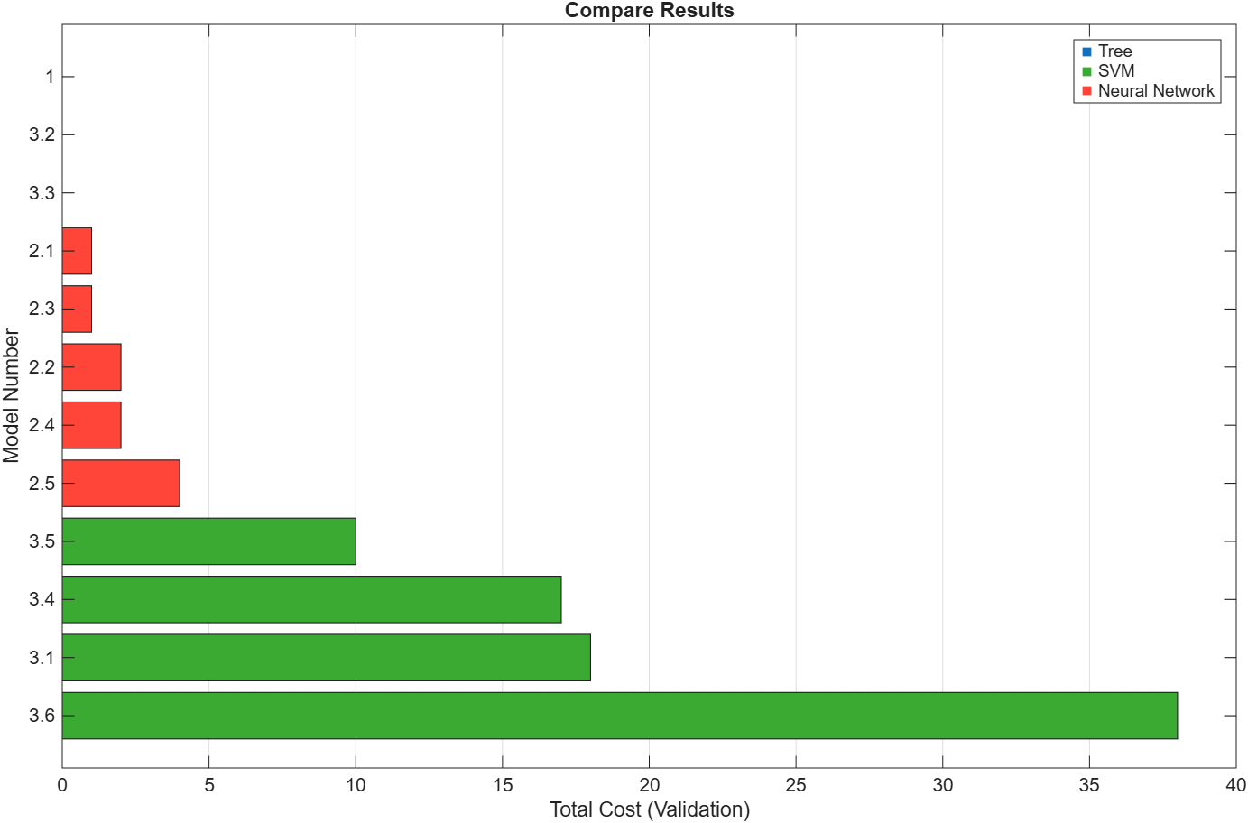
Figure 70 – Gear Tooth Fault - Model Comparison - Total Cost

Training Time
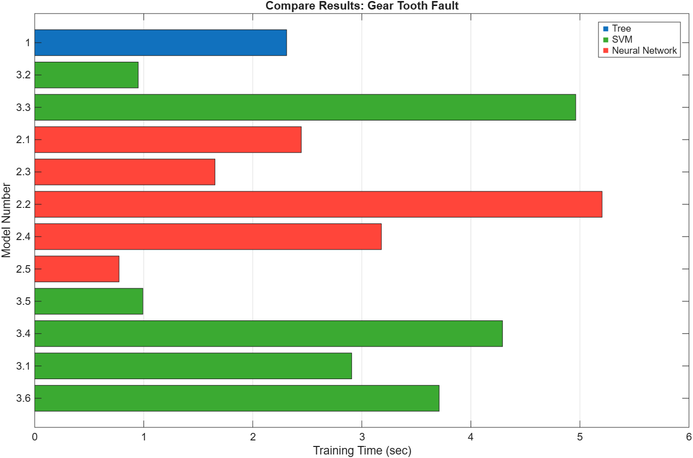
Figure 71 – Gear Tooth Fault - Model Comparison - Training Time

Output Shaft Wear

Results Table

An expanded data table can be found in the appendix.

Table 4 – Output Shaft Wear – Results Table
Model Number | Model Type | Accuracy % (Validation) | Total Cost (Validation) | Preset | Error Rate % (Validation) | Weighted Precision % (Validation) | Weighted Recall % (Validation) | Weighted F1 Score % (Validation) | Prediction Speed (obs/sec) | Training Time (sec) | Compact Model Size (bytes) | Coder Model Size (bytes)
1 | Tree | 85.096 | 31 | Fine Tree | 14.904 | 85.125 | 85.096 | 85.093 | 28783.35 | 2.770 | 9455 | 4324
2.1 | Neural Network | 71.154 | 60 | Narrow Neural Network | 28.846 | 71.185 | 71.154 | 71.143 | 24788.76 | 0.758 | 8688 | 5184
2.2 | Neural Network | 71.154 | 60 | Medium Neural Network | 28.846 | 71.154 | 71.154 | 71.154 | 25042.44 | 2.336 | 11208 | 7704
2.3 | Neural Network | 73.558 | 55 | Wide Neural Network | 26.442 | 73.560 | 73.558 | 73.557 | 22374.97 | 3.395 | 23808 | 20304
2.4 | Neural Network | 72.115 | 58 | Bilayered Neural Network | 27.885 | 72.189 | 72.115 | 72.092 | 27432.67 | 1.190 | 10412 | 6408
2.5 | Neural Network | 74.519 | 53 | Trilayered Neural Network | 25.481 | 74.631 | 74.519 | 74.490 | 28030.08 | 3.086 | 12136 | 7632
3.1 | SVM | 59.615 | 84 | Linear SVM | 40.385 | 59.647 | 59.615 | 59.582 | 32310.18 | 1.380 | 33249 | 30214
3.2 | SVM | 71.635 | 59 | Quadratic SVM | 28.365 | 71.685 | 71.635 | 71.618 | 27585.11 | 0.933 | 26713 | 23814
3.3 | SVM | 70.192 | 62 | Cubic SVM | 29.808 | 70.200 | 70.192 | 70.190 | 29646.52 | 0.547 | 25113 | 22214
3.4 | SVM | 60.577 | 82 | Fine Gaussian SVM | 39.423 | 61.404 | 60.577 | 59.849 | 29748.71 | 0.243 | 37589 | 34694
3.5 | SVM | 61.058 | 81 | Medium Gaussian SVM | 38.942 | 61.141 | 61.058 | 60.985 | 28170.54 | 2.764 | 35989 | 33094
3.6 | SVM | 57.212 | 89 | Coarse Gaussian SVM | 42.788 | 57.410 | 57.212 | 56.924 | 23750.53 | 0.596 | 39189 | 36294

Fine Tree

Scatter Plot
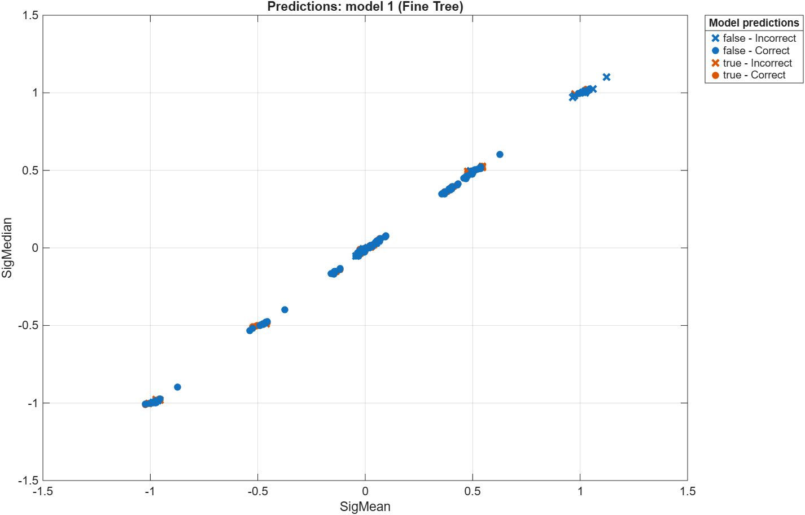
Figure 72 – Output Shaft Wear - Scatter Plot - Fine Tree

Validation Confusion Matrix
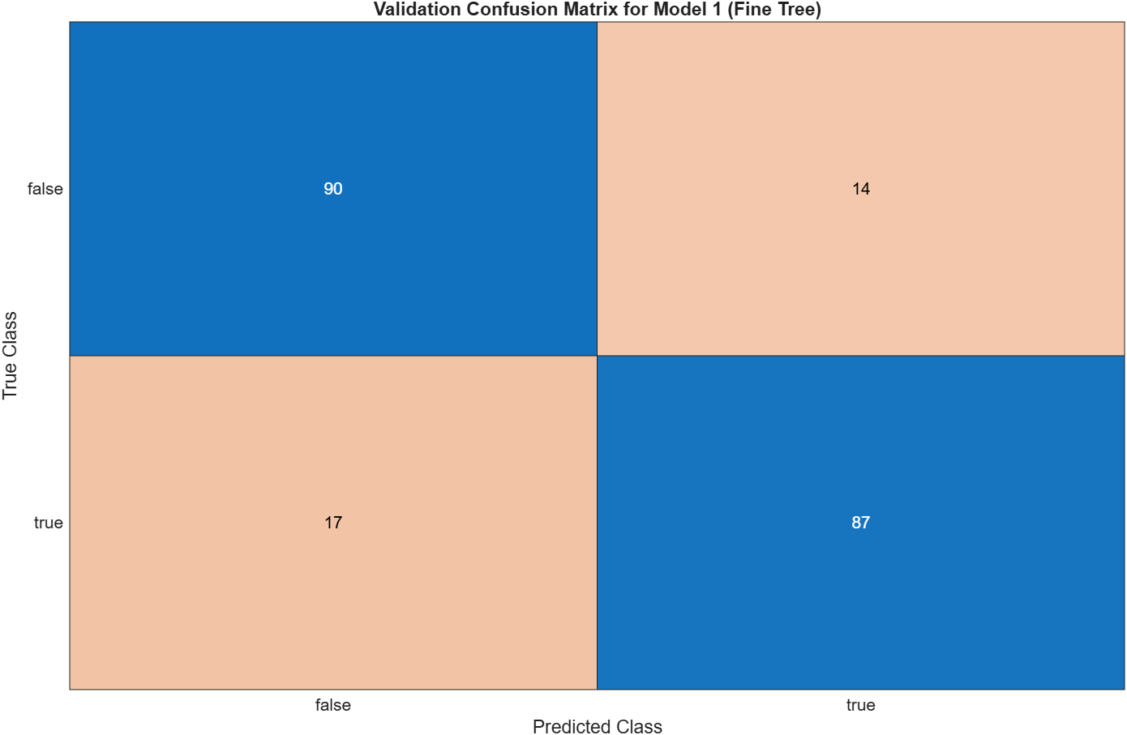
Figure 73 – Output Shaft Wear - Validation Confusion Matrix - Fine Tree

SVM

Scatter Plot

Linear SVM
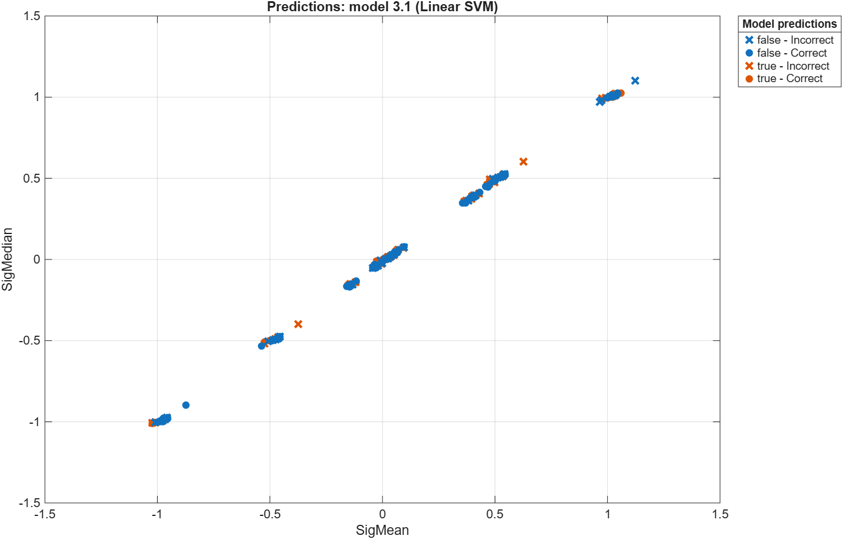
Figure 74 – Output Shaft Wear - Scatter Plot - Linear SVM

Cubic SVM
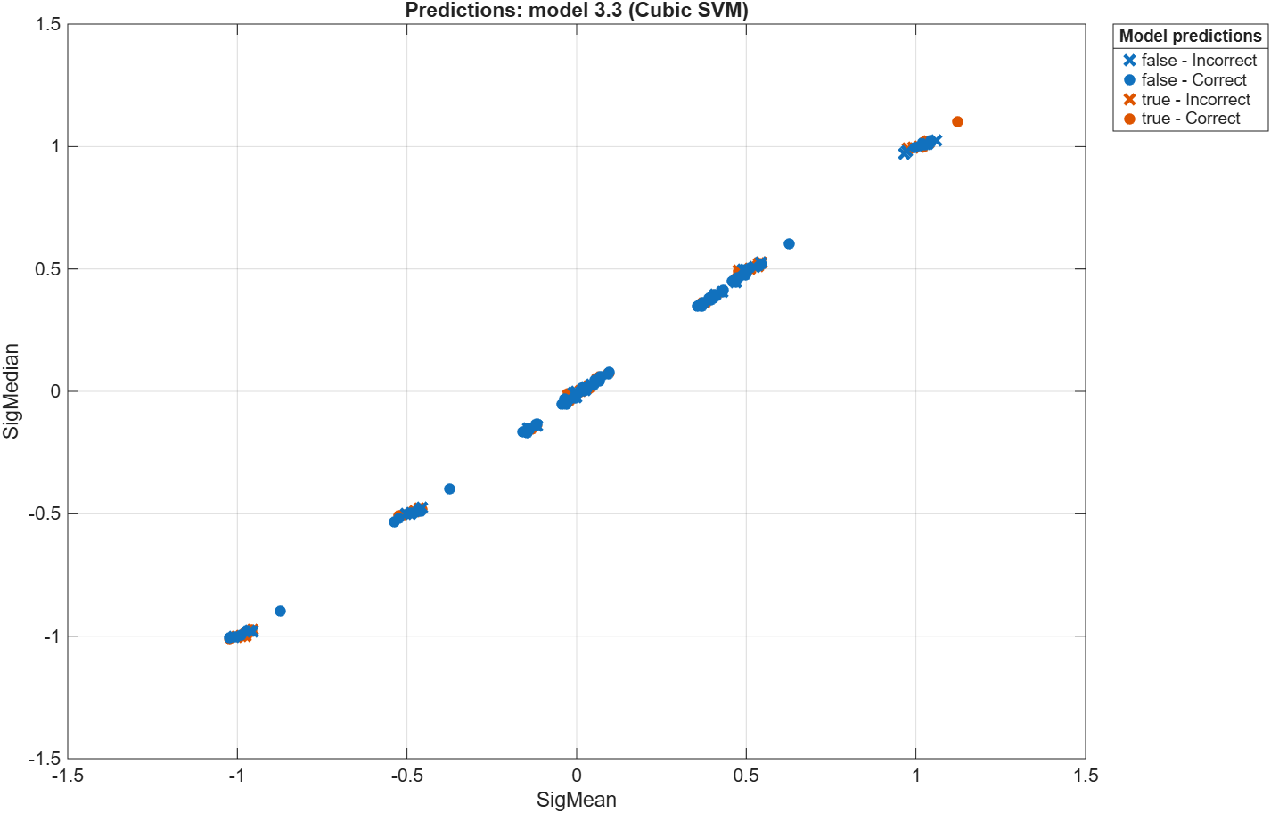
Figure 75 – Output Shaft Wear - Scatter Plot - Cubic SVM

Quadratic SVM
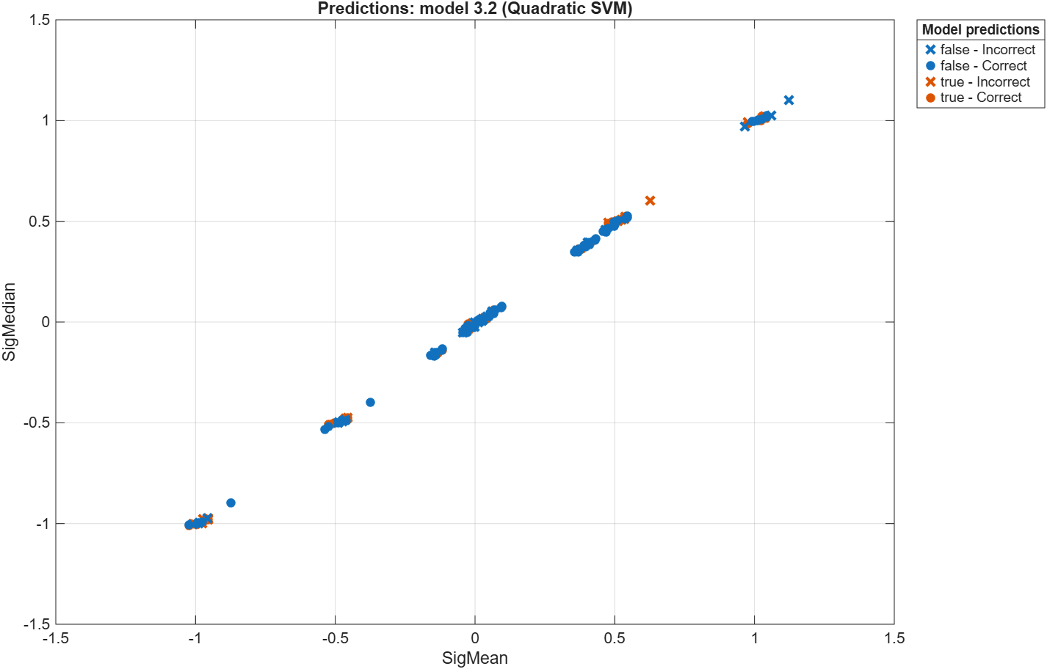
Figure 76 – Output Shaft Wear - Scatter Plot - Quadratic SVM

Fine Gaussian SVM
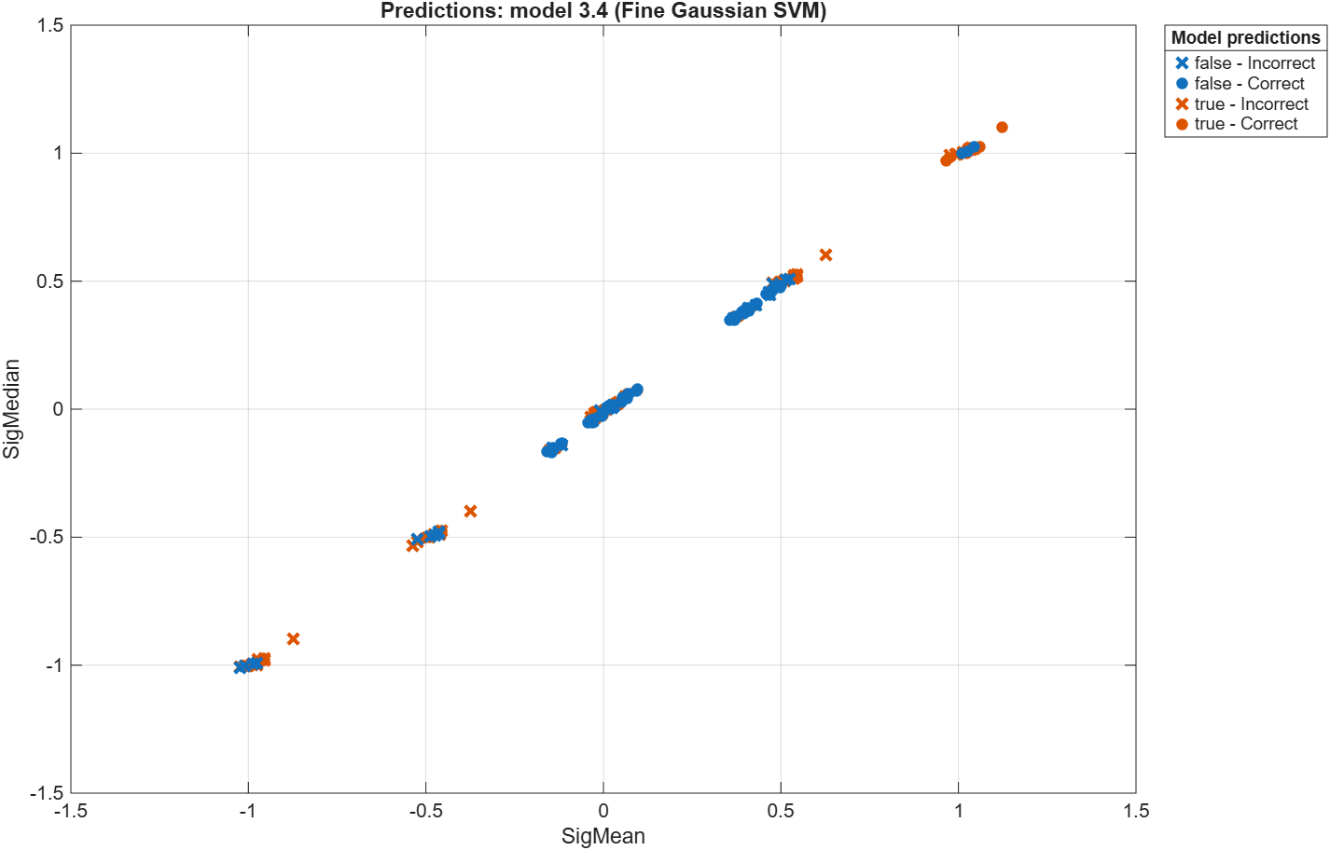
Figure 77 – Output Shaft Wear - Scatter Plot - Fine Gaussian SVM

Medium Gaussian SVM
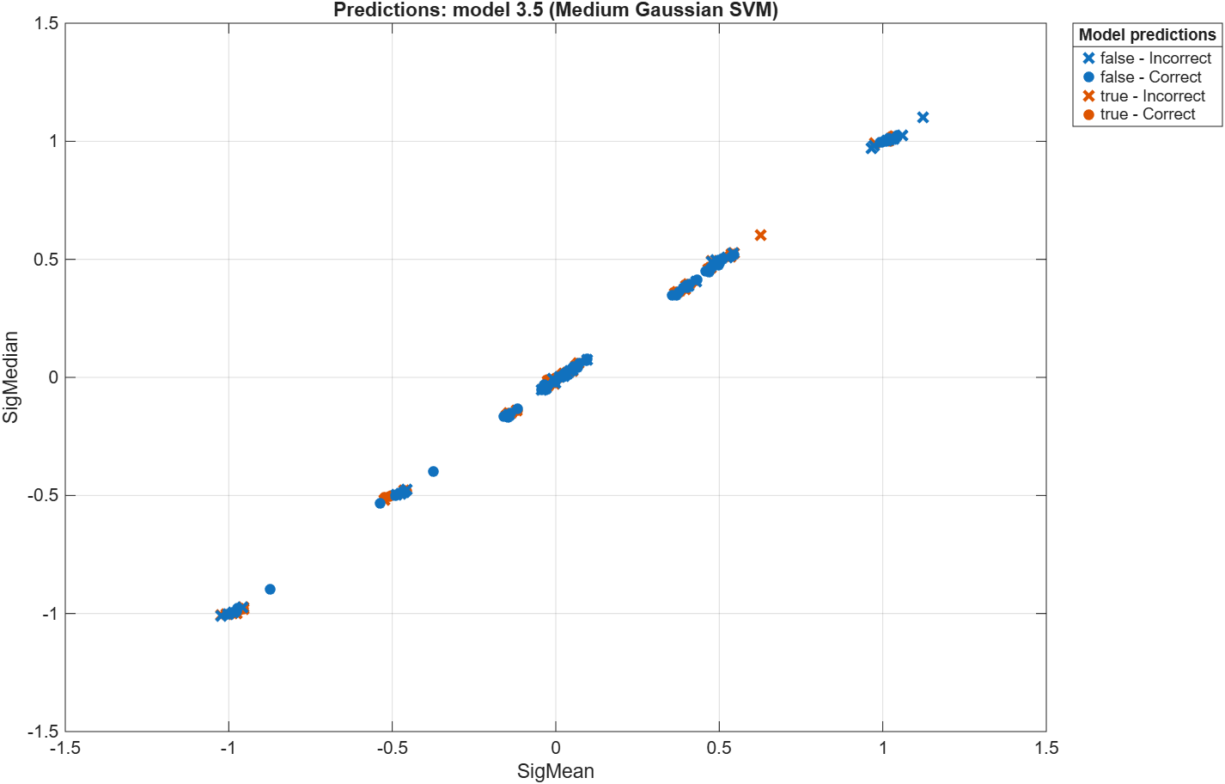
Figure 78 – Output Shaft Wear - Scatter Plot - Medium Gaussian SVM

Coarse Gaussian SVM
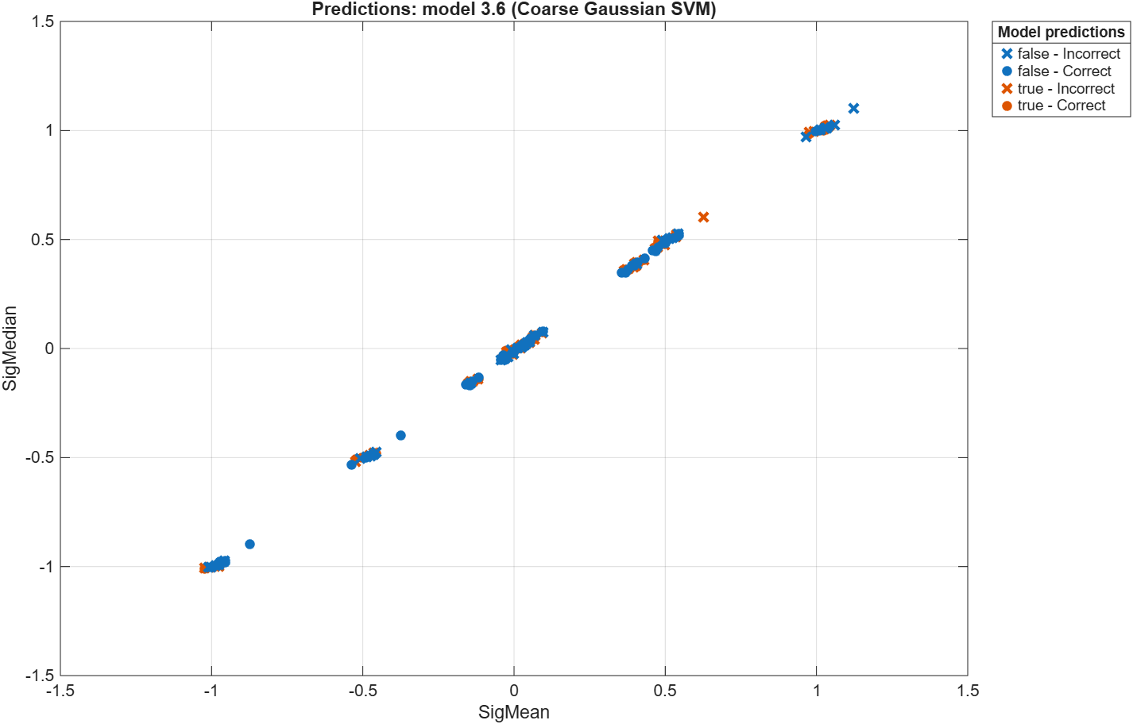
Figure 79 – Output Shaft Wear - Scatter Plot - Coarse Gaussian SVM

Validation Confusion Matrix

Linear SVM
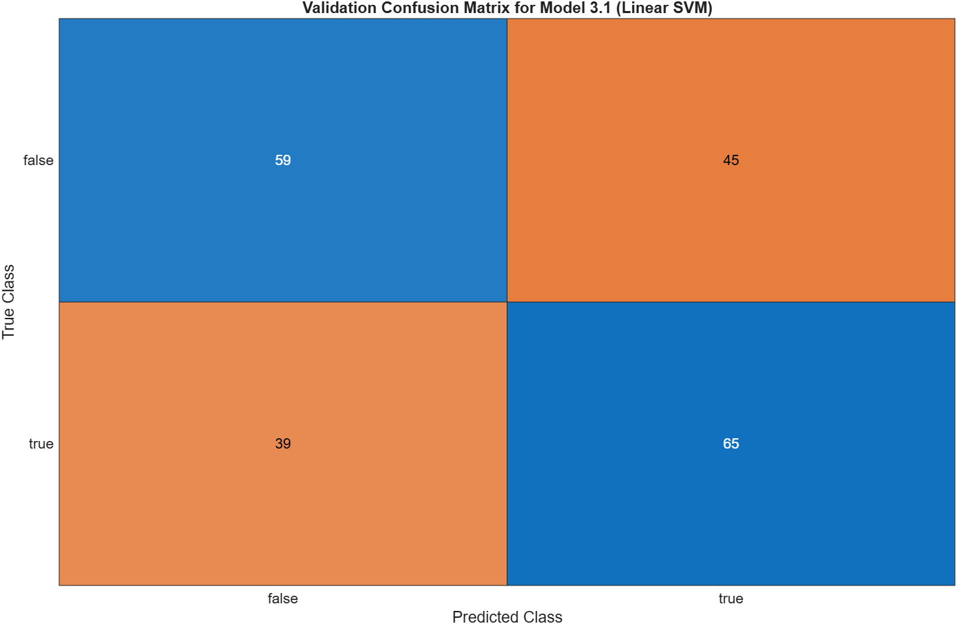
Figure 80 – Output Shaft Wear - Validation Confusion Matrix - Linear SVM

Cubic SVM
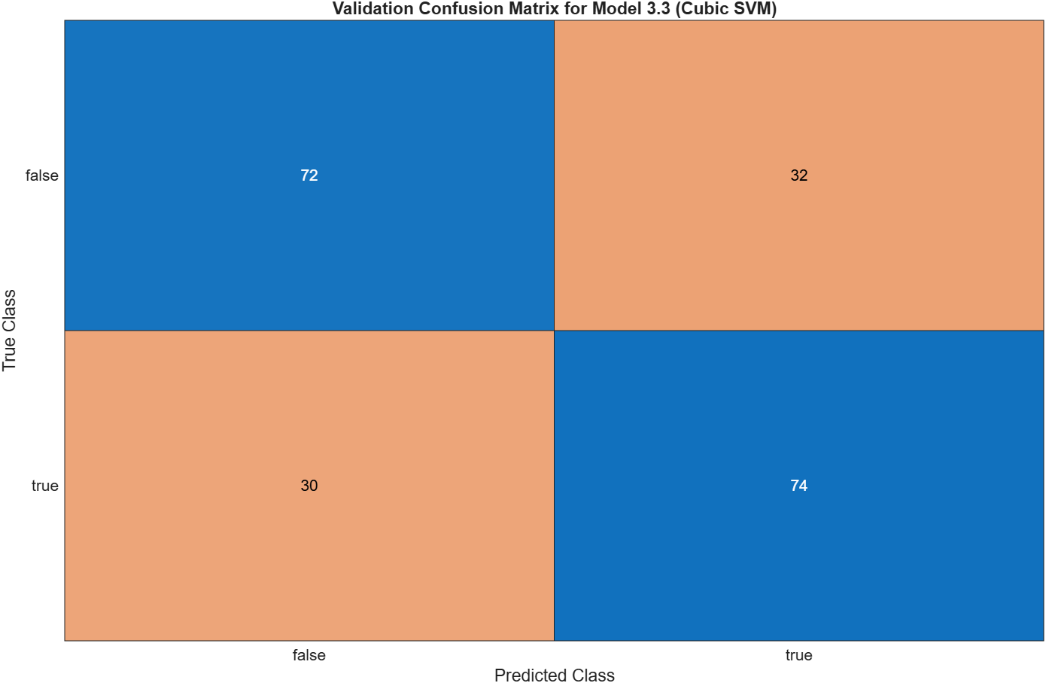
Figure 81 – Output Shaft Wear - Validation Confusion Matrix - Cubic SVM

Quadratic SVM
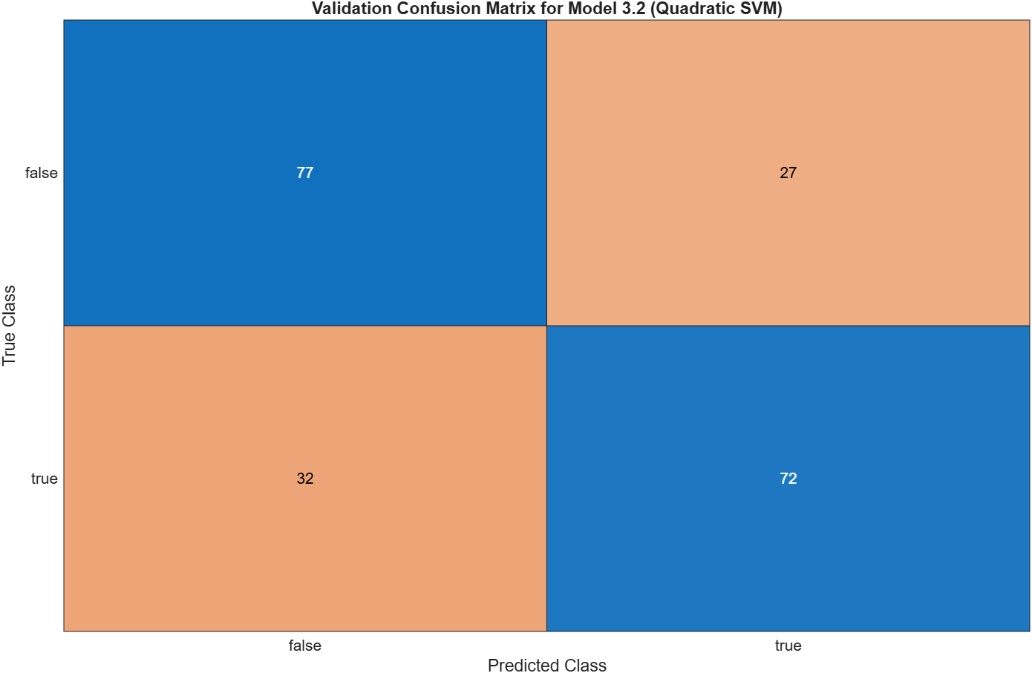
Figure 82 – Output Shaft Wear - Validation Confusion Matrix - Quadratic SVM

Fine Gaussian SVM
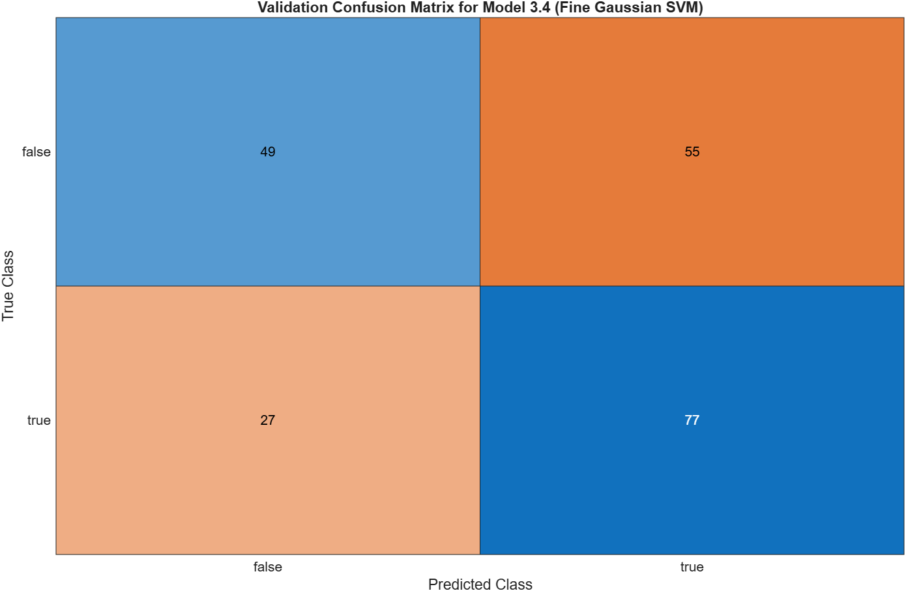
Figure 83 – Output Shaft Wear - Validation Confusion Matrix - Fine Gaussian SVM

Medium Gaussian SVM
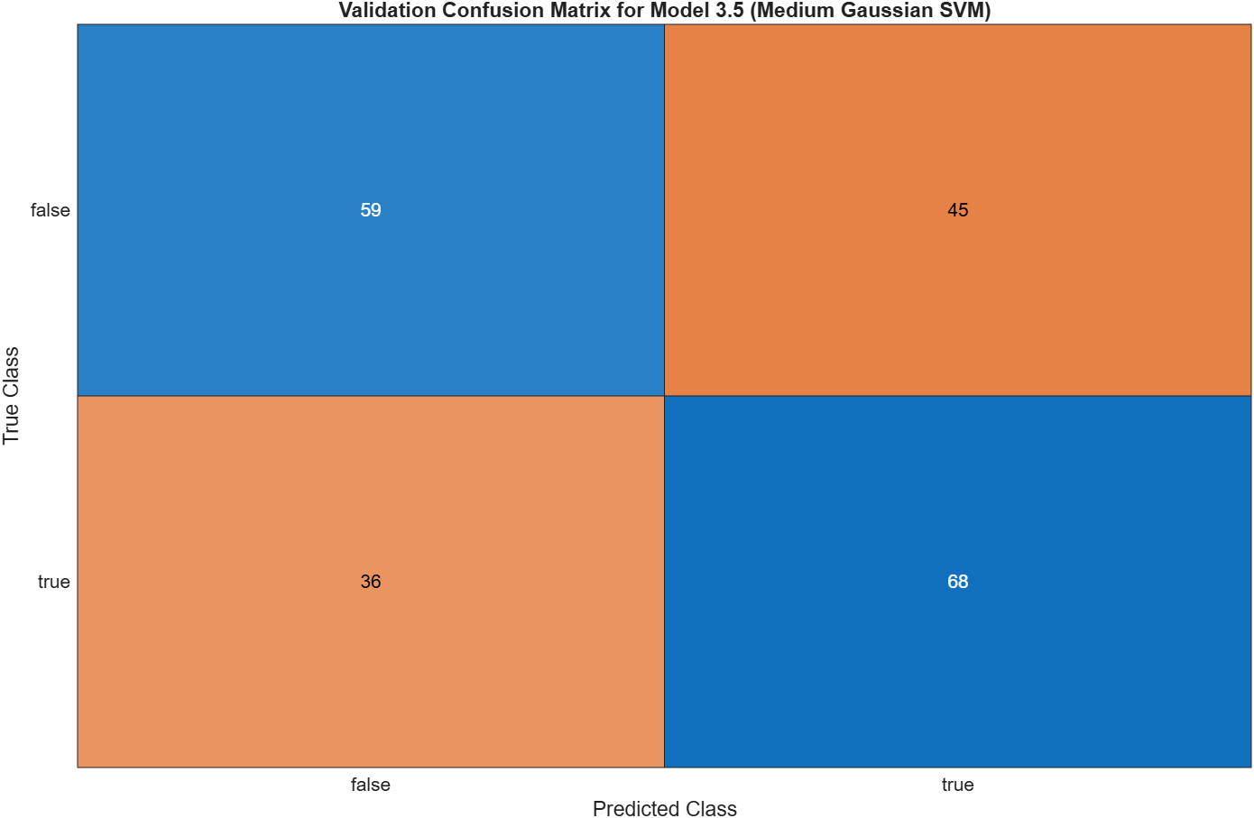
Figure 84 – Output Shaft Wear - Validation Confusion Matrix - Medium Gaussian SVM

Coarse Gaussian SVM
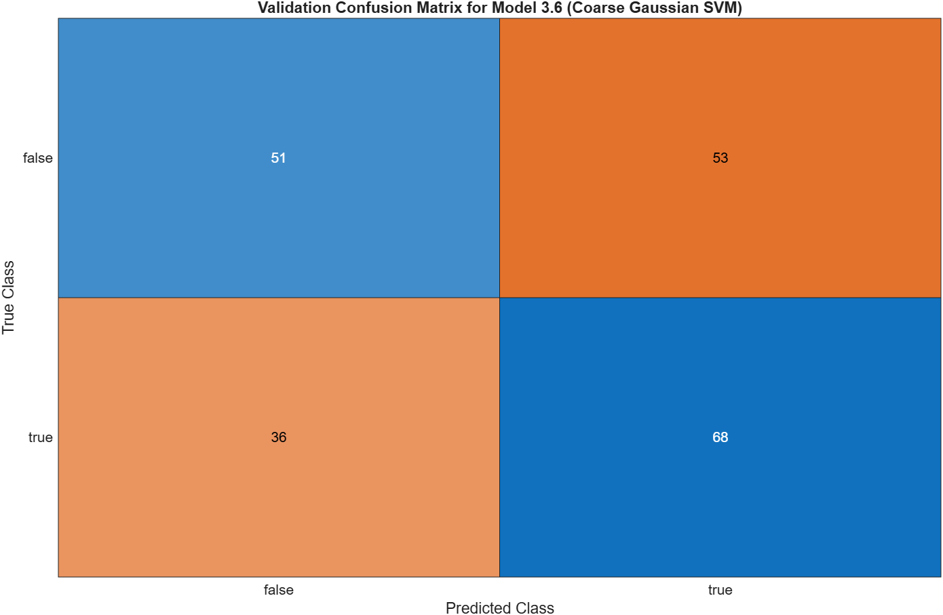
Figure 85 – Output Shaft Wear - Validation Confusion Matrix - Coarse Gaussian SVM

Neural Network

Scatter Plot

Narrow Neural Network
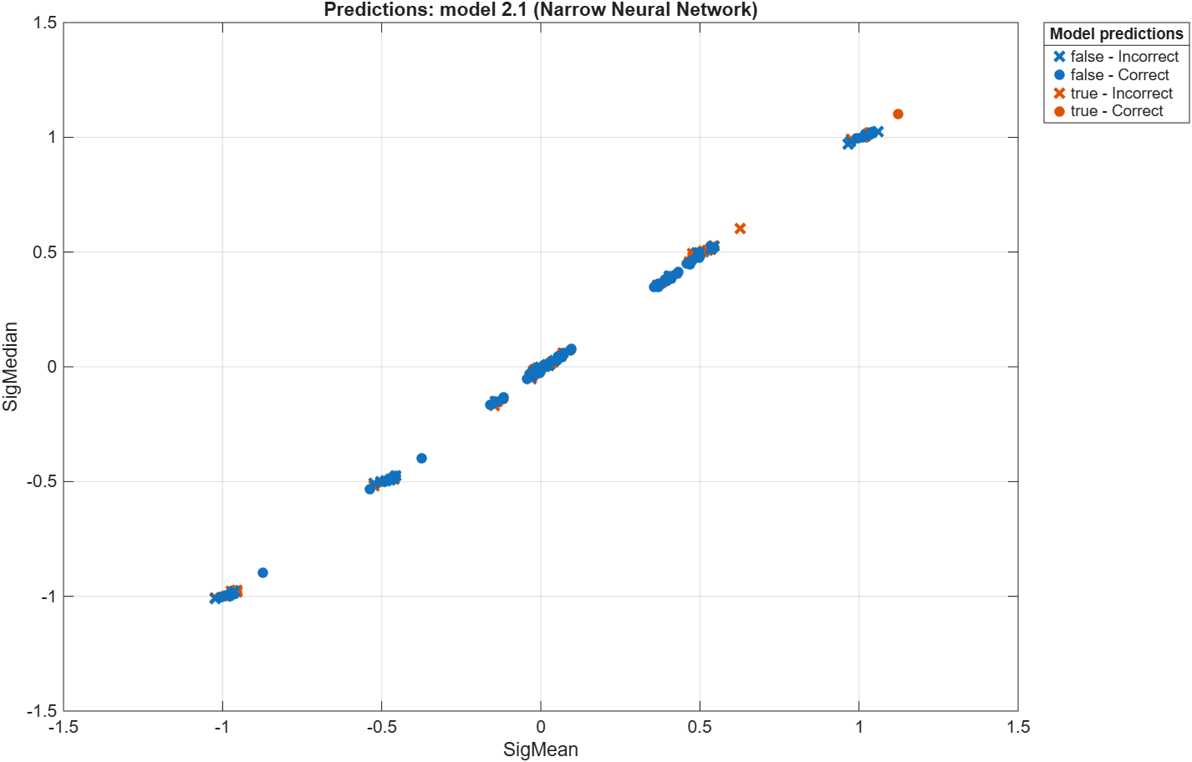
Figure 86 – Output Shaft Wear - Scatter Plot - Narrow Neural Network

Medium Neural Network
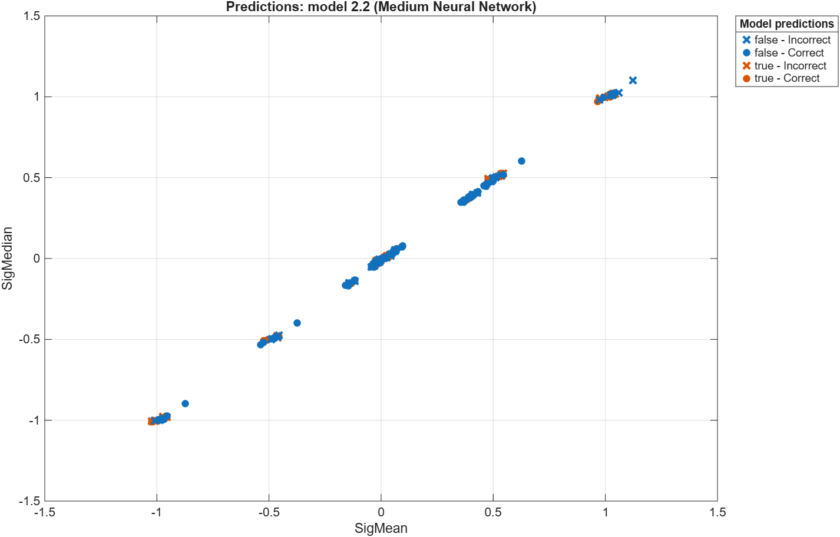
Figure 87 – Output Shaft Wear - Scatter Plot - Medium Neural Network

Wide Neural Network
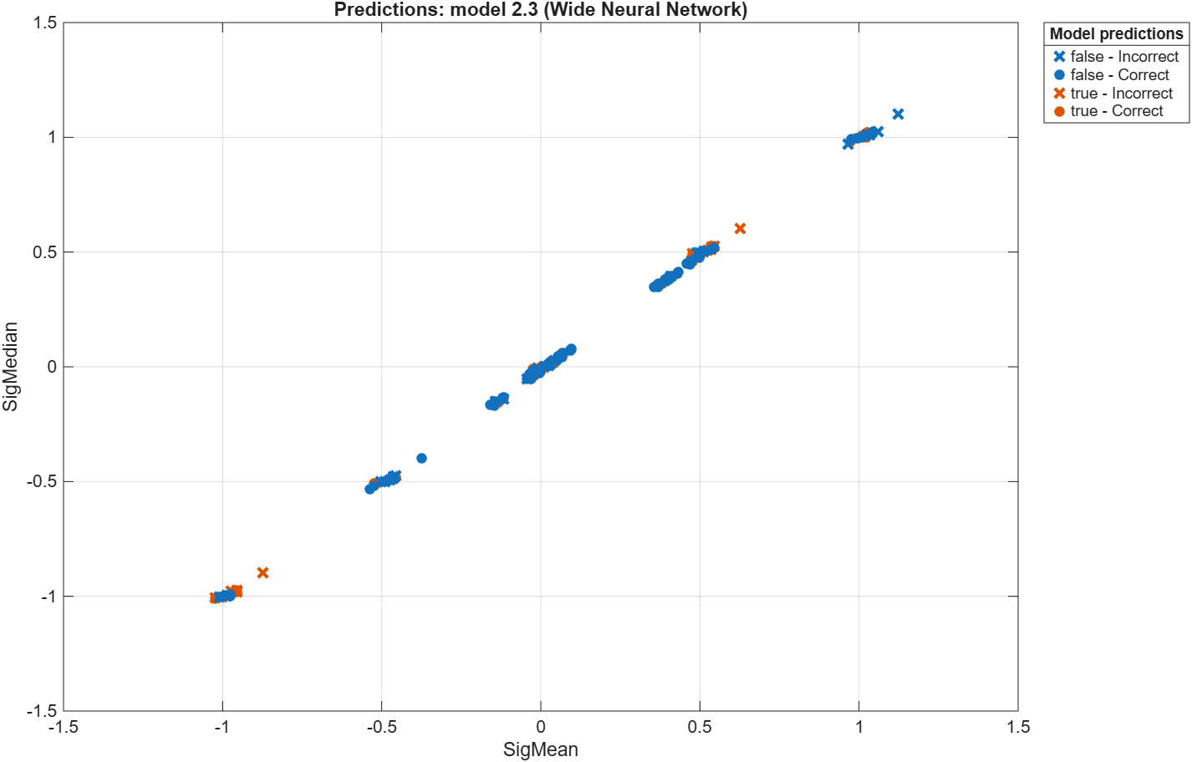
Figure 88 – Output Shaft Wear - Scatter Plot - Wide Neural Network

Bilayered Neural Network
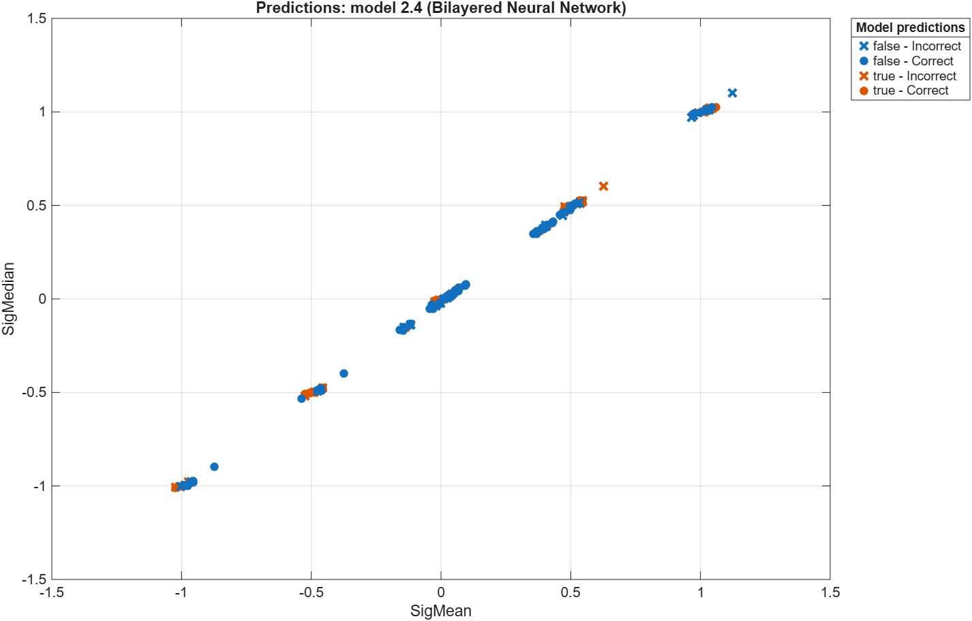
Figure 89 – Output Shaft Wear - Scatter Plot - Bilayered Neural Network

Trilayered Neural Network
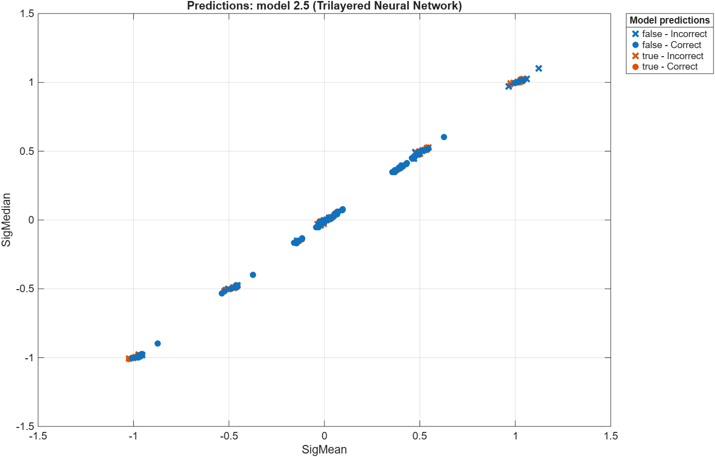
Figure 90 – Output Shaft Wear - Scatter Plot - Trilayered Neural Network

Validation Confusion Matrix

Narrow Neural Network
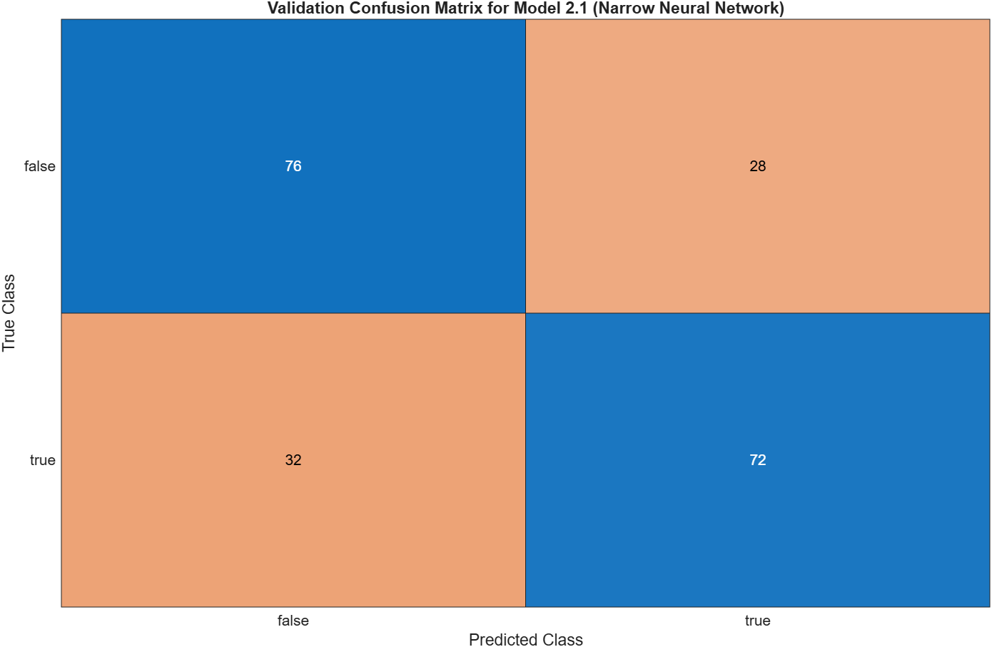
Figure 91 – Output Shaft Wear - Validation Confusion Matrix - Narrow Neural Network

Medium Neural Network
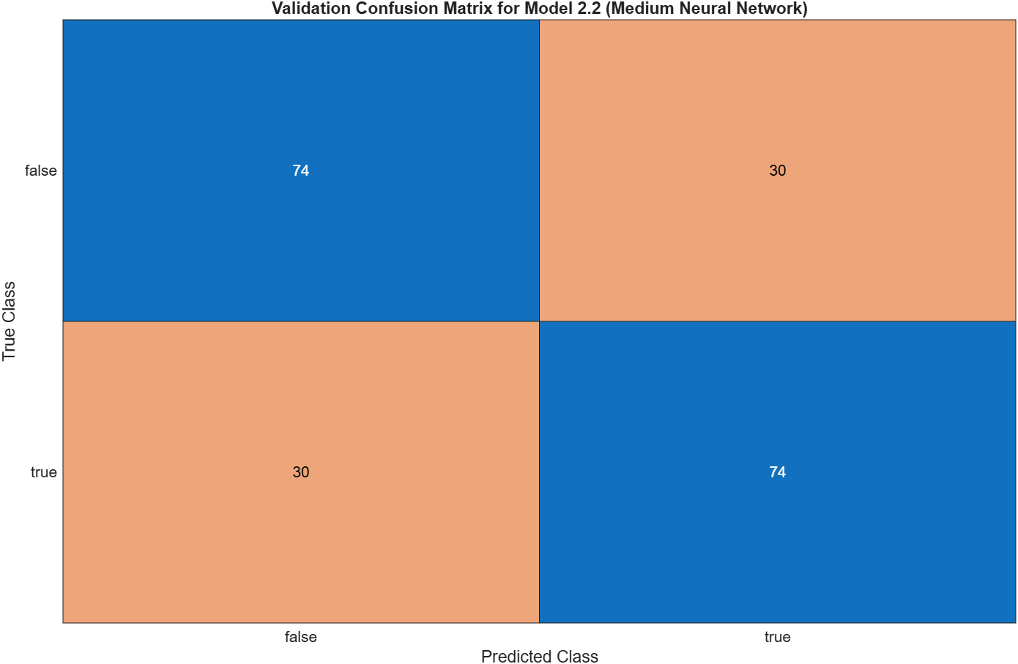
Figure 92 – Output Shaft Wear - Validation Confusion Matrix - Medium Neural Network

Wide Neural Network
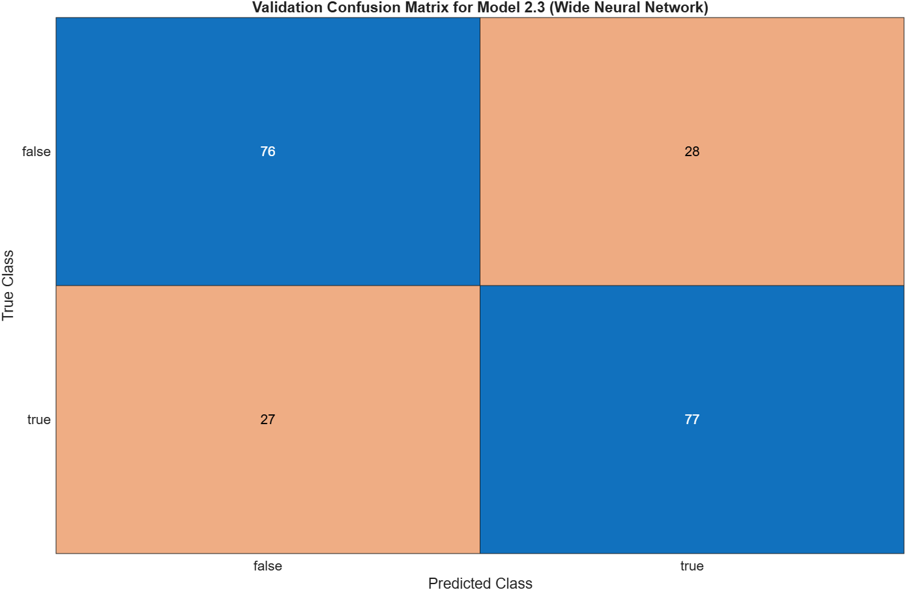
Figure 93 – Output Shaft Wear - Validation Confusion Matrix - Wide Neural Network

Bilayered Neural Network
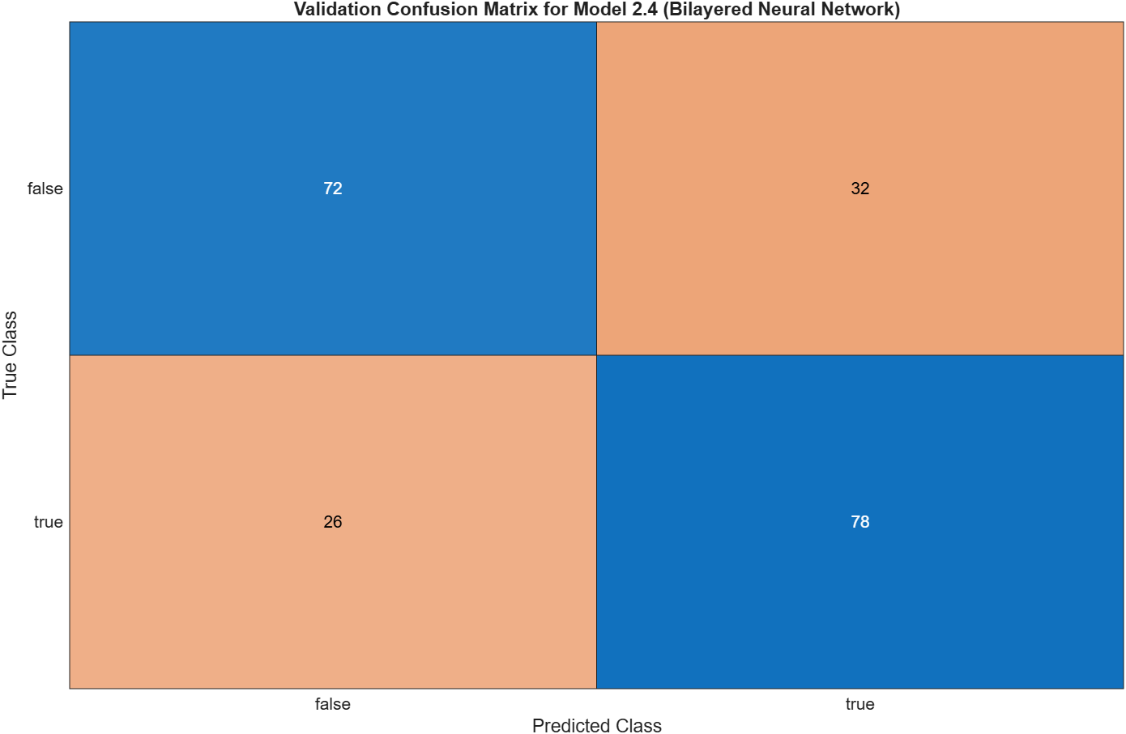
Figure 94 – Output Shaft Wear - Validation Confusion Matrix - Bilayered Neural Network

Trilayered Neural Network
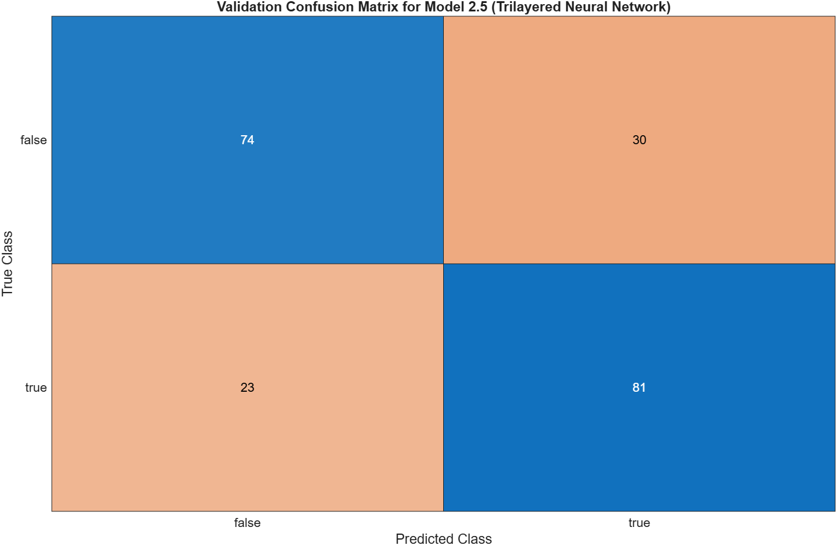
Figure 95 – Output Shaft Wear - Validation Confusion Matrix - Trilayered Neural Network

Training Process

Narrow Neural Network
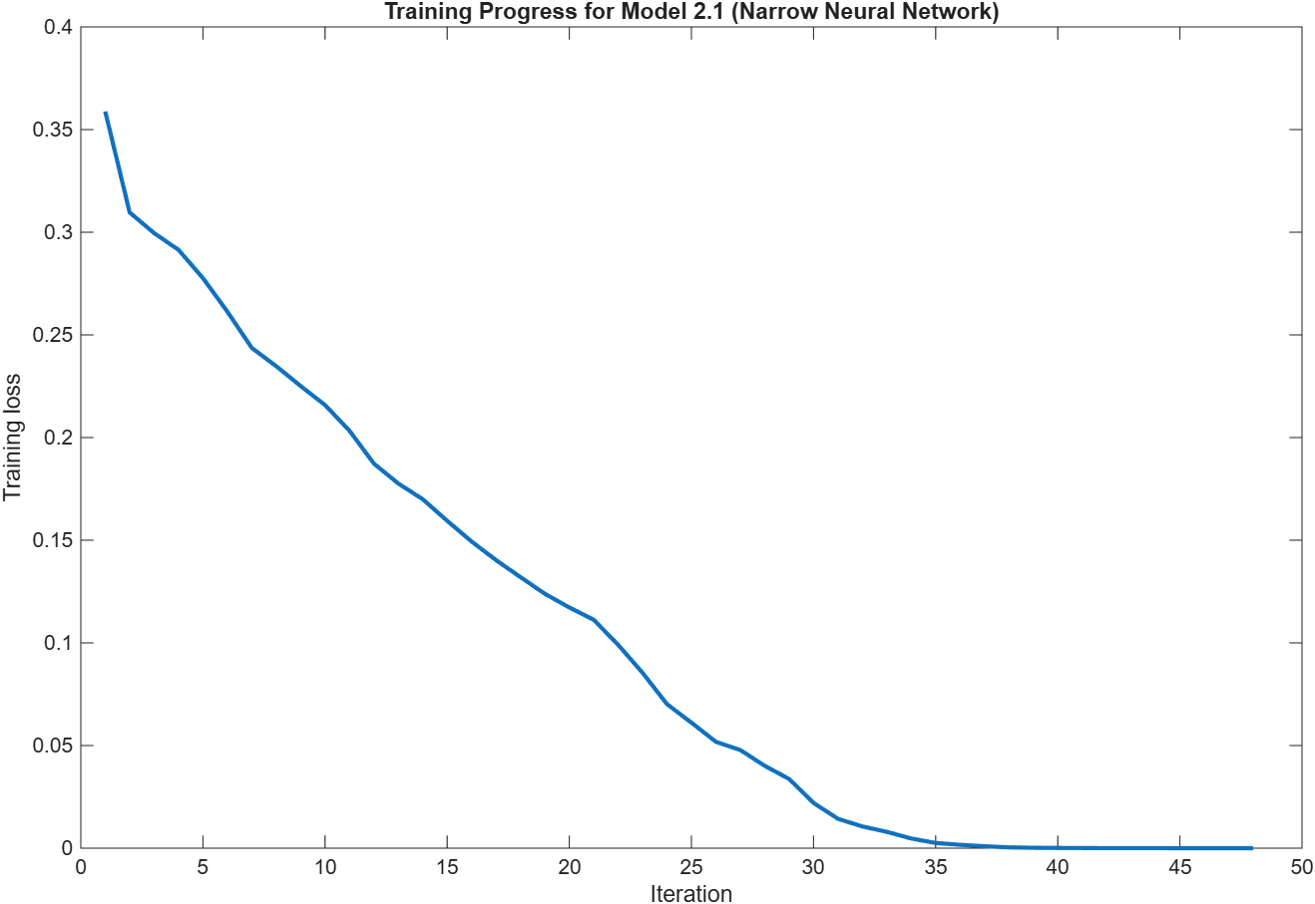
Figure 96 – Output Shaft Wear - Training Process - Narrow Neural Network

Medium Neural Network
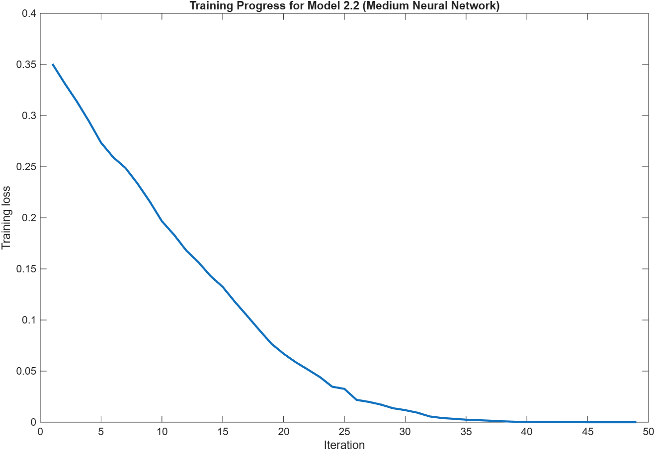
Figure 97 – Output Shaft Wear - Training Process - Medium Neural Network

Wide Neural Network
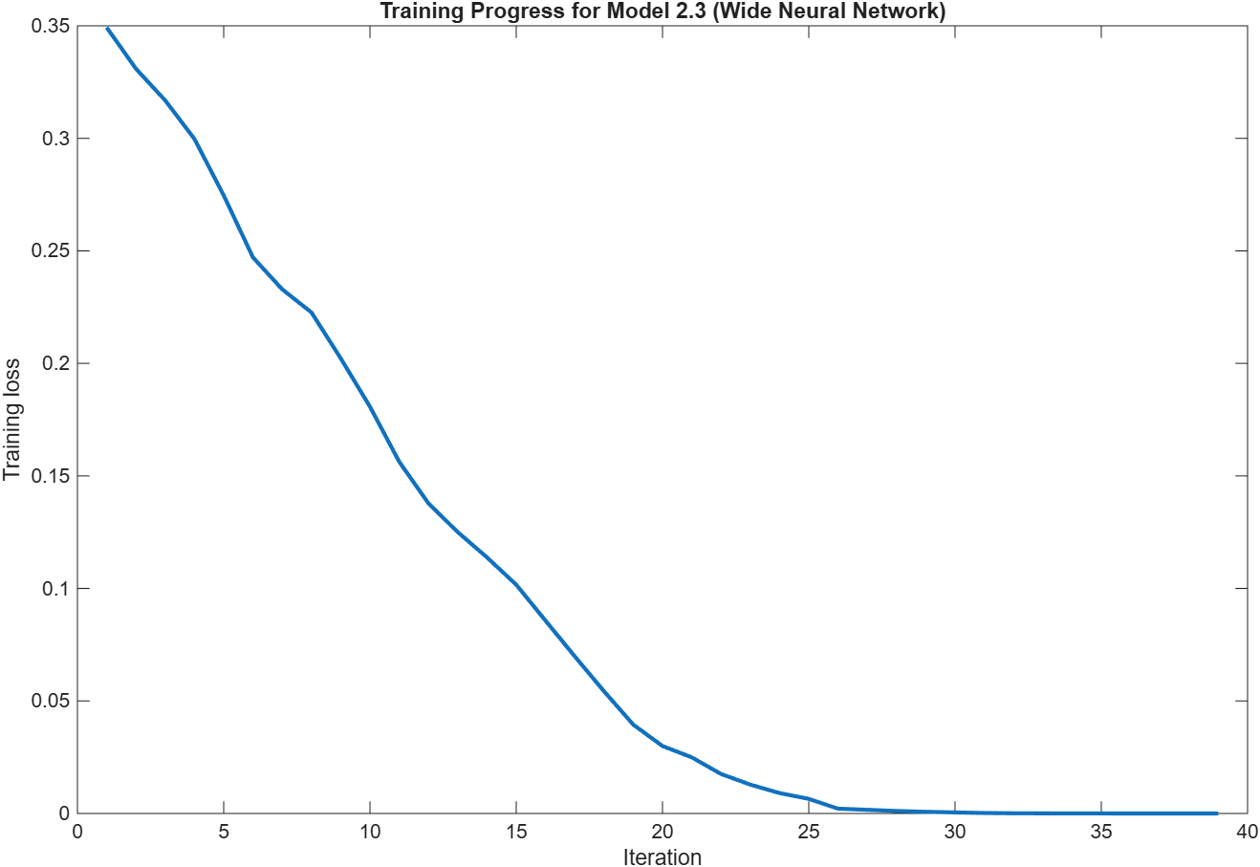
Figure 98 – Output Shaft Wear - Training Process - Wide Neural Network

Bilayered Neural Network
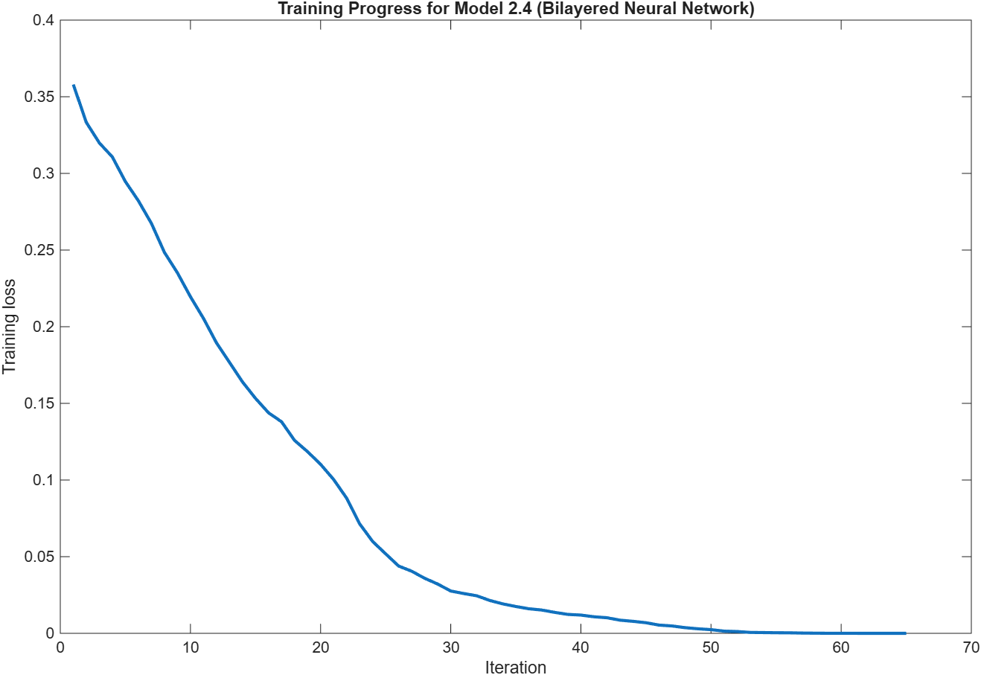
Figure 99 – Output Shaft Wear - Training Process - Bilayered Neural Network

Trilayered Neural Network
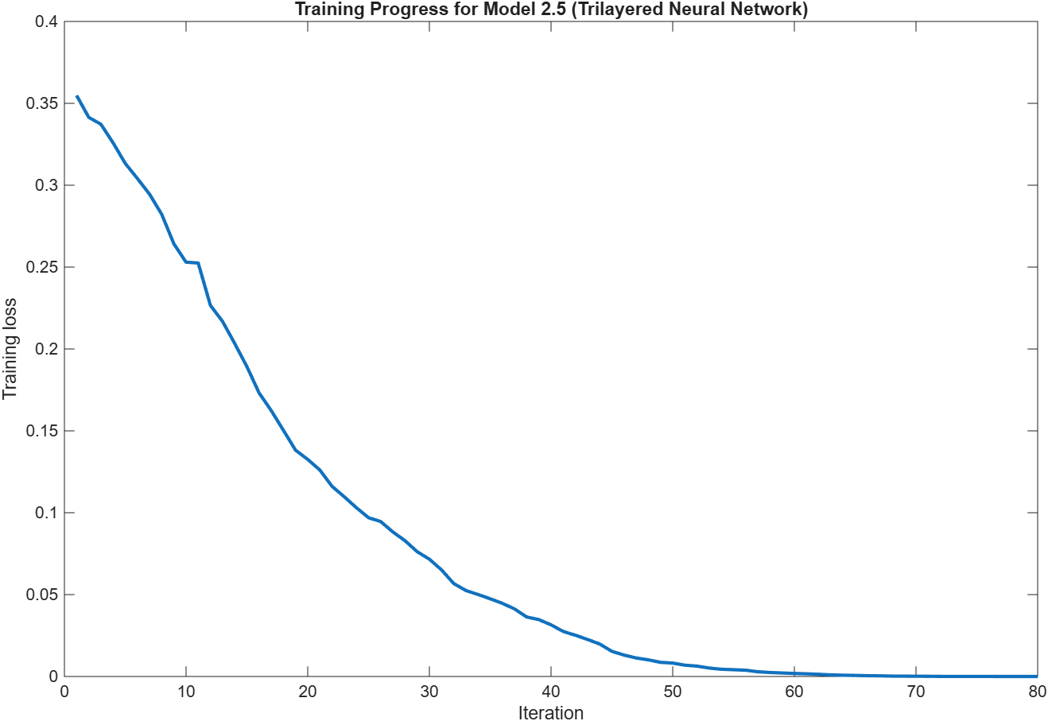
Figure 100 – Output Shaft Wear - Training Process - Trilayered Neural Network

Model Comparison

Accuracy
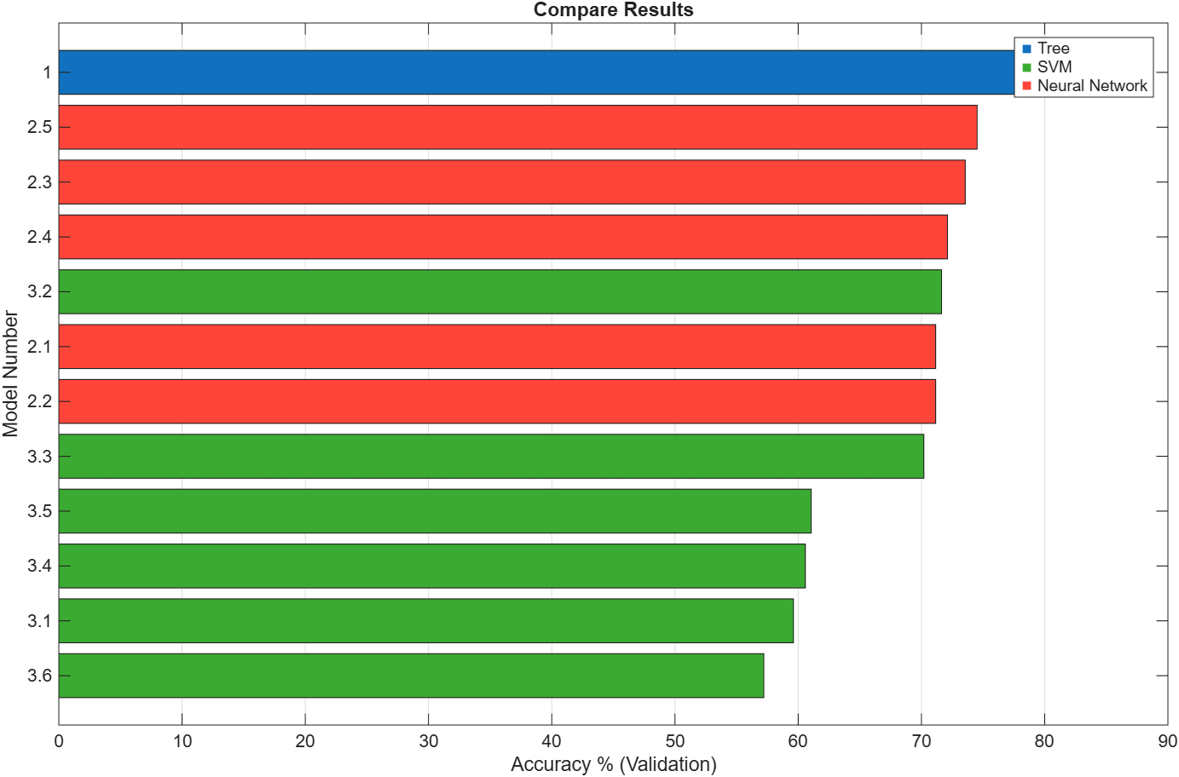
Figure 101 – Output Shaft Wear - Model Comparison - Accuracy

Coder Model Size
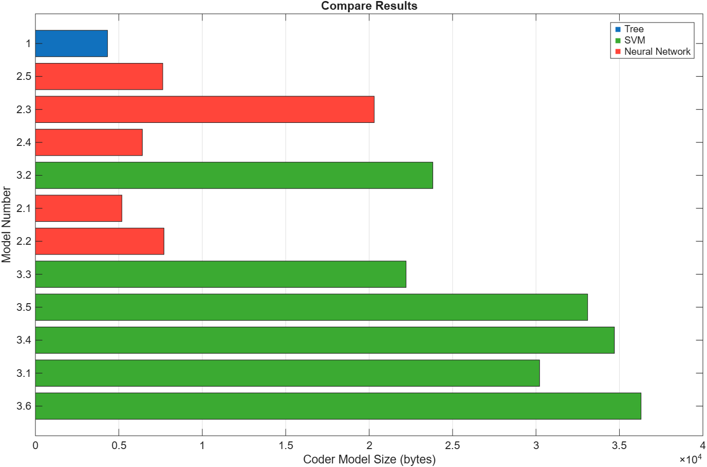
Figure 102 – Output Shaft Wear - Model Comparison - Coder Model Size

Error Rate
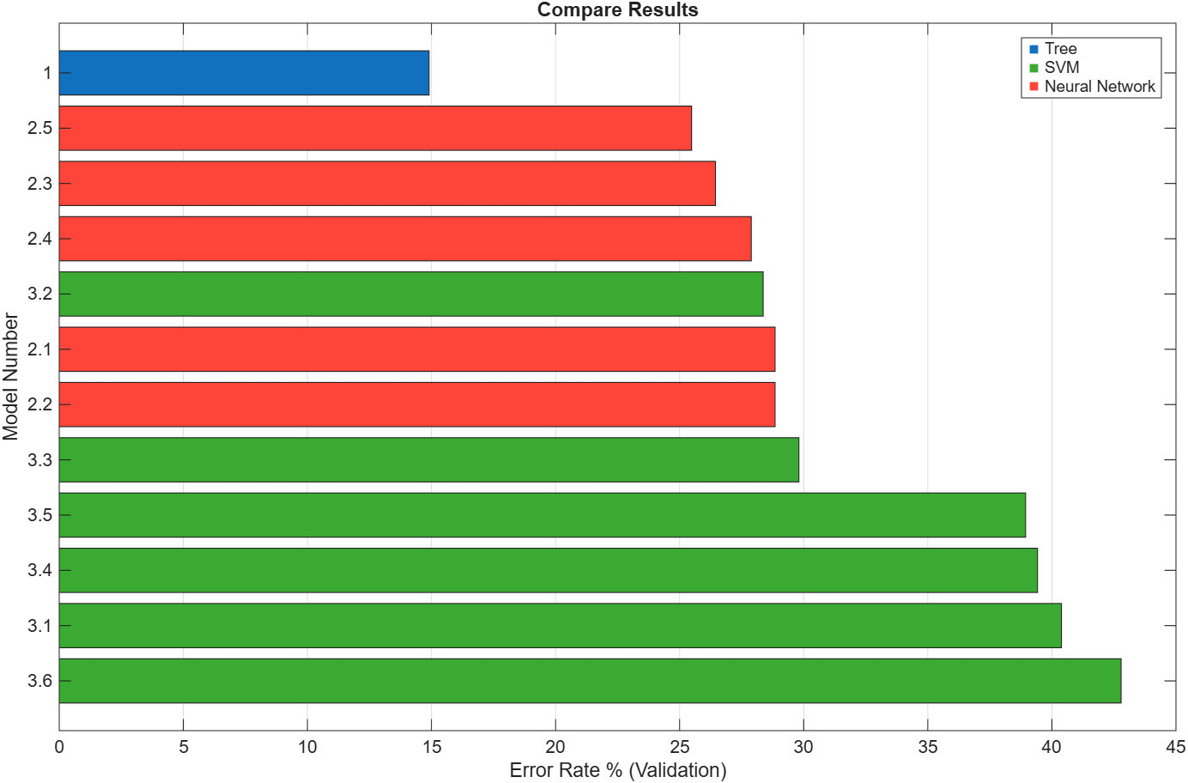
Figure 103 – Output Shaft Wear - Model Comparison - Error Rate

Prediction Speed
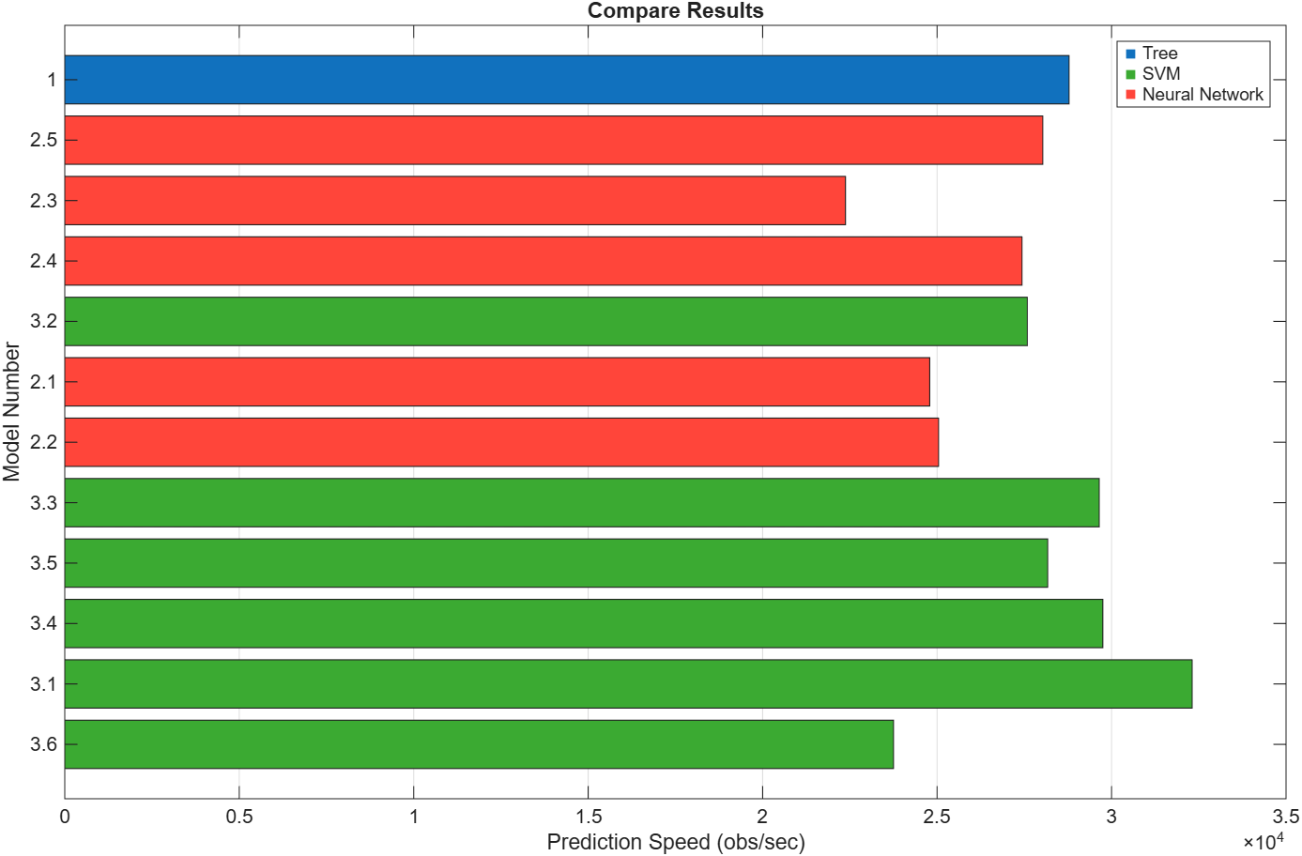
Figure 104 – Output Shaft Wear - Model Comparison - Prediction Speed

Total Cost
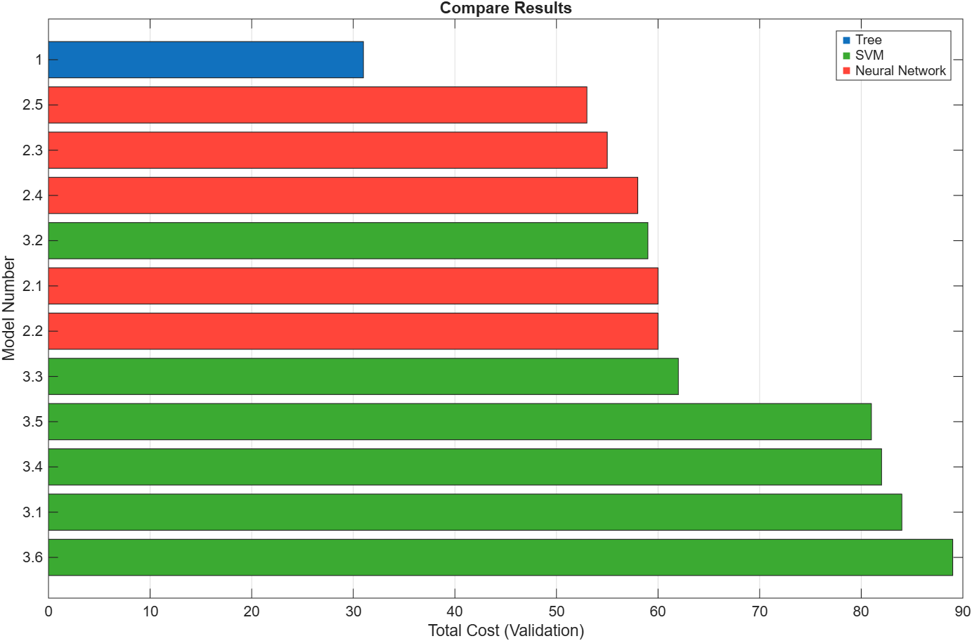
Figure 105 – Output Shaft Wear - Model Comparison - Total Cost

Training Time
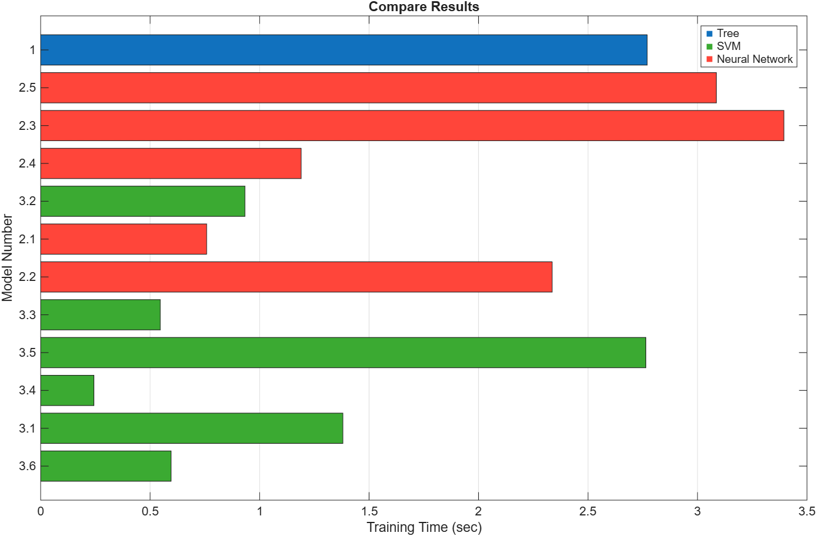
Figure 106 – Output Shaft Wear - Model Comparison - Training Time

Overall Results Comparison
Additional experiments were conducted using a Fine Tree classifier; however, the primary comparison in this study focuses on the SVM and neural network models, as these represent the conventional machine learning and contemporary deep learning approaches respectively. Consequently, the Fine Tree results have been excluded from the analysis and discussion.

According to the model comparison graphs in sections 5.1.5, 5.2.5, and 5.3.5, the top 3 models which best suited each fault can be found in the table below:

Table 5 - Results comparison - Top 3 models per 3 faults
 | Accuracy (1=Most Accurate) | Coder Model Size (1=Smallest) | Error Rate (1=Least Error) | Prediction Speed (1=Fastest) | Total Cost (1=Cheapest) | Training Time (1=Fastest)
Sensor Drift | - Cubic SVM  - Trilayered Neural Network  - Wide Neural Network | - Narrow Neural Network  - Bilayered Neural Network  - Medium Neural Netowrk | - Cubic SVM  - Trilayered Neural Network  - Wide Neural Network | - Narrow Neural Network  - Medium Neural Network  - Quadratic SVM | - Cubic SVM  - Trilayered Neural Network  - Wide Neural Network | - Coarse Gaussian SVM  - Fine Gaussian SVM  - Quadratic SVM
Gear Tooth Fault | - Quadratic SVM  - Cubic SVM  - Narrow Neural Network | - Narrow Neural Network  - Bilayered Neural Netwrok  - Trilayered Neural Network | - Quad SVM  - Cubic SVM  - Narrow Neural Network | - Medium Neural Network  - Quadratic SVM  - Wide Neural Network | - Quadratic SVM  - Cubic SVM  - Wide Neural Network | - Trilayered Neural Nwetwork  - Quadratic SVM  - Medium Gaussian SVM
Shaft Wear | - Trilayered Neural Network  - Wide Neural Network  - Bilayered Neural Network | - Narrow Neural Network  - Bilayered Neural Network  - Trilayered Neural Network | - Trilayered Neural Network  - Wide Neural Network  - Bilayered Neural Network | - Linear SVM  - Fine Gaussian SVM  - Cubic SVM | - Trilayered Neural Network  - Wide Neural Network  - Bilayered Neural Network | - Fine Gaussian SVM  - Cubic SVM  - Coarse Gaussian SVM

Results and Discussion

Comparative Performance Analysis
Table 5 summarises the performance of the highest-ranked SVM and neural network models for sensor drift, gear tooth fault and shaft wear classification. The results demonstrate that no single classifier achieved the highest performance across all fault categories. For sensor drift classification, the Cubic SVM achieved the highest validation accuracy of 98.08%, marginally outperforming the best neural network model, the Trilayered Neural Network, which achieved 97.60%. Similarly, for gear tooth fault detection, both the Quadratic and Cubic SVM achieved 100% validation accuracy, outperforming the highest-performing neural network models, which achieved 99.52%.
In contrast, shaft wear classification was dominated by neural network models. The Trilayered Neural Network achieved the highest validation accuracy of 74.52%, compared with 71.64% for the best-performing SVM model, the Quadratic SVM. Whilst SVM models generally produced stronger results for sensor drift and gear tooth faults, neural networks demonstrated a clear advantage for shaft wear detection.
The difference between the highest-performing SVM and neural network models was relatively small for sensor drift and gear tooth fault classification, with SVM models achieving approximately 0.5 percentage points greater validation accuracy. However, the Trilayered Neural Network achieved approximately 2.9 percentage points greater validation accuracy than the best-performing SVM model for shaft wear detection. These findings suggest that SVMs are better suited to faults with distinctive vibration signatures, whereas neural networks are more effective for identifying more subtle degradation patterns.

Fault Detectability Analysis

Gear Tooth Damage
Gear tooth damage produced the strongest overall classification results. Both the Quadratic and Cubic SVM achieved 100% validation accuracy with zero classification error. Neural network models also performed exceptionally well, with the Narrow and Wide Neural Networks achieving 99.52% accuracy. The strong performance across multiple classifiers suggests that gear tooth damage produces clear and distinctive vibration characteristics that can be readily identified within the vibration spectrum and extracted feature sets (Heaton, 2017).

Output Shaft Wear
Output shaft wear was considerably more difficult to classify than the other fault types. The highest-performing model was the Trilayered Neural Network, achieving a validation accuracy of 74.52%, whilst the best-performing SVM achieved 71.64%. All classifiers experienced a notable reduction in accuracy compared to gear tooth fault and sensor drift detection. This suggests that shaft wear produces more subtle changes within the vibration signal and is therefore more challenging to distinguish from healthy operating conditions. The improved performance of the neural network may be attributed to its ability to learn complex relationships directly from spectral data without relying solely on predefined features (Heaton, 2017).

Sensor Drift
Sensor drift classification produced consistently high results across several machine learning approaches. The Cubic SVM achieved the highest validation accuracy at 98.08%, closely followed by the Trilayered Neural Network at 97.60%. The relatively low error rates observed across the best-performing models indicate that sensor drift generated distinguishable signal characteristics, enabling reliable separation between healthy and faulty conditions.

Hardest Fault Class to Detect
Based on the validation accuracy and error rate results, output shaft wear was the most difficult fault condition to detect. Whilst gear tooth damage and sensor drift achieved validation accuracies exceeding 97%, the highest accuracy achieved for shaft wear was only 74.52%. Furthermore, all models demonstrated substantially higher error rates for shaft wear classification. This suggests that the vibration characteristics associated with shaft wear are less pronounced than those produced by gear tooth damage or sensor drift, resulting in greater overlap between healthy and faulty operating conditions (Heaton, 2017).

Feature Effectiveness
The results indicate that the feature-based approach employed by the SVM classifiers was highly effective for identifying gear tooth damage and sensor drift. These faults produce distinctive characteristics within the vibration signal, allowing the extracted statistical and spectral features to provide strong class separation. In contrast, neural network models demonstrated superior performance for shaft wear classification, suggesting that learning directly from spectral inputs enabled the identification of more subtle patterns that may not have been fully captured through manual feature extraction (Heaton, 2017). This finding is consistent with the ability of neural networks to automatically learn hierarchical relationships within complex datasets (IBM, 2021; Heaton, 2017).

Industrial Implications
The ability to accurately classify faults has important implications for refinery maintenance operations. Early identification of gear tooth damage could prevent severe gearbox failures and reduce unplanned downtime, whilst reliable detection of sensor drift would improve confidence in the condition monitoring system. The comparatively lower performance achieved for shaft wear detection highlights the continued challenge of identifying gradual degradation mechanisms. Based on the results obtained, SVM models appear particularly suitable for faults with clear vibration signatures, whereas neural networks may provide advantages when monitoring more subtle fault conditions.

Conclusions, Limitations and Recommendations

Conclusions
This study investigated the application of SVM and neural network classifiers for the diagnosis of gear tooth damage, output shaft wear and sensor drift within a simulated pump drivetrain system. The results demonstrated that SVM models achieved the highest classification performance for sensor drift and gear tooth fault detection, whilst neural network models achieved the strongest performance for output shaft wear classification. Overall, no single classifier consistently outperformed all alternatives, indicating that classifier effectiveness is dependent upon the specific fault being monitored.

Study Limitations
A key limitation of this study is the reliance on synthetic vibration data generated using a physics-based Simulink model rather than data collected from an operating refinery system. Although synthetic data provide a practical solution when historical fault data are unavailable, they may not fully capture the variability and uncertainty present in real industrial environments (Marwala, Fournier-Tombs and Stinckwich, 2023). Additionally, only three fault modes were investigated, and the study was performed using a limited range of operating conditions and fault severities.

Recommendations
Based on the results obtained, SVM classifiers are recommended for the detection of sensor drift and gear tooth damage due to their superior classification performance and low error rates. For output shaft wear monitoring, neural network models are recommended as they demonstrated greater classification accuracy than the SVM alternatives.

Future work
Future work should focus on validating the developed models using real plant vibration data and extending the investigation to include additional fault classes. Further research could also explore hybrid approaches that combine feature-based SVM classification with neural network spectral analysis to improve fault detection performance across a wider range of operating conditions.

References

Abe, S. (2006). Support vector machines for pattern classification. Springer Science & Business Media.
Awad, M. and Khanna, R. (2015). Support vector machines for classification. Efficient Learning Machines, pp.39–66. doi:10.1007/978-1-4302-5990-9_3.
Cervantes, J., Lamont, F.G., Mazahua, L.R. and Lopez, A. (2020). A comprehensive survey on support vector machine classification: Applications, challenges and trends. Neurocomputing, [online] 408(1), pp.189–215. doi:10.1016/j.neucom.2019.10.118.
Di Franco, G. and Santurro, M. (2020). Machine learning, artificial neural networks and social research. Quality & Quantity, [online] 55(3), pp.1007–1025. doi:10.1007/s11135-020-01037-y.
El Naqa, I. and Murphy, M.J. (2015). What is machine learning? Machine Learning in Radiation Oncology, [online] 1(1), pp.3–11. doi:10.1007/978-3-319-18305-3_1.
Gunasegaran, V., Chelladurai, H., Amarnath, M. and Praveen Krishna, I.R. (2026). Condition monitoring and fault diagnosis of helical geared systems under progressive seeded faults using ICEEMDAN technique. Journal of Vibration Engineering & Technologies, 14(4). doi:10.1007/s42417-026-02359-1.
Heaton, J. (2017). Ian Goodfellow, Yoshua Bengio, and Aaron Courville: Deep learning. Genetic Programming and Evolvable Machines, [online] 19(1–2), pp.305–307. doi:10.1007/s10710-017-9314-z.
Hector, I. and Panjanathan, R. (2024). Predictive maintenance in industry 4.0: A survey of planning models and machine learning techniques. PeerJ Computer Science, [online] 10, p.e2016. doi:10.7717/peerj-cs.2016.
Hughes, B. (2021). Monitoring gearboxes. [online] Bakerhughes.com. Available at: https://www.bakerhughes.com/bently-nevada/orbit-home/orbit-article/monitoring-gearboxes [Accessed 10 Sept. 2026].
IBM (2021). What is a neural network? [online] IBM. Available at: https://www.ibm.com/think/topics/neural-networks [Accessed 28 Aug. 2026].
ISO (2018). ISO 17359:2018. [online] ISO. Available at: https://www.iso.org/standard/71194.html [Accessed 22 Sept. 2026].
James, G., Witten, D., Hastie , T. and Tibshirani, R. (2014). An introduction to statistical learning—With applications in R by Gareth James, Daniela Witten, Trevor Hastie & Robert Tibshirani. International Statistical Review, 82(1), pp.156–157. doi:10.1111/insr.12051_19.
Jenkins, J. (2026). Predictive Maintenance Strategies: Assignment Brief.
Jordan, M.I. and Mitchell, T.M. (2015). Machine learning: Trends, perspectives, and prospects. Science, 349(6245), pp.255–260. doi:10.1126/science.aaa8415.
Kufel, J., Bargieł-Łączek, K., Kocot, S., Koźlik, M., Bartnikowska, W., Janik, M., Czogalik, Ł., Dudek, P., Magiera, M., Lis, A., Paszkiewicz, I., Nawrat, Z., Cebula, M. and Gruszczyńska, K. (2023). What is machine learning, artificial neural networks and deep learning?—Examples of practical applications in medicine. Diagnostics, 13(15), p.2582. doi:10.3390/diagnostics13152582.
Luo, D.Y. and Wang, W. (2025). A new evolving technology for gearbox condition monitoring and fault diagnosis. Intelligent Control and Automation, [online] 16(04), pp.158–174. doi:10.4236/ica.2025.164007.
López, O.A.M., López, A.M. and Crossa, J. (2022). Fundamentals of Artificial Neural Networks and Deep Learning. Multivariate Statistical Machine Learning Methods for Genomic Prediction, pp.379–425. doi:10.1007/978-3-030-89010-0_10.
Marwala, T., Fournier-Tombs, E. and Stinckwich, S. (2023). The use of synthetic data to train AI models: Opportunities and risks for sustainable development. [online] arXiv.org. Available at: https://arxiv.org/abs/2309.00652 [Accessed 7 Sept. 2026].
Meng, Q. and Qu, L. (1991). Rotating machinery fault diagnosis using Wigner distribution. Mechanical Systems and Signal Processing, 5(3), pp.155–166. doi:10.1016/0888-3270(91)90040-c.
Mushtaq, S., Islam, M.M.M. and Sohaib, M. (2021). Deep learning aided data-driven fault diagnosis of rotatory machine: A comprehensive review. Energies, 14(16), p.5150. doi:10.3390/en14165150.
Noble, W.S. (2006). What is a support vector machine? Nature Biotechnology, [online] 24(12), pp.1565–1567. doi:10.1038/nbt1206-1565.
Taoufyq, H., El Guemmat, K., Mansouri, K. and Akef, F. (2025). Predictive maintenance approaches: A systematic literature review. Journal of Industrial Engineering and Management, 18(3), p.427. doi:10.3926/jiem.8537.
Wang, H., Wang, H. and Tang, X. (2025). A review of deep learning in rotating machinery fault diagnosis and its prospects for port applications. Applied Sciences, [online] 15(21), p.11303. doi:10.3390/app152111303.
Xu, Y., Zomer, S. and Brereton, R.G. (2006). Support vector machines: A recent method for classification in Chemometrics. Critical Reviews in Analytical Chemistry, 36(3–4), pp.177–188. doi:10.1080/10408340600969486.
Yousof Gholipour (2025). A comprehensive review of maintenance strategies: From reactive to proactive approaches. SSRN Electronic Journal. [online] doi:10.2139/ssrn.5349871.
Zhou, S.K., Greenspan, H. and Shen, D. (2017). Deep learning for medical image analysis. Academic Press.

Appendices

Results Tables

Sensor Drift
Training Data: featureData Observations: 208 | Predictors: 18 Predictor Names: SigMean, SigMedian, SigRMS, SigVar, SigPeak, SigPeak2Peak, SigSkewness, SigKurtosis, SigCrestFactor, SigMAD, SigRangeCumSum, SigCorrDimension, SigApproxEntropy, SigLyapExponent, PeakFreq, HighFreqPower, EnvPower, PeakSpecKurtosis | |Response Name: SensorDrift Response Classes: 2 Response Class Names: false, true | Validation: 5-fold cross-validation

Model Number | Status | Model Type | Preset | Accuracy % (Validation) | Total Cost (Validation) | Error Rate % (Validation) | Macro Precision % (Validation) | Micro Precision % (Validation) | Weighted Precision % (Validation) | Macro Recall % (Validation) | Micro Recall % (Validation) | Weighted Recall % (Validation) | Macro F1 Score % (Validation) | Micro F1 Score % (Validation) | Weighted F1 Score % (Validation) | Accuracy % (Test) | Total Cost (Test) | Error Rate % (Test) | Macro Precision % (Test) | Micro Precision % (Test) | Weighted Precision % (Test) | Macro Recall % (Test) | Micro Recall % (Test) | Weighted Recall % (Test) | Macro F1 Score % (Test) | Micro F1 Score % (Test) | Weighted F1 Score % (Test) | Prediction Speed (obs/sec) | Training Time (sec) | Compact Model Size (bytes) | Coder Model Size (bytes) | Hyperparameters | Selected Features | Feature Ranking Algorithm | PCA | Costs | Optimizer Options
1 | Trained | Tree | Fine Tree | 100 | 0 | 0 | 100 | 100 | 100 | 100 | 100 | 100 | 100 | 100 | 100 | NaN | NaN | NaN | NaN | NaN | NaN | NaN | NaN | NaN | NaN | NaN | NaN | 3275.709199 | 5.3641119 | 5627 | 2816 | Maximum number of splits = 100; Split criterion = Gini's diversity index; Surrogate decision splits = Off; | 18/18 | None | Disabled | Default | Not applicable
2.1 | Trained | Neural Network | Narrow Neural Network | 95.67307692 | 9 | 4.326923077 | 91.42011834 | 95.67307692 | 95.86936732 | 94.08914729 | 95.67307692 | 95.67307692 | 92.68035191 | 95.67307692 | 95.740582 | NaN | NaN | NaN | NaN | NaN | NaN | NaN | NaN | NaN | NaN | NaN | NaN | 3082.202945 | 9.5143995 | 8688 | 5184 | Number of fully connected layers = 1; First layer size = 10; Activation = ReLU; Iteration limit = 1000; Regularization strength (Lambda) = 0; Standardize data = Yes; | 18/18 | None | Disabled | Default | Not applicable
2.2 | Trained | Neural Network | Medium Neural Network | 95.67307692 | 9 | 4.326923077 | 91.42011834 | 95.67307692 | 95.86936732 | 94.08914729 | 95.67307692 | 95.67307692 | 92.68035191 | 95.67307692 | 95.740582 | NaN | NaN | NaN | NaN | NaN | NaN | NaN | NaN | NaN | NaN | NaN | NaN | 3158.38224 | 7.0786082 | 11208 | 7704 | Number of fully connected layers = 1; First layer size = 25; Activation = ReLU; Iteration limit = 1000; Regularization strength (Lambda) = 0; Standardize data = Yes; | 18/18 | None | Disabled | Default | Not applicable
2.3 | Trained | Neural Network | Wide Neural Network | 97.11538462 | 6 | 2.884615385 | 94.14860681 | 97.11538462 | 97.20528697 | 96.05943152 | 97.11538462 | 97.11538462 | 95.06875296 | 97.11538462 | 97.14593136 | NaN | NaN | NaN | NaN | NaN | NaN | NaN | NaN | NaN | NaN | NaN | NaN | 13530.83143 | 14.2414732 | 23808 | 20304 | Number of fully connected layers = 1; First layer size = 100; Activation = ReLU; Iteration limit = 1000; Regularization strength (Lambda) = 0; Standardize data = Yes; | 18/18 | None | Disabled | Default | Not applicable
2.4 | Trained | Neural Network | Bilayered Neural Network | 95.19230769 | 10 | 4.807692308 | 90.35714286 | 95.19230769 | 95.49450549 | 93.79844961 | 95.19230769 | 95.19230769 | 91.9504644 | 95.19230769 | 95.29054537 | NaN | NaN | NaN | NaN | NaN | NaN | NaN | NaN | NaN | NaN | NaN | NaN | 20579.9998 | 3.3880141 | 10412 | 6408 | Number of fully connected layers = 2; First layer size = 10; Second layer size = 10; Activation = ReLU; Iteration limit = 1000; Regularization strength (Lambda) = 0; Standardize data = Yes; | 18/18 | None | Disabled | Default | Not applicable
2.5 | Trained | Neural Network | Trilayered Neural Network | 97.59615385 | 5 | 2.403846154 | 97.34199134 | 97.59615385 | 97.58541459 | 94.15374677 | 97.59615385 | 97.59615385 | 95.6563505 | 97.59615385 | 97.55428759 | NaN | NaN | NaN | NaN | NaN | NaN | NaN | NaN | NaN | NaN | NaN | NaN | 27291.93182 | 2.7695356 | 12136 | 7632 | Number of fully connected layers = 3; First layer size = 10; Second layer size = 10; Third layer size = 10; Activation = ReLU; Iteration limit = 1000; Regularization strength (Lambda) = 0; Standardize data = Yes; | 18/18 | None | Disabled | Default | Not applicable
3.1 | Trained | SVM | Linear SVM | 92.30769231 | 16 | 7.692307692 | 88.57677903 | 92.30769231 | 92.00518583 | 83.26873385 | 92.30769231 | 92.30769231 | 85.59307359 | 92.30769231 | 92.02397602 | NaN | NaN | NaN | NaN | NaN | NaN | NaN | NaN | NaN | NaN | NaN | NaN | 16663.19517 | 3.0222838 | 15169 | 12134 | Kernel function = Linear; Kernel scale = Automatic; Box constraint level = 1; Multiclass coding = One-vs-One; Standardize data = Yes; | 18/18 | None | Disabled | Default | Not applicable
3.2 | Trained | SVM | Quadratic SVM | 91.82692308 | 17 | 8.173076923 | 86.53679654 | 91.82692308 | 91.6033966 | 84.07622739 | 91.82692308 | 91.82692308 | 85.2315917 | 91.82692308 | 91.6845778 | NaN | NaN | NaN | NaN | NaN | NaN | NaN | NaN | NaN | NaN | NaN | NaN | 12890.83078 | 2.8260966 | 13433 | 10534 | Kernel function = Quadratic; Kernel scale = Automatic; Box constraint level = 1; Multiclass coding = One-vs-One; Standardize data = Yes; | 18/18 | None | Disabled | Default | Not applicable
3.3 | Trained | SVM | Cubic SVM | 98.07692308 | 4 | 1.923076923 | 97.6673428 | 98.07692308 | 98.06522078 | 95.54263566 | 98.07692308 | 98.07692308 | 96.56482246 | 98.07692308 | 98.05500858 | NaN | NaN | NaN | NaN | NaN | NaN | NaN | NaN | NaN | NaN | NaN | NaN | 23261.01543 | 5.0358463 | 12953 | 10054 | Kernel function = Cubic; Kernel scale = Automatic; Box constraint level = 1; Multiclass coding = One-vs-One; Standardize data = Yes; | 18/18 | None | Disabled | Default | Not applicable
3.4 | Trained | SVM | Fine Gaussian SVM | 79.80769231 | 42 | 20.19230769 | 51.41414141 | 79.80769231 | 71.95415695 | 50.45219638 | 79.80769231 | 79.80769231 | 48.67215041 | 79.80769231 | 74.81063003 | NaN | NaN | NaN | NaN | NaN | NaN | NaN | NaN | NaN | NaN | NaN | NaN | 23075.21633 | 1.9755629 | 37429 | 34534 | Kernel function = Gaussian; Kernel scale = 1.1; Box constraint level = 1; Multiclass coding = One-vs-One; Standardize data = Yes; | 18/18 | None | Disabled | Default | Not applicable
3.5 | Trained | SVM | Medium Gaussian SVM | 90.86538462 | 19 | 9.134615385 | 86.87333743 | 90.86538462 | 90.3987817 | 79.10206718 | 90.86538462 | 90.86538462 | 82.22941679 | 90.86538462 | 90.32935903 | NaN | NaN | NaN | NaN | NaN | NaN | NaN | NaN | NaN | NaN | NaN | NaN | 21384.65651 | 4.113755 | 19509 | 16614 | Kernel function = Gaussian; Kernel scale = 4.2; Box constraint level = 1; Multiclass coding = One-vs-One; Standardize data = Yes; | 18/18 | None | Disabled | Default | Not applicable
3.6 | Trained | SVM | Coarse Gaussian SVM | 82.69230769 | 36 | 17.30769231 | NaN | 82.69230769 | NaN | 50 | 82.69230769 | 82.69230769 | 45.26315789 | 82.69230769 | 74.8582996 | NaN | NaN | NaN | NaN | NaN | NaN | NaN | NaN | NaN | NaN | NaN | NaN | 27552.95333 | 0.9887943 | 18229 | 15334 | Kernel function = Gaussian; Kernel scale = 17; Box constraint level = 1; Multiclass coding = One-vs-One; Standardize data = Yes; | 18/18 | None | Disabled | Default | Not applicable
4 | Trained | SVM | Quadratic SVM | 91.82692308 | 17 | 8.173076923 | 86.53679654 | 91.82692308 | 91.6033966 | 84.07622739 | 91.82692308 | 91.82692308 | 85.2315917 | 91.82692308 | 91.6845778 | NaN | NaN | NaN | NaN | NaN | NaN | NaN | NaN | NaN | NaN | NaN | NaN | 22107.90358 | 3.4040929 | 13593 | 10694 | Kernel function = Quadratic; Kernel scale = Automatic; Box constraint level = 1; Multiclass coding = One-vs-One; Standardize data = Yes; | 18/18 | None | Disabled | Default | Not applicable
5 | Trained | SVM | Linear SVM | 92.30769231 | 16 | 7.692307692 | 88.57677903 | 92.30769231 | 92.00518583 | 83.26873385 | 92.30769231 | 92.30769231 | 85.59307359 | 92.30769231 | 92.02397602 | NaN | NaN | NaN | NaN | NaN | NaN | NaN | NaN | NaN | NaN | NaN | NaN | 22920.11019 | 1.8463014 | 15169 | 12134 | Kernel function = Linear; Kernel scale = Automatic; Box constraint level = 1; Multiclass coding = One-vs-One; Standardize data = Yes; | 18/18 | None | Disabled | Default | Not applicable

Gear Tooth Fault
Training Data: featureData Observations: 208
Predictors: 18 Predictor Names: SigMean, SigMedian, SigRMS, SigVar, SigPeak, SigPeak2Peak, SigSkewness, SigKurtosis, SigCrestFactor, SigMAD, SigRangeCumSum, SigCorrDimension, SigApproxEntropy, SigLyapExponent, PeakFreq, HighFreqPower, EnvPower, PeakSpecKurtosis
Response Name: ToothFault Response Classes: 2 Response Class Names: false, true | Validation: 5-fold cross-validation

Table 6 - Gear Tooth Fault - Results - Full
Model Number | Status | Model Type | Preset | Accuracy % (Validation) | Total Cost (Validation) | Error Rate % (Validation) | Macro Precision % (Validation) | Micro Precision % (Validation) | Weighted Precision % (Validation) | Macro Recall % (Validation) | Micro Recall % (Validation) | Weighted Recall % (Validation) | Macro F1 Score % (Validation) | Micro F1 Score % (Validation) | Weighted F1 Score % (Validation) | Accuracy % (Test) | Total Cost (Test) | Error Rate % (Test) | Macro Precision % (Test) | Micro Precision % (Test) | Weighted Precision % (Test) | Macro Recall % (Test) | Micro Recall % (Test) | Weighted Recall % (Test) | Macro F1 Score % (Test) | Micro F1 Score % (Test) | Weighted F1 Score % (Test) | Prediction Speed (obs/sec) | Training Time (sec) | Compact Model Size (bytes) | Coder Model Size (bytes) | Hyperparameters | Selected Features | Feature Ranking Algorithm | PCA | Costs | Optimizer Options
1 | Trained | Tree | Fine Tree | 100 | 0 | 0 | 100 | 100 | 100 | 100 | 100 | 100 | 100 | 100 | 100 | NaN | NaN | NaN | NaN | NaN | NaN | NaN | NaN | NaN | NaN | NaN | NaN | 26704.66947 | 2.3103057 | 5343 | 2700 | Maximum number of splits = 100; Split criterion = Gini's diversity index; Surrogate decision splits = Off; | 18/18 | None | Disabled | Default | Not applicable
2.1 | Trained | Neural Network | Narrow Neural Network | 99.51923077 | 1 | 0.480769231 | 98.71794872 | 99.51923077 | 99.53155819 | 99.70588235 | 99.51923077 | 99.51923077 | 99.20315673 | 99.51923077 | 99.52164355 | NaN | NaN | NaN | NaN | NaN | NaN | NaN | NaN | NaN | NaN | NaN | NaN | 31283.84069 | 2.4445911 | 8688 | 5184 | Number of fully connected layers = 1; First layer size = 10; Activation = ReLU; Iteration limit = 1000; Regularization strength (Lambda) = 0; Standardize data = Yes; | 18/18 | None | Disabled | Default | Not applicable
2.2 | Trained | Neural Network | Medium Neural Network | 99.03846154 | 2 | 0.961538462 | 98.39009288 | 99.03846154 | 99.03846154 | 98.39009288 | 99.03846154 | 99.03846154 | 98.39009288 | 99.03846154 | 99.03846154 | NaN | NaN | NaN | NaN | NaN | NaN | NaN | NaN | NaN | NaN | NaN | NaN | 27434.48039 | 5.2034301 | 11208 | 7704 | Number of fully connected layers = 1; First layer size = 25; Activation = ReLU; Iteration limit = 1000; Regularization strength (Lambda) = 0; Standardize data = Yes; | 18/18 | None | Disabled | Default | Not applicable
2.3 | Trained | Neural Network | Wide Neural Network | 99.51923077 | 1 | 0.480769231 | 98.71794872 | 99.51923077 | 99.53155819 | 99.70588235 | 99.51923077 | 99.51923077 | 99.20315673 | 99.51923077 | 99.52164355 | NaN | NaN | NaN | NaN | NaN | NaN | NaN | NaN | NaN | NaN | NaN | NaN | 28360.67138 | 1.653461 | 23808 | 20304 | Number of fully connected layers = 1; First layer size = 100; Activation = ReLU; Iteration limit = 1000; Regularization strength (Lambda) = 0; Standardize data = Yes; | 18/18 | None | Disabled | Default | Not applicable
2.4 | Trained | Neural Network | Bilayered Neural Network | 99.03846154 | 2 | 0.961538462 | 99.41860465 | 99.03846154 | 99.04964222 | 97.36842105 | 99.03846154 | 99.03846154 | 98.35625099 | 99.03846154 | 99.02827929 | NaN | NaN | NaN | NaN | NaN | NaN | NaN | NaN | NaN | NaN | NaN | NaN | 33091.51075 | 3.1794301 | 10412 | 6408 | Number of fully connected layers = 2; First layer size = 10; Second layer size = 10; Activation = ReLU; Iteration limit = 1000; Regularization strength (Lambda) = 0; Standardize data = Yes; | 18/18 | None | Disabled | Default | Not applicable
2.5 | Trained | Neural Network | Trilayered Neural Network | 98.07692308 | 4 | 1.923076923 | 97.73901809 | 98.07692308 | 98.06698469 | 95.75851393 | 98.07692308 | 98.07692308 | 96.71250198 | 98.07692308 | 98.05655858 | NaN | NaN | NaN | NaN | NaN | NaN | NaN | NaN | NaN | NaN | NaN | NaN | 31029.03004 | 0.7736949 | 12136 | 7632 | Number of fully connected layers = 3; First layer size = 10; Second layer size = 10; Third layer size = 10; Activation = ReLU; Iteration limit = 1000; Regularization strength (Lambda) = 0; Standardize data = Yes; | 18/18 | None | Disabled | Default | Not applicable
3.1 | Trained | SVM | Linear SVM | 91.34615385 | 18 | 8.653846154 | 85.98191214 | 91.34615385 | 91.18838203 | 84.48916409 | 91.34615385 | 91.34615385 | 85.20625889 | 91.34615385 | 91.25451362 | NaN | NaN | NaN | NaN | NaN | NaN | NaN | NaN | NaN | NaN | NaN | NaN | 32487.30964 | 2.9073675 | 14369 | 11334 | Kernel function = Linear; Kernel scale = Automatic; Box constraint level = 1; Multiclass coding = One-vs-One; Standardize data = Yes; | 18/18 | None | Disabled | Default | Not applicable
3.2 | Trained | SVM | Quadratic SVM | 100 | 0 | 0 | 100 | 100 | 100 | 100 | 100 | 100 | 100 | 100 | 100 | NaN | NaN | NaN | NaN | NaN | NaN | NaN | NaN | NaN | NaN | NaN | NaN | 27494.67952 | 0.9492175 | 11993 | 9094 | Kernel function = Quadratic; Kernel scale = Automatic; Box constraint level = 1; Multiclass coding = One-vs-One; Standardize data = Yes; | 18/18 | None | Disabled | Default | Not applicable
3.3 | Trained | SVM | Cubic SVM | 100 | 0 | 0 | 100 | 100 | 100 | 100 | 100 | 100 | 100 | 100 | 100 | NaN | NaN | NaN | NaN | NaN | NaN | NaN | NaN | NaN | NaN | NaN | NaN | 31058.68299 | 4.9619207 | 12633 | 9734 | Kernel function = Cubic; Kernel scale = Automatic; Box constraint level = 1; Multiclass coding = One-vs-One; Standardize data = Yes; | 18/18 | None | Disabled | Default | Not applicable
3.4 | Trained | SVM | Fine Gaussian SVM | 91.82692308 | 17 | 8.173076923 | 95.45454545 | 91.82692308 | 92.56993007 | 77.63157895 | 91.82692308 | 91.82692308 | 83.21226796 | 91.82692308 | 90.84404296 | NaN | NaN | NaN | NaN | NaN | NaN | NaN | NaN | NaN | NaN | NaN | NaN | 33653.14608 | 4.2898553 | 37429 | 34534 | Kernel function = Gaussian; Kernel scale = 1.1; Box constraint level = 1; Multiclass coding = One-vs-One; Standardize data = Yes; | 18/18 | None | Disabled | Default | Not applicable
3.5 | Trained | SVM | Medium Gaussian SVM | 95.19230769 | 10 | 4.807692308 | 93.57674104 | 95.19230769 | 95.0999896 | 89.90712074 | 95.19230769 | 95.19230769 | 91.60206718 | 95.19230769 | 95.08671238 | NaN | NaN | NaN | NaN | NaN | NaN | NaN | NaN | NaN | NaN | NaN | NaN | 29953.91705 | 0.9922249 | 15989 | 13094 | Kernel function = Gaussian; Kernel scale = 4.2; Box constraint level = 1; Multiclass coding = One-vs-One; Standardize data = Yes; | 18/18 | None | Disabled | Default | Not applicable
3.6 | Trained | SVM | Coarse Gaussian SVM | 81.73076923 | 38 | 18.26923077 | NaN | 81.73076923 | NaN | 50 | 81.73076923 | 81.73076923 | 44.97354497 | 81.73076923 | 73.51444851 | NaN | NaN | NaN | NaN | NaN | NaN | NaN | NaN | NaN | NaN | NaN | NaN | 34010.8246 | 3.708789 | 18869 | 15974 | Kernel function = Gaussian; Kernel scale = 17; Box constraint level = 1; Multiclass coding = One-vs-One; Standardize data = Yes; | 18/18 | None | Disabled | Default | Not applicable

Output Shaft Wear
Training Data: featureData Observations: 208
Predictors: 18 Predictor Names: SigMean, SigMedian, SigRMS, SigVar, SigPeak, SigPeak2Peak, SigSkewness, SigKurtosis, SigCrestFactor, SigMAD, SigRangeCumSum, SigCorrDimension, SigApproxEntropy, SigLyapExponent, PeakFreq, HighFreqPower, EnvPower, PeakSpecKurtosis
Response Name: ShaftWear Response Classes: 2 Response Class Names: false, true | Validation: 5-fold cross-validation

Table 7 - Output Shaft Wear - Results - Full
Model Number | Model Type | Status | Accuracy % (Validation) | Total Cost (Validation) | Preset | Error Rate % (Validation) | Macro Precision % (Validation) | Micro Precision % (Validation) | Weighted Precision % (Validation) | Macro Recall % (Validation) | Micro Recall % (Validation) | Weighted Recall % (Validation) | Macro F1 Score % (Validation) | Micro F1 Score % (Validation) | Weighted F1 Score % (Validation) | Accuracy % (Test) | Total Cost (Test) | Error Rate % (Test) | Macro Precision % (Test) | Micro Precision % (Test) | Weighted Precision % (Test) | Macro Recall % (Test) | Micro Recall % (Test) | Weighted Recall % (Test) | Macro F1 Score % (Test) | Micro F1 Score % (Test) | Weighted F1 Score % (Test) | Prediction Speed (obs/sec) | Training Time (sec) | Compact Model Size (bytes) | Coder Model Size (bytes) | Hyperparameters | Selected Features | Feature Ranking Algorithm | PCA | Costs | Optimizer Options
1 | Tree | Trained | 85.09615385 | 31 | Fine Tree | 14.90384615 | 85.1253817 | 85.09615385 | 85.1253817 | 85.09615385 | 85.09615385 | 85.09615385 | 85.09305283 | 85.09615385 | 85.09305283 | NaN | NaN | NaN | NaN | NaN | NaN | NaN | NaN | NaN | NaN | NaN | NaN | 28783.34994 | 2.7703355 | 9455 | 4324 | Maximum number of splits = 100; Split criterion = Gini's diversity index; Surrogate decision splits = Off; | 18/18 | None | Disabled | Default | Not applicable
2.1 | Neural Network | Trained | 71.15384615 | 60 | Narrow Neural Network | 28.84615385 | 71.18518519 | 71.15384615 | 71.18518519 | 71.15384615 | 71.15384615 | 71.15384615 | 71.14317425 | 71.15384615 | 71.14317425 | NaN | NaN | NaN | NaN | NaN | NaN | NaN | NaN | NaN | NaN | NaN | NaN | 24788.75925 | 0.7582732 | 8688 | 5184 | Number of fully connected layers = 1; First layer size = 10; Activation = ReLU; Iteration limit = 1000; Regularization strength (Lambda) = 0; Standardize data = Yes; | 18/18 | None | Disabled | Default | Not applicable
2.2 | Neural Network | Trained | 71.15384615 | 60 | Medium Neural Network | 28.84615385 | 71.15384615 | 71.15384615 | 71.15384615 | 71.15384615 | 71.15384615 | 71.15384615 | 71.15384615 | 71.15384615 | 71.15384615 | NaN | NaN | NaN | NaN | NaN | NaN | NaN | NaN | NaN | NaN | NaN | NaN | 25042.43971 | 2.3361526 | 11208 | 7704 | Number of fully connected layers = 1; First layer size = 25; Activation = ReLU; Iteration limit = 1000; Regularization strength (Lambda) = 0; Standardize data = Yes; | 18/18 | None | Disabled | Default | Not applicable
2.3 | Neural Network | Trained | 73.55769231 | 55 | Wide Neural Network | 26.44230769 | 73.55987055 | 73.55769231 | 73.55987055 | 73.55769231 | 73.55769231 | 73.55769231 | 73.55708111 | 73.55769231 | 73.55708111 | NaN | NaN | NaN | NaN | NaN | NaN | NaN | NaN | NaN | NaN | NaN | NaN | 22374.97445 | 3.3946484 | 23808 | 20304 | Number of fully connected layers = 1; First layer size = 100; Activation = ReLU; Iteration limit = 1000; Regularization strength (Lambda) = 0; Standardize data = Yes; | 18/18 | None | Disabled | Default | Not applicable
2.4 | Neural Network | Trained | 72.11538462 | 58 | Bilayered Neural Network | 27.88461538 | 72.18923933 | 72.11538462 | 72.18923933 | 72.11538462 | 72.11538462 | 72.11538462 | 72.09216249 | 72.11538462 | 72.09216249 | NaN | NaN | NaN | NaN | NaN | NaN | NaN | NaN | NaN | NaN | NaN | NaN | 27432.67126 | 1.1897513 | 10412 | 6408 | Number of fully connected layers = 2; First layer size = 10; Second layer size = 10; Activation = ReLU; Iteration limit = 1000; Regularization strength (Lambda) = 0; Standardize data = Yes; | 18/18 | None | Disabled | Default | Not applicable
2.5 | Neural Network | Trained | 74.51923077 | 53 | Trilayered Neural Network | 25.48076923 | 74.63081638 | 74.51923077 | 74.63081638 | 74.51923077 | 74.51923077 | 74.51923077 | 74.490339 | 74.51923077 | 74.490339 | NaN | NaN | NaN | NaN | NaN | NaN | NaN | NaN | NaN | NaN | NaN | NaN | 28030.07843 | 3.0862429 | 12136 | 7632 | Number of fully connected layers = 3; First layer size = 10; Second layer size = 10; Third layer size = 10; Activation = ReLU; Iteration limit = 1000; Regularization strength (Lambda) = 0; Standardize data = Yes; | 18/18 | None | Disabled | Default | Not applicable
3.1 | SVM | Trained | 59.61538462 | 84 | Linear SVM | 40.38461538 | 59.64749536 | 59.61538462 | 59.64749536 | 59.61538462 | 59.61538462 | 59.61538462 | 59.58175257 | 59.61538462 | 59.58175257 | NaN | NaN | NaN | NaN | NaN | NaN | NaN | NaN | NaN | NaN | NaN | NaN | 32310.17771 | 1.3804809 | 33249 | 30214 | Kernel function = Linear; Kernel scale = Automatic; Box constraint level = 1; Multiclass coding = One-vs-One; Standardize data = Yes; | 18/18 | None | Disabled | Default | Not applicable
3.2 | SVM | Trained | 71.63461538 | 59 | Quadratic SVM | 28.36538462 | 71.68473728 | 71.63461538 | 71.68473728 | 71.63461538 | 71.63461538 | 71.63461538 | 71.61821504 | 71.63461538 | 71.61821504 | NaN | NaN | NaN | NaN | NaN | NaN | NaN | NaN | NaN | NaN | NaN | NaN | 27585.10935 | 0.9332577 | 26713 | 23814 | Kernel function = Quadratic; Kernel scale = Automatic; Box constraint level = 1; Multiclass coding = One-vs-One; Standardize data = Yes; | 18/18 | None | Disabled | Default | Not applicable
3.3 | SVM | Trained | 70.19230769 | 62 | Cubic SVM | 29.80769231 | 70.19977802 | 70.19230769 | 70.19977802 | 70.19230769 | 70.19230769 | 70.19230769 | 70.18955155 | 70.19230769 | 70.18955155 | NaN | NaN | NaN | NaN | NaN | NaN | NaN | NaN | NaN | NaN | NaN | NaN | 29646.52223 | 0.5465268 | 25113 | 22214 | Kernel function = Cubic; Kernel scale = Automatic; Box constraint level = 1; Multiclass coding = One-vs-One; Standardize data = Yes; | 18/18 | None | Disabled | Default | Not applicable
3.4 | SVM | Trained | 60.57692308 | 82 | Fine Gaussian SVM | 39.42307692 | 61.40350877 | 60.57692308 | 61.40350877 | 60.57692308 | 60.57692308 | 60.57692308 | 59.84934087 | 60.57692308 | 59.84934087 | NaN | NaN | NaN | NaN | NaN | NaN | NaN | NaN | NaN | NaN | NaN | NaN | 29748.70922 | 0.2432845 | 37589 | 34694 | Kernel function = Gaussian; Kernel scale = 1.1; Box constraint level = 1; Multiclass coding = One-vs-One; Standardize data = Yes; | 18/18 | None | Disabled | Default | Not applicable
3.5 | SVM | Trained | 61.05769231 | 81 | Medium Gaussian SVM | 38.94230769 | 61.14112715 | 61.05769231 | 61.14112715 | 61.05769231 | 61.05769231 | 61.05769231 | 60.98464674 | 61.05769231 | 60.98464674 | NaN | NaN | NaN | NaN | NaN | NaN | NaN | NaN | NaN | NaN | NaN | NaN | 28170.54012 | 2.7641011 | 35989 | 33094 | Kernel function = Gaussian; Kernel scale = 4.2; Box constraint level = 1; Multiclass coding = One-vs-One; Standardize data = Yes; | 18/18 | None | Disabled | Default | Not applicable
3.6 | SVM | Trained | 57.21153846 | 89 | Coarse Gaussian SVM | 42.78846154 | 57.40951838 | 57.21153846 | 57.40951838 | 57.21153846 | 57.21153846 | 57.21153846 | 56.9237929 | 57.21153846 | 56.9237929 | NaN | NaN | NaN | NaN | NaN | NaN | NaN | NaN | NaN | NaN | NaN | NaN | 23750.52811 | 0.5959856 | 39189 | 36294 | Kernel function = Gaussian; Kernel scale = 17; Box constraint level = 1; Multiclass coding = One-vs-One; Standardize data = Yes; | 18/18 | None | Disabled | Default | Not applicable

