AI ACKNOWLEDGEMENT:
I acknowledge the use of CANVA (https://www.canva.com) on 25 May 2025 to draft the infographic and charts/photos in this report. I confirm that I have not presented any AI generated text as my own work. I confirm I have copies of my drafts, notes, and other resources I used before, and after the use of AI tools which I may be asked to provide in evidence.
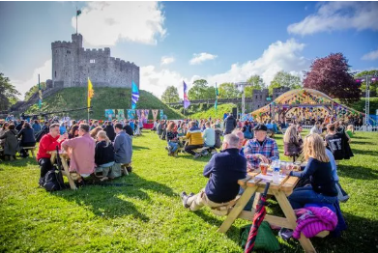  REPORT. Planning and Delivering an International Meeting/Event.  “Croeso Wales” | International Meetings Management: BMIH6007 Module Lead: Kathryn Flynn  C M ASIM  Student ID: 2246597

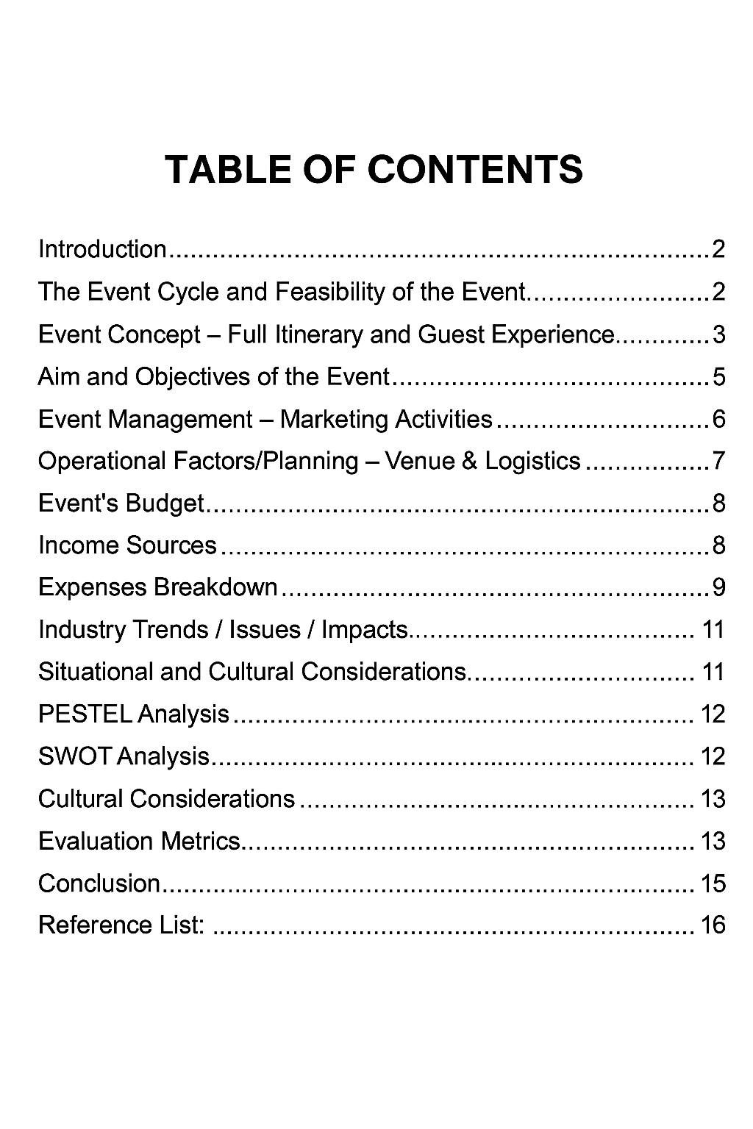

Introduction
The “Season of Welcome” launch in January 2025 is coinciding with the beginning of “Wales Hwyl” and also a broader series of Year of Croeso events are taking place across multiple locations throughout Wales. The proposed event, “Croeso Wales- A cultural welcome,” is designed to reflect the spirit of Wales Hwyl and will be held near the city center at the iconic Cardiff Castle. This event aims to promote Wales as a welcoming, diverse, culturally rich, and vibrant nation. This event promises to offer a unique and memorable experience, positioning Wales as a must-visit destination in the coming years (Visit Wales, 2025).
One of the highlights is that Cardiff Castle will be turned into a colourful festival site, with world renowned live music, visual arts, Welsh food, interactive workshops and stage shows! The venue is not only symbolic, given that it's backdrop is the historical Cardiff Castle, but practical too. As such a core icon of Welsh pride, it is in the perfect location and well equipped to hold large public events (Cardiff Castle, 2025). Happening in August 2025 during the peak of the tourism period the festival will appeal to the culturally curious travellers and international VIPs. The idea is consistent with Visit Wales’ strategy and aligns with an increasing demand for experiential MICE events (Berridge, 2019; Getz & Page, 2020). Although the presentation details are adopted in a feasibility context, the fine-tuning of the planning model is here reported based on a theory-driven, professional approach to strategic planning and execution.

The Event Cycle and Feasibility of the Event
The Event Cycle provides an organized presentation of events across five phases: feasibility, planning, implementation, event delivery and evaluation (Bowdin et al., 2011). This model provides a framework that we can apply to “Croeso Wales”- A Cultural Welcome and thereby build a roadmap that stretches from the idea to the evaluation phase.
Derived from Visit Britain 2025 forecast, UK will welcome 41.2 million inbound visits in 2024-2025, with overseas visitors spending approximately £31.5 billion. This robust evidence raises the possibility of attracting large number of international visitors to events such as “Croeso Wales” (VisitBritain, 2025).
The chosen venue is Cardiff Castle; it is capable of hosting more than 3,000 people a day in its peripheral area, and it has previously catered for large public events, thus ideal to be used as a setting (Cardiff Castle, 2025). There is a need for crowd segmentation in planning to ensure safety and access, such as families, food courts and performance stages. Advanced ticketing will help with crowd control. Guests from abroad can stay in central Cardiff hotels like Park Plaza, Clayton Hotel and Radisson Blu, all just a 10 minute walk from the arena. Group books with discounts available and booking assistance through partnership agreements with Visit Cardiff and local hospitality partners (Cardiff Council, 2023).
Implementation addresses infrastructure, contractor management and security, while delivery is designed to facilitate real-time coordination between volunteers, performers, tech teams and health and safety officers. Stakeholders include Visit Wales, Cardiff Council, local businesses, cultural organizations, and sponsors such as Transport for Wales and Brains Brewery, who will benefit from the brand exposure, the CSR value, and direct visitor engagement (Tum et al., 2006).

Event Concept – Full Itinerary and Guest Experience
“Croeso Wales” is a colourful, two-day programme designed for an all-around in-depth experience of Welsh traditions, arts, music, interactive sessions, stage performances and food. Influenced by its wide-reaching audience, the event is designed to cater for all generations with an engaging programme of shows, hands-on activities and community spirit.
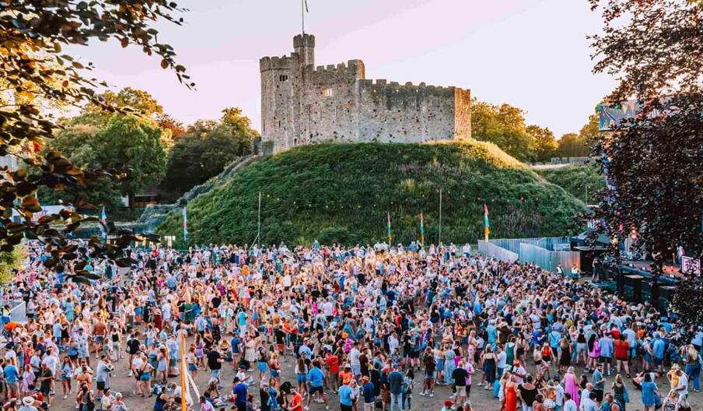(WalesOnline, 2016)

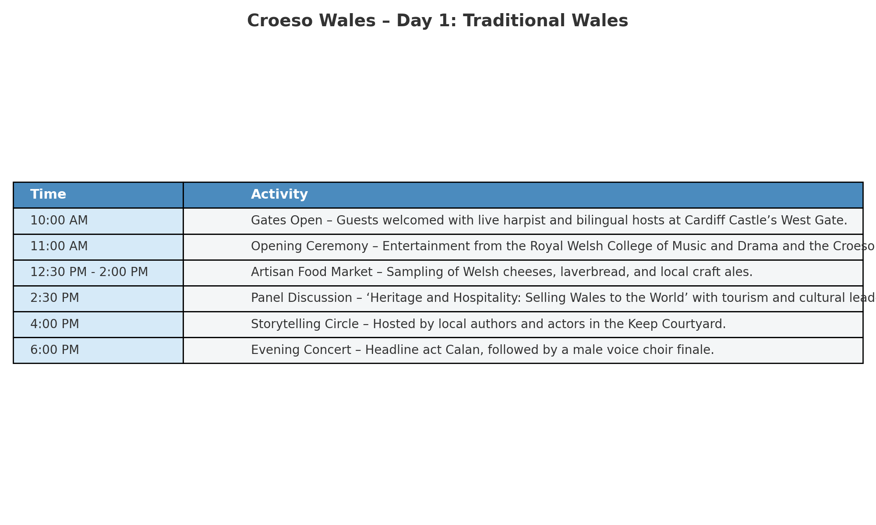

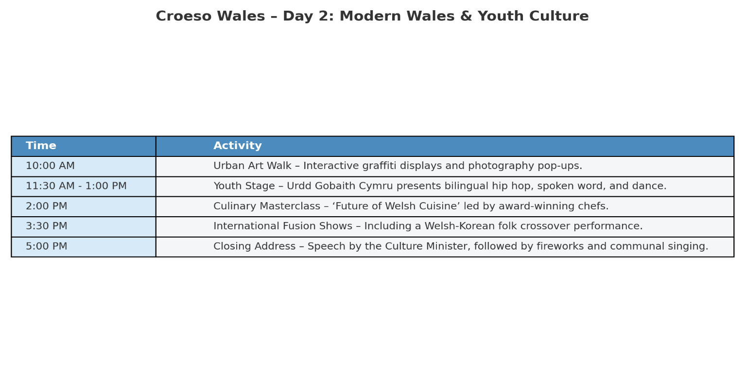
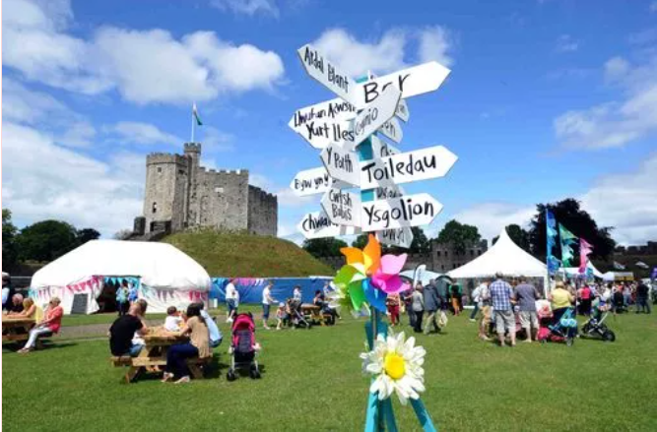
(WalesOnline, 2016)
By promoting co-creation and participation, the session is in line with the experience economy model of Pine and Gilmore (1999), where engagement leads to emotional attachment and memory retention. The event demonstrates cultural authenticity through tactile, visual and participative features and contributes to increasing Wales’ international tourist appeal (Andersson & Mossberg, 2017).

Aim and Objectives of the Event
The main objective of “Croeso Wales” is to support the long-term strategic ambitions of the Welsh Government, by projecting Wales as a sustainable, welcoming, and culturally rich country. This project targets advancing inbound tourism and expanding the MICE market. It directly contributes toward the aims of Visit Wales’ 10-Year Tourism Strategy and the Net Zero Wales Plan through the support of sustainable tourism which builds local identity and reduces environmental impact. (Welsh Government, 2022).
Following the impact on overseas travel caused by the pandemic, the event will re-invigorate the visitor economy and drive regional growth. Planned for summer 2025, the event will mark a bold reopening of Wales to the world - based on genuine cultural storytelling and green tourism.
SMART Objectives In order to accomplish these goals, the following objectives are outlined:
1-Strategic Tourism Aim: Increase inbound tourists to Cardiff by a minimum of 10% for the duration of the event compared to the same weekend in 2024 in selected international markets in conjunction with Visit Wales, Creative Wales and cultural embassies.
2. MICE and Objectives: Develop international collaborations (with cultural organisations, MICE operations, and the diaspora) and secure long term sponsorships or investment promises for future creative tourism projects taking place in Wales post-event.
These objectives will help create a lasting, sustainable tourism legacy, ensuring international visitors view Wales as not just a destination, but a warm and vibrant cultural host.

Event Management – Marketing Activities
Good marketing is essential for the success of “Croeso Wales”, especially in raising overseas awareness and building excitement. In event and hospitality industry, marketing has a greater impact on consumer behavior, and ticket sales, public relation, customer satisfaction and media reputation (Berridge, 2019). We utilise the 7Ps of marketing (Product, Price, Place, Promotion, People, Process, and Physical Evidence) to shape our strategy. Our “product” is an immersive, culturally rich experience, while “promotion” will be a digital-first, bilingual campaign that reflects Wales' inclusive identity.

Starting in May 2025, our marketing campaign will begin with teaser videos, insider stories, and anecdotes released on Instagram, TikTok, Facebook, and the Visit Wales website. We will partner with European, North American, and Canadian cultural influencers, along with international website platforms such as Lonely Planet and special interest travel websites for experiential virtual tours. We will augment our reach with Google Ads and live presentations at international tourism festivals.

Driven by Maslow’s hierarchy of needs, we emphasize belonging, self-esteem, and cultural interest—emotional motivators in traveling choices (Pine and Gilmore, 2011). Our clientele are international visitors, the diaspora of Wales, and culture professionals. To stand out from the competitors, our tech-enabled and bilingual solutions bring a contemporary, inclusive approach to the presentation of Welsh culture.

There are seven strategic steps in the marketing plan: 1) Executive Summary; 2) SWOT Analysis; 3) Competitive Positioning; 4) Customer Personas; 5) Goal Setting; 6) Multi-platform Strategy; and 7) Budget Allocation. We further utilize the PIECE model to describe the way visitors recognize needs, compare alternatives, and make a decision to visit (Masterman and Wood, 2016).

The marketing initiatives will not just bring visitors in but will tell a consistent, emotionally resonant narrative of contemporary Wales.

Operational Factors/Planning – Venue & Logistics
The event centres on Cardiff Castle, a landmark site with a rich history perfectly placed in the capital's center. It has accessibility to transport routes, local hotels, and emergency services, making it a wise choice of venue (Cardiff Council, 2024). The castle has been booked for the planned dates in August 2025, and an initial logistics support has been secured in association with the events department of Cardiff Council.
Highlighting the welcoming nature of 'Croeso'—which equates to 'welcome,' we will employ bilingual hosts, cultural ambassadors, and accessibility personnel. Our staff will comprise AV technicians, food (including Halal, Vegan etc.) and beverage vendors, multilingual translators, cleaners, and a solid security presence. To accommodate visitor and security needs, we will provide short-term infrastructure in the form of mobile stages, lighting equipment, portable toilets, recycling receptacles, and first-aid stations (GoGather, 2024).Staff will undergo training in inclusive engagement, disability awareness, and culturally responsive practice to maximize the experience for guests (Shone and Parry, 2021).
A Gantt timeline will be used to monitor the procurement process, the setup of the different stages, staffing, rehearsals, coordination with vendors, and delivery tasks. This organized timeline will eliminate potential choke points, assuring the event to be delivered on time and to the scope.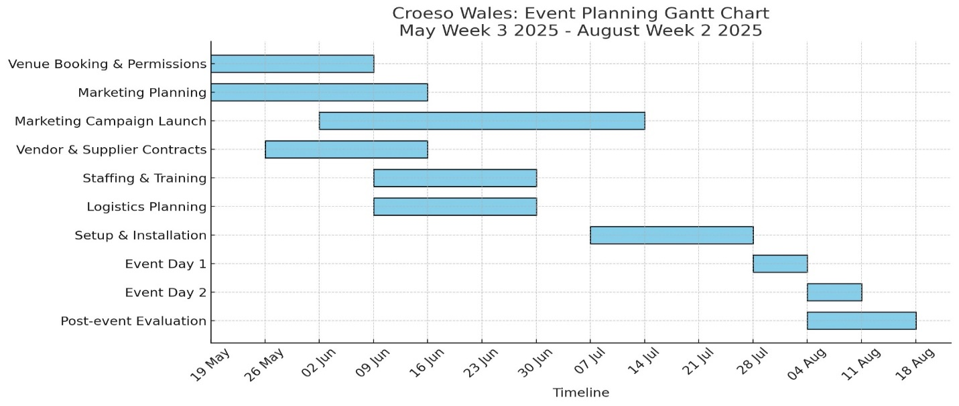
Overall, these strategic operational considerations reflect best practices in event logistics and contribute to a seamless and culturally rich experience for both international and local guests.

Event’s Budget
The budget proposed for “Croeso Wales” has been carefully planned at £50,000 to achieve a balance of quality, accessibility, and economic sustainability. With expected income at £65,000, we project a healthy net profit of around £15,000.

Income Sources
Ticket Sales: We anticipate selling around £35,000 through a multi-tiered pricing strategy, featuring advance-purchase discounts, family packages, and affordable pricing.
Sponsorships: Tourism boards and local businesses with cultural outreach activities are anticipated to provide £20,000 of sponsorship.
Stallholder charges: A further £10,000 is approximated from fees for participation by the local producers, food stalls, and green brands (Eventbrite, 2025; Creative Wales, 2024).

Expenses Breakdown
Venue Rental: Roughly £11,000 will be used to hire Cardiff Castle, paying for both permissions and site preparation in advance.
Staging, AV, and Lighting: This budget stands at £10,000 to achieve top quality production.
Staff and Security: Approximately £14,000 will be used to recruit professional staff, security personnel, and to support volunteers.
Marketing: £8,000 will support digital promotions and collaborations with overseas media to drive maximum exposure.
Other expenses: Sanitation services, accessibility features, insurance, and licenses will amount to a total of £7,000.
Contingency: A £3,000 buffer has been put in place to cater for unexpected expenses (Business Wales, 2024). Overall, this budget funds not only a successful event, but an event which provides a meaningful, inclusive experience at a financially responsible cost.
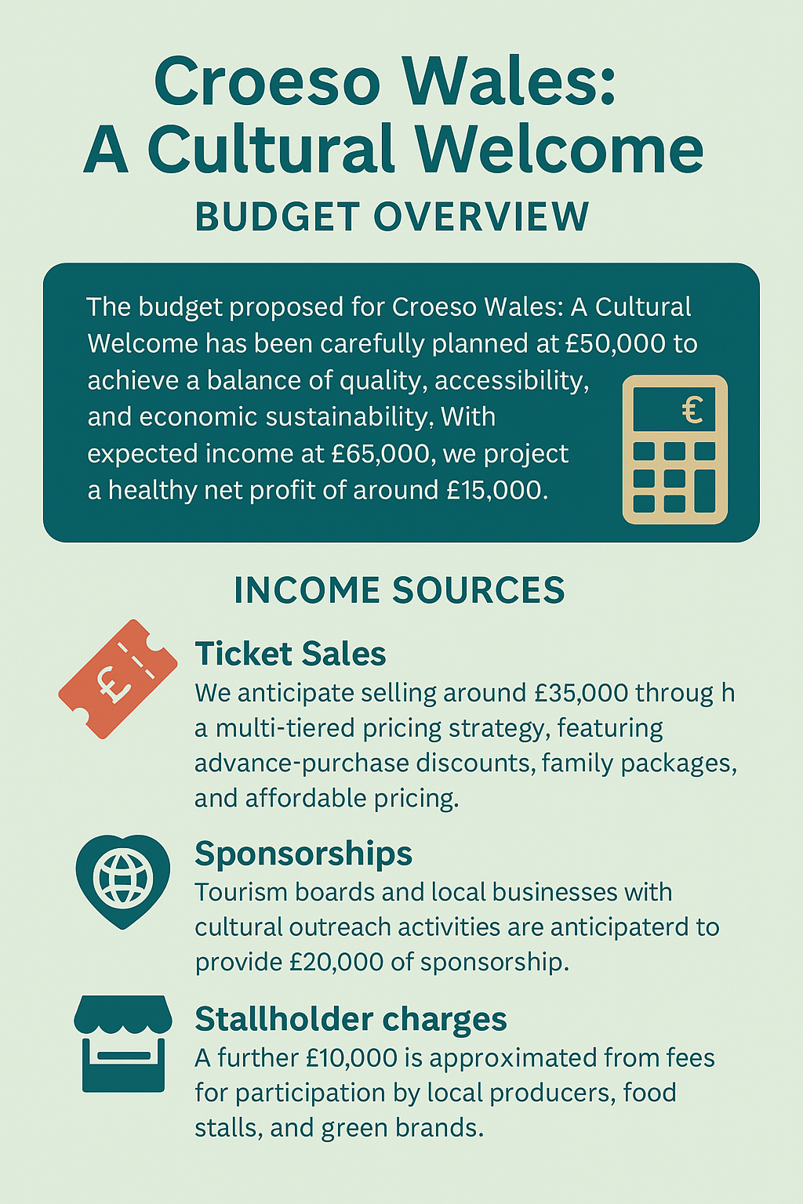
To have pliability, “Croeso Wales” will also apply for grant funding from schemes such as Creative Wales and Arts Council Wales, which offer in-kind and promotional support to boost regional cultural activities (Creative Wales, 2024; Arts Council Wales, 2023).
This financial framework ensures strategic cost management and inclusive pricing, reinforcing the sustainability and positive cultural impact of the event.

Risk Management & Compliance
Risk management and legal compliance Is crucial to a success of “Croeso Wales”. An indoor back-up space is being booked in Cardiff’s civic centre to deal with weather insecurities. The health, safety and welfare of visitors, performers and staff will be a priority and the venue will follow advice from Cardiff Council. The rules and regulations of health and safety, crowd safety, emergency procedures and food hygiene are set by the public health guidelines (Cardiff Council, 2024).
The event is designed around and risk planned for inclusivity. Features of accessibility will encompass wheelchair ramps, multilingual information, quiet zones for neurodivergent attendees and sensory-sensitive performance times, and engaging bilingual staff on-site in line with recommendations for accessible events and as part of our commitment to equity and well-being (Darcy et al., 2020).
Insurance will relate to third party liability, bad weather and damage to equipment. Cancellation language will be included in all venue and supplier contracts to mitigate financial exposure. The force will work in conjunction with local police and security forces and all personnel will be briefed and trained in security issues. The risk register & contingency plans will be scrutinised on a weekly basis in the final preparations phase to ensure we remain strategically ahead of evolving risks.

.

Industry Trends / Issues / Impacts

There are three main trends affecting the international meetings and events industry today: digitalization, sustainability drivers, and a heightened interest in inclusive, localized experiences. Post-pandemic recovery has accelerated the uptake of hybrid and immersion technologies, such as augmented reality, virtual attendance, and mobile ticketing, to maximize the level of engagement (Allied Market Research, 2023). Events today are anticipated to create both physical and digital touchpoints, enabling wider accessibility and a deeper return on engagement.

Sustainability is another key trend. Event planners are coming under mounting pressure to deliver environmental goals through minimizing event waste, carbon footprints, and the consumption of resources. This has special relevance in the UK, where the Net Zero Strategy requires lower-emission transport, energy-efficient venues, and circular waste management. Events showing green compliance are likely to secure funding, visitors, and favorable media attention (M&IW, 2025).
A third trend is the cultural immersion and inclusion movement. Business travelers increasingly demand authenticity and-place attachment, leading to a growth in interest in regional festivals and cultural heritage events. Localization and diversity are now integral to successful events (Skift Meetings, 2024).
“Croeso Wales” adopts new media, inclusivity and sustainability rooted in Welsh culture, positioning it as a progressive response to industry trends in cultural tourism and MICE event planning.

Situational and Cultural Considerations
Planning “Croeso Wales” requires careful navigation of various situational and cultural factors that influence its delivery, relevance, and sustainability. Two effective tools for assessing these dimensions are the PESTEL and SWOT frameworks.

PESTEL Analysis
The PESTEL method considers outside factors influencing the event:
- Political: The Welsh Government's tourism plan prioritizes sustainable development and community happiness, seeking to maximize tourism to deliver wider economic value (Welsh Government, 2024).
- Economic: International attendance can be affected by increased travel expenses and inflation, requiring reasonable accessibility and pricing policies.
- Socio-Cultural: The resurgence of cultural identity and belonging post-pandemic fuels the demand for genuine, inclusive experiences evocative of heritage.
- Technological: Advances in augmented reality (AR) and virtual reality (VR) along with online interaction enable opportunities to reach audiences around the world.
- Environmental: There's a rising demand to achieve net-zero and reduce waste targets, prompting the incorporation of low-impact event strategies.
- Legal: Ensuring compliance with accessibility and public safety laws is a key aspect of venue and operations planning.

SWOT Analysis
SWOT analysis considers the internal factors:
- Strengths: Sources of strength are governmental support, strategic timing at the height of the tourist season, and a special cultural appeal.
- Weaknesses: Budget limitations and inclement weather are a challenge, although these are to some extent cushioned by contingency planning indoors.
- Opportunities exist for forming international partnerships and increasing digital tourism flows.
- Threats: The potential risks involve event fatigue over the summer and rivalry from other UK and European festivals.

Cultural Considerations
Culturally, the event must prioritize bilingual representation and respect for diverse Welsh and international communities. This approach ensures that “Croeso Wales” reflects true inclusivity, maximizing community resonance and impact.

Evaluation Metrics
Success will be evaluated through several key metrics:
- Attendance: Monitoring visitor numbers to evaluate the event's popularity and scope.
- Social Media Engagement: Monitoring interaction, shares, and mentions on various platforms to measure interest and engagement by audiences.
- Earned Media: Measuring the media coverage and publicity the event creates to gauge the impact it has on brand exposure.
- Participant Feedback: Gathering qualitative and quantitative inputs from participants, performers, and vendors to understand the strengths and areas of improvement.
The project has the potential to create major economic, cultural, and reputational benefits for Wales in 2025 and beyond.

EMBOK FRAMWORK:
EMBOK Framework – Croeso Wales:
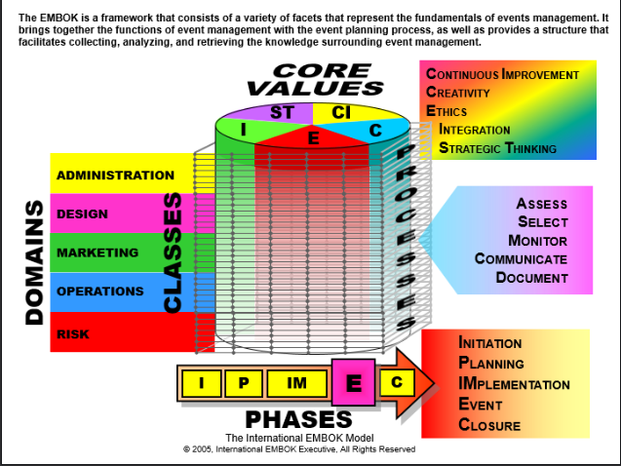
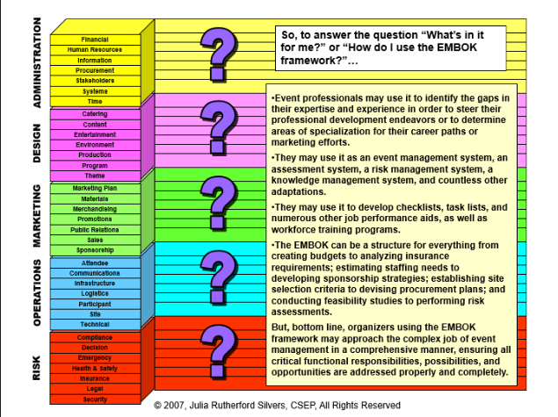
(EMBOK, n.d.)
The Event Management Body of Knowledge (EMBOK) provides an internationally recognised reference model for event management. In the case of “Croeso Wales” and the potential application of EMBOK, focussing on the strategic, inclusive and sustainable delivery of the event is valuable (Bowdin et al., 2011).
It corresponds, with an EMBOK five-stage cycle of initiation, planning, implementation, delivery and appraisal (Bowdin et al., 2011). “Croeso Wales” evolved from a feasibility study (underpinned by Wales tourism strategy (Visit Wales, 2025)) to detailed logistic planning to logistics, stakeholder management, and marketing. Live event phases are partnership-led volunteer teams to AV and health officers to vendors, with post-event analysis mainly from visitor feedback.
Consistent with EMBOK’s stage model—assessment, selection, communication, and documentation (Silvers, 2008)—the team observes environmental risks and the wants and needs of stakeholders in this stage and then captures progress through use of tools such as Gantt charts and risk registers (Shone & Parry, 2021).
Values including creativity, ethics, integration, and improvement are expressed in bilingual inclusive promotion, green operations, and cultural representation (Darcy et al., 2020). Equity is supported through access and neurodivergent-friendly programming. These are then influenced by the five EMBOK knowledge domains that are delivered: administration (Business Wales, 2024), design (Pine and Gilmore, 1999), marketing (Masterman and Wood, 2016) (Berridge,2019),operations (Cardiff Council, 2024), and risk (Arts Council Wales, 2023).
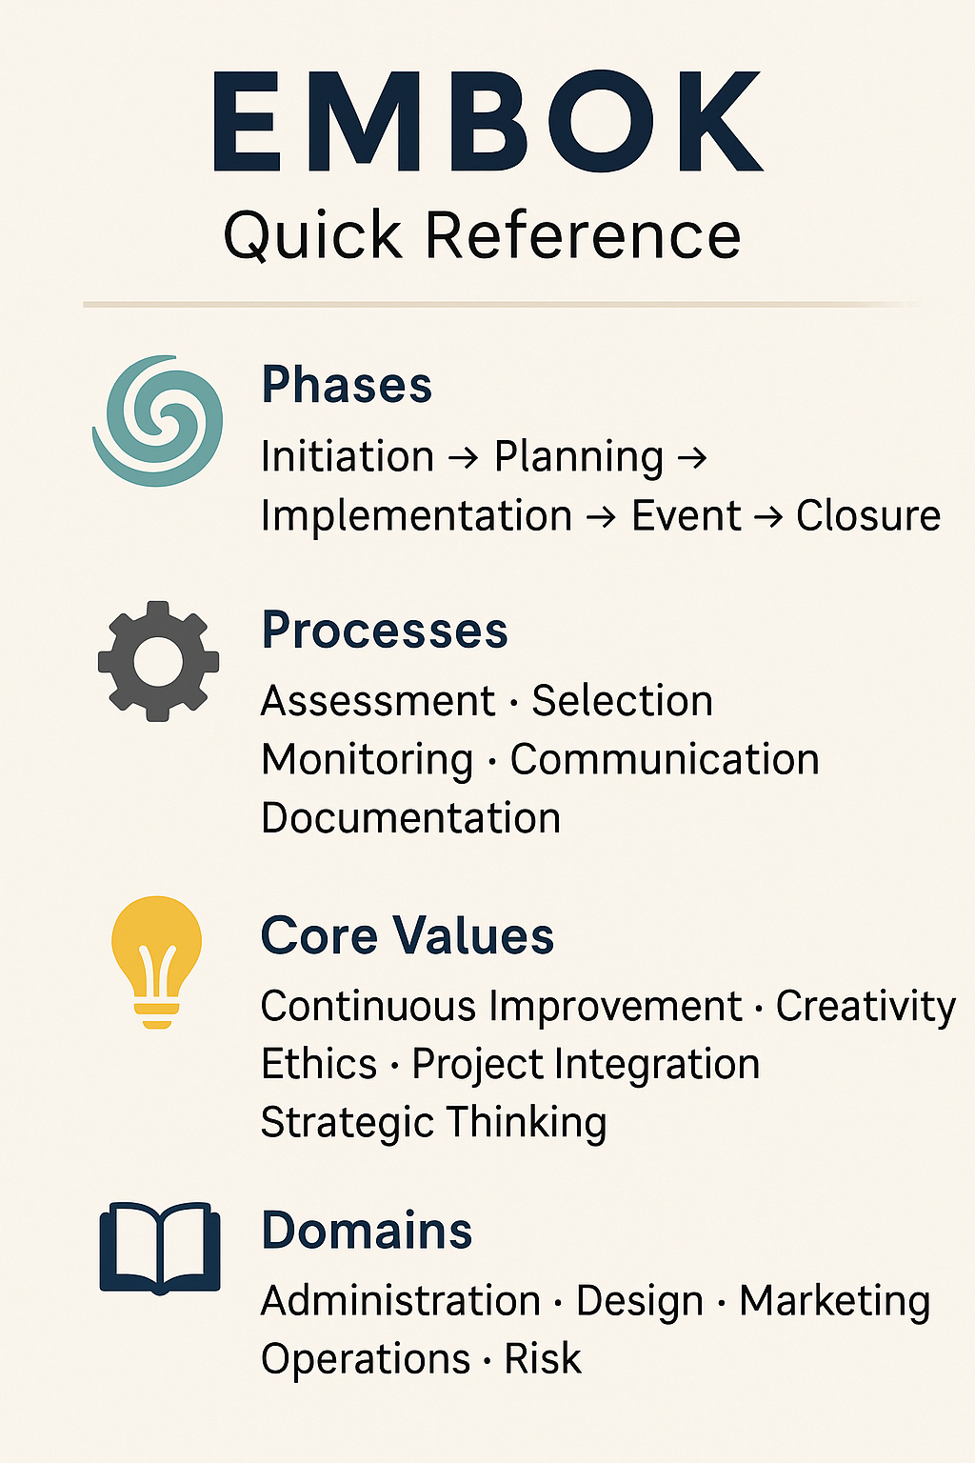
By using EMBOK, “Croeso Wales” ensures professional delivery and long-term gains in tourism, sustainability, and international recognition.

Conclusion
“Croeso Wales” is an innovative and inspired platform for presenting Welsh culture on the world stage. On account of its bilingual nature and inclusivity, the model does not only help restore tourism, but also serves the national branding purpose. The event serves to celebrate Wales' rich history and culture, bringing communities together and attracting international attention. We're pretty sure that you will sign off on the feasibility of this event when you read the report that reflects our professionalism, knowledge and experience in managing events such as this.

Reference List:
- Allied Market Research (2023) Events Industry Market by Type and Revenue Source: Global Opportunity Analysis and Industry Forecast, 2023–2032. Available at: https://www.alliedmarketresearch.com/events-industry-market (Accessed: 25 May 2025).
- Andersson, T.D. and Mossberg, L. (2017) Travel for experiences: The value of experience creation. Scandinavian Journal of Hospitality and Tourism, 17(3), pp. 259–278. Available at: https://doi.org/10.1080/15022250.2016.1275290 (Accessed: 24 May 2025).
- Arts Council Wales (2023) Funding – Arts Council of Wales. Available at: https://arts.wales/funding (Accessed: 26 May 2025).
- Arts Council Wales (2023) Support for Cultural Events in Wales. Available at: https://arts.wales (Accessed: 25 May 2025).
- Berridge, G. (2019) Event Experience: A Case Study of Differences Between Planned and Unplanned Events. Event Management, 23(1), pp.1–13.
- Berridge, G. (2019) Event Experiences: Design, Management and Impact. London: Routledge.
- Berridge, G. (2019) Events Design and Experience. 2nd edn. London: Routledge.
- Bowdin, G., Allen, J., Harris, R., O'Toole, W. and McDonnell, I. (2011) Events Management. 3rd edn. Oxford: Routledge.
- Business Wales (2024) Event Planning and Costing Guide. Available at: https://businesswales.gov.wales/ (Accessed: 26 May 2025).
- Business Wales (2024) Food Tourism and Culture: Small Grant Scheme – Food & Drink Festivals & Events 2024. Available at: https://businesswales.gov.wales/foodanddrink/growing-your-business/food-tourism-and-culture (Accessed: 25 May 2025).
- Cardiff Castle (2025) Visit Cardiff Castle. Available at: https://www.cardiffcastle.com/?utm_source=chatgpt.com (Accessed: 24 May 2025).
- Cardiff Council (2023) Stay in Cardiff. Available at: https://www.visitcardiff.com/stay (Accessed: 20 May 2025).
- Cardiff Council (2024) Cardiff Events Team: Major Events in the City. Available at: https://www.cardiff.gov.uk (Accessed: 24 May 2025).
- Cardiff Council (2024) Events at Cardiff Castle: Guidelines and Services. Available at: https://www.cardiffcastle.com/events/ (Accessed: 26 May 2025).
- Cardiff Council (2024) Temporary Event Notice. Available at: https://www.cardiff.gov.uk/ENG/Business/Licences-and-permits/Entertainment-and-alcohol-licences/Temporary-event-notices/Pages/default.aspx (Accessed: 25 May 2025).
- Creative Wales (2024) Supporting Creative Industries. Available at: https://www.creative.wales (Accessed: 25 May 2025).
- Darcy, S., Maxwell, H. and Green, J. (2020) Accessible tourism: inclusive event planning. Journal of Policy Research in Tourism, Leisure and Events, 12(2), pp.173–188.
- Darcy, S., Maxwell, H. and Green, J. (2020) Accessible tourism: Inclusion, disability, ageing population and tourism. Oxford: CABI Publishing.
- EMBOK (n.d.) EMBOK Model – Event Management Body of Knowledge. Available at: https://www.embok.org/index.php/embok-model (Accessed: 4 June 2025).
- Eventbrite (2025) TRNDS 2025: Eventbrite’s Annual Event Trends Report. Available at: https://www.eventbrite.co.uk/l/event-trends/ (Accessed: 25 May 2025).
- Getz, D. and Page, S. J. (2020) Event Studies: Theory, Research and Policy for Planned Events. 4th edn. London: Routledge.
- GoGather (2024) Event planning logistics: best practices for 2025. Available at: https://gogather.com/blog/event-logistics-best-practices (Accessed: 24 May 2025).
- M&IW (2025) Top 5 Practices for Sustainable Events. Available at: https://meetings-incentives.com/top-5-practices-for-sustainable-events/ (Accessed: 25 May 2025).
- Masterman, G. and Wood, E. (2016) Innovative Marketing Communications: Strategies for the Events Industry. 2nd edn. London: Routledge.
- Masterman, G. and Wood, E.H. (2016) Innovative Marketing Communications: Strategies for the Events Industry. 2nd edn. Abingdon: Routledge.
- Pine, B.J. and Gilmore, J.H. (1999) The Experience Economy: Work is Theatre & Every Business a Stage. Boston: Harvard Business Press.
- Pine, B.J. and Gilmore, J.H. (2011) The Experience Economy. Updated edn. Boston: Harvard Business Review Press.
- Shone, A. and Parry, B. (2021) Successful Event Management: A Practical Handbook. 5th edn. Andover: Cengage Learning EMEA.
- Silvers, J.R. (2008) Risk Management for Meetings and Events. Oxford: Butterworth-Heinemann.
- Skift Meetings (2024) How Accurate Were Skift Meetings' 2024 Event Industry Predictions?. Available at: https://meetings.skift.com/2025/01/02/trends-2024-vs-reality/ (Accessed: 25 May 2025).
- Tum, J., Norton, P. and Wright, J. (2006) Management of Event Operations. Oxford: Routledge.
- Urdd Gobaith Cymru (2025) Performing Course (Primary). Available at: https://www.urdd.cymru/en/residential-centres/gwersyll-haf/performing-course/ (Accessed: 24 May 2025).
- Visit Wales (2020) Welcome to Wales: Priorities for the visitor economy 2020–2025. Available at: https://www.gov.wales/welcome-wales-priorities-visitor-economy-2020-2025 (Accessed: 24 May 2025).
- Visit Wales (2025) Year of Croeso. Available at: https://industry.visitwales.com/get-involved/visit-wales-themed-year-campaigns/year-croeso (Accessed: 24 May 2025).
- Visit Wales (2025) Year of Wales Hwyl: Marketing Campaign and Events Strategy. Available at: https://www.visitwales.com (Accessed: 27 May 2025).
- VisitBritain (2025) 2025 Inbound Tourism Forecast. Available at: https://www.visitbritain.org/research-insights/inbound-tourism-forecast (Accessed: 24 May 2025).
- WalesOnline (2016) David Cameron answered your questions on the EU referendum - this is what he said. Available at: https://www.walesonline.co.uk/news/politics/david-cameron-answered-your-questions-11377241 (Accessed: 2 June 2025).
- Welsh Government (2022) Net Zero Wales: Carbon Budget 2 (2021–2025). Available at: https://www.gov.wales/net-zero-wales-carbon-budget-2-2021-2025 (Accessed: 24 May 2025).
- Welsh Government (2024) Welcome to Wales: Priorities for the Visitor Economy 2020–2025: Summary and Evidence. Available at: https://www.gov.wales/welcome-wales-priorities-visitor-economy-2020-2025-summary-and-evidence (Accessed: 25 May 2025).
- Welsh Government (2025) Tourism Barometer: February Wave 2025. Available at: https://www.gov.wales/tourism-barometer-february-wave-2025-html (Accessed: 25 May 2025).

Bottom of Form

