How are themes of colonialism and post 9/11 terror present in War of the Worlds?

Introduction –
War of the worlds is a sci-fi, thriller with horror elements depicting an alien invasion of earth by Martians. The film is based on the book “The war of the worlds” by HG Wells which was first published in 1898 and since then has had numerous film adaptations most notable being in 1953 and 2005 the latter of which I will be looking at in this essay. The film was released on July 1st, 2005, and is directed by Steven Spielberg and stars Tom Cruise in the lead role. The main plot of the film follows Ray (Cruise) and his two children as they flee to Boston trying to evade the Martian invaders. There are many themes referenced and alluded to in the film but the one I will be focusing on is the ideology based around colonialism and the themes of war.
Overview –
On the surface war of the worlds seems like a standard sci-fi alien invasion film but on closer inspection and looking back at the source material the film is based on many themes about the time period the book was written in shine through and some of those themes are still relevant today. The book was written between 1895 and 1897 and at the time Britain was the world’s leading superpower. In many of his books HG Wells would make reference to issues plaguing the world at the time and war of the worlds is no exception. Essentially the Martians in the story represent colonial Britan and the characters in the story are the countries Britain invaded. This links in to one of the key changes in the film as the film is set in America which is now the most powerful country on the planet and not Britain. The themes of war are also prevalent as steven Spielberg is known for adding subtly political messages in his films are the demise of the Martians in the film can be seen as reference to the American military in the Vietnam war. A massively advanced nation beaten by their own overconfidence in their ability.
Analysing a scene – 1
The main theme of war of the worlds at heart is that of colonialism with the Martian invades set on conquering and terraforming the earth the suit their needs. A technologically superior and far more advanced force attempting to expend it empire is a perfect summery of the British empire in the 1800s. The film makes the key change of changing the country to America which may seem like convenience of an American film being made in America but in the 21st century it’s America that is the world’s superpower and not Great Britain. Towards the end of the film Ray and his daughter are hiding in a cellar with Harlan Ogilvy played by Tim Robbins and the pair begin openly discussing the similarities of their situation to humanities past. “This isn’t a war. It never was a war, anymore than there’s war between man and ants”. (Wells pg 166). This line helps show the viewer what it’s like to be on the receiving end of war an annihilation with little to no hope of fighting back. In the film this sense of hopelessness is what leads to Harlan losing his mind and having a fight to the death with Ray as their own selfish priorities take over. Ray ultimately wins the fight, but he and his daughter end up being taken captive by the Martians showing that they we’re never going to be able to escape and like many people in the real world they we’re taken captive by their foreign invaders.
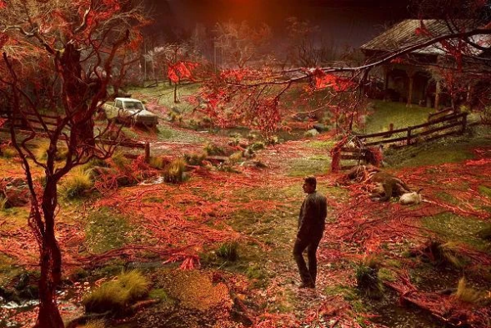
Another key aspect of the film depicting themes of colonialism is that of the red weed. “Another aspect of colonialism mirrored in War of the Worlds is the spread of British ideals in Africa. This is signified by the Martian red weed that spreads throughout England while the Martians are in control.” (Anon, n.d.) The red weed is what the Martians produce to terraform earth to suit their needs for survival. From an aerial view the red weed gives the Earth the appearance of Mars transforming the earth into “the weird and lurid landscape of another planet” (Well’s chapter six). One shot in particular see’s Ray looking out over the land drowned by the red weed and sombrely stares out as the land he once knew has been ravaged and transformed into something different. We could view this in quite a literal sense of the British taking over native American colonies and transforming them into large towns and cities taking all the natural resources and destroying the land the natives know for their own personal gain. Although the red weed may be that colour to show its relation to the planet mars it could also be seen as a metaphor for the British as the British soldiers wore red uniforms and hence gained the nickname the red coats. “American Revolutionaries came up with negative names for these soldiers, based on that coloring, including “lobsters” and “bloody backs.” (www.amrevmuseum.org, n.d.)

(War Of The Worlds Wiki, n.d.)
Analysing a scene – 2
A secondary theme which is exclusively explored in the film is the connection of the Martian invasion to that of the 9/11 attacks. Steven Spielberg is well known for masterfully putting social commentaries into his films and war of the worlds is no exception. The idea that the film has some commentary on post 9/11 can potentially first be seen by the release date of the film. “The film was abruptly green-lit in mid-August 2004 for a 2005 release” (www.imdb.com, n.d.) The next pieces of evidence I will be looking at are two scenes in the first half of the film which when looking at it through the lens of post 9/11 seem to be obvious commentaries on this. The first scene is when Ray (Cruise) returns home after initial attack. He his covered in “human ash” as in the film the humans get vapourised by the Martians, but the look of the character is eerily similar to images of survivors in the streets of New York on 9/11. After a shell-shocked Ray composes himself, he takes his children, and they flee along a motorway full of cars and people fleeing the attack which is another metaphor for people who were fleeing New York.
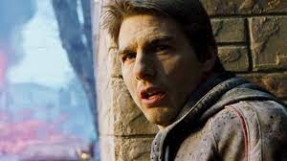
“It’s an unfamiliar theme to all of us because we don’t often see images of American refugees, except after local and national disasters like hurricanes and people fleeing—and approaching hurricanes in the Florida Keys. And of course, the image that stands out in my mind the most was the image of everybody in Manhattan fleeing across the George Washington Bridge in the shadow of 9/11, which is something that is a searing image that I haven’t been able to get out of my head.” (faroutmagazine.co.uk, 2023)

(Vespe, 2022)
The second scene follows shortly after when after hiding in a cellar the three characters narrowly survive a plane crash which can be seen as the more obvious reference to 9/11. The scene is foreshadowed earlier on the film when the characters are fleeing, and Robbie asks “why aren’t there any planes in the sky” which can be referenced back to all aircraft being grounded during the attacks. The final element that can be traced back to the themes of war may not be an intentional idea by the film but one of the stories being far ahead of it’s time. In the end of the film the all-conquering Martians are defeated by tiny inferior bacteria something which, in their confidence the Martians overlooked. We can view this as a view into what has happened multiple times with America. A country so sure of its military prowess that it invades countries expecting an easy result but time and time again underestimates its opponent.
“From the moment the invader arrived, breathed our air, ate and drank, they were doomed”. (www.imdb.com, n.d.)

Conclusion –
As a whole Spielberg’s adaptation of The War of the World’s is the most faithful adaptation of HG Well’s novel we have so far. It keeps the underlaying themes of imperialism and colonialism with a more updated take on the topic. As a modern interpretation the film also adds its own messages using visceral imagery of the 9/11 attacks such as the crashed plane, the human ash and scenes of nationwide panic to add commentary of terrorism and war in a post 9/11 world. The use of the red weed and how the film portrays it from the point of view of the two characters really helps sell the sense of hopelessness and defeat while also keeping the film entertaining for viewers. The film also shows that the themes written about the world well over 100 years ago are still prevalent in todays world and can still be relevant in a modern “post-colonial” world.

Bibliography – References and citations.

War of the worlds (2005)

Wells, HG. (1898). The war of the worlds, pg 166.

Anon, (n.d.). Thematic Elements – Victorian Science Fiction. [online] Available at: https://blog.uvm.edu/scalexan-vsf/the-war-of-the-worlds/thematic-elements/#:~:text=Another%20aspect%20of%20colonialism%20mirrored.

Wells, HG. (1898). The war of the worlds, pg chapter six

War Of The Worlds Wiki. (n.d.). Red Weed. [online] Available at: https://waroftheworlds.fandom.com/wiki/Red_Weed [Accessed 7 Mar. 2024].
www.amrevmuseum.org. (n.d.). Big Idea 3: Soldiers of the Revolutionary War. [online] Available at: https://www.amrevmuseum.org/big-idea-3-soldiers-of-the-revolutionary-war#:~:text=British%20soldiers%20who%20fought%20in.
www.imdb.com. (n.d.). War of the Worlds (2005) - Trivia - IMDb. [online] Available at: https://www.imdb.com/title/tt0407304/trivia/?item=tr0775196 [Accessed 5 Mar. 2024].

faroutmagazine.co.uk. (2023). Steven Spielberg on how 9/11 informed ‘War of the Worlds’. [online] Available at: https://faroutmagazine.co.uk/steven-spielberg-explains-how-9-11-informed-the-making-of-war-of-the-worlds/.

Vespe, E. (2022). The Daily Stream: Steven Spielberg’s War Of The Worlds Remains A Complex, Atypical Blockbuster. [online] SlashFilm. Available at: https://www.slashfilm.com/882050/the-daily-stream-steven-spielbergs-war-of-the-worlds-remains-a-complex-atypical-blockbuster/ [Accessed 7 Mar. 2024].
www.imdb.com. (n.d.). War of the Worlds (2005) - IMDb. [online] Available at: https://www.imdb.com/title/tt0407304/characters/nm0000151.

‌

