
Level 5
BA (Hons) Leadership and Management Skills
in the Workplace
Student Name: | Anamaria Bock
Student Number: | 2114314
Module No: | BMSK5009
Module Title: | Developing a high-performance culture

Statement of Confirmation of Authenticity
By the act of making this submission, the student declares that this is the work of the student named above. The work has not, in whole or in part, been knowingly presented elsewhere for assessment, or where assessment has been built on a previous assessment, this has been identified. Where materials have been used from other sources it has been properly acknowledged. If this statement is untrue, the student acknowledges that an assessment offence has been committed.
Attention is drawn to the plagiarism and unfair practice policies of both the University and of ILM.
Contents
Introduction 3
Culture 4
Ethical standards, values, and beliefs 5
Communication channels for sharing information and building relationships. 8
Sustainability 8
CSR- Corporate Social Responsibility 11
Barriers of effective functioning of an organisation 14
Organisational efficiency 16
Conclusion 17
References 18

Introduction
This project’s focus is culture in within organisations, from ethical standards, values and beliefs to communications channels, collaboration, sustainability and effective and efficient organisations with examples and theories.

Culture
Culture is the element that impacts on any organisation’s success. To create a high-performance culture, the leaders should build a culture that supports the strategies to achieve the desired goals (Institute, 2017). Because culture includes the values, beliefs, attitudes, systems, and rules that shape an individual to be able to reach the maximum possible performance that pushes the organisation one step forward, to develop and succeed.
According to the research (Psychological Safety, 2023) we can determine that Edgar Schein divided the culture in three different levels: artefacts, espoused values and basic assumptions; the artefacts being the visible side of the organisation such as branding, uniform, tools, product; the espoused values being represented by how people describe the organisation, it’s values or what they assume the organisation does; and basic assumptions being the unspoken, unconscious elements of the organisation.
Digging deeper in the concept of culture, there are several theories that define and explain better what it is and what should the organisation focus on to create a better environment for the employees. One of these theories is Hall’s Cultural Dimensions written by Edward T. Hall in 1990 who divided the culture in three dimensions. According to the research (Bhagat & Steers, 2009) these three dimensions are: context, space, and time.
As an example, we will have a look at one small organisation, a coffee shop called Costa in Bridgend, having 10 employees, one manager and one assistant manager.
The importance of context is the fact that every message that goes from directors to manager, or from manager to employees, must be perfectly understood by everyone. It is essential that all employees know what they must do to be able to accomplish the targets and deliver great customer service.
Regarding space, people like to have their personal space, but in the workplace, employees must feel comfortable with sharing physical space with others, especially in retail where the employees work close together like in this coffee shop where there are four people behind the counter on every shift.
Hall is also saying that time is one of the dimensions of culture because people can approach one or multiple tasks at a time. So, monochronic is represented by the individual who will focus on one task, in the coffee shop is usually the person responsible with the till, taking orders and the polychronic represented by the people that have distributed attention on multiple tasks, the example here being the other employees that are preparing the drinks and food, serving the people at the tables, cleaning the tables, making sure the customers are happy and the floor is clean and tidy.
On the other hand, there is another interesting theory, Handy’s culture.
Handy divides the culture in four different sections (AQA, 2017): power culture being defined as a centralised culture because it’s focus is on key decision makers, such as small businesses where the owner takes all decisions; role culture where individuals know their position and know the clear rules and procedures; task culture having it’s focus on specific tasks, when individuals are called in only when needed; person culture where individuals have the freedom to work independently. In Costa they are applying the role culture, the employees know exactly what their attributions are and how to perform any task, every individual works on a specific section and they communicate very well if they have to switch tasks.

Ethical standards, values, and beliefs
What are ethical standards? According to the research (University, 1987) “ethics refers to well-founded standards of right and wrong that prescribe what humans ought to do, usually in terms of rights, obligations, benefits to society, fairness, or specific virtues. Ethics, for example, refers to those standards that impose the reasonable obligations to refrain from rape, stealing, murder, assault, slander, and fraud.” All organisations have different standards, but they tend to guide by the same ethics. Employers want to hire honest, correct, responsible and reliable.
According to US Department of Labour (2012) employers want to see professionalism in every employee which means responsibility, integrity, accountability and excellence, the ability to communicate effectively to be productive. In Costa coffee, being able to meet all these criteria is vital. Attention for details is very important because a busy day will not allow the employees to organise sometimes, but working together and relying on each other, being able to coordinate without effort, gives them the confidence that each busy day will be a success.
So, what’s the importance of ethical standards?
” The Committee has reflected before that high ethical standards are important for society as a whole and that they are particularly important where public money is being spent on public services or public.
functions. This is because:
■ outcomes for society are better when the decisions of public office holders are made fairly and on merit and not influenced by personal and private interests.
■ low levels of corruption and confidence in the integrity of the trading and operating environment are
crucial factors in the functioning of advanced democracies.
■ high standards benefit the economy through their effect on international confidence.
■ impartiality and objectivity increase predictability, which improves economic efficiency.
■ Governments which are not perceived to uphold high standards have less legitimacy and basic public
institutions such as tax and benefit systems rely on public trust to function effectively.”, explains Lord Paul Bew in Ethical Standards for Providers of Public Services. (Lord Paul Bew, 2014). In other words, the roots of ethical standards are honesty and trust, compliance with the law, concern for the well-being of others and preventing harm to others.
Now, looking to our organisation’s ethics, Costa coffee states “We strive to create workplaces in which open and honest communications among all team members are valued and respected.”, and so it is. This being the case in Bridgend. But are all the franchise guiding by the same ethics? Here is a contradiction of these ethics found in an online article (Business and Human Rights Resource Centre, 2019) saying that 26 employees have been complaining that they are not treated like human being, the employer doesn’t want to pay them overtime or sick leave, more than that they are not even allowed to keep the tips they make from the customers. Being an employer with no work ethic, no respect for the employees or customers, thinking just about the money, the business will clash for sure.
Thinking about values, how we define them and what are the best values that help us in the workplace, we find out from Rene Brown (Brown, 2020) “Living into our values means that we do more than profess our values, we practice them. We walk our talk—we are clear about what we believe and hold important, and we take care that our intentions, words, thoughts, and behaviours align with those beliefs.”

Here is Brown’s list of values:
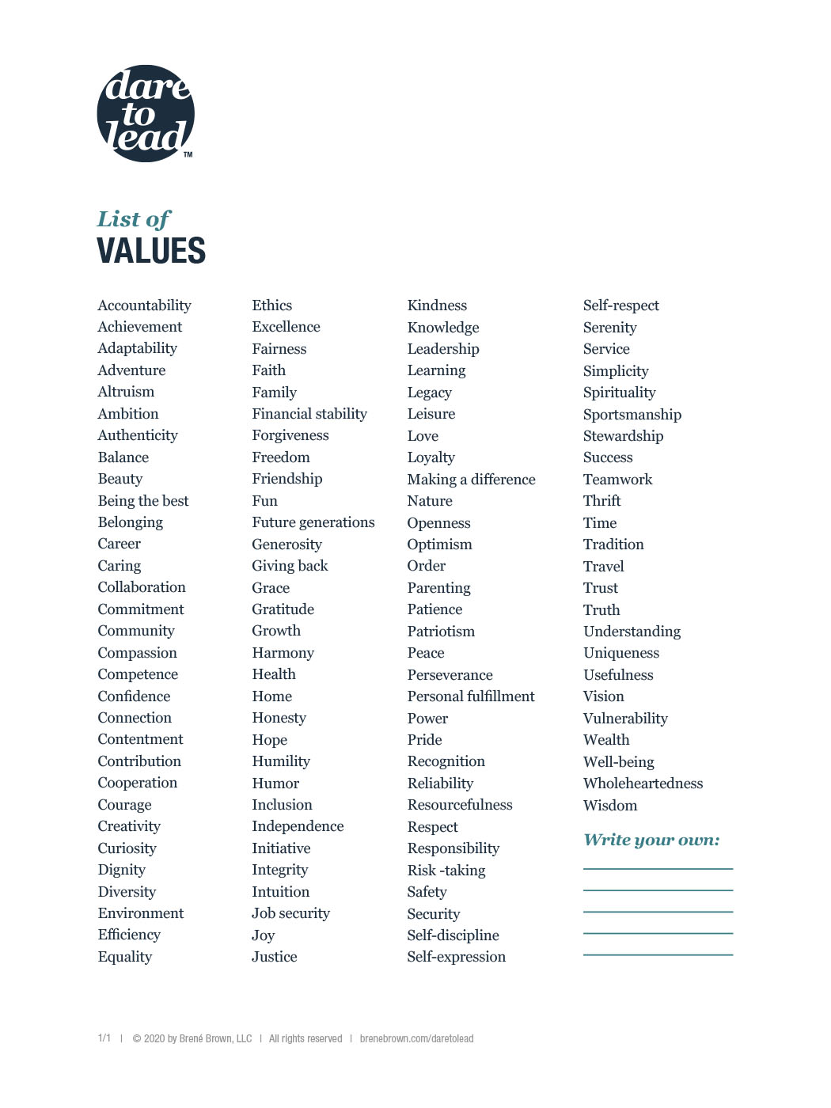
In Costa coffee, the employees have common values which include achievement, respect, job security, teamwork, trust, reliability.
An interesting approach regarding values is the one found on Harappa school of leadership (Harappa Learning private limited, 2021) who split the values in different categories such as values for behaviours and traits related to the way someone behaves and treats others (compassion, kindness, loyalty) values about rights and causes related to the rights and causes that really matter to the individual such as human rights, social justice, tolerance, equality, freedom, and values about life, these are actually the internal beliefs that help us lead our lives and they differ from one individual to another.(belief in maintaining a healthy work-life balance.

Communication channels for sharing information and building relationships.
Communication channels are represented by all the ways individuals share information being verbal, written or signs of communication.
According to Jouany and Martic (2022) there are three types of communication channels by formality: formal, informal, and unofficial. The formal communication refers to the information containing goal, business strategy, annual reports, workplace safety. In Costa coffee, this type of formal communication is shared with the employees once a week, the manager likes to motivate the employees by telling them how well they have done the previous week and what the targets are for the following g week, as well as all other formal communications coming from head office or directors. The informal communications purpose is still to deliver official information but in a more relaxed way. In Costa coffee, the manager will sometimes start a conversation during the lunch break, telling the employees how well the competitors have performed the previous week and ask them if they have any ideas for improvement. On the other hand, is unofficial communication which includes everything, not work related, outside the workplace.
According to Gardner (2016), collaboration is also very important as “today’s problems simply demand that specialists in the context of professional service firms work together to integrate their separate knowledge bases and skill sets to forge coherent, unified solutions.” It is well known that no matter how capable a person is or how qualified a different person is, always working together and sharing work experiences and skill sets will provide a better understanding and a better solution to any problem. For example, in Costa coffee, during a busy morning, one employee dropped a tray with three coffees and two teas. In the next second the person responsible for the floor shop came and cleaned the mess so the employee serving the customers went straight back to the counter to take other drinks for his customers.

Sustainability
According to the research (Willard, 2015), there are three models of sustainability. The first one is represented by three overlapping circles: economy, society, and environment. Every organisation has its own preferences, for example, some may represent the economy circle bigger because it is the main thing in the organisation, but the important part is how all three circles overlap to create sustainability.
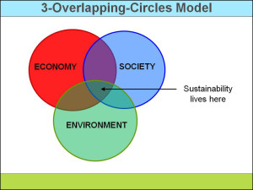

The second model of sustainability is represented by 3-nested-dependencies-model that reflects the co-dependent reality. It shows that human society is owned by the environment, because humans could not live without water, food, oxygen, and other resources. And than human society influences the economy because they decide how they will exchange goods and services and what methods they will use.
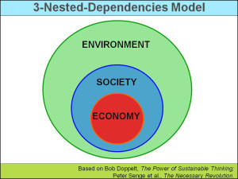
The third model is called three-legged stool. This metaphor is used to describe the three elements of sustainability, environment, society, and economy, that are required for humans to be able to enjoy a high-quality life. It is represented as a stool to show that the three dimensions (the legs) should be equal to sustain the individual (the seat).
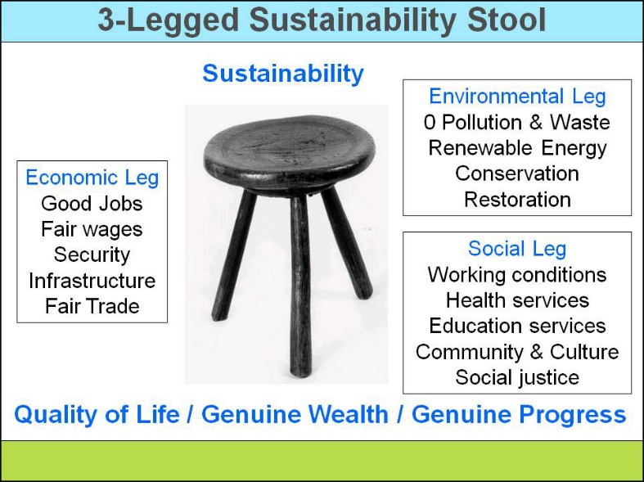
According to Bateman (2019) “A strong sustainability culture exists if people share a belief in sustainability’s importance and behave in ways that support it.” So, he found five ways to create a strong sustainability culture. First, he talks about understanding the concept of sustainability by knowing that the environmental issues, like climate change, affects everyone, it is about profit and loss, problem and opportunity, business, and morality. The second way to support the sustainability is by establishing and following a sustainable vision, doing this by involving the employees in the creation process, listening to all new ideas that could improve any sector of the business, encouraging them to speak up and share any new strategies that might help coordinate the group. The third way to create a stronger sustainability culture is by facing the reality, as there are so many businesses that do not take seriously the climate change and do not understand how it could affect the business. The fourth way is embedding sustainability in decision-making processes.” Sustainability is culturally ingrained when it enters major decisions of every type: corporate and business strategies and performance goals at every organizational level, in every function, and core managerial processes and operations.” (Bateman, 2019) And the fifth way is to engage fully. To have powerful employees able to make the right moves you must trust them and give them the empowerment to make decisions. Being trained appropriately and having the right mindset and all the knowledge they need to make the right choices; they will feel trusted and motivated to improve and to impress.

CSR- Corporate Social Responsibility
“Corporate Social Responsibility is a management concept whereby companies integrate social and environmental concerns in their business operations and interactions with their stakeholders. CSR is generally understood as being the way through which a company achieves a balance of economic, environmental, and social imperatives.” (UNIDO, 2023)
According to the research (HSGUniStGallen, 2012), Corporate Social Responsibility it’s about risk management by preventing bad practice like corruption and fraud, it is also about how companies contribute to a good society through a good business practice, it is about how companies make profit, it is about social and ecological criteria, about business ethics.
According to Stobierski (2021) there are four types of corporate social responsibilities. Environmental responsibility, which implements the fact that all companies should try to protect the environment and they can do this by reducing harmful practices (decreasing pollution, reducing water consumption, reducing general waste), regulating energy consumption (increasing reliance on renewables), offsetting negative environmental impact (planting trees, donating to good causes). Ethical responsibility, it’s about fair practice, the way a company operates in an ethical manner, how a company treats its own employees, stakeholders, and customers. Philanthropic responsibility, looking at the companies thriving to make the world and the society a better place by sharing their earnings for good causes like charities.
Costa coffee is a business that always tried to do its best regarding corporate social responsibilities. Related to environmental responsibilities they have replaced the plastic straws with the paper ones and also changed the packaging of the sandwiches from plastic to paper, then deciding to reduce the general waste, because they cannot sell the sandwiches the following day (they make fresh ones every morning), one hour before closing they were giving the sandwiches for free to the people in need( also philanthropic responsible). Regarding ethical responsibility, all employees are equal and treated the same way, their wages are higher than minimum wage because working in such a busy environment is not easy and they feel motivated and appreciated; the customers are the centre of the business and the loyal customers are rewarded with free coffee and discounts for food, free birthday cake and other treats.
Costa coffees CSR is hanging on a wall in the kitchen, visible to all the employees.
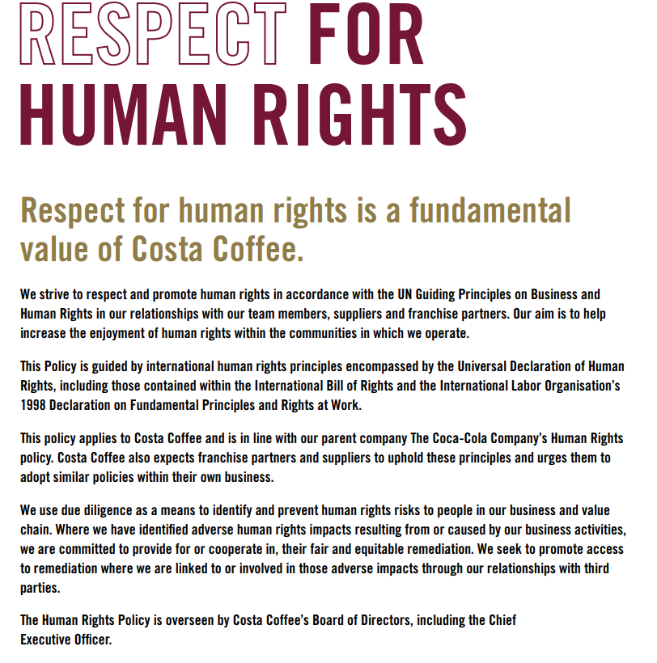
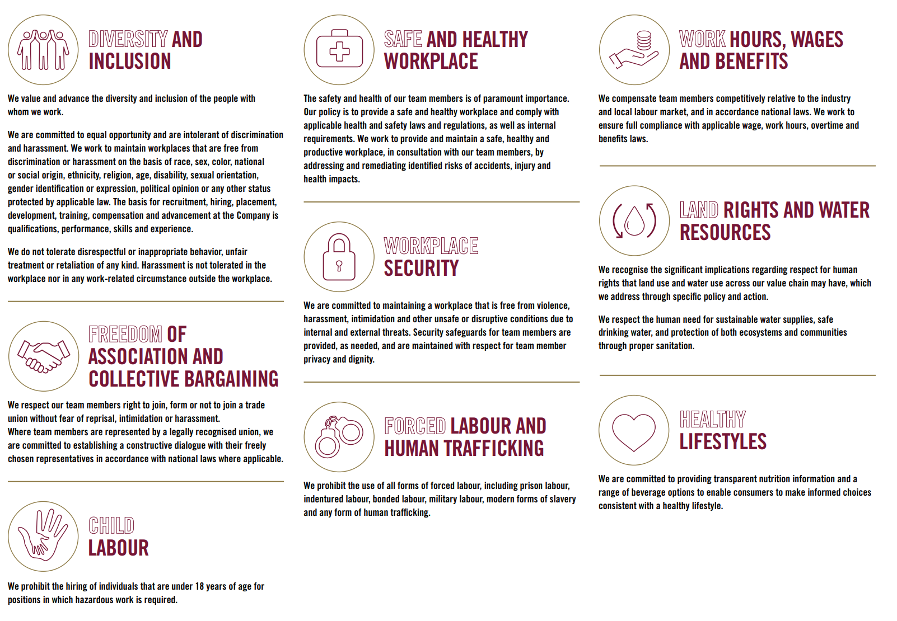
Having a look at Demings cycle (Lean Enterprise Institute, 2023) Plan (set goals and think on how to achieve them), Do (implement, change product), Check (evaluate the performance), Act (adjust things if needed to improve the product ), to be a company that is always improving, and every new thing implemented is successful, Costa coffee’s manager decided to try some new coffee flavours for the Christmas holidays. So, he planned everything according to the recipes, he ordered everything he needed, from new festive coffee cups, to syrups, they tried the new coffee together and changed just the amount of syrup added, and they started selling the festive coffee one month before Christmas. It was a real success.

Barriers of effective functioning of an organisation

According to the research (Team,2023) we can determine that organisational effectiveness is crucial to any organisation. Organisational effectiveness is measuring a business ability to achieve its goals and maximise its resources. It is also about the organisations strength to adapt to the environmental changes and remain competitive. For example, when the pandemic COVID 19 happened, Costa coffee had the ability to stay strong, management and employees stayed together and put a plan in place to help them survive this storm. When all retail businesses were closing the doors, they decided to put in place all the safety measures to keep the employees safe and started selling all the products on just eat, by delivering them straight to the customers.
The key components for an organisation to be effective are strategy, leadership and management, communication and collaboration, performance management and feedback, continuous improvement, and innovation.
Then what can stop us in having an effective organisation? The opposites of all the above, of course, poor leadership, poor communication, lack of commitment, lack of motivation and the list can continue.
According to the research (Lencioni, 2012) the five dysfunctions of a team are absence of trust, fear of conflict, lack of commitment, avoidance of accountability, and inattention to results. Lencioni put these dysfunctions in a pyramid and explained how a high performing team would look like comparing to a dysfunctional team. If the individuals in the dysfunctional team don’t trust each other and will not communicate to achieve the set goal, the individuals in the high performing team will trust each other and work together as a team always sharing ideas and helping each other. If the dysfunctional team will hide the misunderstandings because they are afraid to confront the others, the high performing team will always embrace the opportunity to discuss any problems and try to find the best solutions to any issues together. If the individuals in the dysfunctional team present a total lack of interest and go to work just because they need money without wanting to get involved too much or commit, the individuals in the high performing team have common objectives and walk together in the same direction, being always highly engaged. In the dysfunctional team, poor performance is tolerated which make employees feel helpless, they are missing deadlines, but in the high performing team, if poor performance happens, they manage it. So, if all the above are respected, the high performing team will have great results and they will be motivated to always succeed, but on the other hand, the dysfunctional team will always have poor performance and will never be able to do things right.
As identified in part one, culture is the element that impacts on every organisation’s success. It is created by the people in the organisation by learning from trying in order to improve. The external forces that can impact on the organisation are technology, environment, politics, economic, Brexit, national, international.
According to the research (Oxford College of Marketing, 2019) we can determine that one of the best methods to analyse the external forces impacting on the organisation is PESTEL analysis.
Below is a PESTEL analysis done on Costa Coffee.
Political |  | All the policies implemented by the government are very well analysed by the managers.
Economical |  | Coffee beans doubled in price in the last 2 years which makes the company increase the price of one cup of coffee.
Social |  | Focusing on the customers, always keep an eye on the trends.
Technologic |  | Technology changes fast so keeping up to date will help.
Environmental |  | Government environmental policies affects all the businesses.
Legal | Consumer law and health and safety is what concerns the organisation.

According to Kenton (2023) we can determine that to be able to analyse external factors but also the internal factors that impact an organisation we can use SWOT analysis.” SWOT (strengths, weaknesses, opportunities, and threats) analysis is a framework used to evaluate a company's competitive position and to develop strategic planning. SWOT analysis assesses internal and external factors, as well as current and future potential.” (Kenton, 2023)
Applying the SWOT analysis on Costa Coffee
STRENGHTS  Great customer service.  Excellent coffee.  Wide product range. | WEAKNESSES  Inefficient marketing strategy.  More expensive than other brands.
OPPORTUNITIES  Developing new healthier products.  Insisting on performing a good marketing strategy.  Plan to form strategic alliances with other businesses in catering industries. | THREATS  Increasing the price of raw materials.  Coffee being perceived as unhealthy drink.  Competition.

Organisational efficiency

“Organizational efficiency examines how to increase the output an organization can achieve, using a specific amount of resources. The more output delivered using those same resources, the more efficient the organization is. “(Sheffield, 2020)
As Sheffield pointed above, organisational efficiency is about how to simplify certain tasks, how to use the same amount of time to do more things in a better way. For example, in Costa coffee, it takes one minute to make a coffee and two minutes to make a sandwich. In a quiet day, when it is just one bartender serving, if 2 customers want 2 coffees and 2 sandwiches, that should normally take 6 minutes. So, the team figured out that if you first put both sandwiches in the toaster to cook together and then start preparing the coffees, using a bigger jug for milk to do them both at the same time, they can manage to have everything ready in just two minutes.

Conclusion
To develop a high-performance culture, any organisation must have strong leadership, great communication, focus on customers, constantly improve, trust, coaching and mentoring, emotional intelligence, creativity and innovation.

References
AQA. (2017). Teaching guide: Handy’s culture. Aqa.org.uk. https://www.aqa.org.uk/resources/business/as-and-a-level/business-7131-7132/teach/teaching-guide-handys-culture
Bateman, T. (2019, January 16). 5 ways to create a strong sustainability culture | Greenbiz. Www.greenbiz.com. https://www.greenbiz.com/article/5-ways-create-strong-sustainability-culture
Bhagat, R. S., & Steers, R. M. (2009). Cambridge Handbook of Culture, Organizations, and Work. In Google Books. Cambridge University Press. https://www.google.co.uk/books/edition/Cambridge_Handbook_of_Culture_Organizati/isjgx2WCqiIC?hl=en&gbpv=1&dq=culture+in+organisations&printsec=frontcover
Brown, B. (2020). Dare to Lead List of Values. Brené Brown. https://brenebrown.com/resources/dare-to-lead-list-of-values/
Business and Human Rights Resource Centre. (2019, August 27). UK: Costa Coffee employees allegedly “not treated like human beings.” Business & Human Rights Resource Centre. https://www.business-humanrights.org/en/latest-news/uk-costa-coffee-employees-allegedly-not-treated-like-human-beings/
Costa Coffee. (n.d.). POLICY COSTA COFFEE Now is the moment. https://www.costa.co.uk/docs/costa-coffee-human-rights-policy.pdf
Gardner, H. K. (2016). Smart Collaboration : How Professionals and Their Firms Succeed by Breaking Down Silos. Harvard Business Review Press.
Harappa Learning Private Limited. (2021, May 13). Examples Of Personal Values. Harappa. https://harappa.education/harappa-diaries/examples-of-personal-values/
HSGUniStGallen. (2012, October 1). What is Corporate Social Responsibility (CSR)? Www.youtube.com. https://www.youtube.com/watch?v=E0NkGtNU_9w&t=144s
Institute, N. (2017). 6 Characteristics of a High Performance Culture [YouTube Video]. In YouTube. https://www.youtube.com/watch?v=0kkPmppKm_4
Jouany, V., & Martic, K. (2022, February 19). Top Communication Channels to Consider for Your Business. Haiilo. https://haiilo.com/blog/top-communication-channels-to-consider-for-your-business/
Kenton, W. (2023, October 30). SWOT Analysis: How to with Table and Example. Investopedia. https://www.investopedia.com/terms/s/swot.asp
Lean Enterprise Institute. (2023). Plan, Do, Check, Act (PDCA) — A Resource Guide. Lean Enterprise Institute. https://www.lean.org/lexicon-terms/pdca/
Lencioni, P. (2012). The Five Dysfunctions of a Team. Pfeiffer.
Lord Paul Bew. (2014). Ethical standards for providers of public services Committee on Standards in Public Life. https://assets.publishing.service.gov.uk/media/5a7da9f7e5274a5eaea65955/CSPL_EthicalStandards_web.pdf
Oxford College Of Marketing. (2019, June 30). What is a PESTEL analysis? Oxford College of Marketing Blog. https://blog.oxfordcollegeofmarketing.com/2016/06/30/pestel-analysis/
Psychological Safety. (2023, February 3). Psychological Safety: Edgar Schein’s Three Layers of Organisational Culture – Psychological Safety. Psychological Safety. https://psychsafety.co.uk/psychological-safety-edgar-scheins-three-layers-of-organisational-culture/
Sheffield, L. (2020, March 8). What is Organizational Efficiency & Why It’s Critical for Long-Term Success. GuideSpark. https://www.guidespark.com/blog/what-is-organizational-efficiency-&-why-it/
Stobierski, T. (2021, April 8). What is corporate social responsibility? 4 types. Harvard Business School Online; Harvard Business School. https://online.hbs.edu/blog/post/types-of-corporate-social-responsibility
Team, W. (2023, May 27). Organizational Effectiveness | Definitions, Models, & Examples. Blog Wrike. https://www.wrike.com/blog/organizational-effectiveness-definition-models-examples/
UNIDO. (2023). What Is CSR? United Nations Industrial Development Organization. https://www.unido.org/our-focus/advancing-economic-competitiveness/competitive-trade-capacities-and-corporate-responsibility/corporate-social-responsibility-market-integration/what-csr
University, S. C. (1987). What is Ethics? Www.scu.edu. https://www.scu.edu/ethics/ethics-resources/ethical-decision-making/what-is-ethics/#:~:text=Ethical%20standards%20also%20include%20those
US Department of Labour. (2012, October 17). Soft Skills--Professionalism. Www.youtube.com. https://www.youtube.com/watch?v=7dPWVjQSad4&feature=youtu.be
Wasieleski, D. M., & Weber, J. (2019). Business ethics. Emerald Publishing.
Willard, B. (2015, May 9). 3 Sustainability Models. Sustainability Advantage. https://sustainabilityadvantage.com/2010/07/20/3-sustainability-models/

