Project Title – “Effectiveness of Employee Engagement in Maximising Organisational Performance: A Study on Richmond Hill Hotel”

Student Name: Johurul Islam
Student ID: 2020451
Module Name: Personnel Resourcing and Development
Module Number: BMIH5005
Lecturer Name: Kathryn Roberts

Table of Contents
Task 01 4
Background of the Hotel 4
Research Rationale 4
Research Aim 4
Research Objectives 5
Research Questions 5
Task 02 5
Primary Research 5
Research Philosophy 5
Research Approach 5
Data Type 6
Research Method 6
Data Collection and Analysation 6
Sampling Method 6
Sample Size 7
Ethical Considerations 7
Task 03 7
Secondary Research 7
Literature Review 7
Understanding the Concept of Employee Engagement 7
Models of Employee Engagement 8
Significance of Employee Engagement for Hotels 9
Measuring Employee Engagement and Reasons behind it 10
Task 04 11
Evaluation, Summarisation, and Conclusion 11
Bibliography 12

Task 01

Background of the Hotel
Richmond Hill Hotel is a UK-based business organisation founded in 1913 and listed in the tourism and hospitality industry (IZUHA, 2014). The directors of the organisation are Sir Guy Weston and Charles Mason. The firm has many hotels and restaurants in many different locations that are operated using around 150 employees. In 2021, the revenue of the organisation was £10 and its employee retention rate was 67% (Mallick, 2022). Richmond Hill Hotel has many bars and terraces, and destination restaurants and the bedrooms of the hotel are made with great design and comfort.

Research Rationale
Nowadays, employees are considered human resources and the most crucial assets for business organisations. Without ensuring employee engagement, no business can compete with other firms inside the same sector and profit levels will not be met as expected (Gomez-Mejia, 2017).
Organisation such as Richmond Hill Hotel experience employee engagement issues due to poor management, staff shortage and lack of training and benefits provided to the employees. From the annual report for 2021, it is found that the organisation reduced employee benefit expenses by £600,000 (GOV.UK, 2022).
Besides, the report also did not provide any strategies for employees which can increase employee engagement. The employee's work in the organisation is also limited for which employees also have sufficient scope to develop their skills and knowledge following their colleagues. These are the reasons found appropriate for poor employee engagement in Richmond Hill Hotel.
So, this study will find ways to increase employee engagement by measuring employees' opinions and past research data. Besides, the benefits of employee engagement will be also shown through this study.

Research Aim
The study aims to investigate the effectiveness of employee engagement in boosting the organisational performance of Richmond Hill Hotel.

Research Objectives
- To analyse the relationship between employee engagement and organisational performance.
- To identify the reasons behind the lack of employee engagement in Richmond Hill Hotel.
- To find out the ways that will help to ensure employee engagement inside the firm.
- To justify the impact of employee engagement on increasing organisational performance and competency.

Research Questions
- Is there any positive relationship between employee engagement and organisational performance?
- What are the steps taken by the authority of Richmond Hill Hotel to increase employee engagement?
- Does employee engagement contribute to ensuring organisational efficiency of Richmond Hill Hotel?
- Can greater employee engagement result in an increased level of organisational competency?

Task 02

Primary Research

Research Philosophy
Research philosophy is about the belief of how the data will be collected, gathered, and used for the research purpose (Crossan, 2013). There are many types of research philosophies and among these, positivism research philosophy will be used here in this project as it enables the researcher to investigate actual and real issues.

Research Approach
Between two major categories of research approaches, the inductive and the deductive research approach, the second one is chosen by the researcher and this will be used in this research project. The deductive research approach will enable the researcher to use existing information and compare it with the newly collected information (Flanagan, 2018).

Data Type
Both primary and secondary data will be collected for this research project on Richmond Hill Hotel. Primary data has more reliability and secondary data is easy to collect and ready to use. To utilise the positive sides of both these types of data, both will be used here in the project.

Research Method
A mixed-method of research will be used in this project. There are mainly two types of research methods including quantitative and qualitative research methods where the first one only deals with numeric data and the other one works with descriptive information (Williams, 2017). But in this project, the researcher will use both these types of data and that is why the mixed method is selected.

Data Collection and Analysation
For measuring employee engagement, the researcher will use staff questionnaires which is a primary research method. The staff questionnaires will include questions about the benefits employees obtain from Richmond Hill Hotel, the types of training provided to them, and whether they are satiated with the organisation's training and other employee benefits scheme of the organisation. The staff questionnaires method is selected than an interview method because questionnaires are easy to obtain the answer from a large population (Khodakarami et al., 2018). Besides, analysation of statistical data is also easier. However, this method cannot provide satisfactory in-depth knowledge as staff questionnaires are a statistical method of data collection.
The researcher will use graphs and charts to analyse the collected data. Employee information will be coded to ensure anonymity. Besides, the researcher will use e-mail to allocate the questions which will aid to avoid bias in the study.

Sampling Method
The process of selecting samples from the population is called the method of sampling (Taherdoost, 2016). Convenience sampling will be used to select the responders which are non-probability sampling. Besides, quota sampling will be also selected as the employees comprise both males and females. By using these methods, both male and female participants can be selected equally.

Sample Size
The sample size will be 50 from 100 populations. Here both managers and employees of the organisation will be selected as samples. For this project, 50 participants will be sufficient to collect the primary data.

Ethical Considerations
Before collecting data and participating in the survey, the researcher will inform the participants about the motive and intention of the research project. A detailed guideline will be provided to the participants which will provide a summary of the method the researcher will consider to anonymise employees' information.

Task 03

Secondary Research
Besides primary data, secondary types of data will also be used for getting a larger idea from the research and a comparison between these two categories of data will also be taken place to ensure the accuracy of the research project. The secondary data will be collected from online portals and articles mainly. Besides, magazines, books, and journals will also be used as the source of secondary data collection.

Literature Review

Understanding the Concept of Employee Engagement
According to Macey (2018), the term employee engagement refers to the level of motivation, enthusiasm, and dedication of the employees of a particular business organisation to achieve the business organisation’s objectives and goals effectively and efficiently. This term is commonly used in the concept of human resource management and plays a significant role in accomplishing the organisational vision.
Saks (2014), stated that employee engagement is like communication and commitment in two ways that are the organisation and the members or employees of the organisation. This term is a common approach that most business organisations try to apply to ensure organisational efficiency and performance.
Kular (2018), suggested employee engagement as the level of mental and emotional attachment and commitment of the employees towards the organisation they are working. When the employee engagement level is high inside a particular business organisation, the employees feel passionate and committed to their job and the organisation as well as where they belong.
According to Little (2016), the firms that have a sufficient level of employee engagement, the employees of these firms are called “engaged employees” and these firms have a higher probability of gaining organisational success and a greater level of competency.

Models of Employee Engagement
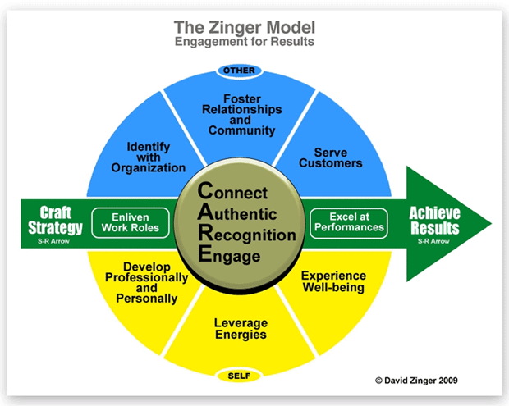
Figure 1: The Zinger Model of Employee Engagement
(Managementstudyguide.com, 2020)
According to Padhi (2015), employee engagement can be improved and facilitated using employee engagement models. These models are necessary and very effective for the firms to make the blueprint for understanding what are the elements that make the employees committed and enthusiastic. Among various employee engagement models, there are very common that is including The Zinger Model, The Deloitte Model, and The AON Hewitt Model.
Kusuma (2015), stated that the Zinger Model of employee engagement identifies and focuses on the core needs of the employees of an organisation. There are 10 essential elements and actions in this model and the managers of the firms concentrate on these ten determinates. These actions are divided into four rows where the bottom row is called necessities and enliven energy, make meaning, leverage strengths, and enhance well-being are the four actions in this row. Relationship building, fostering recognition, and mastering moments are the three actions of the second row called uniting the company. The third pyramid row includes maximising performance and marking progress and finally, the top pyramid has one action called achieving result.
According to Remo (2012), the Deloitte Model of employee engagement intends to create an organisational culture that ensures and facilitates employee involvement, respective traditions, and challenges. There is another significant model of employee engagement namely the AON Hewitt Model works with the strategies of employee engagement by creating a hostile environment inside the firms and ensures the relationship between employee engagement drivers and outcomes of the organisations.

Significance of Employee Engagement for Hotels
According to AbuKhalifeh (2013), among various types of business industries, the sector of hotel and tourism demands the highest level of employee engagement. This is because here in the hotels and restaurants, the customers and visitors directly observe and take services from the employees. So, if the employees are not eager to serve or seem unenthusiastic to the customers, then it will affect the number of customers and the profitability as well of the hotels.
According to Krishnan (2013), researchers have found that the hotels that have more employee engagement or have more engaged employees, make 14% more profit than ordinary hotels. Besides, engaged employees have a direct relationship with the customer satisfaction level of the hotels and restaurants. Around 35% of international hotels use and focus on ensuring employee engagement as their major business strategy.
Yadav (2019) stated that without ensuring employee engagement inside the hospitality industry, it is impossible to provide the customers with the best service and customer satisfaction decreases if the hotels do not have enough engaged employees and the rate of turnover of employees is 59% lower in the firms that have more engaged employees.

Measuring Employee Engagement and Reasons behind it
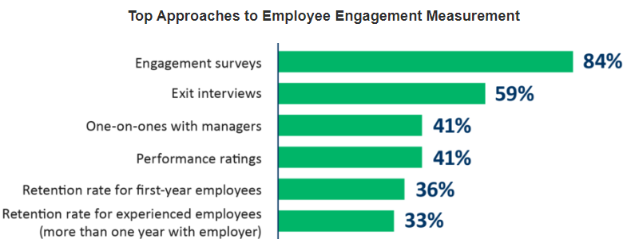
Figure 2: Employee engagement measures
(Shrotryia, 2019)
Some techniques of measuring employee engagement are including establishing engagement goals of the employees and these goals have to be clear, using engagement surveys, calculating eNPS, setting up virtual meets, checking retention, and looking at the productivity of the employees. According to Shrotryia (2019), surveys are the most effective ways to measure employee engagement as his study shows surveys have more success rate compared to other methods.
Kumar (2015), stated that measuring employee engagement has to be done to make sure the best use of this term. Engaged employees with high levels have 17% more productivity than usual and 21% more profitability. Besides, measuring should be conducted for identifying problematic areas, building trust, complete understanding of what is going on, and observing the trends.

Task 04

Evaluation, Summarisation, and Conclusion
After the post-pandemic crisis, the employees are noticeably demotivated and their level of engagement with their jobs and organisation has decreased significantly, especially in the hotel and tourism sector (Risley, 2020). This has become a major concern for international hotel management and to solve the issue related to lack of employee engagement, sufficient data is needed. for this, a particular organisation is selected called Richmond Hill Hotel. Primary data will be collected from the employees and managers of the hotel by participating in a survey and secondary data about employee engagement issues and their impact on international hotels and restaurants will be collected from online news portals, websites, and research that has been done previously by other researchers. That will be helpful to compare both the primary data and secondary data and provide the users of this research with a proper and accurate result. As in this research project, both primary and secondary data will be used with a mixed research method, the outcome of this research will be reliable enough and appropriate for further use of secondary data. This research project will help to eliminate the problems inside Richmond Hill Hotel related to lack of performance and employee engagement.

Bibliography
Abrams, L.S., 2016. Sampling ‘hard to reach populations in qualitative research: The case of incarcerated youth. Qualitative social work, 9(4), pp.536-550.
AbuKhalifeh, A.N. and Som, A.P.M., 2013. The antecedents affect employee engagement and organizational performance. Asian Social Science, 9(7), pp.41-46.
Connelly, L.M., 2014. Ethical considerations in research studies. Medsurg Nursing, 23(1), pp.54-56.
Crossan, F., 2013. Research philosophy: towards an understanding. Nurse Researcher (through 2013), 11(1), p.46.
Flanagan, J.C., 2018. A research approach to improving our quality of life. American psychologist, 33(2), p.138.
Gomez-Mejia, L.R., Balkin, D.B., Cardy, R.L. and Carson, K.P., 2017. Managing human resources. Upper Saddle River, NJ: Pearson/Prentice Hall.
GOV.UK, 2022. RICHMOND HILL HOTEL (OPERATIONS) LIMITED filing history - Find and update company information - GOV.UK. [online] Find-and-update.company-information.service.gov.uk. Available at: <https://find-and-update.company-information.service.gov.uk/company/07091174/filing-history> [Accessed 2 July 2022].
IZUHA, T., 2014. Some facts of Richmond Hill in the time of Turner's Richmond Terrace, Surrey. Journal of the Faculty of International Studies, Utsunomiya University, (38), pp.89-98.
Khodakarami, N., Dirani, K. and Rezaei, F., 2018. Employee engagement: finding a generally accepted measurement scale. Industrial and Commercial Training, 50(6), pp.305-311.
Krishnan, D.S.G. and Wesley, D.J., 2013. A study on the impact of employee communication on employee engagement level. International Research Journal of Business and Management.
Kular, S., Gatenby, M., Rees, C., Soane, E. and Truss, K., 2018. Employee engagement: A literature review.
Kumar, V. and Pansari, A., 2015. Measuring the benefits of employee engagement. MIT Sloan Management Review, 56(4), p.67.
Kusuma, P.G. and Madasu, S., 2015. 'A Great Place to Work': A comparison of Employee Engagement Practices of select companies with David Zinger Engagement Pyramid. Aweshkar Research Journal, 19(1).
Little, B. and Little, P., 2006. Employee engagement: Conceptual issues. Journal of Organizational Culture, Communications and Conflict, 10(1), pp.111-120.
Macey, W.H. and Schneider, B., 2018. The meaning of employee engagement. Industrial and organizational Psychology, 1(1), pp.3-30.
Mallick, M., 2022. The Downsides of Making a Counteroffer to Retain an Employee. [online] Harvard Business Review. Available at: <https://hbr.org/2022/05/the-downsides-of-making-a-counteroffer-to-retain-an-employee> [Accessed 2July 2022].
Managementstudyguide.com, 2020. Zinger Model of Employee Engagement. [online] Managementstudyguide.com. Available at: <https://www.managementstudyguide.com/zinger-model-employee-engagement.htm> [Accessed 2 July 2022].
McGhee, G., Marland, G.R. and Atkinson, J., 2019. Grounded theory research: literature reviewing and reflexivity. Journal of advanced nursing, 60(3), pp.334-342.
Nankervis, A.R. and Debrah, Y., 2015. Human resource management in hotels: a comparative study. Tourism Management, 16(7), pp.507-513.
Padhi, B., Panda, D. and Kumar, A., 2015. A study on employee engagement models for sustainability of organisation. Padhi, B. and Panda, AK (2015)." A Study on Employee Engagement Models for Sustainability of Organisation". International Journal of Research and Development-A Management Review (IJRDMR), 4(4), pp.79-85.
Remo, N., 2012. Comparing two models of employee engagement: An examination of antecedents and outcome variables.
Risley, C., 2020. Maintaining performance and employee engagement during the COVID-19 pandemic. Journal of Library Administration, 60(6), pp.653-659.
Saks, A.M. and Gruman, J.A., 2014. What do we know about employee engagement?. Human resource development quarterly, 25(2), pp.155-182.
Shrotryia, V.K. and Dhanda, U., 2019. Measuring Employee Engagement: Perspectives from Literature. IUP Journal of Organizational Behavior, 18(3).
Taherdoost, H., 2016. Sampling methods in research methodology; how to choose a sampling technique for research. How to choose a sampling technique for research (April 10, 2016).
Williams, C., 2017. Research methods. Journal of Business & Economics Research (JBER), 5(3).
Yadav, S. and Morya, K.K., 2019. A Study of Employee Engagement and Its Impact on Organizational Citizenship Behavior in the Hotel Industry. IUP Journal of Organizational Behavior, 18(1).

