
A China Joint Venture:
Pros and Cons

Student Name: Alina Mutoi
Student ID: 2028702
Course name: International Business Communications
Lecturer: Riaz Bhatti


Joint Venture

A business arrangement in which
two or more parties agree to pool their resources for the purpose of accomplishing a specific task (Investopedia, 2023).



Example of a joint venture:

A UK's brand clothing company
manufacturing products in China.

The fabric for the clothes is
imported from Bangladesh, the
design is produced in London, UK
and sent to China manufacturer
company to be stitched and
labeled.

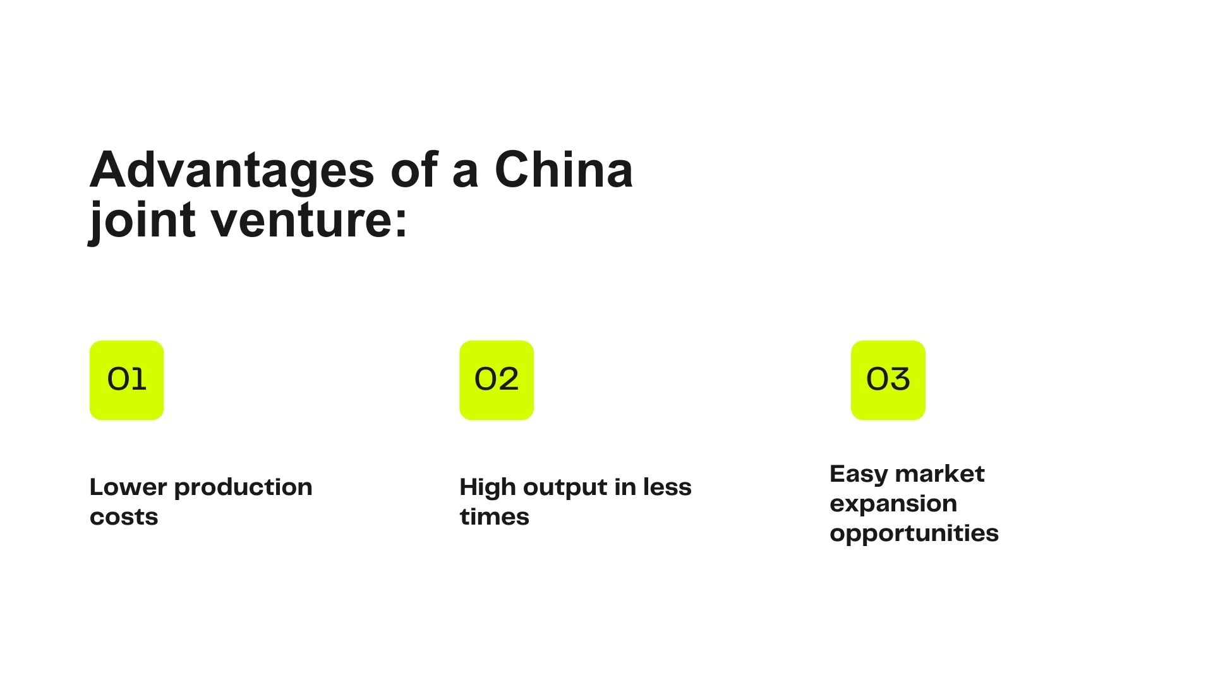

(Cad Crowd, 2023)

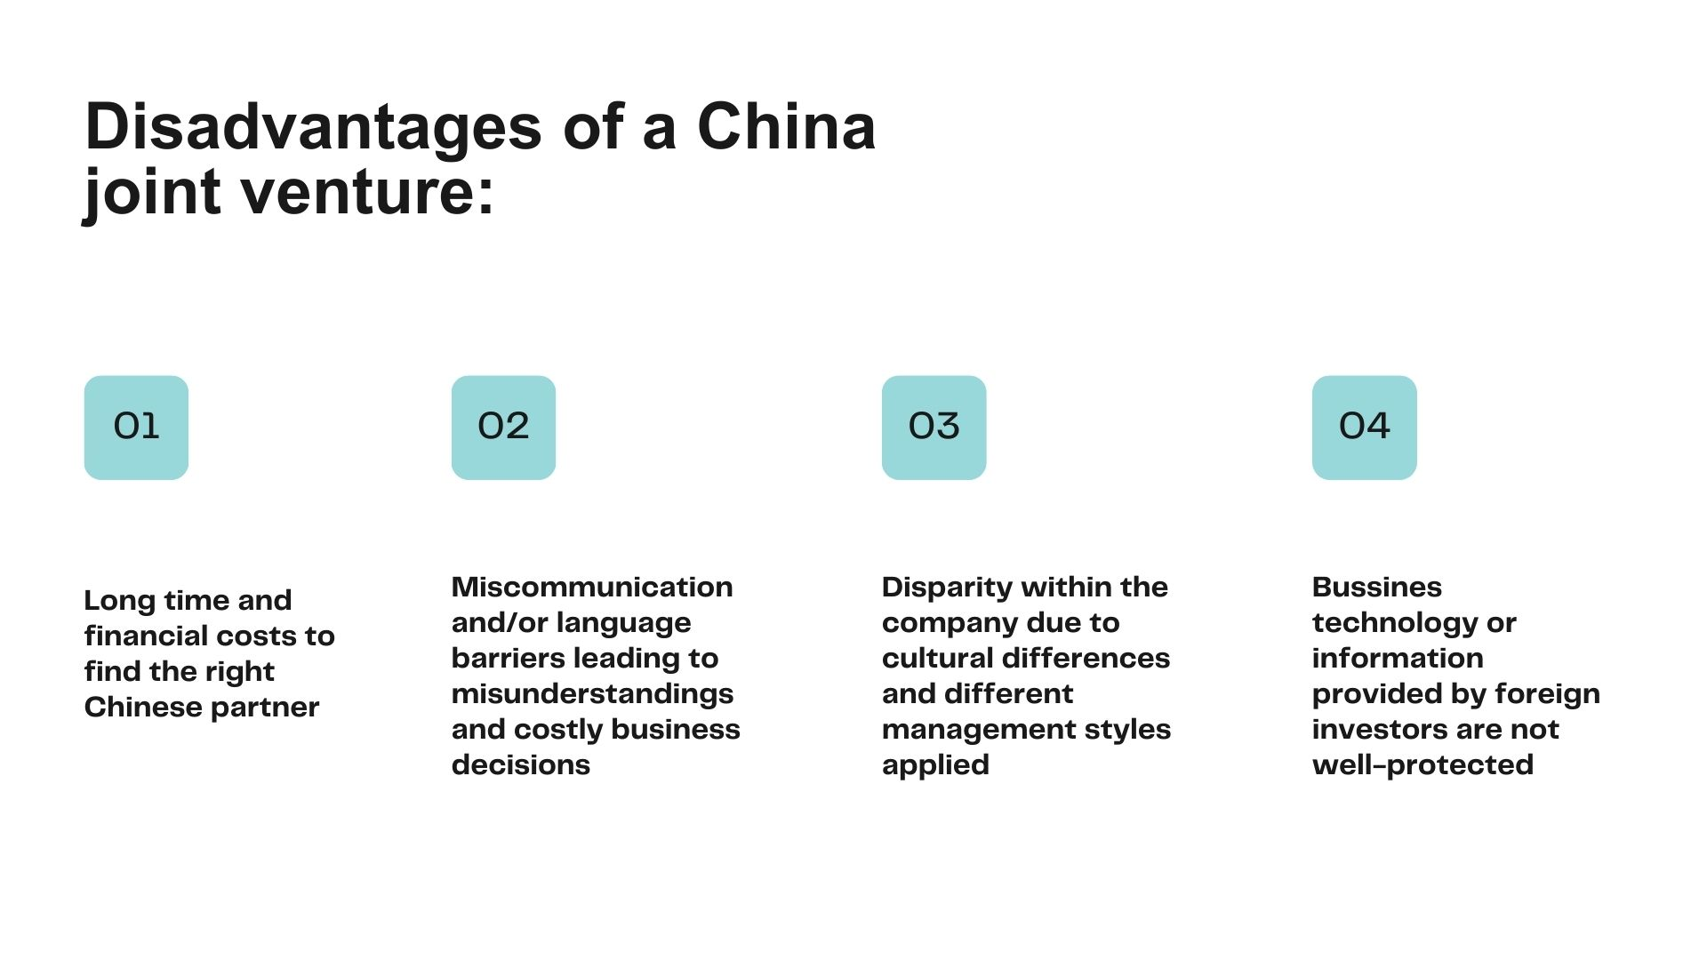

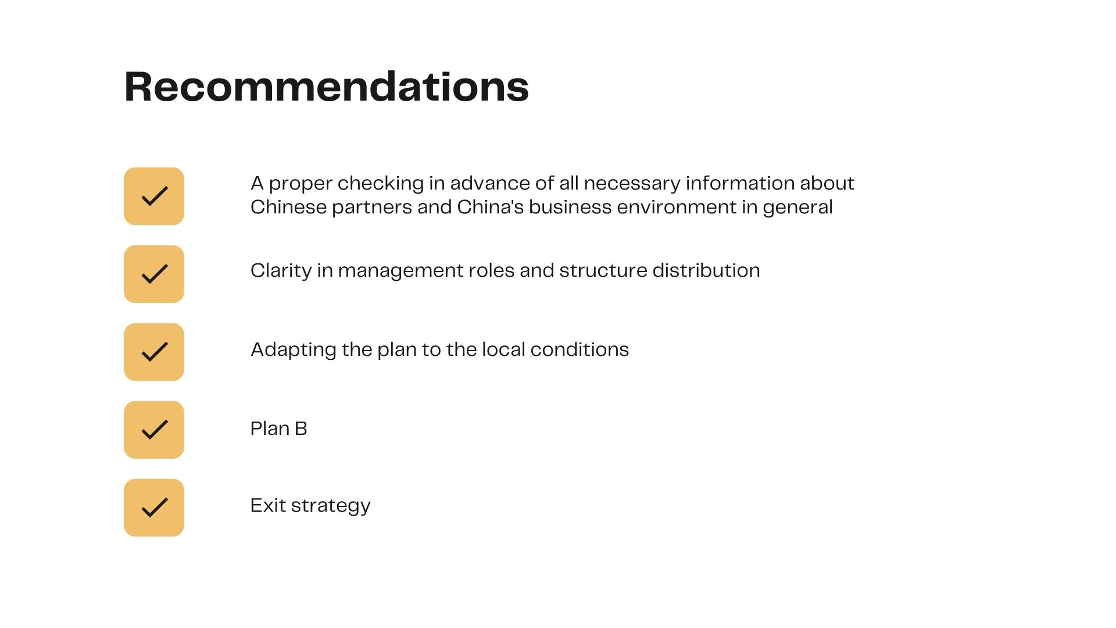
(Lang, N., Khanna, D. et al, 2016)
References:

- Cad Crowd, 2023. The Pros and Cons of manufacturing in China 2023. https://www.cadcrowd.com/blog/the-pros-and-cons-of-manufacturing-in-china/ (Accessed on 20th July, 2023)
- China Briefing, 2023. Setting up a joint venture in China. https://www.china-briefing.com/news/setting-up-joint-venture-china/ (Accessed on 20th of July, 2023)
- Investopedia, 2023. Join Venture (JV): What is it and why do companies form one? https://www.investopedia.com/terms/j/jointventure.asp (Accessed on 19th of July, 2023)
- Lang, N., Khanna, D. et al., 2016. How to successfully manage joint ventures in China. https://www.bcg.com/publications/2016/corporate-development-finance-how-to-successfully-manage-joint-ventures-in-china (Accessed on 21st of July, 2023)
- Lee, B., 2022. 14 Pros and Cons of starting joint venture in China. https://www.hongdaservice.com/blog/14-pros-cons-of-starting-joint-ventures-in-china (Accessed on 21st of July, 2023)
- S.J. Grand, 2023. Joint ventures in China: How to make your partnership successful? https://sjgrand.cn/joint-ventures-china-how-make-your-partnership-successful/ (Accessed on 23th of July, 2023)

