Module Assignment Submission
Cover Page

Student Name: | Emma Henderson-Wright
Student Number: | 1811453
Module No: | BMMB7012
Module Title: | Marketing Management.

Date submitted: | 29/06/2022
Time submitted: | 23:58
Statement of Confirmation of Authenticity
By the act of making this submission, the student declares that this is the work of the student named above. Where materials have been used from other sources it has been properly acknowledged. If this statement is untrue, the student acknowledges that an assessment offence has been committed. Proven incidents of plagiarism, collusion or cheating can result in a learner being withdrawn from a
qualification.
Attention is drawn to the Plagiarism, Collusion and Cheating Policy and Unfair Practice policies of the University and ILM.
Permission for ILM to use this script
ILM uses learners’ submissions – on an anonymous basis – for assessment standardisation. By submitting, both the centre and the learner agree that ILM may use this script on condition that identifying information is removed. However, if you are unwilling to allow ILM use this script, please refuse by ticking the box: □

Executive Summary.

The organisation is this report is Apple inc. In 2016 a terror incident occurred in San Bernardino. The terrorists were shot dead, but the FBI retrieved a mobile phone. Apple have end to end encryption on their iPhone, and they pride themselves on their digital security. The FBI approached Apple and asked them to hack into the phone for the benefit of the national security, if there was information on there relating to other terrorist groups or incidents the FBI needed to find it for the safety of everyone. Apple refused and the FBI had no other option than to start legal proceedings. Apple would not change their view, stating that it was their own legal obligation to their customers that they must keep their information safe. The FBI found someone who was able to access the information on the phone and dropped the legal proceedings. This issue has not been resolved. The FBI has asked Apple to give them backdoor access on their iPhones and Apple has refused. The recommendation that has been made that will be investigated in this assignment, is to find ways to strengthen the relationship with the government.

Contents
Executive Summary. 2
1.0 Introduction. 4
2.0 Main Findings. 4
2.1 The Marketing Concept. 4
2.2 The Macro and Microenvironments. 5
2.2.1 The Macro Environment. 5
2.2.2 The Microenvironment. 6
2.3 The Target Market. 8
2.3.1 Segmentation. 8
2.3.2 Targeting. 9
2.3.3 Positioning. 9
2.4 The Marketing Mix. 9
2.5 Marketing Media. 10
2.6 Measuring Success. 10
3.0 Conclusion. 11
4.0 Recommendations. 11
References. 12
Appendix 1 14
Appendix 2 15
Appendix 3 16
Appendix 4 17
Appendix 5 18
Appendix 6 19

1.0 Introduction.

During this report there will be critical analysis of Apple and their marketing strategy. There will be analysis of the macro and microenvironment using PESTLE, SWOT, and Porters 5 forces model. The target market will be sectioned and Segmentation, Targeting and Positioning will be analysed. The 7p’s model will be used in the marketing mix, marketing media and how to measure the successes of marketing on different medias will be evaluated. There will be a conclusion made and future recommendations. Any models will be placed in Appendices.

2.0 Main Findings.

2.1 The Marketing Concept.
The marketing concept is defined by Fahy & Jobber (2019) as the ability to accomplish the organisations goals by satisfying the needs of the customer and to outperform their competitors. Apple inc. is very successful at achieving this. According to Johnson et al (2012) Apple’s superb marketing strategy is to sell a lifestyle. Apple’s products sell themselves; their logo is simple and effective, their marketing is visual and without any jargon, or prices. Instead of baffling the consumer with technological facts, Apple sell emotions. Their adverts show happiness and simplicity. As the brand leader apple is in the position to tease the customer on their latest products. Apple will design adverts that create mystery, they want to raise the hype of the newest model. Apple’s loyal fans will be in anticipation for months. The loyal followers will sign up to new product releases before the item is on sale, so they can be the very first to have the latest model. Apple never market on price, they know that the customer loves the brand, they sell the emotion, and the customer pays the price willingly knowing that it will make them happy.

Dave (2018) agrees with Johnson et al (2012) Apple’s marketing strategy is superb. They know what the customer wants. The first iPhone in 2007 was marketed five months before release. The public were astounded that there was a device that could do the job of iPods, phones, and cameras all in one. The anticipation was palpable. Apple continue to create hype around any new releases. Advertising a new iPhone will see hundreds of people queuing outside Apple stores all over the world, without knowing how much it will cost. Their customers are loyal. From the beginning Apple has differentiated from its competitors. Their innovation means that they are continually moving forward. They keep designs hidden and bring out a new iPhone every year using the latest technology advancements. Apple are the brand leaders since their inception they have outperformed their competitors.

2.2 The Macro and Microenvironments.

2.2.1 The Macro Environment.

Dibb et al (2005) explains that environmental scanning and analysis is vital for marketers to be able to monitor any changes. The marketing department must be mindful of the evidence collected, it must be relevant and concise. If the organisation collects too much information, it could be difficult to analyse and that could lead to confusion. There are models available for examining the macro environment. The most popular model for environmental scanning is to conduct PESTEL analysis. PESTEL – Political, Economic, Social, Technological, Environmental and Legal. Jobber & Ellis-Chadwick (2019) agree with Dibb et al (2005) that there must be a scan of the environment. The marketing department must know if there are any potential changes that need action. This could include positive and negative aspects, any trends that could affect or increase the performance of the business.
PESTEL analysis has been conducted on Apple in Appendix 1. The recommendation of strengthening the relationship between Apple and the government is at the forefront of this analysis. Political – Apple seem to have constant issues with government agencies. Menn (2020) states that since the backlash of the San Bernardino shooting incident, Apple must try to avoid being portrayed negatively by these agencies. Political figures including the president at that time, were quick to share negatives on social media. The president tweeted that Apple protects violent criminals including those who have committed crimes against children. This would not be good for Apple’s marketing department who try to market the iPhones on emotions, TV adverts capturing happiness and bliss, which includes children and their families.
Economic -Barrett (2016) reports that since the San Bernhadino incident Apple has its first drop in sales since 2003. They state that this has coincided with the FBI being able to hack into the iPhone without assistance from apple. The FBI has therefore highlighted that Apple’s security may not be as safe as they say it is, which may be a concern to some users.
Social – loyal iPhone users have always wanted a premium product at any price. The latest iPhone is a status symbol. According to Seitz (2019) this is starting to change, the frequency and expense of the later models are not receiving the sales of earlier years. Instead, consumers are opting for the older models, which have very minute changes in appearance. The consumer is still having a premium product that looks as good as a newer model, but for a fraction of the price.
Technological – Apple is an innovative company and prides itself on its end-to-end data encryption. Fingas (2020) has reported that all is not what it seems, Apple does not have true end to end encryption because users do not hold encryption keys. This makes the data available to the police and at risk from hackers, meaning that the data is not as safe as Apple say it is. Apple have admitted that some elements of the iPhone, including the iCloud do not have end to end encryption, with many believing that this is due to the issues with the FBI.
Environmental – Apple continues to make environmental changes. Brown (2020) reports that Apple has made a change to the size of its packaging. This reduction in size would allow more items to be transferred, which in environmental terms equates to the removal of 450,000 cars from the road every year. The only way that the reduction can be made is to omit items from the box. The items removed are the plastic charging block and the wired earphones. Apple are under the impression that most Apple customers will already have these items and therefore it is a waste. Any customers that do not have these items have an option to purchase them directly from Apple. Apple’s change of eliminating the charging block and earphones was not received well, many customers fearing that Apple is trying to cash in. Many of Apple’s competitors were quick to take advantage of this scenario and decided to market their own products on the inclusion of these items when purchasing their brand. Environmental changes where the consumer does not lose any items may have a better reception.
Legal – Owsley (2017) states that Apple may encounter legal battles in the future. The FBI took Apple to court when they refused to unlock the San Bernadino shooters iPhone, this case was only stopped because the FBI paid for an external source to gain access. The FBI would have no option to start legal proceedings if this was to happen again, if necessary, they could take it to the supreme court. There is a chance that the FBI could start legal proceedings that would prevent Apple and its competitors from fully encrypting devices.

2.2.2 The Microenvironment.

Fahy & Jobber (2019) explain that the microenvironment is forces close to the organisation which can have an effect. These forces are not controlled by the organisation, however, if they are identified, there is a chance that the organisation can make decisions based on their findings. In some cases, they may be able to have some influence on them. Chernev (2018) agrees of the importance to marketing that a thorough microenvironment analysis is completed. There are two relevant frameworks that can be used. SWOT analysis, this is identifying and analysing all Strengths, Weaknesses, Opportunities and Threats, once they have been identified the marketing department can work on converting the weaknesses into strengths and the threats into opportunities. The second model is Porters Five Forces. The marketing department must identify and analyse 1- Bargaining power of suppliers. 2- Bargaining power of buyers. 3 – Threat of new entrants. 4 – Threat of substitutes. 5 – Competitive Rivalry.
SWOT Analysis has been conducted on Apple in Appendix 2. Strength – High brand recognition. Wijaya (2013) describes the Apple iPhone as being very recognisable as a high end, expensive product. It is a well-made, attractive device which is used as a status symbol. It is marketed as a lifestyle and appeals to customers who are trying to enhance their self-image. Weakness – High Prices. Tien et al (2019) compare both Apple and their competitor Samsung. Apple is marketed as a luxury device and its price is relative. Samsung have expensive models; however, they do have reasonable priced models, this enables sales to those customers who may not want to spend a lot, or a lower model could be purchased for children. Apple have released an affordable model previously the 5C and the iPhone SE. Apple would benefit by having a range of models, with a fair pricing structure. Opportunities – Virtual Reality. Technology advances very quickly, Kepuska & Bohouta (2018) explain that this brings opportunity to improve on Artificial Intelligence. A virtual assistant such as Apple’s Siri, who currently obey voice commands, could be improved. There is scope for innovation, this could be to heighten the interactions that can be made between humans and machines. Machines could have the potential to respond to gestures, facial expressions, and touch in the future. This would be a great marketing tool for Apple. Threats – Supply chain disruption. According to Sawik (2022) Apple iPhones are made all over the world including Thailand, China, and the Czech Republic, however, the component parts are supplied from 43 countries. Any supply chain disruption can have a huge impact on Apple. During the Covid-19 pandemic there has been supply chain issues. The results of these issues meant that Apple lost around $6 billion when they lost the sales for approximately 10 million iPhones. If Apple could use more local suppliers, this could potentially alleviate some supply chain disruption and it would be a great marketing tool especially for their carbon footprint and corporate social responsibility.
Porters Five Forces has been analysed and can be found in Appendix 3. Bargaining power of suppliers. According to Chernev (2018) for the supplier to have power over their competitors they need to have little competition themselves and has high switching costs. Van De Vliert (2021) agrees that is when suppliers are strong, however, in the case of Apple they are fortunate that there are different suppliers available. If Apple should choose to, they can negotiate with their current suppliers to get a better rate. Bargaining power of buyers. Chernev (2018) states that if a product has little difference between them and are low cost to switch to, then the buyer holds the power. Van De Vliert (2021) agrees that the buyer is powerful in this circumstance. Apple’s competitors, such as Samsung and Huawei, make products that are very similar to Apple’s iPhone, and there is also a financial difference, the competitors are often considerably lower in price. The buyer holds the power as they could simply switch to one of Apple’s competitors. Apple relies on its strong marketing team to push its brand loyalty. Threat of new entrants. Chernev (2018) explains that there is a chance that there can be new entrants into the market. The power is affected by the ability of other competitors starting in the same market. Khan et al (2015) agrees that there is always a chance of new entrants, however, heavy costs will limit this in Apple’s case. New entrants would be a low threat to Apple. Apple has a loyal brand following. Apple has many patents and copyrights and therefore, there can not be any direct replicas. Threat of substitutes. Chernev (2018) states that a threat of substitutes is only a threat if there are items that can provide the same service or product. Kabeyi (2018) thinks that the only similar product to Apple would be a tablet. A tablet has similar functions and enable the user to do some of the things that they do on the iPhone, but not all. The threat of substitutes for Apple is low. Competitive rivalry. Chernev (2018) explains that the similar the competitor, same products, same price, same marketing strategy, the stronger the rivalry will be between them. Berendt et al (2018) researched many brands including Apple and its closest rival Samsung. They believe that rivalry among competitors can be a positive and it can meet a main objective of marketing which is making the brand distinctive. Competitive rivalry can draw attention to both organisations, the marketing department should engage in light-hearted banter, on social media for example which will help raise both profiles.

2.3 The Target Market.

2.3.1 Segmentation.

Larsen (2010) explains that market segmentation is splitting the market into sections/groups. This is to determine that the organisation can target the right people. These groups will be divided into four categories. Demographics, including Age, Gender, Education, Occupation etc. Geographics, including City, population, region etc. Psychographics, including Values, Lifestyle, Attitudes etc. Behavioural, including Benefits, Usage, Life Cycle of the product. Perner (2013) warns that it will not be possible to please everyone. There can be some difficult choices, however, these must be narrowed down and specifically targeted to give the organisation the best results. Laugesen & Yuan (2010) state that out of the four categories, Apple concentrated on Demographics. The iPhone was originally targeted at males who were between twenty-five and thirty-four years old, who had a college education and earned on average $100,000 per year. In a later survey this was confirmed, and the results showed that 50 percent of iPhone customers were aged under thirty and in professional industries.

2.3.2 Targeting.

Deciding who the organisation targets is a critical marketing decision. There can be conflicting information and similarities that can make the decision difficult. There are tools available for complex cases such as the Analytical Hierarchy Process (AHP) which is a mathematical model, that is logically arriving at the most suitable choice. Aghdaie & Alimardani (2015) agree that targeting the correct audience is vital. They believe Apple have targeted the correct demographic. While their competitors were targeting businesses, Apple had segmented the market and through research established that personal use, with a younger technologically advanced audience was stronger than business use.

2.3.3 Positioning.

According to Kostelijk & Alsem (2020) brand positioning is the customer placing the organisation where they believe they deserve to be in the market. To be in a good position the brand must be strong and have an impact on the consumers. Lee et al (2016) states that marketing analysts will rely on information from customers and competitors to be able to identify where the consumers are putting Apple on the perpetual map. The perpetual map in Appendix 4, will show that Apple is in the top left corner as it has a wide product range and a high price.

2.4 The Marketing Mix.

Jain (2013) describes the marketing mix model 7P’s as being an exceptional marketing tool. This model allows the marketing analyst to break down the information into sections for thorough examination and establish what the customer wants. The 7p’s consist of Product, Price, Place, Promotion, People, Processes and Physical Evidence. Jain (2013) states that the 4p’s are as useful as the 7p’s. Akroush (2011) disagrees with Jain (2013) stating that 4p’s have been highly criticised and it is imperative to add the extra 3p’s to the model for it to be successful. The 7p’s model in Appendix 5 has been used for Apple inc. Product – As shown in the perpetual map Apple have a wide range of products, starting originally with computers. Apple marketed the iPhone in 2007 Dala-Ali et al (2011) and has since progressed to items that sync together such as headphones and watches. Price – Apple products are expensive, they price them high and then reduce as necessary, Huimin & Hernandez (2011) refer to this as skimming. Place – Apple is a global organisation, and they use other companies such as Curry’s and Argos to resell their products Apple.com (2022). Promotion – Apple products are advertised on social media platforms, through television advertising, on billboards, they have a high street presence and allow celebrities and the media to do product placement Devlin & Combs (2015). People- Apple is highly regarded for having excellent customer service staff and highly trained technical support officers Johnson et al (2012). Processes – Apple has simple processes, ordering a new device is simple and can be done instore or online, they have technical staff on hand and will guide customers to their wide range of phones and devices Apple.com (2022). Physical Evidence – Apple have a loyal following, they have always been customer central with their main aim being to ‘make neat stuff’ customers continue to stay loyal to Apple, continually upgrading and adding new devices Pinson & Brosdahl (2014).

2.5 Marketing Media.

As stated above by Devlin & Combs (2015) Apple use product placement as well as other media advertising. This has always been successful in showing off their products, particularly with celebrity endorsements. Karniouchina et al (2011) agrees that there is still a market for product placement, despite it first starting forty years ago it is as effective as ever. It is worth noting that only 29% of product placements are paid, many companies are more than happy to give products away for free. Another popular media outlet for Apple is social media. Social media platforms are favoured due to the fact there can be interactions with loyal followers, new customers, and staff. On sites such as twitter there can be interaction with other organisations and celebrities. There is an opportunity for customers to contact a customer service agent through messenger and have an immediate response. These platforms build relationships with consumers, allowing two-way private conversations as well as group conversations on main pages, Alves et al (2016).

2.6 Measuring Success.

Technology is so advanced that it can give organisations a wealth of data. Many organisations use a Customer Relationship Manager, any information for that customer is electronically logged and available to anyone in the organisation that has access to that system. As stated above most organisations have a social media platform. According to Sterne (2010) he data available from that is immense. Organisations can measure the traffic to the site, see the interactions with the pages, quantify likes, comments, and shares. Hoffman & Fodor (2010) state that organisations want to know their return on investment and if their marketing is being successful, and as much as they want quantifiable data it is just as important that they have interactions with their customers on these platforms, this links with building relationships through media marketing above.

3.0 Conclusion.

This report has focused on Apple and their marketing strategy. There has been analysis of the macro and microenvironment using PESTLE, SWOT, and Porters 5 forces model. The target market was sectioned, and Segmentation, Targeting and Positioning was analysed. The 7p’s model has been used in the marketing mix, marketing media and marketing on different medias has been measured. Future recommendations have been made. Any models have been placed in Appendices.

4.0 Recommendations.

It is important that Apple attempt to move forward after the San Bernardino shootings. The SOSTAC model, Smith et al (1999), in Appendix 6 has been used. The recommendations are that Apple, and the government agencies try to find a middle ground that will satisfy them, Apple, and the customers. The current situation is that there has not been any resolution so far, the objectives are to find an agreement that suits all parties and the strategy for this is to communicate effectively. Social media would be the ideal platform as this is transparent and measurable using quantitative and qualitative data retrieved from the platform’s technology.

References.

AGHDAIE, M.H. and ALIMARDANI, M., 2015. Target market selection based on market segment evaluation: a multiple attribute decision making approach. International Journal of Operational Research, 24(3), pp. 262-278.
AKROUSH, M.N., 2011. The 7Ps classification of the services marketing mix revisited: an empirical assessment of their generalisability, applicability and effect on performance evidence from Jordan’s services organisations. Jordan Journal of Business Administration, 153(3141), pp. 1-32.
ALVES, H., FERNANDES, C. and RAPOSO, M., 2016. Social media marketing: a literature review and implications. Psychology & Marketing, 33(12), pp. 1029-1038.
Apple.com., 2022. Accessed 12/06/2022
BARRETT, D., 2016. FBI Plans to Keep Apple iPhone-Hacking Method Secret; Move would likely keep Apple in the dark about security weakness. New York, N.Y: Dow Jones & Company Inc.

BERENDT, J., UHRICH, S. and THOMPSON, S.A., 2018. Marketing, get ready to rumble—How rivalry promotes distinctiveness for brands and consumers. Journal of Business Research, 88, pp. 161-172.

BROWN, A., 2020. ‘It’s not just iPhone 12! Apple has also ditched the charger from iPhone 11, iPhone SE, Xr’, Express (Online).
CHERNEV, A., 2018. Strategic marketing management. Cerebellum Press.
DAVE, J.G., 2018. A Case Study on Marketing Strategy: Apple i-Phone. IJRAR-International Journal of Research and Analytical Reviews (IJRAR), 5(4), pp. 106-114.
DEVLIN, M. and COMBS, J., 2015. From Apple to Omega: an analysis of brand placement in 2010 top-earning films. Journal of Global Scholars of Marketing Science, 25(1), pp. 75-90.
DIBB, S., SIMKIN, L., PRIDE, W.M. and FERRELL, O.C., 2005. Marketing: Concepts and strategies. Houghton Mifflin.
FAHY, J. and JOBBER, D., 2019. EBOOK: Foundations of Marketing, 6e. McGraw Hill.
FINGAS, J., 2020. Apple reportedly dropped iCloud encryption plans amid FBI pressure. New York: AOL Inc.
HOFFMAN, D.L. and FODOR, M., 2010. Can you measure the ROI of your social media marketing. MIT Sloan management review, 52(1), pp. 41-49.
HUIMIN, M. and HERNANDEZ, J.A., 2011. Price skimming on a successful marketing strategy: study of iPad launching as Apple’s innovative product, Proceedings of the 8th International Conference on Innovation & Management 2011, Japan, pp. 389-393.
JAIN, M.K., 2013. An analysis of marketing mix: 7Ps or more. Asian Journal of Multidisciplinary Studies, 1(4), pp. 23-28.
JOBBER, D. and ELLIS-CHADWICK, F., 2019. EBOOK: Principles and Practice of Marketing, 9e. McGraw Hill.
JOHNSON, K., LI, Y., PHAN, H., SINGER, J. and TRINH, H., 2012. The Innovative Success that is Apple, Inc.
KABEYI, M.J.B., 2018. Michael porter’s five competitive forces and generetic strategies, market segmentation strategy and case study of competition in global smartphone manufacturing industry. IJAR, 4(10), pp. 39-45.
KARNIOUCHINA, E.V., USLAY, C. and ERENBURG, G., 2011. Do marketing media have life cycles? The case of product placement in movies. Journal of Marketing, 75(3), pp. 27-48.
KEPUSKA, V. and BOHOUTA, G., 2018. Next-generation of virtual personal assistants (microsoft cortana, apple siri, amazon alexa and google home), 2018 IEEE 8th annual computing and communication workshop and conference (CCWC) 2018, IEEE, pp. 99-103.
KHAN, U.A., ALAM, M.N. and ALAM, S., 2015. A critical analysis of internal and external environment of Apple Inc. International Journal of Economics, Commerce and Management, 3(6), pp. 955-961.
KOSTELIJK, E. and ALSEM, K.J., 2020. Brand positioning: Connecting marketing strategy and communications. Routledge.
LARSEN, N., 2010. Market Segmentation. Aarhus School of Business, .
LAUGESEN, J. and YUAN, Y., 2010. What factors contributed to the success of Apple's iPhone? 2010 Ninth International Conference on Mobile Business and 2010 Ninth Global Mobility Roundtable (ICMB-GMR) 2010, IEEE, pp. 91-99.
LEE, A.J., YANG, F., CHEN, C., WANG, C. and SUN, C., 2016. Mining perceptual maps from consumer reviews. Decision Support Systems, 82, pp. 12-25.
MENN, J., 2020. Exclusive: Apple Dropped Plan for Encrypting Backups after FBI Complained Sources. Reuters, January, 21.
Owsley, B.L., 2017. Can Apple build a privacy minded iPhone security system so secure that Apple cannot access it?. Health and Technology, 7(4), pp.369-376.
PERNER, L., 2013. Segmentation, targeting and positioning. Cell, 213, pp. 304-1726.
PINSON, C. and BROSDAHL, D.J., 2014. The Church of Mac: Exploratory examination on the loyalty of Apple customers. Journal of Management and Marketing Research, 14, pp. 1.
SAWIK, T., 2022. Stochastic optimization of supply chain resilience under ripple effect: A COVID-19 pandemic related study. Omega, 109, pp. 102596.
SEITZ, P., 2019. Apple Customers Voting With Their Wallets For Cheaper iPhones. Los Angeles: Investor's Business Daily, Inc.
SMITH, P.R., SMITH, P.R., SMITH, P., BERRY, C. and PULFORD, A., 1999. Strategic marketing communications: new ways to build and integrate communications. Kogan Page Publishers.
STERNE, J., 2010. Social media metrics: How to measure and optimize your marketing investment. John Wiley & Sons.
WIJAYA, I.M., 2013. The influence of brand image, brand personality and brand awareness on consumer purchase intention of apple smartphone. Jurnal emba: jurnal riset ekonomi, manajemen, bisnis dan akuntansi, 1(4),.
VAN DE VLIERT, D., 2021. Apple iPhone: a market case study.

Appendix 1

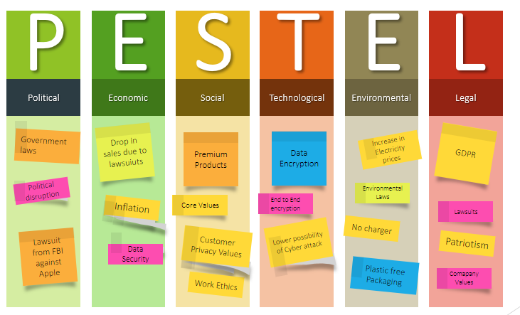

Appendix 2

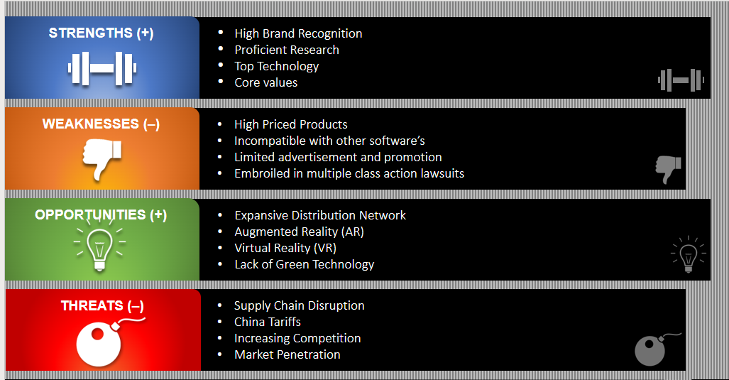

Appendix 3

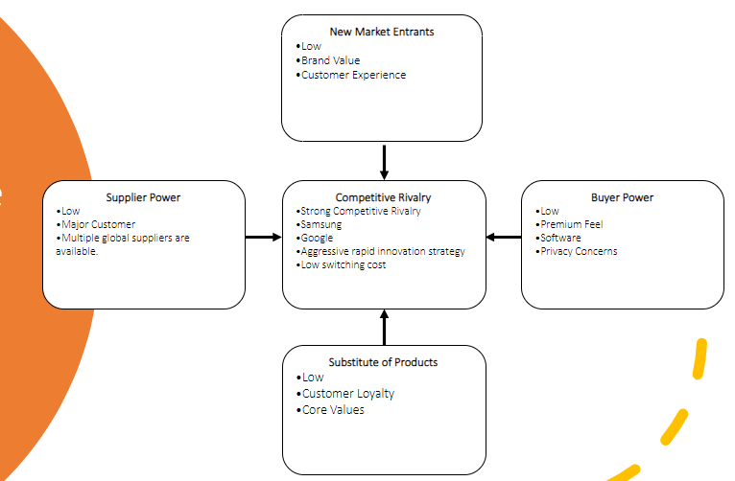

Appendix 4

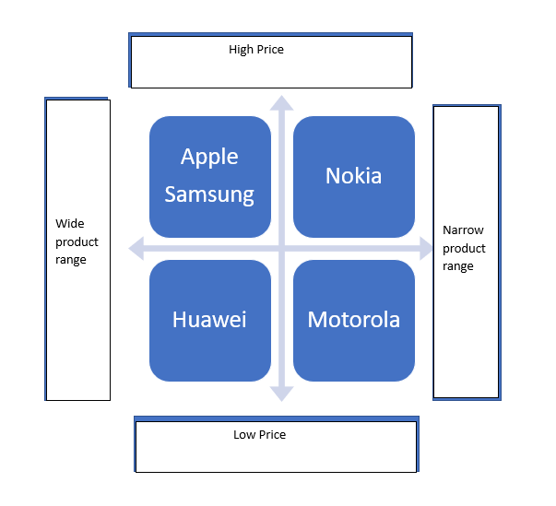

Appendix 5

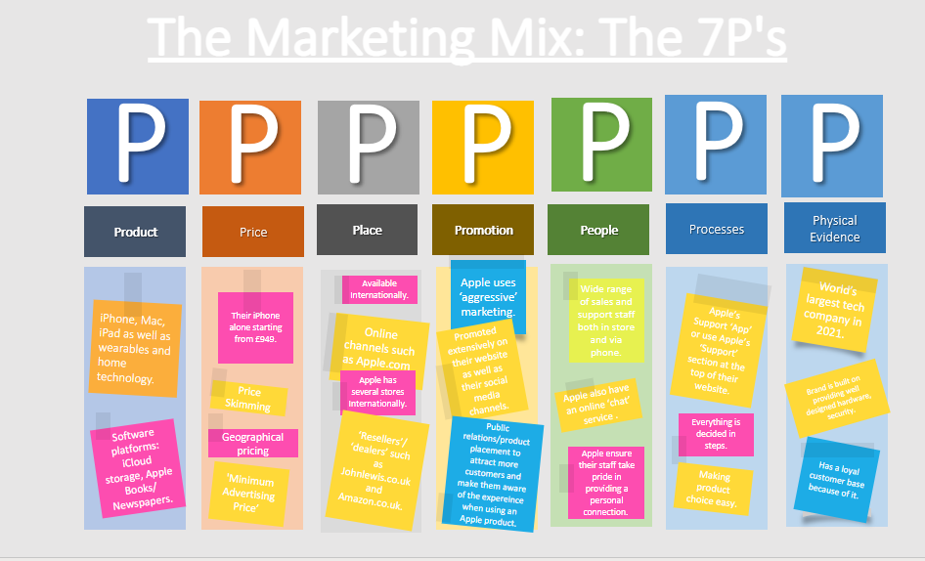

Appendix 6



