Continuing Professional Development (BMPF7001)

Wendy Laurita Davies
  - Student ID: 2131403

CONTENTS
 | Title
Assignment | How the influence of leaders of my past have developed me into the leader I am today.
Appendix 1 | Annotated Curriculum Vitae
Appendix 2 | Annotated Job Description  Project Manager Workforce Planning
Appendix 3 | Strengths, Weakness, Opportunities & Threat Analysis
Appendix 4 | Training Needs Analysis
Appendix 5 | Personal Development Plan
Appendix 6 | Myers-Briggs Typefinder  self-assessment
Appendix 7 | Kiersey Temperament Sorter  self-assessment
Appendix 8 | Honey & Mumford Learning Styles Questionnaire self-assessment
Appendix 9 | Capability Matrix Assessment
Appendix 10 | Workforce Planning Meetings Schedule
Appendix 11 | Strategic Workforce Planning Team Audit
Appendix 12 | VARK Questionnaire – Learning Style

Wendy Davies – Module BMPF7001
Leaders and me.
Reflective review - How the influence of leaders of my past have developed me into the leader I am today. This module Continuing Professional Development has required me look back over the last three decades of my career to help me understand what has moulded and shaped me into the person who am I today and how have I got here by their influence.
Albert Bandura’s psychological theory in his book published in 1977 titled “Social Learning Theory” gives emphasis on how observational learning, imitation, and modelling of one’s own behaviour is influenced by past experiences.
This resonates deeply with me when I reflect on leaders of my past during the span of my career and how their behaviours and traits have influenced my leadership style and the leader that I am today and leader I wish to be in the future.
I started in the Health Board as a volunteer 32 years ago with very little in terms of academic attainment, but since then I have taken every opportunity to grow, learn and develop myself professionally to allow me to rise through the hierarchal structure into my current role of Project Manager for Strategic workforce planning in Hywel Dda University Health Board. I was fortunate to gain my present position through parity of esteem when compared to the rest of my colleagues whereby my extensive vocational experience was considered to be equal to that of the essential academic education required for the role.
Whilst I do seem to present as an extrovert I do actually struggle with self-belief, and I have first-hand knowledge of working through highs and lows of work life.
Throughout the first 5 years of my NHS career, I was managed by 2 exceptionally poor managers. They had management styles and traits that contrasted with someone who I most definitely did not want to be. They lacked compassion, kindness and understanding and there one of particular to note.
As described by Kellerman in 2004, bad leadership can be grouped into 7 categories: incompetent, rigid, intemperate, callous, corrupt, insular, and lastly and most chillingly, evil. This is not a word to use loosely, however as a young 22 year old pregnant employee who had been only married 1 year and just taken on a mortgage and who was moved to another department due to financial cut backs and not at their own request, who says to their new manager full of hope, optimism and gratitude “ they say as one door closes another one opens” for them to hastily reply with such look of distaste written across their face and in reply with such venom says “ they also say as one door closes another slams shut right in ones face”. That feeling of rejection still haunts me to this day, and remembering how that made me feel on my first day was awful due to their heinous behaviour. There was no empathy or emotional intelligence displayed at all. I was elated and overjoyed when I returned from maternity leave to discover they had retired.
It was here at this pivotal point in my life; now as a wife and mother, I felt ready to develop and I aspired to move into supervisory roles and as part of this journey and self-discovery I started to consider transformational leadership and I learnt of the work of Bass, Avolio and Atwater (1996).
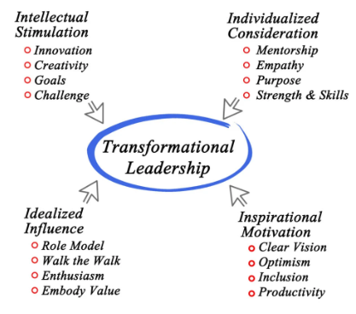

I wanted to become a transformational leader in a role where I could be a role model, able to motivate others and in a lifelong career that would encourage critical thinking, but a role that also showed empathy and purpose. Therefore, to have the job satisfaction I desired and be employed in an occupation that brought opportunity, hope, and optimism to others; I knew at that point I wanted to work with people for people and there started my career in Human Resources.
So, I left the world of finance and moved into the Workforce and Organisational Design Directorate under the leadership of Andrea Thomas who was Head of Agenda for Change Terms and conditions of service at that time. The NHS in 2004 introduced a whole new pay grading system nationally for all health workers (other than doctors and dentists). As part of this national work for this transformational agenda, all staff groups, and all job roles across the NHS function; with the exceptions above, had to have their job descriptions re-written and job evaluated under the new pay band deal. As you can imagine this work was very sensitive, and very difficult to manage and high powered. Health Board employees across the whole of the UK Executive Directors to Domestics, were awaiting the outcome of how much they were going to be paid as part of the new pay deal, and, wanted to know what this was going to mean to them personally and remuneration they were going to receive. Salaries are always a very emotive subject and some salaries increased, and some did decrease, the calmness in her approach and her ability to manage the room in a non-adversarial manner ensured meetings ran smoothly and expectations managed delicately, sensitively even in hostile circumstances.
Under Andrea’s management she always instilled a sense of calm amongst the raging chaos. She was always, kind, genuine, sincere, and embodied all the characteristics that Bass, Avolio and Atwater (1996) alluded to Idealised Influence, Intellectual Simulation, Individualised Consideration and Inspirational Motivation. I was privileged to be under the management of a transformational leader and understood exactly what their theory meant in practice.
Not only was Andrea a transformational leader she also drove the transformation agenda within the organisation but also with compassion. A transformational compassionate leader. We worked together on many whole organisational change projects for more than a decade together. Every day that I worked under her management by natural osmosis I could hear myself talking her words and I modelled my professional behaviour on hers, and I still do to this day.
It was Andrea who encouraged me to return to academic learning. She had belief in me and gave me the courage to walk through those college doors knowing that if I was going to be able to share my knowledge and be a leader of others; I would need the qualification and theory behind me as well as the practical vocational knowledge. I required a Human Resources Qualification to allow me to progress. At the age of forty-five I returned to learning and in 2018 I successfully obtained the Level 5 CIPD qualification and became an Associate member of the CIPD. My graduation day epitomised as much a success for her as it was I she was as proud of me as my family were.
Compassionate leadership involves a focus on relationships through careful listening to, understanding, empathising with, and supporting other people, enabling those we lead to feel valued, respected, and cared for, so they can reach their full potential and do their best work. There is clear evidence that compassionate leadership results in more engaged and motivated staff with high levels of wellbeing, which in turn results in high-quality care. (West 2021)
Andrea was the first leader who I admired. She is an exemplary person and there was a solid professional psychological contract (Guest, Isaksson, Witte, 2010) in place between us both and I was suitably challenged and happy and under her management.
Under her management I managed aspects of large-scale quality improvement projects such as the implementation of the Hywel Dda Staff Benefit Strategy, and more broadly on the regional scale; I managed the introduction of the E-Expenses system into the Health Board from regional procurement through to implementation. I managed and coordinated wide scale service change management. Always working in unison and in collaboration with internal and external stakeholders, staff side trade union representatives. This Health Board wide initiative allowed the movement from paper to an electronic based claiming process. I also designed and delivered training material to all disciplines from Band 2 to the Executive Team wide and provided regular progress and update reports implementing improvement measures when necessitated. My role was always kept varied and I enjoyed every new day and the challenge that it presented.
In 2020 Andrea was successful in obtaining a new role at an All-Wales Level, and at a similar time the role that I am currently in was also advertised. Again, it was Andrea who gave me self-belief to put in the application form. I had at this point over 15 years of managing wide scale projects and now with my HR qualification I was in a position to allow me to apply. With her glowing reference I was successful in my current appointment of Project Manager – Workforce Planning under the management of Tracy Walmsley, within the Workforce Directorate.
Having reflected on Andreas management of me, and even though I moved out from under Andreas management in 2020 she is still my inspiration, confidant, sounding board and friend and someone who I will continually look up to. She helped me to believe in myself and my capability and on her foundation the building blocks of my career were cemented.
When I moved into my current role not only did, I apply for the job, I also applied to be managed by a likeminded manager like the one that I had just left. Tracy inspired me and she too was admired as being a self-aware, compassionate leader and who is well-liked by her peers and her subordinates alike. I knew I would be working in a psychologically safe environment. After my appointment and in my first one to one session with Tracy as my manager she asked me why I had not progressed with my career sooner; and I informed her that staff do not leave jobs, they leave bad managers, and I had a good one so was content to stay where I was.
On reflection I had become perhaps too comfortable, and I was not being challenged enough. Even though I had taken on personal development Andrea moving into a new role outside of the organisation was the catalyst of change I needed to allow me to progress both personally and professionally and take on new tasks to stretch me. I was content prior to learning, and I did not explore new opportunities or had considered an exit strategy that leaded towards a promotion – but this was not for the want of Andrea encouraging me.
Belbin (2010) affirms “A good team leader treats members of a team like actors on a stage. There need to be exits and entrances. Not everyone is required to be on the stage at the same time”.
I was going to be part of new Team of 4. We were all going to be starting on an equal footing as my colleagues and I all came from different backgrounds that could complement each other well; and we continue to do so – we are and continue to be a formidable team.
Anna came from NHS clinical background and was an Operating Department Practitioner by profession, Mia was an external applicant from private practice and private industry with a specialist interest in Data and analytics, Shelley came from an NHS educational and training background, and I brought project management, 28 years operational health board knowledge; specialising in workforce NHS terms and conditions of service and Job Evaluation. When considering the 6 Steps Methodology for NHS workforce Planning framework developed by Skills for Health Wales and Health Education Improvement Wales for use in NHS practice, the 4 of us as a unit we almost made up each of the elements of a workforce plan with our offer.
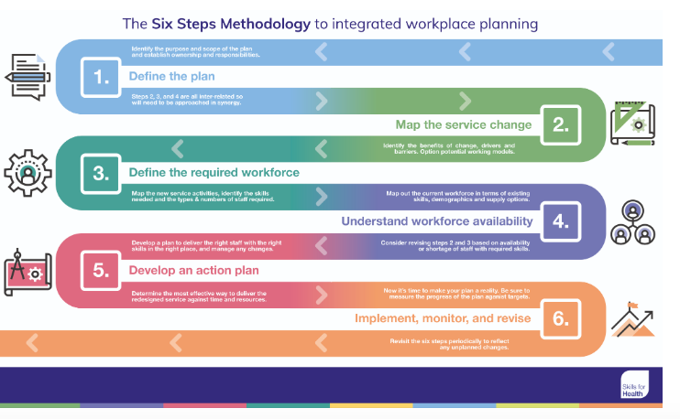
As applicants we all did not have the Workforce Planning Post Graduate Certificate as this is a very niche area, therefore we were all progressed on Hywel Dda Health Boards Annex 21 developmental trainee pathway.
Tracy is a very visible, authentic, and supportive manager. We are given the autonomy and trust and have been from the early outset to find our way and make the job our own. As a team we are not managed with traditional hierarchical methodologies, but with a compassionate approach. We have daily catch ups and weekly team meetings so that ‘worry beads’ can be shared, defined, understood, and explored and a team member with the best skillset to tackle the issue will progress with the work. There is never a feeling of isolation or a fear of asking a stupid or wrong question.
In the published book of Michael West he confirms “Compassionate leadership helps to create psychologically safe working environments by encouraging team members to share learning and improve the quality of their work through regular reviews” (West 2021). Regular touchpoints and opportunities to collaborate are of great importance and valuable to our team and important for my development.
The NHS has seen a huge shift when it come to workforce, culture and leading with compassion. This is also acknowledged by the Kings Fund and also In the Future Healthcare Journal of Bailey and Burhouse where it states that it is recognised that “The NHS Long Term Plan recently published recognises the critical role of leadership to the delivery of high-quality, sustainable healthcare and sets out an ambition for compassionate and inclusive leadership behaviours”.
Developing more measured, compassionate, and supportive leadership has many advantages and can lead to improvements in all aspects of the NHS. The NHS is an employer who provides care, so compassion is paramount both for improved patient outcomes and better for our staff.
This too was a finding of Dr Christian Turner as part of campaign to raise awareness amongst healthcare professionals regarding the impact of incivility has on teamwork and patient outcomes, and where no compassionate leadership exists. As a development opportunity I had the opportunity to attend one of his events. Being civil to one another should come naturally but sadly in times under such pressure it does not, and that is the time it needs to happen the most. This can have a life and death impact on patient outcomes.
According to research undertaken by Atkins and Parker in 2012 Compassionate Leadership involves a focus on 4 key behaviours: Attending, Understanding, Empathising and Helping.
In 2021 and in the middle of the COVID pandemic my world shattered around me. I was diagnosed with breast cancer. Following this diagnosis and as part of my treatment plan I required six rounds of chemotherapy, eighteen rounds of immunotherapy and a double breast mastectomy. I had moved into a new job role; the NHS was inundated and the need for workforce planning was at its maximum. There were in uncertain times due to the ongoing management and delivery of medical interventions, I had become unwell, and the team would be reduced to 3.
When I informed the team of my diagnosis; whilst I was of course concerned for my own health, I was also concerned about how my absence from the workplace was going to affect my colleagues and the team. Tracy true to type as a compassionate leader even with the pressures on the team was so poised, supportive and was happy for me to approach my condition on my terms and allowed me to dictate what work was going to look like. I continued to work through my treatment and as my absence was so well managed by her, I never felt that there were long periods where I was in touch with the team. I was allowed to participate and still undertake meaningful work – but protected from the daily anarchy that COVID was causing.
Conclusion
Andrea and Tracy with their transformational and compassionate leadership style has developed me into the leader who I am today and will always draw on the knowledge and wisdom that they imparted to me.
I model both their behaviour, and I am a compassionate leader, who is considerate, kind and one who always will focus on giving hope. I am dedicated and committed to Hywel Dda and with longevity in employment myself; I want to be the person to make a difference for our staff and to help them grow and develop creating opportunities through workforce plans that also will enable them to have long satisfied careers. I am a strategic thinker, and I can identify and address retention challenges; and I am adept at making well rounded decisions with deep rooted understanding. I understand the importance of positive employee experience and engagement, including the person-centred approach and how to deal with the management of those facing adversity.
I agree with Goleman (2020) that “Leadership is not domination, but the art of persuading people to work to a common goal”.
In my current role I will always strive to be a compassionate leader just as those who I have modelled my behaviour on. I will take time to listen to the successes and the failures. I will work to understand the challenges that others are facing, acknowledge differing of opinions respectfully and I work to navigate my way through to solutions with kindness, tact, diplomacy, and excellent negotiating skills. I am willing to go the extra mile to provide the support to help staff at all levels overcome challenges both professionally in work or their home life that maybe affecting the ability to work and the need for them to work differently of more flexibly. I empathise and offer solutions of help with problems that may seem insurmountable, and I provide solutions through robust workforce planning solutions that free up resources or provides additional training.
Undertaking my Masters qualification will allow me to become an expert in my field and through my training needs analysis and personal development plan and through continuous personal development this will allow me to explore my strengths, weaknesses and put the learning in place to address these. However, it is my intention to approach any ongoing work or development with compassion. I am the of legacy of two formidable compassionate leaders.
To close in the words of Dalai Lama
“When we are motivated by compassion and wisdom, the results of our actions benefit everyone”.

3,028 words

References
Bandura, A. (1977). Social Learning Theory. Englewood Cliffs, NJ: Prentice-Hall
Kellerman, B. (2004). Bad Leadership: What It Is, How It Happens, Why It Matters. Harvard Business Review Press.
Hasson, G. (2014) Emotional Intelligence: Managing emotions to make a positive impact on your life and career. Chichester: Capstone, Wiley
Bass, B.M., Avolio, B.J. and Atwater, L. (1996) ‘The Transformational and Transactional Leadership of Men and Women’, Applied psychology, 45(1), pp. 5–34. Available at: https://doi.org/10.1111/j.1464-0597.1996.tb00847.x.
Goleman, D. (2000) ‘Leadership that gets results’, Harvard business review, 78(2), p. 78–.90.
Guest, D., Isaksson, K. and Witte, H. de (2010) Employment contracts, psychological contracts, and employee well-being an international study. Oxford: Oxford University Press.
Bailey, S. and Burhouse, A. (2019) ‘From super-hero to super-connector, changing the leadership culture in the NHS’, Future healthcare journal, 6(2), pp. 106–109. Available at: https://doi.org/10.7861/futurehosp.6-2-106.
Belbin, R.M. (2010) Team roles at work. 2nd ed. London: Routledge.
Baron, A. et al. (2017) Inside the compassionate organization : culture, identity, and image in an English hospice. First edition. Oxford: Oxford University Press.
Gopin, M. (2022) Compassionate reasoning : changing the mind to change the world. New York, New York: Oxford University Press.
Guerra, N. (2024) Seven Virtues of Highly Compassionate People : Tools for Cultivating a Life of Harmony and Joy. Routledge.
Guah, M.W. (2021) Handbook of research on innate leadership characteristics and examinations of successful first-time leaders. Edited by M.W. Guah. Hershey, Pennsylvania: IGI Global. Available at: https://doi.org/10.4018/978-1-7998-7592-5.
Cook, S. (2021) Well-Being in the Workplace : A Guide to Resilience for Individuals and Teams. Ely: IT Governance Ltd.
Roffey, Sue. (ed.) (2012) Positive Relationships : Evidence Based Practice across the World. 1st ed. 2012. Dordrecht: Springer Netherlands. Available at: https://doi.org/10.1007/978-94-007-2147-0.
ARTICLES
Van Wart, M., Macaulay, M. and Haberstroh, K. (2022) ‘Jacinda Ardern’s compassionate leadership: a case of social change leadership in action’, The International journal of public sector management, 35(6), pp. 641–658. Available at: https://doi.org/10.1108/IJPSM-03-2022-0071.
Talbot, R. (2021) ‘60 The ABC of compassionate leadership – improving internal medicine trainees’ experiences during COVID-19 pandemic’, BMJ leader, 5(Suppl 1), pp. A22–A22. Available at: https://doi.org/10.1136/leader-2021-FMLM.60.
Papadopoulos, I. et al. (2022) ‘Enactment of compassionate leadership by nursing and midwifery managers: results from an international online survey’, BMJ leader, 6(3), pp. 186–191. Available at: https://doi.org/10.1136/leader-2020-000385.
Anderson, N.R. and West, M.A. (1998) ‘Measuring climate for work group innovation: development and validation of the team climate inventory’, Journal of organizational behavior, 19(3), pp. 235–258. Available at: https://doi.org/10.1002/(SICI)1099-1379(199805)19:3<235::AID-JOB837>3.0.CO;2-C.
West, M.A. et al. (2014) ‘Collective leadership for cultures of high quality health care’, Journal of organizational effectiveness : people and performance, 1(3), pp. 240–260. Available at: https://doi.org/10.1108/JOEPP-07-2014-0039.
Sundberg, N.D. (2004) ‘Chance and Choice, Change and Continuity-That’s Life’, Journal of personality assessment, 83(2), pp. 105–119. Available at: https://doi.org/10.1207/s15327752jpa8302_03.
Workforce Planning - NHSGGC, https://www.nhsggc.scot/staff-recruitment/hrconnect/workforce-planning-and-analytics/workforce-planning/.
Web Access
What Is Compassionate Leadership? | The King's Fund (kingsfund.org.uk)
Six Steps Methodology to Integrated Workforce Planning® | Skills for Health
18623.pdf (nhsemployers.org) Annex 21 Arrangements for pay and banding of trainees.
https://www.researchgate.net/publication/234377766_Understanding_Individual_Compassion_in_Organizations_The_Role_of_Appraisals_and_Psychological_Flexibility
Compassionate Leadership – Swirling Leaf Press
Home | Civility Saves Lives Christian Turner
Belbin Team Roles | Belbin

Visual representations
Transformational Leadership Theory: Inspire & Motivate (simplypsychology.org)
Six Steps Methodology to Integrated Workforce Planning® | Skills for Health

Appendix 1
Curriculum Vitae

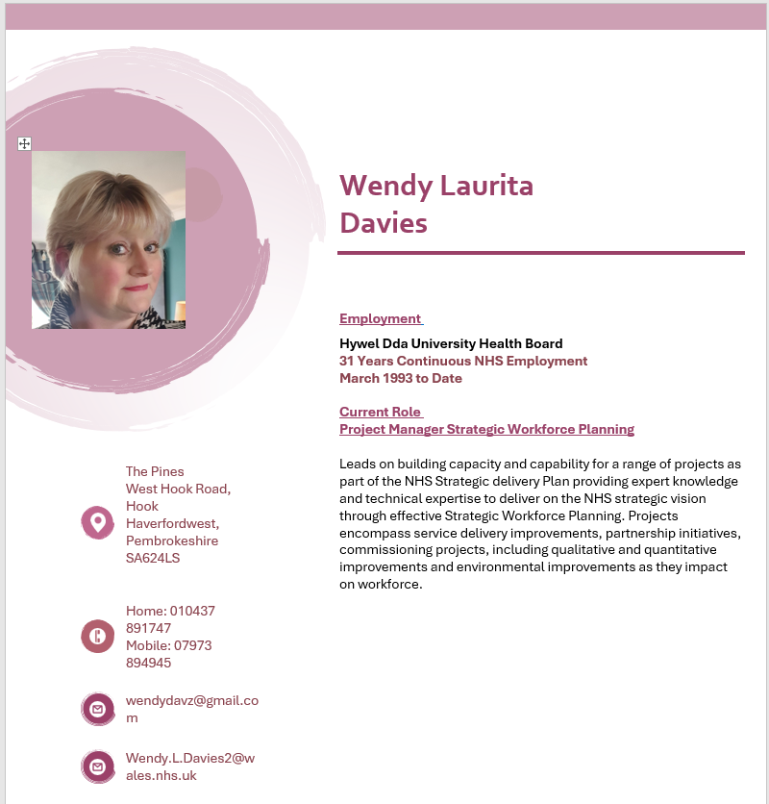

Employment
Hywel Dda University Health Board
31 Years Continuous NHS Employment
March 1993 to Date

Current Role

NHS Project Manager Strategic Workforce Planning

Leads on building capacity and capability for a range of projects as part of the NHS Strategic delivery Plan providing expert knowledge and technical expertise to deliver on the NHS strategic vision through effective Strategic Workforce Planning. Projects encompass service delivery improvements, partnership initiatives, commissioning projects, including qualitative and quantitative improvements and environmental improvements as they impact on workforce.

Extensive 32 years’ continuous NHS experience and working knowledge in the following areas of workforce management that inform workforce strategy.

- Strategic Workforce Planning
- Workforce supply, pipeline.
- HEIW Education & Commissioning
- Agenda for Change Terms & Conditions of Service
- Job Descriptions - Role Design & Re-Design.
- Job Evaluation.
- Pay, remuneration & pensions.
- Staff Benefits, Reward, and Retention.
- Workplace mediation (ACAS trained).
- Conflict and resolution Policy.
- Carers Policy
- Rotas & rostering.
- ESR.
- E-Expenses.
- Workforce risk & incidents.
- Job Evaluation Trainer
- COVID 19 Response
- Health Promotion
- Serving the Executive Board

Professional Responsibility

Hywel Dda University Health Board Healthcare People Management Representative
Term of Office 2012 - 2020
The Pines
West Hook Road, Hook
Haverfordwest, Pembrokeshire
SA624LS

 |  | Home: 010437 891747  Mobile: 07973 894945
 |  | wendydavz@gmail.com
 |  | Wendy.L.Davies2@wales.nhs.uk
Education
Tasker Milward VC School Haverfordwest 1989-1990
GCSE’s (English Language, English Literature, Computer Studies, Economics, Maths, Art & Design, French, Biology) Grades B-D
WJEC Typing Elementary & Familiarisation – Credit & Distinction
Pitman Typing Elementary & Intermediate – Pass & 1st Class Pass.
Pitman Word Processing – Pass
WJEC Keyboard Skills RSA Stages I & II – Pass
City & Guilds – Information Technology – Pass

Further Education
City & Guilds Certificate of Pre-Vocational Education
Technical College Course Health & Social Care
Technical College Course Business & Admin Services

Pembrokeshire College
ECDL – Pass
BTEC National Diploma Business & Finance – 1st Year Pass

Grwp Llandrillo Menai
Level 2 Application of Number
Level 2 Application of Communication Skills
Level 2 Essential Digital Literacy

Clinical Courses
Level 2 Diploma Clinical Healthcare Support

Professional Courses
Workplace Mediator Trainer - ACAS
Introduction to Adlerian Counselling
Level 5 Human Resource Management
CIPD – Level 5 Diploma in Applied Human Resources

MA Professional Practice (March 2022 – Ongoing)

Leadership

Leads and manages the interface between partners, external professionals and agencies, and operational Managers and clinicians, regularly consulting with the Directorate Management Teams and corporate Health Board departments.

Interests & Hobbies

Civilian Instructor for Royal Air Force Air Cadets
(2012 – 2022)
British Royal Legion Volunteer
Breast Cancer Fundraiser

Appendix 2
Job Description – Project Manager Workforce Planning
(Wendy Davies – annotated specific to my role)

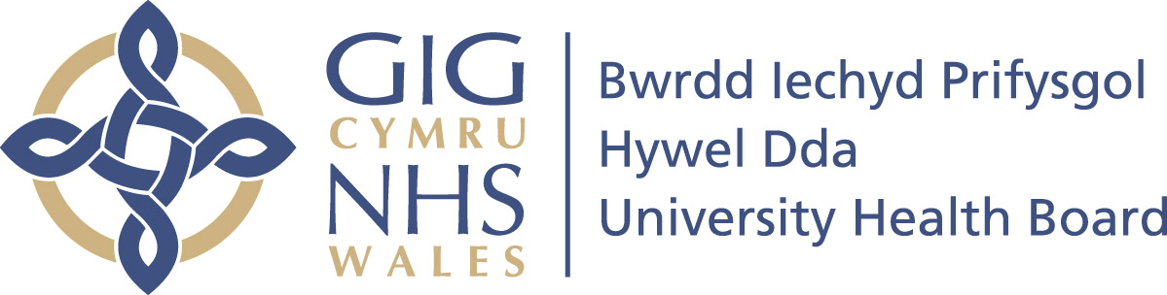
For office use only
CAJE REFERENCE HD2020/0115
DATE APPROVED 23/07/2020

JOB DESCRIPTION

JOB DETAILS

Job Title: Project Manager – Workforce Planning

This was a newly developed post, and I was going to be part of a Team of 4. We were the first team that a Health Board organisation had invested in fully across the whole of NHS Wales (Trail blazers!). If truth be told I do not think that the extent of what the role would encompass was fully understood at the time. The role has evolved substantially from the Job Description that I was appointed into. We are not project managers in the true sense of the job title as we do not manage projects from end to end. Our skills, knowledge, and specialist expertise to lead services in the role of strategic workforce planning should be better reflected in our job title. Strategic Workforce Planning Lead may be more appropriate.

Pay Band: Band 7

Directorate: Workforce and OD

Department: Workforce Planning/Workforce and OD

ORGANISATIONAL ARRANGEMENTS

Accountable to: Workforce Planning
I am accountable to the Assistant Director of People Planning

Reports to: Workforce Planning
I report to the Assistant Director of People Planning

Responsible For: Building capacity and capability in workforce planning across the Health System for Primary, Community and Secondary Care
The role is very broad and there are constant competing demands. My remit covers all the above areas of work, and I am the ambassador Lead for Primary Care for Workforce Planning.

JOB SUMMARY / PURPOSE

Leads on building capacity and capability for a range of projects as part of the delivery of the Health Boards Workforce Planning Group. The projects will encompass service delivery improvements, partnership initiatives, commissioning projects, including qualitative and quantitative improvements and environmental (estate) improvements as they impact on workforce.
I am a competent compassionate leader and have a wealth of NHS experience and working knowledge to draw upon. (Refer to CV). I am a credible resource and have a proven history in working in collaboration and can gain co-operation and agreement overcoming barrier to understanding and able to provide highly specialised advice. I assist services navigate through workforce issues and draw in the expertise from wider workforce colleagues when required. I have set up and run workshops to aid service delivery improvements and work with services to draw up action plans. I am part of commissioning meetings for regional services that are out-sourced due to workforce fragility within our own organisation. I am also part of the task and finish groups and sit on working groups on Strategic Outline Cases and Business Outline cases for Welsh Government for new Capital estate projects i.e., new Health and Wellbeing Centre’s that are being built in the community to move to a shift left model and to deliver wide care in the community rather than in acute hospital sites. I am also part of the potential Hospital Build (PBC) working groups and represent workforce planning at meetings in presence of very senior and Executive colleagues.

Focuses on the development of capability and capacity in workforce planning which will include the creation of resources which may include the development of training, webinars, frameworks, and networks to facilitate access for service managers, partner’s agencies and workforce and OD colleagues.
Whilst this was a significant part of my role in the beginning this now a lesser part as there is a Project Manager who has now been given a specific focus on training; however, I have done and continue to provide training within our own orgnaisation to support to develop our service managers. Early on a suite of training resources was created by me and the team and Training toolkits were developed around requirements of Six Steps Methodology for workforce planning. Most training that I now deliver is All Wales Job Evaluation training and delivered in other Health Boards in NHS Wales.

Contributes to the development of the UHB Annual Plan/Integrated Medium-Term Plan.
The IMTP is the plan submitted by our Executive Team to Welsh Government that sets out the Health Boards vision, agenda, and direction of travel both in the short, medium, and long term. I contribute to this by the reporting and writing the complex, multifaceted and multi stranded workforce Technical Document which is fundamental to the IMTP that depicts the Health Board wide workforce position – also linking future Educational & Commissioning requirements, workforce risks, and aligning to National shortages in workforce supply.

Collaborating with clinicians and staff across the UHB and wider organisation the post holder will promote innovation and best practice in workforce planning for service change in support of national priorities and drivers to local health need. I work with service managers at a prominent level, negotiating and advising at a specialist level as we work through their workforce operational plans. This allows me to gain understanding of their pinch points in service delivery and the alignment aspirations of their service and how this meets the requirements to deliver on Health Board A Healthier Mid and West Wales Strategy Healthier mid and west Wales - Hywel Dda University Health Board (nhs.wales) and Welsh Government A Healthier Plan for Health & Social Care. A Healthier Wales (gov.wales) which I can then feed the intelligence into my board papers.

The post holder will provide support and advice to managers and clinicians in the UHB on project delivery of the strategic intentions of the All Wales and HB’s Health & Social Care Workforce Strategy with a focus on the workforce planning agenda. Including contributions to the All-Wales Workforce Planning Network. I provide specialist advice locally and regionally. As part of a team, I have assisted with several strategic programmes including modelling and scenario planning and application of insights to maximise opportunities. An example of this would be the South Wales Cancer Network and the subsequent advice fed into this workstream and aligned opportunities with future Integrated Care Centre planning to optimise future workforce planning decisions.

The post holder will either lead or contribute to projects in collaboration with colleagues and partners and contribute to service reviews and offer guidance on workforce planning processes to colleagues across the UHB. Through operational workforce plans provide expert technical advice on the Health Boards regeneration framework in practice and helping to facilitate solutions and highlighting workforce risk and fragility.

Analyses available data and service information to facilitate redesign, supporting the delivery and development of improved performance and quality across the UHB.
I utilise data extraction reports that I have run from ESR (Health Board) and WNWRS (Primary Care) reporting systems to aid service change discussion and future forecasting and succession planning requirements.

The post holder will be expected to liaise widely within and outside the Directorate ensuring a professional approach is adopted and projecting a positive view of the Health Board. See key relationships below:

MAIN DUTIES AND RESPONSIBILITIES

Key Relationships
The post holder will manage the interface between partners, external professionals and agencies, and operational Managers and clinicians, regularly consulting with the Directorate Management Teams and corporate Health Board departments.
I have gained a good working relation with colleagues across several corporate functions and regularly form part of task and finish groups as required. These include:
- Planning & Transformation
- Finance
- Public Health
- Communications
- Corporate Governance
- Medical
- Nursing Quality and Patient experience
- Operations
- Digital and Performance,
- Therapies and Health Science
- Primary Care and Long-Term Care Directorates.

I have good network of colleagues across NHS Wales. I attend meeting that are chaired by the Executive team where strategic decisions are being made and I actively contribute where I have intelligence to feed into discussions regarding the workforce position.

I feed into Workforce Directorate reports and ensure that wider workforce colleagues are kept up to speed at regular intervals for work that I know may be coming their way as part of operational workforce plans i.e., Learning and Development, Recruitment, Operational colleagues regarding potential organisational changes to teams that are imminent, Job Evaluation, and workforce system colleagues.

Service Management
The post holder will manage a range of projects and programmes with potentially conflicting timescales and priorities. This work may have wide implications for the UHB care pathways, clinical standards, performance, and protocols. Due to so many competing demands as this exercise shows prioritisation is hard to manage with so many competing demands and conflicting timescales. This does have an impact on time for self-development, my wellbeing and work life balance. I am cognisant of this and as part of my PDP I intend to put in control measures and coping strategies to gain greater control.

Work across multiple streams of work, providing support to Workforce and Organisational Development in implementing the Health Board’s Health & Care Strategy including Health Board’s strategic objectives, supporting the planning cycle and the delivery of the Annual Plan / Integrated Medium-Term Plan. Since being in post I have contributed to 3 Annual Planning cycles and IMTP submissions.

Leads and/or contributes to projects and service reviews across the UHB and in collaboration with partner organisations, offering guidance on workforce planning processes to colleagues. As per above

Leads and/or contribute to pathway development and support and develop initiatives which focus on new ways of working by providing the frameworks for role design and assessing workforce risks.
I am responsible for the management and reporting of Health Board workforce associated risk. I have developed a process that highlights workforce risks with the greatest severity and where targeted inventions are urgently required to assist with risk mitigation and risk control. I undertake regular analysis of workforce risk RAG ratings and to identify trends in workforce risk. The Wales Audit Office also monitor workforce risk and its control. As part of my role, I embed governance and provide strategic guidance, signposting and facilitating solutions through my risk monitoring and evaluation framework that I have been developing. I have an enhanced level of risk assessment skills.

Monitor and review workforce plans, feeding back on changes in local need and national policy guidance as it relates to workforce. I keep abreast with research relating to workforce issues and its impact on service delivery – and to maintain alignment with Health Education Improvement Wales Strategy (Workforce plan for Genomics, Dental services, Mental Health, Perinatal Plan, Workforce plan for Primary Care, Workforce plan for Pharmacy)

Participate in and take minutes at project and other meetings when required.

Report on progress to relevant Project Groups and relevant Health Board meetings at regular intervals. I am responsible for writing SBARs and papers that get fed up through appropriate Health Board assurance committees and to the Exec Director of workforce & OD/Assistant Chief Executive Officers. At meetings I report on work going on in other areas to ensure that isolated service plans consider wider interdependency impact it could have on other workforce in workstreams that are in development concurrently which could prove to be a blocker in service re-configuration ambitions.

Leads and/or participates in projects to develop new ways of working in line with organisational objectives and best practice. Similarly, I keep abreast with research and provide expert advice relating to workforce issues and its impact on service delivery – and to maintain alignment with Health Education Improvement Wales Strategy (Workforce plan for Genomics, Dental services, Mental Health, Perinatal Plan, Workforce plan for Primary Care, Workforce plan for Pharmacy)

Prioritise own work to ensure effective support to others and delivery of key objectives.
Competing demands do cause prioritisation issues.

Support workforce planning policy implementation to modernise the service and improve the experience of service users. Worked with Heads of Nursing to understand implementation of new standard of the NHS Nurse staffing Act is an example of this to ensure that the Health Board is working within the legislation. Nurse Staffing Levels (Wales) Act 2016 post-legislative scrutiny link here for Hywel Dda Consultation display (senedd.wales)

Leads and/or participates in and facilitates meetings and or workshops on topics relating to delivery of the Health and Care strategy. Supports the workforce planning of effective services for the UHB which reflect local community and stakeholder influence.
As outlined above.

Provide advice and support for workforce planning to managers, clinicians and staff involved in projects to take forward service modernisation and improvement.

Ensures the activity is fully aligned to the plans and strategies of the Health Board and Welsh Government.

Leads on and/or supports development of workforce planning project which impact across the UHB, including collaborative working with other agencies and partners to be delivered in primary, community and hospital-based settings as appropriate.
I am currently on the project group that is aligning the 6 Goals for Urgent and Primary Care, Primary care, community and long-term conditions and I am the ambassador and liaison for workforce planning with Primary Care. I work across NHS organsaitions and represent workforce at the following forums, strategy, and planning meetings:
- Regional Cardiology
- Regional Dermatology
- Regional Eye Care Services
- Regional Neurological Disorders
- Regional Orthopaedics
- Regional Pathology
- Regional Stroke
- Southwest Wales Cancer Network including Radiotherapy and Non systemic Cancer Treatments.
- Microbiology

Support work to ensure alignment of workforce planning approaches across the Health Board i.e., capacity and demand planning, values based healthcare, and new role design.

Communications
Communication requirements will include the need to effectively communicate extraordinarily complex or potentially contentious information, seeking to influence and requiring co-operation to each agreement. Covers all aspects of workstreams listed above.

Communicates effectively and establishes good working relations with a wide range of people:
- Workforce and OD
- Directorate and operational teams
- Corporate Health Board Teams including finance, workforce, estates, IT, performance, and planning.
- Senior Managers and Clinicians
- Local Authority and Voluntary sector partners
- Colleagues across the Health Board
- Primary and secondary care colleagues across the Health Board
- Workforce Clients and Service users

Presents and facilitates workshops on workforce planning transformation to large groups of staff and stakeholders. All Wales Trainer and delivers in house training on Six Steps workforce planning methodology, presented and facilitated bespoke workshops as required.

Communicates with Senior Health Professionals, Managers, and partners on a regular basis in relation to Service and workforce planning infrastructure i.e., frameworks, tools, and resources.

Communicate with relevant stakeholders on design of workforce planning projects and advises on the steps needed to support changes to models of care.

Persuade and influence stakeholders and project teams in relation to timely completion and adoption of workforce planning methodologies – I have excellent and strong analytical and evaluation skills and able to critique submissions of operational workforce plans.

Provide updates on project deliverables as required to large groups of staff and stakeholders.

Works with external agencies as appropriate in collaborative schemes for the delivery of UHB and service development.

Builds and maintain strong influential relationships with colleagues, Health Board staff and stakeholders. As explained above – context of level of meetings attended which can all be seen at Appendix 10 in my meeting schedule over the last 12 months – these are actual meetings that I have been in attendance and contributed to the workforce planning discussions.

Provide information to groups which may comprise Health Board staff and colleagues from partner organisations in relation to project plans.

Demonstrates sensitivity to staff and service users in services where change is envisaged.
I am a compassionate leader and always exhibit the Health Board values and behaviours and always conduct myself in a professional manner setting a good example to those within my own team and to the wider NHS services and directorates. I lead with compassion, mutual respect sincerity, kindness sensitivity and understanding.

The post holder will need to communicate effectively in verbal and written terms and will regularly produce reports on programmes/projects for reporting to management groups or Board Sub Committees and Committees in the agreed format.
Authors reports for People and OD Culture committee, Strategic People Planning and Education Groups, Assurance and Governance committees and regularly consult with a wide range of stakeholders.

Information Processing
Define information requirements and analyse data to feed into workforce planning, service development.

Create reports based on a range of information from a variety of sources, presenting those two groups, as necessary.
As outlined above in reports that I develop.

Contribute to service reviews and audit activity to measure service change and sustainability and assess workforce risk. Identifying mitigations as appropriate.
I am lead for Workforce Risk within the Directorate and assess service current and future potential risks.

Utilise best practice in workforce planning, working with an evidence-based approach, undertaking research and signposting to the outcomes of relevant audits.

Summarise documents and analyse data from a range of sources to support the development of options and pathways and facilitate decision making.

Personal and People Development and People Management
May be required to deliver teaching sessions and development programmes for clinicians and staff in area of expertise across the Directorate.

Work within HR policies and processes.
I always work within the parameters of Health board Policies and Procedures. I have 10 years’ experience working in the operational field (See CV) and advising on policies, procedures and terms and conditions was within my remit. I am an expert in this field.

Actively support the workforce planning processes for the Health Board.

Prepares for and takes on active part in the PADR process in accordance with organisation policy in partnership with reviewer, identifies opportunities to develop own competence/own skills to achieve objectives.
I have PADRs regularly and have regular 121s with the Assistant Director of People Planning. Clear objectives are set, and personal development needs are discussed. Those needs as identified in my learning needs analysis and in my personal development plan as part of this Ma module will be incorporated in this year’s annual review.

Provides appropriate support to others within Workforce and OD, and wider UHB services to improve their knowledge and understanding and shares own knowledge, skills, and experience with others during induction and training sessions for staff e.g., support delivery of training as above – regularly feed intelligence and learning into wider agenda.

Business Planning
Will participate in the production of UHB annual / medium term planning cycle and may be asked for contribution to areas of plan development.
As outlined in annotations above previously.

The post holder will participate in the development of business cases for service change and capital infrastructure modernisation in relation to workforce.
As outlined in annotations above previously.

Health, Safety and Security
Act within legislation, policies and procedures relating to information governance.

Attend statutory/mandatory training.

Support managers and clinicians in relation to project management and delivery of service change utilising project and programme management processes. As outlined in annotations above previously.

Ensure that feedback from stakeholder engagement and consultation is built into service and project planning and development to bring about improvements to access, quality, value for money and return on investment. Surveys to assess team impact around the operational workforce planning support was undertaken in the last 3 months.
There was a 30% return rate, and the feedback was incredibly positive and comments on where we could have done better has been taken on board and improvements will be made accordingly.

Quality
Develops policies to improve performance in specific areas which will impact across the Directorate.

Ensure that project plans are based on evidence and good practice and that quality and safety are the main drivers for service change.

Utilise existing systems for assessing service users’ views on quality of services provided and for involving patients, their carers or their representatives in workforce planning or related project work.
Strategic Business cases require formal consultation processes with all stakeholders and the general public so that their voices and concerns are heard. I am required to feed into these as required.

Supports others effectively during times of change and work with others to overcome problems and tensions as they arise and ensure that own workload is managed effectively. I always offer support to colleagues. Unmanageable workloads and where additional support are required is discussed at weekly team meetings.

Equality and Diversity
Actively promotes equality of opportunity and diversity in own area of responsibility. It is intended to go beyond compliance with equality legislation and move towards a situation where there is awareness in your area of and active commitment to the need to ensure equality of opportunity and the benefits of diversity.

Finance and Resources
Will be required to review and monitor budgets for designated service areas and/or specific initiatives and projects. As part of operational workforce plans budget establishment is scrutinised and understood to look in depth where financial savings can be realised as part of alternative workforce delivery where high-cost locum and variable pay exists.

Will be involved in or lead specific projects associated with the commissioning of services.
As annotated above – I sit on regional meetings where commissioned services and service level agreements are in place with neighbouring Health Boards form part of the agenda.

Promote and secure value for money, ensuring that the services of the team operate in an efficient manner. (Value Based Health Care)

Will be required to participate in the costing of service development proposals and will need to ensure the costs of initiatives are understood by the Directorate and wider organisation. Relates to financial savings targets imposed by Welsh Government on the wider financial position and the Health Board is currently in financial extraordinary measures with significant financial scrutiny and workplace plans are required to exercise financial prudence and frugal innovation.

Effort and Environmental
All the below are required to undertake all the workstreams annotated above.
Frequent VDU use is required for this post of periods of up to 3 or 4 hours at a time in
order to produce complex reports and analysis to support decision making.

Frequent concentration will be required on a wide variety of complex issues throughout the day. The post holder will frequently have to adapt to changing priorities and re-focus the
work of self and others on new priority areas that may require urgent action.

The post holder will participate in and facilitate meetings which require a high level of concentration on a wide range of topics, with a variety of audiences and mixtures of attendees.

The role will require regular negotiation with senior NHS professionals.

Analysis of facts figures to support work.

Critical path analysis and patient pathway analysis

Dealing with demanding situations/ circumstances - Significant service change agenda will require this. Challenging service requirements and challenging current norms is difficult, but I overcome with tact, professionalism, and diplomacy and if required as a last resort willing to exercise assertiveness.

General
Undertaking other relevant duties required by the workforce planning lead to be determined as the role develops.

PERSON SPECIFICATION

Please refer to previous (Appendix 1) CV, which outlines all my Knowledge, Training and Experience that allowed me to be considered for the role.
My 31 years extensive NHS Experience afforded me parity of esteem where essential criteria was not met.

ATTRIBUTES | ESSENTIAL | DESIRABLE | METHOD OF ASSESSMENT
Qualifications and Knowledge | Educated to degree level or equivalent level of NHS working experience.  Excellent knowledge of programme and project management.  Knowledge of the Skills for Heath Workforce Planning Methodology  Evidence of further development education and training to Masters Level or equivalent level of experience. | Higher degree  CIPD  Project Management qualification e.g. PRINCE 2 / MSP / Agile  Wish to obtain this Qual in the future.  Knowledge of Workforce Information BI  Knowledge of Organisational Development and Learning Theory. | Application form and interview
Experience | Experience of managing service change projects and coordinating and leading activities to achieve the project objectives, ideally related to workforce.  Experience of planning and prioritisation own work and deliver to time and objectives.  Experience of report writing, programme planning, business case processes and communicating on multi agency workstreams.  Experience of delivering training/presentations to multiple audiences. | Good understanding of national HR initiatives within the NHS  NHS experience  Understanding of a range of analytical techniques, software and tools for data manipulation; modelling, scorecard  Developing protocols and policies & procedures  Development and management of HR policy and practice  Developing and implementing new systems and procedures | Application form and interview.
Aptitude and abilities | Able to work in a multidisciplinary and multi-agency environment.  Able to work to demanding timescales.  Have the ability to communicate effectively to internal and external stakeholders.  Ability to analyse data and situations and recommend solutions to problems.  Able to research and evaluate.  Keyboard skills.  Suitable time management and organisational skills.  Effective interpersonal skills.  Experience of engagement and collaborative working with the public, key stakeholders, and patients / service users / consumers | Welsh Speaker | Interview
Other | Ability to travel within and outside the Health Board in a timely manner.  Flexible approach to the needs of the service. |  | Application form and interview

GENERIC STATEMENTS

NHS CODE OF CONDUCT FOR MANAGERS
** For Managers only:
The post holder will be expected to adhere to the standards always laid down in the NHS Code of Conduct for Managers and act in a manner that reflects and promotes the values of the HB. The post holder must ensure all activity and service objectives are effectively met in compliance with HBs standing orders and SFIs, scheme of delegated authority and employment legislation.

REGISTERED HEALTH PROFESSIONAL
** For Registered Health Professionals only:
All staff who are members of a regulatory body must comply with standards of professional practice/conduct. It is the postholders responsibility to ensure they are both familiar with and adhere to these requirements.

HEALTHCARE SUPPORT WORKERS
** For Healthcare Support Workers only:
All healthcare support workers should be familiar with and must comply with the Code of Conduct for Healthcare Support Workers in Wales.

COMPETENCE
The post holder is required to participate in the Hywel Dda PDR process and work towards meeting identified development needs. The postholder is required to demonstrate on-going continuous professional development. At no time should the postholder work outside their defined level of competence. If the postholder has concerns regarding this, they should immediately discuss this with their Manager/Supervisor/Consultant. The postholder has the responsibility to inform those supervising their duties if they are not competent to perform a duty.

OUR VALUES
Hywel Dda University Health Board is a value driven organisation. The post holder is expected to uphold our values of dignity, respect, fairness, integrity, honesty, openness and caring, kindness & compassion underpin a behaviour framework which are supported by our organisational values of
- Putting people at the heart of everything we do
- Working together to be the best we can be.
- Striving to deliver & develop excellent services.

TEAM BRIEF
The post holder is required to actively participate in Hywel Dda Team Briefing to aid communication within the Health Board. Managers and supervisors will deliver the Team Brief verbally to their own staff teams by means of a Core Brief and additional departmental information.

RISK MANAGEMENT/HEALTH & SAFETY
The postholder has a responsibility to themselves and others in relation to managing risk, health and safety and will be required to work within the policies and procedures laid down by the Hywel Dda. All staff have a responsibility to access occupational health, other staff support services and/or any relevant others in times of need and advice. The postholder has the responsibility for monitoring the progress on action plans in relation to risk, health and safety. The postholder has the responsibility for the development of risk profiles and a risk register within their area of responsibility. The postholder has the responsibility for developing systems to monitor performance against agreed performance indicators.

HARRASSMENT & BULLYING
The HB condemns all forms of harassment and bullying and is actively seeking to promote a workplace where employees are treated with dignity, respect and without bias. All staff is requested to report any form of harassment and bullying to their line manager or to any Director of the HB.

RECORDS MANAGEMENT
The postholder has the responsibility for timely and accurate record keeping and where appropriate in accordance with professional guidelines. The postholder has the responsibility for the creation and maintenance of records in accordance with Hywel Dda policy and the data protection act.

FLEXIBILITY STATEMENT
The developing and rapidly changing nature of the organisation will require considerable flexibility from the post holder. This job description indicates the main functions and responsibilities for the post and is not intended to be a fully inclusive list and the duties and responsibilities specified in this job description are subject to change as the needs of the HB evolve. On agreement with the post holder, this job description will be amended, as necessary, in the event of future organisational and professional changes and/or personal development.

CONFIDENTIALITY
All staff may have access to confidential information about patients, staff, or health service business. On no account must such information be divulged to anyone who is not authorised to receive it. Confidentiality of information must be always preserved whether at or away from work. Any breach of such confidentiality is considered a serious disciplinary offence, which is liable to dismissal and /or prosecution under current statutory legislation (Data Protection Act) and the HB Disciplinary Policy.

EQUAL OPPORTUNITIES
Hywel Dda University Health Board is committed to ensuring that, as far as is reasonably practicable, the way we provide services to the public and the way we treat our staff, patients and others reflects their individual needs and that individuals or groups will not face discrimination, harassment or victimisation, or be treated less favourably on the basis of sex, pregnancy and maternity, gender reassignment, disability, race, age, sexual orientation, religion and belief, family circumstances including marriage and civil partnership. To this end, the UHB has an Equality and Diversity Policy and Equality Impact Assessment Policy and Procedure and it is for each employee to contribute to enacting these policies.

OUTSIDE EMPLOYMENT/OUTSIDE INTERESTS
Any other work or outside interests must not conflict with the duties and responsibilities of your attendance for work as an employee of the HB.
ENVIRONMENTAL
The Hywel Dda Health Board is committed to its environmental responsibilities. The Board recognizes that its activities, including energy consumption, waste generation, transportation emissions, water use and resource consumption, have a significant impact on the environment. As an integral part of its commitment to ensure high quality patient care, all staff have a responsibility to adhere to environmental policy and procedure at both an organisational level and within their own area of work to ensure legal compliance. Staff will do their utmost to minimize the environmental impacts of Health Board activities and services and seek to continually improve operations to minimize their environmental effects. Staff should take note of relevant communications and attend mandatory training when required.

SMOKE FREE POLICY
All Health Board sites and premises and grounds are designated as smoke free areas. This policy applies to all staff, contractors/service providers, patients*, visitors and the public.
*Those patients staying in residential mental health units will be exempt under the Smoke-Free Premises (etc) Wales Regulations 2007.

SAFEGUARDING ADULTS AND CHILDREN
Every employee of the Health Board, whatever their job, role, profession, status, or place of work, paid or voluntary, has a responsibility for Safeguarding both adults and children. Staff must:
- Understand the nature of abuse and how children and adults might be at risk of harm and neglect.
- Understand their own safeguarding responsibilities and what actions they may need to take.
- Know where they can access local policies and procedures in relation to Safeguarding Children and Safeguarding Adults.
- Report allegations or suspicions of abuse to their line manager, including suspicions about a colleague or manager, irrespective of their status, profession, or authority. This includes whistle-blowing
- Know how to make a Safeguarding referral to Social Services and/or the Police for both adults and children to report allegations or if they have concerns.
- Know what services, advice and support are available locally to vulnerable children and adults and how to access help needed.

INFECTION CONTROL
"The document Commitment to Purpose: Eliminating Preventable Healthcare Associated Infection: A Framework of actions for healthcare organisations in Wales stipulates that all staff must understand their responsibility and accountability for Infection Prevention & Control and the Health Board must be assured of this on an ongoing basis". IP&C is the personal and individual responsibility of all Health Board staff. All staff have a responsibility to protect and safeguard patients, service users, visitors, and employees against the risk of acquiring healthcare associated infections. This responsibility includes being aware of the content of and consistently observing, Health Board Infection Prevention & Control Policies and procedures; and best practice guidance to maintain exacting standards of Infection Prevention & control.

GENERALThe postholder needs to ensure they are familiar with their terms and conditions of service.
Appendix 3
SWOT – Self assessment

SWOT Analysis – Wendy Davies

Introduction
SWOT analysis is a technique used to map out the Strengths, Weaknesses, Opportunities and Threats of a situation. It is often used to assess a business situation, but here you can apply it to your own career. This simple but powerful exercise will help you to build on your strengths and seize opportunities
This exercise first asks you to reflect on things you feel you have achieved both in and outside of work. From this you’ll be able to identify some of your strengths and weaknesses. To help you think about threats and opportunities, you are asked to describe areas of your work or personal life where you would like to achieve something, or make a change.
Make sure you separate internal issues from external issues: Strengths and Weaknesses are internal resources that are personal and that would not exist without you, while Opportunities and Threats are external issues in your environment that exist independent of you.

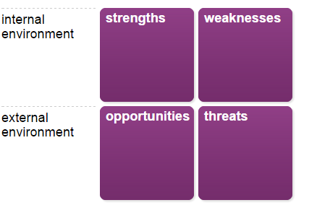

Stage 1 of 7
Your achievements and target areas
Before you start, spend some time thinking about your achievements over the last two to three years, or longer if that is relevant for you. Also, think about the future and what aspects of your life and work you would like to develop or change. Your notes here will help you identify your strengths and weaknesses in the stages that follow.
Your achievements
Make a note of up to three achievements where you feel you made important contributions. These could be at work or in other areas of your life.
Achievement 1
My family, health, wellbeing, and work are very important to me.
I have been married for 31 years to my wonderful husband John and have 2 sons Joshua and Bradley who make me proud every day. I have supported my husband whilst he has risen through the academic ladder throughout our marriage, and have also been there to tirelessly support, coach and educate my children to help them attain good grades to allow them both to excel in their chosen and desired career path. My husband is now employed as an Architectural Surveyor within the Local Authority, my eldest son is now serving as a Corporal Airforce Engineer in the Royal Air Force currently studying his Masters Degree and my youngest son after completing his Level 3 Extended Diploma in Public Service has secured a very sought after developmental employment opportunity to allow him to become a process operator working for Valero Oil Refinery. My significant contribution to all their ongoing journey of growth, and self-development gives me a great sense of pride and achievement; their successes I also see as a success of my own too.

Achievement 2
I joined the health service as Administrative Assistant in 1993 as a Band 2 clerk and in 2024, I will have completed 31 years full time continuous NHS Service. During this time, I have grasped every opportunity of self-development that has been offered to me. This has afforded me the opportunity to grow both professionally and personally and to allow me to rise through the ranking and pay structure to attain the Band 7 role of Project Manager Workforce Planning that I presently hold today.
On moving into the workforce directorate, I represented Hywel Dda’s as the organisations Wales Healthcare People Management Committee creating learning opportunities to develop the workforce profession within NHS Wales. Our mission statement was to ‘improve health through people’. Excellent managers lead to improved health outcomes and improved quality of care for the population that we serve. I held the term of office for a period of 6 years and during this time worked closely alongside Workforce Directors and Senior NHS Executives across NHS Wales.

Achievement 3
The most recent achievement is in my current role. I have introduced a mechanism within Workforce that allows for the analysis, interrogation, and greater depth of understanding of the overall Workforce Risk Score position across the Health Board. This tool ensures that targeted workforce strategies can be put in place to reduce the identified workforce risk and provide mitigation measures according to the level of severity and their RAG rating. As an extension of this work, I have also embedded a new process that allows for the triangulation of risk between the service, finance and workforce. This tool has proved to be fundamental for effective risk management and is being used to contribute to organisational long and short-term planning and aligns the Health Boards Strategic Vision and goals as well as informing key decision making on the NHS stabilisation and recovery agenda.

Your target areas
Describe up to three areas of your work or personal life where you would like to achieve something or make a change.
Target area 1
Personal and professional growth has always been very important to me.
I have always wanted to gain my MA Qualification and would regard this as a lifelong ambition and achievement when graduating.
I am very grateful for this opportunity and investment in me.

Target area 2
I have been in my present role for almost a year and a half, and I now work in the strategic space giving expert advice, providing training and consultation to managers of all levels across the Health Board to assist them in addressing their Workforce Planning issues, future service vision and aspirations. The Health Board is a huge organisation and there is still the need to for me to gain the correct exposure within directorates and develop positive working relationships so that I can perform at my optimum level and increase my confidence, working knowledge and gain a greater understanding of co-dependency’s of interlinked NHS services across service areas that will inform the success of service re-design and improved patient pathways.

Target area 3
Within my portfolio I am the Project Lead for workforce Planning for Cancer Services across the Hywel Dda Health Board geography (Pembs, Ceredigion & Carmarthenshire). The way in which we are delivering cancer care is changing rapidly. Medical Oncology is very fragile in Hywel Dda UHB and Consultant Oncologists are defined as Hard to Recruit posts and this is also the case Nationally. Hywel Dda has a Collaborative Agreement with Swansea Bay University Health Board (SWUHB) and this gives some additional limited service but, as the backlog of Cancer patients now enter the NHS system as a result of the COVID Pandemic patients are attending with more acute presentations and with cancer in more advanced stages. This too adds to the strain on both visiting consultants to Hywel Dda from SWUHB and also increases the patient stream transfer attending Morriston hospital which creates an additional burden to their already limited and stretched Medical oncology workforce in SBUHB. Therefore, to address this long-term shortfall within the Medical Workforce the Oncology Nursing Workforce has been upskilled to take on Clinical Nurse Specialist roles. This is a delivery model of care I would like to work with Cancer services to expand across the Health Board to provide a more robust provision of care for all Hywel Dda patients entering the cancer patient pathway. I need to work on my ability to be able to negotiate, influence and respectfully challenge at a senior level.

Stage 2 of 7

Your strengths
Guidance
For each achievement ask yourself:
- How did you stand out from the others?
- What skills and knowledge did you demonstrate effectively?

Record specific strengths which enabled you to make a contribution in each situation. You might want to ask others for feedback on what they see as your strengths. Focus on the key skills, knowledge and attitudes you demonstrated.

Your strengths
Strength 1
I always enjoy a challenge and the opportunity to learn something new and self-development and the ability to grow professionally has always been an aim of mine.
Applying for my current role and being successful in my appointment; this has been down to an extensive wealth of NHS experience, knowledge, Health Board procedures, policies and NHS Terms and conditions.
I want to enhance career prospects further by obtaining a Master’s Level 7 Qualification to put me in good stead for future career advancement. I like to succeed, and I am self-motivated, resilient, and determined to do well and apply myself fully.

Strength 2
I am naturally inquisitive, tenacious, and an excellent communicator with staff of all disciplines and designations and able to gain cooperation and trust when working in collaboration. I have the ability to communicate effectively to internal and external stakeholders.
I have a good reputation with peers and management and can always be relied on to contribute and deliver effectively.
I am able to work in a multidisciplinary and multi-agency environment and able to work to demanding timescales and deliver the expectation of delivery that is placed with me. I possess effective interpersonal skills and have experience of engagement and collaborative working with the public, key stakeholders, and patients / service users / consumers.

Strength 3
I am a very experienced professional with vast NHS knowledge spreading across many disciplines. I have strong leadership skills and can adapt well in any given situation. I am able to ‘think on my feet’ and have the ability to remain calm and focused in stressful situations and work well when under pressure.
I have the ability to analyse data and situations and make recommendations and offer pragmatic solutions to problems and able to research and evaluate accordingly to provide depth and greater understanding.
I can provide expert advice on Job Evaluation and role re-design and have the ability to challenge respectfully in a non-adversarial manner. This allows for meaningful workforce change conversations where strong differing of opinions exist.
I have the ability to gain cooperation from peers and senior management and contribute in a credible and meaningful manner.

Record any other strengths.

Are there any other strengths you would like to record?
I am very approachable and have a natural kind disposition. I will always consider how my behaviour impacts on others and work and manage in a way that I would like to be treated; and I also reflect well always looking for where I can make improvements. I am a reflector. Whilst I jump to solutions I do not jump to assumptions. I am an ACAS trained workforce mediator and I am patient and effective at asking probing questions and making others feel at ease in my company.
I am confident, and have the ability make people feel at ease and able to build rapport.
I am resilient by nature and have a positive outlook on life irrespective of the challenges faced both in work and in my personal life.
I possess good time management and organisational skills and I am methodical and thorough and thrive on a disciplined approach.
Uphold core values of dignity, respect, fairness, integrity, honesty, openness and caring, kindness & compassion.

Stage 3 of 7

Your weaknesses

Guidance
For each aspect ask yourself:
- What did you need to do better in this situation?
- What skills and knowledge do you need to improve?
- What weaknesses did others identify in you?

Record any weaknesses you observed in yourself in each situation or elsewhere. These may be development points identified by yourself or others as part of your performance appraisal or feedback you have received.

Your weaknesses
Weakness 1
I always strive to work with services to allow them to be the decision makers when working through potential service change or service improvements. However, I know I can be guilty of jumping into solution mode very early on in the decision process.
These are not impulsive, however drawing on my vast past NHS experience, where things have been tried and tested before I do have the ability very early on to see both potential gains and losses from project ideas. I need to better counteract positive views with negative views as sometimes I think I can come across as being pessimistic on times (I am also a realist) and I know that this when not being balanced well can hamper innovation.
I need to be less solution focussed and hold back with judgements so that full cases for change can be worked through.

Weakness 2
Sometimes it is easier to ‘do things myself’ as very often time is of the essence with a lot of projects. Delegating work and tasks do not come easy to me, and this very often leaves me feeling overwhelmed and the workload on occasion insurmountable because I have not delegated.
It is never that I feel I can do the job better than my peers, just that I do not like feeling that I am shifting the burden of work onto other team colleagues.
I need to understand my leadership style better and I need to master the art of delegation.

Weakness 3
I am my own worst critic and strive for excellence all the time. This can be tiring and sometimes leaves me feeling exhausted and that I am underperforming.

Record any other Weaknesses

What do you avoid doing because you don’t feel confident, or because you know they are things you are not good at?
I do tend to procrastinate and therefore there is the avoidance in starting tasks early. There are so many competing demands, and it is very easy to become focussed heavily on one single piece of work rather than allowing sufficient time for projects that are also running concurrently.
By my nature I like to start a task, see that through and when finished start a new one. In my line of work this is hardly ever possible – there are always and will always be competing demands. A fair proportion of my work is approached via the fire-fighting approach and prioritised by their urgency.
I hate to say no, and I hate to miss deadlines. I will work endlessly and tirelessly to make sure they are met. I like to make formulated decisions and on times can be cautious and taking risks does not sit comfortably with me.
I need to work to find a solution that will allow me to multi-task more effectively and better plan my workload that does not compromise my own health and wellbeing and impacts on time I spend with my family.

Stage 4 of 7

Your opportunities
Guidance
For each target area ask yourself:
- What changes in your organisation or working environment might create an opportunity for you in this target area?
- What new trends, services of products are emerging in your field of work which might help you achieve in this target area?
- What changes in your personal circumstances present an opportunity to achieve in this target area?

Consider the change and development 'target areas' you have selected. Record any opportunities that are emerging in your current situation which could help you achieve or make a change in these areas. Remember to think broadly across the whole of your organisation, sector and life outside work, not just your immediate job and team.

Your opportunities
Opportunity 1
There is the opportunity for me to delegate. I need to better utilise the workforce project support that we have in the team so that I don’t feel overwhelmed.
There is the opportunity for me to say ‘no’. As the saying goes ‘A willing horse is always put on’ – There is the opportunity for me to speak up and say no and not be afraid to disappoint on expectation if the workload is unmanageable.

Opportunity 2
There is the opportunity for me to protect time for learning.
This in fact is encouraged by the organisation. It is only my feeling of guilt of blocking out my diary and leaving work undone by a certain time that stops me from taking the opportunity for real, whole ‘Study Days’.

Opportunity 3
There is the opportunity to collaborate better with colleagues in the wider Workforce and OD Directorate and there is the opportunity to enhance communication between the teams within workforce.
There can be silo working and on occasion there is also a duplication of effort. There is the opportunity to share workforce intelligence gathered more effectively when working with services so that the right team are providing the right support first hand.

Record any other Opportunities.
There is the opportunity to change my working pattern.
My current work pattern is working 37.5 hours per week flexibly 7.5 hours over 5 days per week; but there is the opportunity for me to work a 37.5 hours 4 day working week with condensed hours across 4 days as other colleagues within the team currently do. There is also this opportunity for me to work this shift pattern. This may improve my work life balance and allow more structured study time.

Stage 5 of 7

Your threats

Guidance
For each target area ask yourself:
- What changes in your organisation or working environment might prevent you from achieving in this target area?
- What new trends, services of products are emerging in your field of work which might make it more difficult to achieve in this target area?
- What changes in your personal circumstances might limit you?

Now think about barriers or constraints which might prevent you achieving in the career 'target areas' you have selected and record them.

Your threats
Threat 1
My health is sadly a major threat. I have hopes and aspirations and the desire for career development, but I also must be realistic and not put myself under stress which could exacerbate my medical/past medical condition.
In the last 3 years I have been treated for breast cancer. I have had 6 rounds of chemotherapy, 18 rounds of immunotherapy and had a double breast mastectomy. I still have more surgery ahead of me for a hysterectomy and breast reconstruction. I am presently on the NHS waiting list for both procedures and could be called at any time which makes life and work difficult to plan.

Threat 2
Due to the sheer volume of work in the Strategic workforce planning team and the need to balance conflicting demands and my on-going Health needs I do worry about me actually being able to finish the full Masters Qualification.
I have become too afraid to look too far in the future as I do not know what the future holds for me, and dealing with the probability that my future will be shorter than most others to overcome this I only look one piece of work, one module at a time – but this ongoing health nagging gnawing away does make me procrastinate badly!

Threat 3
The nature of workforce planning means that things never stay still long enough so that a solid plan can be worked through. A plan is out of date the day after its created in the NHS. There is always service change, service reconfiguration.
Small changes in one service can almost always have an impact downstream on interdependent services that will also be required to change to bring the new plan into fruition along the patient pathway.

Record any other threats
There is a lot of uncertainty and financial instability in the NHS nationally now. The NHS have long waiting lists for referral and procedures into secondary care and are still experiencing backlogs following the COVID pandemic.
Hywel Dda Health Board has currently been placed in Targeted Intervention by Welsh Government which means there are significant savings to be made within and across the organisation to bring the huge financial deficit down.
The financial restraints have hampered innovation, and this has led to service cuts which is a huge threat to service delivery when demand is ever increasing at fast pace, but capacity is decreasing when workforce leave, and they are not being replaced and funded establishments are being cut to meet the savings target.
There is also the General Election imminent, and this too poses a threat to NHS strategy – this vision of Healthcare is likely to change with according the political party that is elected.
Monies that had been ring fenced to Capital Planning projects has also been squeezed and this also causes significant challenges to the building of new Integrated Health & Wellbeing centres which are required to keep alignment with Welsh Government A Healthier Mid & West Wales Strategy.

Stage 6 of 7

Building on your strengths

Review your strengths, listed earlier. Then note down what you might do to take advantage of the opportunities and confront the threats you have identified, building on the strengths you have. You will have the chance to review your weaknesses later.
Your strategy
- How can you exploit the opportunities you have identified by building on your strengths?
- How can you confront the threats in your environment by using your strengths?
There is the opportunity to collaborate better with colleagues in the wider Workforce and OD Directorate. I do have the ability to gain co-operation and I am an effective team player. Through my approachable, kind leadership style I can actively seek every opportunity that will allow for greater collaboration. I have a good reputation amongst my peers and need to find the confidence that allows me to be a greater contributor in meetings and workshops where I can bring to the table great understanding of Health Board Policies and Procedures and draw on my extensive NHS experience and knowledge. I am an excellent communicator I just need to ensure that I create opportunities where I can work together with my wider directorate colleagues so that I can also grow and develop from shared learning.
There is the opportunity for me to delegate. I am very self-motivated, and this means a lot of the time that I keep tasks to myself that could easily be delegated. Delegation does not come easy for me as I regard myself as ‘a doer’ but with a conscious effort and having this in the front of my thinking it is ok to ask team members for support. Asking for assistance should not be perceived as a sign of weakness by me, but a strength in the realisation that I am spreading myself too thinly and I may then be not performing as well as I could be. Appropriate entrustment in other team members would allow me to continue to work at a higher strategic level, and free up valuable time to allow me to work more effectively with stakeholders to facilitate organisational change.
There is the opportunity for me to protect time for learning. I am a workforce planner and can plan the work of others but when it comes to myself, I will always procrastinate and put ‘daytime work’ in the way of self-development time. I have recently become very self-aware that I seem to dedicate time towards study better in the evenings and outside of working hours as there is not, the conflict in my head that in daytime hours I should prioritise daytime work first. However, I am also aware it is not conducive to work all day and then study all evening either. Therefore, as the opportunity exists, I intend to try to 4 day working week for a few months and on the day, I do not have work, I can then study for my Masters late afternoon into the evening so I can also maintain a healthy balance between home, work, and study.

Stage 7 of 7

Minimising your weaknesses

Stage 7 of 7

Minimising your weaknesses

Review your weaknesses identified earlier. Then note down what you might do to minimise their impact when choosing the opportunities and avoiding the threats you have identified.
Your strategy
- How can you ensure these opportunities are not derailed by your weaknesses?
- Which of these threats is biggest, given your weaknesses?
Collaboration both within my own Directorate and the wider organisation is key to my success. I must not jump to conclusions and try to become less solution focussed and hold back with judgements. I need to be cognisant that working in the NHS means a lot of the time plans need to allow for fluidity and change and on times at pace. Very often the actual amount of time that a change in service delivery can be brought about or come to fruition can sometimes take years; by which time the original objective in the original strategy/plan has changed. I need to be more flexible in my approach so that I can adapt and change accordingly to service demand. I like structure, but know it is not always possible to start a job and finish a job before moving onto the next task. I am going to look for digital solutions that help me to manage my competing demands so that I can ring fence time and allocate time slots that are dedicated to each project that I have running concurrently and to help strike a balance between work, study, and my wellbeing.
I procrastinate. I need to understand the traits and triggers of this better so that I can better manage my time and multitask more effectively. I intend to undertake research on the subject and find coping mechanisms so that they do not hamper career aspirations or my development.
I need to delegate and utilise the project support assigned to me more effectively. This too can allow for them to grow and develop with careers with the correct support in place from me. I need to understand their limitations better and work with them to put in place a learning plan for them which will also aid their personal development and coach and mentor them accordingly.

Appendix 4
Training Needs Analysis

Wendy Davies – Training Needs Analysis
Skills Audit (Classroom Handout issue MA Professional Practice, UWTSD with expansion relating to NHS specifics)
Skill | Descriptors | Skill Level –  Where am I now?  Low High | Comments/Actions required
Organisation & time management | Prioritising, dealing with paperwork, interruptions, planning your day. | 1 2 3 4 | Set clear goals allocating time accordingly for each specific task. To assist momentum with projects that are running concurrently so that traction can remain on each project (and to move away from type of starting and finishing a piece of work before commencing another) - ring fence time and split working hours am and pm so that deliverables are achieved and to deadlines and service expectation is managed accordingly.  Protect time for learning – ensure that time self-development is also prioritised amongst other competing demands.  Manage dairy to also include preparatory and reading time ahead of meetings so that I am in an informed position and feel well prepared going into high pressure meeting environments.  Explore project management software that could assist with effective time management.
Decision making & problem solving | Ability to make decisions, selecting suitable solutions, analysis of appropriateness. | 1 2 3 4 | I am good at assimilating information and undertake analysis of data in a well-structured manner. I can make well rounded decisions and judgements drawn on extensive NHS knowledge and experience.  Shadowing Head of Workforce Planning at Executive meetings to gain greater understanding on how decisions are drawn upon at an Executive level will assist in increasing my current level.
Planning | Leading teams; consulting team members; task allocation; objective setting. | 1 2 3 4 | Continue to plan broad range of complex planning activities. Formulate strategic workforce plans as required to meet service delivery allocating work to project support staff. Continue to consult with all stakeholders and adjust plans and strategies accordingly to resources available and timeframes of delivery. Continue to set SMART objectives and formulate action plans.  Transfer current outdated systems to  Utilise MS office To Do Lists & Tasks and Microsoft Project and MS One Note so that task allocation can be done with greater automation.
Delegation | Assigns tasks to staff, providing guidance and advice maintaining staff motivation and focus. | 1 2 3 4 | Become more proficient in the art of delegation and do not spread myself too thinly which then impacts on own stress, and wellbeing.  Better delegation to project support team also provides opportunity for their personal development. Create shadow opportunities to broaden their knowledge and experience. Enhance the psychological contract with reports, invest time support and imparting own knowledge to aid their own personal development, maintain momentum and focus.  Consider formal Leadership and Management training (ILM) to enhance own knowledge and attend Managers passport training.
Motivation | Applying motivational techniques; understanding individual motives, making tasks challenging, encouraging creativity, providing team support; engendering trust and openness. | 1 2 3 4 | Continue to promote positive working relationships and a positive culture.  Promoting learning and training development opportunities to keep staff motivated. Ensure that work loads are varied and not repetitive.  Open door Policy approach.  Continue to be honest open and transparent regarding projects and key deliverables. Sharing positive feedback and celebrating team successes and supporting with slipping deadlines.  Undertake Belbin Analysis to understand better Teams and Motivation
Coaching | Providing guidance, listening skills, ability to draw out information; reinforcing behaviour using feedback; negotiating, planning goals and objectives. | 1 2 3 4 | Continue to develop my coaching and mentoring skills.  I have already received having difficult conversations training and utilise when required.  Consider Coaching and mentoring course as a self-development opportunity.
Target Setting | Understanding and communicating organisational objectives; use of SMART objectives to reach targets | 1 2 3 4 | Continue to work with service and directorates to develop both strategic and in year operational workforce plans.  From findings during stakeholder engagement and service analysis with the service set clear SMART objectives and put in place action plans and anticipated output dates of delivery.  Continue to have cohesive joined up Team targets that allow as team for us to progress and strive for excellence with clear deliverable targets.
Interpersonal skills | Relating to others, building rapport and positive relationships, being sensitive to people’s needs; using influencing and persuasive skills to help others improve performance or overcome problems; listening effectively and providing feedback; being assertive, use of body language. | 1 2 3 4 | Continue to be a compassionate leader. Ensure that time is protected and there are engagement opportunities for reports scheduled on a regular basis and 121 discussions. Continue with regular Team Meetings where all staff contribute equally irrespective of level of seniority. Continue to ensure employees voices are heard. Continue to exhibit Health Board values. PADR opportunities should continue to be meaningful to listen to aspirations and concerns equally and effectively. Continue to adopt the open-door policy. Continue to provide support, and mentorship tailored to individual needs. Empower others so that they remain happy in work, innovative and creative in their thinking and ensure that their opinions are valued. Know when to signpost to other services for sensitive personal needs i.e., Occupational Health or Staff Psychological and Wellbeing Service.  Continue to utilise ACAS Mediator training skills.  I can exercise assertiveness if necessitated as a last resort, but always work with the aim towards building positive working relationships, overcoming professional difference of opinions in a kind and sensitive manner.  Attend Compassionate Leaders update training to ensure that current skills are up to date.  Also, as per oral Communication skills below.
Written communications | Structure and format of letters, emails, reports and SBARS | 1 2 3 4 | Regard my written communication skills to be of a high standard.  Continue to write Reports at a high level that feed into Health Board Assurance Committees, Regional Committees, and Steering Groups.  Competence high in this area.
Oral Communications | Structure and format; techniques for effective presentations and face to face conversations | 1 2 3 4 | Regard my oral communications also to be of a high standard.  Able to provide and impart highly sensitive information where there is the requirement for agreement and cooperation. Able to influence and negotiate well and overcome barriers to understanding.  Continue to provide Job Evaluation training at an NHS All Wales level where discussing pay and NHS terms of conditions where training environments can become emotive and challenging.
Knowledge of NHS Terms and Conditions, Policies and Procedures | Lead and influence NHS change with credibility. | 1 2 3 4 | Continue to impart wealth of NHS Knowledge and experience.  I have specialist knowledge across many NHS procedures.  Lead and influence change through non-adversarial routes drawing on 31 years’ experience working with staff, management and alongside trade union colleagues.  Prior to current role assisted to manage all NHS Terms and Conditions queries brought into Operational Workforce Team, Job roles, Job descriptions and re-evaluation of Pay band requests.
IT Skills | Knowledge and exposure to a variety of computer hardware and software | 1 2 3 4 | 10 years ago I would have said I was a solid level 3 – Undertook ECDL etc. However, since the introduction of Microsoft Office Suite of applications there is a lot of new software for me to become fully conversant with.  I know I need training in Power BI, advanced Excel as this will also assist with Data Analytics and Data presentation when writing reports and presenting training material.
Risk Management | Work with services to identify workforce risks and RAG rate accordingly. Support with mitigation measures/interventions. | 1 2 3 4 | Continue to work with services to identify their workforce risks and issues/threats to service delivery and where demand is outstripping capacity. Assess and analyse accordingly and assign workforce support from within the workforce directorate best placed to provide service support.  Continue to keep abreast in knowledge of National workforce supply issues and work with service to consider alternative workforce supply routes.  Continue to monitor workforce themed risks and mitigation measures put in place as means of control and report workforce themed risks into Governance and Assurance Committees.
Personal Development | Continuous professional development. | 1 2 3 4 | Continue with current MA Professional Practice qualification.  Continue to take every learning opportunity, workshops, conferences, and short courses to continually develop professionally and maintain CPD portfolio to maintain CIPD registration.  Identify and explore the need for further education as the role evolves. Assess and address additional learning needs through annual PADR process.
Collaboration | Takes every opportunity to encourage collaborative working and | 1 2 3 4 | Continue to make positive working relationships with team, peers, management, senior management, Executives and Staff side trade union members.  Create opportunities for wider collaboration both within own Directorate through collaboration events, but also wider stakeholder events.  Continue to attend Regional Steering group meetings, and All Wales meetings to foster good working relationship with wider NHS Wales colleagues and counterparts so the best practice knowledge and new innovative practice can be shared.  Create workshops / focus groups for key personal objective areas or continue to be an active participant for services and directorates already involved as part of stakeholder mapping.
Prioritisation | Work with services to aid and promote effective prioritisation | 1 2 3 4 | Continue to use the Health Board Workforce Themed Risk register as a Tool for prioritisation and to highlight areas to that require targeted strategic workforce planning intervention and support.  Continue to use the Health Board Escalation framework and Fragile Services framework to highlight areas to that require targeted strategic workforce planning intervention and support.

Appendix 5
Personal Development Plan

Personal Development Plan –

Wendy Davies

Name: | Wendy Laurita Davies
Covering the period from: | January 2024 | To: | December 2028

What do I want/need to learn? | What will I do to achieve this? | What resources or support will I need | What will my success criteria be? | Target dates for Review/  Completion/  Ongoing.
Improved time Management to improve own Health & Well-being | Set clear goals allocating time accordingly for each specific task.  Ring fence time and split working hours am and pm so that deliverables are achieved and to deadlines and service expectation is managed accordingly.  Trial 4 day working week.  Protected time for research, and contextual reading around projects to greater understand National, Regional, Local drivers.  Manage dairy more effectively and block out scheduled breaks and take them and allow adequate break times between scheduled Microsoft Teams calls to allow processing time.  Say no when feeling overwhelmed. | Dedicated administrative support from Project Support Team to maintain project management system and meeting.  Introduction of management software that could assist with effective time management.  Support from Assistant Director of People Planning when there is the requirement to push back on project delivery due to volume of work.  Support from Project Support Staff within the team.  Support from Manager and Project Support Team and delegate work appropriately. | Improved management of competing demands and increased productivity.  A healthier work-life balance will be achieved.  Diary and meeting commitments scheduled to allow adequate rest breaks to aid wellbeing | Ongoing
Improved project prioritisation | Continue to plan broad range of complex planning activities. Formulate strategic workforce plans as required to meet service delivery allocating work to project support staff. Continue to consult with all stakeholders and adjust plans and strategies accordingly to resources available and timeframes of delivery. Continue to set SMART objectives and formulate action plans. | Dedicated support to transfer current outdated systems to  Utilise MS office To Do Lists & Tasks and Microsoft Project and MS One Note so that task allocation can be done with greater automation | Project Prioritisation software in place and utilised by team for real time project information dashboard.  Realistic project deliverables will be set with clear objectives.  Working smarter not harder.  More robust and well managed workforce plans through application of enhanced knowledge | July 2025
Improved decision-making skills | Attend Executive meetings and gain exposure at Operational Planning, Governance and Performance Meetings,  Strategic People Planning and Education Group, Audit Risk & Assurance Committees.  Continue Ambassador for Primary Care, Community and Long-Term Conditions Role | Work closely with the Assistant Head of Workforce Planning and shadow meetings to gain exposure at meetings where high-level decisions take place to help identify my areas of strength and weakness and to gain and understanding of the appropriate areas of development I require.  Shadowing Head of Workforce Planning at Executive meetings to gain greater understanding on how decisions are drawn upon at an Executive level | Make well rounded decisions and influence operational workforce planning outcomes having been trained and mentored by senior health board management.  Improved influence in internal and external decision-making | Ongoing
Improved delegation skills | Assign tasks to staff, providing guidance and advice maintaining staff motivation and focus | Create learning and shadowing opportunities for support staff to broaden their knowledge and experience and level of competency.  Require protected time /invested time for project support staff development / coaching to impart my own knowledge to enhance their development.  Support from organisation to undertake formal Leadership and Management Training (ILM)  Undertake Belbin Analysis to understand in greater detail Teams and Motivation Theory. | Enhanced Psychological contract between myself and project support staff.  Working cohesively in a positive working environment where staff feel valued and motivated. | Ongoing
Improved leadership skills | Attend Health Board Managers passport/Leap/STAR management training programme. | Time away from the workplace and attend facilitated training delivered by Health Board Learning & Development Management Training service.  ½ Day per month dedicated to developing skills and redistribution of workload across team to allow attendance. | Complete the course and put compassionate management techniques into daily practice.  Apply learning trends and theories to develop others.  Greater adaptability and able to apply critical thinking. | April 2025
Greater governance/quality assurance of workforce themed risks as established risk lead for directorate | Ongoing monitoring of workforce themed risks  Create a framework that provides governance and assurance of workforce themed risks. Work with services to identify workforce risks and RAG rate accordingly. Support with mitigation measures/interventions  Keep abreast in knowledge of National workforce supply issues and work with service to consider alternative workforce supply routes. | Regular meetings with Risk & Assurance Team  Regular meetings with fragile services group  Regular meetings with Variable pay and efficiencies working groups.  Attendance at Workforce Planning Network events/meetings. | Accurate reporting to Board Risk and Assurance Committees  Better interpret health Board performance data to identify risks and mitigating actions. | Ongoing
Improved IT Skills | Further Develop IT Proficiency to become fully conversant in Microsoft Office Applications including Power BI for reporting. | Undertake Learning & Development Microsoft Office courses.  Spend time with WFP Data Lead (Mia) to gain greater understanding of Establishment Control Tool, Data modelling & scenario planning. | Courses completed and proficiency increased.  Enhanced Data analytics and Data presentation skills.  Put into practice Advanced level of Microsoft Excel | April 2025
Improved  Workforce Analytics | Gain further expertise in workforce analytics by working with Health Board workforce analysts – Outputs from ESR  Gain further knowledge of pathway mapping software by collaborating with Health Informatics Team | Dedicated time and support from Workforce Intelligence colleagues/create shared learning opportunity.  Dedicated time and support from Health Informatics colleagues/create shared learning opportunity. | Enhanced knowledge of Workforce Intelligence to better understand workforce metrics and statistical modelling.  Enhanced knowledge of Health Informatics to better understand Service demand and capacity issues.  Drive strategic decisions and practice collecting and interpreting relevant data to drive decision making processes.  Robust workforce plans that have developed insight, aligned with organisational strategy, finance and with well round service proposals based on accurate data current and predictive. | April 2025  April 2025
Advance Career prospect through  CPD and additional Quals. | Continue with MA Qualification and maintain continuous professional development to maintain CIPD Registration by attending Conferences, Webinars, and short courses to supplement MA learning relevant to role. | Protected time for learning 18 days MA study leave approved per annum and supported by Assistant Director of People Planning.  Support from Manager - AD People & Planning  CPD Opportunities through Workforce Planning Network, HPMA & Internal Health Board CPD Offering.  External Industry and Company tutorials and Webinars.  Assess and address additional learning needs through PADR process with Asst Director of People Planning.  Regularly review Learning Needs Analysis and PDP | MA in Professional Practice achieved.  Able to apply new learning and knowledge into practice.  Improved confidence and competency  20 Hours additional CPD hours in year.  Attendance at 3 webinars and 1 annual conference (HPMA or CIPD)  PADR that addresses ongoing developmental needs.  A developmental schedule that addresses areas of weaknesses and where growth is required. | April 2026  April 2025  July 2025  December 2024  Ongoing
Engagement & Integration | Include all stakeholders in decision making – this will also provide a wider representation and will continue to improve my overall relationships internally and externally to ensure plans deliver positive outcomes for patients and staff users.  Maintain effective communication with all service leads and senior management.  Undertake Effective stakeholder mapping and continue to build and maintain meaningful relationships.  Build confidence, participation, and contribution by keeping abreast with knowledge. | Undertake thorough stakeholder mapping analysis of the Health Board also considering interdependent services.  Consider coaching and mentoring courses as part of PADR process.  Work more closely with Planning, performance, and transformation teams to understand workforce implications.  Protect time 3 hours per week for research. | Greater confidence and enhanced knowledge improving overall engagement and integration with all whom I work with.  Credibility amongst Senior management and W&OD Colleagues.  Going into meetings in a well-informed position and in a position of knowledge with evidence to aid positive workforce planning outcomes. | Ongoing.  April 2026  Ongoing  Ongoing
Horizon Scanning | Environmental Scanning to analyse the context the organisation is operating in.  Detect strengths, weaknesses, opportunities, and threats that has the potential to impact on Health Board strategy; short, medium and Long-Term Goals.  Read major business news and industry publications.  Keep abreast with knowledge from Office of National Statistics to understand population Health and epidemiological pressures for Health Board Geography also research into modality across HB Geography to inform workforce plans.  Keep up to date with National, Regional and Local Strategy and assess impact that this has on local planning deliverables.  Continue to lead on project work. | Collaborate with Values Based Healthcare Team and Transformation team, Commissioning Team, Risk and Assurance teams to understand the wider context of projects to gauge the risks that these have for workforce.  Keep updated with contents in HEIW Data Observatory and population Health information.  Continue to receive updates from ONS protecting time to read articles fully.  Continue to keep updated with Welsh Government publications and updated regarding A Healthier Wales – Our Plan for Health & Social Care; The Strategic Programme for Primary Care; 6 Goals for Urgent & Emergency Care; Social Care & Wellbeing Act, National, Regional and Local legislation for NHS Staff groups; Digital advancement and developments for Health care; HEIW future Strategy and publications from Public Health Wales. | Going into meetings in a well-informed position and in a position of knowledge with evidence to aid positive workforce planning outcomes.  Going into meetings in a well-informed position and in a position of knowledge with evidence to aid positive workforce planning outcomes.  Use insight and exercise ability to undertake meaningful benchmarking within own organisation against findings to assist with business cases. | Ongoing  Ongoing  Ongoing

Appendix 6
Myers-Briggs Self Assessment

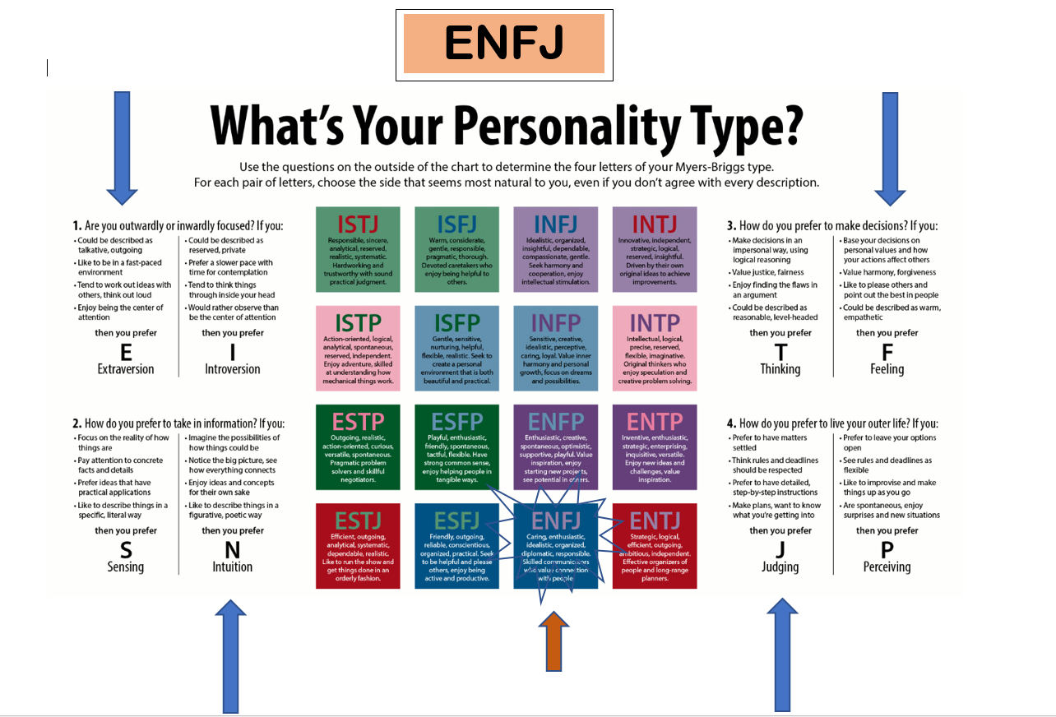

Appendix 7
Kiersey Temperament Sorter Self-assessment

Wendy Davies Keirsey Assessment Sorter
Project Manager Workforce Planning
Hywel Dda University Health Board
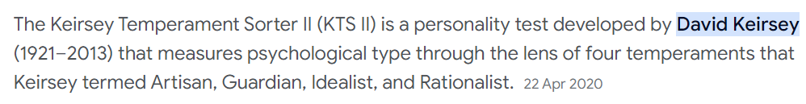
Idealist Teacher - ENFJ
 | IMAGINATIVE | INTUITIVE | RELATIONAL
IDEALIST | ROMANTIC | KINDHEARTED | SENSITIVE
 | AUTHENTIC | EMPATHETIC | DIPLOMATIC

IDEALISTS make up 15% of the entire population


Idealists share the following core characteristics
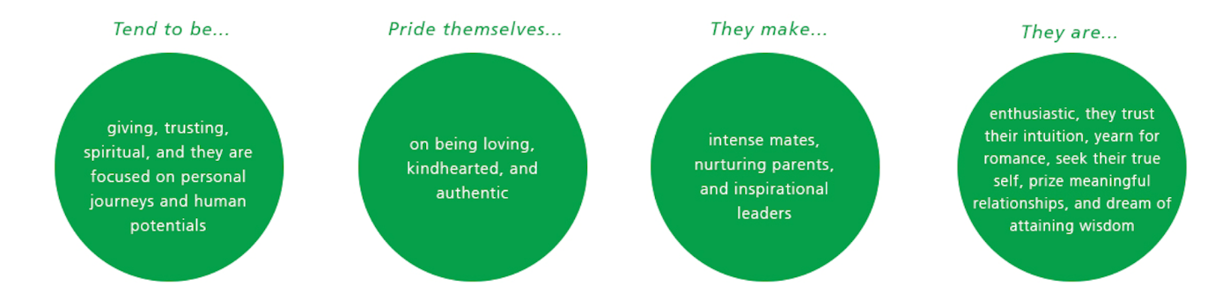

Idealists, as a temperament, are passionately concerned with personal growth and development. Idealists strive to discover who they are and how they can become their best possible self -- always this quest for self-knowledge and self-improvement drives their imagination. And they want to help others make the journey. Idealists are naturally drawn to working with people, and whether in education or counselling, in social services or personnel work, in journalism or the ministry, they are gifted at helping others find their way in life, often inspiring them to grow as individuals and to fulfil their potentials.
Idealists are sure that friendly cooperation is the best way for people to achieve their goals. Conflict and confrontation upset them because they seem to put up angry barriers between people. Idealists dream of creating harmonious, even caring personal relations, and they have a unique talent for helping people get along with each other and work together for the good of all. Such interpersonal harmony might be a romantic ideal, but then Idealists are incurable romantics who prefer to focus on what might be, rather than what is. The real, practical world is only a starting place for Idealists; they believe that life is filled with possibilities waiting to be realized, rich with meanings calling out to be understood. This idea of a mystical or spiritual dimension to life, the "not visible" or the "not yet" that can only be known through intuition or by a leap of faith, is far more important to Idealists than the world of material things.
Highly ethical in their actions, Idealists hold themselves to a strict standard of personal integrity.
They must be true to themselves and to others, and they can be quite hard on themselves when they are dishonest, or when they are false or insincere. More often, however, Idealists are the very soul of kindness. Particularly in their personal relationships, Idealists are without question filled with love and good will. They believe in giving of themselves to help others; they cherish a few warm, sensitive friendships; they strive for a special rapport with their children; and in marriage they wish to find a "soulmate," someone with whom they can bond emotionally and spiritually, sharing their deepest feelings and their complex inner worlds.
Idealists are relatively rare, making up no more than 15 to 20 percent of the population. But their ability to inspire people with their enthusiasm and their idealism has given them influence far beyond their numbers.
There are four types of Idealists

Although all Idealists share core characteristics, not all of them are the same. In Keirsey’s observations, he noted that there were four kinds of Idealists. They are: the Idealist Champions (ENFP), Idealist Healers (INFP), Idealist Teachers (ENFJ), and Idealist Counselors (INFJ).

Teachers have a natural talent for leading students or trainees toward learning, or as Idealists like to think of it, they are capable of calling forth each learner's potentials. But perhaps their greatest strength lies in their belief in their students. Teachers look for the best in their students, and communicate clearly that each one has untold potential, and this confidence can inspire their students to grow and develop more than they ever thought possible.



Counsellors have an exceptionally strong desire to contribute to the welfare of others, and find great personal fulfilment interacting with people, nurturing their personal development, guiding them to realize their human potential. Although they are happy working at jobs (such as writing) that require solitude and close attention, Counsellors do quite well with individuals or groups of people, provided that the personal interactions are not superficial, and that they find some quiet, private time every now and then to recharge their batteries.


Champions are rather rare, say three or four percent of the population, but even more than the others they consider intense emotional experiences as being vital to a full life. Champions have a wide range and variety of emotions, and a great passion for novelty. They see life as an exciting drama, pregnant with possibilities for both good and evil, and they want to experience all the meaningful events and fascinating people in the world.

Healers present a calm and serene face to the world, and can seem shy, even distant around others. But inside they're anything but serene, having a capacity for personal caring rarely found in the other types. Healers care deeply about the inner life of a few special persons, or about a favorite cause in the world at large. And their great passion is to heal the conflicts that trouble individuals, or that divide groups, and thus to bring wholeness, or health, to themselves, their loved ones, and their community.

Appendix 8
Honey & Mumford
Learning Styles Questionnaire self-assessment

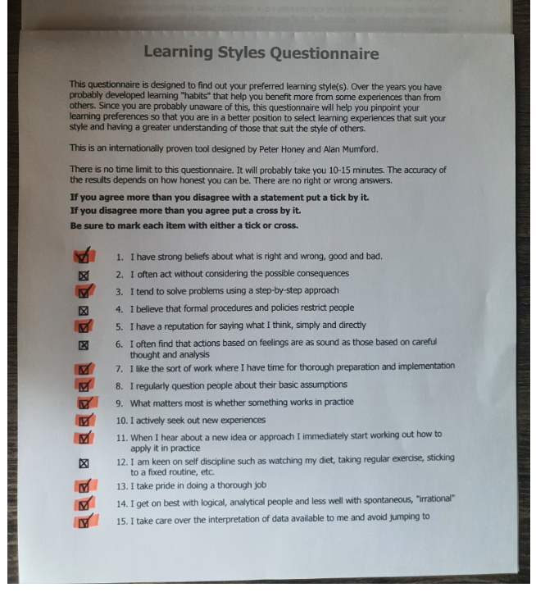

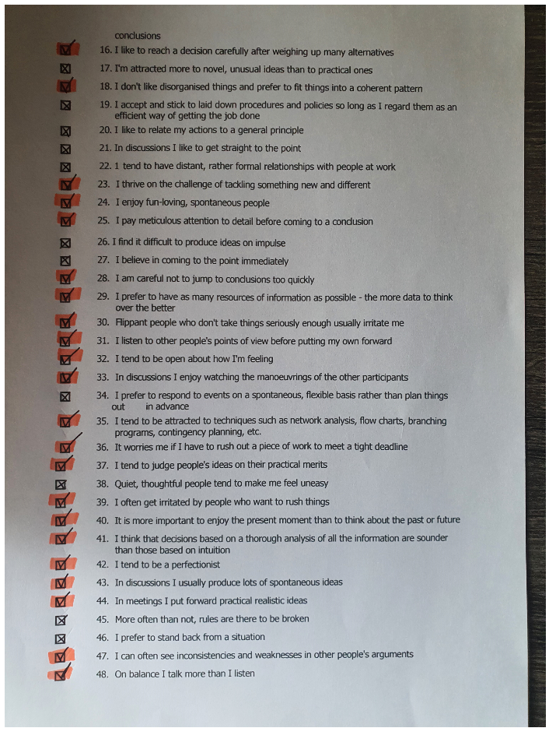
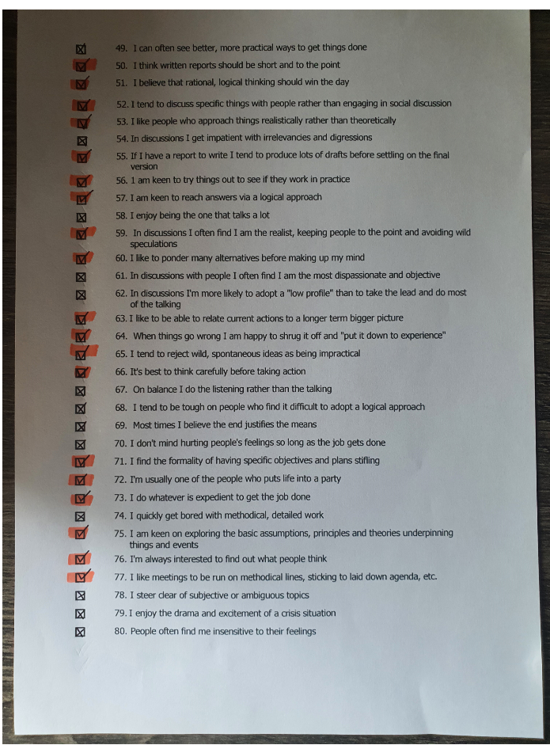
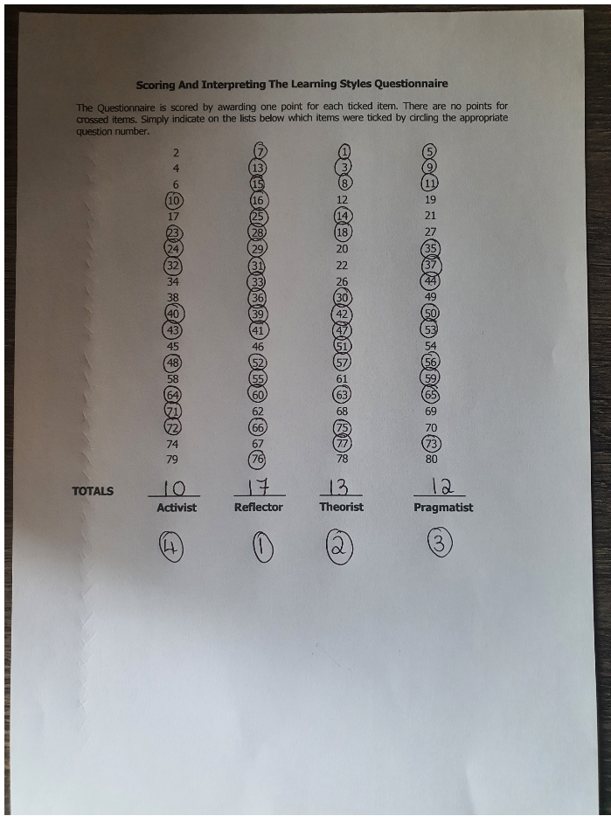
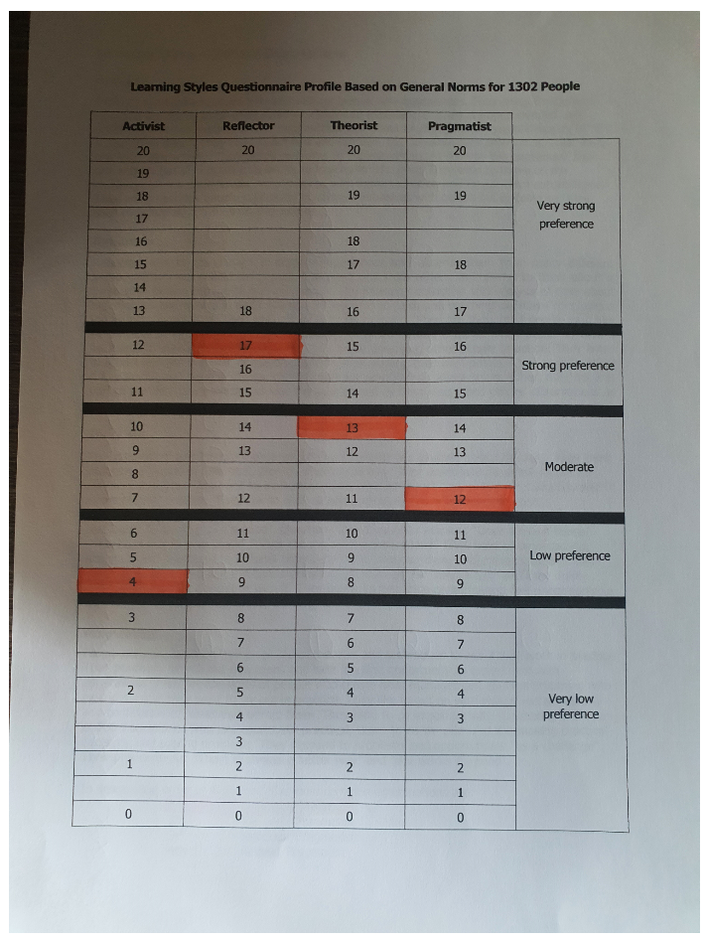

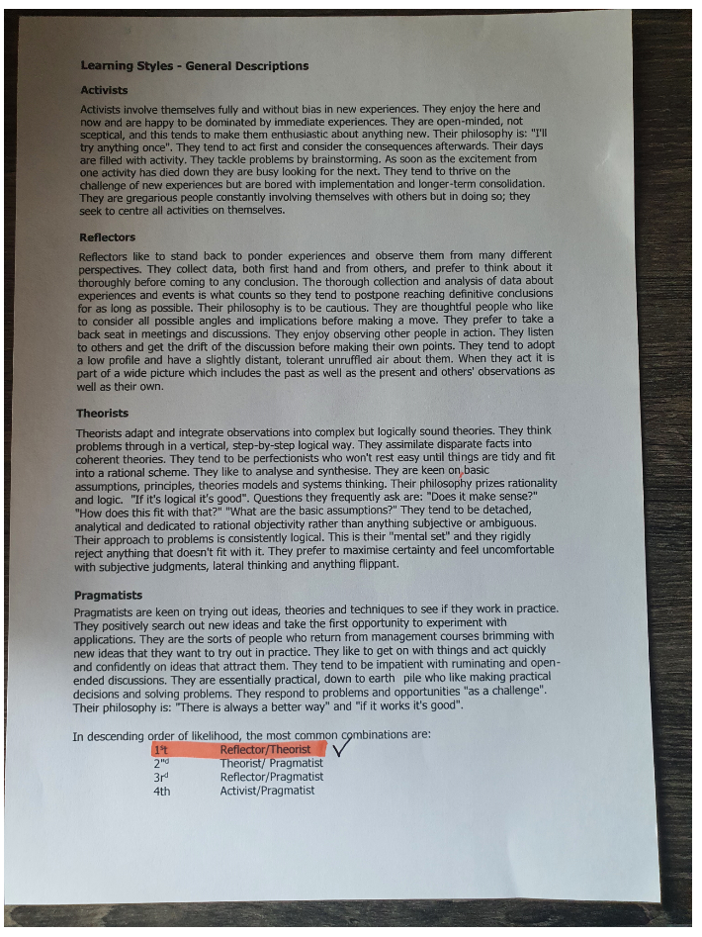

Appendix 9
Capability Matrix Assessment
(Health Education Improvement Wales Tool)
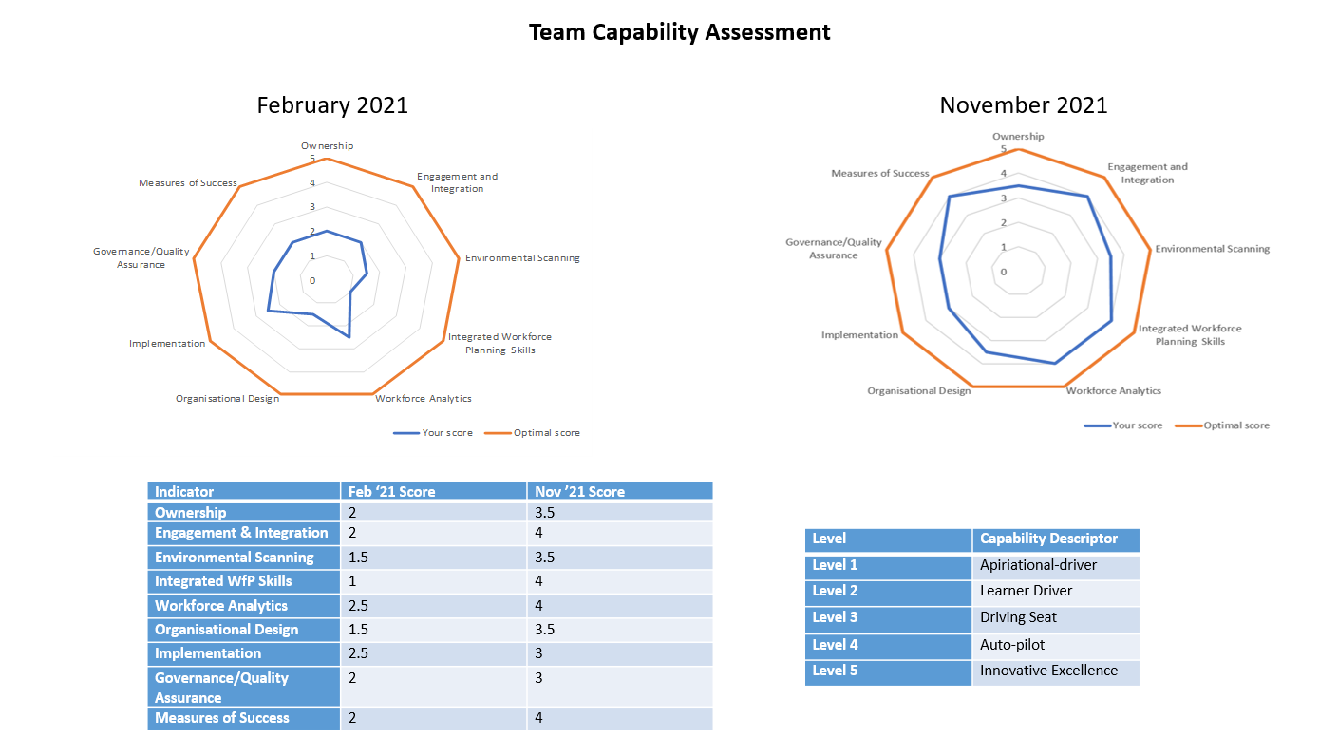
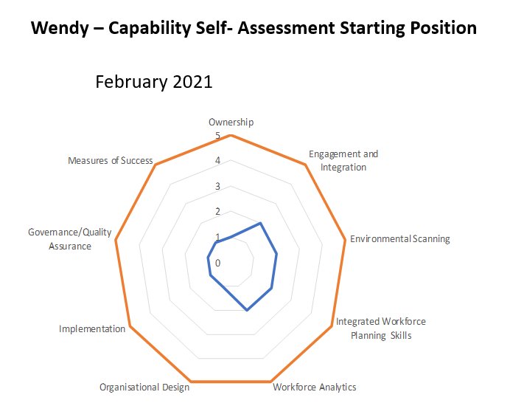

Wendy Davies – Personal Assessment to feed into Personal Development Plan
Indicator | Recommendation
Ownership | Overview  Knowledge in this area signifies clarity in areas such as; who owns the plan, the lines of responsibilities, the purpose of the plan, the scope of the plan, the staff groups that may be affected by the plan and the relevant stakeholders with input and effect on the workforce plan.  Present level of Capability  From the information provided, your knowledge in this area is considered as achieving. This is indicative of someone who has clarity as to the true owner of a plan or is the plan owner themselves.  Development Actions  To be able to work at the next level of capability there is need to work closely with the workforce planning lead for your organisation. This will help point out areas of strength and weakness in your plan so as to be able to access the appropriate development needs required.
Engagement & Integration | Overview  For a plan to be successful, inputs from stakeholders are required in the decision-making process. This is more so as stakeholders come with a vast array of experience, information and knowledge which can play a central role in setting up the plan’s objectives and priorities. Ability in this area will not only strengthen relationships internally and externally but will also ensure plans deliver positive outcomes for patients and service users. This is through the use of effective communication, stakeholder mapping and building and maintaining meaningful relationships.  Present level of Capability  Your score for this area is indicative of someone who is achieving and meeting expectations and set targets. This applies to someone who is able to utilise their experience and transferable skills to ensure that the direction of travel of the team's objective is aligned to prevailing contemporary issues within the business environment.  Development Actions  There is room for development and to be able to work at the next level of capability, the following suggestions will serve to build confidence.  Keep yourself up to date by reading major business news and publications from industry giants like the Office of the National Statistics and gain an understanding of how these external factors bear on the work of your organisation.  You can ask your manager to allow you lead on a project work and research what factors will bear heavily as risks to be avoided or opportunities to be explored. It is also worthwhile having a conversation with experienced senior leads or studying other project works and learning from their insights.
Environmental Scanning | Overview  Environmental Scanning is the ability to carefully and constantly analyse the context in which the organisation is operating. This is in order to fully understand the external and internal issues affecting the organisation and hence able to detect opportunities, trends, threats, weaknesses and strength which can adversely impact the strategic objectives of the organisation both in the short and long term.  Present level of Capability  From the information provided, your knowledge and skills at this level is emerging. This is typical of someone with little or no experience or expertise in the analysis of forces at play within the macro and micro environments of business entities.  Development Actions  To be able to work at the next level of capability, it will be advisable to spend time studying and researching the environment within which your organisation is operating in. It will also be worthwhile to have a conversation with your manager or any other senior member of staff knowledgeable in this area to share practices and good examples. The reading materials listed below will build a better understanding of the need and definition of Environmental Scanning.  http://citeseerx.ist.psu.edu/viewdoc/download?doi=10.1.1.983.8496&rep=rep1&type=pdf  https://www.cipd.co.uk/knowledge/strategy/organisational-development/swot-analysis-factsheet  https://www.cipd.co.uk/knowledge/strategy/organisational-development/pestle-analysis-factsheet
Integrated Workforce Planning Skills | Overview  An effective workforce plan ensures that the right staff with the right skills is in the right place and at the right time to deliver safe, high-quality care to the patients and service users. The plan needs to be evidence based and should allow for an effective integration of finance, service and workforce. It is advisable to adopt a framework or methodology to ensure consistency of approach across the organisation.  Present level of Capability  The score shows the skills and knowledge in this is business as usual. This is typical of someone who has carried out workforce planning either in conjunction with a team or working in silo. Notwithstanding the level of experience, there are pockets and gaps in the way you demonstrate your ability. This is usually due to lack of complete grasp of the competence needed to ensure alignment of processes obtainable in finance, service and workforce planning.  Development Actions  There is need to have a conversation with your manager or with workforce planning leads and confer the need to work in partnership with your colleagues in finance and service planning to ensure alignment of processes. Depending on your level of experience and training, there will be need to undergo a more intense training to develop your understanding of strategic workforce planning. It will also be instrumental if you teach yourself to understand the tools, processes and language used by colleagues in finance and service planning. The link below will help to understand standards of performance expected of individuals in different roles;  https://www.ukstandards.org.uk/
Workforce Analytics | Overview  Expertise in workforce analytics involves the use of an organisation information system to collate employee related data and using a combination of software and statistical modelling to produce a cleansed data or report. Organisations usually have dedicated workforce analysts trained in the use of software and methodologies that can turn these data into metrics required to give insights into workforce related decisions.  Present level of Capability  From the information provided, your capability in this area is either developing or meeting set expectations for someone working at your level of practice. This is indicative of someone with experience in using workforce analytics to inform the decision-making process. Emphasis here is more medium-term than short-term with an expanded awareness of the need to integrate multiple data sources in data modelling.  Development Actions  To be able to work at the next level of capability you need to develop the courage and ability to question data to ensure its robustness. Speake to your manager to understand more how data can be used to drive strategic decisions and practice collecting and interpreting relevant data to drive decision making processes. It will be worthwhile to research what is out there in the use of data in guiding decisions and the following links will be useful;  https://www.cipd.co.uk/knowledge/strategy/analytics/factsheet  https://www.xperthr.co.uk/good-practice-manual/people-analytics/161599/  https://www.mindtools.com/
Organisational Design | Overview  To be effective in this area, one needs to have a full grasp of the present state of the organisation and its intended future state. Then once the gaps are identified, be able to design and align organisations structures, processes, framework and systems in line with its people dynamics to bridge the gaps.  Present level of Capability  The information provided shows that your competence at this level is developing and meeting expectations. This is typical of someone with a greater level of exposure to organisations design practices.  Development Actions  The results obtained shows that you are quite knowledgeable in this area but there is always room for development if you want to work at the top of your practice. To work at the next level up, there is need to fully understand and grasp the interaction that exists both vertically and horizontally at the different level of the organisation. Explore ways in which data collected can be used in more productive way to make the design process more efficient. Learn from your experience and from those who are experts in the field, build and maintain effective relationships as they will inform your practice. Study and research and keep up to date with contemporary practices in this area of practice.  https://www.cipd.co.uk/knowledge/strategy/reward/market-pricing-factsheet  https://www.cipd.co.uk/knowledge/strategy/organisational-development/job-design-factsheet
Implementation | Overview  Implementation is one of the last processes in the six steps methodology of workforce planning. Capability in this area will require knowledge, skills and competence in change and project management required to ensure the success of any plan.  Present level of Capability  Your score shows that your experience and expertise in this area are meeting expectations. This is usually synonymous with someone who has either supported an individual or team in the implementation of change, has implemented a change project or has been trained in both change and project management.  Development Actions  There is always room for development and to be able to work at the next level of capability, it will be a good start to review your past practices to ensure that it is in line with good practices obtainable across different organisations. Speak with your manager to allow assess your team to identify any development issues, then take necessary steps to implement any relevant change. It will also be very helpful to undergo more in-depth training at this stage which can be agreed with your manager. The links below will also be helpful in expanding your knowledge. https://peopleprofession.cipd.org/profession-map/core-knowledge/change
Governance/  Quality Assurance | Overview  This indicator covers both governance; a system of accountability or reporting structure and quality assurance; which involves monitoring, controlling and reviewing the implementation of the workforce plan. Where governance ensures a reporting framework with an established lead; quality assurance provides a way of dealing with any unintended consequences of a plan.  Present level of Capability  The information you provided shows your competence in this indicator is achieving and meeting set targets for your level of practice. This is typical of someone that with greater knowledge and experience in change implementation. You therefore understand the need to monitor and review plans in order to take early corrective actions when needed whilst keeping the necessary person/s informed at all stages.  Development Actions  Your result show that you that you are currently meeting expectations but there is always room to improve your practice in order to work at the next level of capability. Always and constantly review your past decisions and actions so that you can learn from experience. Use a systematic approach to planning and always keep a detailed record of all assumptions, data, modelling etc so it's easy to retrace your steps and make updates if needed. If you have never led on any plan, then speak to your manager to allow you conduct one to improve your knowledge and skills.
Measures of Success | Overview  Every plan has its intended or desired outcomes and bearing in mind that time, finance and workforce availability are all finite resources, it becomes more critical for every plan to be efficiently evaluated to help determine if outcomes are achievable and where required, make minor adjustments to ensure the plan is on course. Efficiency in this area requires deep understanding of the plan and therefore what measures to use to determine the success of the plan.  Present level of Capability  Your score indicates that your ability for this area of practice is meeting expectations. This is typical of someone capable of drawing on past experiences and using transferable skills to exhibit behaviour expected at this level of practice.  Development Actions  The information provided shows that this area of practice is business as usual because of your level of experience but there is still for development if you want to work at the next level of capability. Reflect on your past experience to identify what further data, KPI's or levers that would have proved valuable in ensuring success. Identify what relationships you have built or need to build and what information they would require, ensuring better inputs in your plan. Ask your manager to allow you support a much wider organisation plan to broaden your knowledge and understanding.
Current position as at October 2023

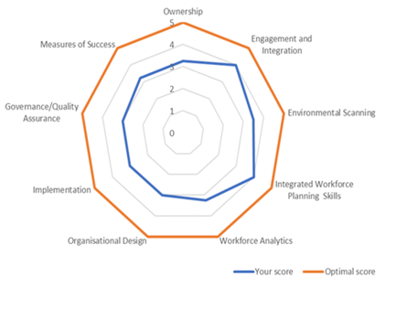

Appendix 10
Workforce Planning Meetings attended by Wendy Davies
Wendy Davies - Project Manager Strategic Workforce Planning
Meetings 1 Dec 2022 - 30 Nov 2023
Advanced Technologies into Clinical Practice - TRITECH Site Visit
AHMWW Finance & Workforce
ARCH Ophthalmology
ARCH Radiology - CTSim 1 recommissioning & CTSim 2
ARCH Regional Radiology Group
ARCH Strategic Development Group Meeting
Audiology Deep Dive - Integrated Care Centres
Benefits Workshop - Regional Pathology Programme
BGH Strategy Steering Group
BiLingual Skills Policy Update
Business Service Meeting - Pembrokeshire County
Cancer Services and Workforce Planning
Carmarthen Hwb Benefits Workshop
Carmarthen Hwb Project Group
CEDA
Cellular Pathology Work Stream Meeting - ARCH Regional Pathology Programme
Cellular Pathology Work Stream Meeting - ARCH Regional Pathology Programme
Creating change together in Ceredigion
Cross Hands Development, Service Design, Digital & Workforce Sub Group Meetings
CYP Working Group
Data Science Platform
Datix risk training
Dental Service Review Meetings
Design Review ARCH Pathology Steering Group
Development of a Strategic Workforce Plan for Primary Care
Development of Fishguard Health & Wellbeing Centre
Digital & Workforce Planning
Digital Champions Forum
Early Years Service Design & Workforce Subgroup - Cross Hands Wellbeing Centre and Carmarthen Hwb
Education & Commission Forums
Engagement Session - HEIW Education and Training Plan 2024/25
Future Workforce Planning
Healthier Pembs Operational Forum
Honorary Contracts Governance
Horizon Scanning Meeting
Hywel Dda Ultrasound Control Group
Industrial Action Planning & Management Group
Job Evaluation - 2 Day training provided to HEIW (29 &30th June)
Medacs Medical Monthly Meeting
Microbiology Working Group meeting - Regional Pathology Programme
Morriston Regional Pathology User Group HOT LAB SERVICES
National Stroke Programme Workshop - Service Specifications, Modelling & Pathways
Nurse Retention Self-Assessment Tool - Training
Nursing Workforce Planning Group
Oncology Outpatients Working Group
Ophthalmology Workforce Planning Workshop
Pathology Workforce Road Map
Pelvic Health Workforce Plan Group
Pembs Finance & Workforce Meetings
Pembs ODG Homebased Care
PPH - MIU
Primary and Community Services Academy - Steering Group meeting
Primary Care and Community Strategy Group
Primary Care SWfP Training
Radiology/Workforce Meeting Key Decisions for Data (Risk)
Regional Pathology ODN Development Board
Regional Pathology ODN Development Board
Regional Pathology Programme & Governance Meetings
Regional Pathology Project Team Meetings
Regional Pathology Workshop - Transition Board Development & ODN Progression
Risk & Assurance & Workforce Meetings
Robot Process Automation
Robotic Surgery Task and Finish Group
Robotics Business Case Meeting
SDEC Delivery Group
SLT Development Group
SPPC Multi-Professional Working - Development Matrix discussion
Strategic Workforce Plan for Primary Care - Exploring the impact of Digital Transformation on the Primary Care Workforce
Stroke Task & Finish Group
SWP & Risk Assurance & Governance
Tissue Viability Service (linked to Risk)
TUEC Programme Delivery Group
Wales JE Trainers Meeting
Wales Monitoring Group - Job Evaluation
WFPN Discovery Event: Workforce Intelligence for Workforce Planning
WOD EDI visioning workshop
Women & Children's Directorate Monthly Quality, Safety & Experience Meeting
Workforce & OD Collab Meetings
Workforce / Digital Strategy Development
Workforce Planning Network Meetings
Workforce Subgroup (ODN Development Board) Service Leads
Workforce Subgroup (ODN Development Board) Workforce Only
Workshop Community health services proposed at Cross Hands, Pentre Awel and Carmarthen Hwb

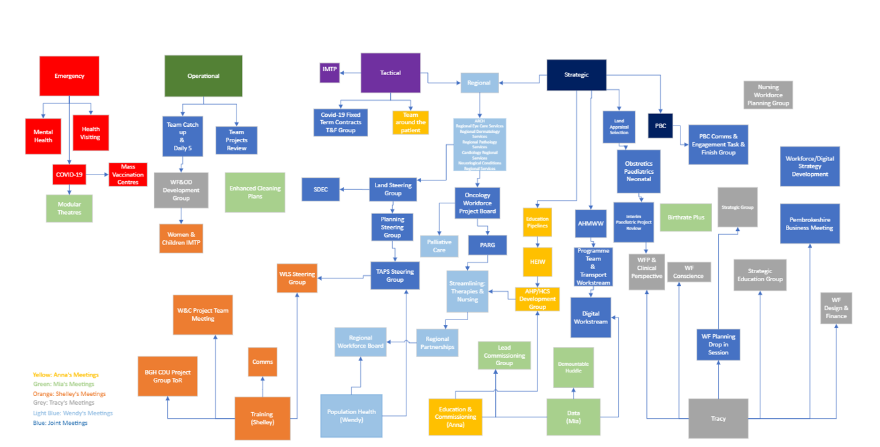

Appendix 11
Strategic Workforce Planning Team Audit
The Strategic Workforce Planning Team came together in January 2021 to strengthen the workforce planning offer within the Workforce & OD Directorate. Since June 2021, every quarter the team have organised team sessions/away days to plan, prioritise and set outcomes, objectives and schedules of work for the next forthcoming quarter. New Health Board developments are shared and the impact of these assessed against current workstreams in progress – this includes, National, Regional and local strategic drivers.
As part of these away days our own team performance is audited and scored to ascertain how as a team we are feeling and is also used as a temperature check where issues and concerns are raised discussed and action plans created.
The Team Audit Assessment is based on how we feel we are performing , how we interact as a team, and how we feel we are viewed and received by corporate services, our wider workforce directorate and by the services whom we work with.
Team Identity, Team Objectives, Team Decision Making, Team Communication, Constructive Debate and Inter Team Working as part of this exercise as all considerations.
Below is example of the depth and discussion around the Audit and the action plan below.
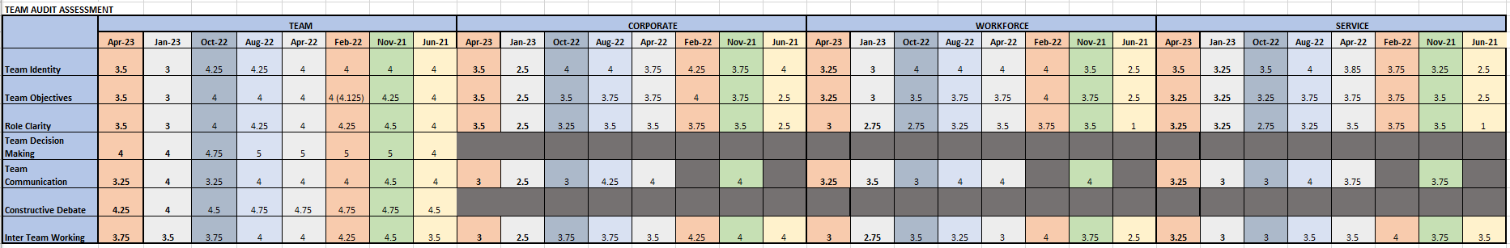

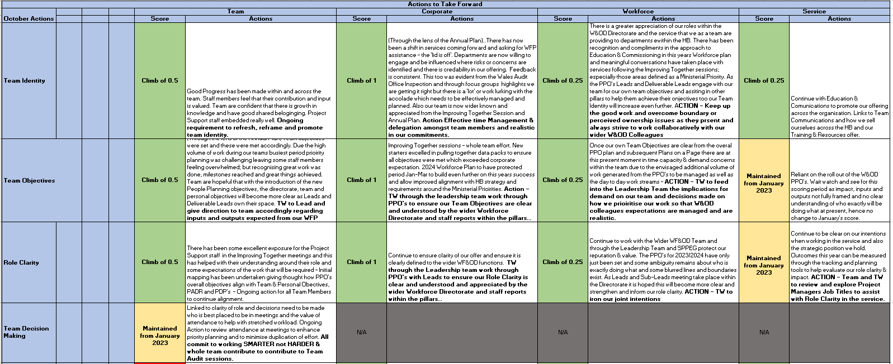
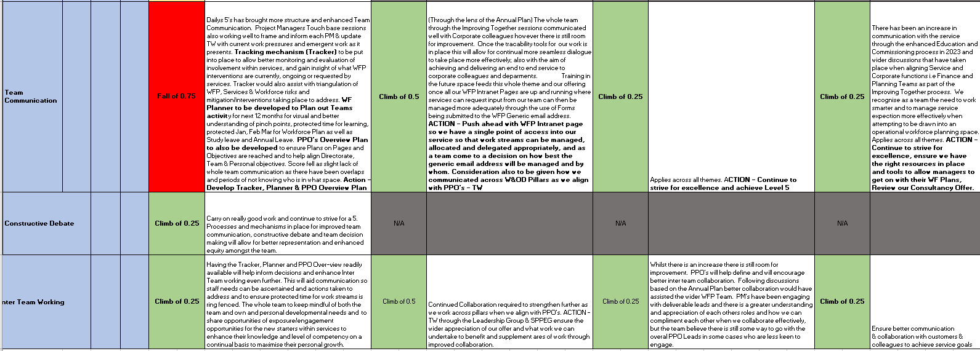

Appendix 12
VARK Learning Style Questionnaire
Result – Visual Learner



