

DEVELOPING INNOVATION AND
CREATIVITY FOR BUSINESS
Why Innovation is Essential for Business
Success.

Student: Zilvinas Miksys
Student nr.:1815997
Module Code: BMSW6102_SWAN
Tutor: Lect. Davina Evans
Date of report publication: 01/03/2024
Word count: 2552

Executive summary
The evaluation covered creativity and innovation in the enterprise. This contributed to the advancement of knowledge about the significance of invention for the company. Tesla is the chosen company. Tesla, Inc. is a global American automotive and green power company that produces, evolves, and sells solar panels, electric cars, and a kind of battery called static storage of electricity that may be utilized by homes or on a grid. Austin, Texas is the site of the business's headquarters. The business also provides associated products and services. The assessment's primary recommendations addressed the idea that innovation as its many forms. The innovation models that have been identified can be useful in understanding the firm as a whole. Additionally, the evaluation of its efficacy is provided.
Table of Contents
1.Introduction 4
2.Main findings 4
2.1Overview of innovation opportunity 4
2.2Types of innovation 5
2.3The creative thinking process 7
2.4Models of innovation 7
2.5Assessment of effectiveness 11
2.5.1 Barriers and risks 11
2.5.2Leadership and management 11
3 Conclusion 12
Reference List 13

1. Introduction
The assessment will discuss innovation and creativity for business. This will be helpful to promote a better understanding of how innovation is important for business. The selected firm is Tesla. Tesla, Inc. is an international American car and green power corporation that manufactures, develops, and markets electric vehicles, solar panels, and a type of battery known as static energy storage that can be used for grid-scale or residential applications. Its headquarters are located in Austin, Texas. The company also offers related goods and services. The assessment will focus on the main findings where the concept of innovation and its types will be discussed. The models of innovation will be highlighted that can help understand the overall business accordingly. Moreover, the assessment of its effectiveness will be delivered.

2. Main findings

2.1Overview of innovation opportunity
Innovation can be considered to be one of the key aspects that helps to improve the quality of the firm. The introduction of solar roofs for the car is an innovation for the cars. This will help them recharge the car in times of need. This can be considered to be an important part that will help the firm to create proper innovation.
Battery-powered automobiles in areas with frequent snowfall can be charged by retractable solar-powered roofs composed of transparent, glass-free photovoltaic panels (Saxena, 2021). An additional feature is the solar roof panel, which uses a high-tech silicone PV (photovoltaic) material that functions as a conductor to "absorb" sunlight and produce power. The Inventive Solar Technology of the Electrified G80 may allow for a further extension of its WLTP 323-mile range (Habib et al., 2020). This ingenious development may provide around 0.7 kWh of energy, or an additional 3 km / 1.8 miles of length every day, or 1,150 km / 715 miles annually, considering an average of slightly less than eight hours of daylight. Clients may save money and time by doing this.

2.2Types of innovation
Innovation and creativity have many meanings and applications. While creativity is the ability to come up with fresh ideas, innovation is the process of putting those original concepts into action to bring value (Kumari and Bhat, 2021). Inspiration is the act of producing something new and valuable. Individuals can create things that are virtual or tangible, such as hypotheses, jokes, and ideas. People cultivate interests in a wide range of concepts and fields, such as psychology, physics, accountancy, business management, and blogging. Creativity serves as a gauge for the effectiveness of learning and education. In other words, creativity is just the process of coming up with new things (Bredenfeld et al., 2020).
Innovation is the process of bringing concepts for products and utilities to life. Innovation is improving the products and services that are provided. To breathe new life into the products and services that are already on the market, innovative tactics, ideas, and plans are put into practice. Despite the wide range of opinions around creativity, it's interesting to note that there are four primary categories of growth. Innovation comes in five flavours: building, disruptive, radical, and gradual.
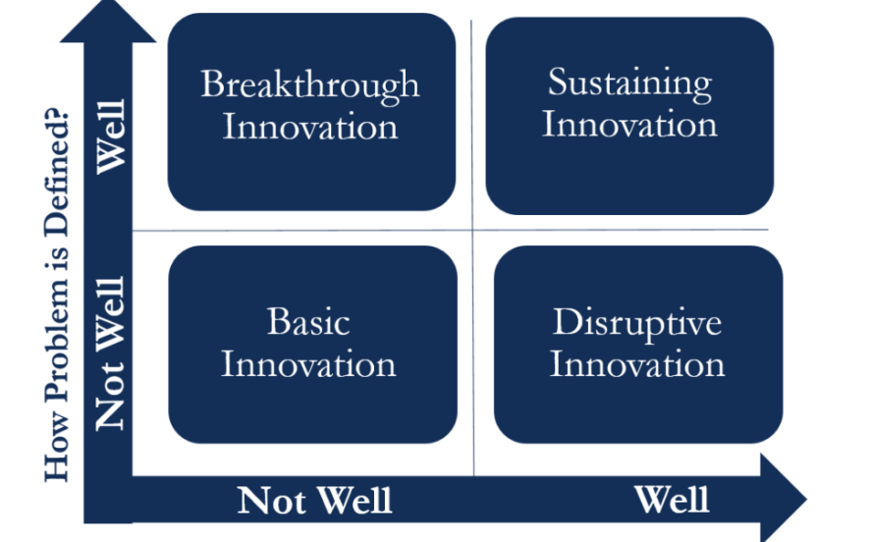
Figure 1: Innovation types
(Source: Agnihotri and Bhattacharya, 2022)

Breakthrough innovation
Innovation that advances anything to the highest possible point and originates inside of the organization qualifies as breakthrough innovation (Hensmans, 2022). It modifies how clients engage with a marketplace or trade and permits an organization to enter new markets. A noteworthy instance of revolutionary technology is Zipcar. Tesla's electric car technology is its main creation (Calic et al., 2022). The firm revolutionized the public's view of electric vehicles (EVs) by introducing a line of vehicles. When it was introduced in 2012, the Tesla Model S received notoriety for its outstanding performance, range, and stylish exterior.
Sustaining innovation
Teslas are by no means cheap cars; their pricing is on par with that of Mercedes and BMW. Our production facilities are designed to use the least amount of water, energy, and waste. They can produce our products more sustainably with each Gigafactory (Tiku, 2022). The factories are built using the least amount of waste, water, and energy possible. Sustaining innovative thinking is the committed endeavour to improve the current outstanding offerings to ensure recurring business. If innovation is to survive, it must stay true to its existing, richer audience.
Basic innovation
Tesla has prioritized battery development to boost the power of its vehicles' engines. Innovation in battery packs lowers the price of Tesla's goods. Its innovative strategy gains from collaborating with Panasonic as well. Tesla's Solar Roof tiles are the first items of their kind available on the market (Khan, 2021). Its solar roof tiles are more than three times tougher than conventional roof tiles and are made to resist any weather. A 25-year warrant is attached. According to Tesla, the company's in-house team of energy experts has installed 3.6 GW of pure solar energy on 4 lakh rooftops, or 10 million solar cells.
Disruptive innovation
Tesla is a prime example of a disruptive invention (Hoeft, 2021). The business is thought to be disruptive in the industry since it was among the first to standardize and market innovative automotive technologies. Autonomous driving and electric cars are two breakthroughs that have made Tesla a disruptive force in the industry. Tesla's electric cars and state-of-the-art automatic driving systems have revolutionized the automotive business. Due to its exceptional products' efficacy, intellect, and design, it has become incredibly well-liked (Jing, 2020). In the auto industry, Tesla is often mentioned and seen as a disruptor. driving the transition of the automotive sector to electrification and making high-quality EVs available to the general public. Some people may consider this to be disturbing. However, the disruptive question also revolves around this relativity concern.

2.3The creative thinking process
To bring the newest innovation to the market, Tesla's basic principle is to submit a proposal, obtain finance, and then commercialize the idea. The Corporate Innovation System defines the success of the ideas generated (Matthews et al., 2020). Tesla's creative concepts consist of five parts. Among these are Organization and People, Process, Leadership and Management, and Culture. Elon Musk, the owner of Tesla, teaches his employees how to handle issues creatively, which encourages them to think creatively and to constantly be on the lookout for new trends. Elon Musk also promotes the free exchange of ideas among his employees, which might result in some incredible breakthroughs for the company. He also reduces the size of the executive group to promote cooperation inside the organization.
The degree of each component that goes into a Tesla product is also taken into account in its ecosystem strategy (Li et al., 2021). the parts of a system that restrict performance, or bottlenecks, are typically the ones making the most money in a given business. In the case of electric motorbikes, packs are a block to the whole system's efficiency even though they are composed of typical components and their power capacity restricts the functionality of most applications, notably autos. Tesla is making a purchase in batteries in the hopes of controlling the industry's bottleneck and, consequently, its revenue centre going forth. Batteries are being produced at scale and in simpler procedures.

2.4Models of innovation
Tesla has also considered the system level, which comprises all the add-ons required for a consumer to use its product. For this reason, Tesla has built a network of charging stations around the country for its cars (Hadzigeorgiou, 2021). Tesla became the only electric car capable of long-distance recharge because of its early initiative in creating the infrastructure required for such travel. If other manufacturers build charging networks that branch out from their present dealership networks in an attempt to offer potentially more convenient service, this benefit could be lessened in the future. The company has developed an amazing strategy with several facets to drastically transform an industry. The primary approach varies depending on the stage of the ecosystem: they contest the basic product architecture and occupy key bottleneck components.

2.4.1Open and closed innovations
The distinctions between open and closed innovation are determined by the processes used to generate it (Pierzgalski, 2016). Closed technology is developed in a closed company environment, whereas open innovation incorporates outside information into innovation administration. Tesla Motors uses the connected strategy of open innovation and works on research and development with major companies. It can further the advancement of its innovative technologies in this way. The surge in CO2 emissions worldwide has been mostly attributed to the car industry. Automotive companies often use petroleum and petroleum-based electrical gadgets. Automakers are searching for innovative ecologically friendly technologies to include in their vehicles as a result of government restrictions on the environment and the impending depletion of oil resources (Daraojimba et al., 2023). Electric cars are often mentioned as the most feasible solution.
2.4.2The innovation process
Tesla uses a high system-level incremental innovation approach for its item development while making electric automobiles and energy solutions. It enables customers to benefit from significant technological advancements in the car industry, such as the autopilot program. Despite issues with intellectual property rights, supply delays, and a lack of semiconductors, Tesla established the standard for the electric vehicle industry (Maamoun, 2021). Even if Tesla is leading the capital market, it is still in a great position because its real competitors are not new energy operators. Owing to constraints imposed in the near future by factors like capacity, market, funding, and chip, Tesla needs to focus on its innovative potential and maximize the company's strategy to promote development.

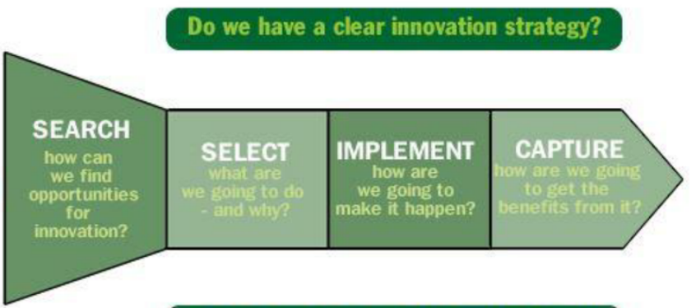

Figure 2: Innovation steps
(Source: Braun and Boström, 2021)

Environmental degradation and energy scarcity persist despite the public's growing awareness of environmental concerns and the fast growth of technology. The creation of new energy vehicles is one innovative strategy required to achieve a balance between the competing goals of environmental preservation and energy security (Han, 2021). The environmental harm that electric cars create might be minimized if green energy-producing technologies are continually developed. The escalating cost of gasoline is driving up demand for electric vehicles. The need for car batteries is rising globally, and major competitors in the industry include Toyota, Nissan, and Tesla. Tesla's market valuation surpassed $600 billion by 2020, a seven-fold rise. In terms of market capitalization, it was the most profitable car when compared to Toyota.
2.4.3The 4P’s to innovation
Product innovation
The first electrical vehicle to be sold successfully in history is the Tesla. It is constantly committed to technology advancements and product innovation to boost the competitiveness of products (Ignjatović et al., 2023). Among Tesla's most enticing innovations are the powerful generators, long-range on a single charge, charging technology, and automated systems. The development of integrated design is of utmost importance to Tesla Motors to ensure battery safety and dependable functioning. This comprises not just the "cell" pack but also controls for emptying and charging.

Process innovation
Tesla introduced process innovation by changing how they produce their products and coming up with concepts. They shifted to the present open innovation methodology from the earlier close innovation strategy. Tesla forged partnerships with companies such as Toyota, Daimler AG, and Panasonic. Together with these companies and a few research and development teams, Tesla was able to successfully use open innovation to innovate their technology and products. One way that this process innovation helped Tesla was by enabling it to boost its external resources and support. This raises the possibility that Tesla will add new features and extend the life of its goods.
Position innovation
In this regard, Tesla rose to prominence and created a new market for high-end, long-range electric vehicles. The original gas-powered motor cars and the engines for the less expensive electric vehicles are not quite the same as the new market that Tesla created. Their target audience is everyone interested in innovative, eco-friendly ideas (Maradin et al., 2022). For example, Tesla used the blue ocean strategy to develop many deep oceans for their companies. Sports vehicles and green automobiles, for example, are offered in different areas and often appeal to different consumer groups. Tesla entered the market in a novel way by fusing the terms "sports" and "green" to produce the first-ever "sports green" car, meeting the demands of consumers who want both.
Process innovation
Tesla presents a novel idea to its clientele: enhancing one's level of life shouldn't come at the expense of the environment. Furthermore, Tesla is aware that using its goods improves environmental preservation and quality of life. The Tesla is the first automobile to run entirely on electricity thanks to its integrated electric power plant, which satisfies the unique needs of the battery-powered vehicle (Pierzgalski, 2016). Therefore, society and the government must create a whole new social construction automobile system, which might lead to a revolutionary infrastructure. Changes to the structure of social networks, however, might lead to some issues. With this feature, Tesla changed people's perceptions and made it easier for them to conceptually embrace the new class of cars.

2.5Assessment of effectiveness

2.5.1 Barriers and Risks
Battery Suppliers: In the past, battery suppliers had a lot of pricing power because Tesla concentrated on lithium-ion cells. However, Tesla is working to reduce this power through initiatives like its partnership with Panasonic and in-house battery development projects.
Specialized Parts Required for EVs: Tesla needs certain parts that aren't available for regular cars. If fewer firms are competing for these parts, companies will have more negotiating leverage.
Vertical Integration: Tesla has lowered its reliance on subcontractors and, as a result, their negotiation leverage by manufacturing a large number of its parts and, more recently, aiming to create battery cells (Maamoun, 2021).
Consequence for Tesla: While certain suppliers have leverage due to the extremely specialized nature of EV technology, Tesla's vertical integration strategy mitigates this risk.

2.5.2Leadership and management
Even though Elon Musk's Tesla Motors is still a long way from reaching mass-market sales volume, it is regarded as the top startup in the electric car manufacturing sector. With initiatives like their business plan joint venture with Panasonic Company (Braun and Boström, 2021), Musk and other top management members of Tesla are keeping the company going forward and making it the world's largest producer of lithium-ion battery packs. Musk and the leadership of Tesla have various relationships with creditors, even if the company has not made a profit. The company's shares have found it difficult to continue their strong upward trajectory from 2018. Even though he prioritizes inventions and long-term planning, The creative thought processes, evaluation, and problem-solving abilities of the prior management style are among its strong points (Kim, 2020).

3 Conclusion
Based on the comprehensive investigation, it can be inferred that Tesla's innovative concept has enhanced the company's performance. The development of a solar roof is regarded as one of the most important and efficient examples of corporate strategy and innovation. In addition, models such as the 4 P's of innovation have been considered to be a major component in improving the assessment's quality. Since Tesla's obstacles were well-managed, they were also surmounted. This is said to be the essential component that helps Tesla develop a stronger business and raises the standard of operations.

Reference List
Agnihotri, A. and Bhattacharya, S., 2022. Tesla Innovation and Growth at the Cost of Quality?. SAGE Publications: SAGE Business Cases Originals.
Braun, S. and Boström, M., 2021. Organizing for the generation of radical innovations.
Braun, S. and Boström, M., 2021. Organizing for the generation of radical innovations.
Bredenfeld, L., Cherubim, M., Kellermann, A.C., Lehmann, C., Malberg, S., Rafn, J., Kwon, Y. and Choi, S., 2020. Tesla Moving Forward. 신산업경영저널, 38(1), pp.47-70.
Calic, G., Shevchenko, A., Ghasemaghaei, M., Bontis, N. and Ozmen Tokcan, Z., 2020. From sustainability constraints to innovation: enhancing innovation by simultaneously attending to sustainability and commercial imperatives. Sustainability Accounting, Management and Policy Journal, 11(4), pp.695-715.
Daraojimba, C., Abioye, K.M., Bakare, A.D., Mhlongo, N.Z., Onunka, O. and Daraojimba, D.O., 2023. Technology and innovation to growth of entrepreneurship and financial boost: a decade in review (2013-2023). International Journal of Management & Entrepreneurship Research, 5(10), pp.769-792.
Habib, T., Kristiansen, J.N., Rana, M.B. and Ritala, P., 2020. Revisiting the role of modular innovation in technological radicalness and architectural change of products: The case of Tesla X and Roomba. Technovation, 98, p.102163.
Hadzigeorgiou, Y., 2021. Biographical profiling of Nikola Tesla for the creation of an engaging story. Education Sciences, 12(1), p.12.
Han, J., 2021. How does Tesla motors achieve competitive advantage in the global automobile industry?. Journal of Next-generation Convergence Information Services Technology Vol, 10(5), pp.573-582.
Hensmans, M., 2022. The innovation pyramid: five approaches to strategic decision-making. Journal of Business Strategy, 43(4), pp.229-238.
Hoeft, F., 2021. Auto makers and radical innovation: culture, capital and talent form road blocks. Journal of Business Strategy, 43(4), pp.210-221.
Ignjatović, A., Vujko, A. and Bojović, R., 2023. EDUCATION AND INOVATION AS A DRIVER FOR RURAL DESTINATION DEVELOPMENT. Economics of Agriculture, 70(2), pp.537-552.
Jing, N., 2020, December. Research on Tesla’s Customer Care Innovation. In 2020 Management Science Informatization and Economic Innovation Development Conference (MSIEID) (pp. 469-478). IEEE.
Khan, M.R., 2021. A critical analysis of Elon Musk’s leadership in Tesla motors. Journal of Global Entrepreneurship Research, 11(1), pp.213-222.
Kim, H., 2020. Analysis of how Tesla creates core innovation capability. International Journal of Business and Management, 15(6), p.42.
Kumari, D. and Bhat, S., 2021. Application of artificial intelligence technology in tesla-a case study. International Journal of Applied Engineering and Management Letters (IJAEML), 5(2), pp.205-218.
Li, Y., Lin, J. and Xu, S., 2021, September. Analysis of Tesla’s Business Model: A Comparison with Toyota. In 2021 International Conference on Financial Management and Economic Transition (FMET 2021) (pp. 30-39). Atlantis Press.
Maamoun, A., 2021. REVENGE OF THE ELECTRIC CAR IN THE 2020s: A CASE STUDY. Global Journal of Entrepreneurship Volume, 5(1).
Maamoun, A., 2021. REVENGE OF THE ELECTRIC CAR IN THE 2020s: A CASE STUDY. Global Journal of Entrepreneurship Volume, 5(1).
Maradin, D., Malnar, A. and Kaštelan, A., 2022. Sustainable and Clean Energy: The Case of Tesla Company1. Journal of Economics, Finance and Management Studies, 5(12), pp.3531-3542.
Matthews, T., Hirve, M., Pan, Y., Dang, D., Rawar, E. and Daim, T.U., 2020. Tesla Energy. Innovation Management in the Intelligent World: Cases and Tools, pp.233-249.
Pierzgalski, M., 2016. VISION AND MISSION IN MODERN TECHNOLOGIES OF TESLA CAR BRAND EXAMPLE. POSZERZAMY HORYZONTY TOM XXXIII, p.167.
Pierzgalski, M., 2016. VISION AND MISSION IN MODERN TECHNOLOGIES OF TESLA CAR BRAND EXAMPLE. POSZERZAMY HORYZONTY TOM XXXIII, p.167.
Saxena, A.K., 2021. Innovation, Creativity, Entrepreneurship Management: An Analytical Approach. In Handbook of Research on Future Opportunities for Technology Management Education (pp. 313-330). IGI Global.
Tiku, S., 2022. Disruptive Innovations and Deep Market Penetration with Respect to Timing: A Complete Overview of Tesla, and the Urban Company along with Timing, Diversification. Journal of Student Research, 11(3).

