

Task 1 – Reading Task Template
Upload your photo of your A3 in-class notes here:
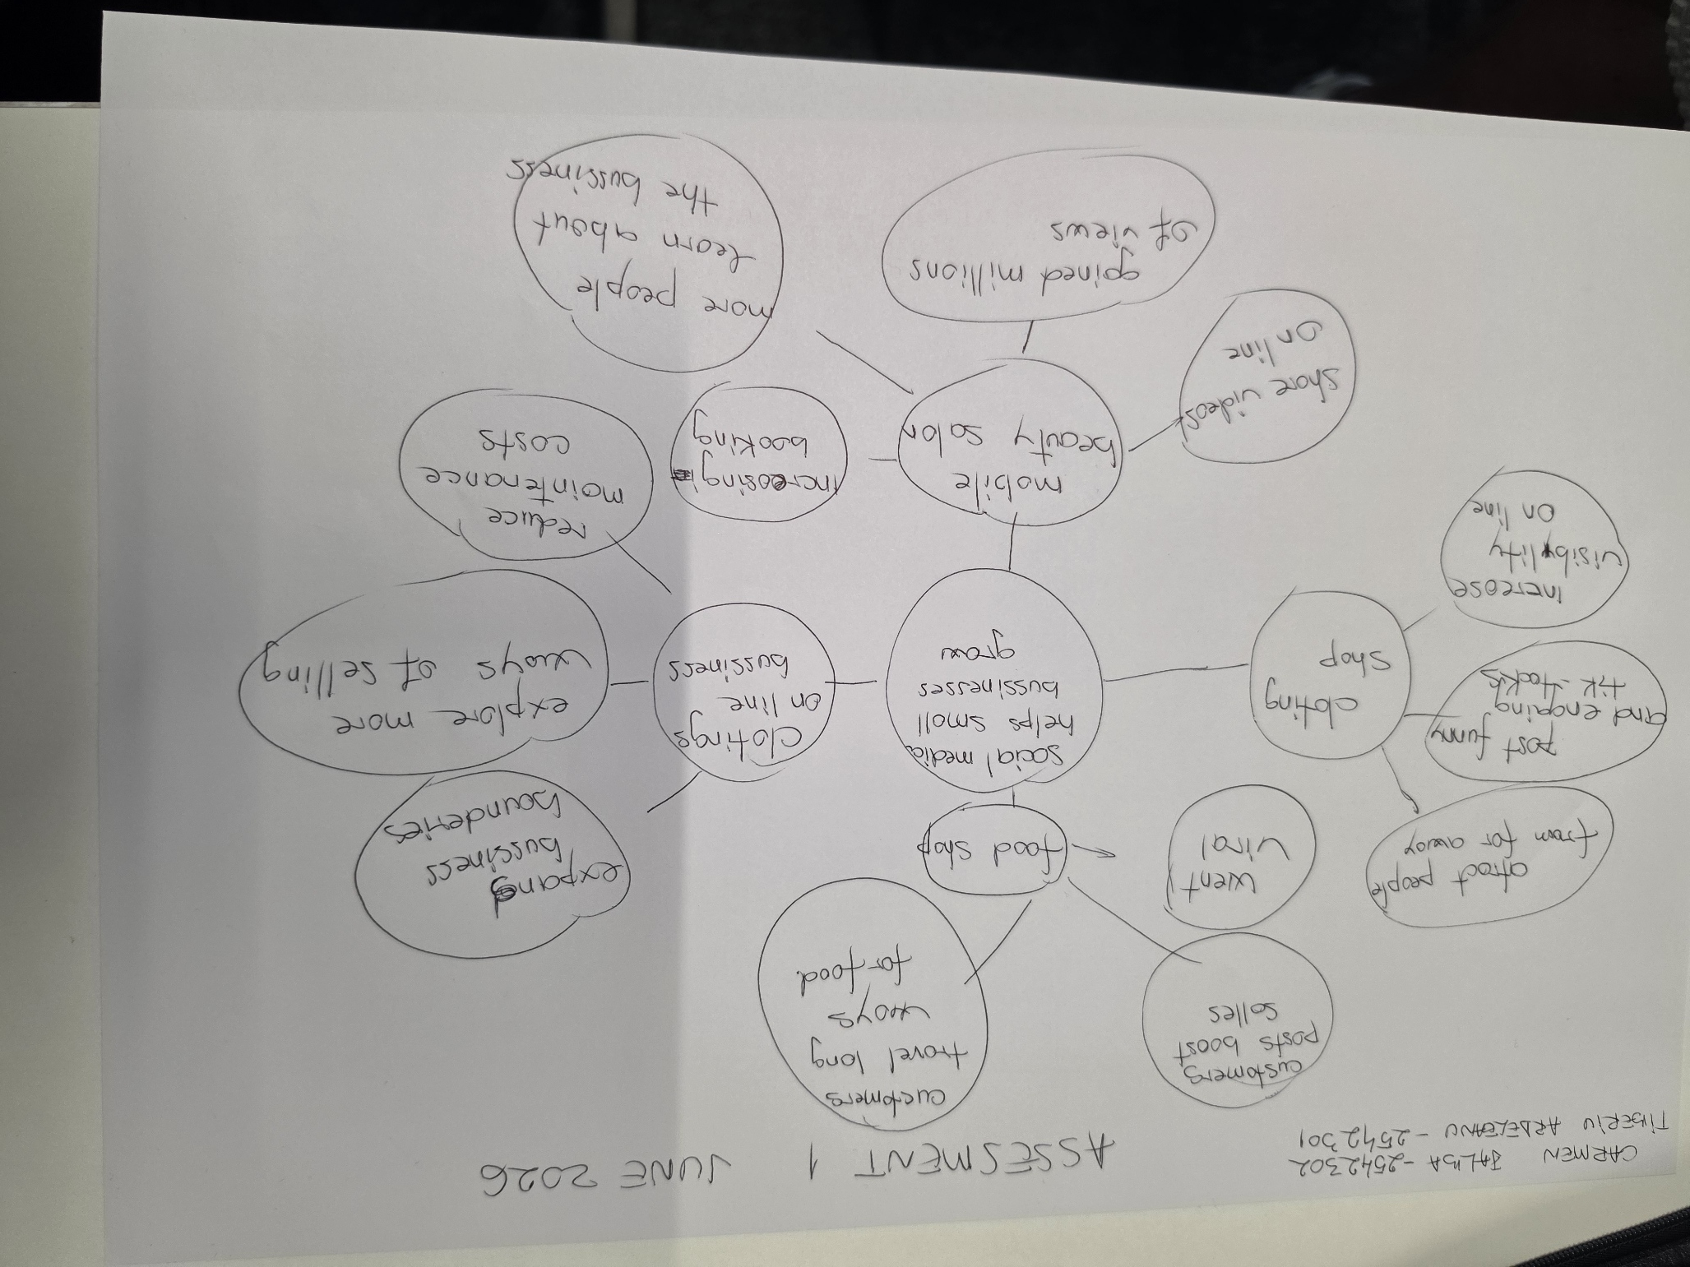

1. Answer these questions using the sentence starters below
a. What is the main idea of the text?
The main idea is that social media helps business grow
b. What are two key points?
One key point is different types of business
Another key point is challenges and choices offered by social media
c. What part of the text did you find most important? Why?
The most important part is posting on social media changes the business.
Help them to understand better costumers needs
d. Was anything unclear or difficult to understand?
I was not sure about key points
e. How did your group help you understand the text better?
My group helped me by showing me different ways of making the mindmap.
3. One sentence reflection
Question: What did you find challenging about this task?
The hardest part was to organise the key point in the correct way.

