

Entrepreneurship, Small Business Owners and Entrepreneurs, and SMEs. Types of Entrepreneurs. Analysis of SMEs Population, Employment, Turnover 2019-2022

By Slavena Panayotova
Student ID 1906636
For Module: Entrepreneurship LCMB7004
Lecturer: Vasilios Tavlaridis

Table of Contents
1. Summary 3
2. What is Entrepreneurship, SMEs, and the difference between Entrepreneurs and Small Business Owners? 4
2.1. What is Entrepreneurship? 4
2.2. What are the differences between entrepreneurs and small business owners? 4
2.3. What are SMEs? 6
3. Type of UK Entrepreneurs 6
4. UK SME Figures for 2019-2022 7
4.1. SME Population Trends between 2019 and 2022 7
4.2. SME Legal form composition between 2019-2022 8
4.3. SME Employment Trends between 2019 and 2022 9
4.4. SME Turnover Figures between 2019 and 2022 10
5. Employment and Business population figures for 2022 of the top five industries 10
6. Discussion 12
7. Conclusions 12
8. Reference List 13
9. Appendix 17

Summary
This report examines the significance of entrepreneurship, small business ownership, and small and medium-sized enterprises (SMEs) in the UK economy between 2019 - 2022 and highlights the essential role of SMEs in driving innovation and job creation. Entrepreneurship is the process of identifying and pursuing opportunities to create new ventures, products, or services, while managing their growth and development. Entrepreneurs take on financial and personal risks to create and manage their own businesses (Gartner, 1985). In contrast, small business owners start and run businesses that are not designed for rapid growth or expansion. Statistics show that SMEs are essential to the UK economy, accounting for over 99% of all businesses and employing around 60% of the workforce.
The UK has seen significant changes in its economy and labour market in recent years, with fluctuations in employment rates, wages, and productivity. The COVID-19 pandemic has also had a major impact on the UK's economy, with many businesses facing closures and substantial job losses. Despite these challenges, the UK's labour market has shown resilience and adaptability, while recovering from the Pandemic.
The report also provides an overview of the trends in SME populations, employment, and turnover figures between 2019 and 2022 in the UK. In 2019 and 2020, there was a growing trend in the number of active businesses, including companies with no employees, medium-sized companies, and all SMEs combined. However, between 2020 and 2021, there was a decline in every business segment due to the Pandemic, with the number of businesses dropping from 5.9 million to 5.5 million, and the number of employed people decreasing by 800,000. The total turnover of the private sector increased by almost £200 billion between 2019 and 2020. Overall, the SME sector remains a significant contributor to the UK's business population, accounting for 99.8% of the total business population in 2021 and 99.9% in 2022.
However, despite these positive trends, there are still challenges facing small and medium-sized enterprises (SMEs) in the UK. According to a report by the Federation of Small Businesses, SME confidence has declined due to various factors, including COVID-19, rising costs, supply chain disruptions, and Brexit-related issues (FSB, 2022).
The report highlights the importance of entrepreneurship and SMEs in driving innovation and job creation, as well as in creating a dynamic and resilient economy.
It concludes that policymakers, investors, and other stakeholders prioritise supporting SMEs by creating a favourable business environment that encourages entrepreneurship and innovation. Collaboration between SMEs, government, and other stakeholders is also necessary to create a supportive ecosystem for entrepreneurship and small business development. Such efforts will ultimately lead to job creation, economic growth, and the creation of new ventures, products, and services.

What is Entrepreneurship, SMEs, and the difference between Entrepreneurs and Small Business Owners?

2.1. What is Entrepreneurship?
Entrepreneurship is a multidimensional concept that has been studied extensively in academic business literature for decades. Scholars have offered various definitions of entrepreneurship, reflecting different perspectives and contexts.
First to propose a meaning was the French economist Jean Baptiste Say in late eighteenth – early nineteenth century, who viewed Entrepreneurship as a process of mediatorship between a service seeker and a service provider and the Entrepreneur as intermediator of that process (Koolman, 1971).
In the early twentieth century, Entrepreneurship was defined as the "carrying out of new combinations", which involves the introduction of new products, new methods of production, new markets, and new forms of organisation (Schumpeter, 1952), with emphasis on innovation, as well as taking upon risks (Harvey, Kiessling, and Moeller, 2010). Later it was recognised as is a phenomenon that should be seen in the context of the entire economic system, and that helps the capitalist system grow by creating new goods and services and advancing technology (Baumol, 1990).
Modern definitions step on the historical context and present Entrepreneurship as a complex of processes including Planning, Organising, Directing, and characteristics such as creativity, innovative thinking, risk-taking in order to achieve a goal, with focus on the general development of the venture, rather than its management (Youssef & Mufidah, 2021). Entrepreneurial ventures require new resources and strategies for growth (Reuer et al., 2019), and involve coordinating assets to create value through identifying and exploiting opportunities (Shane and Venkataraman, 2000), recombining resources in innovative ways, introducing new products or services, creating new markets, or developing new organisational forms (Foss & Klein, 2012).
The Global Entrepreneurship Monitor states that entrepreneurship involves "any attempt at new business or new venture creation, such as self-employment, a new business organisation, or the expansion of an existing business, by an individual, a team of individuals, or an established business" (Global Entrepreneurship Monitor cited in Business News Daily, 2002), and managing those ventures through their growth and development (Kuratko, 2016).

2.2. What are the differences between entrepreneurs and small business owners?
Entrepreneurs are individuals who create, own, and manage their own businesses or organisations, taking on financial and personal risks to do so (Hisrich, Peters, and Shepherd, 2017). They are driven by a desire to innovate, to identify opportunities, and to create value by developing new products, services, or business models. Entrepreneurs can come from a variety of backgrounds, and they can operate in a range of industries and sectors. Some entrepreneurs start small businesses, while others create large corporations or social enterprises. The key characteristic of an entrepreneur is their willingness to take on risk and chase opportunities in pursuit of their vision (Baron & Shane, 2018). Schumpeter, often called “the father” of Entrepreneurship, goes even further by naming the entrepreneurs as the most significant figures in the capitalism (Schumpeter, 1991).
Small business owners are individuals who start and run businesses that are not designed to grow rapidly or become large enterprises (Barringer & Ireland, 2016).
Small business owners and Entrepreneurs are often used interchangeably, but there are some differences between the two.
The first key distinction is the mindset - entrepreneurs typically have a growth-oriented mindset, whereas small business owners may be more focused on maintaining the status quo. Entrepreneurs are often driven by a desire to innovate, disrupt markets, and create something new, while small business owners may be more interested in providing a stable income for themselves and their families (Business News Daily, n.d.).
The second difference is the risk tolerance - entrepreneurs tend to be more willing to take risks than small business owners. They are often willing to invest significant time, money, and resources into a new venture with the hope of generating a large return on investment. Small business owners, on the other hand, may be more risk-averse and focused on maintaining profitability and stability (Business News Daily, n.d.). Another distinctive feature between entrepreneurs and small business owners is the drive for innovation: entrepreneurs are often associated with innovation and disruption, while small business owners may be more focused on providing existing products or services in a particular market. Entrepreneurs may be more likely to introduce new products, services, or even business models that challenge traditional ways of doing things, while small business owners may be more focused on meeting existing customer needs and demands (Business News Daily, n.d.). Last, but not least, the growth potential is an entrepreneurial trait, as entrepreneurs are often concentrating on building businesses that have the potential for rapid growth and expansion. They may seek out funding from investors or lenders to fuel this growth. Small business owners, on the other hand, may be content with maintaining a stable, profitable business that provides a good living for themselves and their employees (Business News Daily, n.d.).
While some traits might be existing to an extent in both, it's worth noting that not all small business owners are entrepreneurs, and not all entrepreneurs are small business owners. The lines between the two can be blurry, and there is no universal and exhaustive definition. Ultimately, the distinction between a small business owner and an entrepreneur may come down to the individual mindset, goals, and aspirations (Business News Daily, n.d.).

2.3. What are SMEs?
Small and medium-sized enterprises (SMEs) are an essential part of the UK's economy, comprising over 99% of all businesses and employing around 60% of the workforce. The definition of SMEs varies depending on the industry and sector, but according to the UK government, SMEs are defined as enterprises with fewer than 250 employees and an annual turnover of less than £50 million (Department for Business, Energy & Industrial Strategy, 2021) or a balance sheet total of less than £43 million (HM Government, 2018).
SMEs play a significant role in driving innovation, competition, and job creation, making them critical to economic growth and prosperity. Despite their importance, SMEs often face challenges such as limited resources, access to finance, and regulatory burden, which can obstruct their growth and development.

Type of UK Entrepreneurs
There are many types of entrepreneurs in the UK, but the most common classifications are:
- Serial entrepreneurs: These are individuals who have started and run multiple businesses over their career (Casson, 2010). They may sell their previous businesses and move on to new ventures, or they may continue to manage multiple businesses simultaneously (Mason & Brown, 2014).
- Lifestyle entrepreneurs: These are individuals who start a business primarily to support their desired lifestyle. They may prioritise work-life balance, flexibility, and independence overgrowth and financial success (Neck & Greene, 2011).
- Social entrepreneurs: These are individuals who start a business with a primary goal of addressing a social or environmental issue (Nicholls, 2010). They may operate as a non-profit or for-profit enterprise, but their mission is to make a positive impact on society (Dees, 1998).
- Scalable entrepreneurs: These are individuals who start a business with the goal of rapid growth and scalability. They may seek funding from investors and focus on developing innovative products or services that can be rapidly scaled to meet demand (Blank, 2013).
- Intrapreneurs (corporate entrepreneurs): These are individuals who work within a larger company or organisation but have an entrepreneurial mindset (Kuratko, Hornsby & Covin, 2014). They may be responsible for developing new products or services, or for identifying and pursuing growth opportunities within and for the company. (Burgelman, 1983)
- Immigrant entrepreneurs: These are individuals who come to the UK from other countries and start businesses (Ram et al., 2013). They may bring with them unique skills, experience, and cultural perspectives that enable them to identify and pursue opportunities in the UK market (Kloosterman & Rath, 2003).
- Necessity entrepreneurs are individuals who start businesses out of necessity, such as unemployment or a lack of other options (Kelley et al., 2016).
- Opportunity entrepreneurs are individuals who start businesses to pursue a specific opportunity in the market (Kelley et al., 2016).
- Innovation-driven entrepreneurs are individuals who start businesses based on innovative ideas or technologies (Kelley et al., 2016).
These are just a few examples of the types of entrepreneurs in the UK. The entrepreneurial landscape is diverse and constantly evolving, with new types of entrepreneurs emerging as the business environment changes.

4. UK SME Figures for 2019-2022

4.1. SME Population Trends between 2019 and 2022

The period over the past four years could be divided into three conceptual groups: pre- Pandemic period, 2019 – 2020, Active Pandemic period 2020 – 2021, and post- Pandemic period 2021 - 2022.
In 2019 and 2020 there was an overall growing trend in the number of active businesses, as well as in companies with no employees, medium-sized companies, and consequentially all SMEs combined.
Businesses with no employees are close to 4.5 million in 2019, where in 2020 that number is 4.6m or 100,000 more compared with the previous year.
Companies with hired personnel below 50 people are 1.4m in 2019 and 1.3m in 2020, which is the only negative change. Nevertheless, the decrease in this metric could be due to some companies becoming mid-sized, and others letting go of the existing employees, or transforming into sole proprietorships.
Medium-sized companies grew from 35,600 in 2019 to 36,100 in number in 2020.
Altogether, the whole SME sector increased from 5.9 million companies in 2019 to almost 6 million in 2020, with a share of 99.9% of the total business population, and leading the general trend of 1.9% growth, or 113,000 companies more in 2020.
There is a big contrast in the SME population trends in 2020, 2021, and 2022 as a result of the Pandemic.
Between 2020 and 2021 there is a decline in every business segment – companies with no employees suffer the biggest drop from 4.6 to 4.2 million, while small enterprises with less than 50 people keep the same numbers. Middle-sized companies decline in numbers with 500 as well, adding to the already outlined trajectory of decreasing trend of SME numbers from 5.9million to 5.5m, and contributing to the significant drop of 6.5% (-390,000 business) in the whole business population, which is the biggest in the last 20 years and controversial to the established annual growth with 3% on average (table 1), leaving SMEs with 99.8% of the total business population.
The business population continued declining between 2021 and 2022 with another 1.5% or 82,000 business. The companies with no employees have reduced their number to 4.1 million which is 1% negative difference with the previous year and therefore, constituting for 74% of the whole business population. On the other hand, organisations with below 50 employees marked increasing with 70,000, and made up 25.2% of the business population. The medium enterprises also increased slightly with 300 companies, but the overall trend in SME declined to 5.4 million, which have a share of 99.9% of the total business population in 2022.
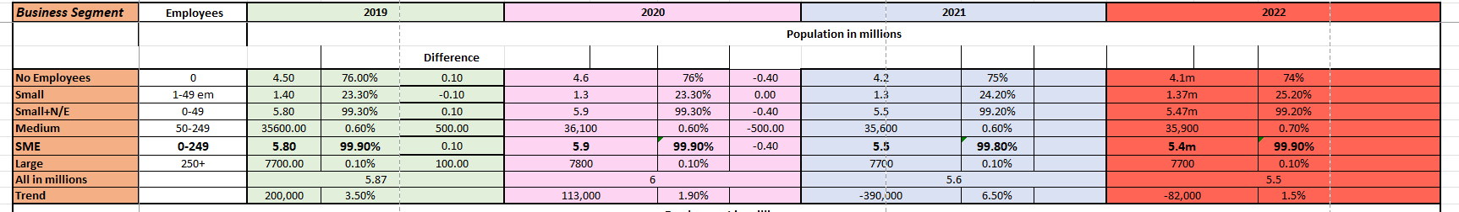Table 1

4.2. SME Legal form composition between 2019-2022
According to the Department for Business, Energy, and Industrial Strategy (BEIS), in terms of legal form composition, the majority of SMEs in the UK are sole traders or unregistered partnerships. In 2019, 61.5% of SMEs were sole traders, 28.5% were companies, and 9.8% were partnerships (Department for Business, Energy, and Industrial Strategy, 2020).
Between 2019 and 2022, there haven't been significant changes in the legal form composition of SMEs in the UK. However, the number of limited companies has been increasing steadily in recent years, while the number of sole traders has been decreasing slightly. (Department for Business, Energy, and Industrial Strategy, 2020, 2021,2022). The COVID-19 Pandemic had undeniable impact on the legal form composition of the SMEs in the UK, with some businesses switching from sole trader status to become limited companies to take advantage of government support schemes.
It's worth noting that the legal form composition can vary by sector, with companies being more prevalent in certain industries such as finance and manufacturing, while sole traders are more common in sectors such as retail and construction.
Overall, the legal form composition of SMEs in the UK has remained relatively stable in recent years, with sole traders being the most common legal form, but also the most vulnerable (Department for Business, Energy, and Industrial Strategy, 2020).

4.3. SME Employment Trends between 2019 and 2022
In the Pre- Pandemic period, the overall trend in the business employment was increasing, in 2020 the number of employed people grew with close to 300,000, to 27.7 million, which is 0.73% increase.
Companies with no employees made up 17.6% of the total employment, engaging 4.835 million people in 2019, where in 2020 those number are respectively 17.5%, which is 4.966 million people.
Companies with employees below 49 people increased the hired personnel from 8.322 million (30.4%) in 2019, to 8.4 million people in 2020 making up 30.5% of the total employment.
Medium-sized companies were responsible for the employment of 3.5m people in 2019 and 2020, or 13% of the total employment.
The whole SME sector employed 16.6 million people in 2019, which accounts for the 60% of the total employment, where in 2020 SMEs employed 16.8m or 61% of the total employment.
The Active Pandemic period (2020-2021) marks a significant drop of the total employment with 2.9%, which equals 800,000 people leaving the work force.
The engagement in the companies with no employees decreased to 4.5m in 2021 making up 17% of the total employment. Enterprises with less than 50 employees lost 100,000 people accounting for 31% of the total employment or 8.3m people engaged.
Medium-sized companies employed 3.4m people, which is 100,000 less than the previous year (table 2).
The total employment in SMEs has been reduced to 16.3m, which equals 500,000 people.
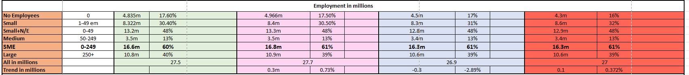
Table 2

4.4. SME Turnover Figures between 2019 and 2022

The Pre-Pandemic period is market by growth in every segment of the business. In 2019 the total turnover of the private sector was £4.149 trillion, where in 2020 that number increased with almost £200 billion- 4.75% to £4.346 trillion.
Enterprises with no employees account for 7.4% of the total turnover in 2019, which equals just over £300 billion, followed by an increase to £315 billion constituting respectively 7.25% in 2020.
Small companies with employees produced £1.2 trillion turnover in 2019, which is nearly 30% of the total. In 2020 their turnover increased to £1.26 trillion, or 28.75% of the total.
The turnover of the medium companies in 2019 is 0.6 trillion, accounting for 15% of the total, and in 2020 it as risen to £0.7 trillion, which is 16% of the total.
The turnover of the whole SME sector in 2019 accounts for 52% of the total, or £2.2 trillion, and in 2020 it is £2.3 trillion, keeping the same ratio with the total.
In 2021 businesses with no employees contributed to the total turnover with £302 billion close to 6.8%, suffering a drop of £13 billion. On the contrary, every other business segment kept the same figures and percentages of the total turnover. SMEs alone also kept the same numbers, but the total amount of the turnover grew with another 2.37% to £4.449 trillion, which is about £103 billion.
The total turnover of the private sector in 2022 is 4.156 trillion, which marks a very significant drop of 6.6%, or £293 billion. Companies with zero employees account for £227 billion in 2022, or 6.5% of the total turnover, which is the significant £75 billion less than 2021. The decreasing trend of the turnover continues in the next business population segment of employment of up to 50 people, where the total amount of £1.14 trillion is over £14 billion less than 2021. Medium sized enterprises’ performance in 2022 resulted in the same turnover of 700 billion, representing 17% of the total. In total, the SMEs’ turnover adds up to £2.1 trillion – £200b less than previous year, accounting for 51% of the total in the private sector (table 3).
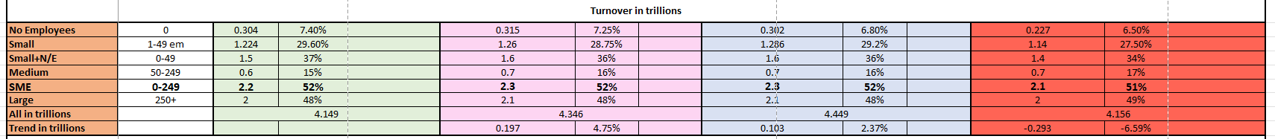
Table 3

5. Employment and Business population figures for 2022 of the top five industries
The top five industries in terms of population in the UK, arranged in a declining order are: Construction, Professional, Scientific and Technical, Wholesale and Retail/ Repair of Motor Vehicles, Administrative and Support Service Activities, Information and Communication.
In the Construction Industry there are 914,000 companies, making up 17% of SME and 16.6% of the whole population in the private sector. The sector accounts for 34% of the SMEs turnover and 11% of the employment with almost 1.8 million people engaged, which makes it second biggest in terms of share of turnover and third in employment.
The Professional, Scientific and Technical sector represents 762,000 companies, which is 14% of SME and 16.6% of the population in the private sector. The sector accounts for 11% of SMEs’ turnover and 12% of its employment with 1.96m people engaged.
The Wholesale and Retail/ Repair of Motor Vehicles industry takes third place in population with 547,000 companies, responsible for 10% of SME population and 9.9% of the total. The industry occupies first place in percentage of SME turnover and employment, with respectively 34% and 14%, employing close to 2.3 million people.
The fourth sector in population is the Administrative and Support Service Activities sector with 472,000 companies, responsible for 9% of SME population and 8.5% of the total. The sector is last in terms of SME turnover, responsible for 8% of it, and 9% of the SME employment.
The Information and Communication industry is at fifth position with 334,700 companies, accounting for 6.1% of the SME population and 6% of the total.
In every industry there is a declining trend in number of companies and total turnover for 2022 as compared with previous years (table 4).
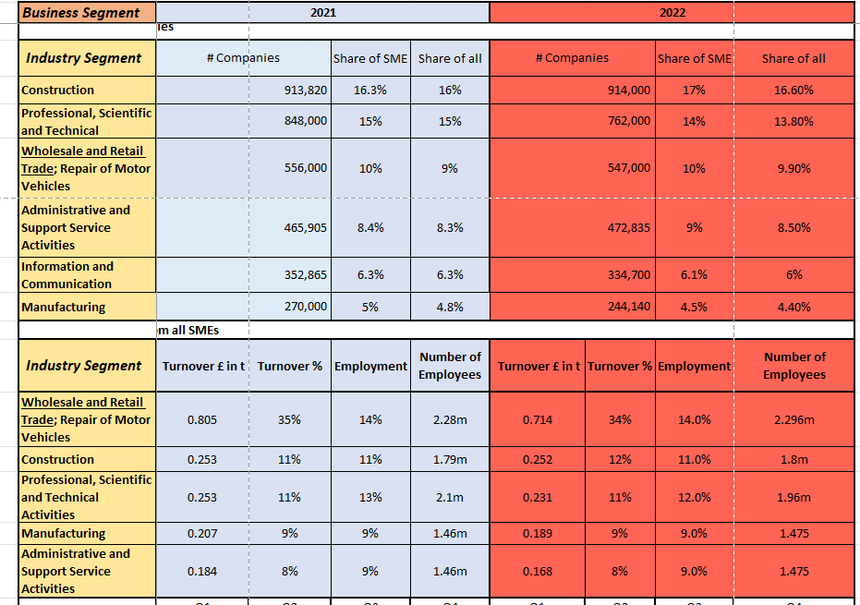
Table 4

6. Discussion
There are few things worth discussing before drawing conclusions. According to the most recent data from the last quarter of 2022, of the Federation of Small Business, the Small Business Index (SBI), which represents the overall health of the small business, by conducting research every quarter in a representative number of small businesses, there is a declining trend (table 5). This suggests that the confidence and the optimism among the small companies is declining, while the sector is suffering from challenges, as lower number represents decline in the revenue, investments, and performance, among other factors (FSB, 2022).
Table 5
There are a number of tools that could be used by the policymakers to improve the small business confidence and encourage investments, such as tax relieves, as one example, while the organisations are recovering from the Pandemic. In any event, the health of SMEs and particulary the small businesses should be a priority in the government’s decision-making process, as they are the back bone of the economy with their massive share of contribution to the turnover and employment in the UK.

7. Conclusions
Entrepreneurship is the creation and management of a new business to achieve financial gain. This involves identifying a market gap, developing a product/service, attracting resources, managing risks/rewards, and building/leading effective teams. Successful entrepreneurs are characterised by their ability to recognise market opportunities, take calculated risks, persist through challenges, and mobilise/manage resources (Bolton and Thompson, 2013).
Small businesses play a significant role in economies due to several reasons. They are a crucial source of employment, with about 60% of the UK's private sector workforce employed in small firms. Additionally, small businesses contribute to reducing regional disparities in economic performance and promote technological innovation, diversity, and competition in the economy, and may create local community-based enterprises, leading to more participative democracy (Carter and Jones-Evans, 2006).
In conclusion, the SME sector in the UK experienced growth in the pre-pandemic period, followed by a significant decline during the pandemic period, which continued into the post-pandemic period. This decline was evident in the number of active businesses, employment figures, and turnover figures, with companies with no employees and small and medium-sized enterprises experiencing the biggest drop.

8. Reference List

Barringer, B. R., & Ireland, R. D. (2019) Entrepreneurship: Successfully launching new ventures. Pearson.

Baron, R. A., & Shane, S. A. (2018) Entrepreneurship: A process perspective. Cengage Learning.

Baumol, W. J. (1990) ‘Entrepreneurship: Productive, unproductive, and destructive’, The journal of political economy, 98(5), pp. 893-921.

Blank, S. (2013) ‘Why the lean start-up changes everything’, Harvard Business Review, 91(5), pp. 63-72.

Bolton, B. & Thompson, J. (2013) ‘Entrepreneurs: Talent, Temperament, Technique’ (3rd edn) Oxford: Elsevier Butterworth-Heinemann.

Burgelman, R. A. (1983) ‘A process model of internal corporate venturing in the diversified major firm’, Administrative science quarterly, pp. 223-244.

Business News Daily (n.d.) Entrepreneur vs. Small Business Owner: What's the Difference? Available at: https://www.businessnewsdaily.com/2648-entrepreneur-vs-small-business-owner.html, (Accessed 26 Feb. 2023).

Casson, M. (2010) Entrepreneurship: Theory, networks, history. Edward Elgar Publishing.

Carter, S. and Jones-Evans, D. (2006) Enterprise and small business: principles, practices and policy. 2nd edn. Prentice Hall.

Centre for Entrepreneurs (2017) From the ground up: Entrepreneurs and small business owners in the UK. Available at: https://centreforentrepreneurs.org/wp-content/uploads/2017/06/CFE-From-the-ground-up.pdf, (Accessed 26 Feb. 2023).

Dees, J. G. (1998) ‘The meaning of social entrepreneurship’, Stanford social innovation review, 1(1), pp. 35-43.

Department for Business, Energy & Industrial Strategy (2019) Small and medium-sized enterprises (SME) statistics for the UK and regions. Available at: https://www.gov.uk/government/statistics/business-population-estimates-2019-summary-uk-statistics-html, (Accessed 17 Jan. 2023).

Department for Business, Energy & Industrial Strategy (2020) Business Population Estimates for the UK and Regions 2020. Available at: https://www.gov.uk/government/statistics/business-population-estimates-2020-html, (Accessed 17 Jan. 2023).

Department for Business, Energy & Industrial Strategy (2021) SMEs: Key Statistics and Analysis. Available at: https://www.gov.uk/government/statistics/small-and-medium-sized-enterprises-smes-business-population-statistics-html, (Accessed 17 Jan. 2023).

Department for Business, Energy & Industrial Strategy (2022) Business Population Estimates for the UK and Regions 2022: Statistical release. Available at: https://www.gov.uk/government/statistics/business-population-estimates-2022/business-population-estimates-for-the-uk-and-regions-2022-statistical-release-html. (Accessed 17 Jan. 2023).

Foss, N. J., & Klein, P. G. (2012) ‘Entrepreneurship and the economic theory of the firm: Any gains from trade?’, Academy of Management Perspectives, 26(2), pp. 64-83.
Federation of Small Businesses (2019) FSB Small Business Index Q4 2020. Available at: https://www.fsb.org.uk/resources-page/fsb-sbi-q4-2019-pdf.html, (Accessed 27 Feb. 2023).
Federation of Small Businesses (2020) FSB Small Business Index Q4 2020. Available at: https://www.fsb.org.uk/resource-report/sbi-q4-2020.html, (Accessed 27 Feb. 2023).

The Federation of Small Businesses (2021) Small Business Index Q4 2021. Available at: https://www.fsb.org.uk/resource-report/sbi-q4-2021.html, (Accessed 27 Feb. 2023).

Federation of Small Businesses (2022) Small business index Q4 2022. Available at: https://www.fsb.org.uk/resource-report/sbi-q4-2022.html, (Accessed 27 Feb. 2023).

Gartner, W. B. (1985) ‘A conceptual framework for describing the phenomenon of new venture creation’, Academy of Management Review, 10(4), pp. 696-706.

Harvey, Kiessling, T., & Moeller, M. (2010) ‘A view of entrepreneurship and innovation from the economist “for all seasons”: Joseph S. Schumpeter’, Journal of Management History, 16(4), pp. 527–531, Available at: https://doi.org/10.1108/17511341011074004.

Hisrich, R. D., Peters, M. P., & Shepherd, D. A. (2017) Entrepreneurship. McGraw-Hill Education.

HM Government (2018) Annual Small Business Survey 2018: SME employers. Available at: https://assets.publishing.service.gov.uk/government/uploads/system/uploads/attachment_data/file/757108/SBS_2018_-_Employer_report.pdf, (Accessed 23 Feb. 2023).

Kelley, D. J., et al. (2016) Global entrepreneurship monitor 2015/2016: UK report. London: Global Entrepreneurship Research Association.

Koolman, G (1971) ‘Say’s Conception of the Role of the Entrepreneur’, Economica 38, (151), pp. 269–86. Available at: https://doi.org/10.2307/2552843.

Kloosterman, R. C., & Rath, J. (2003) ‘Immigrant entrepreneurs in advanced economies: Mixed embeddedness further explored’, Journal of ethnic and migration studies, 29(4), pp. 741-762.

Kuratko, D. F., Hornsby, J. S., & Covin, J. G. (2014) ‘Diagnosing a firm’s internal environment for corporate entrepreneurship’, Business Horizons, 57(1), pp. 37-47.

Mason, C., & Brown, R. (2014) Entrepreneurial ecosystems and growth-oriented entrepreneurship. Final Report to OECD, Paris.

Neck, H. M., & Greene, P. G. (2011) ‘Entrepreneurship education: Known worlds and new frontiers’, Journal of Small Business Management, 49(1), pp. 55-70.

Nicholls, A. (2010) ‘The legitimacy of social entrepreneurship: Reflexive isomorphism in a pre-paradigmatic field’, Entrepreneurship theory and practice, 34(4), pp. 611-633.

Ram, M., et al. (2013) ‘Access to finance for ethnic minority and immigrant entrepreneurs’, Environment and Planning C: Government and Policy, 31(1), pp. 82-98.

Reuer, J., Matusik, S. and Jones, J. (2019) 'The Interplay of Entrepreneurship and Collaboration', The Oxford Handbook of Entrepreneurship and Collaboration, Available at: https://doi.org/10.1093/oxfordhb/9780190633899.013.40, (Accessed 26 Feb. 2023).

Shane, S., & Venkataraman, S. (2000) ‘The promise of entrepreneurship as a field of research’, Academy of Management review, 25(1), pp. 217-226.

Schumpeter, J. (1952) Can Capitalism Survive?, Harper and Row, New York, NY.

SCHUMPETER, J.A. (1991) The Economics and Sociology of Capitalism, Princeton University Press.

Youssef, E. M., & Mufidah, I. (2021) ‘Entrepreneurship: A review of definitions, dimensions, and theories’, Handbook of Research on Entrepreneurship and Innovation, pp. 117-140.

9. Appendix
A. Excel Spreadsheet with Private Sector Statistics for 2019-2022

