Destination Management: Maldives

Sustainable hospitality and tourism management
Module code: BMIH5006

Moshfique Khaled Chowdhury
Student ID: 2017480
Lecturer’s Name: Dr. Huw Thomas
Submission Date: 06.12.2022

Table of Contents:
Introduction 3
Critical evaluation of sustainable tourism concept 3
Relation between the sustainable principles with the development of the tourism sector 5
Identification of sustainable practices in the chosen destination 6
Butler's Life cycle model 7
Doxey’s irridex model 9
Conclusion 10
Recommendation for the future development 10
References 12

Introduction
The term destination, in simple terms, means a physical area in which a visitor spends one night or more than that. The tourism destination includes attractive places with support services and resources for the visitor's convenience. Destination planning comprises three stages of planning such as national and regional, destination and individual sites and businesses. A destination management organization, also known as DMO, is responsible for marketing, providing assistance and support, and advancing a partnership with destination management. In this report, a critical evaluation of sustainable tourism in the chosen destination, Maldives, will be done.

Critical evaluation of the sustainable tourism concept
The UN World Tourism Organization (UNWTO), sustainable hospitality, concentrates on the climate, social, cultural, and economic elements in tourism development approaches and activities. The approaches include using minimal environmental resources to ensure long-term benefits and maintenance of biodiversity. In the words of Guo et al. (2019), the preparation of sustainable tourism plans and policies aims to increase economic growth. The principles of sustainable tourism include respecting the socio-cultural differences of the hosting association. Another principle of sustainable tourism involves well-informed engagement of the stakeholders.
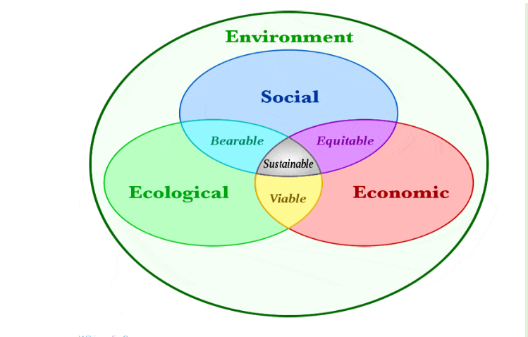
Figure: Three Pillars of sustainability
(Source: MacKenzie and Gannon 2019)

Important preconditions of sustainable tourism include ensuring high-quality tourist attraction and satisfaction, attractive tourism underpinning, and providing community support and tolerance. For sustainable tourism, it is important to manage the security and safety of the tourists. Sustainable tourism also involves the maintenance of ethical behaviour and government assistance at every stage of the process. According to MacKenzie and Gannon (2019), sustainable tourism attempts to provide monetary help to the local communities for the development of infrastructure and facilities. The concept of sustainable tourism focuses on holistic approaches toward sustainability-related issues.
Khoshnava et al. (2018) opined that the three pillars of sustainability include social, economic, and ecological aspects. Thus, sustainable tourism aims to balance these three pillars while developing strategies and operations. The principles of sustainable tourism focus on improving the social, economic, and ecological conditions by using minimal natural resources and contributing to the financial aspect. Sustainable tourism uses sustainable transport to achieve holistic development. The sustainable development plan is developed based on the three pillars of sustainability. Popular destinations adopt either a traditional approach or a sustainability approach. The sustainable approaches include minimum use of natural resources and ensuring high-quality tourist satisfaction.

Relation between the sustainable principles in the hospitality sector
The tourism industry is considered the largest industry across the globe, and it is the short-term “circular migration" of visitors outside their homes with the sole motive of leisure and relaxation. As per the census of 2020, it has been observed that the global tourism sector has resulted in an increase of GDP by 21.7% after the pandemic (Statista, 2022). The fundamental components of eco-friendly tourism are climate sustainability, social sustainability, and economic sustainability.
The general principles of development in the tourism sector include environmental, social, economic, and ecological aspects. The main objective of the hospitality industry is to maintain and perform its operations by the principles of development. There are two main approaches to tourism, including traditional and sustainable. Traditional tourism aims to enchant the tourist with scenically attractive tourist destinations like inclusive resorts and infrastructure, whereas ecotourism emphasizes sustainable approaches by lowering the use of natural resources. Thus, a travel destination that focuses more on preserving and protecting the environment, society, and economy and providing high-quality visitor satisfaction is considered sustainable.
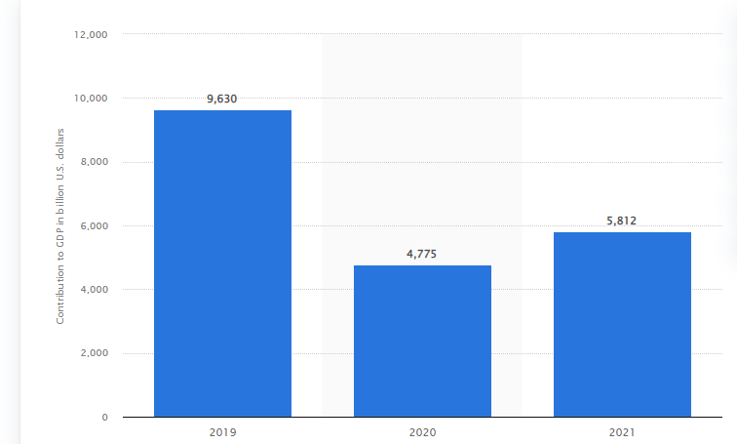
Figure: Tourism sector contribution to GDP growth
(Source: Statista Research Department)

Identification of sustainable practices in the chosen destination
The Maldives is a leading tourist spot in the world, attracting thousands of visitors every year. The Maldives has white sand, blue water, and marine life. The famous tourist destination has attempted to become a sustainable tourist spot with strategies like reducing carbon emissions. The Maldives government aims to achieve carbon-neutral projects by the year 2030. The resorts and hotels in the Maldives commit to reducing the usage of plastic products that threaten marine creatures. As per Sae-Tang Yamchuti's (2021) views, most of the visitors to Maldives are from Europe, and the tourists are attracted to Maldives due to its attractive natural features, including beaches, sand, tropical vegetation, and islands.
An important element of sustainable tourism includes the natural environment, sea, wildlife, people, and culture. Therefore, it is considered that the Maldives is a sustainable tourism spot as it is enriched with natural environments like the sea, beach, marine life, different cultures, and people. According to Giampiccolo et al. (2019), in the year 2006, Maldives contributed to the country's economy by increasing the national GDP by 22.7%. Hence it can be said that the country has contributed to the economic aspect of the three pillars of sustainability. Since tourism impacts local communities, community engagement is essential to sustainable tourism. Community-based tourism is important for balancing negative and mass tourism impacts.
The community-based tourism practised in the Maldives believes in empowering underprivileged groups within the Maldivian population. The social and economic aspect is considered in the Maldives as the country contributes by earning foreign currency and empowering the weaker sections of the community. The main attractions in the Maldives are its natural environment, including the Sun, sea, and Sand. Though the country is successful in providing luxury tourism, it is falling behind the community stage compared to other Asian countries (Giampiccolo et al. 2019).
Maldives tourism has aligned with the two aspects of the three pillars of sustainability, yet the ecological aspect is in danger. Cowburn et al. (2018) opined that Maldives' luxurious resorts running on the small islands pose a threat to the ecological aspect of the adjacent coral reefs.
It has been observed that resort operations like construction, pollution, and sand pumping affect marine life and reduce coral reefs. The resorts constructed on the islands resulted in lower algal cover and loose sediments. The country has taken measures to empower the local community, yet the region lags in the ecological aspect of the three sustainability pillars. As a sustainable tourism destination, Maldives needs to adopt strategies to protect the ecological aspect of sustainability. In support of the views of Cowburn et al. (2018), it has been said by Techera and Cannell-Lunn (2019) that the preservation and use of sustainable practices play a vital part in the growth of tourism in the Maldives.

Butler's Life cycle model
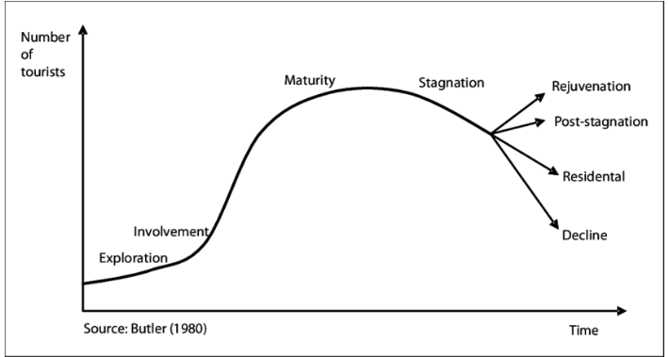
Figure: Butler's life cycle model
(Source: Kruczek et al. 2018)
Butler's life cycle model is the most used framework that helps in studying a specific tourism destination. The model comprises six tourist evolution stages: "Exploration, Involvement, Development, Consolidation, Stagnation and Decline or rejuvenation”. As per the views of Kruczek et al. (2018), there is an increase in the use of Butler's cycle to understand the changes in tourism. With the help of this framework, the evolution in the tourism of Maldives will be done.
Maldives has shown resilience after the pandemic and maintained the sustainability approaches to protect the environment and society. The Maldivian government implemented policies and restrictions to protect the environment. The marketing and promotional strategies with successful campaigns like “Isolation never looked this good” maintained sustainable tourism (Valerie, 2022). The development stage of Butler’s cycle refers to the stage in which a tourism destination flourishes; growth is observed with the influx of new tourists and an increase in social media presence. Since there has been an increase in the number of tourists, around 80%, after the pandemic, thus, it can be said that the famous tourism destination Maldives has shown features of the development stage post-pandemic.

Doxey’s irridex model
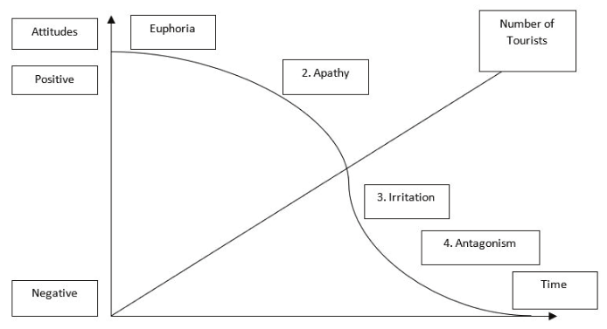
Figure: Doxey’s irridex model
(Source: Doxey,1975)
Doxey's Irritation Index model of 1975 states that a community experiences a set of reactions resulting from the evolution of the tourism industry in a particular destination. The stages of reactions include "Euphoria, Apathy, Annoyance, and Antagonism". At the Euphoria level, the locals exhibit signs of excitement and interest to the tourists due to the opportunities and economic growth in the region. The next stage of apathy is when the local people take the tourists for granted, and the tourists are considered a means of profit. In the third level of irritation, the locals cannot handle the influx of tourists without growing facilities as the industry is at saturation. Lastly, in the final stage of antagonism, the locals blame the tourists for any negative impact, like an increase in taxes and cultural changes. Maldives practices community-based tourism, which engages the local community and empowers them, instilling a feeling of happiness (Ahmed 2018). Besides this, the country aims to reduce inequalities and poverty among the local people as a part of its sustainable development goals. Thus, it can be said that the country believes in providing the local communities to gain control over their natural resources and cultures, which enhances the empowerment of the underprivileged people in the Maldivian community. As a result, it can be said that the Maldives' local people might experience the stages of Euphoria and apathy. Since the increase in the rate of tourists has resulted in the improvement of the underprivileged people and created a sense of unity among the locals and the visitors, the feeling of apathy might result from the region's economic development. However, there might be a feeling of annoyance and antagonism, as the resorts and hotels built on the small islands have harmed the region's ecological balance.

Conclusion
Based on the discussion, it can be concluded that tourism has two approaches, including traditional and sustainable. Sustainable tourism balances environmental, social, economic, and ecological elements while ensuring high-quality visitors' satisfaction. The report has helped in understanding that three pillars of sustainability must be aligned with sustainable tourism. Butler's life cycle model has been used to analyse the evolution of tourists in the Maldives. It has also been observed that though the Maldives is successful in maintaining the social and economic aspects of the sustainability pillars yet it lacks in the ecological aspects.

Recommendation for the future development
- Maldives can reduce the usage of plastic bottles and substitute them with "reusable glass bottles".
- Maldives can increase the use of solar panels and solar energy to reduce the environmental impact.
- The travel destination can incorporate green practices and sustainable approaches in the resorts and hotels.
- Maldives can arrange “community programs” to train and educate the local communities regarding sustainable tourism and practices.
- The sustainability programs include regular beach cleaning programs and reef cleaning programs.
- Maldives can use boats that have biofuel to reduce the environmental impact and as a means of sustainable transport.

Based on the entire discussion, it is recommended that Maldives can improve the ecological aspect by reducing plastic harmful to marine life. The country can improve sustainable tourism by adopting changes like using solar power boats and biofuel boats and arranging education programs for the local people to educate them on the importance of tourism. Sustainable transport is another important feature of sustainable tourism with the help of biofuel boats and boats using solar power and battery. Thus, these approaches might help Maldives improve the sustainability principles' ecological aspect.

References
Ahmed, M., (2018). Guest-houses in the Maldives: Towards Community-based Tourism. LAP LAMBERT Academic Publishing. Available at: https://www.researchgate.net/profile/Musliha-Ahmed/publication/335443516_Guesthouses_in_the_Maldives_Towards_Community-Based_Tourism/links/5bdfd5f64585150b2b9f5232/Guesthouses-in-the-Maldives-Towards-Community-Based-Tourism.pdf (Accessed: 4 December 2022).
Cowburn, B. et al (2018). Can luxury and environmental sustainability co-exist? Assessing the environmental impact of resort tourism on coral reefs in the Maldives. Ocean & coastal management, 158, pp.120-127. Available at: https://www.sciencedirect.com/science/article/am/pii/S0964569117304908 (Accessed: 4 December 2022).
Giampiccoli, A., Muhsin, B.A. and Mtapuri, O., (2020). Community-based tourism in the case of the Maldives. GeoJournal of Tourism and Geosites, 29(2), pp.428-439. Available at: https://www.researchgate.net/profile/Oliver-Mtapuri/publication/340540043_Community-based_tourism_in_the_case_of_the_Maldives/links/5e8f8b114585150839ceaaa1/Community-based-tourism-in-the-case-of-the-Maldives.pdf (Accessed: 4 December 2022).
Guo, Y., Jiang, J., and Li, S., (2019). A sustainable tourism policy research review. Sustainability, 11(11), p.3187. Available at: https://www.mdpi.com/2071-1050/11/11/3187/pdf (Accessed: 4 December 2022).
Khoshnava, S.M.et al (2018). The rank of green building material criteria is based on the three pillars of sustainability using the hybrid multi-criteria decision-making method. Journal of Cleaner Production, 173, pp.82-99. Available at: https://www.academia.edu/download/49988162/Rank_of_GBMs_criteria_based_on_the_3Ps_of_sustainability_using_the_hybrid_MCDM.pdf (Accessed: 4 December 2022).
Kruczek, Z., Kruczek, M. and Szromek, A.R., (2018). Possibilities of using the tourism area life cycle model to understand and provide sustainable solutions for tourism development in the Antarctic Region. Sustainability, 10(1), p.89. Available at: https://www.mdpi.com/2071-1050/10/1/89/pdf (Accessed: 4 December 2022).
MacKenzie, N. and Gannon, M.J., (2019). Exploring the antecedents of sustainable tourism development. International Journal of Contemporary Hospitality Management. Available at:https://strathprints.strath.ac.uk/65573/1/MacKenzie_Gannon_IJCHM2018_Exploring_the_antecedents_of_sustainable_tourism_development.pdf (Accessed: 4 December 2022).
Statista, (2022) Travel and tourism: Contribution to global GDP 2021, Statista. Available at: https://www.statista.com/statistics/233223/travel-and-tourism--total-economic-contribution-worldwide/ (Accessed: 4 December 2022).
Sae-Tang, N. and Yamchuti, H., (2021). Relationship between sustainable tourism and environment: Case studies of Maldives and Amphawa floating market, Thailand. Journal of Humanities and Social Sciences Thonburi University, 15(1), pp.149-160. Available at: https://so03.tci-thaijo.org/index.php/trujournal/article/download/242273/168119 (Accessed: 4 December 2022).
Techera, E.J. and Cannell-Lunn, M., (2019). A review of environmental law in the Maldives concerning conservation, biodiversity, fisheries, and tourism. Asia Pacific Journal of Environmental Law, 22(2), pp.228-256. Available at: https://scholar.archive.org/work/qhk2uvs73nastmhrsntajtnpba/access/wayback/https://www.elgaronline.com/downloadpdf/journals/apjel/22-2/apjel.2019.02.03.pdf (Accessed: 4 December 2022).
Valerie Mercer Blackman., (2022) World Bank Blogs. The changing face of tourism and work: How the Maldives is successfully adapting to the pandemic Available at: https://blogs.worldbank.org/endpovertyinsouthasia/changing-face-tourism-and-work-how-maldives-successfully-adapting-pandemic (Accessed: 4 December 2022).

