Critical Review

Coursework 2: Showreel and Business Card

Business Card
Side A
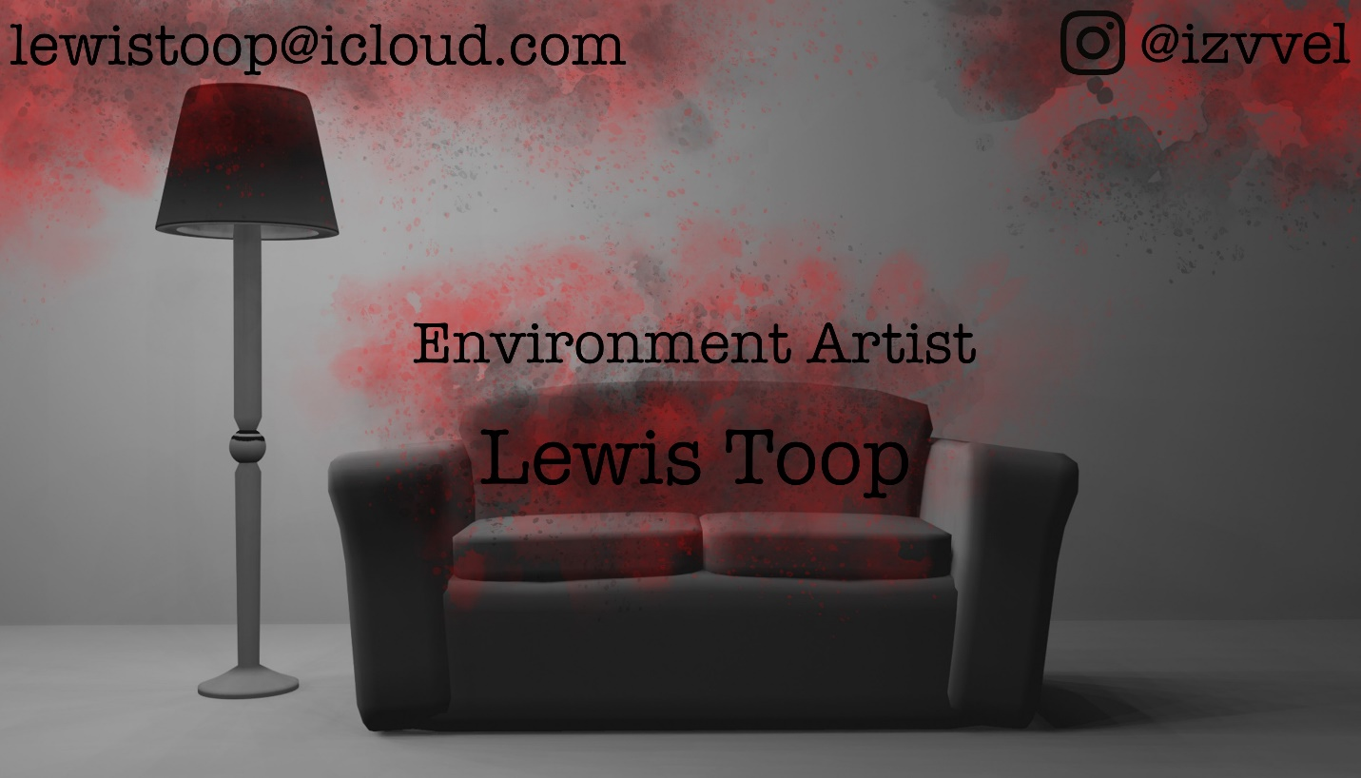
Side B
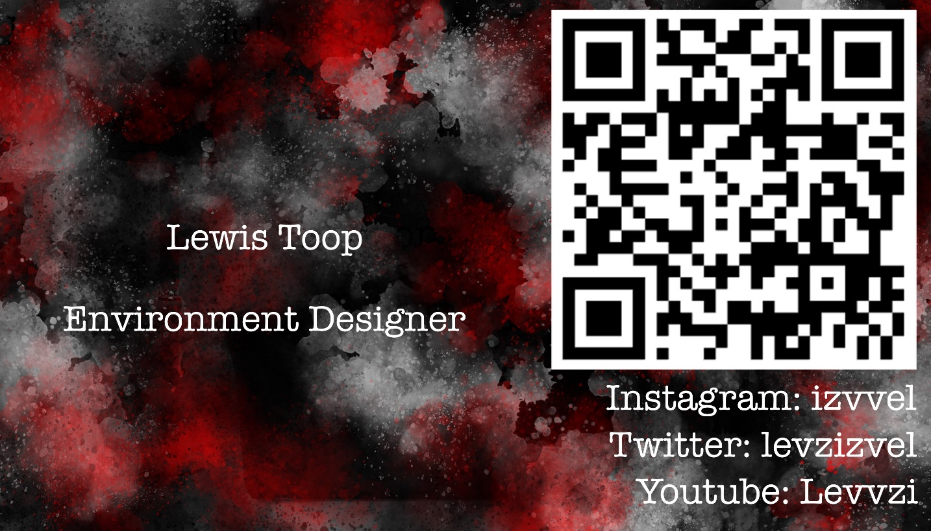

Showreel
Note: YouTube was refusing to upload my showreel at a higher resolution
https://www.youtube.com/watch?v=yr-vSkbJDp4

Bibliography
Twitter. (2023). Levzvel (Profile). [online] Available at: https://twitter.com/levzvel
Instagram. (2023). Izvvel (Profile). [online] Available at: https://www.instagram.com/izvvel/
YouTube. (2023). Levvzi (channel. [online] Available at: https://www.youtube.com/@levvzi9898
(All Images I used, are my original captures and renders and music was created by a contact of mine, my cousin: Joshua Toop)

