Assignment 2: Practical & Professional Development

Module: Changemakers: Creativity and Value Creation

Module code: ACCA5033

Supichchaya Kongyim: 2406077

Contents
Introduction: 1
Task1: Initial Feedback 1
1.2: Implementation 2
Troubleshooting: 3
Task2: Enterprise 3
PRST: 4
Task3: Project feedback and reflection 5
Conclusion 7

Introduction:
This report will be discussing about the practical development of my application, enterprise considerations and evaluate and reflect on my project. my website is an ingredient-based meal planner website designed for university students.[1][2] The system allows users to enter ingredients manually or pick on from the recommend lists which the system will generates meals suggestions with estimated calories information, time it take to cook and how easy it is to cook. [3][4]
This assignment builds on the ideation, research and planning completed in assignment 1 which focuses more on the implementation, feedback and the foundation of the website. The aim of this report is to demonstrate practical development skills, critical thinking and how creativity can be applied to create value to a real work solution.

Task1: Initial Feedback
To gather feedback for my design, I designed to use a google form to collect data that can be used to improve my design. I collected response from my peer and another participant. They were asked to review my project ideas, early interface sketches and a basic prototype with questions focusing on usability, clarity, usefulness and possible improvements.
Overall, the feedback was very positive and showed that the ideas is useful, especially for students who struggle with meal planning or on a budget. All participants a agreed that the calories estimation feature would be helpful for supporting healthier eating habits. In term of interface, most users preferred simple and clean design as they wanted something quick and easy to use.[2] Participant also suggested adding icons to make the interface more visual and engaging.
The image upload feature was seen one of the most interesting parts of the system. [4] However, several participants mentioned the accuracy would be very important and suggested that user should also be able to manually edit the ingredients if the system makes mistakes. Participants also said they would prefer multiple meal suggested added feature like filers such as ‘quick meal’, ‘vegetarian’ and low budge meal. While calories information was one of our main features, user mentioned that it should be displayed clearly without overwhelming the interface.
Based on all the feedback, I made serval changes to improve the design. The interface was simplified to make it more user friendly and adding a manual editing option for detected ingredients. I also adding a feature for the system to return multiple meal suggestions instead of just one as well as include optional filter such as vegetarian, quick meal as the feedback suggested. The calories information was also adjusted to be displayed more clearly. This improvement helped ensure that the system better matches user needs and expectations.

1.2: Implementation
the old prototype of the application was developed using HTML, CSS and JavaScript in visual studio code. The main aim of this stage was not to create a fully complete system but to showcase the core feature of the application and show how the idea could work in practice. [5][6][7]
The system allows user to enter ingredients into a text field, which are then processed using JavaScript. Based on the input the system will generates meal suggestions using simple conditional logic. For example, if the users enter ingredients such as ‘egg’ or ‘tuna’ the system will return meals that include those ingredients. This shows how the application could match user input with possible recipes.
The prototype also includes a basic interface that is design to be simple and easy to use. The layout focuses on cleatiy so that users can quickly enter ingredients and view results without confusion. Not only that, estimate calorie information is display alongside each meal suggestion to support user in making healthier choices.
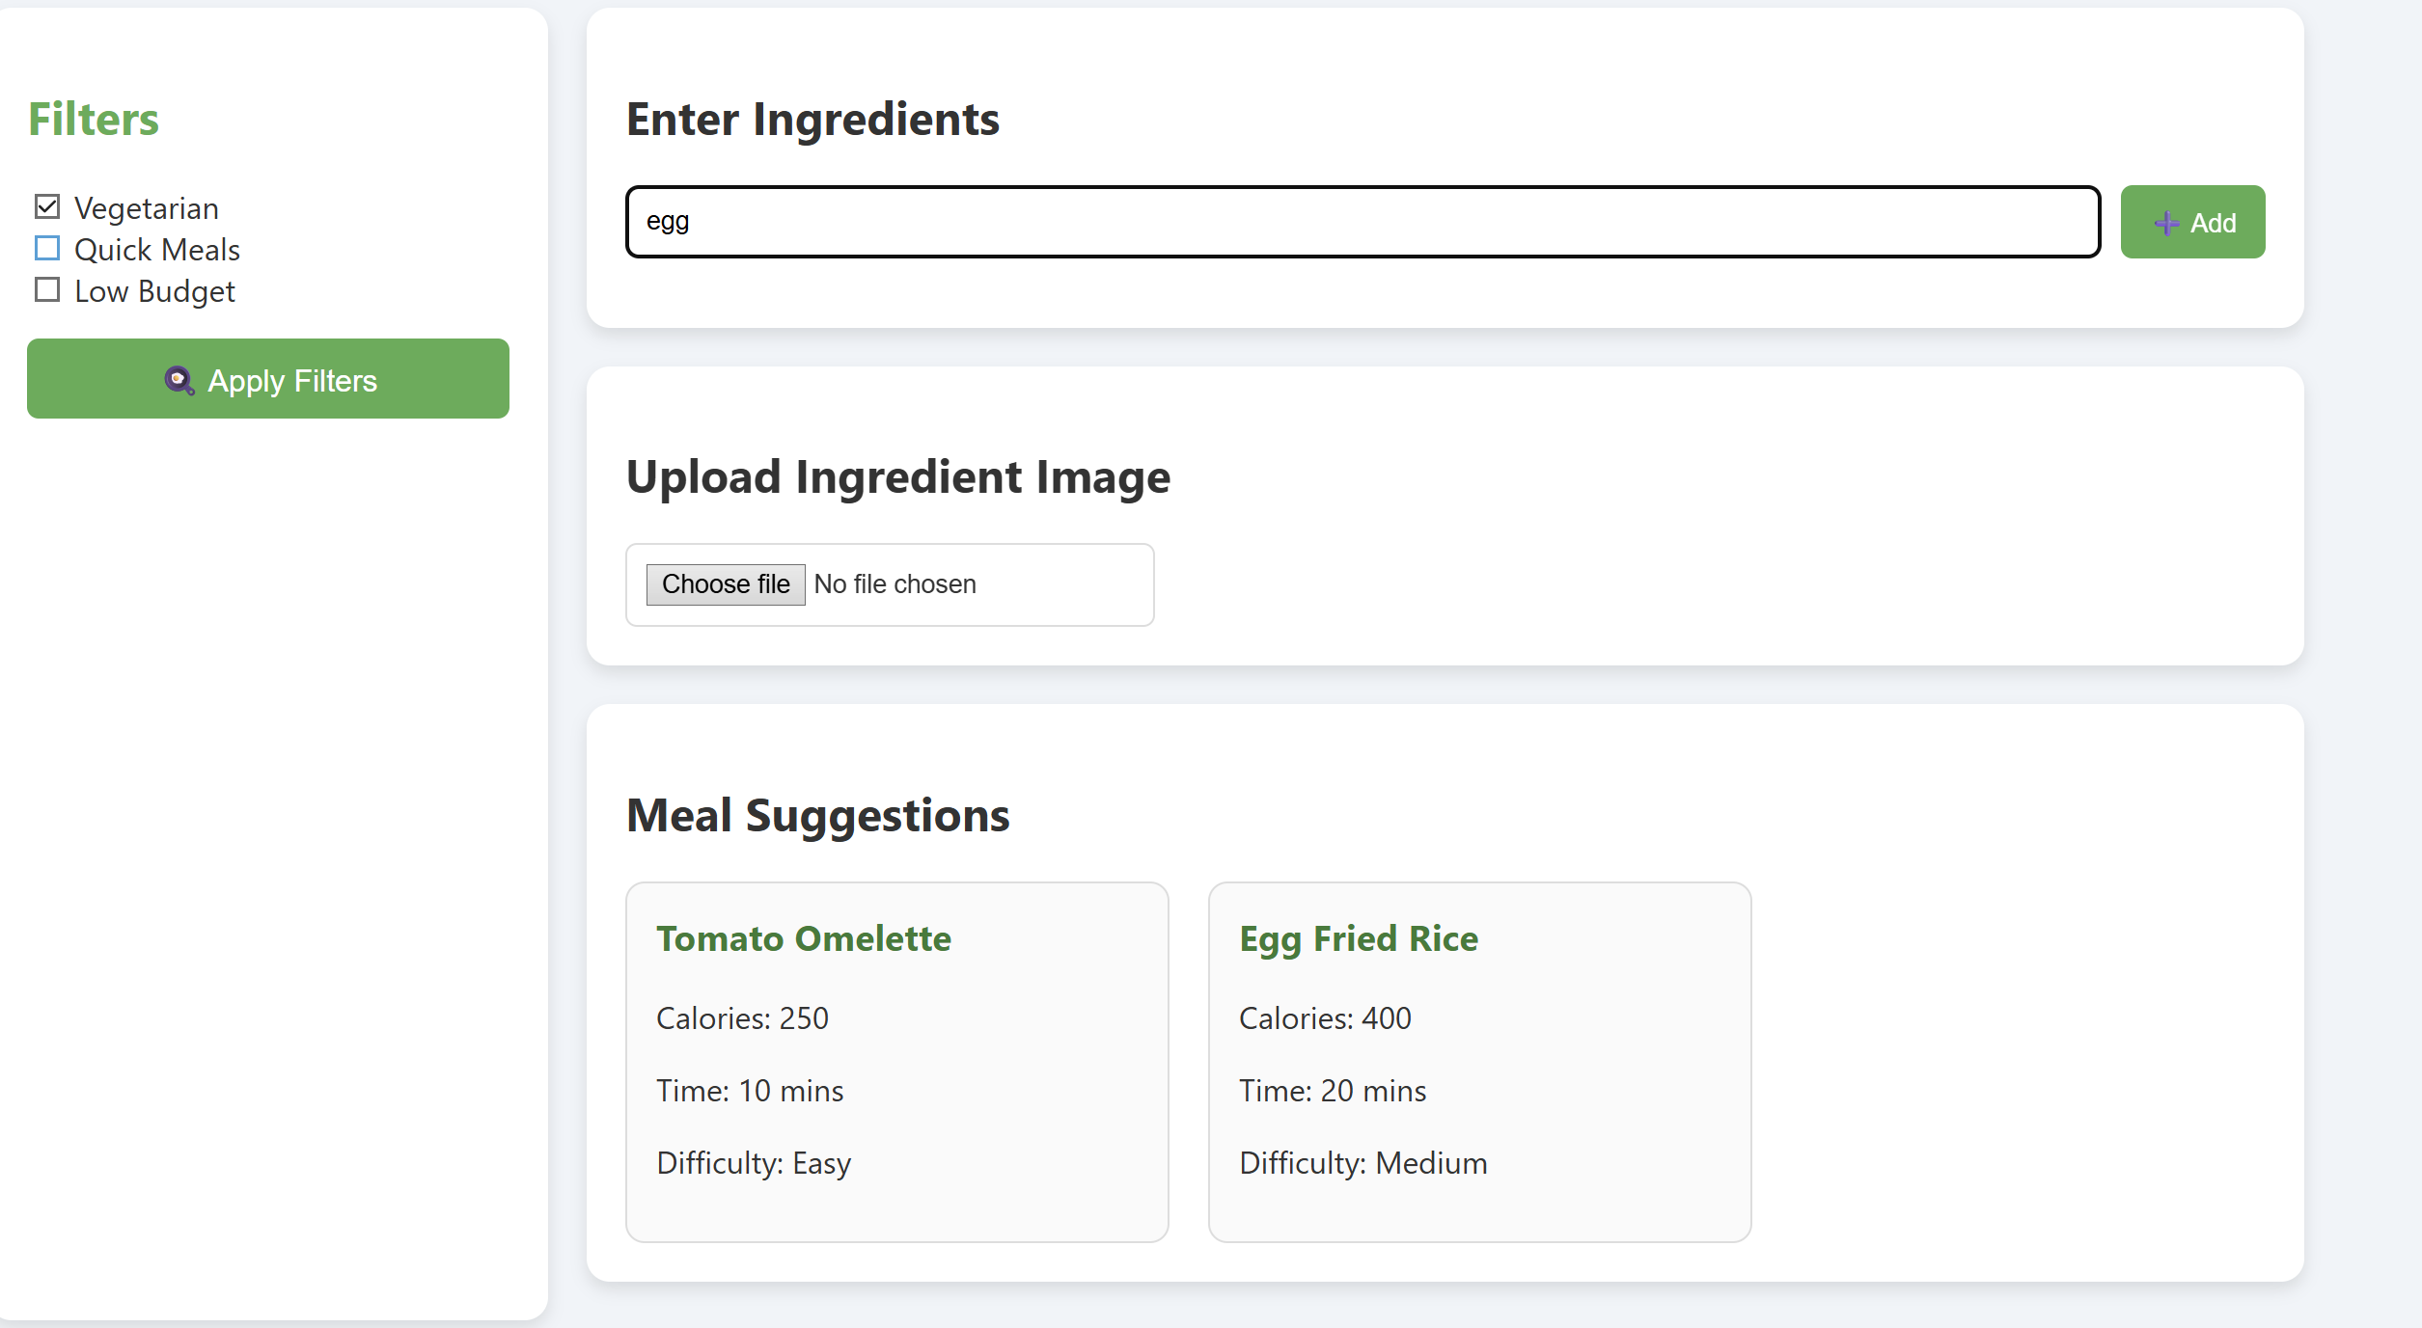
more screenshots

Troubleshooting:
During the development process, serval issues that need to be fixed for the program to be able to work properly. One of which being the input was not responding correctly which was caused by the JavaScript function not properly linked to the button. This was fixed by correcting the function call and ensuring the event was triggered correctly.
Other issues were that the results were not display on the page. This problem was solved by checking the element IDs and using the correct method to update the content. At first, the system only returned very limited meal suggestions, so additional conditions were added to improve the variety of results.
There was also some limitedatons with the user interface as the design was initially too basic. This was improved by making small changes to the layout using CSS to make it clearer and easier to use. These problems were resolved thought testing, debugging and using online resources such as W3schol and MDN. Overall, this process helped improve my understanding of how each elements work together.

Task2: Enterprise
I create a startup based on the ingredients-based meal planner application called ‘SmartMeal’. The ideas behind this are to create a platform that helps students and young people make affordable and healthier meal using ingredients they already have at home. The main goal of the application is to help reduce food waste while also making meal planning easier, cheaper and more convenient for people who may struggle with budgeting.
The logo concept for SmartMeal would include a simple bowl outline with ingredient icons such as a carrot, egg, and tomato placed above it. The design would use soft green and orange colours to represent healthy eating, freshness, and positivity. The logo is designed to look simple and modern, so it is easy for users to recognise and remember
SmartMeal would operate as a Private Limited Company.[8] I chose this type of business structure because it is commonly used by technology startups and provides limited liability protection. It would also help make the business appear more professional and reliable if it were developed further in the future.
The main target audience for the application would be university students, young adults and anyone on a tight budget who may struggle with meal planning or finding affordable meals. The application would help users save money, reduce food waste and improve eating habits by providing simple meal suggestions and calorie information based on ingredients they already have
To support the development and future growth of the application, several funding opportunities could be explored. These may be university enterprise funding, crowdfunding platforms such as Kickstarter, government grants for digital innovation projects. [9][10]

PRST:
A PRST analysis is a useful business tools used to identify external factors that may affect the success and development of SmartMeal application. It focuses on Political, Economic, Social and Technological factors, helping to identify possible opportunities, challenges and important considerations for future development.
Political:[11]
SmartMeal would need to follow data protection regulations such as GDPR as user information is stored within the application. Making sure personal data is handled safely is important for building user trust and protecting privacy.
Economic:[8]
Affordable meal-planning tools can help users save money and reduce food waste. However, development costs and limited funding could become challenges when improving the system or adding more advanced features in the future
Social:[2]
There is increasing awareness around healthy eating, sustainability and reducing food waste, which all connect with the goals of the application.
Technological:[3][4]
SmartMeal Studio would rely on technologies such as nutrition APIs and image-recognition systems to generate meal suggestions and calorie information. Improvements in artificial intelligence and cloud computing could help improve the accuracy and overall performance of the application. However, regular updates and maintenance would still be needed to keep the system secure, reliable, and working properly.
Legal & Ethical Considerations:
Legal and ethical considerations would also need to be managed carefully. User data should be protected responsibly and the application would need to comply with GDPR regulations. Calorie information should be as accurate as possible to avoid misleading users

Task3: Project feedback and reflection
3.1: Practical feedback
After completing the second version of my website, I collected further feedback from the same group of participants. They tested the system and shared their opinions on usability and how they feel about it.
The feedback showed that users found the interface easy to understand and simple to use, which was a positive outcome. The meal suggestions were considered helpful although some users mentioned that the variety were still limited. The calorie information was clear and easy to spot. But there are thing that can be improved on such as sometime the image upload features doesn’t work as intended that need to be improve for better accurate information.
Based on this feedback, I would improve the system by explain the recipe database to provide more meal option and improving the accuracy of the image recognition feature. I would also add additional feature such as a shopping list generator and the ability to save favourite meals for easy access; as those would improve the overall user experience.
3.2: Project progress diary
Weekly Project progress forms:
Date: 15/04/2025

Progress:
During this week, I continued working on improving the overall structure and features of the application. I researched meal-planning applications and nutrition APIs to better understand how meal suggestions and calorie information could be implemented within the system.
Actions:
Continue improving the website interface and layout design.
Add more meal suggestions and improve the ingredient input system.
Continue testing the prototype and fixing any issues found during development.

Date: 22/04/2026

Progress:
I focused on testing and evaluating the SmartMeal prototype. I reviewed feedback collected from users and identified several areas that could be improved, including increasing meal variety and improving the design of the interface.
Actions:
Continue improving the interface design and navigation.
Research additional features that could improve user experience.
Continue fixing bugs and testing the system functionality.

Date: 29/04/2026

Progress:
I focused on final improvements and reviewing the overall project. I continued testing the SmartMeal prototype and made small changes to improve the layout, readability, and usability of the website.
Actions:
Complete final testing and review all features.
Organise screenshots and evidence for the report.
Finalise documentation and prepare for submission.

3.3: skills
This project helped me develop a range of important skills and improved my understanding of HTML, CSS, and JavaScript while creating the SmartMeal website.[5][6][7] I also developed problem solving and debugging skills by identifying and fixing issues during the development and testing process. Researching APIs and image recognition technologies also helped improve my research abilities and technical knowledge within web development.
I also improved my communication skills through collecting feedback, analysing user responses and explaining my ideas clearly throughout the report.
Overall, this project helped me gain both technical and professional skills that will support me in future software development projects and future employment opportunities.

3.4: Positive social impact
SmartMeal has the potential to create a positive social impact by helping students and young adults manage meals more effectively while reducing food waste. Many students struggle with budgeting and deciding what to cook, especially when they only have limited ingredients available at home. By suggesting meals based on ingredients users already have, the application could help reduce unnecessary food waste and encourage more sustainable habits.
Overall, I feel that the project show how digital technology can be used to solve everyday problems and create practical value for us.

Conclusion
In conclusion, this project helped me develop important technical, research, problem solving and project management skills while also improving my understanding of how creativity and value creation can be applied within software development. User feedback and testing also helped identify areas for future improvements and highlighted the importance of creating systems that focus on user needs and accessibility.
Although the current prototype is relatively simple, it still provides a strong foundation for future development. With further improvements and additional features, SmartMeal could become a useful application that helps users plan affordable meals more easily while also reducing food waste and encouraging healthier eating habits.

References
[1] S. H. Nguyen and C. T. Vi, "Meal-Plan App: Personalized Meal Plans Based on Unique Needs", pp. 487–501. [Online].doi: 10.1007/978-981-96-4288-5_37.Available: https://link.springer.com/chapter/10.1007/978-981-96-4288-5_37?utm_source=copilot.com
[2] A. Abeltino, et al., "Digital applications for diet monitoring, planning, and precision nutrition for citizens and professionals: a state of the art," Nutr Rev. vol. 83, no. 2, pp.e574–e601, -02-01 2025, doi: 10.1093/nutrit/nuae035. Accessed: May 6, 2026. Available at: https://doi.org/10.1093/nutrit/nuae035.
[3] "Nutritionix - Largest Verified Nutrition Database," Accessed: May 6, 2026. Available at: https://www.nutritionix.com/.
[4] "Edamam - Food Database API, Nutrition API and Recipe API," Accessed: May 6, 2026. Available at: https://www.edamam.com/.
[5] "JavaScript Tutorial." Accessed: May 6 2026. [Online]. Available: https://www.w3schools.com/js/
[6] "CSS Tutorial." Accessed: May 6 2026. [Online]. Available: https://www.w3schools.com/css/
[7] "HTML Tutorial." Accessed: May 6 2026. [Online]. Available: https://www.w3schools.com/html/
[8] "PESTLE Analysis of the Food Industry (with Example)." Accessed: May 6 2026. [Online]. Available: https://pestleanalysis.com/pestle-analysis-of-the-food-industry/
[9] "PEST Analysis for Startup Founders: The Complete Guide 🚀" Go Minder - Your Hub for AI and Software Trends. (-04-052026). Accessed: May 6, 20262026, [Blog]. Available at: https://www.go-minder.com/pest-analysis-startup-founders-complete-guide/
[10] "PEST Analysis: PEST: Applying PEST Analysis to Identify Competitive Advantages in Startup Ecosystems." Accessed: May 6 2026. [Online]. Available: https://fastercapital.com/content/PEST-Analysis--PEST---Applying-PEST-Analysis-to-Identify-Competitive-Advantages-in-Startup-Ecosystems.html
[11] "Legal framework of EU data protection - European Commission." Accessed: May 6 2026. [Online]. Available: https://commission.europa.eu/law/law-topic/data-protection/legal-framework-eu-data-protection_en

