Professional Placement Task: Research, summarise and outline a methodology for the extraction of charcoal from core samples.
Module code HPGE5001.
Gareth Jenkins. Student number 99091195.
Date 13 February 2025.

Abstract, page 2.
1. Introduction, page 2.
2. Methodology, page 2.
2a. Main aims, page 2.
2b. Experimentation, page 3.
3. Discussion, page 3.
3a. Agreed methodology, page 4.
3b. The sediment core, page 4.
3c. Background of the core, page 4.
3d. Laboratory utilisation, page 5.
3e. The Experiments, page 6.
3f. Control Samples, page 12.
4. Summary of Results, page 13.
5. Conclusion, page 15.
6. List of Appendices, page 16.
7. List of Figures, page 16.
8. References, page 17.
9. Bibliography, page 18.
10. Appendices, page 21.

Professional Placement Task: Research, summarise and outline a methodology for the extraction of charcoal from core samples.

Abstract.
This report will describe research carried out during the course of the University of Wales Trinity St. David Lampeter campus's Professional Placement module HPGE5001, which is offered as part of their BA in Archaeology curriculum. The research focuses on the techniques used by archaeology for the extraction of charcoal from sediment cores and aims at identifying a methodology that does not use harmful chemicals for this process.
Keywords: Charcoal, Extraction, Hydrogen peroxide, Sugar.
(All images unless otherwise stated are the authors own).
- Introduction.
This report will outline research conducted during the course of a Professional Placement module HPGE5001, provided by the University of Wales Trinity St. David Lampeter campus, as part of their BA in Archaeology programme.
This particular placement involved working with Professor Martin Bates, a Pleistocene Geoarchaeologist, and a lecturer at the University, who tasked a project to research, summarise and outline a methodology for the extraction of charcoal from core samples (Bates, 2025, (a)).
Burned wood (charcoal) and other burnt plant remains are an essential source of paleoenvironmental and archaeological data because they record historical climatic conditions, and cultural activity (Ascough, P.L. et al. (2010), pp.69-78; Renfrew & Bahn, 2020, p.246). The organic components found in many sediments may provide a date that indicates the age of the sediments (Ascough, P.L. et al. (2010), pp.69-78). Charred organic matter is frequently used for radiocarbon (C14) dating and allows for chronological control through such dating (Ascough, P.L. et al. (2010), pp.69-78; Renfrew & Bahn, 2020, p.246; Weiner, 2010, p.178-255). Charcoal analysis can occasionally be used in conjunction with other data to provide insights into both the local environment and how humans have adapted to it (Renfrew & Bahn, 2020, pp.246-247).

- Methodology.
Desktop research was conducted of all available online databases, including the UWTSD library, to identify any relevant journals, books and papers relating to the extraction of charcoal from soil sediments and the techniques used. This research examined several fields of study including, anthracology, environmental archaeology, geoarchaeology, microarchaeology, palynology and paleoethnobotany.
2a. Main aims of the research.
- Identify a methodology for the extraction of charcoal from archaeological cores.
- Identify techniques and chemicals which are not dangerous, toxic or flammable.
- The methodology and any chemicals used must be inexpensive, and easily obtainable.
- The technique must be easy to perform.
- Must have a reasonably high success rate.
2b. Experimentation.
Following the research and the identification of suitable techniques, experiments would be carried out at the Environmental Archaeology laboratory on the Lampeter campus to evaluate the identified techniques and compare them to the current means of charcoal extraction used at the University which is by the use of a diluted solution of Hydrogen peroxide (H₂ O₂). See Figure 1.
During this process, the diluted Hydrogen peroxide (H₂ O₂), (30% concentration) solution is allowed to oxidise the sediments for 24hrs, sometimes longer and the sediment is then sieved through a series of sieves to catch both the light fraction ‘flots’ and the heavy fraction. These samples are allowed to air dry before further examination. This would be the fall-back method if a safer method was not identified. Hydrogen peroxide is used in certain industries such a hairdressing. Their normal concentrations though range from 3% to 12%, depending on the amount of bleaching required (Saddiq, n.d.).

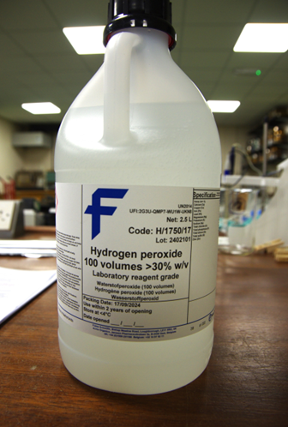
Figure 1 a photograph of the Hydrogen peroxide used at the University.

- Discussion.
Numerous techniques were identified as being used in archaeological research for the extraction of charcoal, and other macroremains from soil sediments. Several use highly toxic and dangerous chemicals for chemical flotation, such as Hydrochloric acid, Sodium hydroxide and Nitric acid (Pearsall, 2016, pp.81-95; Rebollo et al, 2008, pp.298-307; Struever, 1968; Tsakiridou, Cunningham & Hardiman, 2021). Among the less dangerous techniques the following are widely used, Dry sieving, Wet sieving, Manual flotation (Fairbairn 2005; Pearsall, 2016, pp.81-95) and Mechanical flotation (Cobb & Faulkner, 1978; Gumerman & Umemoto, 1987; Hunter & Gassner 1998; Pearsall, 2016, pp.81-95; Ramenofsky et al, 1986). Several techniques using non-harmful chemical solutions were also identified, such as the use of a sugar solution and the use of a diluted bicarbonate of soda solution (Kidder, 1997; Ross & Duffy, 2000). A brief summary of the techniques considered was provided for discussion with Professor Bates with a view of agreeing on a methodology to take forward. This summary can be seen at Appendix A.
3a. Agreed methodology.
The agreed methodology was the use of sugar/water solution to separate the light fraction or ‘flots,’ followed by immersion in a water/ bicarbonate of soda solution to deflocculate the soil of aggregates (Ross, A. & Duffy, R. 2000). The sugar solution increases the specific gravity of the heavy fraction and charcoal should float to the top (Kidder, T. R.,1997).
It was decided to use both the Sugar and Bicarbonate solution methods and the Hydrogen peroxide method on the same sample from a sediment core to assess which was the most efficient at deflocculation and extracting charcoal samples (Bates, 2025, (b)).
3b. The Sediment core.
A 5-metre core drilled during the course of an archaeological investigation at Skaill near Skara Brae, on the Island of Orkney by Professor Martin Bates, as part of the Viking Canal project (Bates, 2025, (a); Bates, 2025, (c)). The core is currently in storage at the Environmental Archaeology Laboratory at Lampeter University (Bates, 2025, (c)).
The core was drilled using a Winkie drill to a total depth of 6.30metres on the 16 October 2023 (Bates, 2025. (c)). It is divided into three sections with depths of
- 1.60m – 3.10m
- 3.20m – 4.70m
- 4-80m – 6.30m
There is a 10cm gap in between each core sample which is created by the drill head (Bates, 2025. (c)). The 1.6 m topsoil being too sandy was not recovered. The cores cover a time period ranging from 15,000 to 2,500 years (Bates, 2025. (c)). The cores have been examined using a core scanner and samples taken for the purpose of Radiocarbon dating. The results of these examinations are pending (Bates, 2025. (c)).
3c. Background of core.
On Orkney, the prehistoric and Viking-Age environment surrounding the Bay of Skaill is essential to our knowledge of local human activities (McKiernan, 2022, p.2). The broader landscape setting here is still not well known, despite several excavations and studies of the shifting environments (McKiernan, 2022, p.2). These difficulties are addressed by research done in the northern portion of the bay, towards the Loch of Harray, as well as next to Skara Brae (McKiernan, 2022, p.2). For the first time, a lengthy (yet comparatively comprehensive) record of environmental change in the region has been compiled thanks to a landscape-scale geophysical survey and the drilling of numerous boreholes (McKiernan, 2022, p2).
3d. Laboratory utilisation.
For the purposes of these experiments, it was necessary to use the facilities at the Sediments and Soil Laboratory within the Environmental Archaeology laboratory at Lampeter, under the guidance of the Laboratory Manager Dr Rod Bale. Prior to commencing any work, consideration had to be given to laboratory working practices, and in particular the following.
- Working within an active laboratory environment.
- Expensive laboratory equipment.
- Dangerous/toxic chemicals in storage and in use.
- Health & safety procedures.
- Laboratory Risk Assessment.
- Identify locations of First Aid equipment.
- Wear protective clothing when conducting the experiments.
- Avoiding cross-contamination of samples.
A copy of the laboratory risk assessment was provided for information and adherence. First aid equipment can be found just inside the entrance to the Sediments and Soil laboratory, see Figure 2 below. Protective clothing included laboratory gown, rubber gloves, and rubber gauntlets when using hazardous chemicals. See Figure 3 below.
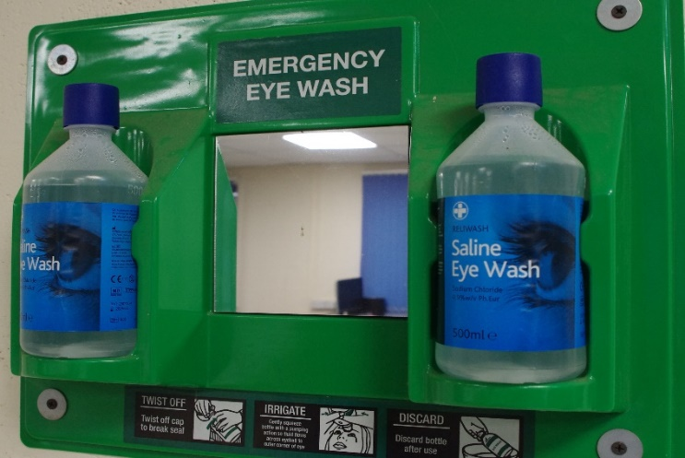
Figure 2. Photograph of first aid equipment available in the laboratory.
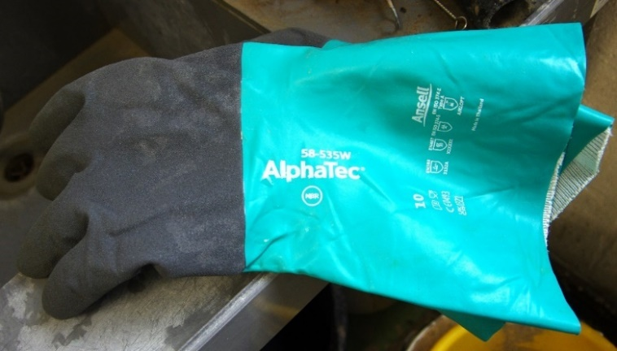
Figure 3, photograph of rubber gauntlets used to handle hazardous chemicals.

3e. The Experiments.
A 2cm sample of sediment was removed from various levels of the core. Although taken at random, consideration was given to the sediment type, that is whether it was peat, clay, or sandy sediment. Samples of each type were sampled to ensure a good cross-section of samples. See figure 4 below of the three sections of the core, with Figure 5 a photograph of a section of a core showing the sediment type and a soil sampling section.

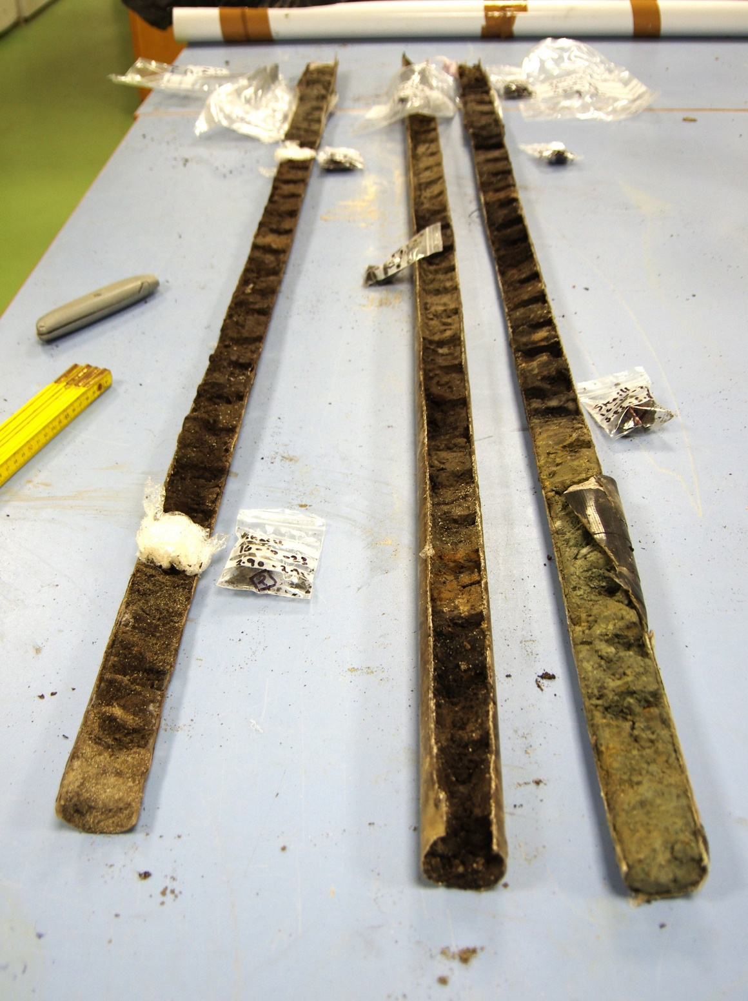
Figure 4 a photograph of the core in the laboratory prior to sampling.

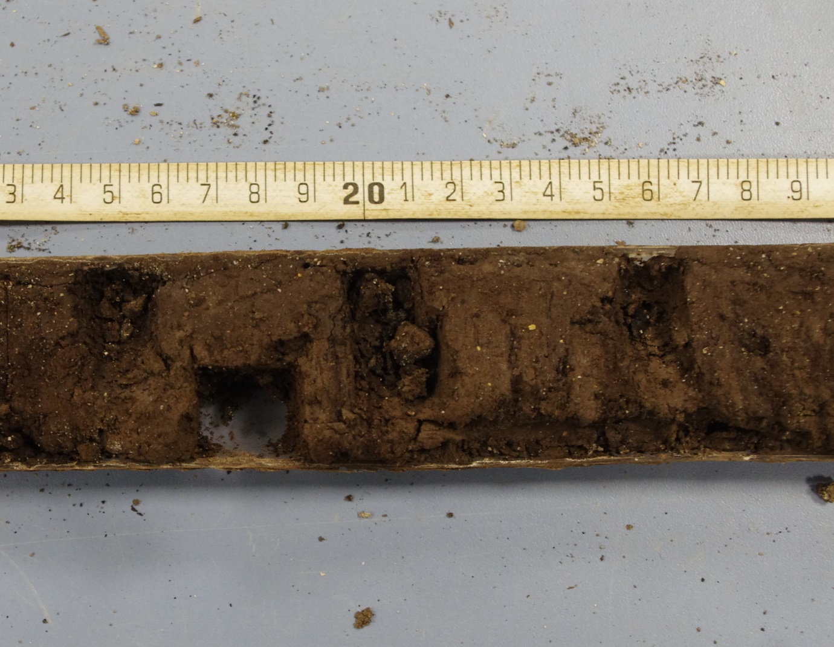
Figure 5 photograph of a section of a core showing the sediment type and a soil sampling section.

A spreadsheet providing an assessment of the observed sediment types at each level of the core was provided by Professor Bates and can be seen below at Figure 6.
Project |  | Skaill |  | BH | 16-10-23/1
Easting |  |  |  | Northing
Elevation |  |  |  | Date drilled | 16/10/23
Date to laboratory |  | - |  | Date recorded | 03/01/24
Date sampled |  | 03-04/01/24 |  | Location of samples | Lampeter/Orkney
Depth below  ground surface (m) | Context number |  | Lithological description |  |  | Environment of deposition
0.00 – 1.95 |  |  | Dark grey shelly sands
 |  |  | ---abrupt contact---
1.95 – 2.02 |  |  | Brown organic silt to peat with some sand and shell fragments.
 |  |  | ---diffuse contact---
2.02 – 2.15 |  |  | Brown organic silt.
 |  |  | ---diffuse contact---
2.15 – 2.86 |  |  | Bedded organic sands and peat with grey patches of clay-silt.
 |  |  | ---abrupt contact---
2.86 – 3.63 |  |  | Grey sand with shelly sands and organics. Possibly bedded.
 |  |  | ---sharp contact---
3.63 – 3.86 |  |  | Grey clay silt.
 |  |  | ---diffuse contact---
3.86 – 3.91 |  |  | Grey clay with some brown organic patches.
 |  |  | ---abrupt contact---
3.91 – 4.03 |  |  | Brown organic silt.
 |  |  | ---diffuse contact---
4.03 – 4.23 |  |  | Grey clay silt with some sand and organic material.
 |  |  | ---diffuse contact---
4.23 – 4.36 |  |  | Brown organic sand.
 |  |  | ---diffuse contact---
4.36 – 4.55 |  |  | Grey clay silt with patches of organic material.
 |  |  | ---abrupt contact---
4.55 – 5.05 |  |  | Brown organic silt.
 |  |  | ---abrupt contact---
5.05 – 5.17 |  |  | Grey clay silt.
 |  |  | ---sharp contact---
5.17 – 5.23 |  |  | Brown peat.
 |  |  | ---sharp contact---
5.23 – 5.35 |  |  | Grey organic silt.
 |  |  | ---abrupt contact---
5.35 – 5.92 |  |  | Brown peat, probably bedded.
 |  |  | ---abrupt contact---
5.92 – 6.00 |  |  | Yellow brown clay with gravel clasts.
 |  |  | ---diffuse contact---
6.00 - |  |  | Grey gravelly clay.
 |  |  | ---base of borehole 6.20m---
Figure 6. (Bates, 2025 ( c )).
All samples taken were weighed and then split into two pieces, with each piece placed in a 500ml beaker. The beakers are labelled with a sample number followed by an A or a B, i.e. sample 1 is divided into 1A and 1B, sample 2 is divided into 2A and 2B and so on. The A beaker sample is immersed in the diluted sugar solution of 400ml hot water and 80g of sugar, followed a short time later, having been rinsed with water, is immersed in the diluted bicarbonate of soda solution of 400ml hot water and 40g of bicarbonate of soda. The B beaker is used on each occasion for the diluted Hydrogen peroxide solution of 400ml hot water and 80ml Hydrogen peroxide. A recommended 10-20% solution was used for this purpose (Pearsall, 2015, p.85). They were agitated and left to settle. The majority of the samples were left for twenty-four hours, with some left for longer to ensure sufficient time was given for the deflocculation process.
They were examined for evidence of deflocculation, before being rinsed with water, and sieved using an Endicott 106 micro sieve and placed on foil trays to dry. As a further experiment based on the research undertaken, a piece of chiffon cloth was also used to sieve a number of the samples to test its efficiency (Fairbairn, 2005). The chiffon was pegged to a beaker before been used as a sieve. See Figure 7 below of the chiffon sieve technique.

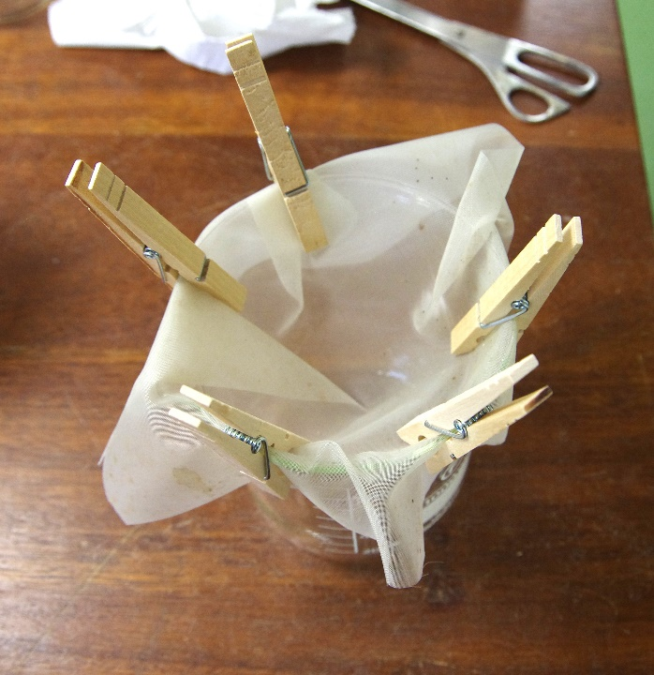
Figure 7 photograph of the chiffon sieve technique.

Further samples were taken using consecutive numbers and given the same treatment. Every step of each procedure including timing of immersion and sieving was noted in a notebook and brief details put on a spreadsheet for comparison of results. Photographs were taken of each stage of the procedure and of the resulting dried samples. When dried the samples were transferred to petri-dishes for further examination, assessment of success or otherwise and storage. See photographs of each stage at Figures 8, 9 and 10 below.

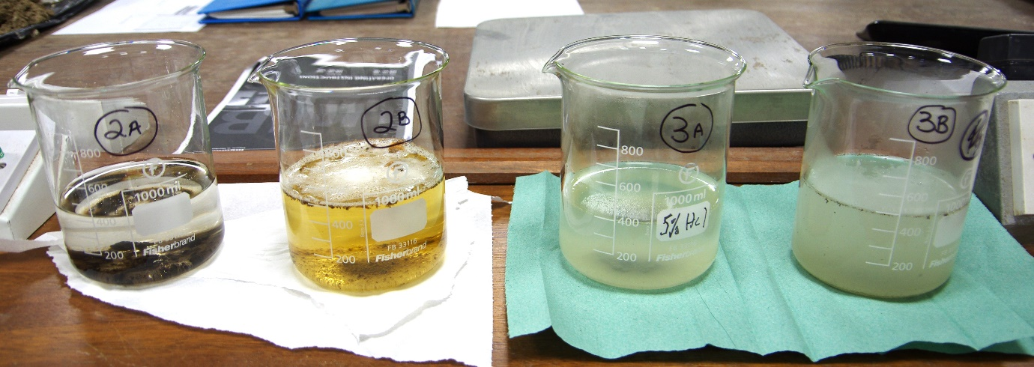
Figure 8, photograph of beakers containing samples 2 and 3.

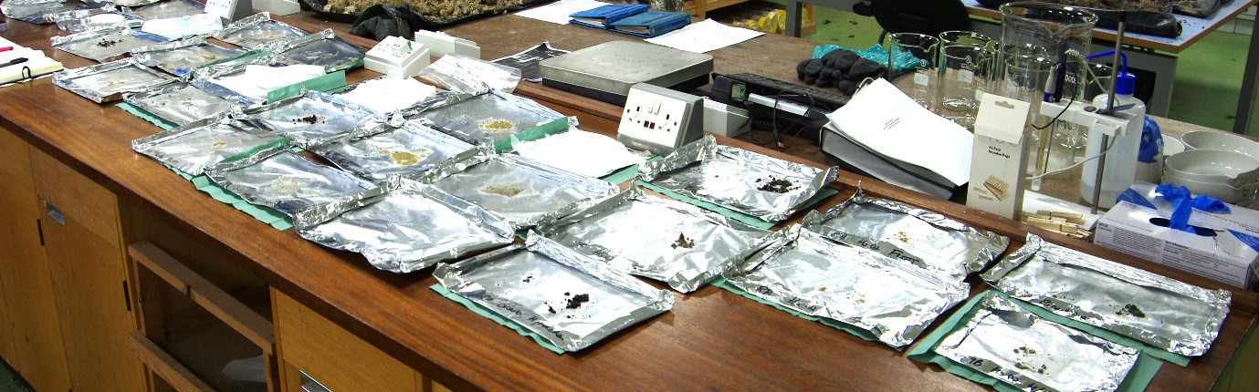
Figure 9, sediments being dried on foil trays following any deflocculation.

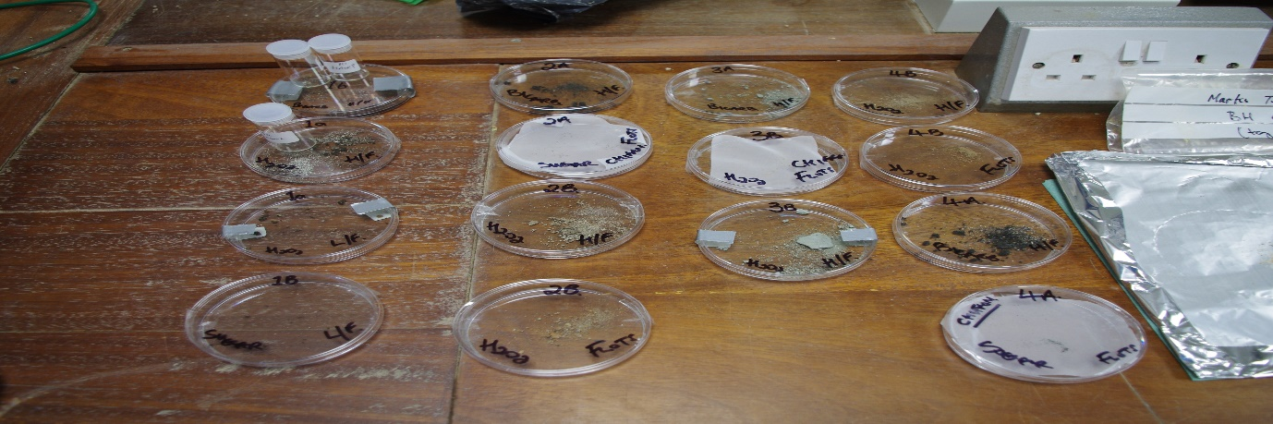
Figure 10, dried sediments having been placed in petri dishes for further examination.

Figure 11 is a chart that shows where the samples were taken in relation to the core depths. The red numbered samples are the samples that featured in the initial experiments, and the blue numbered samples are samples that were used during the next stage which is documented below. The next stage samples were deflocculated using other chemical solutions.

Figure 11.

The next stage of the experiment involved further research and experimentation with other chemicals. This included using a distilled malt vinegar solution, which is a basic acetic acid, commonly found in supermarkets (Lievois, n.d.), and a solution of water and sodium hexametaphosphate (NaPO³)⁶ an organic salt which is used in various industries (Andreola, 2004). Samples were taken from the core as indicated in blue on Figure 11.

Sample 10 was divided into two with 10A being immersed in an undiluted 120ml solution of distilled malt vinegar, and sample 10B immersed in a diluted solution of 400ml hot water and 40g of Sodium hexametaphosphate. Both were agitated and left to settle overnight. Figure 12 below is a photograph of sample 10 during the deflocculation process.

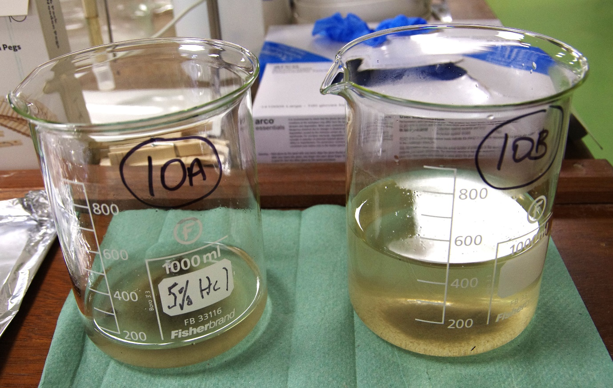
Figure 12.

The final sample, sample 11, was immersed in a stronger solution of 200ml hot water and 40g of sodium hexametaphosphate, to assess its deflocculation efficiency.
Following deflocculation both samples were rinsed, sieved, and placed on foil trays to air dry. Once dry they were placed in petri-dishes for further examination.

3f. Control samples.
Professor Bates provided a small sample of a heavy yellow/brown clay sediment from a separate archaeological investigation that he was conducting at Marks Tey in Essex, as a control to the Orkney sediment analysis (Bates, 2025 ( c )). A sample of this sediment was divided into two pieces and given the sample numbers 5Ai and 5Bi. Sample 5Ai was subjected to the sugar and bicarbonate of soda solution, and sample 5Bi was subjected to the Hydrogen peroxide solution. Figure 13 is a photograph of these samples during the immersion stage. Both solutions changed colour but neither sample appeared to have any light fraction. Deflocculation appeared to be minimal.

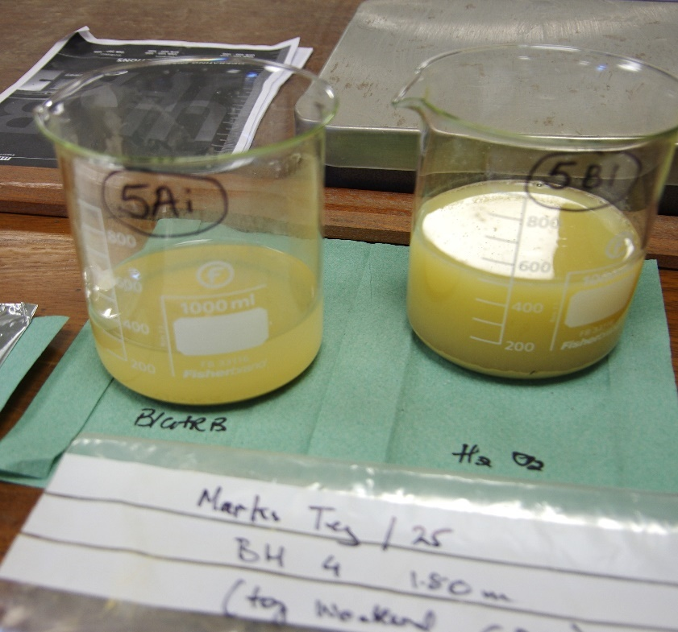
Figure 13

- Summary of Results.
The Sugar solution did not appear to work well on the peat or clay soil from the core. It worked better with the sandy sediment. The Bicarbonate of soda solution provided slightly better deflocculation, and provided reasonable separation, but further work is required to establish how well it disperses the charcoal. This can be judged during microscope analysis of the dried samples. The Hydrogen peroxide solution worked well in each case, with good separation. This is highlighted in Figure 14, a photograph of sample 4 during the deflocculation process, with a clear indication of the solution bubbling in sample 4B, whilst 4A appears to have little dispersion. However, there was significant bleaching of the 4B sample, and possible disintegration of charcoal within the sample. Bleaching was noted in several of the samples immersed in the Hydrogen peroxide solution. Similarly, Figure 15 below is a photograph of sample 6 shows significant more deflocculation in 6B than in 6A.
The control sample was a heavier clay soil and both solutions appeared to struggle to deflocculate. Sample 5Bi was allowed to deflocculate for five days until the bubbling of the solution ceased.
The samples immersed in vinegar and sodium hexametaphosphate appeared to work well and showed signs of better dispersal.
When examined under a microscope the levels of deflocculation and separation were more apparent than when under visual inspection in the beakers and foil trays.
The use of chiffon as a sieve worked very well and could be utilised in the future.

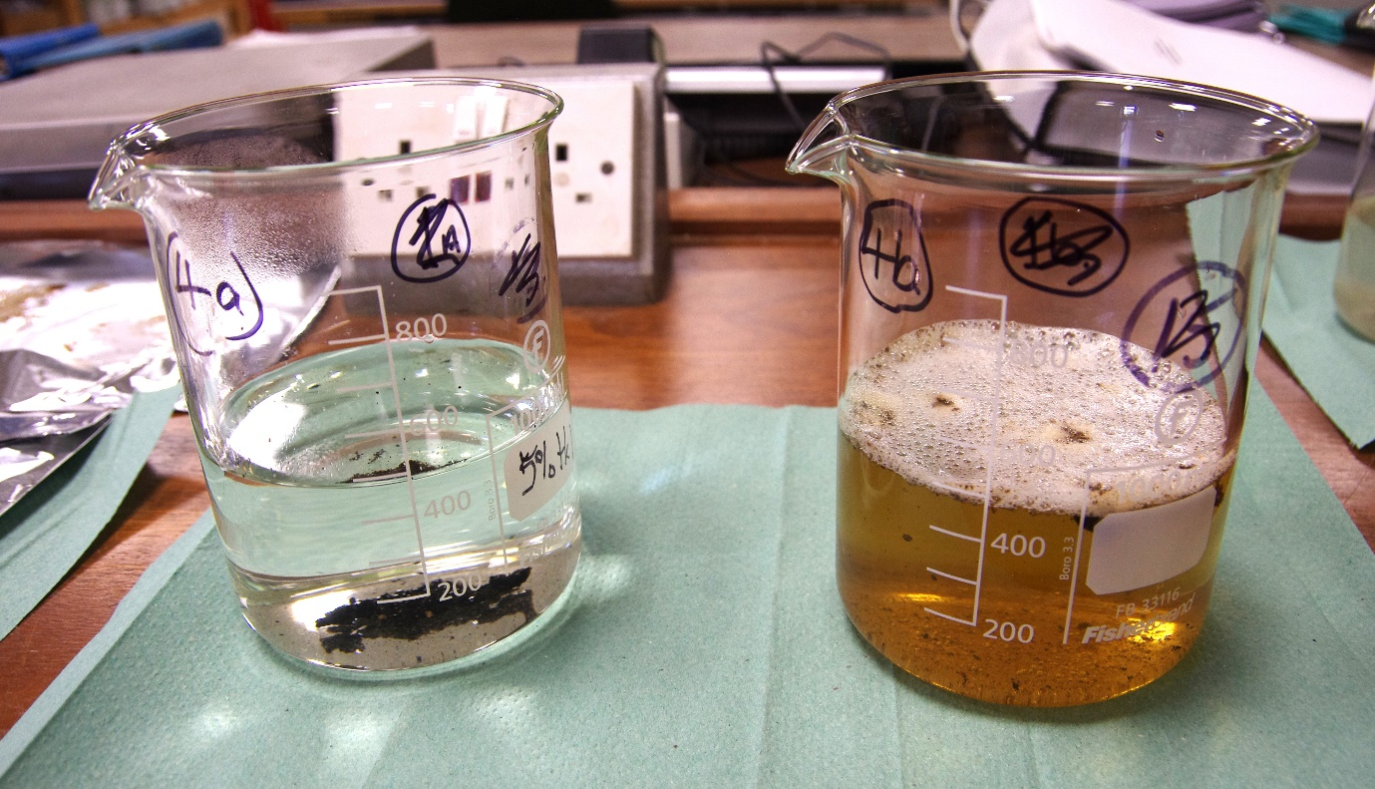
Figure 14.

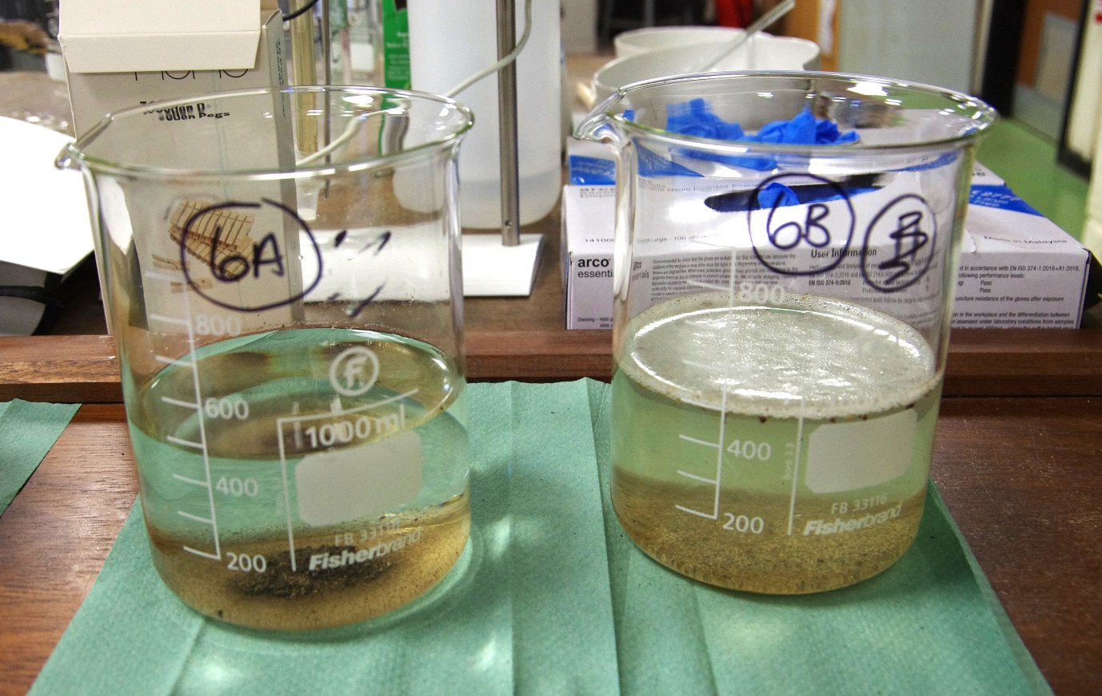
Figure 15.

- Conclusion.
During a short period of experimentation, it was apparent that the diluted sugar solution did not work well on the peaty and clay soils from Orkney. However, when using this solution on sandy sediment better deflocculation was noted. The difficulty of using this method with clay soils was highlighted within the research articles (Kidder, 1997; Ross & Duffy, 2000). The diluted sodium bicarbonate solution appeared to work slightly better but again was more useful with sandy sediment. It became apparent that hot water was required to dissolve both chemicals following the initial sampling process.
The diluted Hydrogen peroxide solution worked well on all samples but tended to bleach most of the soil types. There were particular changes of colour of the solutions during the deflocculation period. This may have been as a result of the bleaching of the soil.
The samples tested were only 2cm. A very small sample compared to the normal bulk samples that are normally tested. This could have had a detrimental effect on the sampling, because once separated into two smaller samples there was less to work with and a possibility that there was no charcoal in either of the relevant samples.
The secondary experiments using vinegar and a Sodium hexametaphosphate solution was successful but requires further investigation to validate the two results achieved. It was noted that the Sodium hexametaphosphate powder, when mixed with hot water, tended to bind together into a solid mass, and had to be rigorously agitated to dissolve. This could be addressed in future experimentation.
A binding or solidification of some samples during the drying process was a concern and could be as a result of inefficient water rinsing and the use of a fine 106 micro sieve. Air drying may have allowed the samples to solidify. It was noted that a chemical residue remained on the foil trays after drying. Consideration must be given to using wider mesh sieves or a chiffon sieve, and also an oven drying method with any future experiments to assess whether there would be any improvement with the condition of the resulting samples.
Further research and experimentation should be implemented to confirm the result of this experiment. The use of other deflocculating agents should also be researched and examined under laboratory conditions.
The tasked work placement provided a valuable learning experience in relation to the protocols required for working in a laboratory environment and in particular the use of dangerous chemicals. There is a huge amount of literature dealing with soil analysis, deflocculation and charcoal extraction and there is much more to consider. Such as looking at how other industries conduct soil deflocculation. Overall, it was an enjoyable experience which provided an insight to the various scientific methods used by archaeology. The author would like to acknowledge the support provided by Professor Martin Bates in conducting this research and for allowing access to important geoarchaeological core samples for use in the experiments. The author would also like to acknowledge the guidance and support provided by Dr Rod Bale during the period of experimentation in the Environmental Archaeology Laboratory on the UWTSD Lampeter campus.

- List of Appendices.
- Research notes of techniques used to extract charcoal from sediment cores without using harmful acids or other chemicals.
- Spreadsheet of results noted during deflocculation stage.
- Spreadsheet of microscope analysis.

- List of Figures.
- Photograph of the Hydrogen peroxide used at the University.
- Photograph of first aid equipment available in the laboratory.
- Photograph of rubber gauntlets used to handle hazardous chemicals.
- Photograph of the core in the laboratory prior to sampling.
- Photograph of a section of a core showing the sediment type and a soil sampling section.
- A spreadsheet providing a breakdown of observed sediment types at each level of the core.
- Photograph of the chiffon sieve technique.
- Photograph of beakers containing samples 2 and 3.
- Photograph of the sediments being dried on foil trays following any deflocculation.
- Photograph of the dried sediments having been placed in petri dishes for further examination.
- Chart that shows where the samples were taken in relation to the core depths.
- Photograph of sample 10 during the deflocculation process.
- Photograph of samples 5Ai and 5Bi during the immersion stage.
- Photograph of sample 4 during the deflocculation process.
- Photograph of sample 6 showing significant more deflocculation in 6B than in 6A.

- References.
Andreola, F. et al. (2004). “The role of sodium hexametaphosphate in the dissolution process of kaolinite and kaolin.” Journal of the European Ceramic Society, volume 24, Issue 7, pp. 2113-2124. Available at: https://doi.org/10.1016/S0955-2219(03)00366-2. (Accessed: 2 February 2025).
Ascough, P.L. et al. (2010). “Alkali Extraction of Archaeological and Geological Charcoal: Evidence for Diagenetic Degradation and Formation of Humic Acids.” Journal of Archaeological Science, 38 (1). Pp.69-78. Available at: https://www.academia.edu/57609730/Alkali_extraction_of_archaeological_and_geological_charcoal_evidence_for_diagenetic_degradation_and_formation_of_humic_acids?email_work_card=view-paper (Accessed: 17 January 2025).
Bates, M., (2025). Conversation with Gareth Jenkins on 9 January.
Bates, M., (2025). Conversation with Gareth Jenkins on 23 January.
Bates, M., (2025). Email correspondence with Gareth Jenkins on 31 January.
Cobb, J. E. & Faulkner, C. H. (1978). “The Owl Hollow Project Laboratory Flotation Device.” In SEAC Newsletter Vol. 20. No.1.
Fairbairn, A. (2005). “Simple bucket flotation and wet-sieving in the wet tropics.” Palaeoworks Technical Papers 4. Available at: https://core.ac.uk/works/51741969/?t=e1c86db4ec1e63f31518692691bc29cd-51741969 (Accessed: 11 January 2025).
Gumerman, G. & Umemoto, B. S. (1987). “The Siphon Technique: An Addition to the Flotation Process.” American Antiquity, Vol. 52. No.2, pp. 330-336. Cambridge University Press. Available at: https://www.jstor.org/stable/281784 (Accessed: 9 January 2025).
Hunter, A.A. and Gassner, B.R. (1998) ‘Evaluation of the Flote-Tech Machine-Assisted Flotation System’, American antiquity, 63(1), pp. 143–156. Available at: https://doi.org/10.2307/2694781 (Accessed: 12 January 2025).
Kidder, T.R. (1997) ‘Sugar Reflotation: An Alternative Method for Sorting Flotation-derived Heavy Fraction Samples’, Journal of field archaeology, 24(1), pp. 39–45. Available at: https://doi.org/10.1179/jfa.1997.24.1.39. (Accessed: 12 January 2025).
Lievois, M. (n. d.). The Importance of deflocculation in pottery. Available at: https://creamik.com/deflocculants-in-pottery/?lang=en#:~:text=The%20use%20of%20vinegar%20in,consistency%20in%20slip%20and%20glaze. (Accessed: 2 February 2025).
McKiernan, E. (2022). Royal Society AA21/100192 APEX Final Reporting Form (1). Internal report collected on behalf of the British Academy, the Royal Academy of Engineering and the Royal Society. Unpublished.
Pearsall, D. M. (2016). Paleoethnobotany: A Handbook of Procedures. 3rd Ed. Routledge.
Ramenofsky, A.F. et al. (1986) ‘A New Technique for Separating Flotation Samples’, American Antiquity, 51(1), pp. 66–72. Available at: https://doi.org/10.2307/280394. (Accessed: 12 January 2025).
Rebollo, N. et al. (2008) ‘Structural Characterization of Charcoal Exposed to High and Low pH: Implications for 14C Sample Preparation and Charcoal Preservation’. Available at: https://doi.org/10.1017/S0033822200033592. (Accessed: 16 January 2025).
Renfrew, C. & Bahn, P. (2020). Archaeology: Theories, Methods and Practice. 8th Ed. Thames & Hudson.
Ross, A. and Duffy, R. (2000) ‘Fine mesh screening of midden material and the recovery of fish bone: The development of flotation and deflocculation techniques for an efficient and effective procedure’, Geoarchaeology, 15(1), pp. 21–41. Available at: https://doi.org/10.1002/(SICI)1520-6548(200001)15:1<21::AID-GEA2>3.0.CO;2-L. (Accessed: 11 January 2025).
Saddiq, R. (n.d.). “Morphological properties of hair and their variation when subjected to oxidation via chemical bleaching.” Journal of Huddersfield student research. University of Huddersfield Press. Available at: www.fieldsjournal.org.uk (Accessed: 9 February 2025).
Struever, S. (1968). “Flotation Techniques for the Recovery of Small-Scale Archaeological Remains.” American Antiquity, Vol.33, No. 3, pp. 353-362. Cambridge University Press. Available at: https://www.jstor.org/stable/278703 (Accessed: 12 January 2025).
Tsakiridou, M., Cunningham, L. and Hardiman, M. (2021) ‘Toward a standardized procedure for charcoal analysis’, Quaternary research, 99, pp. 329–340. Available at: https://doi.org/10.1017/qua.2020.56. (Accessed: 10 January 2025).
Weiner, S. (2010). Microarchaeology: Beyond the Visible Archaeological Record. Cambridge University Press.

- Bibliography.
Arranz-Otaegui, A. (2017). Evaluating the impact of water flotation and the state of the wood in archaeological wood charcoal remains: Implications for the reconstruction of past vegetation and identification of firewood gathering strategies at Tell Qarassa North (south Syria). Quaternary International, 457, 60–73. https://doi.org/10.1016/j.quaint.2016.06.030
Banning, E. (2020). Archaeological Soils, Sediment and Geoarchaeology. [video]. Available at: https://www.youtube.com/watch?v=cwLTiYgvuK0 (Accessed: 14 January 2025).
Bates, C. R. et al. (2020) ‘The Norse Waterways of West Mainland Orkney, Scotland’, Journal of Wetland Archaeology, 20(1–2), pp. 25–42. Available at https://doi.org.10.1080/14732971.2020.1800281. (Accessed: 13 January 2025).
Bates, C.R., Bates, M. & Dawson, S. (2022). 'The Rising Tides Project, Orkney' Archaeology Scotland, vol. 44, pp. 26-28.
Bates, M., Anderson-Whymark, H. and Stafford, E. (2013) Thames holocene : a geoarchaeological approach to the investigation of the river floodplain for High Speed 1, 1994-2003. Salisbury: Oxford Wessex Archaeology.
Bergslien, E. (2012). An Introduction to Forensic Geoscience. Willey- Blackwell.
Chiou, K.L., Cook, A.G. and Hastorf, C.A. (2013) ‘Flotation versus dry sieving archaeobotanical remains: A case history from the Middle Horizon southern coast of Peru’, Journal of field archaeology, 38(1), pp. 38–53. Available at: https://doi.org/10.1179/0093469012Z.00000000035. (Accessed: 11 January 2025).
Cobb, J. E. & Faulkner, C. H. (1978). “The Owl Hollow Project Laboratory Flotation Device.” In SEAC Newsletter Vol. 20. No.1.
Courty, M.A. Marie-A., Goldberg, P. and Macphail, R. (1989) Soils and micromorphology in archaeology. Cambridge: Cambridge University Press.
Cuenca‐García, C. (2019) ‘Soil geochemical methods in archaeo‐geophysics: Exploring a combined approach at sites in Scotland’, Archaeological prospection, 26(1), pp. 57–72. Available at: https://doi.org/10.1002/arp.1723. (Accessed: 28 January 2025).
Čufar, K. (2010). Recovery techniques for waterlogged archaeological sediments: a comparison of different treatment methods for samples from Neolithic Lake shore settlements. Vegetation History and Archaeobotany.
Decaix, A. and Douché, C. (2022). Introduction to Archaeobotany (Part 2). [video]. Available at: https://www.youtube.com/watch?v=fo-Q8Xxm4sE (Accessed: 14 January 2025).
Harrison, S. (2020) ‘David Griffiths, Jane Harrison and Michael Athanson, Beside the Ocean: Coastal Landscapes at the Bay of Skaill, Marwick and Birsay Bay, Orkney: Archaeological Research 2003–2018’, Scottish Archaeological Journal. UK: Edinburgh University Press, pp. 126–128. Available at: https://doi.org/10.3366/saj.2020.0129. (Accessed: 28 January 2025).
Hastorf, C.A. and Popper, V.S. (1988) Current paleoethnobotany : analytical methods and cultural interpretations of archaeological plant remains. Chicago, Ill. ; University of Chicago Press.
Kabukcu, C. (2018). Wood Charcoal Analysis in Archaeology. Environmental Archaeology: Current Theoretical and Methodological Approaches, 133–154. https://doi.org/10.1007/978-3-319-75082-8 (Accessed: 17 January 2025).
Kabukcu, C. (2022). Highway to Science Introduction to wood charcoal analysis in archaeology. [video]. Available at: https://www.youtube.com/watch?v=EI8y6Xl_prc (Accessed: 14 January 2025).
Langgut, D., Lev-Yadun, S., 2024. Archaeobotany: Wood and Charcoal Remains. In: Nikita, In E., Rehren, T. (Eds.), Encyclopedia of Archaeology, 2nd Edition, vol. 2, pp. 674–686, London: Academic Press. Available at: https://www.academia.edu/121001944/Archaeobotany_Wood_and_Charcoal_Remains_Langgut_and_Lev_Yadun_2024_In_Encyclopedia_of_Archaeology_2nd_Edition_ARC2_?nav_from=7d398d94-61a2-454e-8cfd-61a672d4fa8d (Accessed: 13 January 2025).
Latkova, M and Hajnalova, M., (2014). Plant macro-remains from the palaeochannel sediments, trench B 2012. In Poláček, L. (ed.). Mikulčice river archaeology. New interdisciplinary research into bridge No. 1. Brno : The Institute of Archaeology of the Academy of Sciences of the Czech Republic, Brno, 2014. s. 93-112. Available at: https://www.academia.edu/11778918/Plant_macro_remains_from_the_palaeochannel_sediments_trench_B_2012 (Accessed: 13 January 2025).
Mas, B. (2019). Flotación Manual - Bucket Flotation: to recover archaeological remians. Available at: https://www.youtube.com/watch?v=CubTMey6ED4 (Accessed:14 January 2025).
Macphail, R. and Goldberg, P. (2018) Applied soils and micromorphology in archaeology. Cambridge, United Kingdom ; Cambridge University Press.
Monnier, G.F. (2018) ‘A review of infrared spectroscopy in microarchaeology: Methods, applications, and recent trends’, Journal of archaeological science, reports, 18, pp. 806–823. Available at: https://doi.org/10.1016/j.jasrep.2017.12.029. (Accessed: 16 January 2025).
Monteiro, P. M. (2013). “Wood charcoal analysis of Mesolithic Archaeological contexts from Portugal: State of the art.” In Revista Arkeogazte/Aldizkaria N.º 3, año 2013. urtea 3.zbk. Monographic: Archaeology and environment, there and back again. Available at: https://www.academia.edu/5183073/Wood_charcoal_analysis_of_Mesolithic_Archaeological_contexts_from_Portugal_State_of_the_art (Accessed: 13 January 2025).
Nguyen, Q. & Nguyen, D & Rouw, S. (2022). Portable Hybrid Flotation Tank. Northern Illinois University, USA. Available at: https://www.niu.edu/ceet/_files/senior-design/2022/abstracts/team-42-abstract-sp-2022.pdf (Accessed: 19 January 2025).
O’Connor, T. and Evans, J.G. (2005) Environmental archaeology : principles and methods. 2nd ed. rev. & updated. Stroud: Sutton.
Panagiotis, T. K. & Goldberg, P. (2019). Reconstructing Archaeological Sites: Understanding the Geoarchaeological Matrix. Willey Blackwell.
Rising Tide Orkney https://www.abdn.ac.uk/staffpages/uploads/arc007/Rising%20Tide%20Project%20Information%20June%2009.pdf
Shelton, C.P. and White, C.E. (2010) ‘The Hand-Pump Flotation System: A New Method for Archaeobotanical Recovery’, Journal of field archaeology, 35(3), pp. 316–326. Available at: https://doi.org/10.1179/009346910X12707321358838. (Accessed: 11 January 2025).
Sobolik, K. D. (2003). Archaeologist’s Toolkit 5: Archaeobiology. AltaMira Press.
Stevenson, J. & Haberle, S., (2018). Macro Charcoal Analysis: A modified technique by the Department of Archaeology and Natural History. Palaeoworks Technical Papers 5. Australian National University. Available at: https://d1wqtxts1xzle7.cloudfront.net/82292238/paltr05-libre.pdf?1647556057=&response-content-disposition=inline%3B+filename%3D (Accessed: 10 January 2025).
Tolar, T. et al. (2010) ‘Recovery techniques for waterlogged archaeological sediments: a comparison of different treatment methods for samples from Neolithic Lake shore settlements’, Vegetation history and archaeobotany, 19(1), pp. 53–67. Available at: https://doi.org/10.1007/s00334-009-0221-y. (Accessed: 15 January 2025).
VanDerwarker, A.M. et al. (2016) ‘New World Paleoethnobotany in the New Millennium (2000–2013)’, Journal of archaeological research, 24(2), pp. 125–177. Available at: https://doi.org/10.1007/s10814-015-9089-9. (Accessed: 18 January 2025).
Veal, R. J., O’Donnell, L., McParland, L. (2011). Measuring burn temperatures from charcoal using the reflectance method, first results from an Irish Bronze Age cremation site. Available at: https://www.academia.edu/75274239/_PDF_Measuring_burn_temperatures_from_charcoal_using_the (Accessed: 19 January 2025).
Veal, R. J. (2014). Protocols for the Collection, Identification and Interpretation of Archaeological Charcoal and Wood. Technical Report, University of Cambridge. Available at: https://www.academia.edu/18712282/Charcoal_and_Wood_Field_Collection_Protocols (Accessed: 9 January 2025).
Wilkinson, K. and Stevens, C. (2003) Environmental archaeology : approaches, techniques & applications. Stroud: Tempus.

- Appendices.

Appendix A.
Techniques used to extract charcoal from sediment cores without using harmful acids or other chemicals.
Research Notes. (NB. Not in any specific order).

Weiner, S. (2010). Microarchaeology: Beyond the Visible Archaeological Record.
One of the most important components of the archaeobotanical record includes burned wood (charcoal) and other burnt plant remains, particularly seeds and fruits. Charred organic material and phytoliths are the main materials used for identifying plant species, their use, and for reconstructing plant assemblages of a site. The most commonly used material for radiocarbon dating is charred organic debris (Weiner, 2010, p.178).
Dating wood charcoal is challenging, because the date records the time the wood was created rather than when it was burned. Because trees can live for hundreds of years, the date obtained may be inaccurate. Furthermore, the reusing of timber for different purposes might also lead to errors (Weiner, 2010, p.255).
Many sediments include organic materials, which might potentially offer a date that reflects the sediments' age. However, in fact, distinct organic components collected from sediments frequently provide different dates. Sediments cannot be accurately dated in this manner (Weiner, 2010, p. 255).
Measure the fluorescence of the charcoal using Raman spectroscopy, which will provide an idea of purity. Allow samples to air dry before wrapping in aluminium foil to avoid contamination. Purify using an acid to remove carbon-containing contaminants, then an alkali before a final cleaning with acid. (Commonly known as the acid-alkali-acid treatment). Good for well-preserved charred materials, poorly preserved will tend to disintegrate (Weiner, 2010, pp. 258-259).
Weiner referred to the work of Robello et al 2008 in the above process. Examination of Rebollo paper STRUCTURAL CHARACTERIZATION OF CHARCOAL EXPOSED TO HIGH AND LOW pH: IMPLICATIONS FOR 14C SAMPLE PREPARATION AND CHARCOAL PRESERVATION, which refers to a complicated and repetitive acid/alkali/water/drying process, which takes time and the use of harmful acids.

“Radiocarbon dating of ''old'' charcoal using a wet oxidation-stepped combustion procedure. Barrows, T. (1999).
I have put the below in even though they mention the use of acids. Out of interest.
“We present results that validate a new wet oxidation, stepped-combustion procedure for dating "old" charcoal samples. An acid-base-wet oxidation (ABOX) pretreatment procedure has been developed that is used in place of the conventional acid-base-acid (ABA) pretreatment. Combustions and graphitizations are performed in a vacuum line that is insulated from the atmosphere by a second backing vacuum to eliminate the risk of atmospheric leakage into the line at any stage of the procedure. Combustions are performed at 3 temperatures (330 °C, 630 °C and 850 °C) with a graphite target produced from the CO2 evolved during each combustion step. In this way, the removal of any contamination can be monitored, and a high degree of confidence can be placed on the final age. The pretreatment, combustion, graphitization, and measurement blank for the procedure, based on the analysis of a "radiocarbon-dead" graphite, is 0.5 ± 0.5 tg C (16, n=14), equivalent to 0.04 ± 0.02 pMC or an "age" of approximately 60 ka for a 1 mg graphite target. Analyses of a "radiocarbon-dead" natural charcoal after ABOX pretreatment and stepped combustion suggest that the total blank (including contamination not removed by pretreatment) may be higher than for graphite, ranging up to 0.10 ± 0.02 pMC. Additional experiments confirm good agreement with accepted values for the international low-14C "New Kauri" standard (0.16-0.25 pMC). They also confirm excellent reproducibility, with 3 separate dates on different aliquots of a charcoal sample from Ngarrabullgan Cave (Queensland, Australia) ranging from 35.2 to 35.5 ka 14C BP. It is also demonstrated that the ABOX pretreatment, in conjunction with the new vacuum line described here, is able to remove contamination not removed by the conventional ABA pretreatment, suggesting that the technique can be used to produce reliable 14C dates on charcoal up to at least 50 ka.”

Ascough, P.L. , Bird, M.I., Francis, S.M. and Lebl, T. (2010) Alkali
extraction of archaeological and geological charcoal: evidence for
diagenetic degradation and formation of humic acids.
“Charcoal forms a crucial source of archaeological and palaeoenvironmental data,
providing a record of cultural activities, past climatic conditions and a means of
chronological control via radiocarbon (14C) dating. Key to this is the perceived
resistance of charcoal to post-depositional alteration, however recent research has
highlighted the possibility for alteration and degradation of charcoal in the
environment. An important aspect of such diagenesis is the potential for addition of
exogenous “humic acids’ (HA), to affect the accuracy of archaeological and
palaeoenvironmental reconstructions based upon chemical analyses of HA-containing
charcoal. However, the release of significant quantities of HA from apparently pristine
charcoals raise the question whether some HA could be derived via diagenetic
alteration of charcoal itself. Here we address this question through comparison of
freshly-produced charcoal with samples from archaeological and geological sites
exposed to environmental conditions for millennia using elemental (C/H/O) and
isotopic (δ13C) measurements, Fourier Transform Infrared Spectroscopy (FTIR) and
proton Liquid-State Nuclear magnetic Resonance (1 H-NMR). The results analyses
show that the presence of highly carboxylated and aromatic alkali-extractable HA in
charcoal from depositional environments can often be attributable to the effects of
post-depositional processes, and that these substances can represent the products of
post-depositional diagenetic alteration in charcoal.”

Wood Charcoal Analysis in Archaeology, Kabukcu, C. (2018), examines the different techniques used over time of examining wood charcoal remains, (anthracology). The purpose being to investigate past woodland vegetation dynamics and human impacts on the landscape. This article concentrates on identifying the type of wood used, i.e. species, dead wood, rotting wood, and what this may imply about its collection and use, including woodland management and landscape use. It does not examine any charcoal extraction techniques per se.

Langgut, D., Lev-Yadun, S., 2024. Archaeobotany: Wood and Charcoal Remains. In: Nikita, In E., Rehren, T. (Eds.), Encyclopedia of Archaeology, 2nd Edition, vol. 2, pp. 674–686,
Discusses the identification and interpretation of wood remains in archaeological contexts. The technical and biological aspects of the identification of archaeological wood remains are examined as well as field sampling, microscope analysis and data interpretation.
Several sampling techniques are mentioned, including hand-picking relevant material during excavation. Dry and wet sieving of excavated sediments, using several mesh sizes. Flotation in water tanks, which results in less fragmentation of charcoal compared to manual wet-sieving. (Larger wooden beams can be cored or sawn). Delicate samples can have small thin slices cut with a razor blade or otherwise examined using non-destructive methods under medical imaging instruments.
If charcoal is too fragile, they should be embedded with an agent that infiltrates the air spaces such as paraffin and then sectioned with a rotary microtome. Sometimes a short process of oven-drying of waterlogged samples may assist. Material in sediments may be embedded with suitable resins and then sectioned in situ. £d scanning can also be useful. Discusses the “Inside Wood” electronic database of wood anatomy as an id tool.
Cobb, J. E. & Faulkner, C. H. (1978). “The Owl Hollow Project Laboratory Flotation Device.”
One of the articles presented at the Southeastern Archaeological Conference, at Knoxville, Tennessee, USA in 1978.
Discusses in detail the construction and use of an indoor laboratory flotation device, which was adapted to incorporate equipment already in the lab. See image below.
The flotation device was easily constructed and adapted (apparently), economic to operate and proved to be an efficient technique for soil processing. It was easily operated by one person and could sample large amounts of soil very quickly. No chemicals were used, and no further processing was required apart from drying the collected samples for analysis.

Gumerman, G. & Umemoto, B. S. (1987). The Siphon Technique: An Addition to the Flotation Process.
Discusses the historical use of flotation techniques for the recovery of botanical remains in the archaeological record. The authors state that this process was found to be improved by the use of an inexpensive fishtank syphon to retrieve non-suspended botanical material from the heavy fraction.
They obtained a syphon from the local aquarium supply store. Normally used to clean the gravel at the bottom of fish tanks. The shape of the siphon permits only the lighter material to be drawn into the chiffon net, whereas the heavier gravel and non-botanical artifacts are only partially elevated up the siphon tube.
The siphon was sued after the lighter floating material had been drained off the surface of the flotation tank. The heavy fraction was lightly agitated to assist the collection of relevant material into a chiffon net. The procedure was repeated for several minutes to allow the collection of material. Once all the material has been collected the material in the net is allowed to dry. ( I believe that this method can be used in the field as well as in the laboratory).
Their experiment showed a significant improvement in the retrieval of botanical remains compared to the normal floatation method. No chemicals were used. See below.

(NB. Fishtank siphons are very cheap. See small selection below)
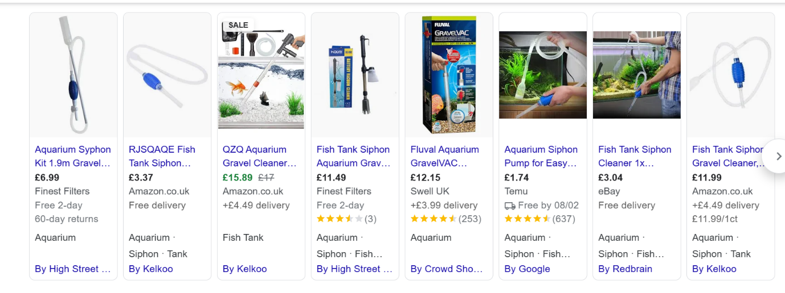

Struever, S. (1968). “Flotation Techniques for the Recovery of Small-Scale Archaeological Remains.”
Quite a dated paper from the USA on using two step Water flotation and then a chemical solution flotation technique. It is not clear whether this solution is a mixture of water and a chemical. I do not think that it is.
The initial water flotation is done in the field with adapted zinc tubs and using a local water source, i.e. a creek. The process is repeated several times and both the lighter material, and the heavier fraction are dried separately. The separated material is then taken to the lab where it undergoes a second flotation using a zinc chloride solution.
Zinc chloride is caustic, and any recovered material must be washed/rinsed in water. Not ideal for our purposes.
The article claims that this process is cheap, effective and processes large quantities of soil very quickly.

Fairbairn, A. (2005). “Simple bucket flotation and wet-sieving in the wet tropics.”
Discusses flotation and wet-sieving techniques for recovering material from archaeological deposits. Author claims that no single method is suitable for every archaeological site. Practice and experimentation are key.
Author discusses his experiences of using bucket flotation and wet-sieving in Papua New Guinea.
“Basic principles –
1) Sieve size determines what is retained for analysis, so set the sieve size slightly
smaller than the smallest objects you expect to find. Usually the flotation sieve
contains mesh of 0.25mm in diameter and wet-sieving uses a 1mm diameter mesh.
2) The smaller the mesh the greater chance you have of blocking the sieves and the
longer the flotation and wet-sieving will take
3) Flotation and wet-sieving produces at least two products: the floated fraction, hereafter
“flot” and the wet-sieve residue, hereafter “heavy residue”. You need adequate drying
space (trays, bags etc) and storage (bags) for these fractions and you also need to make
sure that all fractions are adequately labelled. In addition, if the heavy residue is sorted
in the field into different fractions, many bags of finds will be produced. Careful
recording of these bags is recommended and correct labelling is essential.
4) Drying the flot and heavy residue is important, as wet material will grow fungus and,
in the case of charred plant remains, makes them very fragile. As the tropics are very
humid and prone to extended periods of rain, drying is not easily achieved and has to
be planned carefully.
5) Take care not to mix the soil sample, flot and heavy residues of different samples.
Mixing reduces or negates the usefulness of samples. This is an obvious thing to say,
but it is easier than you may think to mix samples or their products together during
processing.
6) This process is very labour intensive and can, if done carelessly, cause damage to back
muscles. Take time in planning the location of your processing area to minimise the
risk of back pain.”
Author discusses equipment used and explains how to make flotation bags. He also provides examples of paperwork he uses to log and label each process. Interesting article which I am sure we could utilise. See below.

Requirements for 1 bag [Figure 18]:
1x 28cm x 28cm piece of 250μm (0.25mm) grade scientific mesh (a in Figures 1 and 2)
1x 45cm x 100cm piece of chiffon (nylon, very fine netting – b in Figures 1 and 2)
1x 130cm length of cord (c in Figure18, boxes 1 and 2) The square of scientific mesh a forms the base of the flotation bag. One of the long edges of
the chiffon b is sewn around the edge of the base mesh. In Figures 1 and 2 the folds y in the
chiffon correspond to the corners of a and x shows the attachment points. The seam between
a and b should overlap (Figure 18, box 3) and double sewn (dashed lines in Figure 3), with
the seam positioned on the outside of the bag (to the right of Figure 18, box 3), reducing the
places in which plant material can become caught. The two short edges of the chiffon z are
then sewn together, again with an overlapping seam. The free edge of the chiffon is folded
along line w and sewn to form a 2cm pocket along the edge of the bag. The end of this pocket
should be left open and the cord c can then be threaded into it (Figure 18, box 2). The
drawstring allows closure of the bag and can also be used to hang it up to dry.
Note that it is important to use synthetic material in the bags as cotton etc absorbs water and
takes longer to dry.

Figure 18. A pattern for making a flotation bag

Kidder, T.R. (1997) ‘Sugar Reflotation: An Alternative Method for Sorting Flotation-derived Heavy Fraction Samples’

This paper discusses the use of sugar to process heavy fractions as an alternative to using hazardous chemicals. Sugar increases the specific gravity of a solution. One gallon of tap water is mixed with 2.5lb sugar, approx. gravity of 1.11g/ml. This solution is capable of floating charcoal and seeds but is not dense enough to float bone, lithics or fired clay. Recovery rates were found to be between 96-100%.

This method is inexpensive, does not use harmful chemicals and achieves high rates of recovery. However, a major drawback is the risk of contaminating refloated samples so that they cannot be used for radiocarbon dating. Although this risk has not been fully assessed, the author does not use sugar-refloated samples for dating.

May be worth trying on a sample to assess results.

Ramenofsky, A.F. et al. (1986) ‘A New Technique for Separating Flotation Samples.’

Another dated article examines the use of a seed blower to separate small-scale archaeological samples. These devices are used by seed laboratories in the USA to test for seed quality and purity. Could it be adapted for use in archaeology?

There are various types of such blowers in the USA, with the one mentioned in this article being called the South Dakota seed blower. Air from a small electric motor is forced through a clear plastic cylinder. The cylinders have fine mesh screens at top and bottom. The bottom one holds the sample and the top one prevents loss of any blown material. There are two plastic debris traps that catch the material as it is forced through the cylinder. See diagram below.

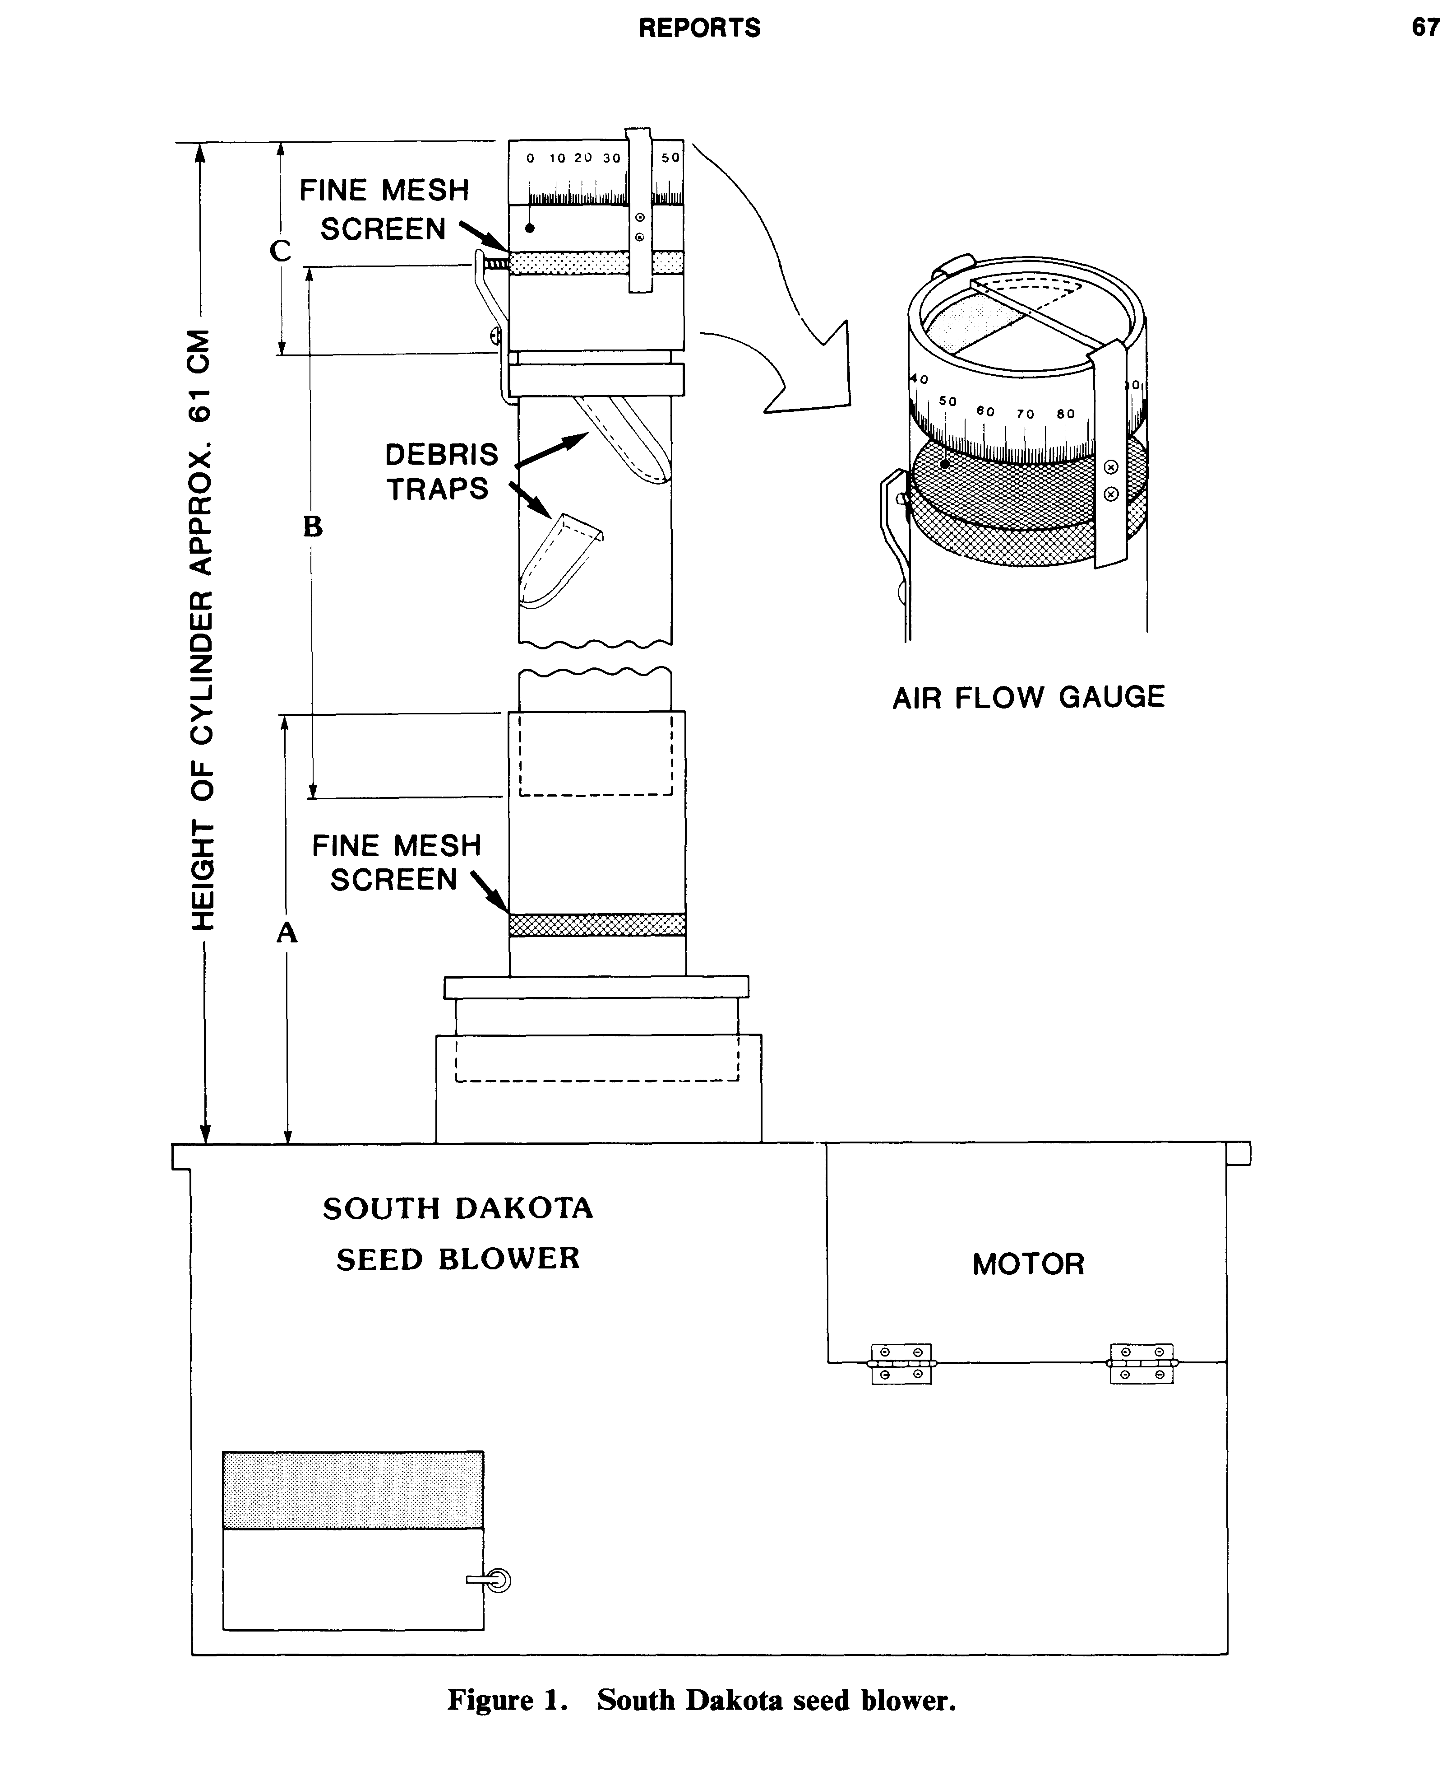
The authors present the blower as an alternative to standard water-flotation techniques. However, they then state that heavy clay samples had to be deflocculated before recovering debris. It does also appear as though the blower is used after an initial flotation using a weak sodium metahexaphosphate solution and screened through several fine sieves.

It seems a drawn-out process, and there is the use of chemicals. Hand separation is done after using the blower. There is also a risk of damage to samples.
Hunter, A.A. and Gassner, B.R. (1998) Evaluation of the Flote-Tech Machine-Assisted Flotation System.

“The Flote-Tech machine assisted flotation system uses water recirculation in a closed loop between a water reservoir and a flotation tank, aided by diffused air, to extract archaeological botanical remains from soil samples.” This paper is a critical review of two experiments conducted with this system to assess recovery rates and the potential for cross-contamination of samples.

The Flote0Tech system is a portable unit made of two 50-gallon water tanks, an electric water pump, hand operated diaphragm sludge pump and a hose spray, on wheels. It can be run in the field or in the laboratory. In the field an electric generator is used. During flotation water is circulated in a closed loop from the water reservoir through silt filters into the flotation tank and back into the reservoir. The rate of flow can be adjusted for efficient soil processing.

All materials carried to the surface during flotation are carried over a sluice into a light fraction tray. Once the light fraction is collected the heavier fraction can also be processed so that nothing is lost. Any sludge is removed from the bottom of the flotation tank by the sludge pump.

Soil sample poured into the main box in the flotation tank.

The experiments conducted by the authors identified that the Flote-Tech system works very well with excellent recovery rates. Using different mesh screens ensured all relevant material was recovered. There was no cross-contamination of samples.

This is once again a dated article, however the machine works well and is portable. Although 100 gallons of water is also needed to run the system. Is there a more modern and smaller machine available today? Could we build one? (See hybrid flotation tank built by Northern Illinois University below, and the following article by Shelton and White).

(Nguyen, Q. & Nguyen, D & Rouw, S. (2022). Portable Hybrid Flotation Tank)
Shelton, C.P. and White, C.E. (2010) The Hand-Pump Flotation System: A New Method for Archaeobotanical Recovery.

This paper discusses the use of an uncomplicated and cheaper flotation system using a hand pump. They concluded that with both financial and time constraints the construction of hand-pump flotation tanks proved to be easy to construct maintain and operate. They required only one person to operate the system. Although samples could not be processed as quickly as machine-powered systems, they demonstrated that all sizes of carbonised material were recovered down to the sub-millimetre level by employing a 250-micron light fraction mesh. It proved to be low impact system with then main problems being the cleaning of the sludge at the bottom of the tank at the end of each day and ensuring this was examined for any missed material.

Details of flotation tank. A) The ‘‘Whale Gusher Urchin’’ manual bilge pump, mounted on a
board across the second settling tank; B) The interior of the main tank, showing the water inflow pipe (centre), the wire insert
above it, and the inside of the outflow spout (top); C) The exterior of the main tank outflow spout and the supports for the
colander holding the light fraction mesh; D) Interior of the main tank outflow spout showing fastening bolts and washers;
E) Interior of the outflow spout of the first settling tank; F) Exterior of the first settling tank (upper left), showing outflow spout.

Materials needed to build included the below –

Parts list to construct the flotation tank used by the Sangro Valley Project.
Part Quantity Approximate total cost (U.S. dollars)
Main tank 1 20
Settling tanks 2 20
Bilge pump (Whale Gusher Urchin) 1 65
1 inch hose (poly or rubber) ca. 2 m 12
Elbow hosing connectors at least 8 12
Main tank flat wire support 1 free (scraps used)
Hooks for wire rack support 4–6 free (scraps used
Clothespins ca. 30 3
PVC spout for main tank (half pipe) 1 6
PVC spout for 1st settling tank 1 4
Waterproof bolts and washers ca. 8 of each 10 (for price per column)
1 1/461 inch Neoprene washers ca. 8 3
Flat neoprene sheet ca. 5 mm thick ca. 10610 cm 3
Metal supports for colander 2 free (scraps used)
Colander 1 3
Wooden board (pump support) 1 free (scrap used)
Screws for attaching pump to board 4 2
C-clamps for attaching support to tank 2–4 4–8
Wooden pallet and/or cement blocks – free (scavenged)
Heavy fraction screen (,1 mm) ca. 100 sq m 30
Sheer mesh (250 microns or less) ca. 10 sq m 20
Total: 217

Dimensions of the Sangro Valley Project flotation system. These measurements are exact for this flotation system, but should serve only as guidelines; there is flexibility possible.
Part Measurement (cm)
Diameter main tank (top) 48
Height main tank 65
Depth wire support (length metal hooks) 18
Diameter metal support 43
Length vertical interior hose 21
Length horizontal interior hose 16.5
Diameter settling tank 38
Depth main spout 6
Width main spout 10
Distance colander supports below spout 10
Distance from top of main tank to top of first settling tank 40
Distance between top of second and third settling tanks 11
Height settling tank 50
Height pallet 10
Height cinder block 25
Interior part of settling tank spout 4
Exterior part of settling tank spout 16.5
Diameter of settling tank spout 5
Length vertical pump intake hose 17
Length horizontal pump intake hose 1 5
Length horizontal pump intake hose 2 4
Length of body of pump 15
Length pump outflow hose 1 19
Length pump outflow hose 2 41
Length pump outflow hose 3 51

Further details of the Sangro Valley Project flotation tank. A) View from above of the outflow spout of the first settling
tank; B) View of the outflow spout of the first settling tank entering the second settling tank near the hand pump; C) View of the
backside of the tank (where the operator stands) showing the hoses connecting the outflow point of the pump back up to the
top of the main tank.

Chiou, K.L., Cook, A.G. and Hastorf, C.A. (2013) Flotation versus dry sieving archaeobotanical remains: A case history from the Middle Horizon southern coast of Peru.

This article compares the use of dry sieving and water flotation processes of sediments. The experiments were conducted in Peru and were of coastal desert dry soil samples. They concluded that although dry sieving of very dry soil samples is preferential and easier to conduct, a lot depends on the location and in particular the soil itself. Dry sandy soil goes through the sieves very quickly. Silt and clay soils do not break up as easily and will only go through a sieve with the use of water. Dry samples are also often not clean and can be difficult to identify in a sieving when hand picking samples, whereas wet samples are usually clean and more visible.

To get the best of both worlds they suggest the use of both systems, however this feels very time consuming, when in fact one system would be best suited. It all depends on the research question and the end goal. To recover the full range of taxa the water flotation system is best option, even of sandy sediments. This is particularly of value when the study of the landscape and how it has been utilised is required.

Veal, R. J. (2014). Protocols for the Collection, Identification and Interpretation of Archaeological Charcoal and Wood.

This article discusses the appropriate methods of collecting and interpreting charcoal samples. I found this article to be particularly valuable. It advocates the use of hand collection of samples, dry sieving and flotation of recovered soil samples. The appropriate methods should normally be agreed upon after a field assessment and a detailed research question applied.

The research is normally conducted for three specific purposes. C14 dating, Palaeo-environmental reconstruction and Economic reconstruction, i.e. wood use, forest management etc. Charcoal can be collected for all three purposes, but it will depend on the site, the time period and project goals.

The article goes into great detail on all three collection and interpretation techniques, or as the title states, ‘protocols. Rather than summarise here I recommend reading the whole article. I think this article will be a ‘go to’ for me when trying to decide on a methodology.

Veal, R. J., O’Donnell, L., McParland, L. (2011). Measuring burn temperatures from charcoal using the reflectance method, first results from an Irish Bronze Age cremation site.

In this further article by Veal, and others, they examine the technique of reflectance testing as a tool for establishing burn temperatures of charcoal. They briefly mention dry sieving samples in over 4 or 5mm mesh and /or flotation methods to obtain particles.

They discuss the method of crushing the charcoal and then mounting in either a cold set or a hot set epoxy resin blocks. The blocks are then ground and highly polished and inspected under oil and a reflecting microscope for their reflectivity. The results shows that the charcoal “does not always demonstrate the temperatures associated with the known cultural processes in question.” They therefor suggest using this technique in a selective manner with very careful interpretation.

Tsakiridou, M., Cunningham, L. and Hardiman, M. (2021) Toward a standardized procedure for charcoal analysis.

The authors discuss their examination of three chemicals that are be used for the analysis of archaeological charcoal. They also tested the chemicals on modern charcoal. This was done in an attempt to create a standardised procedure for charcoal analysis.

The chemicals used were Hydrogen peroxide, Sodium hypochlorite (Bleach) and Nitric acid.
They based the success of any evidence on the chemical treatment that had adequately disaggregating the sediment while leaving the charcoal particles intact. They found that clay-rich sediment broke down easily with all three chemicals, but that organic rich sediments were much harder to break down.

During the course of their experiment found that both Sodium hypochlorite and Nitric acid to have detrimental effects on the samples and suggest the use of Hydrogen peroxide, even though it is caustic, as the most effective treatment for digesting and bleaching resistant highly organic sediments.

Stevenson, J. & Haberle, S., (2018). Macro Charcoal Analysis: A modified technique by the Department of Archaeology and Natural History.

This analysis is designed by the authors to be “carried out on contiguously sampled sediments i.e. the whole core is able to be analysed.” As it mentions sampling cores I had a look at it.

Methodology – measure about 1-2cc wet sediment into a test tube or vial. Disperse in 5-10ml of Sodium Pyrophosphate, (usually used in food processing). Leave overnight. Stir if necessary.
Pour off supernatant after sediment settles. Re-suspend in very dilute Hydrogen Peroxide, (4-6% only). Leave overnight.
Wet sieve and store samples in water until analysed.
Microscope analysis or photograph in petri dish.

Seems a long drawn-out process if using a test tube. Could it work on larger samples. We already Hydrogen Peroxide, would we also need to use the Sodium Pyrophosphate? Its purpose being to remove humic acid and disaggregate the sediment.

Tolar, T. et al. (2010) Recovery techniques for waterlogged archaeological sediments: a comparison of different treatment methods for samples from Neolithic lake shore settlements.

This paper examines three methods for the investigation of botanical macro remains. They include 1. Rough wet sieving and then drying of the fractions. 2. Rough wet sieving and keeping fractions wet. 3. Washing over and keeping fractions wet.

The authors concluded that the third method of gentle washing over, systematic subsampling, examination and sorting while wet, using a -.355mm mesh sieve gave the best results. The first two methods gave a biased plant spectra result.

They further state that when using the gentle wash over technique many plant remains were very well preserved, as were fragile animal remains such as insects, molluscs coprolites and fish scales.

This sounds like a good one to try. No chemicals used, although they did mention that if samples are compacted and/or frozen then gentle thawing and same pre-treatment may be necessary.

Latkova, M and Hajnalova, M., (2014). Plant macro-remains from the palaeochannel sediments, trench B 2012.

The purpose of this paper is to analyse and evaluate plant macro-remains preserved by carbonisation and/or water logging, which were obtained during excavation.

Two extraction methods were used. In most cases the sediments were already saturated with water. Two flotation techniques were used, for each sample.

First to catch the light fractions they were processed in flotation tanks and collected. The remaining heavy fraction was then manually hand washed, and the artefacts removed by hand.

Sieves with a mesh size of 0.25mm were used for the flotation tank and manual wash over.

Dried flot was then examined under a microscope in the laboratory.

Ross, A. and Duffy, R. (2000) Fine mesh screening of midden material and the recovery of fish bone: The development of flotation and deflocculation techniques for an efficient and effective procedure.

This article is undoubtedly the best that I have read. It basically fulfils all of the criteria that our research requires. Inexpensive, non-harmful chemical extraction technique, with quick time results. It is well worth a read. (Link to document in Bibliography).

Basically, through various experimentation methods the authors conclude that the best and quickest method is an initial dry sieve of the material, (probably not necessary for us), followed by, for light fraction extraction the use of sugar in hot water flotation. Decant through a fish net to capture light fraction. Repeat. Wash with water and dry.

For the remaining heavy fraction, hot water with bicarbonate of soda to deflocculate with gentle stirring. Repeat until all material is clean. Wash and dry.

Some of the sugar and bicarb solutions can be reused a few times, no more than 3 times.

Authors claim it is quick, cheap and thorough. Their article is very comprehensive.

Discussion/Conclusion.

The above are a small sample of the papers that are available to help construct a reasonable methodology for the extraction of charcoal from soil sediment. Two of the main methods used are sieving, both dry and wet, and flotation. There are several machine flotation tank systems available. Some archaeologists construct their own home-made flotation systems. It seems to be one of the most preferred methods.

The use of chemicals is also widely accepted, including the use of Hydrogen peroxide, as we do now. However, to fulfil our research protocols, of an inexpensive method that does not use harmful chemicals but still produces good results, the last paper by Ross and Duffy appears to be the solution.

The table below taken from their document outlines their process. If I may, I would like to utilise this table as a potential methodology for our core sampling, or at least experiment using their technique to see what results we get.

Recipe” for chemical flotation and deflocculation procedure.
1. Dry sieve 100 g of residue through a 1 mm Endicott sieve before chemical flotation or deflocculation.
Presieving isolates the 1 mm fraction from very fine powdery sediments that would only
complicate the sorting process.
2. Dissolve 80 g of sugar in 400 ml of hot water in a 500 ml beaker. Gently stir the solution until the
sugar grains have completely dissolved.
3. Pour the sieved 100 g sample of residue into the sugar solution. Decant the solution through a fish
tank net to capture the light fraction. When the material in the heavy fraction approaches the
lip of the beaker, cease pouring. Catch the sugar solution in a second container and pour back
into the beaker.
4. Repeat step 3 three to four times to ensure that any charcoal or organic matter attached to the
side of the beaker is rinsed out.
5. Rinse the material caught in the fish tank net with water and lay it out to dry on paper towelling.
Keep the sugar solution in a separate container; this can be reused a further three times before
being replaced (i.e., sugar solution can be used on four 100 g samples).
6. Rinse the heavy fraction that is retained in the 500 ml beaker with water; then pour off as much
of the rinsing water as possible.
7. Combine 400 ml of hot water with 40 g of bicarbonate of soda in the beaker containing the heavy
fraction. The bicarbonate is added to deflocculate the soil aggregates. Very gently stir the solution
until all the bicarbonate has completely dissolved.
8. Carefully decant the majority of solution out of the beaker and into another container. Leave a
thin film of the bicarbonate solution covering the heavy fraction. Agitate the residue by rotating
the beaker in a circular motion for 30–50 s. The friction caused by fragments of residue (e.g.,
shell, bone, pebbles) combined with bicarbonate deflocculates the soil.
9. Pour the decanted bicarbonate solution back into the beaker. Repeat step 8 three or four times or
until it is visibly evident that most, if not all the soil aggregates have deflocculated. The shell
fragments should be clean and white.
10. Pour off the bicarbonate solution and thoroughly rinse the residue left in the beaker. Wash the
heavy fraction in a 1 mm sieve, rinsing thoroughly with tap water. Place the washed residue on
paper towelling to dry. Discard the bicarbonate solution.

Appendix B. Spreadsheet of results noted during deflocculation stage.
Beaker No. | Sample No. | Weight. | Technique. | Results. | Comment.
1A | 558-560 | 1.80g | H2O2 solution - 500ml water + 60ml H2O2 (12% mix) | Flots and Heavy sediment. | Possibly solution to weak, leave overnight and use hot water.
1B. | 558-560 | 2-22g | a. Sugar solution, followed by  b. bicarbonate of soda solution. | a. small amount of flots.  b. not fully deflocculated. | Bicarbonate/Sugar solution did not fully dissolve.  Use HOT water and leave for longer.
2A | 500-502 | 2.33g | a. Sugar solution, followed by  b. bicarbonate of soda solution. | a. Very little flots, just a few small bits  b. very little flots after 5 hours. | NB. Hotter water dissolved sugar better.
2B | 500-502 | 2.14g | H2O2 solution (Hot water) | Good flocculation.
3A | 605-607 | 2.07g | a. Sugar solution (400ml water + 80g sugar).  B. bicarbonate soda solution | Negative result. No flocculation seen. Very clay near till, so could be due to the lack of organic remains in sediment. | NO FLOTS. Flocculation difficult to judge.
3B | 605-607 | 3.20g  incl. large stone. | H2Os solution - 400lm Hot water  + 80ml H2O2. | Slightly more flots - although very small  amount of organics. | Small amount of flots and heavy fraction. Did not expect much  due to sample type.
4A | 456-458 | 0.76g | a. Sugar solution.  b. bicarbonate solution. | a. Very little flots, just a few small particles  b. No flots.
4B | 456-458 | 1g. | H2O2 solution - 400ml water +  80ml of H2O2. | Skim on surface of solution and good flots. | Solution colour dark yellow like strong urine colour.  H2O2 bleaching soil.
5Ai | CONTROL  BH/4 1.80m | 23.99g | a. Sugar solution.  b. bicarbonate solution. | No flots at all, clay soil still solid.  After bicarbonate appears to be separation. | This is a very heavy clay soil.
5Bi | CONTROL | 23.88g | H2O2 solution. | A bit sticky?
6A | 337-339 | 3.94g | a. Sugar solution.  b. bicarbonate solution. | Very few small particles but good separation. | Good separation. Result similar to H2O2.  This may be down to the sediment type.
6B | 337-339 | 3.40g | H2O2 solution. | Flots and separated heavy fraction. | Good result.
7A | 217-219 | 3g. | Skip sugar straight to bicarbonate  solution. | No Flots. Not good separation.
7B | 217-219 | 2.80g. | H2O2 solution. | No Flots. Not good separation. Is it the sediment.
8A | 274-276 | 2.03g | Bicarbonate solution only. | Very few flots - some small flecks. Very little separation.
8B | 274-276 | 3.11g. | H2O2 solution. | Flots. Good separation.
9A | 595-597 | 3.35g. | Bicarbonate solution - 400ml hot water + 43g bicarb. | No flots- just small flecks.
9B | 595-597 | 3.06g. | H2O2 solution, 400ml hot water +  80ml H2O2. | No flots. | Bleaching of sample.
10A | 404-406 | 2.09g | 120ml undiluted distilled malt  vinegar. | No flots, sediment appears dispersed  but still clumped. Can be broken up  with glass rod.
10B | 404-406 | 1.51g | 400ml hot water and 40g Sodium  hexametaphosphate. | No flots. Sample appears dispersed, but  still has small clumps.
11 | 237-239 | 4.18g | 200ml hot water and 40.11g  sodium hexametaphosphate. | No flots.  H/F appears lumpy although some evidence of separation. | During the dissolving in water, sodium bonded and had to be agitated for some time to dissolve completely.
how other industries conduct soil deflocculation.
It

Appendix C. Microscope analysis of dried samples.
Sample No. | Result.
1A H2O2 (error with labelling) | Partial separation, some lumps of peat. Insect case and coral.
1B Sugar (error with labelling) | Some undissolved sugar. Lumpy sediment.
2A Bicarb sol | Partial separation, with large lumps of peat. Charcoal visible.
2A Sugar. Flots | Some small bits of charcoal. (Chiffon sieve used).
2B H2O2 Flots | Good separation, some charcoal. Bleaching of sediment.
2B H2O2 H/F | Good separation. Bleaching. No charcoal seen.
3A Bicarb H/F | Good separation. Some small charcoal pieces.
3B H2O2 Flots | Small amount of light organic material. (Chiffon sieve used). Charcoal.
3B H2O2 H/F | Good separation. Possible bleaching. No charcoal seen.
4A Sugar. Flots | Many small fragments of charcoal. Good result. (Chiffon sieve used)
4A Bicarb. H/F | Partial separation, some lumpy bits. Charcoal. (Ash, this was dried in oven first before sampling).
4B H2O2 Flots | Good separation, Bleaching. Few small fragments of charcoal.
4B H2O2 H/F | Good separation. Bleaching. One small piece of charcoal.
5Ai Bicarb. H/F | Partial separation with clumpy bits. Very crystalline sediment. Some small piece of charcoal. (Black leaf or tooth?)
5Bi H2O2. H/F | One large solid mass and several smaller pieces as if bound together, like a sediment skim. Some small charcoal piece seen.
6A Sugar, Flots | Very small organic particles. (Chiffon sieve used).
6A Bicarb. H/F | Good separation. Sany sediment. Large amount of shell fragments and several pieces of charcoal.
6B H2O2 Flots | Very few fragments, some charcoal.
6B H2O2. H/F | Good separation of sandy sediment. Large amount of shell fragments, some small pieces of charcoal.
7A Bicarb. H/F | Partial separation, with large clumps which are rock hard. Numerous shell fragments.
7B H2O2 H/F | Partial separation, some very hard clumpy pieces. Shell fragments. No charcoal.
8A Bicarb. H/F | Partial separation. Several clumpy bits solidified. Charcoal pieces. Some shell fragments.
8B H2O2 Flots | Some very fine organic fragments, bleached. No charcoal.
8B H2O2 H/F | Partial separation and a few clumps. Bleached. No charcoal.
9A Bicarb H/F | Good partial separation, some clumpy bits easily broken up. Some small pieces of charcoal. Poss bleaching?
9B H2O2 H/F | Good separation, fine granular sediment. Bleached. No charcoal.
10A Vinegar H/F | Partial separation with some clumpy bits that break up easily. Some pieces of charcoal.
10B Sodium hexametaphosphate | Good separation of granular sediment. Charcoal clearly visible.
11 Sodium hexametaphosphate | Poor separation. Very clumpy bits which were hard to break up. Some charcoal visible but not cleaned very well.

