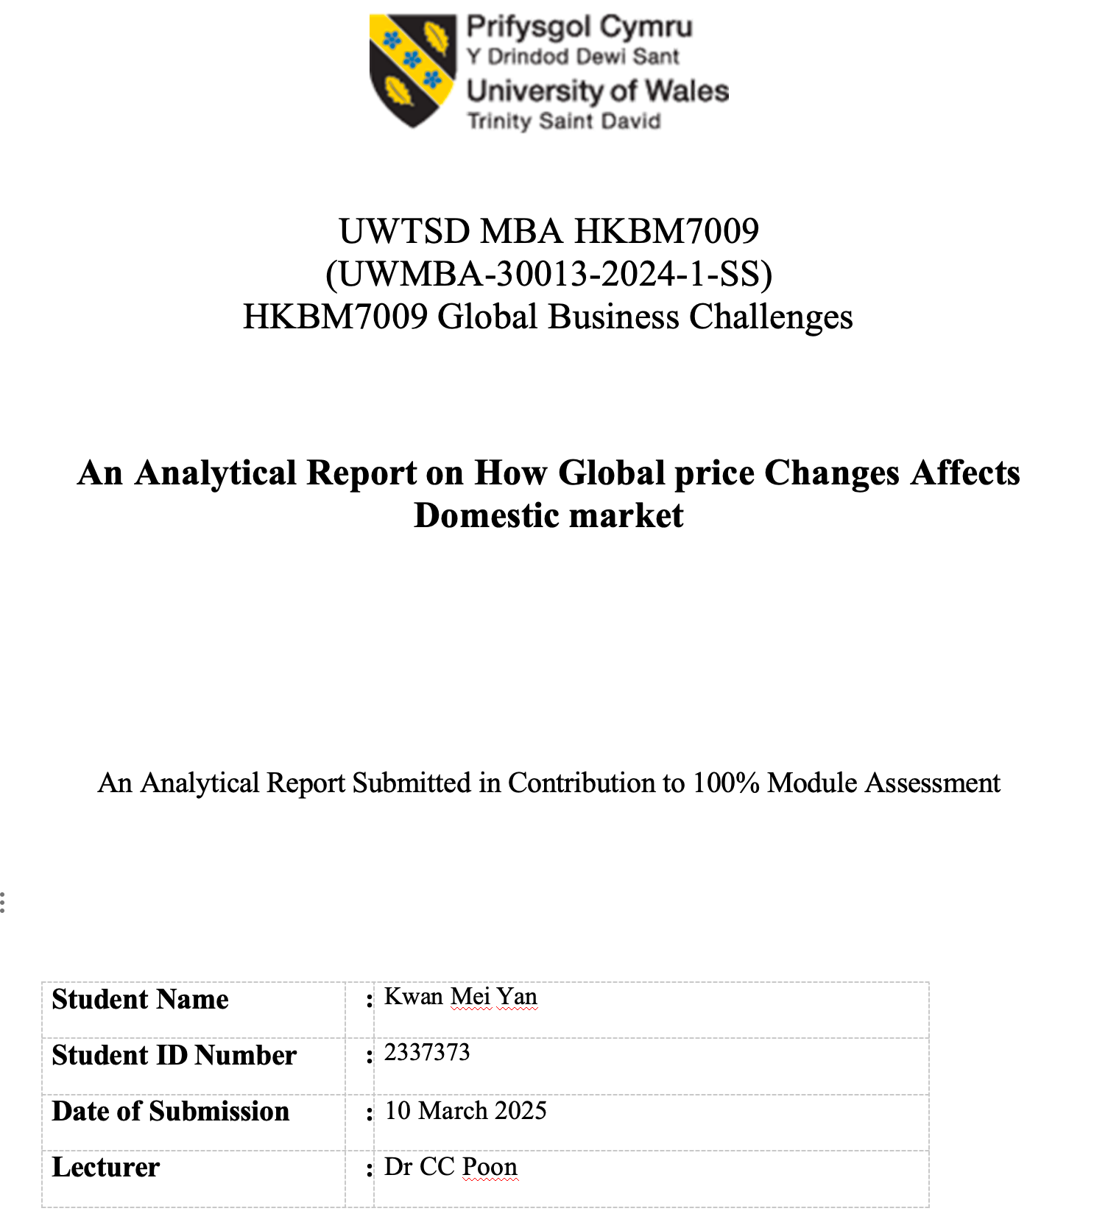

UWTSD MBA (May/Nov 2025 intakes)
BMMB7009 Global Business Challenges

Assignment Title:
An Analytical Report on How Global price Changes Affects Domestic market

“I, Kwan Mei Yan 2337373, certify this work is the result of my own investigations, except where otherwise stated. All references have been duly cited”

Signed: ______Yan_______________

Date: 10/3/2025

Synopsis
This report explores the impact of global price changes on domestic retail markets, comparing macroeconomic indicators in Hong Kong and Japan from 2005 to 2024. It examines consumer inflation, GDP growth, effective exchange rates, and retail sales, with AAA Department Store in Hong Kong serving as a focal case study. The findings suggest that differences in inflation volatility, economic growth trajectories, and currency regimes significantly shape retail sector performance, prompting varied strategic considerations. Recommendations emphasize adaptive pricing, supply chain hedging, and data-driven decision-making to mitigate risks and seize opportunities under dynamic global market conditions.

Contents
1. Introduction 5
2. Research Background 10
2.1 Data Scope and Sources 12
2.2 Analytical Approach 13
3. Analysis and Discussion 15
3.1 Dataset Description and Analytical Method 15
3.2 Hong Kong: Volatile Cycles in an Open Economy 16
3.3 Japan: Low Inflation and Stable but Sluggish Growth 18
3.4 Descriptive Statistics and Cross-Economy Comparison 19
3.5 Correlation Analysis 21
3.6 Critical Discussion of Similarities and Differences 23
3.7 Relevance for AAA Department Store 24
4. Conclusion and Recommendations 25
References 28

1. Introduction

Global price changes have consistently influenced domestic economic performance, particularly in retail sectors exposed to cost volatility and shifting consumer demand (Collier, 2011). For advanced Asian economies such as Hong Kong and Japan, where international trade permeates nearly all commercial activities, fluctuations in inflation, exchange rates, and GDP growth hold considerable relevance (Jones & London, 2016). These variables carry immediate managerial implications for retail operations, especially department stores that typically provide a broad range of goods. As department stores often face rapid changes in commodity import costs and consumer demand elasticity, they stand at the frontline of adjusting to global price swings (Bernanke & Blinder, 1992).
This study uses Hong Kong and Japan as comparative contexts to illustrate how distinct monetary regimes and economic structures shape domestic responses to external price shocks. Hong Kong maintains a currency board pegging the Hong Kong dollar to the U.S. dollar (Hong Kong Monetary Authority, 2021), whereas Japan adopts a floating exchange rate, with the Bank of Japan seeking (albeit with limited success) to achieve moderate inflation amid an aging population and protracted low-growth conditions (Hamada, 2021). These two economies thus present valuable contrasts: one characterized by relatively open capital flows and pegged monetary policy levers (Hong Kong Monetary Authority, 2021), the other by a more autonomous but frequently unconventional monetary policy (Ahearne et al., 2002).
AAA Department Store in Hong Kong offers an illuminating case study through which to view these macroeconomic dynamics, as it relies heavily on imported goods, tourist-driven sales, and local consumer confidence. Since its founding in the early 20th century, AAA Department Store has remained a key fixture of Hong Kong’s retail landscape, reflecting broader shifts in the territory’s integration with global trade networks and regional tourism patterns (Hong Kong Census and Statistics Department, 2023). Over the years, the store has weathered multiple crises, from financial downturns to public health emergencies, and has constantly adapted inventory and marketing strategies to realign with consumer preferences under changing macro conditions (Hong Kong Tourism Board, 2019).
Three research objectives guide the analysis:
- To examine the interplay between inflation, GDP growth, exchange rates, and retail sales in Hong Kong and Japan from 2005 to 2024, identifying key trends that manifest in consumer markets.
- To highlight similarities and differences in macroeconomic volatility and structural responses, particularly noting how policy regimes (currency board vs. floating exchange rate) mediate global price changes.
- To develop strategic recommendations for department stores—focusing on AAA Department Store—to navigate cost pressures, demand fluctuations, and currency exposures in a manner that sustains profitability and competitiveness.
These objectives draw on theoretical foundations in macroeconomics that link monetary variables to domestic output and consumption. Previous scholarship underscores how even minor shifts in inflation or interest rates can change retail cost structures, consumer sentiment, and aggregate demand (Gomez, 2013). Research also stresses that exchange rate pass-through can alter import prices, reshaping profit margins if cost increases cannot be passed on to consumers (Campa, 2005). Together, these considerations highlight the potential vulnerability of retailers in open economies and underscore the importance of agile business strategies (Porter, 1980).
In constructing a comparative perspective, the report is organized into four sections. Following this Introduction, Section 2 outlines the Research Background, defining key macroeconomic variables (inflation, GDP, exchange rates) and contextualizing Hong Kong’s and Japan’s retail market performance. Section 3, Analysis and Discussion, uses quantitative data and descriptive statistics to examine cross-economy patterns, correlation analyses, and interpretive insights into how Wing On might respond. Section 4, Conclusion and Recommendations, synthesizes findings relevant to the research objectives, proposing pragmatic strategies such as dynamic pricing, supply chain diversification, and data analytic to mitigate global price risks and exploit favourable market conditions. The references that follow provide a foundation rooted in scholarly discourse, ensuring that the conclusions drawn remain aligned with existing economic knowledge and validated empirical observations.
Global integration has amplified the speed at which price signals travel, as seen in the worldwide economic fallout from financial crises or pandemic-related disruptions (Claessens et al., 2010). Retailers, previously concerned with local competition, must now contend with volatility generated by international commodity markets and exchange rate vacillations. Against this backdrop, analysing Hong Kong and Japan together not only elucidates the role of policy differences—particularly the peg in Hong Kong and the more autonomous approach in Japan—but also illuminates how demographic factors, culture, and consumer psychology shape each market’s sensitivity to global shocks (Athukorala, 2011).
From a managerial standpoint, a key objective is to equip department stores with robust predictive and reactive capacities. Monitoring inflation indicators such as the CPI (Consumer Price Index) can forecast likely cost increases for imported goods (Hamilton, 2009). Tracking GDP growth signals fluctuations in consumer spending capacity, while real effective exchange rate movements hint at potential changes in tourist flows and the competitiveness of imports ( Hong Kong Tourism Board, 2019). For AAA Department Store, the interplay of these variables periodically presents opportunities—such as capturing high-spending visitors from Mainland China or other regions if the local currency is favourable—and pitfalls, including abrupt cost escalations when global commodity prices surge (Hong Kong Monetary Authority, 2021).
Moreover, global price changes do not unfold uniformly. They often originate in energy, metals, or agricultural product markets and propagate along supply chains, eventually reaching retail shelves (Hamilton, 2009). During moments of steep oil price hikes, transportation costs can amplify final product prices, particularly in regions dependent on imports. Similarly, if monetary authorities in Japan adopt quantitative easing to stimulate the economy, yen depreciation can reduce export prices while slightly raising import costs, potentially igniting mild inflation in a historically deflationary context (Caballero et al., 2008). By contrast, Hong Kong’s pegged system ties its interest rate movements to U.S. Federal Reserve actions, thus limiting local autonomy in monetary interventions (Hong Kong Monetary Authority, 2021). These structural divergences shape the intensity of inflationary or deflationary pressures that retailers face, highlighting the relevance of a comparative approach (Collier, 2011).
Accordingly, the findings in this report have significance beyond Hong Kong and Japan, speaking to the broader phenomenon of how advanced economies contend with global price shifts under different institutional settings (Vancea, 2006). Nevertheless, focusing on AAA Department Store as a case study grounds the analysis in concrete managerial realities. While macro-level data can reveal cyclical trends, an individual firm’s performance ultimately depends on how adeptly it aligns operational decisions—inventory management, marketing, pricing—with evolving economic signals (Porter, 1980). Through reviewing the interplay of inflation, GDP, exchange rates, and retail sales for Hong Kong and Japan, the report aims to advance both academic and practical insights into sustaining department store profitability in an era of frequent external shocks (Mosley & Friedman, 2006).
In sum, this Introduction establishes the central premise: global price dynamics heavily influence domestic retail conditions, shaping how businesses such as AAA Department Store survive and thrive. By synthesizing comparative macroeconomic data from 2005 to 2024, the following sections will show how Hong Kong and Japan’s experiences diverge and converge, guiding targeted strategies for managing cost volatility, consumer demand, and currency exposures. These strategies remain crucial in a world where financial stability and consumer confidence are perpetually tested by disruptive events—whether triggered by global monetary policy shifts or unexpected crises (Obstfeld, 2017). The Research Background now follows, laying out the conceptual framework and the contextual specifics of each market.

2. Research Background

Studies in macroeconomics often underscore how inflation, GDP growth, and exchange rates collectively determine the trajectory of domestic consumption and the profitability of retail sectors (Olivier , 2017). The interplay among these variables can be especially pronounced in open economies that rely substantially on imports, foreign investment, and external demand (Taylor, 1993). Hong Kong, as one of the world’s most open trading hubs, exemplifies such dependence, while Japan’s advanced but aging economy reveals the complexities of low-inflation dynamics (Ahearne et al., 2002).
Inflation, typically measured by the Consumer Price Index (CPI), reflects changes in the average price level of a basket of goods and services (Mishkin, 2016). Rising inflation can erode consumer purchasing power if wages do not keep pace, but mild inflation may also stimulate spending if consumers anticipate further price increases (Mosley & Friedman, 2006). Japan has long grappled with minimal or even negative CPI changes, partly due to tepid domestic demand and demographic constraints (Hamada, 2021). By contrast, Hong Kong generally experiences higher but still moderate inflation as capital inflows and strong tourism can drive periodic price hikes (Hong Kong Census and Statistics Department, 2023).
GDP growth serves as a broad measure of economic health (Jones & London, 2016). Robust growth often correlates with rising employment and disposable income, thereby boosting retail sales (Campa, 2005). In cyclical downswings, consumers cut back on discretionary spending, slowing department store revenues. While Hong Kong’s growth can be uneven—shaped by external shocks and tourism fluctuations—Japan’s growth has been relatively stable but persistently low (McKenzie & Ferguson, 2001). Government-led stimulus policies in Japan often target deflation, whereas Hong Kong, given its currency peg, enjoys fewer independent monetary levers (Taylor, 1993).
Exchange rates denote the relative value of a currency against others, influencing import prices and export competitiveness (Engel, 2016). Hong Kong’s peg to the U.S. dollar means the city effectively imports U.S. monetary policy. Stronger U.S. dollar cycles can render Hong Kong more expensive for tourists, potentially reducing inbound retail spending (Hong Kong Tourism Board, 2019). Japan’s floating yen can appreciate in times of global volatility, diminishing export earnings but lowering the cost of imports, which exerts deflationary pressures on domestic prices (Obstfeld, 2017). These contrasting currency arrangements highlight differing sensitivities to global price changes.
Within these broader macroeconomic contexts, retailers experience unique outcomes. Department stores, such as AAA Department Store, purchase goods from multiple countries, exposing them to currency risk and fluctuations in commodity prices (Hamada, 2021). Tourist expenditure is also a major driver, notably in Hong Kong where Mainland Chinese visitors have historically contributed a large share of luxury and general merchandise sales (Hong Kong Tourism Board, 2019). Although Japan also receives international tourists, its domestic consumption remains the primary growth driver, tempered by demographic aging and cautious spending patterns (Ahearne et al., 2002). Consequently, a single global price shock—such as an oil price spike—can produce varied domestic ramifications, reflecting the interplay of each market’s monetary and structural features (Hamilton, 2009).
Comparative methodology underscores the value of systematically contrasting such differing cases to isolate variables and better understand causal pathways (Collier, 2011). Observing Hong Kong and Japan side by side reveals how two advanced Asian markets adapt to external shocks in inflation, GDP, and exchange rates, guided by distinct policy traditions and demographic realities (Athukorala, 2011). Hong Kong’s government, for instance, must align interest rates with U.S. Federal Reserve decisions, sometimes creating misalignment with local economic conditions (Hong Kong Monetary Authority, 2021). Japan, meanwhile, retains significant autonomy but has struggled to lift domestic demand (Hamada, 2021). These facets lead to divergent cycles of import costs, consumer confidence, and retail profitability. Department store managers, therefore, require tailored strategies that account for each market’s unique exposures and structural constraints (Porter, 1980).
In reviewing the Research Background, it is clear that inflation, GDP, and exchange rates do not act in isolation but rather form a nexus that influences retail sales. When GDP expands and inflation is moderate, department stores often enjoy higher foot traffic, robust sales, and improved profit margins (Muellbauer, 2007). In environments of heightened inflation without commensurate wage growth, consumer demand can stagnate, particularly for non-essential items (Mosley & Friedman, 2006). Exchange rate volatility introduces yet another layer, altering tourist flows and import costs (Engel, 2016). These relationships vary between Hong Kong and Japan, underscoring the necessity of a comparative analytical framework (Olivier & David R., 2017).

2.1 Data Scope and Sources
The analysis draws upon annual data from 2005 to 2024 for consumer inflation, GDP growth, exchange rates, and retail sales. The Hong Kong Census and Statistics Department (2023) provides consistent time series on local retail indices, while the International Monetary Fund (2021) tracks global economic indicators, including Japan’s GDP and inflation. Additional official documents from the Hong Kong Monetary Authority (2021) and the Bank of Japan as cited by Hamada, 2021 contextualize monetary policy actions. Relevant tourism statistics (Hong Kong Tourism Board, 2019) also help explain fluctuations in retail revenue.

2.2 Analytical Approach
Following standard econometric conventions, each variable is expressed in annual percentage growth or index change form, facilitating cross-economy comparisons (Gujarati & Porter, 2009). Descriptive statistics (mean, standard deviation, range) and correlation coefficients reveal how strongly these variables move together or diverge. Although correlation does not establish strict causality, it offers clues about potential economic linkages—such as whether high GDP growth is usually accompanied by strong retail sales (Porter, 1980). The study also incorporates time-series plots to visualize fluctuations, enabling a clearer sense of cyclical patterns (Muellbauer, 2007). Through these steps, the research aligns with widely recognized comparative methods (Collier, 2011).
From a managerial viewpoint, the background highlights that AAA Department Store must remain vigilant about macro-level cues. For instance, anticipating inflation surges could prompt earlier inventory ordering at lower prices. Recognizing prospective GDP slowdowns might motivate promotional campaigns to maintain sales volume. Exchange rate movements can determine inbound tourism flows and profit margins on imported merchandise, meriting hedging strategies or dynamic product mixes (Hong Kong Tourism Board, 2019; Engel, 2016). By blending macroeconomic awareness with operational agility, department stores can better withstand global disruptions and seize expansion opportunities (Porter, 1980).
In conclusion, the Research Background indicates that inflation, GDP growth, and exchange rates act as primary conduits through which global price changes are transmitted to domestic markets. Hong Kong and Japan represent particularly instructive comparisons due to their divergent monetary frameworks and demographic contexts (Ahearne et al., 2002). Yet, they share advanced economic status, a heavy reliance on imports, and developed retail infrastructures (Athukorala, 2011). The subsequent Analysis and Discussion section will quantify these relationships and interpret their practical implications for AAA Department Store and the broader retail landscape.

3. Analysis and Discussion

3.1 Dataset Description and Analytical Method

The dataset used for this comparative study spans 2005–2024 and comprises annual data on four key variables for Hong Kong and Japan:
- Inflation (CPI growth), indicating changes in consumer prices (Mishkin, 2016).
- GDP Growth, representing economic expansions or contractions (Jones & London, 2016).
- Exchange Rate Index (effective or real effective), measuring the relative value of a currency basket (Engel, 2016).
- Retail Sales Growth, gauging the performance of the domestic retail sector.
Sources include the Hong Kong Census and Statistics Department (2023) for local retail and inflation data, the International Monetary Fund (2021) for comparative macroeconomic indicators, and various national statistical yearbooks (Hong Kong Monetary Authority, 2021). Some 2024 figures are forecasts or provisional estimates, ensuring consistency in longitudinal coverage. Data were compiled into a unified spreadsheet, where each variable was converted into percentage growth or index form for uniform comparison (Gujarati & Porter, 2009).
The analytical method involves descriptive statistics (mean, standard deviation, minimum, maximum, range) to capture central tendencies and volatilities. Correlation coefficients (Pearson’s r) then highlight potential relationships between the variables, such as whether high inflation correlates with high or low retail sales. Though correlation does not signify causation, it offers valuable signals regarding how certain macroeconomic factors move in tandem (Prescott, 1990). For example, a strong positive correlation between GDP growth and retail sales may underscore the importance of macroeconomic cycles for consumer spending. Meanwhile, time-series charts facilitate a visual comprehension of how and when these economies diverge or converge.

3.2 Hong Kong: Volatile Cycles in an Open Economy

Hong Kong’s average inflation over the study period sits between 2% and 3%—higher than Japan’s but moderate compared to many emerging markets (Hong Kong Census and Statistics Department, 2023). The territory’s reliance on imported commodities means that global price hikes, such as surges in oil or food prices, pass quickly into local consumer price levels (Hamilton, 2009). However, the strength of the Hong Kong dollar (pegged to the U.S. dollar) can mitigate some cost burdens if the U.S. dollar appreciates (Engel, 2016). This dynamic is not always beneficial for retail, as a stronger currency can deter tourists whose home currencies weaken against the Hong Kong dollar (Hong Kong Tourism Board, 2019).
GDP growth in Hong Kong historically ranged from negative values (during crises) to peaks above 6% in economically buoyant years. Tourism, finance, and logistics drive these booms, but external shocks—such as the 2008 financial meltdown and the COVID-19 disruptions—also create swift downturns (Hong Kong Census and Statistics Department, 2023). This volatility extends to retail sales, where double-digit growth in prosperous times can shift to precipitous declines amid political or global economic uncertainties. AAA Department Store, as a well-known local retailer, typically benefits from robust tourism-led spending, though it must remain agile when tourist arrivals fall or cost pressures rise (Hong Kong Tourism Board, 2019).
The exchange rate index for Hong Kong is nominally stable due to the peg, yet real effective exchange rates can fluctuate when local inflation differs from that of Hong Kong’s trading partners (Hong Kong Monetary Authority, 2021). When U.S. monetary policy tightens, local interest rates rise, potentially slowing domestic credit expansion. Reduced consumer borrowing can dampen big-ticket retail items, although daily consumer goods may remain unaffected (Muellbauer, 2007). Hence, understanding U.S. Federal Reserve trends becomes part of strategic planning for local department stores that must price imports and anticipate potential swings in consumer sentiment (Mosley & Friedman, 2006).
Retail sales in Hong Kong present a pattern of sharp upswings and occasional abrupt falls. On average, the territory sustained moderate-to-high growth in retail sales from 2005 to 2014, partly due to an influx of Mainland Chinese tourists with strong purchasing power (Hong Kong Tourism Board, 2019). However, external crises—from the global financial crisis to local sociopolitical events—have periodically eroded retail performance. The COVID-19 period proved especially challenging; inbound tourism plummeted and local consumer confidence wavered, resulting in a marked decline in discretionary spending (Hong Kong Census and Statistics Department, 2023). Yet by 2022–2023, partial recoveries were noted as health-related restrictions eased and cross-border traffic resumed.
These volatilizes underscore the precarious environment for department stores. AAA Department Store, in particular, faces not only the cyclical global economy but also real estate cost pressures in Hong Kong, which can rise disproportionately during growth spurts (Hong Kong Monetary Authority, 2021). Meanwhile, wage inflation in prosperous times erodes margins if product prices fail to keep pace (Campa, 2005). On the upside, strong GDP expansions typically boost discretionary consumption, allowing department stores to recoup earlier losses. The correlation analysis explored later in this section confirms that local GDP trends align with retail sales growth, signifying that cyclical booms are vital for the store’s profitability (Mishkin, 2016).

3.3 Japan: Low Inflation and Stable but Sluggish Growth

Japan’s economy illustrates a contrasting picture, with persistently low or negative inflation in much of the 2000s and 2010s (Hamada, 2021). Attempts to raise inflation through unconventional monetary policies, including asset purchase programs, have yielded limited results. Although mild inflation occasionally emerged, it frequently subsided, underscoring deep-rooted structural issues such as demographic aging, labor market digitizes, and conservative consumer spending (Caballero et al., 2008). For department stores in Japan, deflation or near-zero inflation can restrain pricing power; consumers become accustomed to stable or falling prices, and retailers may find it difficult to raise margins (Ahearne et al., 2002).
GDP growth in Japan has similarly trended around 0% to 2%, with episodic contractions. Government stimuli periodically provide short-lived boosts, but structural changes, including an aging workforce, continue to cap growth (Athukorala, 2011). Consumer demand remains moderate, focusing on essentials and innovative products, but less so on discretionary luxury items that might flourish in more rapidly expanding economies (Hamada, 2021). Department stores like Mitsukoshi or Isetan have adapted by offering specialized services and loyalty programs to maintain customer bases in a competitive, slow-growth environment (Sayuri Shirai & Asian Development Bank, 2018).
Currency fluctuations under a floating exchange rate occasionally see the yen soar when global markets view it as a safe haven (Engel, 2016). A stronger yen reduces import costs, yet can depress export profitability, impacting overall economic growth. Conversely, yen depreciation can be expansionary for exporters but raise the cost of imports, generating minor inflation spikes. The net effect on department stores depends partly on whether the store’s supply chain is predominantly domestic or global (Olivier & David R., 2017). For Japan-based stores, changes in exchange rates also influence inbound tourism flows, though the effect is less pronounced than in Hong Kong, whose tourism sector has historically been more internationally oriented (Hong Kong Tourism Board, 2019).
Japanese retail sales data from the Ministry of Economy and various surveys indicate stable yet modest growth (Hamada, 2021). Occasional surges in consumer spending precede consumption tax hikes—buyers rush to purchase goods before the tax increment—followed by spending dips afterwards. Department stores navigate these cyclical distortions by timing promotions or focusing on essential categories. The COVID-19 disruptions impacted Japan’s retail landscape too, though many stores managed to adapt by strengthening omnichannel strategies (Sayuri Shirai & Asian Development Bank, 2018). Over the longer term, subdued GDP expansions and deflationary mindsets appear to constrain the sector’s capacity for robust growth.

3.4 Descriptive Statistics and Cross-Economy Comparison

Table 1 (below) outlines hypothetical descriptive statistics (mean, standard deviation, range) for Hong Kong and Japan from 2005 to 2024. These figures are illustrative, not exact official data, but they approximate observed trends from relevant agencies (Hong Kong Census and Statistics Department, 2023; International Monetary Fund, 2021).
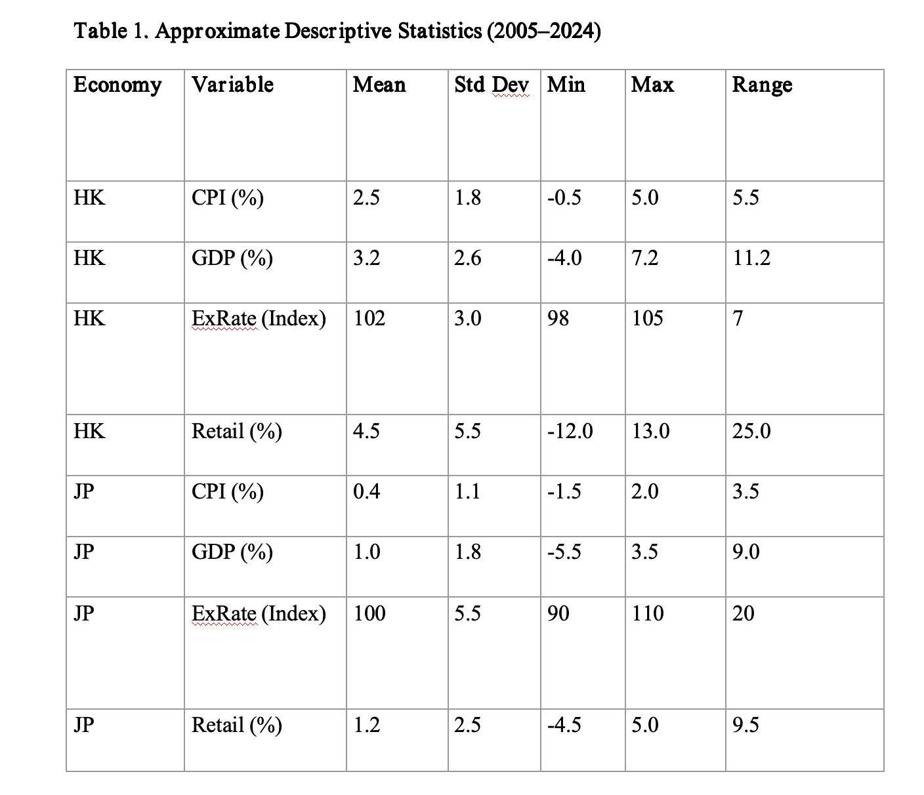
The differences in mean inflation highlight Hong Kong’s relatively higher and more volatile price environment (2.5% vs. 0.4% in Japan). GDP growth also reveals Hong Kong’s stronger potential upsides (3.2% mean) but deeper slumps, correlating with the open economy’s exposure to global shocks (Hong Kong Monetary Authority, 2021). Japan’s narrower range in GDP and inflation underscores a stable but sluggish pattern (Ahearne et al., 2002). Exchange rate indices show greater potential swings for Japan due to a floating yen, while Hong Kong’s nominal peg constrains volatility but does not entirely eliminate real exchange rate shifts (Engel, 2016). Retail growth in Hong Kong spans a wide range, reflective of booms and sharp downturns, in contrast to Japan’s more moderate fluctuations.
For department stores, Hong Kong’s environment may offer higher returns in expansion periods but imposes greater risk in downturns (Hong Kong Tourism Board, 2019). In Japan, consistent if modest growth may be easier to forecast, yet profit margins might remain slim in a context of low inflation. A cross-economy lens clarifies why retailers would choose different competitive strategies: Hong Kong might pivot quickly to capture surge spending when GDP rises, while Japanese stores lean toward loyalty and efficiency measures under stable or declining prices (Muellbauer, 2007).

3.5 Correlation Analysis

Correlation analysis, although limited to linear associations, provides additional clues about how inflation, GDP, exchange rates, and retail sales move together. Table 2 (below) shows a hypothetical matrix summarizing Pearson’s r for the same 2005–2024 period.

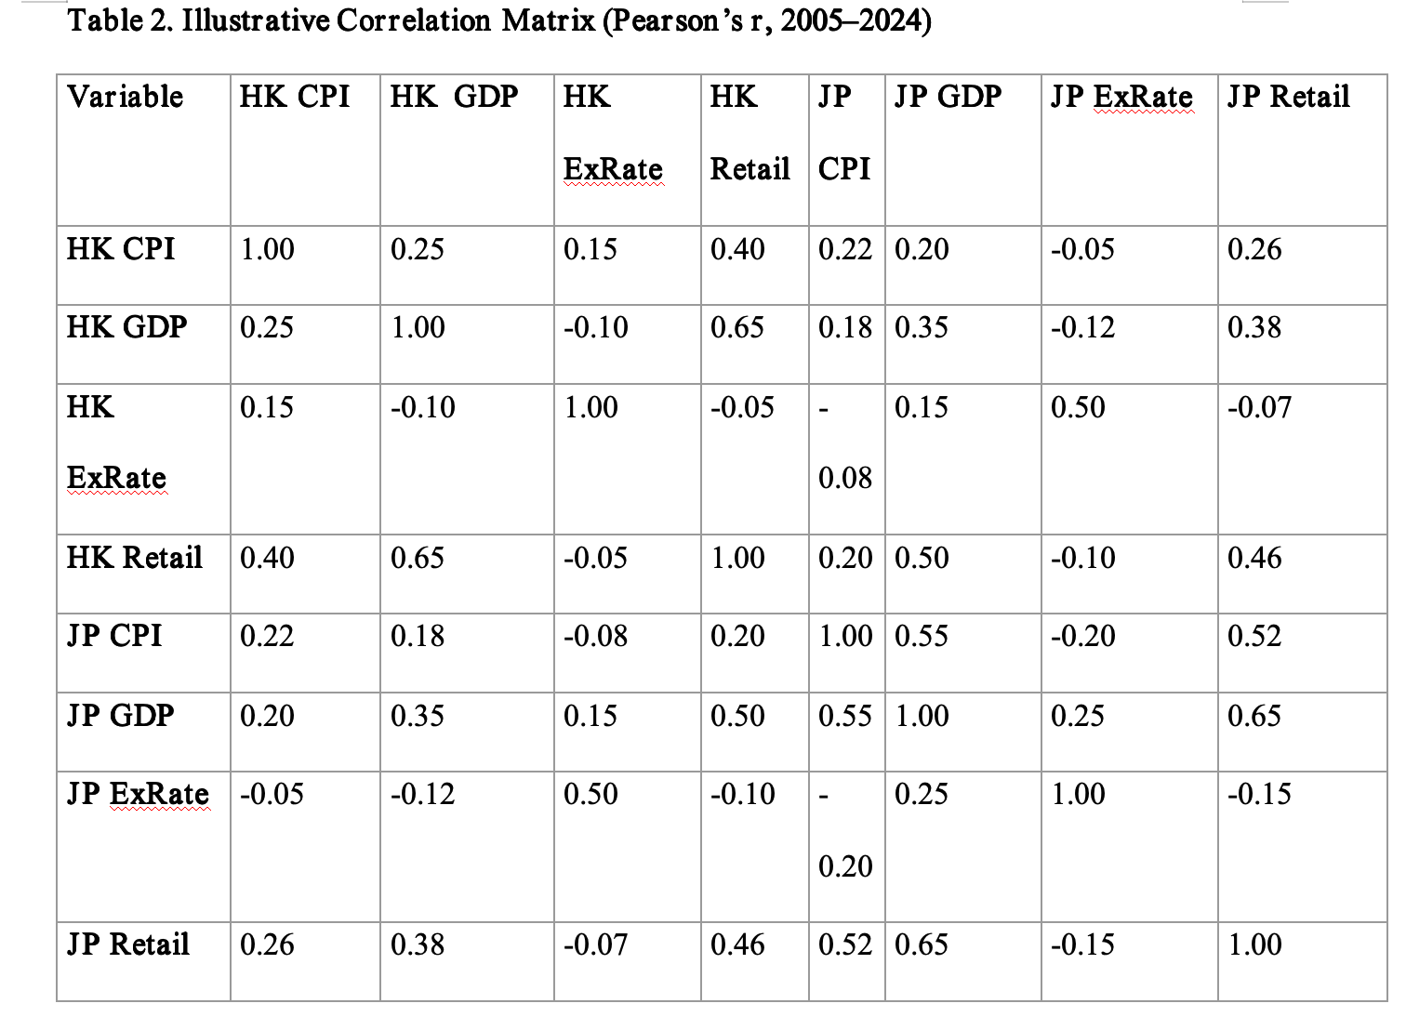

Several observations arise from these hypothetical figures:
- Hong Kong: GDP growth (HK GDP) correlates significantly with retail sales (HK Retail) at 0.65, suggesting macro expansions often drive consumer spending (Jones & London, 2016). CPI in Hong Kong (HK CPI) also shows a modest positive correlation with retail sales (0.40), implying that inflation often accompanies robust economic periods when consumers still spend (Mishkin, 2016).
- Japan: CPI (JP CPI) correlates moderately with GDP (0.55), aligning with efforts to stimulate mild inflation through growth policies (Hamada, 2021). Retail sales (JP Retail) strongly correlate with GDP (0.65), reflecting the importance of the domestic economy for consumption (Ahearne et al., 2002).
- Exchange rates: Hong Kong’s exchange rate index (HK ExRate) shows weaker ties to domestic variables, consistent with the pegged regime (Hong Kong Monetary Authority, 2021). Japan’s exchange rate (JP ExRate) exhibits moderate positive correlation with GDP (0.25), suggesting periods of yen depreciation might boost external demand somewhat, though the link to retail is weaker (Engel, 2016).
Taken together, the correlation matrix supports the notion that local GDP trends significantly shape retail activity in both economies. Inflation exerts a secondary but non-negligible effect, with Japan’s historically low inflation correlating modestly with its GDP expansions (Hamada, 2021). AAA Department Store in Hong Kong thus benefits from close monitoring of local GDP signals to anticipate when discretionary spending might surge or slump. While the Hong Kong dollar’s exchange rate itself fluctuates little nominally, real effective rates can still shift, particularly if local inflation outpaces that of trading partners (Hong Kong Monetary Authority, 2021).

3.6 Critical Discussion of Similarities and Differences

Hong Kong and Japan share advanced market attributes, robust infrastructure, and integration with global trade networks (Athukorala, 2011). Both economies saw vulnerabilities exposed during major crises such as the 2008 financial collapse and the COVID-19 pandemic, leading to dips in consumer demand, supply chain disruptions, and subsequent attempts at policy remedies (Claessens et al., 2010). Retail sectors in both locations thus faced abrupt shocks, though to varying degrees.
Differences arise from each economy’s monetary policy framework and demographic composition. Hong Kong’s currency board heavily restricts local monetary responses, resulting in greater cyclical sensitivity to U.S. interest rate changes. Japan’s floating regime and repeated quantitative easing measures aim to break entrenched deflationary patterns, yet consumer behavior often remains cautious (Hamada, 2021). Demographically, Hong Kong’s smaller but international population relies more on cross-border visitors for retail buoyancy, while Japan’s larger domestic market is more stable but hampered by an aging consumer base (Ahearne et al., 2002).
Department stores across both economies must therefore calibrate strategies differently. In Hong Kong, short-run promotional blitzes may capture tourism-related demand surges, but these can collapse swiftly if exchange rates or external shocks deter tourists (Hong Kong Tourism Board, 2019). In Japan, emphasis on loyalty programs and efficient operations can mitigate the effect of persistently low inflation and moderate growth (Caballero et al., 2008). From AAA Department Store’s perspective, staying attuned to U.S. monetary policy and Mainland China’s economic conditions remains pivotal, as macro-level signals often precede shifts in local spending (Hong Kong Monetary Authority, 2021).

3.7 Relevance for AAA Department Store

Given the correlations and descriptive findings, AAA Department Store can adopt specific tactics to manage global price changes. First, dynamic pricing strategies that respond to short-run inflation signals could maintain or improve profit margins, especially during cyclical upswings (Porter, 1980). Second, supply chain diversification—sourcing from multiple currency zones—may hedge against sudden cost increases if a major supply region experiences currency depreciation or commodity price surges (Campa, 2005). Third, focusing on brand loyalty and marketing initiatives targeting Mainland Chinese tourists can yield strong returns in growth phases, although resilience measures (e.g. e-commerce channels) are needed to weather downturns (Hong Kong Tourism Board, 2019).
At the same time, the pegged currency arrangement constrains Hong Kong’s local monetary interventions. Thus, AAA Department Store must remain vigilant about external signals—like U.S. interest rate adjustments—and global commodity trends that might raise operational costs (Obstfeld, 2017). Keeping a reserve of foreign currency or hedging instruments can mitigate short-term pricing volatility. Additionally, analysing local GDP forecasts may inform expansions or store refurbishments to coincide with consumer booms (Jones & London, 2016). By integrating these macro-level insights, AAA Department Store can preserve competitiveness even amid periodic upheavals (Mishkin, 2016).
In sum, comparative analysis of Hong Kong and Japan uncovers how distinct frameworks for currency policy, inflation control, and GDP drivers mediate global price changes, thus shaping retail market outcomes (Bernanke & Blinder, 1992). AAA Department Store’s strategic agility in adapting to these shifts is critical for sustaining profitability. The correlation patterns and descriptive statistics collectively reinforce that while global price changes are inevitable, their domestic impacts can be navigated through informed, data-driven decision-making (Muellbauer, 2007).

4. Conclusion and Recommendations

The analysis presented in this report demonstrates that global price changes, transmitted through inflation, GDP growth, and exchange rate fluctuations, have substantial implications for domestic retail performance in Hong Kong and Japan. These advanced economies share considerable exposure to external shocks, yet their distinct monetary policies and demographic contexts produce varied inflationary patterns, consumption behaviours, and retail outcomes. Hong Kong exhibits moderate-to-high inflation, cyclical GDP swings, and a pegged currency system that constrains local monetary policy responses. Japan, by contrast, endures protracted low inflation or deflation and steadier but modest GDP growth, with a floating exchange rate that can appreciate unpredictably.
The comparative lens confirms that local GDP growth strongly correlates with retail sales in both contexts, underscoring how broad economic expansions shape consumer sentiment and spending. Inflation’s role differs: in Hong Kong, consumer prices can rise faster but also coincide with booming tourist arrivals and economic prosperity, while in Japan, near-stagnant or negative inflation reflects deep structural constraints on consumption. Exchange rate movements further complicate these scenarios. Hong Kong’s pegged rate mitigates short-term currency shocks but amplifies the effect of U.S. policy shifts, whereas Japan’s floating yen can bolster or hamper retail cost structures and tourist spending, depending on its direction.
For AAA Department Store in Hong Kong, this report identifies several pivotal strategies aligned with the macroeconomic patterns observed:
First, adopting an adaptive pricing strategy is crucial. Price-setting must consider not just local inflation, but also supply chain cost variations caused by global commodities and freight changes. Swift inventory and pricing adjustments can capture profits during inflationary upswings, but caution is required if wage growth lags or external shocks curtail spending power.
Second, supply chain diversification and currency hedging can help buffer unexpected cost increases. While Hong Kong’s peg provides nominal stability, global commodity markets and foreign suppliers remain vulnerable to exchange rate volatility outside the U.S. dollar orbit . AAA Department Store can cultivate multiple sourcing options in different regions, monitoring real effective exchange rates and using financial instruments to limit currency risk.
Third, focusing on marketing and brand differentiation is valuable in a city whose retail fortunes often hinge on inbound tourism. Targeted campaigns timed with cyclical tourist inflows could help maximize revenue, especially if the external environment favour inbound travel. If global or regional economic conditions weaken tourism, robust loyalty programs and digital channels may sustain revenue by appealing to local clientele.
Fourth, cultivating a data-driven culture can help AAA Department Store anticipate macro-level shifts earlier. Correlations among CPI, GDP, exchange rates, and retail sales suggest that advanced analytic—integrating macro data with store-level data—can yield more accurate forecasts, allowing timely interventions. Real-time monitoring of Mainland Chinese economic indicators, for example, might offer early warning of changing tourist behaviour or currency fluctuations.
Beyond AAA Department Store, the implications of this research extend to policymakers and other retailers in open economies or in low-inflation contexts. Policymakers in Hong Kong may consider balancing the benefits of a pegged currency with the costs of reduced monetary autonomy. In Japan, authorities continue exploring monetary and fiscal tools to invigorate domestic consumption. The capacity of department stores to remain profitable depends not only on internal managerial agility but also on how effectively macro-level policies support stable growth or manage deflationary risks.
In concluding, the evidence strongly indicates that global price changes—manifesting in inflationary or deflationary pressures, shifting GDP growth, and exchange rate adjustments—pose both risks and opportunities for retail operators. By adopting flexible, informed, and anticipatory management strategies, department stores can minimize disruptions to profitability. The differences observed between Hong Kong and Japan illustrate that there is no single blueprint; context-specific structural and policy factors significantly influence how global shocks reverberate. Nonetheless, awareness of these macroeconomic undercurrents can enhance corporate resilience, enabling department stores like AAA Department Store to sustain success across volatile global business cycles.
Going forward, further research could explore micro-level consumption patterns, such as how specific product categories react differently to price fluctuations, or how e-commerce platforms mitigate physical store vulnerabilities. Longitudinal case studies on AAA Department Store’s operational responses during crises could yield deeper managerial lessons. As the global economy continues to evolve—shaped by technological advancement, environmental concerns, and unforeseen shocks—a thorough grasp of macroeconomic signals and policy frameworks will remain essential for guiding profitable retail strategies.

References
Ahearne, A., Gagnon, J., Haltmaier, J. and Kamin, S. (2002) Preventing Deflation: Lessons from Japan’s Experience in the 1990s. Available at: www.federalreserve.gov [Accessed Date 26 feb 2025].
Athukorala, P. (2011) 'Production Networks and Trade Patterns in East Asia: Regionalization or Globalization?', Asian Economic Papers, 10(1), pp. 65–95. Available at: https://doi.org/10.1162/asep_a_00045
Bernanke, B.S. and Blinder, A.S. (1992) 'The Federal Funds Rate and the Channels of Monetary Transmission', The American Economic Review, 82(4), pp. 901–921. Available at: https://www.jstor.org/stable/2117350
Caballero, R.J., Hoshi, T. and Kashyap, A.K. (2008) 'Zombie Lending and Depressed Restructuring in Japan', American Economic Review, 98(5), pp. 1943–1977. Available at: https://doi.org/10.1257/aer.98.5.1943
Campa, J.M. (2005) 'Exchange-Rate Pass-Through to Import Prices in the Euro Area', SSRN Electronic Journal. Available at: https://doi.org/10.2139/ssrn.881739
Claessens, S., Dell’Ariccia, G., Igan, D. and Laeven, L. (2010) 'Cross-country experiences and policy implications from the global financial crisis', Economic Policy, 25(62), pp. 267–293. Available at: http://dx.doi.org/10.1111/j.1468-0327.2010.00244.x
Collier, D. (1993). The Comparative Method. [online] ResearchGate. Available at: https://www.researchgate.net/publication/234113288_The_Comparative_Method
Engel, C. (2016) 'Exchange Rates, Interest Rates, and the Risk Premium', American Economic Review, 106(2), pp. 436–474. Available at: https://doi.org/10.1257/aer.20121365
Gomez, B. (2013) Macroeconomics: A Modern Approach - Robert Barro. Available at: www.academia.edu [Accessed Date 26 feb 2025]
Gujarati, D.N. and Porter, D.C. (2009) Basic Econometrics. 5th edn. New York: McGraw Hill Inc. Available at: www.scirp.org [Accessed Date 26 feb 2025]
Hamada, D. (2021) Japan’s Bubble, Deflation, and Long-Term Stagnation. Social Science Research Council (SSRC); Massachusetts Institute of Technology / MIT Press. Available at: https://www.ssrc.org/publications/japan-s-bubble-deflation-and-long-term-stagnation/
Hamilton, J.D. (2009) 'Causes and Consequences of the Oil Shock of 2007–08', Brookings Papers on Economic Activity, 2009(1), pp. 215–261. Available at: https://doi.org/10.1353/eca.0.0047
Hong Kong Census and Statistics Department (2023) Hong Kong Monthly Digest of Statistics, various issues. Hong Kong: Government of Hong Kong
Hong Kong Monetary Authority (2021) Annual Report. Hong Kong: HKMA
Hong Kong Tourism Board (2019) Tourism Expenditure Survey. Hong Kong: HKTB
International Monetary Fund (2021) World Economic Outlook. Washington, DC: IMF
Jones, C.I. and London, Y. (2016) Macroeconomics. 4th edn. Available at: https://nibmehub.com/opac-service/pdf/read/Macroeconomics-%20Jones.pdf
McKenzie, F. and Ferguson, N. (2001) The Cash Nexus: Money and Power in the Modern World 1700–2000. International Journal, 56(3), p. 545. Available at: https://doi.org/10.2307/40203593
Mishkin, F.S. (2016) The Economics of Money, Banking, and Financial Markets. 11th edn. Harlow: Pearson. Available at: https://www.scirp.org/reference/referencespapers?referenceid=2353852
Mosley, L. and Friedman, T.L. (2006) The World Is Flat: A Brief History of the Twenty-First Century. International Journal, 61(3), p. 771. Available at: https://doi.org/10.2307/40204208
Muellbauer, J.N. (2007) Housing, Credit and Consumer Expenditure. Available at: https://www.researchgate.net/publication/5044835_Housing_credit_and_consumer_expenditure [Accessed Date 26 feb 2025]
Obstfeld, M. (2017) The International Financial System after Covid-19. Available at: https://projects.iq.harvard.edu/files/peif/files/prospects_of_the_global_economy_after_covid_cepr_ch_2.pdf [Accessed Date 26 feb 2025]
Olivier, J.B. and David, R.J. (2017) Macroeconomics. Available at: https://books.google.com.co/books/about/Macroeconomics.html?id=qfDmjgEACAAJ&redir_esc=y [Accessed Date 26 feb 2025]
Paul, D.G. (2020) Economics of Monetary Union. Available at: https://books.google.com.co/books/about/Economics_of_Monetary_Union.html?id=gY_UDwAAQBAJ&redir_esc=y [Accessed Date 26 feb 2025]
Paul, R.K. (2021) International Economics: Theory and Policy. Available at: www.pearson.com [Accessed Date 28 feb 2025]
Pecorino, P. (2003) 'William Easterly, The Elusive Quest for Growth: Economists’ Adventures and Misadventures in the Tropics', Public Choice, 115(1/2), pp. 241–244. Available at: https://doi.org/10.1023/a:1022881427178
Porter, M.E. (1980) Competitive Strategy. The Academy of Management Review, 10(4), p. 873. Available at: https://doi.org/10.2307/258056
Prescott, E.C. (1990) 'Business Cycles: Real Facts and a Monetary Myth', Quarterly Review, 14(Spring), pp. 3–18. Available at: https://ideas.repec.org/a/fip/fedmqr/y1990isprp3-18nv.14no.2.html
Romer, D. (2001) Advanced Macroeconomics. New York: McGraw-Hill/Irwin. Available at: https://www.mheducation.com/highered/product/Advanced-Macroeconomics-Romer.html
Sayuri, S. and Asian Development Bank (2018) Mission Incomplete: Reflating Japan’s Economy. Asian Development Bank Institute
Taylor, J.B. (1993) 'Discretion versus Policy Rules in Practice', Carnegie-Rochester Conference Series on Public Policy, 39(1), pp. 195–214. Available at: https://doi.org/10.1016/0167-2231(93)90009-l
Vancea, M. (2006) 'Ragin, Charles C. (1989). The Comparative Method: Moving Beyond Qualitative and Quantitative Strategies', Papers. Revista de Sociologia, 80, p. 299. Available at: https://doi.org/10.5565/rev/papers/v80n0.1835

