

Undergraduate Dissertation coversheet & feedback form

PLEASE COMPLETE THE TOP SECTION OF THIS FORM AND SUBMIT ONE COPY WITH YOUR DISSERTATION
For completion by student:
Student Name: James Kennaway

Student University Email: 1200518@student.uwtsd.ac.uk
Module code: HPAN6030 | Student ID number: 1200518 |  |  |  | Educational support needs:  Yes/No
Dissertation title: Embodied learning: an auto-ethnographical examination of its processes and uses with particular reference to the glamping industry in the festival space.
Supervisor: Luci Attala |  |  | Word count: 10701
I confirm that this is my original work and that I have adhered to the University policy on plagiarism.
Signed ……………………………………………………………
For completion by the first marker:
Comments:

First Marker’s Mark:  Signature: |  |  |  | Date:
For completion by the second marker (if appropriate):

Comments:

Second Marker’s Mark:  Signature: |  | Date:
NB. All marks are provisional until confirmed by the final examination board.

How agreed mark was decided upon—comments for External Examiner:

Proposed Mark:

Signature of External Examiner:

Final Agreed Mark:

DECLARATION

This work has not previously been accepted in substance for any degree and is not being concurrently submitted for candidature for any degree

Singed………………………………………….. (candidate)
Date…………………………………………….

STATEMENT
This thesis is the result of my own investigation, except where otherwise stated.
Other sources are acknowledged by explicit references and a Reference List is appended.

Singed………………………………………….. (candidate)
Date…………………………………………….

Embodied learning: an auto-ethnographical examination of its processes and uses with particular reference to the glamping industry in the festival space.

Figure 1
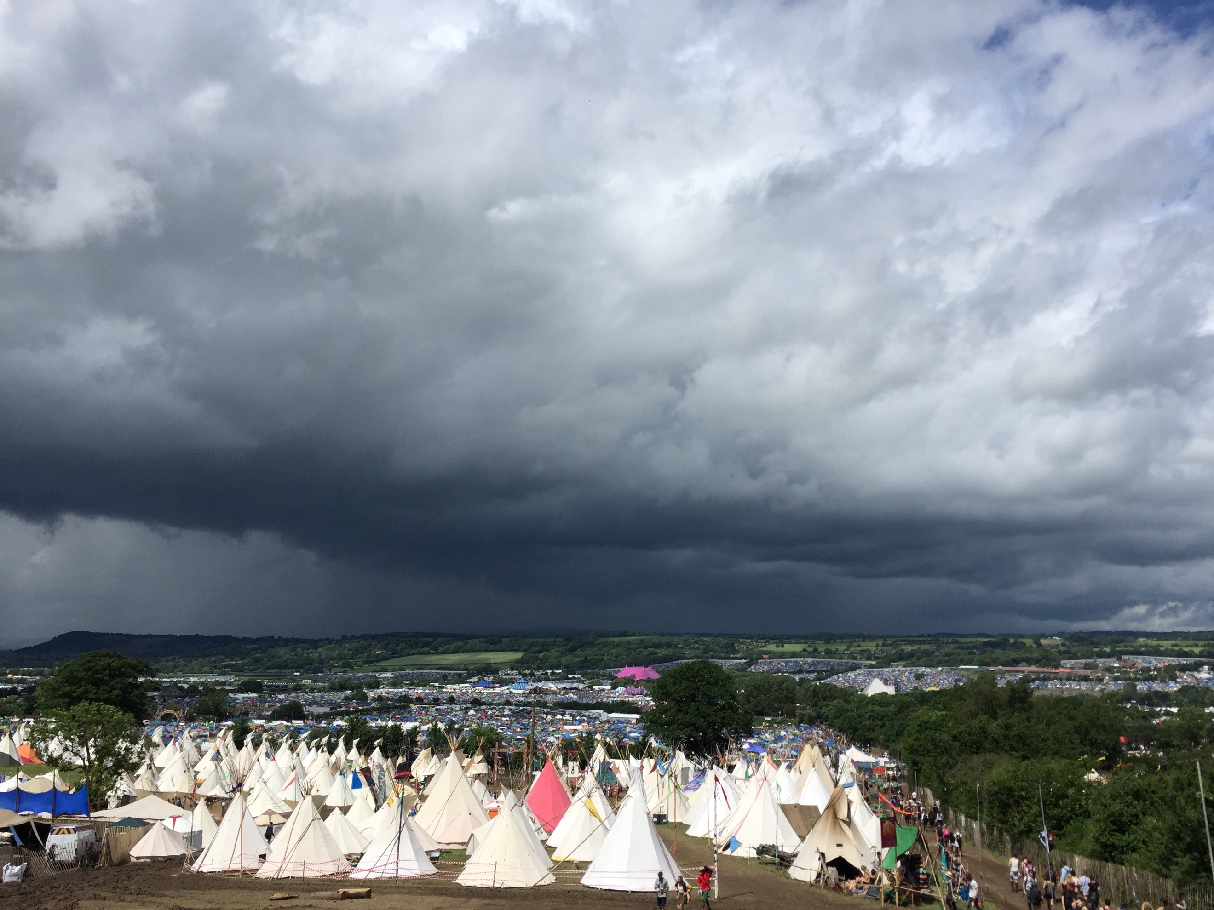

Table of Contents
4. Title Page
5. Table of Contents
6. List of Figures
7. Acknowledgements
8. Introduction
13. Methodology
17. Findings and Discussion
19. Feeling the field
24. Working with the Collective
28. Creation of the Worker
33. Tying the Crown together
35. Conclusion

Table of Figures
Figure 1- Page one: Kennaway JS 2016, Tipi field at Glastonbury festival. Taken from James Kennaway’s private dissertation photographs 2017
Figure 2- Page seven: Kennaway JS 2016, Completed tipis at Carberry Festival. Taken from James Kennaway’s private dissertation photographs 2017
Figure 3- Page eight: Kennaway JS 2016, Crew in half completed yurt at Carberry Festival. Taken from James Kennaway’s private dissertation photographs 2017
Figure 4- Page eleven: Kennaway JS 2017, Photo of used journals. Taken from James Kennaway’s private dissertation photographs 2017
Figure 5- Page thirteen: Kennaway JS 2016, Crew in the back of a lorry at Camp Bestival. Taken from James Kennaway’s private dissertation photographs 2017
Figure 6- Page fourteen: Kennaway JS 2016, Structure at wedding outside of Bath. Taken from James Kennaway’s private dissertation photographs 2017
Figure 7- Page twenty-one: Kennaway JS 2016, Pole racks at yard in Pilton, Somerset. Taken from James Kennaway’s private dissertation photographs 2017
Figure 8- Page twenty-three: Kennaway JS 2016, Glastonbury site after the festival has ended. Taken from James Kennaway’s private dissertation photographs 2017
Figure 9- page twenty-seven: Kennaway JS 2016, A worker and step ladder at Glastonbury festival. Taken from James Kennaway’s private dissertation photographs 2017

Acknowledgements
This dissertation owes its creation to a whole host of people who helped me along the way. Tara Weightman, the creator and owner of Hearthworks, for allowing me to be part of the crew. The team leaders who taught me: Dan Chalmers, Luke Tyack, Sirius Hiraz, Sven Krusel and Jose Sparrow for enduring my many questions and general ineptness on the field. The same goes to all those who I worked alongside with as a crew member, with special mention to ‘Flailin’ Dave, Adam Reeves, Jacob Hatfield, Osh Oleary, Adam Barker and Lee for giving me the inspiration to undertake this dissertation.

Thanks also to the tireless Lecturers of the Anthropology Department; Luci Attala, Emma-Jayne Abbots and Penny Drusant. Thank you all for your ever helpful pointers and words of encouragement, not only for this dissertation period but for my whole degree.

Finally thank you to my Father, Guy Kennaway for always telling me to push to the end and always to re-read everything.

Introduction
‘I hypothesise that embodied learning is a central pillar in the lives of those who work in the festival space.’

There has been a refocusing within the field Anthropology to better understand how we think and learn through our bodies. The question of how we acquire new skills and techniques within the body and use them practically, excited me enough to take a job in the field, both anthropologically and literally.
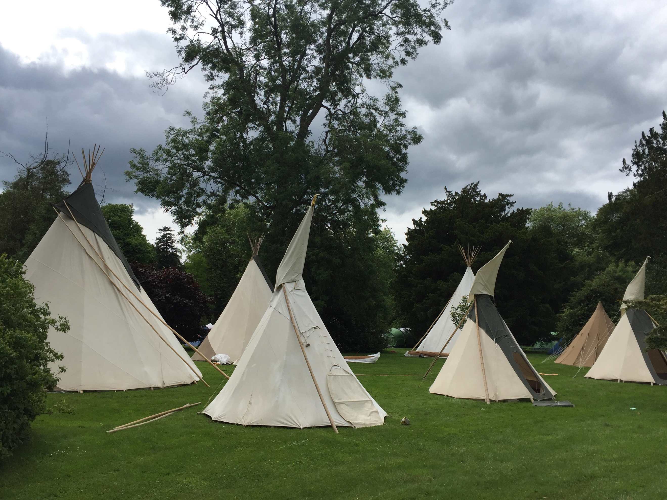
This is the sum of research and refinement, having spent a total of eight months, over the summers of 2016/2017, to learn the bodily techniques required in constructing and maintaining tipis and yurts at music festivals in the UK. Having no prior practical knowledge of tipis and yurts, I had taken a module on North American Religion and watched a few Western films in my life, the task seemed somewhat daunting. My new job was on the crew of the Hearthworks Yurts and Tipis Company based in Pilton, Somerset; I selected this company as it was located at the centre of the glamping industry with its close proximity both geographically and historically to the Glastonbury Festival. The work is seasonal and so the people who tend to have jobs there are to a large extent living somewhat of a nomadic lifestyle in this modern age. Some live in vehicles adapted to facilitate their lifestyle all year round, whilst others look to winter in warmer climates, India and Portugal being the most common, looking to return each summer to work at Hearthworks and replenish their cash flows.
Figure 2: Structures awaiting their residents
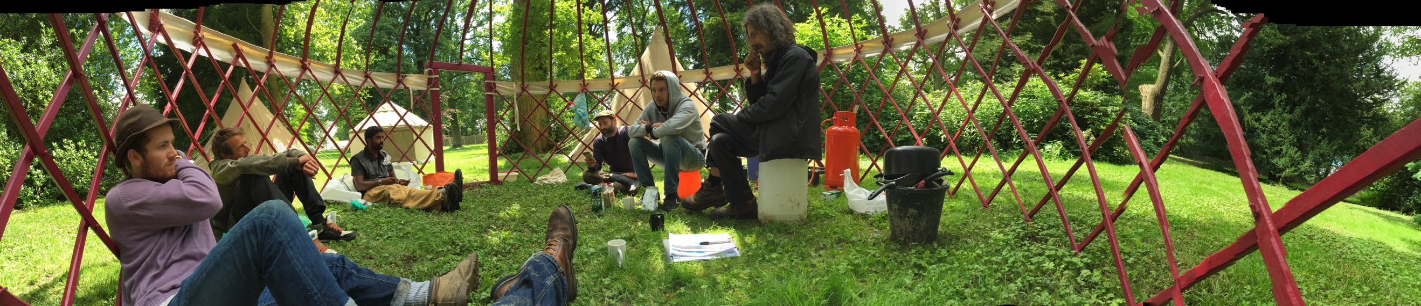
Many of these people had like myself never actually come into contact with a tipi or yurt. That being said many had acquired knowledge of skills and techniques in the course of their lives that seemed, in my eyes at least, to be transferrable into this new field of work. As I got to know my fellow co-workers I found myself being introduced to another array of beings who were involved in the job. These where the yurts and tipis themselves, and all of their individual parts that we had to navigate and negotiate in order for the structures to be successfully erected and maintained. Here my interest was piqued; not only were individuals able to re-align their own knowledge to fit new tasks, but they were also in constant dialogue with the elements required for the task.
Figure 3: The Crew at rest
Influenced by the work of Hannah Ardents the Human Condition, I began to see a split between what it is a worker within a production system does, ie. Labouring, and the act a craftsman performs within a task in order to create the object from start to finish, ie. work. (Arendt 1958:79). The first is the act of producing to maintain a life, an act of repetition; the latter is where the act of production is one of more creativity, and the individual chooses to become specialized in a role. Richard Sennet in The Craftsman looks to continue her theory. Whilst he follows Arendt’s idea that that there is a split between the acts of labouring and working, Sennet proposes that creativity is not a purely intellectual act (Sennet 2008:9). ‘Skill’ and ‘craftsmen’ evoke thoughts of a creative acts that require individuals who are interacting with resources, tools and the environment (ibid 152). Tim Ingold added an environmental element to this idea around embodied learning. These two writers come to similar conclusions on the interactions between the individual and the environment they find itself in (Ingold 2000, 2013 and Sennet 2008). Whereas Sennet finds these conclusions through a more ‘actor’/’person’ centred method, Ingold looks to build up a collective of focal points from the individual performing, the historical and geographical context and the tools and resources ‘at hand’ (Ingold 2013:49). This is not to say Sennet totally disregards all these factors, it is that he places them in the background whilst bringing the individual’s body to the fore.
I observed in the field a mix of focus points, which created a chaotic collage of competing factors on how information of a theoretical and bodily type. Whilst the craftsman’s body is the main tool for creative expression, in the field physicality only got you so far. There were many aspects of builds that needed to be thought through. The weather, the land, the people and the resources all played a role in whether or not the build would be successful.
Here Levi-Strauss sets out in ‘The Savage Mind’ a version of an individual, called the ‘bricoleur’, who has the ability to complete tasks with skills and information they had acquired earlier, and not be constrained by the environment they find themselves in (Levi-Strauss 1974:17). This seems a jump away from the direction Ingold and Sennet were taking us in, but it is in fact crucial to remember this theory of Levi-Strauss’s in this analysis. For, none of the workers in this ‘field’ have ever led lives that have brought them into contact with tipis and yurts until this point. It is the ability they have to take what they have learnt as builders, electricians, mechanics or any of the plethora of jobs that had been held before coming to this new profession which had applicable skills. Here the mind of the individual, who they are, and the journey which had led them to Hearthworks, are of the utmost importance. This focus on the ‘mind’ of the individual as the receptacle of knowledge, and by extension skill, is obviously veering heavily away from Sennet and Ingold’s more embodied and environmentally conditioned learning. The important point to me in Levi-Strauss’s work is that the ‘bricoleur’, that he was describing in the 1950s, has no exact profession and is in fact more suited to roaming from role to role, fitting his work with his life (ibid 21), rather like the people I was working with in the summers of 2016/2017.
The issue I find with the bricoleur is that the person seems to have no agency to their action, descried as a ‘wanderer’ by Levi-Strauss, I feel this does an injustice to the workers who very much plan and execute their lives to their desires. This led me to the work of Deleuze and Guattari Anti-Oedipus and A Thousand Plateaus, especially the Body without Organs (BwO) and the desiring machine that drives it. Within this concept the two writers look to throw off the shackles that capitalism has placed upon the individual and allow it to run free, pursing what they desire to be happy (Deleuze and Guattari 1987:151). This fits with the lives I saw being lived around me. Many of the workers would be away from home for months clocking in fourteen hour days and after two seasons of this would then leave the country to travel the world at their own leisure.
Levi-Strauss’s ‘bricoleur’ only illuminates half the process of embodied learning, the subject of this dissertation. For the other half I look to Latour’s work found in Pandora’s Hope and Reassembling the Social. Here we find a more materially bound sense of learning and the use of skill (Latour 2007:72); the individual is moving through a ‘collective’ of resources, some actors and some ‘actants’. In the field I discovered that the line around agency in the learning and use of skill is blurred. It is only by understanding all the component parts of a task that it may be fully mastered. Latour’s ‘black box thinking’ (Latour 1999:184) is seen in the field when a structure is not coming together, not ‘fitting’, and every stage must be unpacked and thought over; but we will return to this in more detail later.
The importance of bringing in Latour’s theory is that it ties together the ideas of the ‘bricoleur’ as being a ‘traveller’ or ‘jack of all trades’ with the material world in the ‘collective’. The individual is able to move through an environment of ‘docile’ or ‘weak’ objects, awaiting to be ‘awoken’ or ‘strengthened’ by the intention of the individual (Latour 2007:72). As well as tying Levi-Strauss into the world, Latour’s theory is nicely positioned to help us with the somewhat shaky placement of agency in Sennet and Ingold’s work. This is then further helped by the addition of the desiring machine moving the Body without Organs, of Deleuze and Guattari, through the world. As the Body without Organs looks to not only find happiness in the individuals life, but also connect them with those around them (Deluze and Guattari 1987:153), something that has become more difficult with the advancement of late capitalism. All of these writers hold an ethereal thread when they talk of agency within a task. For them the ‘collective’ of Latour has just as much voice as the individual does. This is a problematic view when brought into contrast with what is experienced in the world where individuals and beings are bound by social forces to create something. Here the resources and environment are important in the whole show, and have their own solos, but the main character is still the individual (ibid 85). It is through my own personal experience of being a worker in these settings that I hope be able to shed more light on what it is ‘to learn’.

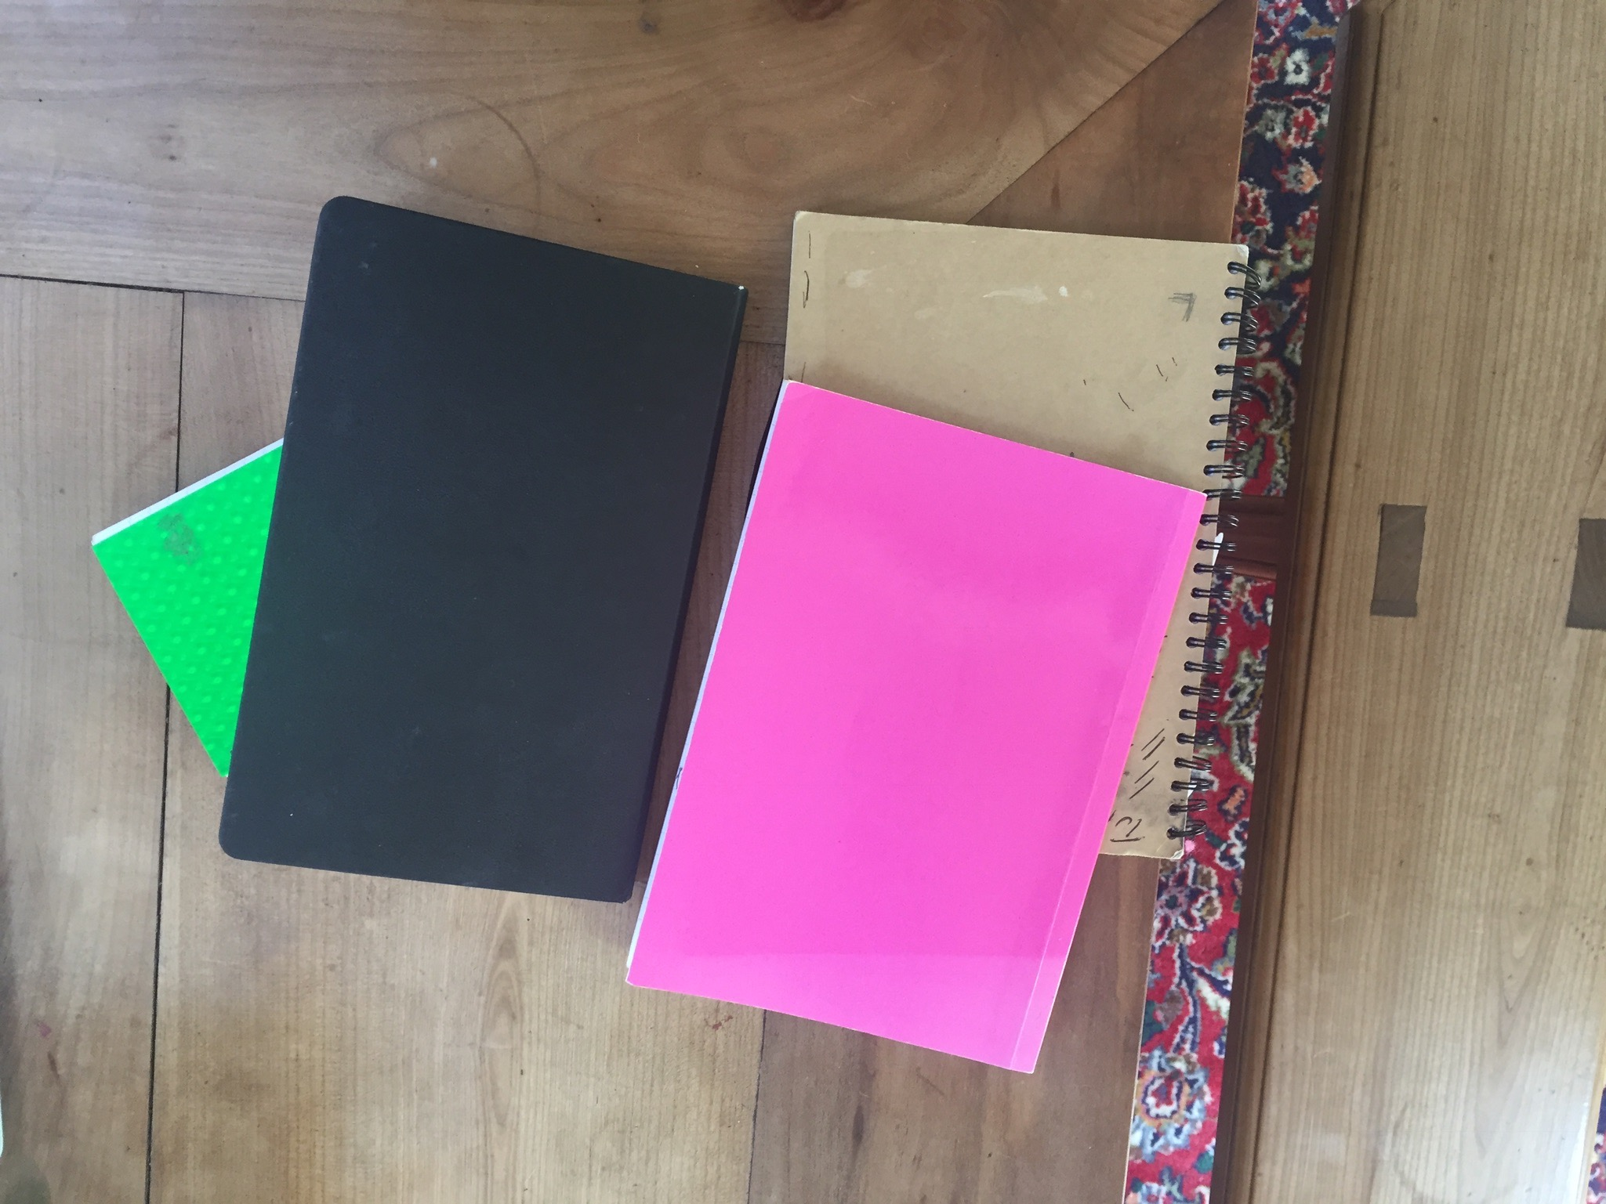
Methodology
One of the main issues with the project was how best to document the events effectively. From day one I confirmed the most important rule of fieldwork, never let anyone see you writing (Pink 2001:8). The moment I was seen to be jotting something down or stepping away to remember a thought or document an action, those around me reacted with an observable change to their bodily actions. I noticed a tendency in them to become stiff and mechanical, not wanting to show me any signs of sloth or weakness, which I put down to the fact many saw me as a figure of judgement. This was a group that has sort to live as far away as possible from the all reaching glare of authority. When I first started working in ‘the yard’ at Hearthworks it was a place of sound, of people interacting with other people and materials; this sound was muted when the notebook arrived. Being watched changed the actions and when the bodily actions were the area of my analysis this created an issue of authenticity.
Figure 4: The scraps of my field notes
Ethnographic fieldwork cannot be seen as a museum piece, hanging on a wall, seemingly unconnected to the world around it. Instead it must be situated within the many complexities and oddities of the lived experiences of the community that it is about (Agar 2008:16). It is here that the true chaos of the whole project is revealed. Even though many still try and cling to the qualitive data collected in laboratories of the natural sciences, when in the field this seemed almost impossible. Not only are the ‘experiments’ not repeatable they are not truly known until after they have taken place (Button 1993:110). These results, referred to as ‘Rich Points’ (Agar 2008:31), do not give you the answer all at once, but illuminate certain blind spots the researcher may be unaware of.
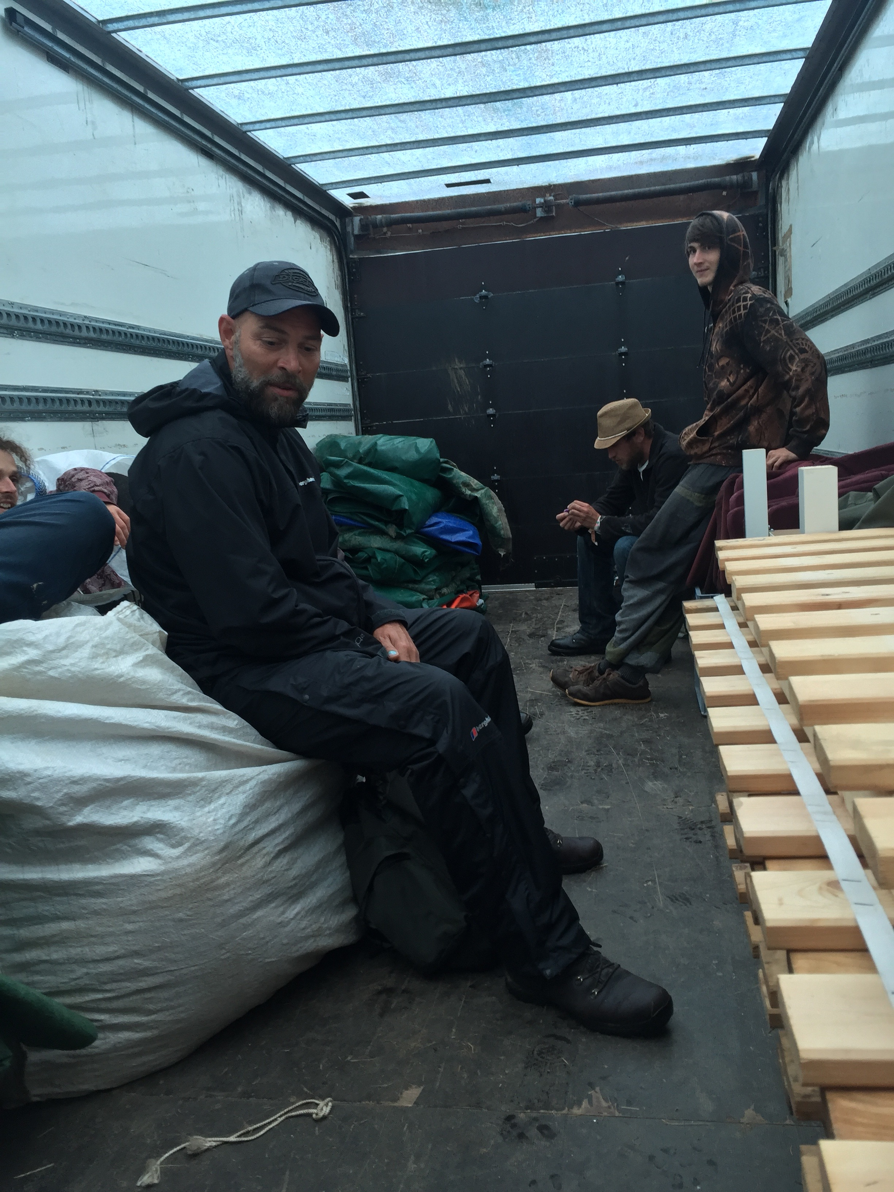
For it is only by understanding that the role of the ethnographer is not one of a clip board holding, lab coat wearing scientist, but as a ‘researcher-as-instrument’ (Robson 2002:165). The story unfolds as you interact with the community. It is only by immersing yourself in the tasks that the whole picture may become clear (ibid 187). This was useful for this research as I was looking at the embodied knowledge of the community I could only gain access to this by throwing myself into the work.
Figure 5: Waiting in the lorry
Therefore, I decided that the best method of collecting data was through auto-ethnography. As this dissertation is based on the experience, processes and uses of embodied learning the place where the data will be most accessible will be within myself. Throughout the two seasons working there I kept a journal of my experiences on field and in the yard. The yard was a living history of the company as all components of the structures in any state of use or disrepair were found there. This allowed me to gently ease myself into the community and allow them to become accustomed to my presence. I had told many of them what I was collecting data for my dissertation many treated me as an outsider at first. It was at the yard that I was able to furnish myself with an identity that more suited the environment (Sutton 1998:58). This is not to say I became someone different just that I became more aware of what the wants and needs were of the people and place, which would become my wants and needs as well (Ellis 2004:10). By immersing myself within the community it meant that the learning aspect of the field work became second nature as it was my job. I bought Dickies workmen trousers, steel toed-boots, a pen knife and a rucksack all items required to fulfil the role of the worker at Hearthworks. Being a neophyte within the crew meant that those around me were more open to showing me the ins and outs of the community (Connerton 1989:72).
The issue comes when we turn to the notes taken in the field. Out of sixty-four days I spent on jobs at festivals about a quarter of the entries at the end of the day are simply the single word ‘Tired’. The second most popular entry was just one word more: ‘Tired and wet’. They illustrate perfectly the issues faced out in the field. The working days could span between nine to fourteen hours and could run at that length for days in a row. After working a twelve-hour shift, I could barely muster the energy to eat or get undressed before passing out in my tent. Attempting to remember what had taken place over the previous twenty-four hours would almost bring me to tears. Emotion is therefore a key tool in fieldwork and should be included in the write up (Coffey 1999:5), by having these emotional outbreaks I was better able to understand the process of becoming a worker and gaining the knowledge that goes along with the title. This is what working life at a festival is really like and I felt it would be wrong to not include these realities. To perform an auto-ethnography properly it must be warts and all (Ellis 2004:120).
Despite the trying conditions on site, I went to interview the people who had been around me as I was learning the skills and techniques. The moment my pen hit the page the person opposite me would pause and attempt to read what I had written. One of my interviewees ‘X’ showed clear signs of trying to read my notes, which I felt compromised the integrity of the interview. I thought about overcoming this by placing a division between myself and the participant, but that made me feel as if I was performing some sort of ‘Voight-Kampff’-esque test on them. A piece of propped up A4 cardboard or my own arm were tried out as dividing tools and found to be inadequate. I began to employ a method I read in Skinners The Interview on the field, where I would try and have as many conversations in a day with my co-participants about anything they wanted to talk about. I did not walk up to them and directly ask them point blank about matters I was interested in as this would surely have precipitated the guarded responses I was attempting to stay away from. Instead I would just chat with them, at tea break or in the van or waiting for materials to arrive on site. Some of the conversations led to nothing, others gave me useful insight into the workings of the co-participants. What was important was that I did not try and push and grab at the point, but let it instead come to me. So I was experiencing data as well as colleting it.
What the interviews were able to show me is that the participants’ work which they performed in the yard and on the festival sites was intricately woven to their lives. Each one had come across Hearthworks by the way of other spaces and activates within festivals. They all wanted to live lives away from the power structures of modern life and to be able to join and leave when they pleased (Sutton 1998:66).

Findings and Discussion
This section is an analysis of the actions and techniques I was taught in the field and how I became attuned to them over time. Each of the tasks will be viewed through the lens of those writers’ and their theories that were outlined above. By doing this I will expose the nuanced and multi-faceted dynamics of learning a craft that take place within the individual and the festival space.

Feeling the field
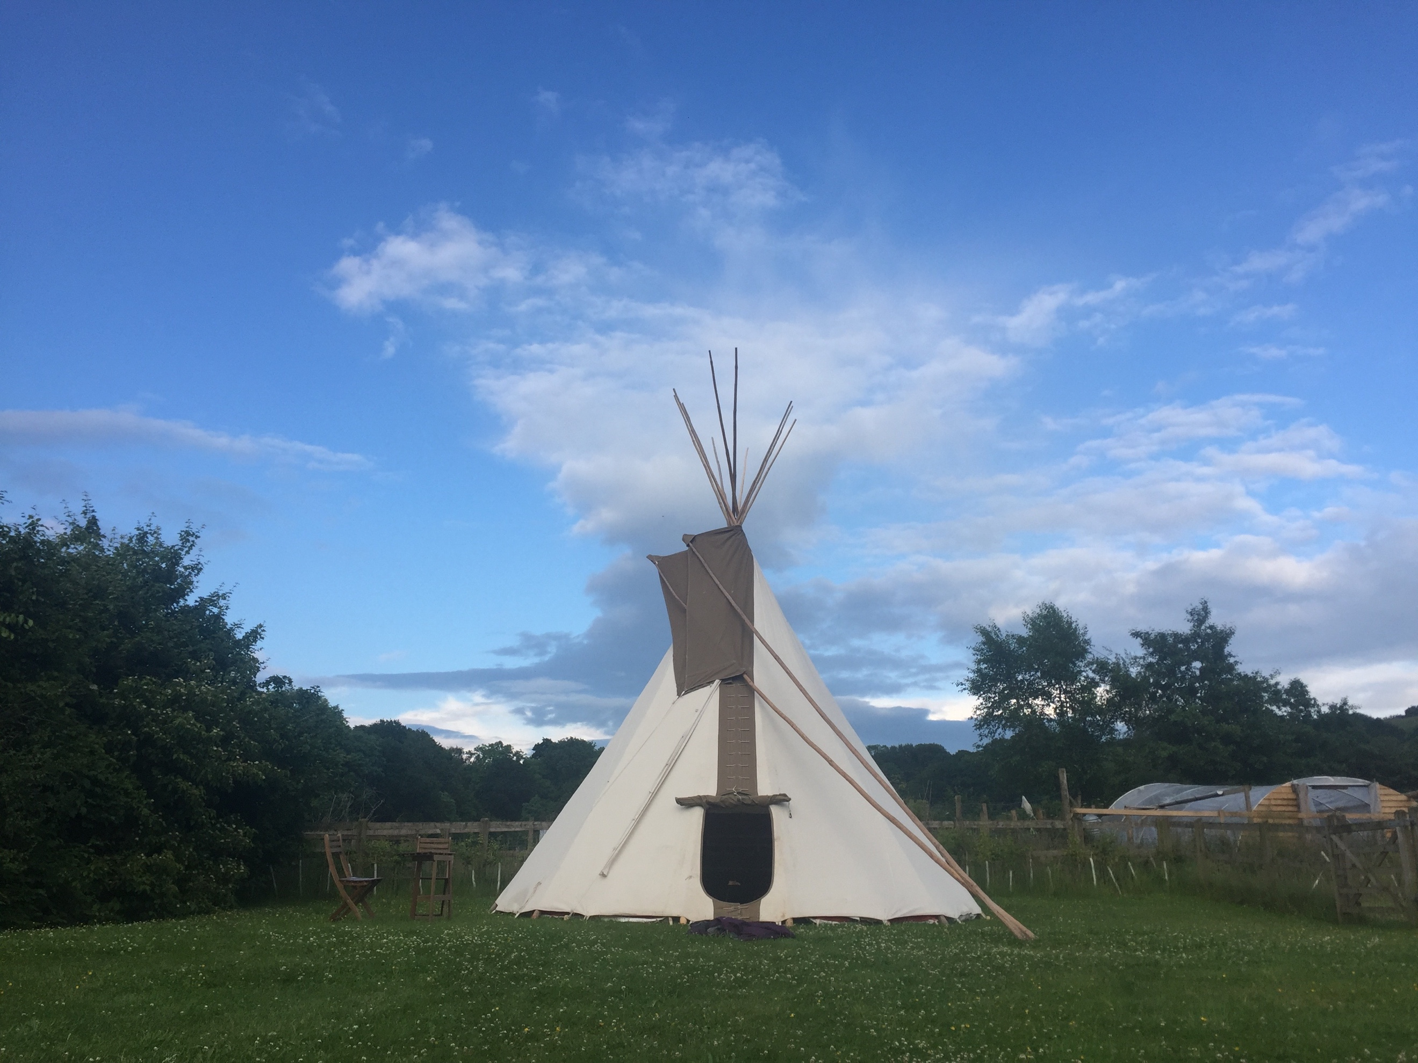
The activities undertaken by the crew in the preparation and construction of the site can appear to be repetitious. You arrive at the field, unpack lorries of all equipment, lay out the equipment and then build all of the structures before the festival itself begins; and once the festival is over you take the structures down, repack them into the lorry and move onto the next site
Figure 6: The first tipi I constructed
It is never as simple as this. My first job was a single structure for a wedding. Neither myself or my senior team member had ever been to the location, and I had obviously had never put up a Tipi. When we arrived we were directed to the location that had been chosen for us. I immediately went to start unpacking the Sprinter Van to find my boss standing still and looking around himself. It was as if he was taking in the environment around us, from the far off hills to the fence dividing us from a herd of cows and back to the impending storm clouds that had hoved into view as we arrived. Then suddenly he clapped his hands together and we were away; this almost hap-hazard start to the job struck me as strange. We had a time limit and the oncoming storm was shortening this even more. I continued to see this occur at each site I went to, no matter the size or place, the team leader always spent a period of time taking in the surroundings.
This is something found in Ingold writings (2013:4, 2000:298 & 2015:18), where there is a dialogue between the creator and the surrounding environment where the action takes place. This dialogue seems somewhat obvious, but the fact is that the field of Anthropology has been hamstrung by its older cousin philosophy by concentrating too much on the mind (Malafouris 2008). After two years I had been back to sites multiple times to perform the tasks involved in building and breaking structures before and after a festival. Rarely would the conditions mimic my prior experience; often the site would have been redesigned placing us at a new location, new structures had been added, and as always the British weather was at its unpredictable best. It was therefore down to the skill of the team leader to be able to use their prior knowledge accumulated from many different jobs to deal with obstacles met at other locations (Ingold 2000:300). This relationship between the individual and the environment goes deeper than solving weather and location problems. The resources on hand which are to be used to make the structures are just as much in flux as the locations they are placed in.
To build an eighteen-foot Tipi you require a minimum of nine poles, the canvas, twelve 12” stakes, around twenty-four canvas pegs, ground sheet, ground sheet string and at least ten meters of rope. All of these items are collected together and packed onto the lorry at ‘the yard’ by those workers who will accompany it to the field and form them in to the structures. How the lorry is filled is the first action where the relationship between the workers and resources can be seen. Here we must think about not only how the objects will ‘ride’ together, so that none are damaged, but how they need to be unpacked when on the site.

It may make sense from the point of view of optimising the space in the lorry to put the poles and canvas bags at the back, but none from the point of view optimising the ease of construction because they are the first things required to begin building. This highlights the processional method of building these structures; each step must be thought of in relationship to the previous and subsequent steps (Ingold 2013:4). The workers who had experience on their side and therefore were more at ease with the skills needed understood that there were sometimes trade-offs between stages in order for the whole process to run smoothly. An example of this is that the furnishings would often arrive after the wood and canvas, as they were not needed until that point and would have just taken up space on the site. The team leader is also in constant dialogue with their team and the ‘yard manager’ as to any changes that might be needed to be made to the inventory. These changes occurred due the fact that many of the workers had experiences that anticipated problems that could appear on site. These were issues like, the ground being uncooperative and difficult to perform the work on, the site not permitting certain types of vehicle movement, the customers asking for extra furnishings and other maintenance issues that inevitably arose. These obstacles that were familiar to the workers allowed them to be better prepared for the tasks that cropped up on the field. These experiences allowed the workers to choose the materials best suited to complete the build as efficiently as possible.
It is this marrying of the making (poiesis) and doing (praxis), which Ingold separates, that makes this field so interesting (Ingold 2000:295). The ‘making’ period is found in the yard where the pieces are assembled for the job, from the workers in the team to the materials that are to be used. When on the field the ‘doing’ stage takes place, where all these individuals and materials start to interact to produce the structures. The skill of knowing to tweak certain structure packs to fit the location is the bridge between ‘making’ and ‘doing’. It is the life experience and repetitive interactions with the materials that allow the workers to foresee obstacles in the second stage and are able to overcome them by making a change in the first stage (Ingold 2013: 21 & Inogld 2011:150).
This ability to problem solve over large amounts of time and space is a key component in the life of a craftsmen. The understanding of how all materials and individuals will flow together, to form in this case the structures, is something that is as much in the craftsman’s body as it is in their mind (Sennet 2008:9).
The ‘poieses’ and ‘praxis’ division lends itself to the idea that whilst the body and the mind are not separate, they are each the primary tool for the individual in the two stages. The mind is at the foreground during the ‘poises’ stage, as the ‘making’ of a site is done by planning how the structures will be built and where they will be built. Whilst the ‘praxis’ or ‘doing’ stage is where the body comes to the fore, here the body must have techniques learnt to overcome the obstacles that were forecasted in the earlier stage. This dialogue allows the worker not only perform the task effectively but also allows them to perfect the skill over numerous repetitions; as the dialogue not only runs between the stages but also between events. This engagement with materials and the obstacles associated with them; and progression of a skill and techniques is something that is at the foundation of what being a craftsman is (ibid 20). We see here a synthesis of the mind and body, working in tandem with each other in order to make the process as a whole flow with ease.
I learnt these new skills and associated techniques in order to most effectively perform my job. At the yard there were many books on how to construct tipi’s and yurt’s, from sewing the fabric skins, to the wood work and finally the actually building of the structure. In my entire two years at the job I never saw someone actually look at these books with any more interest than to pass the time at lunch break. Very few things were written down about the actual building process of the structures. The handbook had little to no information, more concentrating on health and safety and other dos and don’ts of life on the field. Some written information was given on tying certain knots, but this was no more than a one-page printout of diagrams.
All of my knowledge on how to build and break festival glamping sites was acquired whilst on the sites themselves, from watching and listening to senior team members and from my own trial and error. At first you are expected to keep to the grunt work. Banging in pegs, holding canvas, moving poles and other tasks can be seen as not needing a large amount of skill. That is not to say there in none involved in these actions, the hammer must be held correctly and the poles are easier to drag then actually carry. These are simple actions, that usefully highlight the importance of the body on the field, were the hands of the worker become their main tool for enforcing their agency onto the world around them (Sennet 2008:151).
Beyond these actions that are somewhat ‘simple’ or even ‘subconscious’, as they are built into the bodily action of a task, there began to appear a set of techniques and skills connected to them that were specific to certain parts of the build and break of the structures. When we arrive at the site and have unloaded all of the resources and tools from the lorry, the first task of action is the allocation of poles. There are two types of poles used, the shorter and older bamboo poles for the smaller tipis and the larger and newer pine poles. The smallest ‘duo tipi’ is little over twelve feet tall, whilst the largest is a thirty-foot tipi ‘sun lodge’. Both are built using the same process. First you tie the tripod together, this is your foundation, then the other poles are placed on this foundation tied off and then the skin is placed on with a lifting pole and staked down. All the tipis need somewhere between eight and eleven poles. Obviously there are larger poles for the larger structures and vice versa for the smaller, so when unloading this is the first categorisation that takes place, each pole is put with its corresponding colour.
When thinking about building the tripod, the strongest and straightest poles must be used. As this is the foundation of the structure, if a choice is wrong it will cause numerous problems further down the line. Watching the team leader, and then doing it myself, the choosing is not done simply by looking for the thickest three poles. The poles must be handled in specific ways, they are lifted, first to hip and then to shoulder height, the give being tested and the straightness verified. When the most appropriate are found they then must be compared with each other, as the tripod will form the base for the crown it must fit together well and not have any give. Poles that seemed to me, a novice, to be perfect for the role were rejected by the more experienced team leaders. A pole may be too thick, off-setting the crown, or kinked slightly at the crown meaning they’d be no room for the later poles to fit in to position. This dialogue between the objects and the craftsmen, causing the plan of the structure to be tweaked with every pole found, is an example of how the surrounding milieu demands to be taken into account when an individual wants to act (Ingold 2013:21). This blurring of the line between the individual’s agency and the objects’ constraints has to bring about a new idea of the ‘body’, as the body is having to change what the mind holds as the end product due to the relationship with the surrounding environment and allocated resources. The ‘cognitive process’ flows from the mind, through the hands and into the environment and back again (Malaouris 2008).
This ‘cognitive process’ is the starting point for the learning to be a ‘skilled craftsman’ in the field of glamping. The ability to allow the individual and the environment to flow between each other allows for problem solving in those more learned practitioners and it allows the less experienced ones, like myself, to become more accustomed to the skills, techniques and resources (Marchand 2016:2). For the newcomer time must be put into watching and mimicking the actions and steps set out by the team leader. This is not to say that there needs to be a rigid and highly formulated way of working; watching another worker lays the foundations for your own actions, and also allows room for your own input. It is by allowing this input from the learner that the skills and techniques will be better transferred over to them (ibid 11), as the student has knowledge grounded in their own experience of how obstacles arise and the best way to deal with them.
The tying of the tripod knot is a step in the process of building the tipi that offers us a setting to see this learning process take place. The knot is tied in a specific way that allows the three poles to move around each other whilst being bound together tightly as the foundation. The knot has been shown to me numerous times, I myself do not know it’s technical name just the actions used to create it but it is colloquial know to the crew as the tri-pod knot. In being taught these actions little was ever verbal, apart from a few words about the orientation of the poles and rope; most of the knowledge was transferred via action. A finger slipped between rope and pole to show the little give, a hand placed at the level where the knot was needed to be tied or a pulling of the rope to show tightness of the knot. These actions came in no particular order each time I was shown this stage, which makes sense as the obstacles that could arise in any order during the process.
This is why the visual method of teaching in the craft world is more applicable than the audio method. Words and the sentences they form have a linear flow to them, each point coming after the last (ibid 77). This leads to a structured approach to learning, building a belief in the student that the actions will always take place as they have been told. The hap-hazard almost chaotic nature of visually aided learning prepares the student for when the safety net of the teacher is removed, at which point they should be able to recognize the issue and employ a technique to solve the problem (Sennet 2008:168). As time progresses the individual becomes more attuned to the task, the techniques become more engrained into their body until the action needed to problem solve becomes second nature to the individual.
As the tipi is built the worker will be searching for issues within the forming structure, a working model of the finished structure held in the mind. This model is updated by what is seen and felt in the world, so the tipi is built on a cooperation between the force of the material, its feel or rhythm, and the individual’s wants as towards the created products final form (Marchand 2016:137). This rhythm of action is something that needs to be learnt over time, just like a dance or musical instrument. There is little ‘theory’ involved; learning must be done on the move during the action, but that is not to say there is no thought put into the work. Many times there will be a break in the work and a conversation will ensue, usually over a coffee and cigarette, where the individual workers will bring up obstacles they have met for the first time in their builds. The pole are wrong, the rope is frayed, the ladders is too short, the land uneven or hard; and when these obstacles are shown to the group others chime in with solutions they have had to use in the past to overcome these obstacles. Often these dialogues will move between verbal and visual communication, a new knot must be named and then shown, poles must be felt and compared. These dialogues deepens the understanding not only of the two in conversation, but also the others around how may be causally listening and just as importantly watching this during the break (ibid 84).
To learn the skill and techniques of building and breaking yurts and tipis, the time must be spent in the field repeating the action until the body of the worker becomes aligned with wants and needs of the elements that they find themselves surrounded by. The knowledge transferred not only from master to student, but also from the environment into the individual will only be able to go so far. It is then the ability to meld that knowledge to fit new situations and tweak the skills connected to the knowledge that enables the worker to overcome obstacles with all their nuances and ensuing chaos (Ingold 2000:298 & Ingold 2013:52). It is this relationship between the individual and the collective objects found in the surrounding environment that will be analysed next to better understand how the idea of agency and the power objects have over the individual’s actions.

Working within the Collective
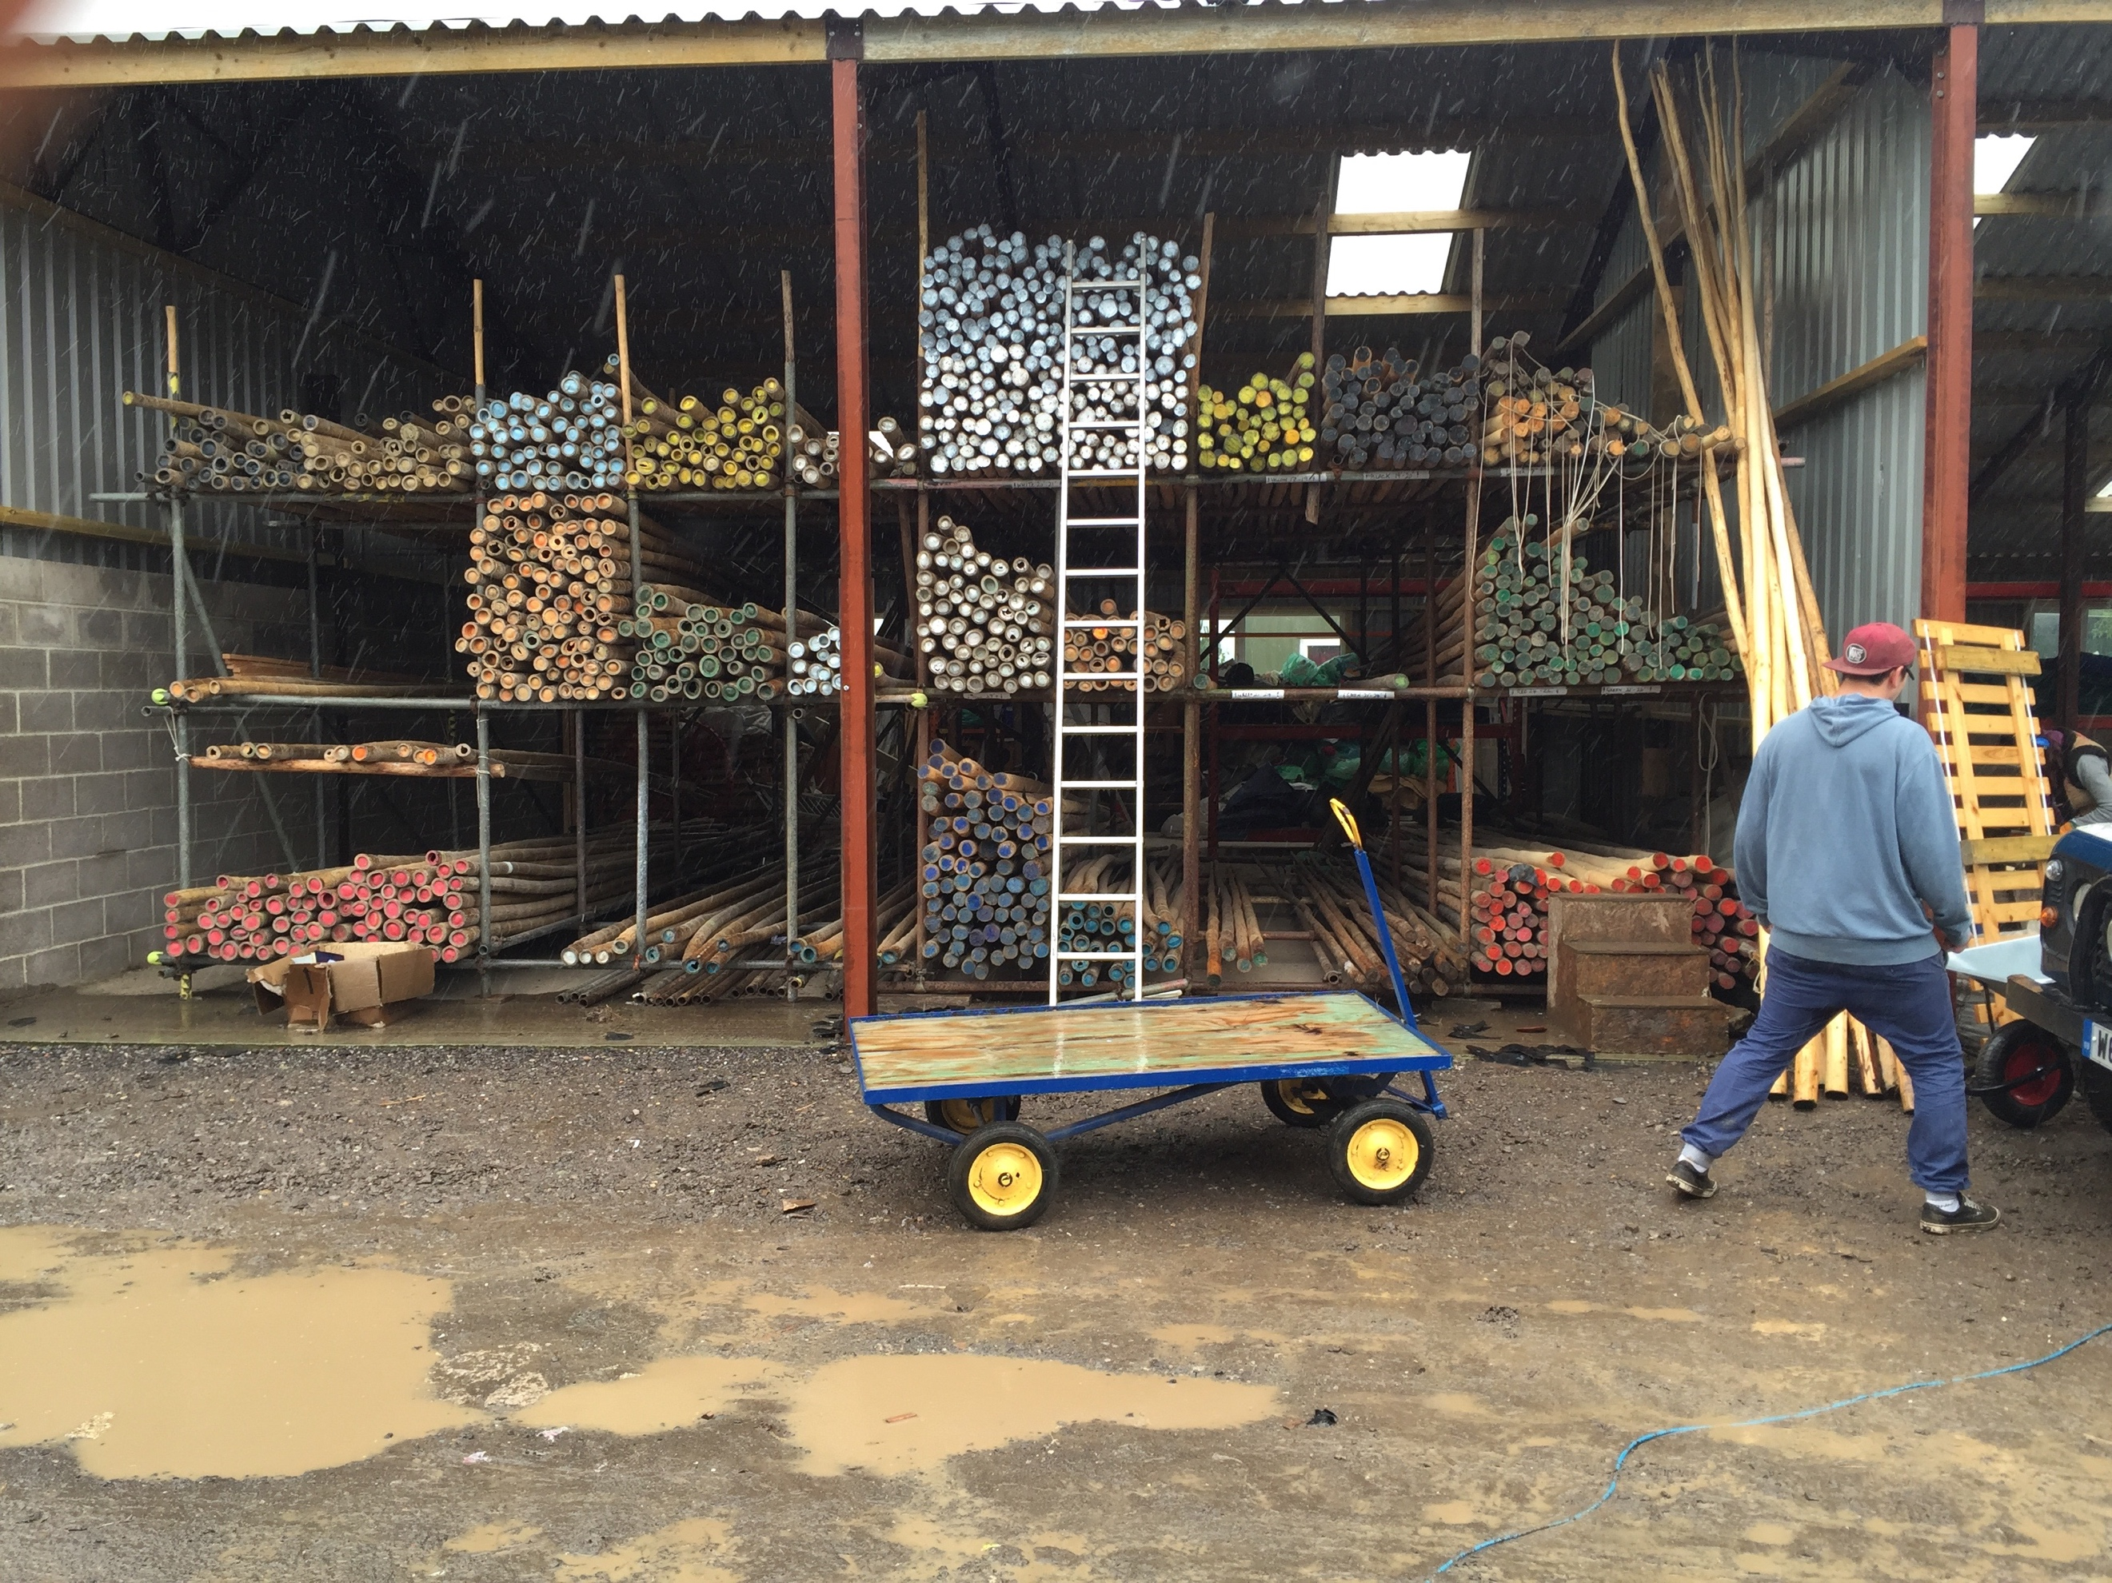
The ‘collective’ is a term first coined by Latour when he began to expand on his Actor-Network-Theory. It is used to define a sum of materials that have the dormant ability to be something as a whole; but require the interaction, and therefore agency, of an individual who has the knowledge and skill to create the wholly finished product from the collective (Latour 2007:75). Wishing to draw this point out more: the idea that not only do you have to operate within a collective when creating, but also when destroying and moving, as is done in the festival glamping industry. When the resources needed to build the structures are not being used on site, they are either in transit to or from a site or are being stored and maintained in the yard. Within this process the materials are not simply thrown in and taken out of the lorry to be placed in a hap-hazard milieu within the yard. Everything has its place, from the pole racks to the structure bag shelves, to carpet world and finishing off in duvet-world, these locations are highly controlled and maintained spaces, so that the business runs smoothly.
Figure 7: Pole racks at the yard

When loading a lorry for a site many things must be taken into account when handling the resources that the team will take with them. Stronger items such as wood work and structure bags will obviously have to be placed below the softer items such as duvet’s and pillows. If only it were as simple as going from strongest to weakest. Often when loading the lorry you will only be able to load half of what you need, as the lorry is not big enough to be able to carry the full inventory. Frequently there are more than one festival taking place at the same and the second lorry is transporting all the equipment needed there. So obviously you will need to divide what you need at first from what can loaded in the second delivery. This tracks back to the section before this in the division of the ‘making’ and ‘doing’ (Ingold 2000:295), as once again two stages must interact with each other for the whole process to flow efficiently. Not only are the two stages of one process communicating with each other, two processes (the build and break of two different festivals) are also communicating together. The team leaders from the two jobs must tell each other what they will require and when they will require it.The teams must try and remember what the challenges of the site may be and how to overcome them. Within this constant dialogue between the many individuals it is the materials and the environments that are deciding how those workers will use their agency (Latour 2007:72). Certain sites will demand items be sent out of the usual order; if it is known that it will rain, a weather-proof structure is usually placed to be unloaded first, so that when it is erected all other resources may be safely placed inside. Other sites will have transport constraints on them, to protect the ground for the paying public, so wheelbarrows will have to be loaded on board. All this shows that the environment the worker wishes to enter and successfully build the structures is going to be have to be worked with as much as the materials (Knappet 2005:53).
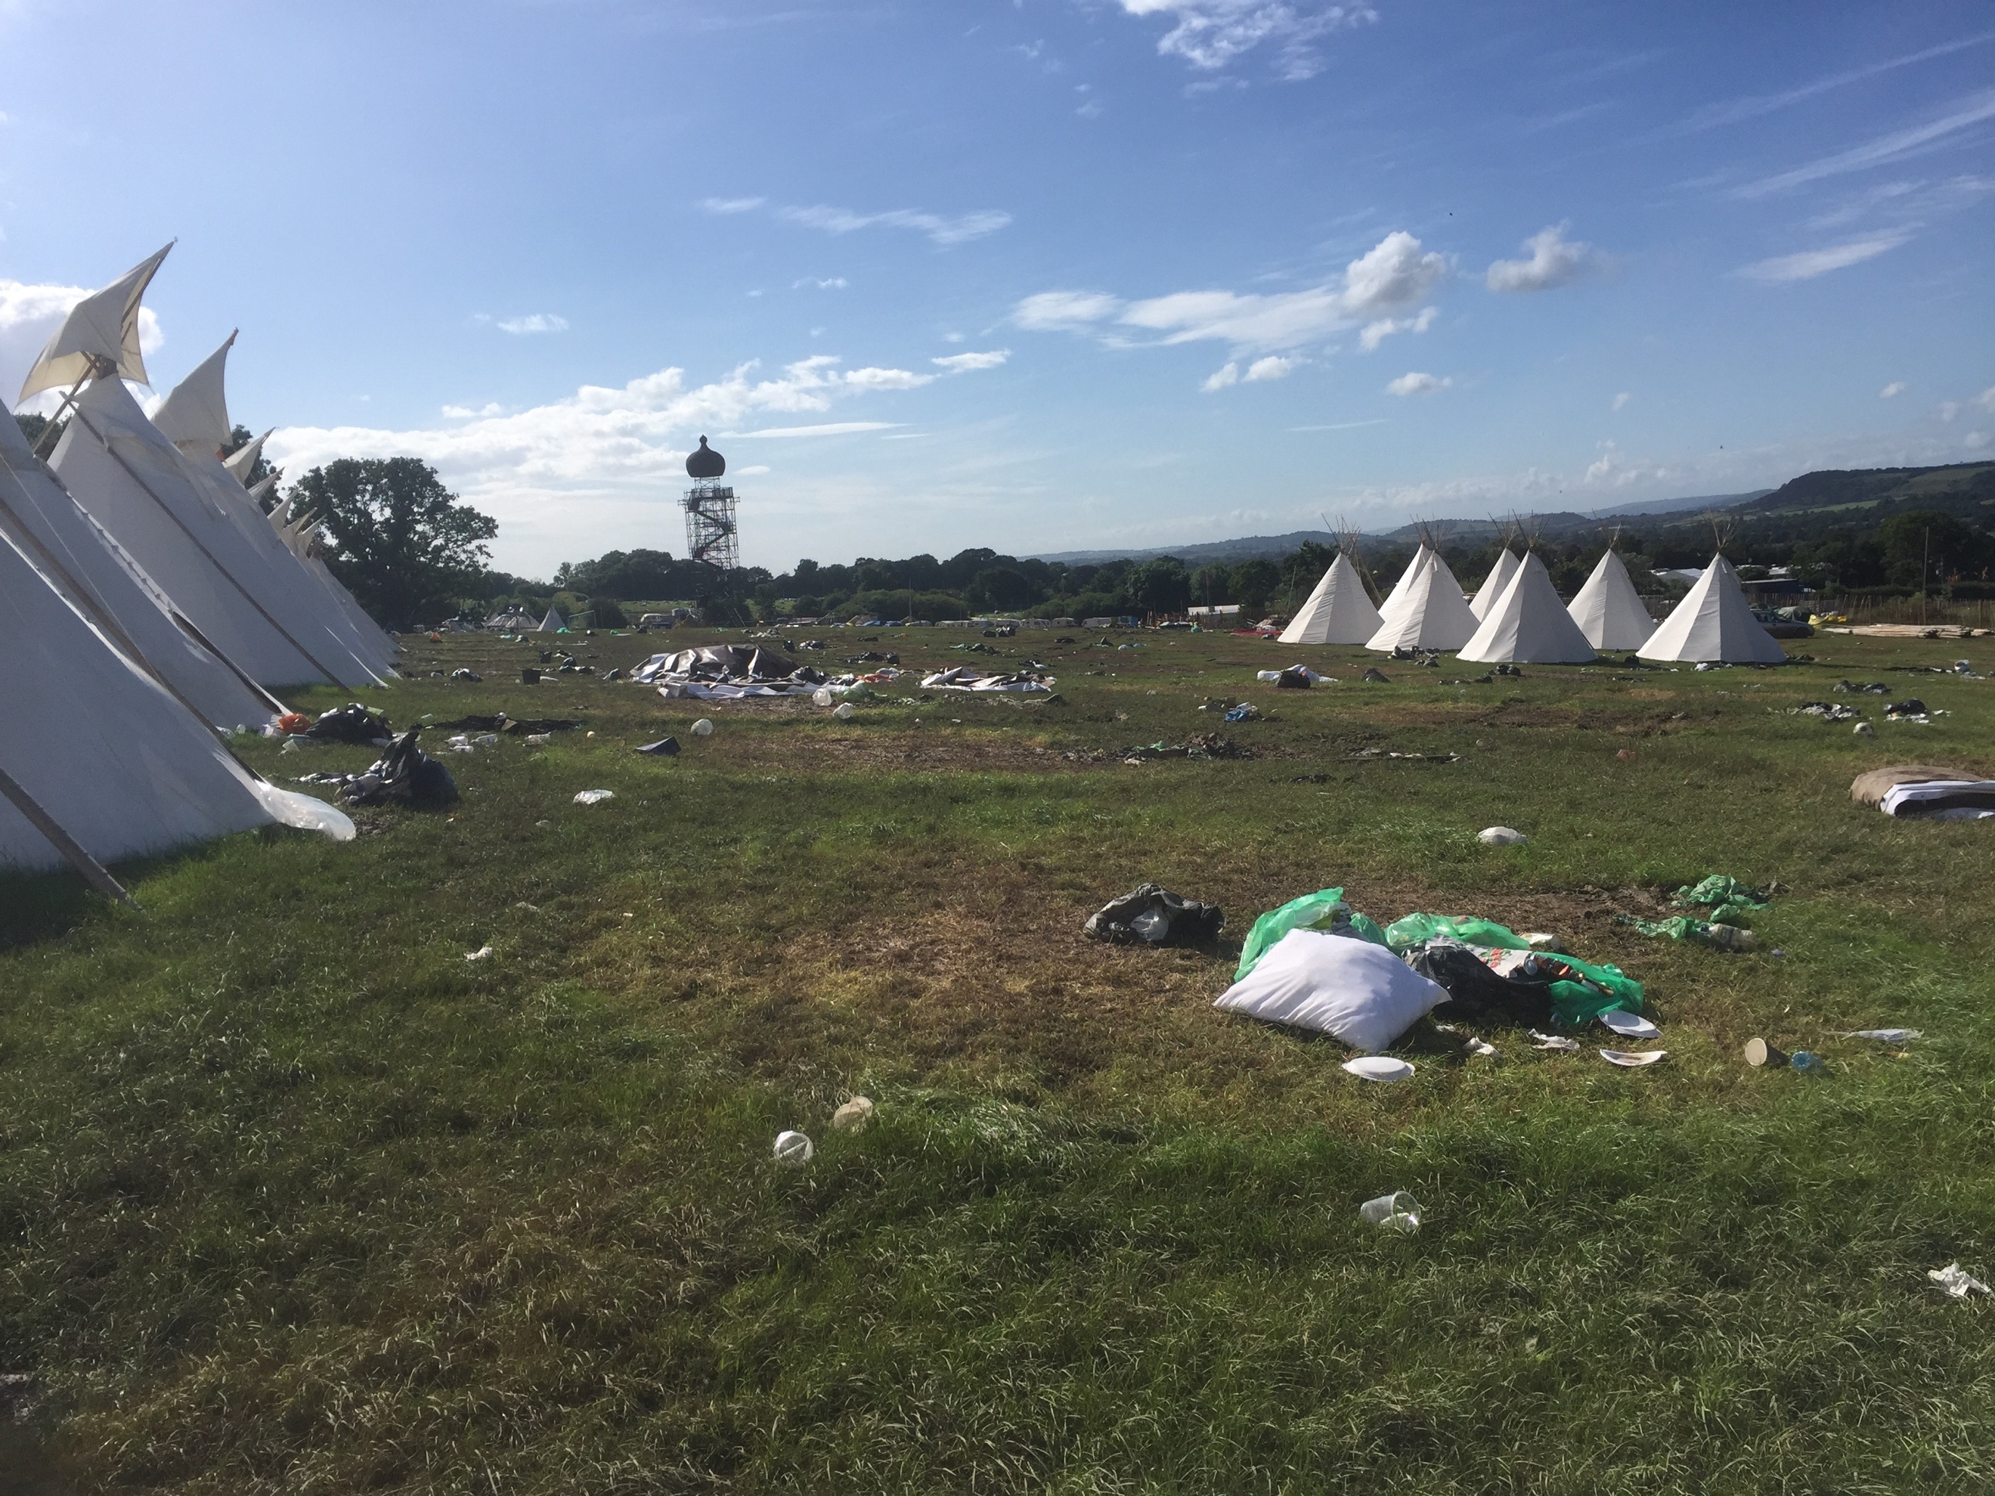
On the return leg of the journey, after the breaking of the festival, the constraints on the workers concerning what must be placed in the lorry first are found back in the Yard. There, the unloading of the vehicle must be done as quickly and efficiently as possible, with many of the items only spending a few days in the yard before heading back out. What this means is that on the field you must think about how your lorry will be unloaded at the yard. Having felt the scorn of other workers from a badly loaded van I quickly found that this was a nerve you didn’t want to tread on. This shows, not only the high work ethic of those around me, but the respect for the materials being worked. They were the reason why we were all there, these pieces that together formed the structures that allowed us to make our living. It is easy to see them as being as an important actant within the social milieu as a factor that draws people together and get them driving in one direction (Latour 2007:73).
Back on the field the materials play a role in the construction of the site in more than just a simple subservient role. The ‘collective’ of materials, before the introduction of an agent, has many possibilities to how and where it may all be used (ibid 83). Out of the entire collection of materials transported only the animal skins and wooden furniture have a single use. All the other parts of the equipment may be transferred to a new use when needed. Koi matting is a heavy duty matting made from coconut fibres. It is used in large semi-circles as floor matting in the larger structures, but due to its durability and the fact there are many older pieces being phased out for new synthetic carpets, it has found new uses. From make shift shelters, to bedding, to filler on trailers and even as fuel for a fire to keep the team warm, coir is used for tasks that would be totally unimaginable to the creator or the original consumer (Knappet 2005:47). Most of these actions are based on off the cuff decisions; no-one teaches you how and when to use the coir but after a few weeks on the job you begin to understand what the protocol is.
Figure 8: Glastonbury festival break
The main subject of this section is learning within the field. The focus will shift to push the objects that populate the environment, in which the individual finds themselves, into the forefront. The ‘collective’ is simply the sum of all materials in the area before the agent arrives and begins to form them into a construct designed at an earlier date. The ‘collective’ is moved not only physically by the worker, but also conceptually, in their mind (Latour 1999:175). This links back to the ‘doing’ and ‘making’ divide Ingold theorized about and that the line seems to be blurring more and more. This line becomes ever more elusive. As the worker tries to force their own agency onto the objects they are immediately met by a certain level of resistance from those objects. The pine poles used for the tipis and the roof sections for the yurts are good examples of this almost agent like strength being exhibited over the process.
The worker must work with the nuances and chaos of the individual parts. The poles have already been spoken about; each one even at the same length will have a distinct personality and its own rhythm. As the structure is built up all the materials’ rhythms must be taken into account; it is not that these materials jar against each other just that there is always a bit of re-jigging needed. This is not done at the end of the task, but rather as the task is ongoing (Knappert 2005:41). The worker is always testing the structure against the plan they have in their minds. When a problem arises the worker must be able to discern where within the multi-stage process the error is and unpack the structure back to that point. This is defined as ‘black-box thinking’ by Latour (1999:184); here the whole structure is in fact the sum of many processes that fit into each other. So that the final structure looks solid and secure, but is at the same time easily manipulated to fix a problem.
This dovetails into what was earlier talked about in regards to learning through repetition, where only by constantly being in touch with the materials and learning their problems and solutions can the worker be fully skilled in maintaining the structures (Delande 2006). When a tipi had almost been pegged in and pronounced finished, a team leader approached and surveyed the structure. As they moved through the whole area, touching the skin and then the poles they often stopped and looked up. Most problems arose within the tripod knot, crown and lifting pole and the leader is trying to discern which stage has gone wrong. It is always a moment filled with nervousness as the structure has just been fully constructed for the first time. Does it fit the plan in the leader’s head, and if not can it be fixed without totally destroying the whole (Latour 2007:89)? This shows the collective force put in between the workers and materials; as the goal has to be achieved through the two sides working in tandem to overcome obstacles, created by either one of them or by the environment they find themselves in.
This section has looked to expand the analysis of the role of materials in the process of construction of tipis and yurts. The materials transform from tools and resources, literal bystanders to the worker’s whim, to a more serious role of being able to direct the flow of agency (Latour 1999:209). The worker must be able to use the skill they have refined over time to employ certain techniques in order to properly understand in what way the materials will block them and how best to overcome this.

Creation of the worker
The ability of the worker to be able to come to tasks of differing settings and available resources and utilise the skills acquired from past tasks is a key component in being a skilled craftsman (Marchand 2016:8). The term ‘bricoleur’ (noun) and ‘bricolage’ (verb) was first termed by Levi-Strauss in his work The Savage Mind (1974). He uses these terms to describe the individual, and their actions, who ‘wander’ through the world working here and there (Levi-Straus 1975:16). This may seem like the antithesis of what Sennet and Ingold were defining as ‘craftsman’, as their individual needed to put in many hours of hard work to master their chosen skill. But these two conflicting ideas seemed to complement each other, especially in the festival work space. A third aspect is now added as a foundation stone for these two supposedly opposing ideas; that is the Body without Organs (BwO) from the writings of Deleuze and Guattari. Here the body is placed in a state of freedom from the constraints of capitalism and instead of being driven by a societal code, the individual finds their way through desiring to create something (Deleuze and Guattari 1984:400). This then allows the bricoleur and craftsman to lie beside each other in harmony. As the bricoleur is given the agency to follow their desires wherever they may take them and the multiplicity of permutations of the BwO allows the craftsman to work on honing his skills without the perils of the capitalist market hanging over them.
Much of the workforce in the UK will perform the same type of jobs for most of their lives. That is not to say that they will not move companies and even enter into different aspects of an industry. For the most part they will find themselves performing tasks of the same type in the same settings. The ‘bricoleur’ is someone on the other hand who looks to move and change from profession to profession, not only learning new skills but importantly reusing old skills in new settings (Johnson 2012:358). It is this facet that was most I most noticed in the workers at Hearthworks, almost all of whom had never seen a tipi or yurt up close before, let alone know how to construct or maintain one. What many of them did bring was a wealth of knowledge accumulated on previous jobs. Some had been marquee builders, or worked for the stage construction firms; there were many builders and mechanics, some the products of apprenticeships and some self-taught. All this knowledge was brought with each of them to the new task and its own problems and solutions, there it was assimilated by the individual who then choose the best skills for the task in hand (Hatton 1989:75). This movement between spaces goes further than just work for some of the individuals. Many will in fact work for two or three seasons, and I mean flat out work not only gaining as many hours with Hearthworks but also in as many other jobs as they can manage, and then leave to some far flung part of the globe for two or three years. They desire to be free from the constraints of home life, often dictated by capitalist based society (Deleuze and Guattari 1984:155). It is that these people have made decisions in their lives to move away from the ‘disciplinary societies’ that Foucault talks of (Deleuze 1992), and instead opt for a life where they choose to go where their desire takes them. This is not to say that they simply chase the seven sins across the seven seas; but that they looking to free themselves from the enclosures of society and find where they desire to be.
As someone who had not come from any sort of profession, but was still at university, I found myself having to play catch up. All of the other crew were adept in the use of the tools of the trade, that is not to say I had never seen a hammer or ladder before, but it had only ever been in a layman, or DIY sense. There had been no onus on learning or refining the skill, which is obviously not what the ‘bricoleur’ does (Hatton 1989:74). The ‘bricoleur’ whilst living in a world of unstructured movement does have structure in the tasks they attempt. As they will be reusing old knowledge for the new task the knowledge itself is engrained into their body and mind which they have repeated sufficiently to become a skilled practitioner at (Burkett 1998:68). This ability to hold skills as tools within the body and mind, ready to be brought out when the opportunity arises is a key facet of both the ‘bricoleur’ and the craftsman.
This repetition of an act to become a skill is really the key characteristic that ties together the ‘bricoleur’ and the craftsmen. The ‘bricoleur’ looks to build their ‘bricolage’ from these skills, it is like a tool box they have in their body which is constantly updates as they meet new tasks and refine the skills they have through using them (Levi-Strauss 1974:18). Just as in the craftsman’s life his skill is learnt through constant repetition of a single act, or collection of closely related acts (Marchand 2016:11), so it would not be difficult to see a craftsman being able to learn more than one ‘craft-skill’.
This tool box being pieced together by the workers not only opens up the possibilities for employment it also opens up their body for the addition, and perhaps subtraction, of skills and techniques. As the worker goes through their life, as a ‘bricoleur’ they are by definition a ‘wanderer’ or ‘traveller’, they will be moving through locations and meeting scenarios that have never been presented to them before (Johnson 2012:367). This will mean that not only will they have to take new idea and skills on to properly negotiate these unknown terrains, the reverse will take place where they will have to lose old and unneeded patterns and habits (Deleuze and Guattari 1984:157). This permeability of the body in relationship to skill and knowledge is something I experienced on the field. Throughout my entire life I had always thought you needed to be constantly watched and managed by an elder; this meant I was good at following precise instructions and never rushed ahead even if I understood the path. On the field there are many times where you are left for the entire day without speaking to your team leader, or any other member of your team; I had to leave these old methods behind and take on the new challenges and hone the skills required for the task.
In the festival space the ‘bricoleur’ is a person of unbiased thinking, by this I mean at the start of each task there is no piece of knowledge that stands first among many in the workers’ mind (Burkett 1998:75). At the outset of a task, all the collective knowledge held by the individuals and team are laid out at on an equal field to be properly utilized. This is what is going on during the brief cigarette breaks and longer tea breaks. Even if you have just put up ten tipis and after the break you’ll put another ten of the same design, you will still communicate your plan with everyone present. The comparison of technique and method allows for different viewpoints to be taken into account and will hopefully illuminate any obstacles in the road ahead.
The task is obviously much easier when you have previous meetings to guide you. In the second year of working with the tipis a new design was brought in called the Tri-Lodge. This was a simplified Tipi structure, only needing three poles on the outside instead of the eight or more on the inside. Before getting to the site I had never seen or erected one before, although there had been a prototype of sort built on a grassy patch at the yard. I had walked around and inside the structure so that I understood what the end product should look like.
When we tried the first attempt at raising the tri-lodge we almost snapped the poles. We had thought to walk the three legs inwards, whilst the skin was suspended over the crown by a rope held by another worker. This was impossible due to the unevenness of the ground, and placed too much pressure on the poles, as each one was being moved separately. The half-built structure came down, cigarettes were lit, coffee was poured and we sat in pensive silence looking at our task. After a few minutes our team leader walked back to the site and looked out to the lake, then to the other structures we had finished earlier, and then to the current task. He returned to the van we were sitting, found a tape measure and walked back to the structure. Now looking inwards he measured the distance from the ground to where the crown would rest and then used that measurement to mark three spots on the ground. At this point the rest of us had collected around him and were trying to discern the reason for his actions. Turing back to us has asked for nine fifteen inch pegs and three hammers. Once the resources had been found he set us about hammering the pegs where he had marked the three points. Once it was ready we lined up two poles, on the downhill side, against their newly built their buttresses, and then walked the last free pole up to its resting place. As this was finished we quickly went to hammer down the skin and attach the ground sheet, it was at that point we realised we had used the pegs needed here as the supports. Now we had to quickly retrieve the pegs, without moving the poles and get the skin down before the now strengthening wind turned the tipi into a kite. There was no way we could have predicted all the obstacles we met on this task, and when I erected the same structure a few weeks later the problems were almost all of a new variety. The team leader showed what the ‘bricoleur’ is best suited for, as the environment and resources began to shorten our options, he was still able to hold in his mind what the end product should be (Johnson 2012:363). We were able to work through these obstacles by using skills we had learnt before.
It is this dialogue between the individual and the world around them that makes the ‘bricoleur’ such an important part of the act of embodied learning. The ‘bricoleur’ by Levi-Strauss’s definition is a ‘wanderer’ or ‘traveller’, and this would mean that the skills must be easily movable between places, tasks, and resources (Levi-Strauss 1974:18). Whilst Levi-Strauss looked at the ‘bricoleur’ as the opposite of a craftsman (ibid 17), I believe that in the time between the creation of the word during the 1950s and the present, the world of professions has changed dramatically. Now ‘the craftsman’ must live a traveller’s lifestyle, due to the fact that opportunities to make money may not stay in one location for an extended amount of time. Though this is a constraint capitalism places upon them and one I believe the workers try and actively rebuke. Through the ownership of live in vehicles and expansive knowledge of skills that together allows the individuals to work almost any place around the globe that they may desire to be.
Figure 9: A worker and his tools

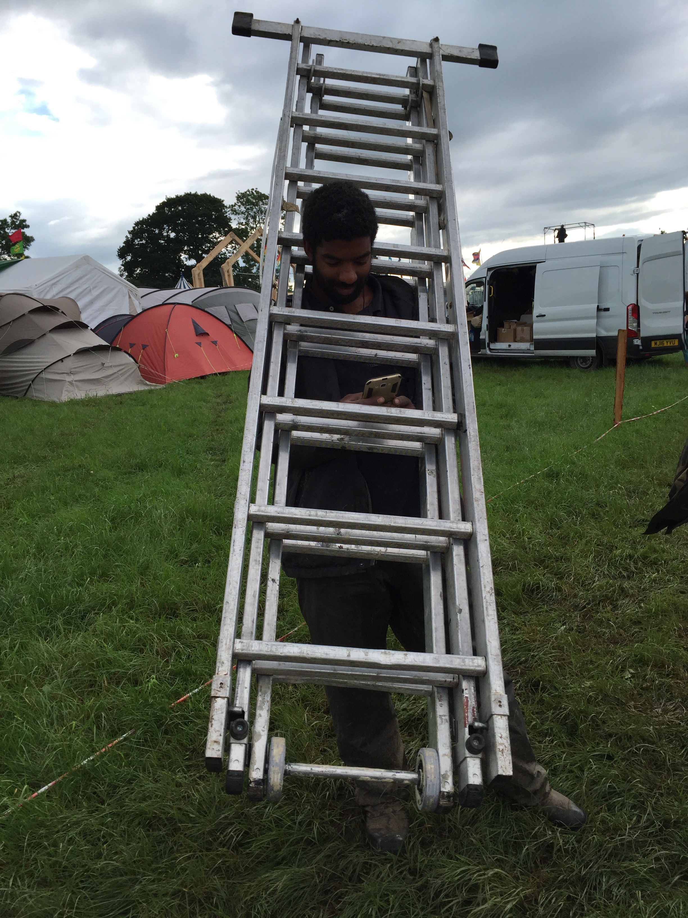

Tying the crown together
The main point of this section has been to show how the act of embodied learning in the field is something that is manifest in three ways. First it is in the mind of the individual, who must carry with him the skills and techniques of past actions, never truly knowing if they will be used again. Being prepared to sacrifice certain aspects of those techniques and skills, in the workers ‘tool box’ in order to see clearly what will be the best course of action to overcome an obstacle (Clark and Chalmers 1998). Slowly over time the body and mind become more attuned to the environment and are able to spot issues before they arrive.
The environment itself, where it is combined with the available resources are used as receptacles for past knowledge to be placed into, making them come alive with an almost agent-like verve (Latour 1999:177). This addition of new ‘actants’ within the field allows the individual to have a better understanding of what each piece requires to be able to fit into the whole. The term used by Latour ‘Homo Fabre’ is intricately linked with that of the ‘bricoleur’. Although the latter is concerned with the relationship between the knowledge, skills and techniques the individual has accumulated over time and the former is concentrated more on how to navigate the resources and environment in order to complete the task. Both have the ability to see the task as single events, built up as a chain of steps leading to the goal (Latour 2007:72 & Levi-Strauss 1974:18). This means that they have an understanding of the task that is able to change and negotiate most obstacles that may arise.
The synthesis of these two paths, which may seem to veer off in opposite directions, is the third piece in building the act of embodied learning. Here the individual and the environment are blurred, not into one, but closely enough so that knowledge may freely move back and forth between them. This relationship is not something that comes quickly or easily. It is up to the individual to hone the skills and techniques they find within themselves in order to best navigate through the task (Ingold 2000: 298 & Ingold 2013:52), which takes time and effort.
This adding and subtracting from a body that does not have totally solid lines of demarcation, is paramount to the work done in the festival space and the act of embodied learning. By being able to take into account many facets of the task at once and see through any personal bias to the correct path, and in this way creating a new world for their body to occupy (Deleuze and Guattari 1984:161). In this world the worker is not king, does not rule over all, does not bend all to his will, but instead is able to negotiate problems with ease and flows through the world without causing disturbance.

Conclusion
Drawing the three threads of this dissertation together we are able to see how embodied learning takes place, not only in the individual or the collective materials used in the task but through a synthesis of both. This is why it is important in the festival glamping space to utilize these processes correctly; as the actions taking place are difficult to teach in a class room setting (Connerton 1989:76). The modern day craftsman is no longer able to live their lives in a single location, as the demand for the product they create is no longer high enough to make it possible for them to live there for extended periods of time (Ingold 2011:150). Instead the craftsman must go out into the world and find places where his craft, or the knowledge of the skills and techniques, can be put into practice. This can mean that these skills will be used in new tasks as and when they are needed.
The worker in the field of glamping must be seen as a craftsman by this standard. The lives these people live are not based in the need for work to simply scape a life together where they can. All of my co-participant’s I worked with lead lives that take them far away from the locations of their labour. Many look to use this work to fund these lifestyles not only in an economic sense which it does, but also in being taught new skills and techniques that are transferrable to other aspects of their lives (Ardent 1958:83). The ownership of live-in vehicles has been mentioned briefly at the start of this dissertation and is a useful example of the relationship between work and life of the people who live in them. At tea breaks, especially on a hard day, the subject of work would be met with some repute. So one of the popular alternate subjects would be to talk about the issues and plans each had with their vehicles. Knowledge passed between individuals would not only help them in their private lives but could also be helpful in the work environment as well. Now they knew how to make their vehicles into what they had planned and through the sharing of information become more intertwined with the community at large (Ingold 2015:18). This learning, practicing and reworking of skills is what makes the craftsman such an elusive character.
This ability to understand what skills are needed when and where is paramount in the festival space. Levi-Strauss’s ‘bricoleur’ holds this ability as its main characteristic, and is unluckily placed as the antithesis of the craftsman by Levi-Strauss. This can be overlooked due to the changing face of the work place in the interceding period between when Levi-Strauss termed the idea and today. The craftsman now must be a ‘traveller’ or ‘wayfarer’, no longer tied directly to his workshop he must go out into the world with his bag of skills and techniques and look to employ them where he can. The combination of the bricoleur with Deleuze and Guattari’s Body without Organs gives this ‘wanderer’ an agency to follow his desires, his dreams, through the world. This is done in opposition to the normal ‘life-plan’ laid out by most as it looks to negate the pressures if capitalism and instead organise the body to fulfil goals of happiness.
It may not be in the same area as the skill was learnt so there must be a decoupling of certain knowledge with actions (Clark and Chalmers 1998). So that when the individual meets this new task they have the ability to see the what actions will require what skills. Even if the skill has been learnt under different circumstances the bricoleur must look upon them all as equal and then make his decision by seeing what the activity and environment require (Johnson 2012). This shows, the intimate relationship between the individual, available resources and environment in the learning and using of skills and techniques.
When looking at the materials used on the festival sites there is found an agency among them. Even though the worker is in control and the driving force behind the tasks completion it is only by understanding how the materials will work together best do they complete the task to the best of their ability (Connerton 1989:92). By understanding how the ‘collective’ is wanting to be used the worker is able to negotiate with them on much better terms (Latour 2007:75). Now with this understanding the worker is able to become more attuned with the materials as if they were part of the individual’s body (LJ Nicholson 1990:198). In this growing understanding between individuals and materials the issues that arise are better understood and overcome with more ease, due to the fact the process is understood not as simply one action but as many smaller steps leading to the eventual goal (Delande 2006). Through this step-by-step understanding the process no longer needs to be restarted each time an issue arises, as the individual now understands each step and will be able to discern where exactly the problem lies.
Over the two seasons these changes took place within my body and mind. When I first arrived I did not even understand how to carry a structure bag correctly let alone put the entire thing up. It took time, effort and failure for me to begin to get a grasp on what was going on and how best to tackle the situation. By working with, watching and listening to more experienced members of the team I was able to better understand the rhythms of what we had to do I have slowly but surely become a crafts man in my own right.

WORD COUNT: 10,701

Bibliography
Agar MH (2008) The Professional Stranger, Emerald Group Pub. Ltd, Bingley

Ardent, H (1998) The Human Condition, University of Chicago Press, London

Button, G (1993) Ethnomethodology and the Human Sciences, Cambridge University Press, Cambridge

Burkett, I (1998) Journal for the Theory of Social Behaviour, ‘Bodies of Knowledge: Beyond Cartesian Views of Persons, Selves and Mind’, 28:1 pp63-84.

Clark and Chalmers (1998) Analysis, ‘The Extended Mind’, 58:1 pp7-19, Oxford University Press

Coffey, A (1999) The Ethnographic Self Fieldwork and the Representation of Identity, SAGE Pub. London

Connerton, P (1989) How Societies Remember, Cambridge University Press, Cambridge

Delanda, M (2006) ‘A new philosophy of social-assemblage theory’, Continuum

Deleuze, G (1992) ‘Postscript on the Societies of Control’ October Vol 59, MIT Press

Deleuze and Guattari (1984) A Thousand Plateaus Capitalism and Schizophrenia, University of Minnesota, Minneapolis

Hatton, E (1989) Anthroplogy and Education Quarterly ‘Levi-Strauss Bricolage and Theorizing teachers work’ 20:2 pp74-96

Ingold, T (2000) The Perceptions of the Environment, Routledge, London

Ingold, T (2011) Being Alive, Routledge, London

Ingold, T (2013) Making, Routledge, London

Ingold, T (2015) The Life of Lines, Routledge, London

Johnson, C (2012) Paragraph ‘Bricoleur and Bricolage: From Metaphor to Universal concept’ 35:5 pp335-372

Knappert, C (2005) Thinking through Material Culture: An Interdisciplinary Perspective. University of Pennsylvania. Penn.

Latour, B (1999) Pandora’s Hope, Harvard University Press, London

Latour, B (2007) Reassembling the Social, Oxford University Press, Oxford

Malafouris, L (2008) Is it ‘me’ or is it ‘mine’ The Mycenaean Sword as a body-part, (From Past Bodies ed J. Robb & D. Boric), University of Cambridge Press, Cambridge

Marchand THJ ed. (2016) Craftwork as Problem Solving: Ethnographic Studies of Design and Making, Routledge, London

Pink, S (2001) Doing Visual Ethnography, SAGE Publications, London

Robson, C (2000) Real World Research, Blackwell Publishing, London

Sennet, R (2008) The Craftsman, Penguin Books, London

Sutton, DE (1998) Memories Cast in Stone, Berg Press, Oxfordshire

