

Student name: Magie Oligo
Student ID: 2436384
Module name: Introduction to Physiology
Module code: BMHP5023_LON
Lecturer name: Dr. Soban Sadiq
Assessment: 1 Diabetes - Level 5

Table of Contents
Type 2 Diabetes: Blood Glucose Regulation, Cellular Metabolism, Monitoring and Lifestyle Management 3
Introduction: 3
Regulation of Blood Glucose and Homeostasis: 3
Importance of Homeostasis: 3
Role of the Pancreas, Insulin and GLUT4: 4
Insulin Action and Negative Feedback: 4
Role of Glucagon During Low Blood Glucose: 4
Disruption of Homeostasis in Type 2 Diabetes: 4
Production of Energy from Glucose and Oxygen: 5
Importance of Recording and Monitoring Blood Glucose: 6
Evidence-Based Lifestyle Recommendations: 7
Healthy Eating and Weight Management: 7
Physical Activity: 8
Smoking Cessation: 8
Conclusion: 8
References: 9

Type 2 Diabetes: Blood Glucose Regulation, Cellular Metabolism, Monitoring and Lifestyle Management

Introduction:
Diabetes mellitus is a chronic metabolic condition which is defined as having abnormally high blood glucose. Carbohydrate-derived glucose is a vital fuel for the body's cells; insulin helps glucose enter insulin-sensitive tissues, such as skeletal muscle and fat. Diabetes occurs when the insulin is missing, not enough or not working well. Long-term hyperglycaemia can lead to damage to blood vessels and organs which can increase the risk of cardiovascular disease, kidney disease, neuropathy (nerve damage), visual impairment and delayed wound healing (NICE, 2022; American Diabetes Association Professional Practice Committee, 2024a).
There are two main types of diabetes: Type 1 and Type 2. The cause of type 1 diabetes is an autoimmune disorder where beta cells in the pancreas are damaged, and the insulin supply is completely depleted. This means that in people with Type 1 diabetes insulin must be taken for life. Type 2 diabetes is the most common type and is characterized by the combined factors of insulin resistance and progressive decline in the functioning of pancreatic beta cells. While excess body weight, inactivity, smoking, and an unhealthy diet are risk factors, age, family history and ethnicity are also important factors that cannot be changed (Davies et al., 2022; Diabetes UK, 2024).
This report builds on the content of the initial case-study document and focuses on aspects of blood glucose homeostasis, cellular respiration and glucose monitoring and evidence-based lifestyle management.

Regulation of Blood Glucose and Homeostasis:

Importance of Homeostasis:
The body's ability to keep the internal environment relatively stable despite varying food intake, physical activity and energy demands is called homeostasis. This is also important to note for blood glucose regulation, as both hyperglycaemia and hypoglycaemia can affect physiological function. The pancreas, liver, skeletal muscles, and adipose tissue and endocrine hormones regulate the maintenance of glucose in an appropriate range (Tortora and Derrickson, 2021; Marieb and Hoehn, 2023).

Role of the Pancreas, Insulin and GLUT4:
Clusters of cells are found in the endocrine pancreas, and these are referred to as islets of Langerhans. Insulin is produced by beta cells and glucagon is produced by alpha cells. Following a carbohydrate-rich meal, digestion releases glucose which enters the bloodstream. This increase in blood glucose triggers an increase in insulin production by the pancreatic beta cells. Insulin binds to receptors on target cells which activates intracellular signalling pathways. In skeletal muscle and adipose tissue, this signalling promotes the translocation of glucose transporter type 4 or GLUT4 to the cell membrane, which increases the uptake of glucose.

Insulin Action and Negative Feedback:
Insulin also stimulates glycogenesis, which involves the liver and muscles storing excess glucose as glycogen. It increases fat production and decreases liver glucose production. These actions work together to reduce glucose levels in the bloodstream back to normal levels. After the primary rise is corrected, the release of insulin is reduced. It is an example of negative feedback in which the physiological response counteracts the initial change (Marieb and Hoehn, 2023).

Role of Glucagon During Low Blood Glucose:
Pancreatic alpha cells release glucagon when blood glucose decreases between meals, during fasting or during longer periods of activity. Glucagon acts mainly on the liver, promoting the liberation of glucose from glycogen (glycogenolysis) and the synthesis of glucose from non-carbohydrate sources, such as lactate, glycerol and some amino acids (gluconeogenesis). Glucose is then poured into the blood stream. When blood glucose increases, the secretion of glucagon decreases which is another negative feedback loop (Tortora and Derrickson, 2021).

Disruption of Homeostasis in Type 2 Diabetes:
With Type 2 diabetes, the muscle, liver and fat cells become less responsive to insulin. The initial response of the beta cells is to secrete more insulin. However, a continued demand for insulin can lead to progressive metabolic dysfunction of the beta cells, which is a deficit in insulin production. When the amount of glucose in the blood is elevated, the liver could continue to produce glucose. This means that food will cause a rise in blood glucose, and fasting (10–14 h) can also increase blood glucose (Davies et al., 2022). The opposing actions of insulin and glucagon are represented in the homeostasis diagram on page 6 of the original report, but a more elaborated scientific or academic presentation would refer to the original scientific or educational source directly.
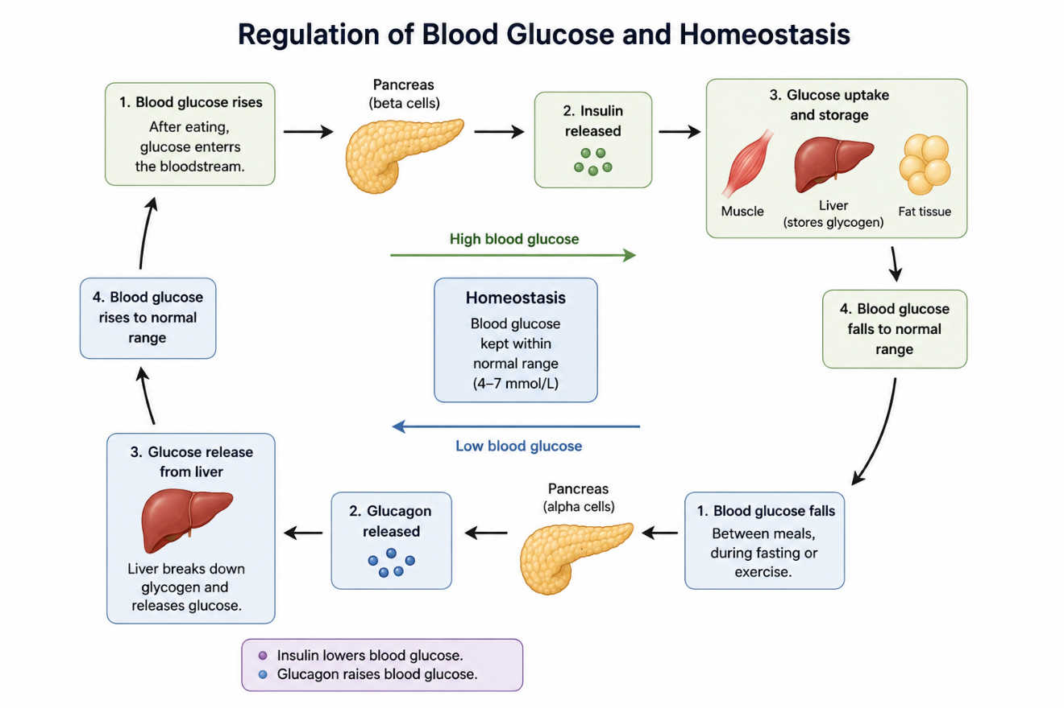

Production of Energy from Glucose and Oxygen:
Cells require energy for muscle contraction, active transport, tissue repair, growth, protein synthesis and maintenance of organ function. Adenosine triphosphate (ATP) provides most cellular energy. Chemical energy within glucose is released in aerobic cellular respiration by a series of interdependent processes and converted to ATP:
Glucose + Oxygen → Carbon Dioxide + Water + ATP
Glycolysis takes place in the cytoplasm and breaks one molecule of glucose into two molecules of pyruvate. It is a producer of a small amount of ATP and reduced nicotinamide adenine dinucleotide. If there is enough oxygen, the pyruvate is transported into the mitochondria and converted into acetyl coenzyme A. This goes into the citric acid cycle (also known as the Krebs cycle) that generates carbon dioxide and donates high-energy electrons to carrier molecules.
The electron carriers are then used to donate their electrons to the mitochondrial electron-transport chain. O2 is the final electron acceptor, allowing oxidative phosphorylation to occur and the production of the majority of ATP in aerobic respiration. O2 + e- and H+ (protons) give water. In this way, oxygen is required to aid the efficient production of energy but is not directly involved in the breakdown of glucose in glycolysis (Tortora and Derrickson, 2021; Marieb and Hoehn, 2023).
If oxygen levels are low, Pyruvate can be turned into Lactate. This way glycolysis can continue to produce ATP but with significantly less ATP than aerobic respiration. Increased lactate could be linked to muscle fatigue during heavy exercise, though there are several physiological causes of fatigue and it is important to remember that it is not solely due to lactate.
With Type 2 diabetes, glucose can be present in the blood, but is not taken up by some tissues, because of insulin resistance. This adds to the fatigue and exercise intolerance that some experience. Chronic hyperglycaemia also causes oxidative stress, inflammation and abnormal protein glycation to small and large blood vessels. Poor circulation and nerve damage can create problems with the delivery of oxygen to tissues and poor tissue sensation and wound healing (American Diabetes Association Professional Practice Committee, 2024b).

Importance of Recording and Monitoring Blood Glucose:
Monitoring can help determine the effectiveness of diabetes management and patterns of meals, activity, illness and medications. Monitoring, however, should be for a specific purpose and must be interpreted with the help of health care professionals.
Self-monitoring of blood glucose is a test that uses a glucose meter to test a finger prick blood sample. Not everyone who has Type 2 diabetes needs to check their blood sugar every day. It is recommended specifically for people using insulin, who have previously experienced hypoglycaemia, are taking medication which can lead to hypoglycaemia, are pregnant or must be monitored for certain clinical reasons (NICE, 2022). Results can be used to alert the patient and clinician to high or low glucose levels and make appropriate treatment decisions.
A glycated haemoglobin (HbA1c) test gives an indication of average glycaemic exposure measured over a period of about 8-12 weeks. The higher the average glucose level, the more haemoglobin will be bound, and therefore the higher the HbA1c. Periodic testing enables health professionals to check longer term control and to determine if the medication, diet or activity regime needs to be changed or adjusted. One target should not be used for all patients, but should be individualised based on the patients' age, comorbidities, risk of hypoglycaemia, duration of diabetes and personal preferences (American Diabetes Association Professional Practice Committee, 2024a; Davies et al., 2022).
CGMs are a sensor that measures glucose levels under the skin and provides repeated estimates of the glucose level throughout the day and night. Can show trends and alert the user of increasing or decreasing glucose. There is growing evidence and guidance for the use of continuous monitoring in individuals with Type 2 diabetes who are using insulin or have challenging hypoglycaemia, specifically selected people (NICE, 2022; American Diabetes Association Professional Practice Committee, 2024c).
If you're just written down numbers, without really comprehending them, there may be little benefit and more anxiety. Therefore, practice nurses need to help the patients to link the results with meals, medication, activity and symptoms. Shared decision making can enhance confidence, self-management and treatment adherence.

Evidence-Based Lifestyle Recommendations:

Healthy Eating and Weight Management:
No one single diet plan is appropriate for everybody who has Type 2 diabetes. Cultural appropriateness, affordability and individual preference are key considerations in dietary recommendations. The recommended diet typically focuses on eating vegetables, whole grains, pulses, fruit, unset fats, fish and limiting sugary drinks, refined carbohydrate and processed meat, and foods high in saturated fat and salt (Davies et al., 2022).
Minimally processed carbohydrates and carbohydrates with higher fibre content are slower to be broken down and may result in less glucose increase after eating than refined carbohydrates. Portion awareness and setting up meals regularly can also help maintain an energy balance. In overweight or obese individuals, a sustained weight loss can enhance insulin sensitivity, blood pressure and lipid levels. Greater weight loss can result in significant glycaemic improvement, and in some newly diagnosed people, the benefits can be sufficient to achieve remission of Type 2 diabetes (which must be monitored to prevent a recurrence of hyperglycaemia) (NICE, 2022; Davies et al., 2022).

Physical Activity:
Moderate exercise enhances insulin sensitivity and glucose uptake by skeletal muscles. For adults with Type 2 diabetes, these three types of exercise should be integrated, supporting them in their health, mobility and preference. Activities can be brisk walking, cycling, swimming, chair-based exercise and strength training. The current evidence indicates 150 minutes of moderate to vigorous aerobic activity weekly, distributed over multiple days; resistance exercise 2 to 3 days per week, if clinically appropriate (Kanaley et al, 2022).
Exercise plans should begin gradually, especially for sedentary people or those with cardiovascular disease, neuropathy, foot problems or visual impairment. People receiving insulin or hypoglycaemia-lowering drugs may require guidance regarding glucose monitoring, carbohydrate intake and medication adjustments prior to exercise.

Smoking Cessation:
Smoking adds to the heart and blood vessel (cardiovascular), kidney (renal) and circulatory risks already high in diabetes. It can also lead to increased insulin resistance and delayed healing of wounds. Smoking status should be assessed, and non-judgemental brief advice given to patients and refer them to evidence-based smoking cessation services. Prescribed medicines, nicotine-replacement therapy and behavioural support can enhance the likelihood of successful tobacco cessation if selected based on individual needs (American Diabetes Association Professional Practice Committee, 2024d).

Conclusion:
Type 2 diabetes results from a combined effect of insulin resistance and gradual loss of insulin-producing ability of the beta-cells. Regulation of blood glucose is normally achieved by the coordinated negative feedback of insulin and glucagon, which are secreted by the pancreas, and are regulated by the liver, muscles and adipose tissue. ATP production in the mitochondria is fostered by glucose and oxygen, and poorly controlled diabetes disrupts the use of glucose and has a negative impact on tissues over time.
When combined with the interpretation of the results in context, HbA1c testing, and self-monitoring and CGM, can assist in informed treatment decisions. Managing glucose levels is only part of the picture; education and personalised nutrition, regular exercise, quitting smoking, taking the right medication and collaborative care are all part of the process. Practice nurses can set realistic goals with individuals and help minimize the risk of potential issues down the road.

References:
American Diabetes Association Professional Practice Committee (2024a) ‘6. Glycaemic goals and hypoglycaemia: Standards of Care in Diabetes—2024’, Diabetes Care, 47(Supplement 1), pp. S111–S125. https://doi.org/10.2337/dc24-S006
American Diabetes Association Professional Practice Committee (2024b) ‘12. Retinopathy, neuropathy, and foot care: Standards of Care in Diabetes—2024’, Diabetes Care, 47(Supplement 1), pp. S231–S243. https://doi.org/10.2337/dc24-S012
American Diabetes Association Professional Practice Committee (2024c) ‘7. Diabetes technology: Standards of Care in Diabetes—2024’, Diabetes Care, 47(Supplement 1), pp. S126–S144. https://doi.org/10.2337/dc24-S007
American Diabetes Association Professional Practice Committee (2024d) ‘5. Facilitating positive health behaviours and well-being to improve health outcomes: Standards of Care in Diabetes—2024’, Diabetes Care, 47(Supplement 1), pp. S77–S110. https://doi.org/10.2337/dc24-S005
Davies, M.J., Aroda, V.R., Collins, B.S., Gabbay, R.A., Green, J., Maruthur, N.M., Rosas, S.E., Del Prato, S., Mathieu, C., Mingrone, G., Rossing, P., Tankova, T. and Tsapas, A. (2022) ‘Management of hyperglycaemia in Type 2 diabetes, 2022: A consensus report by the ADA and EASD’, Diabetes Care, 45(11), pp. 2753–2786. https://doi.org/10.2337/dci22-0034
Diabetes UK (2024) Type 2 diabetes. Available at: https://www.diabetes.org.uk/about-diabetes/types-of-diabetes/type-2-diabetes
Kanaley, J.A., Colberg, S.R., Corcoran, M.H., Malin, S.K., Rodriguez, N.R., Crespo, C.J., Kirwan, J.P. and Zierath, J.R. (2022) ‘Exercise/physical activity in individuals with Type 2 diabetes: A consensus statement from the American College of Sports Medicine’, Medicine & Science in Sports & Exercise, 54(2), pp. 353–368. https://doi.org/10.1249/MSS.0000000000002800
Marieb, E.N. and Hoehn, K. (2023) Human Anatomy & Physiology. 12th edn. Harlow: Pearson.
National Institute for Health and Care Excellence (NICE) (2022) Type 2 diabetes in adults: Management (NG28). Available at: https://www.nice.org.uk/guidance/ng28
Tortora, G.J. and Derrickson, B. (2021) Principles of Anatomy and Physiology. 16th edn. Hoboken, NJ: Wiley.

