
Skills for the Workplace
Module Assignment Submission
Student Name: | Shelly Williams
Student Number: | 2017568
Module No: | BMSK4007
Module Title: | Digital Skills and Personal Branding

Statement of Confirmation of Authenticity
By the act of making this submission, the student declares that this is the work of the student named above. The work has not, in whole or in part, been knowingly presented elsewhere for assessment, or where assessment has been built on a previous assessment, this has been identified. Where materials have been used from other sources it has been properly acknowledged. If this statement is untrue, the student acknowledges that an assessment offence has been committed.
Attention is drawn to the plagiarism and unfair practice policies of both the University and of ILM.
Table of Contents
Introduction
With technology ever changing this essay will explore how important it is to keep our online presence fresh and up to date, society is evolving to a life online and to stay relevant we need to grow with it. Modern technology has changed the way we do everything and ‘google it’ has opened up and entire new world. We will explore how maintaining a great personal brand can increase employability and progression in your career. Also exploring the downside of social media and how intrusive it can be and how everything we do is now influenced by what happens online.

Impact of Modern Technology in the Workplace
1.1 What Technology is Used in the Workplace in General Terms
21st century has changed the way companies work, with mobile phones and devises we are no longer tied going into the office or workplace. Cloud storage enables us to access data or files without any human interaction. With 4/5G (phone data) we can use cloud storage from anywhere in the world not needing a connection to wifi. Social media is now a huge part of not only our private lives but within the workplace it has a unique advertising strategy which is exploited and we have adapted to this online world.
1.2 What is Used in Your Industry
We are telecommunicated customer service and sales, so essential to my role is telephone, email, wifi and laptop or computer, Social media is used for marketing also dealing with consumer questions and feedback. Customers can call us with their queries which is logged into and inhouse system as not all enquiries are straight forward and it’s important for us to be able to monitor the case for the more complex issues and reconnect with customers when relevant.
1.3 What is Used in Your Workplace
An inhouse system called Stan he covers customer information, when we clock in for work and breaks, we can save cases in stan and he will flag if any changes have been made. It also monitors our call times and provide managers with information on where we can improve. We have a network called Sky today which is our intranet service this gives us up to date information on products offers, I know2 is an information page that supports enquires and anything employees are unsure of. More recently all staff have been given a laptop to work from home this is preloaded with Stan and only work related pages. Chatter is similar to Facebook as you can message and post and is only available through Sky’s network. We do not use any mobile apps so not to encourage use of phones in our office if we are caught with our phones at our desks it’s a sackable offence due to the high standard of data protection our company maintains. In the office we have desktop computers, printers and televisions playing the latest content.
1.4 Gap Analysis of What is Used and What for Vs What it Could Be Used For
What Technology is Used in my Workplace. | What it is Used for. | What it could be used for. | Improvement Suggestions.
Iknow 2 | Employee information page. | It should be regularly updated and open to customers. | It really needs updating weekly, also opening to the public will save the company time and money.
Sky VIP | Customer Reward system. | The rewards and system needs changing so all customers can benefit. | A new system in which all customers can be rewarded for tenure.

Iknow 2 in an information page which can be used during calls or emails, you can use the search bar to find the relevant topic its strait forward and easy to use. The issues with it is updating so many changes happen in the company day by day and it can take a while to catch up, It can solve queries in more detail than the Sky.com help page so if this was open to public customers can find solutions to simple questions the call wait time is usually over an hour and customers can by quite distressed by the time they get through if open they can find answer keeping call wait time down and allowing staff to have more time to work on harder cases . Sky rewards is a system that rewards tenure starts from bronze to platinum some consumers have been with the company for twenty years and the rewards are things like a free movie from the store or Sky.go extra an add on to let you watch sky television from anywhere this is not relevant to older customers as they do not use apps or watch the movies, its not a good representation for the company not to be able to reward all consumers. We are told to promote on every call so after we have done that its deflating for the customer to realise that none of the rewards apply to them.
Social Media
1.1 What is Social Media?
Social media is an online network used to create, share and post, it can be either an application or through a website, Its focus is communication and to connect with others. There are lots of different social media platforms such as Facebook, YouTube and WhatsApp all three have over a billion users except Facebook which has over two billion and is the most globally used. These sites or apps are a fantastic way to keep in touch with friends or up to date with the latest news Facebook even allows you to ‘add friends’ so you can stay connected with the people who are relevant to you these could be family or friends or even a stranger and you can stay in touch from anywhere in the world, you can also join groups of interest and share things with likeminded people I like cooking and history pages so that’s what comes up on my feed it will tailor what you see to things you have already interacted with and there are thousands of different things of interest to follow it could be anything from the latest US election to silly cat videos or your favourite football team. With your online profile you can upload photographs or write a status so anybody can have a voice or opinion online. Social media is rapidly growing and gaining more users by the day which makes it perfect for advertising as it can reach so many people in such a short time most if not all big brands make use of this unique marketing strategy, I work for Sky and the company has had to develop new departments just to cover the feedback they receive through online platforms. WhatsApp is a completely different to Facebook as it is used through your mobile phone, contact is still its purpose this is achieved by adding your personal details to the app them takes the numbers from your phonebook and you can message other WhatsApp users without charge all that is needed is wifi or data on your phone, this is not its only feature it allows you to video call send pictures most importantly it can create a group for example we have a group for my team in work so if our manager wants to address all of us together he can send a WhatsApp to the group its very convenient quick and easy to use. People have made successful careers out of social media, one of the highest paid youtubers net worth is 50 million dollars and ‘influencers’ are becoming increasingly popular.
1.2 What is the Impact of Social Media and Employability?
LinkedIn is a professional social media site which allows you to showcase your skill set you can make connections this site you want potential employers to see, other social media platforms which are private and personal to us can be detrimental to future progression depending on what content we decide share. People who find you on the internet have only that content on which to judge you so maintaining a good online image is paramount.
1.3 Safety and Security Online
This is ultimately down to you there are lots of steps to take to keep yourself protected it seems simple but keeping passwords hard to guess nothing memorable like a date of birth. Using a VPN (virtual private network) when connecting to public wifi will keep your data protected and browsing online anonymous, companies use VPN to secure connections across the internet and it allows users to conduct work remotely. Social media apps and sites offer privacy settings and you can control who sees what you post, It is recommended that users don’t post any personal information. In the video I Know What You Did Five Minuets Ago its demonstrated how easy it is to find out sensitive information and locations. The General Data Protection Regulation (GPDR) is a legal act that covers what data and personal information can be collected from individuals in the EU and it’s tailored by the Data Protection Act (2018). The Facebook – Cambridge Analytica Scandal was a massive breach of this act they harvested personal data and information for the promotion of political advertising purpose resulting in them being sued.
LinkedIn
I have designed a profile for LinkedIn and included a screen shot of it, also my Facebook profile the first difference noticed are the photographs used for both, for LinkedIn a simple photo of myself without any filters and for the background I chose an accountancy themed picture I felt this was fitting as it’s the field I have the most experience in, Facebook is my and my son although its personal to me it’s not the image I wish to portray over a professional network. LinkedIn allows you to make connections these can be people you are friends with or somebody trusted professionally, they are then considered a 1st grade connection and can be contacted through private message, you now have an extended network of 2nd connections through your 1st.
shelly williams | LinkedIn
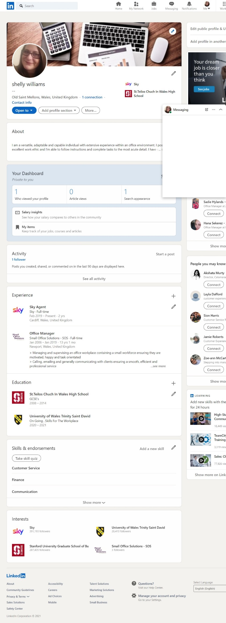
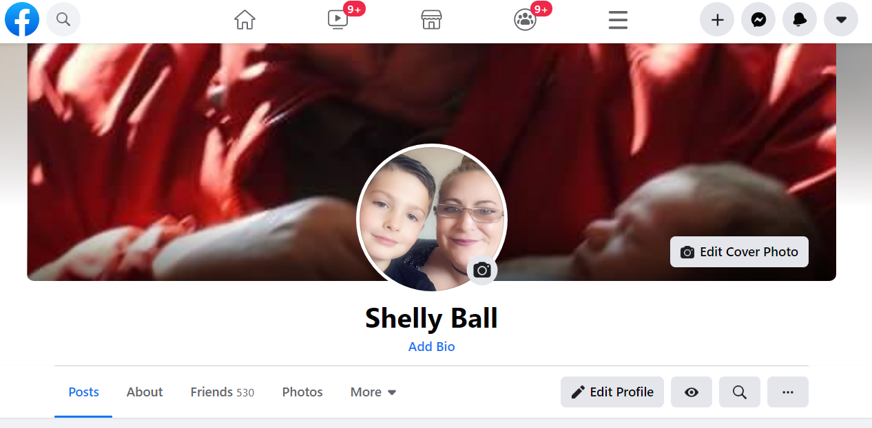
Personal Branding
1.1 What is it?
Crating a brand as a person rather than a business or product. Its your values and what you believe in as an individual, its promoting yourself to the highest standard and showing off your skill set, I value my work ethics in customer service and pride myself on getting the best result for the customer/client.
1.2 How do you Create Your Own Brand?
The first step to creating your own brand is laying a foundation that you can confidently build on. You need to be authentic. People buy into people it needs to be clear, interesting and trustworthy my skill is with accountancy I enjoy this position
1.3 How do you Promote and Maintain Your Brand?
Keeping your content fresh and up to date personal details, it shows that you care about how your perceived online.
1.4 What is the Impact of Your Personal Brand on Employability
If your brand has a great reception it will be noticed
Conclusion
With this ever changing and growth of social media how do we really know the impact it is having on our society? is it as good for our wellbeing as it really claims to be, researched has proved that interacting online is highly addictive and is designed manipulate our behaviours these websites and apps use a variable ratio schedule, this process creates a high level of responses and the things we post can get rewarded with either a like, comment or even a new follower this releases the feel good dopamine hit to our brains making us come back for more with push notifications giving us even more reason to pick up our phones or log on to see what we may have missed. With everybody having the freedom of speech online it gives rise to organisations like Isis they were able to spread their propaganda and encourage terrorism, they would broadcast torture and mass executions Facebook seam powerless at stopping this so hate groups can get their messages heard quickly before detection. Fake news is a problem with so many individuals desperate for likes or the reward, misinformation is spread through social media with ease and clickbait articles tempt people to reading to enhance advertising within the site. The impact of social media on our lives is detrimental in this pandemic its been a lifeline to some too see their family every day.
References
Maund, et al. (2017) Certificate in Higher Education: Skills for the Workplace Student Yearbook. PP. 106 – 129 London: Sage Publications Ltd.
https://youtu.be/cYVBshcN7wU​
Government Digital Service (2018). Data Protection. [online] GOV.UK. Available at: https://www.gov.uk/data-protection
Criddle, C. (2020). Facebook sued over Cambridge Analytica data scandal. BBC News. [online] 28 Oct. Available at: https://www.bbc.co.uk/news/technology-54722362

