2020
Tata Steel

Joseph John Garland (1707750)

Group project reflective essay
Module M5X00400

Summary

The project was completed within the scheduled time frame and managed to reach its goals/targets of increasing the productivity of coil inspection line 1 (C.I.L 1).these goals/targets were met by reducing the risk of contamination caused by the welder head unit and eliminating the risk of potential bearing failures on the welder head.
In order to achieve these goals/targets it was extremely important to have to defensible plan for the project. The process of planning a project is essential to its effectiveness and overall success. The project team were able to achieve their goals/targets mainly due to thorough planning of the job which allowed the carrying out of the project to be done smoothly and problem free
The project team achieved this by following a number of different management and motivation tools such as SMART goals/objective, Belbin’s theory, Tuckmans’s theory, McGregor’s Theory X+Y and Maslow’s hierarchy of needs.
The relevant risk assessment of the project was also carried out using tools such as critical path analysis, PERT and cause and effect diagrams.

Contents
Summary 3
Introduction 5
The Project 6
Figure 1 – Shift reports of leakage problems on Welder head 7
Figure 2 – List of Welder Head changes in last 10 years 10
Figure 3 – Defensible project planning 11
Figure 4 – New welder head cost 12
Figure 5 – Cost of old weld head bottom unit 12
Figure 6 – Cost of old welder head top unit 13
Figure 7 – C.I.L Maintenance Schedule February 25th/26th 14
Figure 8 – C.I.L Maintenance Manning numbers 14
Figure 9 – Critical Path for installation of welder head and commissioning 15
Reference List 18
Bibliography 20
Appendix 1 – Belbin’s Team Roles 21
Appendix 2 – Maslow’s hierarchy of needs 22
Appendix 3 – Tuckman’s theory 24
Appendix 4 - McGregor’s Theory X Theory Y 26
Appendix 5 – SMART Goals and Objectives 28
Appendix 6 – Cause and Effect Diagrams 29
Appendix 7 – Before and After of Project 30

Introduction

The project team were made aware of problems being experienced on the welder head equipment on coil inspection line 1. The problems were proving to be detrimental to the lines productivity and quality of the strip steel being sent to customers. The main problem, contamination, was found to be caused by a design fault from the original equipment manufacturer (OEM). The hydraulic seals on the welder head unit were found to be leaking during operation as a result of the necessary operational pressure being too high for the seals. The operational pressure was also causing the welder wheel bearings to fail prematurely due to excessive point loading.
Due to the line being the final process the product undertakes before being sent to customers, it was seen as essential to rectify the problems as they could result in excess scrapping of product, unnecessary cost or customer dissatisfaction. The line performance improvement team were then tasked with the job of finding a cost effective and reliable solution.

The Project

As part of the project, an initial meeting was held between members of the team to discuss how best to tackle the problem being experienced. During this meeting all members of the team were given a clear and direct idea of their roles and responsibilities within the team helping them better understand what was required of them. Following this a set of clear next steps were created for the team to begin with work for the project. As a result of the first meeting it was agreed that all manual tasks needed to be carried on for the project would have to be done during a scheduled down time period on the line in order to cause as little impact on the lines target monthly output as possible.
Firstly a “look and see” was agreed to be carried out on the problem in question in order to better understand what actions needed to be taken to resolve the problem. The production scheduler was made aware of the need to carry out a “look and see” and arranged for a suitable time for it to be carried out. Following the “look and see” it became clear that there were two different problems being causes by the same thing. The hydraulic pressure needed for effective operation of the welder head unit was too high for the seals on the unit causing oil leakage from the seals during operation. This was found to be a design fault from the Original equipment manufacturer (OEM). This was a critical problem as if any of the oil drips onto the strip steel being run through the line it would cause contamination resulting in either scraping of the product or customer dissatisfaction. The other problem being caused by the operation hydraulic pressure was the roller bearing of the welder wheels were being overloaded during operation. This was also found to be a design fault from the OEM.

Figure 1 – Shift reports of leakage problems on Welder head
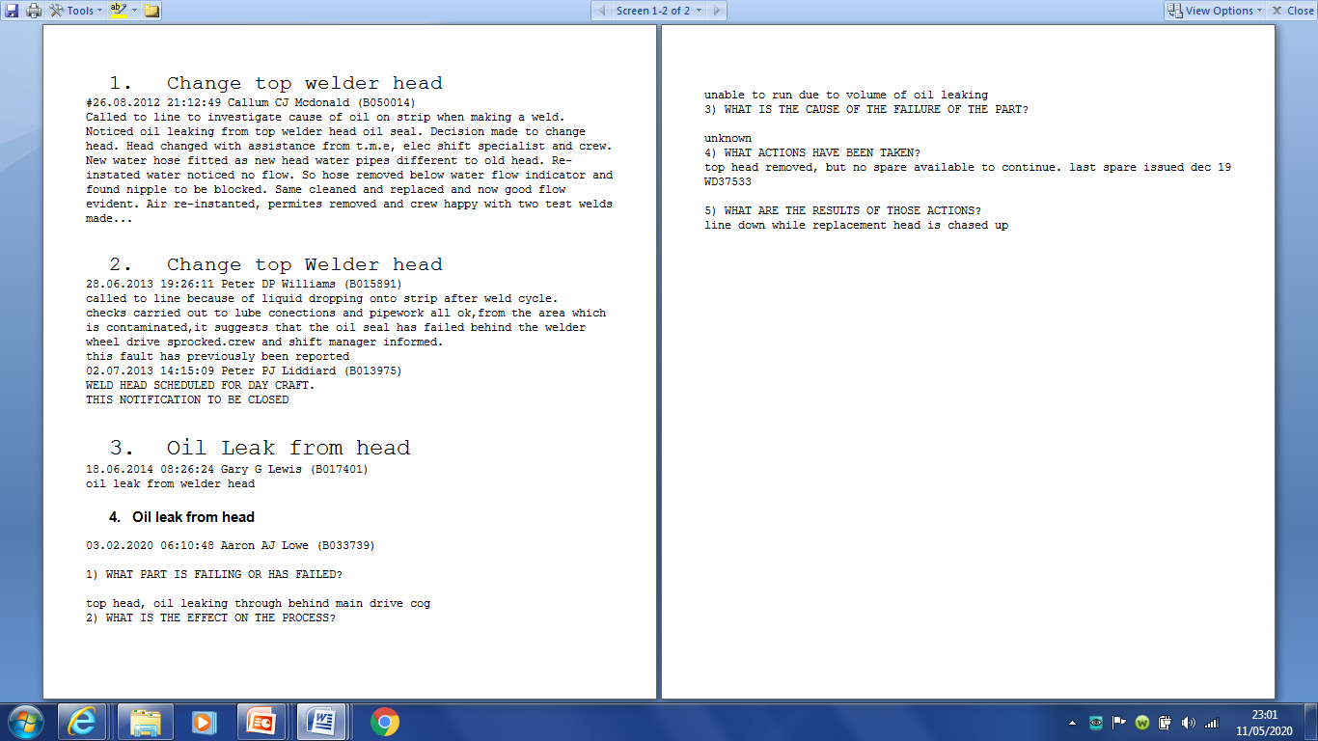

A follow up meeting then took place to discuss how best to resolve the problem. During this meeting it was agreed that an alternative welder head unit should be fitted. The team were aware of the welder head unit intended to be installed being used elsewhere in other lines across the works. Therefore the team were confident of the project being successful and achieving its goal of reducing down time due to mentioned problems. Production crew members on these lines were then asked on their experience with the intended welder head unit and of any flaws they had experienced. Following conversations with production crews from all different shift rota across site this it was found that the new welder head unit experienced very little to no unexpected issues or failure. Further to this a look into the product specification was carried out on the new welder head unit. The new unit was found to be suitable as it did don’t rely on bearing or heavy lubrication to work. Instead a copper shaft and shaft casing are used for the rotation of the welder wheels as they are self lubricating materials.
A suitable down time period was then agreed upon with the production schedulers to carry out the removal and reinstatement of both the top and bottom welder head units. This allowed the team members to ensure they were all readily available during this time and ensured that people’s time was used efficiently and effectively.

As part of the project I requested to aid the performance improvement team for the production lines in my area of work in order to gather a better understanding of the effects on production of the line the project will have and what effect it may also have if the project does not take place. The team consisted of two mechanical line engineers, one electrical line engineer, a production manager and a craftsman (myself). The personnel within the team means the team had a good balance of experience, skill, knowledge, perspective and enthusiasm.
The aims and objectives of the project must be identified and prioritised by using SMART objectives (see appendix 5).

Name | Position | Role within project
Gregg Fortey | Manufacturing support engineer (Mechanical) | To spec and buy equipment, manage budgets and oversee project. assist with Commissioning.
Peter Temple | Maintenance Schedule Engineer (Mechanical) | Plan and oversee the project mechanically, project planning, organising of crasftsmen to do the work, day to day management of project.
Gareth Jones | Manufacturing support Engineer (Electrical) | To spec and buy equipment, manage budget. Plan and oversee Electrical installations and software modifications. Assist with commissioning
Andrew Fagan | Production Manufacturing manger | Provide product specifications, analysis of line performance, chair meetings, secure funding for project. Assist with commissioning
Joseph Garland | Craftsman (Mechanical) | Provide assistance to project engineers and carry out a successful removal and installation process of the project.
Richard Brown | Crasftman (Electrical) | Provide assistance to project engineers and carry out a successful removal and installation process of the project.

The team is an experience long standing team that have worked well together for a number of years on reaching set production goals and targets. When working as a team there are several different techniques used to motivate team members in order to get the desired output from the team. One theory used to motivate members of a team is Belbin’s theory (see appendix 1), this identifies 9 different trends in behaviour which when used effectively can help with placing the most suited roles within the project upon members of the project team. The team should assess each member’s behavioural traits when allocating task/roles to team members in order to achieve good team moral, high performance and ensure each member of the team is given a role/task best suited to them. This can be done by carrying out Belbin’s self-perception inventory.
Team however are often are not made up of 9 different members so each member of the team sometimes has to pick up two or three different roles. Other Techniques such as Maslow’s hierarchy of needs (see appendix 2), Tuckman’s two factor theory (see appendix 3) and Mcgregor’s Theory X theory Y (see appendix 4) can used within a team to motivate its members.
After carrying out Belbin’s self-perception inventory the roles I found my strengths were in the roles of an implementer and team-worker. I feel these strengths best suit me and suited the roles/tasks within the team I was given. The team performed well due to the correct allocation of tasks/roles to each member within the team. It is also my belief that working within the team on the project has aided the personal professional development of all members of the team.

In order to gain sufficient funding for the project the team had to provide the manufacturing manager with a valid reason for the change of the welder head and a well structured plan of how the project would be completed. This was done using a viva presented by Peter Temple and Greg Fortey. The viva included a detailed plan of how the project resource would be used and how the money needed was going to be used.

Figure 2 – List of Welder Head changes in last 10 years
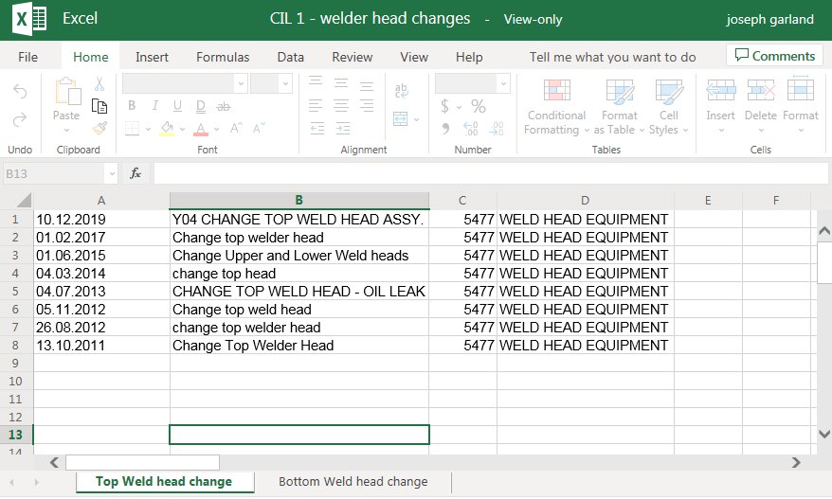
The planning for the project must therefore be defensible. Defensible project planning being fully justified even in spite of a negative outcome, all necessary steps have been considered during planning stages. Defensible project planning is often used as a way of avoiding any legal repercussions in the event of a project failure. (Carson, D. 1996)

Figure 3 – Defensible project planning

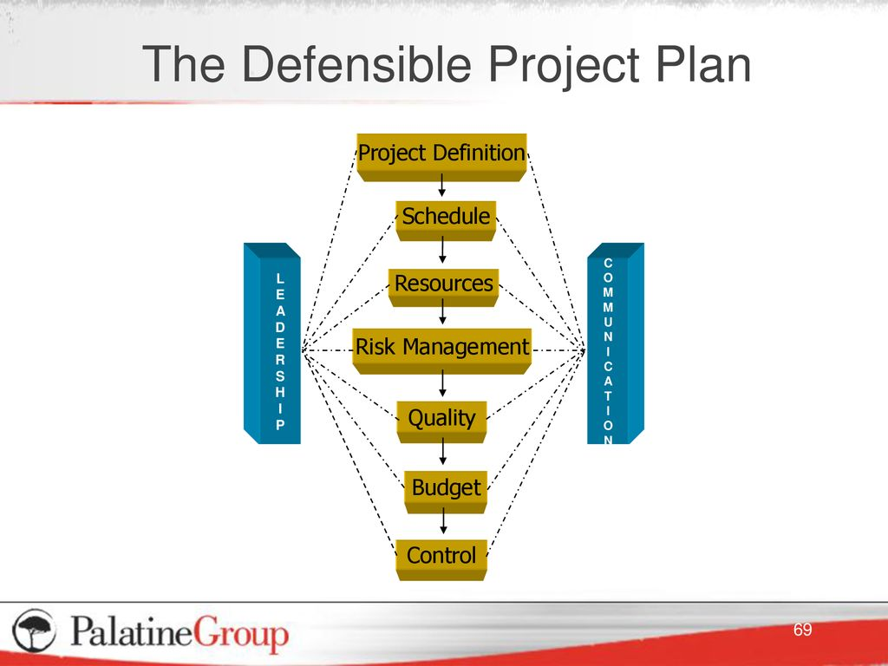
www.Slideplayer.com (2019)

As the team were aware of the equipment needed for the project being stocked in the works stores I was tasked with using systems application and products in (SAP), to create a job for the intended date and book the necessary mechanical equipment for the project out from stores. Then gather the equipment and take it to the project site, coil inspection line 1 (C.I.L 1) ready for work to commence. It was important that these tasks were completed before the scheduled period of down time the project was intended to be completed during in order to meet project deadlines and cost estimations and to not affect the production schedule for the line.
When establishing an accurate cost for the project equipment the team used the works SAP system as you are able to locate and find all pricing of equipment on there. When researching the cost of the new welder head it was also found that it was cheaper than the old welder head unit. This made it easier to plan the project and justify costing of the project to the production manager.

Figure 4 – New welder head cost
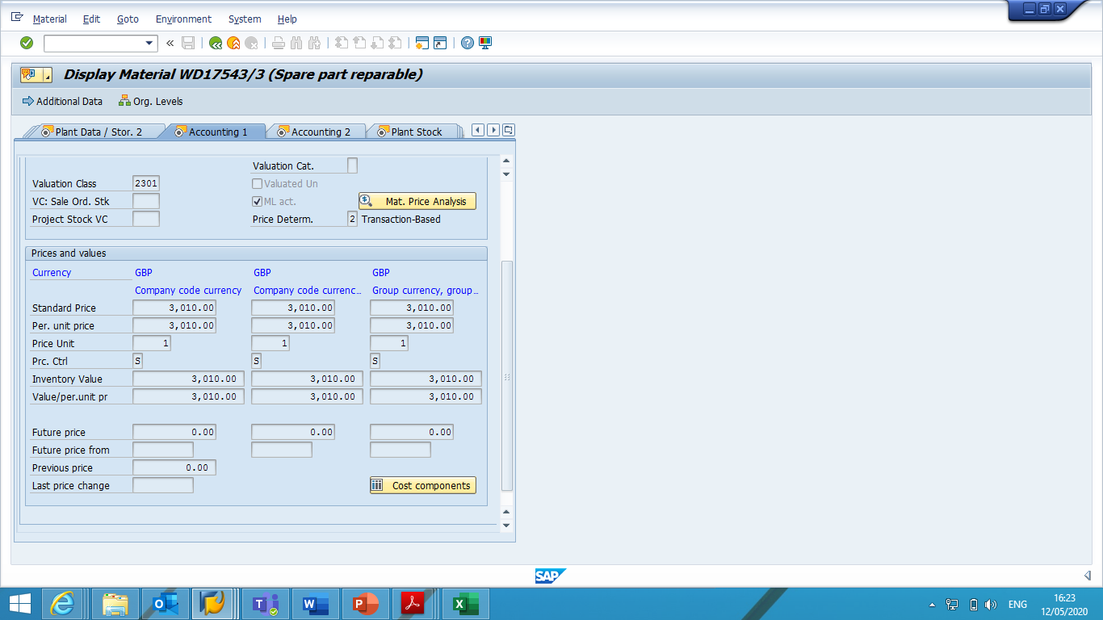

Figure 5 – Cost of old weld head bottom unit
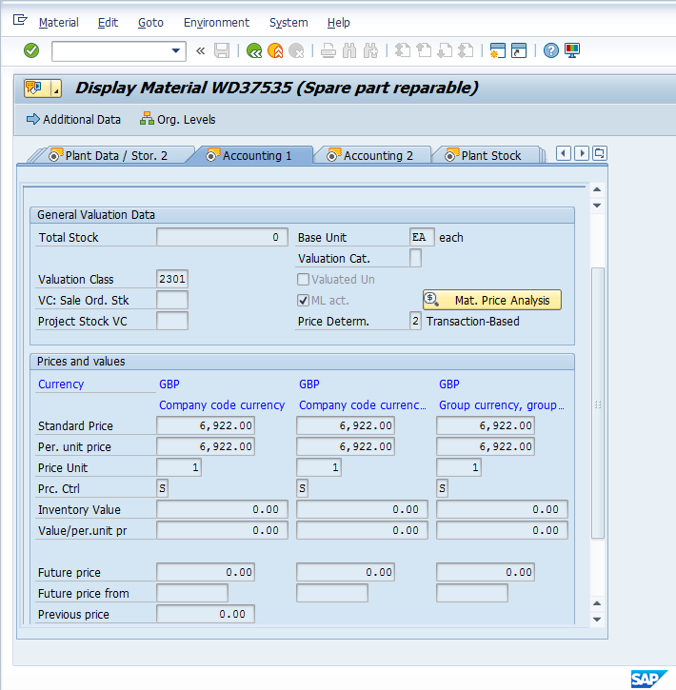

Figure 6 – Cost of old welder head top unit
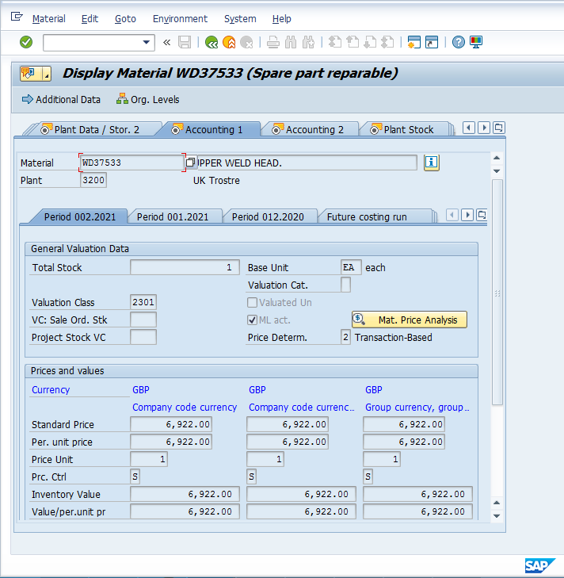

Project definition – significantly reduce line down time due to contamination or bearing failures, ultimately improving tonnage output of line and quality of product for customers. This was a good definition as it was very easily measurable due to the lines tonnage output being constantly monitored and through feedback from customers.
Work schedule and resource – it was decided upon by the team that the work needed to be done would be carried out during 1 of the line three monthly planned maintenances. Carrying out the job during a planning maintenance period allows for no unpredicted loss in production to occur. The job created for the project was then added to the maintenance pack and the relevant craftsmen were made aware of their involvement in the fitting of the new welder head unit. The maintenance pack allows all those involved to be fully aware of when the line is intended to be shut down, when permits are going to be issued and cleared ready for the line to be re-commissioned. This give clear and concise idea of the goals of the maintenance.

Figure 7 – C.I.L Maintenance Schedule February 25th/26th
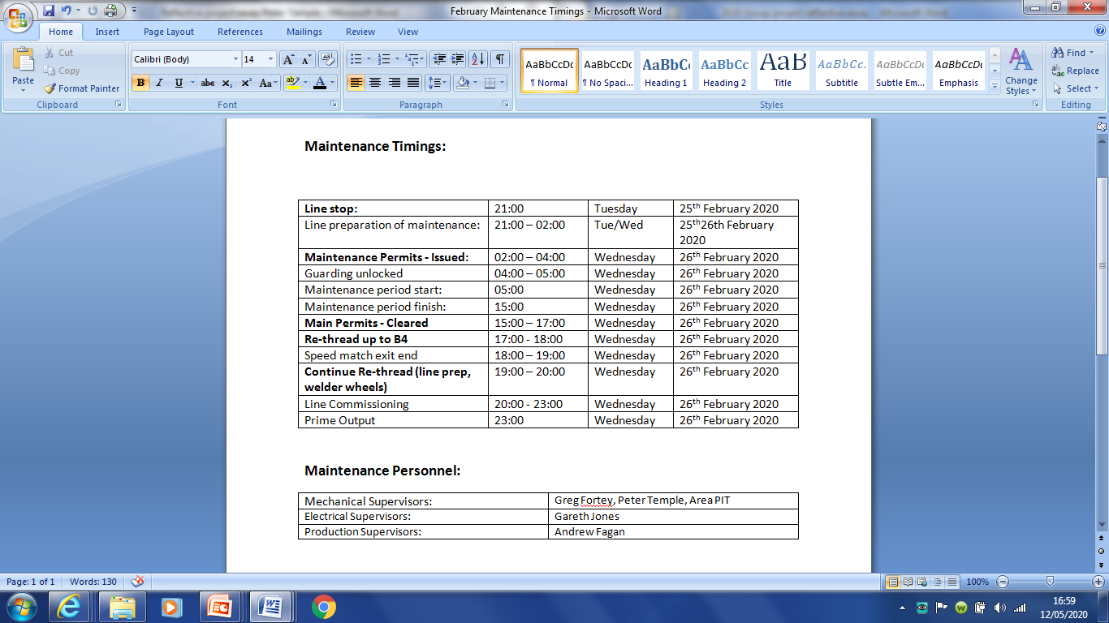

Figure 8 – C.I.L Maintenance Manning numbers

The maintenance manning numbers gave the team a clear idea of how many different skilled people would be needed to complete the maintenance and allowed us to ensure the correct level of manning needed for the project. The manning number were clearly communicated to all parties involves in the maintenance in order workers aware of all work going on around the line thus improving the efficiency the work is carried out and the safety of those carrying it out. If with the manning levels provided we not suitable some planned work of the maintenance would need to be cancelled and re-planned.
I found the planning of both the maintenance and the project to be good as both plans were clearly communicated to each other allowing the team to aviod clash of work in certain areas of the line. This reduces any delays that could have occurred.
Risk assessment - It was essential that all tasks involved in the project were completed on time in order to not hindering the planned start up time of the line (see figure 7). Mindtools.com (2020) states that a critical path can greatly benefit the planning of a project as it allows planners to see exactly what tasks have to be completed before another can commence and what tasks can be carried out alongside one another. Before work could commence with the removal of the old welder head and fitting of new welder head line permits/isolations must be complete and electrical days craftsmen must have disconnected the welder head unit of any connecting wires. Mindtools.com (2020) also states that another technique used to calculate the estimated shortest time needed to complete a task is the programme evaluation and review equation.
$$\frac{Shortest time+4 ×likely time+longest time}{6}$$
(www.mindtools.com,2020)
The use of these techniques stops timescales for tasks being set unrealistically and allows for a more realist time scale to be calculated.

Figure 9 – Critical Path for installation of welder head and commissioning
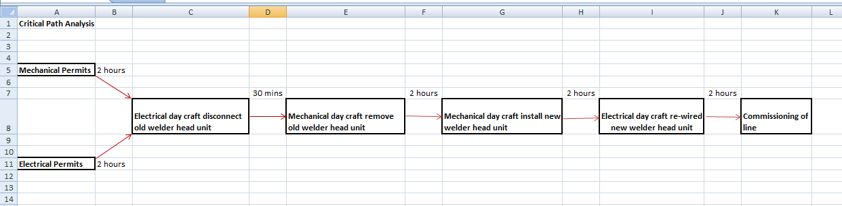

Above is the critical path analysis for the installation of the new welder head unit and commissioning of C.I.L 1. From studying the critical path analysis the team were able to see the job would be completed during the allocated time frame and allowed for an additional two hours in case the team were to encounter any difficulties. This proved to be useful as it allowed the project team to have a clear understanding of the sequence the work would take place before being able to hand the line over to the production crew. It was also important the job was completed on time to ensure the target of the maintenance timings were met (see figure 7).
Another risk associated with the project was the equipment being installed correctly. However the project team were confident of the installation going well as the member of the days craftsmen both mechanical and electrical had experience of carrying out the same job on other similar lines across Trostre.
Damaged/faulty equipment was also identified as another risk involve in the project. any damage to the project equipment could lead to the project not being able to be completed on time. To combat this all equipment needed for the job were given a thorough visual inspection by members of the day craft before being taken to the intended line in the days prior to installation.
Performance of equipment – the equipment intended for use in the project was already used on other line across Trostre, therefore already proving its capabilities of meeting its performance targets. Members of the production crew on these lines were also asked of their experience with the equipment to better gauge how to expect the equipment to perform.
Quality – As Siemens (2020) state quality “at its most basic level, manufacturing quality is conformance to specification”. The improvements made to the line must prove to be both reliable and user friendly as it will be in frequent use by the numerous different crews on the line for prolonged periods of time.
Due to thorough planning and preparation that had taken place prior to the day of installation there were no problems encountered during the installation of the new welder head unit. This proved to be extremely beneficial as the line managed to meet the target start up time for the maintenance and having zero effect on the lines production schedule. As a result of the good planning of the project he cost predictions provided to the production manager proved to be very accurate, allowing the project to come in on budget.
As a whole the project run very smoothly and managed to achieve the goals set at the start of the project. I believe this was due to the team member’s good working relationships, thorough and effective planning and the experience of the job needed to be done within the team. The project eliminated the problem of the bearing failures on the welder head equipment and thus far (date of project completion – current date) has also eliminated the problem of contamination due to oil leakage and therefore was deemed a success. Monthly review meetings of the lines performance are continuously held in order to remain up to date with any issues the line has experienced.

Reference List

https://www.belbin.com/about/belbin-team-roles/
Accessed 12th May 2020
https://moodle.uwtsd.ac.uk/pluginfile.php/240221/mod_resource/content/1/Wk3%20Managing%20your%20time.pdf
Accessed 12th May 2020
www.Slideplayer.com (2020), Defendable project plan [online]
Accessed 10th May 2020
https://www.google.com/search?rlz=1C1AWUA_enGB814GB814&biw=1094&bih=510&tbm=isch&sa=1&ei=Qw7QXIikF8iNlwSJ3ZKQCQ&q=the+defensible+project+plan&oq=the+defensible+project+plan&gs_l=img.3...32336.34703..35272...0.0..0.73.512.8......0....1..gws-wiz-img.XZBEYl0l5zc#imgrc=ZDRyYsW7SLeaWM:
Accessed 10th May 2020
www.mindtools.com (2020), Cause and effect analysis [online]
https://www.mindtools.com/pages/article/newTMC_03.htm
Accessed 12th May 2020
https://www.plm.automation.siemens.com/global/en/our-story/glossary/manufacturing-quality/38123 (2020), Manufacturing Quality [online]
Accessed 12th May 2020
https://www.belbin.com/about/belbin-team-roles/https://www.mindtools.com/pages/article/newLDR_83.htm (2020), Belbin’s team roles
Accessed May 12th
https://www.simplypsychology.org/maslow.html (2020) Maslow’s Hierarchy of Needs
Accessed May 13th
Mindtools.com
(2020). Theory X and Theory Y: Understanding People's Motivations. [online] Available at: https://www.mindtools.com/pages/article/newLDR_74.htm
Accessed 13th May 2020
https://thinkmarketingmagazine.com/how-to-create-smart-goals/ (2020) Smart goals and objectives
Accessed 13th May
https://moqups.com/templates/business-strategy/cause-effect-diagram/ (2020) Cause and Effect diagrams
Accessed May 13th
https://www.smartdraw.com/cause-and-effect/ (2020) cause and effect diagrams
Accessed May 13th

Bibliography

Chapman, A (2013) “Tuckman forming storming norming performing model” Available at: www.businessballs.com Accessed: 06/05/2020
Carson, D. (1996) Risking legal repercussions In: Kemshall, H. and Pritchard, J. Good Practice in Risk Assessment and Risk Management, Ch 1, Vol. 1 Jessica Kingsley Publishers. [Accessed 13th May]
Mindtools.com. (2020). Theory X and Theory Y: Understanding People's Motivations. [online] Available at: https://www.mindtools.com/pages/article/newLDR_74.htm [Accessed 14 Feb. 2020].
Belbin, R Meredith. Team Roles at Work. Abingdon, Oxon: Routledge; 2012.
Cherry, K (2015). The Five Levels Of Maslow's Hierarchy Of Needs. [online] About.com Education. Available at: <http://psychology.about.com/od/theoriesofpersonality/a/hierarchyneeds.htm> [Accessed 13th May 2020].
Belbin, M., 2010. Team Roles At Work. 1st ed. Butterworth Heinemann, p.97.

Appendix 1 – Belbin’s Team Roles

Figure 1 -
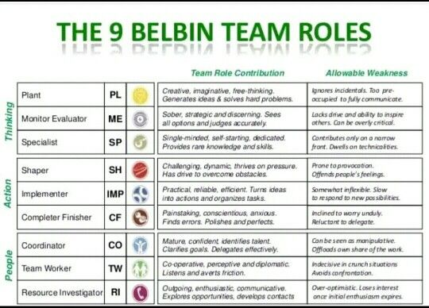
https://www.pinterest.co.uk/pin/824862487970861868/
Belbin (2010) states in order for a team to be a high performance team it must be able to access each of Belbin’s nine different behavioural traits; Plant, Monitor evaluator, Specialist, Shaper, Implementer, Completer finisher, Co-ordinator, Team worker and Resource investigator. These nine different behaviours fall under three categories of management; thinking, action and people. In order to know what behavioural team role a member falls under they must first carrying out Belbin Self-perception inventory to pin-point both their strengths and weaknesses. It is believed that by using Belbin’s team role behaviours individuals within a team gain a better understanding or what their strengths are, in turn leading to a higher performing team.

Appendix 2 – Maslow’s hierarchy of needs

Figure 1 -
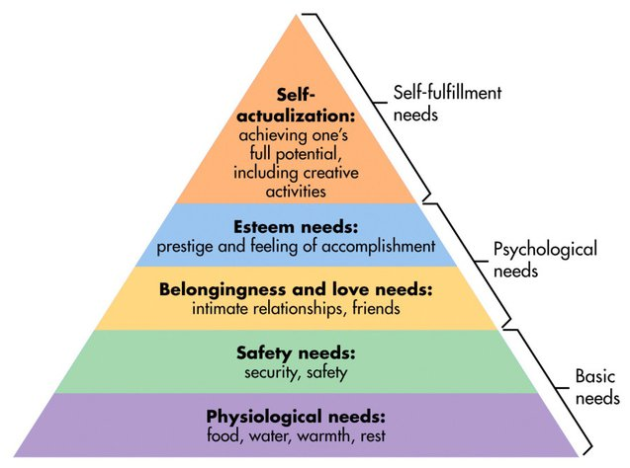
https://www.simplypsychology.org/maslow.html
Cherry K. (2015) states the theory of Maslow’s hierarchy of needs suggests that there are five different tiered specific human needs when it comes to motivation. This is illustrated in the tiered diagrams above (figure 1). In order from bottom to top theses needs are physiological needs and safety at the most basic level , belongingness and love, esteem at a psychological level and at the top self-actualisation needs were categorised as self-fulfilment needs.
Physiological needs include things such as; food, water, warmth and rest
Safety needs include security and safety
Belongingness and love needs include
Esteem needs included feeling of a accomplishment and prestige
Self-actualisation need include achieving one’s full potential in both mundane and creative activities
It was originally stated by Maslow (1945) that individuals must first have satisfied the lower be basic needs before progressing on to higher individual growth. He however changed this later on quoting his initial statement could have given “the false impression that a need must be satisfied 100 percent before the next need emerges” (1987, p. 69).

Appendix 3 – Tuckman’s theory

Tuckman (1965) first published his forming, storming, norming and performing theory but later added to this in 1970 when he added adjourning. Tuckman (1970) states that there are five different stages to management/leadership and that as a team develops in experience, ability and better working relationships are made that the style of management/leadership also changes. These different approaches to management and leadership can be seen below (see figure 1)
Figure 1 -
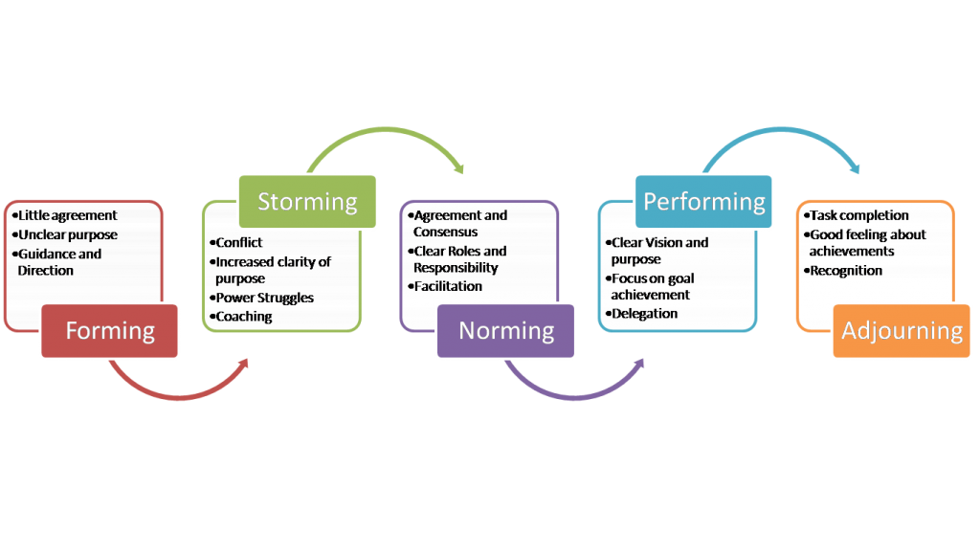 https://www.businessballs.com/team-management/tuckman-forming-storming-norming-performing-model/
Forming - At this stage there is no bond and the group are more of a collection of individuals. Everybody is focused on finding their place within the team.
Storming - People now begin to view themselves as part of a team. However at this stage they may challenge each other and the leader, This stage is prone to conflict. This can result in lower productivity as there may be a lack of focus on the task.
Norming - This is the phase where team members start to work together, establishing rules, clarifying roles, and deciding how things should be done.
Performing
This is the final stage where focus is on the combination of task importance and on team relationships. Performance is optimised through everyone working effectively together.
Adjourning - is the final stage, referring to when the task is completed, now the team will move on to new things, feeling positive for their achievements

Appendix 4 - McGregor’s Theory X Theory Y

Theory X
Management under theory X assumes:
Theory X assumes that the majority(both managers and team members) of employees dislike their job and struggle to find motivation in their day to day tasks.
This results in management tending to think that employees need to be prompted, rewarded or sometimes punished in order to create a more motivated team of employees.
Number driven.
At organisation where mcgregor’s theory x is used as their management approach work can often be repetitive with a carrot and stick approach often employed to achieve their goals and ensure team members are performing as required.
Managers regularly have to intervene to ensure work in completed.
Mcgregor’s theory x as a whole has fallen out of favour with most companies now, however some very large companies do find themselves having to employ the approach due to the number of people they employ and being deadline orientated.
Figure 1 –
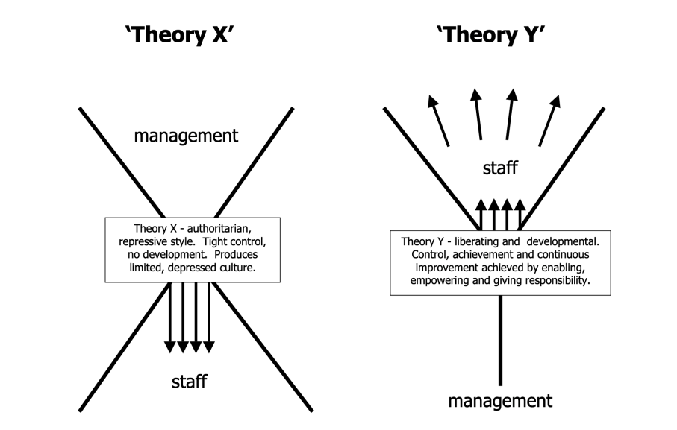
https://www.mindtools.com/pages/article/newLDR_74.htm

Theory Y
Management to Theory Y assume:
Optimistic, positive approach to managing.
Greater responsibilities given to employees encouraging them, installing confidence in what they are doing is right.
Encourages development of skills and progression.
Work under own initiative
Seek and accept responsibility
View work as challenging and fulfilling
Theory y is now a much more popular style of management with companies and employees in recent years as it reflects workers increasing desires and more meaningful careers. It is generally believed that theory y is superior to theory x as it gives workers great motivation, resulting in them staying at the companies longer

Appendix 5 – SMART Goals and Objectives

Figure 1 –
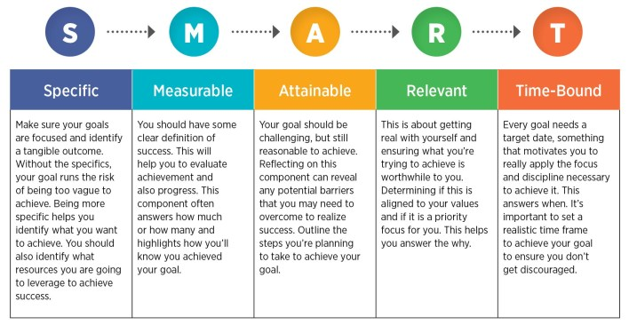
https://thinkmarketingmagazine.com/how-to-create-smart-goals/

Appendix 6 – Cause and Effect Diagrams

Cause and effect diagrams are used as a method of finding the reason for a failure or the cause of potential failures. It does this by arranging potential causes into categories and exploring the contributing factors of these catrories.
Figure 1 – basic cause and effect diagram
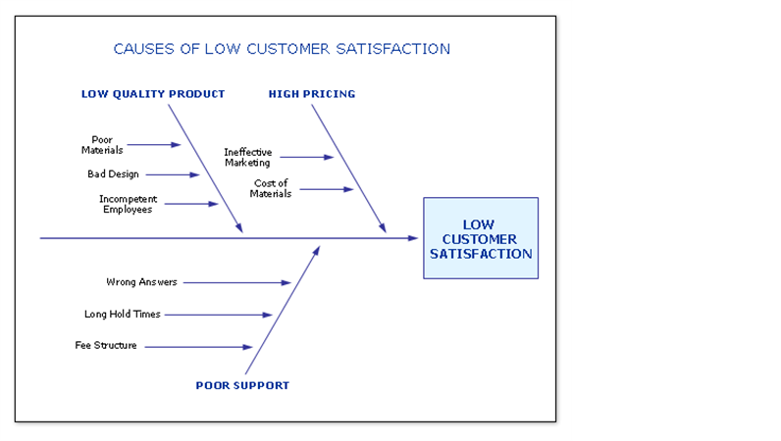
cause-and-effect-diagram-tm06082737

Appendix 7 – Before and After of Project

Figure 1 – old welder head unit
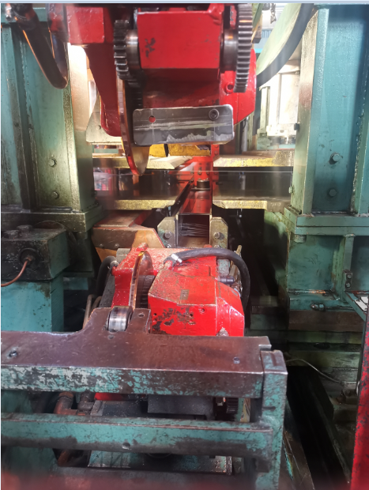
Area of oil leak
Area of bearing failure
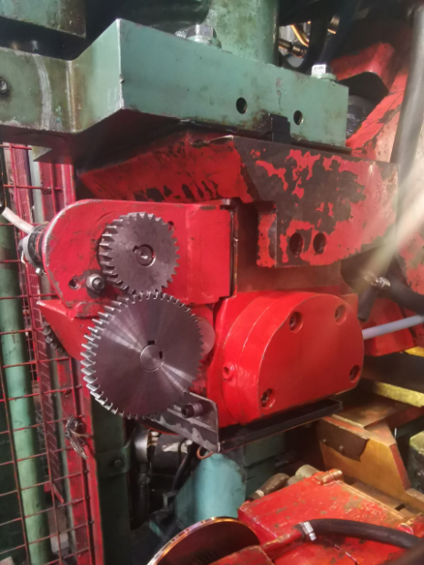
Area of bearing failure
Area of oil leak

Figure 2 – new welder head unit
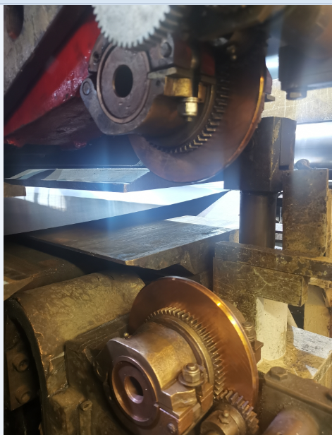
New bearing/lubrication free welder wheel shaft and housing

